Appendix A

Supplementary Tables
Table A 1. Population designation by ecotype, designatable unit (DU), and SARA for woodland caribou in western Canada.
Population | Ecotype | DU | SARA Listing
Calendar | Boreal | Boreal | Boreal
Chinchaga | Boreal | Boreal | Boreal
Maxhamish | Boreal | Boreal | Boreal
Snake-Sahtaneh | Boreal | Boreal | Boreal
Westside Fort Nelson | Boreal | Boreal | Boreal
Barkerville | Mountain | Southern Mountain | Southern Mountain- Southern Group
Central Selkirks | Mountain | Southern Mountain | Southern Mountain- Southern Group
Columbia North | Mountain | Southern Mountain | Southern Mountain- Southern Group
Groundhog | Mountain | Southern Mountain | Southern Mountain- Southern Group
Hart Ranges | Mountain | Southern Mountain | Southern Mountain- Southern Group
Narrow Lake | Mountain | Southern Mountain | Southern Mountain- Southern Group
North Cariboo | Mountain | Southern Mountain | Southern Mountain- Southern Group
Purcells South | Mountain | Southern Mountain | Southern Mountain- Southern Group
Wells Gray North | Mountain | Southern Mountain | Southern Mountain- Southern Group
Wells Gray South | Mountain | Southern Mountain | Southern Mountain- Southern Group
Kennedy Siding | Northern | Central Mountain | Southern Mountain- Central Group
Quintette | Northern | Central Mountain | Southern Mountain- Central Group
Graham | Northern | Northern Mountain | Southern Mountain- Northern Group
Itcha-Ilgachuz | Northern | Northern Mountain | Southern Mountain- Northern Group
Telkwa | Northern | Northern Mountain | Southern Mountain- Northern Group
Tweedsmuir | Northern | Northern Mountain | Southern Mountain- Northern Group
Wolverine | Northern | Northern Mountain | Southern Mountain- Northern Group
Atlin | Northern | Northern Mountain | Northern Mountain
Carcross | Northern | Northern Mountain | Northern Mountain
Finlay | Northern | Northern Mountain | Northern Mountain
Frog | Northern | Northern Mountain | Northern Mountain
Gataga | Northern | Northern Mountain | Northern Mountain
Horseranch | Northern | Northern Mountain | Northern Mountain
Liard Plateau | Northern | Northern Mountain | Northern Mountain
Little Rancheria | Northern | Northern Mountain | Northern Mountain
Muskwa | Northern | Northern Mountain | Northern Mountain
Pink Mountain | Northern | Northern Mountain | Northern Mountain
Rabbit | Northern | Northern Mountain | Northern Mountain
Swan Lake | Northern | Northern Mountain | Northern Mountain

Table A 2 Season date range and descriptive ecology of biologically relevant seasons for woodland caribou based on previous literature.
Season | Date range | Ecology
Calving | 15 May - 30 June | Calving period often signified by a substantial drop in daily movement rates, where it has been documented that females tend to show fidelity to calving grounds or sites. Caribou tend to be the most dispersed during calving and occupy the smallest home ranges.
Summer | 1 July –  15 September | Females tend to have low rates of movement to accommodate presence of neonates and reduce opportunities for predation. Forage is widely available during summer period.
Rutting (breeding) | 16 September - 15 November | During the rutting season, caribou can be found in mixed sex groups. Rutting habitat can include closed pine, pine-spruce, or spruce forests at moderate elevations, or subalpine forests and alpine meadows at high elevations depending on the population. Movement to rutting grounds usually in mid-September, entailing a gradual shift from summer ranges. Rutting behaviour can include males sparring and defending females. Fidelity to rutting areas has been observed.
Movement | 16 November - 30 November | More direct and linear movement has been observed in autumn, suggesting seasonal range shifts to locate seasonal food sources while minimizing predation.
Winter | 1 December - 30 April | Females tend to show variable winter range use, with the greatest rates of movement being observed in early winter or late spring (likely representative of movement between seasonal ranges). Similarly, these periods are when the largest home ranges have been identified. During late winter, caribou display the lowest rates of movement, with the largest range size. In some caribou groups, movement between ranges is signified by an elevational shift in habitat use (i.e. DU 9; Southern Mountain caribou).
* see DeCesare et al., 2012; Edmonds, 1988; Ferguson and Elkie, 2004; McDevitt et al., 2009; Rettie and Messier, 2001; Rudolph and Drapeau, 2012; Theoret et al., 2022; Wood, 1996 for definitions of various biologically relevant seasons, including observed changes in movement.
Table A 3. Median behavioural variation across clusters with 95% confidence interval (lower bound= 2.5%, upper bound= 97.5%).
Cluster | 1 (N_{indiv}=44, N_{pop}=11) |  | 2 (N_{indiv}=88, N_{pop}=17) |  | 3 (N_{indiv}=56, N_{pop}=15) |  | 4 (N_{indiv}=46, N_{pop}=5) |  | 5 (N_{indiv}=45, N_{pop}=6) |  | 6 (N_{indiv}=23, N_{pop}=1)
Behaviour | Median | 95% CI | Median | 95% CI | Median | 95% CI | Median | 95% CI | Median | 95% CI | Median | 95% CI
Calving Area (km²) | 66.4 | (25.81-215.1) | 149.5 | (50.01-401.9) | 702.2 | (81.03-2376) | 93.82 | (12.19-297.2) | 182.2 | (75.18-415.4) | 899.3 | (495.6-1222)
Calving Date (Day of Year) | 158 | (137.3-179.9) | 153 | (138-168.8) | 156 | (146.1-175.6) | 141 | (137-167.4) | 154 | (143.1-177.7) | 157 | (151.6-161.9)
Calving Edge:Area | 0.53 | (0.27-0.99) | 0.37 | (0.24-0.65) | 0.19 | (0.09-0.7) | 0.43 | (0.25-1.26) | 0.316 | (0.186-0.487) | 0.154 | (0.131-0.222)
Calving Elevation (m) | 1587 | (898-1882) | 1687.7 | (1346-1940) | 1475 | (963.8-1881) | 486 | (370.2-819.3) | 1520 | (1345-1742) | 1815 | (1679-1910)
Calving Elevation Gain (m) | 106.4 | (-942.9-893.2) | -65.32 | (-523.8-394.6) | -324.2 | (-812.4-400.6) | -1.31 | (-87.13-78.57) | 13.76 | (-278-140.2) | -571.8 | (-734.8--397.6)
Calving MCP Shape | 1.22 | (1.03-1.46) | 1.26 | (1.07-1.71) | 1.38 | (1.19-1.8) | 1.26 | (1.07-1.7) | 1.21 | (1.08-1.45) | 1.31 | (1.1-1.5)
Calving Path Length (km) | 85.86 | (41.49-191.6) | 165.6 | (50.56-316) | 274.5 | (69.51-421.9) | 171.4 | (94.23-320) | 230.9 | (130.5-286) | 331.6 | (200-431.4)
Canopy Cover (%) | 32.5 | (0-93.78) | 0 | (0-47.56) | 0 | (0-89.5) | 41.25 | (0-83.75) | 73 | (0-94) | 0 | (0-23.45)
Migration (IO) | 0.48 | (0-1) | 0.555 | (0-1) | 0.048 | (0-1) | 0.886 | (0.288-1) | 0.579 | (0.007-1) | 0.47 | (0-0.828)
Movement Distance (km) | 13687 | (4022-46482) | 35991 | (2767-81277) | 55.43 | (2.58-123.72) | 70.01 | (12.31-156.2) | 35.17 | (17.34-59.33) | 66.68 | (10.25-128.3)
Movement Elevation Range (m) | 375.5 | (153.8-692.2) | 376.5 | (36.18-1149) | 359.3 | (45.13-861) | 51.98 | (7.13-169.3) | 595 | (250.5-903.9) | 227 | (62.6-512.9)
Rutting Elevation (m) | 1630 | (1413-1720) | 1605 | (932.8-1789) | 1453 | (634.5-1815) | 470.5 | (366.3-774.1) | 1469 | (1298-1673) | 1648 | (1558-1811)
Seasonal Elevation Difference (m) | 178.9 | (21.16-610.5) | 120.3 | (7.27-420) | 363.3 | (24.45-763) | 16.03 | (0.31-80.66) | 47.3 | (3.5-138.6) | 489.5 | (227.3-640.4)
Summer Area (km²) | 60.28 | (15.63-148) | 135.3 | (41.18-484.8) | 145.6 | (34.41-890.7) | 69.37 | (20.62-248.5) | 100.2 | (33.69-297.9) | 608.1 | (240.5-1117)
Summer MCP Shape | 0.279 | (0.203-0.61) | 0.186 | (0.098-0.369) | 0.18 | (0.076-0.364) | 0.25 | (0.14-0.51) | 0.206 | (0.135-0.39) | 0.101 | (0.074-0.178)
Winter Edge:Area | 0.481 | (0.227-1.031) | 0.303 | (0.195-0.667) | 0.163 | (0.094-0.4) | 0.183 | (0.121-0.531) | 0.326 | (0.203-0.54) | 0.085 | (0.071-0.125)
Winter MCP Shape | 1.3 | (1.03-1.76) | 1.24 | (1.09-1.76) | 1.28 | (1.11-1.95) | 1.2 | (1.1-1.42) | 1.23 | (1.09-1.5) | 1.14 | (1.1-1.32)

Table A 4. Seasonal area (km²) of behavioural cluster ranges, computed as the 95% KDE of female woodland caribou throughout British Columbia.
Behavioural Cluster | Annual | Calving* | Summer* | Rutting* | Winter*
1 | 87190.3 | 111403.3 | 108076.8 | 162198.1 | 99516.6
2 | 143046.6 | 174174.0 | 165326.6 | 201934.6 | 164063.5
3 | 326931.3 | 357814.7 | 393466.8 | 531703.5 | 423015.9
4 | 39799.5 | 43152.1 | 43207.8 | 49964.6 | 43998.2
5 | 21096.9 | 22537.5 | 22911.2 | 25612.6 | 20786.2
6 | 5529.1 | 1333.6 | 2637.2 | 2646.1 | 4401.2
* Seasons are defined as calving; 1 May – 30 June, summer; 1 July – 15 September, rutting (or breeding); 16 September – 15 November, and winter; 1 December – 30 April (McDevitt et al., 2009; Table S 1).

Table A 5. Seasonal 95% KDE percentage of overlap for each behavioural cluster of female woodland caribou in British Columbia. Percentage is a function of the area of intersection (km²) by the area of the 95% KDE (km²).
Season (date range) | Behavioural Cluster | 1 | 2 | 3 | 4 | 5
Annual | 1 | 100
Annual | 2 | 1.01 | 100
Annual | 3 | 4.14 | 29.9 | 100
Annual | 4 | 0 | 0 | 18.3 | 100
Annual | 5 | 25.6 | 68.3 | 48.1 | 0 | 100
Annual | 6 | 0 | 0 | 98.3 | 0 | 0
Calving  (15 May -30 June) | 1 | 100
Calving  (15 May -30 June) | 2 | 0.982 | 100
Calving  (15 May -30 June) | 3 | 3.50 | 33.2 | 100
Calving  (15 May -30 June) | 4 | 0 | 0 | 9.52 | 100
Calving  (15 May -30 June) | 5 | 19.2 | 79.0 | 49.9 | 0 | 100
Calving  (15 May -30 June) | 6 | 0 | 0 | 100 | 0 | 0
Summer  (1 July – 15 September) | 1 | 100
Summer  (1 July – 15 September) | 2 | 0.322 | 100
Summer  (1 July – 15 September) | 3 | 4.82 | 36.9 | 100
Summer  (1 July – 15 September) | 4 | 0 | 0 | 13.3 | 100
Summer  (1 July – 15 September) | 5 | 23.2 | 74.9 | 0.00179 | 0 | 100
Summer  (1 July – 15 September) | 6 | 0 | 0 | 82.3 | 0 | 0
Rutting  (16 September – 15 November) | 1 | 100
Rutting  (16 September – 15 November) | 2 | 0.873 | 100
Rutting  (16 September – 15 November) | 3 | 5.44 | 33.9 | 100
Rutting  (16 September – 15 November) | 4 | 0 | 0.0210 | 31.1 | 100
Rutting  (16 September – 15 November) | 5 | 13.5 | 82.9 | 64.2 | 0 | 100
Rutting  (16 September – 15 November) | 6 | 0 | 0 | 100 | 0 | 0
Winter  (1 December – 30 April) | 1 | 100
Winter  (1 December – 30 April) | 2 | 2.00 | 100
Winter  (1 December – 30 April) | 3 | 4.71 | 27.0 | 100
Winter  (1 December – 30 April) | 4 | 0 | 0 | 30.9 | 100
Winter  (1 December – 30 April) | 5 | 14.6 | 75.3 | 0.00270 | 0 | 100
Winter  (1 December – 30 April) | 6 | 0 | 0 | 100 | 0 | 0

Supplementary Figures
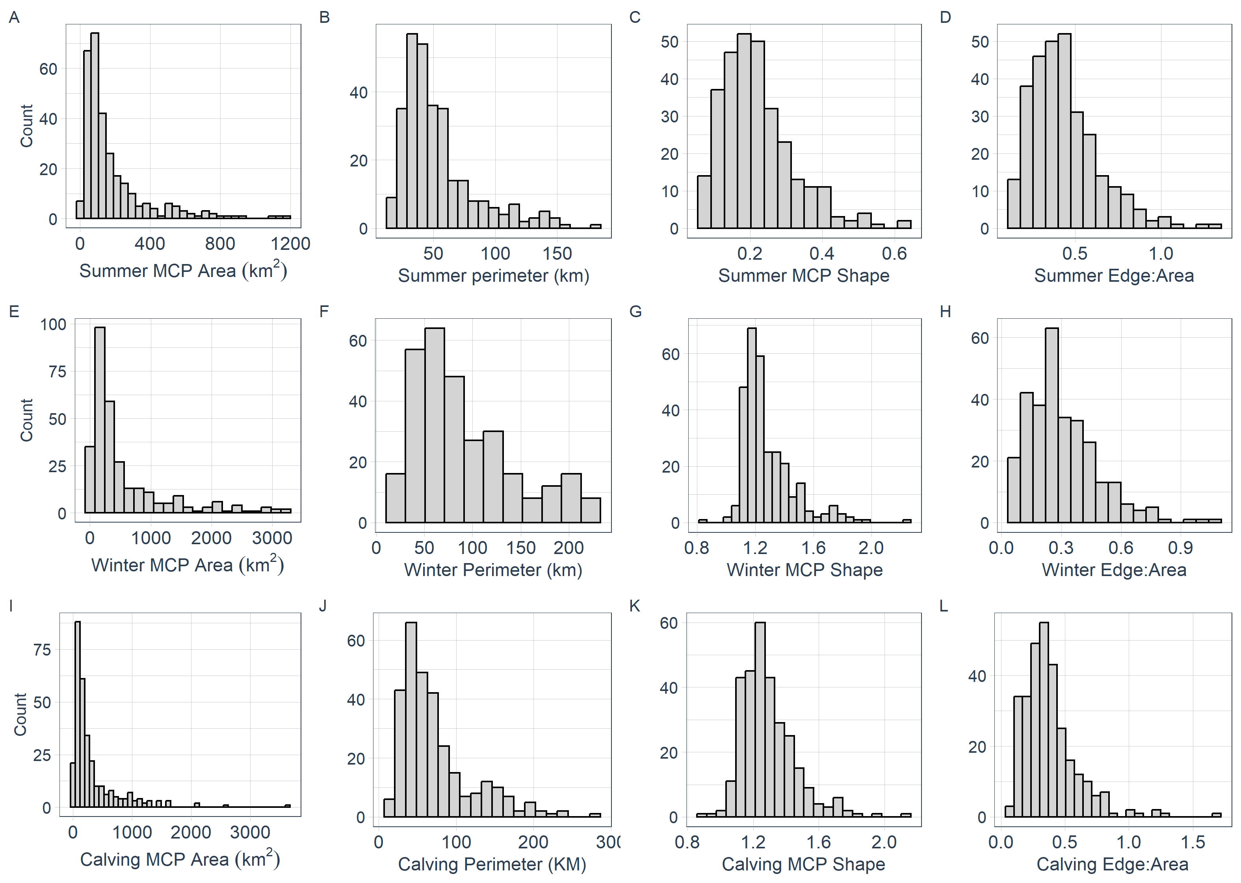
Figure A 1. Data distribution of behavioural discriminatory variables relating to home range (space-use) metrics. X-axis represents the value for each measured trait, while the y-axis displays the count for a total of 302 female woodland caribou.
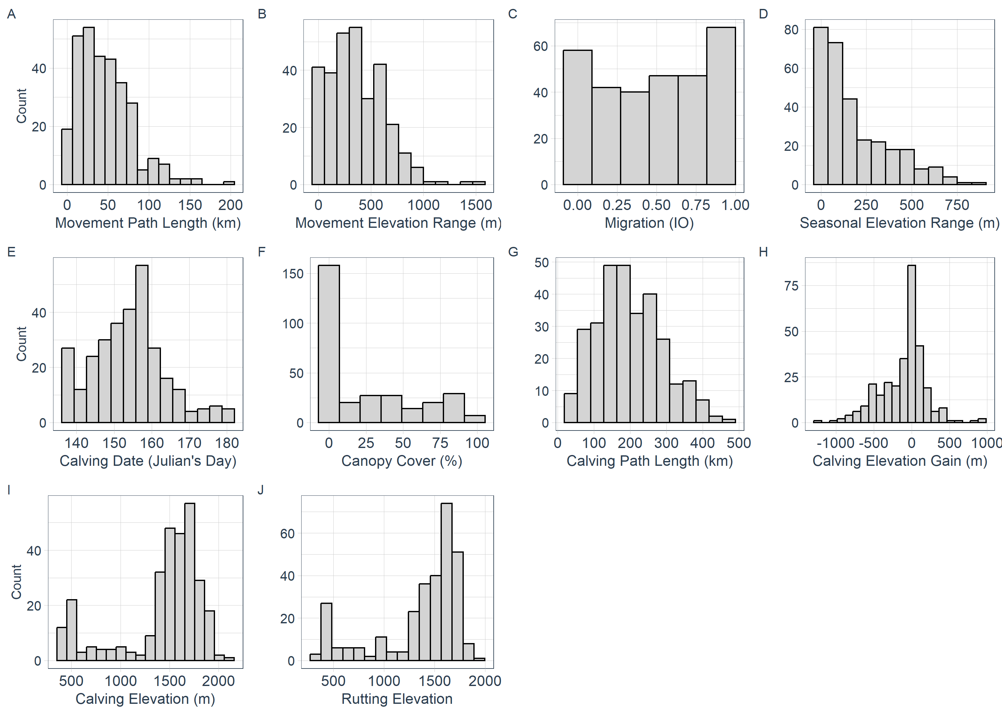
Figure A 2. Data distribution of behavioural discriminatory variables relating to movement metrics. X-axis represents the value for each measured trait, while the y-axis displays the count for a total of 302 female woodland caribou.

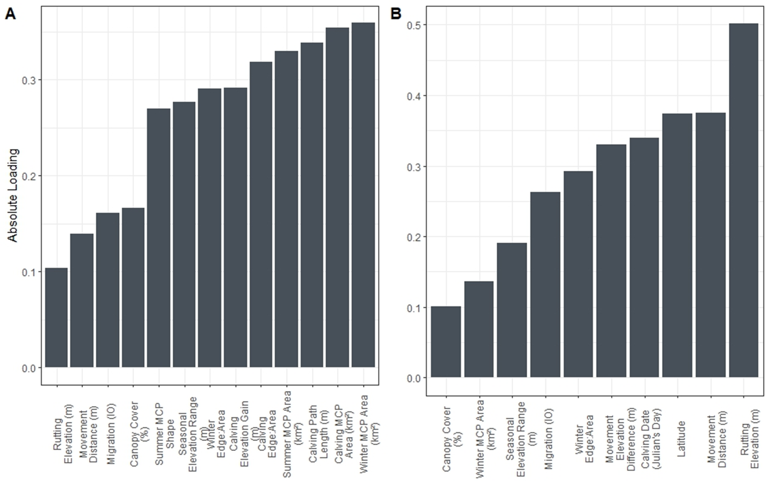
Figure A 3. Variable contribution (absolute loading) for A.) PC1 and B.) PC2.

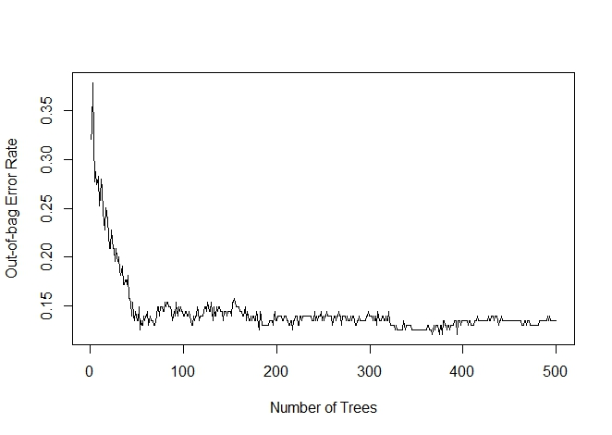
Figure A 4. Out of Bag Error Rate (OOB) in relation to the number of trees used within Random Forest (RF) models. This illustrates the RF model performance as the number of trees increases, showing a diminishing trend in error rate with increasing tree count. The stabilization of error rate suggests the model achieves stable performance with approximately 100 trees, indicating that the use of 500 trees was sufficient.

