Supporting Information

Advanced DNA-gold biointerface for PCR-free molecular detection of Leishmania infantum

Paolo Calorenni^{1‡}, Giovanni Bella^{1‡}, Marco Sebastiano Nicolò¹, Emanuele Luigi Sciuto¹*, Maria Vittoria Balli², Giovanni Valenti², Tommaso Gritti³, Stefania Varani³, Luca Prodi² and Sabrina Conoci^{1,2,4}
¹ Department of Chemical, Biological, Pharmaceutical and Environmental Sciences, University of Messina, Viale Ferdinando Stagno d’Alcontres 31, Messina, 98166 Italy.
² Department of Chemistry ‘‘Giacomo Ciamician’’, University of Bologna, Via Francesco Selmi 2, Bologna, 40126, Italy.
³ Department of Medical and Surgical Sciences, University of Bologna, Via Massarenti 9, Bologna, 40138 Italy.
⁴ URT LAB SENS DSFTM CNR Messina, Viale Ferdinando Stagno d’Alcontres 31, Messina, 98166, Italy.

1. Background of CA and SFE analysis

Contact angle measurements represent a fast and cheap way to evaluate the surface chemical properties of functionalized interfaces. CA is thermodynamically defined as function of a three-phase mechanical equilibrium that occurs in a solid-liquid-gas interface that is created by spotting a fluid drop on a solid surface.^{[1]} This equilibrium is described by the Young's equation^{[2]} (1):
γlv cos θy = γsv – γsl (1)

where γlv, γsv and γsl represent, respectively, the liquid-vapor, solid-vapor and solid-liquid interfacial tensions and θy is the CA, as illustrated in Figure S1a. CA is primarily used to evaluate the surface wettability and morphology but, by controlling the variables related to the three-phase interface, CA could be used to study the surface isoelectric properties too.

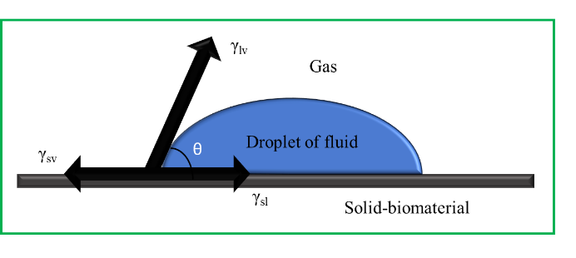 | 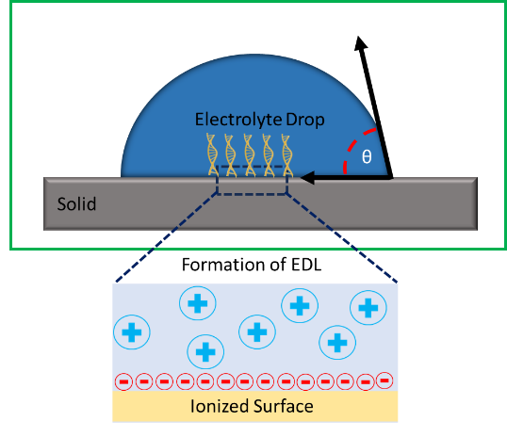
a | b
Figure S1. (a) Contact angle (θ) in a three-phases interface formed by the liquid droplet on a solid-biomaterial and the surrounding gas. (b) Scheme of the electrical double layer (EDL) produced by the droplet and the exposed surface charged functional groups.

The study of correlation between wettability^{[3]} and CA allows to understand how the droplet diffuses on the solid substrate and to evaluate the droplet tendency to form surface interactions with the solid. Therefore, through this combined investigation is possible to obtain fundamental information on surface functionalization processes and applications based on phases interactions.
The correlation between surface wettability and pH can be, also, used as valid tool for the study of isoelectric properties and charge density of functionalized interfaces. The spotting of a drop of an electrolyte solution onto an interface create an electric double layer (EDL)^{[4]}, as shown in Figure S1b. Within EDL, the combination of counterions of drop with the charges of functional groups exposed by the interface generates an electrostatic attractive force and a potential that at certain pH decrease to zero (potential of zero charge, PZC), identifying an isoelectric condition of the functionalized interface. Therefore, by tuning the pH of the drop solution is possible to modify the charges environment of EDL and the CA value as function of the isoelectric properties of the studied interface.
A last parameter that correlates both wettability and surface charges is the surface free energy (SFE) which measures the surface tension of a substrate. SFE arises from molecular interactions at the air-solid interface so that the higher SFE value the more hydrophilic is the solid surface.
In our work to calculate the SFE of the functionalized biointerface we employed the Owens-Wendt-Rabel-Kaelble (OWRK) model^{[5,6]} by which the surface tension of the liquid, γ_{LV}, is calculated by the sum of a dispersive component (γ^{D}_{LV} e.g. Van der Waals interactions) and a polar component (γ^{P}_{LV}, e.g. hydrogen bonding). Also, the solid SFE (γ_{SV}) is a sum of dispersive and polar components such that γ_{SV} = γ^{D}_{SV} + γ^{P}_{SV}. The OWRK model, then, combines the liquid surface tension, solid SFE, and liquid-solid contact angle (θ) calculation into the following equation (2):
$$γ_{LV}\left(1+cosθ\right)=2[(γ_{SV}^{D}γ_{LV}^{D})^{\frac{1}{2}}+(γ_{SV}^{P}γ_{LV}^{P})^{\frac{1}{2}}] (2)$$

In this approach the solid is theoretically smooth and chemically homogeneous and the CA is measured from two liquids with known polar and dispersed fractions of SFE.
Every system strives to achieve equilibrium with a free energy state that is as low as possible.
Every system aspires to a state of equilibrium, solids, in particular, form an interface with a liquid to attempt to minimize free energy, therefore having a wettable surface^{[7]}. Therefore, the SFE of a solid is closely related to its wettability, if high the surface of the solid will be wettable.

2. CA experimental data

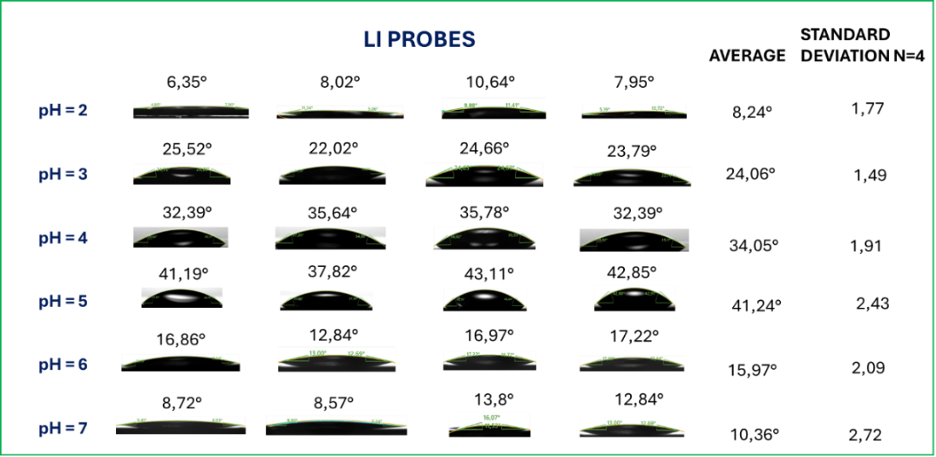
Figure S2. LI probes average contact angles and standard deviations of four different trials (n=4) at various pH.
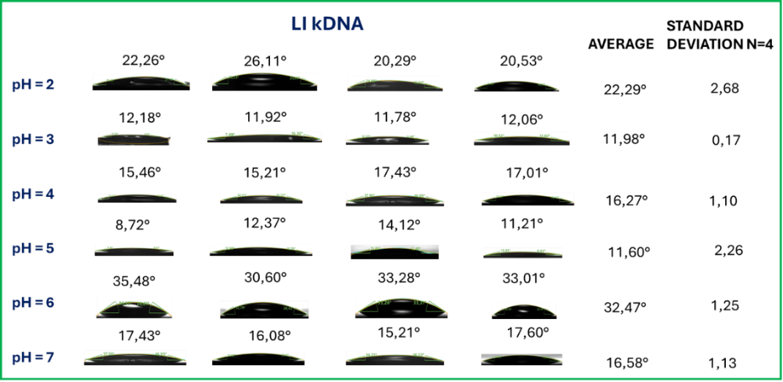
Figure S3. LI probes-kDNA average contact angles and standard deviations of four different trials (n=4) at various pH.
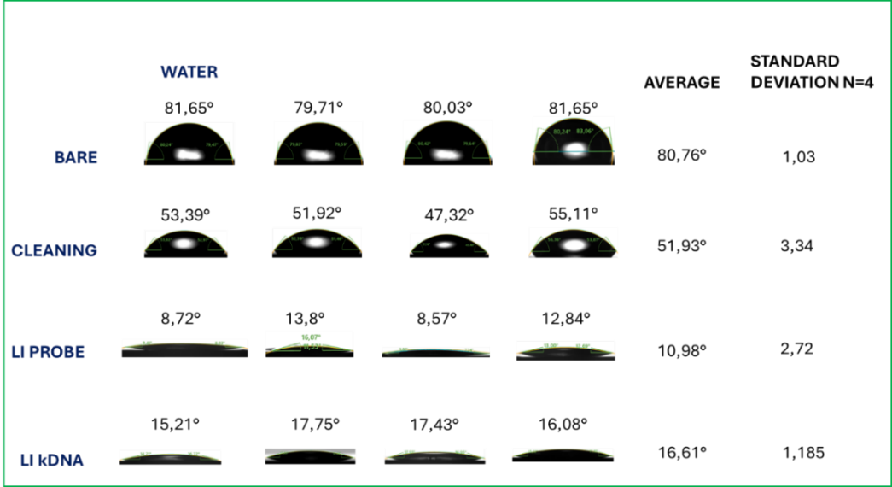
Figure S4. SFE analysis: water average contact angles and standard deviations of four different trials (n=4).
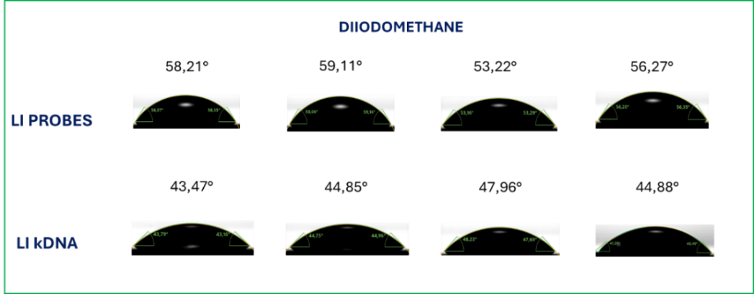
Figure S5. SFE analysis: diiodomethane average contact angles and standard deviations of four different trials (n=4).

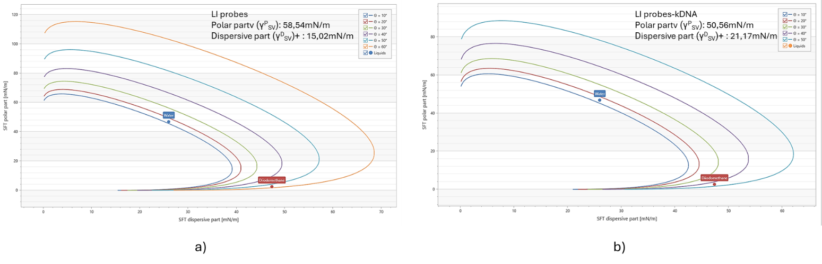
a
b
Figure S6. Wetting envelopes for (a) Li probes and (a) LI probes-DNA in SFE analysis.

3. Electrode preparation for EIS analysis

A CHI101 gold electrode (CH Instruments) was functionalized as schemed in Figure S7. First, it has been polished with 0.3 and 0.05 μm alumina slurry (mechanical cleaning procedure), in order to obtain a mirror surface, and then washed by sonication in a 50:50 ethanol:deionized water solution for 5 min. Subsequently, an electrochemical cleaning procedure has been applied, upon performing 10 cycles of cyclic voltammetry in a solution of 0.5 M H₂SO₄, using a voltage range of −1V to +1 V and a scan rate of 0.1 V/s. After the CV, electrode surface was dried using a light flux of Ar. Then, the electrode was incubated with a 10 µM solution of thiol-modified probes, suspended in PBS 10 mM at pH=7.4, at 25°C for 4 h with 40 rpm of stirring. The once functionalized with probes SAM, the electrode surface was washed with PBS at pH 7.4 and incubated overnight with 10 μΜ of C₆H₁₄OS, dissolved in 0.01 M PBS, used to block the uncover sites of the surface and stabilize the assembled layer of probes. Subsequently, a washing step with PBS buffer was used to remove the unbound probes. For the hybridization, the probe-gold biointerface assembled on the electrode surface was dipped in kDNA solution of 10⁷ copies/μL in PBS at pH 5.5 and incubated at 50 °C for 3.5 h. Lastly, a washing step with PBS buffer removed the unbound kDNA. For the cross-reactivity test, the probes-modified electrode has been incubated with 10⁴ copies/μL dsDNA genome of Hepatitis-B Virus (HBV) used as unspecific (US) target.
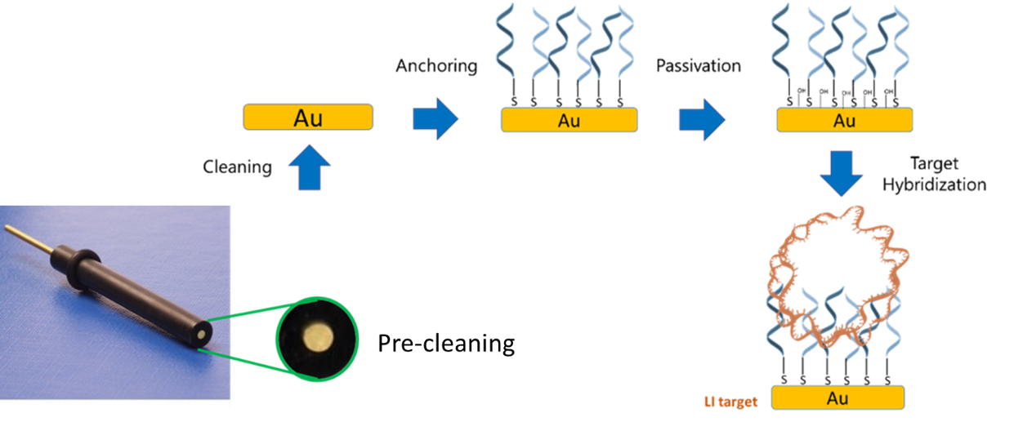
Figure S7. CH101 gold electrode functionalization with capture probes and kDNA.

4. EIS additional analyses

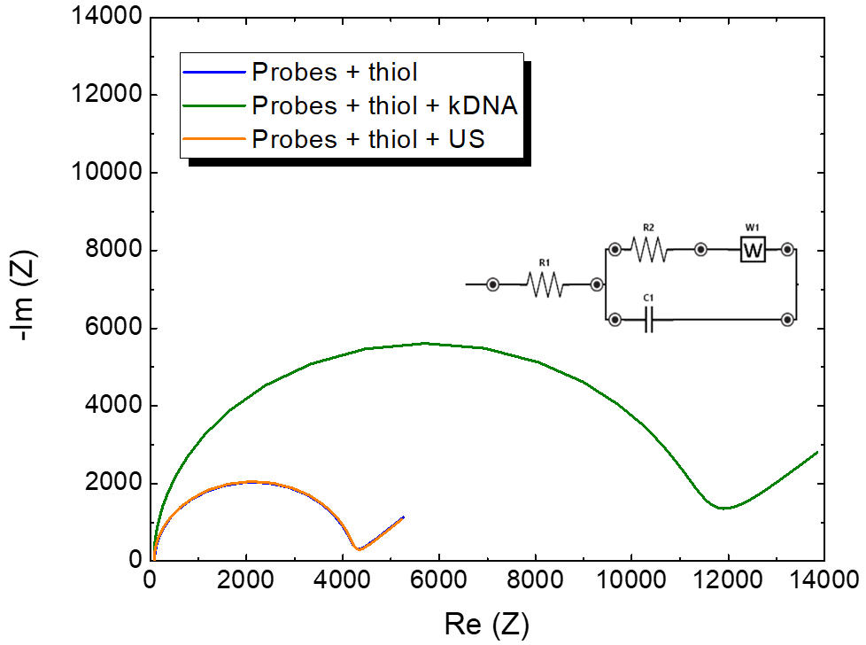 | 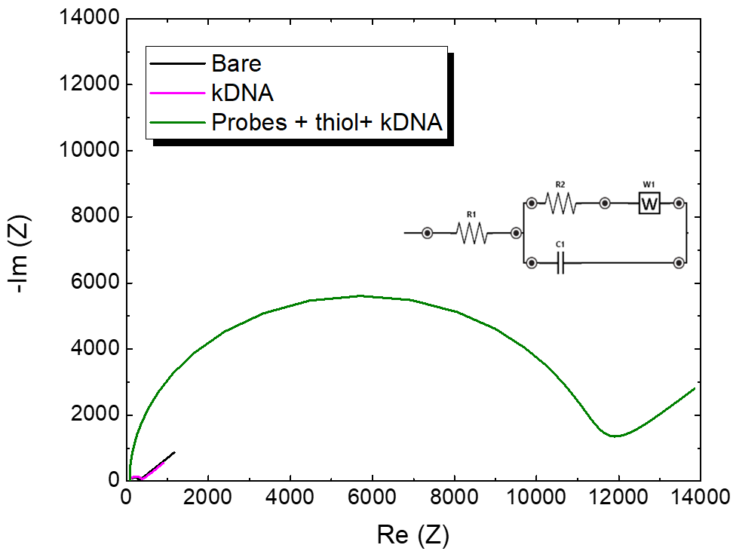
a | b
Figure S8. EIS additional analysis on DNA-functionalized gold electrodes: a) Nyquist plot obtained on functionalized electrode with LI probes and thiol passivator (blue line), upon hybridization with 10⁷ copies/µL of LI kDNA (green line) and after probes-thiol exposure to unspecific genome (orange line); b) Nyquist plot obtained on bare (black line) and functionalized electrode with 10⁷ copies/µL of kDNA spotted without LI probes (magenta line) and hybridized with LI probes array (green line). All EIS measurements have been performed in the 0.1 Hz – 100 kHz frequency range, thus it has been chosen to maintain fixed the current interval (1 mA). Open circuit potential (Eocp) fixed at 0.230 V for all the measurement time. Inserts: equivalent circuit for data fitting.

Results of additional analysis showed that the sensing activity of probes is selective towards the identification of not amplified genetic target. The Nyquist plot in Figure S8a, indeed, reported an overlapping of probes + thiol curve (blue line) with that of probes + thiol + US (orange line), suggesting that the HBV genome did not modify the EIS signal since not hybridized to the probes and easily removed from the electrode surface; on the contrary, the signal of hybridized kDNA curve (green line) markedly increased as expected from the target molecules interaction with the sensing surface. It was also proved the dependence of surface target capture from the probes array. In Figure S8b the curve of kDNA-treated electrode (magenta line) almost reproduced the bare electrode curve (black line) suggesting that the kDNA without probes, respect to the probes + thiol + kDNA surface, was only physiosorbed on the surface and easily removed by washing.

References
[1] H. Gu, C. Wang, S. Gong, Y. Mei, H. Li, W. Ma, Surface and Coatings Technology 2016, 292, 72.
[2] C. J. van Oss, in Interface Science and Technology (Ed: C. J. van Oss), Elsevier, 2008, pp. 13–30.
[3] H.-Y. Tsai, C.-N. Hsu, C.-R. Li, Y.-H. Lin, W.-T. Hsiao, K.-C. Huang, J. A. Yeh, Micromachines (Basel) 2021, 12, 44.
[4] M. F. Ismail, M. A. Islam, B. Khorshidi, M. Sadrzadeh, Materials Chemistry and Physics 2021, 258, 123933.
[5] D. K. Owens, R. C. Wendt, Journal of Applied Polymer Science 1969, 13, 1741.
[6] F. M. Fowkes, Ind. Eng. Chem. 1964, 56, 40.
[7] M. Jin, F. Thomsen, T. Skrivanek, T. Willers, in Advances in Contact Angle, Wettability and Adhesion, John Wiley & Sons, Ltd, 2015, pp. 419–438.

