Supplementary Material

Supplementary Table 1. Lipid droplets and ROS raw data, mean and error.
 | 2 hours | 7 hours | 24 hours | Statistical significance 24 hours vs 2 hours
ROS | 368.97± 105.38 | 268.64± 32.07 | 130.65± 17.43 | *p=0.037
Lipid droplets | 273.83± 6.48 | 560.41± 11.82 | 1058.76± 53.37 | ***p=0.0001
Lipid peroxides | 2.82± 0.54 | 1.43± 0.33 | 0.24± 0.11 | ***p=0.0009

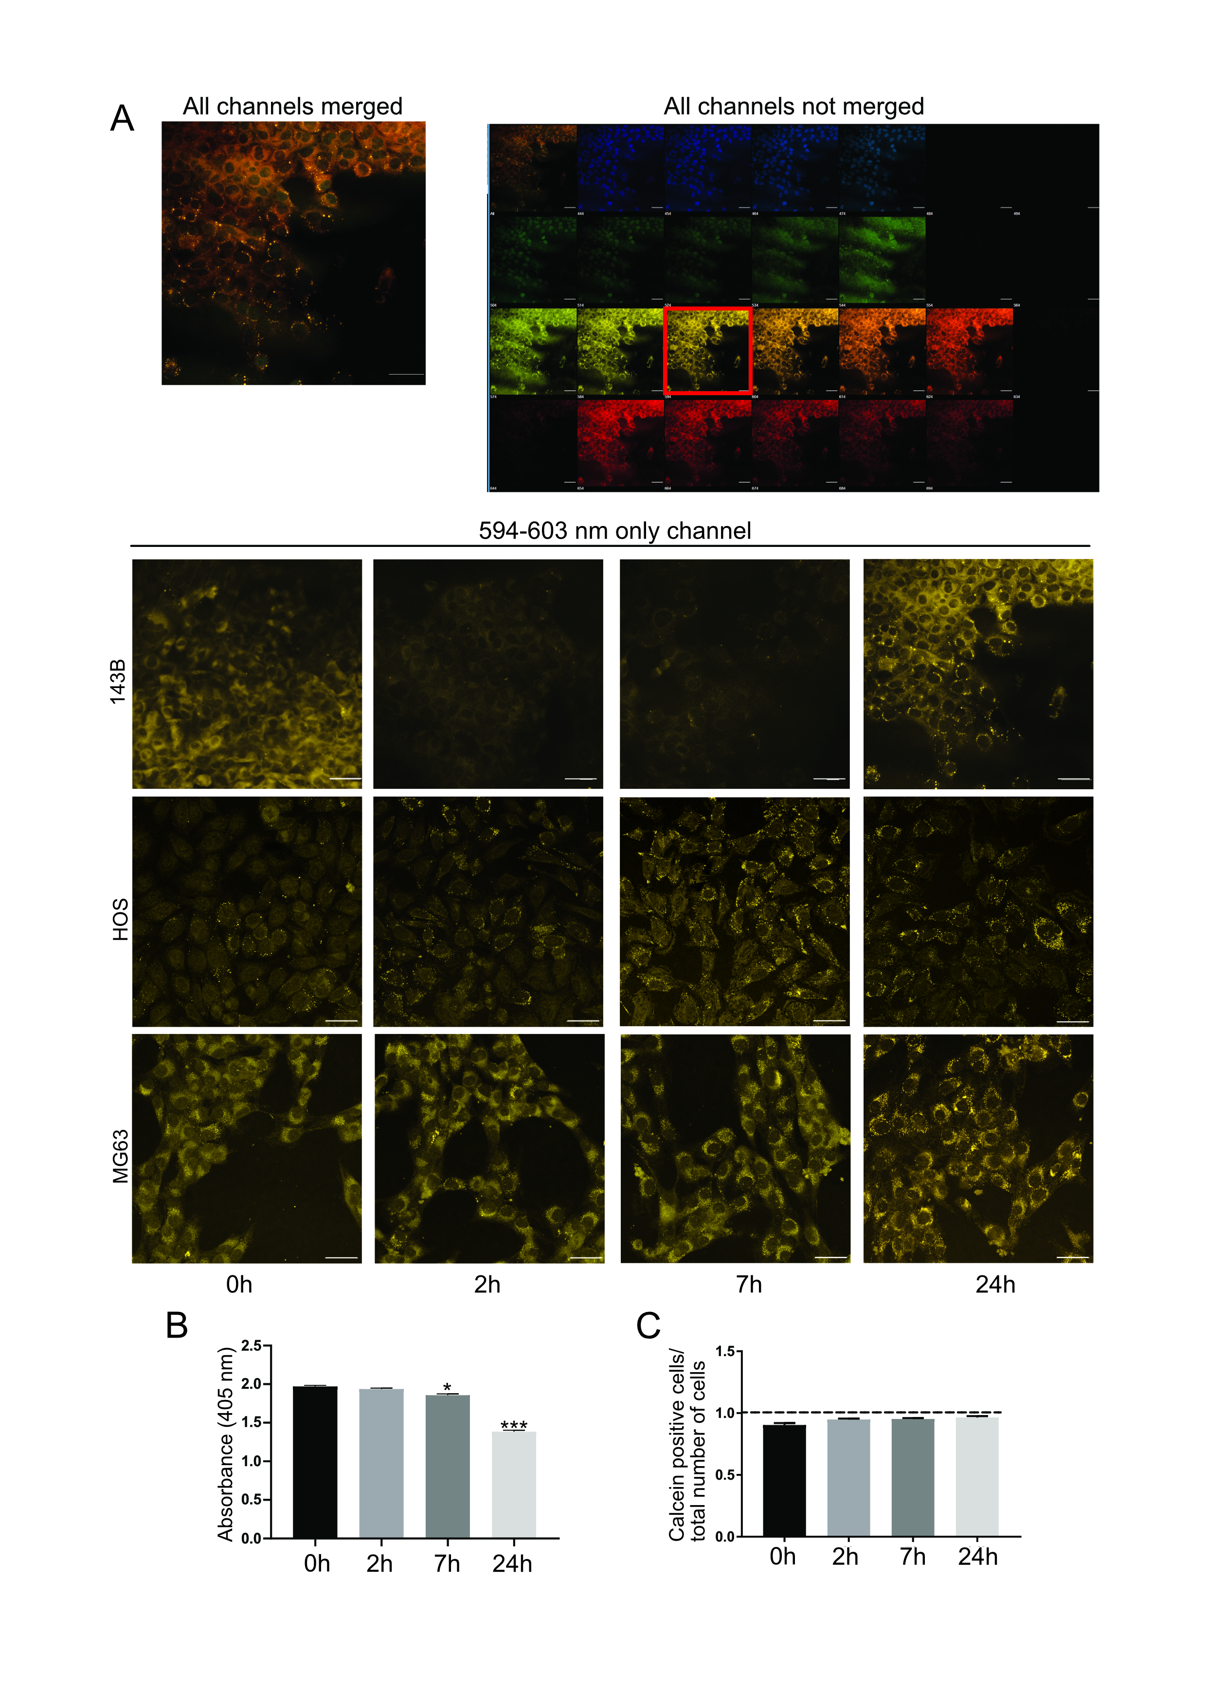
Supplementary Fig.1 Acidosis leads to lipid droplet (LD) increase in 143B, MG63 and HOS cells. A) Images were acquired with confocal spectral detector on the full spectrum to avoid unspecific background, not related to LD, during fluorescent quantification. In representative top panels, all the channels corresponding to different wavelength of fluorescent emission are shown, merged (on the left) and not merged (on the right). For the quantification of the fluorescent signal associated with LD, we considered only the channel that corresponds to 594-603 nm range (on the bottom) for pH 6.8 24h. We used ROIs on single LD. Lower panels show. Scale bar= 50μm. B) Acid phosphate test, measured at 405 nm; *p < 0.05 7 hours vs time point 0; ***p < 0.001 24 hours vs time point 0; n=2 from 2 independent experiments. C) Calcein-positive cells expressed on the total number of nuclei at the indicated time points.

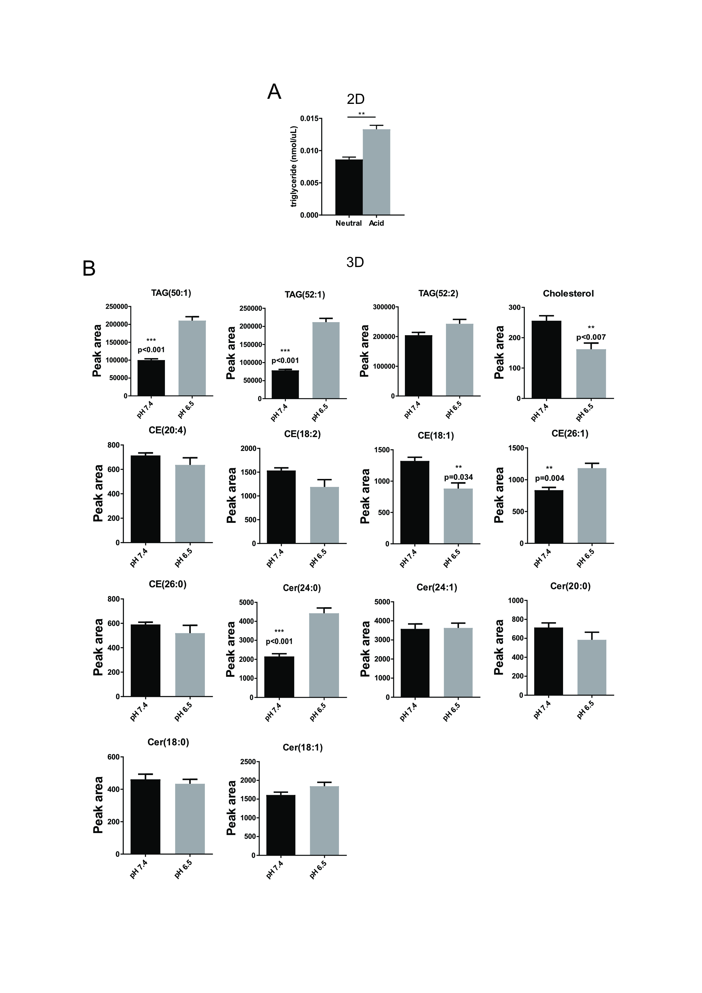
Supplementary Fig.2. Acidosis increases triglycerides levels. A) Triglycerides were measured on 143B cells in monolayer cultured with neutral (7.4) or acid (6.8) medium for 24h. **p < 0.005 neutral versus acid control; n=4 from 2 independent experiments. B) Quantification of the indicated lipid species on spheroids of 143B cells cultured in neutral or acid conditions. Five individual biological replicates of spheroids were prepared for the two experimental groups.
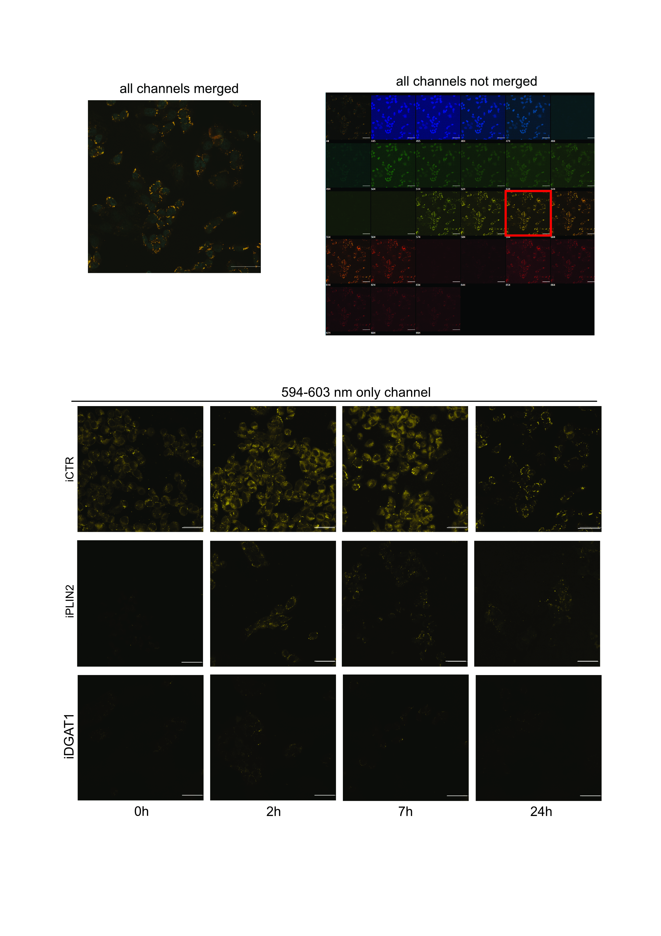
Supplementary Fig.3. PLIN2 and DGAT1 silencing leads to lipid droplet decrease in 143B cells. Images were acquired with confocal spectral detector on the full spectrum, to avoid unspecific background, not related to LD, during fluorescent quantification. In representative top panels, all the channels corresponding to different wavelengths of fluorescent emission are shown, merged (on the left) and not merged (on the right). For the quantification of the fluorescent signal associated with LD, we considered only the channel that corresponds to 594-603 nm range (on the bottom ) for pH 6.8 24h. We used ROIs on single LD. Scale bar= 50μm.
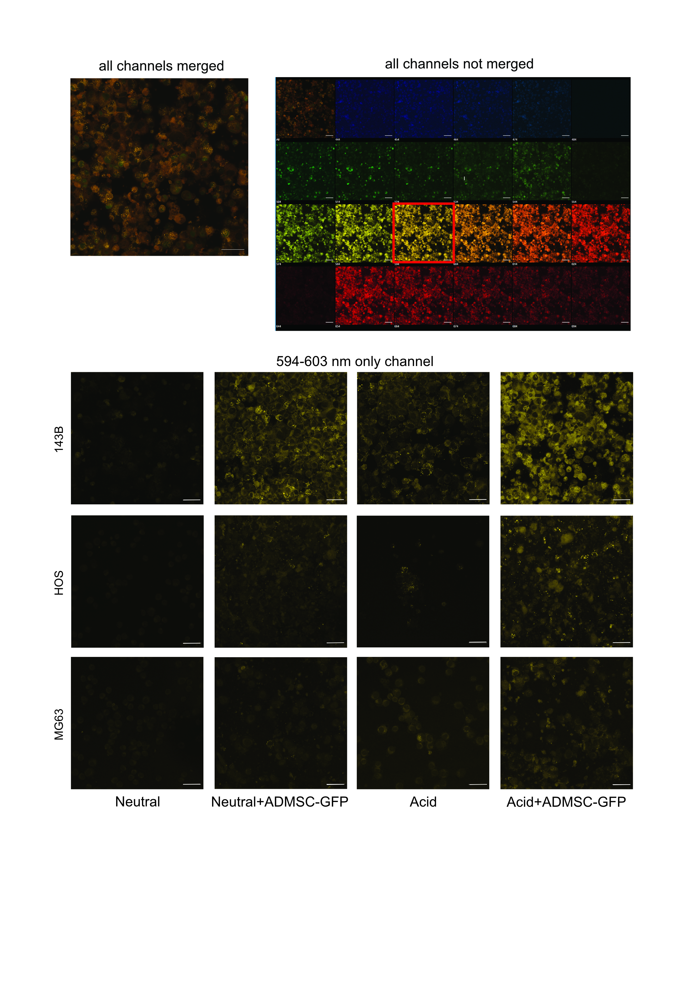
Supplementary Fig.4. ADMSC-GFP increase lipid droplet content in 143B, MG63 and HOS cells. Images were acquired with confocal spectral detector on the full spectrum, to avoid unspecific background, not related to LD, during fluorescent quantification. In representative top panels, all the channels corresponding to different wavelength of fluorescent emission are shown, merged (on the left) and not merged (on the right). For the quantification of the fluorescent signal associated with LD, we considered only the channel that corresponds to 594-603 nm range (on the bottom) for pH 6.8 24h. GFP-positive cells (AD-MSC GFP) were selected on the 514-523 nm range and excluded from LD count. We used ROIs on single LD. Scale bar= 50μm.
Supplementary Materials and Methods
- Triglyceride quantification
Triglycerides were measured with Triglyceride Assay Kit (Abcam, # ab65336) on 143B cells cultured in monolayer at pH 7.4 or pH 6.8 after 24h acidosis. Protocol was followed according to the manufacturer’s instructions.

- Lipidomics
Lipidomics was already described elsewhere [22]. Briefly, spheroid samples were extracted by adding 1 mL of isopropanol and sonicating at room temperature for 10 minutes. The samples were then centrifuged at 9000 g for 10 minutes, and 0.9 mL of the supernatant was transferred to glass vials and dried under a nitrogen stream. For tissue samples, the tumors were dismembered and the powder was weighed to normalize the amount of dissolving solution. On the day of analysis, the dried lipid content was re-dissolved in 0.1 mL of a 9:1 methanol:chloroform solution and analyzed using liquid chromatography coupled with high-resolution mass spectrometry. Five individual biological replicates of spheroids were prepared for the two experimental groups.

