SUPPLEMENTARY MATERIALS
Impact of newly diagnosed cancer on bleeding events in patients with atrial fibrillation treated with direct oral anticoagulants.

Short title: Bleeding risk in atrial fibrillation.
Journal: American Journal of Cardiovascular Drugs.

Authors: Francesco Angeli, MD,^{a,b*} Luca Bergamaschi, MD, ^{a,b*} Matteo Armillotta, MD,^{a,b} Angelo Sansonetti, MD,^{a,b} Andrea Stefanizzi, MD,^{a,b} Lisa Canton, MD,^{a,b} Francesca Bodega, MD,^{a,b} Nicole Suma, MD,^{a,b} Sara Amicone, MD,^{a,b} Damiano Fedele, MD,^{a,b} Davide Bertolini, MD,^{a,b} Andrea Impellizzeri, MD,^{a,b} Francesco Pio Tattilo, MD,^{a,b} Daniele Cavallo, MD, ^{a,b} Lorenzo Bartoli, MD,^{a,b} Ornella Di Iuorio, MD, ^{a,b} Khrystyna Ryabenko, MD,^{a,b} Marcello Casuso Alvarez, MD, ^{a,b} Virginia Marinelli, MD,^{a,b} Claudio Asta, MD, ^{a,b} Mariachiara Ciarlantini, MD,^{a,b} Giuseppe Pastore, MD,^{a,b} Andrea Rinaldi, MD, PhD, ^{a,b} Daniela Paola Pomata, MD,^{c} Ilaria Caldarera, MD, ^{a,b,} and Carmine Pizzi ^{a,b} MD.
Affiliations:
a) Cardiology Unit, Cardiac Thoracic and Vascular Department, IRCCS Azienda
Ospedaliero-Universitaria di Bologna, Bologna, Italy;
b) Department of Medical and Surgical Sciences- DIMEC, University of Bologna, Via
Giuseppe Massarenti 9, 40138, Bologna, Italy;
c) Division of Emergency Medicine, IRCCS Azienda Ospedaliero-Universitaria di Bologna, Bologna, Italy.
* The first two authors contributed equally to this work
Competing interests and Funding: None to declare.
Corresponding author:
Carmine Pizzi, MD, FESC
Cardiology Unit, Cardiac Thoracic and Vascular Department, IRCCS Azienda Ospedaliera-
Universitaria di Bologna. Department of Medical and Surgical Sciences – DIMEC
Alma Mater Studiorum, University of Bologna, Italy
Tel. +39 051 2144933
E-mail: carmine.pizzi@unibo.it
Population according to Cancer at Baseline

Out of 1170, cancer at baseline (CB) cohort was constituted by 81 (6.9%) patients, while the other patients weren’t affected by cancer at enrollment (no-CB population 1089, 93.1%). The most frequent cancer location was upper and lower gastrointestinal system (6.3% and 22.2%, respectively, Supplementary Table 1).
CB patients were less frequently female (43.2% vs 52.4%, p=0.009), but no other differences were observed regarding age, cardiovascular risk factors or other comorbidities (Supplementary Table 2).
A similar incidence of major and non-major bleeding was found between CB and no-CB cohorts during follow up, despite lower basal level of hemoglobin (11.4 vs 12.3, p= 0.02) and higher HAS-BLED (p= 0.048) and ATRIA (p< 0.01) in CB population. Ischemic events, MACEs and ACS rates between CB e no-CB populations were similar (Supplementary Table 4).

SUPPLEMENTARY TABLES

Supplementary Table 1. Demographic characteristics, type of DOAC, dose reduction criteria and location of cancer in patients with CFU and CB.

 | CFU  (N = 81) | CB  (N = 81)
Demographic characteristic
Age, years  Female Sex, n (%) | 75 [69-83]  43 (53.1) | 78 [72-84]  35 (43.2)
Type of DOAC
Apixaban 5 mg  Apixaban 2.5 mg  Rivaroxaban 20 mg  Rivaroxaban 15 mg  Edoxaban 60 mg  Edoxaban 30 mg  Dabigatran 150 mg  Dabigatran 110 mg | 30 (37)  2 (2.5)  16 (19.7)  10 (12.3)  5 (6.3)  7 (8.6)  10 (12.3)  1 (1.3) | 22 (27.2)  3 (3.7)  18 (22.2)  6 (7.4)  10 (12.3)  13 (16)  5 (6.3)  4 (4.9)
Reduced dose DOAC, n (%)  Dose reduction criteria, n (%) | 20 (24.7) | 25 (30.8)
eGFR <50 ml/min  Weight <60 kg  Age >80 years  and creatinine >1.5 mg/dL  Age >80 years  and weight <60 kg  High bleeding risk  Age>80 years | 15 (75)  2 (10)  1 (5)  1 (5)  1 (5)  0 (0) | 12 (48)  6 (24)  1 (4)  2 (8)  1 (4)  3 (12)
Cancer site
Upper GI  Lower GI  Lung  Breast  Melanoma  Urinary tract  Brain  Leukaemia/lymphoma  Prostate  Other | 4 (4.9)  17 (20.9)  8 (9.8)  5 (6.3)  7 (8.6)  8 (9.8)  2 (2.5)  9 (11.1)  10 (12.3)  11 (13.6) | 5 (6.3)  18 (22.2)  9 (11.1)  7 (8.6)  3 (3.7)  9 (11.1)  1 (1.3)  13 (16)  8 (9.8)  8 (9.8)

Abbreviations: CB: Cancer at baseline; CFU: Cancer at follow-up; DOAC: Direct Oral Anticoagulant; eGFR: estimated Glomerular Filtration Rate; GI: Gastro-Intestine
Supplementary Table 2. Baseline population characteristics in total population, CB and no-CB patients.

 | Total  (N = 1170) | No-CB  (N = 1089) | CB  (N = 81) | P value
Age, years | 77 [69-83] | 77 [68-83] | 78 [72-84] | 0.257
Female Sex, n (%) | 606 (51.8) | 571 (52.4) | 35 (43.2) | 0.009
BMI, Kg/m² | 26 [23.4-29.3] | 26 [23.1-29.2] | 26 [22.9-28.6] | 0.357
Cardiovascular risk factor
Smoking, n (%) | 434 (37.1) | 400 (36.7) | 34 (41.9) | 0.687
Dyslipidemia, n (%) | 563 (48.2) | 527 (48.4) | 36 (44.4) | 0.284
Type-2 diabetes, n (%) | 157 (13.4) | 151 (13.9) | 6 (7.4) | 0.890
Hypertension, n (%) | 901 (77.1) | 842 (77.3) | 59 (73.2) | 0.267
Past medical history
PAD, n (%)  Prior stroke, n (%) | 50 (4.3)  124 (10.6) | 44 (4.4)  115 (10.6) | 6 (7.4)  9 (11.1) | 0.300  0.76
Basal Laboratory data
Hb, mg/dL | 13.64 ± 1.84 | 13.7 ±1.3 | 12.9 ±1.5 | 0.002
PLTs, count x 10^9 per L | 228 [190-275] | 228 [190-276] | 227 [188-267] | 0.579
WBC, N/μl | 9.5±7.2 | 9.41 ±5.7 | 9.8 ±7.5 | 0.061
Adm. Creatinine, mg/dL | 0.96 ± 0.3 | 0.96 ±0.3 | 01.0 ±0.4 | 0.384
CRP, mg/dL | 0.44 [0.17-1.75] | 0.31 [0.17-1.76] | 0.78 [0.21-4.16] | 0.07
Basal AF Risk scores
CHA2DS2VASc score | 4 [3-5] | 4 [3-5] | 4 [3-5] | 0.493
ATRIA stroke score | 6 [4-7] | 4 [4-7] | 6 [5-7] | 0.700
HASBLED score | 3 [2-4] | 3 [2-4] | 4 [3-5] | 0.043
ATRIAbleed score | 3 [1-4] | 3 [1-3] | 3 [2-6] | 0.001
ORBIT score | 2 [1-3] | 2 [1-3] | 2 [2-4] | 0.001
TIMIAF score | 5 [3-6] | 5 [3-6] | 5 [4-6] | 0.038
Continuous variables are presented as median [IQR] or mean ± SD according to values distribution, while categorical ones as n (%).
Abbreviations: CFU = Cancer at Follow-Up; BMI=Body mass Index; PAD=peripherical artery disease; Hb= Hemoglobin; PLTs=platelets; WBC=white blood cell; CRP= C Reactive Protein.

Supplementary Table 3. Distribution of different sites of bleeding in total population, in CFU and no-CFU cohorts
Bleeding site, n (%) | Total Population | No-CFU | CFU
Upper GI | 31 (12.5) | 26 (12.4) | 5 (12.8)
Lower GI | 48 (19.3) | 31 (14.8) | 17 (43.5)
Urinary tract | 37 (14.9) | 29 (13.8) | 8 (20.5)
Gynaecologic tract | 8 (3.2) | 4 (1.9) | 4 (10.2)
Skin | 12 (4.8) | 12 (5.7) | 0 (0.0)
ENT | 61 (24.5) | 60 (28.7) | 1 (2.5)
Neurologic | 22 (8.8) | 21 (10) | 1 (2.5)
Others | 18 (7.2) | 17 (8.1) | 1 (2.5)
More sites | 11 (4.4) | 9 (4.3) | 2 (5.1)
Abbreviations: FU: Cancer ad Follow up; ENT: ears, nose and throat; GI: Gastro-Intestine

Supplementary Table 4. Ischemic and Hemorrhagic events occurred at follow-up according to CB presence.

 | Total  (N = 1170) | No CB  (N = 1089) | CB  (N = 81) | P value
CV deaths, n (%) | 48 (4.1) | 44 (4.0) | 4 (4.9) | 0.78
ACS n (%) | 32 (2.7) | 29 (2.6) | 3 (3.7) | 0.07
Bleedings, n (%) | 248 (21.2) | 229 (21.0) | 19 (23.8.) | 0.52
Major bleeding, n (%) | 63 (5.4) | 57 (5.2) | 6 (7.4) | 0.43
Stroke/TIA events, n (%) | 82 (7) | 76 (7) | 6 (7.4) | 0.89
MACE, n (%) | 162 (13.8) | 152 (14.0) | 10 (12.3) | 0.62

Abbreviations: CB = Cancer at Baseline; CV: Cardiovascular; ACS= acute coronary syndrome; MACE= Major adverse cardiovascular events; TIA = Transient ischemic attack

Supplementary Table 5. Multivariable analysis – Predictors of ischemic events (TIA or stroke)

Variables | HR | Standard Error | 95% CI | p-value
CFU | 1.67 | 0.81 | 0.41-2.62 | 0.08
CB | 1.04 | 0.49 | 0.64 – 4.35 | 0.28
Age | 1.02 | 0.02 | 0.98-1.01 | 0.25
CHA2DS2-VASc | 1.43 | 0.11 | 1.21 - 1.68 | <0.001
Abbreviations: CB: Cancer at baseline; CFU: Cancer at follow up; CI: Confident Interval; HR: Hazard Ratio; TIA = Transient ischemic attack.

Supplementary Figure Legend

Online Fig. 1 Study Flow chart
Online Fig. 2 Distribution of different types of cancer diagnosed during follow up (CFU).

Online Fig. 1 Study Flow chart

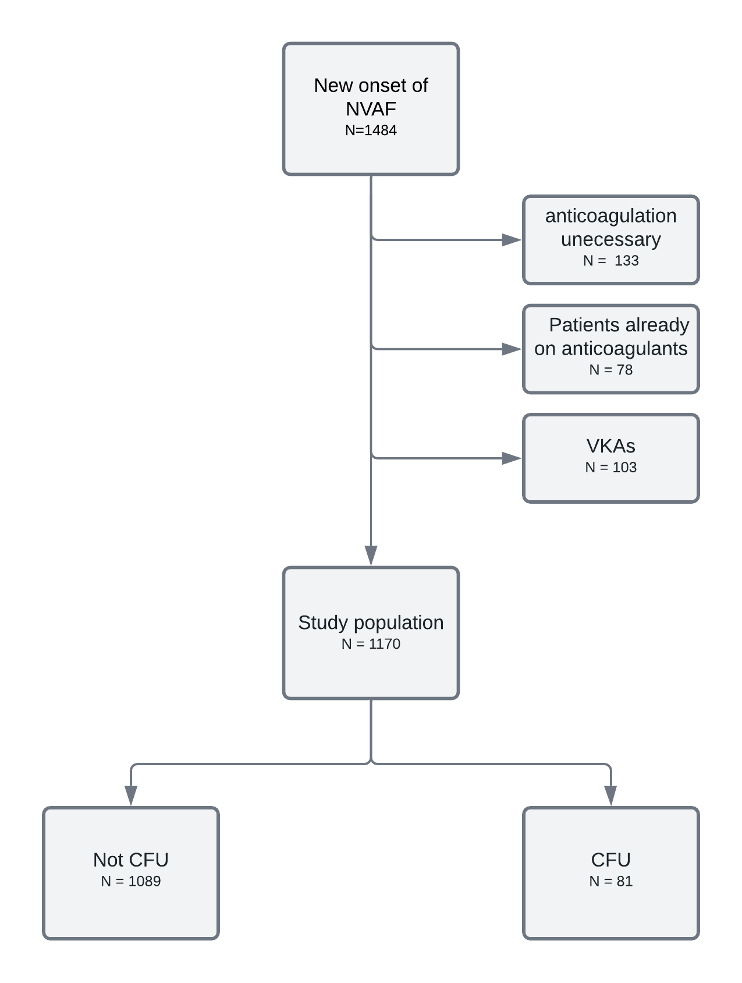
CFU: Cancer at follow up; NVAF: Non-valvular atrial fibrillation; VKA: Vitamin K antagonists.

Online Fig. 2 Distribution of different types of cancer diagnosed during follow up (CFU).
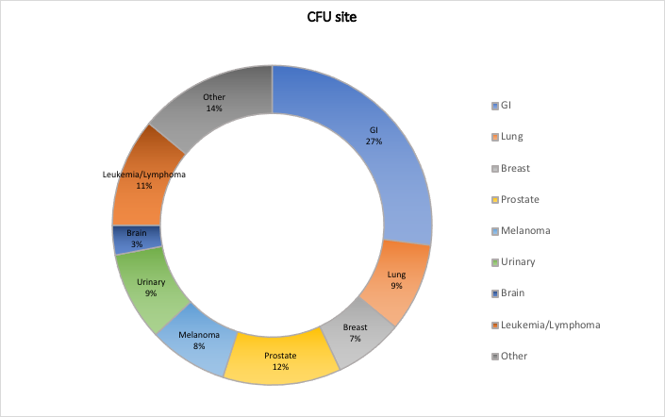
GI: Gastro-Intestine; CFU: Cancer at follow up

