A Online Appendix

A.1 Details on data and variables construction
ESS: Voting decisions are captured through questions on turnout and party preferences. Specifically, the survey questions are: Did you vote during the last national election? and Which party did you vote for in the last national election?. We classify parties along two dimensions: political leaning (left or right), and whether they are populist or not according to the Chapel Hill Expert Survey (Bakker et al., 2015; Jolly et al., 2022).
Manifesto Project: Before constructing our measures, we create a corpus of documents and we start the pre-processing procedure by removing numbers, punctuation, hyphens, and all the superfluous parts of the text (Ash & Hansen, 2023). In addition to the measures discussed in the main text, we count the total number of stopwords. The stopwords are an uninformative component of the content of a manifesto, and their frequency should not vary across manifestos and over time. To identify them, we use the multilingual stopwords list provided by the R package Quanteda (Lewis et al., 2004; Benoit et al., 2018, 2021). For our robustness checks, we also compute the total number of times “EU” and “taxes” related words are used in each manifesto. We use the following words for the two topics: ’European Union/Europe’, and ’taxation/tax’.
After identifying the word “pension” in a sentence of a manifesto, we select the two subsequent sentences as well. We refer to the resulting collection of sentences as a “segment”. We then run the manifestoberta model to identify the specific sub-topics of each sentence. We identify subtopics with a weight in the text above 1% and we re-scale these weights on the identified sub-topics to make sure that they sum to 1 within a sentence. We then aggregate the sub-topic classification at the segment level, building sub-topic shares for each sub-topic that we have identified in the sentences included in the segment. Next, we multiply each of these sub-topic shares by the number of pension-related words in the segment and we sum across segments to build a word count for each sub-topic in the manifesto. This procedure ensures that the sum of word counts across sub-topics is equal to the total number of pension words in the manifesto. We then decompose the total percentage increase in pension-related mentions over the period 1999-2003 into the various subtopics. To this end, we divide the over-time change in the share of a sub-topic over the total words in the manifesto by the initial share of pension words over the total number of words of the manifesto.
For further evidence about the content of pension-related mentions, we count for words related to early or late retirement (“flexible/early”, “late/delay”) within the retirement-related segments of each manifesto. We compute for each segment the share of late- and early-retirement-related words out of the total retirement words with one mention of early or late retirement. Then, we multiply these shares by the number of pension-related words in the segment and we sum across segments to obtain the total number of retirement-related words that belong to the late and early retirement categories. We then quantify how much of the total percentage increase in pension-related words is attributable to late and early retirement. To this end, for each of the two categories we measure the over-time change in their share over total manifesto’s words and divide it by the baseline share of pension-related words over total manifesto’s words.

A.2 Details on the specification
To control for differences in observable characteristics in the analysis of changes in the propensity to turnout, we run the following specification:
yi,t =λUnder50i,t + βtU50Under50i,t × ESS Roundt + βtO50Over50i,t × ESS Roundt + δc + Xi,t + ϵit.
(3)
The equation outlines the regression model employed in Panel (a) of Figure 2. This regression model employs a binary outcome variable, y_{i,t}, denoting whether the respondent i voted in the last national election at time t. Dummy variables Under50_{i,t} and Over50_{i,t} indicate if the respondent i is under or over 50 years old at time t, respectively. We further include dummy variables representing each European Social Survey (ESS) round, with the initial round (2002) serving as the reference category, which we interact with dummy variables Over50_{i,t} and Under50_{i,t}. We control for country fixed effects (δ_{c}), along with individual-level covariates such as years of education, income, and gender (X_{i,t}). Standard errors are clustered at the country-ESS round level. The coefficients β_{t}^{U50} and β_{t}^{O50} measure the change in the propensity to evade relative to the baseline year (2002) of under-50 and over-50 voters, respectively. In Figure 2 Panel (a), we plot the vectors of these coefficients for each age cohort with their respective confidence interval.

A.3 Decomposing turnout propensity by party
We study how changes in turnout at different ages might have affected the share of votes for left and right by using the following decomposition:
Change in turnout propensity wrt Average - By party =
ρ
left
a,t
ρ
left
t
·

ρ
turn
a,t
′
ρ
turn
t
′
−
ρ
turn
a,t
ρ
turn
t
!
·
s
a,t
|
z
{
}
.
(4)
Change in turnout propensity wrt Average
The equation examines if changes in turnout have disproportionally affected age groups with a specific political orientation. The variables ρ^{left}_{a,t} and ρ^{vote}_{a,t} measure the propensities of age group a in year t to vote for left and to turnout, respectively. The analogous variables ρ^{left}_{t} and ρ^{vote}_{t} measure the same propensities in the full population rather than in a specific age group. s_{a,t} is the share of respondents in age cohort a at time t over the total number of respondents at time t The equation quantifies if the overtime change in the propensity to the turnout of a given age group can favor left parties based on the baseline (time t < t′) propensity of that age group to vote for left (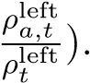 Figure A.4 shows the quantification of this equation for both left and right when the baseline year is 2002 and the year t′ is 2018.

Figure A.1: Analysis sample
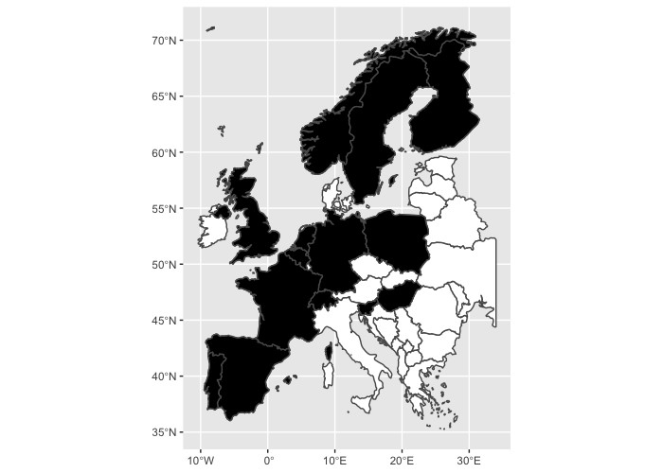
Notes: This map shows (in black) the countries present in our sample of analysis: Belgium, Finland, France, Germany, Hungary,
Netherlands, Norway, Poland, Portugal, Slovenia, Spain, Sweden, Switzerland, and the United Kingdom

Figure A.2: The evolution of the turnout propensity
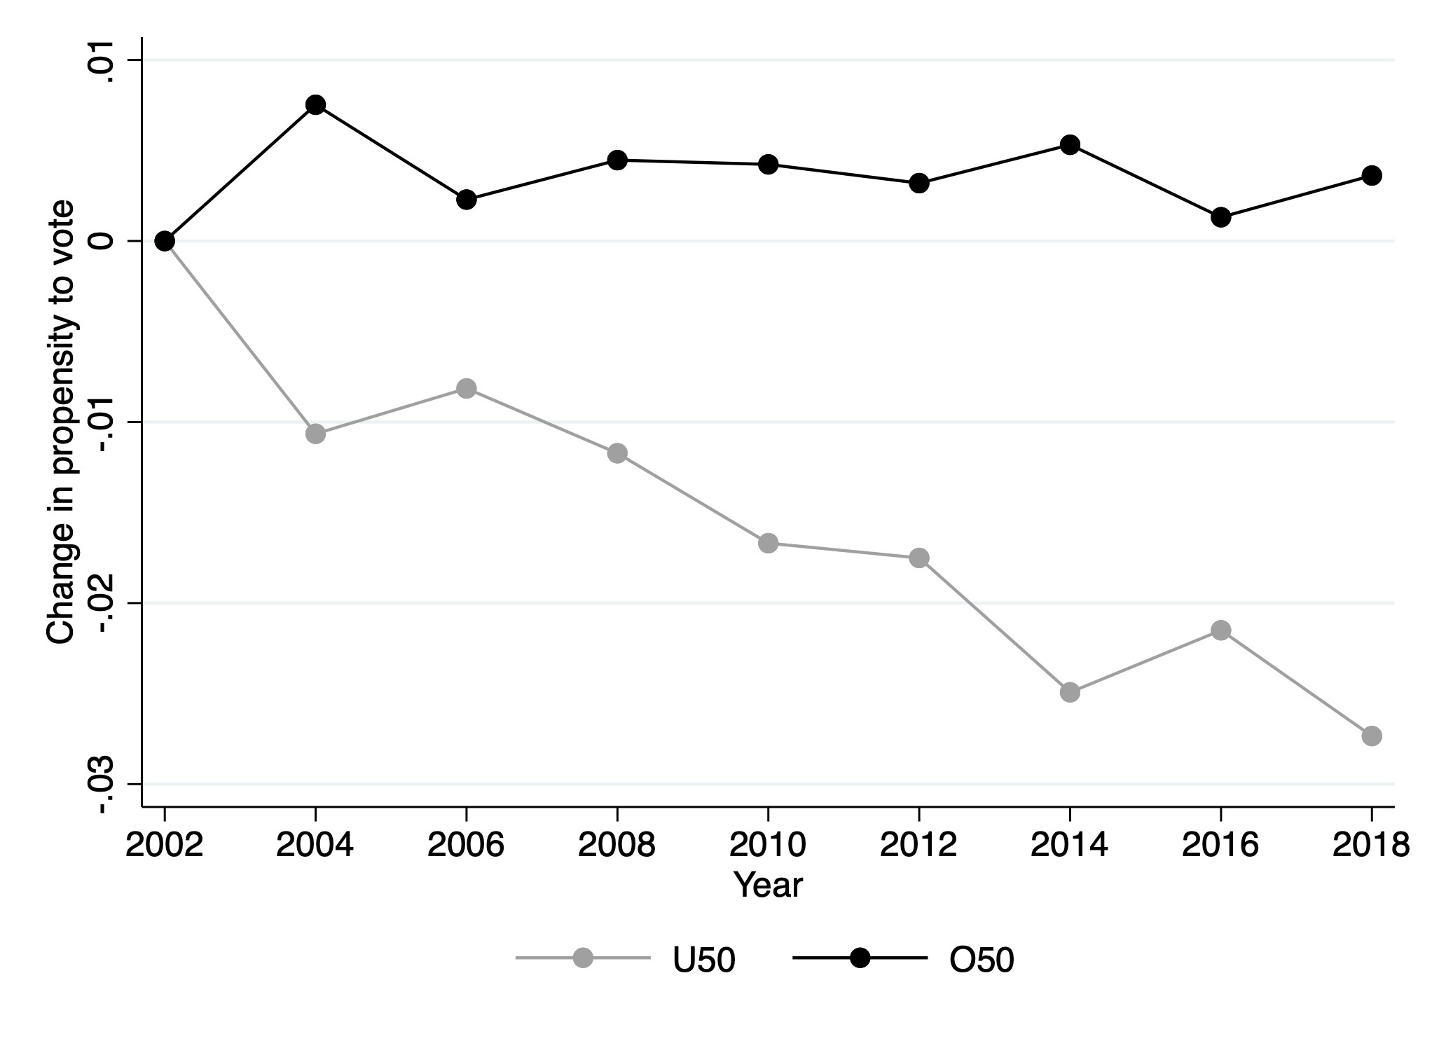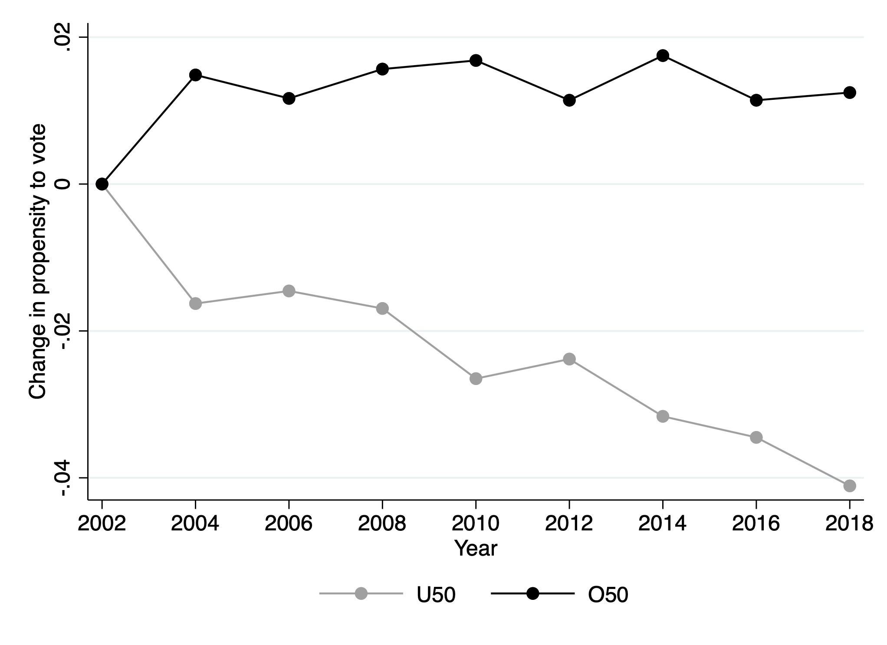
(a) Average turnout (b) Residual average turnout
Notes: This figure presents the turnout propensity in the raw data (Panel (a)) and the residual turnout propensity predicted from a regression controlling for individual characteristics, country FEs, and ESS FEs. Individual characteristics include years of education, gender, income, country, and ESS round (Panel (b)). Each line depicts the change in turnout propensity relative to the baseline year (2002) for a given age group. The age groups considered are under-50 and over-50 voters. This figure is constructed using data from the European Social Survey.

Figure A.3: The evolution of the turnout by age
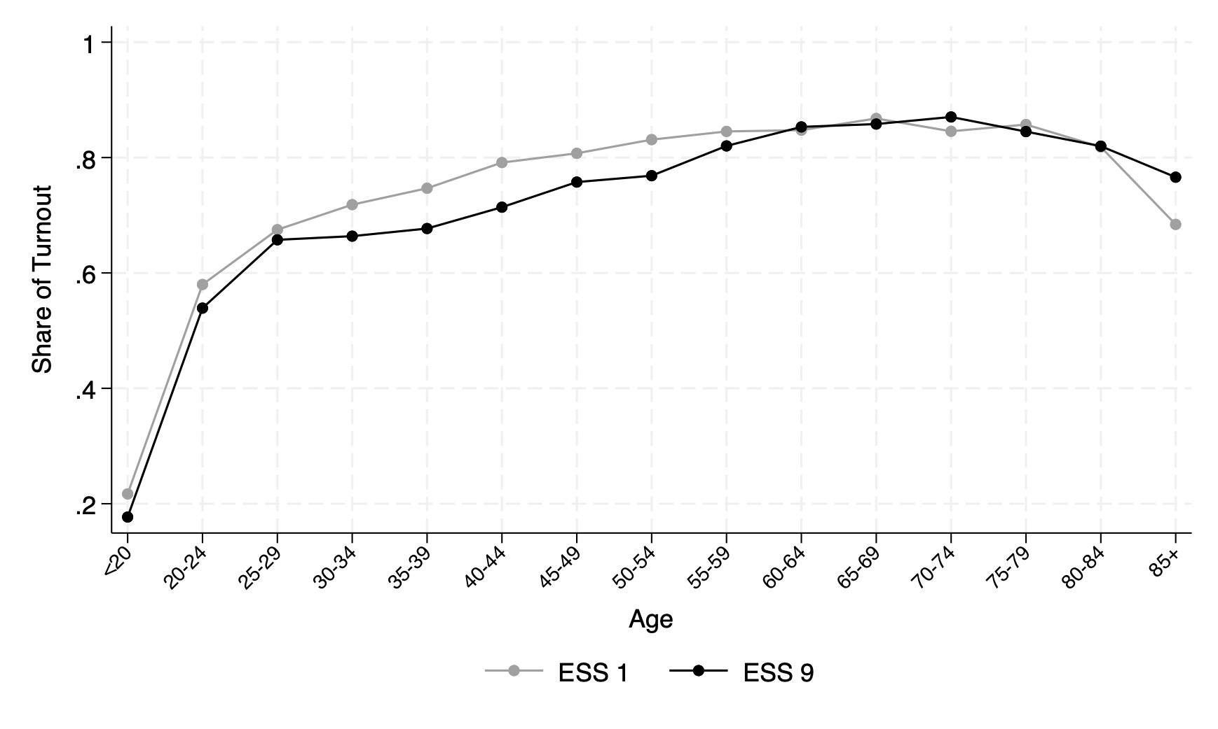
Notes: This figure describes how the voting behavior of various age groups has evolved over 16 years. It depicts voter turnout across different age groups (in 5-year bins), comparing data from two periods: a baseline period (ESS 1; i.e., 2002) and a final period (ESS 9; i.e. 2018). This figure is constructed using data from the European Social Survey.

Figure A.4: Change in turnout propensity and potential consequences on party votes
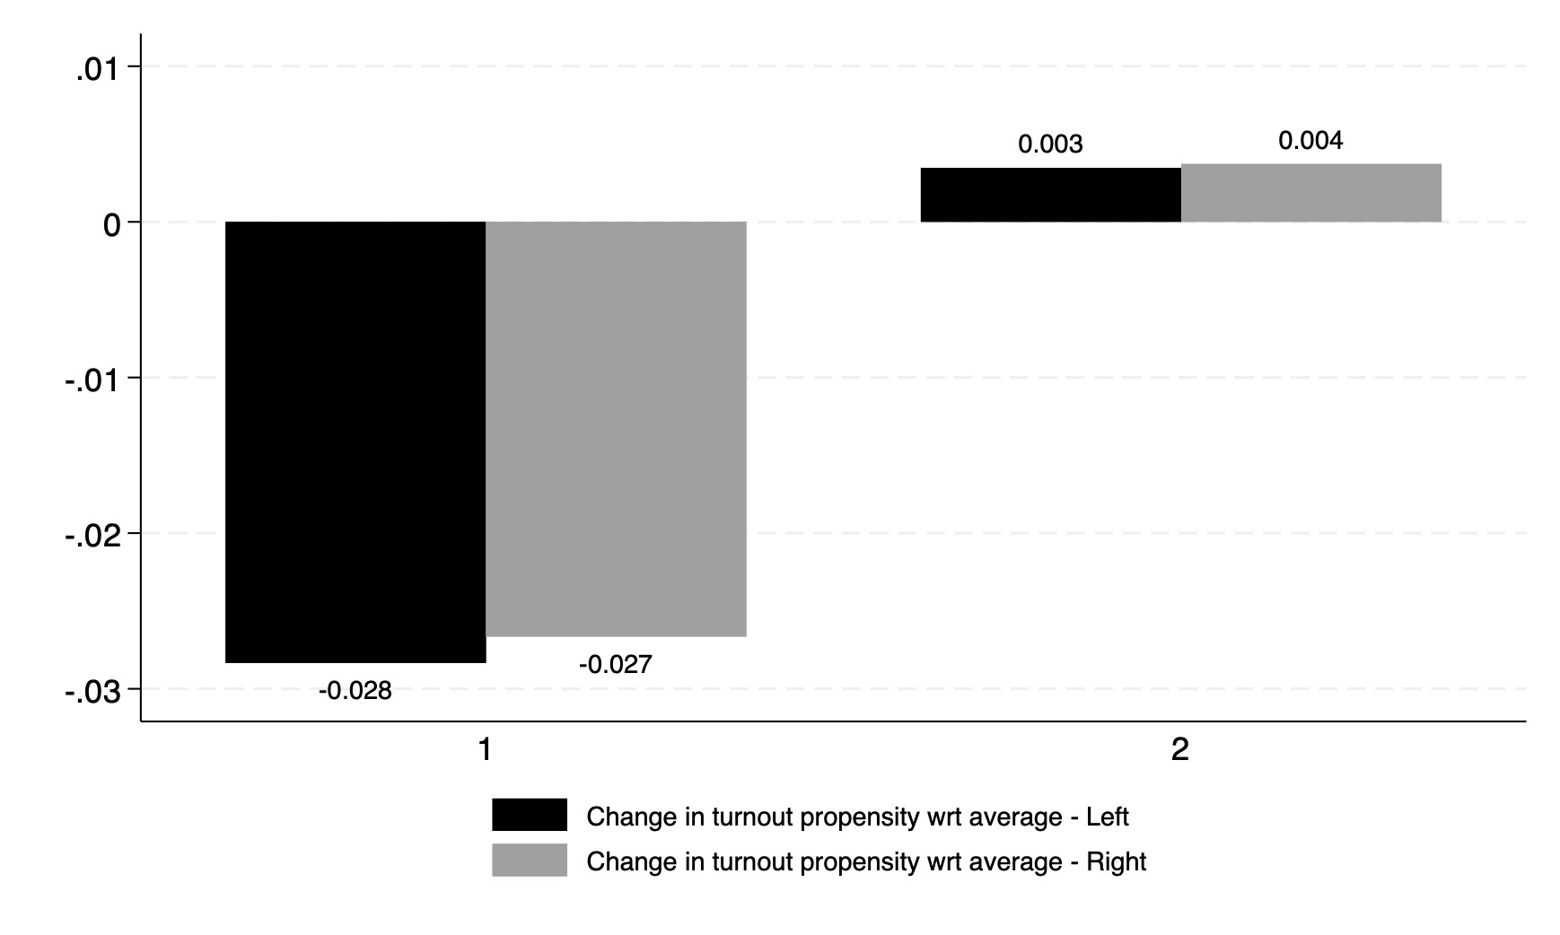
Notes: This figure investigates if changes in turnout have disproportionally affected age groups with a specific political orientation, generating potential consequences for electoral outcomes. It shows the interaction between the change in the turnout of each age group and their initial propensity to vote for left (in grey) or right (in black). We detail this formula in (4). This figure is constructed using data from the European Social Survey.

Figure A.5: Turnout by country and cohort
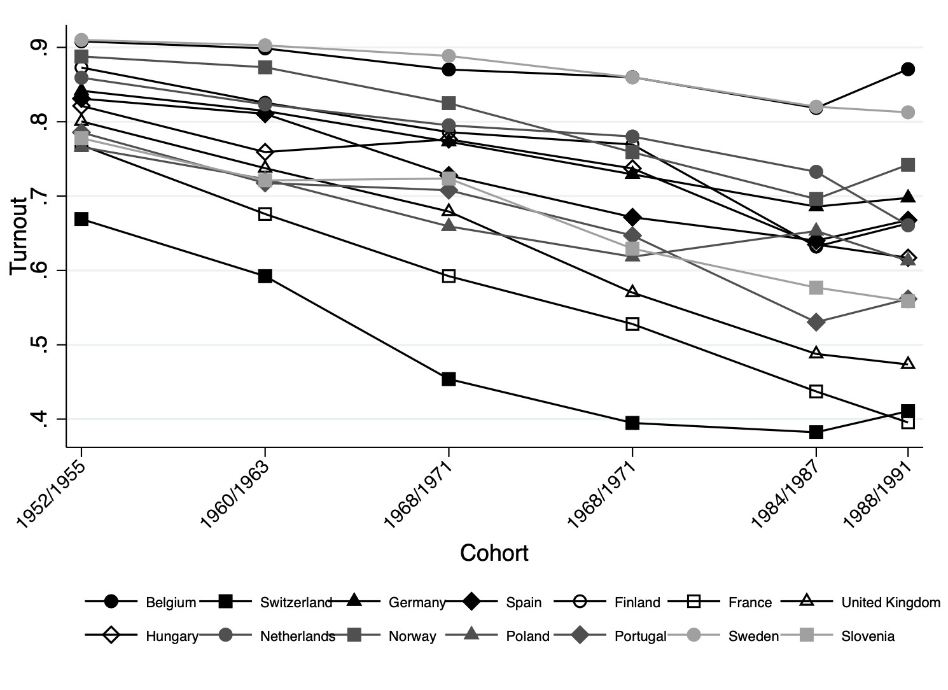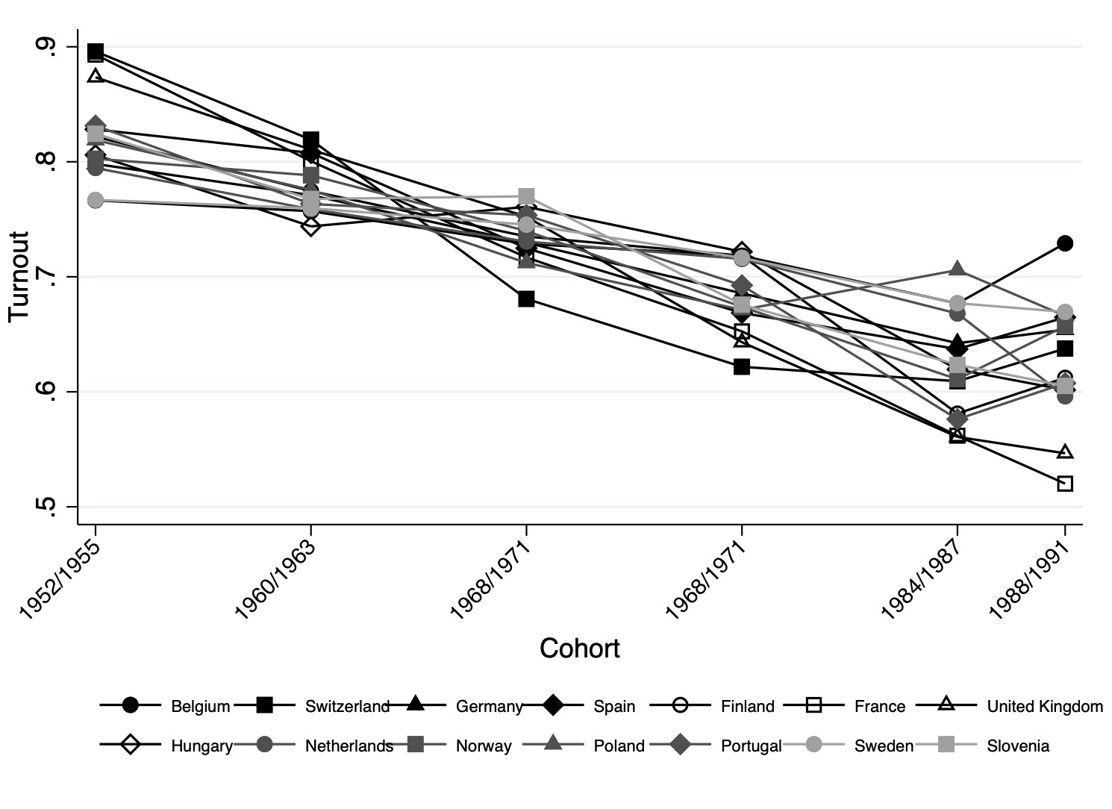
(a) Turnout by country (b) Turnout by country - Residuals
Notes: This figure presents the turnout propensity across cohorts for each country in our sample (Panel (a)). Each line corresponds to a country and depicts the evolution of average turnout across cohort groups (on the x-axis). For each countrycohort combination, the turnout is computed over all the years in the sample, i.e. over all ages at which the cohort is observed. Panel (b) repeats the same exercise using the residual turnout propensity predicted from a regression controlling for the country of the respondent fixed-effects (Panel (b)). This figure is constructed using data from the European Social Survey.

Figure A.6: Turnout trends - Counterfactuals
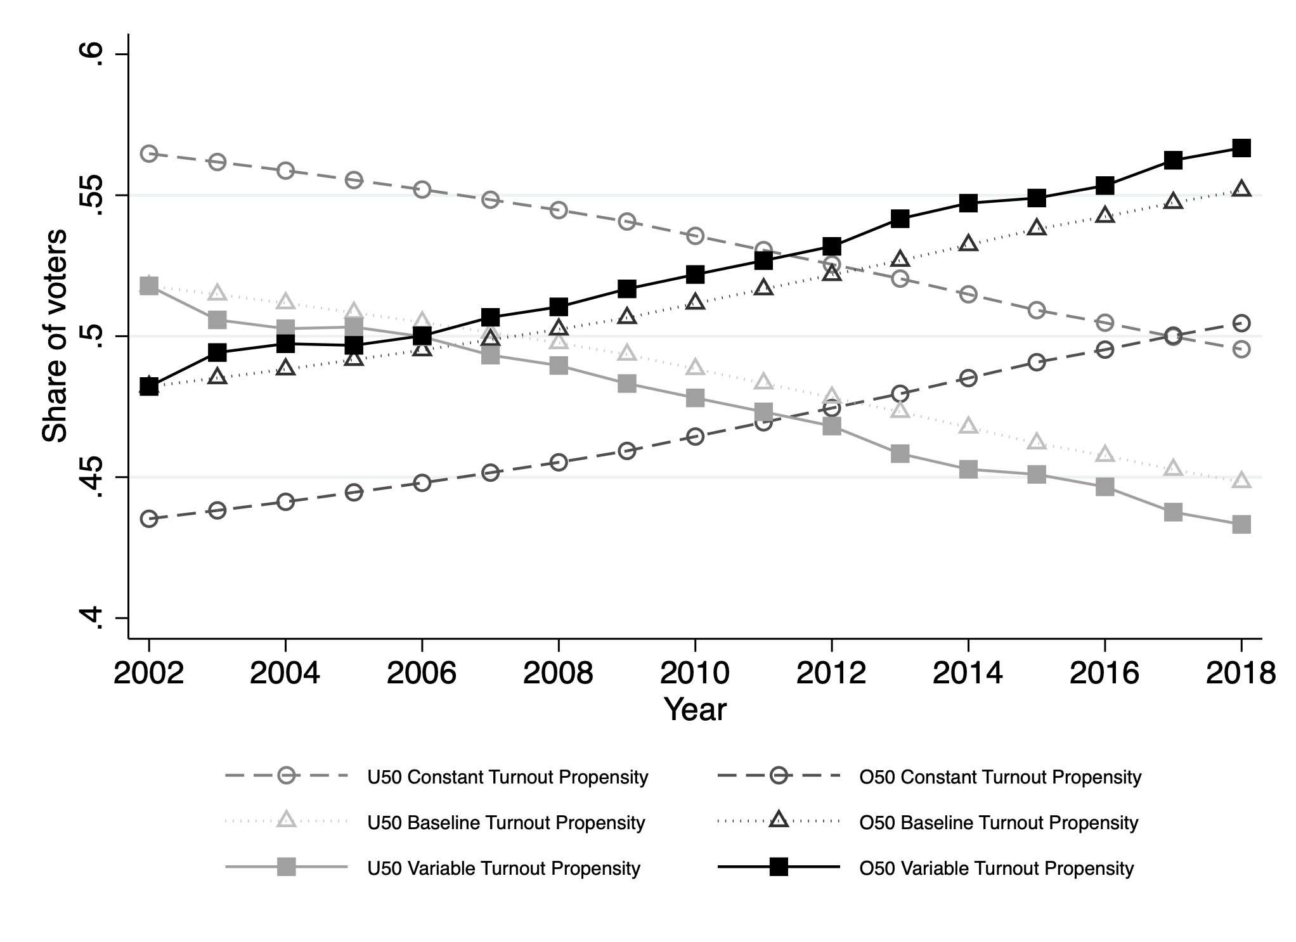
Notes: This figure presents the decomposition of voter turnout trends derived from Equation 1, illustrating the impact of varying turnout propensities across different age groups. The dotted lines show what would have been the evolution of the shares of under-50 and over-50 voters with a constant turnout rate across ages. They visualize a hypothetical scenario where all age groups have identical turnout propensities. This component of the decomposition depicts the pure effect of demographic changes. The lines with triangles project how the share of each age group changes when considering both the demographic composition of a given year t and the propensity of each age group to turnout as measured in the baseline year (2002). This component reflects the combined effect of demographic shifts and the turnout tendencies observed in 2002. Finally, the squared lines show an adjustment for changing turnout propensity: they adjust the share of each age group to account for changes in their turnout propensity between the baseline year b (2002) and a given year t. This component highlights the impact of evolving turnout behaviors within each age group, illustrating how these changes contribute to the deviation from a scenario of homogeneous turnout propensity. This figure is constructed using data from the European Social Survey for turnout rates and demographic composition data from Eurostat.

Figure A.7: Policies discussed - Pension and Unemployment by party
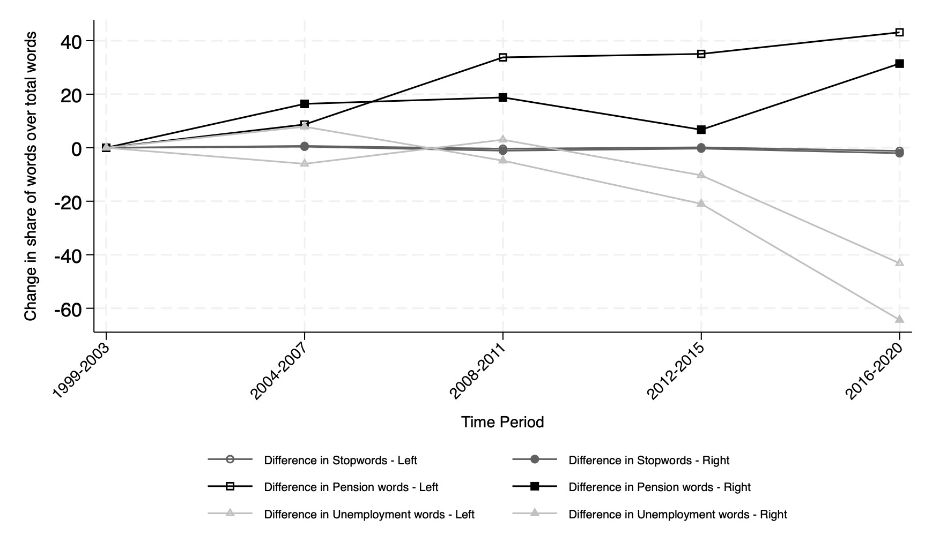
Notes: This figure shows the over time variation in the share of words related to “pension”, “unemployment”, and “stopwords” over the total words reported in political party manifestos across various electoral cycles. The baseline period is 1999-2003. The figure explores whether the results of Figure 2 are heterogeneous by political party. Using the Chapel Hill Expert Survey and the political family assigned by the Manifesto Project Database, we divide each party between “right” or “left” leaning. The dataset is then organized at the electoral cycle-political party level. For each electoral cycle and party group (“right” or “left”), we then calculate the shares by dividing the counts of “unemployment”, “pension”, and stopwords by the total word count in the manifestos for each electoral cycle. The baseline period is 1999-2003.

Figure A.8: Policies discussed - Pension: classification by sub-topics
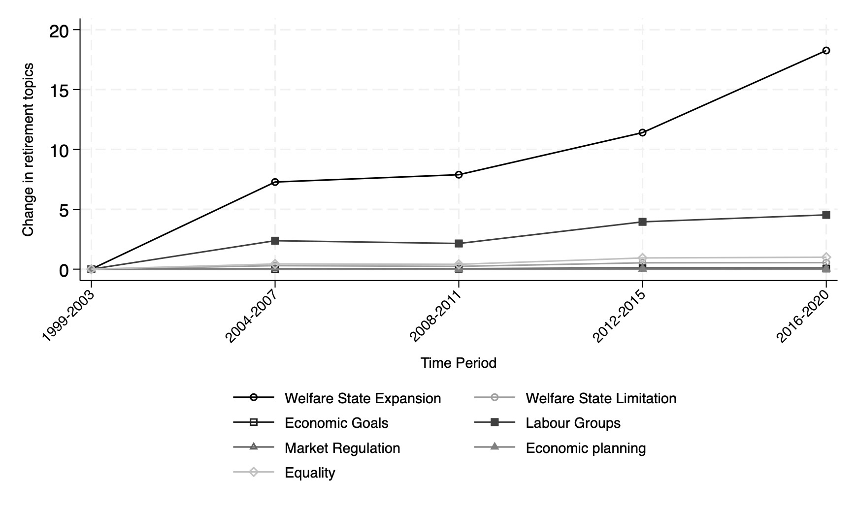
Notes: This figure delves into the specific language used in discussing retirement within the pension sections of political party manifestos. This figure contrasts the frequency of topics associated with welfare state expansions against those related to welfare state limitation and other sub-topics, set against a baseline period for comparison. In constructing this figure, we first segment the manifesto text to focus specifically on sentences surrounding the mentions of “pension.” We identify the word “pension” in a sentence, and we select the two subsequent sentences as well. If two consecutive sentences contain a mention of the word “pension,” we select the two sentences subsequent to the last one that presents the mention of the word “pension.” We refer to the resulting collection of sentences as a “segment”. We then run the manifestoberta model to identify the specific sub-topics of each sentence. We identify sub-topics with a weight in the text above 1% and we re-scale these weights on the identified sub-topics to make sure that they sum to 1 within a sentence. The most relevant in terms of appearance are: “Welfare State Expansion”, “Welfare State Limitation”, “Economic Goals”, “Market Regulation”, “Equality”, “Labour Groups”, and “Economic Planning”. We then aggregate the sub-topic classification at the segment level, building sub-topic shares for each sub-topic that we have identified in the sentences included in the segment. Next, we multiply each of these sub-topic shares by the number of pension-related words in the segment and we sum across segments to build a word count for each sub-topic in the manifesto. This procedure ensures that the sum of word counts across sub-topics is equal to the total number of pension words in the manifesto. We then decompose the total percentage increase in pension-related mentions over the period 1999-2003 into the various subtopics. To this end, we divide the over-time change in the share of a sub-topic over the total words in the manifesto by the initial share of pension words over the total number of words of the manifesto. The baseline period is 1999-2003.

Figure A.9: Policies discussed - Pension: Late vs Early Retirement
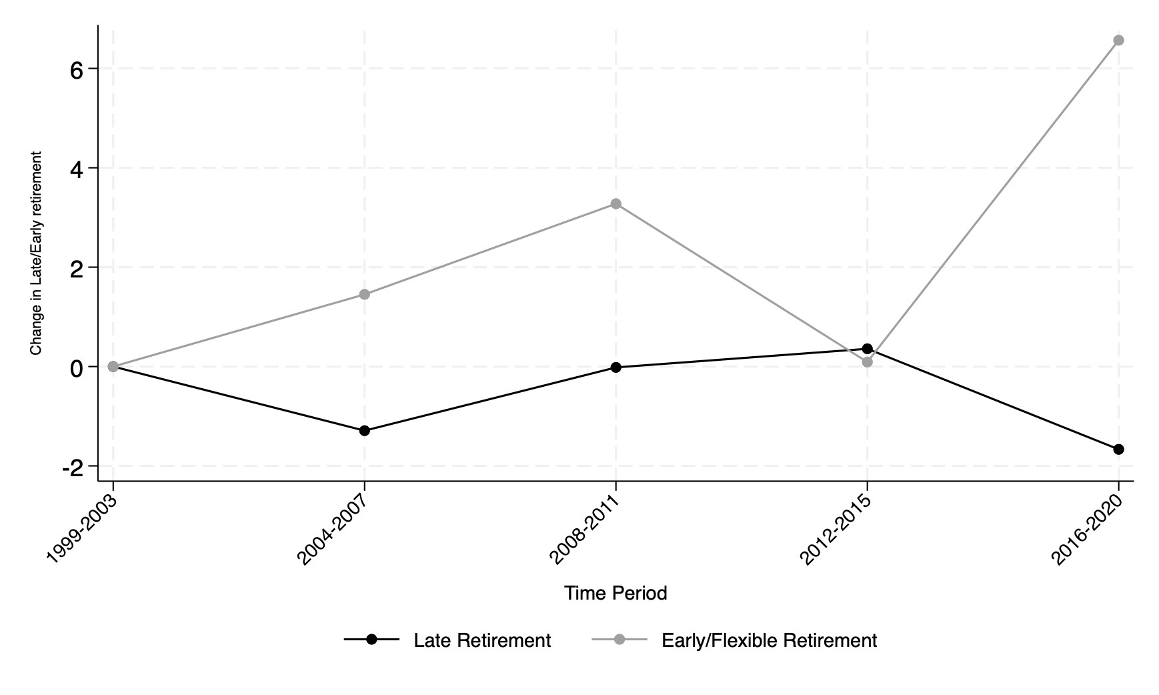
Notes: This figure delves into the specific language used in discussing retirement within the pension sections of political party manifestos. In constructing this figure, we first segment the manifesto text to focus specifically on sentences surrounding the mentions of “pension.” We count for words related to early or late retirement (”flexible/early”, ”late/delay”) within the retirement-related segments of each manifesto. We compute for each segment the share of late- and early-retirement-related words out of the total retirement words with one mention of early or late retirement. Then, we multiply these shares by the number of pension-related words in the segment and we sum across segments to obtain the total number of retirement-related words that belong to the late and early retirement categories. We then quantify how much of the total percentage increase in pension-related words is attributable to late and early retirement. To this end, for each of the two categories we measure the over-time change in their share over total manifesto’s words and divide it by the baseline share of pension-related words over total manifesto’s words. The baseline period is 1999-2003.

Figure A.10: Policies discussed - Robustness checks on topics prevalence
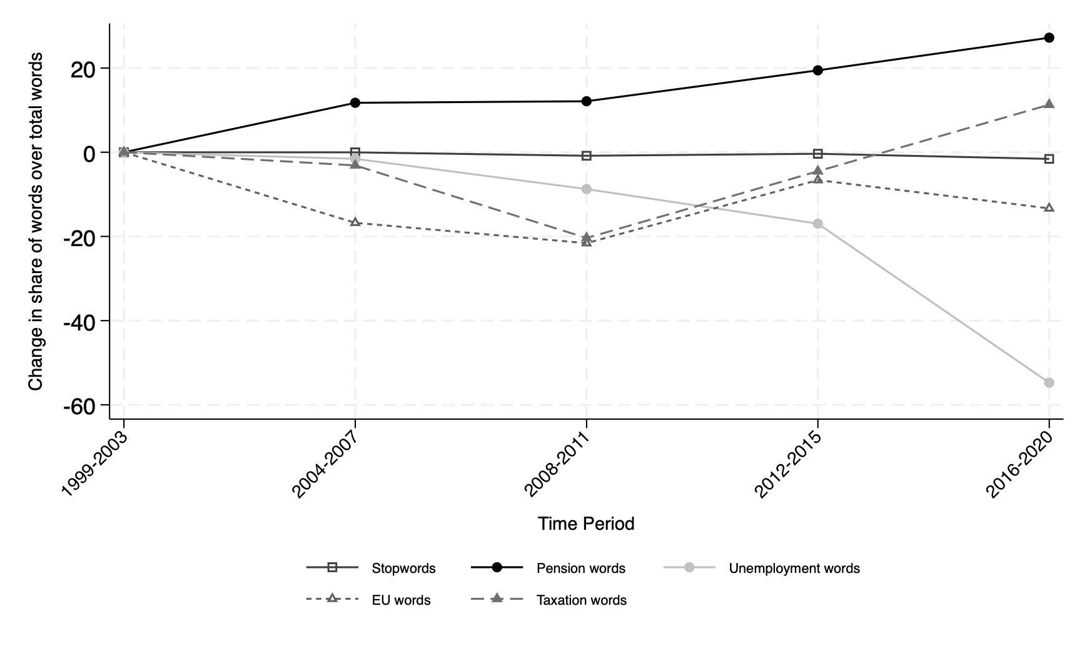
Notes: This figure shows the over time variation in the share of words related to “pension”, “unemployment”, “European Union/Europe”, “taxation/tax” and “stopwords” over the total words reported in political party manifestos across various electoral cycles. The baseline period is 1999-2003. This analysis utilizes data from the Manifesto Project Database. We construct this figure by counting the occurrences of “pension”, “unemployment”, “European Union/Europe”, “taxation/tax” and “stopwords” in the manifestos, alongside the total word count. The dataset is then organized at the electoral cycle level, which typically spans 4-5 years, to create a more structured panel. We then calculate the shares by dividing the counts of “pension”, “unemployment”, “European Union/Europe”, “taxation/tax” and “stopwords” by the total word count in the manifestos for each electoral cycle. The figure displays these shares for each period relative to the baseline period (1999-2003).

Table A.1: ESS: Summary Statistics
Variables | Obs | Mean | SD | Min | Max
Age | 226,271 | 49.38 | 17.90 | 18 | 90
Over 50 | 226,271 | 0.49 | 0.50 | 0 | 1
Voted | 226,271 | 0.74 | 0.44 | 0 | 1
Voted Left | 167,797 | 0.39 | 0.48 | 0 | 1
Voted Right | 167,797 | 0.47 | 0.49 | 0 | 1
ESS round | 226,271 | 4.91 | 2.55 | 1 | 9
Notes: This table reports some summary statistics for the data we use from the European Social Survey. We focus on the subset of countries for which the data is available throughout the entire period, from the first ESS wave to the last available ESS 9 (2018): Belgium, Finland, France, Germany, Hungary, Netherlands, Norway, Poland, Portugal, Slovenia, Spain, Sweden, Switzerland, and the United Kingdom. The variable Age represents the age of each respondent (we drop all respondents younger than 18 and older than 90). From this variable, we create a dummy variable taking value 1 if the individual is above 50 years old and 0 otherwise (Over 50). Variables Voted is a dummy variable equal to one if an individual has voted, Voted Left is a dummy variable equal to 1 if an individual has voted for the left and Voted Right is a dummy variable equal to one if an individual has voted for the right. To construct these variables, we focus on two questions on voting behavior: Did you vote during the last national election?; Which party did you vote for during the last national election?. We classify each party by political leaning (left or right) following the Chapel Hill Expert Survey Jolly et al. (2022).

Table A.2: Differences in trend and propensity turnout by country
28
 | Under 50 |  | Over 50
 | (1) | (2) | (3) | (4)
Country | Diff in share of voters (2018-2002) | Diff in propensity to vote (2018-2002) | Diff in share of voters (2018-2002) | Diff in propensity to vote (2018-2002)
Belgium | -0.0825 | -0.0386 | 0.0825 | 0.0152
France | -0.1005 | -0.0503 | 0.1005 | -0.0049
Germany | -0.1044 | -0.0277 | 0.1044 | 0.0105
Hungary | -0.0757 | -0.0394 | 0.0757 | 0.0246
Netherlands | -0.1000 | -0.0141 | 0.1000 | 0.0068
Norway | -0.0730 | -0.0050 | 0.0730 | -0.0066
Poland | -0.1101 | -0.0471 | 0.1101 | 0.0172
Slovenia | -0.1220 | -0.0356 | 0.1220 | 0.0064
Spain | -0.0727 | 0.0001 | 0.0727 | -0.0029
United Kingdom | -0.0354 | -0.0131 | 0.0354 | -0.0100
Notes: This table shows specific country trends in the share of under-50 and over-50 voters (columns (1) and (3)) and the change in propensity to vote over time (columns (2) and (4)). We measure the share of voters of each age group by interacting the turnout propensity with the population’s demographics. We report for each age group (under 50 and over 50) differences between our last and first year of observation (respectively 2018 and 2002). Some countries exhibit strange spikes over time. This is mostly due to missing data. We remove these outliers (Finland, Portugal, Sweden, and Switzerland). We derive the turnout propensity from the European Social Survey letting it change across cohorts and over time, while demographics come from Eurostat.

Table A.3: Differences in policies discussed in Manifestos by country
29
 | (1) | (2) | (3)
Country | Diff in share of pension words | Diff in share of unemployment words | Diff in share of stopwords
Belgium | 75.3168 | -72.1459 | -1.5740
Finland | 53.2353 | -37.5708 | -9.2863
France | -8.7093 | 37.1108 | -1.8162
Germany | 16.3835 | -68.7438 | -1.2389
Hungary | 113.6249 | -55.4948 | -3.4409
Netherlands | 28.5353 | -25.8756 | 0.5219
Norway | 12.2972 | 0.4247 | -0.5426
Portugal | -26.9967 | -42.2735 | -1.2701
Sweden | 79.8440 | -73.2147 | 0.0219
Switzerland | 31.1506 | -46.5826 | -1.7016
Spain | 21.6353 | -46.8992 | -2.8798
United Kingdom | -28.1401 | -88.4636 | -3.0745

Notes: This table shows specific country trends in the changing frequencies of words related to “pension”, “unemployment”, and “stopwords” in political party manifestos across various electoral cycles. This analysis uses data from the Manifesto Project Database. We explain in detail the information available in this database in the Data section. We construct this figure by counting the occurrences of “unemployment”, “pension”, and stopwords in the manifestos, alongside the total word count. The dataset is then organized at the electoral cycle level, which typically spans 4-5 years, to create a more structured panel. We then calculate the shares by dividing the counts of “unemployment”, “pension”, and stopwords by the total word count in the manifestos of each country for each electoral cycle. The figure displays these shares for each period relative to the baseline period. We report for each share differences between the last and first year of observation.

If two consecutive sentences contain a mention of the word “pension,” we select the two sentences subsequent to the last one that presents the mention of the word “pension.”
This model is built upon the foundation of multilingual XLM-RoBERTa large models, which underwent fine-tuning using all annotated statements within the Manifesto Corpus, encompassing over 1.5 million annotated statements to date. Demonstrating robust performance, the model excels in the classification of political texts, with the ability to categorize a diverse array of political discourse according to the comprehensive coding scheme employed by the Manifesto Project, across multiple languages. Leveraging its capabilities, the model facilitates the categorization of various text types into 56 distinct political topics according to the Manifesto Project’s coding scheme.
We obtain these shares giving the same weight to each sentence.
If there is no mention of early or late retirement in a segment, we set to zero both shares for that segment.
We also link each country’s election years to the corresponding ESS waves, ensuring that there is a clear election year of reference for each country-wave in the survey. We incorporate this election year variable as a control.

