A global comparison of stream diatom beta diversity on islands vs. continents across scales

-Supplementary Material -

Table S1: Mean (± sd) dissimilarity computed using Podani’s approach with Btotal (total), Brepl (replacement) and Brich (richness) indexes for the within biogeographic regions (large scale) comparisons for islands and Continental Area Equivalents (CAEs). Significant differences (Kruskal-Wallis p-value < 0.05) are marked in bold.
 | Btotal |  | Brepl |  | Brich
Region | CAEs | islands | CAEs | islands | CAEs | islands
American | 0.751 ± 0.211 | 0.730 ± 0.181 | 0.554 ± 0.222 | 0.543 ± 0.199 | 0.196 ± 0.149 | 0.187 ± 0.137
European | 0.711 ± 0.145 | 0.807 ± 0.130 | 0.504 ± 0.180 | 0.586 ± 0.185 | 0.208 ± 0.161 | 0.221 ± 0.168
African | - | 0.795 ± 0.212 | - | 0.572 ± 0.236 | - | 0.223 ± 0.164
Pacific | - | 0.735 ± 0.206 | - | 0.549 ± 0.240 | - | 0.185 ± 0.143

Table S2: Mean (± sd) dissimilarity computed using Podani’s approach with Btotal (total), Brepl (replacement) and Brich (ricness) indices for the within-islands and within-Continental Area Equivalents (CAEs, small scale) comparisons for each island. Significant differences (Kruskal-Wallis p-value < 0.05) are marked in bold.
 |  | Btotal |  |  | Brepl |  | Brich
Region |  | CAEs | islands |  | CAEs | islands | CAEs | islands
American | Gu | 0.611 ± 0.168 | 0.585 ± 0.158 |  | 0.407 ± 0.154 | 0.381 ± 0.131 | 0.204 ± 0.161 | 0.203 ± 0.158
 | Ha | 0.551 ± 0.162 | 0.441 ± 0.084 |  | 0.384 ± 0.143 | 0.288 ± 0.107 | 0.167 ± 0.121 | 0.153 ± 0.098
 | Ka | 0.576 ± 0.145 | 0.521 ± 0.126 |  | 0.372 ± 0.146 | 0.364 ± 0.150 | 0.204 ± 0.162 | 0.156 ± 0.096
 | Ma | 0.575 ± 0.131 | 0.588 ± 0.131 |  | 0.398 ± 0.135 | 0.443 ± 0.151 | 0.177 ± 0.143 | 0.145 ± 0.102
 | Oa | 0.543 ± 0.129 | 0.544 ± 0.134 |  | 0.379 ± 0.126 | 0.380 ± 0.159 | 0.164 ± 0.117 | 0.164 ± 0.151
European | Co | 0.604 ± 0.128 | 0.673 ± 0.135 |  | 0.424 ± 0.144 | 0.427 ± 0.185 | 0.180 ± 0.146 | 0.246 ± 0.198
 | Cy | 0.610 ± 0.135 | 0.751 ± 0.142 |  | 0.429 ± 0.146 | 0.536 ± 0.191 | 0.180 ± 0.149 | 0.215 ± 0.150
 | Ic | 0.622 ± 0.130 | 0.472 ± 0.115 |  | 0.436 ± 0.152 | 0.312 ± 0.110 | 0.187 ± 0.150 | 0.153 ± 0.131
 | Ir | 0.634 ± 0.137 | 0.679 ± 0.117 |  | 0.440 ± 0.160 | 0.486 ± 0.151 | 0.194 ± 0.154 | 0.193 ± 0.144
 | Md | 0.597 ± 0.127 | 0.584 ± 0.115 |  | 0.406 ± 0.144 | 0.462 ± 0.137 | 0.191 ± 0.154 | 0.122 ± 0.086
 | Mj | 0.594 ± 0.124 | 0.646 ± 0.131 |  | 0.397 ± 0.144 | 0.472 ± 0.154 | 0.197 ± 0.162 | 0.155 ± 0.121
 | Sa | 0.622 ± 0.131 | 0.702 ± 0.161 |  | 0.439 ± 0.150 | 0.470 ± 0.156 | 0.183 ± 0.151 | 0.232 ± 0.202
 | Sm | 0.534 ± 0.122 | 0.504 ± 0.136 |  | 0.399 ± 0.145 | 0.287 ± 0.115 | 0.194 ± 0.156 | 0.217 ± 0.180
African | My | 0.587 ± 0.124 | 0.619 ± 0.144 |  | 0.413 ± 0.125 | 0.380 ± 0.150 | 0.173 ± 0.134 | 0.239 ± 0.182
 | Po | 0.578 ± 0.119 | 0.435 ± 0.136 |  | 0.408 ± 0.125 | 0.276 ± 0.107 | 0.170 ± 0.130 | 0.159 ± 0.176
 | Re | 0.602 ± 0.129 | 0.501 ± 0.137 |  | 0.428 ± 0.124 | 0.311 ± 0.106 | 0.174 ± 0.132 | 0.190 ± 0.128
Pacific | Nc | - | 0.781 ± 0.196 |  | - | 0.571 ± 0.234 | - | 0.209 ± 0.185
 | Nz | - | 0.557 ± 0.126 |  | - | 0.372 ± 0.159 | - | 0.186 ± 0.131
 | Sz | - | 0.507 ± 0.089 |  | - | 0.341 ± 0.131 | - | 0.166 ± 0.113

Table S3: Pseudo-r2 and associated p-values for island spatial and environmental distance-decay, proportion of Continental Area Equivalent resamples with lower explained variability (pseudo-r2) than island models for spatial and environmental distance-decay on each island. For island abbreviations, see the main text (Methods).
Region |  | Island |  |  | Pseudo-r2 islands | P(island > continent) |  | p-value
American region |  | Gu | Spatial |  | 0.01 | 0 | 0.13
 |  |  | Environmental |  | 0.19 | 0.75 | 0.62
 |  | Ha | Spatial |  | 0 | 0.250 | 0.62
 |  |  | Environmental |  | 0 | 0 | 0.13
 |  | Ka | Spatial |  | 0.02 | 0.357 | 0.42
 |  |  | Environmental |  | 0.50 | 1 | < 0.01
 |  | Ma | Spatial |  | 0.02 | 0.375 | 0.72
 |  |  | Environmental |  | 0.10 | 0.500 | 1
 |  | Oa | Spatial |  | 0.23 | 1 | 0.13
 |  |  | Environmental |  | 0.14 | 0.750 | 0.62
European region |  | Co | Spatial |  | 0.06 | 0.711 | < 0.01
 |  |  | Environmental |  | 0.02 | 0.244 | < 0.01
 |  | Cy | Spatial |  | 0 | 0.111 | < 0.01
 |  |  | Environmental |  | 0.02 | 0.264 | < 0.01
 |  | Ic | Spatial |  | 0 | 0.111 | 0.04
 |  |  | Environmental |  | 0 | 0 | < 0.01
 |  | Ir | Spatial |  | 0.03 | 0.571 | 0.79
 |  |  | Environmental |  | 0.28 | 0.857 | 0.02
 |  | Md | Spatial |  | 0.02 | 0.466 | 0.85
 |  |  | Environmental |  | 0.06 | 0.833 | < 0.01
 |  | Mj | Spatial |  | 0.01 | 0.586 | 0.46
 |  |  | Environmental |  | 0.05 | 0.655 | 0.14
 |  | Sa | Spatial |  | 0 | 0.143 | < 0.01
 |  |  | Environmental |  | 0.08 | 0.571 | 0.662
 |  | Sm | Spatial |  | 0 | 0.428 | 0.789
 |  |  | Environmental |  | 0.11 | 0.929 | < 0.01
African region |  | My | Spatial |  | 0 | 0.116 | < 0.01
 |  |  | Environmental |  | 0 | 0.066 | < 0.01
 |  | Po | Spatial |  | 0.11 | 0.847 | < 0.01
 |  |  | Environmental |  | 0.08 | 0.712 | < 0.01
 |  | Re | Spatial |  | 0 | 0 | < 0.01
 |  |  | Environmental |  | 0 | 0 | < 0.01

 | Sor |  | Sim |  | Sne
Region | CAEs | Island | CAEs | Island | CAEs | Island
American | 0.514 ± 0.178 | 0.457 ± 0.135 | 0.413 ± 0.202 | 0.364 ± 0.157 | 0.101 ± 0.094 | 0.093 ± 0.080
European | 0.509 ± 0.137 | 0.519 ± 0.136 | 0.389± 0.162 | 0.416 ± 0.157 | 0.119 ± 0.116 | 0.102 ± 0.098
African | - | 0.498 ± 0.170 | - | 0.381 ± 0.176 | - | 0.117 ± 0.093
Pacific | - | 0.511 ± 0.205 | - | 0.384 ± 0.221 | - | 0.127 ± 0.104
Table S4: Mean (± sd) dissimilarity at genus level computed using Baselga’s approach with Sorensen (total), Simpson (turnover) and nestedness-resultant (nestedness) indexes for the within biogeographic regions (large scale) comparisons for islands and Continental Area Equivalents (CAEs). Significant differences (Kruskal-Wallis p-value < 0.05) are marked in bold.

Table S5: Mean (± sd) dissimilarity at genus level computed using Podani’s approach with Btotal (total), Brepl (replacement) and Brich (richness) indexes for the within biogeographic regions (large scale) comparisons for islands and Continental Area Equivalents (CAEs). Significant differences (Kruskal-Wallis p-value < 0.05) are marked in bold.
 | Btotal |  | Brepl |  | Brich
Region | CAEs | Island | CAEs | Island | CAEs | Island
American | 0.514 ± 0.178 | 0.457 ± 0.135 | 0.341 ± 0.170 | 0.316 ± 0.146 | 0.173 ± 0.135 | 0.140 ± 0.104
European | 0.509 ± 0.137 | 0.519 ± 0.136 | 0.325 ± 0.153 | 0.351 ± 0.148 | 0.183 ± 0.148 | 0.167 ± 0.131
African | - | 0.498 ± 0.170 | - | 0.310 ± 0.160 | - | 0.188 ± 0.137
Pacific | - | 0.511 ± 0.205 | - | 0.295 ± 0.175 | - | 0.215 ± 0.162

Table S6: Mean (± sd) dissimilarity at genus level computed using Baselga’s approach with Sorensen (Sor, total), Simpson (Sim, turnover) and nestedness-resultant (Sne, nestedness) indices for the within-islands and within-Continental Area Equivalents (CAEs, small scale) comparisons for each island at genus level. Significant differences (Kruskal-Wallis p-value < 0.05) are marked in bold.
 |  | Sor |  |  | Sim |  | Sne
Region |  | CAEs | islands |  | CAEs | islands | CAEs | islands
American | Gu | 0.424 ± 0.153 | 0.408 ± 0.180 |  | 0.293 ± 0.158 | 0.309 ± 0.163 | 0.131 ± 0.109 | 0.099 ± 0.077
 | Ha | 0.384 ± 0.139 | 0.308 ± 0.081 |  | 0.252 ± 0.133 | 0.162 ± 0.095 | 0.133 ± 0.108 | 0.146 ± 0.106
 | Ka | 0.403 ± 0.133 | 0.335 ± 0.094 |  | 0.275 ± 0.135 | 0.233 ± 0.099 | 0.129 ± 0.116 | 0.102 ± 0.074
 | Ma | 0.390 ± 0.111 | 0.405 ± 0.128 |  | 0.278 ± 0.121 | 0.337 ± 0.143 | 0.113 ± 0.104 | 0.068 ± 0.060
 | Oa | 0.366 ± 0.118 | 0.347 ± 0.087 |  | 0.260 ± 0.125 | 0.236 ± 0.121 | 0.105 ± 0.092 | 0.111 ± 0.095
European | Co | 0.417 ± 0.118 | 0.456 ± 0.151 |  | 0.302 ± 0.129 | 0.339 ± 0.157 | 0.115 ± 0.107 | 0.118 ± 0.130
 | Cy | 0.425 ± 0.128 | 0.480 ± 0.139 |  | 0.312 ± 0.140 | 0.358 ± 0.162 | 0.113 ± 0.111 | 0.122 ± 0.096
 | Ic | 0.419 ± 0.120 | 0.364 ± 0.093 |  | 0.301 ± 0.131 | 0.272 ± 0.111 | 0.117 ± 0.107 | 0.092 ± 0.070
 | Ir | 0.441 ± 0.128 | 0.418 ± 0.108 |  | 0.318 ± 0.141 | 0.323 ± 0.133 | 0.123 ± 0.124 | 0.094 ± 0.076
 | Md | 0.438 ± 0.127 | 0.361 ± 0.111 |  | 0.319 ± 0.140 | 0.285 ± 0.115 | 0.119 ± 0.115 | 0.077 ± 0.057
 | Mj | 0.429 ± 0.120 | 0.455 ± 0.135 |  | 0.305 ± 0.129 | 0.386 ± 0.151 | 0.124 ± 0.112 | 0.069 ± 0.061
 | Sa | 0.434 ± 0.131 | 0.485 ± 0.156 |  | 0.321 ± 0.141 | 0.370 ± 0.153 | 0.113 ± 0.107 | 0.115 ± 0.111
 | Sm | 0.429 ± 0.112 | 0.362 ± 0.127 |  | 0.300 ± 0.126 | 0.227 ± 0.110 | 0.130 ± 0.118 | 0.135 ± 0.123
African | My | 0.401 ± 0.122 | 0.399 ± 0.142 |  | 0.311 ± 0135 | 0.252 ± 0.129 | 0.090 ± 0.078 | 0.147 ± 0.116
 | Po | 0.395 ± 0.118 | 0.282 ± 0.147 |  | 0.301 ± 0.131 | 0.176 ± 0.109 | 0.094 ± 0.081 | 0.106 ± 0.081
 | Re | 0.422 ± 0.125 | 0.263 ± 0.123 |  | 0.326 ± 0.140 | 0.175 ± 0.129 | 0.095 ± 0.079 | 0.087 ± 0.065
Pacific | Nc | - | 0.593 ± 0.217 |  | - | 0.444 ± 0.265 | - | 0.148 ± 0.136
 | Nz | - | 0.336 ± 0.108 |  | - | 0.214 ± 0.138 | - | 0.122 ± 0.093
 | Sz | - | 0.363 ± 0.106 |  | - | 0.241 ± 0.122 | - | 0.122 ± 0.089

Table S7: Mean (± sd) dissimilarity at genus level computed using Podani’s approach with Btotal (total), Brepl (replacement) and Brich (richness) indices for the within-islands and within-Continental Area Equivalents (CAEs, small scale) comparisons for each island at genus level. Significative differences (Kruskal-Wallis p-value < 0.05) are marked in bold.
 |  | Btotal |  |  | Brepl |  | Brich
Region |  | CAEs | islands |  | CAEs | islands | CAEs | islands
American | Gu | 0.424 ± 0.153 | 0.408 ± 0.180 |  | 0.242 ± 0.138 | 0.254 ± 0.123 | 0.182 ± 0.141 | 0.154 ± 0.122
 | Ha | 0.384 ± 0.139 | 0.308 ± 0.081 |  | 0.208 ± 0.112 | 0.141 ± 0.091 | 0.176 ± 0.138 | 0.166 ± 0.113
 | Ka | 0.403 ± 0.133 | 0.335 ± 0.094 |  | 0.231 ± 0.122 | 0.205 ± 0.094 | 0.172 ± 0.143 | 0.130 ± 0.086
 | Ma | 0.390 ± 0.111 | 0.405 ± 0.128 |  | 0.242 ± 0.116 | 0.306 ± 0.134 | 0.148 ± 0.124 | 0.098 ± 0.077
 | Oa | 0.366 ± 0.118 | 0.347 ± 0.087 |  | 0.228 ± 0.118 | 0.211 ± 0.118 | 0.138 ± 0.116 | 0.136 ± 0.102
European | Co | 0.417 ± 0.118 | 0.456 ± 0.151 |  | 0.260 ± 0.122 | 0.287 ± 0.147 | 0.157 ± 0.131 | 0.170 ± 0.170
 | Cy | 0.425 ± 0.128 | 0.480 ± 0.139 |  | 0.268 ± 0.130 | 0.296 ± 0.145 | 0.156 ± 0.136 | 0.184 ± 0.130
 | Ic | 0.419 ± 0.120 | 0.364 ± 0.093 |  | 0.258 ± 0.124 | 0.243 ± 0.107 | 0.160 ± 0.131 | 0.121 ± 0.083
 | Ir | 0.441 ± 0.128 | 0.418 ± 0.108 |  | 0.272 ± 0.132 | 0.285 ± 0.129 | 0.169 ± 0.145 | 0.133 ± 0.093
 | Md | 0.438 ± 0.127 | 0.361 ± 0.111 |  | 0.271 ± 0.130 | 0.255 ± 0.107 | 0.167 ± 0.141 | 0.106 ± 0.076
 | Mj | 0.429 ± 0.120 | 0.455 ± 0.135 |  | 0.259 ± 0.123 | 0.346 ± 0.109 | 0.171 ± 0.136 | 0.108 ± 0.084
 | Sa | 0.434 ± 0.131 | 0.485 ± 0.156 |  | 0.273 ± 0.128 | 0.305 ± 0.135 | 0.161 ± 0.137 | 0.180 ± 0.151
 | Sm | 0.429 ± 0.112 | 0.362 ± 0.127 |  | 0.255 ± 0.124 | 0.192 ± 0.104 | 0.175 ± 0.140 | 0.169 ± 0.147
African | My | 0.401 ± 0.122 | 0.399 ± 0.142 |  | 0.274 ± 0.124 | 0.203 ± 0.103 | 0.127 ± 0.098 | 0.196 ± 0.141
 | Po | 0.395 ± 0.118 | 0.282 ± 0.147 |  | 0.265 ± 0.120 | 0.148 ± 0.080 | 0.131 ± 0.100 | 0.135 ± 0.110
 | Re | 0.422 ± 0.125 | 0.263 ± 0.123 |  | 0.284 ± 0.129 | 0.158 ± 0.120 | 0.137 ± 0.101 | 0.104 ± 0.073
Pacific | Nc | - | 0.593 ± 0.217 |  | - | 0.317 ± 0.196 | - | 0.275 ± 0.281
 | Nz | - | 0.336 ± 0.108 |  | - | 0.189 ± 0.132 | - | 0.146 ± 0.100
 | Sz | - | 0.363 ± 0.106 |  | - | 0.208 ± 0.113 | - | 0.154 ± 0.104

Table S8: Pseudo-r2 and associated p-values for island spatial and environmental distance-decay at genus level, proportion of Continental Area Equivalent resamples with lower explained variability (pseudo-r2) than island models for spatial and environmental distance-decay on each island.
Region | Island |  |  | Pseudo-r2 islands | P(island > continent) | p-value
American region | Gu | Spatial |  | 0.02 | 0.250 |  | 0.62
 |  | Environmental |  | 0.05 | 0.500 |  | 1
 | Ha | Spatial |  | 0.01 | 0.250 |  | 0.62
 |  | Environmental |  | 0.01 | 0 |  | 0.13
 | Ka | Spatial |  | 0 | 0.210 |  | 0.06
 |  | Environmental |  | 0.09 | 0.786 |  | 0.06
 | Ma | Spatial |  | 0.08 | 0.750 |  | 0.28
 |  | Environmental |  | 0.12 | 0.875 |  | 0.08
 | Oa | Spatial |  | 0.05 | 1 |  | 0.13
 |  | Environmental |  | 0.06 | 0.750 |  | 0.62
European region | Co | Spatial |  | 0.02 | 0.51 |  | 1
 |  | Environmental |  | 0 | 0.088 |  | < 0.01
 | Cy | Spatial |  | 0 | 0.014 |  | < 0.01
 |  | Environmental |  | 0.20 | 0.903 |  | < 0.01
 | Ic | Spatial |  | 0 | 0.333 |  | 0.50
 |  | Environmental |  | 0 | 0 |  | < 0.01
 | Ir | Spatial |  | 0.03 | 0.429 |  | 0.79
 |  | Environmental |  | 0.11 | 0.857 |  | 0.18
 | Md | Spatial |  | 0.01 | 0.433 |  | 0.58
 |  | Environmental |  | 0 | 0.066 |  | < 0.01
 | Mj | Spatial |  | 0.04 | 0.724 |  | 0.03
 |  | Environmental |  | 0.06 | 0.793 |  | < 0.01
 | Sa | Spatial |  | 0 | 0.29 |  | 0.08
 |  | Environmental |  | 0.21 | 1 |  | < 0.01
 | Sm | Spatial |  | 0 | 0.429 |  | 0.789
 |  | Environmental |  | 0.02 | 0.500 |  | 1
African region | My | Spatial |  | 0 | 0.133 |  | < 0.01
 |  | Environmental |  | 0.02 | 0.233 |  | < 0.01
 | Po | Spatial |  | 0.03 | 0.627 |  | 0.07
 |  | Environmental |  | 0.16 | 0.898 |  | < 0.01
 | Re | Spatial |  | 0 | 0.082 |  | < 0.01
 |  | Environmental |  | 0 | 0.033 |  | < 0.01

 | Compete Model | Latitude | Age | Isolation
β_{SOR} | R2 = 0.83; F_{3,15} = 25.27; p < 0.001 | 0.0013; p < 0.001 | 0.0045; p < 0.001 | -0.0009; p = 0.002
β_{SIM} | R2 = 0.86; F_{3,15} = 32.11; p < 0.001 | 0.0020; p < 0.001 | 0.0059; p < 0.001 | -0.0014; p < 0.001
β_{SNE} | R2 = 0.69; F_{3,15} = 11.00; p < 0.001 | -0.0007; p = 0.005 | -0.0014; p = 0.013 | 0.0005; p = 0.005
Table S9: Results of the multiple linear models for the relation between multiple-site dissimilarity at genus level and island attributes chosen by corrected Akaike’ Information Criterion (AICc).

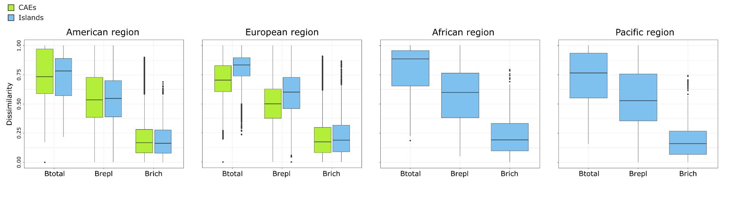
Figure S1: Boxplot of the withing-regions (large scale) pairwise dissimilarities computed with the Podani’s approach for islands (blue) and Continental Area Equivalents (CAEs, except for the African and Pacific regions) (green). Btotal: Sorensen index (total dissimilarity); Brepl: replacement; Brich: richness differences.

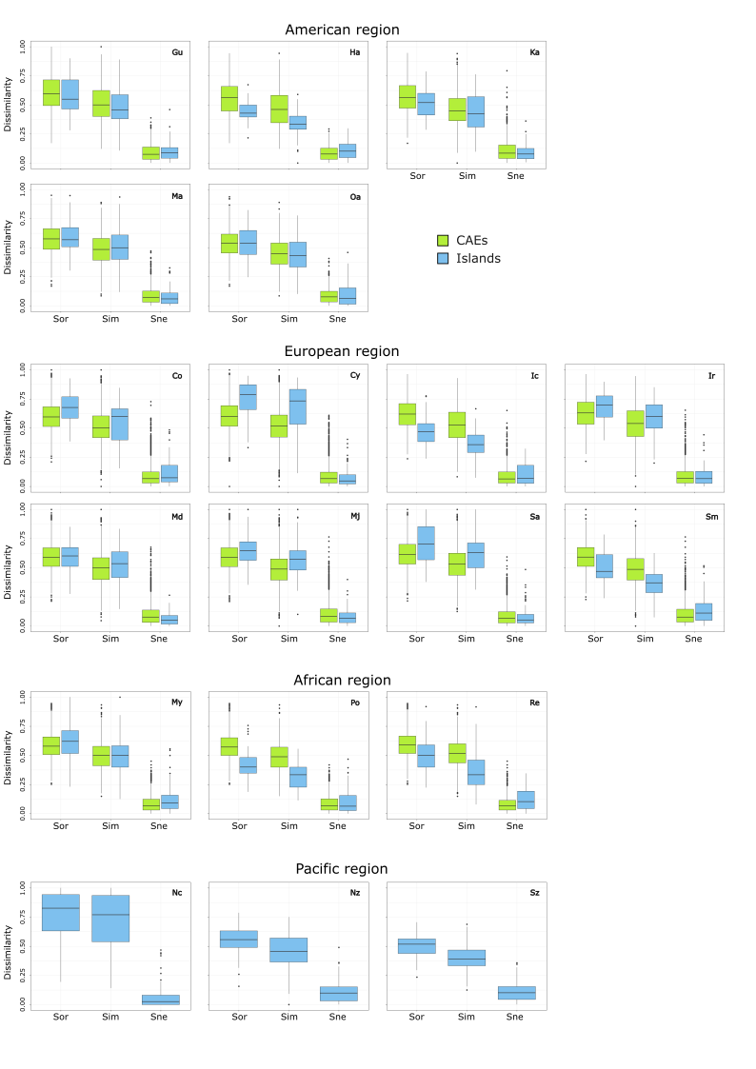
Figure S2: Boxplot of the within-islands (blue) and within Continental Area Equivalents (green) (CAEs, small scale) pairwise dissimilarities for each island computed with Baselga’s approach. Sor: Sorensen index (total dissimilarity); Sim: Simpson index (turnover); Sne: Nestedness-resultant index (nestedness). For island abbreviations, see the main text (Methods).
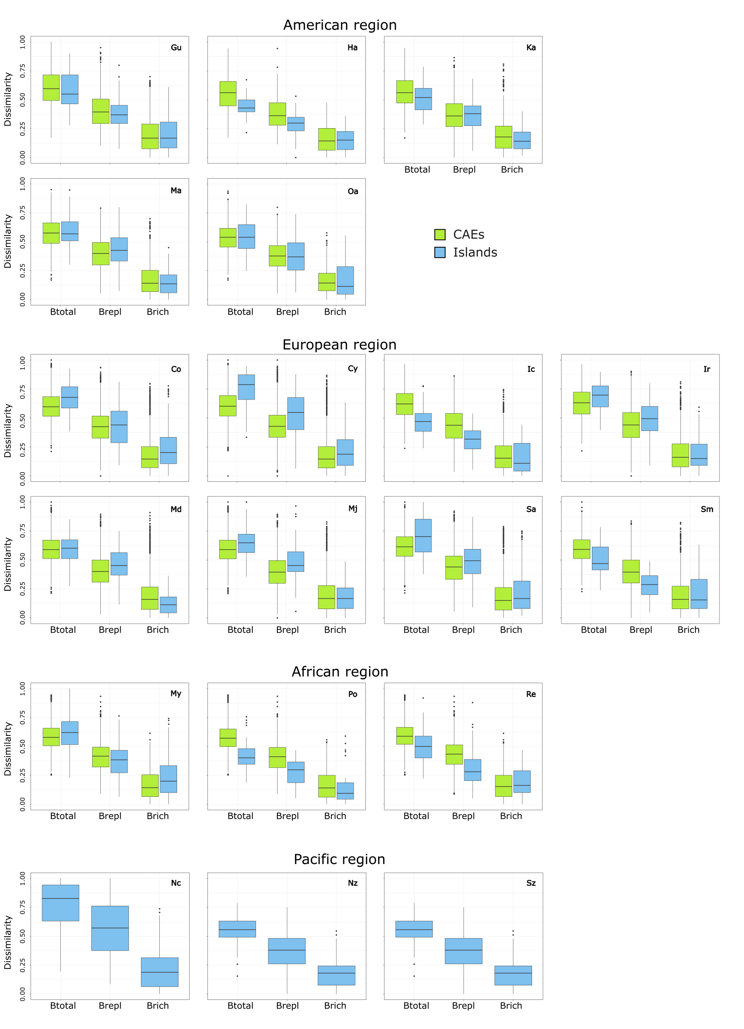
Figure S3: Boxplot of the within-islands (blue) and within Continental Area Equivalents (green) (CAEs, small scale) pairwise dissimilarities for each island computed with Podani’s approach. Sor: Sorensen index (total dissimilarity); Brepl: (replacement); Brich: (richness differences). For island abbreviations, see the main text (Methods).

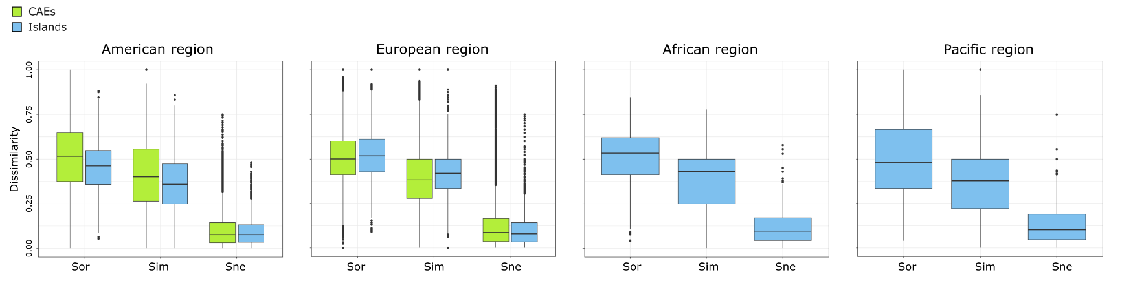
Figure S4: Boxplot of the withing-regions (large scale) pairwise dissimilarities at genus level for islands (blue) and Continental Area Equivalents (CAEs, except for the African and Pacific regions) (green) computed with Baselga’s approach. Sor: Sorensen index (total dissimilarity); Sim: Simpson index (turnover); Sne: Nestedness-resultant index (nestedness).

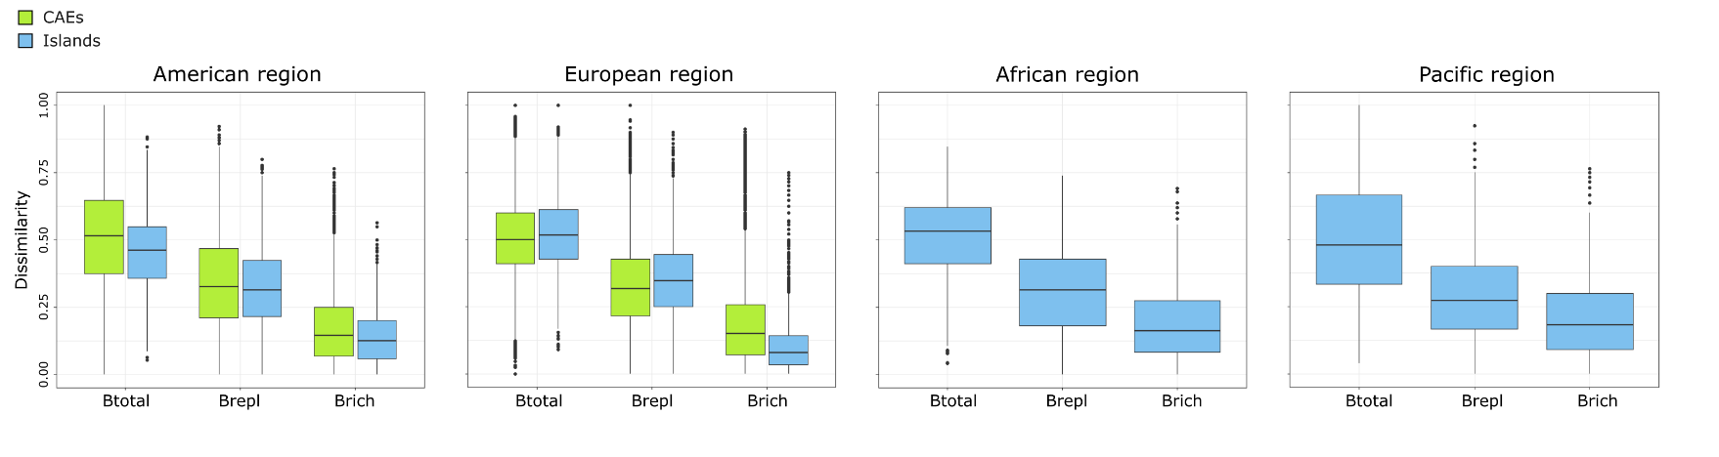

Figure S5: Boxplot of the withing-regions (large scale) pairwise dissimilarities at genus level for islands (blue) and Continental Area Equivalents (CAEs, except for the American and Pacific regions) (green) computed with Podani’s approach. Btotal: Sorensen index (total dissimilarity); Brepl: replacement; Brich: richness differences.

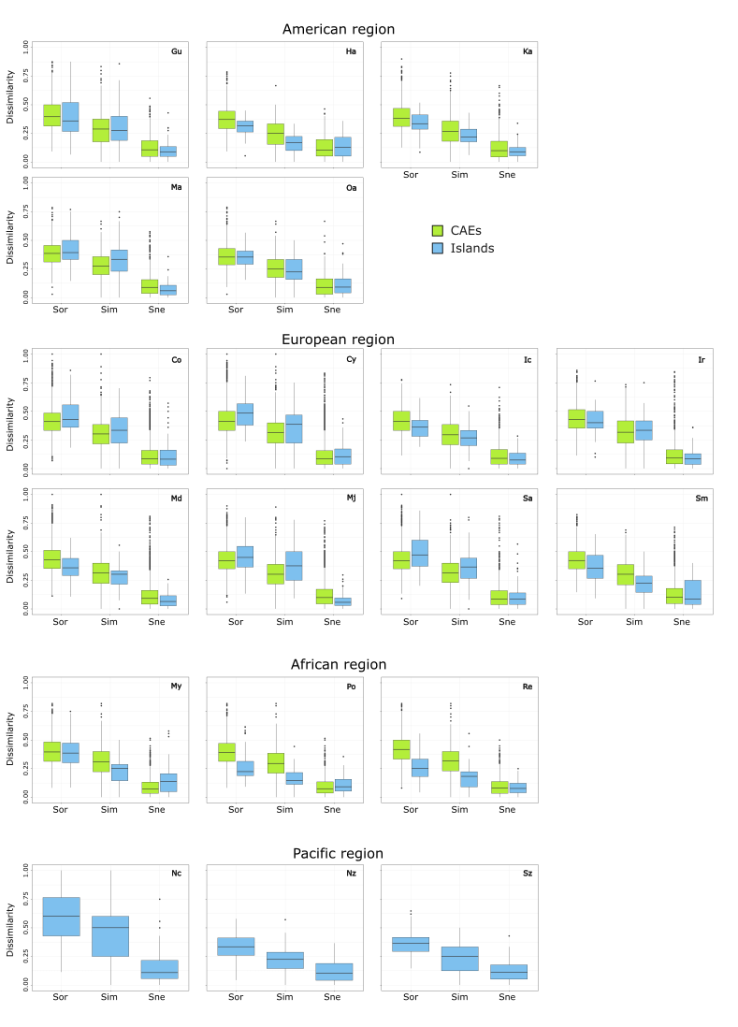
Figure S6: Boxplot of the within-islands (blue) and within Continental Area Equivalents (green) (CAEs, small scale) pairwise dissimilarities at genus level for each island computed with Baselga’s approach. Sor: Sorensen index (total dissimilarity); Sim: Simpson index (turnover); Sne: Nestedness-resultant index (nestedness).
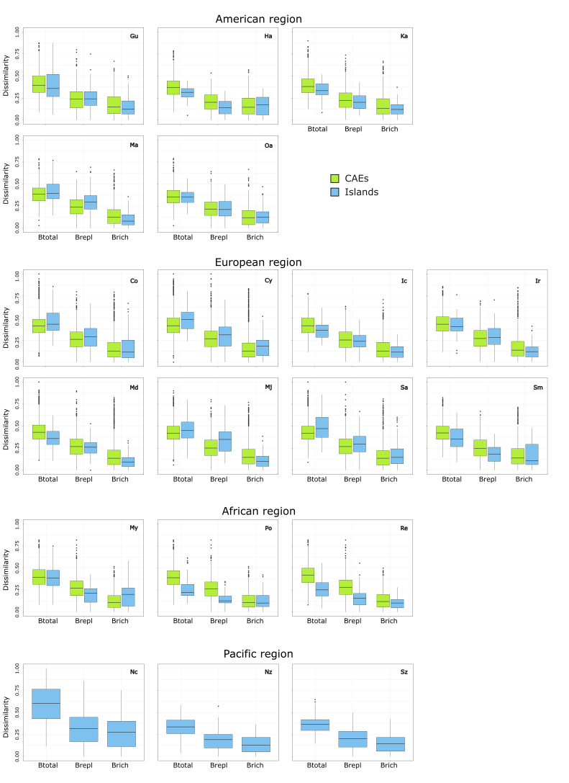
Figure S7: Boxplot of the within-islands (blue) and within Continental Area Equivalents (green) (CAEs, Small scale) pairwise dissimilarities at genus level for each island computed with Podani’s approach. Btotal: Total dissimilarity; Brepl: replacement; Brich: richness differences.

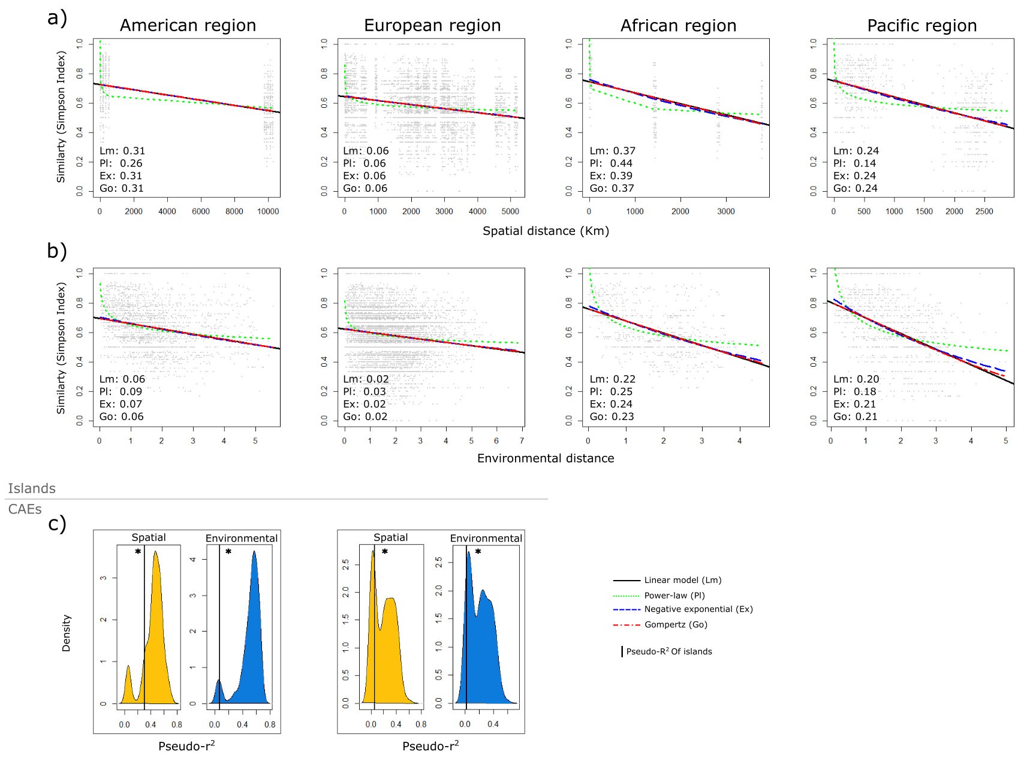

Figure S8: a) Spatial distance-decay at genus level among islands for the four studied regions. b) Environmental distance-decay at genus level among islands for the four studied regions. c) Density of the pseudo-r² of the spatial and environmental distance-decay models (negative exponential function) at genus level for the CAEs resamples, indicating the pseudo-r² of the exponential models for the islands in the same region. Significative differences are indicated with an asterisk.

Appendix S1: Bibliography from which the age of the islands was obtained.
- Rosenbaum, G. & Lister, G.S. (2004) Neogene and Quaternary rollback evolution of the Tyrrhenian Sea, the Apennines, and the Sicilian Maghrebides. Tectonics, 23.
- Ehl, S., Vences, M. & Veith, M. (2019) Reconstructing evolution at the community level: A case study on Mediterranean amphibians. Molecular Phylogenetics and Evolution, 134, 211–225.
- Jolivet, L., Augier, R., Robin, C., Suc, J.-P. & Rouchy, J.M. (2006) Lithospheric-scale geodynamic context of the Messinian salinity crisis. Sedimentary Geology, 188–189, 9–33.
- Samper, A., Quidelleur, X., Lahitte, P. & Mollex, D. (2007) Timing of effusive volcanism and collapse events within an oceanic arc island: Basse-Terre, Guadeloupe archipelago (Lesser Antilles Arc). Earth and Planetary Science Letters, 258, 175–191.
- Samper, A., Quidelleur, X., Komorowski, J.-C., Lahitte, P. & Boudon, G. (2009) Effusive history of the Grande Découverte Volcanic Complex, southern Basse-Terre (Guadeloupe, French West Indies) from new K–Ar Cassignol–Gillot ages. Journal of Volcanology and Geothermal Research, 187, 117–130.
- Einarsson, T. & Albertsson, K.J. (1988) The Glacial History of Iceland During the Past Three Million Years. Philosophical Transactions of the Royal Society of London. Series B, Biological Sciences, 318, 637–644.
- Clark, C.D., Hughes, A.L.C., Greenwood, S.L., Jordan, C. & Sejrup, H.P. (2012) Pattern and timing of retreat of the last British-Irish Ice Sheet. Quaternary Science Reviews, 44, 112–146.
- McDougall, I. (1964) Potassium-Argon Ages from Lavas of the Hawaiian Islands. GSA Bulletin, 75, 107–128.
- Neall, V.E. & Trewick, S.A. (2008) The age and origin of the Pacific islands: a geological overview. Philosophical Transactions of the Royal Society B: Biological Sciences, 363, 3293–3308.
- Fleischer, R.C., Mcintosh, C.E. & Tarr, C.L. (1998) Evolution on a volcanic conveyor belt: using phylogeographic reconstructions and K–Ar-based ages of the Hawaiian Islands to estimate molecular evolutionary rates. Molecular Ecology, 7, 533–545.
- Baksi, A.K. & Hoffman, K.A. (2000) On the age and morphology of the reunion event. Geophysical Research Letters, 27, 2997–3000.
- Geldmacher, J., Hoernle, K., Bogaard, P. v. d., Duggen, S. & Werner, R. (2005) New 40Ar/39Ar age and geochemical data from seamounts in the Canary and Madeira volcanic provinces: Support for the mantle plume hypothesis. Earth and Planetary Science Letters, 237, 85–101.
- Mas, G., Maillard, A., Alcover, J.A., Fornós, J.J., Bover, P. & Torres-Roig, E. (2018) Terrestrial colonization of the Balearic Islands: New evidence for the Mediterranean sea-level drawdown during the Messinian Salinity Crisis. Geology, 46, 527–530.
- Germa, A., Quidelleur, X., Labanieh, S., Chauvel, C. & Lahitte, P. (2011) The volcanic evolution of Martinique Island: Insights from K–Ar dating into the Lesser Antilles arc migration since the Oligocene. Journal of Volcanology and Geothermal Research, 208, 122–135.
- Nougier, J., Cantagrel, J.M. & Karche, J.P. (1986) The Comores archipelago in the western Indian Ocean: volcanology, geochronology and geodynamic setting. Journal of African Earth Sciences (1983), 5, 135–145.
- Valente, L., Phillimore, A.B., Melo, M., Warren, B.H., Clegg, S.M., Havenstein, K., Tiedemann, R., Illera, J.C., Thébaud, C., Aschenbach, T. & Etienne, R.S. (2020) A simple dynamic model explains the diversity of island birds worldwide. Nature, 579, 92–96.
- Grandcolas, P., Murienne, J., Robillard, T., Desutter-Grandcolas, L., Jourdan, H., Guilbert, E. & Deharveng, L. (2008) New Caledonia: a very old Darwinian island? Philosophical Transactions of the Royal Society B: Biological Sciences, 363, 3309–3317.
- Quilty, P.G. (2007) Origin and evolution of the sub-Antarctic islands: the foundation. Papers and Proceedings of the Royal Society of Tasmania, 141, 35–58.
- McKee, E.H. & Moore, R.B. (1992) Potassium–argon dates for trachytic rocks on São Miguel, Azores. Isochron West, 58, 9–11.
- Sibrant, A.L.R., Hildenbrand, A., Marques, F.O., Weiss, B., Boulesteix, T., Hübscher, C., Lüdmann, T., Costa, A.C.G. & Catalão, J.C. (2015) Morpho-structural evolution of a volcanic island developed inside an active oceanic rift: S. Miguel Island (Terceira Rift, Azores). Journal of Volcanology and Geothermal Research, 301, 90–106.

