Table S1 – Previous studies on OCS/OCD in CHR-P populations.

Authors | patients | Assessment | OCS prevalance | Major results
Soyata et al. (2018) | 84 CHR-P  AP naïve | YBOCS-SC | 46% at least 1 OCS  Most frequent obsessions: aggressiveness (25 %) contamination (19%) symmetry (16.7%)  religion (16.7%)  Most frequent compulsions: cleaning/washing (16.7 %) repeating (16.7%)  checking (13.3%) | The duration of subthreshold psychotic symptoms was longer in CHR-P with OCS.  CHR-P who worked/studied before first presentation were more frequent in OCS group.  Depressive symptoms were higher in CHR-P with OCS.  The OCS-negative group’s performance was worse in cognitive tests.
Averna et al. (2018) | 51 OCD patients  AP-naïve  children/adolescents | CY-BOCS | 43.1% OCD with CHR-P symptoms (measured with the SIPS) | Global functioning was worst in OCD patients with CHR-P symptoms. They also showed a more compromised social, and role functioning than individuals without CHR-P symptoms.
Won-Hur et al. (2012) | 65 CHR-P  (78.5% AP-naïve) | YBOCS-SC | 37.5% with OCS | CHR-P with OCS showed more severe clinical symptomatic presentation (more attenuated psychotic symptoms) and poorer global functioning (as compared to both healthy controls and CHR-P/OCS- group).  The CHR-P/OCS- group showed greater cognitive deficits → OCS in CHR-P could serve a protective function with respect to neurocognitive impairments should be studied.  The features that distinguished the groups could be used for developing prognoses and intervention strategies for the heterogeneous CHR-P population.
Sterk et al. (2011) | 29 CHR-P | OCD diagnosis  (DSM-IV-TR) | 3.4% OCD  20.7% OCS | -
Fontenelle et al. (2011) | 312 CHR-P | OCD diagnosis (DSM-IV-TR) at follow-up (7.4 years) | 7.4% with OCD  22.4% in CHR-P with psychosis transition vs. 3.9% in CHR-P without psychosis transition | CHR-P patients who displayed psychosis and OCD were characterized by greater severity of depression both before and after conversion to psychosis and increased rates of depressive disorders.  At follow-up, OCD was significantly more frequent among patients who developed psychosis compared with those that did not develop it. The transition to psychosis was a major risk factor for OCD in CHR-P subjects.
Kennedy et al. (2021) | 156 CHR-P  (73.1% AP-naïve) | SCID-IV | 17% with OCD  53% with obsessions  30% with compulsions | While OCS were found to be common in CHR-P, implausible OCS themes were not predictive of psychosis conversion.
Legend – OCS = Obsessive-Compulsive Symptoms; OCD = Obsessive-Compulsive Disorder; CHR-P = Individuals at Clinical High Risk for Psychosis; AP = Antipsychotic medication; YBOCS-SC = Yale-Brown Obsession Compulsion Scale-Symptom Checklist; CY-BOCS: Children’s Yale-Brown Obsessive Compulsive Scale; SIPS = Structured Interview for Prodromal Symptoms; DSM-IV-TR = Diagnostic and Statistical Manual of mental disorders , IV Edition, Text Revised; SCID-4 = Structured Clinical Interview for DSM-IV mental disorders.

Table S2 – Operative definitions of outcomes.

Persistent Negative Symptoms are defined as:
(a) presence of at least moderate (i.e., score of ≥ 4 on the PANSS) for at least 3 negative symptoms or at least moderately severe (i.e., score of ≥ 5 on the PANSS) for at least 2 negative symptoms;
(b) persistence of negative symptoms for at least 6 months and for an extended period of time prior to the study beginning (i.e., at least 4 weeks);
(c) absence of relevant levels of positive symptoms, depression and extrapyramidal symptoms as defined thresholds on accepted and validated rating scales (i.e., persistent score of ≤ 3 in all items included in the PANSS “Positive Symptoms” domain and in PANSS “Depression” and “Guilt Feelings” items, and concurrently in absence of extrapyramidal symptoms requiring anticholinergic treatment).

DUI was defined as the time interval between the first psychiatric manifestation and the first pharmacological and/or psychosocial intervention (Schultze-Lutter et al., 2015).
Suicide attempt was defined as potentially injurious, self-inflicted behavior without a fatal outcome for which there was (implicit or explicit) evidence of intent to die (Silverman et al., 2007).
Self-harm behavior was intended as acts of deliberate self-harm or intoxication with alcohol or drugs, but where there was no clear intention to die (Silverman et al., 2007).
Service disengagement was defined as a complete lack of contact or untraceable for at least 3 months despite a need of treatment (Robson & Greenwood, 2022).
Current suicidal ideation was identified on the basis of a score of > 2 on item 4 (“Suicidality”) of the Brief Psychiatric Rating Scale (BPRS), corresponding at least to occasional suicidal thinking without specific plans (Pelizza et al., 2020).
Functional recovery was simply defined as return to work or school (Silva & Restrepo, 2019).

Legend – PANSS = Positive And Negative Syndrome Scale.

+) Schultze-Lutter, F., Rahman, J., Ruhrmann, S., Michel, C., Schimmelmann, B.G., Maier, W., & Klosterkötter, J. (2015). Duration of unspecific prodromal and clinical high risk states, and early help-seeking in first-admission psychosis patients. Social Psychiatry and Psychiatric Epidemiology, 50, 1831-1841. https://doi.org/10.1007/s00127-015-1093-3.
+) Silverman, M.M., Berman, A.L., Sanddal, N.D., O’carroll, P.W., & Joiner, T.E. (2007). Rebuilding the tower of Babel: a revised nomenclature for the study of suicide and suicidal behaviors - part 2: suicide-related ideations, communications, and behaviors. Suicide Life Threatening Behavior, 37, 264-277. https://doi.org/10.1521/suli.2007.37.3.264.
+) Robson, E., & Greenwood, K. (2022). Rates and predictors of disengagement and strength of engagement for people with a first episode of psychosis using early intervention services: a systematic review of predictors and meta-analysis of disengagement rates. Schizophrenia Bulletin Open. 1, sgac012. https://doi.org/10.1093/schizbullopen/sgac012.
+) Pelizza. L., Poletti, M., Azzali, S., Paterlini, F., Garlassi, S., Scazza, I., Chiri, L.R., Pupo, S., Pompili, M., & Raballo, A. (2020). Suicide risk in young people at ultra-high risk (UHR) of psychosis: findings from a 2-year longitudinal study. Schizophrenia Research, 220, 98-105. https://doi.org/10.1016/j.schres.2020.03.051.
+) Silva, M.A., & Restrepo, D. (2019). Functional recovery in schizophrenia. Revista Colombiana de Psiquiatria (English Edition), 48, 252-260. https://doi.org/10.1016/j.rcp.2017.08.004.

Table S3 - Distribution of OCS scores in the total CHR-P population at baseline (n = 180).

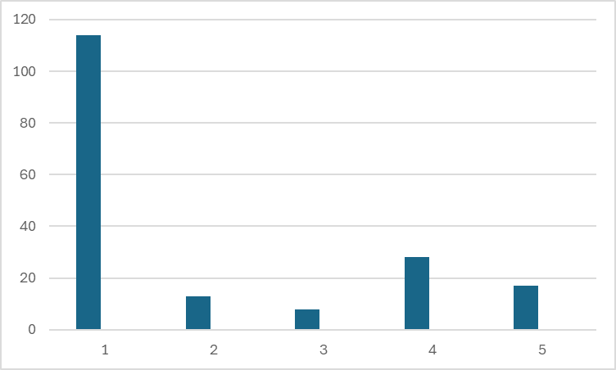

Note – OCS = Obsessive-compulsive symptoms; CHR-P = Clinical High Risk for Psychosis; 1 = absent/questionable; 2 = mild; 3 = moderate; 4 = moderately severe; 5 = severe.

Figure S1 – Obsessive compulsive symptoms in CHR-P participants at baseline.
180 CHR-P participants

66 (36.7%) with OCS
(CAARMS item 7.6 score ≥ 2)
114 (63.3%) without OCS
(CAARMS item 7.6 score < 2)

45 (25.0%) with interfering OCS
(CAARMS item 7.6 score ≥ 4)

8 (4.4% of the total sample) with OCD diagnosis
20 (30.3%) Depressive disorder
10 (15.2%) Psychotic disorder NOS
8 (12.2%) OCD
8 (12.2%) Brief psychotic disorder
7 (10.6%) Anxiety disorder
6 (9.1%) Borderline personality disorder
5 (7.6%) Schizotypal personality disorder

20 (30.3%) Depressive disorder
10 (15.2%) Psychotic disorder NOS
8 (12.2%) OCD
8 (12.1%) Brief psychotic disorder
7 (10.6%) Anxiety disorder
6 (9.1%) borderline personality disorder
5 (7.6%) schizotypal personality disorder
2 (3.0%) Eating disorder
20 (30.3%) Depressive disorder
10 (15.2%) Psychotic disorder NOS
8 (12.2%) OCD
8 (12.1%) Brief psychotic disorder
7 (10.6%) Anxiety disorder
6 (9.1%) borderline personality disorder
5 (7.6%) schizotypal personality disorder
2 (3.0%) Eating disorder
Note – CHR-P = Clinical High Risk for Psychosis; OCS = Obsessive-compulsive symptoms; NOS = Not Otherwise Specified; OCD = Obsessive-compulsive disorder; CAARMS = Comprehensive Assessment of At-Risk Mental States.

