Supporting Information
Novel Multifunctional Tacrine-Donepezil Hybrids Against Alzheimer’s Disease: Design Synthesis and Bioactivity Studies
Gülşah Bayraktar¹, Manuela Bartolini², Maria Laura Bolognesi², Mumin Alper Erdoğan³, Güliz Armağan⁴, Ece Bayır⁵, Aylin Şendemir⁶, Donatella Bagetta⁷, Stefano Alcaro⁷, Vildan Alptüzün¹*
1 Department of Pharmaceutical Chemistry, Faculty of Pharmacy, Ege University, 35100, Izmir, Turkiye
2 Department of Pharmacy and Biotechnology, Alma Mater Studiorum - University of Bologna, Via Belmeloro 6, 40126, Bologna, Italy
3 Department of Physiology, Katip Celebi University School of Medicine, Izmir, Turkiye
4 Department of Biochemistry, Faculty of Pharmacy, Ege University 35100, Izmir, Turkiye
5 Ege University Central Research Test and Analysis Laboratory Application and Research Center (EGE-MATAL), Ege University, 35100, Izmir, Turkiye
6 Department of Bioengineering, Faculty of Engineering, Ege University, 35100, Izmir, Turkiye
7 Dipartimento di Scienze della Salute, Università degli Studi “Magna Græcia” di Catanzaro, Campus “S. Venuta”, Viale Europa, 88100 Catanzaro, Italy
*Correspondence:
Dr, Vildan Alptüzün Department of Pharmaceutical Chemistry, Faculty of Pharmacy, Ege University, 35100, Izmir, Turkiye
Email: vildan.alptuzun@ege.edu.tr

Contents
Table S1. In silico ADME properties predictions.
Table S2. Glide Score values (kcal/mol) for binding hChEs.
Table S3. eeAChE and eqBChE Ki, Vmax and Km values
Figure S1-S25. Best docking pose of compounds into hAChE active site.
Figure S26-S50. Best docking pose of compounds into hBChE active site.
Figure S51. Schematic of detailed H4 interactions with hAChE and hBChE residues.
Figure S52. Kinetic Study on the eeAChE inhibition of H15 Lineweaver Burke reciprocal plots of 1/V versus 1/[S].
Figure S53. Kinetic Study on the eqBChE inhibition of H15 Lineweaver Burke reciprocal plots of 1/V versus 1/[S].
Figure S54. Percentages of cell viability after exposure to compounds (10 µM) against H₂O₂-treated cells.
Spectra 1-80. ¹H NMR, ¹³C NMR and Mass spectras of the compounds 1-28, H3-H28

Table S1. In silico ADME properties predictions.
Compound | CNS  activityª | Volume^{b} | QPlogPo/w^{c} | QPlogS^{d} | QPlogHERG^{e} | QPlogBB^{f} | QPlogKhsa^{g} | %oral absorbstion^{h}
H3 | 1 | 1314 | 5.16 | -5.78 | -7.43 | 0.39 | 0.99 | 100
H4 | 1 | 1375 | 5.56 | -6.22 | -7.64 | 0.33 | 1.12 | 100
H5 | 1 | 1357 | 5.40 | -6.01 | -7.20 | 0.39 | 1.12 | 100
H6 | 2 | 1323 | 5.32 | -5.97 | -7.30 | 0.47 | 1.02 | 100
H7 | 2 | 1347 | 5.54 | -6.25 | -7.31 | 0.52 | 1.08 | 100
H8 | 2 | 1352 | 5.59 | -6.30 | -7.30 | 0.53 | 1.10 | 100
H9 | 1 | 1371 | 4.55 | -5.57 | -7.20 | -0.44 | 0.90 | 100
H10 | 1 | 1367 | 4.44 | -6.40 | -7.32 | -0.28 | 0.78 | 100
H11 | 2 | 1391 | 5.96 | -6.82 | -7.32 | 0.61 | 1.21 | 100
H12 | 1 | 1373 | 5.48 | -6.34 | -7.31 | 0.38 | 1.16 | 100
H13 | 1 | 1386 | 5.24 | -5.87 | -7.22 | 0.33 | 0.99 | 100
H14 | 2 | 1329 | 5.40 | -6.13 | -7.29 | 0.50 | 1.04 | 100
H15 | 2 | 1358 | 5.66 | -6.52 | -7.33 | 0.56 | 1.11 | 100
H16 | 2 | 1366 | 5.73 | -6.61 | -7.33 | 0.57 | 1.14 | 100
H17 | 0 | 1386 | 4.45 | -5.89 | -7.31 | -0.74 | 0.94 | 92.97
H18 | 1 | 1378 | 4.39 | -6.67 | -7.46 | -0.48 | 0.81 | 96.85
H19 | 2 | 1411 | 6.15 | -7.21 | -7.35 | 0.67 | 1.26 | 100
H20 | 1 | 1369 | 5.44 | -6.30 | -7.28 | 0.38 | 1.14 | 100
H21 | 2 | 1329 | 5.40 | -6.13 | -7.29 | 0.50 | 1.03 | 100
Compound | CNS  activityª | Volume^{b} | QPlogPo/w^{c} | QPlogS^{d} | QPlogHERG^{e} | QPlogBB^{f} | QPlogKhsa^{g} | %oral absorbstion^{h}
H22 | 2 | 1357 | 5.66 | -6.51 | -7.32 | 0.56 | 1.11 | 100
H23 | 2 | 1366 | 5.73 | -6.63 | -7.35 | 0.57 | 1.13 | 100
H24 | 0 | 1384 | 4.42 | -5.89 | -7.31 | -0.76 | 0.93 | 92.59
H25 | 1 | 1376 | 4.37 | -6.67 | -7.46 | -0.49 | 0.80 | 96.60
H26 | 2 | 1411 | 6.15 | -7.20 | -7.35 | 0.67 | 1.26 | 100
H27 | 2 | 1337 | 5.50 | -6.19 | -7.18 | 0.55 | 1.06 | 100
H28 | 2 | 1380 | 5.92 | -6.67 | -7.15 | 0.64 | 1.18 | 100
Tacrine | 1 | 709 | 2.59 | -3.13 | -4.15 | 0.04 | 0.07 | 100
ªPredicted central nervous system activity on a -2 (inactive) to +2 (active) scale;
^{b} Total solvent-accessible volume in cubic angstroms. Recommended range: 500 - 2,000;
^{c} Predicted octanol/water partition coefficient. Recommended range: -2.0 - 6.5;
^{d} Predicted aqueous solubility. S in mol/dm⁻³ is the concentration of the solute in a saturated solution that is in equilibrium with the
crystalline solid. Recommended range: -6.5 - 0.5;
^{e} Predicted IC₅₀ value for blockage of HERG K⁺ channels. Recommended values > -5;
^{f} Predicted brain/blood partition coefficient. Recommended range: -3.0 - 1.2;
^{g} Prediction of binding to human serum albumin. Recommended range: -1.5 - 1.5;
^{h} Predicted human oral absorption on 0 to 100% scale.

Table S2. Glide Score values (kcal/mol) for binding hChEs.
Compound | hAChE | hBChE | hChEs SI
H3 | -12.06 | -9.80 | 1.23
H4 | -9.94 | -9.55 | 0.01
H5 | -9.61 | -9.62 | 1.00
H6 | -10.97 | -10.37 | 1.06
H7 | -10.49 | -9.83 | 1.07
H8 | -9.71 | -9.24 | 1.05
H9 | -10.87 | -9.46 | 1.15
H10 | -10.30 | -9.55 | 1.08
H11 | -11.83 | -8.04 | 1.47
H12 | -10.68 | -10.04 | 1.06
H13 | -10.52 | -9.35 | 1.13
H14 | -11.29 | -10.11 | 1.12
H15 | -10.12 | -9.45 | 1.07
H16 | -10.54 | -9.20 | 1.15
H17 | -9.57 | -9.38 | 1.02
H18 | -10.52 | -8.68 | 1.21
H19 | -11.98 | -10.47 | 1.14
H20 | -9.57 | -8.97 | 1.07
H21 | -10.78 | -9.70 | 1.11
H22 | -10.74 | -8.83 | 1.22
H23 | -10.52 | -8.70 | 1.21
H24 | -10.34 | -7.90 | 1.31
H25 | -11.61 | -8.78 | 1.32
H26 | -10.47 | -8.37 | 1.25
H27 | -10.68 | -10.26 | 1.04
H28 | -10.39 | -7.26 | 1.43
4EY7 x-ray ligand | -12.70 | -- | --
5NN0 x-ray ligand | -- | -9.96 | --

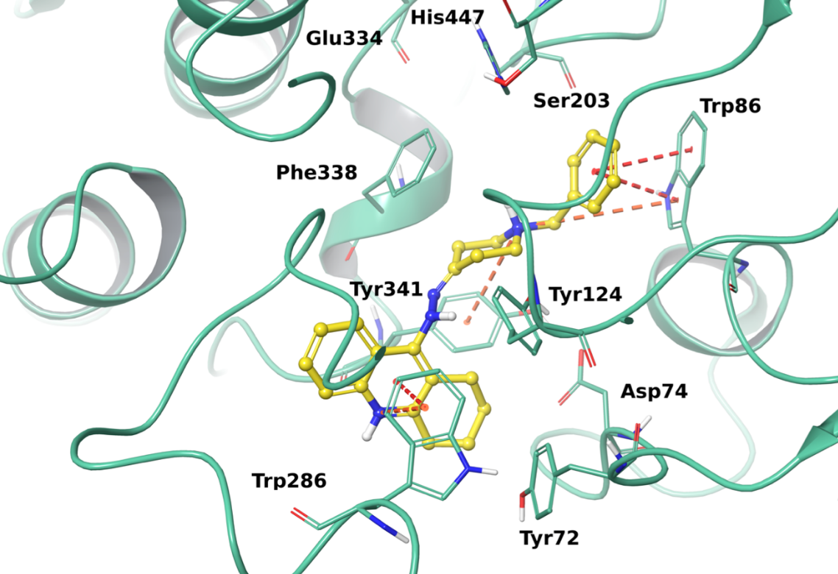
Figure S1. Best docking pose of H3 into hAChE active site. The enzyme is represented in green cartoons, the most relevant interacting residues and the catalytic triad are depicted in tube and the ligand is shown as yellow ball and stick representation. π-π interactions, π-cation contacts, hydrogen bonds, salt bridges are respectively represented in red, orange, light-blue and pink.

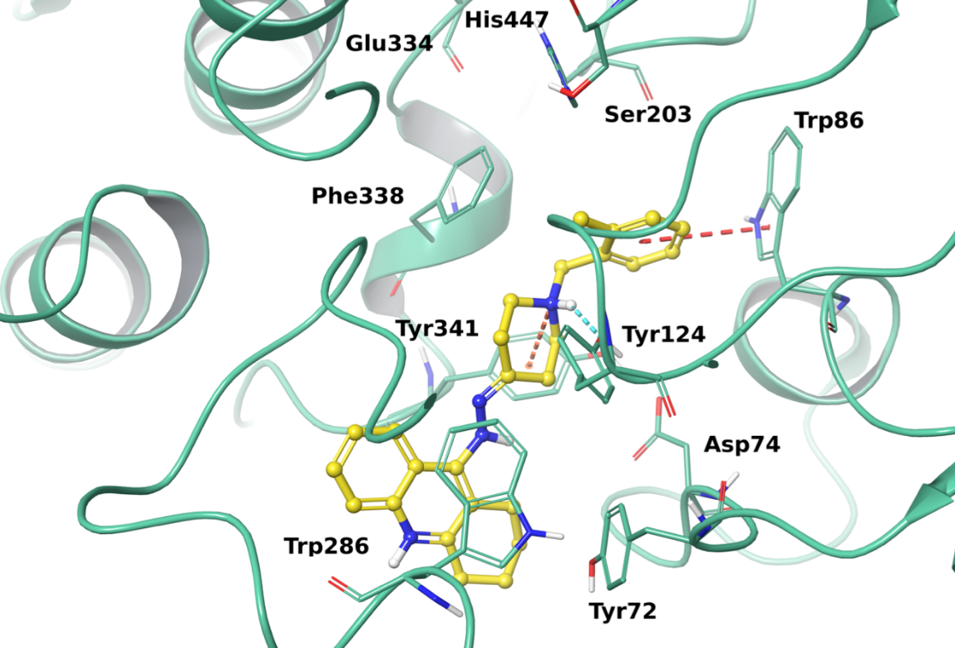
Figure S2. Best docking pose of H5 into hAChE active site. The enzyme is represented in green cartoons, the most relevant interacting residues and the catalytic triad are depicted in tube and the ligand is shown as yellow ball and stick representation. π-π interactions, π-cation contacts, hydrogen bonds, salt bridges are respectively represented in red, orange, light-blue and pink.

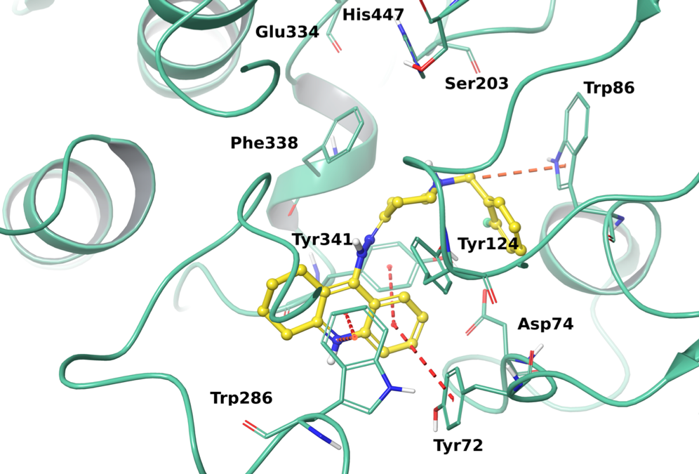
Figure S3. Best docking pose of H6 into hAChE active site. The enzyme is represented in green cartoons, the most relevant interacting residues and the catalytic triad are depicted in tube and the ligand is shown as yellow ball and stick representation. π-π interactions, π-cation contacts, hydrogen bonds, salt bridges are respectively represented in red, orange, light-blue and pink.

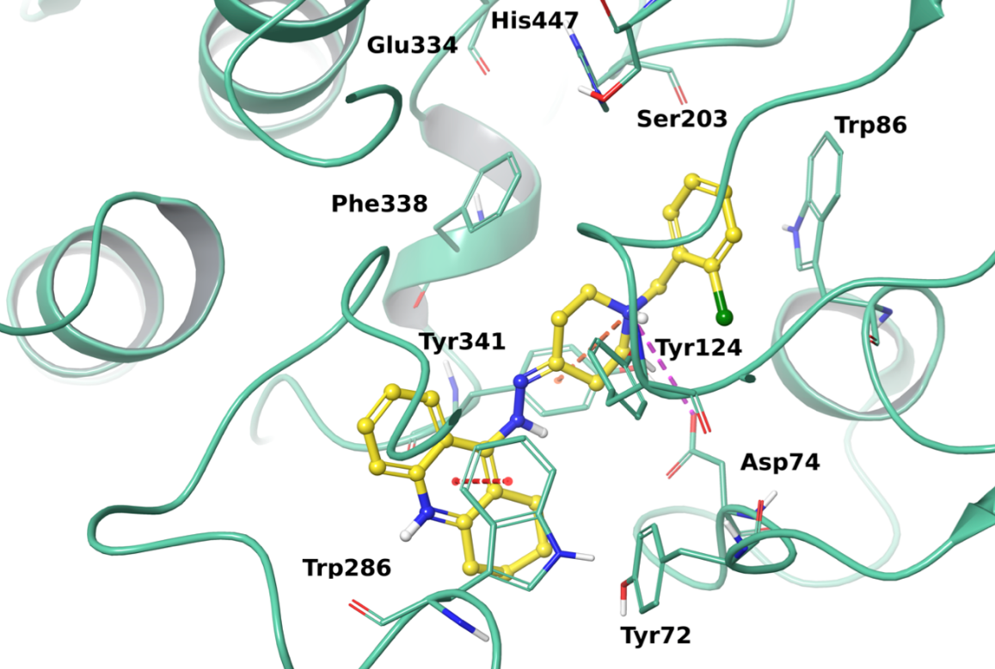
Figure S4. Best docking pose of H7 into hAChE active site. The enzyme is represented in green cartoons, the most relevant interacting residues and the catalytic triad are depicted in tube and the ligand is shown as yellow ball and stick representation. π-π interactions, π-cation contacts, hydrogen bonds, salt bridges are respectively represented in red, orange, light-blue and pink.

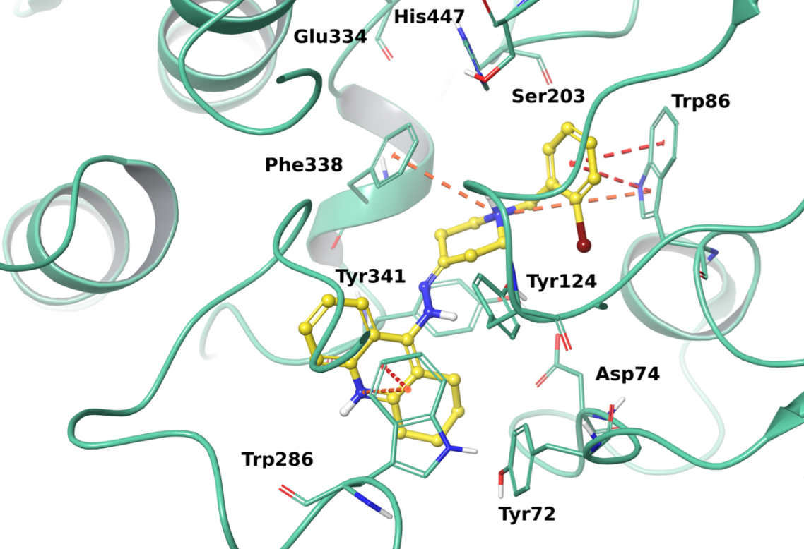
Figure S5. Best docking pose of H8 into hAChE active site. The enzyme is represented in green cartoons, the most relevant interacting residues and the catalytic triad are depicted in tube and the ligand is shown as yellow ball and stick representation. π-π interactions, π-cation contacts, hydrogen bonds, salt bridges are respectively represented in red, orange, light-blue and pink.

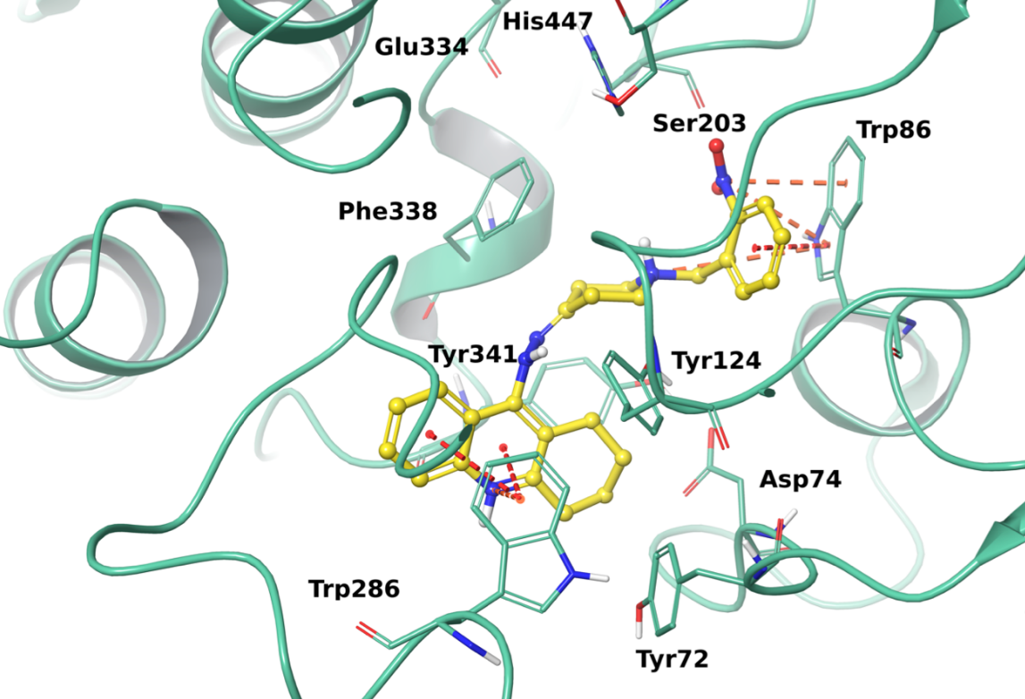
Figure S6. Best docking pose of H9 into hAChE active site. The enzyme is represented in green cartoons, the most relevant interacting residues and the catalytic triad are depicted in tube and the ligand is shown as yellow ball and stick representation. π-π interactions, π-cation contacts, hydrogen bonds, salt bridges are respectively represented in red, orange, light-blue and pink.
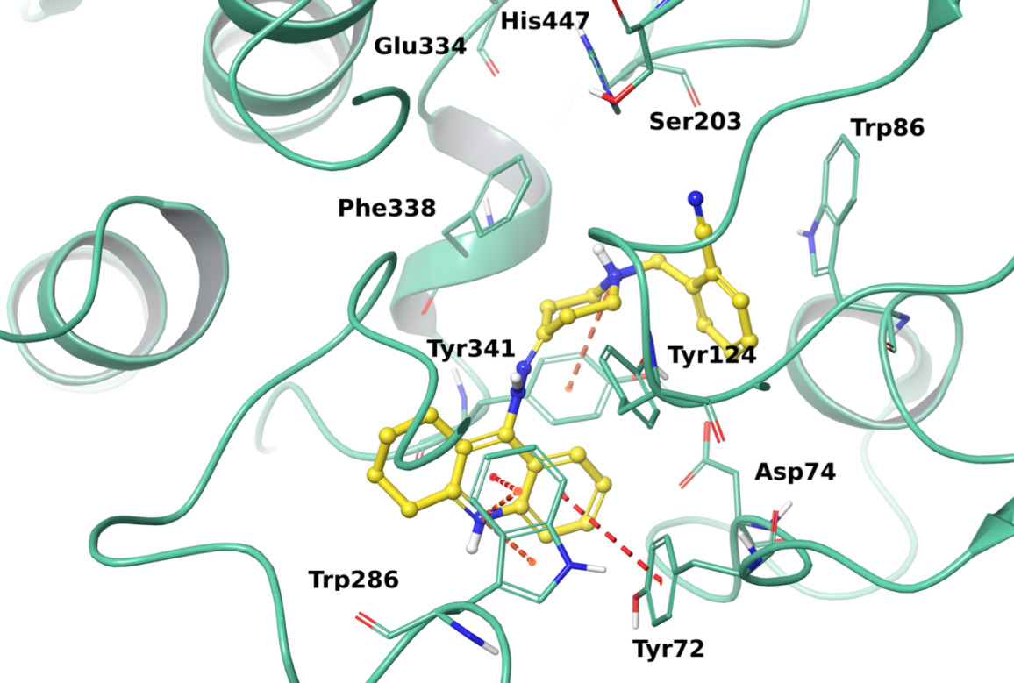
Figure S7. Best docking pose of H10 into hAChE active site. The enzyme is represented in green cartoons, the most relevant interacting residues and the catalytic triad are depicted in tube and the ligand is shown as yellow ball and stick representation. π-π interactions, π-cation contacts, hydrogen bonds, salt bridges are respectively represented in red, orange, light-blue and pink.

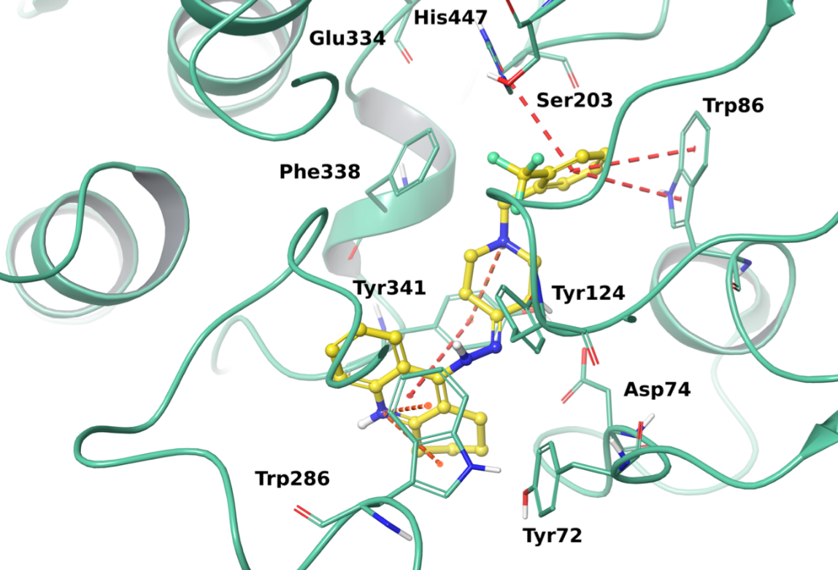
Figure S8. Best docking pose of H11 into hAChE active site. The enzyme is represented in green cartoons, the most relevant interacting residues and the catalytic triad are depicted in tube and the ligand is shown as yellow ball and stick representation. π-π interactions, π-cation contacts, hydrogen bonds, salt bridges are respectively represented in red, orange, light-blue and pink.
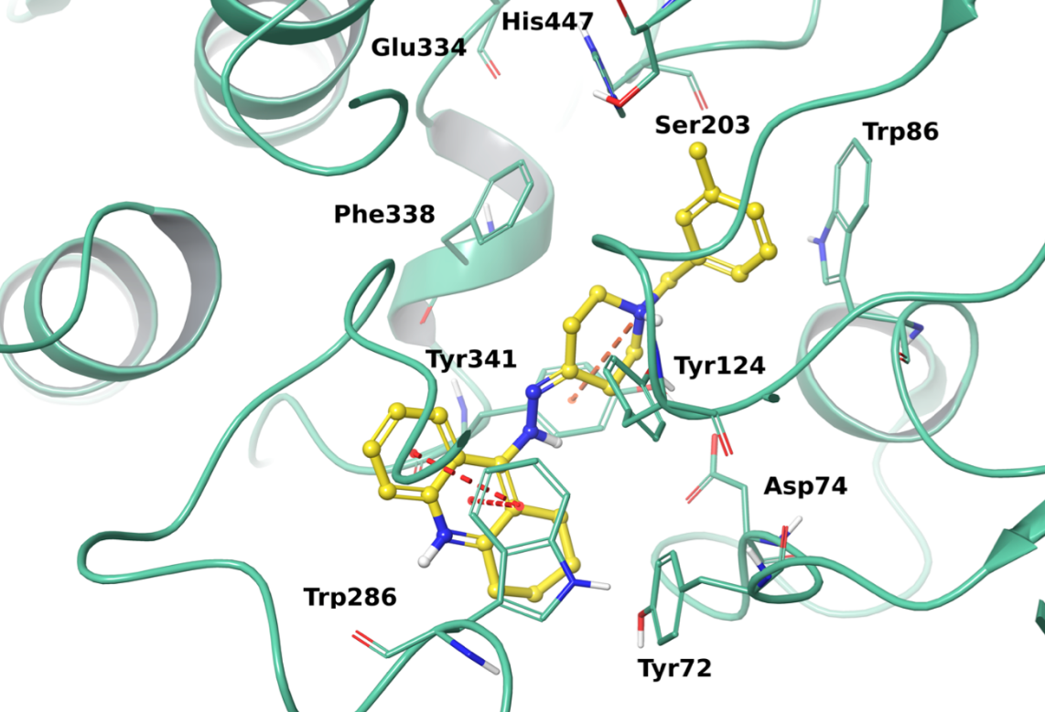
Figure S9. Best docking pose of H12 into hAChE active site. The enzyme is represented in green cartoons, the most relevant interacting residues and the catalytic triad are depicted in tube and the ligand is shown as yellow ball and stick representation. π-π interactions, π-cation contacts, hydrogen bonds, salt bridges are respectively represented in red, orange, light-blue and pink.

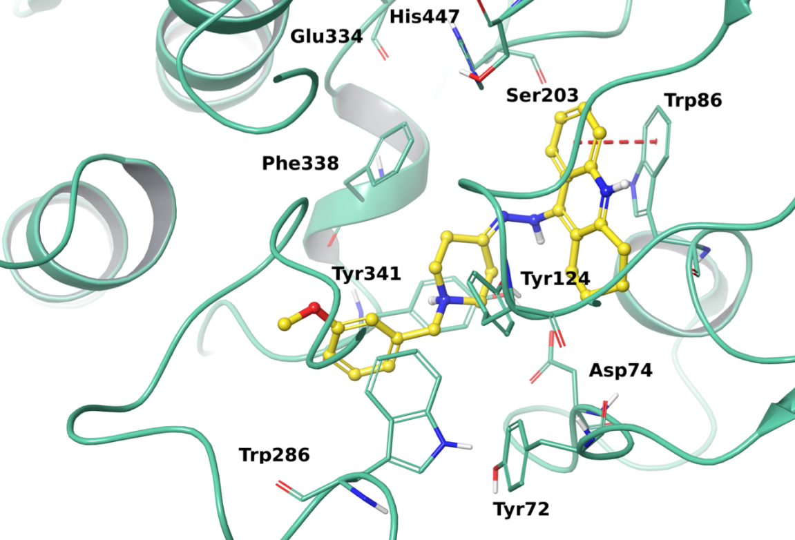
Figure S10. Best docking pose of H13 into hAChE active site. The enzyme is represented in green cartoons, the most relevant interacting residues and the catalytic triad are depicted in tube and the ligand is shown as yellow ball and stick representation. π-π interactions, π-cation contacts, hydrogen bonds, salt bridges are respectively represented in red, orange, light-blue and pin
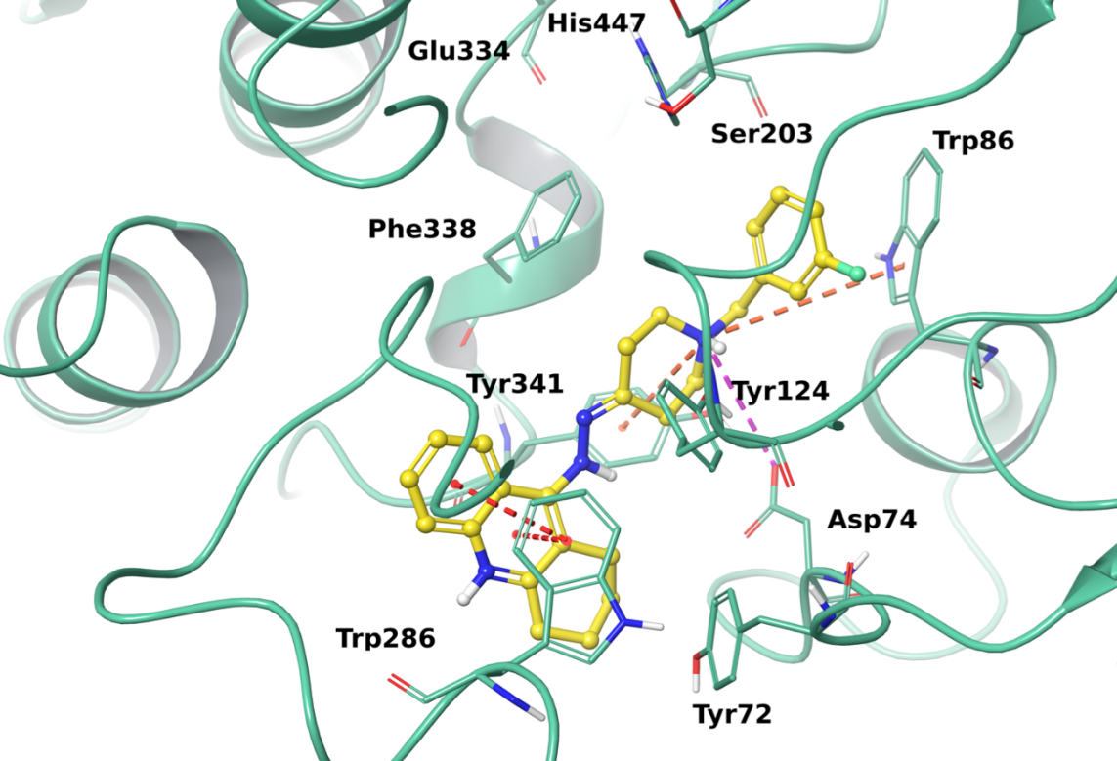
Figure S11. Best docking pose of H14 into hAChE active site. The enzyme is represented in green cartoons, the most relevant interacting residues and the catalytic triad are depicted in tube and the ligand is shown as yellow ball and stick representation. π-π interactions, π-cation contacts, hydrogen bonds, salt bridges are respectively represented in red, orange, light-blue and pink.

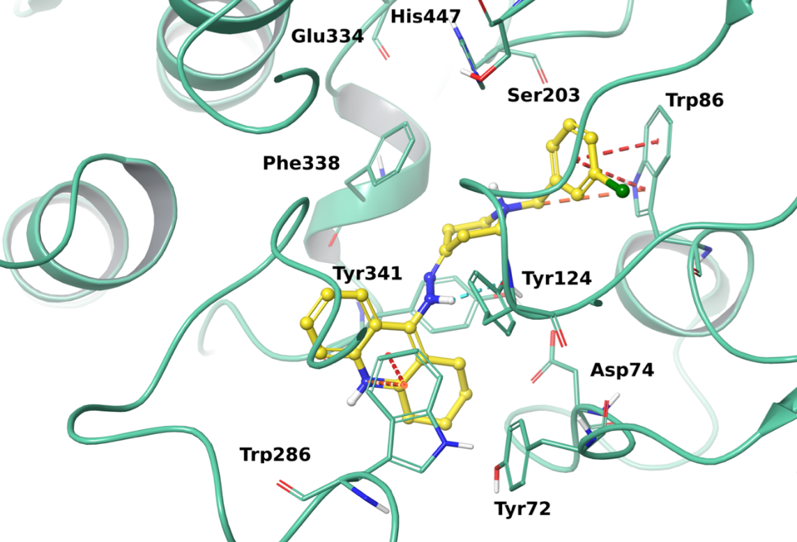
Figure S12. Best docking pose of H15 into hAChE active site. The enzyme is represented in green cartoons, the most relevant interacting residues and the catalytic triad are depicted in tube and the ligand is shown as yellow ball and stick representation. π-π interactions, π-cation contacts, hydrogen bonds, salt bridges are respectively represented in red, orange, light-blue and pink.

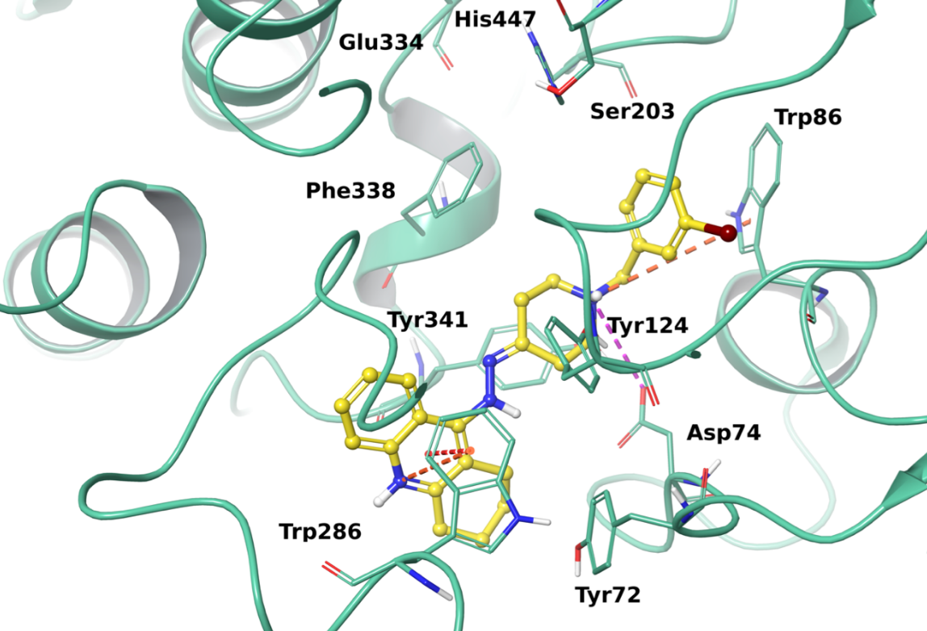
Figure S13. Best docking pose of H16 into hAChE active site. The enzyme is represented in green cartoons, the most relevant interacting residues and the catalytic triad are depicted in tube and the ligand is shown as yellow ball and stick representation. π-π interactions, π-cation contacts, hydrogen bonds, salt bridges are respectively represented in red, orange, light-blue and pink.

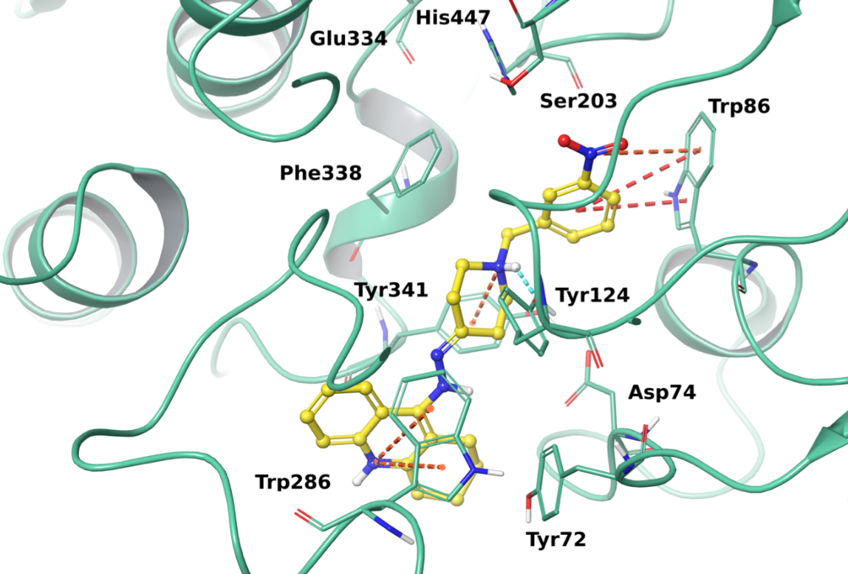
Figure S14. Best docking pose of H17 into hAChE active site. The enzyme is represented in green cartoons, the most relevant interacting residues and the catalytic triad are depicted in tube and the ligand is shown as yellow ball and stick representation. π-π interactions, π-cation contacts, hydrogen bonds, salt bridges are respectively represented in red, orange, light-blue and pink.
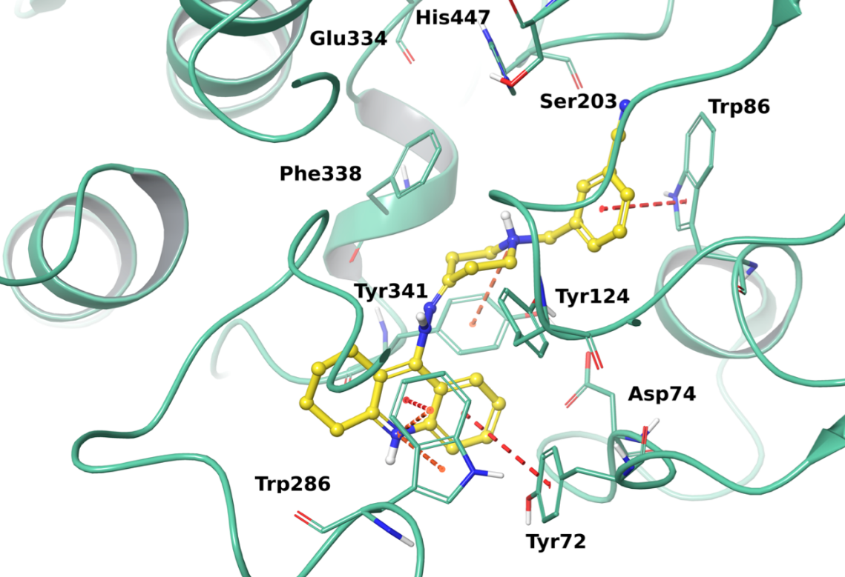
Figure S15. Best docking pose of H18 into hAChE active site. The enzyme is represented in green cartoons, the most relevant interacting residues and the catalytic triad are depicted in tube and the ligand is shown as yellow ball and stick representation. π-π interactions, π-cation contacts, hydrogen bonds, salt bridges are respectively represented in red, orange, light-blue and pink.

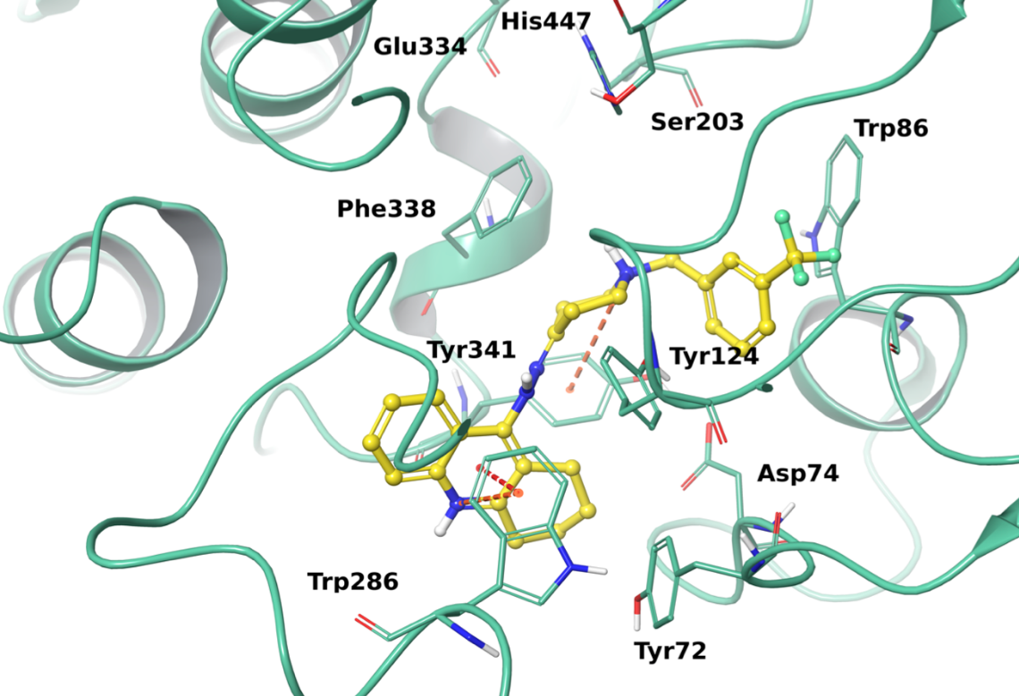
Figure S16. Best docking pose of H19 into hAChE active site. The enzyme is represented in green cartoons, the most relevant interacting residues and the catalytic triad are depicted in tube and the ligand is shown as yellow ball and stick representation. π-π interactions, π-cation contacts, hydrogen bonds, salt bridges are respectively represented in red, orange, light-blue and pink.

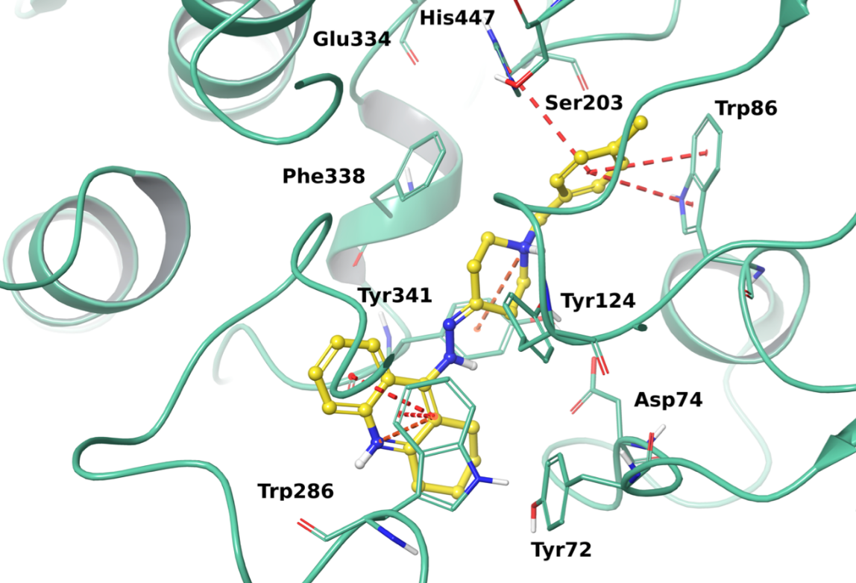
Figure S17. Best docking pose of H20 into hAChE active site. The enzyme is represented in green cartoons, the most relevant interacting residues and the catalytic triad are depicted in tube and the ligand is shown as yellow ball and stick representation. π-π interactions, π-cation contacts, hydrogen bonds, salt bridges are respectively represented in red, orange, light-blue and pink.

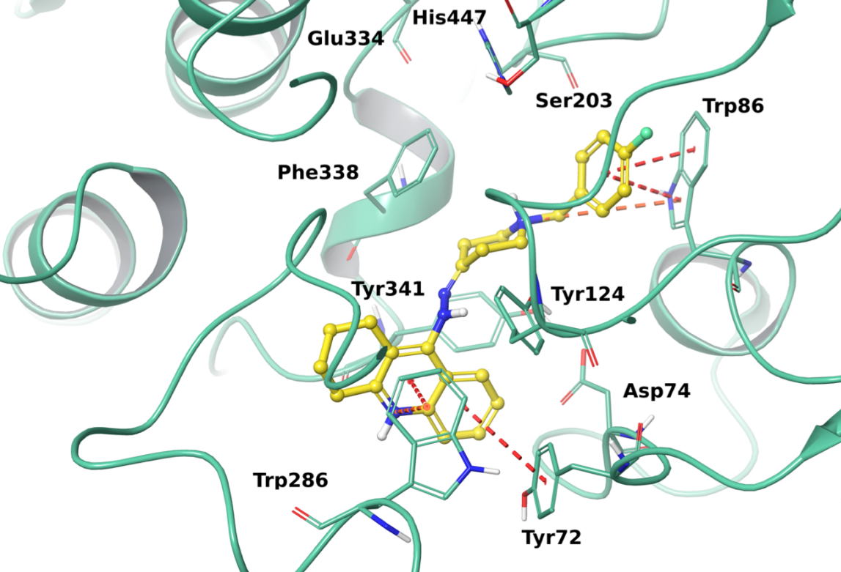
Figure S18. Best docking pose of H21 into hAChE active site. The enzyme is represented in green cartoons, the most relevant interacting residues and the catalytic triad are depicted in tube and the ligand is shown as yellow ball and stick representation. π-π interactions, π-cation contacts, hydrogen bonds, salt bridges are respectively represented in red, orange, light-blue and pink
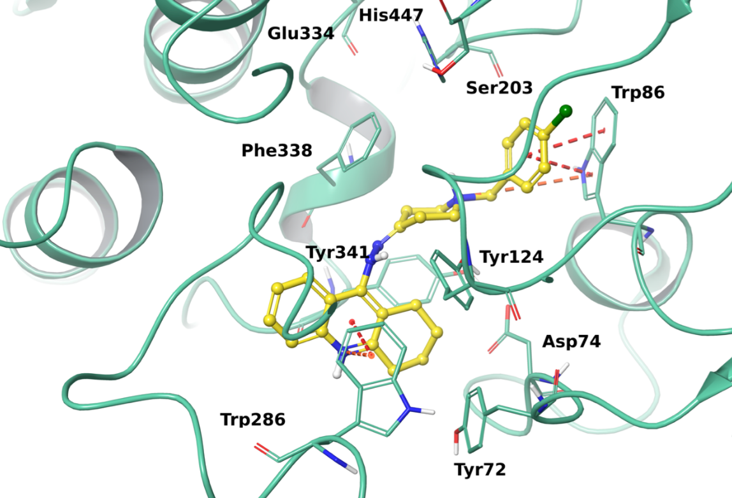

Figure S19. Best docking pose of H22 into hAChE active site. The enzyme is represented in green cartoons, the most relevant interacting residues and the catalytic triad are depicted in tube and the ligand is shown as yellow ball and stick representation. π-π interactions, π-cation contacts, hydrogen bonds, salt bridges are respectively represented in red, orange, light-blue and pink.

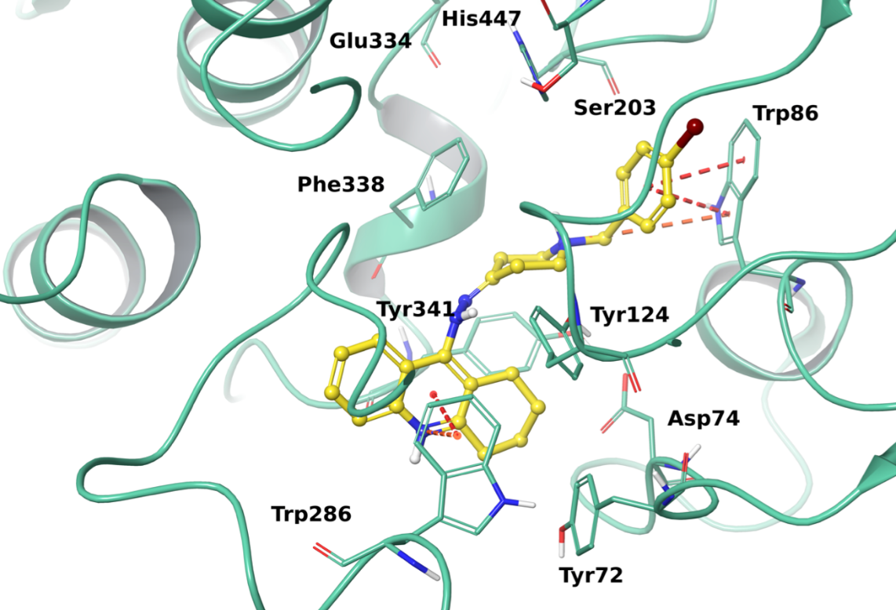
Figure S20. Best docking pose of H23 into hAChE active site. The enzyme is represented in green cartoons, the most relevant interacting residues and the catalytic triad are depicted in tube and the ligand is shown as yellow ball and stick representation. π-π interactions, π-cation contacts, hydrogen bonds, salt bridges are respectively represented in red, orange, light-blue and pink.

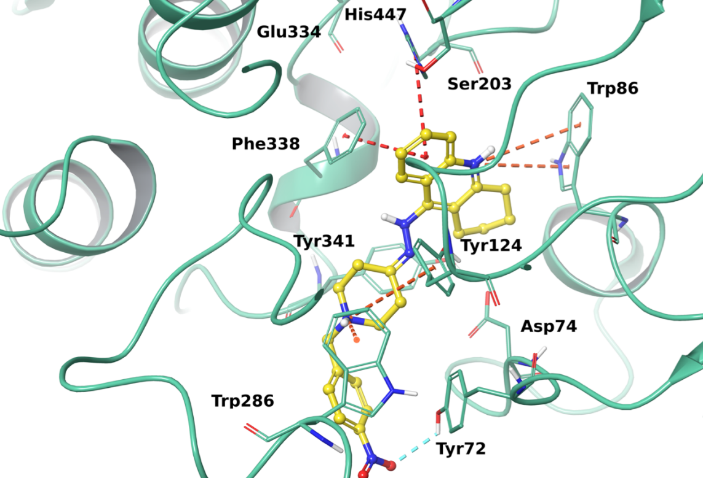
Figure S21. Best docking pose of H24 into hAChE active site. The enzyme is represented in green cartoons, the most relevant interacting residues and the catalytic triad are depicted in tube and the ligand is shown as yellow ball and stick representation. π-π interactions, π-cation contacts, hydrogen bonds, salt bridges are respectively represented in red, orange, light-blue and pink.

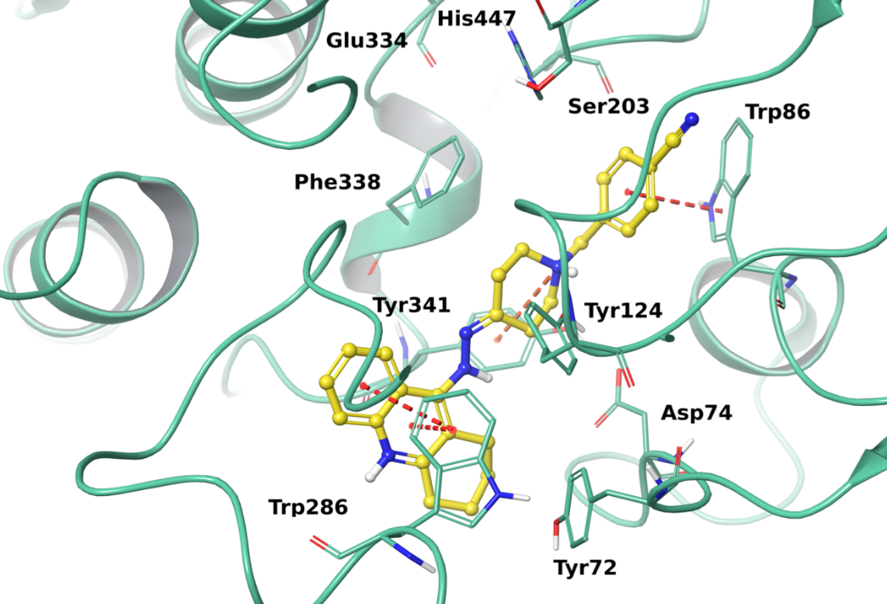
Figure S22. Best docking pose of H25 into hAChE active site. The enzyme is represented in green cartoons, the most relevant interacting residues and the catalytic triad are depicted in tube and the ligand is shown as yellow ball and stick representation. π-π interactions, π-cation contacts, hydrogen bonds, salt bridges are respectively represented in red, orange, light-blue and pink.
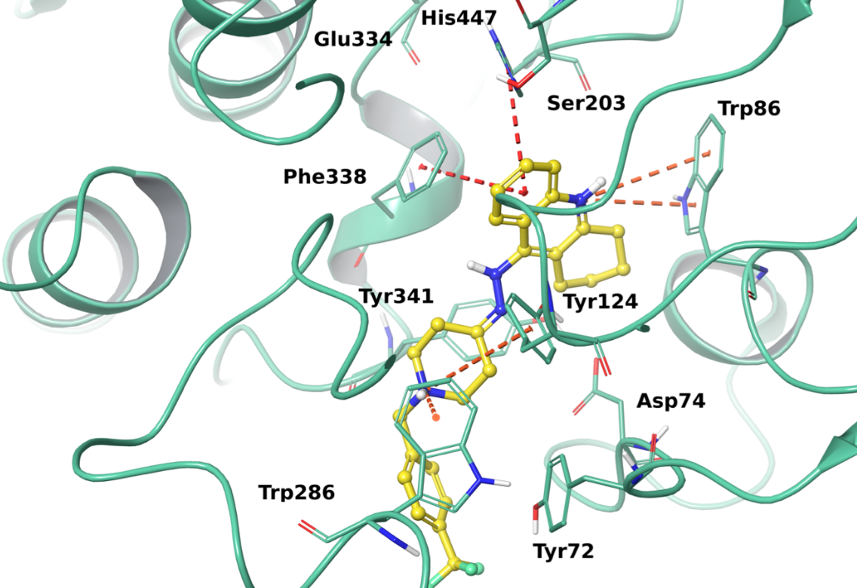
Figure S23. Best docking pose of H26 into hAChE active site. The enzyme is represented in green cartoons, the most relevant interacting residues and the catalytic triad are depicted in tube and the ligand is shown as yellow ball and stick representation. π-π interactions, π-cation contacts, hydrogen bonds, salt bridges are respectively represented in red, orange, light-blue and pink.

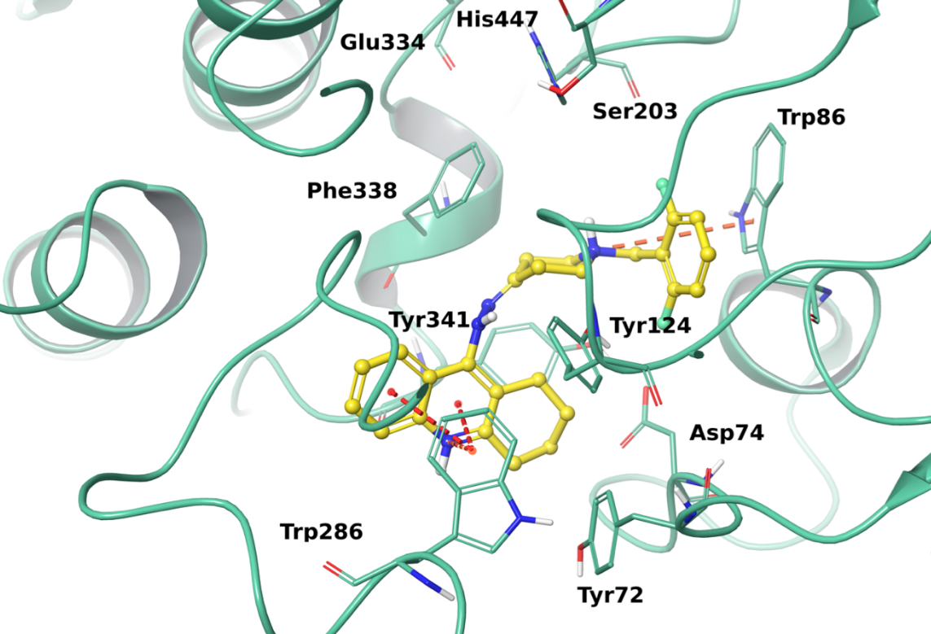
Figure S24. Best docking pose of H27 into hAChE active site. The enzyme is represented in green cartoons, the most relevant interacting residues and the catalytic triad are depicted in tube and the ligand is shown as yellow ball and stick representation. π-π interactions, π-cation contacts, hydrogen bonds, salt bridges are respectively represented in red, orange, light-blue and pink.

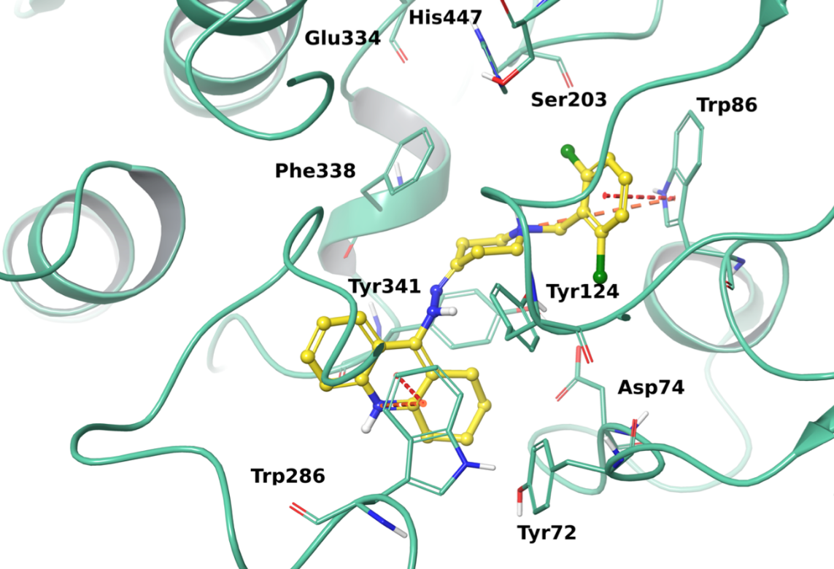
Figure S25. Best docking pose of H28 into hAChE active site. The enzyme is represented in green cartoons, the most relevant interacting residues and the catalytic triad are depicted in tube and the ligand is shown as yellow ball and stick representation. π-π interactions, π-cation contacts, hydrogen bonds, salt bridges are respectively represented in red, orange, light-blue and pink.

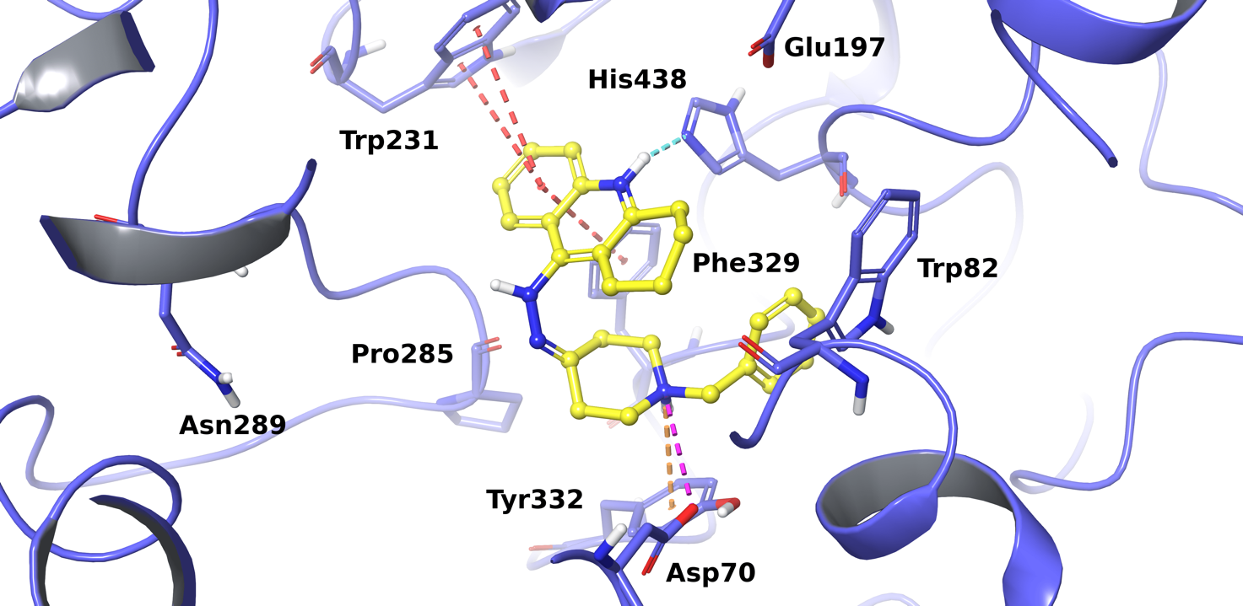
Figure S26. Best docking pose of H3 into hBChE active site. The enzyme is represented in purple cartoons, the most relevant interacting residues and the catalytic triad are depicted in tube and the ligand is shown as yellow ball and stick representation. π-π interactions, π-cation contacts, hydrogen bonds, salt bridges are respectively represented in red, orange, light-blue and pink.

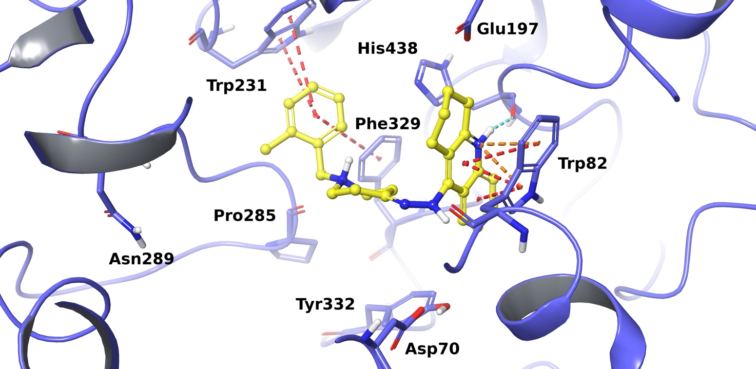
Figure S27. Best docking pose of H5 into hBChE active site. The enzyme is represented in purple cartoons, the most relevant interacting residues and the catalytic triad are depicted in tube and the ligand is shown as yellow ball and stick representation. π-π interactions, π-cation contacts, hydrogen bonds, salt bridges are respectively represented in red, orange, light-blue and pink.

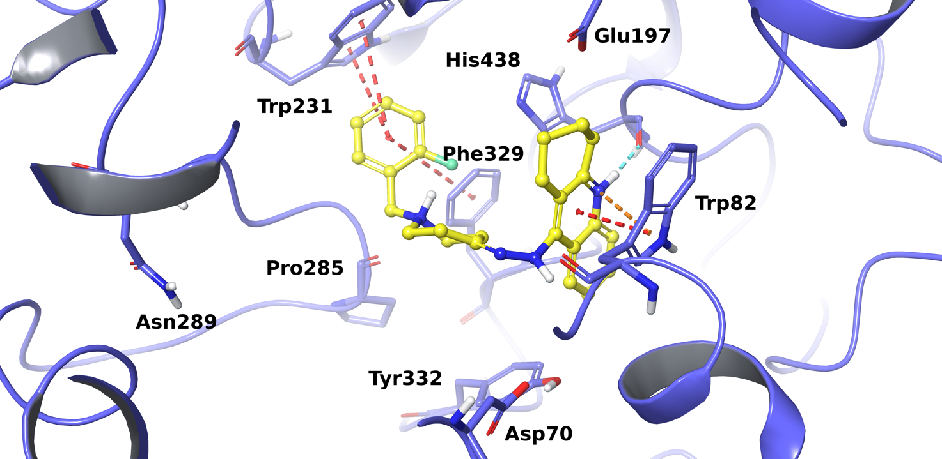

Figure S28. Best docking pose of into H6 hBChE active site. The enzyme is represented in purple cartoons, the most relevant interacting residues and the catalytic triad are depicted in tube and the ligand is shown as yellow ball and stick representation. π-π interactions, π-cation contacts, hydrogen bonds, salt bridges are respectively represented in red, orange, light-blue and pink.

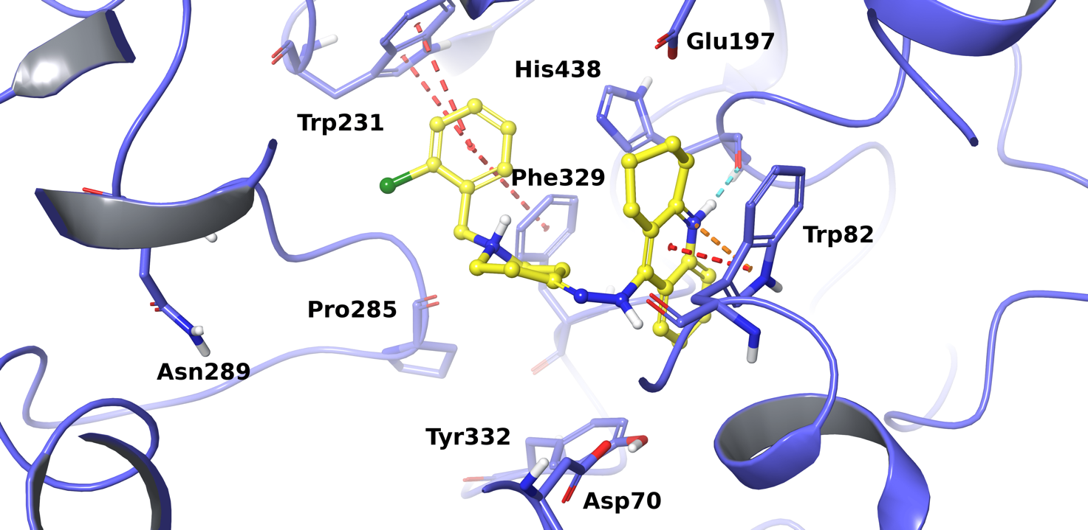 Figure S29. Best docking pose of into H7 hBChE active site. The enzyme is represented in purple cartoons, the most relevant interacting residues and the catalytic triad are depicted in tube and the ligand is shown as yellow ball and stick representation. π-π interactions, π-cation contacts, hydrogen bonds, salt bridges are respectively represented in red, orange, light-blue and pink.

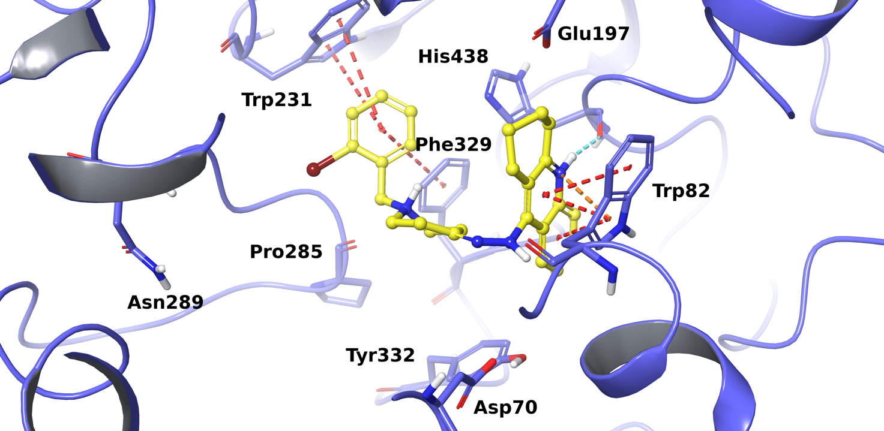 Figure S30. Best docking pose of H8 into hBChE active site. The enzyme is represented in purple cartoons, the most relevant interacting residues and the catalytic triad are depicted in tube and the ligand is shown as yellow ball and stick representation. π-π interactions, π-cation contacts, hydrogen bonds, salt bridges are respectively represented in red, orange, light-blue and pink.

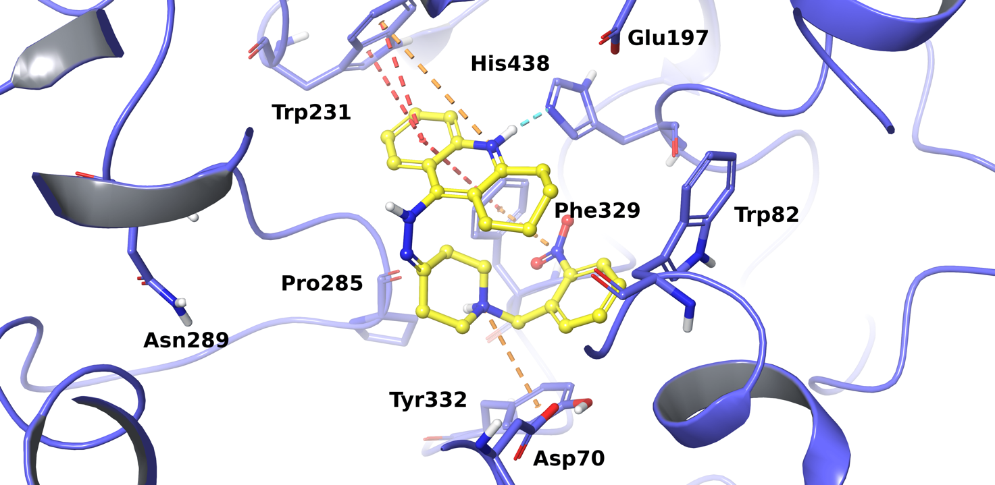 Figure S31. Best docking pose of H9 into hBChE active site. The enzyme is represented in purple cartoons, the most relevant interacting residues and the catalytic triad are depicted in tube and the ligand is shown as yellow ball and stick representation. π-π interactions, π-cation contacts, hydrogen bonds, salt bridges are respectively represented in red, orange, light-blue and pink.

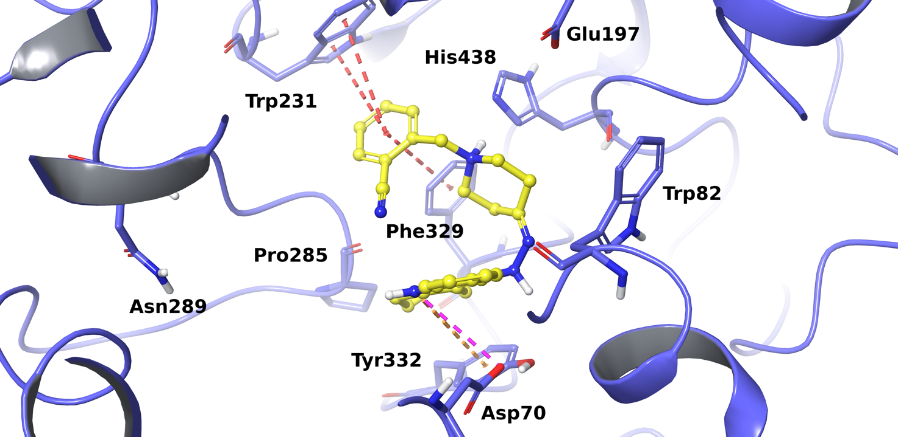 Figure S32. Best docking pose of H10 into hBChE active site. The enzyme is represented in purple cartoons, the most relevant interacting residues and the catalytic triad are depicted in tube and the ligand is shown as yellow ball and stick representation. π-π interactions, π-cation contacts, hydrogen bonds, salt bridges are respectively represented in red, orange, light-blue and pink.

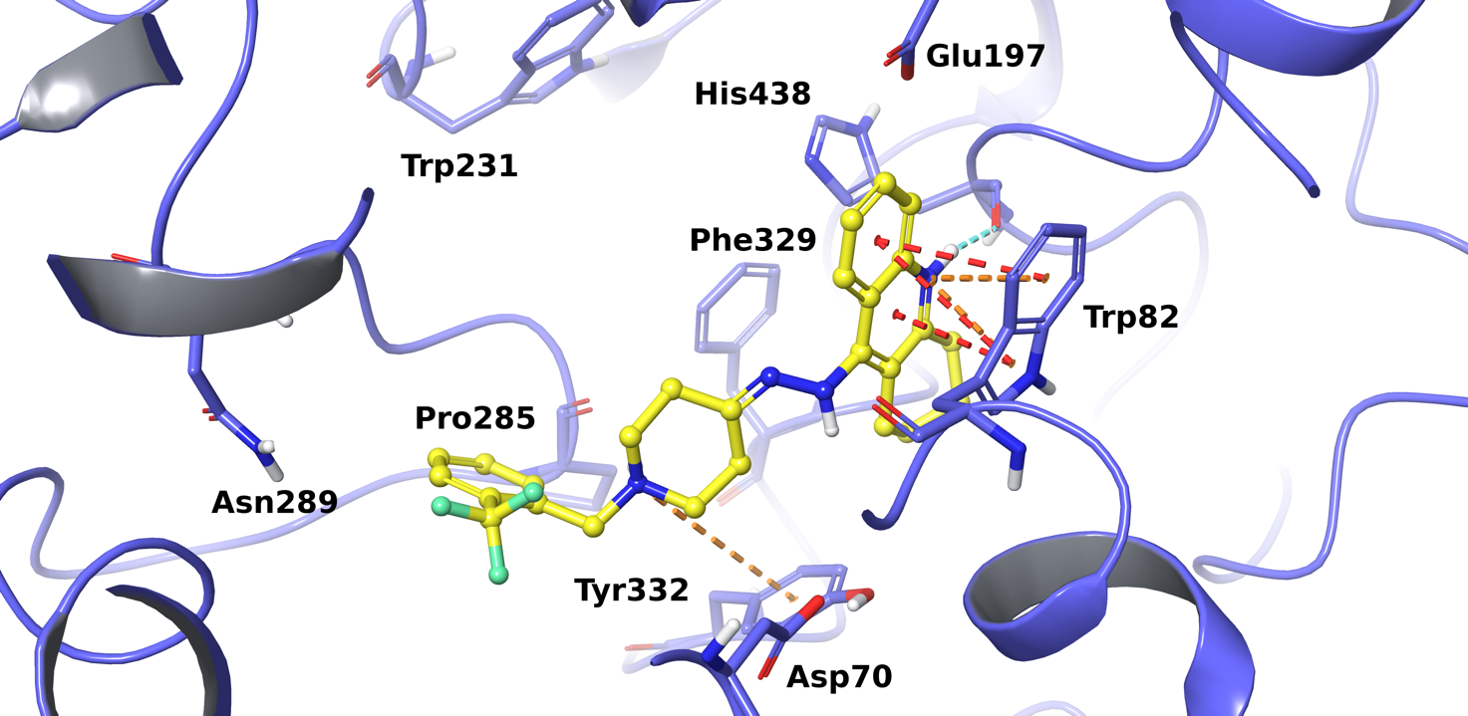 Figure S33. Best docking pose of H11 into hBChE active site. The enzyme is represented in purple cartoons, the most relevant interacting residues and the catalytic triad are depicted in tube and the ligand is shown as yellow ball and stick representation. π-π interactions, π-cation contacts, hydrogen bonds, salt bridges are respectively represented in red, orange, light-blue and pink.

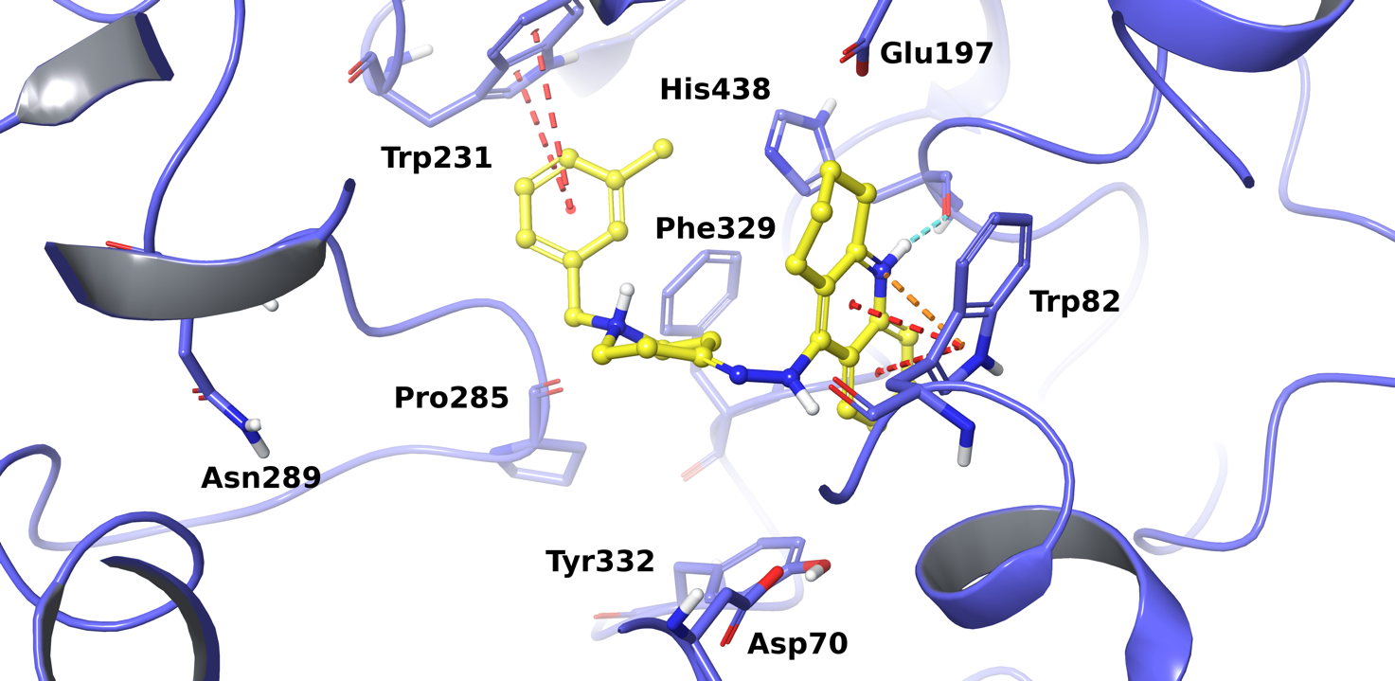 Figure S34. Best docking pose of H12 into hBChE active site. The enzyme is represented in purple cartoons, the most relevant interacting residues and the catalytic triad are depicted in tube and the ligand is shown as yellow ball and stick representation. π-π interactions, π-cation contacts, hydrogen bonds, salt bridges are respectively represented in red, orange, light-blue and pink.

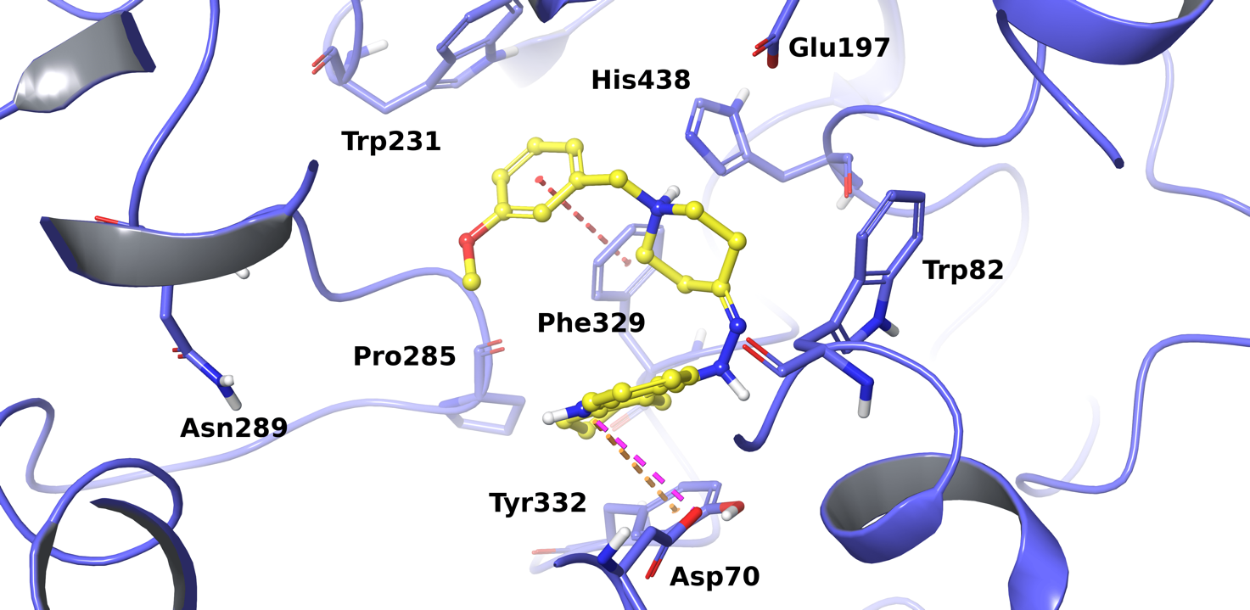
Figure S35. Best docking pose of H13 into hBChE active site. The enzyme is represented in purple cartoons, the most relevant interacting residues and the catalytic triad are depicted in tube and the ligand is shown as yellow ball and stick representation. π-π interactions, π-cation contacts, hydrogen bonds, salt bridges are respectively represented in red, orange, light-blue and pink.

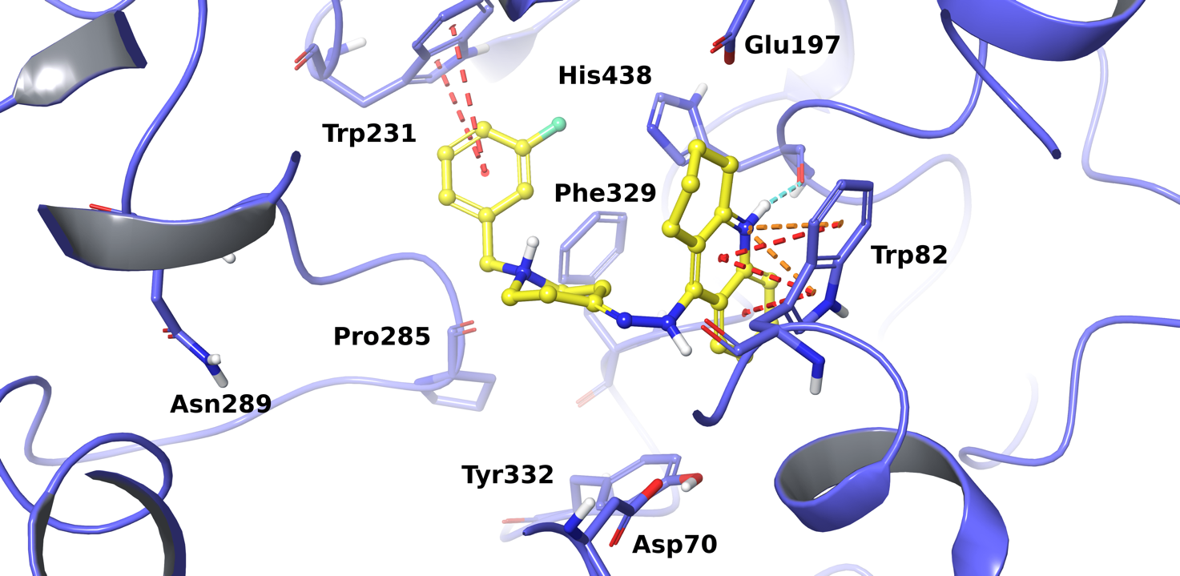 Figure S36. Best docking pose of H14 into hBChE active site. The enzyme is represented in purple cartoons, the most relevant interacting residues and the catalytic triad are depicted in tube and the ligand is shown as yellow ball and stick representation. π-π interactions, π-cation contacts, hydrogen bonds, salt bridges are respectively represented in red, orange, light-blue and pink.

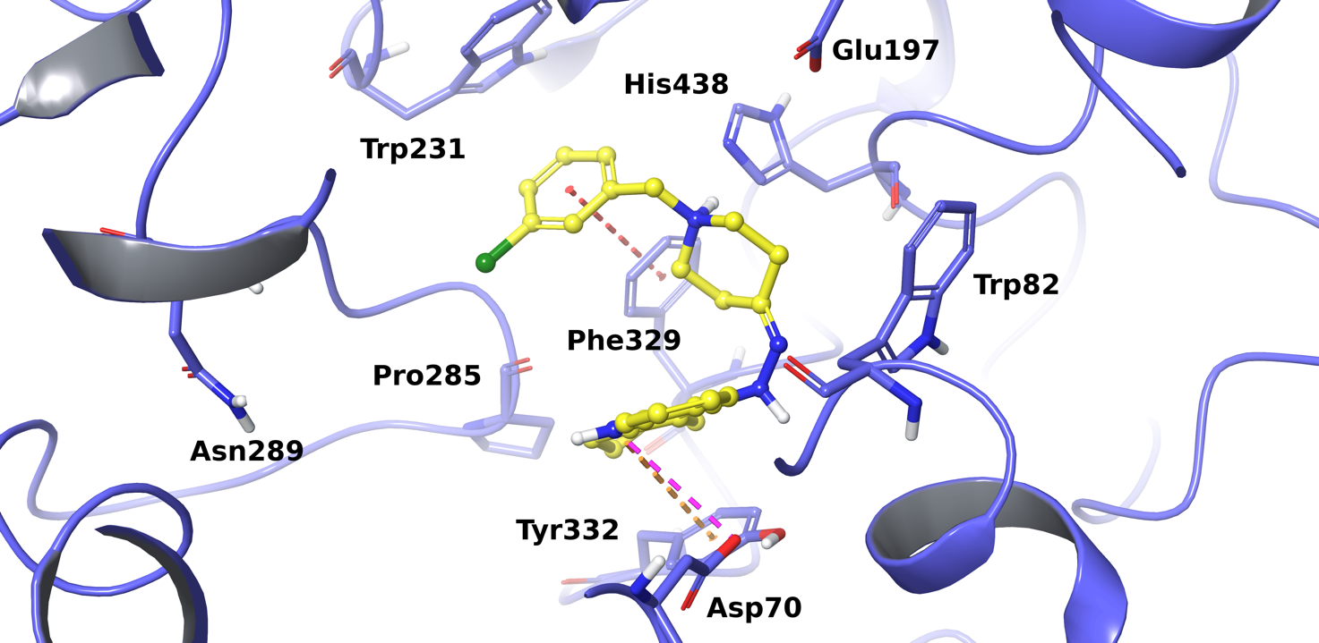 Figure S37. Best docking pose of H15 into hBChE active site. The enzyme is represented in purple cartoons, the most relevant interacting residues and the catalytic triad are depicted in tube and the ligand is shown as yellow ball and stick representation. π-π interactions, π-cation contacts, hydrogen bonds, salt bridges are respectively represented in red, orange, light-blue and pink.

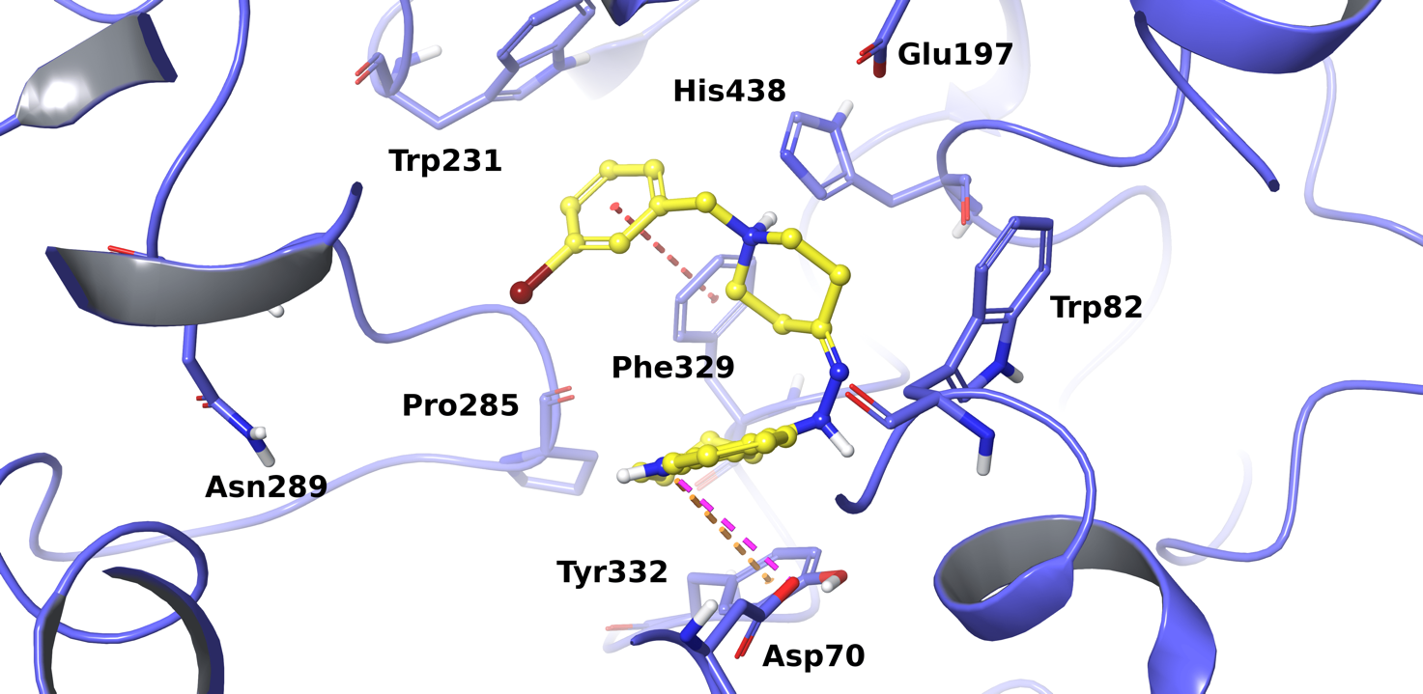 Figure S38. Best docking pose of H16 into hBChE active site. The enzyme is represented in purple cartoons, the most relevant interacting residues and the catalytic triad are depicted in tube and the ligand is shown as yellow ball and stick representation. π-π interactions, π-cation contacts, hydrogen bonds, salt bridges are respectively represented in red, orange, light-blue and pink.

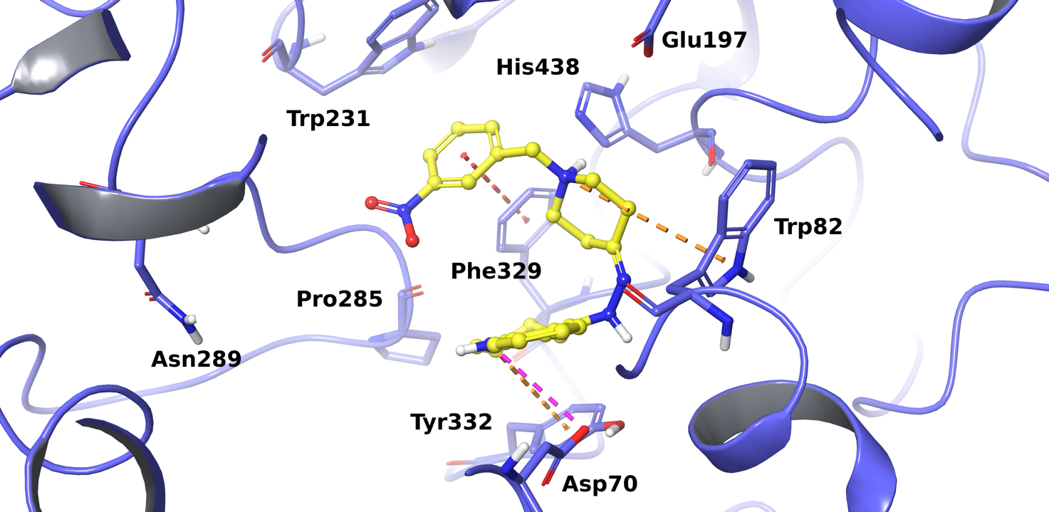

Figure S39. Best docking pose of H17 into hBChE active site. The enzyme is represented in purple cartoons, the most relevant interacting residues and the catalytic triad are depicted in tube and the ligand is shown as yellow ball and stick representation. π-π interactions, π-cation contacts, hydrogen bonds, salt bridges are respectively represented in red, orange, light-blue and pink.

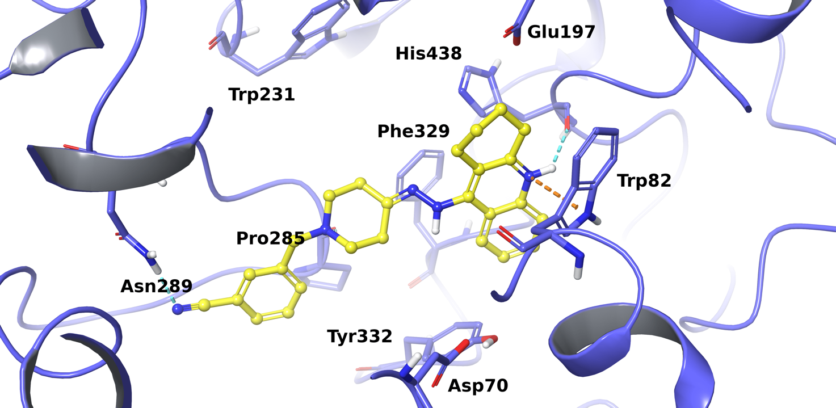 Figure S40. Best docking pose of H18 into hBChE active site. The enzyme is represented in purple cartoons, the most relevant interacting residues and the catalytic triad are depicted in tube and the ligand is shown as yellow ball and stick representation. π-π interactions, π-cation contacts, hydrogen bonds, salt bridges are respectively represented in red, orange, light-blue and pink.

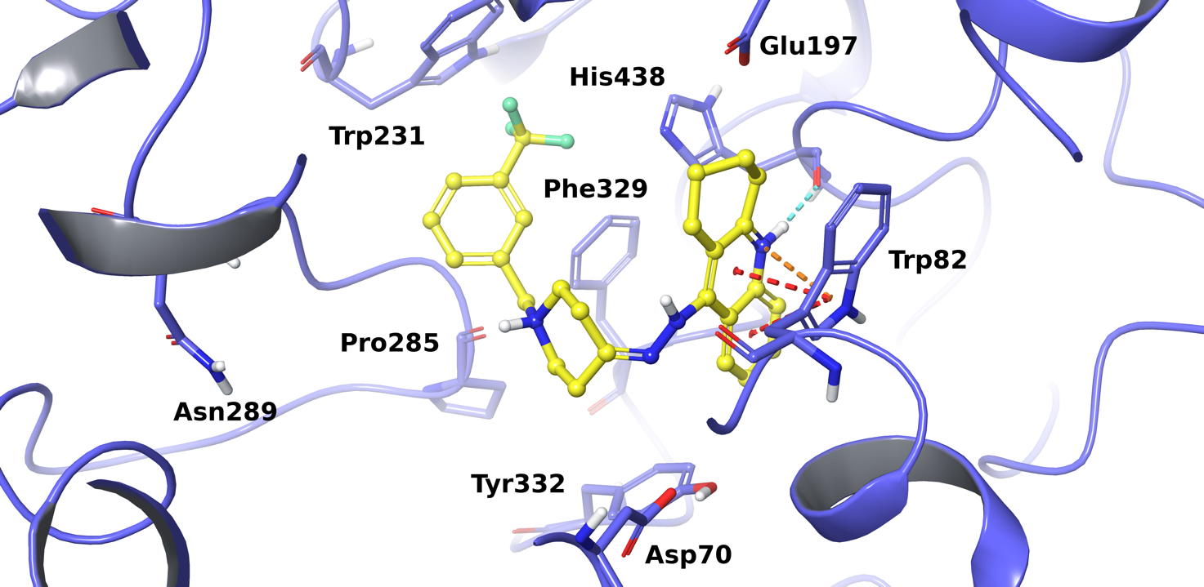 Figure S41. Best docking pose of H19 into hBChE active site. The enzyme is represented in purple cartoons, the most relevant interacting residues and the catalytic triad are depicted in tube and the ligand is shown as yellow ball and stick representation. π-π interactions, π-cation contacts, hydrogen bonds, salt bridges are respectively represented in red, orange, light-blue and pink.

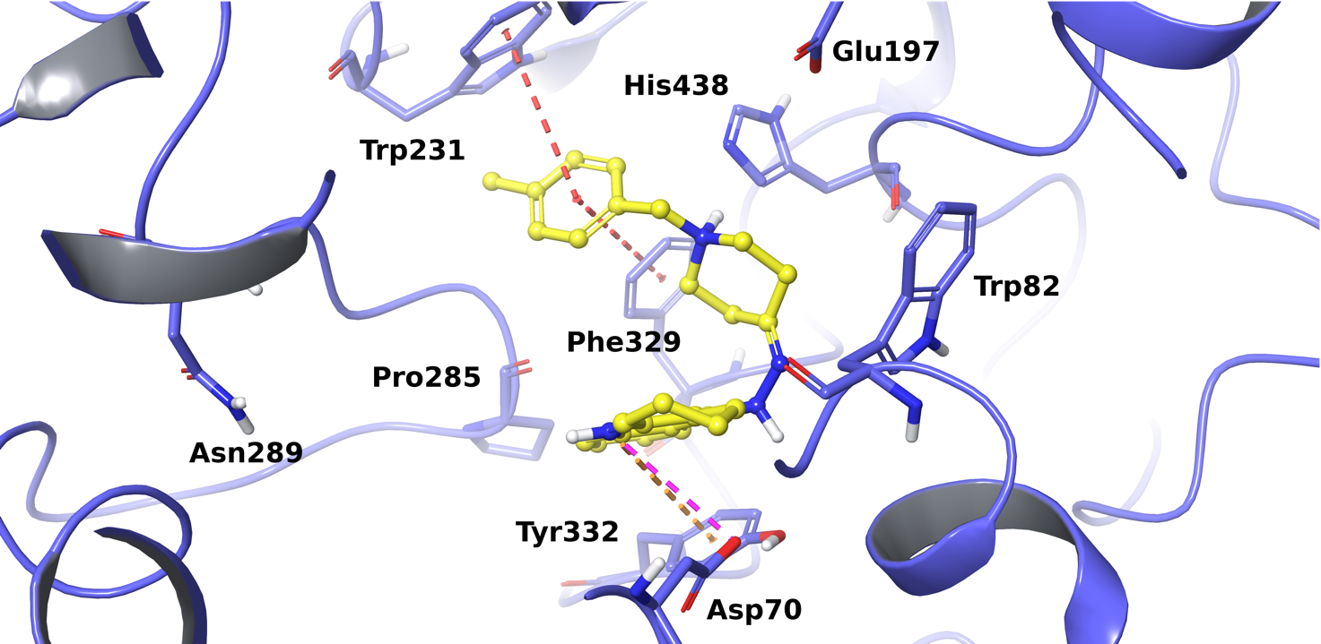 Figure S42. Best docking pose of H20 into hBChE active site. The enzyme is represented in purple cartoons, the most relevant interacting residues and the catalytic triad are depicted in tube and the ligand is shown as yellow ball and stick representation. π-π interactions, π-cation contacts, hydrogen bonds, salt bridges are respectively represented in red, orange, light-blue and pink.

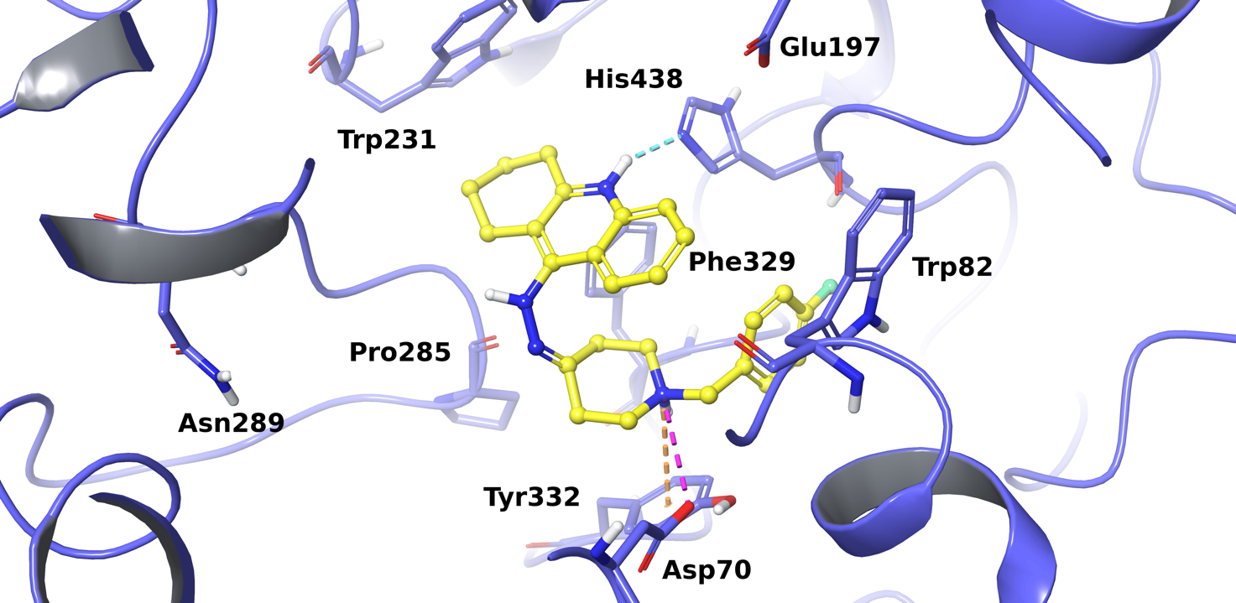 Figure S43. Best docking pose of H21 into hBChE active site. The enzyme is represented in purple cartoons, the most relevant interacting residues and the catalytic triad are depicted in tube and the ligand is shown as yellow ball and stick representation. π-π interactions, π-cation contacts, hydrogen bonds, salt bridges are respectively represented in red, orange, light-blue and pink.

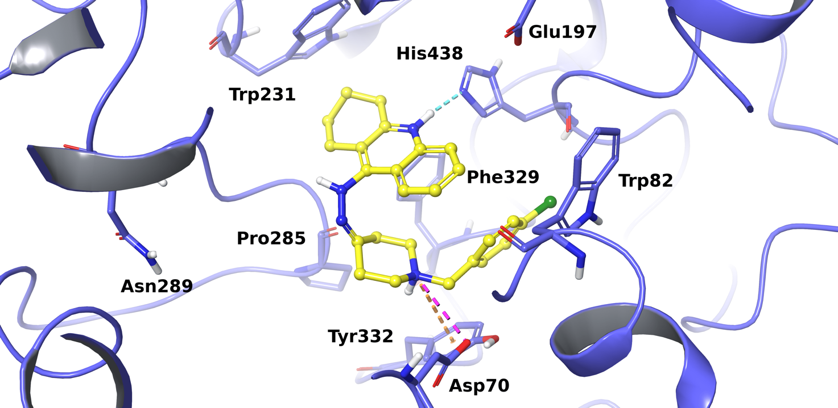 Figure S44. Best docking pose of H22 into hBChE active site. The enzyme is represented in purple cartoons, the most relevant interacting residues and the catalytic triad are depicted in tube and the ligand is shown as yellow ball and stick representation. π-π interactions, π-cation contacts, hydrogen bonds, salt bridges are respectively represented in red, orange, light-blue and pink.

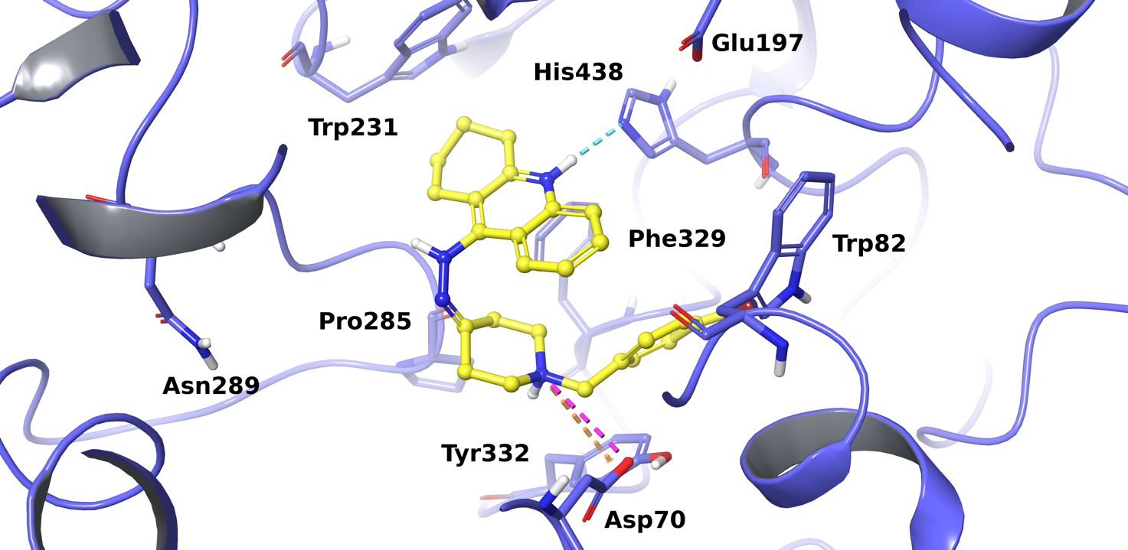 Figure S45. Best docking pose of H23 into hBChE active site. The enzyme is represented in purple cartoons, the most relevant interacting residues and the catalytic triad are depicted in tube and the ligand is shown as yellow ball and stick representation. π-π interactions, π-cation contacts, hydrogen bonds, salt bridges are respectively represented in red, orange, light-blue and pink.

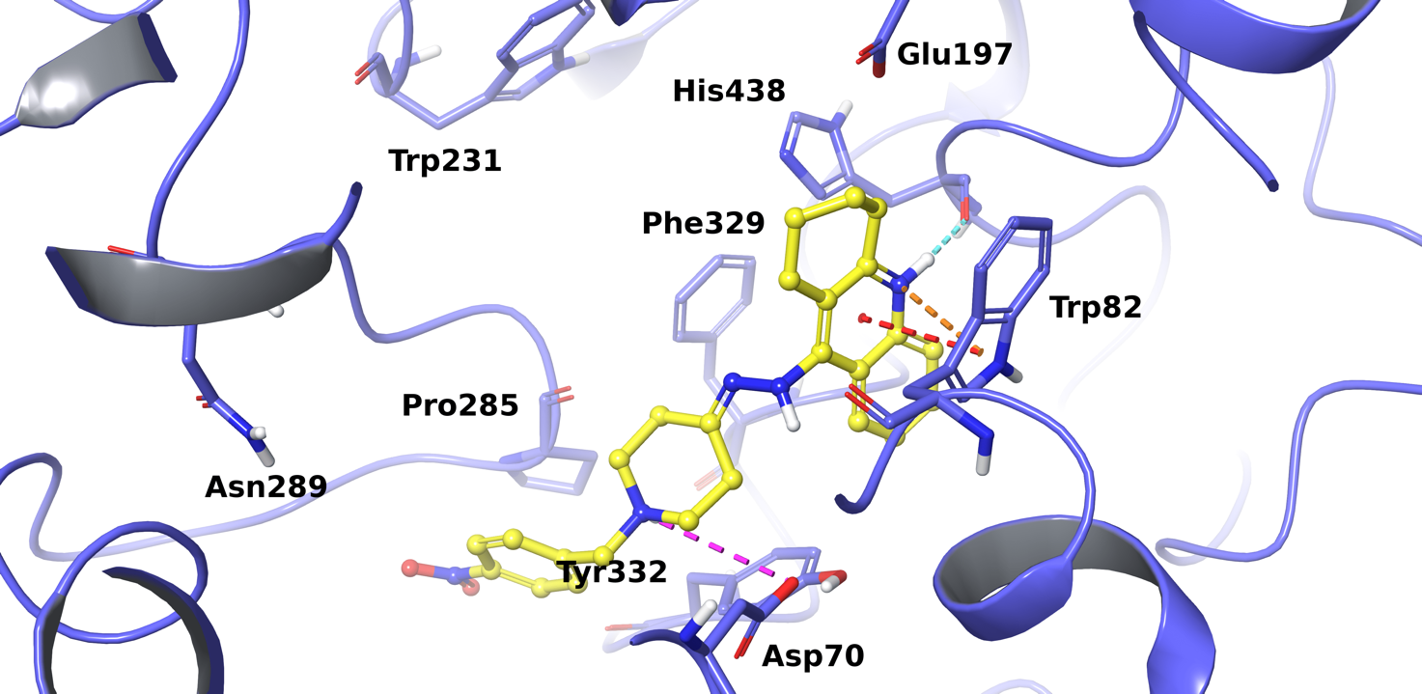 Figure S46. Best docking pose of H24 into hBChE active site. The enzyme is represented in purple cartoons, the most relevant interacting residues and the catalytic triad are depicted in tube and the ligand is shown as yellow ball and stick representation. π-π interactions, π-cation contacts, hydrogen bonds, salt bridges are respectively represented in red, orange, light-blue and pink.

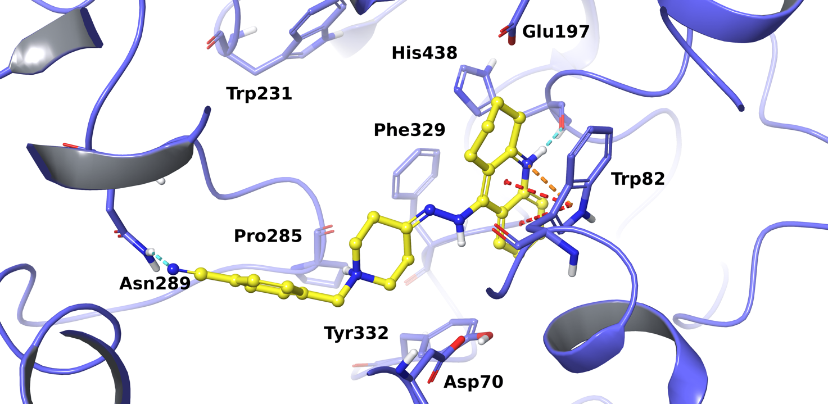 Figure S47. Best docking pose of H25 into hBChE active site. The enzyme is represented in purple cartoons, the most relevant interacting residues and the catalytic triad are depicted in tube and the ligand is shown as yellow ball and stick representation. π-π interactions, π-cation contacts, hydrogen bonds, salt bridges are respectively represented in red, orange, light-blue and pink.

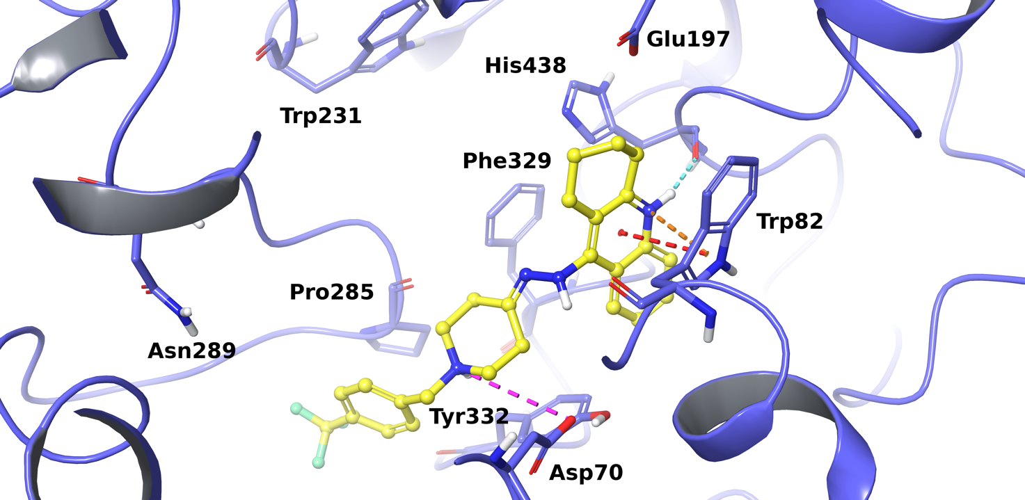 Figure S48. Best docking pose of H26 into hBChE active site. The enzyme is represented in purple cartoons, the most relevant interacting residues and the catalytic triad are depicted in tube and the ligand is shown as yellow ball and stick representation. π-π interactions, π-cation contacts, hydrogen bonds, salt bridges are respectively represented in red, orange, light-blue and pink.

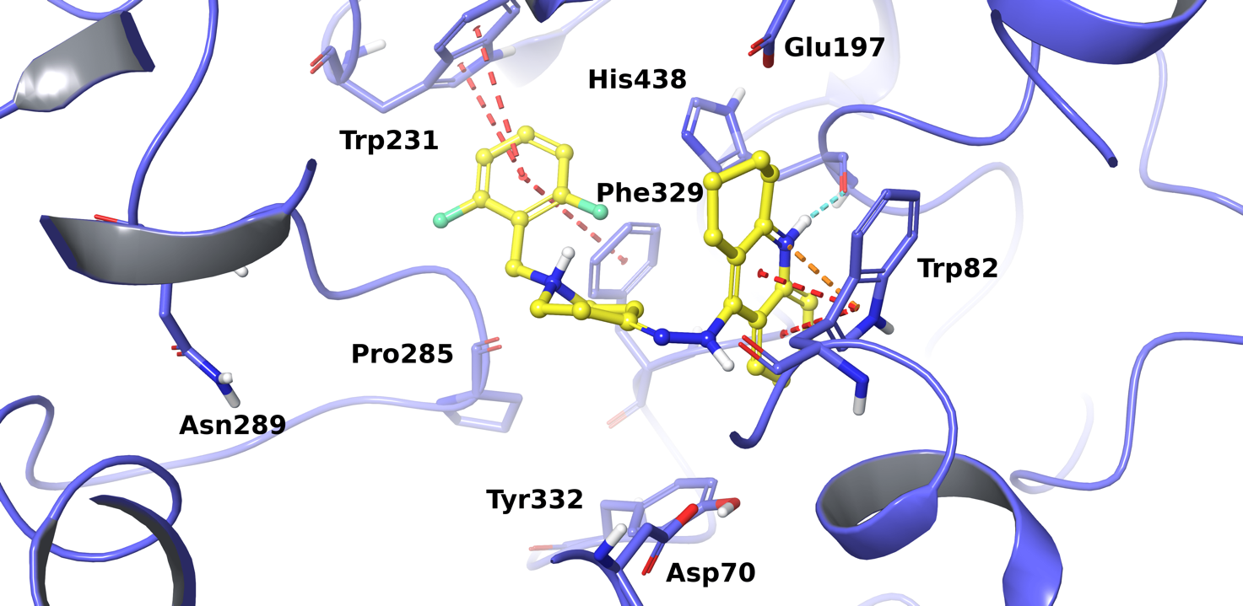 Figure S49. Best docking pose of H27 into hBChE active site. The enzyme is represented in purple cartoons, the most relevant interacting residues and the catalytic triad are depicted in tube and the ligand is shown as yellow ball and stick representation. π-π interactions, π-cation contacts, hydrogen bonds, salt bridges are respectively represented in red, orange, light-blue and pink.

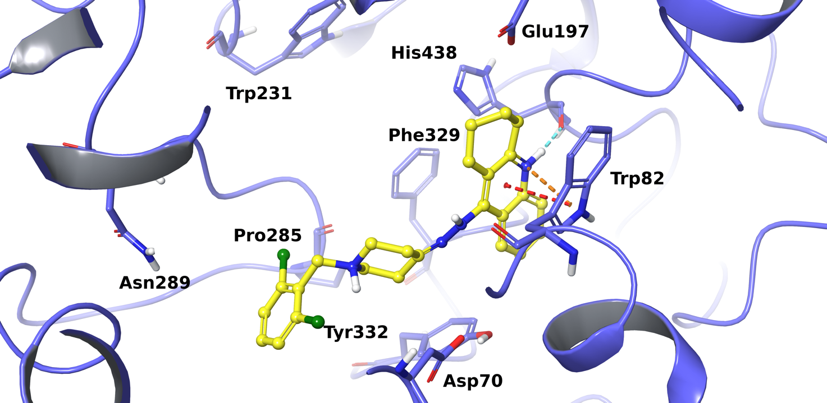 Figure S50. Best docking pose of H28 into hBChE active site. The enzyme is represented in purple cartoons, the most relevant interacting residues and the catalytic triad are depicted in tube and the ligand is shown as yellow ball and stick representation. π-π interactions, π-cation contacts, hydrogen bonds, salt bridges are respectively represented in red, orange, light-blue and pink.

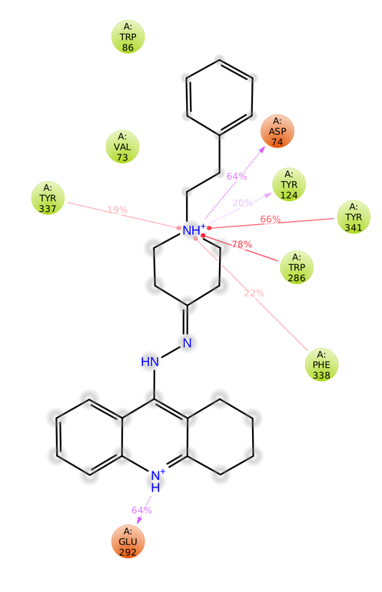
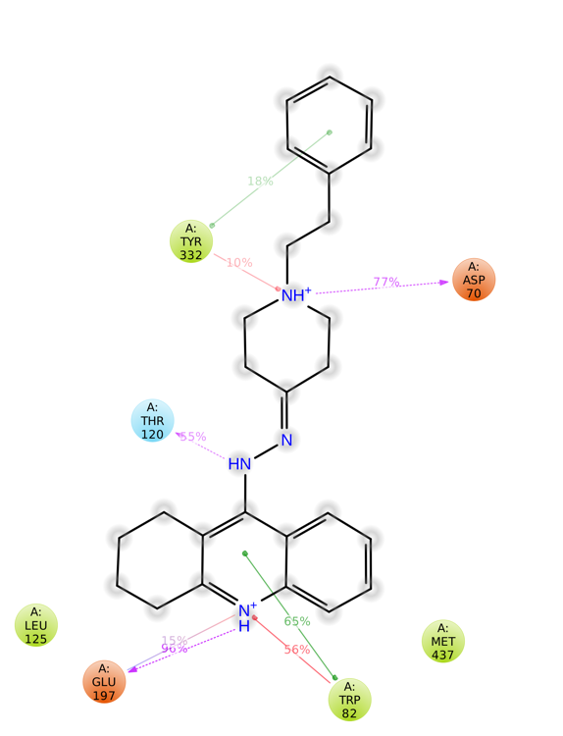
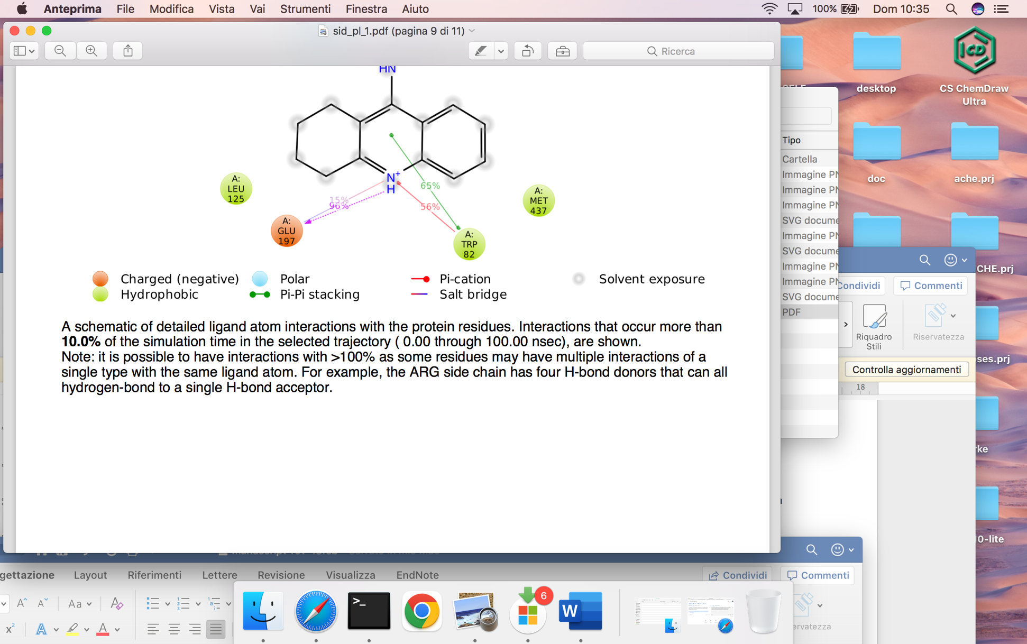
- b)
Figure S51. A schematic of detailed H4 interactions with a) hAChE and b) hBChE residues. Interactions that occur more than 10% of MD simulation time are shown.

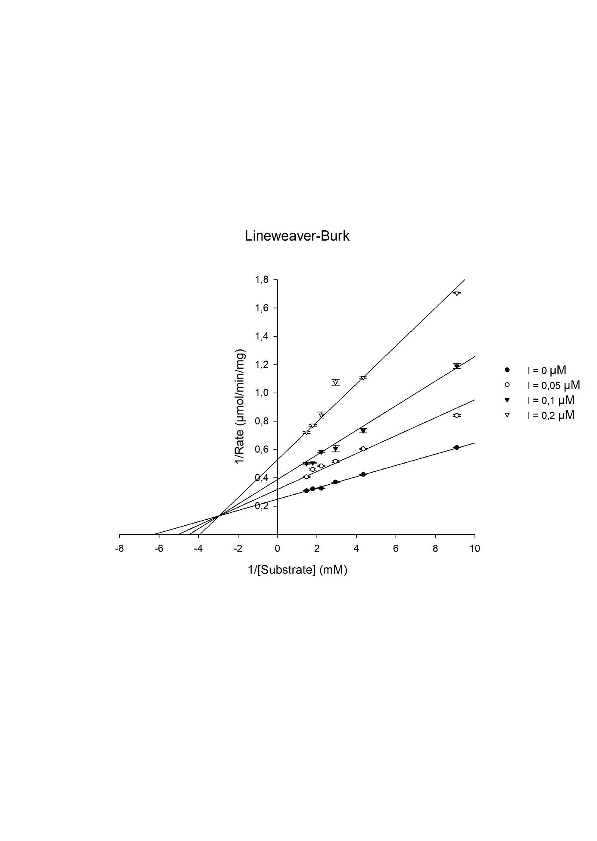
FIGURE S52 Kinetic Study on the eeAChE inhibition of H15 Lineweaver Burke reciprocal plots of 1/V versus 1/[S].

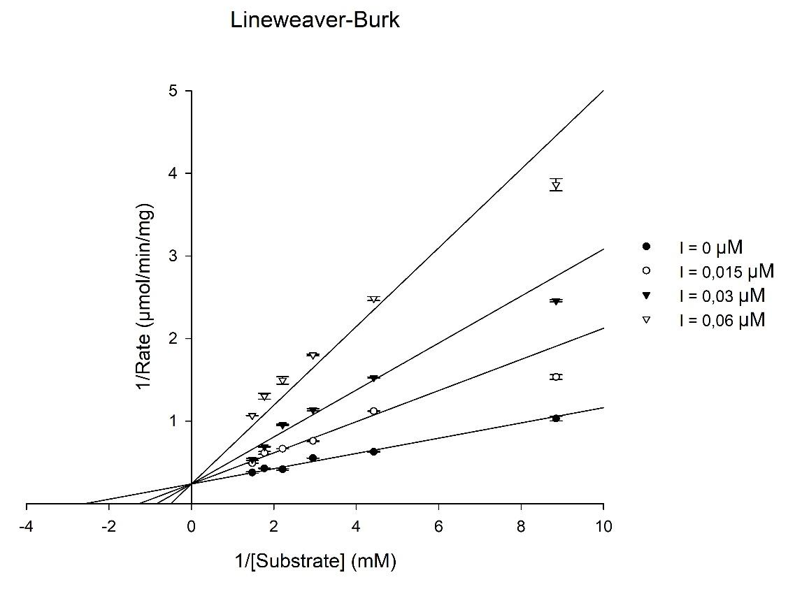
FIGURE S53 Kinetic Study on the eqBChE inhibition of H15. Lineweaver Burke reciprocal plots of 1/V versus 1/[S].
Table S3. AChE and BChE Ki, Vmax and Km values oh H15
 | R² | Ki (µM) | Vmax | Km
eeAChE | 0.99 | 0.084 | 4.01 | 0.16
eqBChE | 0.97 | 0.014 | 4.2 | 0.39

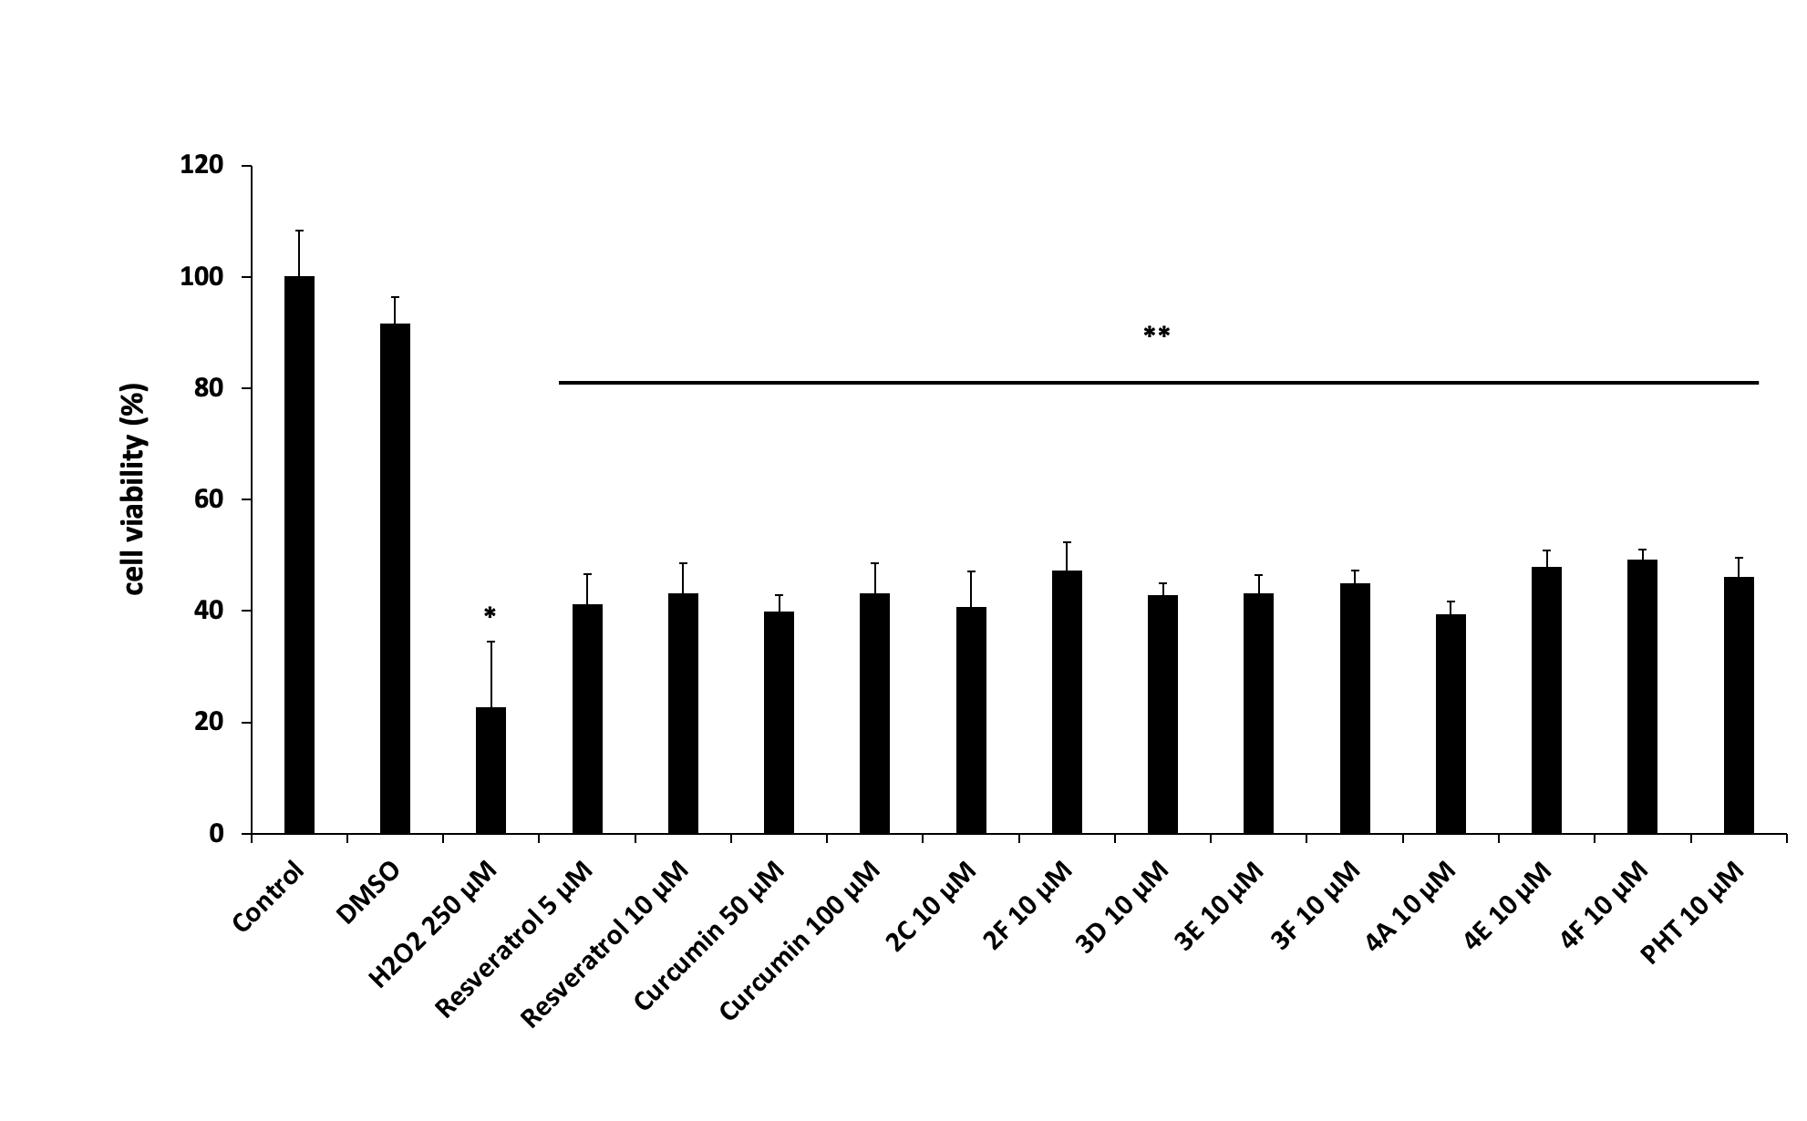
Figure S54. Percentages of cell viability after exposure to compounds (10 µM) against H₂O₂-treated cells. All values are means ± SDs (n = 4-6). *p<0.05 significant difference from untreated and DMSO-treated cells, **p<0.05 significant difference from H₂O₂-treated cells.

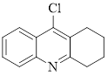
Spectra 1. ¹H NMR spectra of compound 1
Spectra 2. Mass spectra of compound 1
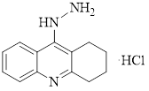
Spectra 3. ¹H NMR spectra of compound 2
Spectra 4. Mass spectra of compound 2
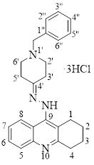
Spectra 5. ¹H NMR spectra of compound H3

Spectra 6. ¹³C NMR spectra of compound H3

Spectra 7. DEPT 135 NMR spectra of compound H3
Spectra 8. COSY spectra of compound H3
Spectra 9. HMBC spectra of compound H3
Spectra 10. HMQC spectra of compound H3
Spectra 11. Mass spectra of compound H3

Spectra 12.¹H NMR spectra of compound H4Spectra 13.¹³C NMR spectra of compound H4
Spectra 14.Mass spectra of compound H4

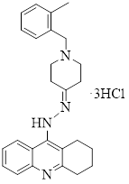
Spectra 15. ¹H NMR spectra of compound H5
Spectra 16. ¹³C NMR spectra of compound H5
Spectra 17. Mass spectra of compound H5

Spectra 18. ¹H NMR spectra of compound H6

Spectra 19. ¹³C NMR spectra of compound H6
Spectra 20. Mass spectra of compound H6

Spectra 21. ¹H NMR spectra of compound H7
Spectra 22. ¹³C NMR spectra of compound H7
Spectra 23. Mass spectra of compound H7

Spectra 24.¹H NMR spectra of compound H8
Spectra 25.¹³C NMR spectra of compound H8
Spectra 26.Mass spectra of compound H8

Spectra 27.¹H NMR spectra of compound H9
Spectra 28.¹³C NMR spectra of compound H9
Spectra 29.Mass spectra of compound H9

Spectra 30.¹H NMR spectra of compound H10
Spectra 31.¹³C NMR spectra of compound H10
Spectra 32.Mass spectra of compound H10

Spectra 33.¹H NMR spectra of compound H11
Spectra 34.¹³C NMR spectra of compound H11
Spectra 35.Mass spectra of compound H11

Spectra 36.¹H NMR spectra of compound H12
Spectra 37.¹³C NMR spectra of compound H12
Spectra 38.Mass spectra of compound H12

Spectra 39.¹H NMR spectra of compound H13
Spectra 40.¹³C NMR spectra of compound H13
Spectra 41.Mass spectra of compound H13

Spectra 42.¹H NMR spectra of compound H14
Spectra 43.¹³C NMR spectra of compound H14
Spectra 44.Mass spectra of compound H14

Spectra 45.¹H NMR spectra of compound H15
Spectra 46.¹³C NMR spectra of compound H15
Spectra 47.Mass spectra of compound H15

Spectra 48.¹H NMR spectra of compound H16
Spectra 49.¹³C NMR spectra of compound H16
Spectra 50.Mass spectra of compound H16

Spectra 51.¹H NMR spectra of compound H17
Spectra 52.Mass spectra of compound H17

Spectra 53.¹H NMR spectra of compound H18
Spectra 54.Mass spectra of compound H18

Spectra 55.¹H NMR spectra of compound H19
Spectra 56.Mass spectra of compound H19

Spectra 57.¹H NMR spectra of compound H20
Spectra 58.¹³C NMR spectra of compound H20
Spectra 59.Mass spectra of compound H20

Spectra 60.¹H NMR spectra of compound H21
Spectra 61.¹³C NMR spectra of compound H21
Spectra 62.Mass spectra of compound H21

Spectra 63.¹H NMR spectra of compound H22
Spectra 64.¹³C NMR spectra of compound H22
Spectra 65.Mass spectra of compound H22

Spectra 66.¹H NMR spectra of compound H23
Spectra 67.¹³C NMR spectra of compound H23
Spectra 68.Mass spectra of compound H23

Spectra 69.¹H NMR spectra of compound H24
Spectra 70.Mass spectra of compound H24

Spectra 71.¹H NMR spectra of compound H25
Spectra 72.Mass spectra of compound H25
Spectra 73.¹H NMR spectra of compound H26
Spectra 74.Mass spectra of compound H26

Spectra 75.¹H NMR spectra of compound H27
Spectra 76.¹³C NMR spectra of compound H27
Spectra 77.Mass spectra of compound H27

Spectra 78.¹H NMR spectra of compound H28
Spectra 79.¹³C NMR spectra of compound H28
Spectra 80.Mass spectra of compound H28

