The future of the Portuguese (SW Europe) most vulnerable coastal areas under climate change – Part I: performance evaluation and shoreline evolution from a downscaled bias corrected wave climate ensemble

SUPPLEMENTARY MATERIAL

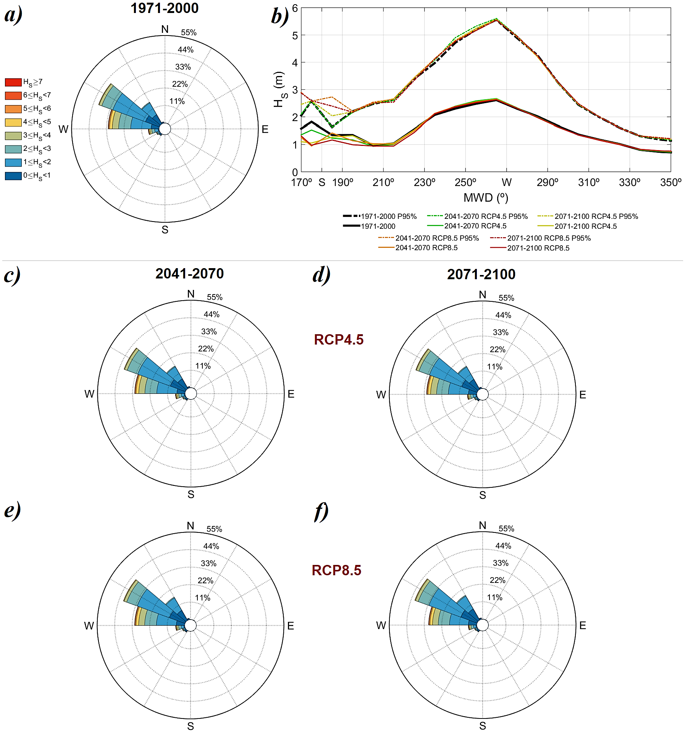
Figure SM1 – Ofir historical and future ensembles projected coastal wave fields (wave roses), mean $H_{S}$ and 95% percentile $H_{S}$ by bin of $MWD$ (10º) across the possible range of incoming directions, considering the future 2041-2070 and 2071-2100 time-slices, under the RCP4.5 and RCP8.5 scenarios.

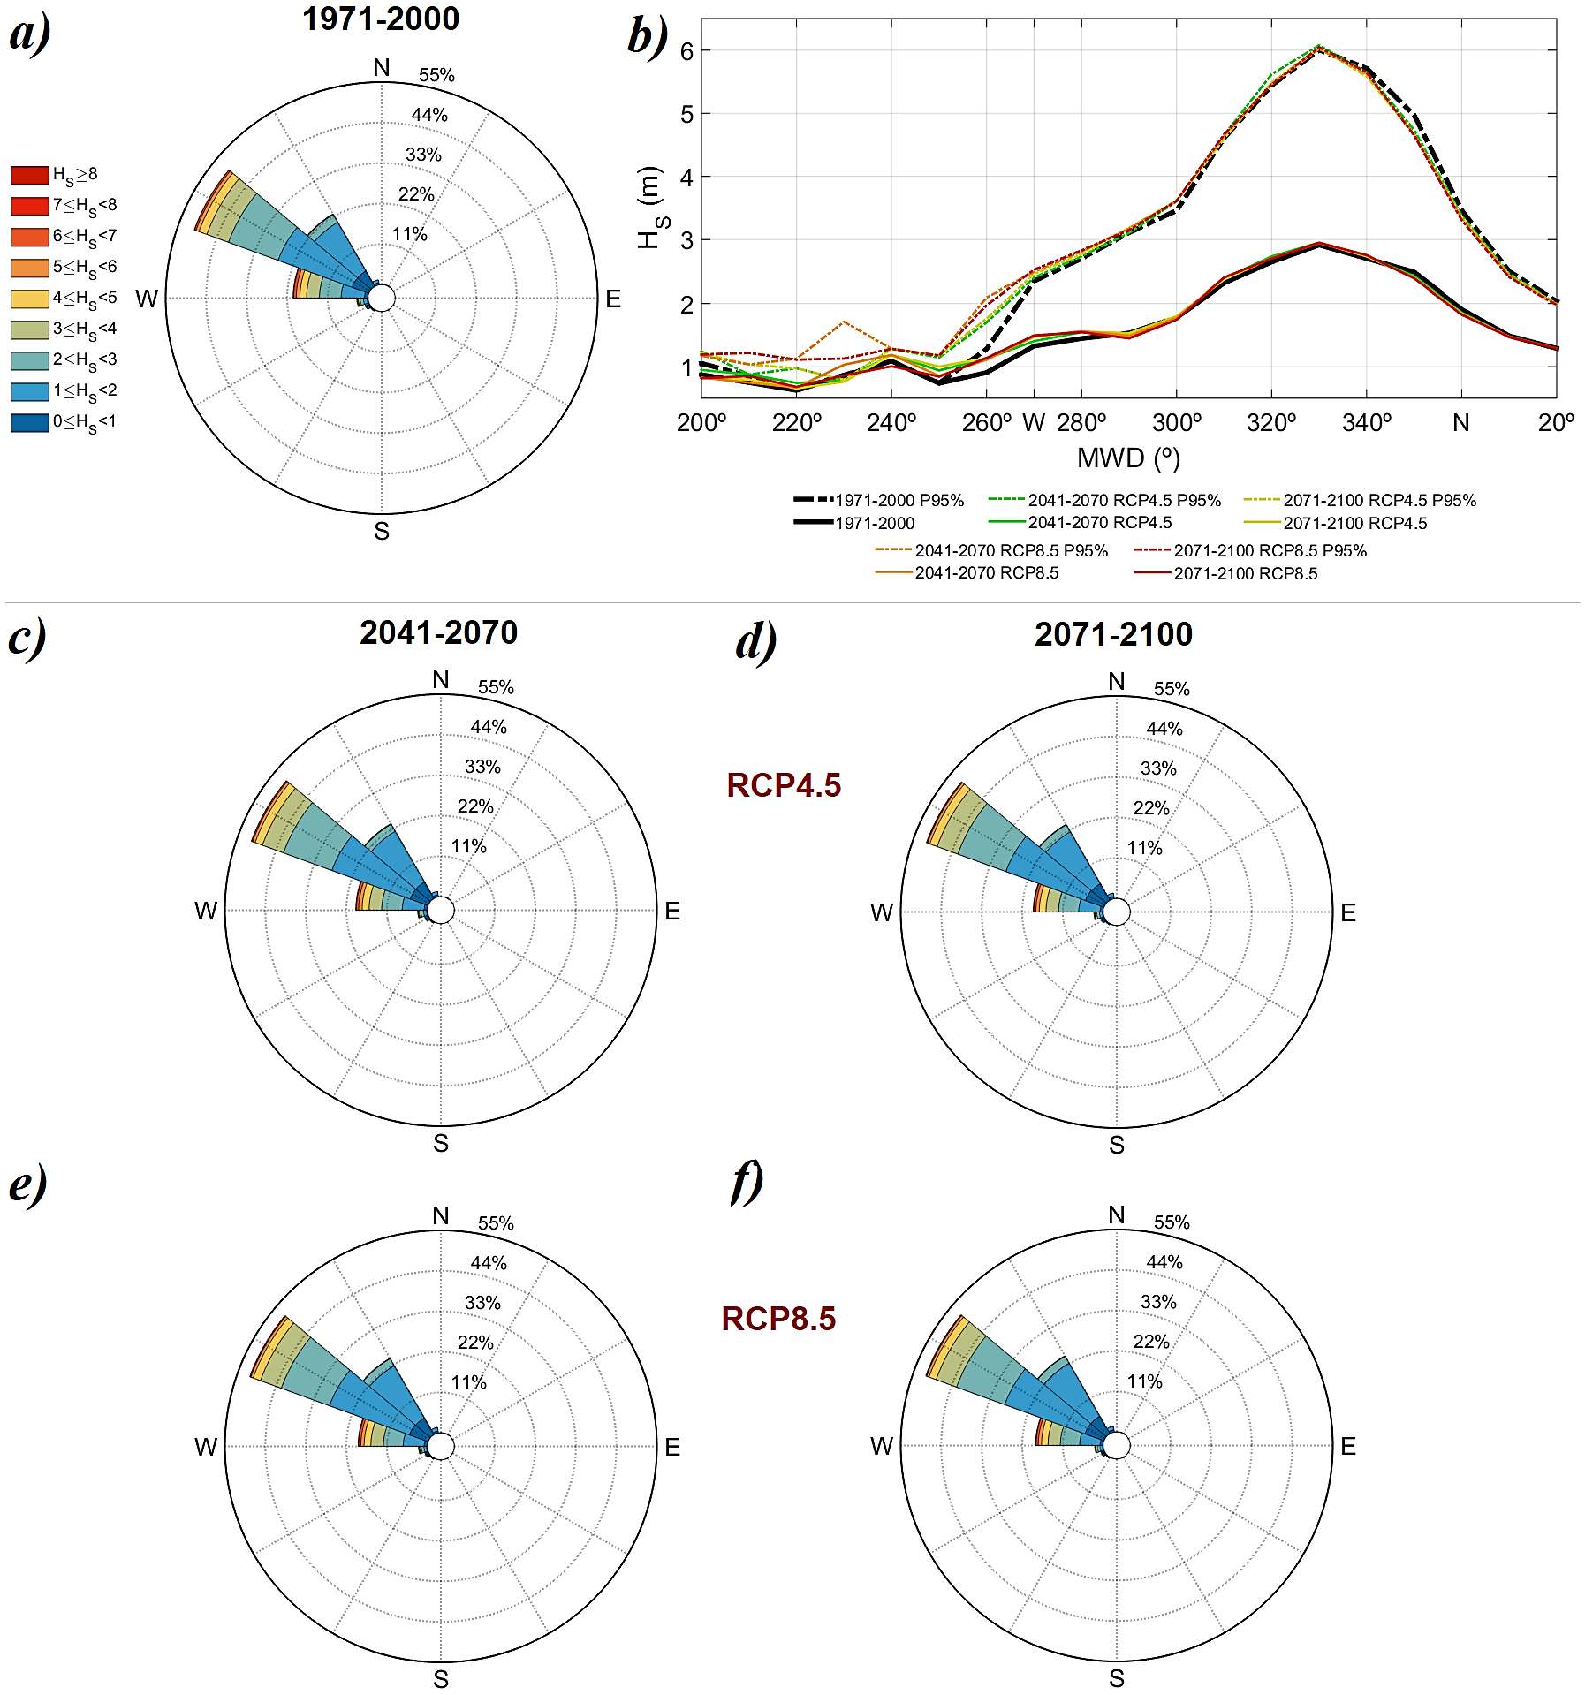
Figure SM2 – Similar to Fig. SM1, but for the Costa Nova key-location.

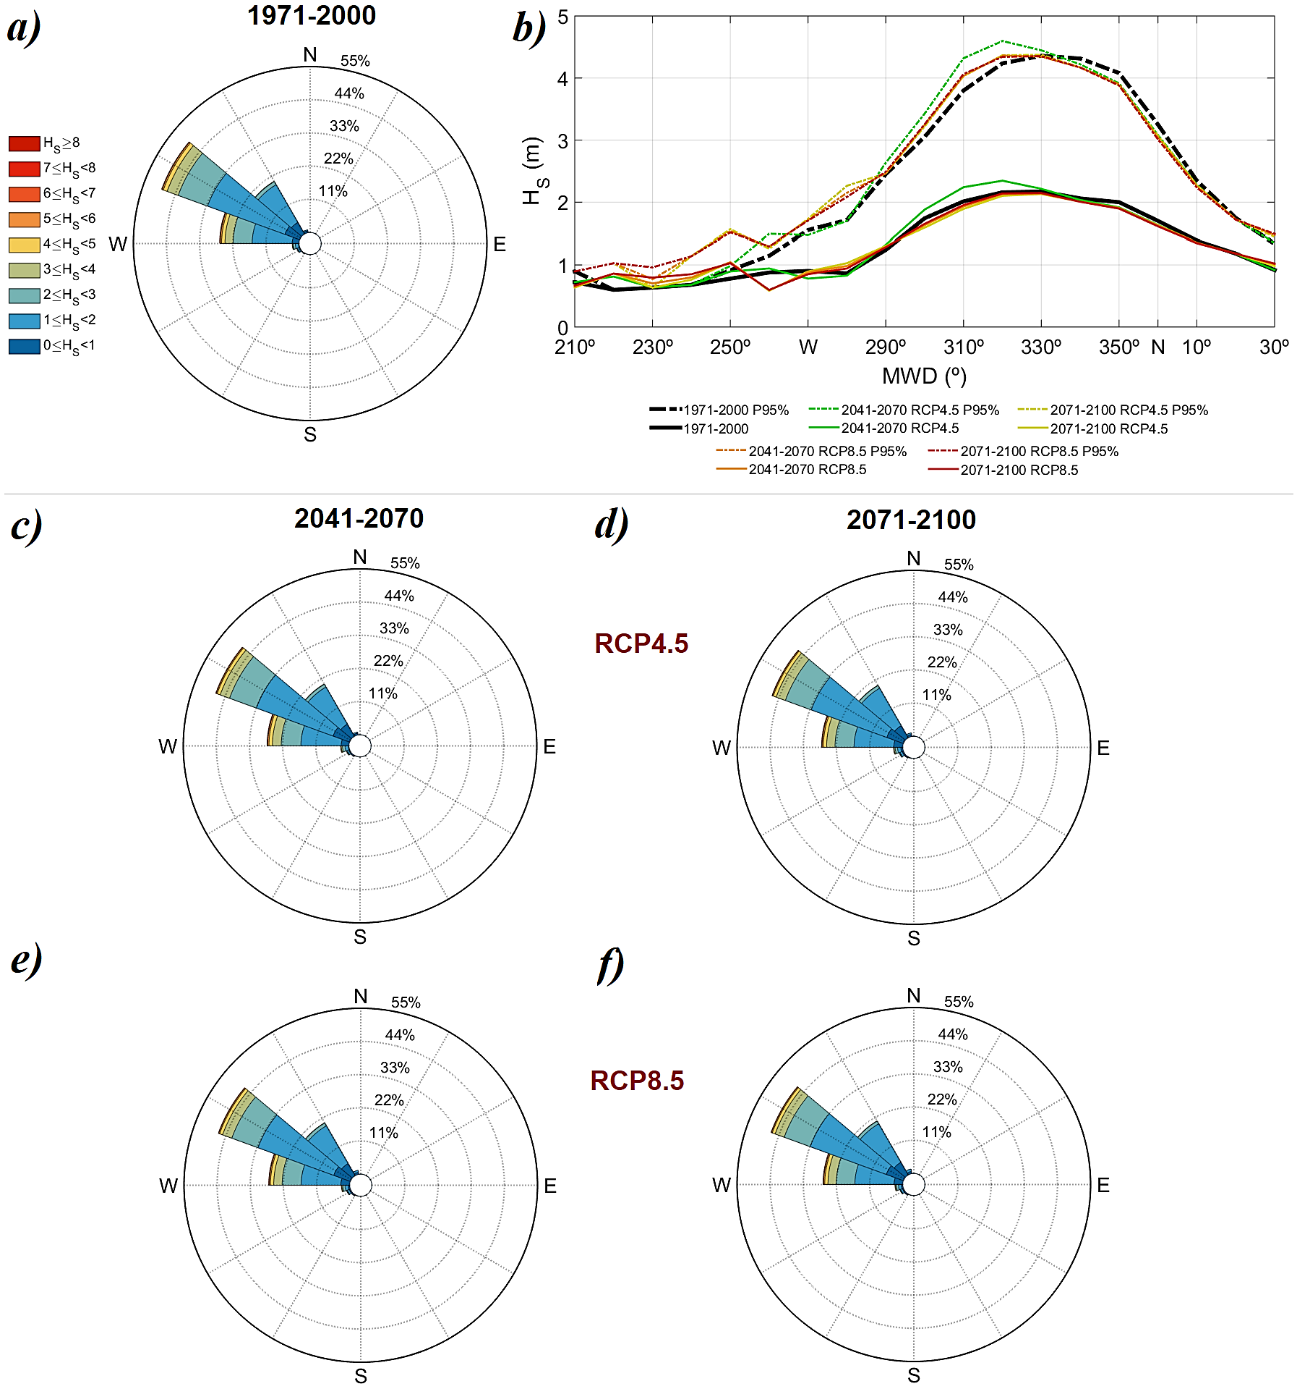
Figure SM3 – Similar to Fig. SM1, but for the Cova Gala key-location.

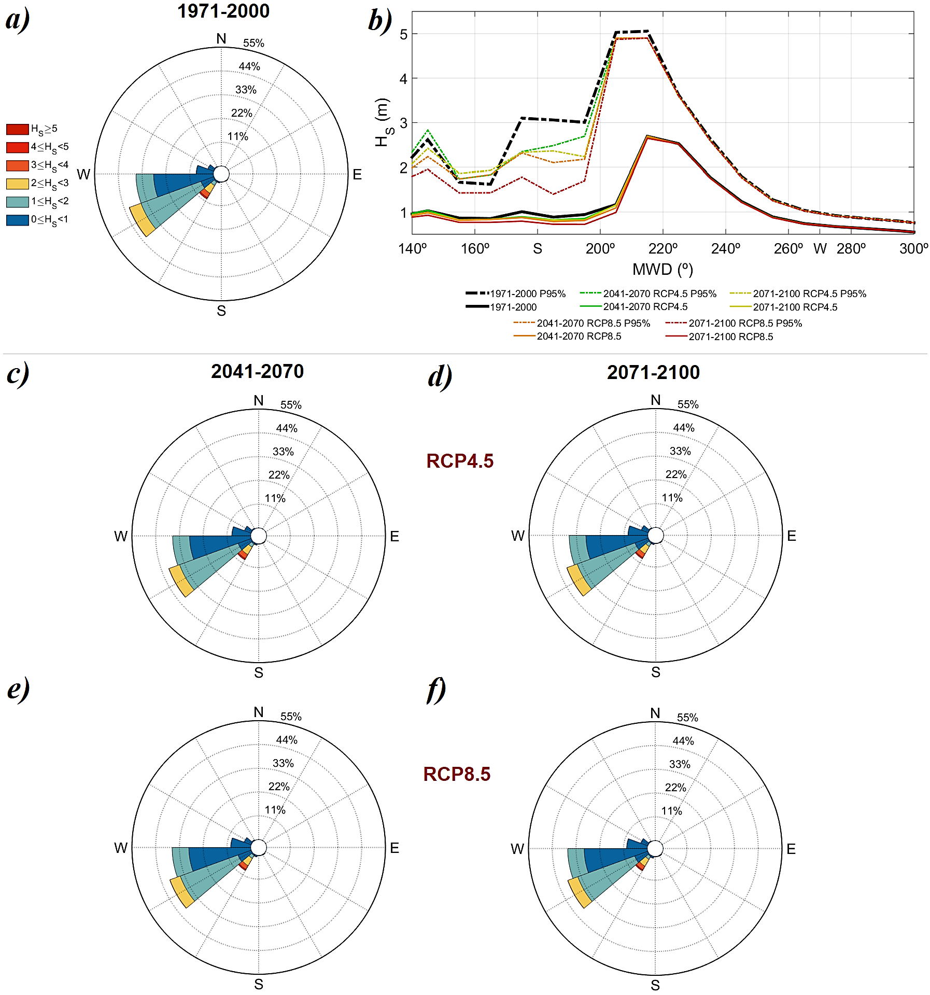
Figure SM4 – Similar to Fig. SM1, but for the Costa da Caparica key-location.

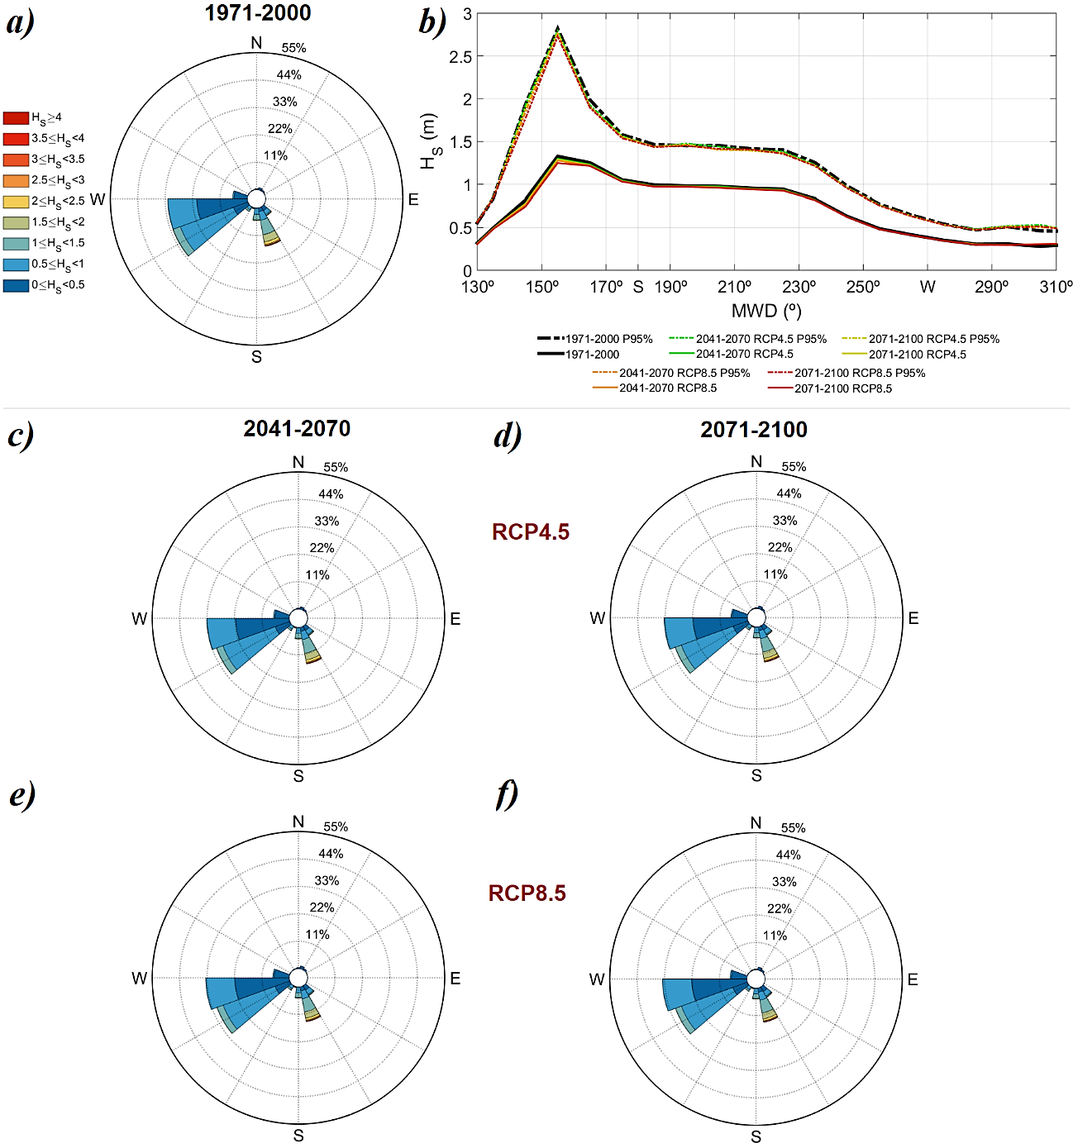
Figure SM5 – Similar to Fig. SM1, but for the Praia de Faro key-location.

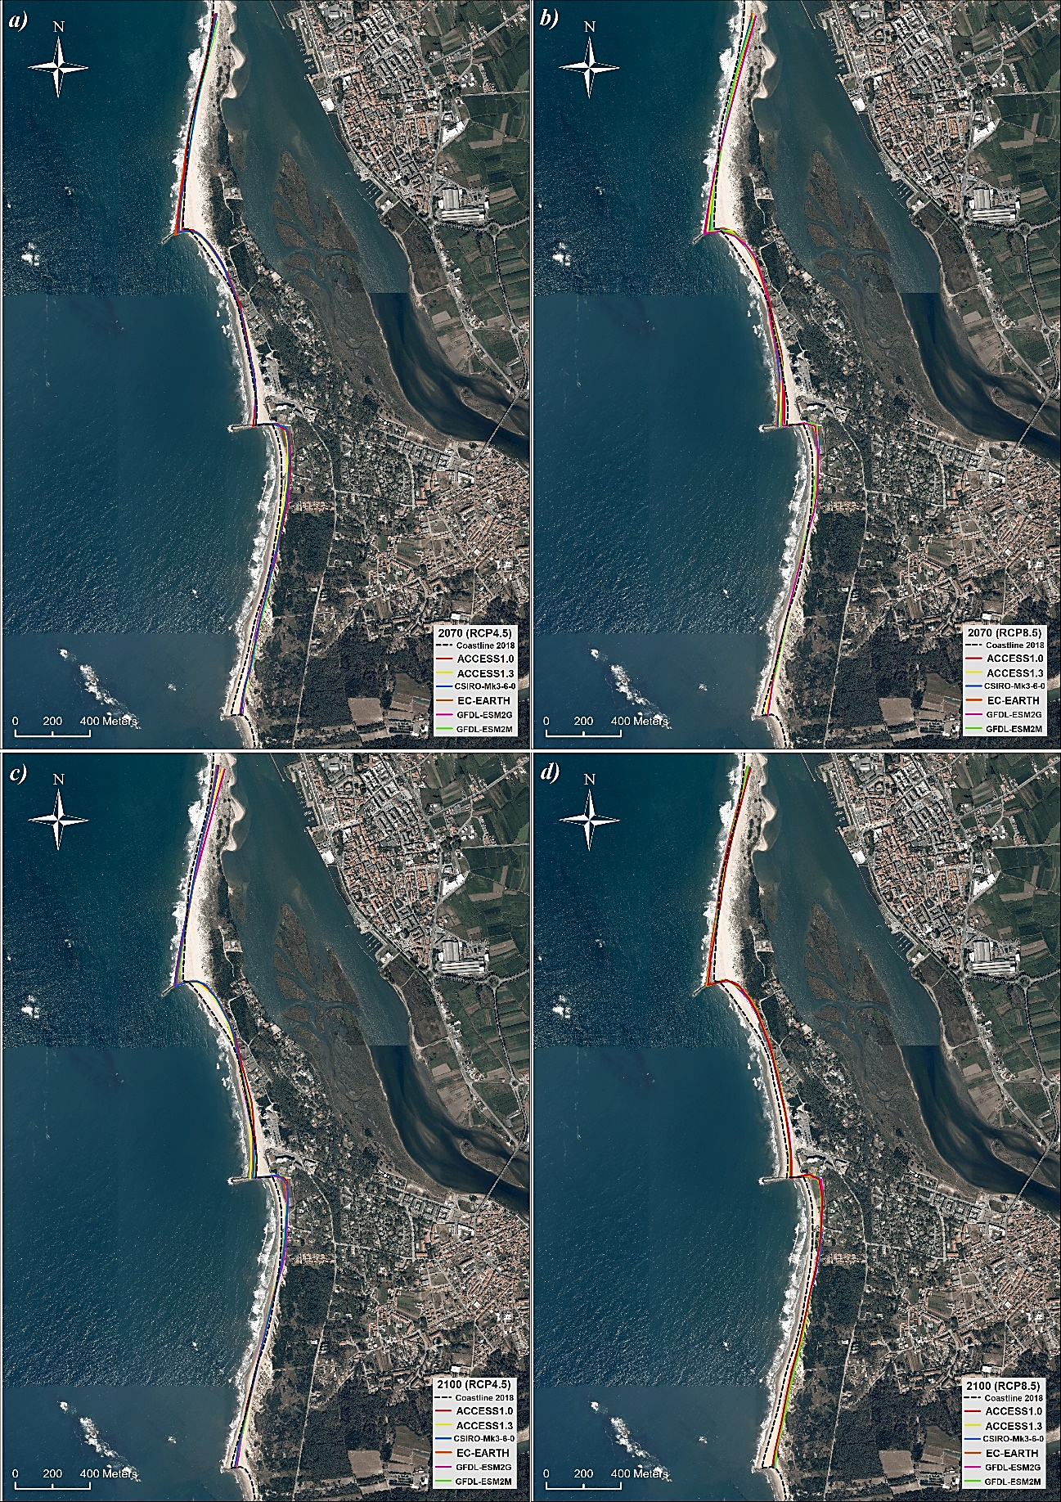
Figure SM6 – Projected shorelines at the Ofir key-location forced by the future wave climate projections, by the end of the (a,b) 2041-2070 and (c,d) 2071-2100 future time-slides (snapshots), under the (a,c) RCP4.5 and (b,d) RCP8.5 scenarios, from wave forcing alone. The black dashed line represents the reference (2018) shoreline.

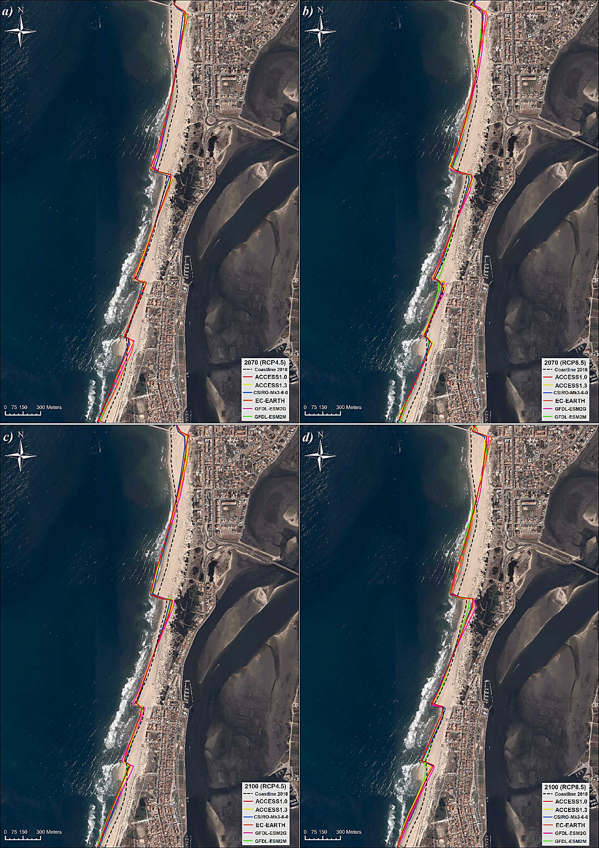
Figure SM7 – Similar to Fig. SM6, but for the Costa Nova key-location.

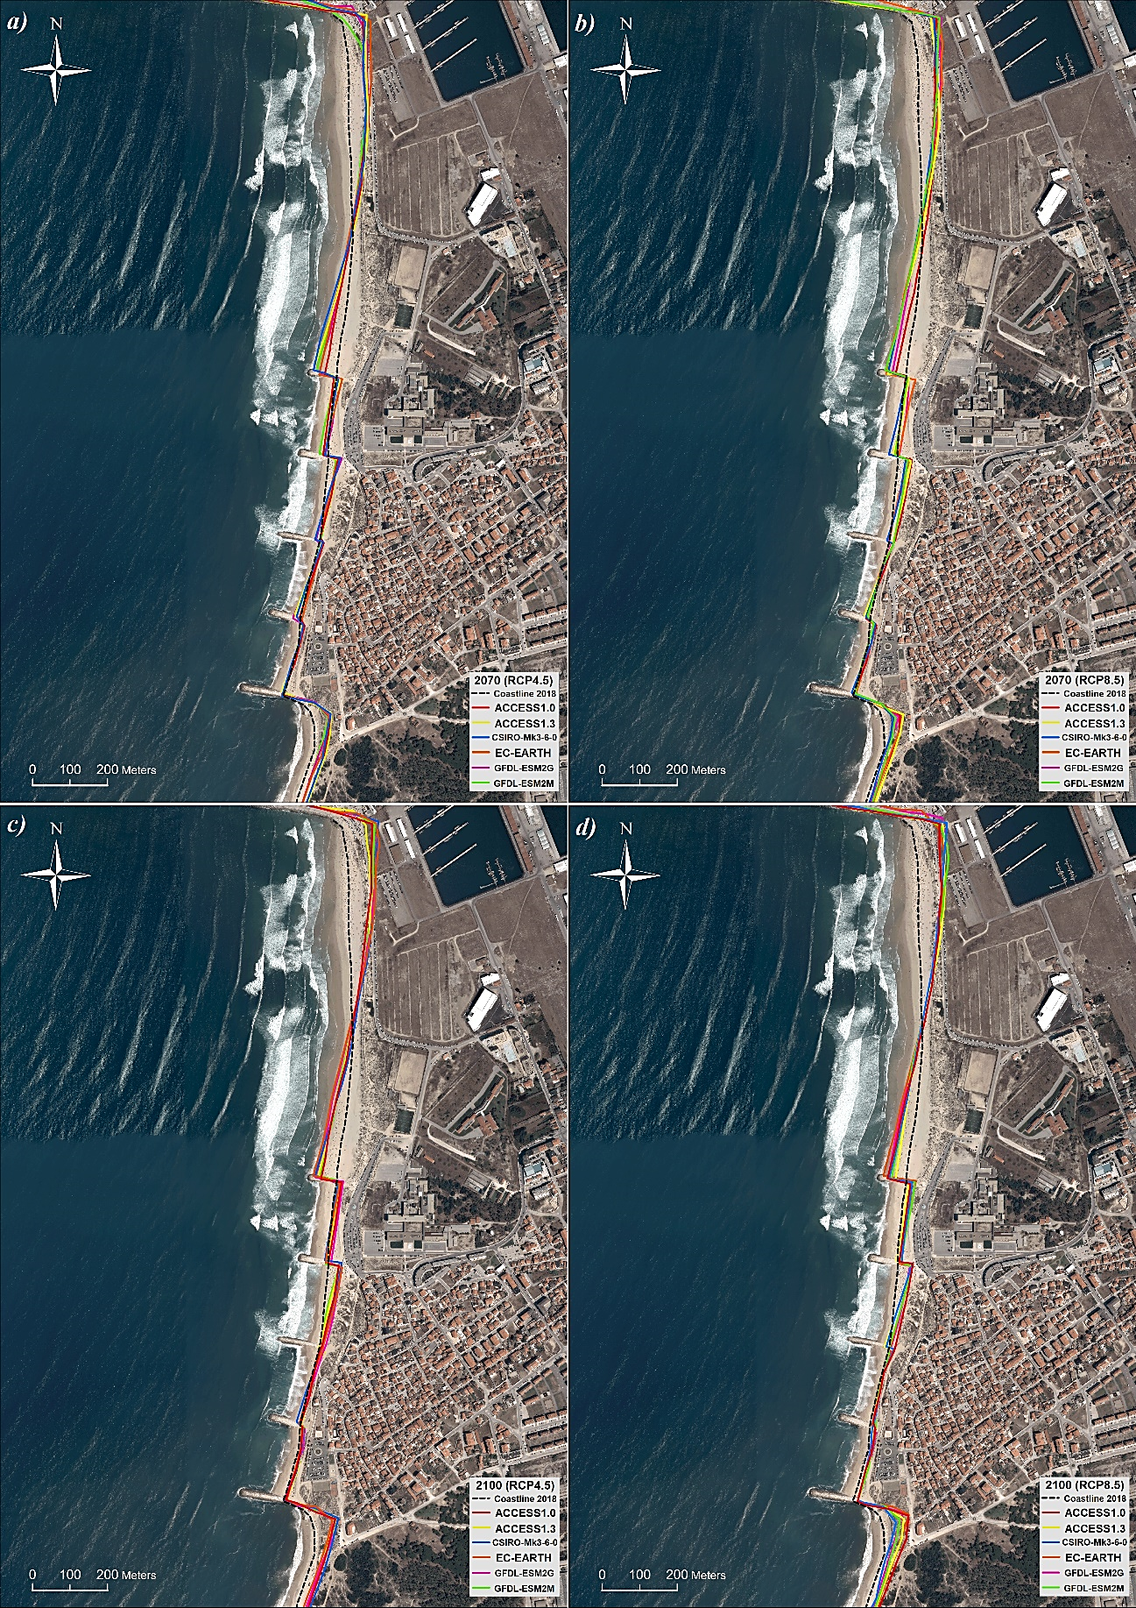
Figure SM8 – Similar to Fig. SM6, but for the Cova Gala key-location.

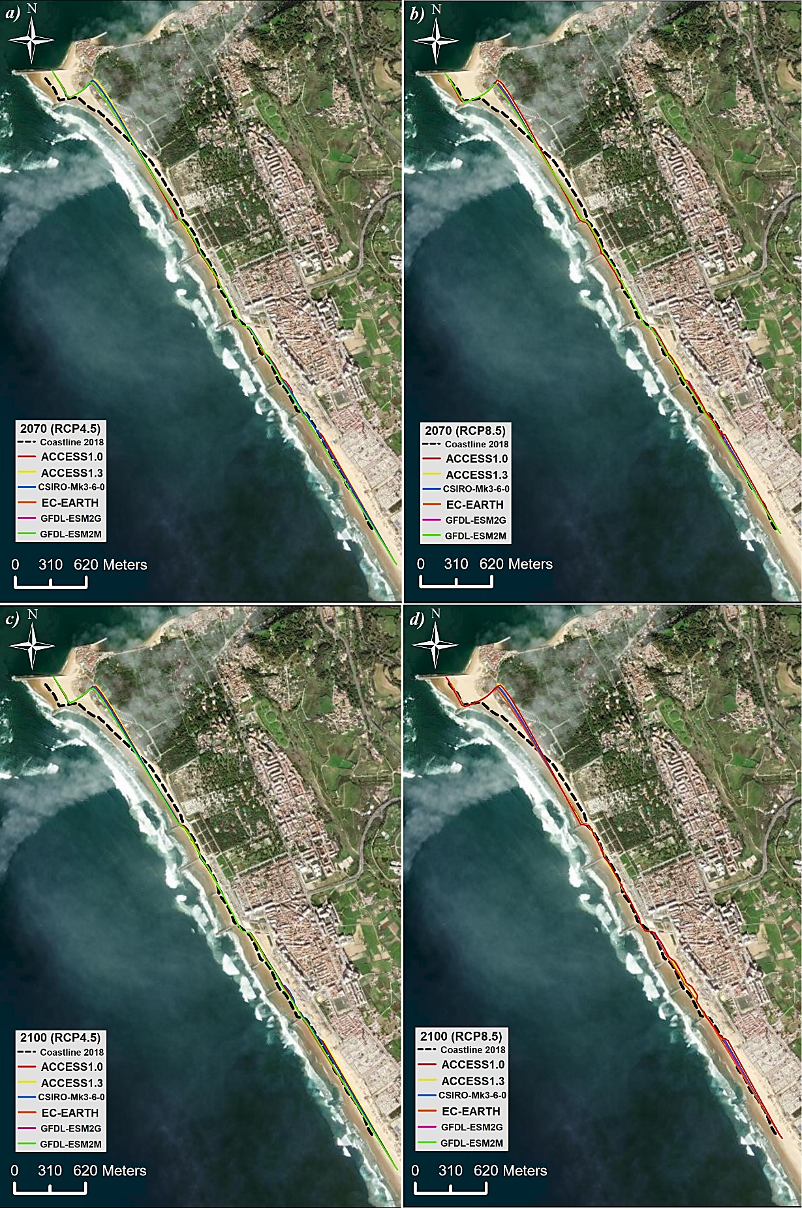
Figure SM9 – Similar to Fig. SM6, but for the Costa da Caparica key-location.

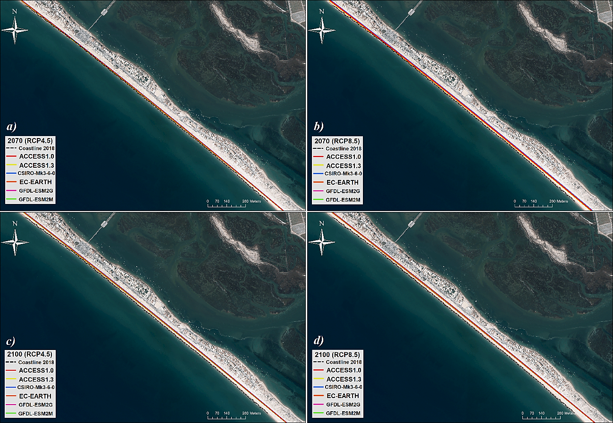
Figure SM10 – Similar to Fig. SM6, but for the Praia de Faro key-location.

Table SM1 – ERA5 (E) and historical ensemble (H) frequencies of occurrence (in %) per bin of propagated-corrected coastal $H_{S}$ and $MWD$at the Ofir key-location. Absolute differences (biases): green below 1%, yellow between 1% and 2%, orange between 2% and 3%, dark orange between 3% and 4%, red between 4% and 5% and dark red above 5%.
Dir. (º) | [0 – 1 [ m |  | [1 – 2 [ m |  | [2 – 3 [ m |  | [3 – 4 [ m |  | [4 – 5 [ m |  | [5 – 6 [ m |  | [6 – ∞ [ m
Dir. (º) | E | H | E | H | E | H | E | H | E | H | E | H | E | H
[350-10[ | 0.04 | 0.06 | - | 0.01 | - | - | - | - | - | - | - | - | - | -
[10-30[ | 0.07 | 0.07 | - | 0.02 | - | - | - | - | - | - | - | - | - | -
[30-50[ | 0.04 | 0.12 | - | 0.02 | - | - | - | - | - | - | - | - | - | -
[50-70[ | 0.03 | 0.01 | - | - | - | - | - | - | - | - | - | - | - | -
[70-90[ | 0.05 | - | 0.01 | - | - | - | - | - | - | - | - | - | - | -
[90-110[ | 0.01 | - | - | - | - | - | - | - | - | - | - | - | - | -
[110-130[ | 0.01 | - | - | - | - | - | - | - | - | - | - | - | - | -
[130-150[ | 0.01 | - | 0.01 | - | - | - | - | - | - | - | - | - | - | -
[150-170[ | 0.01 | - | 0.01 | - | - | - | - | - | - | - | - | - | - | -
[170-190[ | - | - | 0.02 | - | - | - | - | - | - | - | - | - | - | -
[190-210[ | 0.04 | 0.06 | 0.13 | - | 0.01 | 0.01 | 0.01 | - | - | - | - | - | - | -
[210-230[ | 0.10 | 0.67 | 0.45 | 0.37 | 0.44 | 0.19 | 0.15 | 0.05 | 0.03 | 0.01 | - | - | - | -
[230-250[ | 0.17 | 0.29 | 0.79 | 0.79 | 0.60 | 0.59 | 0.37 | 0.31 | 0.15 | 0.14 | 0.05 | 0.05 | 0.05 | 0.01
[250-270[ | 0.65 | 0.62 | 2.30 | 2.18 | 1.69 | 1.84 | 1.13 | 1.03 | 0.55 | 0.60 | 0.29 | 0.32 | 0.16 | 0.20
[270-290[ | 3.92 | 5.01 | 12.1 | 12.8 | 8.68 | 7.57 | 4.42 | 3.94 | 1.86 | 1.71 | 0.72 | 0.66 | 0.26 | 0.25
[290-310[ | 11.1 | 9.37 | 21.8 | 21.9 | 6.50 | 7.38 | 1.13 | 1.74 | 0.18 | 0.34 | 0.03 | 0.04 | - | -
[310-330[ | 6.69 | 6.73 | 9.18 | 8.46 | 0.05 | 0.52 | - | 0.01 | - | - | - | - | - | -
[330-350[ | 0.70 | 0.68 | 0.05 | 0.17 | - | - | - | - | - | - | - | - | - | -
TOTAL | 23.7 | 23.7 | 46.8 | 46.8 | 18.0 | 18.1 | 7.21 | 7.09 | 2.77 | 2.80 | 1.09 | 1.07 | 0.47 | 0.47

Table SM2 – Similar to SM1, but for the Costa Nova key-location.
Dir. (º) | [0 – 1 [ m |  | [1 – 2 [ m |  | [2 – 3 [ m |  | [3 – 4 [ m |  | [4 – 5 [ m |  | [5 – 6 [ m |  | [6 – 7 [ m |  | [7 – ∞ [ m
Dir. (º) | E | P | E | P | E | P | E | P | E | P | E | P | E | P | E | P
[350-10[ | 0.02 | 0.04 | 0.02 | 0.02 | - | - | - | - | - | - | - | - | - | - | - | -
[10-30[ | 0.01 | 0.06 | 0.02 | 0.03 | - | - | - | - | - | - | - | - | - | - | - | -
[30-50[ | 0.01 | 0.07 | 0.02 | 0.04 | - | - | - | - | - | - | - | - | - | - | - | -
[50-70[ | - | - | 0.01 | - | - | - | - | - | - | - | - | - | - | - | - | -
[70-90[ | - | - | 0.01 | - | - | - | - | - | - | - | - | - | - | - | - | -
[90-110[ | - | - | 0.03 | - | - | - | - | - | - | - | - | - | - | - | - | -
[110-130[ | 0.01 | - | 0.02 | - | - | - | - | - | - | - | - | - | - | - | - | -
[130-150[ | - | - | 0.03 | - | - | - | - | - | - | - | - | - | - | - | - | -
[150-170[ | - | - | 0.01 | - | - | - | - | - | - | - | - | - | - | - | - | -
[170-190[ | - | - | 0.02 | - | - | - | - | - | - | - | - | - | - | - | - | -
[190-210[ | 0.05 | - | 0.03 | - | - | - | - | - | - | - | - | - | - | - | - | -
[210-230[ | 0.10 | 0.13 | 0.30 | 0.21 | - | 0.07 | - | - | - | - | - | - | - | - | - | -
[230-250[ | 0.20 | 0.41 | 0.67 | 0.38 | 0.20 | 0.29 | 0.01 | 0.11 | - | 0.02 | - | - | - | - | - | -
[250-270[ | 0.28 | 0.29 | 1.27 | 0.99 | 0.86 | 0.88 | 0.43 | 0.53 | 0.13 | 0.23 | 0.05 | 0.11 | 0.01 | - | - | 0.01
[270-290[ | 1.17 | 0.97 | 4.61 | 6.36 | 6.37 | 5.89 | 4.13 | 3.49 | 2.28 | 1.82 | 1.09 | 0.98 | 0.67 | 0.06 | 0.12 | 0.13
[290-310[ | 3.92 | 4.87 | 23.1 | 21.4 | 14.3 | 14.3 | 5.93 | 6.27 | 1.96 | 2.28 | 0.80 | 0.89 | 0.57 | 0.73 | 0.05 | 0.03
[310-330[ | 6.03 | 4.85 | 14.5 | 15.3 | 2.09 | 2.40 | 0.09 | 0.19 | - | 0.02 | - | - | - | 0.45 | - | -
[330-350[ | 0.65 | 0.55 | 0.71 | 0.81 | - | 0.01 | - | - | - | - | - | - | - | - | - | -
TOTAL | 12.5 | 12.2 | 45.4 | 45.5 | 23.8 | 23.9 | 10.6 | 10.6 | 4.36 | 4.36 | 1.94 | 1.99 | 1.25 | 1.23 | 0.17 | 0.17

Table SM3 – Similar to SM1, but for the Cova Gala key-location.
Dir. (º) | [0 – 1 [ m |  | [1 – 2 [ m |  | [2 – 3 [ m |  | [3 – 4 [ m |  | [4 – 5 [ m |  | [5 – 6 [ m |  | [6 – 7 [ m |  | [7 – ∞ [ m
Dir. (º) | E | P | E | P | E | P | E | P | E | P | E | P | E | P | E | P
[350-10[ | - | - | - | - | - | - | - | - | - | - | - | - | - | - | - | -
[10-30[ | - | 0.01 | - | - | - | - | - | - | - | - | - | - | - | - | - | -
[30-50[ | - | 0.01 | - | - | - | - | - | - | - | - | - | - | - | - | - | -
[50-70[ | - | 0.01 | - | - | - | - | - | - | - | - | - | - | - | - | - | -
[70-90[ | - | - | - | - | - | - | - | - | - | - | - | - | - | - | - | -
[90-110[ | - | - | - | - | - | - | - | - | - | - | - | - | - | - | - | -
[110-130[ | - | - | - | - | - | - | - | - | - | - | - | - | - | - | - | -
[130-150[ | - | - | - | - | - | - | - | - | - | - | - | - | - | - | - | -
[150-170[ | - | - | - | - | - | - | - | - | - | - | - | - | - | - | - | -
[170-190[ | - | - | - | - | - | - | - | - | - | - | - | - | - | - | - | -
[190-210[ | - | - | - | - | - | - | - | - | - | - | - | - | - | - | - | -
[210-230[ | 0.18 | 0.18 | 0.10 | 0.08 | - | - | - | - | - | - | - | - | - | - | - | -
[230-250[ | 0.18 | 0.24 | 0.80 | 0.57 | 0.14 | 0.22 | - | 0.04 | - | 0.01 | - | - | - | - | - | -
[250-270[ | 0.17 | 0.20 | 1.18 | 1.07 | 0.56 | 0.66 | 0.26 | 0.26 | 0.05 | 0.09 | 0.02 | 0.02 | - | 0.01 | - | -
[270-290[ | 1.63 | 2.31 | 11.3 | 13.3 | 7.17 | 6.28 | 3.87 | 2.73 | 1.53 | 1.12 | 0.59 | 0.45 | 0.16 | 0.12 | 0.12 | 0.09
[290-310[ | 6.04 | 5.27 | 28.2 | 27.3 | 10.1 | 10.4 | 3.02 | 3.91 | 0.95 | 1.35 | 0.31 | 0.44 | 0.05 | 0.09 | 0.03 | 0.06
[310-330[ | 4.52 | 4.46 | 14.9 | 14.4 | 0.74 | 1.19 | - | 0.12 | - | 0.01 | - | - | - | - | - | -
[330-350[ | 0.70 | 0.60 | 0.29 | 0.36 | - | - | - | - | - | - | - | - | - | - | - | -
TOTAL | 13.4 | 13.3 | 56.8 | 57.1 | 18.8 | 18.7 | 7.15 | 7.06 | 2.54 | 2.58 | 0.92 | 0.91 | 0.21 | 0.22 | 0.15 | 0.15

Table SM4 – Similar to Table SM1, but for the Costa da Caparica key-location.
Dir. (º) | [0 – 1 [ m |  | [1 – 2 [ m |  | [2 – 3 [ m |  | [3 – 4 [ m |  | [4 – ∞ [ m
Dir. (º) | E | P | E | P | E | P | E | P | E | P
[350-10[ | 0.01 | 0.01 | - | - | - | - | - | - | - | -
[10-30[ | 0.00 | 0.01 | - | - | - | - | - | - | - | -
[30-50[ | 0.00 | 0.01 | - | - | - | - | - | - | - | -
[50-70[ | 0.02 | 0.02 | - | - | - | - | - | - | - | -
[70-90[ | 0.08 | - | - | - | - | - | - | - | - | -
[90-110[ | 0.12 | - | - | - | - | - | - | - | - | -
[110-130[ | 0.06 | - | - | - | - | - | - | - | - | -
[130-150[ | 0.06 | 0.22 | - | 0.07 | - | 0.01 | - | - | - | -
[150-170[ | 0.11 | 0.13 | 0.01 | 0.01 | - | - | - | - | - | -
[170-190[ | 0.08 | 0.12 | 0.06 | 0.01 | - | - | - | - | - | -
[190-210[ | 0.10 | 0.48 | 0.29 | 0.05 | 0.10 | 0.03 | 0.05 | 0.02 | 0.31 | 0.05
[210-230[ | 0.62 | 0.65 | 3.83 | 1.92 | 5.57 | 4.12 | 2.53 | 2.37 | 0.38 | 0.65
[230-250[ | 8.33 | 6.40 | 28.2 | 29.5 | 4.21 | 5.70 | 0.01 | 0.14 | - | -
[250-270[ | 26.2 | 27.7 | 7.28 | 8.17 | - | - | - | - | - | -
[270-290[ | 10.0 | 7.91 | 0.07 | 0.07 | - | - | - | - | - | -
[290-310[ | 1.19 | 3.01 | - | - | - | - | - | - | - | -
[310-330[ | 0.05 | 0.41 | - | - | - | - | - | - | - | -
[330-350[ | 0.02 | 0.01 | - | - | - | - | - | - | - | -
TOTAL | 47.1 | 47.1 | 39.8 | 39.8 | 9.88 | 9.86 | 2.59 | 2.54 | 0.69 | 0.70

Table SM5 – Similar to SM1, but for the Praia de Faro key-location.
Dir. (º) | [0 – 0.5 [ m |  | [0.5 – 1 [ m |  | [1 – 1.5 [ m |  | [1.5 – 2 [ m |  | [2 – 2.5 [ m |  | [2.5 – 3 [ m |  | [3 – 3.5 [ m |  | [3.5 – ∞ [ m
Dir. (º) | E | P | E | P | E | P | E | P | E | P | E | P | E | P | E | P
[350-10[ | 0.17 | 0.44 | - | 0.01 | - | - | - | - | - | - | - | - | - | - | - | -
[10-30[ | 0.11 | 0.89 | - | 0.04 | - | - | - | - | - | - | - | - | - | - | - | -
[30-50[ | 0.17 | 0.54 | - | 0.01 | - | - | - | - | - | - | - | - | - | - | - | -
[50-70[ | 0.16 | 0.07 | - | - | - | - | - | - | - | - | - | - | - | - | - | -
[70-90[ | 0.24 | - | - | - | - | - | - | - | - | - | - | - | - | - | - | -
[90-110[ | 0.58 | - | - | - | - | - | - | - | - | - | - | - | - | - | - | -
[110-130[ | 1.23 | 0.01 | - | - | - | - | - | - | - | - | - | - | - | - | - | -
[130-150[ | 2.67 | 1.71 | 0.72 | 1.84 | - | 0.41 | - | 0.13 | - | 0.05 | - | 0.03 | - | 0.03 | - | 0.01
[150-170[ | 1.92 | 1.55 | 9.21 | 3.49 | 2.91 | 5.86 | 0.49 | 2.95 | 0.07 | 1.07 | - | 0.43 | - | 0.23 | - | 0.09
[170-190[ | 0.03 | 0.09 | 0.79 | 2.46 | 2.59 | 2.17 | 1.74 | 0.31 | 0.71 | 0.02 | 0.41 | - | 0.21 | - | 0.09 | -
[190-210[ | 0.03 | 0.01 | 0.18 | 0.28 | 0.22 | 0.19 | 0.11 | 0.02 | 0.05 | - | - | - | - | - | - | -
[210-230[ | 0.05 | 0.05 | 0.47 | 1.38 | 1.02 | 0.74 | 0.70 | 0.06 | 0.15 | - | 0.04 | - | 0.03 | - | 0.01 | -
[230-250[ | 3.76 | 6.20 | 23.4 | 22.7 | 5.73 | 3.09 | 0.54 | 0.11 | 0.13 | - | 0.02 | - | 0.01 | - | - | -
[250-270[ | 19.7 | 20.3 | 8.90 | 11.6 | 0.05 | 0.08 | - | - | - | - | - | - | - | - | - | -
[270-290[ | 6.29 | 5.43 | 0.57 | 0.53 | - | - | - | - | - | - | - | - | - | - | - | -
[290-310[ | 0.20 | 0.09 | - | - | - | - | - | - | - | - | - | - | - | - | - | -
[310-330[ | 0.10 | 0.09 | - | - | - | - | - | - | - | - | - | - | - | - | - | -
[330-350[ | 0.30 | 0.15 | - | 0.01 | - | - | - | - | - | - | - | - | - | - | - | -
TOTAL | 37.8 | 37.6 | 44.2 | 44.2 | 12.5 | 12.5 | 3.59 | 3.58 | 1.12 | 1.14 | 0.48 | 0.46 | 0.25 | 0.26 | 0.10 | 0.10

Table SM6 – Historical (H) and future projected (F) ensembles’ frequencies of occurrence (in %) per bin of propagated-corrected coastal $H_{S}$ and $MWD$, at the Ofir key-location, considering the 2041-2070 and 2071-2100 future time-slices, under the RCP4.5 and RCP8.5 scenarios.
Dir. (º) | [0 – 1 [ m |  | [1 – 2 [ m |  | [2 – 3 [ m |  | [3 – 4 [ m |  | [4 – 5 [ m |  | [5 – 6 [ m |  | [6 – ∞ [ m
Dir. (º) | H | F | H | F | H | F | H | F | H | F | H | F | H | F
[350-10[ | 0.06 | 0.08  0.07  0.07  0.08 | 0.01 | 0.01  0.02  0.02  0.02 | - | -  -  -  - | - | -  -  -  - | - | -  -  -  - | - | -  -  -  - | - | -  -  -  -
[10-30[ | 0.07 | 0.08  0.09  0.09  0.09 | 0.02 | 0.02  0.02  0.01  0.02 | - | -  -  -  - | - | -  -  -  - | - | -  -  -  - | - | -  -  -  - | - | -  -  -  -
[30-50[ | 0.13 | 0.15  0.16  0.16  0.16 | 0.02 | 0.03  0.03  0.03  0.03 | - | -  -  -  - | - | -  -  -  - | - | -  -  -  - | - | -  -  -  - | - | -  -  -  -
[50-70[ | 0.01 | -  0.01  -  0.01 | - | -  -  -  - | - | -  -  -  - | - | -  -  -  - | - | -  -  -  - | - | -  -  -  - | - | -  -  -  -
[70-90[ | - | -  -  -  - | - | -  -  -  - | - | -  -  -  - | - | -  -  -  - | - | -  -  -  - | - | -  -  -  - | - | -  -  -  -
[90-110[ | - | -  -  -  - | - | -  -  -  - | - | -  -  -  - | - | -  -  -  - | - | -  -  -  - | - | -  -  -  - | - | -  -  -  -
[110-130[ | - | -  -  -  - | - | -  -  -  - | - | -  -  -  - | - | -  -  -  - | - | -  -  -  - | - | -  -  -  - | - | -  -  -  -
[130-150[ | - | -  -  -  - | - | -  -  -  - | - | -  -  -  - | - | -  -  -  - | - | -  -  -  - | - | -  -  -  - | - | -  -  -  -
[150-170[ | - | -  -  -  - | - | -  -  -  - | - | -  -  -  - | - | -  -  -  - | - | -  -  -  - | - | -  -  -  - | - | -  -  -  -
[170-190[ | - | -  -  -  - | - | -  -  -  - | - | -  -  -  - | - | -  -  -  - | - | -  -  -  - | - | -  -  -  - | - | -  -  -  -
[190-210[ | 0.06 | 0.06  0.05  0.05  0.06 | 0.02 | 0.02  0.02  0.02  0.02 | 0.01 | 0.01  0.01  0.01  0.01 | - | -  -  -  - | - | -  -  -  - | - | -  -  -  - | - | -  -  -  -
[210-230[ | 0.67 | 0.75  0.69  0.74  0.84 | 0.37 | 0.35  0.34  0.32  0.31 | 0.19 | 0.19  0.18  0.18  0.17 | 0.05 | 0.05  0.05  0.05  0.05 | 0.01 | 0.01  0.01  0.01  0.01 | - | -  -  -  - | - | -  -  -  -
[230-250[ | 0.29 | 0.27  0.27  0.26  0.25 | 0.79 | 0.71  0.67  0.65  0.63 | 0.59 | 0.59  0.57  0.56  0.52 | 0.31 | 0.31  0.31  0.31  0.29 | 0.14 | 0.13  0.12  0.13  0.12 | 0.04 | 0.06  0.05  0.05  0.04 | 0.01 | 0.02  0.02  0.02  0.02
[250-270[ | 0.62 | 0.56  0.55  0.54  0.53 | 2.18 | 1.84  1.80  1.72  1.62 | 1.84 | 1.63  1.61  1.56  1.45 | 1.04 | 1.00  0.96  0.94  0.88 | 0.60 | 0.58  0.55  0.53  0.50 | 0.32 | 0.30  0.29  0.26  0.24 | 0.20 | 0.19  0.18  0.17  0.16
[270-290[ | 5.01 | 5.16  5.29  5.29  5.30 | 12.9 | 12.6  12.6  12.5  11.9 | 7.58 | 7.46  7.40  7.37  7.07 | 3.94 | 3.81  3.74  3.76  3.59 | 1.72 | 1.68  1.65  1.66  1.59 | 0.65 | 0.65  0.61  0.62  0.61 | 0.25 | 0.25  0.24  0.25  0.25
[290-310[ | 9.37 | 10.1  10.3  10.5  10.9 | 21.9 | 21.7  21.6  21.5  21.4 | 7.38 | 7.07  6.99  7.07  7.14 | 1.74 | 1.71  1.73  1.74  1.78 | 0.34 | 0.35  0.36  0.36  0.39 | 0.04 | 0.05  0.05  0.05  0.07 | - | -  -  0.01  0.01
[310-330[ | 6.73 | 7.12  7.31  7.33  8.10 | 8.46 | 8.70  8.91  9.00  9.25 | 0.52 | 0.55  0.56  0.57  0.59 | 0.01 | 0.01  0.01  0.01  0.02 | - | -  -  -  - | - | -  -  -  - | - | -  -  -  -
[330-350[ | 0.68 | 0.75  0.74  0.74  0.74 | 0.17 | 0.20  0.22  0.23  0.24 | - | -  -  -  - | - | -  -  -  - | - | -  -  -  - | - | -  -  -  - | - | -  -  -  -
TOTAL | 23.7 | 25.1  25.6  25.8  27.0 | 46.8 | 46.2  46.2  46.0  45.4 | 18.1 | 17.5  17.3  17.3  16.9 | 7.09 | 6.89  6.81  6.82  6.60 | 2.80 | 2.75  2.69  2.69  2.61 | 1.07 | 1.05  1.00  0.99  0.97 | 0.47 | 0.47  0.44  0.44  0.43

Table SM7 – Similar to Table SM6, but for the Costa Nova key-location.
Dir. (º) | [0 – 1 [ m |  | [1 – 2 [ m |  | [2 – 3 [ m |  | [3 – 4 [ m |  | [4 – 5 [ m |  | [5 – 6 [ m |  | [6 – 7 [ m |  | [7 – ∞ [ m
Dir. (º) | P | F | P | F | P | F | P | F | P | F | P | F | P | F | P | F
[350-10[ | 0.04 | 0.03  0.03  0.03  0.03 | 0.02 | 0.02  0.02  0.02  0.02 | - | -  -  -  - | - | -  -  -  - | - | -  -  -  - | - | -  -  -  - | - | -  -  -  - | - | -  -  -  -
[10-30[ | 0.06 | 0.06  0.06  0.05  0.06 | 0.03 | 0.03  0.03  0.03  0.03 | - | -  -  -  - | - | -  -  -  - | - | -  -  -  - | - | -  -  -  - | - | -  -  -  - | - | -  -  -  -
[30-50[ | 0.07 | 0.06  0.06  0.05  0.05 | 0.01 | 0.04  0.04  0.04  0.04 | - | -  -  -  - | - | -  -  -  - | - | -  -  -  - | - | -  -  -  - | - | -  -  -  - | - | -  -  -  -
[50-70[ | - | -  -  -  - | - | -  -  -  - | - | -  -  -  - | - | -  -  -  - | - | -  -  -  - | - | -  -  -  - | - | -  -  -  - | - | -  -  -  -
[70-90[ | - | -  -  -  - | - | -  -  -  - | - | -  -  -  - | - | -  -  -  - | - | -  -  -  - | - | -  -  -  - | - | -  -  -  - | - | -  -  -  -
[90-110[ | - | -  -  -  - | - | -  -  -  - | - | -  -  -  - | - | -  -  -  - | - | -  -  -  - | - | -  -  -  - | - | -  -  -  - | - | -  -  -  -
[110-130[ | - | -  -  -  - | - | -  -  -  - | - | -  -  -  - | - | -  -  -  - | - | -  -  -  - | - | -  -  -  - | - | -  -  -  - | - | -  -  -  -
[130-150[ | - | -  -  -  - | - | -  -  -  - | - | -  -  -  - | - | -  -  -  - | - | -  -  -  - | - | -  -  -  - | - | -  -  -  - | - | -  -  -  -
[150-170[ | - | -  -  -  - | - | -  -  -  - | - | -  -  -  - | - | -  -  -  - | - | -  -  -  - | - | -  -  -  - | - | -  -  -  - | - | -  -  -  -
[170-190[ | - | -  -  -  - | - | -  -  -  - | - | -  -  -  - | - | -  -  -  - | - | -  -  -  - | - | -  -  -  - | - | -  -  -  - | - | -  -  -  -
[190-210[ | - | -  -  -  - | - | -  -  -  - | - | -  -  -  - | - | -  -  -  - | - | -  -  -  - | - | -  -  -  - | - | -  -  -  - | - | -  -  -  -
[210-230[ | 0.13 | 0.10  0.09  0.09  0.09 | 0.21 | 0.21  0.20  0.18  0.17 | 0.07 | 0.08  0.08  0.07  0.07 | 0.01 | 0.01  0.01  0.01  0.01 | - | -  -  -  - | - | -  -  -  - | - | -  -  -  - | - | -  -  -  -
[230-250[ | 0.41 | 0.41  0.35  0.38  0.39 | 0.38 | 0.35  0.32  0.31  0.30 | 0.29 | 0.27  0.24  0.24  0.22 | 0.11 | 0.10  0.09  0.09  0.09 | 0.02 | 0.02  0.02  0.02  0.02 | - | -  -  -  - | - | -  -  -  - | - | -  -  -  -
[250-270[ | 0.29 | 0.23  0.23  0.22  0.21 | 0.99 | 0.81  0.77  0.71  0.70 | 0.88 | 0.77  0.77  0.72  0.69 | 0.53 | 0.49  0.47  0.45  0.44 | 0.23 | 0.20  0.19  0.19  0.18 | 0.11 | 0.10  0.09  0.08  0.08 | 0.06 | 0.06  0.05  0.04  0.04 | 0.01 | 0.01  0.01  0.01  0.01
[270-290[ | 0.97 | 0.89  0.87  0.87  0.85 | 6.36 | 5.92  5.78  5.69  5.56 | 5.89 | 5.58  5.47  5.39  5.25 | 3.49 | 3.42  3.41  3.40  3.33 | 1.82 | 1.89  1.84  1.83  1.79 | 0.98 | 0.94  0.90  0.90  0.88 | 0.73 | 0.65  0.59  0.59  0.60 | 0.13 | 0.13  0.13  0.13  0.13
[290-310[ | 4.87 | 5.21  5.38  5.42  5.53 | 21.4 | 22.6  23.0  23.1  23.2 | 14.3 | 14.0  13.9  13.9  13.9 | 6.27 | 6.08  5.99  6.03  5.93 | 2.28 | 2.11  2.12  2.12  2.06 | 0.89 | 0.74  0.69  0.70  0.67 | 0.45 | 0.32  0.27  0.27  0.25 | 0.03 | 0.02  0.02  0.02  0.01
[310-330[ | 4.85 | 5.20  5.22  5.28  5.52 | 15.3 | 15.9  16.3  16.4  16.6 | 2.40 | 2.23  2.20  2.21  2.17 | 0.19 | 0.16  0.16  0.15  0.14 | 0.02 | 0.01  0.01  0.01  0.01 | - | -  -  -  - | - | -  -  -  - | - | -  -  -  -
[330-350[ | 0.55 | 0.61  0.61  0.60  0.65 | 0.81 | 0.91  0.95  0.96  0.99 | 0.01 | 0.01  0.01  0.01  0.01 | - | -  -  -  - | - | -  -  -  - | - | -  -  -  - | - | -  -  -  - | - | -  -  -  -
TOTAL | 12.2 | 12.8  12.9  13.0  13.4 | 45.5 | 46.8  47.4  47.4  47.7 | 23.9 | 22.9  22.7  22.6  22.3 | 10.6 | 10.3  10.1  10.1  9.93 | 4.36 | 4.24  4.17  4.15  4.05 | 1.99 | 1.79  1.68  1.68  1.63 | 1.23 | 1.02  0.90  0.90  0.89 | 0.17 | 0.16  0.15  0.15  0.15

Table SM8 – Similar to Table SM6, but for the Cova Gala key-location.
Dir. (º) | [0 – 1 [ m |  | [1 – 2 [ m |  | [2 – 3 [ m |  | [3 – 4 [ m |  | [4 – 5 [ m |  | [5 – 6 [ m |  | [6 – 7 [ m |  | [7 – ∞ [ m
Dir. (º) | P | F | P | F | P | F | P | F | P | F | P | F | P | F | P | F
[350-10[ | - | 0.04  0.03  0.02  0.02 | - | -  0.01  0.01  0.01 | - | -  -  -  - | - | -  -  -  - | - | -  -  -  - | - | -  -  -  - | - | -  -  -  - | - | -  -  -  -
[10-30[ | 0.01 | 0.01  0.01  0.01  0.01 | - | -  -  -  - | - | -  -  -  - | - | -  -  -  - | - | -  -  -  - | - | -  -  -  - | - | -  -  -  - | - | -  -  -  -
[30-50[ | 0.01 | 0.01  0.01  0.01  0.01 | - | -  -  -  - | - | -  -  -  - | - | -  -  -  - | - | -  -  -  - | - | -  -  -  - | - | -  -  -  - | - | -  -  -  -
[50-70[ | 0.01 | 0.01  0.01  0.01  0.01 | - | -  -  -  - | - | -  -  -  - | - | -  -  -  - | - | -  -  -  - | - | -  -  -  - | - | -  -  -  - | - | -  -  -  -
[70-90[ | - | 0.01  0.01  0.01  0.01 | - | -  -  -  - | - | -  -  -  - | - | -  -  -  - | - | -  -  -  - | - | -  -  -  - | - | -  -  -  - | - | -  -  -  -
[90-110[ | - | -  -  -  - | - | -  -  -  - | - | -  -  -  - | - | -  -  -  - | - | -  -  -  - | - | -  -  -  - | - | -  -  -  - | - | -  -  -  -
[110-130[ | - | -  -  -  - | - | -  -  -  - | - | -  -  -  - | - | -  -  -  - | - | -  -  -  - | - | -  -  -  - | - | -  -  -  - | - | -  -  -  -
[130-150[ | - | -  0.02  0.02  0.02 | - | -  -  -  - | - | -  -  -  - | - | -  -  -  - | - | -  -  -  - | - | -  -  -  - | - | -  -  -  - | - | -  -  -  -
[150-170[ | - | -  -  -  - | - | -  -  -  - | - | -  -  -  - | - | -  -  -  - | - | -  -  -  - | - | -  -  -  - | - | -  -  -  - | - | -  -  -  -
[170-190[ | - | -  -  -  - | - | -  -  -  - | - | -  -  -  - | - | -  -  -  - | - | -  -  -  - | - | -  -  -  - | - | -  -  -  - | - | -  -  -  -
[190-210[ | - | -  0.10  0.08  0.06 | - | -  0.01  0.01  0.01 | - | -  -  -  - | - | -  -  -  - | - | -  -  -  - | - | -  -  -  - | - | -  -  -  - | - | -  -  -  -
[210-230[ | 0.18 | 0.33  0.29  0.30  0.32 | 0.08 | 0.09  0.14  0.12  0.12 | - | 0.01  0.03  0.02  0.02 | - | -  -  -  - | - | -  -  -  - | - | -  -  -  - | - | -  -  -  - | - | -  -  -  -
[230-250[ | 0.24 | 0.22  0.45  0.40  0.36 | 0.57 | 0.59  0.75  0.67  0.61 | 0.22 | 0.26  0.24  0.24  0.22 | 0.04 | 0.07  0.06  0.06  0.06 | 0.01 | 0.02  0.01  0.01  0.01 | - | -  -  -  - | - | -  -  -  - | - | -  -  -  -
[250-270[ | 0.20 | 0.21  0.65  0.53  0.46 | 1.07 | 1.11  1.08  1.01  0.99 | 0.66 | 0.82  0.79  0.74  0.69 | 0.26 | 0.40  0.35  0.33  0.32 | 0.09 | 0.16  0.14  0.13  0.12 | 0.02 | 0.05  0.04  0.04  0.03 | 0.01 | 0.01  0.01  0.01  0.01 | - | 0.01  0.01  0.01  -
[270-290[ | 2.31 | 2.60  3.01  2.95  2.89 | 13.3 | 13.4  13.2  13.2  13.0 | 6.28 | 6.51  6.32  6.29  6.19 | 2.73 | 2.94  2.78  2.79  2.74 | 1.12 | 1.14  1.09  1.09  1.07 | 0.45 | 0.43  0.40  0.39  0.38 | 0.12 | 0.11  0.10  0.10  0.10 | 0.09 | 0.09  0.09  0.09  0.09
[290-310[ | 5.27 | 5.86  5.90  5.89  6.07 | 27.3 | 27.1  26.7  26.8  26.9 | 10.4 | 9.46  9.14  9.25  9.18 | 3.91 | 3.31  3.24  3.25  3.19 | 1.35 | 1.09  1.05  1.06  1.03 | 0.44 | 0.35  0.32  0.33  0.32 | 0.09 | 0.08  0.07  0.07  0.06 | 0.06 | 0.04  0.04  0.04  0.04
[310-330[ | 4.46 | 4.70  4.64  4.67  4.87 | 14.4 | 14.2  14.3  14.4  14.7 | 1.19 | 1.06  1.06  1.06  1.02 | 0.12 | 0.10  0.09  0.09  0.09 | 0.01 | 0.01  0.01  0.01  0.01 | - | -  -  -  - | - | -  -  -  - | - | -  -  -  -
[330-350[ | 0.60 | 0.62  0.63  0.66  0.73 | 0.36 | 0.36  0.57  0.72  0.83 | - | -  -  -  - | - | -  -  -  - | - | -  -  -  - | - | -  -  -  - | - | -  -  -  - | - | -  -  -  -
TOTAL | 13.3 | 14.6  15.8  15.6  15.8 | 57.1 | 56.8  56.7  56.9  57.2 | 18.7 | 18.2  17.6  17.6  17.3 | 7.06 | 6.81  6.54  6.54  6.39 | 2.58 | 2.41  2.30  2.30  2.24 | 0.91 | 0.83  0.76  0.76  0.74 | 0.22 | 0.20  0.18  0.18  0.17 | 0.15 | 0.14  0.14  0.14  0.13

Table SM9 – Similar to Table SM6, but for the Costa da Caparica key-location.
Dir. (º) | [0 – 1 [ m |  | [1 – 2 [ m |  | [2 – 3 [ m |  | [3 – 4 [ m |  | [4 – ∞ [ m
Dir. (º) | P | F | P | F | P | F | P | F | P | F
[350-10[ | 0.01 | 0.01  0.01  0.01  0.02 | - | -  -  -  - | - | -  -  -  - | - | -  -  -  - | - | -  -  -  -
[10-30[ | 0.01 | 0.01  0.01  0.01  0.01 | - | -  -  -  - | - | -  -  -  - | - | -  -  -  - | - | -  -  -  -
[30-50[ | 0.01 | 0.01  0.01  0.01  0.01 | - | -  -  -  - | - | -  -  -  - | - | -  -  -  - | - | -  -  -  -
[50-70[ | 0.02 | 0.01  0.01  0.01  0.01 | - | -  -  -  - | - | -  -  -  - | - | -  -  -  - | - | -  -  -  -
[70-90[ | - | -  -  -  - | - | -  -  -  - | - | -  -  -  - | - | -  -  -  - | - | -  -  -  -
[90-110[ | - | -  -  -  - | - | -  -  -  - | - | -  -  -  - | - | -  -  -  - | - | -  -  -  -
[110-130[ | - | -  -  -  - | - | -  -  -  - | - | -  -  -  - | - | -  -  -  - | - | -  -  -  -
[130-150[ | 0.22 | 0.23  0.26  0.26  0.28 | 0.07 | 0.08  0.08  0.08  0.08 | 0.01 | 0.01  0.01  0.01  0.01 | - | -  -  -  - | - | 0.01  -  -  -
[150-170[ | 0.13 | 0.16  0.15  0.17  0.21 | 0.01 | 0.02  0.01  0.01  0.01 | - | -  -  -  - | - | -  -  -  - | - | -  -  -  -
[170-190[ | 0.12 | 0.15  0.15  0.16  0.21 | 0.01 | 0.01  0.01  0.01  0.01 | - | 0.01  -  -  - | - | -  -  -  - | 0.01 | -  -  -  -
[190-210[ | 0.48 | 0.60  0.58  0.65  0.77 | 0.05 | 0.05  0.05  0.05  0.05 | 0.03 | 0.03  0.03  0.03  0.03 | 0.02 | 0.02  0.02  0.02  0.01 | 0.05 | 0.06  0.06  0.06  0.05
[210-230[ | 0.65 | 0.63  0.56  0.55  0.57 | 1.92 | 1.77  1.76  1.67  1.59 | 4.12 | 3.95  3.84  3.82  3.64 | 2.37 | 2.19  2.07  2.04  1.95 | 0.64 | 0.62  0.57  0.55  0.53
[230-250[ | 6.40 | 6.45  6.56  6.52  6.46 | 29.5 | 28.8  28.5  28.4  28.0 | 5.70 | 5.21  5.07  5.06  4.91 | 0.14 | 0.12  0.11  0.11  0.11 | - | -  -  -  -
[250-270[ | 27.7 | 28.3  28.7  28.7  29.2 | 8.17 | 7.85  7.75  7.73  7.64 | - | -  -  -  - | - | -  -  -  - | - | -  -  -  -
[270-290[ | 7.91 | 8.70  9.11  9.23  9.51 | 0.07 | 0.07  0.08  0.07  0.08 | - | -  -  -  - | - | -  -  -  - | - | -  -  -  -
[290-310[ | 3.01 | 3.35  3.46  3.50  3.51 | - | -  -  -  - | - | -  -  -  - | - | -  -  -  - | - | -  -  -  -
[310-330[ | 0.41 | 0.44  0.42  0.44  0.43 | - | -  -  -  - | - | -  -  -  - | - | -  -  -  - | - | -  -  -  -
[330-350[ | 0.01 | 0.02  0.02  0.02  0.02 | - | -  -  -  - | - | -  -  -  - | - | -  -  -  - | - | -  -  -  -
TOTAL | 47.1 | 49.1  50.0  50.2  51.3 | 39.8 | 38.7  38.2  38.1  37.5 | 9.86 | 9.21  8.96  8.92  8.58 | 2.54 | 2.33  2.21  2.17  2.08 | 0.70 | 0.68  0.64  0.62  0.60

Table SM10 – Similar to Table SM6, but for the Praia de Faro key-location.
Dir. (º) | [0 – 0.5 [ m |  | [0.5 – 1 [ m |  | [1 – 1.5 [ m |  | [1.5 – 2 [ m |  | [2 – 2.5 [ m |  | [2.5 – 3 [ m |  | [3 – 3.5 [ m |  | [3.5 – ∞ [ m
Dir. (º) | P | F | P | F | P | F | P | F | P | F | P | F | P | F | P | F
[350-10[ | 0.44 | 0.41  0.43  0.42  0.44 | 0.01 | 0.01  0.01  0.01  0.01 | - | -  -  -  - | - | -  -  -  - | - | -  -  -  - | - | -  -  -  - | - | -  -  -  - | - | -  -  -  -
[10-30[ | 0.89 | 0.97  1.07  1.10  1.15 | 0.04 | 0.05  0.04  0.04  0.05 | - | -  -  -  - | - | -  -  -  - | - | -  -  -  - | - | -  -  -  - | - | -  -  -  - | - | -  -  -  -
[30-50[ | 0.54 | 0.60  0.67  0.69  0.71 | 0.01 | 0.02  0.02  0.02  0.02 | - | -  -  -  - | - | -  -  -  - | - | -  -  -  - | - | -  -  -  - | - | -  -  -  - | - | -  -  -  -
[50-70[ | 0.07 | 0.09  0.10  0.10  0.11 | - | -  -  -  - | - | -  -  -  - | - | -  -  -  - | - | -  -  -  - | - | -  -  -  - | - | -  -  -  - | - | -  -  -  -
[70-90[ | - | 0.01  0.01  -  - | - | -  -  -  - | - | -  -  -  - | - | -  -  -  - | - | -  -  -  - | - | -  -  -  - | - | -  -  -  - | - | -  -  -  -
[90-110[ | - | -  -  0.01  - | - | -  -  -  - | - | -  -  -  - | - | -  -  -  - | - | -  -  -  - | - | -  -  -  - | - | -  -  -  - | - | -  -  -  -
[110-130[ | 0.01 | 0.02  0.02  0.02  0.02 | - | -  -  -  - | - | -  -  -  - | - | -  -  -  - | - | -  -  -  - | - | -  -  -  - | - | -  -  -  - | - | -  -  -  -
[130-150[ | 1.71 | 1.94  1.98  2.02  2.15 | 1.84 | 1.89  1.95  1.99  2.07 | 0.41 | 0.35  0.38  0.36  0.36 | 0.13 | 0.12  0.13  0.12  0.11 | 0.05 | 0.06  0.06  0.05  0.05 | 0.03 | 0.03  0.03  0.03  0.02 | 0.03 | 0.03  0.03  0.03  0.02 | 0.01 | 0.01  0.01  0.01  0.01
[150-170[ | 1.55 | 1.63  1.62  1.64  1.73 | 3.49 | 3.41  3.29  3.26  3.26 | 5.86 | 5.56  5.43  5.32  5.19 | 2.95 | 2.72  2.60  2.53  2.41 | 1.07 | 0.95  0.89  0.86  0.82 | 0.43 | 0.39  0.36  0.35  0.33 | 0.23 | 0.21  0.20  0.19  0.18 | 0.09 | 0.09  0.07  0.07  0.07
[170-190[ | 0.09 | 0.01  0.09  0.09  0.09 | 2.46 | 2.32  2.33  2.29  2.26 | 2.17 | 1.97  1.87  1.86  1.81 | 0.31 | 0.26  0.25  0.24  0.22 | 0.02 | 0.01  0.01  0.01  0.01 | - | -  -  -  - | - | -  -  -  - | - | -  -  -  -
[190-210[ | 0.01 | 0.01  0.01  0.01  0.01 | 0.28 | 0.26  0.25  0.25  0.25 | 0.19 | 0.17  0.16  0.16  0.15 | 0.02 | 0.02  0.01  0.01  0.01 | - | -  -  -  - | - | -  -  -  - | - | -  -  -  - | - | -  -  -  -
[210-230[ | 0.05 | 0.06  0.06  0.06  0.06 | 1.38 | 1.35  1.36  1.35  1.33 | 0.74 | 0.69  0.67  0.67  0.66 | 0.06 | 0.05  0.05  0.05  0.04 | - | -  -  -  - | - | -  -  -  - | - | -  -  -  - | - | -  -  -  -
[230-250[ | 6.20 | 6.24  6.35  6.30  6.22 | 22.7 | 22.3  22.1  22.2  21.9 | 3.09 | 2.70  2.59  2.60  2.50 | 0.11 | 0.09  0.08  0.08  0.07 | - | -  -  -  - | - | -  -  -  - | - | -  -  -  - | - | -  -  -  -
[250-270[ | 20.3 | 21.5  21.8  21.8  22.1 | 11.6 | 11.5  11.6  11.6  11.7 | 0.08 | 0.06  0.06  0.06  0.05 | - | -  -  -  - | - | -  -  -  - | - | -  -  -  - | - | -  -  -  - | - | -  -  -  -
[270-290[ | 5.43 | 5.84  6.02  6.11  6.24 | 0.53 | 0.52  0.53  0.52  0.53 | - | -  -  -  - | - | -  -  -  - | - | -  -  -  - | - | -  -  -  - | - | -  -  -  - | - | -  -  -  -
[290-310[ | 0.09 | 0.09  0.09  0.09  0.10 | - | 0.01  0.01  0.01  0.01 | - | -  -  -  - | - | -  -  -  - | - | -  -  -  - | - | -  -  -  - | - | -  -  -  - | - | -  -  -  -
[310-330[ | 0.09 | 0.09  0.09  0.09  0.09 | - | -  -  -  - | - | -  -  -  - | - | -  -  -  - | - | -  -  -  - | - | -  -  -  - | - | -  -  -  - | - | -  -  -  -
[330-350[ | 0.15 | 0.18  0.20  0.21  0.22 | 0.01 | 0.01  0.01  0.01  0.01 | - | -  -  -  - | - | -  -  -  - | - | -  -  -  - | - | -  -  -  - | - | -  -  -  - | - | -  -  -  -
TOTAL | 37.6 | 39.8  40.6  40.8  41.5 | 44.2 | 43.7  43.5  43.5  43.4 | 12.5 | 11.5  11.2  11.0  10.7 | 3.58 | 3.26  3.11  3.03  2.87 | 1.14 | 1.02  0.96  0.93  0.88 | 0.46 | 0.41  0.39  0.38  0.35 | 0.26 | 0.24  0.23  0.22  0.20 | 0.10 | 0.10  0.08  0.08  0.08

Table SM11 – 6-member ensemble mean and 95% percentile $H_{S}$ (m) and their associated projected changes (in %), in comparison with the historical (1971-2000; H) period.
Mean / 95% percentile $H_{S}$ (m)
 | 1971-2000  (H) | 2041-2070 (RCP4.5) | 2041-2070 (RCP8.5) | 2071-2100 (RCP4.5) | 2071-2100 (RCP8.5)
Ofir | 1.74 / 3.86 | 1.72 / 3.84  (-1.15 / -0.52) | 1.70 / 3.81  (-2.30 / -1.30) | 1.70 / 3.81  (-2.30 / -1.30) | 1.67 / 3.77  (-4.02 / -2.33)
Costa Nova | 2.11 / 4.52 | 2.08 / 4.41  (-1.42 / -2.43) | 2.05 / 4.35  (-2.84 / -3.76) | 2.06 / 4.36  (-2.50 / -3.54) | 2.03 / 4.33  (-3.79 / -4.20)
Cova Gala | 1.81 / 3.75 | 1.77 / 3.69  (-2.21 / -1.60) | 1.75 / 3.64  (-3.31 / -2.93) | 1.74 / 3.64  (-3.87 / -2.93) | 1.73 / 3.61  (-4.42 / -3.73)
Costa da Caparica | 1.24 / 2.73 | 1.21 / 2.67  (-2.42 / -2.20) | 1.20 / 2.63  (-3.23 / -3.80) | 1.19 / 2.64  (-4.03 / -3.30) | 1.17 / 2.59  (-5.65 / -5.13)
Praia de Faro | 0.71 / 1.55 | 0.69 / 1.50  (-2.82 / -3.23) | 0.67 / 1.47  (-5.63 / -5.16) | 0.68 / 1.48  (-4.23 / -4.52) | 0.66 / 1.44  (-7.04 / -7.10)

Table SM12 – 21-member ensemble future mean SLR projections (m), under the RCP4.5 and RCP8.5 scenarios, during 2041-2070 and 2071-2100.
SLR (m)
 | 2041-2070 (RCP4.5) | 2041-2070 (RCP8.5) | 2071-2100 (RCP4.5) | 2071-2100 (RCP8.5)
Ofir | 0.48 | 0.55 | 0.65 | 0.84
Costa Nova | 0.48 | 0.55 | 0.65 | 0.84
Cova Gala | 0.48 | 0.56 | 0.65 | 0.86
Costa da Caparica | 0.50 | 0.58 | 0.67 | 0.88
Praia de Faro | 0.48 | 0.56 | 0.65 | 0.86

Table SM13 – Ensemble mean projected shoreline retreat (m) driven exclusively by wave action (left) and driven exclusively by SLR (right). The total projected shoreline retreat is displayed inside parentheses.
Mean shoreline retreat driven by wave action – driven by SLR (total; m)
 | 2070 (RCP4.5) | 2070 (RCP8.5) | 2100 (RCP4.5) | 2100 (RCP8.5)
Ofir | 17.2 – 22.3 (39.5) | 11.6 – 19.1 (30.7) | 18.0 – 33.9 (51.9) | 30.4 – 25.8 (56.2)
Costa Nova | 12.6 – 48.1 (60.7) | 11.8 – 38.4 (50.2) | 12.4 – 71.8 (84.2) | 15.3 – 66.3 (81.6)
Cova Gala | 19.7 – 28.7 (48.4) | 21.8 – 31.9 (53.7) | 23.8 – 44.0 (67.8) | 26.7 – 50.3 (77.0)
Costa da Caparica | 27.7 – 15.2 (42.9) | 16.8 – 13.3 (30.1) | 30.7 – 24.2 (54.9) | 24.6 – 19.1 (43.7)
Praia de Faro | 7.35 – 19.3 (26.6) | 13.2 – 22.5 (35.7) | 17.9 – 16.5 (44.4) | 22.8 – 39.9 (62.7)

