Supplemental Material 1 – Intraclass correlation coefficient for radiographic parameters
 | Intraclass Correlation Coefficient (ICC)
Root length (CEJ-apex) | 0.961
Tooth length | 0.998
Defect depth (CEJ-apical defect) | 0.872
Intrabony angle | 0.995

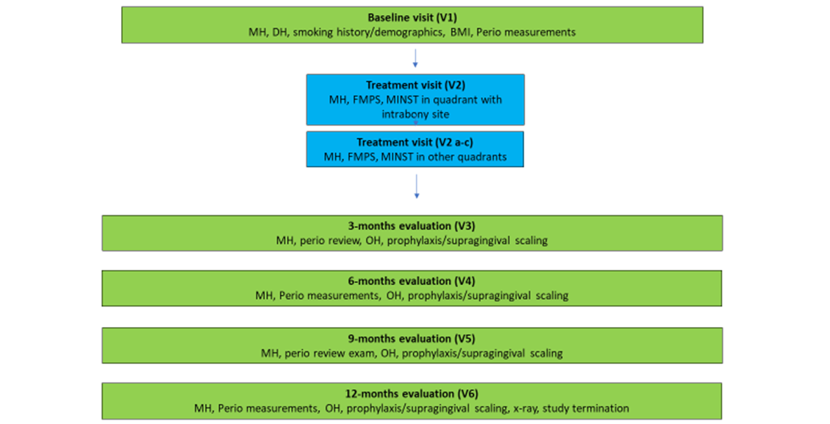
Supplemental Material 2. Study flowchart

Supplemental Material 3 - Schematic representation of landmarks for radiographic analysis
A (cemento-enamel junction), C (apical bone level), B (most coronal position of the alveolar bone crest. A’-B’, horizontal component; B’-C’, intrabony component

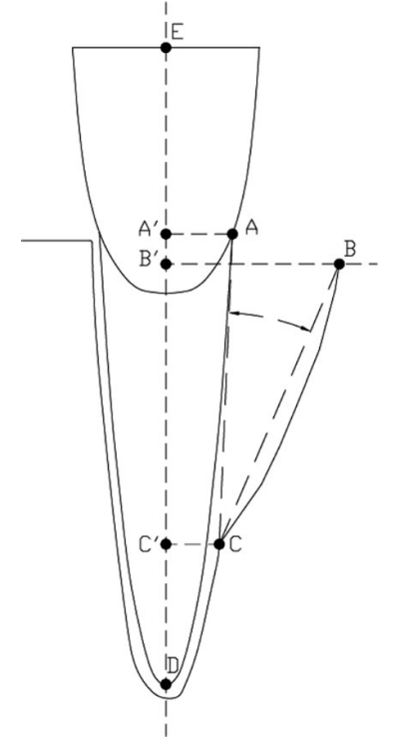

Supplemental Material 4 - Results from univariate analysis showing association of explanatory variables with outcomes of radiographic intrabony defect depth reduction and PPD < 5mm. *Statistically significant difference at 0.05 level
 | p-value for radiographic intrabony defect depth reduction | p-value for PPD<5mm at 12 months
Categorical variables
Gender | 0.658 | 0.244
BMI | 0.599 | 0.991
Smoking history (never, former vs current) | 0.676 | 0.270
Tooth type (incisor, canine, premolar vs molar) | 0.056 | 0.767
Baseline plaque at test site | 0.513 | 0.618
Defect angle (narrow vs. wide) | 0.036* | 0.039*
Defect extension | 0.470 | 0.618
Defects with 1-wall component vs only 2-3 walled | 0.057 | 1.000
Furcation involvement | 0.655 | 0.202
Operator | 0.095 | 0.410
Instrument | 0.066 | 0.013*
Bleeding at the end of treatment  (no bleeding, minor or profuse bleeding) | 0.933 | 1.000
Continuous variables
Age | 0.668 | 0.120
Plaque score | 0.342 | 0.102
Test site PPD | 0.731 | 0.516
Total radiographic defect depth | 0.001* | 0.552
Total treatment time at test site | 0.744 | 0.903

