Supplementary material

Assessment of PD-L1 expression
The PD-L1 expression was assessed in archival, formalin-fixed tumour samples stored at the central laboratory of the University of Verona, Italy, using the PD-L1 IHC 22C3 pharmDx assay (Agilent Technologies). This expression was characterised according to the combined positive score (CPS), which was calculated as the number of PD-L1–positive cells (tumour cells, lymphocytes and macrophages) divided by the total number of tumour cells, multiplied by 100.

Supplementary Figure 1: Waterfall plot of the change in the targeted tumour lesions in the evaluable patients (only 9 out of 11 complete responses have been confirmed at the subsequent evaluation)

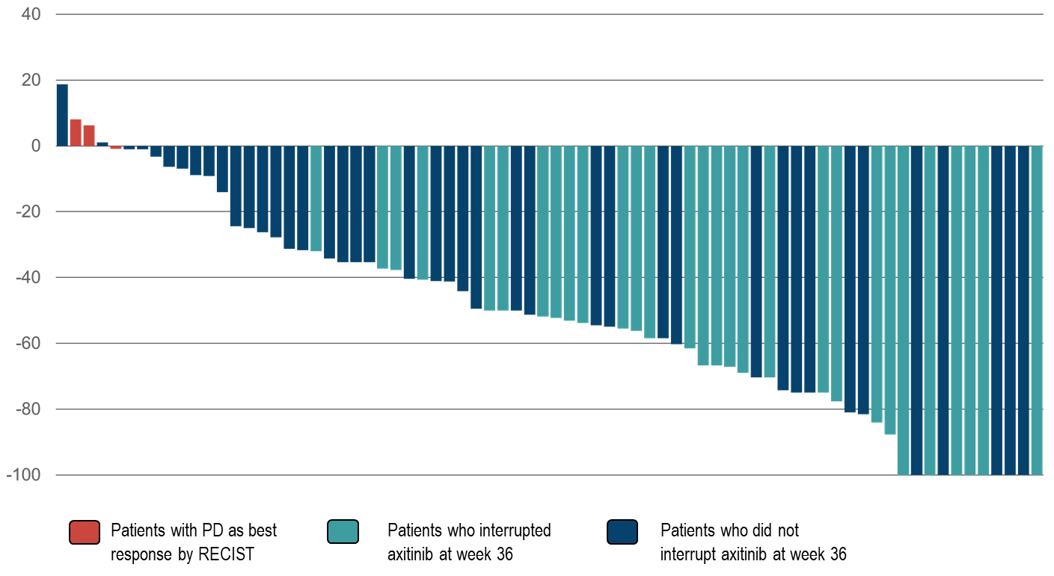

Supplementary Figure 2: The flow of patients who interrupted axitinib at week 36.

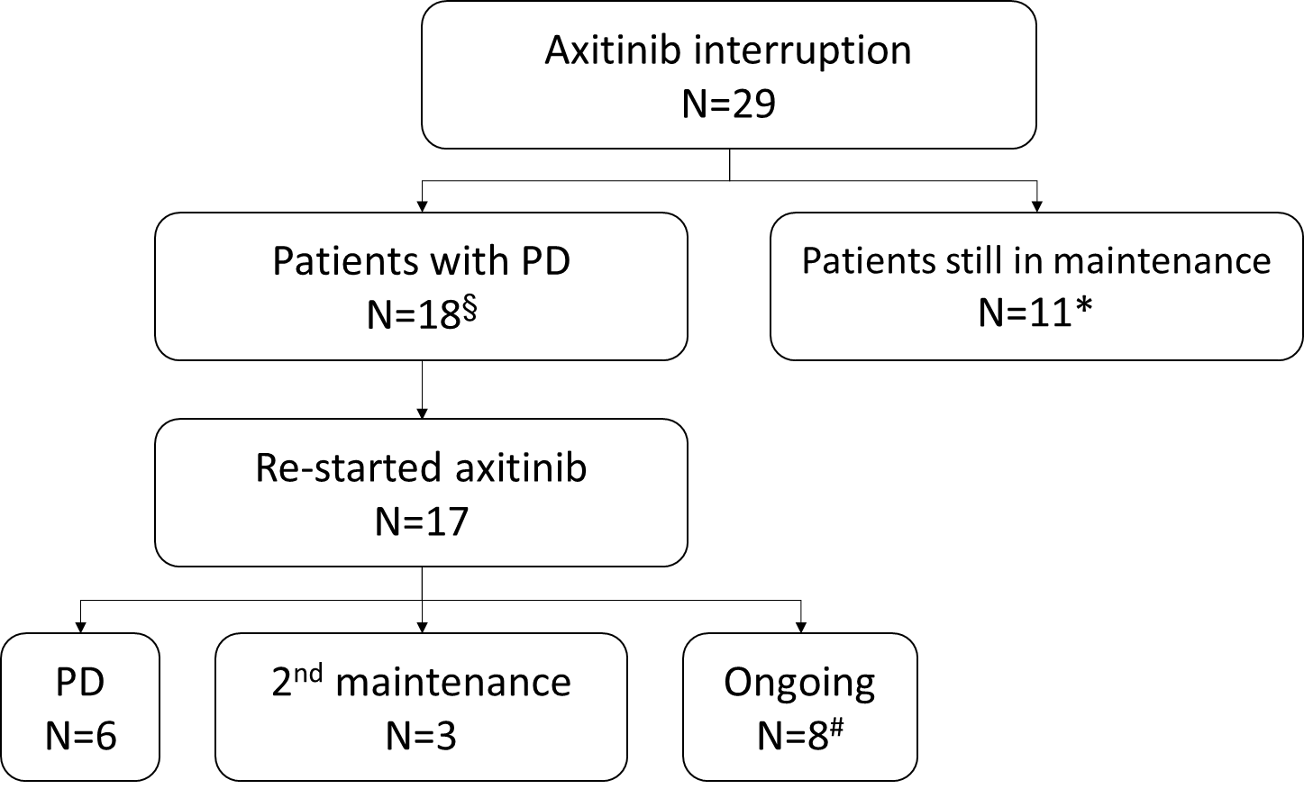

PD: progressive disease
*: 2 patients discontinued therapy without evidence of PD.
§: 1 patient refused to restart axitinib and had subsequent PD.
#: 6 patients have not yet completed 24 weeks of second axitinib intensification and 2 patients had not tumor response and continued the combination.

