Appendix 1. Data preparation

Appendix1, Data preparation, Table A1.1. The number of significant axes and the cumulative variance in the data that they extracted for the principal components analyses (PCA) of 8 CHELSA bioclimate and 11 ISRIC soil variables.
Variables | # Axes | % Variance, 1st | % Variance, 2nd
CHELSA | 2 | 49.131 | 23.805
ISRIC | 2 | 43.919 | 19.256

Appendix 1, Data preparation, Table A1.2. Correlation coefficients for regional species richness with the standard deviations of the individual soils and climate variables (from ISRIC and CHELSA, respectively) and for the metrics for soil and climate derived by applying the shoelace algorithm to points in 2D PCA space for the same original data.
Variable type | Variable name | r
Soils | BDOD | -0.138
 | CEC | 0.501
 | CLAY | 0.431
 | CFVO | 0.088
 | NITROGEN | 0.287
 | OCD | 0.202
 | SAND | 0.027
 | SILT | -0.12
 | SOC | -0.047
 | OCS | -0.108
 | PH | 0.065
 | SoilMetric | 0.590*
Climate | MAT | 0.505
 | MDR | -0.038
 | ISO | -0.345
 | TSY | -0.339
 | WMT | -0.398
 | CMT | -0.2
 | TAR | -0.411
 | WEQT | 0.424
 | DQT | 0.072
 | WQT | -0.227
 | CQT | 0.627*
 | MAP | 0.537*
 | WMP | 0.481
 | DMP | 0.675*
 | PSY | 0.241
 | WEWP | 0.486
 | DQP | 0.495
 | WQP | 0.547*
 | CQP | 0.485
 | ClimateMetric | 0.842**
* p < 0.01; ** p < 0.001

Appendix 1, Data preparation, Table A1.3. The variables entered in the commonality analysis and those not used (latter 4). Richness is the vascular plant species richness, and AreaG is the area of alpine grassland, both from Jimenez-Alfraro et al. (2021); ClimA and SoilA are the areas of climate and soils in 2D PCA space as calculated by the shoelace algorithm (see text and figures below); ElevDiff is the difference in elevation between the highest peak and the regional treeline elevation as reported by Jimenez-Alfraro et al. (2021).
Range | Richness | Log  AreaG | Log  ClimA | Log  SoilA | Elev  Diff | DistX | Dist3 | Rugged | MaxElev
Baetic | 134 | 2.049 | -0.322 | -0.012 | 978 | 2495 | 783 | 6329 | 3370
Balkan | 433 | 2.188 | -0.293 | 0.587 | 773 | 1979 | 500 | 5934 | 2375
C.Apennines | 445 | 2.911 | -0.544 | 0.640 | 1202 | 1544 | 680 | 8240 | 2910
Cantabrian | 407 | 2.501 | 0.728 | 0.680 | 840 | 2221 | 629 | 8370 | 2550
Central | 216 | 2.687 | 0.412 | 0.702 | 782 | 2386 | 642 | 5482 | 2530
Corsica | 77 | 1.255 | -0.643 | 0.235 | 686 | 1633 | 570 | 12259 | 2600
Dinarides | 777 | 3.639 | 1.421 | 1.025 | 1234 | 1715 | 542 | 5738 | 2530
E.Alps | 565 | 3.908 | 1.338 | 1.218 | 2247 | 1528 | 520 | 12202 | 2825
E.Carpathians | 409 | 1.556 | -0.193 | 0.764 | 0 | 2002 | 775 | 6400 | 2800
E.Pyrenees | 503 | 3.125 | 0.742 | 0.597 | 1033 | 1820 | 648 | 7857 | 3030
EC.Alps | 561 | 4.050 | 1.316 | 1.200 | 2146 | 1494 | 407 | 11558 | 3125
Mar.Alps | 485 | 3.134 | 0.575 | 0.354 | 1287 | 2147 | 801 | 9982 | 2800
N.Apennines | 195 | 0.954 | -2.121 | -0.882 | 420 | 1571 | 520 | 6819 | 2040
N.Iberian | 89 | 1.690 | -0.765 | -0.110 | 503 | 1438 | 352 | 4224 | 2250
Rhodope-Rila | 526 | 3.050 | 0.318 | 0.759 | 386 | 2038 | 442 | 6714 | 2900
S.Apennines | 278 | 1.505 | -0.257 | 0.422 | 1070 | 1903 | 558 | 6131 | 2930
S.Carpathians | 516 | 2.967 | 0.243 | 0.984 | 934 | 2089 | 1125 | 7015 | 2525
S.Hellenides | 408 | 2.276 | 0.203 | 0.711 | 1017 | 2032 | 603 | 8835 | 2450
Scardo-Pindhic | 643 | 3.317 | 0.213 | 0.742 | 1040 | 1766 | 490 | 6548 | 2750
W.Alps | 661 | 3.985 | 1.280 | 0.985 | 1820 | 1503 | 385 | 12579 | 3020
W.Carpathians | 411 | 2.686 | 0.409 | 1.017 | 1340 | 1844 | 866 | 9938 | 2427
W.Pyrenees | 569 | 3.223 | 0.755 | 0.825 | 1299 | 1874 | 642 | 10742 | 2980
WC.Alps | 682 | 3.659 | 1.212 | 0.875 | 3009 | 1508 | 389 | 13227 | 2995

Appendix 1, Data preparation, Figure A1.1. The alpine grasslands of 23 mountain ranges of southern and central Europe (Lambert Azimuthal Equal Area Projection; see https://epsg.io/3035). These locations are mapped at 1-km spatial resolution from analyses of Landsat NDVI for the areas above regional treelines (Jiménez-Alfaro et al. 2021).
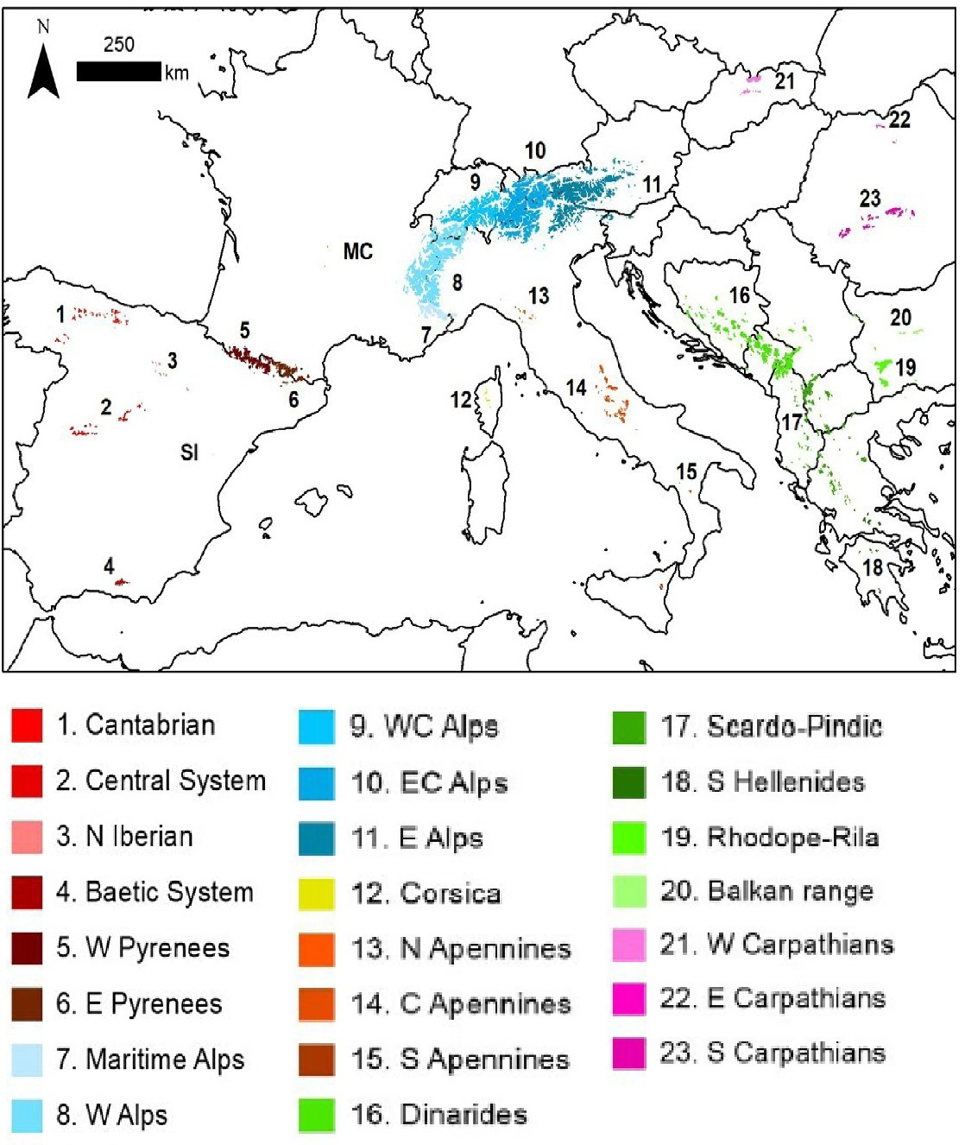
References

Jiménez-Alfaro, B., Abdulhak, S., Attorre, F., Bergamini, A., Carranza, M.L., Chiarucci, A., … & Winkler, M. (2021). Postglacial determinants of regional species pools in alpine grasslands. Global Ecology and Biogeography, 30, 1101-1115.

Appendix 1, Data preparation, Figure A1.2. Examples of the distribution of the alpine grassland habitats in climatic dimensions derived from Principal Components Analysis (PCA) of eight bioclimatic variables from CHELSA and the outline used to calculate the area (ClimA) using the shoelace algorithm.
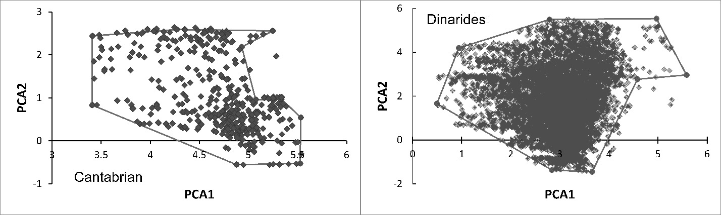

Appendix 1, Data preparation, Figure A1.3. Examples of the distribution of the alpine grassland habitats in edaphic dimensions derived from Principal Components Analysis (PCA) of 11 soils variables from ISRIC and the outline used to calculate the area (SoilA) using the shoelace algorithm.
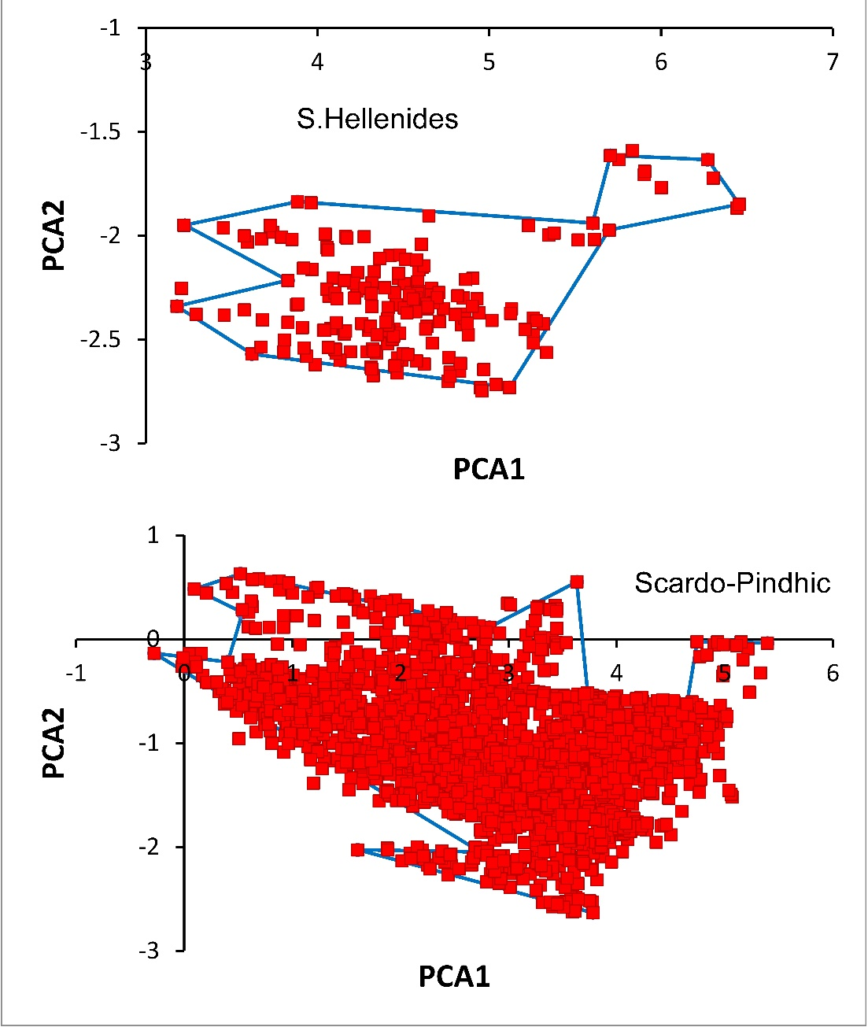

Appendix 2. Simulation background, ODD Protocol
ODD OVERVIEW
Purpose and patterns.
A comparison of different combinations of area and heterogeneity configurations using virtual species adapted to an environmental gradient can elucidate how diversity responds to control by geography vs. environment. Our purpose is to determine the relative roles of the two factors in generating patterns of vascular plant species richness (regional richness) in a general framework.
First, the simulation was parameterized for each of the 23 alpine regions of southern and central Europe (Jimenez-Alfaro et al. 2021). The number of cells and the environmental heterogeneity scaled to observations, and a parameter for carrying capacity accounted for the possibility of limits on the density (number of individuals per cell). Each region was initiated with a fractal pattern of habitat using the NetLogo Hill Climbing Example. This spatial simulation is a microcosm of each of the 23 ranges. The cells and numbers of individuals and species do not represent areas of terrain and generate relative numbers of species. The microcosm allows efficient computation of the relative richness among regions for statistical analysis; it is not meant to represent the number of individuals per square kilometer or the number of species per range. The pattern of diversity across the ranges, not the absolute values, is used to evaluate the simulation, (i.e., we expect a high correlation, but not a 1:1 slope).
Second, we implemented the simulation model in an experimental mode. These simulation experiments used all combinations of 10 levels of area and 10 levels of environmental heterogeneity, and carrying capacity was constant. The experimental designs were run independently, and their results are compared.
Entities, state variables, and scales.
In the first set of simulations the model represents a microcosm of each of the 23 mountain ranges in southern and central Europe. In more general analyses, the model is any area with environmental heterogeneity. The model does not have a specified spatial scale because the simulation experiments address relative effects of the parameters. Each cell of habitat has a value for an environmental gradient that is initialized in one of ten spatial patterns for replication. The plant communities of these alpine habitats are represented by 100 individual species These agents were differently adapted to the environmental gradient in four ways in preliminary analysesin even increments so that they had the potential to fill all niches and occupy all locations.
Process overview and scheduling.
Within each simulation, at each iteration agents reproduce, and the offspring disperse across the grid; agents are removed randomly to maintain a maximum density; and agents are removed depending on their adaptation to the grid cell climate or location. The simulations were replicated 10 times for each of the 10 areas and 10 levels of heterogeneity using the same 10 random number seeds so that the initial fractal pattern would be the same among areas differing in heterogeneity. The simulations equilibrate (no change through 1000 itertions) by 6000 iterations, and the number of species was counted after 10,000 iterations. The experimental designs were run independently.

DESIGN CONCEPTS
The simulations separate the effects of area and environmental heterogeneity.
The agents are not goal-oriented; behavior is random; the agents sense the environment of the grid cell they occupy and their fitness relative to it determines probabilities of reproduction and death.
Agents compete indirectly for space via random deletion of agents when cell density is greater than a set value.
The central processes are Monte Carlo reproduction and mortality so that the species are selected by the environment of the grid cells (i.e., fitness).
The plant diversity of the alpine region, represented by the presence of species on all its grid cells, is the object of analysis.
The diversity for the simulated area is the sole output of the simulation.
The agents do not adapt, learn, or predict, nor is there emergent behavior.
DETAILS
Initialization
The environment of each cell of the grid was initialized in a fractal pattern (hills). A topography subroutine of the NetLogo Hill Climbing Example, is used. It assigns peaks to random cells and successively divides the height of all cells to its neighbors. We scaled the number of peaks and the number of divisions to the area of the grid.
The range of environmental heterogeneity, centered on 0.5, is scaled to the range of elevations and assigned to each cell. Each grid was wrapped into a torus to eliminate edge effects.
Each cell is assigned response value for each of 100 virtual species with Gaussian response functions of the environment of the cell:

$$R_{ix}=e^{-{(((E}_{x}{-m_{i})}^{2}{/2σ}^{2})))}$$

where E_{x} is the position of the cell on the environmental gradient; the m_{i} is the position of the mode of the species on the gradient; and σ² is the standard deviation of the Gaussian function, chosen here as 0.001, which produced distributions of regional richness (2-100) spanning nearly the full possible range across all simulations. Thus, 100 such equations define 100 virtual species.
The values for the distribution of modes and σ were chosen after preliminary analyses. We began with the modes evenly distributed along the gradient and the opposite limit with all species having an identical niche with the mode centered on the gradient. We added two other parameterizations to examine potential bias:
1. The modes are evenly distributed, 0.01-1.0 in increments of 0.01 and σ is constant.
2. All 100 species have the same mode and σ.
3. 10 species were assigned to each of 10 modal points that are evenly distributed on the gradient 0.05-0.95 in increments of 0.1, and random variation is added to each.
4. The modes are randomly distributed along the gradient, and random variation drawn from a normal distribution with a standard deviation of 0.005 is added to σ.

Version 1 embodies the niche theory of diversity (cf. MacArthur and Levins 1967). In version 2, with all response functions identical, only differences due to area are expected except for the expression of HEAT. Version 3 represents the clustering of modes on the gradient that would be found in distinct plant communities. Version 4, a random distribution of modes and breadths is unrealistic but included as a null case. Projected regional richness from versions 1, 3, and even 5 were nearly identical (correlations among all versions, r > 0.93; Appendix 2, Table 1), and we report version 1 because it aligns best with past theoretical representations (MacArthur and Levins 1967), the species have the potential to fill all niches and occupy all locations, and it requires fewer replicate runs. We did not simulate specialist versus generalist species which would require further parameterization (e.g., Malanson 1997); Sfenthourakis et al. (2021) noted that this approach can affect modeling of the HEAT phenomenon.
To initialize the distributions, the species were stochastically allotted on each active cell if a uniform random number (0-1) was less than their response value for that cell. Individuals were randomly selected and removed while the number per cell exceeded 100.
The above steps of initialization were first applied to 23 independent areas with parameters derived from observations of southern and central Europe. Then, in experimental mode, three spatial conditions were represented. The first was a set of 1000 independent islands from 10 areas (100, 400, 900, 1600, 2500, 3600, 4900, 6400, 8100, and 10000 cells), 10 levels of heterogeneity (0.1, 0.2, 0.3, 0.4, 0.5, 0.6, 0.7, 0.8, 0.9, 1.0), and 10 replicates (using the same 10 random number seeds: 50, 150, 250, 350, 450, 550, 650, 750, 850, 950). The second was 10 replicate areas of 12,544 cells using the same random number seeds with the same 10 levels of heterogeneity divided into 10 concentric circles with areas matching the previous set of 10 areas. Thus, 1000 units were defined. The third was a single rectangle of 9600 cells, again with the same 10 levels of heterogeneity and 10 replicates, divided into 6 quadrats, each of which had 4 nested subquadrats of areas matching the smaller units of the previous sets (100, 400, 900, 1600). The quadrats were accumulated as further nested areas of 3200, 6400, and 9600 cells. Here, 2700 units were defined.
Submodels
The models cycle through two submodels or procedures at each iteration: reproduction with dispersal and mortality. In reproduction with dispersal, in each iteration individuals produce an offspring that is dispersed in a random direction at a distance (integer number of cells) randomly selected from an even distribution varying 0-4 at each instance (after preliminary analyses found no significant differences among different dispersal ranges, this constant range was retained to simplify the comparisons). For mortality, individuals were removed at each iteration if a uniform random number (0,1) was greater than their response value for that cell. Additionally, individuals were randomly selected and removed while the number of individuals per cell exceeded a carrying capacity. This limit represents the maximum number of individuals that a cell can support and can represent productivity. In our simulations of the 23 ranges we scaled in relation to the product of warm quarter temperature and warm quarter precipitation with a minimum of 2 and a maximum of 15 (Baetic System and W. Carpathians). In the experimental mode, it is constant at 9.
Output
The diversity for each spatial unit of the simulated areas at the end of each 10000-iteration replication is the output of the simulation. Additional code to record species richness per cell and the Sorenson similarity and its turnover and nestedness components as a measures of beta diversity are available as subroutines, which were not called in this version.
References
Jiménez-Alfaro, B., Abdulhak, S., Attorre, F., Bergamini, A., Carranza, M.L., Chiarucci, A., … & Winkler, M. (2021). Postglacial determinants of regional species pools in alpine grasslands. Global Ecology and Biogeography, 30, 1101-1115.

Appendix 2, Simulation background, Figure A2.1. Examples of a fractal pattern created by the HillClimber model in NetLogo (Wilensky 1999), which was used to initialize the pattern of environmental heterogeneity in the simulations. In the general experiments, the Hills pattern was created at 10 levels of heterogeneity and for 10 areas using 10 random number seeds for replicates.
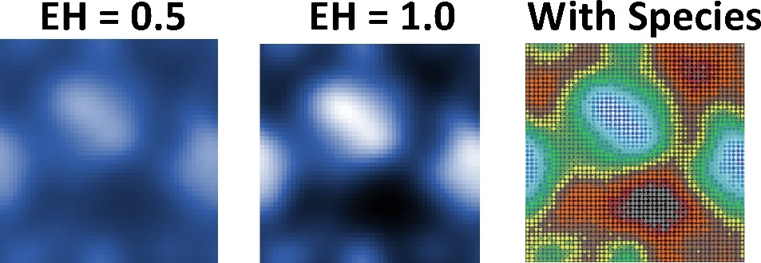

References
Wilensky, U. (1999). NetLogo. http://ccl.northwestern.edu/netlogo/. Center for Connected Learning and Computer-Based Modeling, Northwestern University, Evanston, IL.

Appendix 2, Simulation background, Figure A2.2. Gaussian response functions for 100 virtual species are distributed on an environmental gradient.
Even distribution of modes (center part shown):
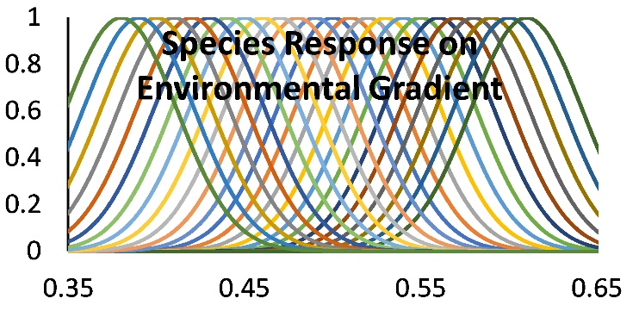

Appendix 2, Simulation background, Figure A2.3. Relationships between versions of species niche with the classical version (modes even) (a), a single mode for all species, random variation around 10 evenly spaced clusters, and completely random.

Appendix 2, Simulation background, Figure A2.4. The spatial representations of islands of varying size and heterogeneity (a,b,c), nested areas in a mainland (d), nested areas in provinces (e), and increased discreteness to increase HEAT (f).
a b c
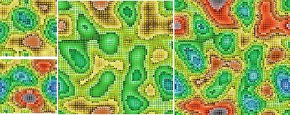
d e f
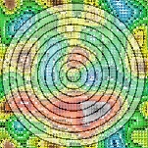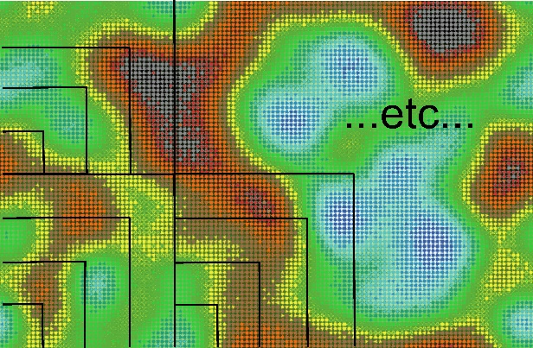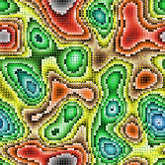

Appendix 2, Simulation background, Table A2.1. Pearson correlations between versions of species niche with the modes even (1), a single mode for all species (2), random variation of 10 clusters (3), and random (4).
Niche Versions | Version 1 | Version 2 | Version 3
Classical Version 1 | - | - | -
Single Version 2 | 0.047 | - | -
Clusters Version 3 | 0.972 | 0.027 | -
Random Version 4 | 0.973 | -0.141 | 0.954

Appendix 2, Simulation background, Table A2.2. The parameters used in the simulation were taken from the empirical data on the 23 ranges of southern and central Europe.
Region | Area  (# cells) | AreaGrassland  (# cells) | EnvHet  (0-1) | Carrying Capacity  (2-15)
Baetic System | 324 | 114 | 0.042 | 2
Balkan range | 256 | 154 | 0.139 | 10
C Apennines | 928 | 815 | 0.151 | 6
Cantabrian | 423 | 317 | 0.270 | 5
Central System | 522 | 486 | 0.220 | 4
Corsica | 58 | 18 | 0.062 | 3
Dinarides | 6397 | 4357 | 0.898 | 11
E Alps | 11236 | 8090 | 1.000 | 12
E Carpathians | 41 | 36 | 0.206 | 11
E Pyrenees | 1387 | 1334 | 0.246 | 7
EC Alps | 16566 | 11218 | 0.956 | 11
Maritime Alps | 1638 | 1361 | 0.153 | 8
N Apennines | 64 | 9 | 0.005 | 5
N Iberian | 50 | 49 | 0.029 | 5
Rhodope-Rila | 1173 | 1121 | 0.233 | 6
S Apennines | 128 | 32 | 0.099 | 4
S Carpathians | 1017 | 927 | 0.356 | 11
S Hellenides | 206 | 196 | 0.203 | 2
Scardo-Pindic | 2524 | 2077 | 0.217 | 6
W Alps | 16156 | 9670 | 0.716 | 8
W Carpathians | 911 | 485 | 0.398 | 15
W Pyrenees | 2255 | 1671 | 0.340 | 8
WC Alps | 7998 | 4559 | 0.588 | 13

Appendix 3. Supporting Results
Appendix 3, Supporting Results, Table A3.1. The observed species richness for the 23 ranges reported by Jimenez-Alfaro et al. (2021) and the corresponding mean values from 10 replications of the simulation.
Range | Observed | Simulated
Baetic System | 134 | 2.2
Balkan range | 433 | 6.3
C Apennines | 445 | 10.2
Cantabrian | 407 | 11.3
Central System | 216 | 8.4
Corsica | 77 | 1.1
Dinarides | 777 | 76
E Alps | 565 | 89
E Carpathians | 409 | 1.6
E Pyrenees | 503 | 18
EC Alps | 561 | 87.9
Maritime Alps | 485 | 12
N Apennines | 195 | 1
N Iberian | 89 | 1.2
Rhodope-Rila | 526 | 13.9
S Apennines | 278 | 2.7
S Carpathians | 516 | 23.9
S Hellenides | 408 | 3.6
Scardo-Pindic | 643 | 16.9
W Alps | 661 | 65
W Carpathians | 411 | 29.3
W Pyrenees | 569 | 26.2
WC Alps | 682 | 51.5
Appendix 3, Supporting Results, Table A3.2. Statistics of the simulation results for the island patterns. Regional richness, as shown in Figure 2A,B respectively, is regressed on area in categories of environmental heterogeneity and on environmental heterogeneity in categories of area.
EnvHet | x Area; y = | R² |  | Area | x EnvHet; y = | R²
0.1 | 15.873x + 2.28 | 0.8759 |  | 100 | 1.5272ln(x) - 4.3668 | 0.7777
0.2 | 32.776x + 0.4933 | 0.9613 |  | 400 | 3.0157ln(x) - 10.368 | 0.8933
0.3 | 42.067x + 0.2333 | 0.9154 |  | 900 | 4.3196ln(x) - 15.122 | 0.899
0.4 | 52.03x - 0.1267 | 0.9206 |  | 1600 | 5.3961ln(x) - 18.051 | 0.8868
0.5 | 57.2x + 1.24 | 0.9338 |  | 2500 | 6.5465ln(x) - 21.964 | 0.9173
0.6 | 62.121x + 0.9933 | 0.951 |  | 3600 | 7.7489ln(x) - 25.623 | 0.9103
0.7 | 67.624x + 1.1067 | 0.9601 |  | 4900 | 9.1777ln(x) - 30.85 | 0.8986
0.8 | 70.509x + 1.66 | 0.9721 |  | 6400 | 10.534ln(x) - 35.346 | 0.9229
0.9 | 71.303x + 2.9733 | 0.9763 |  | 8100 | 12.267ln(x) - 42.398 | 0.9129
1.0 | 75.661x + 2.3267 | 0.9817 |  | 10000 | 13.571ln(x) - 46.91 | 0.9164

Appendix 3, Supporting Results, Table A3.3. Random Forest Model statistics for the representations of islands, concentric circles, and provinces for all simulation runs and then divided into the smaller and larger halves. Statistics are for 500 trees and include explained variance percentage, the tree size at the terminal nodes for the 1st, median, and third quartiles, and the decrease in node impurity as the indicator of importance.
Representation | Statistic | All Areas | Small Areas | Large Areas
Islands | % of Variance | 0.955 | 0.917 | 0.937
 | Residual Mean Square | 17.546 | 18.268 | 26.418
 | Tree Size 1st Q | 43 | 21 | 22
 | Tree Size Median | 50 | 25 | 26
 | Tree Size 3rd Q | 57 | 300 | 30
 | Area Importance | 110011.751 | 30021.087 | 5848.787
 | EnvHet Importance | 241381.208 | 60542.652 | 169961.290
Circles | % of Variance | 0.955 | 0.917 | 0.942
 | Residual Mean Square | 15.895 | 18.268 | 23.162
 | Tree Size 1st Q | 116 | 21 | 38
 | Tree Size Median | 153.5 | 25 | 57
 | Tree Size 3rd Q | 185.25 | 30 | 79
 | Area Importance | 50876.745 | 30021.087 | 3235.005
 | EnvHet Importance | 276497.486 | 60542.652 | 162133.250
Provinces | % of Variance | 0.817 | 0.822 | 0.837
 | Residual Mean Square | 58.680 | 28.387 | 55.902
 | Tree Size 1st Q | 40 | 17 | 17
 | Tree Size Median | 53 | 26 | 25
 | Tree Size 3rd Q | 67 | 33 | 32
 | Area Importance | 28163.340 | 10335.138 | 4872.812
 | EnvHet Importance | 80586.138 | 16466.290 | 49860.006

Appendix 3. Supporting results, HEAT, Figure A3.1. Richness decreased with increasing heterogeneity at all areas if all species have identical niches in the middle of the environmental gradient (a). With two or three clusters (b, c), regional richness has a unimodal pattern at any one area (here, the 900 cell case is shown). With the most discrete habitats (precision of 2 decimal points) and a random distribution of niche modes on the environmental gradient, HEAT was not evident (d).

