Appendix A
Full description of the experimental conditions (both Study 1 and Study 2)
Block | Anthropomorphism | Gaze Direction | Gender | Explanation
1 | High | Direct | Male | This block exposes participants to a male chatbot whose appearance has high levels of anthropomorphism (AI-generated picture taken from www.thispersondoesnotexist.com) and looking straight to the participant
2 | High | Averted | Male | This block exposes participants to a male chatbot whose appearance has high levels of anthropomorphism (AI-generated picture taken from www.thispersondoesnotexist.com) and with an averted gaze from the participant
3 | High | Direct | Female | This block exposes participants to a female chatbot whose appearance has high levels of anthropomorphism (AI-generated picture taken from www.thispersondoesnotexist.com) and looking straight to the participant
4 | High | Averted | Female | This block exposes participants to a female chatbot whose appearance has high levels of anthropomorphism (AI-generated picture taken from www.thispersondoesnotexist.com) and with an averted gaze from the participant
5 | Low | Direct | Male | This block exposes participants to a male chatbot whose appearance has low levels of anthropomorphism (by avatarizing the picture of the chatbot in Block 1) and looking straight to the participant
6 | Low | Averted | Male | This block exposes participants to a male chatbot whose appearance has low levels of anthropomorphism (by avatarizing the picture of the chatbot in Block 2) and with an averted gaze from the participant
7 | Low | Direct | Female | This block exposes participants to a female chatbot whose appearance has low levels of anthropomorphism (by avatarizing the picture of the chatbot in Block 3) and looking straight to the participant
8 | Low | Averted | Female | This block exposes participants to a female chatbot whose appearance has low levels of anthropomorphism (by avatarizing the picture of the chatbot in Block 4) and with an averted gaze from the participant

Sample stimuli
Block 1: Male × Direct Gaze × High Anthropomorphism

Block 4: Female × Averted Gaze × High Anthropomorphism



Block 6: Male × Averted Gaze × Low Anthropomorphism
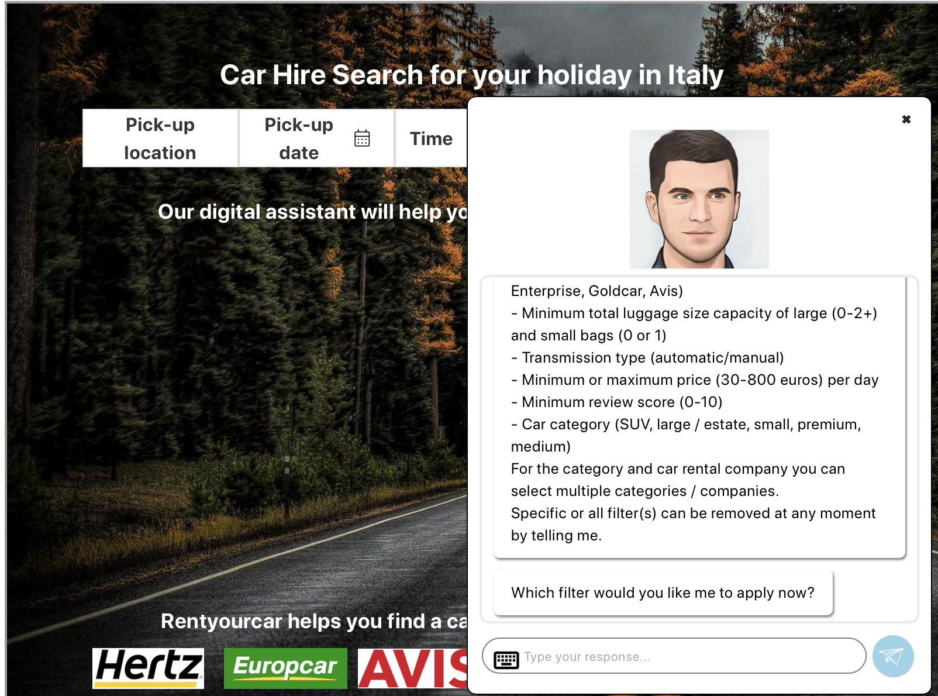

Block 7: Female × Direct Gaze × Low Anthropomorphism
