Potential volatile organic compounds emission in indoor urban farming: a case study
G. Stringari^{1,a}, N. Moraleda¹, A. Rosell^{1,2†}, J. Rieradevall^{4,1}, F. Orsini³, X. Gabarrell^{4,1}
¹Institut de Ciència i Tecnologia Ambientals ICTA-UAB (CEX2019-0940-M), Universitat Autònoma de Barcelona (UAB), Bellaterra, Spain; ²Institució Catalana de Recerca i Estudis Avançats (ICREA), Barcelona, Spain; ³Department of Agricultural and Food Sciences, University of Bologna Alma Mater Studiorum, Bologna, Italy; ⁴Department of Chemical, Biological and Environmental Engineering, (Catalan Biotechnology Reference Network -XRB-), Universitat Autònoma de Barcelona (UAB), Bellaterra, Spain; † Deceased on December 2021.
ªE-mail: gaia.stringari@uab.cat

Abstract
A possible solution to cope with climate change and food insecurity is city greening, through extensive adoption of green infrastructures and urban agriculture. Often, however, little consideration is given to potential impacts that could be derived from elevate Biogenic Volatile Organic Compounds (BVOCs) released by plants. BVOCs can account for up to 90% of global VOC emissions. In indoor spaces, their levels are still unknown, although they may raise as much concern as for GHGs. Here, we present a study on monitoring BVOCs emitted by a mature crop of green beans (Phaseolus vulgaris L. ‘Pongo’) cultivated inside an integrated rooftop greenhouse (i-RTG) in the Mediterranean area. Long-term air measurements were taken by passively sampling the atmosphere inside the i-RTG and in an inner open chamber hosting plants to monitor physiological emissions, as well as from the external outdoor environment, as control. An additional short measurement was taken on four plants in static-head space conditions to check detected BVOCs. Among a wide range of different volatiles terpenes, methanol and acetic acid were always found (including in the control), suggesting that their origin should not be associated with i-RTG plants. However, the detected signals were below the analytical procedure's LLOQ (lower limit of quantitation). In the static-head space sample, most GC-MS signals could be identified as terpenoid compounds based on their MS spectra and by comparison of their chromatographic retention times with standards; though signals were faint, estimated values were below ppb. Accordingly, the results suggested passive sampling as a practical and easy-to-implement method to produce preliminary tracking of BVOC emissions. However, active sampling may improve the quantitative assessment of their levels inside the i-RTG.
Keywords: BVOCs, i-RTG, green bean, protected agriculture, hydroponic cultivation
INTRODUCTION
Implementing urban green spaces represents one of the strategies embraced by the European programme Horizon 2020 to contain climate change impacts and improve citizens’ life quality (European Commission, 2019). In this framework, urban agriculture supports city resilience and liveability (Armanda et al., 2019) and simultaneously tackles issues related to food security and sustainable food production (Langemeyer et al., 2021; Opitz et al., 2016). Due to the limited land available for farming, innovative configurations for urban agriculture that make smart use of existing buildings and available resources have emerged in the last years (Orsini et al., 2014). Nowadays, multiple urban farming systems are available, including indoor, open-air or mixed systems, eventually combined with the urban built environment as for the cases of integrated-rooftop greenhouses (i-RTGs) (Iaquinta and Drescher, 2015; Sabeh, 2020). One direct benefit of city greening relates to plants’ sequestration of tropospheric CO₂ (Jamloki et al., 2021; Saeed Meo and Karim, 2022). Currently, global CO₂ levels have increased and showed a rising future tendency (IPCC, 2021). Including urban farming can therefore improve the environmental performance of the city. However, plants are also big emitters of Biogenic Volatile Organic Compounds (BVOCs), especially terpenes (isoprenoids) that are regularly released into the environment physiologically and under external elicitation (Calfapietra et al., 2013; Niinemets et al., 2004). Some studies forecasted annual levels of BVOCs up to ten times higher than VOCs emitted by anthropogenic activity (Geron et al., 1995; Guenther et al., 2006). Moreover, it was highlighted a disbalancing effect towards the atmosphere (Laothawornkitkul et al., 2009; Peñuelas and Staudt, 2010) connected to BVOCs, e.g., increased residence time of air pollutants (NO_{x}, O₃ and CH₄) (Karl et al., 2008; Peñuelas and Staudt, 2010). Indoors, only abiogenic VOCs were extensively argued by the European Regulation (European Parliament, 2021) and supported by comprehensive guidelines (European Union, 2013; World Health Organization, 2021). Regarding biogenic ones (BVOCS), few studies have been reported on plants’ emissions at the urban level (Niinemets and Peñuelas, 2008; Yang et al., 2009) and still no dedicated directions about their management have been provided. Hence, to better assess plant BVOCs levels inside innovative urban farming systems we performed a study on the measurement of crop emissions inside an i-RTG of the European Mediterranean area (Pons et al., 2015). Since multiple techniques are suggested (Heiden et al., 2015; Lundgren et al., 1994) and given the semi-indoor conditions of i-RTG, we selected the passive sampling for the collection of dynamic flows of cultivated plants (Bartual et al., 1986). Finally, obtained results were compared with those provided by a proofing measurement conducted once in static headspace (Ortega and Helmig, 2008).
MATERIALS AND METHODS
Experimental setting and investigated plants
The experiment was performed from September 13 to October 30, 2018. Crop cultivation was carried out in the South-West oriented i-RTG of ICTA-UAB institute, a building situated on the campus of the Universitat Autònoma de Barcelona (41°29'51.6"N 2°06'31.2"E). Unlike conventional greenhouses, i-RTG shares the environmental flows of the building in which it integrates and communicates with the surrounding outdoor through semi-moving façades (Sanyé-Mengual et al., 2014).
Plant material
Common green bean was selected for the study, a vegetable quite spread in traditional horticulture and broadly consumed by the population of the Mediterranean area. The emission profile of this plant was retrieved from collected literature (Ballhorn et al., 2008; Martins et al., 2019; Quintana-Rodriguez et al., 2015). About 256 seedlings of Phaseolus vulgaris L. ‘Pongo’ of ±10 cm height were equally distributed on lifted perlite bags (fig 1a) inside the cultivable area (40 m²) of the 122.8 m² i-RTG. Plants fertigation with standard nutrient solution for leafy crops dissolved in rainwater was administered via a drip system, several times during the day. Plant feeding was checked daily measuring Electric Conductivity (EC) and pH of the rainy, delivered, and leached water. Climatic conditions inside the i-RTG were tracked by temperature (T) and relative humidity (RH) sensors (CS215, Campbell Scientific) and pyranometers (L202, Hukseflux) for the radiation, distributed at different points of the greenhouse; averages of 10 minutes data were collected by data-loggers (model CR3000 and CR1000X, Campbell Scientific Inc., USA) and used by the automated system (Siemens Building Technologies Ltd) on facades opening to modulate i-RTG’s environmental conditions. Routine greenhouse and crop management, including old leaves shaving, fruit harvesting, and organic chemicals treatment, were carried out for the whole duration of plants cultivation.
Chambers’ design
An open chamber for BVOCs measurements was built aside in the i-RTG (Fig. 1), assembling a steel frame (2 m width x 4.50 m length x 1.70 height x 1.95 m roof height) wrapped by low-density polyethylene (LDPE) cloth divided into two halves of 9 m³ on the long side and left open on the short one. Inside a half, two lines of 32 seedlings on perlite bags (=i-RTG crop arrangement) were placed and grown under the same regime. Air was sustained by an extractor fan (170 m³ h⁻¹ airflow) positioned on the backside to improve plant to grant climatic conditions comparable to the i-RTG. Environmental parameters were recorded by sensors arranged in the chamber, two for T, displaced at the entrance and the end of the section, one for RH, and solar radiation.
A small chamber entirely closed (0.5 m width x 1 m length x 0.6 m height) of 0.33 m³ was constructed to sample volatile emissions in static headspace conditions on a module of four plants (=one perlite bag).
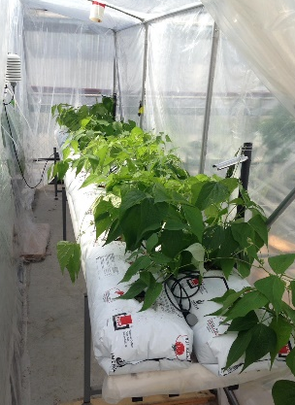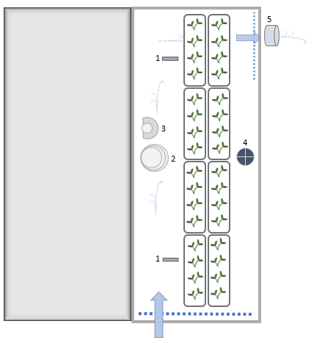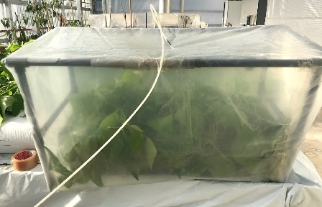
Fig. 1. Arrangement of green beans cultivation inside the open chamber and a schematic representation (left) showing sensors for T (1) and RH (2), pyranometer for radiation (3), extractor fan (5) and the diffusive canister for BVOCs collection (4); static headspace sampling in the close chamber (right).
BVOCs sampling
The sampling period began in the 3rd week of transplanting, at the stems’ average height of 30–35 cm, when plants were fully developed (Ballhorn et al., 2008; Li et al., 2017). The collection of BVOCs was performed with passive sampling carried out twice along the season, either for one week (between Sept 26 and Oct 2), or for two weeks in a row (from Oct 2 to 22), for comparative volatiles accumulation in response to the time of exposure (Bartual et al., 1986). Sampling was performed with diffusive canisters, containing preconditioned stainless-steel tubes (Carbograph 1TD 60/80, Carbosieve SIII 60/80, CAMSCO), positioned in three distinctive spots: one in the midpoint of the open chamber, one in the centre of the i-RTG and one outside, on the building’s rooftop, representing the control sample of indoor emissions (Fig. 2). At the end of the experiment, one measurement of 5 hours (10 am to 3 pm) was taken in the small chamber with active sampling to check BVOCs emitted by enclosed plants. It was performed using a coconut-shell charcoal sorbent (Anasorb® CSC, 6 x 70 mm – 100/50 mg, SKC) mounted with a drying tube (6 x 70 mm, 250 mg, 10/60 mesh, SKC) – to prevent waterlogging in the sorbent– at a suction flow between 330-450 ml min⁻¹, generated and controlled with a pump (M&C) and a mass flow meter (E-7000 Series, Bronkhorst®) system. At the end of sampling, diffusive tubes were capped and stocked at 4°C before analysis that was led by an external laboratory (Centres Científics I Tecnològics, Universitat de Barcelona). Similarly, active sorbent briefly flushed with Nitrogen to prevent BVOCs oxidation was stored under the same condition; its analysis was carried out in situ.
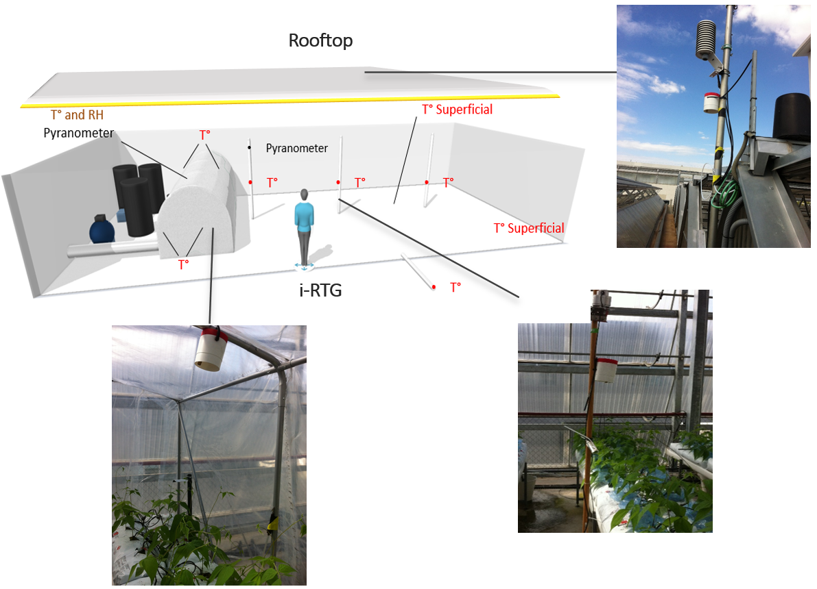
Fig. 2. Allocation of diffusive canisters (sampling points) for the collection of the volatiles throughout the experiment.
Post-sampling BVOCs analysis

1. Diffusive canisters desorption and analysis.
Stainless-steel tubes were analyzed at the Universitat Autònoma de Barcelona using thermal desorption (Unity Series 2-Ultra Series 2, Markes International) coupled to GC-MS system (TD-GC/MS Thermo Focus DSQII GC/MS, ThermoFisher Scientific). To point out eventual differences in instrument response, the first batch (Sep 26) was injected in (double) split mode, while the second one (Oct 2) in splitless. Oven conditions: 300 °C (maintained for 10 min) long primary desorption transported by helium gas at 55 ml min⁻¹; split injection at 11 ml min⁻¹ with initial temperature -27 °C in the cold trap (U-T15ATA-2S: TO-15/TO-17 Air Toxics trap, Markes International); 300 °C (maintained for 10 min) for secondary desorption transported by helium at 1.8 ml min⁻¹ into ZB-624 capillary column (Zebron™, 60 m x 0.32 mm x 1.8 μm, Phenomenex). GC temperature program: initial temperature 40 °C (for 1 min), followed by a 6 °C min⁻¹ temperature ramp to a final temperature of 230 °C (maintained for 5 min). MS transfer line was set at 250 °C and ion source at 200 °C. Ms signal was achieved in MS scan mode at 30-300 amu. By screening selected ranges of m/z fragments, individuated peaks were then identified by MS spectra in the given NIST library.

2. Active sorbent extraction and analysis
Analysis of the active sorbent was performed in the ICTA laboratories following a procedure adapted from Ballhorn et al. (2008). The adsorbent material of the sorbent was transferred to a 4.5 mL glass vial. In the vial 50 μL of a stock solution of 25 ng μL⁻¹ of 1-bromodecane (1-Bromodecane 98% purity Sygma-Aldrich) internal standard and dichloromethane (DCM, ≤ 100 % purity, Supelco) was added and bring to volume with DCM. The resulting solution was analyzed using GC-MS system (7890A/7975C GC/MS, Agilent). An aliquot (1µL) was splitless injected in the GC capillary column Ultra Inert DB-5 MS (25m x 0.25 mm x 0.25μm, Agilent) carried by He at 1 mL min⁻¹ constant flow. BVOCs were eluted using the following GC temperature program: an initial temperature of 40 °C (for 2 min) followed by a 6 °C min⁻¹ temperature ramp to a final temperature of 280 °C (maintained for 4 min). MS transfer line and ion source were set at 250 °C and 150 °C, respectively. Ms signal was acquired in MS scan mode at 35-400 amu. Identification of the chromatographic peaks was performed by comparison of the MS spectra with the NIST08 database using the MassHunter software (Agilent). Concentration estimates were obtained using peak area ratios between the target compound and the internal standard, and assuming the same response factor for both compounds.
RESULTS AND DISCUSSION
Environmental conditions
Throughout crop cycle, in the i-RTG average T and RH were 22.5 °C and 65.1 %, though peaks below and above average T and RH were registered (12.2– 39.5 °C; 18.5–94.1 %) due to seasonal climatic variations. Between the first and the second term of sampling, average T and RH progressed inversely (-3°C; +3%), according to fall progression. In the open chamber, temperature was equally distributed, and levels were equivalent to i-RTG’s ones, except for relative humidity, usually higher (+6%). Average radiation registered in the i-RTG was barely 22% of the total outdoor radiation and even lower inside the chamber.
Samples analyses
1. Passive sampling results
Tentatively identification of volatiles in the two sample batches is reported in Table 1. Due to the huge number of trapped compounds and the high variability of related peak areas in the TIC (Fig. 3), BVOCs researched focussed on those reviewed by literature.
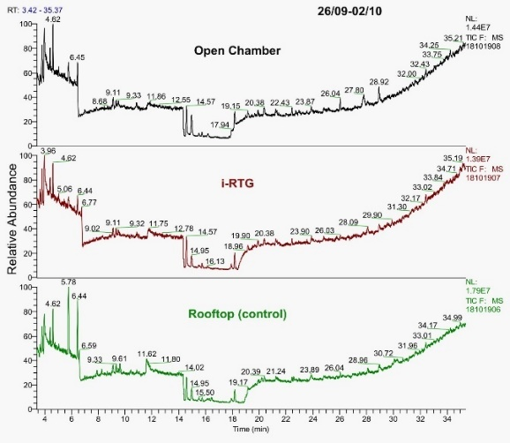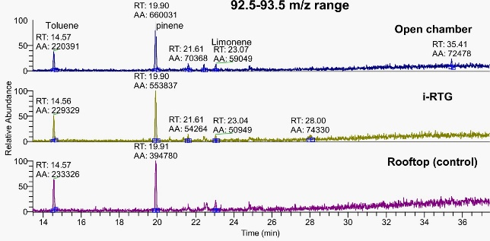
Fig. 3. Total Ion Chromatograms (TICs) of the open chamber, i-RTG and rooftop-control sample, obtained after one week (left) and example of extracted MS channel (right) for monoterpenes (92.50-93.50 m/z).

Quantitation of identified compounds was not possible due to signals below the quantitation limit set by the instrument method. Only preliminary information was given by the peaks’ area (Table 1). Overall, no appreciable differences were detected among the batches nor between the sampling points (open chamber, i-RTG and rooftop). In the control sample, a progressive increase in peaks retention times (RT) was usually observed and was attributed to tube breakthrough by particles other than VOCs (e.g., water droplets). Several peaks were identified with VOCs commonly present in the air (omitted in the summary table). Certain BVOCs were identified with monoterpenes, found in all samples with a variation of less than 40% and with α-pinene as the most abundant. Methanol and acetic acid were also ubiquitous and from 15 to 172-folds higher than terpenes but considering multiple sources emitting, their biogenicity was unconfident. Air pollutant, toluene, was present in all the collected emissions, with variable abundance, higher than most terpenes. The remaining peaks were not identified due to the faint signal-to-noise ratio (S/N) ratio.
Table 2. Identified compounds in the diffusive canisters after one week and two weeks of exposure
Compound type | Compound name | RT (min) | Target ion range (m/z) | relative abundance range (Area counts) | Sampling spotª
Monoterpenes  Benzenes  Aldehydes  Alcohols | α-pinene  β-pinene?  cumene  limonene  toluene  acetic acid  methanol | 19.90  21.61  22.46  23.07  14.57  11.70  4.62 | 92.50-93.50  92.50-93.50  92.50-93.50  92.50-93.50  92.50-93.50  59.50-60.50  30.50-31.50 | 390000 – 660000  56600 – 75800  54000 – 71600  54700 – 63900  220000 – 233000  5700000 – 11000000  8800000 – 10970000 | A, B, C  A, B  A  A, C, B  C, B, A  C, B, A  A, C, B
ªIn order of abundance, the samples obtained from A=open chamber, B=i-RTG and C=rooftop after one week of exposure.

2. Active sampling results
Relevant detected and identified compounds are resumed in Table 2. Among co-eluted signals, in the first 15 minutes of the chromatographic run, separated peaks were attributed to α-pinene, 3-carene, and limonene monoterpenes with a good match (72-83%) in the NIST library. IS (1-bromodecane) was identified (>96% score) confirming the reproducibility of the analytical method performed. Detected peaks of representative mass-to-charge 100 and 173 m/z were unmatched. (Fig. 4).
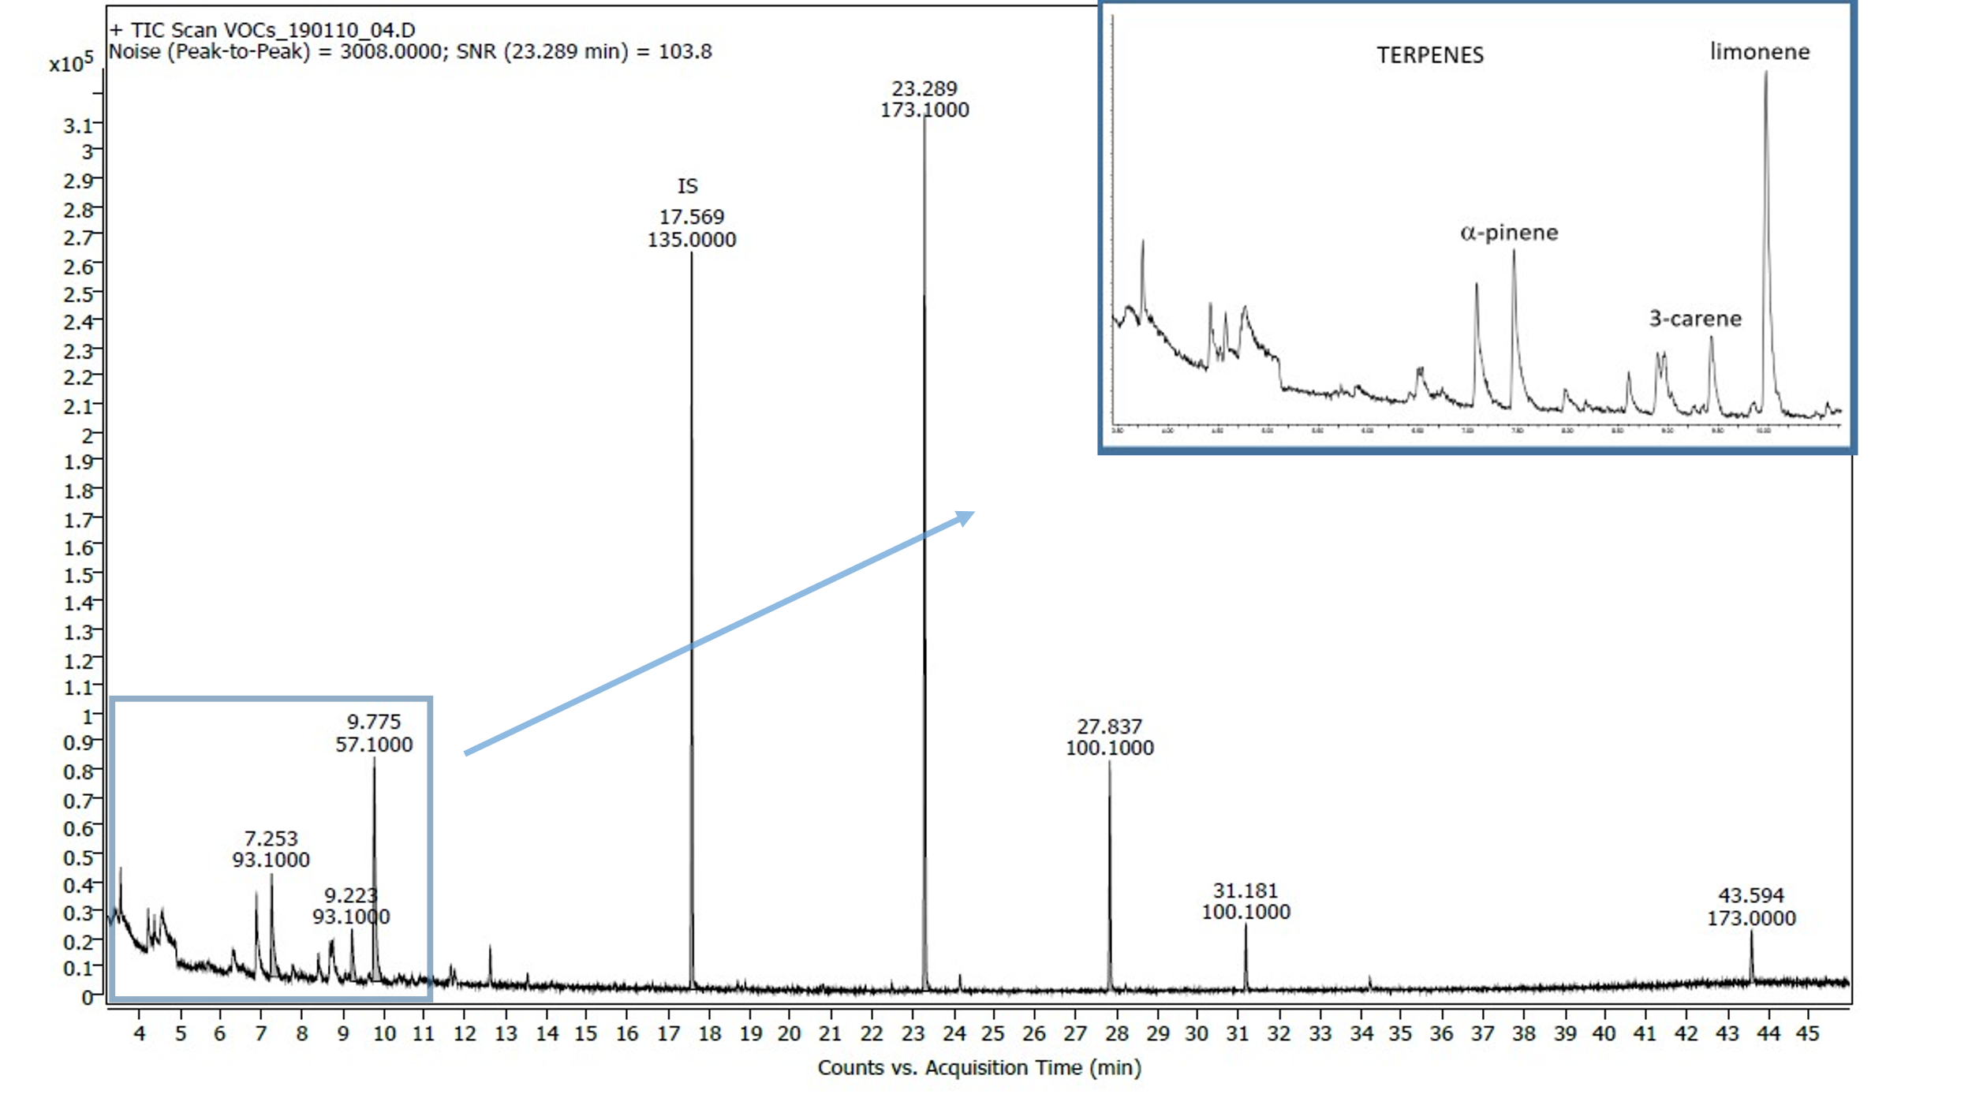
Fig. 4. TIC of the close chamber sample. In the magnification terpenes region and identified compounds are highlighted; in the chromatogram, relevant peaks comprise unknown compounds and the internal standard (IS), with target m/z ion and RT on top.

By comparison of detected peaks’ area, terpenes abundance was between 4 and 53% of the IS. From the known concentration of the IS, terpenes amount was estimated to be 0.4 – 4.9 ppb (0.1 – 1.6 μg) in the chamber. On the contrary, levels of unidentified compounds were found to be 1.0 – 11.8 ppbv (0.3 – 3.8 μg).

Table 2. Detected and identified compounds in the close chamber with active sampling.
Compound type | Compound name | RTª (min) | Target ion (m/z) | Relative abundance (SNR)^{b}
Monoterpenes  Internal standard  Unknown | α-pinene  3-carene  limonene  1-bromodecane  unknown 1  unknown 2  unknown 3  unknown 4 | 7.25  9.22  9.78  17.57  23.29  27.84  31.18  43.59 | 93.1  93.1  57.1  135.1  173  100  100  173 | 12.2  6.1  26.5  87.2  103.8  27.2  7.8  6.2
ªRetention Time.
^{b}Signal-to-Noise-Ratio.
CONCLUSIONS
From the study performed the highlights derived were, for the passive sampling:
- Detected BVOCs could not be attributed with certainty to the i-RTG crop, since they were found also outdoors and were not quantifiable through the method used.
- Despite occasional peaks of temperature and relative humidity inside the open chamber and in the i-RTG, which excite as elicitors on volatiles release (Niinemets et al., 2004), and cumulative collection, there was no significant difference between indoor and outdoor total emissions. Especially in the i-RTG, the role of solar radiation on plant emissions is unclear or at least its impact is not demonstrated.
- The similarity found between indoor and outdoor volatile emissions suggested frequent air turnover in the i-RTG, decreasing the amount of indoor volatiles.
- Resemblance encountered within the open chamber and the i-RTG confirmed the reproducibility of the passive sampling method for this context, though resemblance may be also due to a lack of the technical performance of the devices (e.g., water in the tubes).
- Despite the low sensitivity, passive sampling is easy-to-perform and provides a snapshot of the volatiles population of multiple environments.
And for the static headspace sampling:
- BVOCs found from this sample confirmed green bean as an emitting species.
- The preliminary quantitative information suggested plant emissions did not exceed the ppb in the i-RTG and BVOCs were lower than other volatiles.
- Since found BVOCs levels were much lower than those (≥ppm) provided by the European Report (No 29, 2013) for indoor environments, they were not believed to convey a relevant impact on human health.
- Active sampling on a static headspace system improved both qualitative and quantitative performance of BVOCs analysis but further improvements in its application could define more accurate the chemical profile of current BVOCs and their levels inside the i-RTG.

ACKNOWLEDGEMENTS
We want to thank the Avaluació i Gestió Ambiental of the Diputació de Barcelona for the
equipment lent and consultancy and the Centres Cientı́fics i Tecnològics of the University of
Barcelona for the analytical service. The research leading to these results has received funding
from the European Research Council under the European Horizon2020 research and
innovation program under grant agreement No 862663 (FoodE) as well as, from the Catalan
Agència de Gestió d’Ajuts Universitaris i de Recerca (AGAUR) under grant agreement No
2020FI_B 01004. Finally, we would like to thank the Secretaria d'Universitats i Recerca del
departament d'Empresa i Coneixement de la Generalitat de Catalunya for the grant awarded
under the n° AGAU 2020 PANDE 00021. The publication reflects the author's views. The
Research Executive Agency (REA) is not liable for any use that may be made of the information
contained therein.

Literature cited
Armanda, D.T., Guinée, J.B., and Tukker, A. (2019). The second green revolution: Innovative urban agriculture’s contribution to food security and sustainability – A review. Global Food Security 22, 13–24.
Ballhorn, D.J., Kautz, S., Lion, U., and Heil, M. (2008). Trade-offs between direct and indirect defences of lima bean (Phaseolus lunatus). Journal of Ecology 96, 971–980.
Bartual, J., Doctor, S., and Químicas, C. (1986). NTP 151: Toma de muestras con captadores pasivos (Barcelona)
Calfapietra, C., Pallozzi, E., Lusini, I., and Velikova, V. (2013). Modification of BVOC Emissions by Changes in Atmospheric [CO2] and Air Pollution. 253–284.
Lundgren, B., Crump, D.R., Knoppel, H., Laurent, A.M., Lebret, E., Rothweiler, H., Seifert, B., Wolkoff, P., and Cavallo, D. (1994). Report No. 14, Sampling Strategies for Volatile Organic Compounds (VOCs) in Indoor Air (Luxembourg: European Commission, Joint Research Centre - Environment Institute)
European Parliament (2021). Implementation of the Ambient Air Quality Directives - European Parliament resolution of 25 March 2021 on the implementation of the Ambient Air Quality Directives: Directive 2004/107/EC and Directive 2008/50/EC (2020/2091(INI))
European Commission (2019). COMMUNICATION FROM THE COMMISSION TO THE EUROPEAN PARLIAMENT, THE EUROPEAN COUNCIL, THE COUNCIL, THE EUROPEAN ECONOMIC AND SOCIAL COMMITTEE AND THE COMMITTEE OF THE REGIONS - The European Green Deal (Brussels)
European Union (2013). Urban Air, Indoor Environment and Human Exposure: Harmonisation framework for health based evaluation of indoor emissions from construction products in the European Union using the EU-LCI concept (Luxembourg: Office for Official Publications of the European Communities)
Geron, C.D., Pierce, T.E., and Guenther, A.B. (1995). Reassessment of biogenic volatile organic compound emissions in the Atlanta area. Atmospheric Environment 29, 1569–1578.
Guenther, A., Karl, T., Harley, P., Wiedinmyer, C., Palmer, P.I., and Geron, C. (2006). Estimates of global terrestrial isoprene emissions using MEGAN (Model of Emissions of Gases and Aerosols from Nature). Atmospheric Chemistry and Physics 6, 3181–3210.
Heiden, A.C., Kobel, K., Langebartels, C., Schuh-Thomas, G., Wildt, J., Zhang, Y., Xiong, J., Mo, J., Gong, M., Cao, J., et al. (2015). Practical approaches to plant volatile analysis. Plant Journal 45, 314–325.
Iaquinta, D.L., and Drescher, A.W. (2015). Urban Agriculture: A Comparative Review of Allotment and Community Gardens. In Urban Ecosystem Ecology, (John Wiley & Sons, Ltd), pp. 199–226
IPCC (2021). Technical Summary. Contribution of Working Group I to the Sixth Assessment Report of the Intergovernmental Panel on Climate Change. Climate Change 2021: The Physical Science Basis. 3949.
Jamloki, A., Bhattacharyya, M., Nautiyal, M.C., and Patni, B. (2021). Elucidating the relevance of high temperature and elevated CO2 in plant secondary metabolites (PSMs) production. Heliyon 7, 1–13.
Karl, T., Guenther, A., Turnipseed, A., Patton, E.G., and Jardine, K. (2008). Chemical sensing of plant stress at the ecosystem scale. Biogeosciences 5, 1287–1294.
Langemeyer, J., Madrid-Lopez, C., Mendoza Beltran, A., and Villalba Mendez, G. (2021). Urban agriculture — A necessary pathway towards urban resilience and global sustainability? Landscape and Urban Planning 210, 104055.
Laothawornkitkul, J., Taylor, J.E., Paul, N.D., and Hewitt, C.N. (2009). Biogenic volatile organic compounds in the Earth system: Tansley review. New Phytologist 183, 27–51.
Li, S., Harley, P.C., and Niinemets, Ü. (2017). Ozone-induced foliar damage and release of stress volatiles is highly dependent on stomatal openness and priming by low-level ozone exposure in Phaseolus vulgaris. Plant Cell and Environment 40, 1984–2003.
Martins, S.J., Faria, A.F., Pedroso, M.P., Cunha, M.G., Rocha, M.R., and Medeiros, F.H.V. (2019). Microbial volatiles organic compounds control anthracnose (Colletotrichum lindemuthianum) in common bean (Phaseolus vulgaris L.). Biological Control 131, 36–42.
Niinemets, Ü., and Peñuelas, J. (2008). Gardening and urban landscaping: significant players in global change. Trends in Plant Science 13, 60–65.
Niinemets, Ü., Loreto, F., and Reichstein, M. (2004). Physiological and physicochemical controls on foliar volatile organic compound emissions. Trends in Plant Science 9, 180–186.
Opitz, I., Berges, R., Piorr, A., and Krikser, T. (2016). Contributing to food security in urban areas: differences between urban agriculture and peri-urban agriculture in the Global North. Agriculture and Human Values 33, 341–358.
Orsini, F., Gasperi, D., Marchetti, L., Piovene, C., Draghetti, S., Ramazzotti, S., Bazzocchi, G., and Gianquinto, G. (2014). Exploring the production capacity of rooftop gardens (RTGs) in urban agriculture: the potential impact on food and nutrition security, biodiversity and other ecosystem services in the city of Bologna. Food Security 6, 781–792.
Ortega, J., and Helmig, D. (2008). Approaches for quantifying reactive and low-volatility biogenic organic compound emissions by vegetation enclosure techniques - Part A. Chemosphere 72, 343–364.
Peñuelas, J., and Staudt, M. (2010). BVOCs and global change. Trends in Plant Science 15, 133–144.
Pons, O., Nadal, A., Sanyé-Mengual, E., Llorach-Massana, P., Cuerva, E., Sanjuan-Delmàs, D., Muñoz, P., Oliver-Solà, J., Planas, C., and Rovira, M.R. (2015). Roofs of the Future: Rooftop Greenhouses to Improve Buildings Metabolism. Procedia Engineering 123, 441–448.
Quintana-Rodriguez, E., Morales-Vargas, A.T., Molina-Torres, J., Ádame-Alvarez, R.M., Acosta-Gallegos, J.A., and Heil, M. (2015). Plant volatiles cause direct, induced and associational resistance in common bean to the fungal pathogen Colletotrichum lindemuthianum. Journal of Ecology 103, 250–260.
Sabeh, N. (2020). Rooftop plant production systems in urban areas. Plant Factory: An Indoor Vertical Farming System for Efficient Quality Food Production: Second Edition 129–135.
Saeed Meo, M., and Karim, M.Z.A. (2022). The role of green finance in reducing CO2 emissions: An empirical analysis. Borsa Istanbul Review 22, 169–178.
Sanyé-Mengual, E., Llorach Massana, P., Sanjuan Demás, D., Oliver-Solà, J., Josa Garcia-Tornel, A., Montero, J.I., and Rieradevall Pons, J. (2014). The ICTA-ICP Rooftop Greenhouse Lab (RTG-Lab): closing metabolic flows (energy, water, CO2) through integrated Rooftop Greenhouses. Finding Places for Productive Cities. Proceedings of 6th International AESOP Sustainable Food Planning Conference 693–701.
World Health Organization (2021). WHO global air quality guidelines: particulate matter (‎PM2.5 and PM10)‎, ozone, nitrogen dioxide, sulfur dioxide and carbon monoxide. World Health Organization 1–1302.
Yang, D.S., Son, K.C., and Kays, S.J. (2009). Volatile organic compounds emanating from indoor ornamental plants. HortScience 44, 396–400.

