Supplementary Information
Pilot data
Participants
Participants were recruited through the University of Birmingham Research Participation Scheme and received financial compensation for their time (8 £/h) or course credits (1 credit/h). We could only collect data from 5 participants (1 male, 4 female) before the lockdown measures due to COVID-19 pandemics started (mean age = 21 +/- 2.74, one male, one left-handed). Prior to the experimental session, volunteers underwent a screening phase during which we ascertained that they met the inclusion criteria. Participants did not suffer any neurological illness or engaged in recent recreational drug use in the preceding 24 hours. Participants were all safe to undergo a TMS session and all signed the informed consent. Participants could report at least one experience of intense physical pain and one neutral experience. We also collected information about painful and neutral events that volunteers did not experience.
Stimuli and paradigm
Stimuli consisted of sentences and faces. Four sentences were tailored prior to the experimental session for each participant according to the information collected during the screening phase. The sentences described the two autobiographical (AM) and non-AM contexts and had all a similar syntactic structure (e.g., “This person got their right leg broken” or “This person visited the Birmingham Museum of Art”). Faces were ten Caucasian identities (5 males and 5 females) with neutral and painful facial expression. Faces were in shades of grey and equiluminant as processed with the SHINE toolbox (Willenbockel et al., 2010).
Participants underwent two tasks during the same experimental session: 1) an empathy task; 2) a retrieval task. The empathy task was a pain decision task which previous studies robustly showed to trigger participants’ empathy to targets’ pain (Meconi et al., 2018; Sessa et al., 2014). In this task participants saw a fixation cross (800-1600 ms) followed by a sentence (3000 ms) describing an AM or non-AM context of a physically painful experience or of a neutral episode. After a second fixation cross (800-1600 ms), a painful or a neutral face was presented on the screen (500 ms). Participants’ task was to first rate how much empathy they felt for that person in that context on a 1-6 points scale and then to say whether the face was painful or neutral. Responses were time-pressured but self-paced.
A burst of 3 TMS pulses were delivered at 20Hz at the face offset, consistently with previous results from our lab that showed evidence for memory reactivation in a similar paradigm starting about 600 ms after face onset. The empathy task was composed of 240 pseudo-randomly intermixed trials, 30 trials per condition divided into 8 blocks with 30 minutes break between the first and the second half. Each type of emotional memory could not be presented more than twice in a row and all possible conditions were homogeneously distributed over the entire experimental session. For each half of the task TMS targeted either the left Superior Parietal Lobule (SPL, i.e. the target area MNI coordinates [-36 -58 59]) or the right SPL (i.e. the control area) in a counterbalanced order. The break allowed changing the coil position and preventing carryover effects of the stimulation. No blinding was involved in this study with the usual exception that participants were not aware of which area stimulated by the TMS was the target or the control area.
After the empathy task, participants completed a retrieval task. This was not targeted by the TMS nor did the data from this task serve as pilot for the current study and we will discuss this no further. However, full details about this second task have been pre-registered and are available on the OSF database. Figure S1 shows a schematic representation of the paradigm.

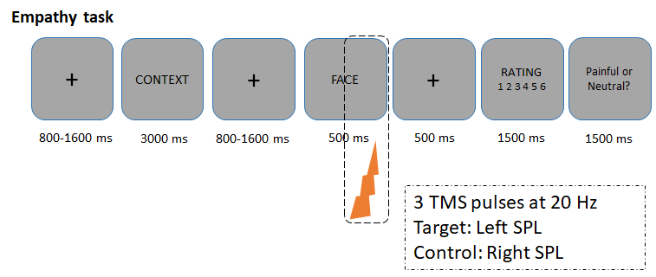
Figure S1.
TMS protocol
A Magstim Rapid stimulator (MagStim, Whitland, UK) with a 70-mm figure-8 (D70 alpha flat) coil was used to deliver a series of 3 TMS pulses at 20 Hz starting at 350 ms after the onset of the face. Individual anatomical scan was available for each participant. The target area was translated from MNI space onto each participant’s T1 anatomical scans and the coil position was guided using Brainsight Frameless Stereotaxic software (Rogue Research, Montreal, Quebec, Canada). The position of the coil and the subject's head was monitored using a Polaris Optical Tracking System (Northern Digital, Waterloo, Ontario, Canada). An adjustable frame allowed to hold the coil firmly and tangentially to participants’ head with the handle pointing posteriorly. Participants could rest their heads on a chin and forehead rest so that head movements were kept negligible and were monitored throughout the whole session.
Statistical analysis
Individual scores of the empathy rates were inserted into a repeated measures ANOVA with 2 (Emotion: Neutral vs. Painful) x 2 (Memory: AM vs. non-AM) x 2 Face (Neutral vs. Painful) x 2 (Stimulation site: Target_{left} SPL vs. Control_{right} SPL) within-subjects factors.
Results
The critical result was a Memory X Stimulation site interaction F(1,4) = 5.565 p = .078, ƞ_{p}² = .582, which was also the largest F we observed among the other two-way interactions. ANOVA showed a main effect of Emotion F(1,4) = 10.434, p = .032, ƞ_{p}²= .723, CI = [-2.466, -.186]; Face(1,4) = 7.605, p = .051, ƞ_{p}² = .655, CI = [-1.702, .006] but non-significant effect of Memory F(1,4) = 3.142, p = .151, ƞ_{p}² = .440, CI = [-.336, 1.523], nor of Stimulation site (F < 1). Among the 3-way interactions, all Fs < 1 but for the Emotion x Memory x Face F(1,4) = 2.991, p = .159, ƞ_{p}² = .428 and for the Emotion x Memoy x Stimulation site interaction F(1,4) = 2.817, p = .169, ƞ_{p}² = .413. The 4-way interaction approached significance F(1,4) = 6.583, p = .062, ƞ_{p}² = .622. Therefore, even though non-significant, the interaction of Memory x Stimulation site interaction showed slight reduced empathy rates after the stimulation of the target area, when compared to the control area. We calculated mean differences for the AM and non-AM rates for each site of stimulation and then performed a paired sample t-test between the differential scores obtained in each site (M_{d} = -.30679, SD_{d} = .29080, correlation between measures: r = .956, t(4) = 2.359, p = .078) with a large effect size Cohen’s d = 1.06.

References
Meconi, F., Doro, M., Lomoriello, A. S., Mastrella, G., & Sessa, P. (2018). Neural measures of the role of affective prosody in empathy for pain. Scientific Reports, 8(1), 291. https://doi.org/10.1038/s41598-017-18552-y
Sessa, P., Meconi, F., & Han, S. (2014). Double dissociation of neural responses supporting perceptual and cognitive components of social cognition: Evidence from processing of others’ pain. Scientific Reports, 4, 7424. https://doi.org/10.1038/srep07424
Willenbockel, V., Sadr, J., Fiset, D., Horne, G. O., Gosselin, F., & Tanaka, J. W. (2010). Controlling low-level image properties: The SHINE toolbox. Behavior Research Methods, 42(3), 671–684. https://doi.org/10.3758/BRM.42.3.671

Figure caption
Figure S1. Schematic representation of the pilot paradigm. A series of three TMS pulses was delivered at the offset of the face. TMS targeted the left SPL (i.e., the target area) and the right SPL (i.e., the control area) for each half of the empathy task, respectively, in a counterbalanced order across participants.

