Syn-orogenic exhumation of high-P units by upward extrusion in an accretionary wedge: Insights from the Eastern Elba nappe stack (Northern Apennines, Italy)

Ryan, E.¹, Papeschi, S.², Viola, G.³*, Musumeci, G.^{4,5}, Mazzarini, F.⁵, Torgersen, E.^{6,1}, Sørensen, B.E.¹ and Ganerød, M.⁶
1: Department of Geoscience and Petroleum, Norwegian University of Science and Technology, Trondheim, Norway
2: Kochi Institute for Core Sample Research, Institute for Extra-cutting-edge Science and Technology Avant-garde Research (X-star), JAMSTEC, Japan
3: Department of Biological, Geological and Environmental Sciences, Università degli Studi di Bologna, Bologna, Italy
4: Dipartimento di Scienze della Terra, Università di Pisa, Pisa, Italy
5: Istituto Nazionale di Geofisica e Vulcanologia, Pisa, Italy
6: Geological Survey of Norway, 7491, Trondheim, Norway

*Corresponding author: giulio.viola3@unibo.it

Authors’ details
Eric Ryan; eric.j.ryan@ntnu.no ORCID 0000-0003-3827-4405
Samuele Papeschi; s.papeschi@jamstec.go.jp ORCID 0000-0002-5774-7119
Giulio Viola; giulio.viola3@unibo.it ORCID 0000-0002-8383-3328
Giovanni Musumeci; giovanni.musumeci@unipi.it ORCID 0000-0001-5343-4708
Francesco Mazzarini; francesco.mazzarini@ingv.it ORCID 0000-0002-3864-6558
Espen Torgersen; espen.torgersen@ngu.no ORCID 0000-0001-6076-1432
Morgan Ganerød; morgan.ganerod@ngu.no ORCID 0000-0003-0051-4020

Content of the Supplementary Materia:
- List and petrographic characterization of investigated samples
- Location map and names of the studied samples
- Raw data of sample ELB5

List and characterization of investigated samples
Table S1 – List of the investigated samples, as they appear on SESAR (https://app.geosamples.org/). Minerals in assemblage and accessories are in modal order from high to low. Pseudomorphosed minerals are reported in brackets. The classification follows the IUGS recommendations for the nomenclature of metamorphic rocks. Abbreviations after Siivola & Schmid (2007).
Sample | Assemblage | Accessories | Classification
IESP3SP53 | Cal, Chl, Wmca, Ab, Ep, Na-Am, Ttn, Qtz | Aln, Rt, Ap, Zrn | Mylonitic calcschist
IESP3SP54 | Cal, Chl, Ab, Wmca, Ep, Na-Am, Ttn, Qtz | Aln, Rt, Ap, Zrn, Tur, (Py) | Mylonitic calcschist
IESP3SP55 | Na-Am, Ca-Am, Cpx, Chl, Ab, Ep, Czo, (Lws), Ttn, Cal, Qtz | Rt, Wmca | Metabasite
IESP3SP56 | Na-Am, Ca-Am, Cpx, Chl, Ep, Czo, Ab, (Lws), Ttn, Qtz, Cal | Wmca | Metabasite
IESP3SP57 | Na-Am, Ca-Am, Cpx, Chl, Ttn, Ep, Czo, Ab, (Lws), Qtz, Cal | Rt, Wmca | Metabasite
IESP3SP58 | Na-Am, Ca-Am, Cpx, Chl, Ep, Czo, Ab, (Lws), Ttn, Qtz, Cal | Rt, Wmca | Metabasite
IESP3SP59 | Cal, Ksp, Pl, Qtz, Wmca, Chl, Ab, Ttn | Zrn, Ap, Tur | Mylonitic calcschist
IESP3SP60 | Cal, Wmca, Qtz, Chl, Ep, Ttn, Hem | Tur, Ap, Zrn | Mylonitic calcschist
IESP3SP61 | Cal, Chl, Wmca, Qtz, Ab, Ksp, Bt, Ep, Ttn, Gr, Hem, Ilm, (Py) | Aln, Rt, Tur, Zrn, Ap, piemontite | Marble
IESP3SP70 | Cal, Wmca, Ab, Chl, Qtz, Ep, Ttn, Hem, Ilm | Aln, Rt, Tur, Ap, Zrn | Calcschist
IESP3SP71 | Wmca, Qtz, Cal, Chl, Ksp, Bt, Ilm, Hem | Ap, Zrn, Tur | Mylonitic calcschist
IESP3SP72 | Qtz, Ksp, Wmca, Chl, Cal, Pl, Hem, Ilm | Ap, Zrn, Tur | Mylonitic calcschist
IESP3SP74 | Wmca, Bt, Qtz, Cd, And, Ilm | Zrn, Ap, Mnz | Schist
IESP3SP94 | Qtz, Wmca, Cal, Chl, Bt, Ksp, Ep, Hem, Ilm | Tur, Zrn, Ap, (Py), Rt | Phyllite
IESP3SP205 | Cal, Ksp, Qtz, Ab, Pl, Chl, Ep, Bt, Ttn, Hem | Zrn, Ap, Tur | Calcschist
IESP3SP206 | Cal, Chl, Bt, Ep, Qtz, Ab, Pl, Ttn | Zrn, Tur, Ap | Mylonitic calcschist
IESP3SP207 | Cal, Qtz, Wmca, Bt, Chl, Ep, Opx, Ca-Am, Ttn | Zrn, Ap, Tur | Impure marble (skarn)
IESP3SP208 | Cal, Di, Tr, Tlc | - | Impure marble
IESP3SP273 | Wmca, Qtz, Bt, (Cd), And, Ilm | Ap, Zrn, Tur | Folded schist
IESP3SP274 | Wmca, Qtz, Bt, Ksp, Pl, Ilm | Zrn. Ap, Tur, Mnz | Metapsammite
IESP3SP275 | Bt, Wmca, Qtz, Ab, (Cd), Ilm, Ep, Ttn, Pl | Zrn, Ap, Tur
IESP3SP276 | Cal, Gr, Wmca, Bt, Qtz, Ab, Pl | Zrn, Ap | Impure marble
IESP3SP279 | Cal, Wmca, Bt, Qtz, Ab, Pl, Ep, Ilm, Ttn | Zrn, Ap, Tur, Piemontite | Mylonitic calcschist
IESP3SP280 | Cal, Qtz, Gr, Ep, Wmca | Zrn, Ap | Impure marble
IESP3SP281 | Cal, Gr, Qtz, Wmca, Bt | Zrn, Ap, Tur | Mylonitic marble
IESP3SP283 | Chl, Wmca, Bt, Cal, Qtz, Ep, Ab, (Na-Am), (Lws), Ttn, Ilm | Aln, Zrn, Ap, Tur, piemontite | Mylonitic metabasite
IESP3ERY10 | Cal, Qtz, Bt, Wmca, Chl | Zrn, Ap | Calcschist
IESP3ERY11 | Cal, Qtz, Bt, Wmca | Zrn, Ap | Calcschist
IESP3ERY14 | Cal, Qtz, Bt, Wmca | Zrn, Ap | Calcschist
IESP3ERY21A | Cal, Chl, Ab, Wmca, Ep, Ttn, Qtz | Aln, Rt, Ap, Zrn, Tur | Mylonitic calcschist
ELB5 | Cal, Chl, Ab, Wmca, Ep, Ttn, Qtz | Aln, Rt, Ap, Zrn, Tur | Calcschist

Location map and names of the studied samples
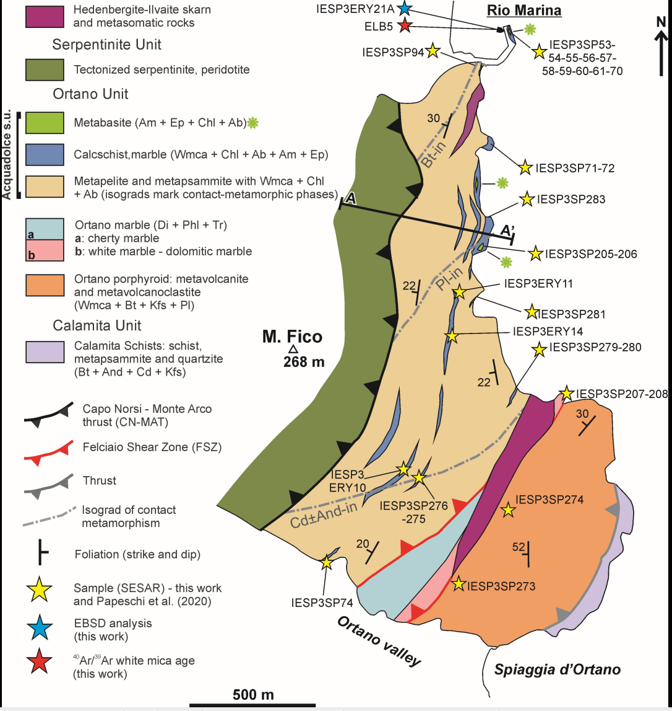

Raw data of sample ELB5

