Supplemental Figure 1
Kaplan-Meier Survival curves for Overall Survival and Disease Free Survival by p27
Supplemental Figure 2
Estimates of p27 Prognostic Effect on Oncologic Outcomes

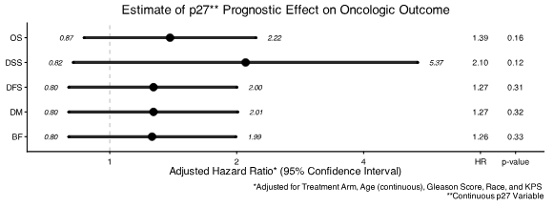

Supplemental Table 1
Baseline Characteristics by p27 Status
 | p27 Missing  (n=1615) | p27 Available  (n=361) | p-value
Age
Mean | 69.8 | 69.5 | 0.36¹
Std. Dev. | 6.5 | 6.8
Median | 70 | 70
Min - Max | 43 - 88 | 48 - 86
Q1 - Q3 | 66 - 74 | 66 - 74
Age category |  |  | 0.71³
< 70 | 828 ( 51.3%) | 189 ( 52.4%)
≥ 70 | 787 ( 48.7%) | 172 ( 47.6%)
Gleason Score |  |  | 0.0001³
≤6 | 641 ( 44.3%) | 108 ( 32.1%)
7 | 466 ( 32.2%) | 122 ( 36.2%)
≥8 | 342 ( 23.6%) | 107 ( 31.8%)
PSA
Mean | 31.0 | 32.1
Std. Dev. | 31.3 | 31.1
Median | 20.1 | 21.3 | 0.38²
Min - Max | 0.123 - 264.6 | 0.2 - 219.7
Q1 - Q3 | 10.8 - 40 | 11.15 - 40.7
PSA Category |  |  | 0.027³
0-30 | 1176 ( 72.8%) | 242 ( 67.0%)
>30 | 439 ( 27.2%) | 119 ( 33.0%)
Note: Patients with missing data omitted

Supplemental Table 2
Number of Events by Endpoint and p27 Category

Event | < median | ≥ median | Total
Death | 141 | 156 | 297
Biochemical Failure | 93 | 101 | 194
Local Progression | 34 | 37 | 71
Distant Metastasis | 45 | 56 | 101
Disease Free Surviva1 | 162 | 168 | 330
Disease Specific Survival | 35 | 49 | 84

