Supplementary Table 1. Detailed search strategy and query strings

PubMed
("Breast Neoplasms"[Mesh]
OR "breast cancer"[tiab]
OR "breast carcinoma"[tiab]
OR "breast neoplasm*"[tiab])
AND
("Neoadjuvant Therapy"[Mesh]
OR "neoadjuvant chemotherapy"[tiab]
OR "neoadjuvant treatment"[tiab]
OR "neoadjuvant immunotherapy"[tiab]
OR "preoperative therapy"[tiab]
OR "primary systemic therapy"[tiab]
OR NAC[tiab])
AND
("Artificial Intelligence"[Mesh]
OR "Machine Learning"[Mesh]
OR "Deep Learning"[Mesh]
OR "machine learning"[tiab]
OR "deep learning"[tiab]
OR radiomics[tiab]
OR "neural network*"[tiab]
OR "computational pathology"[tiab]
OR "computer-aided diagnosis"[tiab]
OR "predictive model*"[tiab]
OR transformer*[tiab]
OR GPT[tiab]
OR BERT[tiab]
OR "large language model*"[tiab]
OR autoencoder*[tiab]
OR "generative adversarial network*"[tiab]
OR GAN[tiab]
OR "federated learning"[tiab]
OR "transfer learning"[tiab]
OR "ensemble learning"[tiab]
OR "self-supervised learning"[tiab]
OR "multimodal AI"[tiab])
AND
("treatment response"[tiab]
OR "pathological complete response"[tiab]
OR pCR[tiab]
OR "residual cancer burden"[tiab]
OR RCB[tiab]
OR "treatment efficacy"[tiab])
Embase
('breast tumor'/exp OR 'breast cancer':ti,ab OR 'breast carcinoma':ti,ab OR 'breast neoplasm':ti,ab)
AND
('neoadjuvant therapy'/exp OR 'neoadjuvant chemotherapy':ti,ab OR 'neoadjuvant treatment':ti,ab OR NAC:ti,ab OR 'primary systemic therapy':ti,ab OR 'neoadjuvant immunotherapy':ti,ab OR 'preoperative therapy':ti,ab)
AND
('artificial intelligence'/exp
OR 'machine learning'/exp
OR 'deep learning'/exp
OR 'radiomics'/exp
OR 'neural network'/exp
OR 'computer aided diagnosis'/exp
OR 'computational pathology':ti,ab
OR 'predictive modeling':ti,ab
OR 'machine learning':ti,ab
OR 'deep learning':ti,ab
OR radiomics:ti,ab
OR 'neural network*':ti,ab
OR 'computer aided diagnosis':ti,ab
OR 'computational pathology':ti,ab
OR 'predictive model*':ti,ab
OR transformer*:ti,ab
OR GPT:ti,ab
OR BERT:ti,ab
OR 'large language model*':ti,ab
OR autoencoder*:ti,ab
OR 'generative adversarial network*':ti,ab
OR GAN:ti,ab
OR 'federated learning':ti,ab
OR 'transfer learning':ti,ab
OR 'ensemble learning':ti,ab
OR 'self supervised learning':ti,ab
OR 'multimodal AI':ti,ab
)
AND
('treatment response':ti,ab
OR 'pathological complete response':ti,ab
OR pCR:ti,ab
OR 'residual cancer burden':ti,ab
OR RCB:ti,ab
OR 'treatment efficacy':ti,ab)
Cochrane CENTRAL
("breast cancer" OR "breast carcinoma" OR "breast neoplasm*"):ti,ab,kw
AND
("neoadjuvant therapy" OR "neoadjuvant chemotherapy" OR "neoadjuvant treatment"
OR "neoadjuvant immunotherapy" OR "preoperative therapy" OR "primary systemic therapy" OR NAC):ti,ab,kw
AND
("artificial intelligence" OR "machine learning" OR "deep learning"
OR radiomics OR "neural network*" OR "computational pathology"
OR "predictive model*"):ti,ab,kw
AND
("treatment response" OR "pathological complete response" OR pCR
OR "residual cancer burden" OR RCB):ti,ab,kw

Supplementary Table 2. Leave-one-out sensitivity analysis of pooled AUC estimates
Removed cohort | Pooled AUC (95%CI) | I² | τ²
Aswolinskiy et al. (1) | 0.79 (0.75-0.83) | 74.815 | 0.152
Aswolinskiy et al. (2) | 0.79 (0.75-0.83) | 73.456 | 0.139
Banerjee et al. | 0.78 (0.74-0.82) | 73.882 | 0.141
Cai et al | 0.79 (0.75-0.83) | 74.098 | 0.147
Du Terrail et al. | 0.79 (0.75-0.82) | 74.857 | 0.152
Fisher et al. | 0.78 (0.74-0.82) | 70.083 | 0.145
Guo et al. | 0.78 (0.74-0.82) | 73.663 | 0.148
Hatamikia et al | 0.78 (0.74-0.82) | 73.670 | 0.139
Huang et al. | 0.78 (0.74-0.82) | 70.105 | 0.128
Lin et al | 0.78 (0.74-0.82) | 73.521 | 0.137
Orozco et al. | 0.79 (0.75-0.83) | 74.393 | 0.153
Park et al. | 0.78 (0.74-0.82) | 73.299 | 0.136
Qi et al. | 0.79 (0.75-0.82) | 74.807 | 0.148
Ramtohul et al. | 0.78 (0.74-0.82) | 72.874 | 0.137
Sturm et al. | 0.79 (0.75-0.83) | 74.231 | 0.145
Xie et al. | 0.79 (0.75-0.83) | 71.178 | 0.132
Zhang et al. | 0.78 (0.74-0.82) | 73.006 | 0.136
Zhao et al. | 0.80 (0.76-0.83) | 46.400 | 0.084
Lin et al. (2) | 0.79 (0.75-0.83) | 74.682 | 0.154
Mohamed et al. | 0.79 (0.74-0.82) | 74.767 | 0.149

Supplementary Table 3. Detailed characterization of pathology-related and computational pathology studies among 58 studies considered for qualitative analysis.

Study | Data input | Methodology | Staining | Segmentation | TILs / TME assessment
Aswolinskiy, 2023 | Pretreatment biopsy WSIs | WSI-based DL | H&E | Automated segmentation of tumour, stroma, lymphocytes and other tissue compartments; mitosis detection | Yes:  cTILs, lymphocyte-to-tumour ratio, inflamed tumour ratio, mitotic rate
Bhattarai,  2024 | Pretreatment biopsy WSIs  (three serial tissue slides) | WSI-based ML with cell-level analysis | H&E  IHC Ki67 IHC pH3 | Manual annotations with Mask R-CNN-based detection of tumour cells, TILs and IHC-positive cells | Yes:  tTILs, sTILs, tumour cells, Ki67, pH3
Du Terrail, 2023 | Pretreatment biopsy WSIs + clinical-biological data | WSI-based DL  (federated learning) | H&E | Weakly supervised federated learning; no conventional ROI annotation | Yes:  TILs and histological variables considered; no explicit TME segmentation pipeline
Duanmu, 2022 | Pretreatment biopsy WSIs  (three serial tissue slides) | WSI-based DL with spatial attention | H&E  IHC Ki67 IHC PHH3 | Mask R-CNN-based tumour cell identification with IHC biomarker quantification and spatial attention | Indirect:  proliferation- and mitosis-related tumour regions
Fisher, 2024 | Pretreatment biopsy WSIs | WSI-based ML with spatial graph analysis | H&E | Manual annotation of histological classes with tile-level classification and map generation | Yes:  tTILs, sTILs, tertiary TILs, MVD, PGCCs and necrosis
Hacking, 2023 | Pretreatment biopsy WSIs (tumour and stromal features) + clinical-biological data | WSI-based ML feature quantification | H&E | Automated quantification of tumour and stromal components | Yes:  myxoid, collagenous and immune stromal features
Krishnamurthy, 2023 | Pretreatment biopsy WSIs + clinical-biological data | WSI-based DL with morphometric clustering | H&E | Expert-guided annotation of morphological categories with unsupervised feature extraction | Yes:  tumour-, stroma- and TIL-related morphometric patterns
Li, 2021 | Pretreatment biopsy WSIs | WSI-based DL | H&E | Automated tumour epithelium identification and pCR score generation | No:  sTILs included as comparator, not as primary computational target
Li, 2022 (npj) | Pretreatment biopsy WSIs + clinical-biological data | WSI-based DL for stromal biomarker analysis | H&E | Epithelium–stroma classification following pathologist-guided ROI segmentation, with stromal tile selection and limited manual intervention | Yes:  stromal morphology, collagen, fibroblasts and sTILs (used as comparator)
Li, 2024 | Pretreatment biopsy WSIs | WSI-based DL | H&E | Pathologist annotation of histological classes with graph construction from label maps | Yes:  immune cells, collagen and spatial TME architecture
Li, 2022 (The Breast) | Pretreatment biopsy WSIs + clinical-biological data | WSI-based DL with patch-level aggregation | H&E | Automated patch classification and feature aggregation without manual ROI annotation | No:  sTILs used as comparator
Mao, 2025 | Pretreatment biopsy WSIs + MRI + clinical-biological data | Multimodal DL integrating WSI, MRI and clinical data | H&E | Automated patch-level classification and feature extraction, followed by multimodal feature integration and attention heatmap exploration | Yes:  immune-related pathways and antitumour microenvironment features explored
Sturm, 2025 | Pretreatment biopsy WSIs | WSI-based DL | H&E | Manual tumour-area annotation with weakly supervised image-level prediction | No
Wang, 2024 | Multiscale WSIs | WSI-based DL (multiscale multitask) | H&E | Foreground segmentation, multiscale patch extraction and attention heatmap generation | Yes:  TILs assessed and immune-related biological associations explored
Zeng et al. | ROI-based biopsy WSIs | ROI-based DL with ML classifier | H&E | Representative ROI selection across magnifications with DL-based feature extraction | No:  General tumour and stromal information; no detailed TME quantification

Abbreviations: 16S rDNA, 16S ribosomal DNA; AI, artificial intelligence; cTILs, computational tumor-infiltrating lymphocytes; DL, deep learning; FISH, fluorescence in situ hybridization; H&E, hematoxylin and eosin; HE, hematoxylin and eosin; IHC, immunohistochemistry; Ki67, Kiel-67 proliferation marker; LPS, lipopolysaccharide; Mask R-CNN, Mask Region-based convolutional neural network; mIF, multiplex immunofluorescence; ML, machine learning; MRI, magnetic resonance imaging; MVD, microvessel density; pCR, pathological complete response; pH3/PHH3, phosphohistone H3; PGCCs, polyploid giant cancer cells; ROI, region of interest; RT-qPCR, real-time quantitative polymerase chain reaction; scRNA-seq, single-cell RNA sequencing; SPP1+, secreted phosphoprotein 1-positive; sTILs, stromal tumor-infiltrating lymphocytes; TILs, tumor-infiltrating lymphocytes; TME, tumor microenvironment; tTILs, intratumoral tumor-infiltrating lymphocytes; WSI, whole-slide image.

Supplementary Table 4. Subgroup meta-analysis of AUC and test for between-group differences

Subgroup | N° of studies by subgroup | AUC (95%CI) | p-value for moderator test
Mixed validation cohort | 8 (40.0) | 0.76 (0.69;0.82) | 0.340
Only TNBC validation cohort | 12 (60.0) | 0.80 (0.75;0.84) | 0.340
Multimodal | 11 (55.0) | 0.80 (0.75;0.85) | 0.337
Unimodal | 9 (45.0) | 0.77 (0.70;0.82) | 0.337
No radiomics data | 8 (40.0) | 0.75 (0.68;0.81) | 0.109
Presence of radiomics data | 12 (60.0) | 0.81 (0.76;0.85) | 0.109
Only baseline data | 14 (70.0) | 0.77 (0.72;0.81) | 0.216
Presence of longitudinal data | 6 (30.0) | 0.82 (0.75;0.87) | 0.216
Absence of clinical data | 9 (45.0) | 0.80 (0.74;0.85) | 0.537
Utilization of clinical data | 11 (55.0) | 0.78 (0.72;0.82) | 0.537
Absence of computational pathology | 15 (75.0) | 0.80 (0.75;0.84) | 0.468
Utilization of computational pathology | 5 (25.0) | 0.76 (0.67;0.84) | 0.468
Absence of genomic data | 17 (85.0) | 0.78 (0.74;0.82) | 0.373
Presence of genomic data | 3 (15.0) | 0.83 (0.72;0.90) | 0.373
Combination of radiomic and clinical data | 7 (35.0) | 0.82 (0.75;0.87) | 0.212
Other studies | 13 (65.0) | 0.77 (0.72;0.81) | 0.212
ML | 18 (90.0) | 0.79 (0.75;0.83) | 0.409
DL +/- ML | 2 (10.0) | 0.73 (0.54;0.86) | 0.409
Study with < 60 pts in validation set | 9 (45.0) | 0.79 (0.71-0.85) | 0.969
Study with >= 60 pts in validation set | 11 (55.0) | 0.79 (0.74-0.83)

Supplementary Table 5. Between-study heterogeneity across subgroups

Subgroup | N° of studies by subgroup | τ² (95%CI) | I² (95%CI)
Mixed validation cohort | 8 (40.0) | 0.227 (0.049;1.198) | 77.4 (42.9;96.8)
Only TNBC validation cohort | 12 (60.0) | 0.074 (0.00;0.438) | 43.6 (0.0;83.5)
Multimodal | 11 (55.0) | 0.062 (0.000;0.679) | 36.3 (0.0;86.2)
Unimodal | 9 (45.0) | 0.189 (0.044;1.132) | 81.6 (50.9;96.4)
No radiomics data | 8 (40.0) | 0.135 (0.031;1.027) | 77.1 (43.5;96.2)
Presence of radiomics data | 12 (60.0) | 0.116 (0.004;0.593) | 50.8 (3.8;84.1)
Only baseline data | 14 (70.0) | 0.159 (0.045-0.789) | 75.7 (46.9-93.9)
Presence of longitudinal data | 6 (30.0) | 0.053 (0.000-0.625) | 35.4 (0.0-86.6)
Absence of clinical data | 9 (45.0) | 0.136 (0.006;0.926) | 57.7 (5.8;90.3)
Utilization of clinical data | 11 (55.0) | 0.156 (0.041;0.798) | 74.3 (43.3;93.7)
Absence of computational pathology | 15 (75.0) | 0.182 (0.052;0.627) | 75.7 (46.9;91.5)
Utilization of computational pathology | 5 (25.0) | 0.087 (0.000;1.167) | 49.7 (0.0;92.9)
Absence of genomic data | 17 (85.0) | 0.143 (0.043;0.480) | 74.6 (46.8;90.8)
Presence of genomic data | 3 (15.0) | 0.218 (0.000;14.356) | 56.4 (0.0;98.8)
Combination of radiomic and clinical data | 7 (35.0) | 0.059 (0.000;1.343) | 36.8 (0.0;93.0)
Other studies | 13 (65.0) | 0.151 (0.038;0.664) | 75.2 (43.5;93.0)
ML | 18 (90.0) | 0.153 (0.049;0.518) | 75.9 (50.6;91.4)
DL +/- ML | 2 (10.0) | 0.000 (0.000;60.896) | 0.0 (0.0;99.7)
Study with < 60 pts in validation set | 9 (45.0) | 0.108 (0.000;1.599) | 32.3 (0.0;87.6)
Study with >= 60 pts in validation set | 11 (55.0) | 0.157 (0.049;0.520) | 82.4 (59.4;93.9)

Supplementary Figure 1. Baujat plot
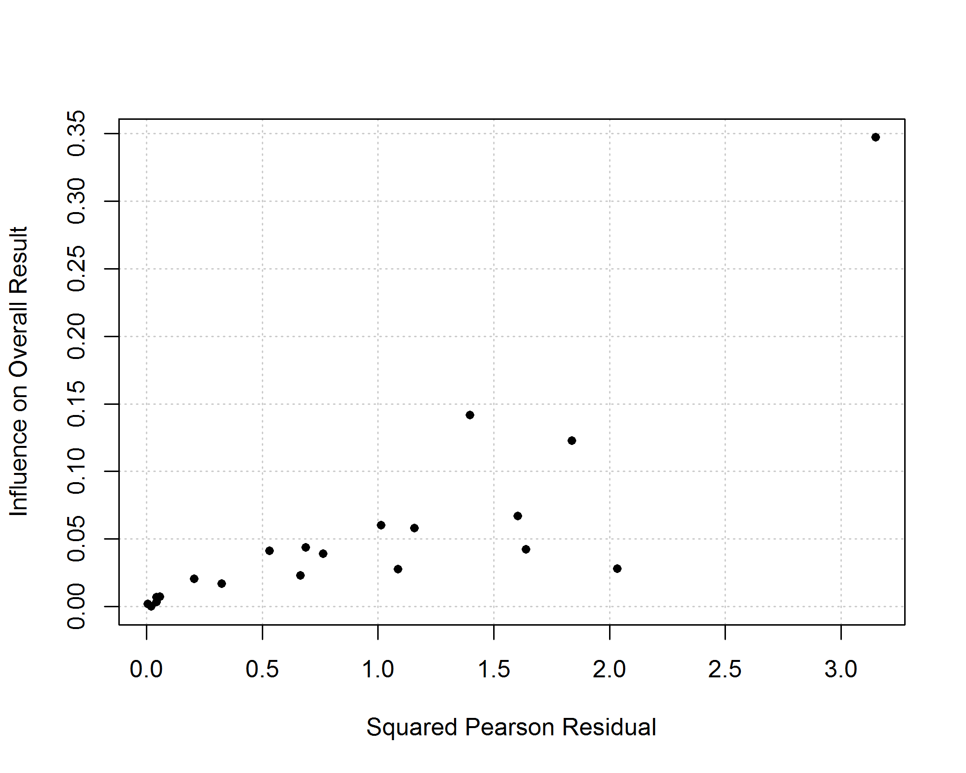

Supplementary Figure 2. Radial plot
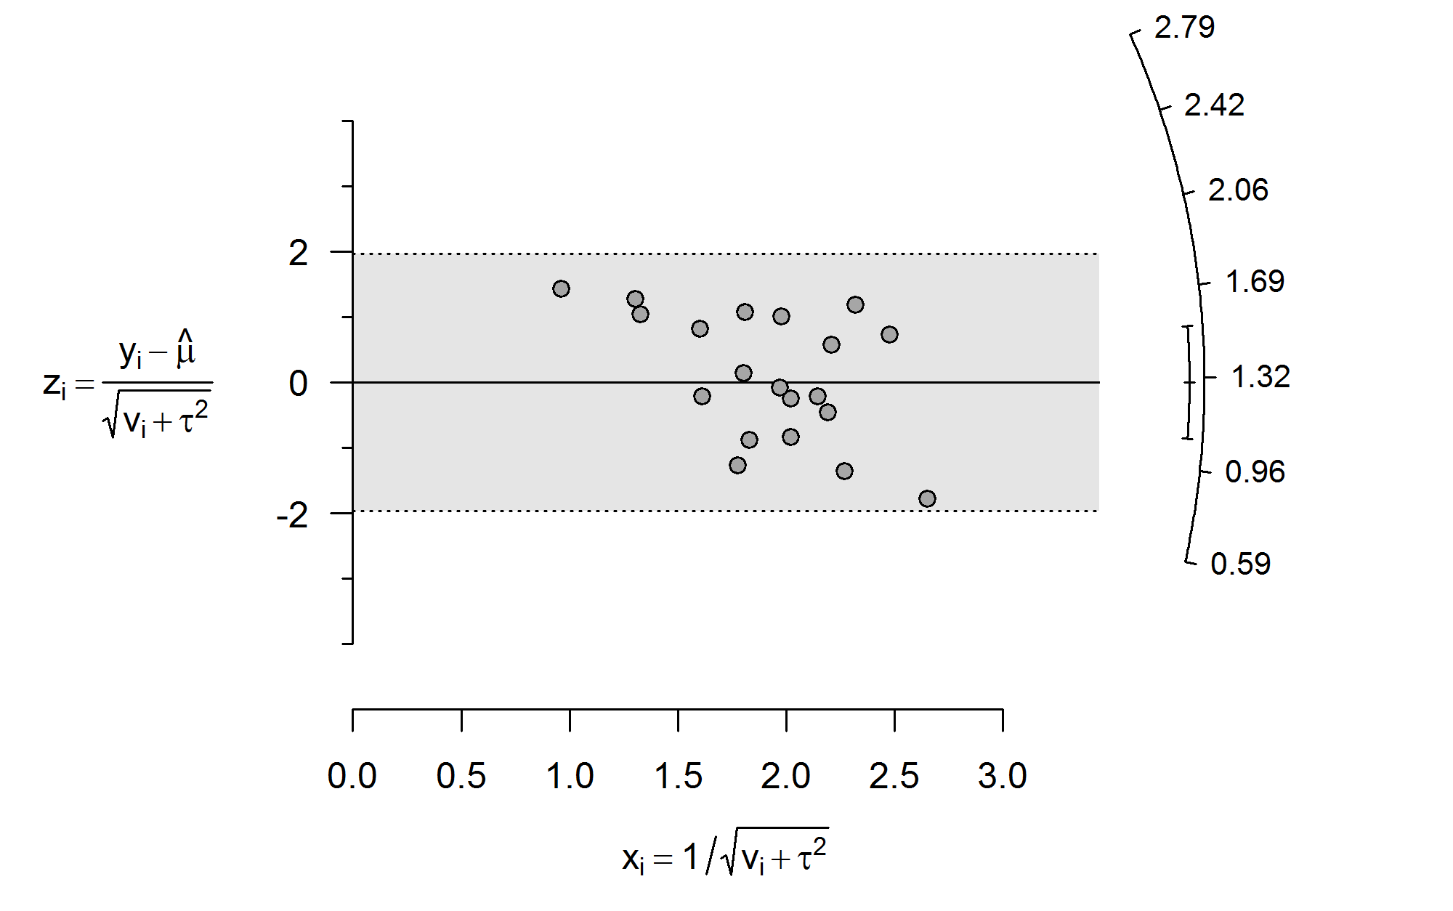

Supplementary results: Assessment of publication bias
Potential publication bias was evaluated visually using funnel plots and formally assessed through statistical testing for funnel plot asymmetry. Visual inspection of the funnel plot suggested asymmetry, with a relative overrepresentation of small studies reporting higher AUC values. This finding was supported by a statistically significant test for asymmetry (p = 0.026), indicating the presence of small-study effects and/or publication bias. Given the limited number of included cohorts, formal tests for funnel plot asymmetry should be interpreted cautiously due to reduced statistical power. These results suggest that studies with less favorable predictive performance may be underrepresented in the published literature. The funnel plot is shown in Supplementary Figure 3.
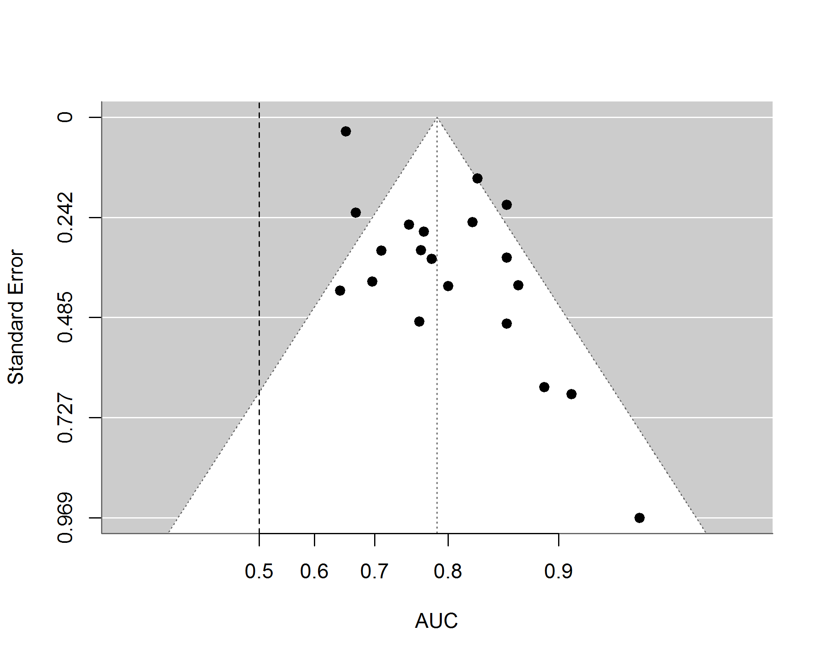
Supplementary figure 3. Funnel plot for studies included in metanalysis

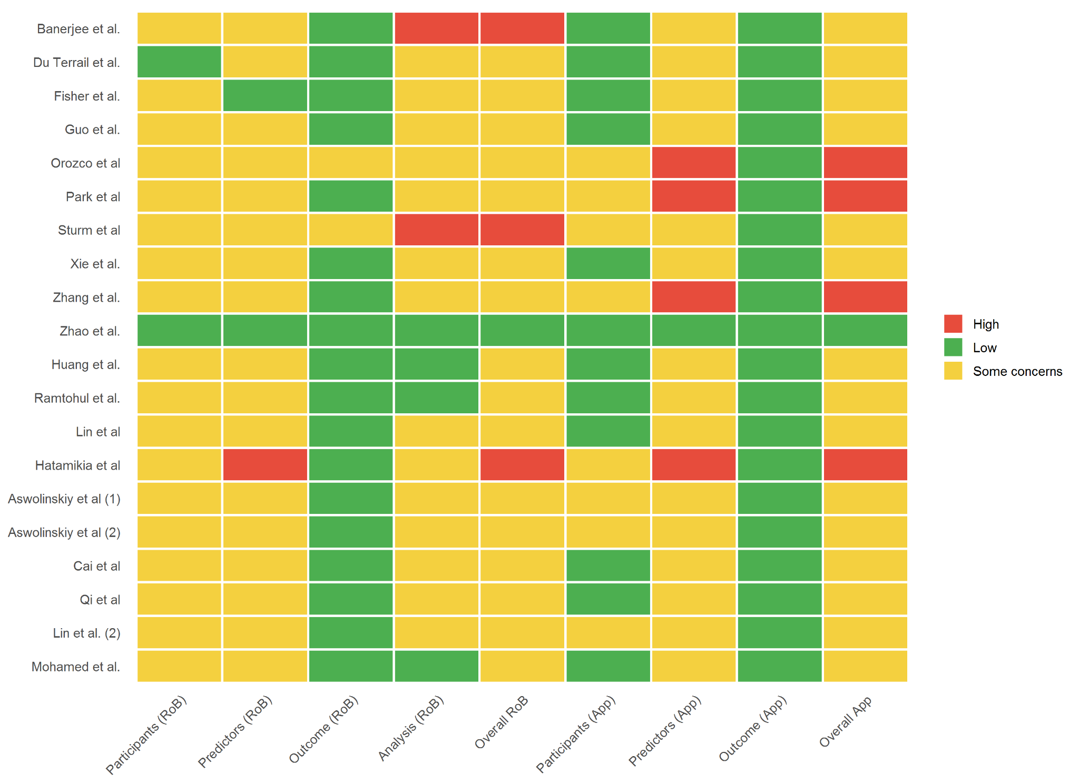
Supplementary figure 4: Application of PROBAST guidelines results’

