Supplementary Material
Supplementary Figure 1. Code used for generating the folds.
Supplementary Figure 2. Code used for Grad-CAM
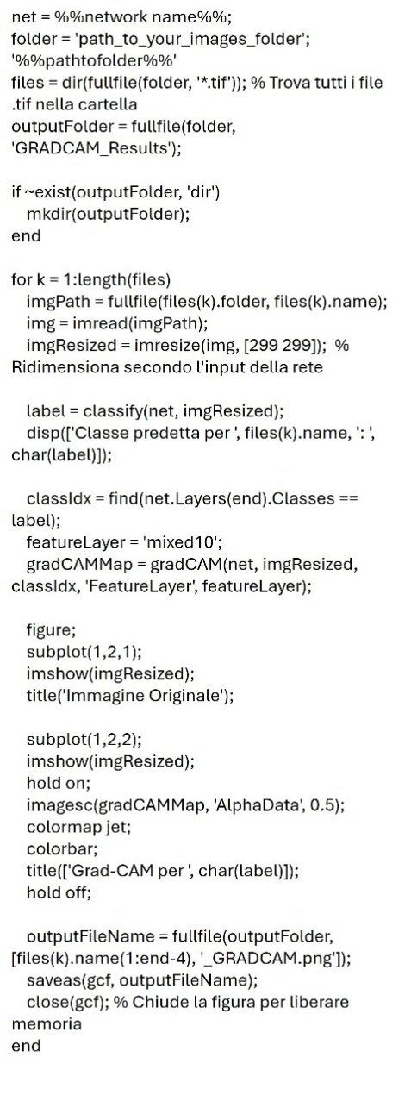

Supplementary Figure 3. Confusion matrices of Training and Test sets for the 5 different folds.
