APPENDIX SA

Table SA1. Types of meat and meat alternative burgers.
burgers
Meat
Hybrid
Plant
Seitan
Tempeh
Quorn®
Mushroom
Cultured
Dairy
Insect

APPENDIX SB

On the following types of burgers, which one do you prefer the most and which one do prefer the least? Please, select only one burger as the most preferred and only one burger as the least preferred.
Most Preferred  ONE ANSWER | Burger | Least Preferred  ONE ANSWER
 | Plant burger
 | Tempeh burger
 | Insect burger
 | Meat burger
Figure SB1. Example of a BWS task.

APPENDIX SC

Table SC1. Description of the meat and meat alternative burgers.
Product | Description
Meat burger | Meat burgers are made of conventional meat (e.g., beef, chicken, etc.). It is produced by slaughtering and processing farmed animals, which are then transformed into a burger.
Plant burger | Plant burger is made of plant proteins (e.g., soybean, pea, etc.). It is produced by processing proteins from plants which are then transformed into a burger.
Hybrid burger | Hybrid burger is made of a mix conventional meat (e.g., beef, chicken, etc.), and plant proteins (e.g., soybean, pea, etc.). It is produced by slaughtering and processing farmed animals; the meat is then mixed with processed plant proteins, which are transformed into a burger.
Tempeh burger | Tempeh burger is made of fermented soybeans. It is produced by the fermentation of soybeans, which are then transformed into a burger.
Seitan burger | Seitan burger is made of gluten derived from wheat. It is produced by processing gluten from wheat, which are then transformed into a burger.
Cultured burger | Cultured burger is made of cultivated meat (e.g., beef, chicken, etc.). It is produced by growing animal cells (e.g., from cattle, chicken, etc.) into a tank, which are then transformed into a burger.
Insect burger | Insect burger is made of insects (e.g., mealworm, house cricket, etc.). It is produced by processing proteins from insects (e.g., mealworm, house cricket, etc.), which are then transformed into a burger.
Dairy burger | Dairy burger is made of fermented dairy milk. It is produced from the fermentation of dairy milk, which are then transformed into a burger.
Quorn burger | Quorn burger is made of mycoproteins. It is produced by using a fungus that produce mycoproteins, which are then transformed into a burger.
Mushroom burger | Mushroom burger is made of mushroom (e.g., portobello, etc.). It is produced by processing mushrooms which are then transformed into a burger.

APPENDIX SD

QUESTIONNAIRE
CONSUMER PREFERENCES FOR FOOD PRODUCTS
This study is being conducted by researchers from the XXX. The purpose is to investigate consumer preferences for food products. You are being asked to participate in a research project by taking an online survey. The online survey should not take more than 15 minutes of your time. You can be assured that your answers will be kept confidential and will only be released as summaries. Your name will not be collected as part of your survey response and thus can never be associated with the data. Your answers are strictly voluntary. You will not be qualified for an incentive if you drop out of the survey or give poor quality data. Please remember that once you have answered the question, you cannot go back, thus please choose the answer carefully. You are free to withdraw from the survey at any time if you wish to do so. In the following screen you will find your unique ID code. Please save it and use it to address yourself if you wish to inform us about your intent to withdraw from the study after completing the survey by contacting XXX (XXX). You are free to withdraw your data up until when the data is aggregated on XX/XX/XXXX. After that, it will no longer be possible to withdraw your contribution from the research. If you decide to withdraw, you would still be qualified for your incentive if the survey is deemed as successfully completed on our conclusion. The submitted data will be used for statistical purposes only and statistical results will be reported in research papers, conferences, and academic journals. There are no anticipated risks in participating in this study. By participating in this survey, you will contribute to research on a better understanding of consumer preferences for food products that in turn can inform public policies. This application has been reviewed according to the procedures specified by the XXX Ethics Committee and has been given a favourable ethical opinion for conduct. If you have questions about your rights as a participant, you may contact the XXX, email: XXX. If you have questions at any time about the study or the procedures, (or you experience adverse effects as a result of participating in this study) you may contact the researcher, XXX (XXX). Completing the survey (questionnaire) and clicking the button to continue will be considered your consent to participate.

Q1. Which country you live in?
Select from the list (1)
▼ Austria (1) ... United States of America (32)

Q2. We care about the quality of our survey data and hope to receive the most accurate measures of your opinions, so it is important to us that you thoughtfully provide your best answer to each question in the survey. Do you commit to providing your thoughtful and honest answers to the questions in this survey?
- I will provide my best answers (1)
- I will not provide my best answers (2)
- I can't promise either way (3)

Q3. What gender do you identify as?
- Male (1)
- Female (0)

Q4. How old are you?_______

Q5. Please indicate your approximate annual household income before taxes:
▼ Under $15,000 (1) ... I don't want to disclose my income (10)

Q6. In which part of the United States do you live?
- Midwest (1)
- Northeast (2)
- South (3)
- West (4)

Q7. Are you fully or partially responsible for food purchases of your household?
- I am primarily responsible for food purchase (1)
- I am responsible for more than half of food purchases (2)
- I am responsible for less than half of food purchases (3)
- I am not responsible for food purchases (4)

DEFINITIONS
On the following screens you will see 10 different types of burgers. All the products adhere to the same food safety regulations and have the same characteristics (e.g., weight, appearance, brand, packaging, etc.) EXCEPT for their content and production method. Now, we will describe the different burgers in detail:
Product | Description
Meat burger | Meat burgers are made of conventional meat (e.g., beef, chicken, etc.). It is produced by slaughtering and processing farmed animals, which are then transformed into a burger.
Plant burger | Plant burger is made of plant proteins (e.g., soybean, pea, etc.). It is produced by processing proteins from plants which are then transformed into a burger.
Hybrid burger | Hybrid burger is made of a mix conventional meat (e.g., beef, chicken, etc.), and plant proteins (e.g., soybean, pea, etc.). It is produced by slaughtering and processing farmed animals; the meat is then mixed with processed plant proteins, which are transformed into a burger.
Tempeh burger | Tempeh burger is made of fermented soybeans. It is produced by the fermentation of soybeans, which are then transformed into a burger.
Seitan burger | Seitan burger is made of gluten derived from wheat. It is produced by processing gluten from wheat, which are then transformed into a burger.
Cultured burger | Cultured burger is made of cultivated meat (e.g., beef, chicken, etc.). It is produced by growing animal cells (e.g., from cattle, chicken, etc.) into a tank, which are then transformed into a burger.
Insect burger | Insect burger is made of insects (e.g., mealworm, house cricket, etc.). It is produced by processing proteins from insects (e.g., mealworm, house cricket, etc.), which are then transformed into a burger.
Dairy burger | Dairy burger is made of fermented dairy milk. It is produced from the fermentation of dairy milk, which are then transformed into a burger.
Quorn burger | Quorn burger is made of mycoproteins. It is produced by using a fungus that produce mycoproteins, which are then transformed into a burger.
Mushroom burger | Mushroom burger is made of mushroom (e.g., portobello, etc.). It is produced by processing mushrooms which are then transformed into a burger.

CHEAP TALK
NOW, PLEASE TAKE TIME TO CAREFULLY READ THE FOLLOWING INSTRUCTIONS BEFORE PROCEEDING. Imagine you are in your usual store or restaurant and considering the purchase of a burger. For each question below, please indicate which burger you consider to be your most preferred and which burger you consider to be your least preferred when you purchase burgers at the store or restaurant. For each question, please select only one burger that you consider as the most preferred and only one burger that you consider as the least preferred. Please carefully examine each option before you make a decision and select the decision that you would make based on your own preferences. Previous similar studies show that people often respond in one way but act differently. We ask you to respond to each of the following choice questions just exactly as you would if you were in a real store or restaurant and had to pay for your choice. Please keep this in mind when answering the following choice questions.
IMPORTANT: CHOOSE only one burger that you consider as the most preferred and only one burger that you consider as the least preferred on each page. Assume that the options on each page are the only ones available, and do not compare options on different pages.

Q8. Before proceeding to the next set of questions, we want to ask for your feedback about the responses you provided so far. It is vital to our study that we only include responses from participants who devoted their full attention to this study. In your honest opinion, should we use your responses, or should we discard your responses since you did not devote your full attention to the questions so far?
- Yes, I have devoted full attention to the questions so far and I think you should use my responses for your study. (1)
- No, I have not devoted full attention to the questions so far and I think you should not use my responses for your study. (0)

Treatments information
ENVIRONMENTAL INFORMATION
Animal production impacts the environment in different ways because it can:
- Produce large quantities of greenhouse gas emissions in the atmosphere, like methane, and carbon dioxide
- Require extensive land use, leading to deforestation, and habitat loss
- Use significant amount of water
- Require a significant amount of energy
- Contribute to significant water, and soil pollution
- Contribute to high biodiversity loss
- Contribute to significant waste generation.
HEALTH INFORMATION
Meat consumption impacts human health in different ways because it can:
- Be a rich source of essential nutrients (i.e. proteins, iron, zinc, and vitamins B)
- Increase the risk of cardiovascular diseases, cancers, and high cholesterol levels
- Increase the risk of colorectal cancer
- Contain antibiotics which can develop of antibiotic-resistant bacteria
- Contain exogenous hormones
- Lead to bacterial contamination which can increase the risk of foodborne illnesses

ANIMAL WELFARE INFORMATION
Animal production impacts animal welfare in different ways because it can:
- Limit animal natural behaviour
- Animals can live in confinement and overcrowding which causes stress, and spread of diseases
- Use hormones which can damage health, and welfare
- Animal transportation can be stressful
- Slaughter process can cause pain, and discomfort to animals
- Involve dehorning, and castration which can cause pain to animals
- Animals can have shorter lifespans, and culling practices of animals can impact their welfare

Example of BWS question
Q9-Q18. On the following types of burgers, which one do you prefer the most and which one do prefer the least? Please, select only one burger as the most preferred and only one burger as the least preferred.
Most preferred |  | Least preferred
 | Meat burger (It is made of conventional meat (e.g., beef, chicken, etc.). It is produced by slaughtering and processing farmed animals, which are then transformed into a burger)
 | Seitan burger (It is made of gluten derived from wheat. It is produced by processing gluten from wheat, which are then transformed into a burger)
 | Dairy burger (It is made of fermented dairy milk. It is produced from the fermentation of dairy milk, which are then transformed into a burger)
 | Quorn burger (It is made of mycoproteins. It is produced by using a fungus that produce mycoproteins, which are then transformed into a burger)

Q19. How familiar were you with the different types of burgers prior to this study?
 | Not familiar at all (1) | Slightly familiar (2) | Moderately familiar (3) | Very familiar (4) | Extremely familiar (5)
Meat burger
(Made of conventional meat)
Plant burger
(Made of plant proteins)
Hybrid burger
(Made of a mix conventional and plant proteins)
Tempeh burger
(Made of fermented soybeans)
Seitan burger
(Made of wheat)
Cultured burger
(Made of growing animal cells in a tank)
Insect burger
(Made of insects)
Dairy burger
(Made of fermented milk)
Quorn burger
(Made of mycoproteins)
Mushroom burger
(Made of mushroom)

Q20. How would you group the following burgers in terms of their similarities or dissimilarities to each other? (Please, click burgers you feel are similar to each other into the same group; use as many or as few groups as you like).
 | Group 1 (1) | Group 2 (2) | Group 3 (3) | Group 4 (4) | Group 5 (5)
Meat burger
(Made of conventional meat)
Plant burger
(Made of plant proteins)
Hybrid burger
(Made of a mix conventional and plant proteins)
Tempeh burger
(Made of fermented soybeans)
Seitan burger
(Made of wheat)
Cultured burger
(Made of growing animal cells in a tank)
Insect burger
(Made of insects)
Dairy burger
(Made of fermented milk)
Quorn burger
(Made of mycoproteins)
Mushroom burger
(Made of mushroom)

Q21. Which of the following burgers do you think is.....? (You can only select one product per statement).
tastiest | ▼ Meat burger (1) ... Mushroom burger (11)
healthiest | ▼ Meat burger (1) ... Mushroom burger (11)
the most nutritious | ▼ Meat burger (1) ... Mushroom burger (11)
the most environmental-friendly | ▼ Meat burger (1) ... Mushroom burger (11)
the most expensive | ▼ Meat burger (1) ... Mushroom burger (11)
the most natural | ▼ Meat burger (1) ... Mushroom burger (11)

Q22. Do you support or oppose that any product labelled as “meat” should only come animals born, raised, and harvested in the traditional animal agricultural manner rather than coming from alternative sources (e.g. culturing meat, plant-based sources, fermentation of soybeans, dairy sources, etc.)?
- Support (1)
- Oppose (0)

Q22.1 Which meat or meat alternatives do you think should be named as “meat”? (Please, check all that apply).
- Meat burger (Made of conventional meat) (1)
- Plant burger (Made of plant proteins) (2)
- Hybrid burger (Made of a mix conventional and plant proteins) (3)
- Tempeh burger (Made of fermented soybeans) (4)
- Seitan burger (Made of wheat) (5)
- Cultured burger (Made of growing animal cells in a tank) (6)
- Insect burger (Made of insects) (7)
- Dairy burger (Made of fermented milk) (8)
- Quorn burger (Made of mycoproteins) (9)
- Mushroom burger (Made of mushroom) (10)

Q23. Which of the following is the diet that you regularly adopt? (Please, mark only one of the option - box next that better resemble your diet).
- Full time meat eater (eating red meat, fish and chicken). (1)
- Flexitarian (reducing meat intake but eating meat now and then). (2)
- Pollotarian (eating no red meat, but eat fish, chicken and other poultry). (3)
- Pescetarian (eating no red meat or chicken, but eat fish and shellfish). (4)
- Macrobiotic consumer (eating unprocessed, organic, and locally grown foods, with a great overlap with foods consumed in a vegetarian diet, yet also including certain kinds of meat). (5)
- Lacto-ovo vegetarian (eating no meat or fish, but eating eggs and dairy produce) (6)
- Lacto-vegetarian (eating no meat, fish or eggs, but eating dairy produce) (7)
- Ovo-vegetarian (eating no meat, fish or dairy produce, but eating eggs). (8)
- Vegan (eating no meat and using no products of animal origin). (9)

Q24. The following statements deal with attitudes related to new foods. Please give us your opinion.
 | Strongly disagree (1) | Disagree (2) | Somewhat disagree (3) | Neither agree nor disagree (4) | Somewhat agree (5) | Agree (6) | Strongly agree (7)
I am constantly sampling new and different foods
I don’t trust new foods
If I don’t know what a food is, I won’t try it
I like foods from different cultures
Ethnic food looks too weird to eat

At dinner parties, I will try new foods
I am afraid to eat things I have never had before
I am very particular about the foods I eat
I will eat almost anything
I like to try new ethnic restaurants

Q25. The following statements deal with your environmental attitudes. Please give us your opinion on the following statements.
 | Strongly disagree (1) | Somewhat disagree (2) | Neither agree nor disagree (3) | Somewhat agree (4) | Strongly agree (5)
We are approaching the limit of the number of people the Earth can support.
Humans have the right to modify the natural environment to suit their needs.
When humans interfere with nature it often produces disastrous consequences.
Human ingenuity will insure that we do not make the Earth unlivable.
Humans are seriously abusing the environment.

 | Strongly disagree (1) | Somewhat disagree (2) | Neither agree nor disagree (3) | Somewhat agree (4) | Strongly agree (5)
The Earth has plenty of natural resources if we just learn how to develop them
Plants and animals have as much right as humans to exist.
The balance of nature is strong enough to cope with the impacts of modern industrial nations.
Despite our special abilities, humans are still subject to the laws of nature.
The so-called “ecological crisis” facing humankind has been greatly exaggerated.
The Earth is like a spaceship with very limited room and resources.
Humans were meant to rule over the rest of nature.
The balance of nature is very delicate and easily upset.
Humans will eventually learn enough about how nature works to be able to control it.
If things continue on their present course, we will soon experience a major ecological catastrophe.

Q26. The following statements deal with general health interest. Please give us your opinion on the following statements.
 | Strongly disagree (1) | Disagree (2) | Somewhat disagree (3) | Neither agree nor disagree (4) | Somewhat agree (5) | Agree (6) | Strongly agree (7)
The healthiness of food has little impact on my food choices
I am very particular about the healthiness of food I eat
I eat what I like and I do not worry much about the healthiness of food
It is important for me that my diet is low in fat
I always follow a healthy and balanced diet
Please select the option: Somewhat agree

 | Strongly disagree (1) | Disagree (2) | Somewhat disagree (3) | Neither agree nor disagree (4) | Somewhat agree (5) | Agree (6) | Strongly agree (7)
It is important for me that my daily diet contains a lot of vitamins and minerals
The healthiness of snacks makes no difference to me
I do not avoid foods, even if they may raise my cholesterol
I do not avoid foods, even if they may be high in sugar content
I pay attention to the salt intake in my diet

Q27. The following statements deal with attitudes related to animal protection. Please give us your opinion on the following statements.
 | Strongly disagree (1) | Somewhat disagree (2) | Neither agree nor disagree (3) | Somewhat agree (4) | Strongly agree (5)
It is morally wrong to hunt wild animals just for sport.
I do not think that there is anything wrong with using animals in medical research.
I think it is perfectly acceptable for cattle and hogs to be raised for human consumption.
The slaughter of whales and dolphins should be immediately stopped even if it means some people will be put out of work.
I sometimes get upset when I see wild animals in cages at zoos.

Q28. Do you support or oppose the ban/abolition of animal agriculture?
- Support (1)
- Oppose (0)

Q29. Do you support or oppose a possible government regulation to tax meat from animals in an effort to reduce meat consumption for environmental, health, and animal welfare objectives?
- Support (1)
- Oppose (0)

Q30. Which of the following two options do you believe would be the most effective in addressing the agri-food related challenges, such as for example sustainability, health, animal welfare, etc. that you think are the most relevant?
- Adopt a more ‘technological’ agricultural production system: utilizing greater innovation, a science-based approach, and research in crops, animals, and food. (1)
- Adopt a more ‘natural’ agricultural production system: utilizing more local, organic, resilient, and unprocessed practices for crops, animals, and food. (0)

Q31. Do you follow any religion?
- Yes (1)
- No (0)

Q31.1 How important is religion in your life?
- Not at all important (1)
- Slightly important (2)
- Moderately important (3)
- Very important (4)
- Extremely important (5)

Q32. When it comes to politics, do you usually think of yourself as:
- Extremely liberal (1)
- Slightly liberal (2)
- Moderate or middle of the road (3)
- Slightly conservative (4)
- Extremely conservative (5)
- I do not know (0)

Q33. What is the highest level of education you have completed?
- Elementary/Some High School (1)
- High School Diploma (2)
- Some college (3)
- Technical School Diploma (4)
- Associate's Degree (5)
- Bachelor's Degree (6)
- Master's Degree (7)
- Doctorate (8)

Q34. How many individuals live in your household where you currently reside, including yourself? __________

Q35. Are children under the age of 18 present in the household?
- Yes (1)
- No (0)

Q36. Do you live today in a rural area (less than 2,500 people) or in an urbanized cluster (between 2,500 and 50,000 people) or in an urbanized area (more than 50,000 people)?
- Rural (less than 2,500 people) (1)
- Urbanized cluster (between 2,500 - 50,000 people) (2)
- Urban area (more than 50,000 people) (3)

END
Thank You!
If you have any comments regarding this survey, please enter them in the box.
________________________________________________________________________________

APPENDIX SE

TREATMENT 1
CONTROL
(No other information provided)

TREATMENT 2
ENVIRONMENTAL INFORMATION
Animal production impacts the environment in different ways: (i) it can produce large quantities of greenhouse gas emissions in the atmosphere, like methane, and carbon dioxide; (ii) it can require extensive land use, leading to deforestation, and habitat loss; (iii) it can use significant amount of water; (iv) it can require a significant amount of energy; (v) it can contribute to significant water, and soil pollution; (vi) it can contribute to high biodiversity loss; and, (vii) it can contribute to significant waste generation.

TREATMENT 3
HEALTH INFORMATION
Meat consumption impacts human health in different ways: (i) it is a rich source of essential nutrients (i.e. proteins, iron, zinc, and vitamins B); (ii) it can increase the risk of cardiovascular diseases, cancers, and high cholesterol levels; (iii) it can increase the risk of colorectal cancer; (iv) it can contain antibiotics which can develop of antibiotic-resistant bacteria; (v) it can contain exogenous hormones; and, (vi) it can lead to bacterial contamination which can increase the risk of foodborne illnesses.

TREATMENT 4
ANIMAL WELFARE INFORMATION
Animal production impacts animal welfare in different ways: (i) it can limit animal natural behaviour; (ii) animals can live in confinement and overcrowding which causes stress, and spread of diseases; (iii) it can use hormones which can damage health, and welfare; (iv) transportation can be stressful; (v) slaughter process can cause pain, and discomfort to animals; (vi) it may involve dehorning, and castration which can cause pain to animals; and (vii) animals can have shorter lifespans, and culling practices of animals can impact their welfare.

APPENDIX SF

Table SF1. Socio-demographic characteristics of the sample.
Variable | Treatment 1  CONTROL  (N=288) | Treatment 2  ENVIRONMENT  (N=293) | Treatment 3  HEALTH  (N=292) | Treatment 4  ANIMAL  (N=291)
Gender  Male  Female  Pearson chi2(3) = 4.63 Pr = 0.20 | 50.69%  49.31% | 54.95%  45.05% | 50.34%  49.66% | 53.95%  46.05%
Age  18-35  36-53  54-71  71+  Chi2(3) with ties = 2.29 Prob = 0.51 | 29.51%  29.17%  29.51%  11.81% | 33.45%  30.03%  24.23%  12.29% | 30.82%  25.34%  30.48%  13.36% | 32.30%  29.21%  26.80%  11.68%
Household size (n° member)  1-5  6-10  11-15  16-20  20+  Chi2(3) with ties = 0.13 Prob = 0.99 | 96.88%  3.12% | 96.93%  2.73%  0.34% | 97.26%  2.74% | 97.25%  2.41%  0.34%
Education  Elementary/some high school  High school diploma  Some college  Technical school diploma  Associate's degree  Bachelor's degree  Master's degree  Doctorate  Chi2(3) with ties = 0.70 Prob = 0.87 | 1.04%  19.10%  23.26%  3.47%  8.33%  23.96%  19.10%  1.74% | 2.05%  16.38%  25.26%  2.73%  6.83%  31.40%  13.31%  2.05% | 2.05%  18.84%  16.78%  6.16%  7.88%  34.93%  10.27%  3.08% | 2.06%  17.87%  21.65%  4.81%  9.28%  31.96%  11.00%  1.37%
Income  Less than $15,000  $15,000-$29,999  $30,000-$44,999  $45,000-$59,999  $60,000-$74,999  $75,000-$99,999  $100,000-$149,999  $150,000-$199,999  More than $200,000  Chi2(3) with ties = 4.07 Prob = 0.25  I don't want to disclose my income | 7.64%  6.60%  10.76%  14.58%  22.92%  13.19%  11.81%  6.25%  5.21%  1.04% | 6.83%  9.22%  6.14%  11.95%  16.38%  18.77%  15.70%  6.83%  5.12%  3.07% | 6.85%  4.79%  8.56%  13.01%  18.84%  17.81%  7.12%  5.14%  5.14%  2.74% | 8.25%  7.22%  9.28%  13.40%  19.93%  13.40%  15.81%  5.84%  5.15%  1.72%
Region  Midwest  Northeast  South  West  Pearson chi2(9) = 14.19 Pr = 0.12 | 24.65%  20.83%  35.76%  18.75% | 20.14%  15.70%  28.33%  35.84% | 26.37%  16.44%  20.21%  36.99% | 20.96%  20.96%  36.43%  21.65%
Presence of child under 18 y  Child  No child  Pearson chi2(3) = 1.40 Pr = 0.71 | 26.74%  73.26% | 29.35%  70.65% | 26.03%  73.97% | 29.55%  70.45%
Area of living  Rural area  Urbanized cluster  Urban area  Pearson chi2(6) = 7.91 Pr = 0.24 | 16.32%  46.88%  36.81% | 14.68%  39.25%  46.08% | 14.38%  45.55%  40.07% | 17.87%  39.52%  42.61%

Table SF2. Types of diet of the sample.
DIET | Treatment 1  CONTROL  (N=288) | Treatment 2  ENVIRONMENT  (N=293) | Treatment 3  HEALTH  (N=292) | Treatment 4  ANIMAL  (N=291)
Full time meat eater (eating red meat, fish and chicken)  Yes  No  Pearson chi2(3) = 1.46 Pr = 0.69 | 67.71%  32.29% | 69.62%  30.38% | 70.55%  29.45% | 66.32%  33.68%
Flexitarian (reducing meat intake but eating meat now and then)  Yes  No  Pearson chi2(3) = 1.98 Pr = 0.58 | 21.18%  78.82% | 21.50%  78.50% | 20.21%  79.79% | 24.74%  75.26%
Pollotarian (eating no red meat, but eat fish, chicken and other poultry)  Yes  No  Pearson chi2(3) = 0.63 Pr = 0.89 | 3.12%  96.88% | 2.73%  97.27% | 2.40%  97.60% | 3.44%  96.56%
Pescatarian (eating no red meat or chicken, but eat fish and shellfish)  Yes  No  Pearson chi2(3) = 0.64 Pr = 0.89 | 0.69%  99.31% | 1.37%  98.63% | 1.03%  98.97% | 1.03%  98.97%
Macrobiotic consumer (eating unprocessed, organic, and locally grown foods, with a great overlap with foods consumed in a vegetarian diet,  yet also including certain kinds of meat)  Yes  No  Pearson chi2(3) = 0.84 Pr = 0.84 | 1.04%  98.96% | 1.71%  98.29% | 1.03%  98.97% | 1.03%  98.97%
Lacto-ovo vegetarian (eating no meat or fish, but eating eggs and dairy produce)  Yes  No  Pearson chi2(3) = 4.98 Pr = 0.17 | 2.78%  97.22% | 0.68%  99.32% | 2.05%  97.95% | 1.03%  98.97%
Lacto-vegetarian (eating no meat, fish or eggs, but eating dairy produce)  Yes  No  Pearson chi2(3) = 3.09 Pr = 0.38 | 1.39%  98.61% | 0.34%  99.66% | 0.68%  99.32% | 0.34%  99.66%
Ovo-vegetarian (eating no meat, fish or dairy produce, but eating eggs)  Yes  No  Pearson chi2(3) = 0.43 Pr = 0.93 | 0.69%  99.31% | 0.68%  99.32% | 0.68%  99.32% | 0.34%  99.65%
Vegan (eating no meat and using no products of animal origin)  Yes  No  Pearson chi2(3) = 0.18 Pr = 0.98 | 1.39%  98.61% | 1.37%  98.63% | 1.37%  98.63% | 1.72%  98.28%

APPENDIX SG

Table SG1. Description of the consumer characteristics used for the sub-samples analysis: variable used, question asked, sub-sample description, measures and acronyms.
VARIABLE | Question | SUBSAMPLE | MEASURE | ACRONYM
GENDER | What gender do you  identify as? | Females  (Respondents who are female)  Males  (Respondents who are male) | - | FEMALES  MALES
AGE | How old are you? | Young  (Respondents who are younger than  47 years)  Old  (Respondents who are equal or older than 47 years) | Median  (47 years) | YOUNG  OLD
INCOME | Please indicate your approximate annual household income before taxes:  - Under $15,000  - Between $15,000 - $ 24,999  - Between $25,000 - $ 34,999  - Between $35,000 - $ 49,999  - Between $50,000 - $ 74,999  - Between $75,000 - $ 99,999  - Between $100,000 - $ 149,999  - Between $150,000 - $ 200,000  - More than $200,000  - I don’t want to disclose my income | Low-income  (Respondents whose income are lower than $50,000 – $74,999)  High-income  (Respondents whose income are equal or higher than $50,000 – $74,999) | Median  (5) | POOR  RICH
Politics | When it comes to politics,  do you usually think  of yourself as:  - Extremely liberal  - Slightly liberal  - Moderate or middle of the road  - Slightly conservative  - Extremely conservative  - I do not know | Respondents who are extremely or slightly liberal  Respondents who are moderate  Respondents who are extremely or slightly conservative | - | LIBERAL  MODERATE  CONSERVATIVE
FOOD NEOPHOBIA (FNS) | Food Neophobia Scale (FNS) (Pliner and Hobden 1992) is composed by 10-items (7–point Likert scale “agree”-“disagree”): (i) I am constantly sampling new and different foods. (ii) I don’t trust new foods. (iii) If I don’t know what a food is, I won’t try it. (iv) I like foods from different cultures. (v) Ethnic food looks too weird to eat. (vi) At dinner parties, I will try new foods. (vii) I am afraid to eat things I have never had before. (viii) I am very particular about the foods I eat. (ix) I will eat almost anything. (x) I like to try new ethnic restaurants. | Low-FNS  (Respondents who have low fears toward new food products. FNS scores lower than 3.6)  High-FNS  (Respondents who have high fears toward new food products.  FNS scores equal or higher than 3.6) | Median  (3.6) | LOW-FNS  HIGH-FNS
PRO-HEALTH ATTITUDE (HEALTH) | Health attitude (HEALTH) (Roininen, Lähteenmäki, and Tuorila 1999) is composed by 10-items (7–point Likert scale “agree”-“disagree”): (i) The healthiness of food has little impact on my food choices. (ii) I am very particular about the healthiness of food I eat. (iii) I eat what I like and I do not worry much about the healthiness of food. (iv) It is important for me that my diet is low in fat. (v) I always follow a healthy and balanced diet. (vi) It is important for me that my daily diet contains a lot of vitamins and minerals. (vii) The healthiness of snacks makes no difference to me. (viii) I do not avoid foods, even if they may raise my cholesterol. (ix) I do not avoid foods, even if they may be high in sugar content. (x) I pay attention to the salt intake in my diet. | Low-Health  (Respondents who have low pro-health attitude. HEALTH scores lower than 4.25)  High-Health  (Respondents who have high pro-health attitude. HEALTH scores equal or higher than 4.25) | Median  (4.25) | LOW-HEALTH  HIGH-HEALTH
PRO-ANIMAL WELFARE ATTITUDE  (AAS) | Animal Attitude Scale (AAS) (Herzog, Grayson, and McCord 2015) is composed by 5-items (5–point Likert scale “agree”-“disagree”): (i) It is morally wrong to hunt wild animals just for sport. (ii) I do not think that there is anything wrong with using animals in medical research. (iii) I think it is perfectly acceptable for cattle and hogs to be raised for human consumption. (iv) The slaughter of whales and dolphins should be immediately stopped even if it means some people will be put out of work. (v) I sometimes get upset when I see wild animals in cages at zoos. | Low-AAS  (Respondents who have low pro-animal welfare attitude. AAS scores lower than 3.4)  High-AAS  (Respondents who have high pro-animal welfare attitude. AAS scores equal or higher than 3.4) | Median  (3.4) | LOW-AAS  HIGH-AAS

APPENDIX SH

Table SH1. Consumer familiarity and perceptions of meat and meat alternatives.
Burger/  Attribute | FAMILIARITY | Tastiest | healthiest | most nutritious | most natural | most environmentally friendly | most expensive
Burger/  Attribute | Mean  (SD) | (% share) | (% share) | (% share) | (% share) | (% share) | (% share)
Meat | 4.68  (0.75) | 78% | 23% | 38% | 48% | 16% | 28%
Plant | 3.20  (1.30) | 7% | 42% | 27% | 23% | 39% | 13%
Mushroom | 2.57  (1.37) | 6% | 14% | 9% | 16% | 17% | 4%
Hybrid | 2.07  (1.30) | 4% | 6% | 8% | 3% | 2% | 17%
Tempeh | 1.82  (1.16) | 0% | 2% | 4% | 2% | 2% | 4%
Cultured | 1.82  (1.15) | 1% | 2% | 3% | 1% | 7% | 18%
Seitan | 1.61  (1.10) | 0% | 4% | 3% | 1% | 4% | 3%
Dairy | 1.44  (1.00) | 2% | 2% | 2% | 1% | 2% | 3%
Quorn® | 1.44  (0.99) | 1% | 1% | 1% | 3% | 2% | 4%
Insect | 1.44  (0.94) | 0% | 2% | 5% | 3% | 9% | 7%
Note. SD: standard deviation.

APPENDIX SI

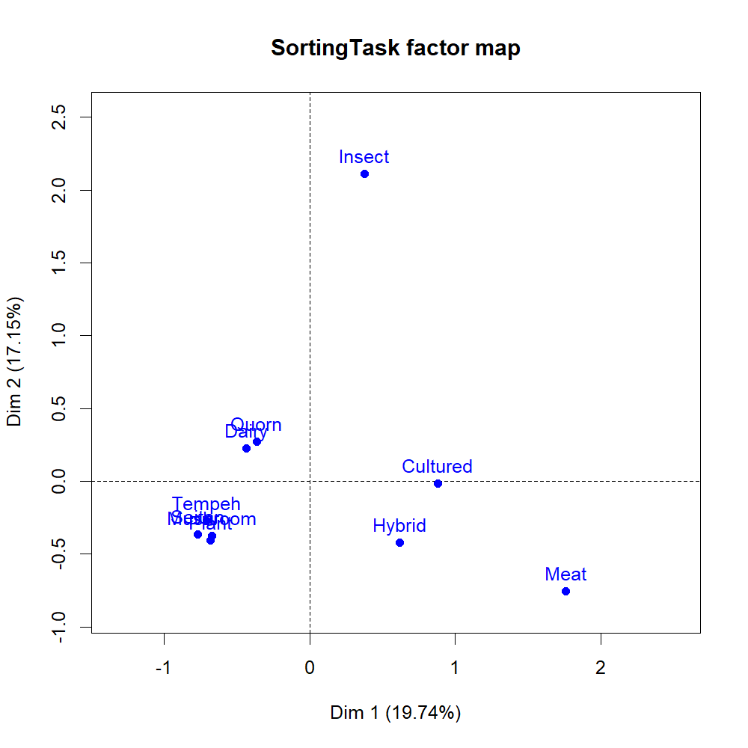
Figure SI1. Representation of the meat and meat alternative burgers in the plane defined by dimensions 1 and 2 of MCA.

APPENDIX SL

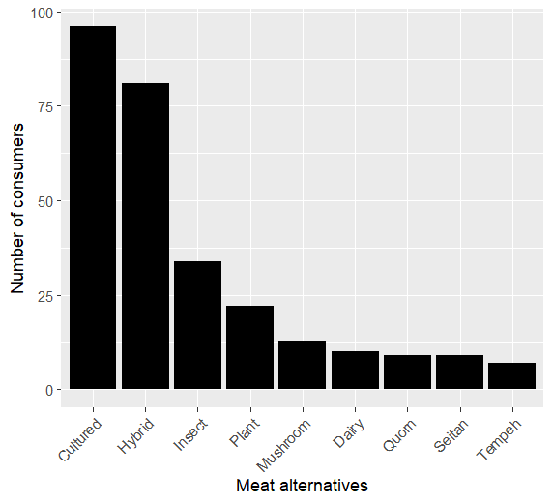
Figure SL1. Consumer preferences for labelling meat alternatives as ‘meat’.

APPENDIX SM

Table SM1. Effect of consumer characteristics on preferences for labeling cultured and hybrid meat alternatives as ‘meat’
VARIABLE | CULTURED MEAT  labeled as “MEAT”  (N=272) |  | HYBRID MEAT  labeled as “MEAT”  (N=272)
VARIABLE | Coefficient (SE) | P-value | Coefficient (SE) | P-value
Intercept | -1.44  (1.56) | 0.35 | -1.98  (0.62) | 0.22
Age: Older | -0.01  (0.01) | 0.45 | -0.03  (0.01) | 0.00
Gender: Male | 0.49  (0.29) | 0.09 | 0.38  (0.31) | 0.21
Income: Higher income | 0.15  (0.29) | 0.61 | 0.13  (0.31) | 0.69
Education: Higher education | 0.71  (0.30) | 0.02 | 0.61  (0.32) | 0.06
Meat familiarity: Higher meat familiarity | 0.05  (0.19) | 0.81 | -0.04  (0.19) | 0.84
NEP: Higher pro-environmental attitude | 0.28  (0.26) | 0.29 | 0.43  (0.28) | 0.13
AAS: Higher pro-animal attitude | -0.25  (0.29) | 0.39 | 0.15  (0.32) | 0.63
Health: Higher pro-health attitude | 0.23  (0.12) | 0.06 | 0.24  (0.13) | 0.07
Religion: Religious | -0.39  (0.29) | 0.18 | -0.16  (0.30) | 0.60
Politics: Conservative | -0.29  (0.14) | 0.03 | -0.34  (0.14) | 0.02
Model statistics
N. of obs. | 272 |  | 272
ll(model) | -158.85 |  | -145.64
df | 11 |  | 11
Prob > chi2 | 0.00 |  | 0.00
LR chi2(10) | 27.63 |  | 36.50
Pseudo-R² | 0.08 |  | 0.11
AIC | 339.70 |  | 313.29
BIC | 379.37 |  | 352.95
Note. SE: standard error.
Note. N. of obs.: number of observations.
Note. ll: log-likelihood.
Note. d.f.: degree of freedom.
Note. LR chi2(10): Likelihood Ratio (LR) chi-squared statistic.
Note. Pseudo-R²: McFadden's pseudo-R2.
Note. AIC: Akaike information criterion.
Note. BIC: Bayesian Information Criterion
Note. NEP: Pro-environmental attitude.
Note. AAS. Pro-animal welfare attitude.
Note: Health: Pro-health attitude.

