APPENDIX S1

3D IMAGING ON BLENDER
The ‘.ply’ meshes resulting from the segmentation process were imported into Blender v4.4.1 (Blender Foundation, Amsterdam, Netherlands). Each mesh was smoothed with a Smooth modifier (factor = 0.5, repeat = 5) to perform a rendering of the single elements in all their informative positions. Since a cervical vertebra, two dorsal vertebrae, and the left fibula were found divided into two fragments, the putative original morphology of each element was restored in Blender before performing the render. Renders of the different tracts of the semicircular canals inside their respective cranial bone, which was made semi-transparent (Roughness = 0.7, IOR = 1.5, Alpha = 0.2), were also produced. In addition, “mounted” versions of the skull, the semicircular canals, the cervical region, and the whole skeleton (Fig. 3 in main text) were produced and rendered, by assembling the preserved elements in their original anatomical position in the Blender environment. The elements in their original position (that is saved during the exportation from Amira) were also aligned with the surface scan of the block, which was made semi-transparent (Roughness = 0.5, IOR = 2.5, Alpha = 0.3), to perform two renders that show the original organization of the preserved elements inside the block (Fig. 2 in main text). Each picture produced in Blender was taken in orthogonal perspectives, using Cycles rendering and two lights (Type: “Sun”, Angle = 0.526°, Max Bounces = 1024), one with a strength of 1.0 and the other of 5.0.

ADDITIONAL ANATOMICAL FIGURES
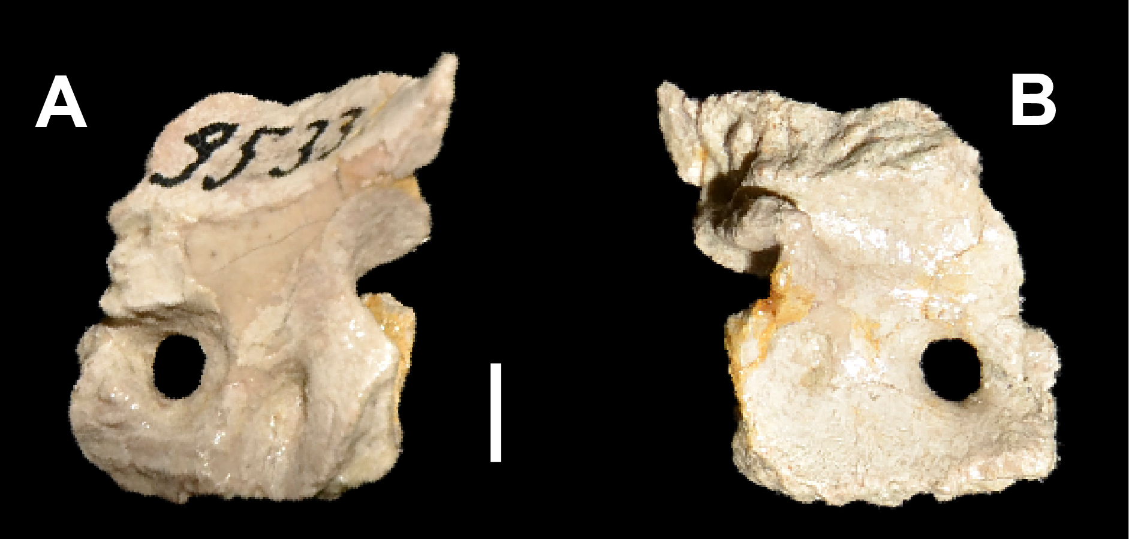
FIG. S1.1. Isolated Dysalotosaurus lettowvorbecki left prootic GPIT-PV-69072, in: A, lateral; B, medial view. Scale bar represents 5 mm.

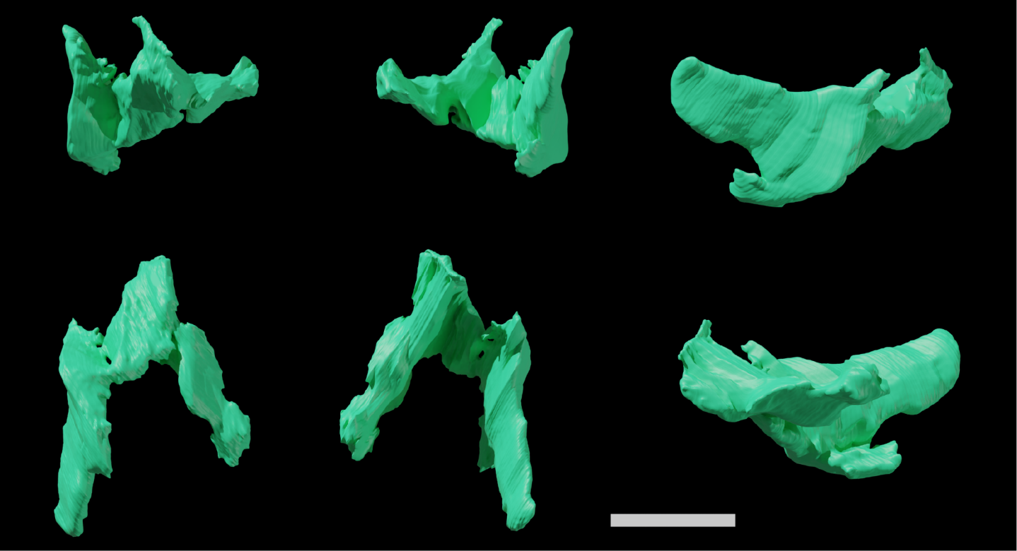
FIG. S1.2. Indeterminate cranial bone of GPIT-PV-122984 in different views. Scale bar represents 10 mm.

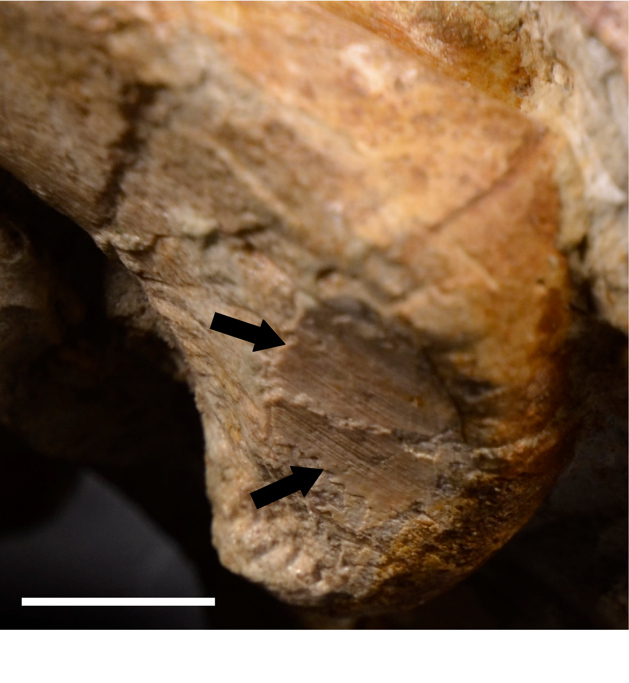
FIG. S1.3. Detail of exposed medial surface of the distal end of left femur of GPIT-PV-122984. Black arrows mark striations on the medial surface of the distal epiphysis. Scale bar represents 10 mm.

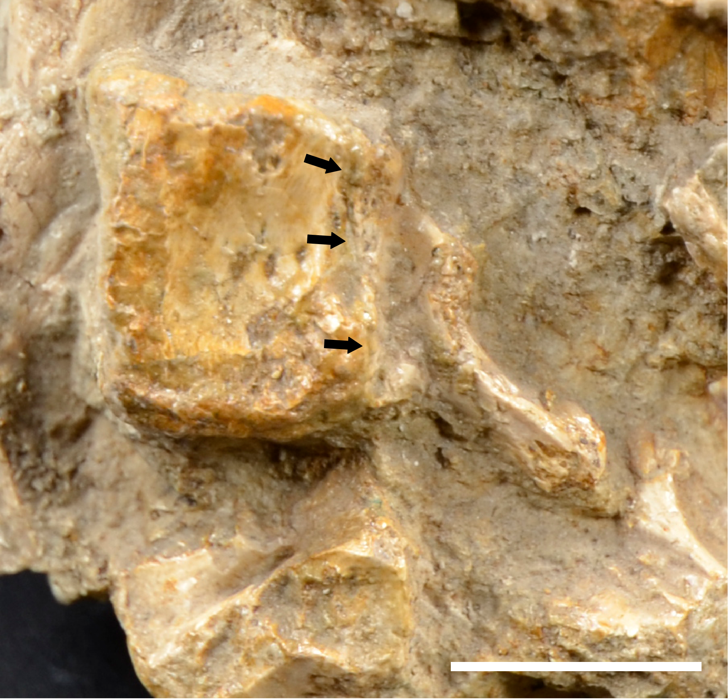
FIG. S1.4. Detail of right lateral side of Cv4 of GPIT-PV-122984. Black arrows mark the visible external neurocentral sutures. Scale bar represents 10 mm.
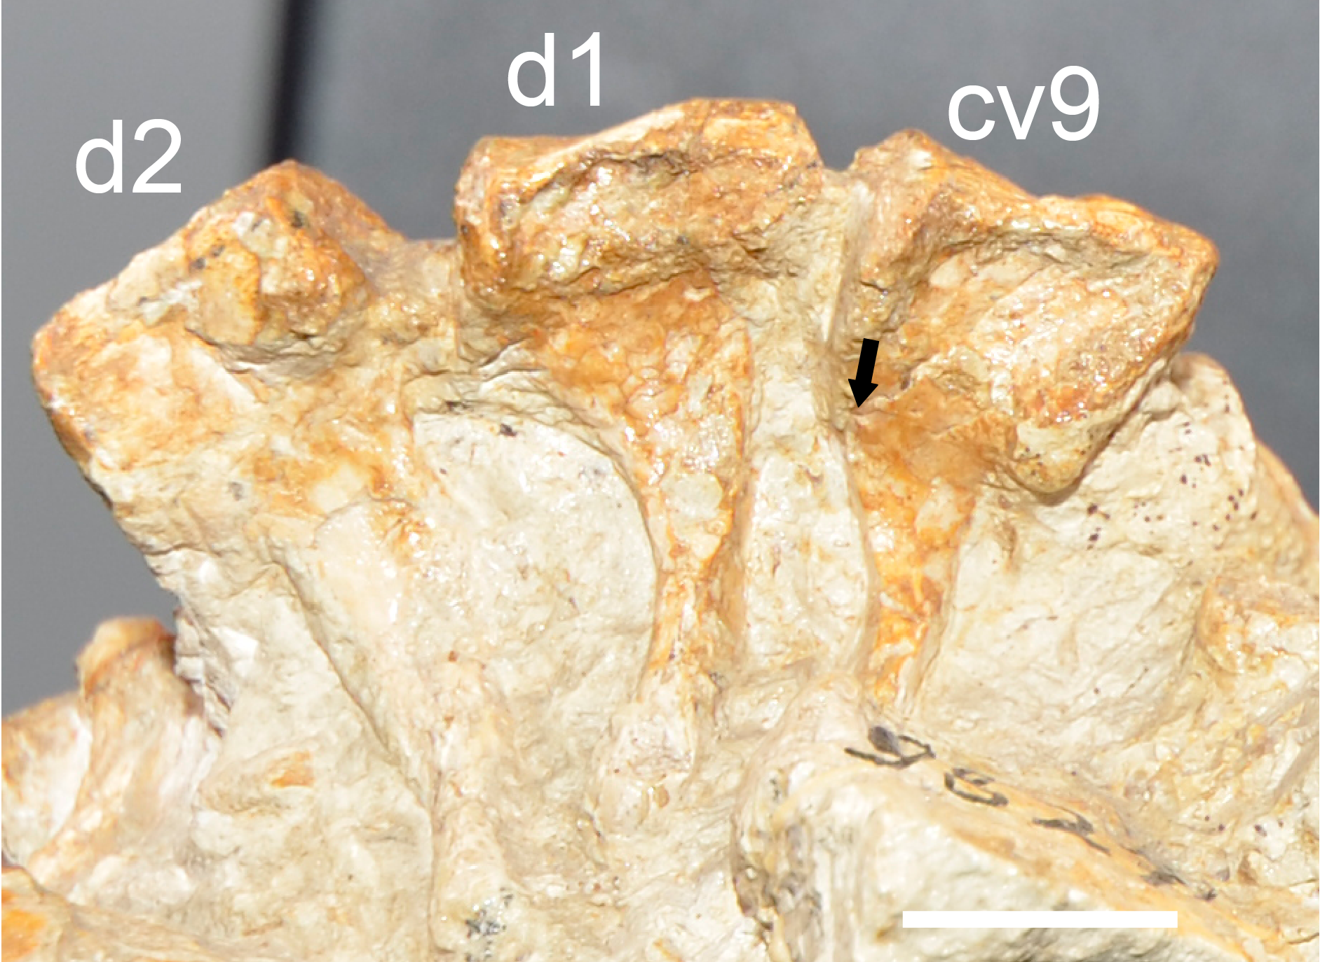
FIG. S1.5. Detail of left lateral side of some semi-articulated vertebrae of GPIT-PV-122984. Abbreviations: cv8-9, cervical vertebra 8-9; d1-2, dorsal vertebra 1-2. Black arrows mark the visible external neurocentral sutures. Scale bar represents 10 mm.

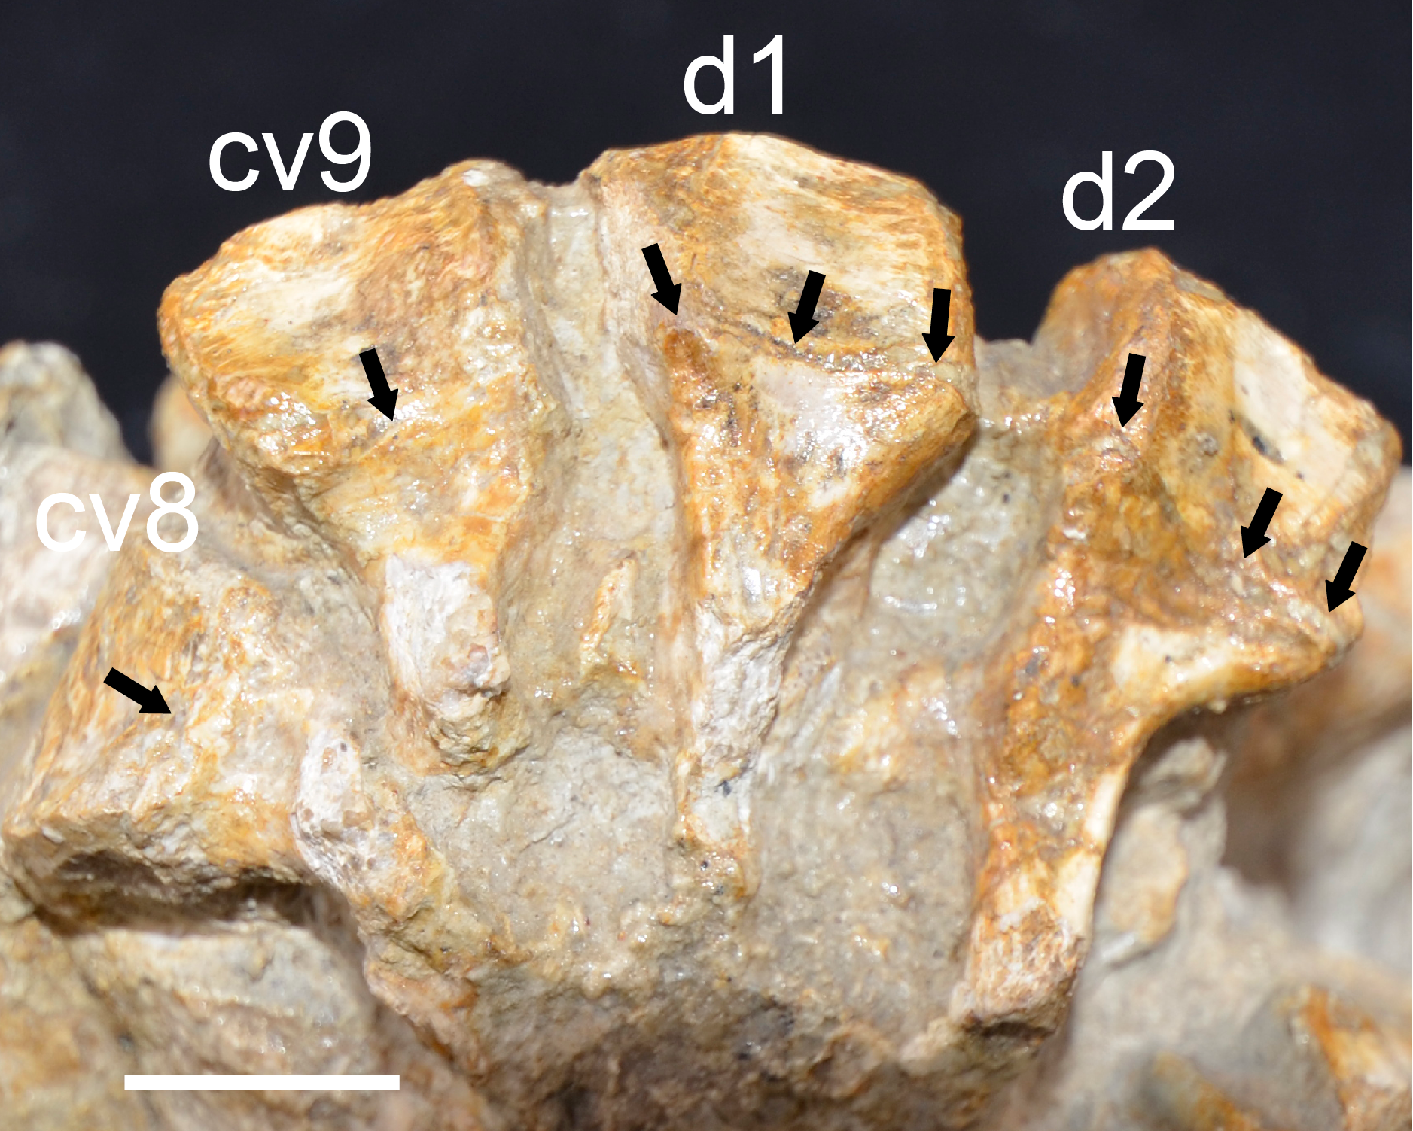
FIG. S1.6. Detail of right lateral side of some semi-articulated vertebrae of GPIT-PV-122984. Abbreviations: cv8-9, cervical vertebra 8-9; d1-2, dorsal vertebra 1-2. Black arrows mark the visible external neurocentral sutures. Scale bar represents 10 mm.
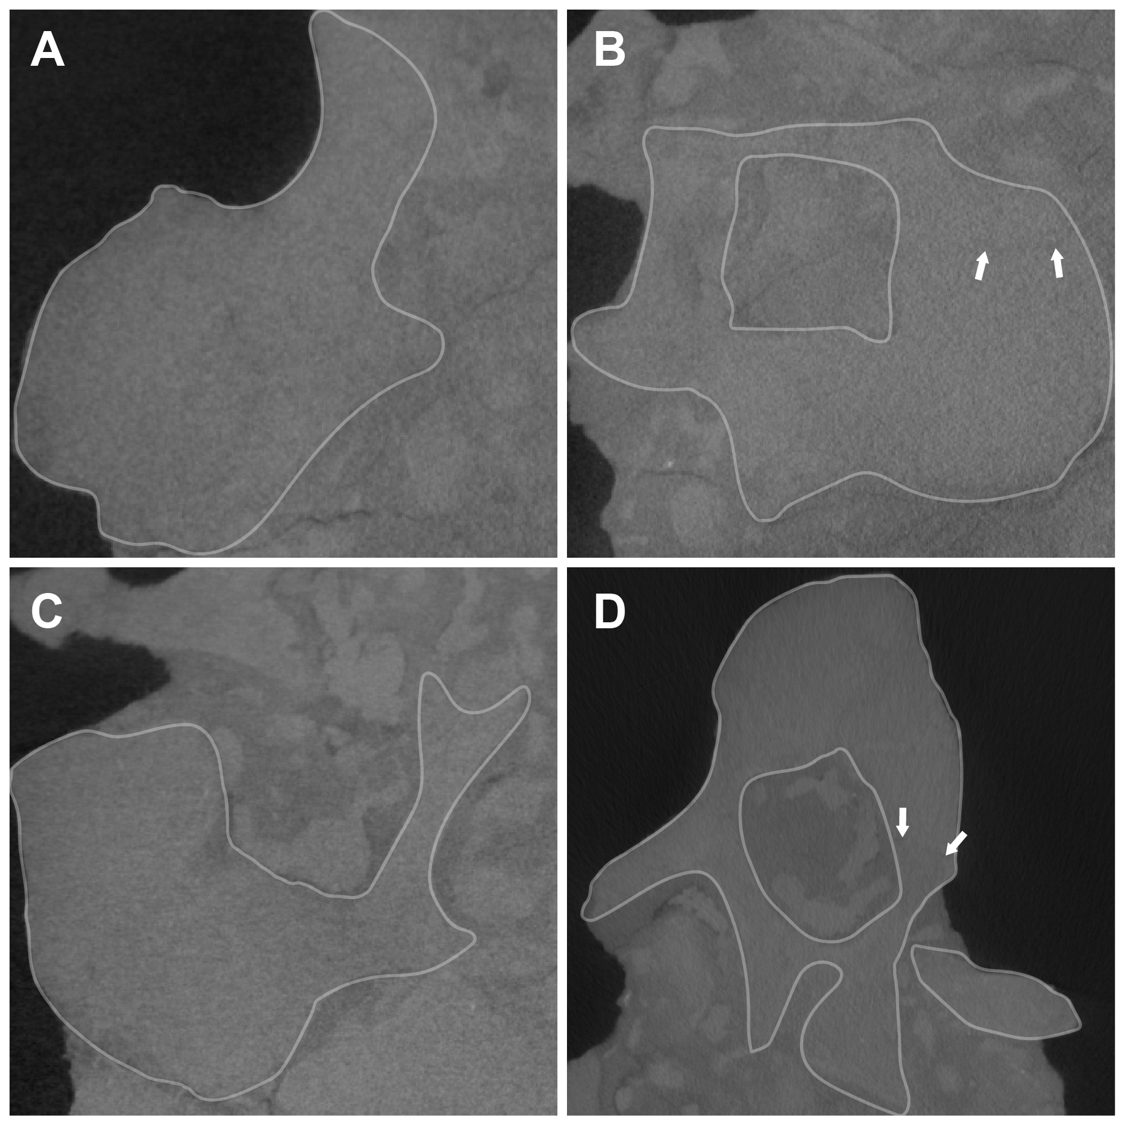
FIG. S1.7. Micro-CT slices of the cervical vertebrae of GPIT-PV-122984. A, Cv5; B, Cv6 6; C, Cv8; D, Cv9. Contour marks the outline of the vertebrae. White arrows indicate mark the visible neurocentral sutures.
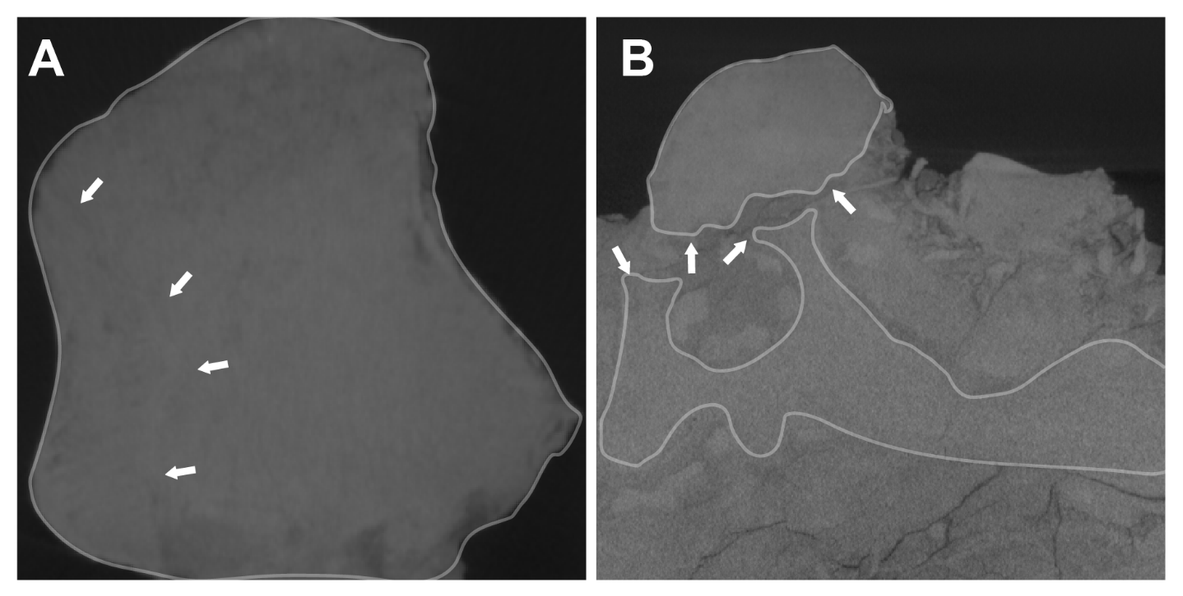
FIG. S1.8. Micro-CT slices of the dorsal vertebrae of GPIT-PV-122984. A, D1; B, Dorsal vertebra ‘Da’. Contour marks the outline of the vertebrae. White arrows indicate mark the visible neurocentral sutures or the related synchondrosial surface.

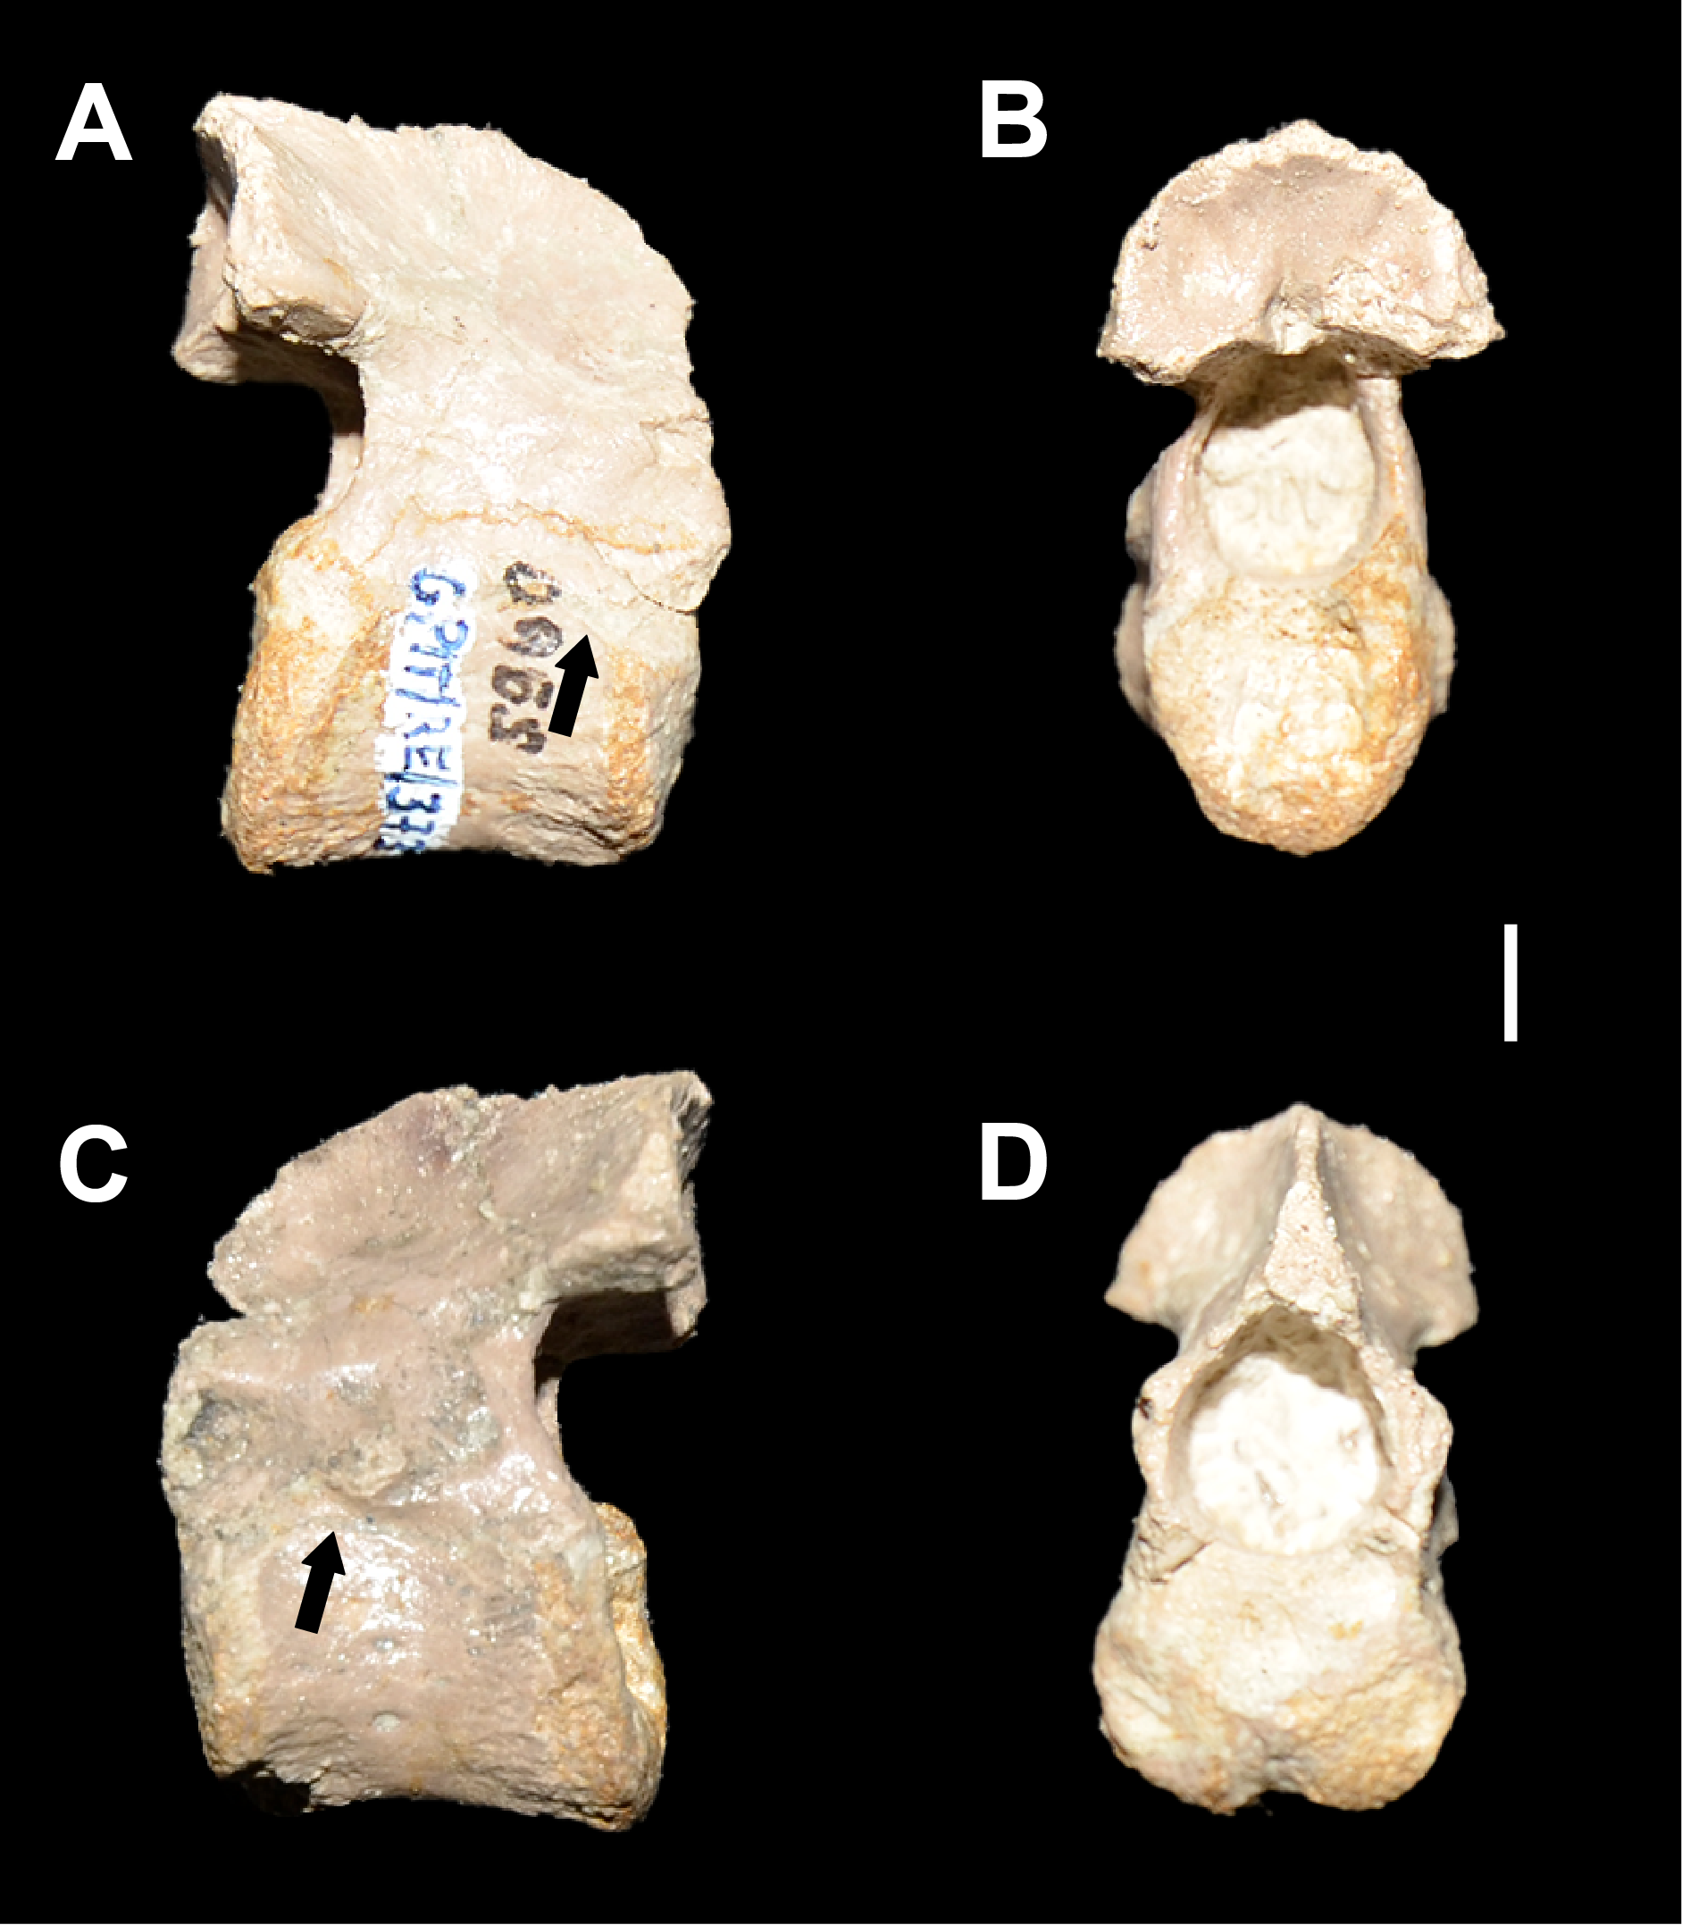
FIG. S1.9. Isolated Dysalotosaurus lettowvorbecki axis GPIT-PV-1120503, in: A, left lateral; B, posterior; C, right lateral; D, anterior view. Black arrows indicate marks the visible external neurocentral sutures. Scale bar represents 5 mm.

MORPHOSOURCE MEDIA
TABLE S1.1. List of mesh and micro-CT image series uploaded to MorphoSource.
Specimen | Description | Type | DOI
GPIT PV 122984 | Dorsal vertebra centrum, "Db" | [Mesh] [CT] | https://doi.org/10.17602/M2/M775159
GPIT PV 122984 | Dorsal vertebra arch, "Db" | [Mesh] [CT] | https://doi.org/10.17602/M2/M775156
GPIT PV 122984 | Dorsal vertebra centrum, "Da" | [Mesh] [CT] | https://doi.org/10.17602/M2/M775153
GPIT PV 122984 | Dorsal vertebra arch, "Da" | [Mesh] [CT] | https://doi.org/10.17602/M2/M775148
GPIT PV 122984 | Dorsal vertebra 2 | [Mesh] [CT] | https://doi.org/10.17602/M2/M775141
GPIT PV 122984 | Dorsal vertebra 1 | [Mesh] [CT] | https://doi.org/10.17602/M2/M775138
GPIT PV 122984 | Cervical vertebra 9 | [Mesh] [CT] | https://doi.org/10.17602/M2/M775132
GPIT PV 122984 | Cervical vertebra 8 | [Mesh] [CT] | https://doi.org/10.17602/M2/M775129
GPIT PV 122984 | Cervical vertebra 7 | [Mesh] [CT] | https://doi.org/10.17602/M2/M775125
GPIT PV 122984 | Cervical vertebra 6 | [Mesh] [CT] | https://doi.org/10.17602/M2/M775120
GPIT PV 122984 | Cervical vertebra 5 | [Mesh] [CT] | https://doi.org/10.17602/M2/M775114
GPIT PV 122984 | Cervical vertebra 4 | [Mesh] [CT] | https://doi.org/10.17602/M2/M775108
GPIT PV 122984 | Cervical vertebra 3 centrum | [Mesh] [CT] | https://doi.org/10.17602/M2/M775102
GPIT PV 122984 | Cervical vertebra 3 arch | [Mesh] [CT] | https://doi.org/10.17602/M2/M775099
GPIT PV 122984 | Supraoccipital | [Mesh] [CT] | https://doi.org/10.17602/M2/M775096
GPIT PV 122984 | Prootic,Left | [Mesh] [CT] | https://doi.org/10.17602/M2/M775093
GPIT PV 122984 | Indeterminate | [Mesh] [CT] | https://doi.org/10.17602/M2/M775090
GPIT PV 122984 | Parabasisphenoid | [Mesh] [CT] | https://doi.org/10.17602/M2/M775087
GPIT PV 122984 | Otoccipital,Left | [Mesh] [CT] | https://doi.org/10.17602/M2/M775084
GPIT PV 122984 | Frontal,Right | [Mesh] [CT] | https://doi.org/10.17602/M2/M775078
GPIT PV 122984 | Basioccipital | [Mesh] [CT] | https://doi.org/10.17602/M2/M775075
GPIT PV 122984 | Dorsal rib | [Mesh] [CT] | https://doi.org/10.17602/M2/M775072
GPIT PV 122984 | Dorsal rib,Right | [Mesh] [CT] | https://doi.org/10.17602/M2/M775054
GPIT PV 122984 | Dorsal rib | [Mesh] [CT] | https://doi.org/10.17602/M2/M775033
GPIT PV 122984 | Cervical rib,Left | [Mesh] [CT] | https://doi.org/10.17602/M2/M775024
GPIT PV 122984 | Cervical rib,Left | [Mesh] [CT] | https://doi.org/10.17602/M2/M775018
GPIT PV 122984 | Cervical rib,Left | [Mesh] [CT] | https://doi.org/10.17602/M2/M775007
GPIT PV 122984 | Cervical rib,Right | [Mesh] [CT] | https://doi.org/10.17602/M2/M774998
GPIT PV 122984 | Phalanx,Right | [Mesh] [CT] | https://doi.org/10.17602/M2/M774992
GPIT PV 122984 | Tibia,Left | [Mesh] [CT] | https://doi.org/10.17602/M2/M774986
GPIT PV 122984 | Fibula upper fragment,Left | [Mesh] [CT] | https://doi.org/10.17602/M2/M774983
GPIT PV 122984 | Fibula lower fragment,Left | [Mesh] [CT] | https://doi.org/10.17602/M2/M774979
GPIT PV 122984 | Femur,Left | [Mesh] [CT] | https://doi.org/10.17602/M2/M774973
GPIT PV 122984 | Chevron | [Mesh] [CT] | https://doi.org/10.17602/M2/M774970
GPIT PV 122984 | Chevron | [Mesh] [CT] | https://doi.org/10.17602/M2/M774967
GPIT PV 122984 | Ulna,Right | [Mesh] [CT] | https://doi.org/10.17602/M2/M774964
GPIT PV 122984 | Radius,Left | [Mesh] [CT] | https://doi.org/10.17602/M2/M774961
GPIT PV 122984 | Humerus,Left | [Mesh] [CT] | https://doi.org/10.17602/M2/M774958
GPIT PV 122984 | Scapula,Left | [Mesh] [CT] | https://doi.org/10.17602/M2/M774955
GPIT PV 122984 | Coracoid,Left | [Mesh] [CT] | https://doi.org/10.17602/M2/M774952
GPIT PV 122984 | Unprepared block | [CTImageSeries] [CT] | https://doi.org/10.17602/M2/M774939

DETAILED MEASUREMENTS
All skeletal measurements conducted on GPIT-PV-122984 are reported below.

CRANIAL SKELETON MEASUREMENTS
TABLE S1.2. Basioccipital measurements following Hübner & Rauhut (2010) and two additional measurements.
Measure definition in Hübner & Rauhut (2010) | Values (mm) | Number of the dimension in Hübner & Rauhut (2010)
Total width of occipital condyle | 8.9 | 1
Height of condyle at foramen magnum | 5.2 | 2
Minimum width of condyle neck | 8.7 | 3
Maximum width at tuberi basioccipitalia | 11.9 | 4
Width of foramen magnum groove at posterior exit (not width of foramen itself) | 4.7 | 5
Average of maximum width of suture area for exoccipital | 2.6 | 6
Width between the tuberi basioccipitalia | 3.3 | 7
Additional measurements
Total anteroposterior length | 14.3 | –
Neck dorsoventral height | 4.6 | –

TABLE S1.3. Otoccipital measurements following Hübner & Rauhut (2010).
Measure definition in Hübner & Rauhut (2010) | Values (mm) | Number of the dimension in Hübner & Rauhut (2010)
Lateral height of paroccipital process | 5.4 | 9
Height of main body until ventral edge of paroccipital process | 8.5 | 11
Length of suture area for basioccipital | 7.8 | 12
Length of suture area for supraoccipital | 8.1 | 13
Part taken at foramen magnum | 8.1 | 14

TABLE S1.4. Supraoccipital measurements following Hübner & Rauhut (2010).
Measure definition in Hübner & Rauhut (2010) | Values (mm) | Number of the dimension in Hübner & Rauhut (2010)
Maximum width | 18.4 | 24
Middle height along and with central ridge | 14.4 | 25
Minimum distance of suture areas for exoccipitals | 4.5 | 26
Length along central ridge | 15.1 | 27
Width of edge bordering foramen magnum dorsally | 4.5 | 28

TABLE S1.5. Prootic measurements following Hübner & Rauhut (2010).
Measure definition in Hübner & Rauhut (2010) | Values (mm) | Number of the dimension in Hübner & Rauhut (2010)
Ventral maximum length anteroposteriorly | 8.8 | 16
Minimum length at middle of its height | 5.8 | 17
Height between foramina (V and VII) along crista prootica | 13.1 | 18
Maximum width anteroventrally | 6.0 | 19

TABLE S1.6. Basisphenoid measurements.
Measure definition | Value (mm)
Length (anteroposterior) of basisphenoid tubera | 6.2
Length (anteroposterior) of the body (tubera and rostrum excluded) | 8.5
Lenght (anteroposterior) without rostrum | 12.5
Length (anteroposterior) of the rostrum | 13.2
Width (lateral) of the body | 7.8

TABLE S1.7. Frontal measurements following Hübner & Rauhut (2010).
Measure definition in Hübner & Rauhut (2010) | Values (mm) | Number of the dimension in Hübner & Rauhut (2010)
Minimum distance between ventral orbital ridge and median suture | 1.6 | 35
Thickness of median suture area at central dome | 3.1 | 36
Measured perpendicular from the median suture area. Maximum width of ventral groove for the cerebellum | 4.1 | 37
Width between median suture area and posterior end of orbital rim dorsally | 6.1 | 38

POSTCRANIAL AXIAL SKELETON MEASUREMENTS
TABLE S1.8. Vertebrae measurements 1. All measurements are reported in millimetres (mm).
Element | Anteroposterior centrum ventral length | Anteroposterior centrum dorsal length | Posterior centrum lateral width | Anterior centrum lateral width
Cv3 | 12.9 | 13.6 | 10.6 | 12.1
Cv4 | 13.8 | 12.4 | 11.0 | 11.3
Cv5 | 14.3 | 12.0 | 11.4 | 13.6
Cv6 | 14.8 | 13.5 | 12.4 | 15.4
Cv7 | 12.7 | 10.1 | 11.6 | 10.1
Cv8 | 12.9 | 11.8 | 13.2 | 12.6
Cv9 | 12.9 | 12.5 | 12.2 | 13.5
D1 | 13.6 | 13.6 | 11.0 | 12.0
D2 | 12.6 | 14.5 | 10.7 | 12.0
Da | 12.4 | 14.9 | 13.5 | 13.4
Db | 13.7 | 16.1 | 12.9 | 12.0

TABLE S1.9. Vertebrae measurements 2. All measurements are reported in millimetres (mm).
Element | Posterior centrum dorsoventral height | Anterior centrum dorsoventral height | Total height | Postzygapophisis lenght
Cv3 | 8.4 | 7.0 | – | 8.0
Cv4 | 7.8 | 10.0 | 19.6 | 7.4
Cv5 | 8.1 | 9.0 | 19.0 | 11.2
Cv6 | 9.4 | 9.2 | 21.2 | 13.7
Cv7 | 10.1 | 9.6 | 23.1 | 10.7
Cv8 | 10.0 | 10.3 | 25.4 | 10.5
Cv9 | 10.6 | 9.6 | 24.8 | 8.3
D1 | 7.3 | 8.0 | 24.6 | 7.1
D2 | 8.1 | 8.2 | 27.7 | 6.2
Da | 7.0 | 9.5 | 28.6 | 4.1
Db | 8.8 | 9.4 | 29.0 | 3.4

TABLE S1.10. Vertebrae measurements 3. All measurements are reported in millimetres (mm).
Element | Prezygapophisis length | Transverse process length | Neural spine height
Cv3 | – | – | –
Cv4 | 9.9 | – | –
Cv5 | 4.8 | 6.7 | –
Cv6 | – | 7.1 | –
Cv7 | – | 10.6 | –
Cv8 | – | 10.9 | –
Cv9 | – | 14.7 | –
D1 | – | 18.1 | 3.9
D2 | – | 19.3 | 6.2
Da | – | 22.7 | 2.7
Db | – | 18.8 | 6.4

APPENDICULAR SKELETON MEASUREMENTS
TABLE S1.11. Scapula measurements following Hübner (2018).
Measure definition in Hübner (2018) | Values (mm) | Number of the dimension in Hübner (2018)
Shaft minimum | 11.7 | 3
Maximum dimension of lateral depression | 25.0 | 4
Maximum width distally between acromion process and glenoid | 29.1 | 5
Length of glenoid | 8.6 | 6
Width of ridge adjacent to the glenoid | 6.5 | 7
Depth of the glenoid | 6.0 | 8
Maximum thickness of the shaft | 2.8 | 10
Thickness of humerus joint face including depth of glenoid | 12.5 | 11
Length of humerus joint face | 15.6 | 12
Maximum thickness of articular surface for the coracoid dorsal to the Foramen supracoracoideum | 9.4 | 13

TABLE S1.12. Coracoid measurements following Hübner (2018).
Measure definition in Hübner (2018) | Values (mm) | Number of the dimension in Hübner (2018)
Distance between the lateroventral corner and the anterior end of the humeral joint face | 20.5 | 2
Length of humeral joint face | 15.1 | 3
Length between sternal process and lateroventral corner | 23.4 | 4
Minimum dimension between the dorsal concavity and the lateroventral corner | 19.5 | 5
Distance between the lateroventral corner and the centre of the Foramen supracoracoideum | 15.5 | 8
Distance between the centre of the Foramen supracoracoideum and the dorsal concavity | 5.5 | 9
Maximum diameter of the Foramen supracoracoideum | 2.7 | 10
Maximum thickness of the scapular articular surface | 8.4 | 11
Thickness of the open canal within the scapular articular surface | 1.9 | 12
Length of this canal. which leads to the Foramen supra- coracoideum | 3.0 | 13
Thickness of the lateroventral corner | 2.7 | 14
Distance between the sternal process and the posterior end of the humeral joint face | 12.2 | 15
Maximum depth between the corners of measured dimension “15” | 2.2 | 16
Maximum thickness of the humeral joint face | 8.4 | 17
Distance between the dorsal concavity and the posterior end of the humeral joint face | 18.8 | 18

TABLE S1.13. Humerus measurements following Hübner (2018).
Measure definition in Hübner (2018) | Values (mm) | Number of the dimension in Hübner (2018)
Width at the deltopectoral crest | 13.7 | 3
Minimum shaft width | 6.9 | 4
Maximum width distally | 13.6 | 5
Length distal from the deltopectoral crest to the condyles | 49.5 | 7
Width between the distal condyles | 5.9 | 8
Maximum thickness at the deltopectoral crest | 4.1 | 10
Maximum thickness of the lateral (radial) condyle | 9.9 | 11
Maximum thickness of the medial (ulnar) condyle | 7.3 | 12
Thickness at the fossa olecranii | 6.6 | 13

TABLE S1.14. Radius measurements following Hübner (2018).
Measure definition in Hübner (2018) | Values (mm) | Number of the dimension in Hübner (2018)
Maximum width proximally in anteroposterior direction | 9.2 | 2
Minimum shaft thickness mediolaterally | 5.9 | 3
Maximum width proximally in mediolateral direction | 6.4 | 5
Minimum shaft thickness anteroposteriorly | 4.7 | 6

TABLE S1.15. Ulna measurements following Hübner (2018).
Measure definition in Hübner (2018) | Values (mm) | Number of the dimension in Hübner (2018)
Medial maximum width proximally | 11.3 | 2
Medial or lateral minimum shaft thickness | 6.1 | 3
Medial width of the base of the olecranon process | 4.7 | 7
Distance between the top of the olecranon process and the anterior most tip proximally | 8.3 | 8
Maximum thickness of the olecranon process mediolaterally | 8.6 | 9

TABLE S1.16. Femur measurements following Hübner (2018).
Measure definition in Hübner (2018) | Values (mm) | Number of the dimension in Hübner (2018)
Height of the base of the 4th trochanter | 24.8 | 6
Partial length from the neck of the 4th trochanter to the distal end laterally | 83.1 | 8
Anteroposterior width distally at the lateral condyle | 29.8 | 9
Partial anteroposterior width distally without the lateral condyle | 17.3 | 10
Minimum anteroposterior thickness of the shaft distal to the 4th trochanter | 12.7 | 11
Minimum anteroposterior thickness of the shaft proxi- mal to the 4th trochanter | 18.1 | 12
Shaft thickness at the dorsal end of the base of the 4th trochanter | 15.6 | 15
Maximum thickness of the distal shaft at the lateral shelf | 22.4 | 16
Maximum lateromedial width distally | 33.7 | 18
Thickness of the lateral condyle | 8.8 | 19
Thickness of the medial condyle | 15.2 | 20
Anteroposterior width distally at the medial condyle | 29.0 | 21
Minimum distance between both distal condyles | 7.0 | 22
Partial length from the posterior nutrient foramen to the distal end laterally | 96.0 | 25
Partial shaft width laterally at the posterior nutrient foramen | 10.7 | 26
Partial shaft width medially at the posterior nutrient foramen | 7.7 | 27
Anteroposterior width distally at the lateral condyle | 28.3 | 28
Minimum anteroposterior thickness of the distal end | 13.9 | 29
Maximum distance between both distal condyles | 10.2 | 30
Depth of the intercondylar extensor groove | 2.8 | 31
Height of the posterior nutrient foramen | 3.0 | 32
Anteroposterior length of the lateral condyle | 11.2 | 33
Height of the medial depression | 16.2 | 34
Maximum width of the medial depression | 9.8 | 35
Partial length from the ventral end of the medial depression to the distal end laterally | 95.2 | 36
Midshaft circumference | 53.4 | 37

TABLE S1.17. Tibia measurements following Hübner (2018).
Measure definition in Hübner (2018) | Values (mm) | Number of the dimension in Hübner (2018)
Minimum lateromedial thickness of the shaft | 15.6 | 3
Maximum width of the distal end | 38.0 | 13
Partial width of the lateral part of the distal end articulating with the calcaneum | 13.4 | 14
Partial lateral width | 22.6 | 15
Partial medial width | 15.0 | 16
Diameter of the circular depression at the top of the articular surface for the astragalus | 6.0 | 17
Maximum thickness distally | 15.3 | 18
Maximum thickness at the border between articular surface for the astragalus and calcaneum | 10.1 | 19

TABLE S1.18. Fibula measurements following Hübner (2018).
Measure definition in Hübner (2018) | Values (mm) | Number of the dimension in Hübner (2018)
Maximum width proximally | 18.7 | 2
Posterior thickness proximally | 4.5 | 3
Thickness at the bend proximally | 4.6 | 4

TABLE S1.19. Phalanx measurements following Hübner (2018).
Measure definition in Hübner (2018) | Values (mm) | Number of the dimension in Hübner (2018)
Median total length | 15.3 | 1
Total length between the medial condyle and the medial edge of the proximal end | 17.1 | 2
Total length between the lateral condyle and the lateral edge of the proximal end | 13.7 | 3
Maximum width of the proximal end | 12.3 | 4
Minimum lateromedial shaft width | 8.9 | 5
Dorsal condyle width | 6.7 | 6
Ventral condyle width | 9.4 | 7
Height of the proximal end | 10.1 | 8
Medial shaft height at level of minimum width | 6.3 | 9
Lateral shaft height at level of minimum width | 6.2 | 10
Height of the medial condyle measured along its side | 7.8 | 11
Height of the lateral condyle measured along its side | 6.9 | 12
Minimum height between both condyles | 5.8 | 13
Dorsal length between the condyle facets and the proximal end | 11.1 | 14
Ventral length between the condyle facets and the proximal end | 12.0 | 15

