Hypothalamic volume reduction in adult patients with Narcolepsy type 1
Lorenzo Motta^{1,†}, Greta Venturi^{1,†},Francesco Biscarini ^{2,3}, Cristiana Fiscone³, Luca Morandi ^{1,3}, David N Manners^{1,4}, Emmanuel Mignot⁵, Fabio Pizza ^{2,3}, Martina Gnazzo^{2,6}, Raffaele Lodi ^{1,3}, Giuseppe Plazzi ^{2,6}, Caterina Tonon ^{1,3}
†These authors contributed equally to this work.

Author affiliations:
¹ IRCCS Istituto delle Scienze Neurologiche di Bologna, Functional and Molecular Neuroimaging Unit, Bologna, 40139, Italy
² IRCCS Istituto delle Scienze Neurologiche di Bologna, UOC Clinica Neurologica, Bologna, 40139, Italy
³ Department of Biomedical and Neuromotor Sciences, University of Bologna, Bologna, 40138, Italy
⁴Department for Life Quality Studies, University of Bologna, Rimini, 47921, Italy
⁵Stanford University Center for Sleep Sciences, Department of Psychiatry and Behavioral Sciences, Stanford University School of Medicine, Palo Alto, CA94305, USA.
⁶ Department of Biomedical, Metabolic and Neural Sciences, University of Modena and Reggio-Emilia, Modena, 41122, Italy

Corresponding author:
Greta Venturi,
IRCCS Institute of Neurological Sciences of Bologna,
Ospedale Bellaria,
Via Altura, 3
40139 Bologna, Italy
Email: greta.venturi5@unibo.it
Supplementary Materials
Table of contents
Supplementary Tables 3
Supplementary Table 1 3
Supplementary Table 2 4
Supplementary Table 3 4
Supplementary Table 4 4
Supplementary Figure 4
Supplementary Figure 1 4

Supplementary Tables

Supplementary Table 1 Comparison between NT1 Patients and Healthy Controls on demographic variables.
 | NT1  mean ± sd  or n (%) | HC  mean ± sd  or n (%) | p (uncorr) | p (corr) | Sign | U/ χ² | effect size (r /V) | 95% CI for r
Sex, male (n) | 39 (52.0%) | 45 (51.7%) | 0.866 | — |  | 0.0286 | 0.013 (V) | —
Age at MRI (years) | 33.1±12.9 | 32.5±8.2 | 0.409 | — |  | 3509 | 0.065 | (–0,090 0.217)

Group comparisons were performed using the Mann–Whitney U test (MW) for continuous variables and the Chi-square (χ²) test for categorical variables. Both uncorrected and Bonferroni-corrected p-values are reported when applicable. Effect sizes are expressed as r for MW tests and Cramér’s V for χ² tests, with 95% confidence intervals (CI) provided for r.

Supplementary Table 2 Comparisons of hypothalamic volume between NT1 patients and healthy controls
Region | p (uncorr) | p (corr.) | Sig. | U | Effect size (r) | 95% CI
Whole Hypo | 0.0016 | 0.0098 | ** | 4201 | 0.25 | (0.097, 0.387)
Anterior Inferior | 0.0001 | 0.0008 | *** | 4397 | 0.3 | (0.152, 0.434)
Anterior Superior | 0.0005 | 0.003 | ** | 4300 | 0.27 | (0.125, 0.411)
Posterior | 0.0051 | 0.0308 | * | 4096 | 0.22 | (0.068, 0.362)
Tuberal Inferior | 0.7193 | 1 |  | 3370 | 0.03 | (–0.126, 0.182)
Tuberal Superior | 0.0064 | 0.0383 | * | 4075 | 0.21 | (0.062, 0.357)
Detailed results of comparisons of hypothalamic subregion volumes between patients with narcolepsy type 1 (NT1) and healthy controls (HC). Statistical analyses were performed using the Mann–Whitney U test (MW), with Bonferroni correction applied for multiple comparisons. Reported are uncorrected and corrected p-values, the U statistic, effect size (r), and 95% confidence intervals (CI) based on Fisher’s z-transformation. All tests are two-tailed. Significance levels: *p < 0.05, **p < 0.01, ***p < 0.001.

Supplementary Table 3 Correlation analysis between hypothalamic subregion volumes (mm³) and clinical variables.
Volume (mm³) | Clinical characteristics | r | p-value
Whole Hypo | Disease Duration (years) | 0.11 | 0.81
Whole Hypo | CSF-orexin (pg/mL) | -0.04 | 0.93
Whole Hypo | HLA-DQB1*0602 (n) | -0.05 | 0.93
Whole Hypo | MSLT mean sleep latency (min) | 0.16 | 0.63
Whole Hypo | MSLT SOREMPs (n) | 0.01 | 0.96
Whole Hypo | EDS onset (years) | -0.02 | 0.94
Whole Hypo | Cataplexy onset (years) | -0.03 | 0.94
Whole Hypo | BMI (kg/m²) | 0.20 | 0.63
Whole Hypo | ESS (score) | -0.30 | 0.38
Whole Hypo | Wake promoting agents Treatment | 0.10 | 0.87
Whole Hypo | Pitolisant Treatment | -0.02 | 0.96
Whole Hypo | Sodium Oxybate Treatment | 0.18 | 0.63
Whole Hypo | Antidepressants Treatment | 0.42 | 0.09
Anterior Inferior | Disease Duration (years) | -0.04 | 0.94
Anterior Inferior | CSF- orexin (pg/mL) | -0.28 | 0.36
Anterior Inferior | HLA-DQB1*0602 (n) | -0.12 | 0.80
Anterior Inferior | MSLT mean sleep latency (min) | 0.10 | 0.87
Anterior Inferior | MSLT SOREMPs (n) | -0.05 | 0.93
Anterior Inferior | EDS onset (years) | 0.03 | 0.94
Anterior Inferior | Cataplexy onset (years) | 0.02 | 0.94
Anterior Inferior | BMI (kg/m²) | 0.28 | 0.42
Anterior Inferior | ESS (score) | -0.29 | 0.40
Anterior Inferior | Wake promoting agents Treatment | -0.01 | 0.97
Anterior Inferior | Pitolisant Treatment | -0.08 | 0.93
Anterior Inferior | Sodium Oxybate Treatment | -0.06 | 0.93
Anterior Inferior | Antidepressants Treatment | 0.25 | 0.42
Anterior Superior | Disease Duration (years) | 0.09 | 0.87
Anterior Superior | CSF- orexin (pg/mL) | -0.23 | 0.42
Anterior Superior | HLA-DQB1*0602 (n) | -0.09 | 0.87
Anterior Superior | MSLT mean sleep latency (min) | 0.19 | 0.55
Anterior Superior | MSLT SOREMPs (n) | -0.05 | 0.93
Anterior Superior | EDS onset (years) | -0.17 | 0.63
Anterior Superior | Cataplexy onset (years) | -0.21 | 0.44
Anterior Superior | BMI (kg/m²) | 0.42 | 0.15
Anterior Superior | ESS (score) | -0.12 | 0.84
Anterior Superior | Wake promoting agents Treatment | 0.07 | 0.93
Anterior Superior | Pitolisant Treatment | -0.08 | 0.93
Anterior Superior | Sodium Oxybate Treatment | 0.01 | 0.98
Anterior Superior | Antidepressants Treatment | 0.35 | 0.22
Posterior | Disease Duration (years) | -0.10 | 0.84
Posterior | CSF- orexin (pg/mL) | 0.06 | 0.93
Posterior | HLA-DQB1*0602 (n) | -0.08 | 0.91
Posterior | MSLT mean sleep latency (min) | 0.15 | 0.69
Posterior | MSLT SOREMPs (n) | -0.22 | 0.42
Posterior | EDS onset (years) | -0.03 | 0.94
Posterior | Cataplexy onset (years) | -0.07 | 0.93
Posterior | BMI (kg/m²) | -0.26 | 0.44
Posterior | ESS (score) | -0.07 | 0.93
Posterior | Wake promoting agents Treatment | 0.13 | 0.80
Posterior | Pitolisant Treatment | 0.03 | 0.94
Posterior | Sodium Oxybate Treatment | 0.19 | 0.63
Posterior | Antidepressants Treatment | 0.07 | 0.93
Tuberal Inferior | Disease Duration (years) | 0.06 | 0.93
Tuberal Inferior | CSF- orexin (pg/mL) | 0.07 | 0.93
Tuberal Inferior | HLA-DQB1*0602 (n) | -0.15 | 0.65
Tuberal Inferior | MSLT mean sleep latency (min) | 0.03 | 0.94
Tuberal Inferior | MSLT SOREMPs (n) | 0.21 | 0.44
Tuberal Inferior | EDS onset (years) | 0.16 | 0.63
Tuberal Inferior | Cataplexy onset (years) | 0.15 | 0.70
Tuberal Inferior | BMI (kg/m²) | 0.16 | 0.73
Tuberal Inferior | ESS (score) | -0.26 | 0.42
Tuberal Inferior | Wake promoting agents Treatment | 0.03 | 0.94
Tuberal Inferior | Pitolisant Treatment | -0.04 | 0.94
Tuberal Inferior | Sodium Oxybate Treatment | 0.23 | 0.44
Tuberal Inferior | Antidepressants Treatment | 0.23 | 0.44
Tuberal Superior | Disease Duration (years) | 0.13 | 0.73
Tuberal Superior | CSF- orexin (pg/mL) | -0.10 | 0.84
Tuberal Superior | HLA-DQB1*0602 (n) | 0.04 | 0.93
Tuberal Superior | MSLT mean sleep latency (min) | 0.07 | 0.93
Tuberal Superior | MSLT SOREMPs (n) | 0.05 | 0.93
Tuberal Superior | EDS onset (years) | -0.14 | 0.70
Tuberal Superior | Cataplexy onset (years) | -0.11 | 0.81
Tuberal Superior | BMI (kg/m²) | 0.30 | 0.42
Tuberal Superior | ESS (score) | -0.15 | 0.73
Tuberal Superior | Wake promoting agents Treatment | 0.05 | 0.93
Tuberal Superior | Pitolisant Treatment | 0.05 | 0.93
Tuberal Superior | Sodium Oxybate Treatment | -0.01 | 0.96
Tuberal Superior | Antidepressants Treatment | 0.31 | 0.36
Spearman partial correlations between hypothalamic subregion volumes and clinical variables, adjusted for age, sex, and total intracranial volume (TIV). BMI = body mass index; ESS = Epworth Sleepiness Scale; CSF = cerebrospinal fluid; MSLT = Multiple Sleep Latency Test; SOREMP = sleep onset REM period; NT1 = narcolepsy type 1.

Supplementary Table 4 Sensitivity analysis of the association between hypothalamic volumes and CSF orexin levels categorized into tertiles and quartiles.
Volume (mm³) | CSF-orexin grouping | r | p-value
Whole Hypo | Tertiles | 0.05 | 0.81
Whole Hypo | Quartiles | 0.09 | 0.56
Anterior Inferior | Tertiles | -0.15 | 0.65
Anterior Inferior | Quartiles | -0.18 | 0.56
Anterior Superior | Tertiles | -0.14 | 0.65
Anterior Superior | Quartiles | -0.09 | 0.56
Posterior | Tertiles | 0.09 | 0.72
Posterior | Quartiles | 0.10 | 0.56
Tuberal Inferior | Tertiles | 0.12 | 0.65
Tuberal Inferior | Quartiles | 0.15 | 0.56
Tuberal Superior | Tertiles | -0.02 | 0.89
Tuberal Superior | Quartiles | 0.03 | 0.82
Spearman partial correlations between hypothalamic subregion volumes and CSF orexin concentrations after categorization into tertiles and quartiles, adjusted for age, sex, and total intracranial volume (TIV). CSF = cerebrospinal fluid.

Supplementary Figure

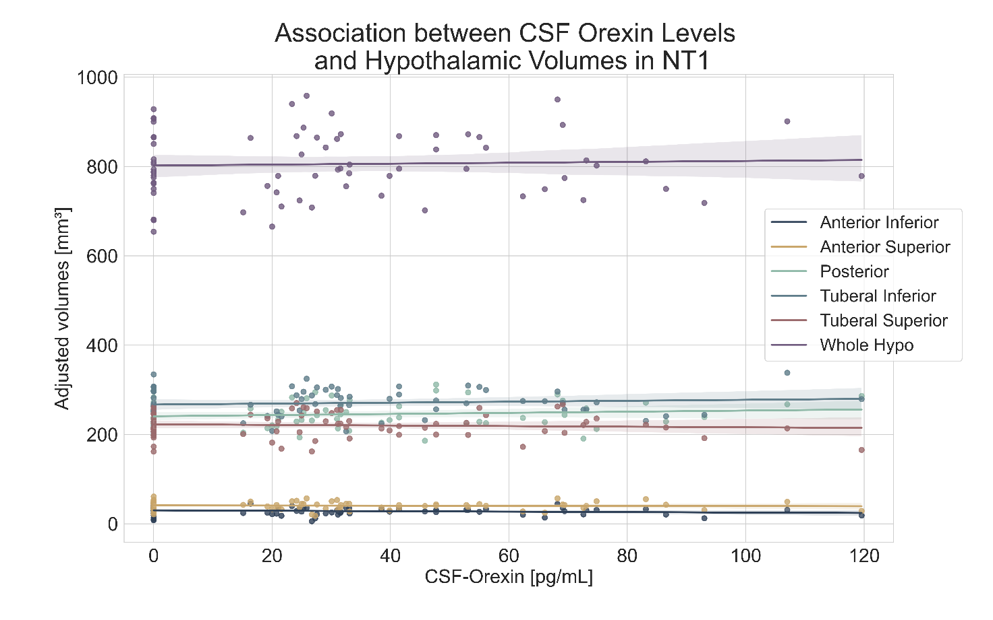
Supplementary Figure 1 Scatterplots showing the relationship between CSF orexin concentrations and adjusted hypothalamic volumes (whole hypothalamus and subunits) in patients with NT1. Volumes were adjusted for age, sex, and total intracranial volume. No significant associations were observed.

