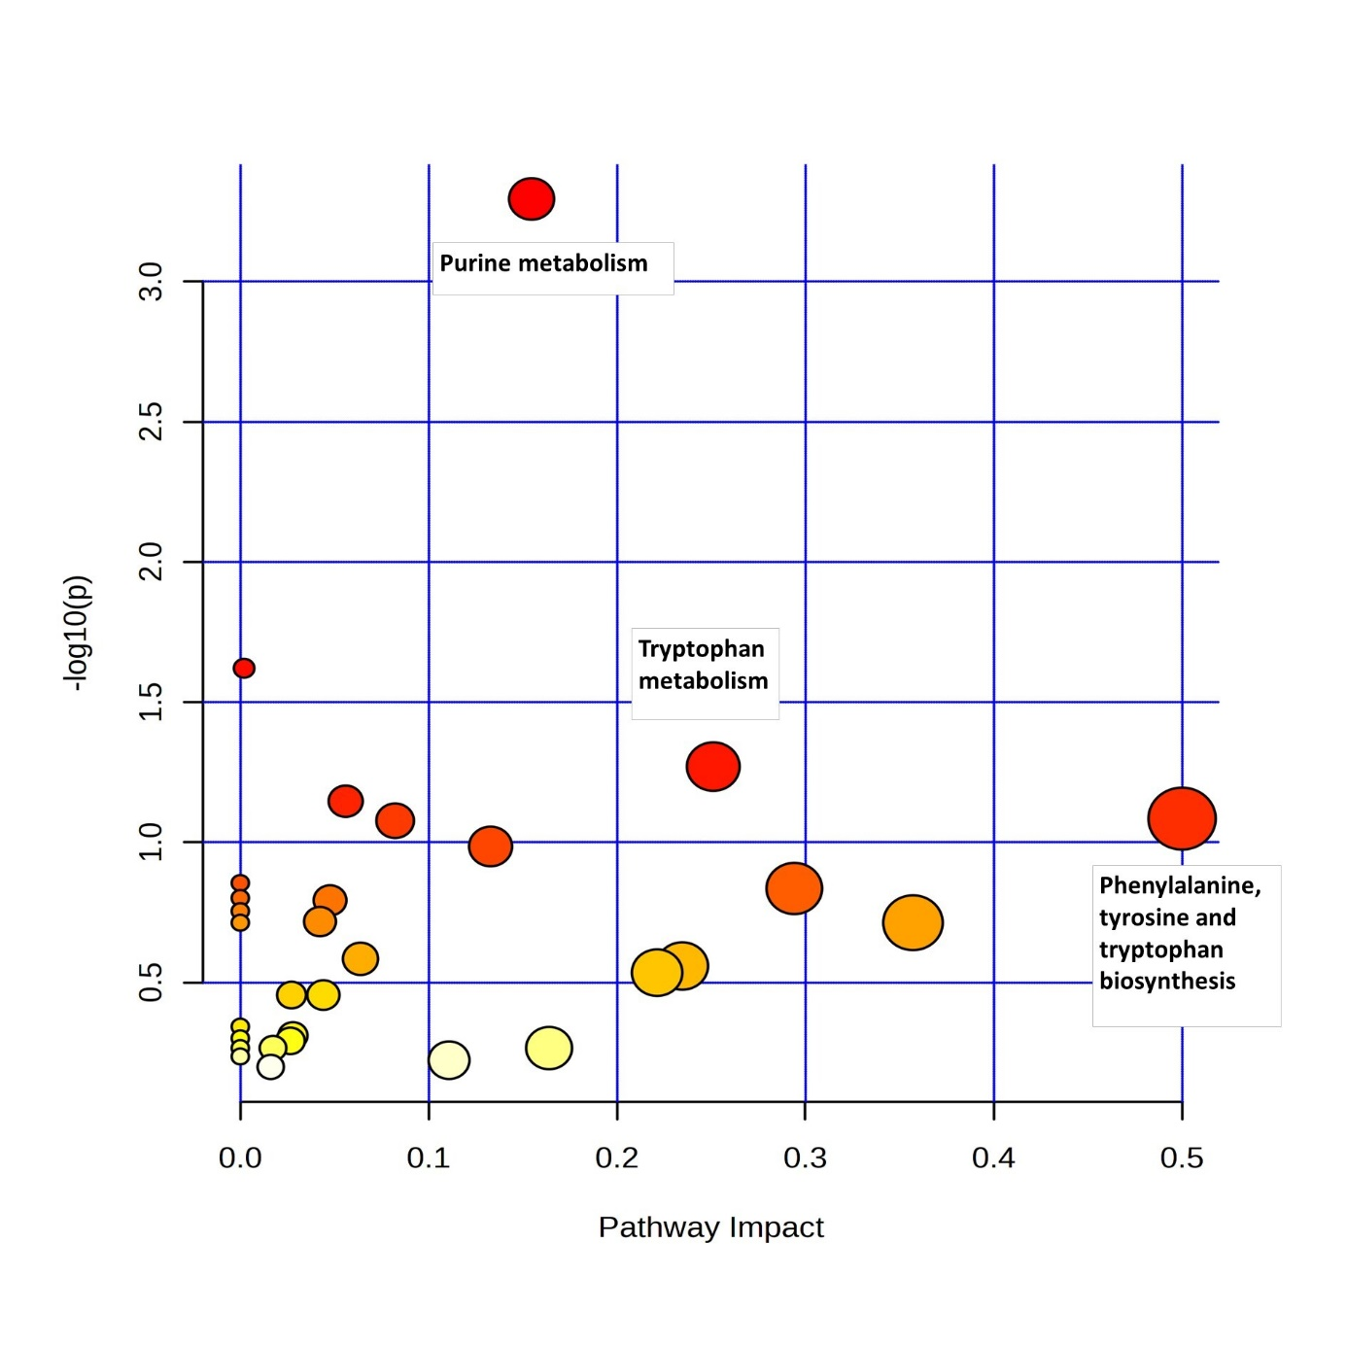
Fig. S1 Metabolic pathway analysis of the 230 metabolites selected by the PLS-DA analysis for the effect of parity on colostrum. Analyses run over the Sus scrofa KEGG and SMPDB databases. Each point represents a metabolic pathway. Size and colour mirror the pathway impact and significance, respectively

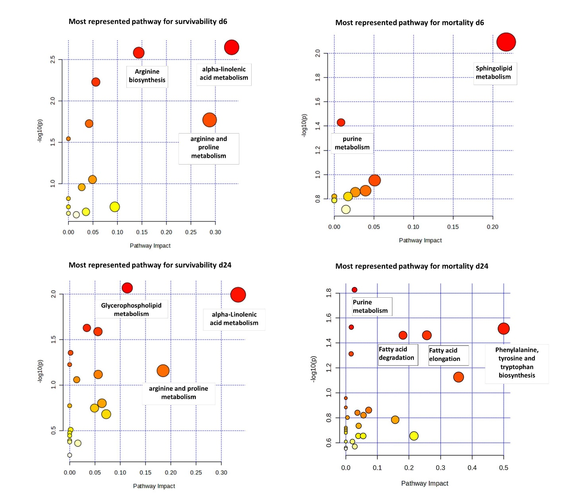

Fig. S2 Metabolic pathway analysis of the metabolites selected by the PLS-DA analysis for the effect of class of mortality of piglets, respectively till day 6 and till day 24 Analyses run over the Sus scrofa KEGG and SMPDB databases. Each point represents a metabolic pathway. Size and colour mirror the pathway impact and significance, respectively

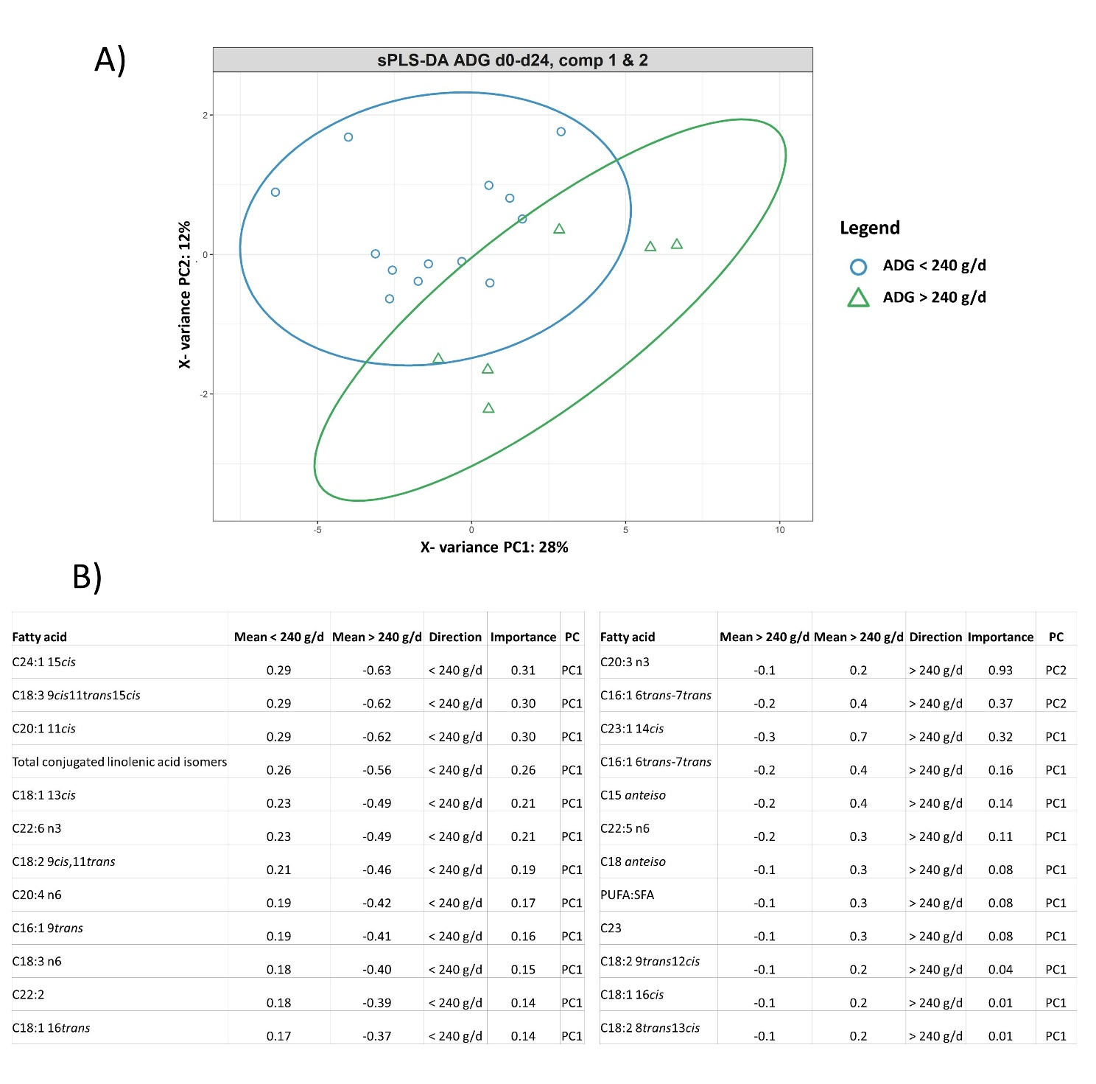
Fig. S3 Colostrum fatty acid profile discriminating for the class of litter average daily gain from day 0 to day 24 of suckling. A PLS-DA plots along the first two PCs (principal components) based on fatty acids profile of colostrum. B) reports the most discriminant fatty acids and ratios per each class of average daily gain respectively for the PC1 and PC2. ADG classes d 0–24: > 240 g/d (6 litters); < 240 g/d (14 litters)

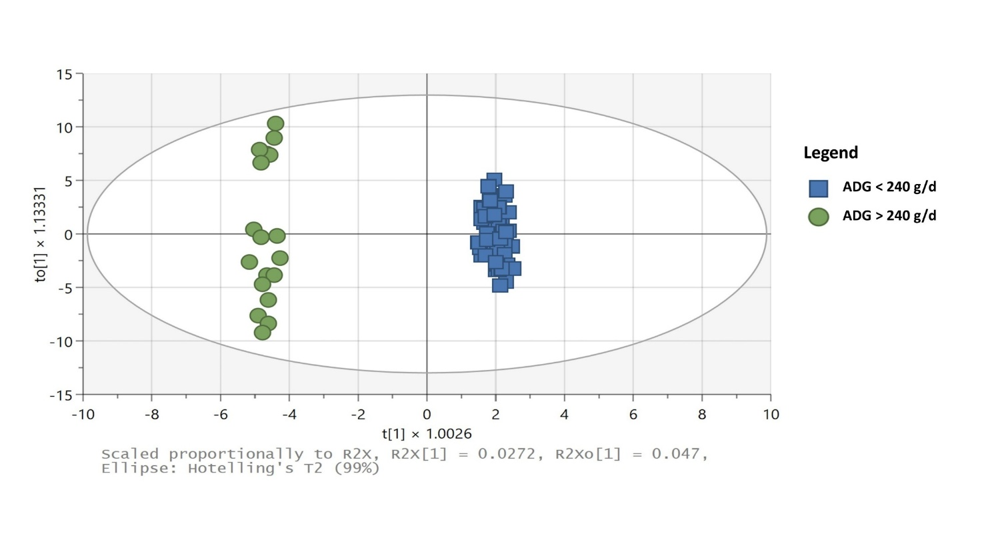 Fig. S4 Colostrum metabolomics profile discriminating for the class of litter average daily gain from day 0 to day 24 of suckling. OPLS-DA plots along the first two PCs (principal components) based on metabolomics profile of colostrum. ADG classes d 0–24: > 240 g/d (6 litters); <240 g/d (14 litters)
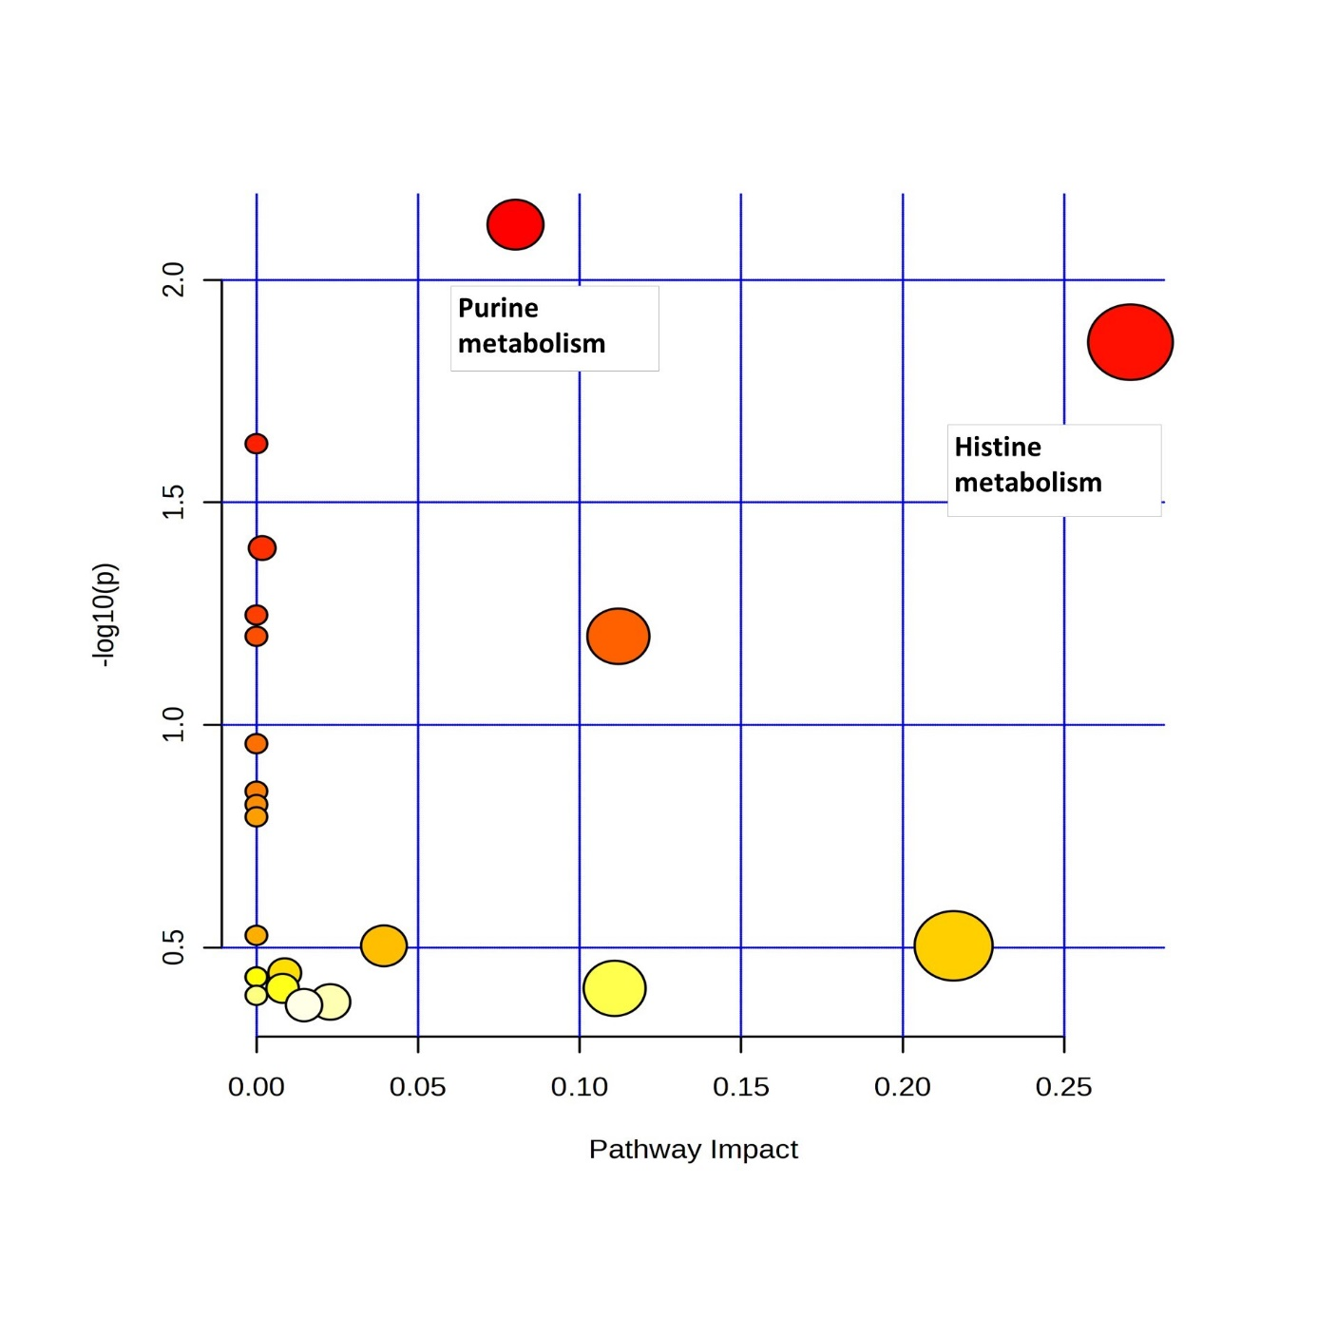
Fig. S5. Metabolic pathway analysis of the metabolites selected by the OPLS-DA analysis for the effect of class of average daily gain from day o to day 24 of suckling piglets. Analyses run over the Sus scrofa KEGG and SMPDB databases. Each point represents a metabolic pathway. Size and colour mirror the pathway impact and significance, respectively

