Supplementary information for: “Out of bounds: the use of model ensembles to explore model structural uncertainty under extreme events”
Margherita Evangelisti ^{1, *}, Vincent Pons ^{2,3}, Spyros Pritsis ², Vittorio Di Federico ¹, Franz Tscheikner-Gratl ², Marco Maglionico ¹
¹ Department of Civil, Chemical, Environmental and Materials Engineering, University of Bologna, Viale del Risorgimento 2, 40136, Italy
² Department of Civil and Environmental Engineering, Norwegian University of Science and Technology (NTNU), Trondheim N-7491, Norway
³ Department of Civil, Environmental, and Natural Resources Engineering, Luleå University of Technology, 97187 Luleå, Sweden
*Corresponding author. Email: margherita.evangelisti@unibo.it
To facilitate comprehension, the supplementary material adopts the same structure as the main paper.

The supplement contains the following sections:
S1 Preliminary investigation on Fossolo sewer network
S2 Event 6 rainfall characteristics
S3 Model B and Model D tested over Event 1, 5 and 9
S4 Model Ensemble A and Model Ensemble C on Event 1, 5, 9
S5 Intra and inter model ensemble disagreement analysis
S5.1 Filtered storms selected to stress Model Ensemble D
S6 Evaluation of the temperature-conditioned Statistical Downscaling Model (MRC)
S7 Model ensemble disagreement under changing conditions

S1 Preliminary investigation on Fossolo sewer network
Preliminary investigations led to doubt about the independence of the system. Four rainfall events were tested, with significant rainfall characteristics presented in Table A.1and the main hydraulic characteristics (maximum discharge and maximum water level) shown in Table A.2.
The four events were subjected to SA: the model parameter selected and relative boundaries are reported in the main paper. Figure A.1 shows the water level trends stemming from calibration process for the best parameter sets, evaluated by maximizing the Nash Sutcliffe Efficiency (NSE) metric. As shown in Figure A.1 and in Table A.3, NSE metric values are above 0.90 for all events, suggesting a good agreement between the model output and the measurement of water level. The three best parameter sets of each event were also adopted in the other three remaining events – cross-validation, by providing good results (Table A.3).
However, by simulating the storm event characterized by a maximum rainfall intensity of 147 mm/h (Event 6), it can be noted that the observed values of water level peak cannot be very reproduced. The observed water level data in the pipe reached a maximum of 1.44 m, which coincides with the pressurized operation of the collector. Even by extending the parameter range (and narrowing the time window), the model fails to capture the extreme peak level, despite the NSE value being very high.
Table A.1: Main characteristics of the rainfall events used for the analysis. *For Event 6, the values in parentheses refer to the portion of the event used in the analysis (first 3 hours), corresponding to the period with the highest rainfall intensity.
Event | Date | Duration (min) | Precipitation Depth (mm) | Maximum Rainfall Intensity (mm/h)
1 | 25/04/94 | 77 | 7.82 | 26.10
5 | 28/10/94 | 289 | 23.06 | 60.00
6 | 23/06/95 | 538 (180*) | 72.72 (38.32*) | 147.97
9 | 13/11/95 | 921 | 42.65 | 60.00

Table A.2: Hydraulic characteristics of the monitored rainfall events.
Event | Date | Maximum water level observed (m) | Maximum discharge (m³/s)
1 | 25/04/94 | 0.44 | 0.89
5 | 28/10/94 | 0.78 | 2.33
6 | 23/06/95 | 1.44 | 4.12
9 | 13/11/95 | 0.33 | 0.50

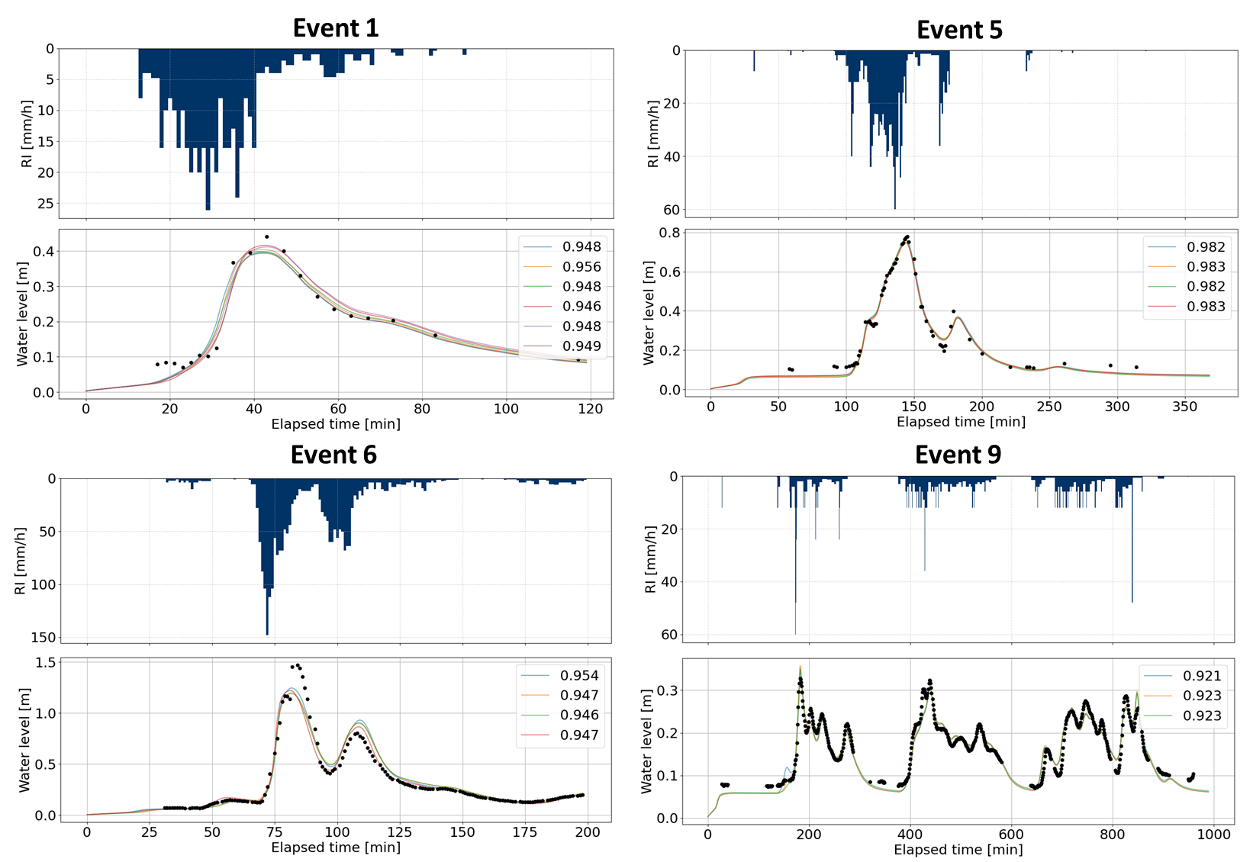
Figure A.1: Simulated and observed water levels for four tested events using the best parameter sets – and relative NSE.
Table A.3: Best performances (NSE) of the original model, tested on each event separately (in bold) and using cross-validation.
Best sets | Event 1 | Event 6 | Event 9 | Event 5
best_e1_1 | 0.956 | 0.898 | 0.846 | 0.918
best_e1_2 | 0.949 | 0.923 | 0.784 | 0.952
best_e1_3 | 0.948 | 0.877 | 0.886 | 0.890
best_e6_1 | 0.908 | 0.954 | 0.795 | 0.954
best_e6_2 | 0.894 | 0.947 | 0.546 | 0.975
best_e6_3 | 0.803 | 0.947 | 0.770 | 0.946
best_e9_1 | 0.891 | 0.825 | 0.923 | 0.817
best_e9_2 | 0.878 | 0.823 | 0.923 | 0.817
best_e9_3 | 0.901 | 0.842 | 0.921 | 0.843
best_e5_1 | 0.906 | 0.925 | 0.475 | 0.983
best_e5_2 | 0.886 | 0.920 | 0.395 | 0.983
best_e5_3 | 0.900 | 0.918 | 0.492 | 0.982

S2 Event 6 rainfall characteristics
Event 6 is characterized by a maximum rainfall intensity of 147 mm/h, and total rainfall depth of 72.72 mm. The event is characterized as a 5-years return period for duration greater than 15 minutes, compared with the DDF elaborated for Bologna for the period 1934-2023. The higher return period is associated with storm duration of 10 minutes, as shown in Figure A.2.
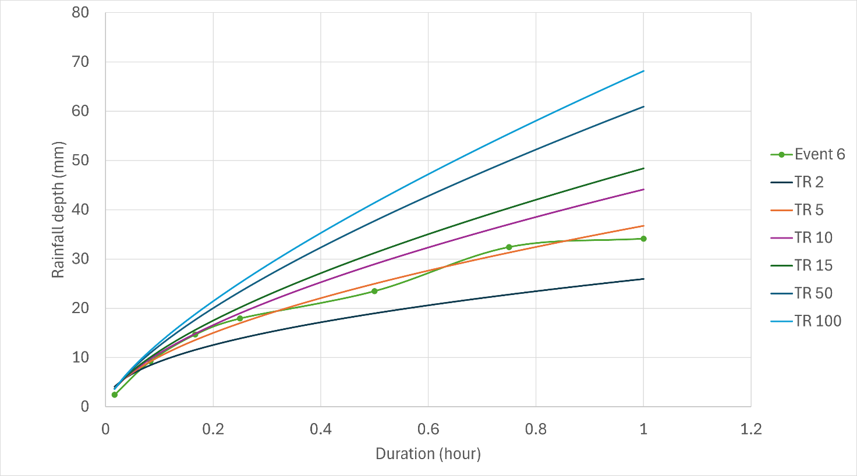
Figure A.2: Comparison of DDF curve of Event 6 with DDF of Bologna for different return periods derived from the statistical analysis of maximum rainfall depths registered in the period 1934-2023.

S3 Model B and Model D tested over Event 1, 5 and 9
To further assess the overfitting of Model B to observed data, the best parameter sets from both the model’s configuration (Model B and Model D) were subjected to the untested events (Event 1, Event 5, Event 9). The comparison is shown in Figure A.3, Figure A.4, and Figure A.5 referred to Event 1, Event 5 and Event 9 respectively. In all cases, Model B parameter sets show a slight overestimation of the peak water levels compared to both observations and Model D results.
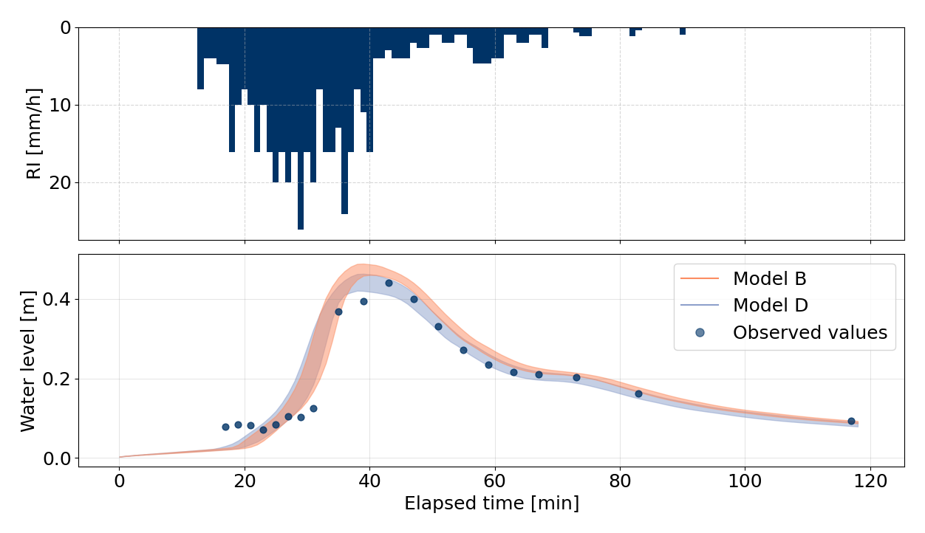Figure A.3: Best parameter sets of Model B and Model D tested over Event 1.
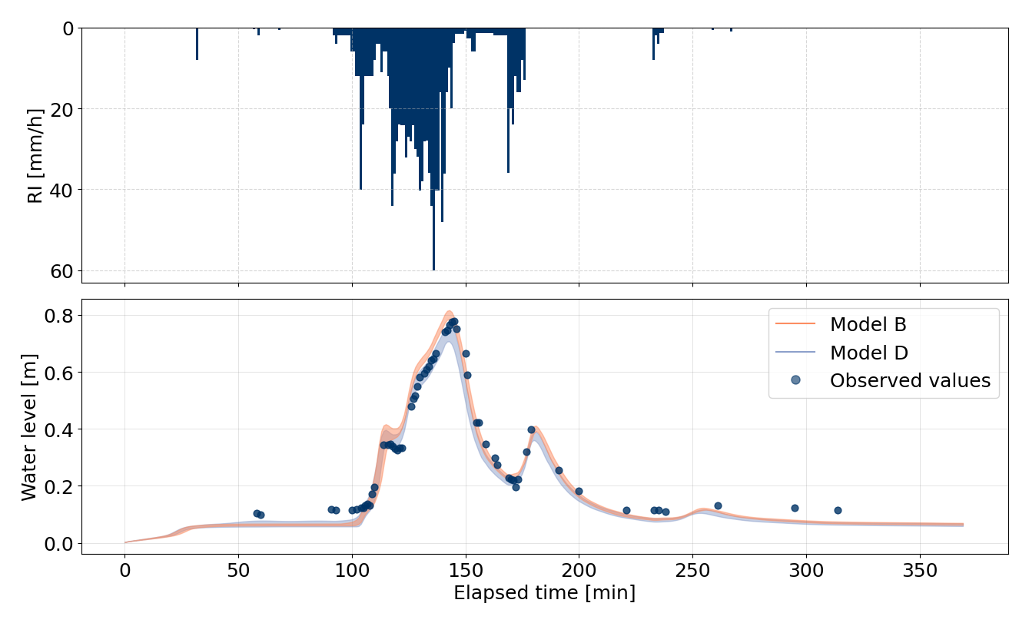Figure A.4: Best parameter set of Model B and Model D tested over Event 5.
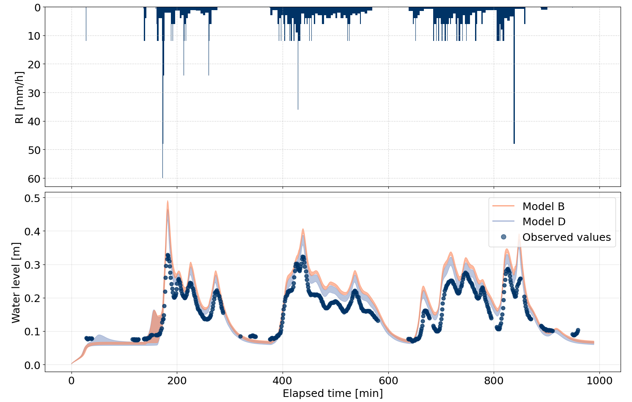
Figure A.5: Best parameter sets of Model B and Model D tested over Event 9.

S4 Model Ensemble A and Model Ensemble C on Event 1, 5, 9
No significant differences were observed in the water level trends produced by Model Ensembles A and C for Events 1, 5, and 9. This suggests that, for this type of rainfall event, structural uncertainty did not manifest, and the inclusion of a timeseries-type boundary condition did not provide substantial benefits, as reflected by the comparable model performance indicated by the NSE values in Table A.4.
Table A.4: Model Ensemble A and C performances expressed through NSE for Event 1, 5 and 9.
 | a_1 | a_2 | a_3 | a_4 | a_5 | a_6
Event 1 | 0.889 | 0.9 | 0.963 | 0.863 | 0.936 | 0.95
Event 1 | c_1 | c_2 | c_3 | c_4 | c_5 | c_6
Event 1 | 0.889 | 0.9 | 0.963 | 0.863 | 0.936 | 0.948
 | a_1 | a_2 | a_3 | a_4 | a_5 | a_6
Event 5 | 0.986 | 0.829 | 0.95 | 0.892 | 0.943 | 0.935
Event 5 | c_1 | c_2 | c_3 | c_4 | c_5 | c_6
Event 5 | 0.986 | 0.837 | 0.951 | 0.899 | 0.947 | 0.94
 | a_1 | a_2 | a_3 | a_4 | a_5 | a_6
Event 9 | 0.511 | 0.922 | 0.725 | 0.895 | 0.824 | 0.824
Event 9 | c_1 | c_2 | c_3 | c_4 | c_5 | c_6
Event 9 | 0.511 | 0.922 | 0.725 | 0.895 | 0.824 | 0.823

S5 Intra and inter model ensemble disagreement analysis
The separated analysis of Model Ensemble A vs Model Ensemble A and Model Ensemble A vs Model Ensemble B demonstrated that model a_1 is the model that presents high divergences within Ensemble A and low divergences within Ensemble B (Figure A.6).
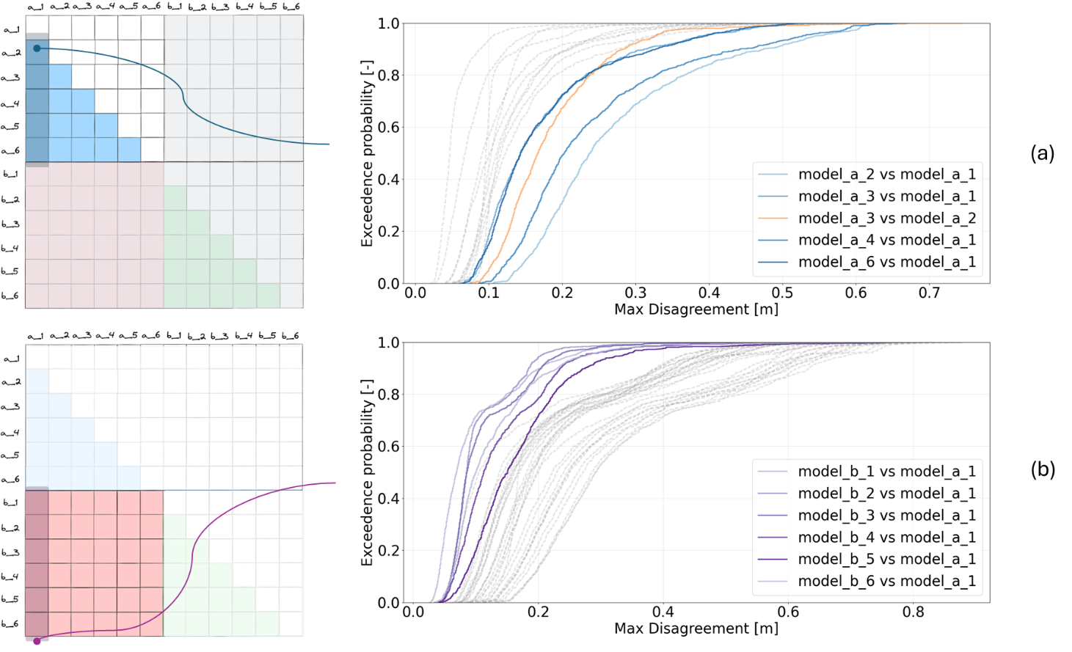
Figure A.6: Cumulative distribution of Errors. (a) Grey lines for Ensemble A vs Ensemble A, colored CDFs focus on model a_1. (b) Grey lines for Ensemble A vs Ensemble B, colored CDFs focus on model a_1.

S5.1 Filtered storms selected to stress Model Ensemble D
- For each model combination (Ensemble A – Ensemble B, salmon square in the maximum matrix disagreement) we considered the storms that produced the 1-percentile highest disagreement (out of 1000 storms). This results in 10 storms for each model combination that produces the highest model disagreement.
- Some of the storms appeared in multiple model combinations: the final set is composed of 32 storms.
- We counted the times for which the 32 storms triggered the model disagreement.
- We stressed Ensemble D with a subset of the filtered storms selected with this logic: if they trigger the disagreement in at least 25% of combination. It resulted in a subset of 15 storms (highlighted green in Table A.4).
Table A.5: Storm identifier and number of times that the storm triggers the ensembles disagreement. The green cells correspond to the selected storms for the subsequent analysis (stress Ensemble D), in orange storms excluded by the process.
Event number | Count | Event number | Count
541 | 35 | 102 | 6
858 | 31 | 511 | 6
6 | 29 | 372 | 5
188 | 29 | 641 | 5
173 | 26 | 661 | 5
413 | 23 | 877 | 4
384 | 20 | 14 | 3
178 | 18 | 55 | 3
953 | 17 | 203 | 3
4 | 15 | 403 | 3
237 | 15 | 605 | 3
845 | 11 | 778 | 3
5 | 9 | 916 | 3
65 | 9 | 500 | 2
515 | 9 | 640 | 2
658 | 7 | 287 | 1

Considering the tail region in Figure 10 (main paper), we computed the Kolmogorov-Smirnov (KS) distance to estimate the differences in the CDFs of water levels simulated by Model Ensemble A, B and D stressed by the subset of 15 storms. In Figure A.7 the KS statistic is evaluated within each ensemble group: Ensemble A is shown in the left column, and Ensemble B in the right column.
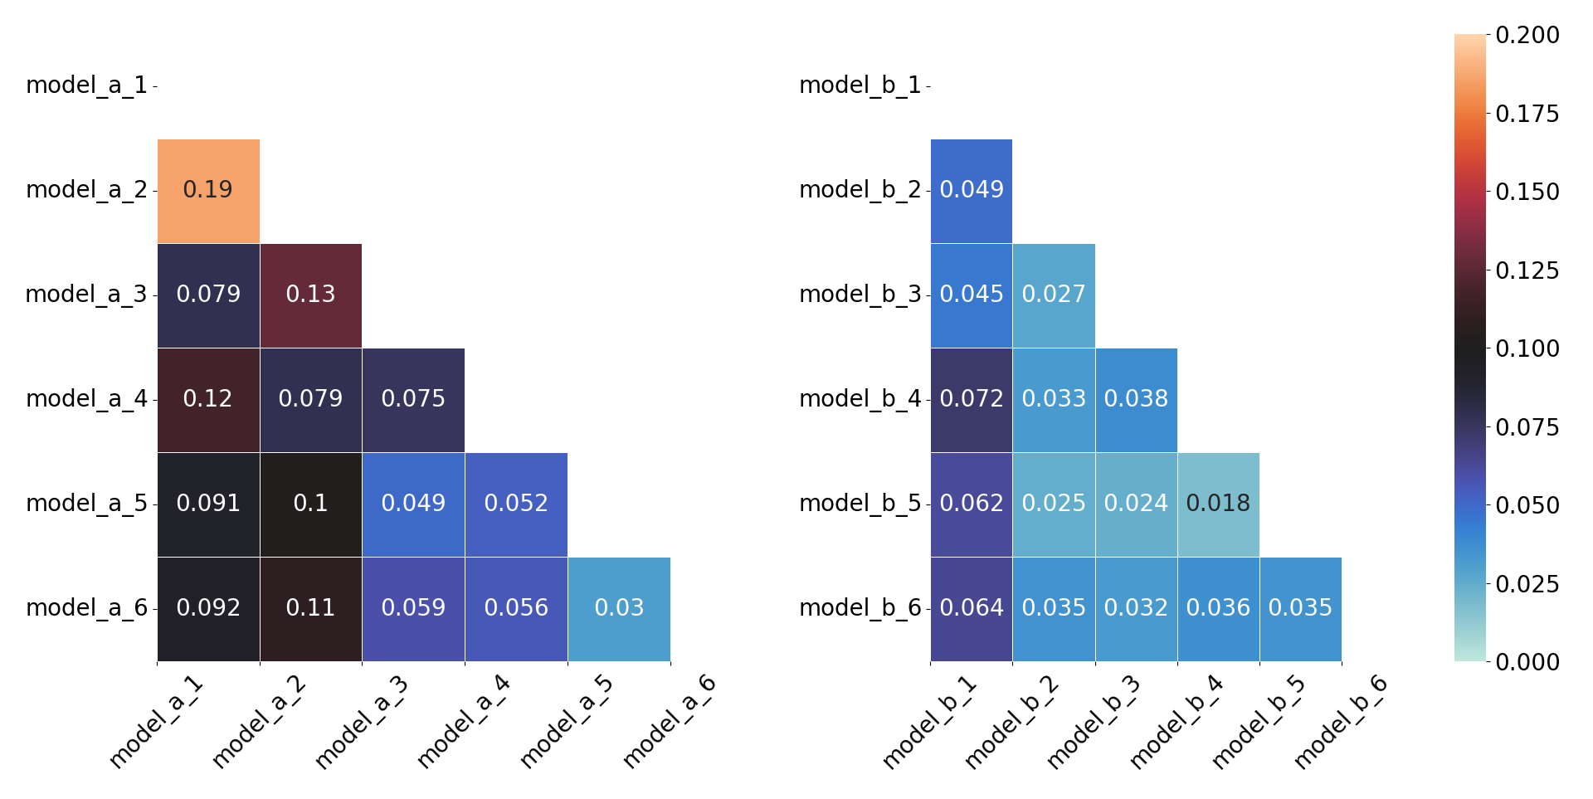
Figure A.7: Heatmap of KS distances values, for Model Ensemble A (left) and Model Ensemble B (right) in the tail region.

S6 Evaluation of the temperature-conditioned Statistical Downscaling Model (MRC)
A qualitative analysis of the MRC model’s ability to reproduce precipitation patterns was conducted under different conditions, comparing results with observed data and convection-permitting model (CPM) outputs. Figure A8 shows the testing of the statistical downscaling model, trained on historical precipitation, from daily to hourly precipitation, and compared to historical precipitation at hourly resolution and convection permitting outputs of climate model for Bologna at hourly resolution.
The result shows that for low temperature range the distribution of precipitation is less intense than for high temperature range. It further shows that the statistical downscaling reproduces those temperatures dependent distribution (shaded red area close to the red line), and that the raw convection permitting outputs with high temperature are biased in this regard (which motivates the bias correction). Further investigation to compare CPM vs MRC would require higher resolution outputs from climate models.
For what concerns the present study, the MRC learns from observed datasets with a temperature dependence which include some convection permitting events, the Figure A8 shows its ability to grasp those dependencies, but no formal validation was possible given the data availability and is considered out of the scope of the current study. The ensembles of extreme events generated with the MRC for the present study are driven by distribution of summer temperature in current and future climate.
The results show more intense precipitation in future climate, which is attributed to the presence of convective summer precipitation in the training dataset. This constitutes an estimate of future distribution of precipitation, but is limited by the nature of the MRC which does learn from the correlation between precipitation and temperature and produce estimates at low computational costs, but does not solve explicitly convective processes. Further research is needed to produce adequate inputs to estimate the impact of climate change on urban infrastructure.
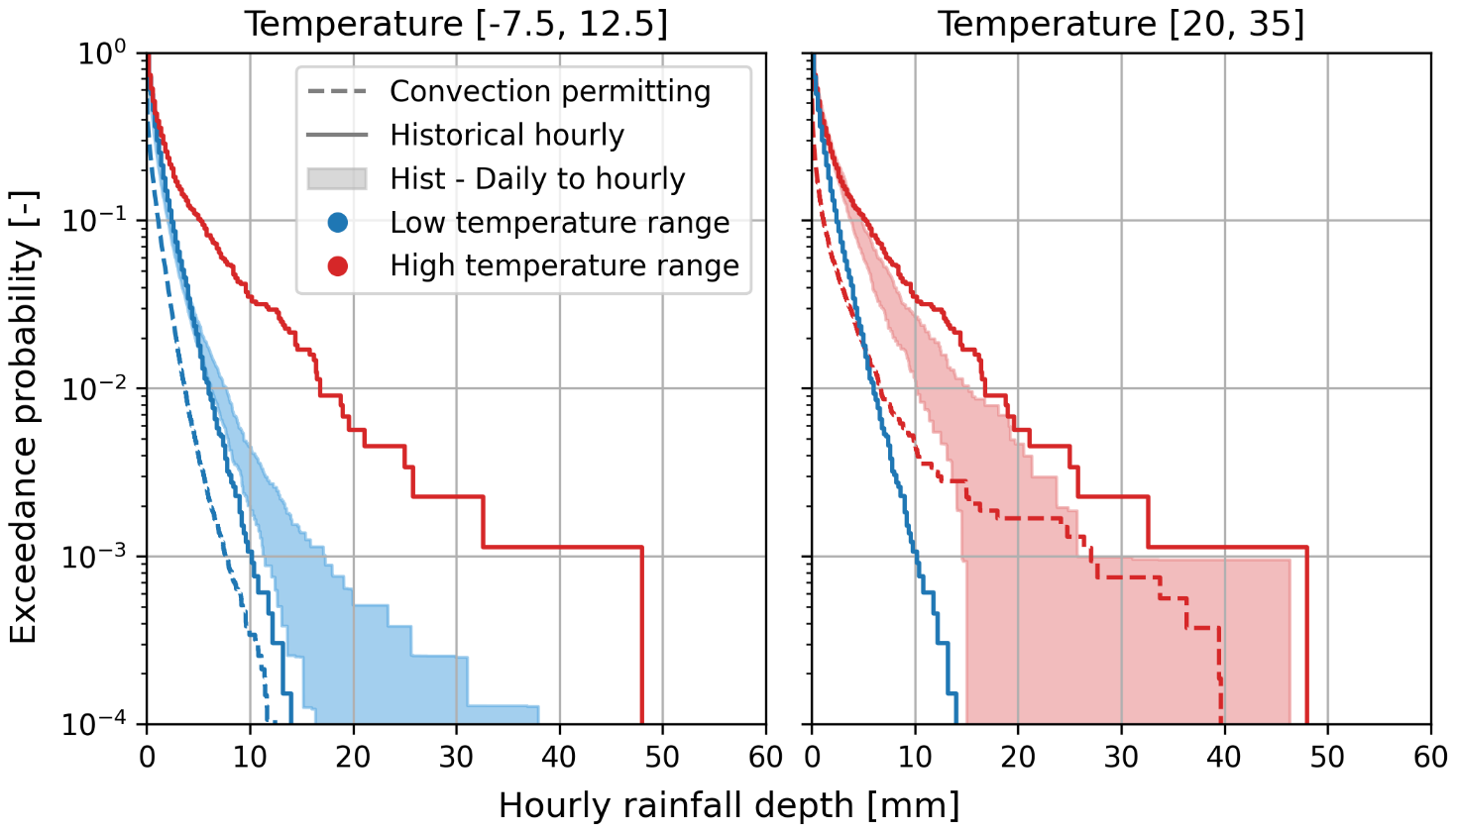
Figure A8: Distribution of hourly rainfall depth for the evaluation period (2004-2023) in two different temperature class based on the Bologna dataset. Figure taken by Pons et al. 2025, contribution presented at the Urban Drainage Modelling Conference (UDM) 2025.

S7 Model ensemble disagreement under changing conditions
The model disagreement was evaluated under future conditions by subjecting Model Ensemble A and Model Ensemble B to a second ensemble of storm events. The Maximum Disagreement Matrix has been built by computing the maximum absolute difference in simulated water levels between each model of the ensembles.
For each inter-ensemble group, we selected the top 1 percentile (out of 1000 storms) with the highest model disagreement, resulting in 10 storms for model combination. Since some storms appeared in multiple model combination, the final set included 49 unique storms responsible for the highest model disagreement. Figure A.9 shows the cumulative distribution function of precipitation depth for the selected storms.
For the identified storms, the corresponding maximum rainfall intensity is shown in Figure A.8. As expected, the tipping rainfall intensity of the filtered storms remains consistent with that observed under current conditions. However, the number of storms that trigger the condition increases (32 storms in current condition, 49 storm events in future condition).
Table A.6: Future storm identifier and number of times that the storm triggers the model ensembles disagreement.
Event number | Count | Event number | Count
423 | 22 | 479 | 6
901 | 22 | 686 | 6
899 | 19 | 128 | 5
147 | 17 | 159 | 5
951 | 17 | 305 | 5
375 | 15 | 602 | 5
640 | 14 | 637 | 5
856 | 14 | 904 | 5
979 | 14 | 994 | 5
254 | 13 | 306 | 4
611 | 13 | 471 | 3
247 | 11 | 478 | 3
954 | 11 | 884 | 3
66 | 10 | 236 | 2
291 | 10 | 263 | 2
529 | 10 | 449 | 2
413 | 9 | 17 | 1
261 | 8 | 96 | 1
63 | 7 | 124 | 1
289 | 7 | 210 | 1
715 | 7 | 278 | 1
821 | 7 | 415 | 1
890 | 7 | 514 | 1
92 | 6 | 861 | 1
136 | 6

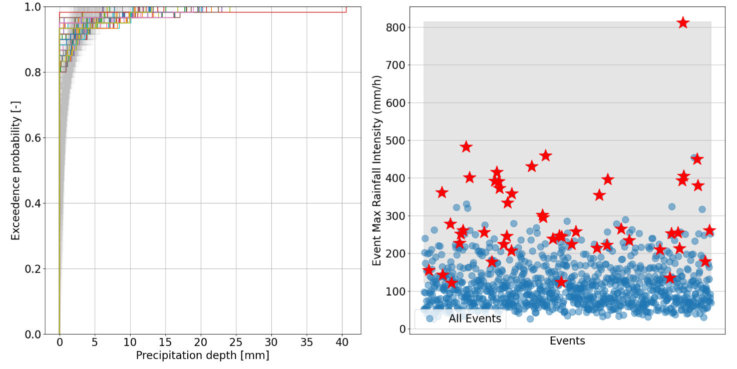
Figure A.9: CDFs of future random storms used for stressing Model Ensemble A and Model Ensemble B: colored CDFs represents the filtered storms, by adopting the percentile approach (b) Red stars are associated with maximum rainfall intensity (mm/h) of the filtered storms.

