Supplementary materials

Table 1 - Data collection on social media posts
 | Facebook | Instagram
Total days considered | 912 (two years, six months)  January 1, 2022, to June 30, 2024 | 912 (two years, six months)  January 1, 2022, to June 30, 2024
Total posts collected  2022  2023  2024 | 4,645,976  1,826,170  1,836,286  983,520 | 4,654,366  1,805,333  1,834,237  1,014,796
Average number of posts collected per day | 5,094.72 | 5,103.47
Total number of unique accounts | 72,753 | 100,726
Average number of posts produced by unique account | 63.85 (max: 33,032; min: 1) | 46,2 (max 26,568; min: 1)
Average count of reactions per post | 2,702 (max: 2,358,845; min: 67) | 6,067.8 (max: 5,073,542; min: 4)

Table 2 - Data collection on social media posts by selected influencers
 | Facebook | Instagram
Total days considered | 304 (ten months) | 304 (ten months)
Total posts collected | 701,394 | 798,312
Average number of posts collected per day | 2,307 | 2,626
Total number of unique accounts | 168 | 188
Average number of posts produced by unique account | 4,439.2 (max: 62,747; min: 1) | 4,246.34 (max: 47,738; min: 6)
Average count of reactions per post | 2,434 (max: 916,564; min: 0) | 39,096 (max: 6,185,664; min: 0)

Integration between survey and Swipe module
The national mass survey includes items and tools (like the Swipe module) previously administered in the high school survey. This sequential and integrated data collection approach allows for comparisons between different samples over time. For example, linking data from conventional surveys to social media activity and content (through the innovative linkage information from the Swipe tool) opens up various analytical possibilities, including more accurately detecting how social media influences political behaviour and monitoring the popularity trajectory of specific figures.
A first example is presented in Figure A, which allows us to observe the impact of an exogenous shock (a scandal known as "Pandoro-gate") on the approval rate trend of a specific social media influencer, Chiara Ferragni, by relying on data collected in high schools. This presented a significant opportunity, given that our survey's timing included a small but notable portion of the sample surveyed before this exogenous shock. Figure B replicates the same analysis with data from the national pre-election survey, using the Rolling-Cross-Section design to examine changes during the election campaign period. As shown in Figure A, the approval ratings of this public figure among high school pupils sharply decreased following the shock event, accompanied by an increase in disapproval ratings and respondents selecting "don't know."
Additionally, this case allows us to observe the popularity trajectory of an influential figure after an exogenous shock, analysing public reactions over the long term and the effects of the individual’s efforts to manage a public relations crisis. Figure A shows that during a period marked by various electoral campaign events, a significant reduction in Ms. Ferragni’s social media activity, and declining media attention, public opinion's approval rating remained relatively stable, with prevalent indifferent feelings toward her. Overall, this approach enhances our understanding of the dynamic interplay between social media activity and public opinion, offering valuable insights for future research.
Figure A – Time-series plot of predicted probabilities of Swipe choices over the Chiara Ferragni card. Based on data from the school survey. Horizontal lines mark significant events related to the personality. Predicted probabilities are derived controlling for geographic area of the school, type of school, and date of data collection.
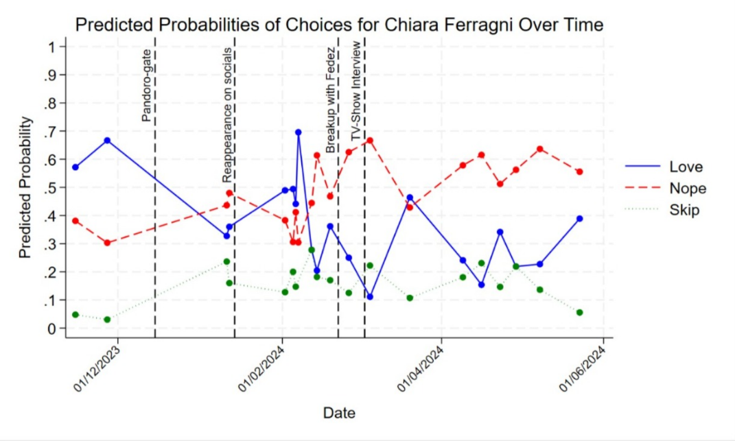
Figure B – Time-series plot of share of Swipe choices over the Chiara Ferragni card based on data from the pre-electoral survey
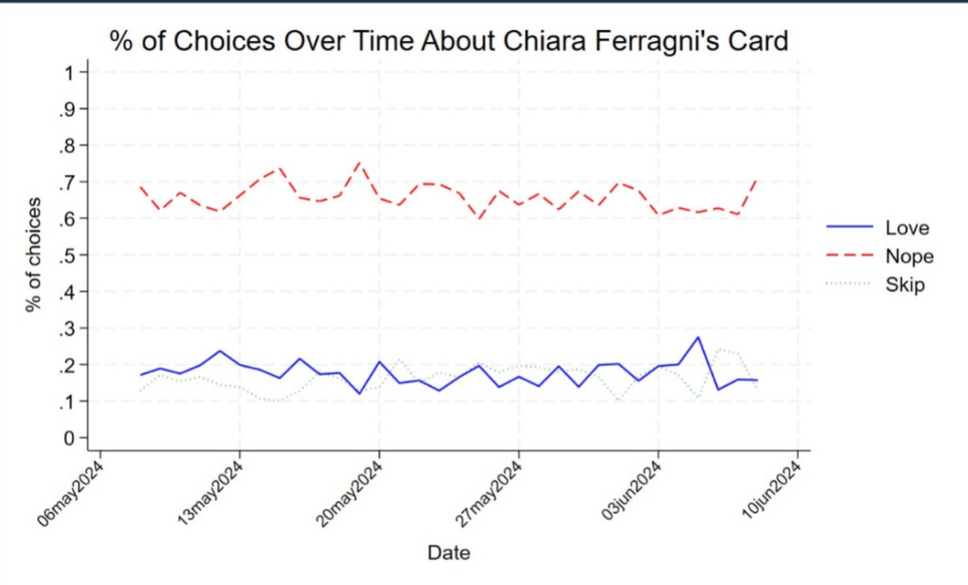
Finally, the data from the national mass survey can be integrated with the high school survey to investigate one of the project’s main objectives: the degree of ideological structuring of opinions among young Italians compared to older generations. The inclusion of the same items on specific topics in both questionnaires facilitates this comparison. A preliminary analysis could focus on the relationship between self-placement on the left-right political spectrum and positions on specific policy issues in both the student sample and the national sample disaggregated by age groups.
For illustrative purposes, we present results for two cultural issues—immigration and soft drugs—that exhibit opposing patterns. Specifically, the graphs in Figure C show the percentage of respondents who support limiting immigration (a “conservative” goal) and legalizing soft drugs (a “progressive” goal) based on left-right self-placement and age. Overall, opinions on both policy goals are associated with ideological orientation. However, among younger individuals, this relationship is stronger for immigration, as the differences in opinion between the left and right are more pronounced than in older age groups, particularly those aged 31-49. Conversely, attitudes toward soft drugs appear more closely associated with ideological orientation among older respondents; notably, in the school sample, even 60% of those identifying as centre-right support legalization.
Figure C - Support (%) for two cultural policy goals (limiting immigration; legalizing soft drugs) by left-right self-placement, separately for the high school survey and for three age groups in the pre-electoral mass survey (weighted data)

The "Pandoro Gate" refers to a controversy involving Italian influencer and entrepreneur Chiara Ferragni. In 2022, Ferragni collaborated with the Italian company Balocco to release a limited-edition pandoro, a traditional Christmas cake, with her signature branding. The proceeds were meant to support a children's hospital in Turin. However, the cake's producer had given money to the hospital months before launching it. Ms Ferragni was fined 1 million euros by Italy’s antitrust authority for misleading consumers and Milan prosecutor initiated an investigation for aggravated fraud.

