Supplementary Materials

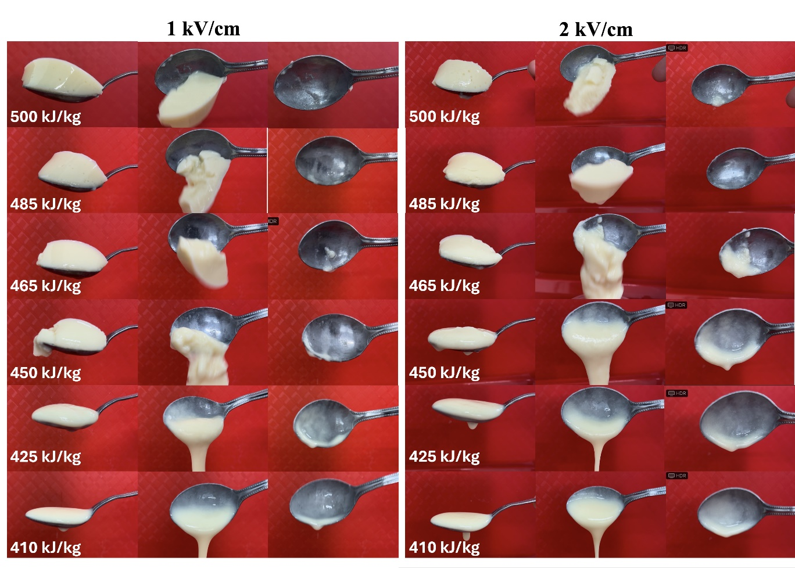
Figure S1. Spoon-tilt test performed according to the IDDSI framework specifications for PEF at electric field strengths of 1 and 2 kV/cm.
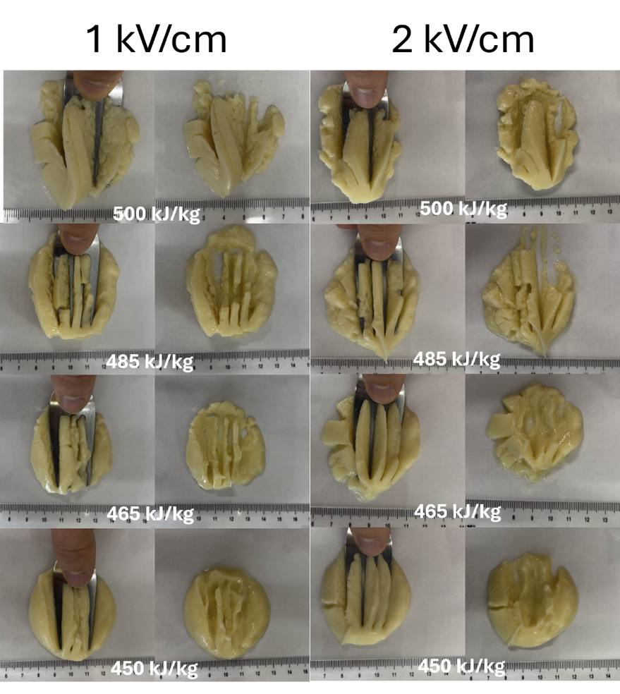
Figure S2. Fork-press test performed according to the IDDSI framework specifications for selected chickpea gel samples fabricated using PEF at electric field strengths of 1 and 2 kV/cm.
Figure S3. Linear fitting obtained for (a) viscosity at 50 s⁻¹, (b) yield stress, and (c) power law constant A’. Circles and squares represent data obtained at electric field strengths of 1 and 2 kV/cm, respectively. Fittings are performed considering only specific energy as a variable, thus 1 and 2 kV/cm sample were fitted together.
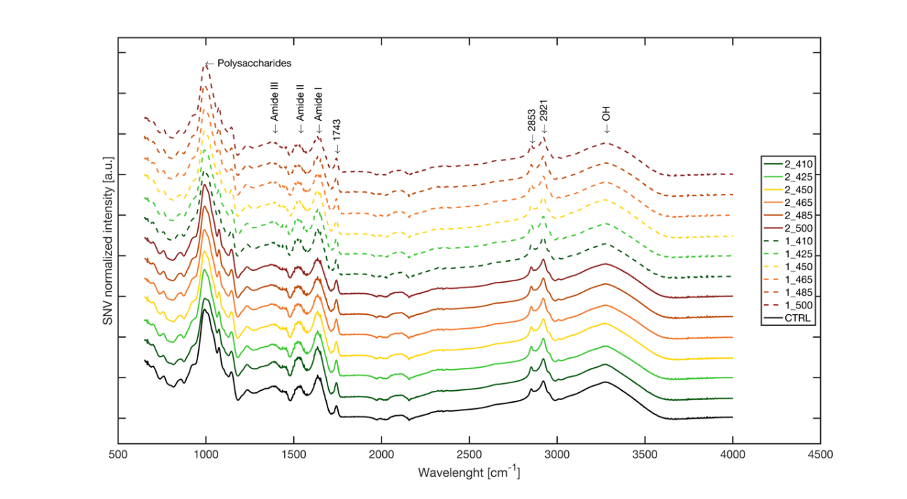
Figure S4. Stacked means (n=3) of ATR-FTIR spectra for untreated and PEF-treated chickpea samples, after SNV correction, revealing the main spectral regions of interest.

Figure S5. (a) Starch and (b) protein simulated small intestinal digestion kinetics for untreated and selected PEF-fabricated chickpea gel samples. Scattered data points represent experimental values while lines indicate fitted models. Broken and full lines refer to chickpea gel samples fabricated using PEF at electric field strengths of 1 and 2 kV/cm, respectively.

