Supporting information
Santi et al. - Plant diversity estimates of Mediterranean islands differ among biodiversity databases

To consult the dataset used to perform data analysis and related R scripts, access the Zenodo repository via the Data Availability section of the manuscript.

Table S1 - Summary of the number and frequency (%) of the Mediterranean islands with plant occurrence data obtained by EVA, GBIF, and GIFT, according to the island size. “Pooled” = islands with any data; “MEDIS” = all Mediterranean islands >0.01 km² (Santi et al. 2024). Percentage values are calculated referring to MEDIS values.

 | EVA | GBIF | GIFT | Pooled | MEDIS
Small | 250 (13.6%) | 218 (11.9%) | 152 (8.3%) | 492 (26.8%) | 1839
Medium | 150 (45.6%) | 197 (59.9%) | 83 (25.2%) | 249 (75.7%) | 329
Large | 46 (93.9%) | 49 (100.0%) | 34 (69.4%) | 49 (100.0%) | 49
Total | 446 (20.1%) | 464 (20.9%) | 269 (12.1%) | 790 (35.6%) | 2217

Table S2 - Number and frequency (%) of islands with plant occurrence data obtained by EVA, GBIF, and GIFT, divided by country. “Pooled” = islands with any data; “MEDIS” = all Mediterranean islands >0.01 km² (Santi et al. 2024). Percentage values are calculated referring to MEDIS values.

Country | EVA | GBIF | GIFT | Pooled | MEDIS
Albania | 1 (25.0%) | 1 (25.0%) | 0 (0.0%) | 1 (25.0%) | 4
Algeria | 0 (0.0%) | 4 (21.1%) | 0 (0.0%) | 4 (21.1%) | 19
Croatia | 108 (17.2%) | 138 (21.9%) | 73 (11.6%) | 240 (38.2%) | 629
Cyprus | 1 (20.0%) | 2 (40.0%) | 1 (20.0%) | 2 (40.0%) | 5
Egypt | 0 (0.0%) | 0 (0.0%) | 0 (0.0%) | 0 (0.0%) | 2
France | 55 (72.4%) | 54 (71.1%) | 1 (1.3%) | 68 (89.5%) | 76
Greece | 157 (18.1%) | 149 (17.2%) | 185 (21.3%) | 312 (35.9%) | 868
Italy | 81 (44.3%) | 62 (33.9%) | 2 (1.1%) | 87 (47.5%) | 183
Lebanon | 0 (0.0%) | 0 (0.0%) | 0 (0.0%) | 0 (0.0%) | 6
Libya | 0 (0.0%) | 0 (0.0%) | 0 (0.0%) | 0 (0.0%) | 5
Malta | 4 (50.0%) | 3 (37.5%) | 1 (12.5%) | 4 (50.0%) | 8
Montenegro | 0 (0.0%) | 1 (20.0%) | 0 (0.0%) | 1 (20.0%) | 5
Morocco | 0 (0.0%) | 0 (0.0%) | 0 (0.0%) | 0 (0.0%) | 2
Spain | 10 (11.0%) | 25 (27.5%) | 6 (6.6%) | 25 (27.5%) | 91
Syria | 0 (0.0%) | 0 (0.0%) | 0 (0.0%) | 0 (0.0%) | 2
Tunisia | 8 (19.5%) | 7 (17.1%) | 0 (0.0%) | 12 (29.3%) | 41
Turkey | 21 (7.7%) | 18 (6.6%) | 0 (0.0%) | 34 (12.5%) | 271

Table S3 – Frequency of the first 100-ranked species in each database for the 63 shared islands. Frequency is expressed as the number of islands of occurrence.

 | EVA |  | GBIF |  | GIFT
 | Species | Freq | Species | Freq | Species | Freq
1 | Drimia maritima | 42 | Pistacia lentiscus | 48 | Dactylis glomerata | 63
2 | Pistacia lentiscus | 42 | Crithmum maritimum | 46 | Lysimachia arvensis | 63
3 | Lysimachia arvensis | 41 | Nerium oleander | 46 | Arenaria serpyllifolia | 61
4 | Lagurus ovatus | 39 | Thymbra capitata | 46 | Avena barbata | 61
5 | Thymbra capitata | 39 | Vitex agnus-castus | 43 | Catapodium rigidum | 61
6 | Trifolium campestre | 39 | Olea europaea | 42 | Geranium rotundifolium | 61
7 | Dactylis glomerata | 38 | Ceratonia siliqua | 41 | Trifolium campestre | 61
8 | Oloptum miliaceum | 38 | Ficus carica | 40 | Trifolium scabrum | 61
9 | Prasium majus | 37 | Pancratium maritimum | 40 | Brachypodium distachyon | 60
10 | Avena barbata | 36 | Ecballium elaterium | 38 | Crithmum maritimum | 60
11 | Catapodium rigidum | 36 | Glebionis coronaria | 37 | Galium murale | 60
12 | Asparagus acutifolius | 35 | Punica granatum | 37 | Geranium molle | 60
13 | Olea europaea | 35 | Cistus creticus | 36 | Olea europaea | 60
14 | Sherardia arvensis | 35 | Cistus salviifolius | 36 | Pistacia lentiscus | 60
15 | Arisarum vulgare | 34 | Cakile maritima | 35 | Reichardia picroides | 60
16 | Asphodelus ramosus | 34 | Glaucium flavum | 35 | Rostraria cristata | 60
17 | Phagnalon rupestre | 34 | Arisarum vulgare | 34 | Senecio vulgaris | 60
18 | Urospermum picroides | 34 | Arundo donax | 34 | Sherardia arvensis | 60
19 | Galium murale | 33 | Convolvulus althaeoides | 34 | Sonchus bulbosus | 60
20 | Geranium purpureum | 33 | Cydonia oblonga | 34 | Sonchus oleraceus | 60

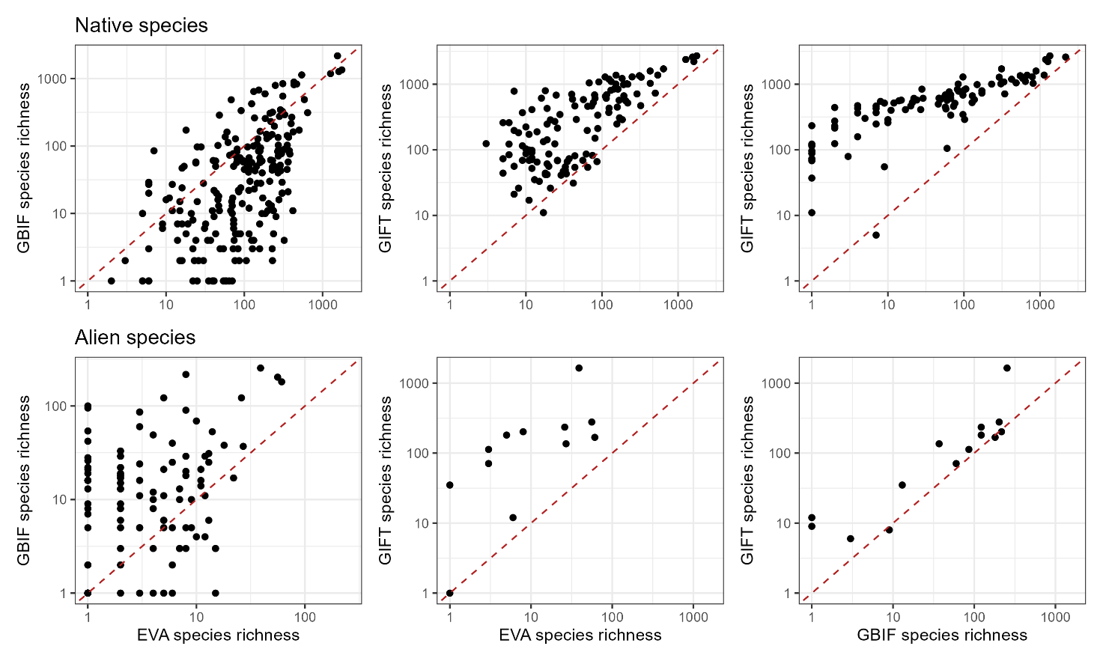
Figure S1 - Paired comparisons of species richness values reported by EVA, GBIF, and GIFT for the islands with shared data. The red dashed line is the bisector y = x that helps to visualise the differences in species richness provided by the databases (islands under the line have higher species richness values in the database on the x-axis, those over the line with the database reported on the y-axis).

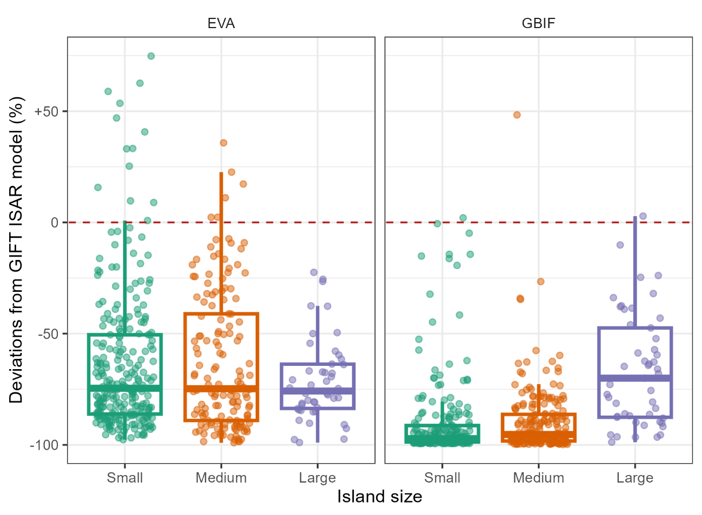
Figure S2 - Deviations of native plants’ richness values for the islands in EVA and GBIF, compared to the values expected from the GIFT ISAR model.

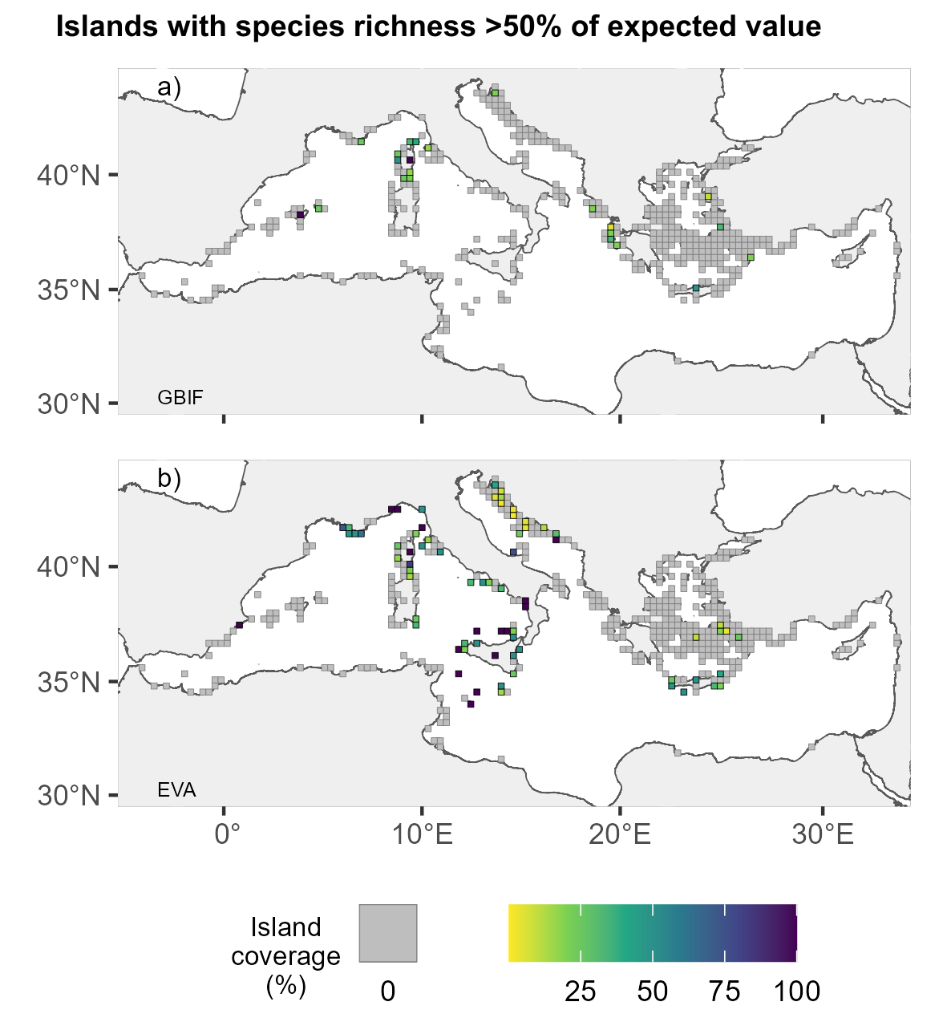

Figure S3 - Geographic distribution of Mediterranean islands with plant species richness reported by EVA (a) and GBIF (b) >50% of the value expected by GIFT ISAR model. Islands are aggregated in grid cells with a 30 km × 30 km resolution. The cell colour represents the proportion of islands covered by each database with respect to the total number of islands per cell.

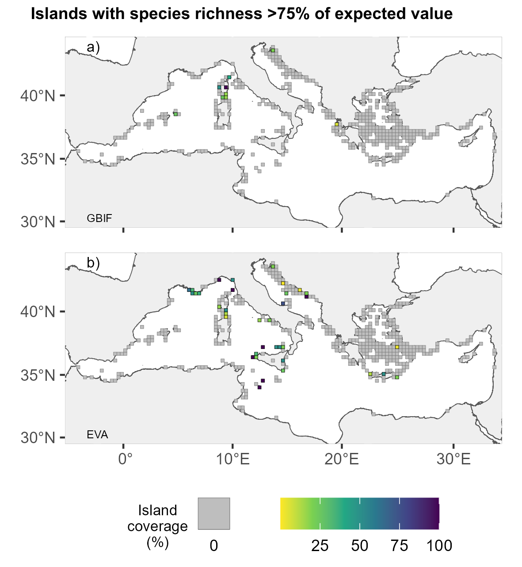

Figure S4 - Geographic distribution of Mediterranean islands with plant species richness reported by EVA (a) and GBIF (b) >50% of the value expected by GIFT ISAR model. Islands are aggregated in grid cells with a 30 km × 30 km resolution. The cell colour represents the proportion of islands covered by each database with respect to the total number of islands per cell.

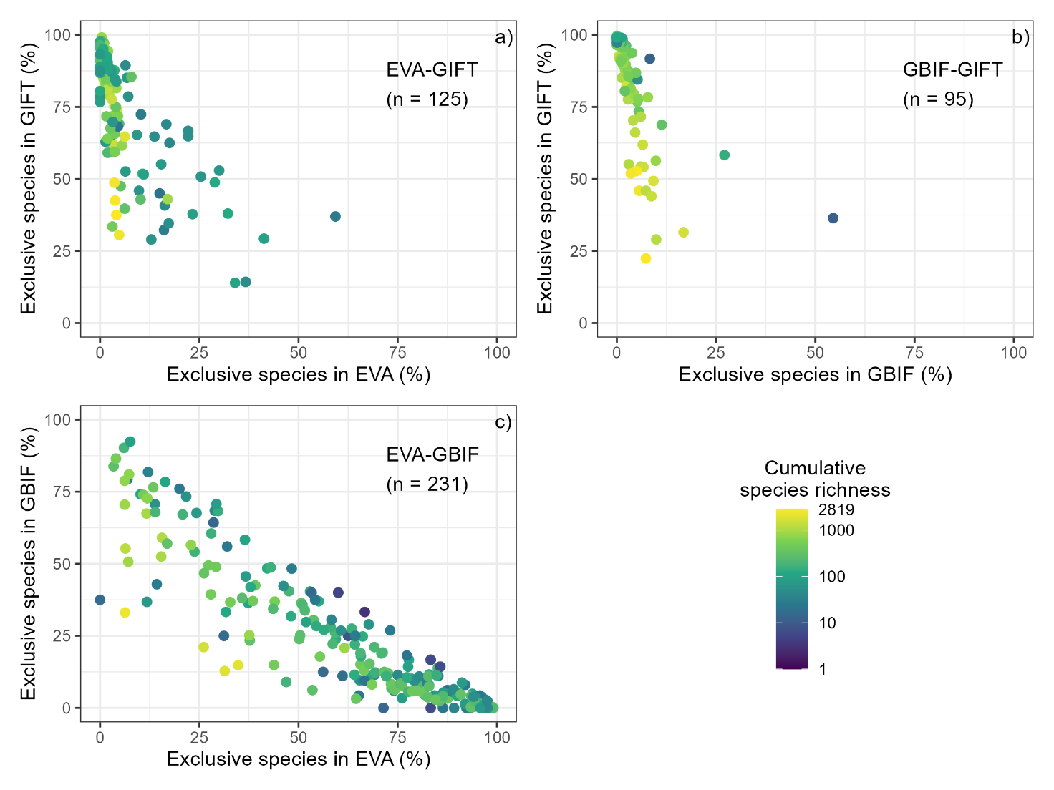

Figure S5 - Paired comparisons of species richness values reported by EVA, GBIF, and GIFT for the islands shared by pairs of databases. Each dot represents an island, whereas the colour represents the cumulative species diversity reported by the two considered databases.

