Supplement materials for the manuscript: A systematic assessment of remote sensing approaches for agricultural zonation and supporting precision agriculture
Authors: Gunay Hasanli^{a,b,c,*}, Sadra Emamalizadehª, Riccardo Mazzoleniª, Marco Benfenatiª, Gabriele Baroniª
Affiliations: ª Department of Agricultural and Food Sciences, University of Bologna, Bologna, Italy; ^{b} Department of Agricultural and Food Sciences, ADA University, Baku, Azerbaijan; ^{c} Agro Research Center, The Ministry of Agriculture of Azerbaijan, Baku, Azerbaijan
*Corresponding author: Gunay Hasanli, gunay.hasanli2@unibo.it
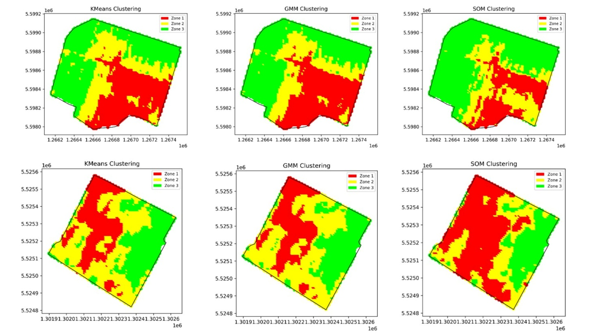
Figure S1. Zonation based on image acquisition on 23/05/2023, NDVI, and three cluster methods (k-means, GMM, and SOM). Based on these maps, the following v-measures are obtained at Bondeno: k-means vs. GMM = 0.89; k-means vs. SOM = 0.59; GMM vs. SOM = 0.60. At Imola, k-means vs. GMM = 0.88; k-means vs. SOM = 0.56; GMM vs. SOM = 0.58.

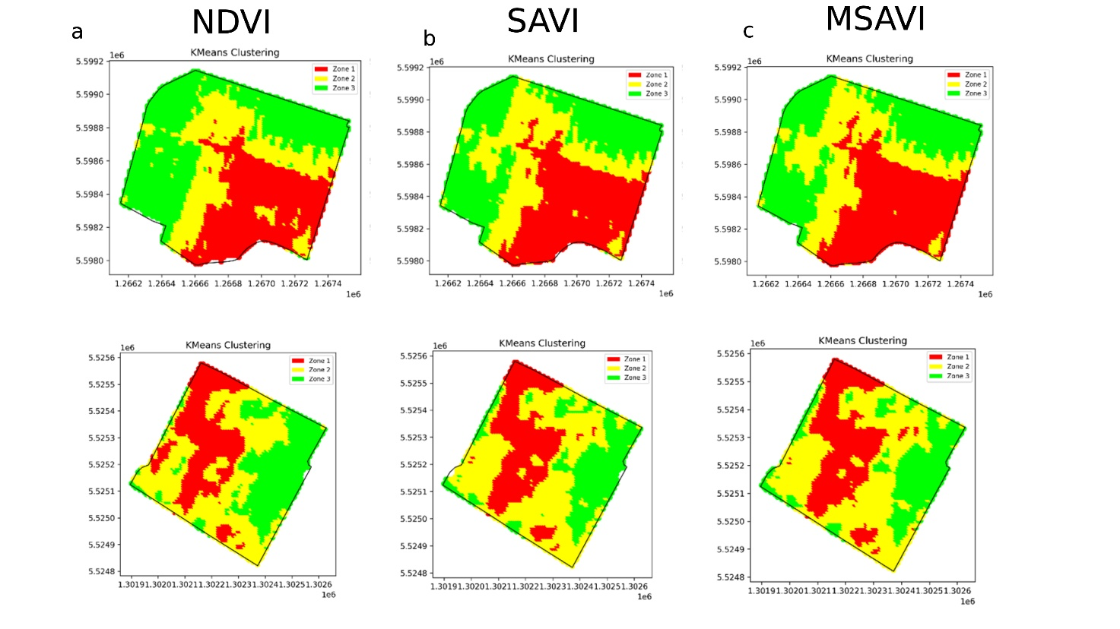
Figure S2. Zonation based on image acquisition on 23/05/2023, k-means, and three vegetation indices (NDVI (a), SAVI (b), and MSAVI (c)). Based on these maps, the following v-measures are obtained at Bondeno: NDVI vs. MSAVI = 0.53; NDVI vs. SAVI = 0.56; SAVI vs. MSAVI = 0.90. At Imola NDVI vs. MSAVI = 0.52; NDVI vs. SAVI = 0.56; SAVI vs. MSAVI = 0.86.

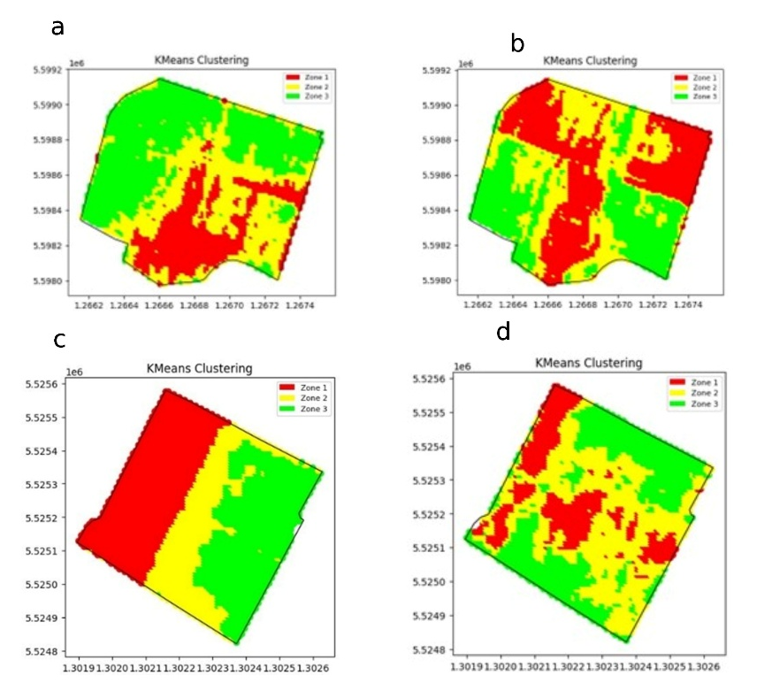
Figure S3. Best and worst clusters obtained in comparison to the reference zonation: a) cluster based on image acquisition on 13/11/2024, k-means, NDVI with v-measure = 0.24 at Bondeno; b) zonation based on image acquisition on 17/6/2023, k-means, NDVI with v-measure = 0.43 for Imola; c) zonation based on image acquisition on 7/04/2024, k-means, NDVI with v-measure = 0.02 for Bondeno; d) zonation based on image acquisition on 29/10/2024, k-means, NDVI with v-measure = 0.07 for Imola.

