Supporting Information
Novel biobased poly(trimethylene 2,5-furanoate-co-trimethylene dodecanedioate) PTFcoDod copolymers for sustainable packaging
Giulia Guidotti ª, Agata Zubkiewicz ^{b}, Anna Szymczyk ^{c}, Rafael Sablong ^{d}, Michelina Soccio ª, Valentina Siracusa ^{e}, Nadia Lotti ª
ªDepartment of Civil, Chemical, Environmental, and Materials Engineering, University of Bologna, Via Terracini 28, 40131 Bologna, Italy
^{b} Institute of Mathematics, Physics and Chemistry, Maritime University of Szczecin, Wały Chrobrego 1, 2,70-500 Szczecin, Poland
^{c} Faculty of Mechanical Engineering and Mechatronics, West Pomeranian University of Technology, Al. Piastów 19, PL 70-310 Szczecin, Poland
^{d} Polymer Technology Group/Eindhoven (PTG/e) B.V., De Lismortel 31, 5612 AR Eindhoven, The Netherlands
^{e} Department of Chemical Science, University of Catania, Catania, Italy
*Corresponding authors: aszymczyk@zut.edu.pl (Anna Szymczyk); nadia.lotti@unibo.it (Nadia Lotti)
*Corresponding authors: aszymczyk@zut.edu.pl (Anna Szymczyk); nadia.lotti@unibo.it (Nadia Lotti)

Molecular characterization
Based on the signals obtained from ¹H NMR (Fig. 1S), the actual compositions of TDod units (ϕ_{TDod}^{B}) (eq. 1S), number average sequence length of TF and TDod repeating units (L_{n,TF}, L_{n,TDod}) (eq. 2S-3S) and the degree of randomness (R) (eq. 4S) of the copolymers were calculated as follows:
$φ_{TDod}^{B} \left(mol \%\right)= \frac{I_{b3}+I_{b4}}{I_{b1}+I_{b2}+I_{b3}+I_{b4}}∙100\%$ (1S)
$L_{n,TF}=1+\frac{I_{c1}}{I_{c2}}$ (2S)
$L_{n,TDod}=1+\frac{I_{c3}}{I_{c2}}$ (3S)
$R=\frac{1}{L_{n,TF}}+\frac{1}{L_{n,TSub}}$ (4S)
where I_{b1}, I_{b2}, I_{b3}, I_{b4}, I_{c1}, I_{c2}, I_{c3} represent the integrals of the corresponding peaks (Fig. 1S).

a)
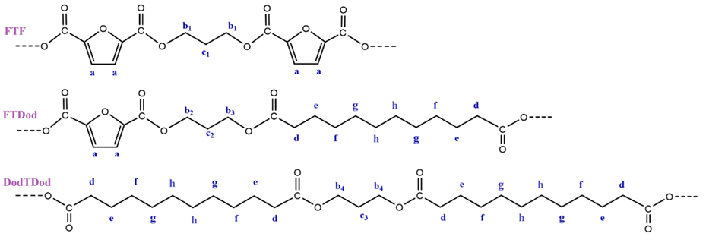
b)
Fig. 1S. ¹H-NMR spectra of PTF and PTFcoDod copolymers.

ATR-FTIR measurements were performed using a Bruker Tensor-27 spectrometer with an ATR attachment in the wavenumber range from 400 to 4000 cm⁻¹, with a resolution of 2 cm⁻¹ and results are presented in Fig. 2S and and corresponding data in Table 1S.
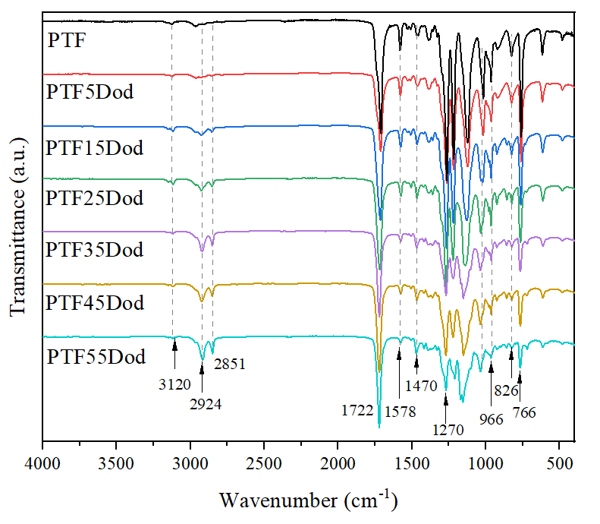
Fig. 2S. FTIR spectra of PTF and PTFcoDod copolymers.
Table 1S. FTIR data for PTF and PTFcoDod copolymers.
Typ of vibration |  | Wavenumber (cm⁻¹)
Typ of vibration | PTT | PTF5PTDod | PTF15PTDod | PTF25PTDod | PTF35PTDod | PTF45PTDod | PTF55PTDod
C-H stretching vibrations in the furan ring | 3121 | 3124 | 3120 | 3120 | 3120 | 3120 | 3120
C–H stretching vibration (CH₂) | 2923  2850 | 2923  2850 | 2924  2853 | 2924  2850 | 2924  2851 | 2924  2852 | 2918  2851
C=O stretching vibration | 1720 | 1720 | 1720 | 1724 | 1721 | 1723 | 1723
C=C ring stretching vibrations of the furan rings | 1580 | 1580 | 1576 | 1578 | 1578 | 1578 | 1578
-CH- deformation and wagging vibrations | 1506  1464 | 1506  1468 | 1506  1468 | 1506  1467 | 1506  1469 | 1506  1469 | 1506  1470
asymmetric and symmetric stretching vibrations of the ester C-O-C groups | 1268  1140 | 1265  140 | 1267  140 | 1270  1140 | 1270  1140 | 1270  1140 | 1270  1140
=C-O-C= ring vibrations of the furan ring | 1023 | 1023 | 1023 | 1023 | 1023 | 1021 | 1021
C-H out-of-plane deformation vibrations of the furan ring) | 964  826  766 | 964  826  766 | 964  826  766 | 964  825  766 | 964  825  766 | 964  825  766 | 964  825  766

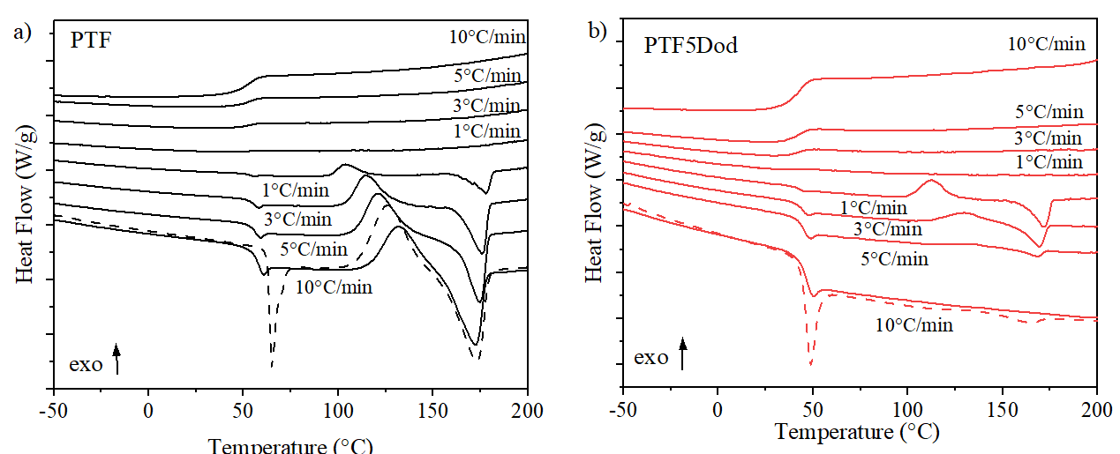
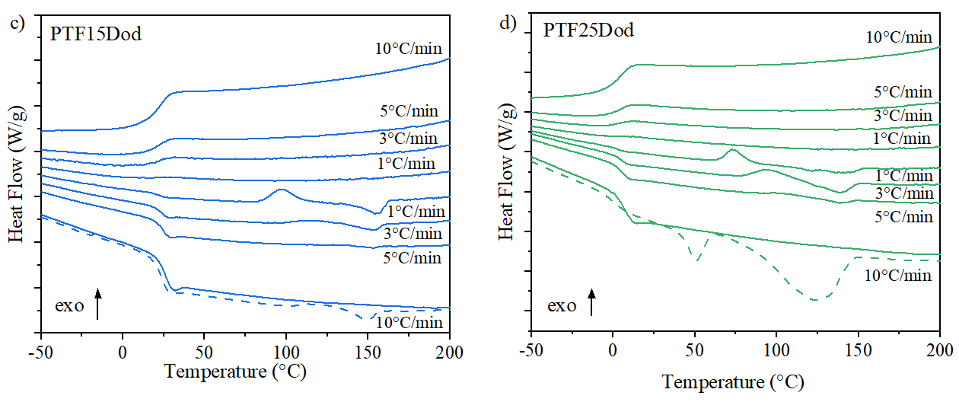
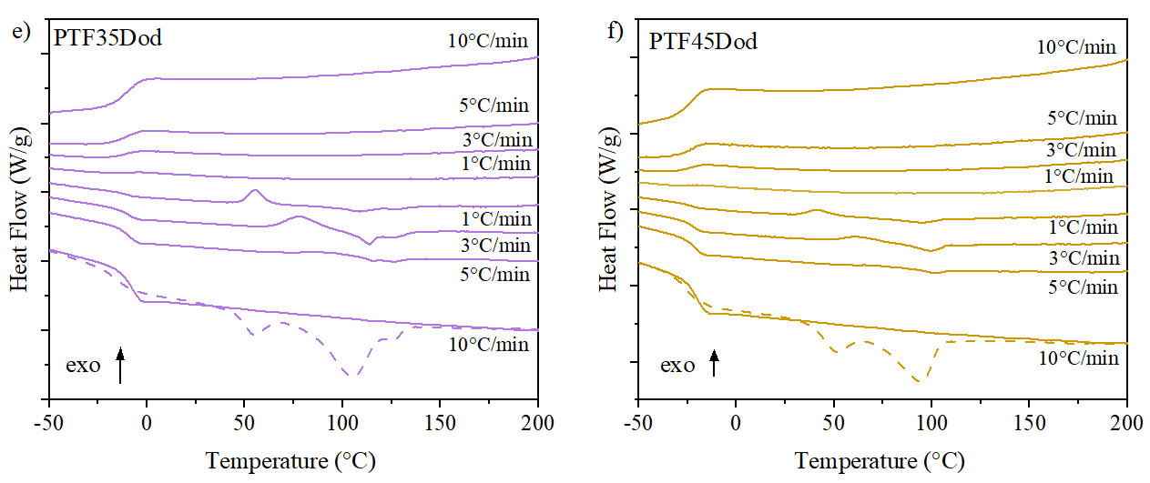
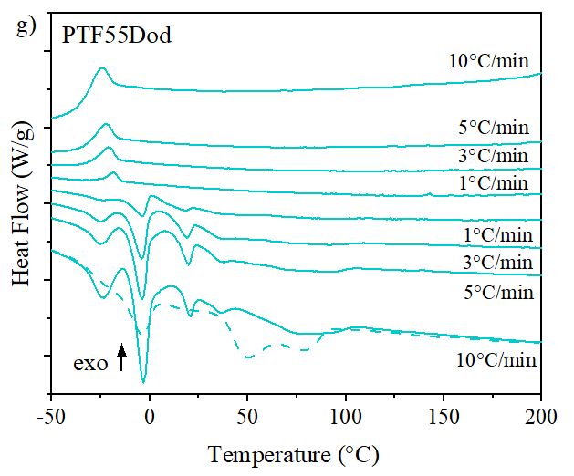
Fig. 3S. DSC heating and cooling scans for PTF and PTFcoDod copolymers at a rate of 1, 3, 5 and 10ºC/min (the dashed lines represent the first heating scans at 10°C/min).

X-ray diffraction and thermal properties of PTF and PTFcoDod copolymers
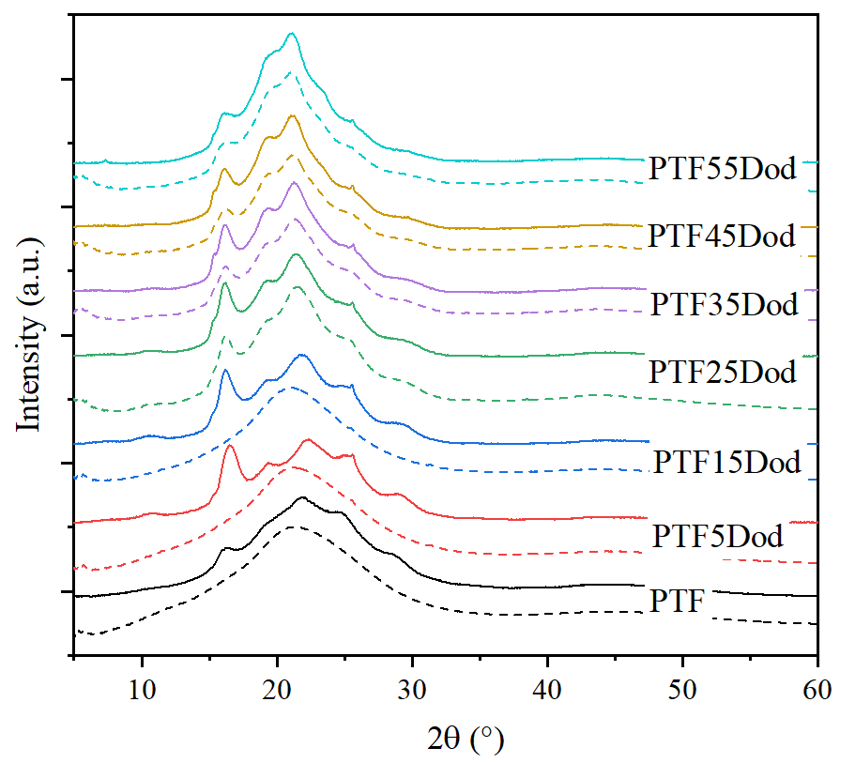
Fig. 4S. X-ray diffraction (XRD) curves of PTF and PTFcoDod copolymers before (dashed lines) and after annealing. PTF, PTF5Dod, PTF15Dod annealed at 100 °C, 1 h; PTF25Dod, PTF35Dod, PTF45Dod annealed at 70 °C, 1 h; PTF55Dod annealed at 50 °C, 1 h.

Fig. 5S. TGA and DTG traces for PTF and PTFcoDod copolymers in inert (a, b) and oxidizing (c, d) atmosphere.

Table 2S. TGA data of PTF and PTFcoDod copolymers.
Sample | Argon |  |  |  |  | Air
Sample | T_{d5%}  (°C) | T_{d15%}  (°C) | T_{d50%}  (°C) | T_{DTG}  (°C) | R₆₀₀  (%) | T_{d5%}  (°C) | T_{d15%}  (°C) | T_{d50%}  (°C) | T_{DTG1}  (°C) | T_{DTG2}  (°C) | R₆₀₀  (%)
PTF | 364 | 377 | 393 | 391 | 4.4 | 360 | 376 | 396 | 393 | 491 | 2.5
PTF5Dod | 367 | 379 | 397 | 394 | 8.0 | 361 | 376 | 396 | 393 | 492 | 2.8
PTF15Dod | 363 | 378 | 397 | 396 | 4.9 | 363 | 378 | 397 | 395 | 519 | 1.1
PTF25Dod | 370 | 382 | 401 | 397 | 9.2 | 360 | 380 | 401 | 397 | 527 | 1.4
PTF35Dod | 370 | 384 | 405 | 400 | 9.2 | 369 | 383 | 403 | 400 | 525 | 1.2
PTF45Dod | 368 | 384 | 406 | 402 | 6.2 | 364 | 380 | 403 | 399 | 515 | 1.1
PTF55Dod | 370 | 386 | 411 | 406 | 7.8 | 367 | 382 | 404 | 398 | 512 | 2.4
T_{d5%}, T_{d15%}, T_{d55%} - temperature corresponding to 5, 15 and 50 % weight loss respectively; T_{DTG1}, T_{DTG2} - temperatures at maximum of weight loss rate; R₆₀₀ – residue at 600˚C.

Tensile properties
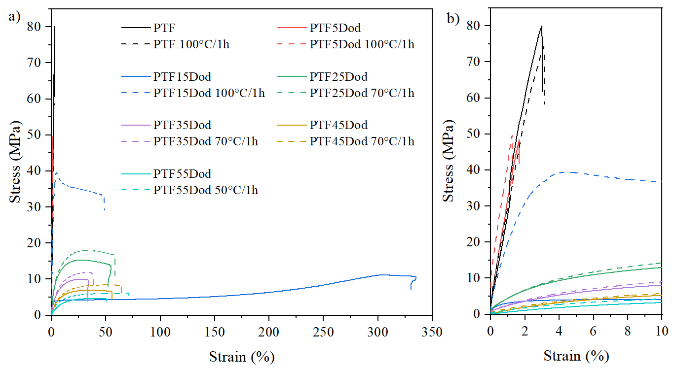
Fig. 6S. Representative stress-strain curves for non-annealed and annealed PTF and copolymeric samples.

Gas barrier properties
Table 3S. GTR data of PTF and PTFcoDod copolymers.
Sample | PTF | PTF5Dod | PTF15Dod | PTF25Dod | PTF35Dod | PTF45Dod | PTF55Dod
O₂-TR  [cm³cm m⁻²d⁻¹atm⁻¹] | 0.08  ±0.01 | 0.17  ±0.02 | 0.51  ±0.04 | 1.93  ±0.10 | 5.21  ±0.30 | 13.4  ±0.90 | 23.4  ±1.10
CO₂-TR  [cm³cm m⁻²d⁻¹atm⁻¹] | 0.05  ±0.001 | 0.22  ±0.001 | 0.50  ±0.03 | 2.49  ±0.20 | 13.60  ±0.50 | 40.50  ±1.20 | 71.60  1.60

Changes of thermal properties of PTF and copolymers during composting
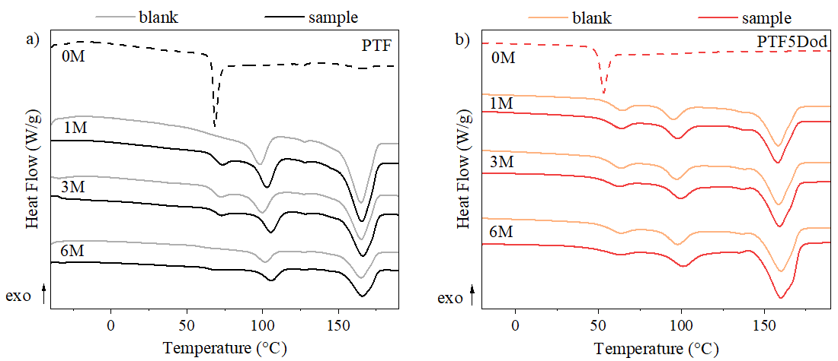
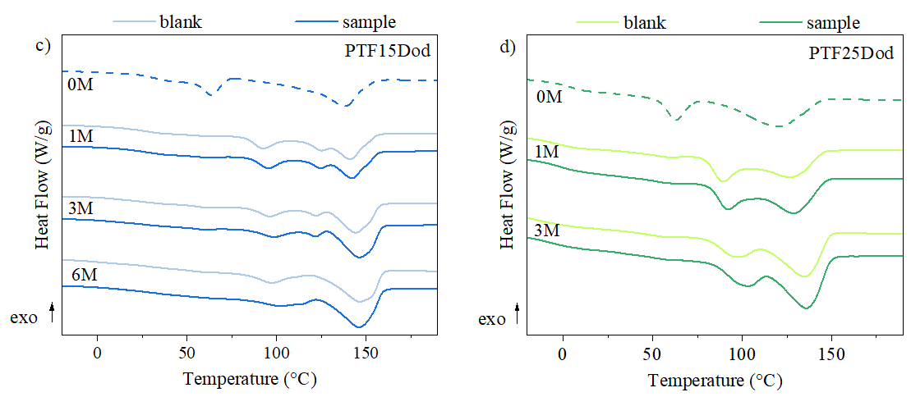
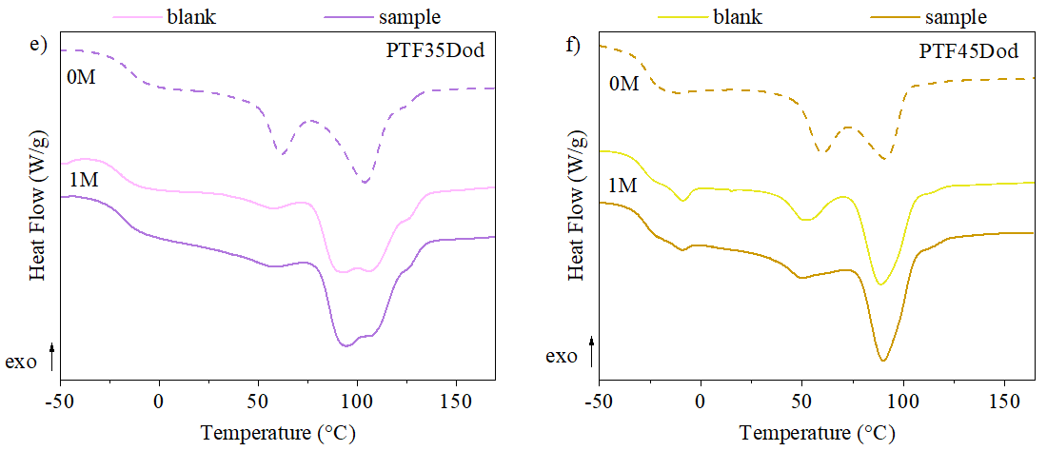
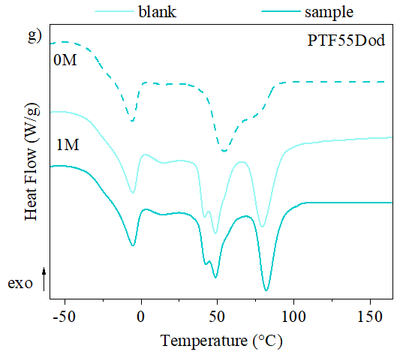
Fig. 7S. I scan DSC curves of samples after 1, 3 and 6 months in compost and their blanks (58 °C, no compost).

Table 4S. Thermal characterization data of partially degraded PTF and PTFcoDod copolymers together with the relative blanks (58 °C, no compost).
Sample | Incubation time | T_{g} | ΔC_{p} | T_{m1} | T_{m2} | T_{m3} | ΔH_{m}
Sample | (month) | (ºC) | (Jg⁻¹ ºC⁻¹) | (ºC) | (ºC) | (ºC) | (Jg⁻¹)
PTF | 0 | 62 | 0.39 | - | - | - | -
PTF | 1 (blank) | 62 | 0.19 | 97 | - | 165 | 8; 31
PTF | 1 | 69 | 0.33 | 103 | - | 165 | 9; 32
PTF | 2 (blank) | 65 | 0.28 | 98 | - | 165 | 9; 33
PTF | 2 | 69 | 0.30 | 105 | - | 166 | 9; 32
PTF | 3 (blank) | 66 | 0.23 | 99 | - | 165 | 9; 33
PTF | 3 | 69 | 0.27 | 106 | - | 166 | 10; 33
PTF | 4 (blank) | 63 | 0.21 | 97 | - | 166 | 8; 32
PTF | 4 | 66 | 0.17 | 106 | - | 166 | 10; 33
PTF | 5 (blank) | 60 | 0.17 | 96 | - | 165 | 8; 34
PTF | 5 | 65 | 0.17 | 106 | - | 166 | 10; 34
PTF | 6 (blank) | 61 | 0.11 | 102 | - | 165 | 10; 31
PTF | 6 | 63 | 0.17 | 106 | - | 166 | 10; 35
PTF5PTDod | 0 | 48 | 0.41 | - | - | - | -
PTF5PTDod | 1 (blank) | - | - | 64 | 95 | 158 | 4; 7; 28
PTF5PTDod | 1 | - | - | 63 | 98 | 158 | 4; 8; 29
PTF5PTDod | 3 (blank) | - | - | 63 | 97 | 159 | 4; 8; 30
PTF5PTDod | 3 | - | - | 62 | 99 | 159 | 3; 8; 31
PTF5PTDod | 6 (blank) | - | - | 63 | 98 | 160 | 3; 8; 32
PTF5PTDod | 6 | - | - | 62 | 101 | 160 | 3; 9; 41
PTF15PTDod | 0 | 31 | 0.21 | 64 | - | 138 | 7; 34
PTF15PTDod | 1 (blank) | 26 | 0.18 | 92 | 125 | 141 | 10; 5; 20
PTF15PTDod | 1 | 26 | 0.21 | 95 | 124 | 142 | 8; 22
PTF15PTDod | 3 (blank) | 25 | 0.23 | 96 | 122 | 144 | 7; 2; 26
PTF15PTDod | 3 | 23 | 0.19 | 98 | 122 | 146 | 6; 25
PTF15PTDod | 6 (blank) | 23 | 0.16 | 97 | - | 147 | 8;31
PTF15PTDod | 6 | 23 | 0.23 | 102 | - | 147 | 7; 33
PTF25PTDod | 0 | 0 | 0.23 | 63 | - | 122 | 7; 25
PTF25PTDod | 1 (blank) | -5 | 0.22 | 89 | - | 126 | 12; 22
PTF25PTDod | 1 | -3 | 0.20 | 92 | - | 128 | 14; 25
PTF25PTDod | 3 (blank) | -12 | 0.17 | 97 | - | 135 | 11; 31
PTF25PTDod | 3 | -7 | 0.15 | 103 | - | 136 | 15; 34
PTF35PTDod | 0 | -15 | 0.32 | 62 | - | 104 | 6; 28
PTF35PTDod | 1 (blank) | -19 | 0.27 | 56 | - | 89; 107 | 1; 30
PTF35PTDod | 1 | -18 | 0.27 | 57 | - | 96; 110 | 2; 33
PTF45PTDod | 0 | -27 | 0.42 | - | 60 | 90 | 16; 21
PTF45PTDod | 1 (blank) | -29 | 0.30 | -9 | 51 | 89 | 1; 6; 22
PTF45PTDod | 1 | -29 | 0.30 | -9 | 49 | 90 | 4; 22
PTF55PTDod | 0 | -28 | 0.39 | -6 | - | 54; 78 | 6; 27
PTF55PTDod | 1 (blank) | -30 | 0.41 | -6 | 42; 48 | 80 | 7; 16; 13
PTF55PTDod | 1 | -29 | 0.39 | -5 | 42; 49 | 82 | 6; 14; 13

Fig. 8S. ¹H-NMR spectra (4.10-4.70 ppm) of PTF5Dod, PTF15Dod and PTF25Dod copolymers before (top) and after (bottom) 4 months in compost.

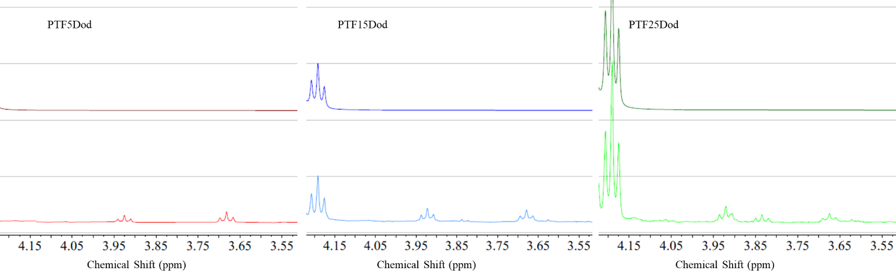
Fig. 9S. ¹H-NMR spectra (3.55-4.15 ppm) of PTF5Dod, PTF15Dod and PTF25Dod copolymers before (top) and after (bottom) 4 months in compost.

