Supporting Information

Modulated Electrochemical Force Microscopy: Investigation of Sodium-Ion Transport at Hard Carbon Anode Surfaces

S. Daboss,^{[a]} N. Franke,^{[b]} B. Fraboni,^{[b]} C. Kranz,^{[a]} T. Cramer^{[b]}
[a] Dr. Sven Daboss, Prof. Dr. Christine Kranz
Institute of Analytical and Bioanalytical Chemistry (IABC)
Ulm University, Albert-Einstein-Allee 11, 89081 Ulm (Germany)

[b] Nikolas Franke, Prof. Beatrice Fraboni, Prof. Dr. Tobias Cramer
Department of Physics and Astronomy
University of Bologna, Viale Berti Pichat 6/2, 40127 Bologna (Italy)
E-mail: tobias.cramer@unibo.it

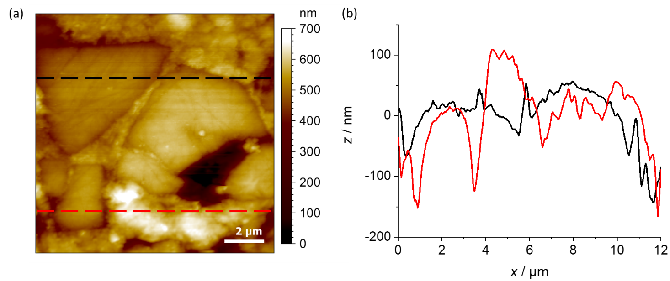
Figure S1: (a) AFM topography image of the embedded HC composite anode. (b) Line scans extracted as marked in the images with the black dotted line and the red dotted line.

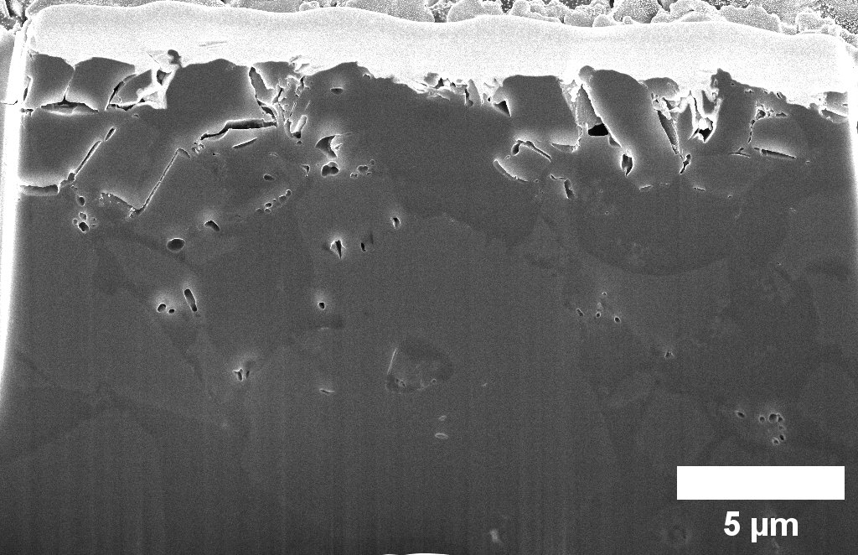
Figure S2: FIB cross-section of the embedded HC composite electrode. The image reveals the electrode architecture, size and the distribution of active material.

Figure S3: Analysis of AFM images of Figure 3e – distribution of |D_{ω}| and fit to Gaussian function to obtain an average value.
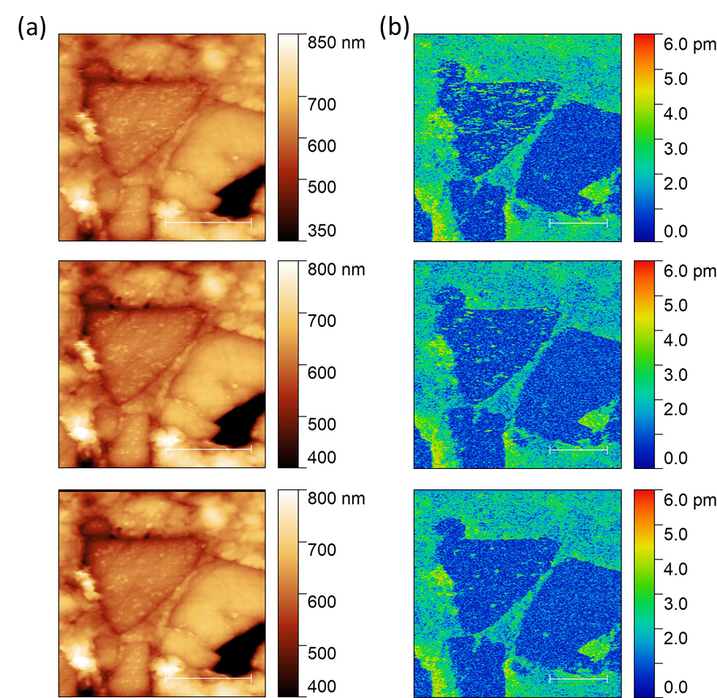
Figure S4: (a) mec-AFM images (E = 2.0 V versus Na/Na⁺) of height and (b) surface oscillation amplitude D_{w} showing accumulation of material on the HC particle and their partial removal with successive scanning.

