Supplementary Materials

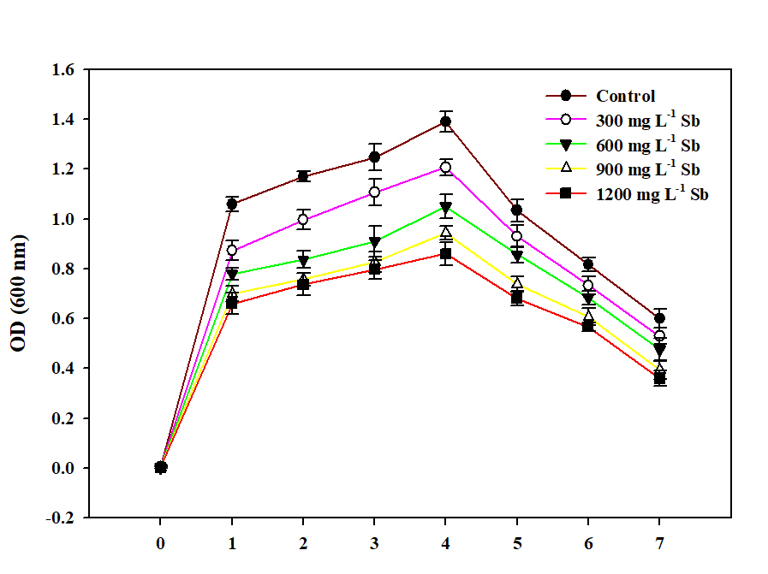

Figure S1. Growth curve of Bacillus subtilis 1.2172 under different Sb concentrations.

A | B
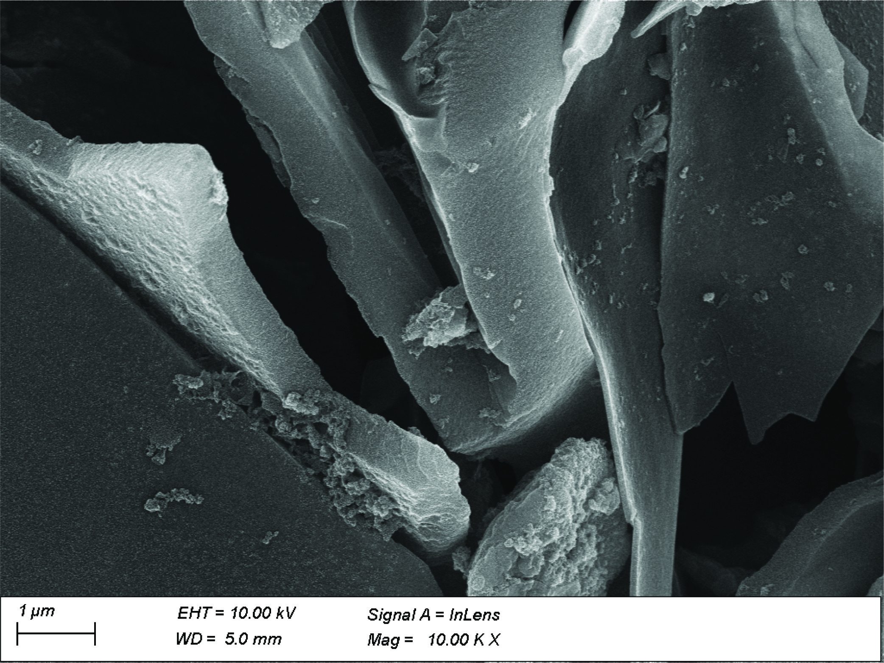 | 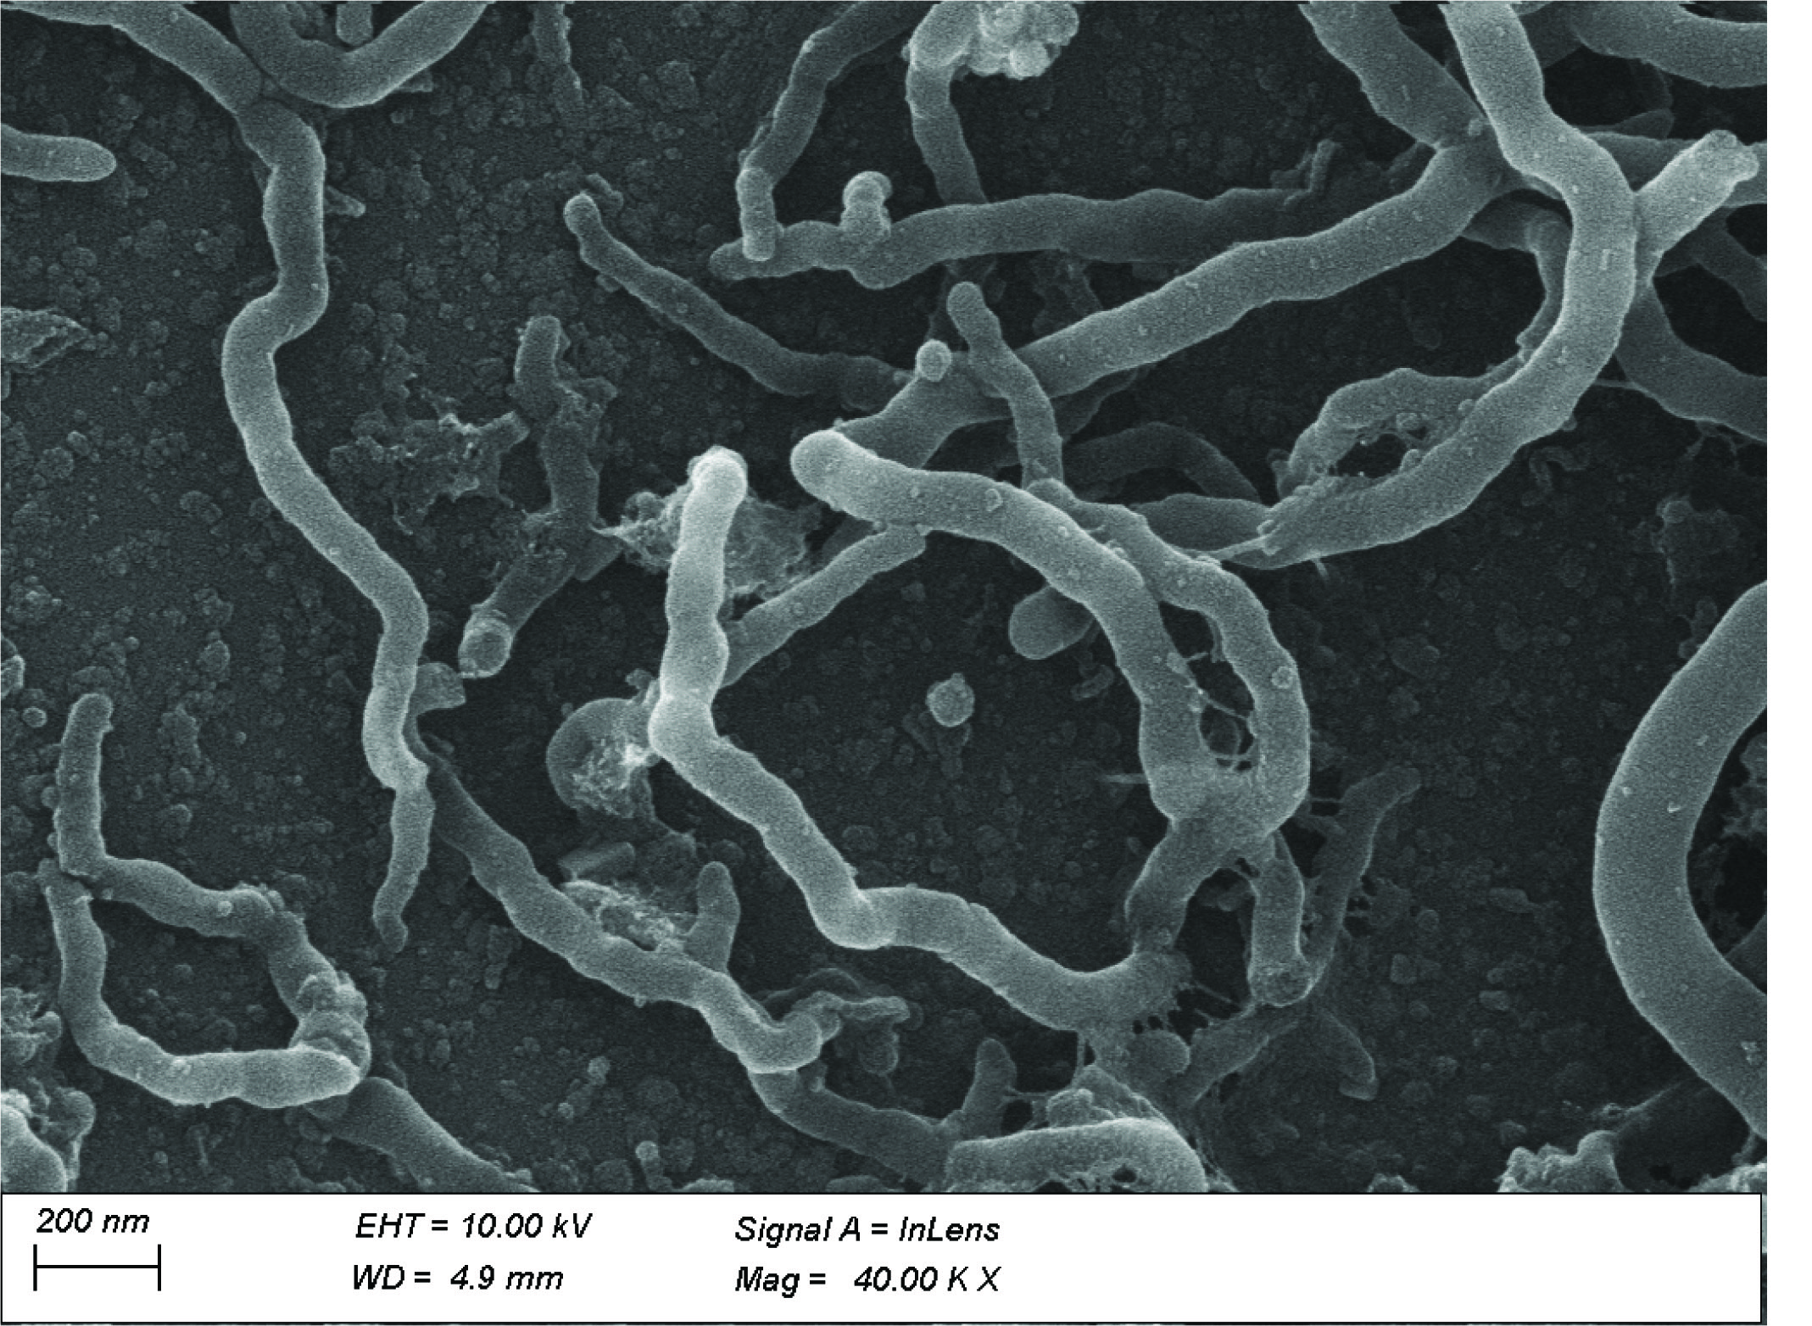
Figure S2. Scanning electron microscope images of biochar (A) and bacterial-inoculated biochar (B).

Table S1. Experimental treatments
Treatment description | Abbreviation | Label
Unstressed soil | Ctrl | T1
Sb stress (1200 mg Sb kg⁻¹) | Sb stress | T2
Sb stress + 1% bio-char (BC) | Sb stress + 1% BC | T3
Sb stress + 2.5% BC | Sb stress + 2.5% BC | T4
Sb stress + 1% BC + bacterial inoculum (BI) | Sb stress + 1% BC + BI | T5
Sb stress + 2.5% BC + BI | Sb stress + 2.5% BC + BI | T6

Table S2. Orthogonal contrast coefficients used to partition treatment sum of squares into five independent tests.
Contrasts | DF | Ctrl | Sb stress | Sb stress +1% BC | Sb stress +2.5% BC | Sb stress +1% BC +BI | Sb stress +2.5% BC +BI
Linear response to BC | 1 | 0 | -0.655 | -0.094 | 0.749 | 0 | 0
Quadratic response to BC | 1 | 0 | 0.487 | -0.811 | 0.324 | 0 | 0
BI vs. no BI | 1 | 0 | 0 | 1 | 1 | -1 | -1
BI x BC interaction | 1 | 0 | 0 | 1 | -1 | -1 | 1
Maximum stress relief | 1 | 2 | 0 | 0 | 0 | -1 | -1
DF, degrees of freedom; Ctrl, unstressed control; BC, bio-char; BI, bacterial inoculum.

Table S3. Bacterial reads (mean values ± SD) and statistical analysis obtained with MaAsLin2 in the most abundant genera in the six soil treatments
Genus | T1 | T2 | T3 | T4 | T5 | T6
Ammoniphilus | 1.7 ± 2.1 ^{(a)} | 52.7 ± 46.3 ^{(b)} | 255.7 ± 21.5 ^{(c)} | 31 ± 9.6 ^{(b)} | 46 ± 22.1 ^{(bc)} | 20 ± 3.6 ^{(bc)}
Anaerolinea | 397 ± 75.4 ^{(a)} | 566.7 ± 126.1 ^{(a)} | 194.3 ± 12.7 ^{(a)} | 15 ± 13.7 ^{(b)} | 15.7 ± 5.5 ^{(b)} | 59.3 ± 11.4 ^{(b)}
Anaeromyxobacter | 395 ± 30.6 ^{(a)} | 540.3 ± 135.4 ^{(a)} | 372.7 ± 28.6 ^{(a)} | 84.3 ± 21.8 ^{(b)} | 73.7 ± 6.1 ^{(b)} | 279.7 ± 74.4 ^{(b)}
Azospirillum | 3.7 ± 6.4 ^{(a)} | 31 ± 29.6 ^{(b)} | 458.3 ± 34.3 ^{(c)} | 91 ± 22.5 ^{(d)} | 80.3 ± 21.6 ^{(bd)} | 729.7 ± 94.6 ^{(bd)}
Bacillus | 32 ± 4 ^{(a)} | 40.3 ± 25.7 ^{(a)} | 98 ± 8.7 ^{(b)} | 325.7 ± 54.1 ^{(c)} | 326 ± 65.5 ^{(bc)} | 156.3 ± 29.2 ^{(bc)}
Brevundimonas | 9.3 ± 15.3 ^{(a)} | 2.3 ± 4 ^{(a)} | 49 ± 7 ^{(b)} | 3323 ± 398.5 ^{(c)} | 1718.3 ± 171.5 ^{(c)} | 203.3 ± 9 ^{(c)}
Bryobacter | 713 ± 68 ^{(a)} | 335 ± 365.9 ^{(b)} | 27.3 ± 6.5 ^{(c)} | 19 ± 12.5 ^{(cd)} | 15 ± 4.6 ^{(d)} | 15 ± 7 ^{(d)}
C0119 | 217 ± 19.3 ^{(a)} | 192 ± 32.5 ^{(a)} | 96.3 ± 15 ^{(a)} | 4 ± 4.6 ^{(b)} | 4.7 ± 5 ^{(b)} | 4.3 ± 6.7 ^{(b)}
Caldicoprobacter | 3.3 ± 4.9 ^{(a)} | 0 ^{(a)} | 5 ± 8.7 ^{(a)} | 94 ± 20.5 ^{(b)} | 248.3 ± 46.2 ^{(b)} | 153.3 ± 16 ^{(b)}
Candidatus Azambacteria | 361.7 ± 31 ^{(a)} | 186.7 ± 173.7 ^{(b)} | 21 ± 4.4 ^{(c)} | 0 ^{(d)} | 0 ^{(d)} | 0 ^{(d)}
Candidatus Koribacter | 246.3 ± 43.7 ^{(a)} | 268.3 ± 26.5 ^{(a)} | 31.3 ± 14 ^{(b)} | 11.7 ± 10.1 ^{(c)} | 6.7 ± 11.5 ^{(c)} | 4 ± 6.9 ^{(c)}
Candidatus Nitrotoga | 162.7 ± 23.8 ^{(a)} | 216 ± 34.7 ^{(ab)} | 214.3 ± 97.6 ^{(b)} | 0 ^{(c)} | 0 ^{(c)} | 0 ^{(c)}
Candidatus Solibacter | 1211.7 ± 79.6 ^{(a)} | 747.7 ± 268.3 ^{(a)} | 630.3 ± 56.6 ^{(a)} | 42 ± 17.4 ^{(b)} | 8.7 ± 7.6 ^{(c)} | 40 ± 5.6 ^{(c)}
Candidatus Udaeobacter | 196.3 ± 58.2 ^{(a)} | 200 ± 38.1 ^{(a)} | 50 ± 18.2 ^{(b)} | 27 ± 7.5 ^{(c)} | 23.3 ± 4 ^{(c)} | 18 ± 8.2 ^{(c)}
Castellaniella | 1.7 ± 2.9 ^{(a)} | 0 ^{(a)} | 0 ^{(a)} | 174 ± 26 ^{(b)} | 295.7 ± 26 ^{(c)} | 43.3 ± 7.6 ^{(c)}
Caulobacter | 0 ^{(a)} | 5 ± 4.6 ^{(b)} | 52.7 ± 4.7 ^{(c)} | 135.7 ± 23.8 ^{(d)} | 172.7 ± 30.2 ^{(d)} | 129.3 ± 12.6 ^{(d)}
Chelatococcus | 0.7 ± 1.2 ^{(a)} | 0 ^{(a)} | 1.3 ± 2.3 ^{(a)} | 45.7 ± 3.1 ^{(b)} | 107.3 ± 24.8 ^{(b)} | 308.7 ± 41.3 ^{(b)}
Chitinophagaceae | 1501.3 ± 48 ^{(a)} | 1416.7 ± 77.5 ^{(a)} | 1058.3 ± 116.3 ^{(a)} | 575.3 ± 104.6 ^{(b)} | 111.7 ± 34.5 ^{(c)} | 90.7 ± 1.2 ^{(c)}
Christensenellaceae_R-7_group | 1.3 ± 2.3 ^{(a)} | 7.3 ± 7.5 ^{(b)} | 81.7 ± 22.1 ^{(c)} | 218.7 ± 26.8 ^{(c)} | 138 ± 21.9 ^{(c)} | 269 ± 62.2 ^{(c)}
Chthonomonadales | 402 ± 39.2 ^{(a)} | 221.7 ± 248 ^{(b)} | 18.7 ± 5.1 ^{(c)} | 0 ^{(d)} | 0 ^{(d)} | 0 ^{(d)}
Citrifermentans | 11.7 ± 10.4 ^{(a)} | 411.7 ± 338.3 ^{(b)} | 207.3 ± 22.2 ^{(b)} | 0 ^{(a)} | 0 ^{(a)} | 0 ^{(a)}
Conexibacter | 318.3 ± 106.3 ^{(a)} | 157 ± 99.7 ^{(a)} | 134 ± 61.5 ^{(a)} | 39 ± 36.4 ^{(b)} | 40.7 ± 22.5 ^{(b)} | 44 ± 3 ^{(b)}
Devosia | 0 ^{(a)} | 8.7 ± 8.1 ^{(b)} | 75 ± 3.5 ^{(c)} | 648.3 ± 91.5 ^{(d)} | 357 ± 48.1 ^{(e)} | 185.3 ± 33.9 ^{(e)}
Ellin6067 (Betaproteobacteria) | 311.3 ± 42.4 ^{(ab)} | 361.7 ± 59.1 ^{(a)} | 125.7 ± 14.4 ^{(b)} | 39 ± 6.6 ^{(c)} | 21.3 ± 18.5 ^{(d)} | 11.7 ± 10.2 ^{(d)}
Flavisolibacter | 234 ± 10.5 ^{(a)} | 337 ± 61.6 ^{(b)} | 778.3 ± 106 ^{(c)} | 341.3 ± 121 ^{(ab)} | 585.7 ± 68 ^{(d)} | 187 ± 5.6 ^{(d)}
Gemmatimonas | 2514.3 ± 75.2 ^{(a)} | 1755.7 ± 669.6 ^{(b)} | 398.7 ± 14.6 ^{(c)} | 82 ± 10.8 ^{(d)} | 142 ± 7.2 ^{(e)} | 464.3 ± 73.4 ^{(e)}
Haliangium | 179.7 ± 16.3 ^{(a)} | 214.3 ± 32.5 ^{(ab)} | 178 ± 45.5 ^{(a)} | 5 ± 5.2 ^{(c)} | 68 ± 16.4 ^{(bc)} | 12 ± 2 ^{(bc)}
HSB_OF53-F07 | 174 ± 55 ^{(a)} | 88 ± 33.6 ^{(a)} | 113 ± 13 ^{(a)} | 22 ± 14.7 ^{(b)} | 42 ± 25.9 ^{(c)} | 43.7 ± 21.5 ^{(c)}
Kaistia | 1.7 ± 2.9 ^{(a)} | 1.7 ± 2.9 ^{(a)} | 3.3 ± 3.1 ^{(b)} | 98.3 ± 8.5 ^{(c)} | 304 ± 31 ^{(bc)} | 161.3 ± 25.9 ^{(bc)}
Kapabacteriales | 17.3 ± 2.9 ^{(a)} | 57.7 ± 30.2 ^{(a)} | 177.7 ± 23.1 ^{(a)} | 57.7 ± 5 ^{(b)} | 0.7 ± 1.2 ^{(c)} | 31.7 ± 2.5 ^{(c)}
KD4-96 | 279.3 ± 46 ^{(a)} | 185 ± 130.8 ^{(a)} | 49 ± 7.9 ^{(c)} | 35.7 ± 8.7 ^{(bd)} | 51.3 ± 14.5 (e) | 41.3 ± 17.8 ^{(e)}
Limnobacter | 8.3 ± 14.4 ^{(a)} | 4.7 ± 8.1 ^{(a)} | 8 ± 1 ^{(a)} | 265 ± 46.1 ^{(b)} | 278 ± 31.7 ^{(b)} | 223.7 ± 17.8 ^{(b)}
Luteimonas | 163 ± 78.8 ^{(a)} | 112.3 ± 30 ^{(a)} | 4 ± 6.9 ^{(a)} | 972 ± 138.3 ^{(b)} | 940.3 ± 163.4 ^{(b)} | 5201 ± 554.5 ^{(b)}
Lutispora | 4.7 ± 8.1 ^{(a)} | 0 ^{(a)} | 24 ± 4.4 ^{(b)} | 85 ± 11.4 ^{(c)} | 217.7 ± 25.7 ^{(c)} | 175.3 ± 32.3 ^{(c)}
Massilia | 182.7 ± 21.5 ^{(a)} | 167 ± 31.5 ^{(a)} | 203.7 ± 7.6 ^{(a)} | 50.3 ± 15.8 ^{(b)} | 17.7 ± 15.9 ^{(c)} | 11 ± 10.1 ^{(c)}
Methyloversatilis | 5.3 ± 9.2 ^{(a)} | 52 ± 45 ^{(b)} | 300.7 ± 30.3 ^{(c)} | 286.3 ± 88.7 (cd) | 173 ± 20.1 (de) | 91 ± 2.6 ^{(de)}
Microvirga | 3 ± 3 ^{(a)} | 20.7 ± 15.9 ^{(b)} | 97.7 ± 27.5 ^{(c)} | 88 ± 39.5 ^{(c)} | 151.3 ± 11.7 ^{(c)} | 256 ± 66.5 ^{(c)}
Mycobacterium | 214.3 ± 76.8 ^{(a)} | 100.3 ± 28 ^{(b)} | 156.7 ± 20.6 ^{(a)} | 34.7 ± 4.7 ^{(c)} | 44.7 ± 18 ^{(c)} | 94.3 ± 33.6 ^{(c)}
Mycoplana | 4 ± 6.9 ^{(a)} | 8 ± 6.9 ^{(a)} | 22.7 ± 5.5 ^{(b)} | 162.7 ± 16 ^{(c)} | 217.3 ± 42.9 ^{(c)} | 391 ± 12.1 ^{(c)}
Nitrosospira | 178.7 ± 17.5 ^{(ab)} | 138.7 ± 31.7 ^{(a)} | 164 ± 43.3 ^{(b)} | 0 ^{(c)} | 0 ^{(c)} | 0 ^{(c)}
Nitrospira | 46.7 ± 20.3 ^{(a)} | 126 ± 89.2 ^{(ab)} | 215.3 ± 7 ^{(b)} | 1 ± 1.7 ^{(c)} | 1.3 ± 2.3 ^{(c)} | 4.3 ± 5.1 ^{(c)}
Ochrobactrum | 1 ± 1.7 ^{(a)} | 0 ^{(a)} | 0 (bc) | 305.7 ± 42.2 (ab) | 121.3 ± 27.5 ^{(c)} | 54.3 ± 5.1 ^{(c)}
Opitutus | 175.3 ± 8.5 ^{(a)} | 281.7 ± 91.6 ^{(a)} | 246.7 ± 11 ^{(a)} | 3.3 ± 5.8 ^{(b)} | 70.3 ± 17.9 ^{(c)} | 3 ± 3 ^{(c)}
Paenibacillus | 3.3 ± 2.1 ^{(a)} | 5.7 ± 3.1 ^{(a)} | 98 ± 7 ^{(b)} | 267 ± 31.5 (bc) | 617 ± 162.4 ^{(c)} | 493 ± 39.4 ^{(c)}
Paracoccus | 0 ^{(a)} | 3 ± 3 ^{(a)} | 3.3 ± 5.8 ^{(a)} | 192 ± 35.6 ^{(b)} | 26.7 ± 2.3 ^{(c)} | 15.3 ± 5.5 ^{(c)}
Parcubacteria | 475.3 ± 87.6 ^{(a)} | 487.3 ± 111.4 ^{(a)} | 7 ± 6 ^{(b)} | 0.3 ± 0.6 ^{(c)} | 0 ^{(c)} | 0.3 ± 0.6 ^{(c)}
Pedosphaeraceae | 99.3 ± 21.5 ^{(a)} | 103.7 ± 2.9 ^{(a)} | 481.7 ± 81.5 ^{(b)} | 49.3 ± 20 ^{(c)} | 1 ± 1.7 ^{(d)} | 0 ^{(d)}
Phenylobacterium | 92.3 ± 20.1 ^{(a)} | 245 ± 145.3 ^{(a)} | 547 ± 83.5 ^{(c)} | 499.7 ± 21.5 ^{(cd)} | 330 ± 17.4 ^{(bd)} | 246.7 ± 23.9 ^{(bd)}
Pseudomonas | 0 ^{(a)} | 0 ^{(a)} | 0 ^{(a)} | 100 ± 11.1 ^{(b)} | 206.3 ± 19.8 ^{(c)} | 0.3 ± 0.6 ^{(c)}
Pseudoxanthomonas | 0 ^{(a)} | 7.7 ± 13.3 ^{(a)} | 0 ^{(a)} | 0 ^{(a)} | 3.7 ± 3.5 ^{(a)} | 3392 ± 311.4 ^{(a)}
Pusillimonas | 0 ^{(a)} | 0.7 ± 1.2 ^{(a)} | 0 ^{(a)} | 295 ± 32.1 ^{(b)} | 20 ± 2.6 ^{(c)} | 91.3 ± 6.7 ^{(c)}
RBG-13-54-9 | 1209.3 ± 112.7 ^{(a)} | 608.3 ± 577.3 ^{(b)} | 102.3 ± 12.7 ^{(c)} | 28.7 ± 5.5 ^{(d)} | 46.7 ± 14.5 ^{(d)} | 23 ± 8.2 ^{(d)}
Roseisolibacter | 265 ± 37.7 ^{(ab)} | 258 ± 43.1 ^{(ab)} | 164 ± 35.2 ^{(ac)} | 365.3 ± 78.4 ^{(b)} | 579.3 ± 92.4 ^{(d)} | 217.3 ± 22.8 ^{(d)}
Roseomonas | 3.3 ± 2.9 ^{(a)} | 14.7 ± 13.3 ^{(a)} | 43 ± 1 ^{(b)} | 152 ± 31.7 ^{(bc)} | 246 ± 59.9 ^{(c)} | 127.7 ± 11 ^{(c)}
Ruminiclostridium | 0 ^{(a)} | 13.3 ± 11.7 ^{(b)} | 85.3 ± 6.7 ^{(cd)} | 173.3 ± 32.3 ^{(c)} | 104 ± 10.4 ^{(d)} | 290.7 ± 26.5 ^{(d)}
S0134_terrestrial_group | 252.3 ± 31.7 ^{(a)} | 152 ± 65 ^{(ab)} | 78.7 ± 7.6 ^{(b)} | 69.3 ± 23.2 ^{(c)} | 317 ± 104.1 ^{(a)} | 43.3 ± 24 ^{(a)}
SC-I-84 | 1277.3 ± 45.1 ^{(a)} | 1212.7 ± 191.4 ^{(a)} | 437 ± 38.2 ^{(b)} | 156.3 ± 26.3 ^{(c)} | 129.3 ± 14 ^{(c)} | 33.7 ± 15.2 ^{(c)}
Sedimentibacter | 2.7 ± 4.6 ^{(a)} | 1.7 ± 2.9 ^{(a)} | 4 ± 2 ^{(a)} | 376.3 ± 57 ^{(b)} | 525 ± 113 ^{(b)} | 2052.3 ± 516.4 ^{(b)}
Sphingomonas | 431.7 ± 10 ^{(a)} | 1375 ± 800.4 ^{(b)} | 1379.7 ± 80.3 ^{(b)} | 262 ± 38.4 ^{(ac)} | 185.7 ± 40.8 ^{(cd)} | 112.3 ± 13.3 ^{(cd)}
Sphingopyxis | 5.7 ± 9.8 ^{(a)} | 3.7 ± 6.4 ^{(a)} | 64.3 ± 14.5 ^{(b)} | 3277.7 ± 451.7 ^{(c)} | 739.3 ± 45.5 ^{(d)} | 638.3 ± 47.1 ^{(d)}
Stenotrophomonas | 4 ± 4.6 ^{(a)} | 0 ^{(b)} | 10.3 ± 3.5 ^{(c)} | 1880.7 ± 160.2 ^{(d)} | 7721.7 ± 928.8 (e) | 152.7 ± 18 ^{(e)}
Tellurimicrobium | 94.7 ± 23.1 ^{(a)} | 260.7 ± 117.7 ^{(a)} | 575.3 ± 46.8 ^{(a)} | 61 ± 13.1 ^{(b)} | 4.3 ± 7.5 ^{(b)} | 2.7 ± 4.6 ^{(b)}
Tissierella | 1 ± 1.7 ^{(a)} | 0 ^{(b)} | 0 ^{(c)} | 463.3 ± 132.2 ^{(a)} | 152.7 ± 61.2 ^{(d)} | 227.7 ± 24.5 ^{(d)}
TK10 | 163.3 ± 59.1 ^{(a)} | 131.3 ± 17.2 ^{(a)} | 71.3 ± 24 ^{(a)} | 8.7 ± 2.5 ^{(b)} | 14 ± 9.6 ^{(c)} | 11 ± 8.2 ^{(c)}
Vulgatibacter | 4 ± 6.9 ^{(a)} | 14.3 ± 13.6 ^{(a)} | 52.7 ± 7.6 ^{(b)} | 533.3 ± 33.9 ^{(c)} | 370.7 ± 112.4 ^{(c)} | 515.7 ± 78 ^{(c)}
WD2101_soil_group | 728.7 ± 121 ^{(a)} | 726 ± 96.4 ^{(a)} | 385 ± 3 ^{(a)} | 201.3 ± 54.9 ^{(b)} | 190.3 ± 32.3 ^{(b)} | 74 ± 26.9 ^{(b)}
WPS-2 | 780.7 ± 101 ^{(a)} | 655 ± 229.7 ^{(a)} | 149 ± 16.4 ^{(b)} | 122.7 ± 16.8 ^{(c)} | 101.3 ± 10.3 ^{(c)} | 46.7 ± 10.1 ^{(c)}
T1, Ctrl; T2, Sb stress; T3, Sb stress + 1% BC; T4, Sb stress + 2.5% BC; T5, Sb stress + 1% BC + BI; T6, Sb stress + 2.5% BC + BI. Different letters indicate significantly different levels at p <0.05.

Table S4. Relative abundance (%) in the bacterial genera present in the six soil treatments
Genus | T1 | T2 | T3 | T4 | T5 | T6 | Involved function | Reference
ADurb.Bin063-1 | - | - | 0.9 | - | - | - | Involved in bioremediation of cadmium-contaminated soil | Song et al. (2024)
Anaerolinea | 1.2 | 1.7 |  | - | - | - | Improving soil property | Lv et al. (2024)
Anaeromyxobacter | 1.2 | 1.6 | 1.1 | - | - | - | Nitrogen fixation | Masuda et al. (2012)
Azospirillum | - | - | 1.4 | - | - | 2.2 | PGPR | Basu et al. (2021)
Bacillus | - | - | - | 1.1 | 1.1 | - | PGPR | Basu et al. (2021), Jiang et al. (2022)
Brevundimonas | - | - | - | 10.3 | 5.3 | - | PGPR | Basu et al. (2021)
Bryobacter | 2.2 | 1.0 | - | - | - | - | PGPR | Wang et al. (2022)
C0119 | 0.6 | 0.5 | - | - | - | - | biomarkers in the 0–10 cm soil layer | Zou et al. (2023)
Caldicoprobacter | - | - | - | - | 0.7 | - | PGPR | Basu et al. (2021)
Candidatus_Azambacteria | 1.1 | 0.5 | - | - | - | - | Soil bacteria | Gagnon et al. (2020)
Candidatus_Koribacter | 0.7 | 0.8 | - | - | - | - | Involved in bioremediation of Cadmium contaminated soil | Song et al. (2024)
Candidatus_Nitrotoga | 0.5 | 0.5 | 0.6 | - | - | - | Nitrifying bacteria | Nowka et al. (2015)
Candidatus_Solibacter | 3.7 | 2.3 | 1.9 | - | - | - | PGPR | Wang et al. (2022)
Candidatus_Udaeobacter | 0.6 | 0.6 | - | - | - | - | Rhizospheric bacteria | Medina-de la Rosa et al. (2021)
Castellaniella | - | - | - | 0.5 | 0.9 | - | Removal of toxic organic compounds | Deng et al. (2021)
Caulobacter | - | - | - | - | 0.5 | - | PGPR | Basu et al. (2021)
Chelatococcus | - | - | - | - | - | 0.9 | Biodegradation of crude heavy oil | Ke et al. (2019)
Chitinophagaceae | 4.6 | 4.4 | 3.2 | 1.7 | - | - | PGPR | Gao et al. (2021)
Christensenellaceae_R-7_group | - | - | - | 0.68 | - | 0.83 | Cellulase activity | Gu et al. (2024)
Chthonomonadales | 1.2 | 0.7 | - | - | - | - | Soil bacteria associated with the decomposition of glycine substrates | Berlow et al. (2024)
Citrifermentans | - | 1.2 | 0.6 | - | - | - | Microbial dysbiosis in symptomatic grapevine | Darriaut et al. (2024)
Conexibacter | 0.9 | - | - | - | - | - | Reduced in infected soil | Hu et al. (2020)
Devosia | - | - | - | 2.0 | 1.1 | 0.5 | Dominant in soil habitats contaminated with various toxins and characterized for its bioremediation potential | Talwar et al. (2020)
Ellin6067 | 0.9 | 1.1 | - | - | - | - | Dominant genera in the rhizospheric soil samples positively correlated to soil nutrient content | Liu et al. (2022)
Flavisolibacter | 0.7 | 1.0 | 2.4 | 1.0 | 1.8 | 0.5 | Involved in bioremediation of Cadmium contaminated soil; improving plant disease resistance and CO₂ fixation | Li et al. (2021);(Xu et al., 2020)
Gemmatimonas | 7.8 | 5.4 | 1.2 | - | - | 1.4 | Microbial nitrogen metabolism, and soil respiration | Qian et al. (2022), Li et al. (2021)
Haliangium | 0.5 | 0.6 | 0.5 | - | - | - | Important for arbuscular mycorrhizae fungi and hydrosphere communities | Zhang et al. (2024)
HSB_OF53-F07 | 0.5 | - | - | - | - | - | Improve the resistance of kiwifruit against Psa and dominant soil bacterial genera under medium and low N applications | Yang et al. (2021)
Kaistia | - | - | - | - | 0.9 | 0.5 | PGPR | Liao et al. (2021), Soldan et al. (2022)
Kapabacteriales | - | - | 0.5 | - | - | - | PGPR and seed-associated bacteria | Liao et al. (2021), Soldan et al. (2022)
KD4-96 | 0.8 | 0.5 | - | - | - | - | A heavy metal-resistant bacterium | Qian et al. (2022)
Limnobacter | - | - | - | 0.8 | 0.8 | 0.6 | A good indicator of perfluorooctanoic Acid (PFOA) pollution in various environments | Guo et al. (2023)
Longimicrobiaceae | - | - | - | - | 0.5 | - | Rhizospheric bacteria | Medina-de la Rosa et al. (2021)
Luteimonas | 0.5 | - | - | 3.0 | 2.9 | 16.2 | Bioremediation, total petroleum hydrocarbons contaminated soils | Ruley et al. (2020)
Lutispora | - | - | - | - | 0.6 | 0.5 | Cellulolytic bacteria | Carver et al. (2015)
LWQ8 | 1.0 | 1.1 | - | - | - | - | Improving soil property | Lv et al. (2024)
Magnetospirillaceae | - | - | - | 1.1 | 1.4 | 1.1 | Diazotrophic bacteria | Wang et al. (2022)
Massilia | 0.5 | 0.5 | 0.6 | - | - | - | PGPR | Fasusi et al. (2021)
Methyloversatilis | - | - | 0.9 | 0.8 | 0.5 | - | Biodegradation of petroleum hydrocarbons | Lee et al. (2023)
Microvirga | - | - | - | - | - | 0.7 | PGPR | Msaddak et al. (2017)
Mycobacterium | 0.6 | - | - | - | - | - | PGPR | Karmakar et al. (2021)
Mycoplana | - | - | - | 0.5 | 0.6 | 1.2 | PGPR | Taye et al. (2020)
Nitrosospira | 0.5 | - | 0.5 | - | - | - | Contributor of ammonia oxidation | Sanders et al. (2019)
Nitrospira | - | - | 0.6 | - | - | - | Involved in soil nutrient cycling and removal of pollutants | Liu et al. (2022)
Ochrobactrum | - | - | - | 0.9 | - | - | Involved in rhizoremediation | Sun et al. (2024)
OM27_clade | - | - | - | - | 0.5 | - | Involved in the mineralization of atrazine | De Souza et al. (2022)
Opitutus | 0.5 | 0.8 | 0.7 | - | - | - | Plant-associated methanol-consuming bacteria (methylotrophs) | Macey et al. (2020)
Paenibacillus | - | - | - | 0.6 | 1.9 | 1.5 | Bioremediation of lead contaminated environmernt, PGPR | Basu et al. (2021);Harun et al. (2024)
Paracoccus | - | - | - | 0.5 | - | - | Salt-tolerant polyhydroxy butyrate producers | Wen et al. (2024)
Parapedobacter | - | - | - | - | - | 0.7 | Bioemulsifier and involved in bioremediation | Devale et al. (2023)
Parcubacteria | 1.4 | 1.5 | - | - | - | - | Rhyzospheric bacteria | Dawson et al. (2017)
Pedosphaeraceae | - | - | 1.5 | - | - | - | Rhyzospheric bacteria | Chen et al. (2021)
Phenylobacterium | - | 0.7 | 1.7 | 1.5 | 1.0 | 0.7 | PGPR | Boonmak et al. (2024)
Pseudomonas | - | - | - | - | 0.6 | - | PGPR | Basu et al. (2021)
Pseudoxanthomonas | - | - | - | - | - | 10.5 | Bioremediation of heavy metals, increasing the content of phosphorus that could be absorbed and used in the plant growth | Yang et al. (2023);Abdul Raheem et al., (2024)
Pusillimonas | - | - | - | 0.9 | - | - | Degradation of aromatic acid | Jiménez-Volkerink et al. (2024)
RBG-13-54-9 | 3.7 | 1.8 | - | - | - | - | Important role in microbial community structure | Ma et al. (2024)
Roseisolibacter | 0.8 | 0.8 | 0.5 | 1.1 | 1.8 | 0.6 | Nitrogen-fixing bacteria | Rodriguez-Mena et al. (2022)
Roseomonas | - | - | - | - | 0.7 | - | Nitrogen-fixing bacteria | Li et al. (2024)
Ruminiclostridium | - | - | - | 0.5 | - | 0.9 | Nitrogen-fixing and cellulolytic bacteria | Tian et al. (2023)
S0134_terrestrial_group | 0.7 | - | - | - | 0.9 | - | Containing resistance genes to heavy metals | Cao et al. (2024)
SC-I-84 | 3.9 | 3.7 | 1.3 | - | - | - | Abundant in soils planted to different rice varieties | Liang et al. (2020)
Sedimentibacter | - | - | - | 1,1 | 1.6 | 6.3 | Bioremediation of organic compounds | Huang et al. (2016)
Sphingomonas | 1.3 | 4.2 | 4.2 | - | - | - | Major degraders of herbicide and polycyclic aromatic hydrocarbons | Zhang et al. (2023)
Sphingopyxis | - | - | - | 10.2 | 2.3 | 1.9 | Biodegradative capabilities for various environmental contaminants | Sharma et al. (2021)
Stenotrophomonas | - | - | - | 5.8 | 24.0 | - | Bioremediation, PGPR | Taye et al. (2020); (Ryan et al., 2009)
Subgroup_7 | 1.2 | 1.7 | - | - | - | - | Abundant in soils planted to different rice varieties | Liang et al. (2020)
Tellurimicrobium | - | 0.8 | 1.7 | - | - | - | Sb resistant rhizobacteria, metabolizing oxalic compounds helping protection plants from infection | Jara-Servin et al. (2023); (Lin et al., 2022)
Tissierella | - | - | - | 1.4 | - | 0.7 | Increased in the Benzo[a]pyrene degradation experiment with phenol as co-substrate | Wu et al. (2019)
TK10 | 0.5 | - | - | - | - | - | Key factors for predicting humus-like dissolved organic matter | Yuan et al. (2022)
Vulgatibacter | - | - | - | 1.6 | 1.1 | 1.6 | Highly abundant under biochar application | Sarfraz et al. (2023)
WD2101_soil_group | 2.2 | 2.2 | 1.1 | 0.6 | 0.5 | - | Phosphorus solubilizer | Aksorn et al. (2022)
WPS-2 | 2.4 | 2.0 | - | - | - | - | Phototrophic bacteria that can thrive under extreme environmental conditions | Ji et al. (2021)
T1, Ctrl; T2, Sb stress; T3, Sb stress + 1% BC; T4, Sb stress + 2.5% BC; T5, Sb stress + 1% BC + BI; T6, Sb stress + 2.5% BC + BI. PGPR, Plant Growth Promoting Rhizobacteria. Relative abundance values < 0.5% are not reported.

Table S5. Degree of similarities between the repeated treatments based on the Permanova test
 | Df | SS | R² | F | p-value
Treatment | 5 | 3.7068 | 0.92584 | 29.962 | 0.001 ***
Residual | 12 | 0.2969 | 0.07416
Total | 17 | 4.0037 | 1.00000

References
Abdul Raheem, N., Selvaraj, G.K., Karuppanan, K., Ganesan, G., Soorangkattan, S., Subramanian, B., Ramamurthy Baluraj, S., Rajaiah, D.K., Hasan, I., 2024. Bioremediation of heavy metals by an unexplored bacterium, Pseudoxanthomonas mexicana strain GTZY isolated from aerobic-biofilm wastewater system. Environmental Science and Pollution Research. https://doi.org/10.1007/s11356-024-34602-1
Aksorn, S., Kanokkantapong, V., Polprasert, C., Noophan, P.L., Khanal, S.K. and Wongkiew, S., 2022. Effects of Cu and Zn contamination on chicken manure-based bioponics: Nitrogen recovery, bioaccumulation, microbial community, and health risk assessment. Journal of Environmental Management, 311, 114837. https://doi.org/10.1016/j.jenvman.2022.114837.
B. Li, R. Xu, X. Sun, F. Han, E. Xiao, L. Chen, L. Qiu, W. Sun, Microbiome–environment interactions in antimony-contaminated rice paddies and the correlation of core microbiome with arsenic and antimony contamination, Chemosphere 263 (2021). https://doi.org/10.1016/j.chemosphere.2020.128227.
Basu, A., Prasad, P., Das, S.N., Kalam, S., Sayyed, R.Z., Reddy, M.S., El Enshasy, H., 2021. Plant growth promoting rhizobacteria (Pgpr) as green bioinoculants: Recent developments, constraints, and prospects, Sustainability, 13, 1–20. https://doi.org/10.3390/su13031140.
Berlow, M., Mesa, M., Creek, M., Duarte, J., Carpenter, E., Phinizy, B., Andonian, K. and Dlugosch, K.M., 2024. Plant G x Microbial E: Plant genotype interaction with soil bacterial community shapes rhizosphere composition during invasion. (2024). https://doi.org/10.1101/2024.04.19.590333.
Boonmak, C., Kettongruang, S., Buranathong, B., Morikawa, M., Duangmal, K., 2024. Duckweed-associated bacteria as plant growth-promotor to enhance growth of Spirodela polyrhiza in wastewater effluent from a poultry farm. Archives of Microbiology, 206, 43. https://doi.org/10.1007/s00203-023-03778-4.
Cao, Y., Li, Z., Du, P., Ji, J., Sun, W., Xu, J., Liang, B., 2024. Effects of different dwarfing interstocks on the rhizosphere, endophytic bacteria, and drought resistance of apple trees. Microbiological Research, 283, 127690. https://doi.org/10.1016/j.micres.2024.127690.
Carver, S.M., Nelson, M.C., Yu, Z., Tuovinen, O.H., 2015. Fermentative metabolism of an anaerobic, thermophilic consortium on plant polymers and commercial paper samples. Biomass and Bioenergy, 75, 11-22. https://doi.org/10.1016/j.biombioe.2015.02.005.
Chen, W.C., Ko, C.H., Su, Y.S., Lai, W.A., Shen, F.T., 2021. Metabolic potential and community structure of bacteria in an organic tea plantation. Applied Soil Ecology, 157, 103762. https://doi.org/10.1016/j.apsoil.2020.103762.
Darriaut, R., Marzari, T., Lailheugue, V., Tran, J., Martins, G., Marguerit, E., Masneuf-Pomarède, I., Lauvergeat, V., 2024. Microbial dysbiosis in roots and rhizosphere of grapevines experiencing decline is associated with active metabolic functions. Frontiers in Plant Science, 15, 1358213. https://doi.org/10.3389/fpls.2024.1358213.
Dawson, W., Hör, J., Egert, M., van Kleunen, M., Pester, M., 2017. A small number of low-abundance bacteria dominate plant species-specific responses during rhizosphere colonization. Frontiers in Microbiology, 8, 975. https://doi.org/10.3389/fmicb.2017.00975.
de Souza, A.J., de Araújo Pereira, A.P., Pedrinho, A., Andreote, F.D., Tornisielo, V.L., Tizioto, P.C., Coutinho, L.L. and Regitano, J.B., 2022. Land use and roles of soil bacterial community in the dissipation of atrazine. Science of The Total Environment, 827, 154239. https://doi.org/10.1016/j.scitotenv.2022.154239.
Deng, L., Ren, Y., Wei, C. and Wang, J., 2021. Biodegradation of pyrene by a novel strain of Castellaniella sp. under denitrifying condition. Journal of Environmental Chemical Engineering, 9, 104970. https://doi.org/10.1016/j.jece.2020.104970.
Devale, A., Sawant, R., Pardesi, K., Perveen, K., Khanam, M.N., Shouche, Y., Mujumdar, S., 2023. Production and characterization of bioemulsifier by Parapedobacter indicus. Frontiers in Microbiology, 14, 1111135. https://doi.org/10.3389/fmicb.2023.1111135.
Fasusi, O.A., Amoo, A.E. and Babalola, O.O., 2021. Characterization of plant growth-promoting rhizobacterial isolates associated with food plants in South Africa, Antonie van Leeuwenhoek, International Journal of General and Molecular Microbiology, 114(10), 1683-1708. https://doi.org/10.1007/s10482-021-01633-4.
Gagnon, V., Rodrigue-Morin, M., Tremblay, J., Wasserscheid, J., Champagne, J., Bellenger, J.P., Greer, C.W. Roy, S., 2020. Vegetation drives the structure of active microbial communities on an acidogenic mine tailings deposit. PeerJ, 8, e10109. https://doi.org/10.7717/peerj.10109.
Gao, M., Xiong, C., Gao, C., Tsui, C.K., Wang, M.M., Zhou, X., Zhang, A.M., Cai, L., 2021. Disease-induced changes in plant microbiome assembly and functional adaptation. Microbiome, 9, 1-18. https://doi.org/10.1186/s40168-021-01138-2.
Gu, M., Liu, H., Jiang, X., Qiu, S., Li, K., Lu, J., Zhang, M., Qiu, Y., Wang, B., Ma, Z. and Gan, Q., 2024. Analysis of Rumen Degradation Characteristics, Attached Microbial Community, and Cellulase Activity Changes of Garlic Skin and Artemisia argyi Stalk. Animals, 14, 169. M. https://doi.org/10.3390/ani14010169.
Guo, C., Ahrens, L., Bertilsson, S., Coolen, M.J., Tang, J., 2023. Microcosm experiment to test bacterial responses to perfluorooctanoate exposure. Science of the Total Environment, 857, 159685. https://doi.org/10.1016/j.scitotenv.2022.159685.
Harun, F.A., Yakasai, H.M., Jagaba, A.H., Usman, S., Umar, H.A., Shukor, M.Y., 2024. Bioremediation potential of Bacillus sp. and Paenebacillus sp. novel lead-resistant isolates: Identification, characterization, and optimization studies. The Microbe 3, 100087. https://doi.org/10.1016/j.microb.2024.100087Hu, Q., Tan, L., Gu, S., Xiao, Y., Xiong, X., Zeng, W.A., Feng, K., Wei, Z., Deng, Y., 2020. Network analysis infers the wilt pathogen invasion associated with non-detrimental bacteria. npj Biofilms and Microbiomes, 6, 8. https://doi.org/10.1038/s41522-020-0117-2.
Huang, Y., Hou, X., Liu, S., Ni, J., 2016. Correspondence analysis of bio-refractory compounds degradation and microbiological community distribution in anaerobic filter for coking wastewater treatment. Chemical Engineering Journal, 304, 864-872. https://doi.org/10.1016/j.cej.2016.05.142.
Jara-Servin, A., Silva, A., Barajas, H., Cruz-Ortega, R., Tinoco-Ojanguren, C., Alcaraz, L.D., 2023. Root microbiome diversity and structure of the Sonoran desert buffelgrass (Pennisetum ciliare L.). Plos one, 18(5) e0285978.Ahttps://doi.org/10.1371/journal.pone.0285978.
Ji, M., Williams, T.J., Montgomery, K., Wong, H.L., Zaugg, J., Berengut, J.F., Bissett, A., Chuvochina, M., Hugenholtz, P., Ferrari, B.C., 2021. Candidatus Eremiobacterota, a metabolically and phylogenetically diverse terrestrial phylum with acid-tolerant adaptations. The ISME Journal, 15, 2692-2707. https://doi.org/10.1038/s41396-021-00944-8.
Jiang, X., Li, W.W., Han, M., Chen, G., Wu, J., Lai, S., Fu, Z., Zhang, S., Deng, W.W., Gao, L., Xia, T., 2022. Aluminum-tolerant, growth-promoting endophytic bacteria as contributors in promoting tea plant growth and alleviating aluminum stress, Tree Physiology 42, 1043–1058. https://doi.org/10.1093/treephys/tpab159.
Jiménez-Volkerink, S.N., Jordán, M., Smidt, H., Minguillón, C., Vila, J., Grifoll, M., 2024. Metagenomic insights into the microbial cooperative networks of a benz (a) anthracene-7, 12-dione degrading community from a creosote-contaminated soil. Science of the Total Environment, 907, 167832. https://doi.org/10.1016/j.scitotenv.2023.167832.
Karmakar, J., Goswami, S., Pramanik, K., Maiti, T.K., Kar, R.K., Dey, N., 2021. Growth promoting properties of Mycobacterium and Bacillus on rice plants under induced drought. Plant Science Today, 8(1), 49-57. https://doi.org/10.14719/pst.2021.8.1.965.
Ke, C.Y., Lu, G.M., Wei, Y.L., Sun, W.J., Hui, J.F., Zheng, X.Y., Zhang, Q.Z., Zhang, X.L., 2019. Biodegradation of crude oil by Chelatococcus daeguensis HB-4 and its potential for microbial enhanced oil recovery (MEOR) in heavy oil reservoirs. Bioresource Technology, 287, 121442. https://doi.org/10.1016/j.biortech.2019.121442.
Lee, J.H., Yang, H., Cho, K.S., 2023. Inoculation effect of methanotrophs on rhizoremediation performance and methane emission in diesel-contaminated soil. Journal of Microbiology and Biotechnology, 33, https://doi.org/10.4014/jmb.2301.01007.
Li, B., Xu, R., Sun, X., Han, F., Xiao, E., Chen, L., Qiu, L. and Sun, W., 2021. Microbiome–environment interactions in antimony-contaminated rice paddies and the correlation of core microbiome with arsenic and antimony contamination. Chemosphere, 263, 128227.B. Li, R. Xu, X. Sun, F. Han, E. Xiao, L. Chen, L. Qiu, W. Sun, Microbiome–environment https://doi.org/10.1016/j.chemosphere.2020.128227.
Li, Y., Sun, X., Yang, R., Guo, L., Li, C., Wang, X., Li, B., Liu, H., Wang, Q., Soleimani, M., Ren, Y., 2024. Phototrophic nitrogen fixation, a neglected biogeochemical process in mine tailings?. Environmental Science & Technology, 58, 6192-6203. https://doi.org/10.1021/acs.est.3c09460.
Liang, X., Li, F., Wang, S., Hua, G., He, M., Tian, G., Khan, S., Poudel, R., Garrett, K.A., 2020. A rice variety with a high straw biomass retained nitrogen and phosphorus without affecting soil bacterial species. Soil Ecology Letters, 2, 131-144. X. https://doi.org/10.1007/s42832-020-0029-3.
Liao, H., Zheng, C., Long, J. and Guzmán, I., 2021. Effects of biochar amendment on tomato rhizosphere bacterial communities and their utilization of plant-derived carbon in a calcareous soil. Geoderma, 396, 115082. https://doi.org/10.1016/j.geoderma.2021.115082.
Lin, Y., Zhang, Y., Liang, X., Duan, R., Yang, L., Du, Y., Wu, L., Huang, J., Xiang, G., Bai, J., Zhen, Y., 2022. Assessment of rhizosphere bacterial diversity and composition in a metal hyperaccumulator (Boehmeria nivea) and a nonaccumulator (Artemisia annua) in an antimony mine. J Appl Microbiol 132, 3432–3443. https://doi.org/10.1111/jam.15486
Liu, A., Wang, W., Chen, X., Zheng, X., Fu, W., Wang, G., Ji, J., Guan, C., 2022. Phytoremediation of DEHP and heavy metals co-contaminated soil by rice assisted with a PGPR consortium: Insights into the regulation of ion homeostasis, improvement of photosynthesis and enrichment of beneficial bacteria in rhizosphere soil. Environmental Pollution, 314, 120303. https://doi.org/10.1016/j.envpol.2022.120303.
Lv, L., Younan, Q., Ijaz, M., Guo, J., Ahmed, T., Wang, D., Wang, Y., Li, N., 2024. Promotive effect of mechanochemically crushed straw on rice growth by improving soil properties and modulating bacterial communities, Plant Growth Regulation https://doi.org/10.1007/s10725-023-01108-8.
Ma, D., Wang, J., Fang, J., Jiang, Y. and Yue, Z., 2024. Asynchronous characteristics of Feammox and iron reduction from paddy soils in Southern China. Environmental Research, 252, 118843. https://doi.org/10.1016/j.envres.2024.118843.
Macey, M.C., Pratscher, J., Crombie, A.T., Murrell, J.C., 2020. Impact of plants on the diversity and activity of methylotrophs in soil. Microbiome, 8, 31. https://doi.org/10.1186/s40168-020-00801-4.
Masuda, M., Ide, M., Utsumi, H., Niiro, T., Shimamura, Y., Murata, M., 2012. Production Potency of Folate, Vitamin B12, and Thiamine by Lactic Acid Bacteria Isolated from Japanese Pickles, Bioscience Biotechnology and Biochemistry, 76, 2061–2067. https://doi.org/10.1271/bbb.120414.
Medina-de la Rosa, G., García-Oliva, F., Alpuche-Solís, Á.G., Ovando-Vázquez, C. and López-Lozano, N.E., 2021. The nutrient-improvement bacteria selected by Agave lechuguilla T. and their role in the rhizosphere community. FEMS Microbiology Ecology, 97, 137. https://doi.org/10.1093/femsec/fiab137.
Msaddak, A., Rejili, M., Durán, D., Rey, L., Imperial, J., Palacios, J.M., Ruiz-Argüeso, T., Mars, M., 2017. Members of Microvirga and Bradyrhizobium genera are native endosymbiotic bacteria nodulating Lupinus luteus in Northern Tunisian soils. FEMS Microbiology Ecology, 93(6), 068.A. https://doi.org/10.1093/femsec/fix068.
Nowka, B., Daims, H. and Spieck, E., 2015. Comparison of oxidation kinetics of nitrite-oxidizing bacteria: nitrite availability as a key factor in niche differentiation. Applied and Environmental Microbiology, 81, 745-753. https://doi.org/10.1128/AEM.02734-14.
Qian, Z., C. Wu, W. Pan, X. Xiong, L. Xia, W. Li, Arsenic Transformation in Soil-Rice System Affected by Iron-Oxidizing Strain (Ochrobactrum sp.) and Related Soil Metabolomics Analysis, Front Microbiol 13 (2022). https://doi.org/10.3389/fmicb.2022.794950.
Ryan, R.P., Monchy, S., Cardinale, M., Taghavi, S., Crossman, L., Avison, M.B., Berg, G., van der Lelie, D., Dow, J.M., 2009. The versatility and adaptation of bacteria from the genus Stenotrophomonas. Nat Rev Microbiol. https://doi.org/10.1038/nrmicro2163Rodriguez-Mena, S., Camacho, M., de los Santos, B., Miranda, L., Camacho-Sanchez, M., 2022. Microbiota modulation in blueberry rhizosphere by biocontrol bacteria. Microbiology Research, 13, 809-824. S. https://doi.org/10.3390/microbiolres13040057.
Ruley, J.A., Tumuhairwe, J.B., Amoding, A., Westengen, O.T., Vinje, H., 2020. Rhizobacteria communities of phytoremediation plant species in petroleum hydrocarbon contaminated soil of the Sudd ecosystem, South Sudan. International Journal of Microbiology, 2020. https://doi.org/10.1155/2020/6639118.
Sanders, T., Fiencke, C., Hüpeden, J., Pfeiffer, E.M., Spieck, E., 2019. Cold adapted Nitrosospira sp.: a potential crucial contributor of ammonia oxidation in cryosols of permafrost-affected landscapes in Northeast Siberia. Microorganisms, 7, 699. https://doi.org/10.3390/microorganisms7120699.
Sarfraz, R., Nadeem, F., Yang, W., Tayyab, M., Khan, M.I., Mahmood, R., Guo, X., Xing, S. and Kim, G.W., 2023. Evaluation of biochar and inorganic fertilizer on soil available phosphorus and bacterial community dynamics in acidic paddy soils for different incubation temperatures. Agronomy, 14(1), 26. https://doi.org/10.3390/agronomy14010026.
Sharma, M., Khurana, H., Singh, D.N. and Negi, R.K., 2021. The genus Sphingopyxis: Systematics, ecology, and bioremediation potential-A review. Journal of Environmental Management, 280, 111744. https://doi.org/10.1016/j.jenvman.2020.111744.
Soldan, R., Fusi, M., Cardinale, M., Homma, F., Santos, L.G., Wenzl, P., Bach-Pages, M., Bitocchi, E., Sanchez, M.I.C., Daffonchio, D. and Preston, G.M., 2024. Consistent effects of independent domestication events on the plant microbiota. Current Biology, 34, 557-567. https://doi.org/10.1016/j.cub.2023.12.056.
Song, L., Zhou, J., Xu, X., Na, M., Xu, S., Huang, Y., Zhang, J., Li, X., Zheng, X., 2024. Inoculation of cadmium-tolerant bacteria to regulate microbial activity and key bacterial population in cadmium-contaminated soils during bioremediation. Ecotoxicology and Environment Safety 271, 115957. https://doi.org/10.1016/j.ecoenv.2024.115957.
Sun, W., Shahrajabian, M.H., Soleymani, A., 2024. The Roles of Plant-Growth-Promoting Rhizobacteria (PGPR)-Based Biostimulants for Agricultural Production Systems. Plants, 13, 613. https://doi.org/10.3390/plants13050613.
Talwar, C., Nagar, S., Kumar, R., Scaria, J., Lal, R., Negi, R.K., 2020. Defining the environmental adaptations of genus Devosia: insights into its expansive short peptide transport system and positively selected genes. Scientific reports, 10, 1151. https://doi.org/10.1038/s41598-020-58163-8.
Taye, Z.M., Helgason, B.L., Bell, J.K., Norris, C.E., Vail, S., Robinson, S.J., Parkin, I.A.P., Arcand, M., Mamet, S., Links, M.G., Dowhy, T., 2020. Core and differentially abundant bacterial taxa in the rhizosphere of field grown Brassica napus genotypes: implications for canola breeding. Frontiers in Microbiology, 10, 3007. https://doi.org/10.3389/fmicb.2019.03007.
Tian, Q., Y. Gong, S. Liu, M. Ji, R. Tang, D. Kong, Z. Xue, L. Wang, F. Hu, L. Huang, S. Qin, Endophytic bacterial communities in wild rice (Oryza officinalis) and their plant growth-promoting effects on perennial rice, Front Plant Sci 14 (2023). https://doi.org/10.3389/fpls.2023.1184489.
Wang, R., Zhang, Z., Lv, F., Lin, H., Wei, L., & Xiao, Y., 2022. Optimizing the bacterial community structure and function in rhizosphere soil of sesame continuous cropping by the appropriate nitrate ammonium ratio. Rhizosphere, 23, 100550. https://doi.org/10.1016/j.rhisph.2022.100550.
Wang, Y., Narayanan, M., Shi, X., Chen, X., Li, Z., Natarajan, D., Ma, Y., 2022. Plant growth-promoting bacteria in metal-contaminated soil: Current perspectives on remediation mechanisms. Frontiers in Microbiology, 13, 966226. https://doi.org/10.3389/fmicb.2022.966226.
Wen, Q., Wang, Z., Liu, B., Liu, S., Huang, H., Chen, Z., 2024. Enrichment performance and salt tolerance of polyhydroxyalkanoates (PHAs) producing mixed cultures under different saline environments. Environmental Research, 251, 118722. https://doi.org/10.1016/j.envres.2024.118722.
Wu, H., Wang, M., Zhu, S., Xie, J., Preis, S., Li, F., Wei, C., 2019. Structure and function of microbial community associated with phenol co-substrate in degradation of benzo [a] pyrene in coking wastewater. Chemosphere, 228, 128-138. https://doi.org/10.1016/j.chemosphere.2019.04.117.
Xu, M., Liu, Y., Deng, Y., Zhang, S., Hao, X., Zhu, P., Zhou, J., Yin, H., Liang, Y., Liu, H., Liu, X., Bai, L., Jiang, L., Jiang, H., 2020. Bioremediation of cadmium-contaminated paddy soil using an autotrophic and heterotrophic mixture. RSC Adv 10, 26090–26101. https://doi.org/10.1039/d0ra03935g
Yang, J., Shi, J., Jiang, L., Zhang, S., Wei, F., Guo, Z., Li, K., Sarkodie, E.K., Li, J., Liu, S., Liu, H., 2023. Co-occurrence network in core microorganisms driving the transformation of phosphorous fractionations during phosphorus recovery product used as soil fertilizer. Science of The Total Environment, 871, 162081. https://doi.org/10.1016/j.scitotenv.2023.162081.
Yang, S., Xiao, J., Liang, T., He, W., Tan, H., 2021. Response of soil biological properties and bacterial diversity to different levels of nitrogen application in sugarcane fields. AMB Express, 11, 172. https://doi.org/10.1186/s13568-021-01331-4.
Yuan, X., Cui, J., Wu, L., Liu, C.C., Zhang, Q., Zeng, Q., Zhou, J., Lin, K., Wu, Y., Lin, H., Zhang, X., 2022. Relationship between soil bacterial communities and dissolved organic matter in a subtropical Pinus taiwanensis forest after short-term nitrogen addition. Forest Ecology and Management, 512, 120165. https://doi.org/10.1016/j.foreco.2022.120165.
Zhang, C., van der Heijden, M.G., Dodds, B.K., Nguyen, T.B., Spooren, J., Valzano-Held, A., Cosme, M., Berendsen, R.L., 2024. A tripartite bacterial-fungal-plant symbiosis in the mycorrhiza-shaped microbiome drives plant growth and mycorrhization. Microbiome, 12, 13. https://doi.org/10.1186/s40168-023-01726-4.
Zhang, M., Shi, C., Li, X., Wang, K., Qiu, Z., Shi, F., 2023. Changes in the structure and function of rhizosphere soil microbial communities induced by Amaranthus palmeri invasion. Frontiers in Microbiology, 14, 1114388. https://doi.org/10.3389/fmicb.2023.1114388.
Zou, X.X., Huang, M.M., Yan, L.I.U., Tong, S.I., Zhang, X.J., Yu, X.N., Feng, G.U.O., Wan, S.B., 2023. Inclusion of peanut in wheat–maize rotation increases wheat yield and net return and improves soil organic carbon pool by optimizing bacterial community. Journal of Integrative Agriculture, 22, 3430-3443. https://doi.org/10.1016/j.jia.2023.04.018.

