Shining under stress: hybrid coordination polymer as a multifunctional solution for mechanochromic materials

E. Contini^{1,2}, L. Contini¹, L. Gatti^{1,2}, F. Mongioì³, D. Fazzi^{1,2}, T.M. Brugo^{3,4}, D. Genovese^{1,2}, L. Maini^{1,2}, C. Gualandi^{1,2,4}

¹Department of Chemistry "G. Ciamician", University of Bologna, via Gobetti 85, 40129, Bologna, Italy
² INSTM UdR of Bologna, University of Bologna, via Gobetti 85, 40129, Bologna, Italy
³ Department of Industrial Engineering, University of Bologna, Viale Risorgimento 2, 40136, Bologna, Italy
⁴ Interdepartmental Center for Industrial Research on Advanced Applications in Mechanical Engineering and Materials Technology, CIRI-MAM, University of Bologna, Viale Risorgimento, 2, 40136 Bologna, Italy

Electronic Supplementary Information

1. Characterization of pristine and ground [(CuI)3-Br-py]_{n} 2
2. Recycling of [(CuI)3-Br-py]_{n} 5
3. Characterization of PVAc - [(CuI)3-Br-py]_{n} composites 9
4. Supporting video 19
5. Bibliography 19

Characterization of pristine and ground [(CuI)3-Br-py]_{n}

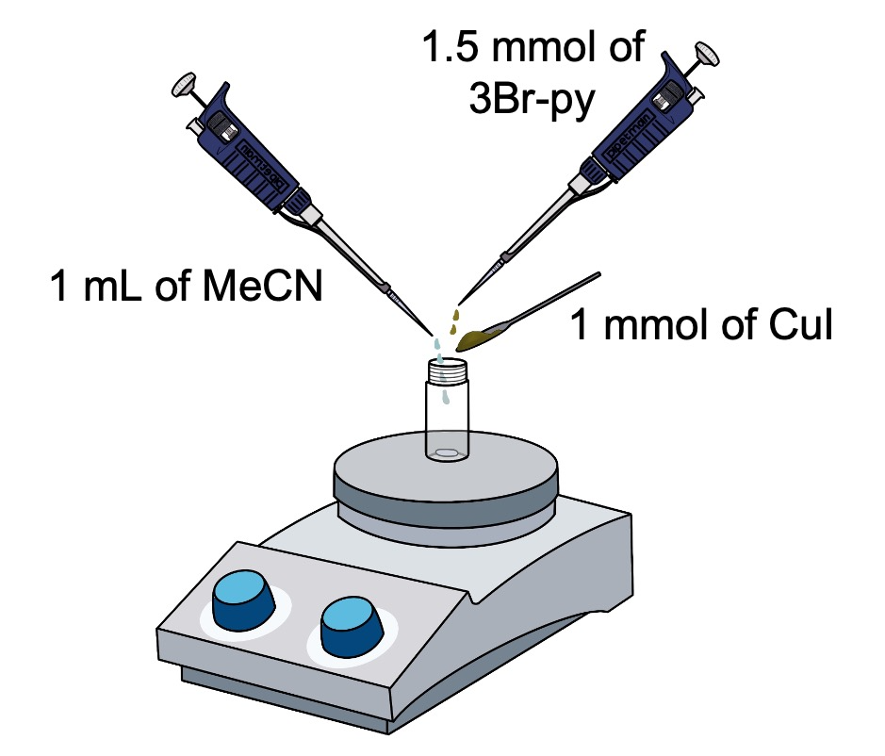
Figure S1. Scheme of the setup employed for the synthesis of [(CuI)3-Br-py]_{n}, where MeCN stands for acetonitrile, CuI for Copper Iodide and 3Br-py for 3-Bromopyridine.

Table S1. Crystallographic table of [(CuI)3-Br-py]_{n}.

Structural Parameters
Chemical formula | C₅H₄BrNCuI
Formula weight | 348.44
Temperature/K | 293(2)
Crystal system | Orthorombic
Space group | P2₁2₁2₁
a / Å | 4.1436(2)
b / Å | 11.6171(6)
c / Å | 16.5174(8)
α / ° | 90
β / ° | 90
γ / ° | 90
Volume /Å³ | 795.09(7)
Z, Z’ | 4, 1
d_{calc} / g cm⁻³ | 2.911
μ / mm⁻¹ | 11.566
Refls. measd./unique | 2288/1565
R_{int} | 0.0265
Goodness-of-fit on F² | 0.993
R₁ [I >2σ (I)] | 0.0412
wR₂ [all data] | 0.0677
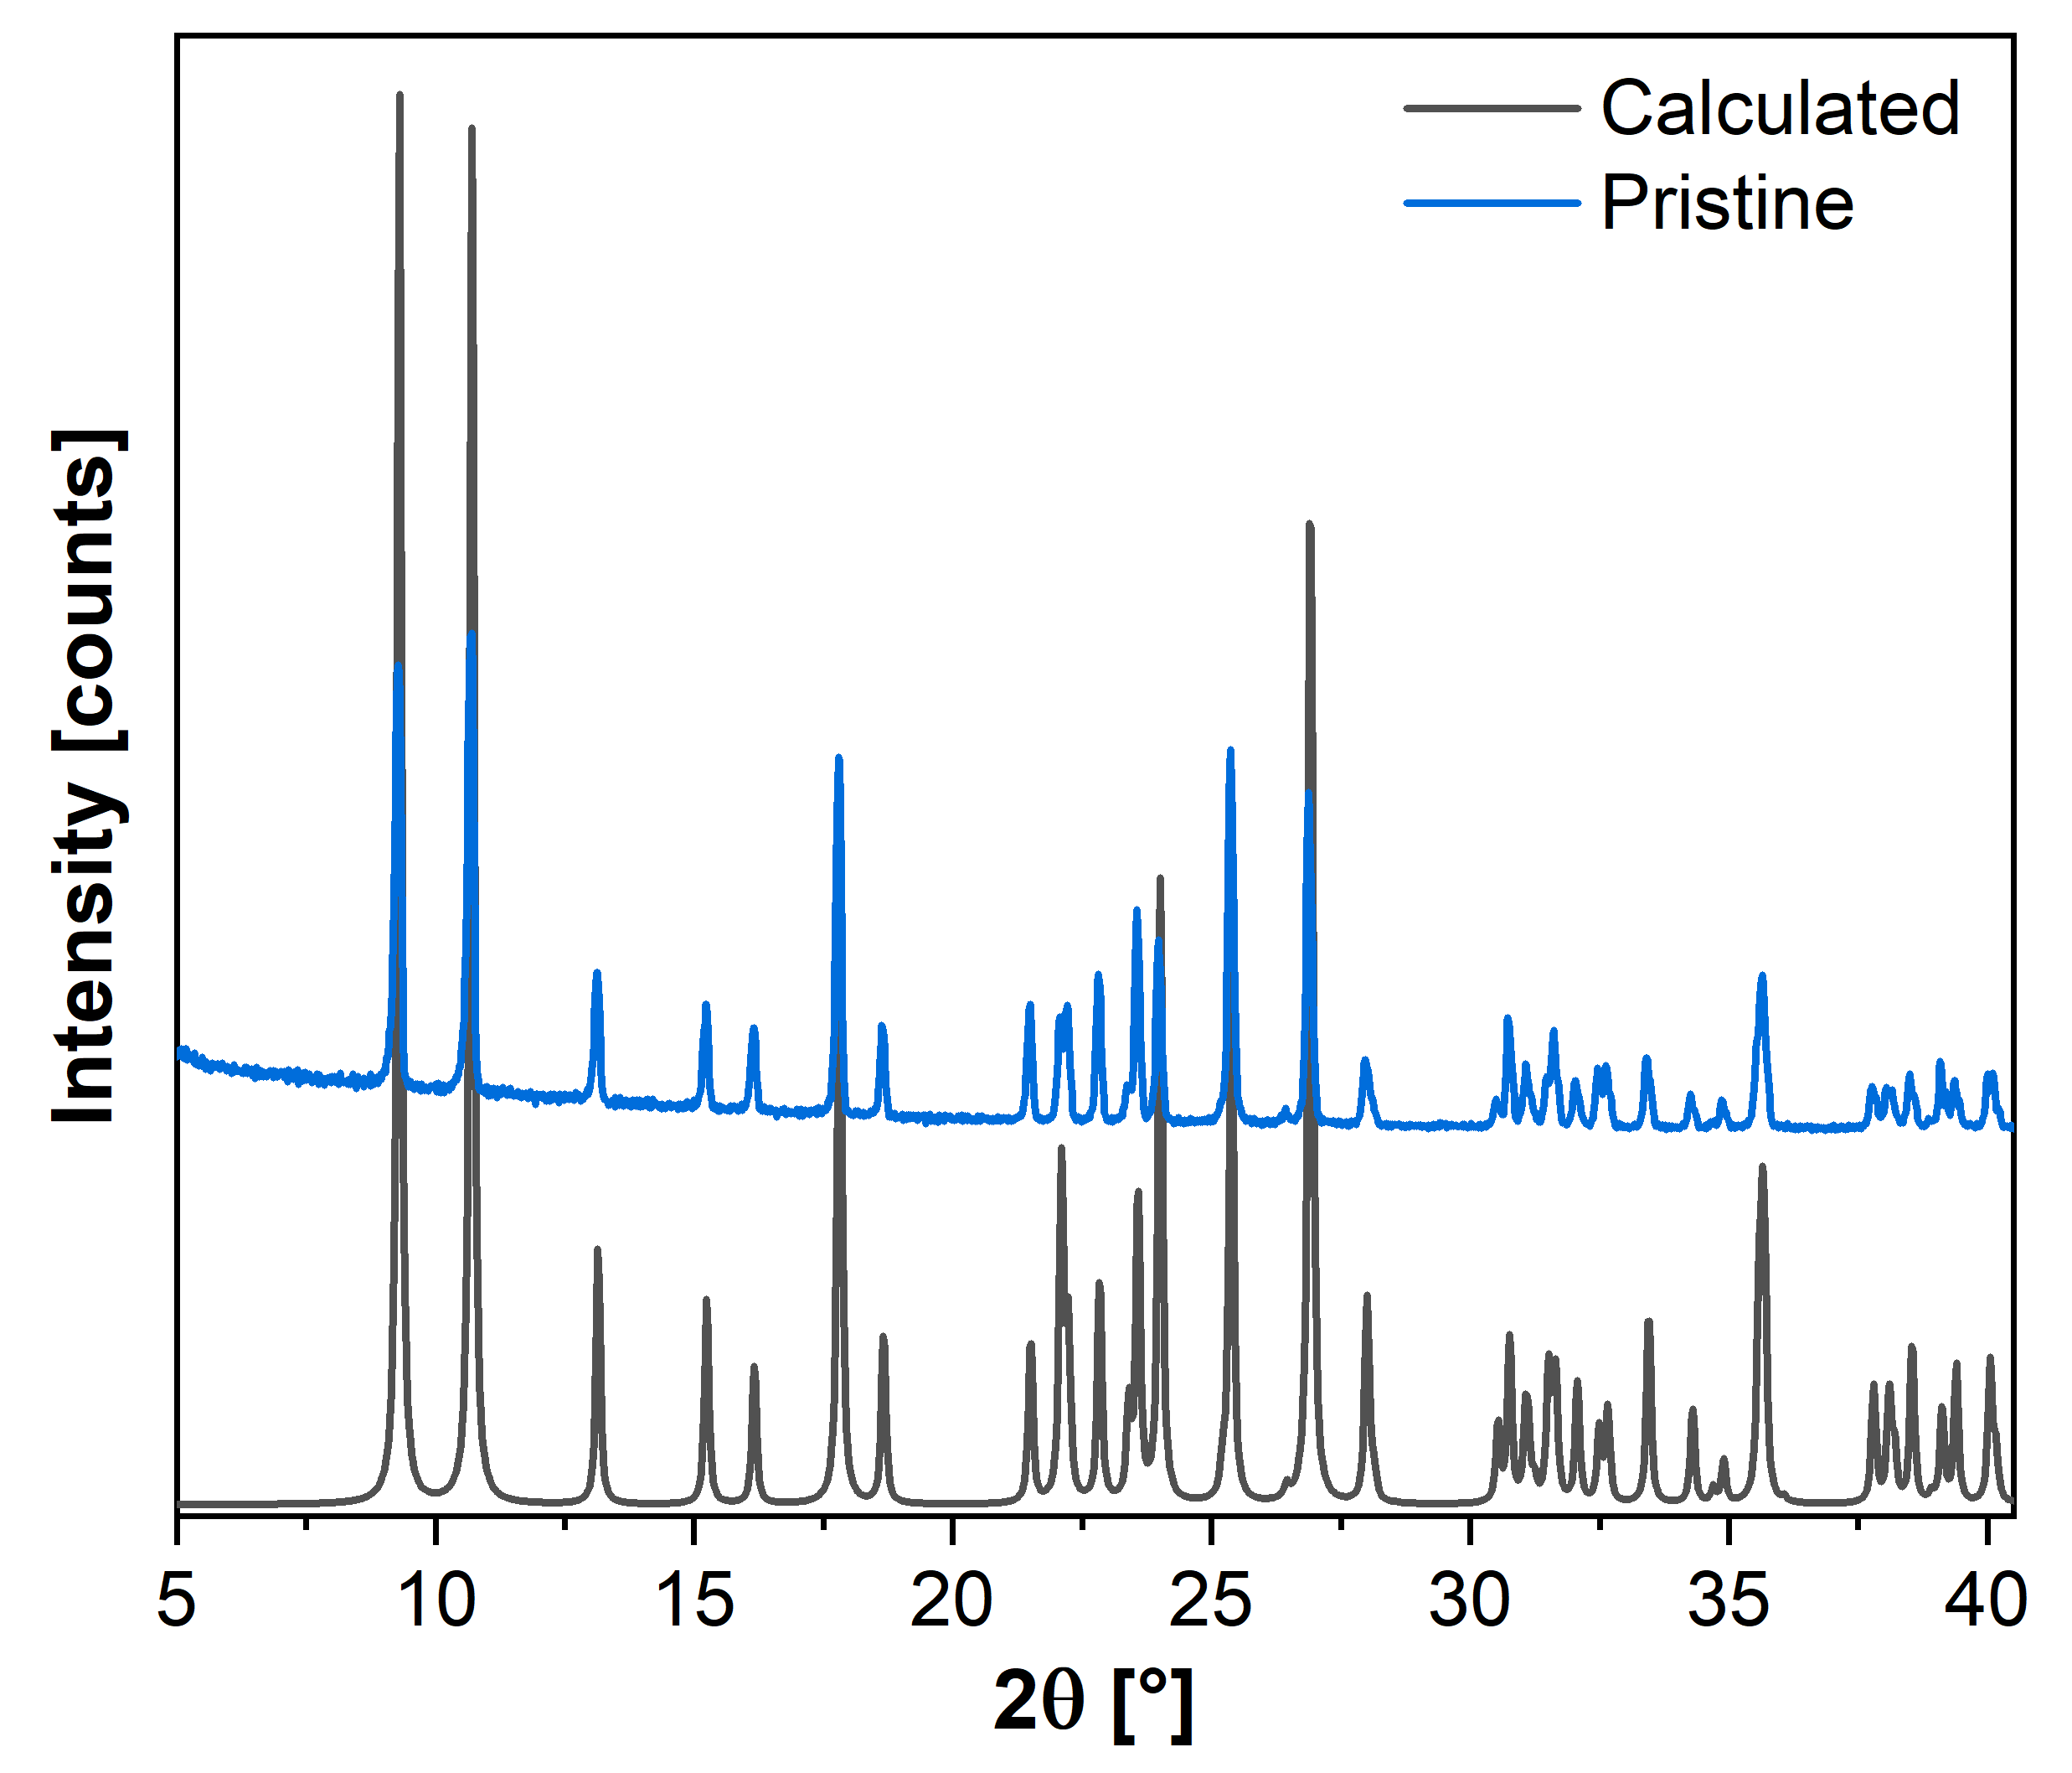
Figure S2. Comparison between the experimental diffractogram of [(CuI)3-Br-py]_{n} obtained via slurry (blue line) and the calculated diffractogram (grey line).

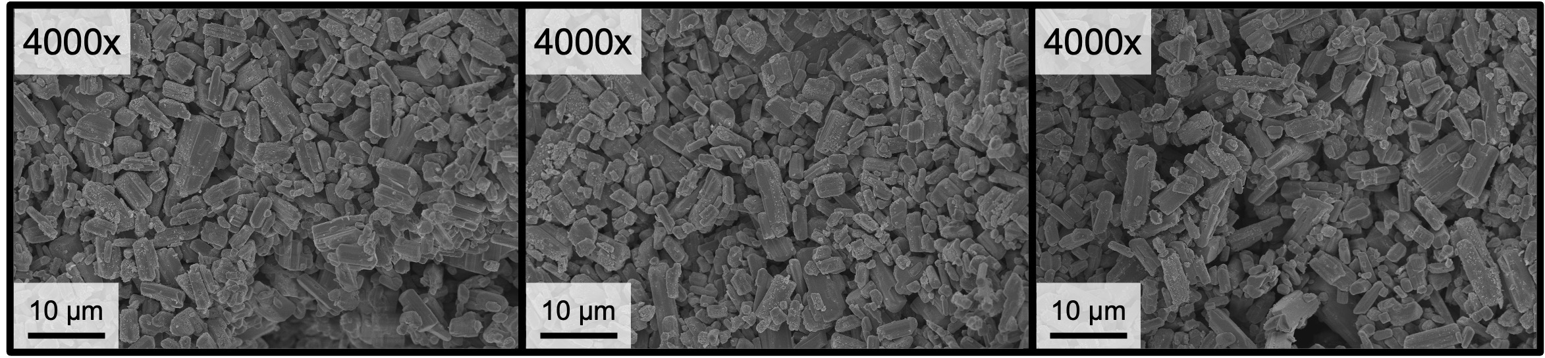
Figure S3. SEM micrograph images of pristine [(CuI)3-Br-py]_{n} employed for the determination of the particle size.

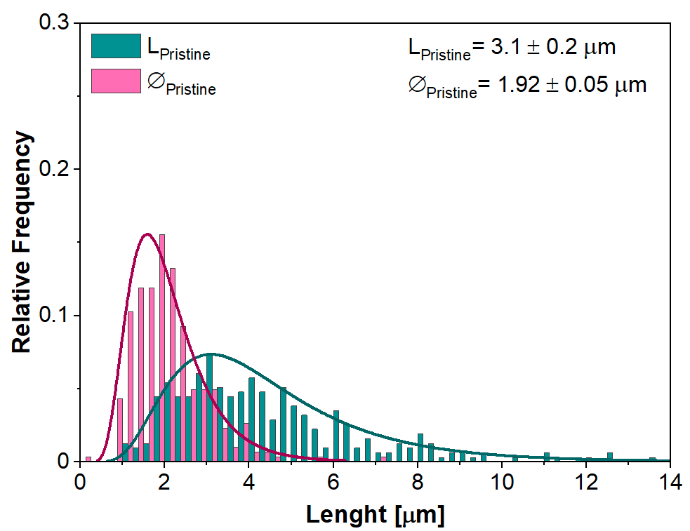
Figure S4. Particle dimensions distribution of [(CuI)3-Br-py]_{n} pristine powder (L = length; ∅ = diameter), determined by SEM image analysis.

In this work HCPs crystallites are described as equiaxed crystalline domains. Crystallites have been modelled as spheres, having a lognormal distribution of diameters (D) Equation 1:
$g\left(D\right)=\frac{1}{Dσ\sqrt{2π}}\exp\left[-\frac{1}{2}{\left(\frac{\ln{D}-µ}{σ}\right)}^{2}\right]$ [1]

Rietveld refinement provided the lognormal mean (µ) and variance (σ) from which the mean diameter of crystalline domains (${<D>}_{vol}$) has been calculated by applying Equation 2:

${<D>}_{vol} =\exp\left(µ+\frac{σ^{2}}{2}\right)$ [2]

The effective domain size ($<L>_{Vol}$) has been determined by applying Equation 3:

$<L>_{Vol} =\frac{3}{4}\exp\left(µ+\frac{7}{2}σ^{2}\right)$ [3]

Table S2. Parameters of the lognormal distribution of pristine and ground [(CuI)3-Br-py]_{n} powder determined by WPPM analysis (Equation 1-3). ^{1–5}

Sample | µ | σ | <D>_{vol} [nm] | <L>_{vol} [nm]
Pristine | 4.98 ± 0.03 | 0.507 ± 0.009 | 166.2 ± 0.8 | 269 ± 9
Ground | 2.523 ± 0.009 | 0.689 ± 0.002 | 15.80 ± 0.03 | 49.2 ± 0.6

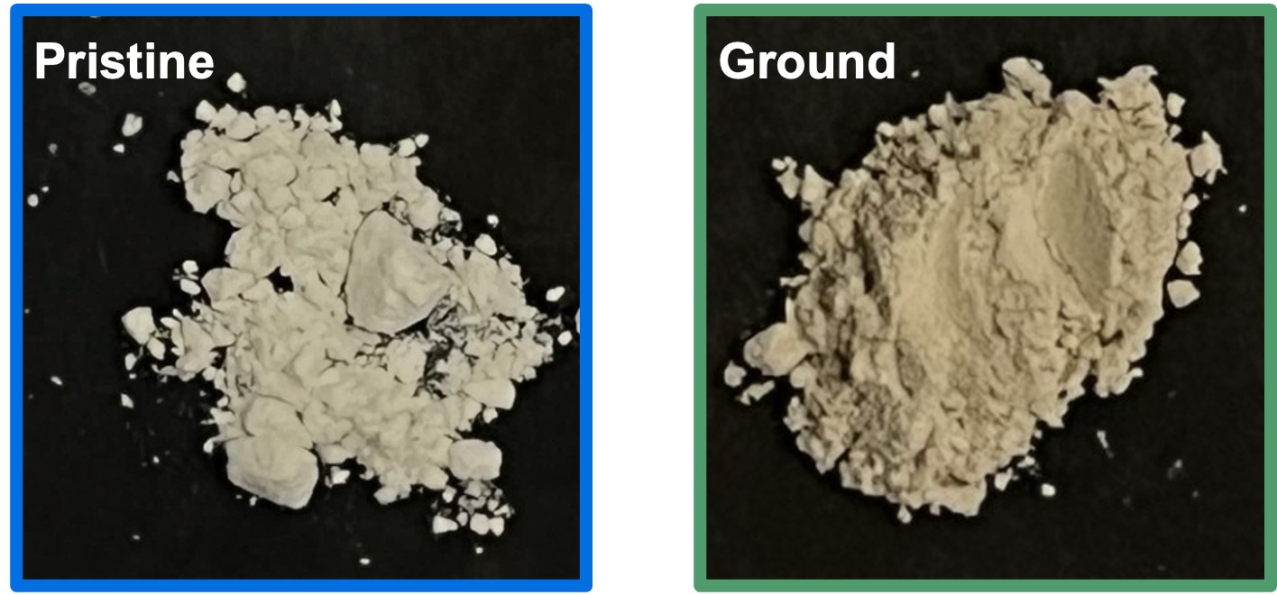
Figure S5. Pristine (left) and ground (right) [(CuI)3-Br-py]_{n} powder observed under white light. The powder was ground with a Retsch mm200 vibrating ball mill for 5 min at 25 Hz using a 5 mL agata jar and an agata ball with a 7 mm diameter.

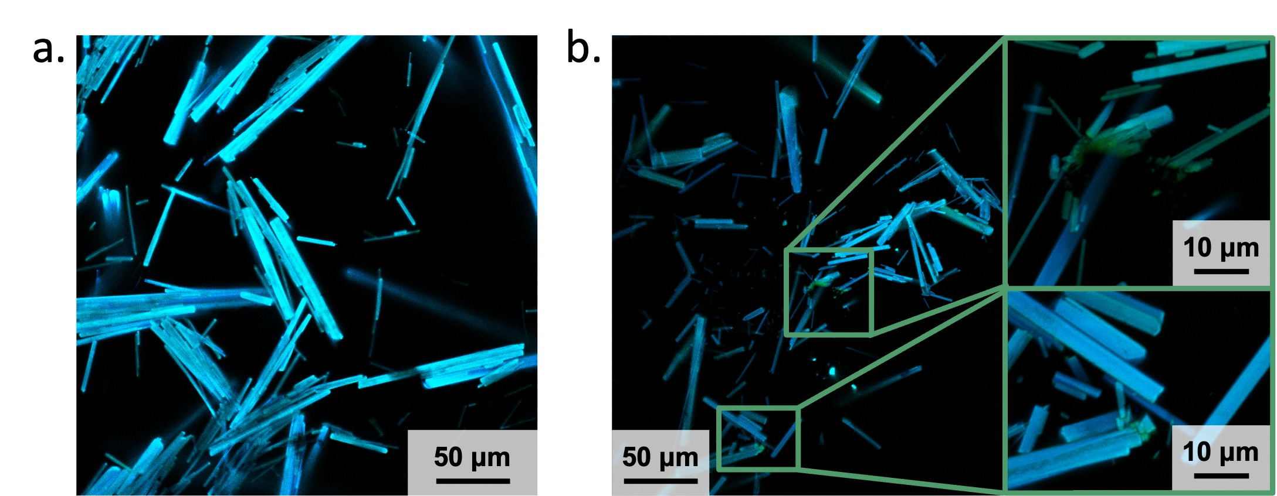

Figure S6. Confocal microscopy images of [(CuI)3-Br-py]_{n} single crystals (a) and [(CuI)3-Br-py]_{n} single crystals damaged with a spatula (b) (magnification: 40x, λ_{ex} at 401.9 nm, λ_{em} at 450 ± 25 nm and 525 ± 25 nm, objNA: 0.95, pixel size 0.31 μm·px⁻¹).

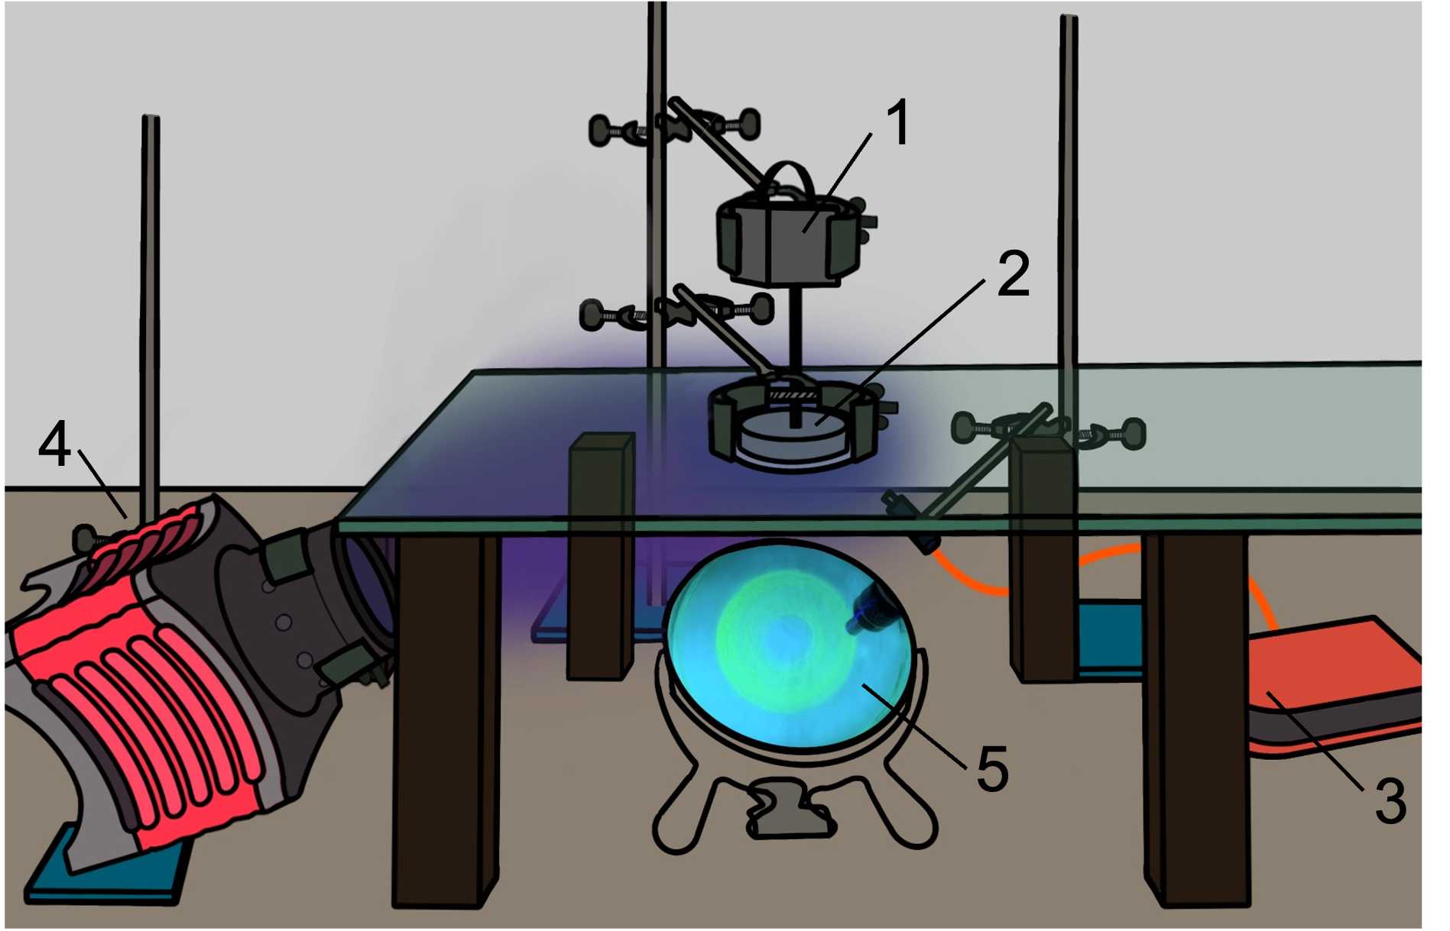
Figure S7. Scheme of the setup employed for monitoring the powder emission real-time under grinding composed by: a stepper motor (1), a rotating plate (2), the compact spectrometer (3), a UV lamp (4) and, a 45° mirror (5).

2. Recycling of [(CuI)3-Br-py]_{n}

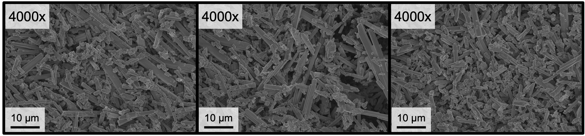
Figure S8. SEM micrograph images of recycled [(CuI)3-Br-py]_{n} employed for the determination of particle size.

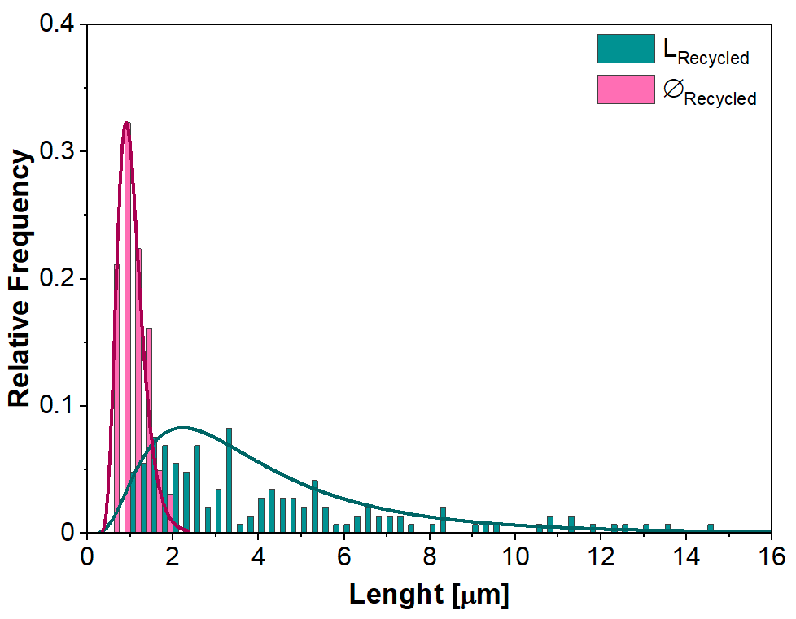
Figure S9. Particle dimensions distribution of [(CuI)3-Br-py]_{n} recycled powder (L = length; ∅ = diameter), determined by SEM image analysis.

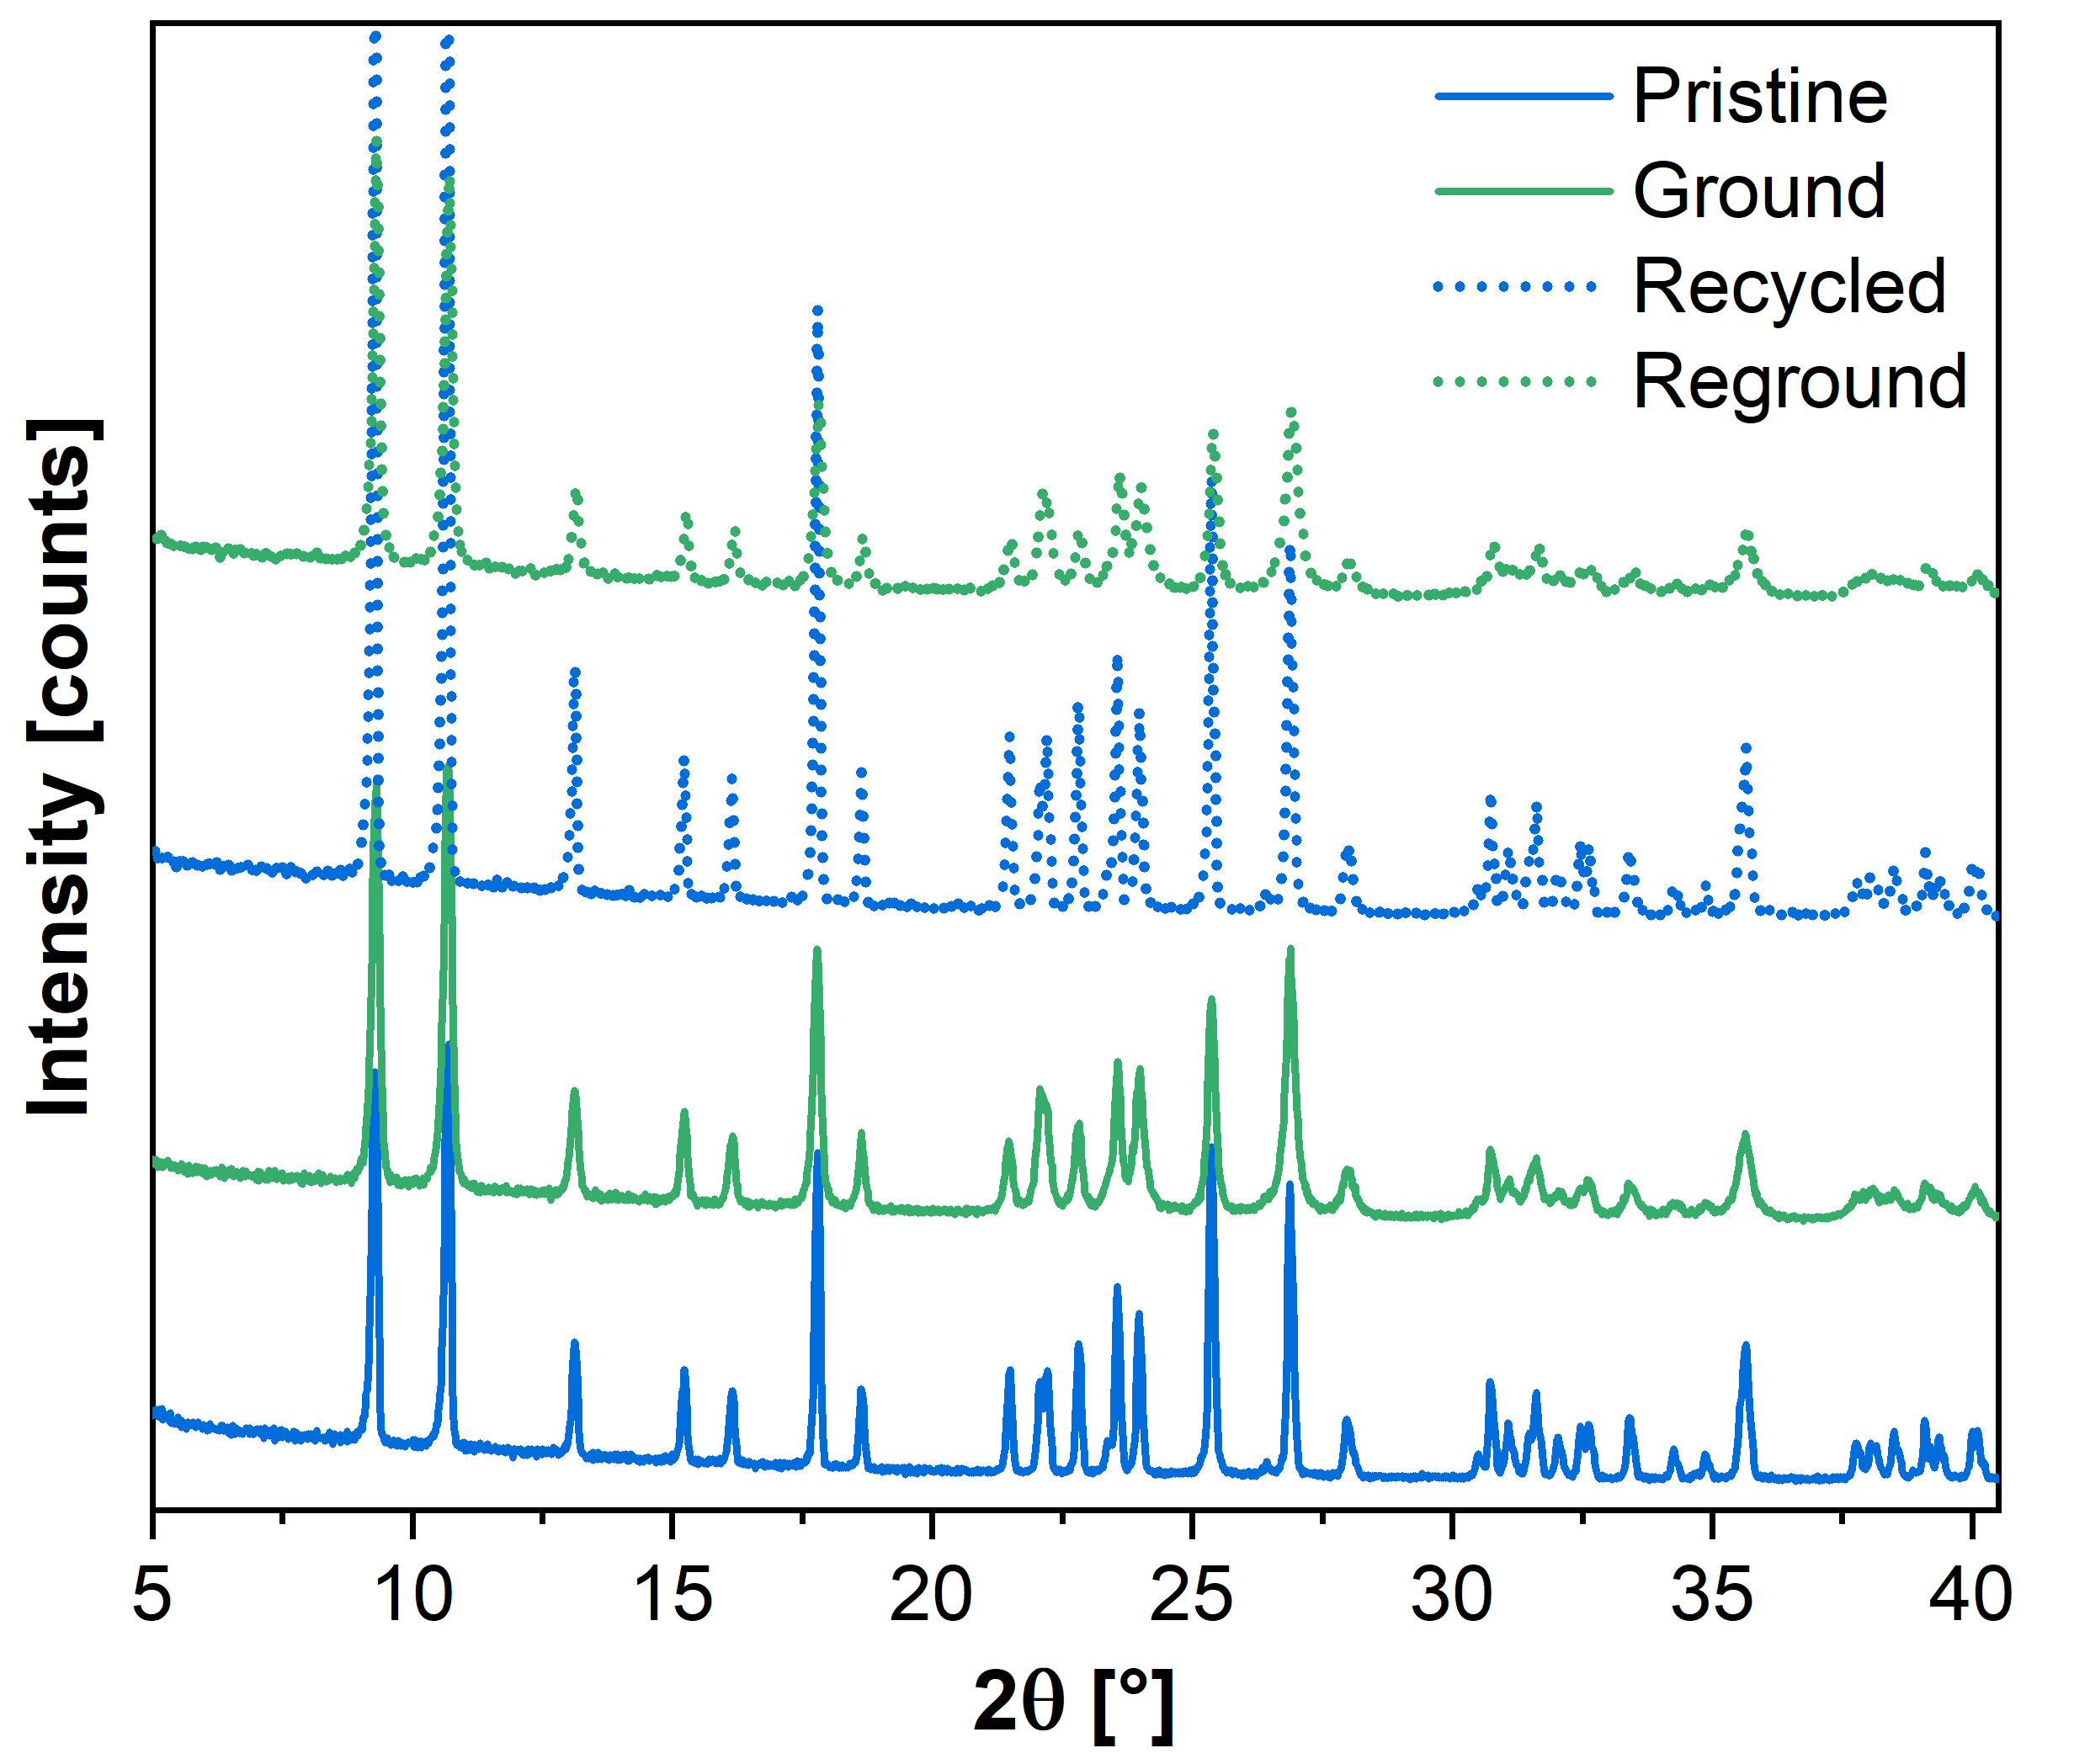
Figure S10. PXRD diffractogram of pristine (blue) and ground (green) [(CuI)3-Br-py]_{n} before recycling (solid line) and after recycling (dashed line).

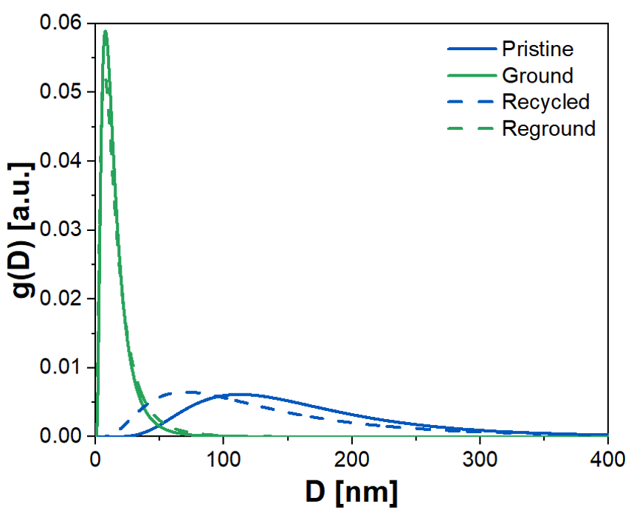
Figure S11. Lognormal crystallite domain size distribution of pristine (blue) and ground (green) [(CuI)3-Br-py]_{n} before recycling (line) and after recycling (dash), determined by WPPM analysis.

Table S3. Parameters of the lognormal distribution of recycled [(CuI)3-Br-py]_{n} powder, before and after grinding, determined by WPPM analysis.

Sample | μ | σ | <D>_{vol} [nm] | <L>_{vol} [nm]
Recycled | 4.72 ± 0.02 | 0.691 ± 0.005 | 143.0 ± 0.5 | 489 ± 11
Reground | 2.58 ± 0.02 | 0.782 ± 0.004 | 17.9 ± 0.3 | 84 ± 2

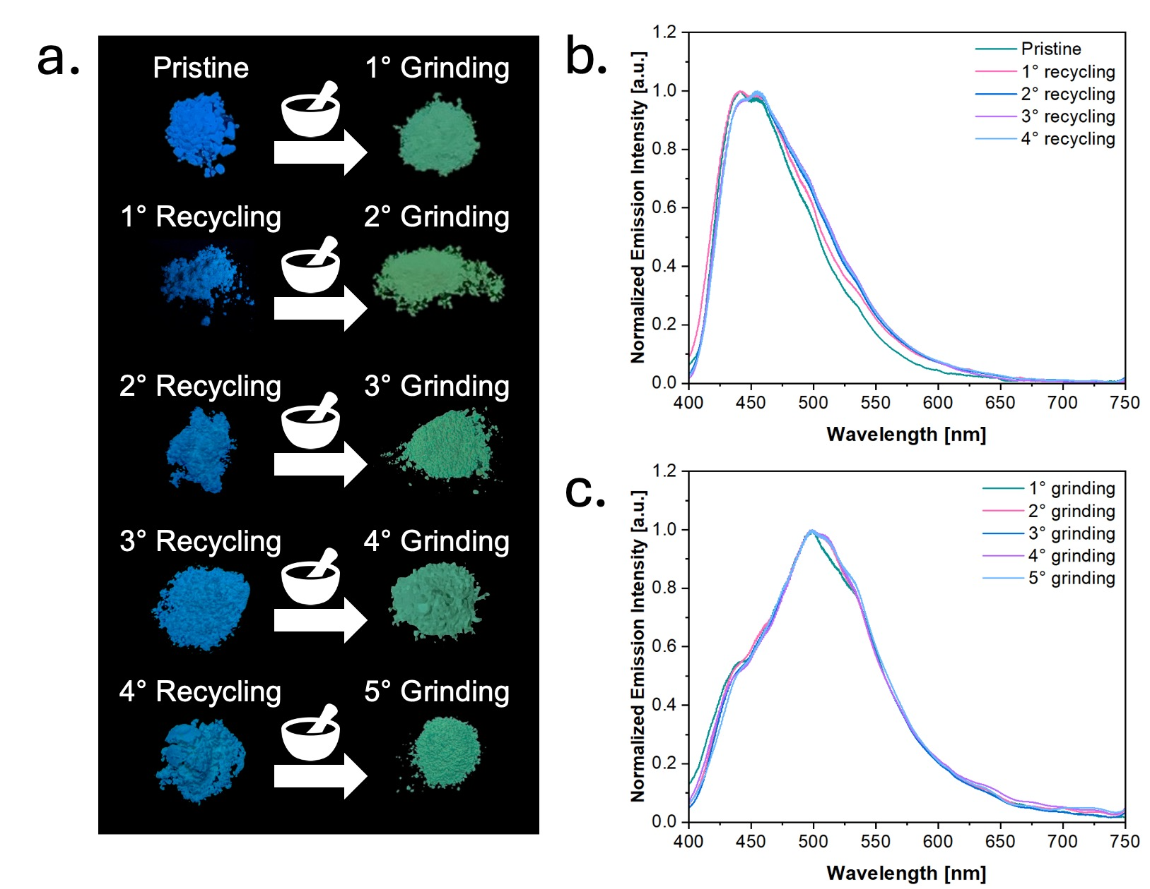
Figure S12. Multiple recycling of [(CuI)3-Br-py]_{n} powder by recrystallization in acetonitrile vapors for 48 h: a) images under UV-light (λ_{ex} at 365 nm) of pristine and ground [(CuI)3-Br-py]_{n} (1st row), after the first recycling (2nd row), after the second recycling (3rd row), after the third recycling (4th row), and after the forth recycling (5th row); b) solid-state emission spectra of pristine [(CuI)3-Br-py]_{n} (teal), after the first recycling (fuchsia), after the second recycling (blue), after the third recycling (purple), and after the fourth recycling (light blue); c) solid-state emission spectra of ground [(CuI)3-Br-py]_{n} (teal), after the first recycling (fuchsia), after the second recycling (blue), after the third recycling (purple), and after the fourth recycling (light blue).

3. Characterization of PVAc - [(CuI)3-Br-py]_{n} composites

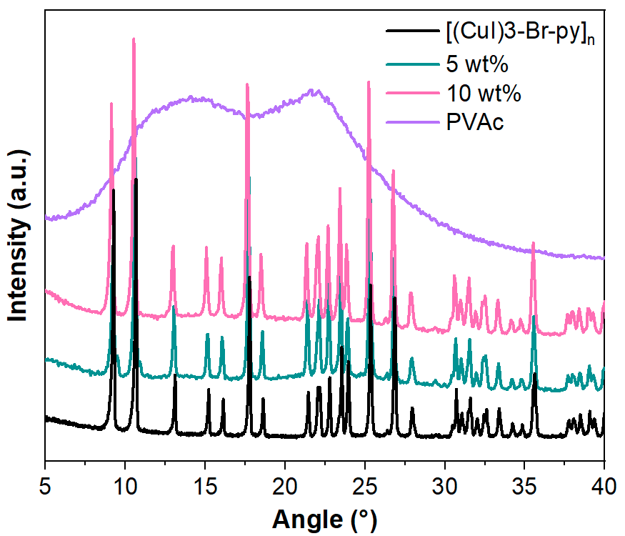
Figure S13. PXRD diffractogram of pristine [(CuI)3-Br-py]_{n} (black), PVAc (purple), 5 wt% PVAc composite (teal) and, 10 wt% PVAc composite (fuchsia).

The thermal stability of PVAc, [(CuI)3-Br-py]_{n}, 5 and 10 wt% composites was determined by Thermogravimetric Analysis (TGA). From Figure S14 it is possible to observe that all the samples under analysis show a stable weight up to 100 °C. This proves that the purified samples show a limited-to-none amount of low molecular weight substances, such as residual solvents, from the casting procedure.
[(CuI)3-Br-py]_{n} displays a two-step degradation with a first weight loss in the temperature range 100-175 °C, ascribable to the loss of 3-Br-py from the HCP,⁶ and a second weight loss in the temperature range 300-450 °C, attributed to the loss of iodine. The residual weight of 23.6% is consistent with the formation of copper oxide (CuO).
PVAc shows a multistep degradation composed of a main weight loss, in the temperature range 275-375 °C, consistent with the loss of acetic acid followed by a multistep degradation (in the temperature range 400-575 °C) ascribed to the breakdown of the polymer backbone at higher temperatures, as previously reported in the literature.^{7,8}
As for the composites, their degradation profiles mostly overlap with that of PVAc, except for a low-temperature weight loss in the range 100-175 °C ascribable to the loss of 3-Br-py from the HCP component. Moreover, the residual mass at 600 °C increases with the increase of HCP nominal content, due to the formation of CuO. Table S4 reports, for the two composites, the weight losses and residual masses calculated from the nominal contents of HCP and the corresponding experimental values. Good matches between the calculated and the experimental values are found. Therefore, it is possible to state that the blending procedure did not cause variations in the chemical structure of the starting materials and that the presence of the HCP did not alter the degradation profile of the polymeric matrix.

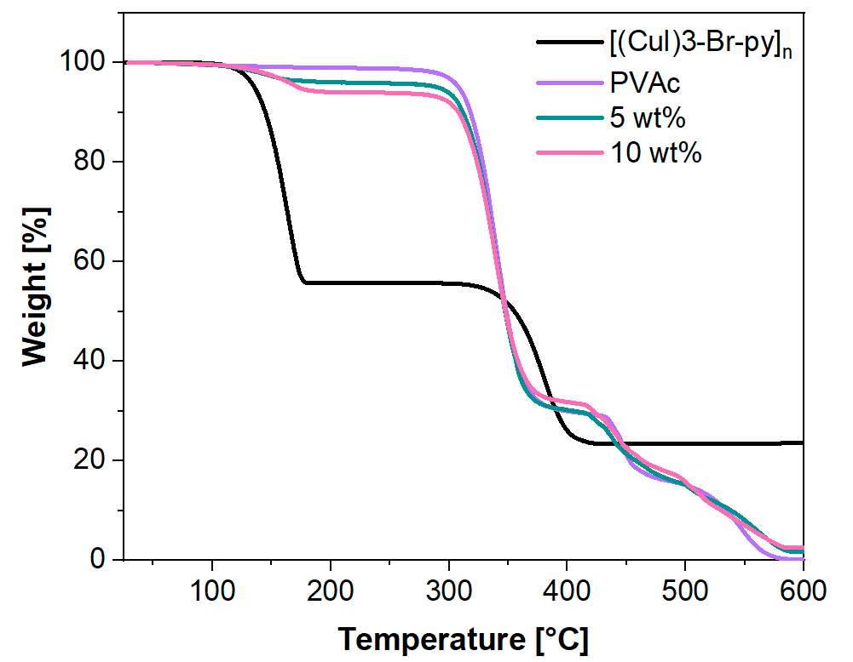
Figure S14. TGA curves of [(CuI)3-Br-py]_{n} (black), PVAc (purple), 5 wt% PVAc composite (teal) and, 10 wt% PVAc composite (fuchsia).

Table S4. Results of TGA analysis on [(CuI)3-Br-py]_{n}, PVAc, 5 wt% PVAc composite, and 10 wt% PVAc composite.

 | Weight lossª  [%] |  | Residue^{c}  [%]
 | Calcd^{b} | Experimental |  | Calcd^{d} | Experimental
[(CuI)3-Br-py]_{n} | 45.3 | 44.2 |  | 22.8 | 23.6
5 wt% | 2.2 | 3.9 |  | 1.15 | 1.4
10 wt% | 4.4 | 5.9 |  | 2.3 | 2.5
a. Weight loss percent in the temperature range 100 °C – 175 °C.
b. Calculated weight loss according to the nominal composition.
c. Residual mass percentage at 600 °C.
d. Calculated residue at 600 °C according to the nominal composition.

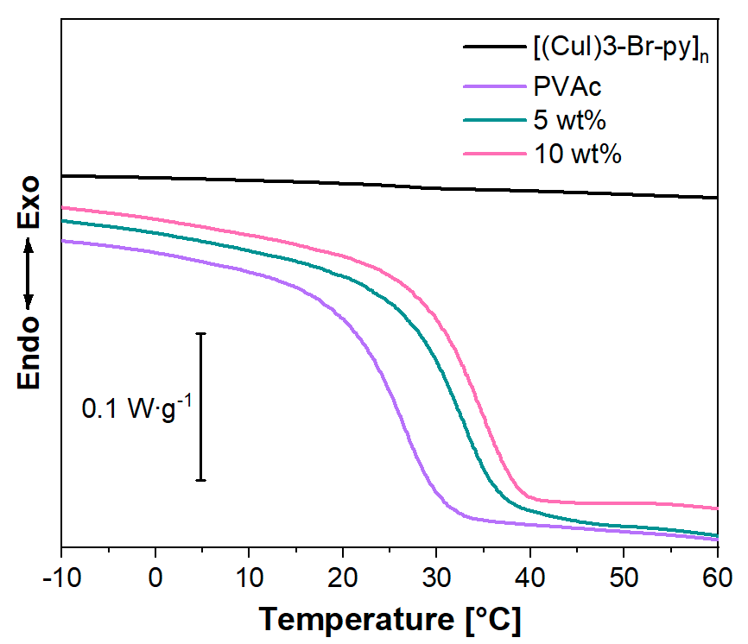
Figure S15. DSC first heating scans of [(CuI)3-Br-py]_{n} (black), PVAc (purple), 5 wt% PVAc composite (teal), and 10 wt% PVAc composite (fuchsia).

Table S5. Calorimetric data of [(CuI)3-Br-py]_{n}, PVAc, 5 wt% PVAc composite, and 10 wt% PVAc composite, determined from DSC first heating scan (T_{g} = glass transition temperature determined at the mid-point of the step-change transition; ΔC_{p} = specific heat capacity).

 | T_{g}  [°C] | ∆C_{p}  [J·g⁻¹·°C⁻¹]
PVAc | 21.6 | 0.55
[(CuI)3-Br-py]_{n} | - | -
5 wt% | 26.6 | 0.52
10 wt% | 27.9 | 0.51

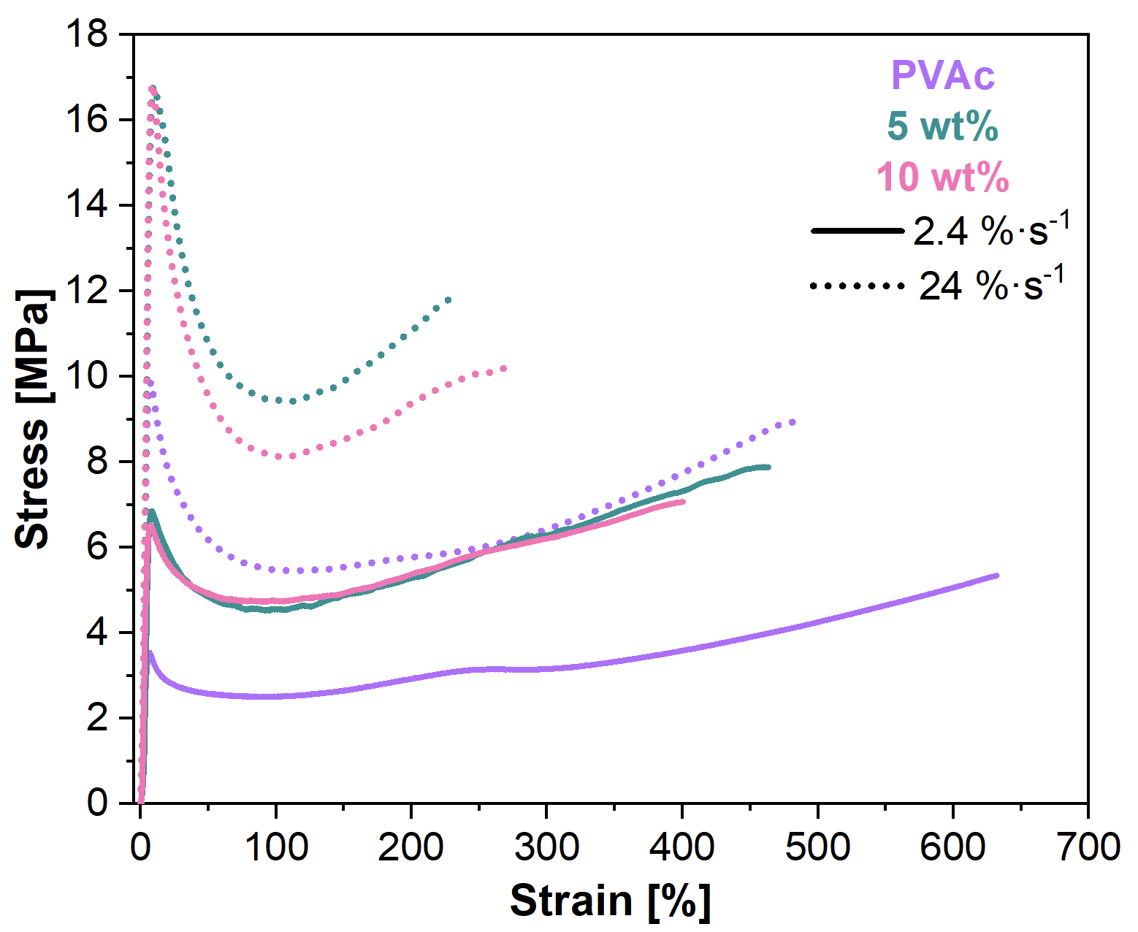
Figure S16. Representative tensile stress-strain curves of PVAc (purple), 5 wt% PVAc composite (teal), and 10 wt% PVAc composite (fuchsia), deformed at 2.4 %·s⁻¹ (solid lines), and 24 %·s⁻¹ (dashed lines).

Table S6. Tensile stress-strain mechanical data of PVAc, 5 wt% PVAc composite, and 10 wt% PVAc composite at two different strain rates.

 | Stress at break  [MPa] | Strain at break  [%] | Young’s Modulus  [MPa]
PVAc [2.4 %·s⁻¹] | 6 ± 1 | 6.8·10² ± 0.4·10² | 1.0·10² ± 0.2·10²
5 wt% [2.4 %·s⁻¹] | 7.1 ± 0.9 | 4.6·10² ± 0.8·10² | 1.7·10² ± 0.2·10²
10 wt% [2.4 %·s⁻¹] | 6.5 ± 0.5 | 4.6·10² ± 0.5·10² | 1.0·10² ± 0.4·10²
PVAc [24 %·s⁻¹] | 9.2 ± 0.6 | 5.0·10² ± 0.3·10² | 2.8·10² ± 0.3·10²
5 wt% [24 %·s⁻¹] | 11.6 ± 0.7 | 2.6·10² ± 0.5·10² | 3.0·10² ± 0.7·10²
10 wt% [24 %·s⁻¹] | 11 ± 1 | 2.9·10² ± 0.6·10² | 2.7·10² ± 0.6·10²

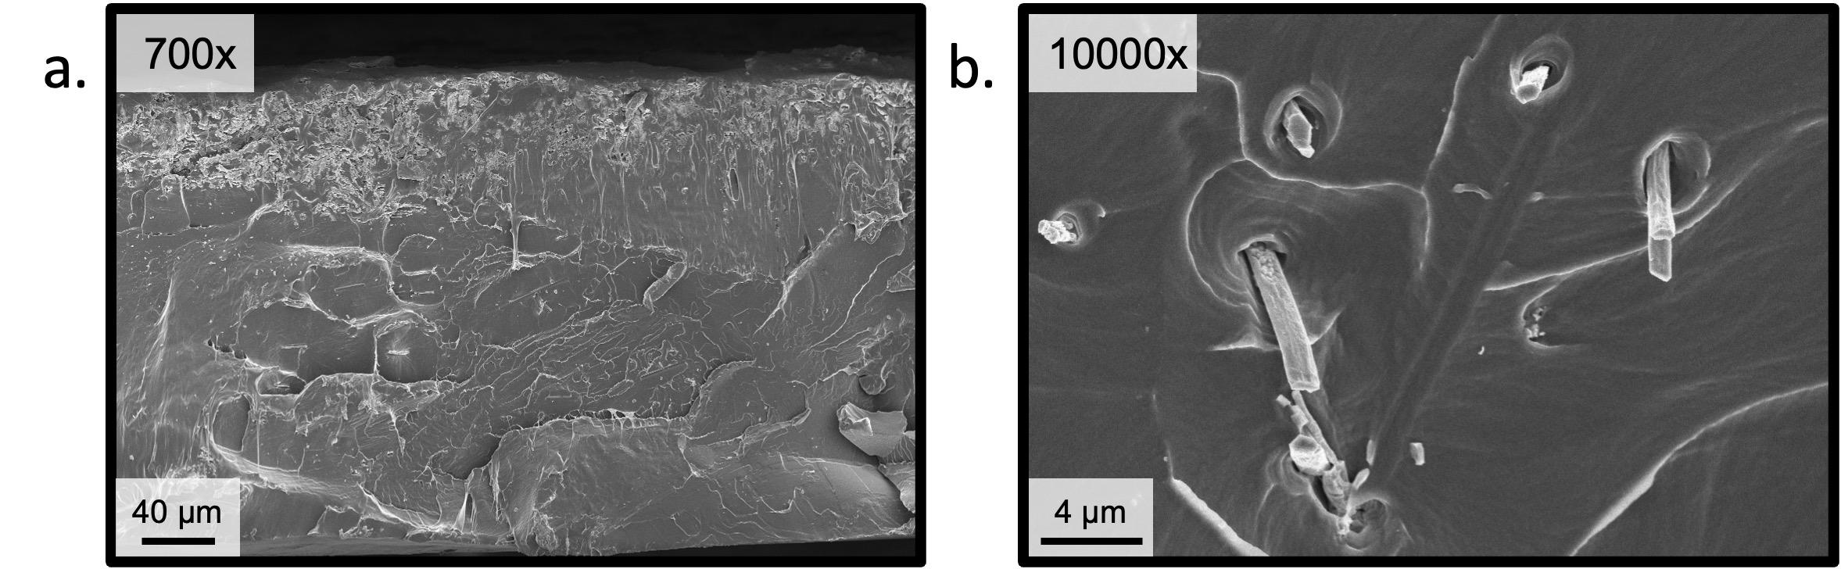
Figure S17. SEM micrograph images of sections of 5 wt% composites at 700x (a) and 10000x (b). [(CuI)3-Br-py]_{n} crystals are more concentrated on one side of the film due to particles settling during solvent casting.

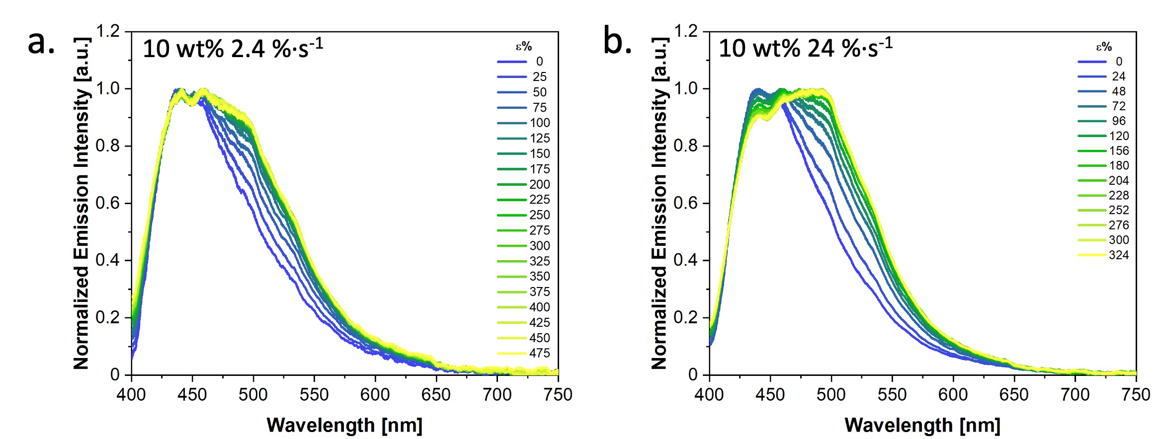
Figure S18. Solid-state emission spectra of 10 wt% PVAc composite at increasing strains deformed under tensile mode with a crosshead speed of a) 2.4 %·s⁻¹ b) 24 %·s⁻¹.

Table S7. Slope of the linear correlation between I_{Green}/I_{Blue} and strain in the range 0÷75% strain for 5 and 10 wt% composites under tensile mode.

Name | Slope | R²
5 wt% [2.4 %·s⁻¹] | 2.8·10⁻³ ± 0.1·10⁻³ | 0.99
5 wt% [24 %·s⁻¹] | 5.4·10⁻³ ± 0.2·10⁻³ | 0.99
10 wt% [2.4 %·s⁻¹] | 3.1·10⁻³ ± 0.1·10⁻³ | 0.98
10 wt% [24 %·s⁻¹] | 5.2·10⁻³ ± 0.4·10⁻³ | 0.96

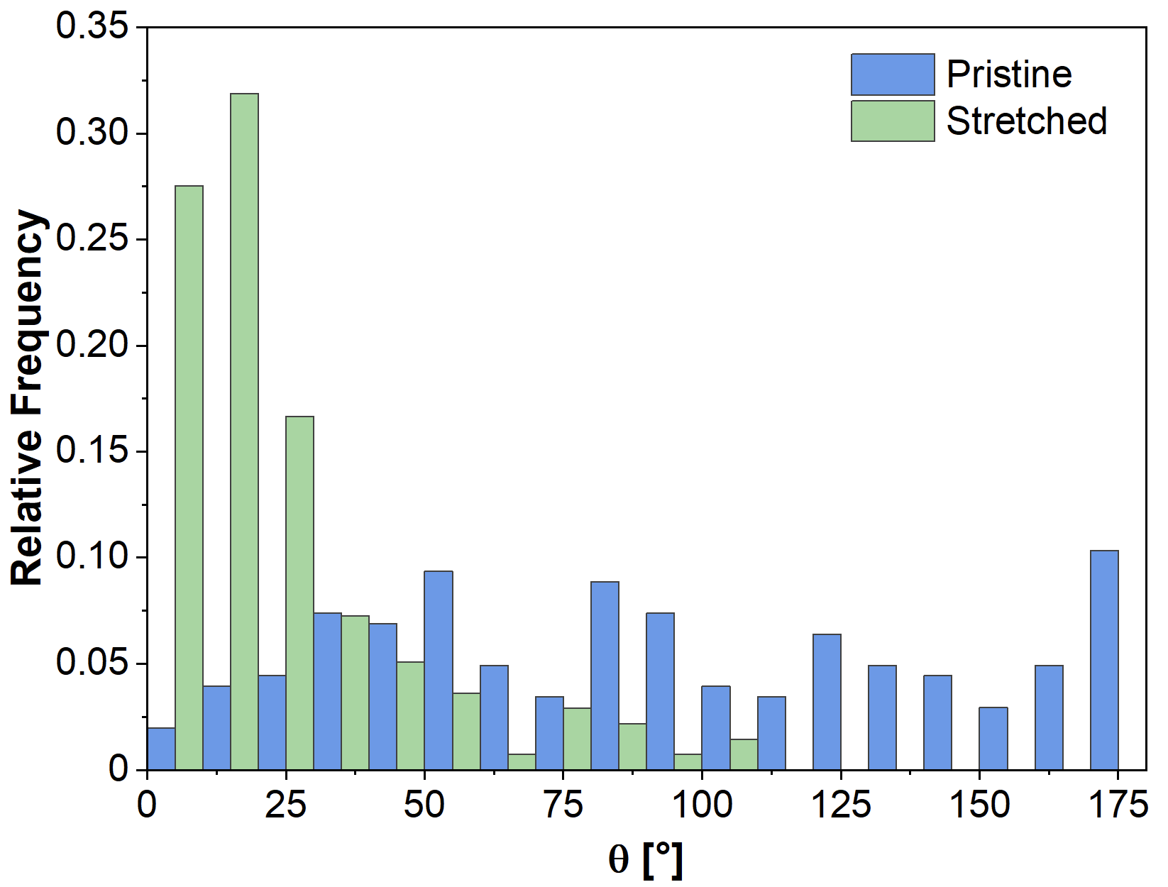
Figure S19. Distribution of angles between the crystal's long axis and the direction of the applied stress in pristine SC-2 wt% PVAc composite (blue) and after streching up to 200% (green).

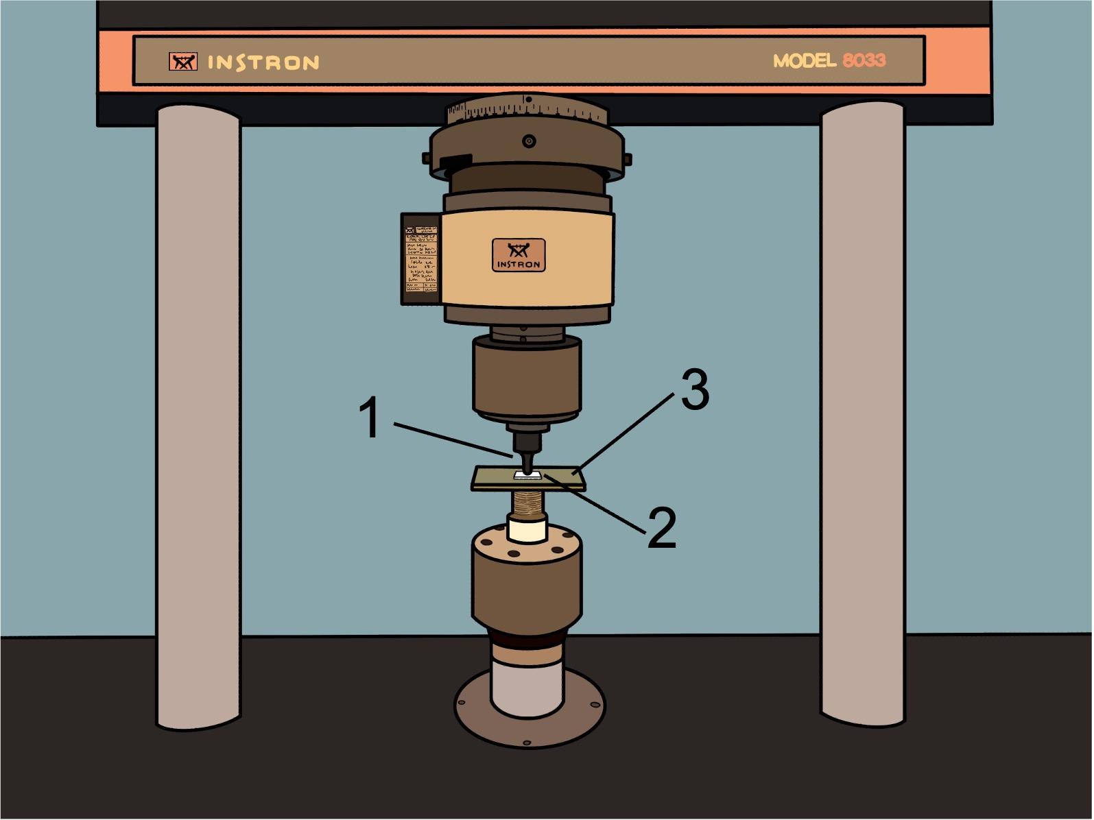
Figure S20. Scheme of the setup employed for compression experiments. The setup is composed by: hemispherical steel indenter (1), sample (2), glass-fiber reinforced plate (3).

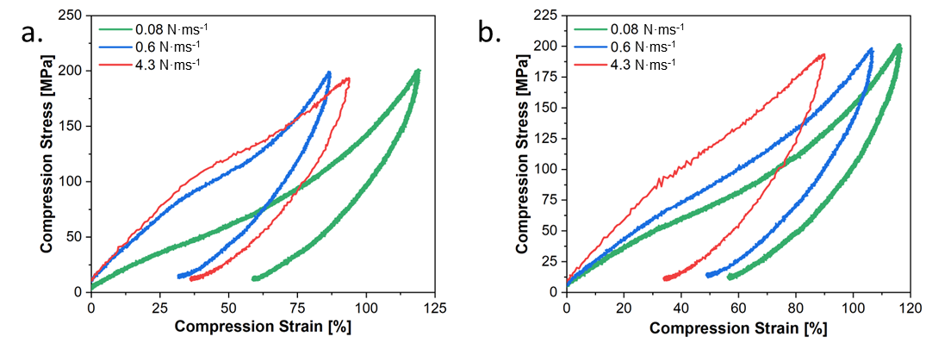
Figure S21. Representative stress-strain compression curves of 5 wt% PVAc composite (a) and 10 wt% PVAc composite (b), compressed at 0.08 N·ms⁻¹ (green), 0.6 N·ms⁻¹ (blue) and, 4.3 N·ms⁻¹ (red).
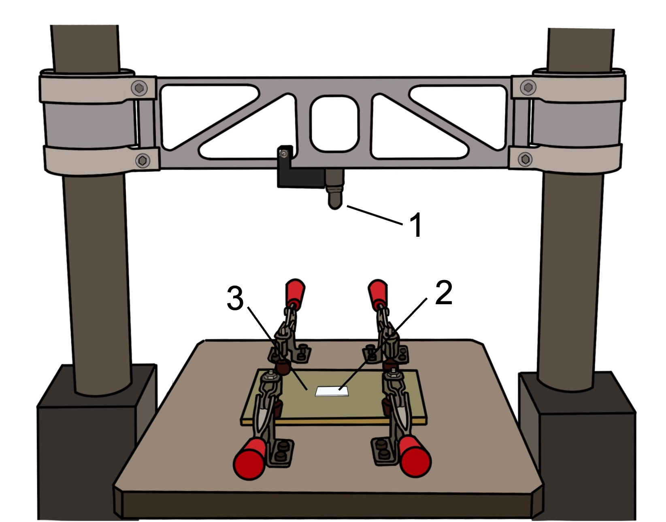
Figure S22. Scheme of the setup employed for impact experiments. The setup is composed by: impactor (1), sample (2), glass-fiber reinforced plate (3).

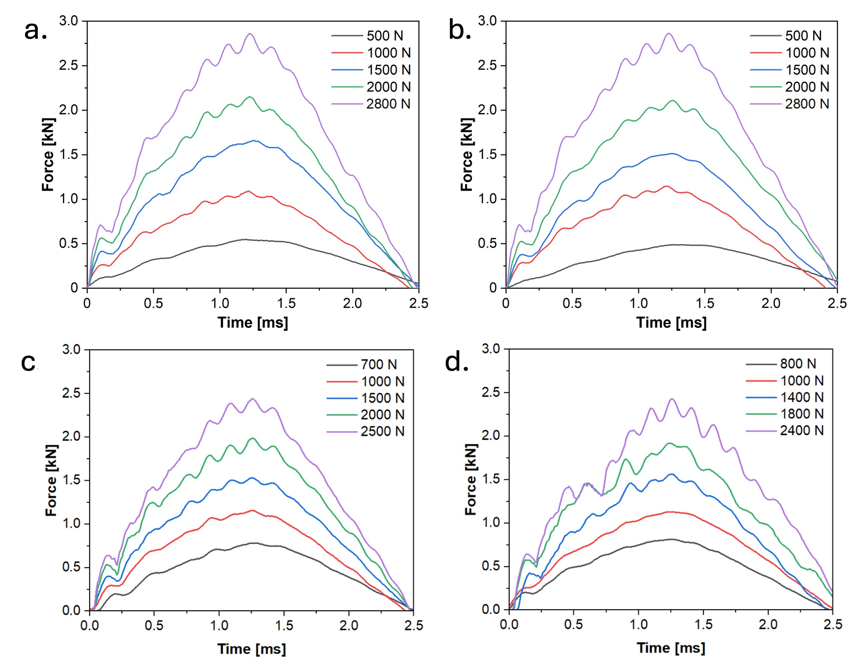
Figure S23. Representative force vs time curves during impact tests of 5 wt% (a), 10 wt% (b), 2.5 wt% (c), and 7.5 wt% (d) PVAc composites.
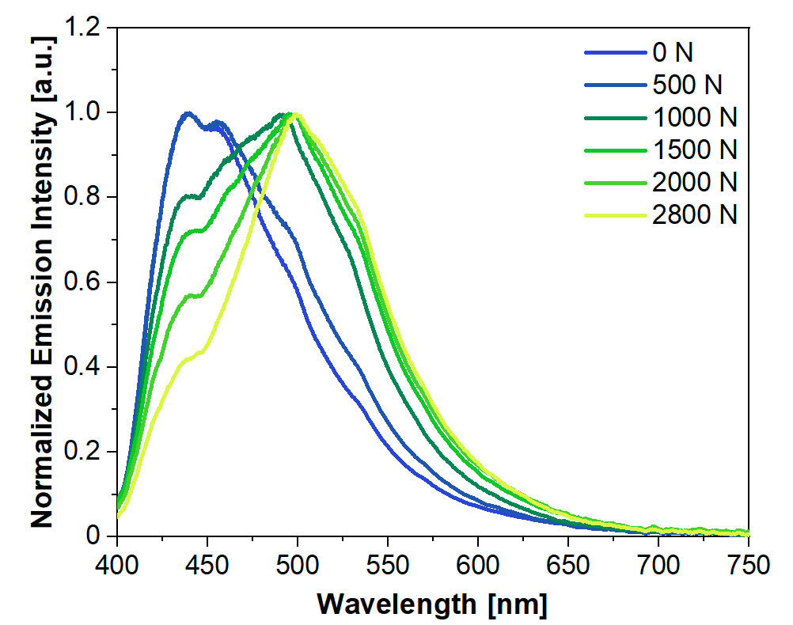
Figure S24. Solid-state emission spectra of 10 wt% PVAc composite, as pristine and after impact at various forces.

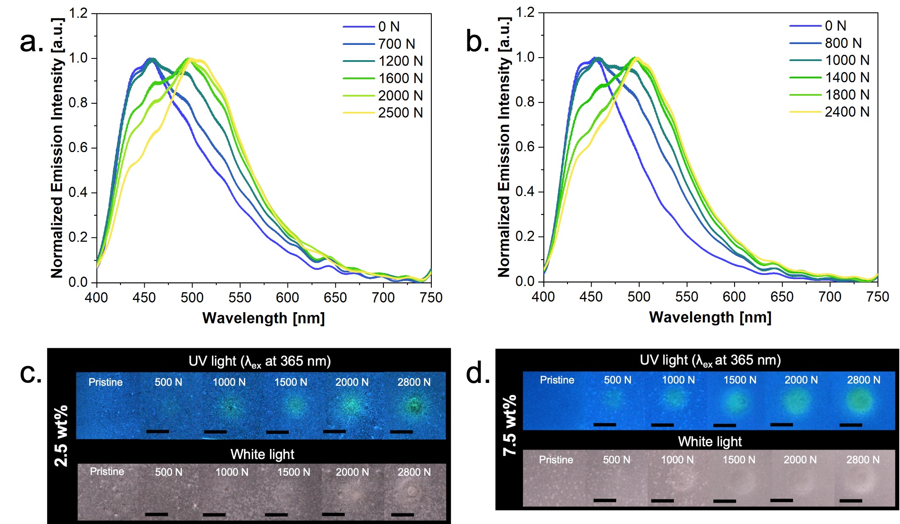
Figure S25. Solid-state emission spectra of 2.5 wt% PVAc composite (a) and 7.5 wt% PVAc composite (b), as pristine and after impact at various forces; c) images under UV (λ_{ex} at 365 nm) and white light of 2.5 wt% (c) and 7.5 wt% (d) PVAc composites, pristine and after impact at various forces (scale bars = 2 mm).

Table S8. Slope of the linear correlation between I_{Green}/I_{Blue} and impact force for 2.5 wt%, 5 wt%, 7.5 wt%, and 10 wt% composites subjected to impact tests.
Name | Slope | R2
2.5 wt% | 4.8·10-4 ± 0.7·10-4 | 0.91
5 wt% | 4.9·10-4 ± 0.7·10-4 | 0.96
7.5 wt% | 5.2·10-4 ± 0.4·10-4 | 0.98
10 wt% | 5.6·10-4 ± 0.3·10-4 | 0.99

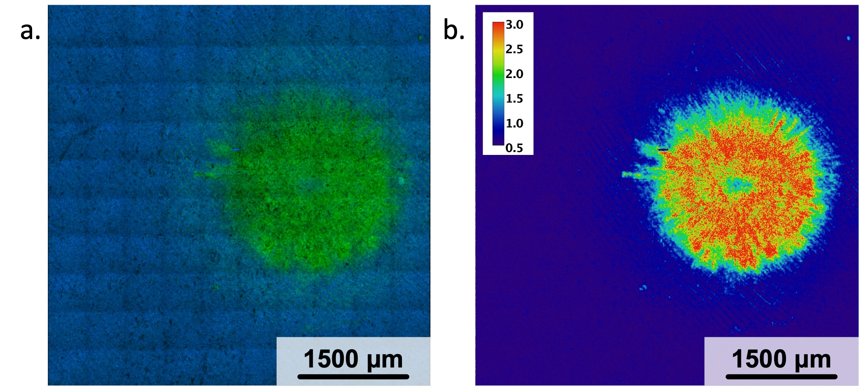
Figure S26. a) XYZ-stacked confocal microscopy image (20x) of 10 wt% sample compressed at 2800 N; b) XYZ-stacked ratiometric confocal microscopy image of 10 wt% sample compressed at 2800 N (magnification: 20x, λ_{ex} at 401.9 nm, λ_{em} at 450 ± 25 nm and 525 ± 25 nm, objNA: 0.75, pixel size 2.5 um·px⁻¹). The color scale express the ratio between the pixel intensity collected at 525 ± 25 nm and at 450 ± 25 nm.

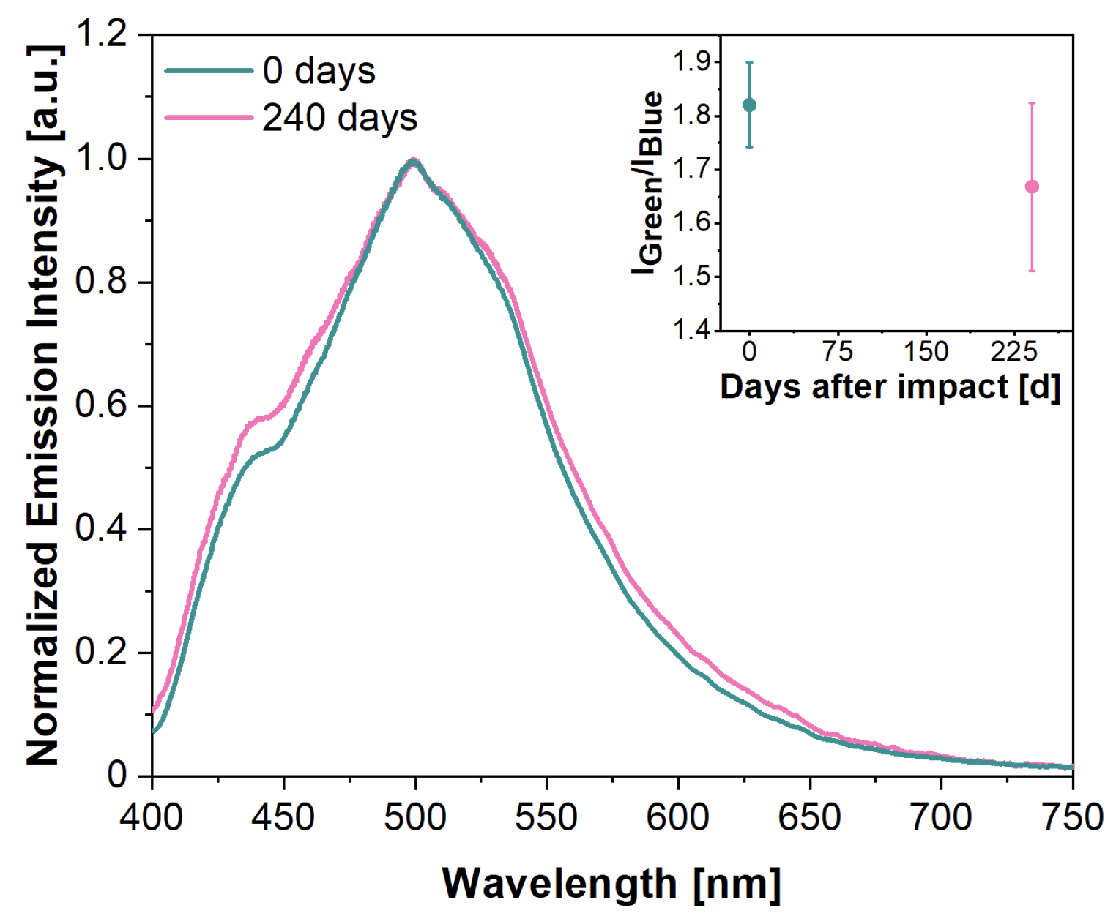
Figure S27. Solid-state emission spectra of 5 wt% PVAc composite impacted with a 2800 N force 0 days after impact (teal) and 240 days after impact (fuchsia); top-right inset displays I_{Green}/I_{Blue} 0 days after impact (teal) and 240 days after impact (fuchsia).

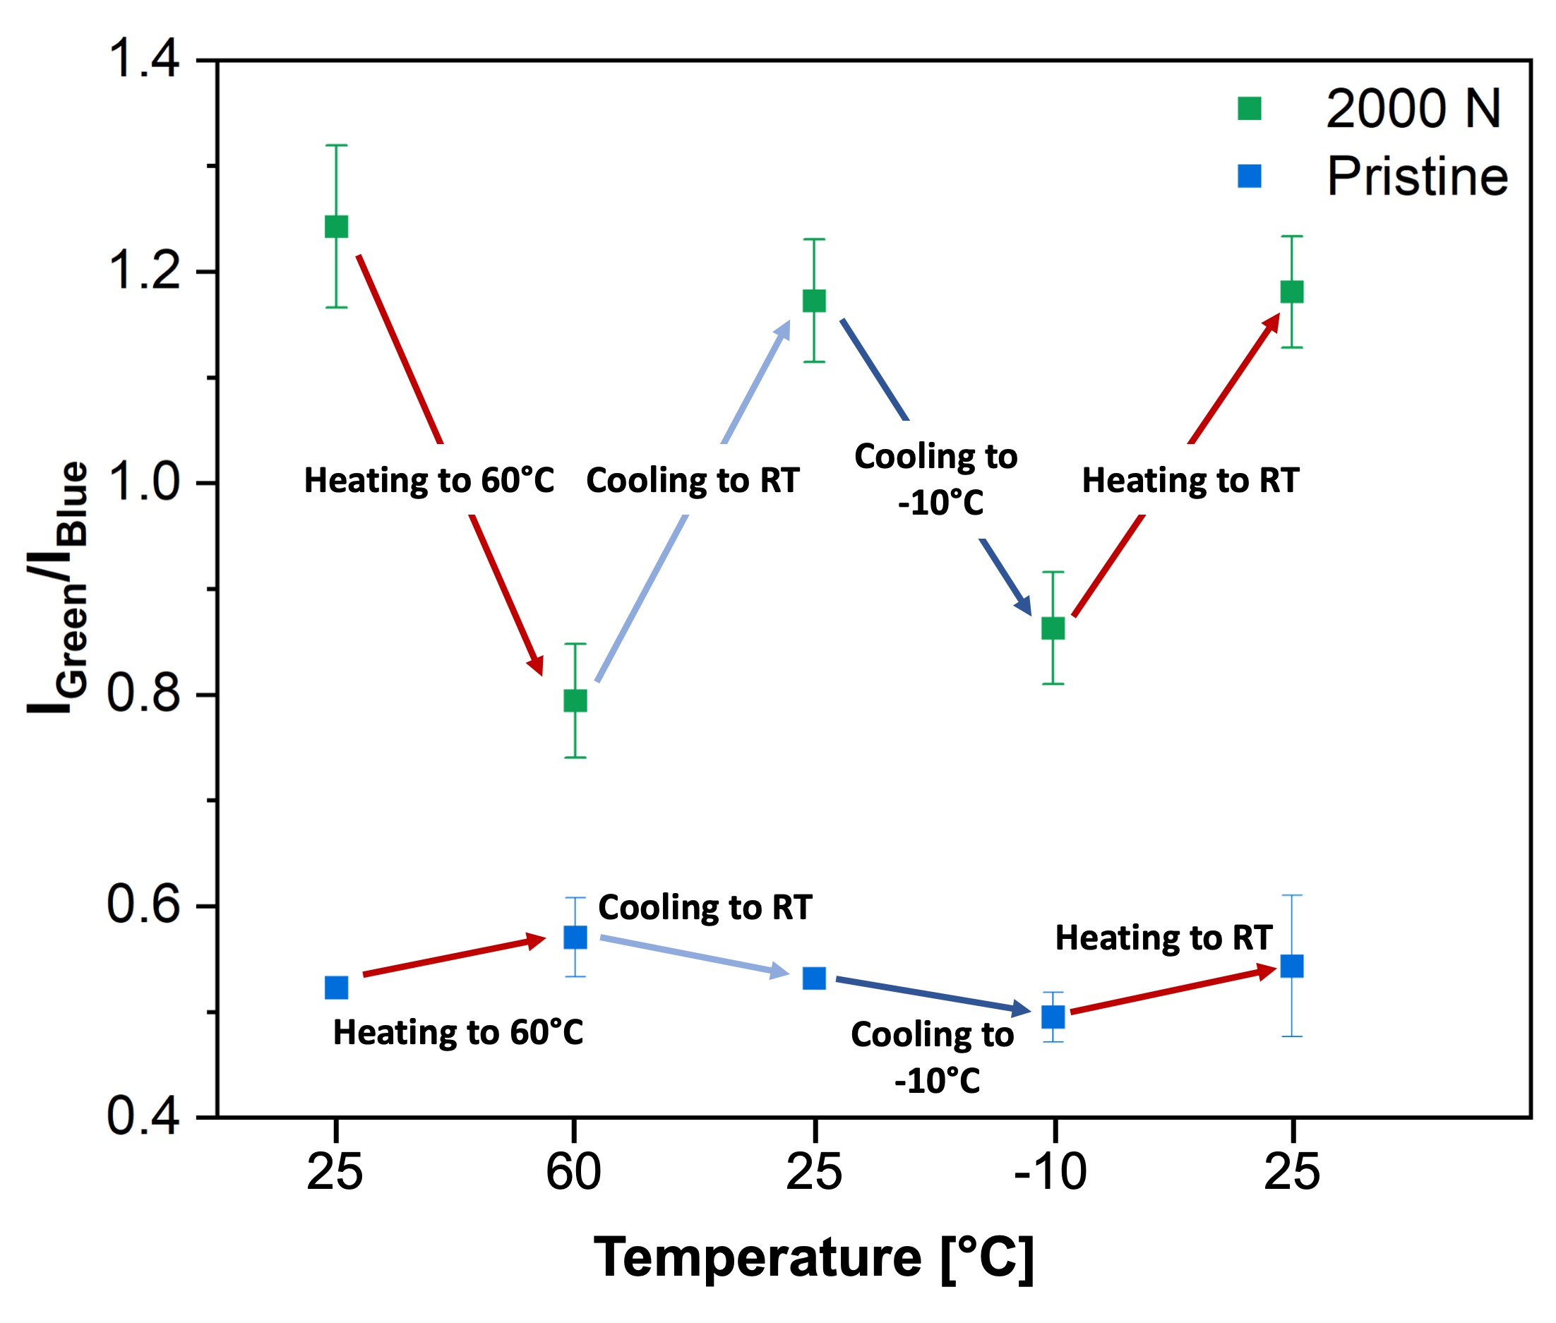
Figure S28. I_{Green}/I_{Blue} as a function of the temperature for 5 wt% PVAc composite impacted with a 2000 N force

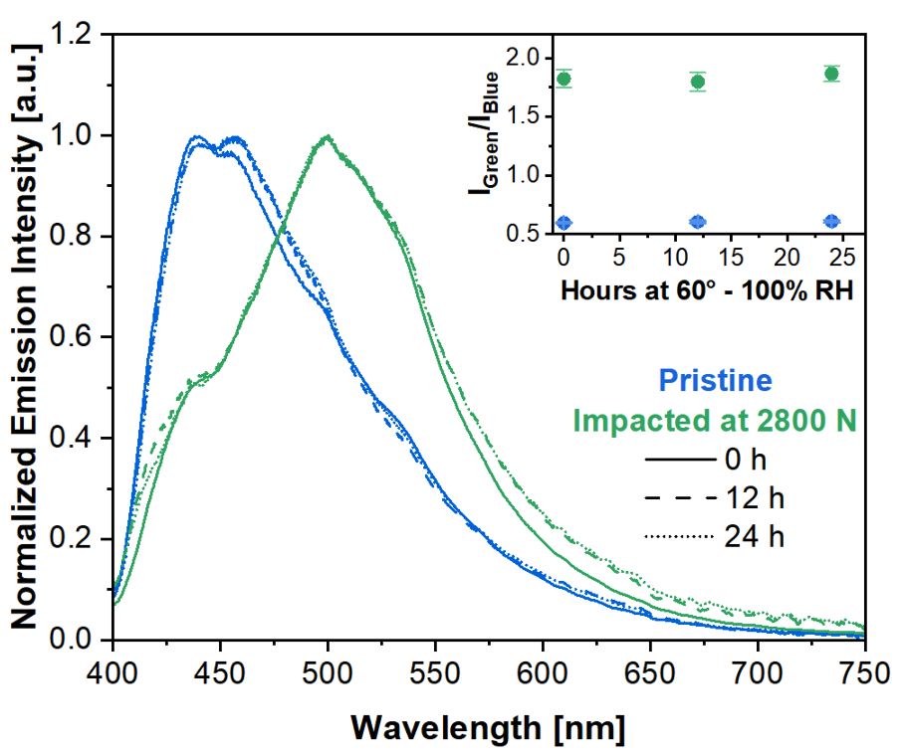
Figure S29. Solid-state emission spectra of 5 wt% PVAc composites pristine (blue line) and impacted with a 2800 N force (green line). The spectra were also recorded after keeping the samples at 60 °C for 12 h at 100% relative humidity (RH) (dashed line) and for 24 h at 60°C at 100% RH (dotted line); top-right inset displays I_{Green}/I_{Blue} for pristine (blue) and impacted (green) sample as a function of time at 60°C and 100% RH.

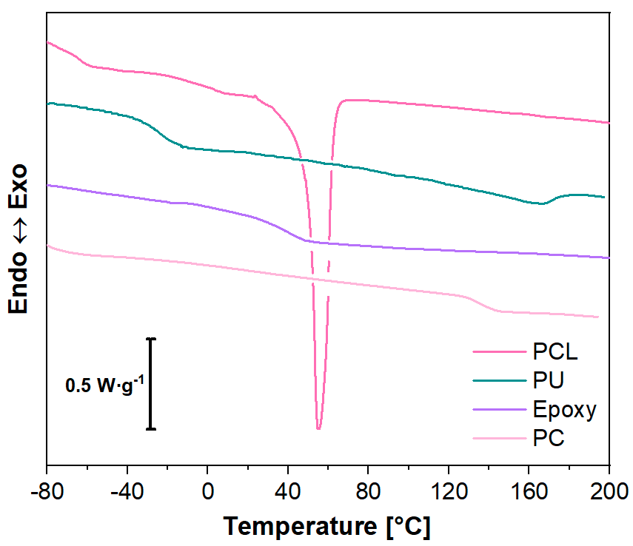
Figure S30. DSC first heating scans of PCL (fuchsia), PU (teal), Epoxy (purple), and PC (pink).

Table S9. Calorimetric data of PCL, PU, Epoxy, and PC (T_{g} = glass transition temperature determined at the mid-point of the step-change transition; ΔC_{p} = specific heat capacity; T_{m} = melting temperature determined at the minimum of the endothermic melting peak; ΔH_{m} = melting enthalpy).

 | T_{g}  [°C] | ∆C_{p}  [J·g⁻¹·°C⁻¹] | T_{m}  [°C] | ∆H_{m}  [J·g⁻¹]
PCL | -58.8 | 0.22 | 65.5 | 82.0
PU | -40.8 | 0.41 | 134.2 | 18.7
Epoxy | 33.8 | 0.31 | - | -
PC | 136.4 | 0.24 | - | -

Table S10. Results of the linear fit of 5 wt% composites prepared by using different polymer matrices subjected to impact tests.

Name | Slope | R²
PCL | 1.2·10⁻⁴ ± 0.3·10⁻⁴ | 0.94
PU | 1.4·10⁻⁴ ± 0.1·10⁻⁴ | 0.99
Epoxy | 3.2·10⁻⁴± 0.08·10⁻⁴ | 0.99
PC | 2.2·10⁻⁴± 0.2·10⁻⁴ | 0.99

4. Supporting video

Video S1. Real-time grinding of [(CuI)3-Br-py]_{n} powder under UV light.

Video S2. Real-time stress-strain experiment on 5 wt% PVAc composite deformed at 24 %·s⁻¹ under UV light.

Video S3. Real-time stress-strain experiment on 10 wt% PVAc composite deformed at 24 %·s⁻¹ under UV light.

Video S4. Real-time stress-strain experiment on SC-2wt% sample under POM (5x magnification).

Video S5. Confocal microscopy XYZ-stacked images of10 wt% PVAc composite impacted at 2800 N (magnification: 20x, λ_{ex} at 401.9 nm, λ_{em} at 450 ± 25 nm and 525 ± 25 nm, objNA: 0.75, pixel size 2.5 um·px⁻¹).

Video S6. Real-time scratching experiment on 5 wt% PVAc composite scratched with a metal spatula under UV light.

Video S7. Real-time bending experiment on 5wt% PVAc composite under UV light.

Video S8. Real-time recycling experiment on 5 wt% PVAc composite scratched with a metal spatula under UV light and recycled using a cotton swab wetted with MeCN.

5. Bibliography
1. P. Scardi, Diffraction Line Profiles in the Rietveld Method. Cryst Growth Des 20, 6903–6916 (2020).
2. P Scardi, Microstructural Properties: Lattice Defects and Domain Size Effects. Powder Diffr 376–413 (2008) doi:10.1039/9781847558237-00376.
3. P. Scardi, M. Leoni, Whole powder pattern modelling. Acta Crystallogr A. 58, 190–200 (2002).
4. P. Scardi, C. L. Azanza Ricardo, C. Perez-Demydenko, A. A. Coelho, Whole powder pattern modelling macros for TOPAS. J Appl Crystallogr 51, 1752–1765 (2018).
5. C. Fandaruff, M. A. Segatto Silva, D. C. Galindo Bedor, D. P. de Santana, H. V. A. Rocha, L. Rebuffi, C. L. Azanza-Ricardo, P. Scardi, S. L. Cuffini, Correlation between microstructure and bioequivalence in Anti-HIV Drug Efavirenz. European Journal of Pharmaceutics and Biopharmaceutics 91, 52–58 (2015).
6. S. Masahara, H. Yokoyama, Y. Suzaki, T. Ide, Convenient synthesis of copper(I) halide quasi-one-dimensional coordination polymers: their structures and solid-state luminescent properties. Dalton Transactions 50, 8889–8898 (2021).
7. A. Ballistreri, S. Foti, G. Montaudo, E. Scamporrino, Evolution of aromatic compounds in the thermal decomposition of vinyl polymers. Journal of Polymer Science: Polymer Chemistry Edition 18, 1147–1153 (1980).
8. N. Grassie, The thermal degradation of polyvinyl acetate. I. Products and reaction mechanism at low temperatures. Transactions of the Faraday Society 48, 379–387 (1952).

