Clinical features in co-occuring obsessive-compulsive disorder and bipolar disorder: a systematic review and meta-analysis

Michele De Prisco ^{1,2,3,4,ψ} (deprisco.michele@gmail.com) (ORCID: 0000-0002-2032-1181);
Cristiana Tapoi ^{5,ψ} (cristiana.tapoi@gmail.com) (ORCID: 0000-0002-2163-1149);
Vincenzo Oliva ^{1,2,3,6} (violiva@recerca.clinic.cat) (ORCID: 0000-0002-5961-6032);
Chiara Possidente ^{2,3,6} (chiara.possidente@studio.unibo.it) (ORCID: 0009-0001-6187-0187);
Robertas Strumila ⁷ (robertas.strumila@gmail.com) (ORCID: 0000-0002-0530-1537);
Christine Takami Lageborn ⁸ (christine.takami.lageborn@ki.se) (ORCID: 0000-0001-6156-5097);
Lorenzo Bracco ^{2,3,9} (lorenzobracco94@gmail.com) (ORCID: 0000-0002-7698-0901);
Nicolaja Girone ¹⁰ (nicolaja.girone@unimi.it) (ORCID: 0000-0003-0761-2096);
Monica Macellaro ¹⁰ (monica.macellaro@unimi.it) (ORCID: 0000-0001-5522-5897);
Eduard Vieta ^{1,2,3,4*} (evieta@clinic.cat) (ORCID: 0000-0002-0548-0053);
Giovanna Fico ^{1,2,3} (gfico@recerca.clinic.cat) (ORCID: 0000-0003-1785-7126)

¹ Institute of Neurosciences (ICN), Department of Medicine, Faculty of Medicine and Health Sciences, Universitat de Barcelona (UB), c. Casanova, 143, 08036 Barcelona, Spain.
² Bipolar and Depressive Disorders Unit, Hospìtal Clinic de Barcelona. c. Villarroel, 170, 08036 Barcelona, Spain.
³ Institut d’Investigacions Biomèdiques August Pi i Sunyer (IDIBAPS), c. Villarroel, 170, 08036 Barcelona, Spain.
⁴ Centro de Investigación Biomédica en Red de Salud Mental (CIBERSAM), Instituto de Salud Carlos III, Madrid, Spain
⁵ Prof. Dr. Dimitrie Gerota Emergency Hospital, Department of Psychiatry, Bucharest, Romania;
⁶ Department of Biomedical and Neuromotor Sciences, University of Bologna, Bologna, Italy;
⁷ Department of Urgent and Post Urgent Psychiatry, CHU Montpellier, 34000 Montpellier, France;
⁸ Department of Medical Epidemiology and Biostatistics, Karolinska Institutet, Stockholm, Sweden;
⁹ Department of Pathophysiology and Transplantation, University of Milan, 20122 Milan, Italy;
¹⁰ Department of Biomedical and Clinical Sciences “Luigi Sacco”, Department of Psychiatry, University of Milan, Milan, Italy

ψ The authors contributed equally

* Corresponding Author
Prof. Eduard Vieta, MD, PhD
Bipolar and Depressive Disorders Unit,
Institute of Neuroscience
IDIBAPS CIBERSAM
Hospital Clinic, University of Barcelona,
170 Villarroel St 12-0, 08036 Barcelona, Catalonia, Spain.
Email: evieta@clinic.cat

Supplementary Materials

Abbreviations used in the Supplementary Materials 3
Appendix I: Deviations from the original protocol 4
Appendix II: Search Strategy 5
Appendix IV: Quality assessment of the included studies, cross-sectional 22
Appendix IV: Quality assessment of the included studies, longitudinal 23
Appendix V: Severity of Obsessive-Compulsive symptomatology 24
Obsessive-Compulsive symptomatology, total symptomatology 24
Obsessive-Compulsive symptomatology, obsessive symptomatology 29
Obsessive-Compulsive symptomatology, compulsive symptomatology 33
Obsessions, number of obsessions, any 37
Obsessions, aggressive obsessions 40
Obsessions, contamination obsessions 44
Obsessions, sexual obsessions 47
Obsessions, hoarding/saving obsessions 51
Obsessions, religious obsessions 54
Obsessions, symmetry/exactness obsessions 58
Obsessions, miscellaneous obsessions 62
Obsessions, somatic obsessions 65
Obsessions, pathological doubt 68
Compulsions, number of compulsions, any 71
Compulsions, cleaning/washing compulsions 74
Compulsions, checking compulsions 79
Compulsions, repeating rituals 82
Compulsions, counting compulsions 86
Compulsions, ordering/arranging compulsions 89
Compulsions, hoarding/collecting compulsions 93
Compulsions, miscellaneous compulsions 97
Appendix VI: Sensitivity analysis, good quality studies only 100
PRISMA Checklist 101

Abbreviations used in the Supplementary Materials

AHRQ - Agency for Healthcare Research and Quality
BD - Bipolar Disorder
CI - Confidence Interval
MDD - Major Depressive Disorder
OCD - Obsessive-Compulsive Disorder
OR - Odds Ratio
PRISMA - Preferred Reporting Items for Systematic Reviews and Meta-Analyses
SMD - Standardized Mean Difference
Y-BOCS - Yale-Brown Obsessive-Compulsive Scale

Appendix I: Deviations from the original protocol

In the original protocol, we planned to conduct sensitivity analyses only by removing one study at the time. However, to better understand the role of the quality of the study on our outcomes, we decided to also conduct one sensitivity analysis considering good-quality studies only.
In addition, we planned to perform meta-regressions only for those meta-analyses that included at least ten studies. However, to better understand the role of different predictors on our results, we decided to explore them whenever high heterogeneity was detected. We added the “age at onset of BD”, the “age at onset of OCD”, the “duration of illness”, and the “% of people with OCD and comorbid MDD” as predictors to be explored through meta-regression analyses.
Finally, the criteria for detecting high heterogeneity were changed to take a more conservative approach. Specifically, the p-value required to detect high heterogeneity was changed from 0.05 to 0.1. In addition, for graphical reasons, the GOSH plots were only shown when the relative meta-analyses included at least five studies.

Appendix II: Search Strategy

PubMed/MEDLINE (07.08.23: 1,590 results)
("bipolar disorder"[Title/Abstract] OR "mania"[Title/Abstract] OR "hypomania"[Title/Abstract] OR "manic"[Title/Abstract] OR "hypomanic"[Title/Abstract] OR "bipolar"[Title/Abstract] OR "bipolar depression"[Title/Abstract] OR "euthymia"[Title/Abstract] OR "euthymic"[Title/Abstract] OR "mixed features"[Title/Abstract] OR "bipolar disorder"[MeSH Terms]) AND ("obsessive compulsive disorder"[Title/Abstract] OR "ocd"[Title/Abstract] OR "obsessive"[Title/Abstract] OR "obsession"[Title/Abstract] OR "compulsive"[Title/Abstract] OR "compulsion"[Title/Abstract] OR "obsessive compulsive disorder"[MeSH Major Topic])

Scopus (07.08.23: 4,385 results)
(TITLE-ABS("bipolar disorder") OR TITLE-ABS(mania) OR TITLE-ABS(hypomania) OR TITLE-ABS(manic) OR TITLE-ABS(hypomanic) OR TITLE-ABS(bipolar) OR TITLE-ABS("bipolar depression") OR TITLE-ABS(euthymia) OR TITLE-ABS(euthymic) OR TITLE-ABS("mixed features") OR INDEXTERMS("bipolar disorder")) AND (TITLE-ABS("obsessive compulsive disorder") OR TITLE-ABS(ocd) OR TITLE-ABS(obsessive) OR TITLE-ABS(obsession) OR TITLE-ABS(compulsive) OR TITLE-ABS(compulsion) OR INDEXTERMS("obsessive compulsive disorder"))

EMBASE (07.08.23: 2,887 results)
('bipolar disorder':ti,ab OR mania:ti,ab OR hypomania:ti,ab OR manic:ti,ab OR hypomanic:ti,ab OR bipolar:ti,ab OR 'bipolar depression':ti,ab OR euthymia:ti,ab OR euthymic:ti,ab OR 'mixed features':ti,ab OR 'bipolar disorder'/exp) AND ('obsessive compulsive disorder':ti,ab OR ocd:ti,ab OR obsessive:ti,ab OR obsession:ti,ab OR compulsive:ti,ab OR compulsion:ti,ab OR 'obsessive compulsive disorder'/exp/mj)

PsycINFO (07.08.23: 1,531 results)
((TI ( bipolar disorder OR bipolar depression OR mania OR manic ) OR TI ( hypomania OR hypomanic OR euthymia OR euthymic state ) OR TI mixed features OR AB ( bipolar disorder OR bipolar depression OR mania OR manic ) OR AB ( hypomania OR hypomanic OR euthymia OR euthymic state ) OR AB mixed features) AND (TI ( obsessive compulsive disorder or ocd ) OR TI ( obession OR obsessive ) OR TI ( compulsion or compulsive ) OR AB ( obsessive compulsive disorder or ocd ) OR AB ( obession OR obsessive ) OR AB ( compulsion or compulsive ))

Appendix III: Excluded studies with reasons

Authors., year | Reason
(Abdel Hamid et al., 2019) | Wrong population
(Abdel-Khalek and Lester, 2002) | Wrong population
(Abreu et al., 2011) | Wrong population
(Abreu et al., 2012) | Wrong population
(Adam et al., 2012) | Wrong outcome
(Agius et al., 2012; Bosanac et al., 2016) | Wrong publication type
(Aguglia et al., 2017) | Wrong population
(Ahn et al., 2022) | Wrong population
(Albert et al., 2012) | Wrong outcome
(Amerio et al., 2016) | Wrong publication type
(Angst et al., 2004) | Wrong outcome
(Angst et al., 2005) | Wrong outcome
(Anholt et al., 2014) | Wrong outcome
(Assarian et al., 2012) | Wrong population
(Baptista et al., 2020) | Wrong population
(Baxter Jr et al., 1989) | Wrong population
(Benatti et al., 2014) | Wrong outcome
(Benatti et al., 2022) | Wrong population
(Bener et al., 2016) | Wrong population
(Besiroglu and Selvi, 2013) | Wrong publication type
(Bogetto et al., 1999) | Wrong outcome
(Bole et al., 2012) | Wrong population
(Bosanac et al., 2013) | Wrong population
(Bosanac et al., 2016) | Wrong population
(Bramante et al., 2021a) | Wrong publication type
(Bramante et al., 2021b) | Data not stratified according to our research question
(Breet et al., 2014) | Wrong outcome
(Cabrera, 2015) | Wrong publication type
(Carta et al., 2020) | Wrong outcome
(Cederlöf et al., 2015) | Wrong population
(Cervin et al., 2022) | Wrong population
(Chabardes et al., 2020) | Wrong population
(Chen et al., 2022) | Wrong population
(Chen and Dilsaver, 1995) | Wrong population
(Christmas and Matthews, 2017) | Wrong publication type
(Cooke, 1995) | Wrong population
(Costa et al., 2013) | Wrong population
(Cunha and Caetano, 1996) | Unrelated to our research question
(d'Ambrosio et al., 2012a) | Wrong population
(D'Ambrosio et al., 2012b) | Wrong population
(da Rocha et al., 2011) | Wrong population
(Darby et al., 2011) | Wrong publication type
(de Avila et al., 2019) | Wrong population
(Di Salvo et al., 2020) | Wrong population
(Dilbaz and Darcin Enez, 2014) | Wrong population
(Dilsaver et al., 2008) | Wrong population
(Du et al., 2017) | Wrong population
(Efe et al., 2022) | Wrong population
(Fanelli et al., 2022) | Wrong population
(Faravelli et al., 2006) | Wrong population
(Feenstra et al., 2011) | Wrong population
(Ferentinos et al., 2020) | Wrong population
(Filomensky et al., 2012) | Wrong population
(Fineberg et al., 2012) | Wrong population
(Fineberg et al., 2013) | Wrong population
(Fistikci et al., 2012) | Wrong publication type
(Flick et al., 1993) | Wrong population
(Fontenelle et al., 2004) | Wrong population
(Fornaro et al., 2020) | Wrong population
(Fornaro and Perugi, 2010) | Wrong population
(Fracalanza et al., 2011) | Wrong population
(Frare et al., 2004) | Wrong population
(Freeman et al., 2002) | Wrong publication type
(Gajera et al., 2016) | Wrong population
(Galimberti et al., 2020) | Wrong population
(Gao et al., 2008) | Wrong population
(Go et al., 1998) | Wrong publication type
(Goes et al., 2012) | Wrong population
(Gojer et al., 1987) | Wrong population
(Goodwin et al., 2002) | Wrong population
(Graat et al., 2019) | Wrong population
(Graat et al., 2020) | Wrong publication type
(Gunduz et al., 2016) | Wrong publication type
(Hamidi et al., 2007) | Wrong population
(Hamidian et al., 2020) | Wrong publication type
(Hankin et al., 2008) | Wrong publication type
(Hantouche et al., 2002b) | Not diagnosed according DSM/ICD criteria
(Hantouche et al., 2002a) | Duplicate
(Hantouche et al., 2002d) | Not diagnosed according DSM/ICD criteria
(Hantouche et al., 2002c) | Not diagnosed according DSM/ICD criteria
(Hantouche et al., 2002e) | Not diagnosed according DSM/ICD criteria
(Hantouche et al., 2003) | Wrong population
(Hasbek et al., 2013) | Wrong population
(Hasler et al., 2005) | Unrelated to our research question
(Hasler et al., 2007) | Wrong population
(Hassani and Kia, 2016) | Wrong population
(Hellberg et al., 2022) | Wrong population
(Henry et al., 2003) | Wrong population
(Hofer et al., 2018) | Wrong population
(Holma et al., 2008) | Wrong population
(Huang et al., 2021) | Wrong population
(Iro and O'Connor, 2009) | Wrong population
(Issler et al., 2005) | Wrong population
(Issler et al., 2010) | Wrong population
(Jacobsen, 1995) | Wrong population
(Jefferson et al., 1991) | Wrong population
(Jeon et al., 2017) | Wrong publication type
(Jeon et al., 2018) | Wrong population
(Joshi et al., 2010) | Wrong population
(Joshi and Wilens, 2009) | Wrong publication type
(Joyce et al., 2007) | Wrong population
(Juckel et al., 2014) | Wrong population
(Kamat et al., 2008) | Wrong population
(Katsuji et al., 2001) | Wrong population
(Kazhungil et al., 2017) | Wrong population
(Kelmendi et al., 2011) | Wrong population
(Keskin and Tamam, 2014) | Wrong population
(Khan, 2019) | Wrong population
(Khosravani et al., 2021) | Wrong population
(Kim et al., 2012) | Wrong population
(Kim et al., 2014) | Wrong population
(Kocabaş et al., 2017) | Wrong publication type
(Kochman et al., 2002) | Unrelated to our research question
(Koyuncu et al., 2010) | Wrong population
(Krüger et al., 2000) | Wrong population
(Krüger et al., 1995) | Wrong population
(Lee and Dunner, 2008) | Wrong population
(Lensi et al., 1996) | Wrong population
(Lester and Abdel-Khalek, 1999) | Wrong publication type
(Magalhães et al., 2010) | Wrong population
(Maina et al., 2007) | Subsample of another study
(Maina et al., 2003) | Wrong publication type
(Maina et al., 2018) | Wrong publication type
(Masi et al., 2004) | Subsample of another study
(Melca et al., 2015) | Wrong population
(Mota-Castillo, 2011) | Wrong publication type
(Mucci et al., 2018) | Wrong publication type
(Nebhinani et al., 2012) | Wrong publication type
(Nestadt et al., 2009) | Wrong population
(Nestadt et al., 2001) | Wrong population
(Oral et al., 2009) | Wrong publication type
(Özdemir et al., 2015) | Wrong population
(Papolos et al., 2005) | Wrong population
(Pashinian et al., 2006) | Wrong population
(Paul et al., 2013) | Wrong publication type
(Paul et al., 2015) | Wrong population
(Peng et al., 2012) | Wrong population
(Perugi et al., 1999) | Wrong population
(Perugi et al., 2001) | Wrong population
(Perugi et al., 2002) | Wrong publication type
(Phelps, 2016) | Wrong population
(Pini et al., 1997) | Wrong population
(Pini et al., 2003) | Wrong population
(Pini et al., 2006) | Wrong population
(Poyurovsky et al., 2020) | Wrong publication type
(Poyurovsky and Weizman, 2021a) | Wrong population
(Poyurovsky and Weizman, 2021b) | Wrong publication type
(Raja, 2005) | Wrong population
(Ratheesh et al., 2011) | Duplicate
(Ravizza et al., 1997a) | Wrong population
(Ravizza et al., 1997b) | Unrelated to our research question
(Rodriguez, 2016) | Wrong publication type
(Rodriguez et al., 2016) | Wrong population
(Ross et al., 2008) | Wrong population
(Rueda-Jaimes et al., 2009) | Wrong publication type
(Russo et al., 2010) | Wrong publication type
(Sachdeva et al., 2022) | Wrong publication type
(Sahraian et al., 2014) | Wrong population
(Sahraian et al., 2018) | Wrong population
(Sahraian et al., 2022) | Wrong population
(Şair and Şair, 2022) | Wrong population
(Salvo et al., 2021) | Wrong population
(Santana et al., 2013) | Wrong population
(Saraf et al., 2017) | Data not stratified according to our research question
(Sarkhel et al., 2010) | Wrong publication type
(Saunders et al., 2012) | Wrong outcome
(Scherk et al., 2008) | Wrong outcome
(Scherk et al., 2009) | Wrong outcome
(Segalas et al., 2013) | Wrong publication type
(Sevincok et al., 2020) | Wrong population
(Sharma et al., 2021) | Wrong population
(Sharma et al., 2008) | Wrong population
(Shashidhara et al., 2015) | Wrong population
(Someshwar et al., 2020) | Wrong outcome
(Spangler et al., 1996) | Unrelated to our research question
(Stieglitz et al., 1989) | Wrong population
(Storch et al., 2015) | Wrong population
(Strom et al., 2021) | Wrong population
(Tackett et al., 2008) | Wrong population
(Tamam and Ozpoyraz, 2002) | Wrong population
(Thaipisuttikul et al., 2014) | Wrong population
(Thomsen, 1992) | Wrong population
(Toni et al., 2008) | Wrong population
(Tonna et al., 2016) | Wrong publication type
(Tonna et al., 2021) | Wrong population
(Topal et al., 2015) | Wrong publication type
(Toprak et al., 2011) | Wrong publication type
(Torres et al., 2014) | Wrong population
(Trost et al., 2011) | Wrong publication type
(Tükel et al., 2007) | Data not stratified according to our research question
(Tukel et al., 2013) | Wrong population
(Tunca et al., 2015) | Wrong population
(Tundo et al., 2021) | Wrong population
(Tundo et al., 2007) | Wrong population
(van Oudheusden et al., 2020) | Data not stratified according to our research question
(Vaschetto et al., 1996) | Unrelated to our research question
(Vats et al., 2020) | Wrong population
(Visinet et al., 2017) | Wrong population
(Viswanath et al., 2010) | Wrong publication type
(Voort et al., 2016) | Wrong publication type
(Vorstenbosch and Laposa, 2015) | Wrong population
(Wheaton et al., 2008) | Wrong population
(White et al., 2015) | Wrong population
(Yang et al., 2015) | Wrong publication type
(Ye et al., 2019) | Wrong population
(Yildirim et al., 2009) | Wrong publication type
(Yu et al., 2022) | Wrong population
(Zerdziński, 2016) | Wrong population
(Zetsche et al., 2015) | Wrong population
(Zhang et al., 2019) | Wrong publication type

References

Abdel Hamid, A.A.L., Nasreldin, M., Gohar, S.M., Saleh, A.A., Tarek, M.A., 2019. Sexual and Religious Obsessions in Relation to Suicidal Ideation in Bipolar Disorder. Suicide & life-threatening behavior 49, 1552-1559.
Abdel-Khalek, A., Lester, D., 2002. Manic-depressiveness, obsessive-compulsive tendencies, and suicidality in Kuwaiti college students. Psychological reports 90, 1007-1008.
Abreu, L.N., Nery, F.G., Miranda-Scippa, A.M., Kapczinski, F., Lafer, B., 2011. Clinical characteristics of suicide attempters among bipolar disorder patients - Results from the Brazilian Research Consortium for Bipolar Disorders. Bipolar Disorders 13, 27.
Abreu, L.N., Nery, F.G., Scippa, A.M., Kapczinski, F., Lafer, B., 2012. Impact of first-episode polarity on clinical features associated to suicide attempts in bipolar disorder type I patients. Bipolar Disorders 14, 38.
Adam, Y., Meinlschmidt, G., Gloster, A.T., Lieb, R., 2012. Obsessive-compulsive disorder in the community: 12-month prevalence, comorbidity and impairment. Social psychiatry and psychiatric epidemiology 47, 339-349.
Agius, M., Darby, L., Zaman, R., 2012. Co-morbidity of obsessive compulsive disorder and bipolar affective disorder in a bedford community psychiatry team. European Psychiatry 27.
Aguglia, A., Di Stefano, A., Maina, G., 2017. A 10-year evaluation on adolescents with anxiety disorders: are they at risk of bipolarity? International Journal of Psychiatry in Clinical Practice 21, 125-130.
Ahn, K., Norman, L.J., Justice, C.M., Shaw, P., 2022. ADHD and its neurocognitive substrates: A two sample Mendelian randomization study. Translational Psychiatry 12.
Albert, U., Aguglia, A., Barbaro, F., De Cori, D., Maina, G., Bogetto, F., 2012. Gender related differences in obsessive-compulsive disorder: A clinical study on a sample of 415 patients. Quaderni Italiani di Psichiatria 31, 190-200.
Amerio, A., Stubbs, B., Odone, A., Tonna, M., Marchesi, C., Ghaemi, S.N., 2016. Bipolar I and II disorders; A systematic review and meta-analysis on differences in comorbid obsessive-compulsive disorder. Iranian Journal of Psychiatry and Behavioral Sciences 10.
Angst, J., Gamma, A., Endrass, J., Goodwin, R., Ajdacic, V., Eich, D., Rössler, W., 2004. Obsessive-compulsive severity spectrum in the community: Prevalence, comorbidity, and course. European Archives of Psychiatry and Clinical Neuroscience 254, 156-164.
Angst, J., Gamma, A., Endrass, J., Hantouche, E., Goodwin, R., Ajdacic, V., Eich, D., Rössler, W., 2005. Obsessive-compulsive syndromes and disorders: Significance of comorbidity with bipolar and anxiety syndromes. European Archives of Psychiatry and Clinical Neuroscience 255, 65-71.
Anholt, G.E., Aderka, I.M., van Balkom, A.J., Smit, J.H., Schruers, K., van der Wee, N.J., Eikelenboom, M., De Luca, V., van Oppen, P., 2014. Age of onset in obsessive-compulsive disorder: admixture analysis with a large sample. Psychological medicine 44, 185-194.
Assarian, F., Davari, R., Arab Gol, F., Ghoreishi, Z., 2012. Comparison of comorbidity pattern of obsessive compulsive disorder in children and adults with bipolar I disorder. Bipolar Disorders 14, 55.
Baptista, T., Galué, L., Martínez, F., 2020. Bidirectional comorbidity between bipolar-and obsessive-compulsive disorders: Symptoms frequency, treatment challenges and underexplored areas. Investigacion Clinica (Venezuela) 61, 189-195.
Baxter Jr, L.R., Schwartz, J.M., Phelps, M.E., Mazziotta, J.C., Guze, B.H., Selin, C.E., Gerner, R.H., Sumida, R.M., 1989. Reduction of prefrontal cortex glucose metabolism common to three types of depression. Archives of General Psychiatry 46, 243-250.
Benatti, B., Dell'Osso, B., Arici, C., Hollander, E., Altamura, A.C., 2014. Characterizing impulsivity profile in patients with obsessive–compulsive disorder. International Journal of Psychiatry in Clinical Practice 18, 156-160.
Benatti, B., Lucca, G., Zanello, R., Fesce, F., Priori, A., Poloni, N., Callegari, C., Fontenelle, L.F., Dell'osso, B., 2022. Application of a staging model in patients with obsessive-compulsive disorder: Cross-sectional and follow-up results. CNS Spectrums 27, 218-224.
Bener, A., Dafeeah, E.E., Abdulla, M.A., Abou-Saleh, M.T., Ventriglio, A., 2016. Comorbid obsessive-compulsive disorder and bipolar disorder in a highly endogamous population: which came first? Int. J. Cult. Ment. Health 9, 407-413.
Besiroglu, L., Selvi, Y., 2013. Obsessive compulsive symptoms may precipitate manic, mixed or hypomanic episodes in patients with bipolar disorder. Klinik Psikofarmakoloji Bulteni 23, 6-7.
Bogetto, F., Venturello, S., Albert, U., Maina, G., Ravizza, L., 1999. Gender-related clinical differences in obsessive-compulsive disorder. European Psychiatry 14, 434-441.
Bole, R.M., Kadam, M.S., Matcheswalla, Y.A., Kale, V.P., 2012. Neuro-cognitive defcit in bipolar & obsessive compulsive disorder patients. Indian Journal of Psychiatry 54, S48.
Bosanac, P., Mancuso, S., Castle, D., 2013. Anxiety symptoms in psychotic disorders. Clin Schizophr Relat Psychoses, 1-22.
Bosanac, P., Mancuso, S.G., Castle, D.J., 2016. Anxiety symptoms in psychotic disorders: results from the second australian national mental health survey. Clinical Schizophrenia and Related Psychoses 10, 93-100.
Bramante, S., Borsotti, A., Rigardetto, S., Maina, G., 2021a. The role of mood disorders in the longitudinal course of obsessive-compulsive disorder: Preliminary data from a 20-year prospective follow-up study. European Psychiatry 64, S135.
Bramante, S., Quarato, F., Mehanović, E., Rigardetto, S., Maina, G., 2021b. The forbidden thoughts dimension and psychiatric comorbidities in a large sample of OCD patients: A possible link to bipolar I comorbid disorder. Journal of Obsessive-Compulsive and Related Disorders 29.
Breet, E., Kidd, M., Stein, D., Lochner, C., 2014. Suicidality in OCD. South African Journal of Psychiatry 20, 116.
Cabrera, C., 2015. Managing Mania and Obsessive-Compulsive Disorder, Handbook of Psychotropic Herbs: A Scientific Analysis of Herbal Remedies for Psychiatric Conditions. Taylor and Francis, pp. 273-281.
Carta, M.G., Fineberg, N., Moro, M.F., Preti, A., Romano, F., Balestrieri, M., Caraci, F., Dell'Osso, L., Disciascio, G., Drago, F., Hardoy, M.C., Roncone, R., Minerba, L., Faravelli, C., Angst, J., 2020. The Burden of Comorbidity Between Bipolar Spectrum and Obsessive-Compulsive Disorder in an Italian Community Survey. Frontiers in Psychiatry 11.
Cederlöf, M., Lichtenstein, P., Larsson, H., Boman, M., Rück, C., Landén, M., Mataix-Cols, D., 2015. Obsessive-compulsive disorder, psychosis, and bipolarity: A longitudinal cohort and multigenerational family study. Schizophrenia Bulletin 41, 1076-1083.
Cervin, M., do Rosário, M.C., Fontenelle, L.F., Ferrão, Y.A., Batistuzzo, M.C., Torres, A.R., Damiano, R.F., Fernández de la Cruz, L., Miguel, E.C., Mataix-Cols, D., 2022. Taboo obsessions and their association with suicidality in obsessive-compulsive disorder. Journal of Psychiatric Research 154, 117-122.
Chabardes, S., Krack, P., Piallat, B., Bougerol, T., Seigneuret, E., Yelnik, J., Fernandez Vidal, S., David, O., Mallet, L., Benabid, A.L., Polosan, M., 2020. Deep brain stimulation of the subthalamic nucleus in obsessive-compulsives disorders: Long-term follow-up of an open, prospective, observational cohort. Journal of Neurology, Neurosurgery and Psychiatry 91, 1349-1356.
Chen, M.H., Tsai, S.J., Liang, C.S., Cheng, C.M., Su, T.P., Chen, T.J., Bai, Y.M., 2022. Diagnostic progression to schizophrenia in 35,255 patients with obsessive–compulsive disorder: a longitudinal follow-up study. European Archives of Psychiatry and Clinical Neuroscience.
Chen, Y.-W., Dilsaver, S.C., 1995. Comorbidity for obsessive-compulsive disorder in bipolar and unipolar disorders. Psychiatry Research 59, 57-64.
Christmas, D., Matthews, K., 2017. Deep brain stimulation for OCD: Using an individual patient-level registry to explore patient characteristics and clinical outcomes. Stereotactic and Functional Neurosurgery 95, 358.
Cooke, R.G., 1995. Comorbidity of obsessive compulsive disorder in bipolar disorder. Journal of Affective Disorders 34, 117-120.
Costa, D.L.C., Diniz, J.B., Ferrão, Y.A., Rosario- Campos, M.C., Miguel, E.C., Shavitt, R.G., Torres, A.R., Fontenelle, L.F., 2013. Fear of dying and fear of guilt: Panic disorder/agoraphobia comorbidity in obsessive-compulsive disorder. European Neuropsychopharmacology 23, S513.
Cunha, J.R., Caetano, D., 1996. Distúrbio obsessivo–compulsivo: características sócio-demográficas e clínicas de 50 pacientes através de seus prontuários Terceira parte: diagnóstico diferencial e comorbidade = Obsessive–compulsive disorder (OCD): The social-demographic and clinical characteristics of 50 patients. Jornal Brasileiro de Psiquiatria 45, 531-534.
d'Ambrosio, V., Albert, U., Boccolini, F.D., Mirra, M., Bogetto, F., Maina, G., 2012a. Il temperamento ciclotimico nei pazienti con DOC = Cyclothymic temperament in obsessive-compulsive disorder's patients. Minerva Psichiatrica 53, 91-100.
D'Ambrosio, V., Albert, U., Domene Boccolini, F., Mirra, M., Bogetto, F., Maina, G., 2012b. Cyclothymic temperament in obsessive-compulsive disorder's patients. Minerva Psichiatrica 53, 91-100.
da Rocha, F.F., Alvarenga, N.B., Malloy-Diniz, L., Corrêa, H., 2011. Decision-making impairment in obsessive-compulsive disorder as measured by the Iowa Gambling task. Arquivos de Neuro-Psiquiatria 69, 642-647.
Darby, L., Agius, M., Zaman, R., 2011. Co-morbidity of bipolar affective disorder and obsessive compulsive disorder in a bedford community psychiatry team. Psychiatria Danubina 23, S130-S133.
de Avila, R.C.S., do Nascimento, L.G., Porto, R.L.d.M., Fontenelle, L., Filho, E.C.M., Brakoulias, V., Ferrão, Y.A., 2019. Level of insight in patients with obsessive–compulsive disorder: An exploratory comparative study between patients with 'good insight' and 'poor insight'. Frontiers in Psychiatry 10.
Di Salvo, G., Maina, G., Pessina, E., Teobaldi, E., Barbaro, F., Martini, A., Albert, U., Rosso, G., 2020. Aripiprazole Augmentation to Mood Stabilizers for Obsessive-Compulsive Symptoms in Bipolar Disorder. Medicina (Kaunas, Lithuania) 57.
Dilbaz, N., Darcin Enez, A., 2014. Anxiety disorders comorbidity in bipolar patients in Turkey. Bipolar Disorders 16, 112.
Dilsaver, S.C., Benazzi, F., Akiskal, K.K., Akiskal, H.S., 2008. Differential patterns of lifetime multiple anxiety disorder comorbidity between Latino adults with bipolar I and major depressive disorders. Bulletin of the Menninger Clinic 72, 130-148.
Du, N., Zhou, Y.-l., Zhang, X., Guo, J., Sun, X.-l., 2017. Do some anxiety disorders belong to the prodrome of bipolar disorder? A clinical study combining retrospective and prospective methods to analyse the relationship between anxiety disorder and bipolar disorder from the perspective of biorhythms. BMC Psychiatry 17.
Efe, A., Açikel, S.B., Uygun, S.D., Canli, M., Temeltürk, R.D., Gürel, Y., Çetinkaya, M., Çakmak, F.H., 2022. A Retrospective Evaluation on Demographic, Phenomenological, and Comorbidity Features of Pediatric Obsessive-Compulsive Disorder. Journal of Nervous and Mental Disease 210, 6-25.
Fanelli, G., Franke, B., De Witte, W., Ruisch, I.H., Haavik, J., van Gils, V., Jansen, W.J., Vos, S.J.B., Lind, L., Buitelaar, J.K., Banaschewski, T., Dalsgaard, S., Serretti, A., Mota, N.R., Poelmans, G., Bralten, J., 2022. Insulinopathies of the brain? Genetic overlap between somatic insulin-related and neuropsychiatric disorders. Translational Psychiatry 12.
Faravelli, C., Rosi, S., Alessandra Scarpato, M., Lampronti, L., Amedei, S.G., Rana, N., 2006. Threshold and subthreshold bipolar disorders in the Sesto Fiorentino Study. Journal of Affective Disorders 94, 111-119.
Feenstra, D.J., Busschbach, J.J.V., Verheul, R., Hutsebaut, J., 2011. Prevalence and comorbidity of axis I and axis II disorders among treatment refractory adolescents admitted for specialized psychotherapy. Journal of Personality Disorders 25, 842-850.
Ferentinos, P., Tzima, S., Tzavara, H., Porichi, E., Dikeos, D., Papageorgiou, C., Douzenis, A., 2020. Temperament and character profile of anxiety disorder comorbidity in bipolar disorder. European Psychiatry 63, S65-S66.
Filomensky, T.Z., Almeida, K.M., Castro Nogueira, M.C., Diniz, J.B., Lafer, B., Borcato, S., Tavares, H., 2012. Neither bipolar nor obsessive-compulsive disorder: Compulsive buyers are impulsive acquirers. Comprehensive Psychiatry 53, 554-561.
Fineberg, N.A., Hengartner, M., Bergbaum, C., Gale, T.M., Jefferies, K., Rössler, W., Angst, J., 2012. Lifetime comorbidity of obsessive-compulsive disorder and sub-threshold obsessive-compulsive symptomatology in the community: Impact, prevalence, socio-demographic and clinical characteristics. Neuropsychopharmacology 38, S360.
Fineberg, N.A., Hengartner, M.P., Bergbaum, C., Gale, T., Rössler, W., Angst, J., 2013. Lifetime comorbidity of obsessive-compulsive disorder and sub-threshold obsessive-compulsive symptomatology in the community: Impact, prevalence, socio-demographic and clinical characteristics. International Journal of Psychiatry in Clinical Practice 17, 188-196.
Fistikci, N., Hacioglu, M., Erek, S., Tabu, A., Erten, E., Saatcioglu, O., 2012. Affective temperament characteristics and bipolar disorder comorbidity in obsessive compulsive disorder. Bipolar Disorders 14, 73.
Flick, S.N., Roy-Byrne, P.P., Cowley, D.S., Shores, M.M., Dunner, D.L., 1993. DSM-III—R personality disorders in a mood and anxiety disorders clinic: Prevalence, comorbidity, and clinical correlates. Journal of Affective Disorders 27, 71-79.
Fontenelle, L.F., Mendlowicz, M.V., Soares, I.D., Versiani, M., 2004. Patients with obsessive-compulsive disorder and hoarding symptoms: A distinctive clinical subtype? Comprehensive Psychiatry 45, 375-383.
Fornaro, M., Novello, S., Fusco, A., Anastasia, A., De Prisco, M., Mondin, A.M., Mosca, P., Iasevoli, F., de Bartolomeis, A., 2020. Clinical features associated with early drop-out among outpatients with unipolar and bipolar depression. Journal of Psychiatric Research.
Fornaro, M., Perugi, G., 2010. The impact of premenstrual dysphoric disorder among 92 bipolar patients. European Psychiatry 25, 450-454.
Fracalanza, K.A., McCabe, R.E., Taylor, V.H., Antony, M.M., 2011. Bipolar disorder comorbidity in anxiety disorders: Relationship to demographic profile, symptom severity, and functional impairment. European Journal of Psychiatry 25, 223-233.
Frare, F., Perugi, G., Ruffolo, G., Toni, C., 2004. Obsessive-compulsive disorder and body dysmorphic disorder: A comparison of clinical features. European Psychiatry 19, 292-298.
Freeman, M.P., Freeman, S.A., McElroy, S.L., 2002. The comorbidity of bipolar and anxiety disorders: Prevalence, psychobiology, and treatment issues. Journal of Affective Disorders 68, 1-23.
Gajera, G., Ram, R., Chandrani, K., 2016. Association of stigma and self-esteem in patients suffering from psychiatric illness. Indian Journal of Psychiatry 58, S135.
Galimberti, C., Caricasole, V., Bosi, M.F., Viganò, C.A., Ketter, T.A., Dell'Osso, B., 2020. Clinical features and patterns of psychopharmacological prescription in bipolar patients with vs without anxiety disorders at onset. Early Intervention in Psychiatry 14, 714-722.
Gao, K., Tolliver, B.K., Kemp, D.E., Verduin, M.L., Ganocy, S.J., Bilali, S., Brady, K.T., Shim, S.S., Findling, R.L., Calabrese, J.R., 2008. Differential interactions between comorbid anxiety disorders and substance use disorder in rapid cycling bipolar I or II disorder. Journal of Affective Disorders 110, 167-173.
Go, F.S., Malley, E.E., Birmaher, B., Rosenberg, D.R., 1998. Manic behaviors associated with fluoxetine in three 12- to 18-year-olds with obsessive-compulsive disorder. Journal of Child and Adolescent Psychopharmacology 8, 73-80.
Goes, F.S., McCusker, M.G., Bienvenu, O.J., Mackinnon, D.F., Mondimore, F.M., Schweizer, B., Depaulo, J.R., Potash, J.B., 2012. Co-morbid anxiety disorders in bipolar disorder and major depression: familial aggregation and clinical characteristics of co-morbid panic disorder, social phobia, specific phobia and obsessive-compulsive disorder. Psychol Med 42, 1449-1459.
Gojer, J., Khanna, S., Channabasavanna, S.M., 1987. Obsessive compulsive disorder, anxiety and depression. Indian J. Psychol. Med. 10, 25-30.
Goodwin, R.D., Stayner, D.A., Chinman, M.J., Wu, P., Tebes, J.K., Davidson, L., 2002. The relationship between anxiety and substance use disorders among individuals with severe affective disorders. Comprehensive Psychiatry 43, 245-252.
Graat, I., van Rooijen, G., Mocking, R., de Koning, P., Denys, D., 2019. Is comorbid autism or bipolar disorder a contra-indication for DBS in patients with OCD? Brain Stimulation 12, 556.
Graat, I., van Rooijen, G., Mocking, R., Vulink, N., de Koning, P., Schuurman, R., Denys, D., 2020. Is deep brain stimulation effective and safe for patients with obsessive compulsive disorder and comorbid bipolar disorder? Journal of Affective Disorders 264, 69-75.
Gunduz, Y., Coskun, M., Kaya, I., Zoroglu, S.S., 2016. Phenomenology and psychiatric comorbidity in young subjects with bipolar disorder. Klinik Psikofarmakoloji Bulteni 26, S145.
Hamidi, A., Jahanguiri, B., Esfahani, M.N., Dadfar, M., 2007. Naltrexone in obsessive-compulsive disorder: An open- label trial. Iranian Journal of Psychiatry and Behavioral Sciences 1, 16-21.
Hamidian, S., Pourshahbaz, A., Bozorgmehr, A., Ananloo, E.S., Dolatshahi, B., Ohadi, M., 2020. How obsessive–compulsive and bipolar disorders meet each other? An integrative gene-based enrichment approach. Annals of General Psychiatry 19.
Hankin, C., Koran, L.M., Culpepper, L., Dunn, J.D., Black, D.W., Hollander, E., Knispel, J., Wang, Z., Bronstone, A., Dougherty, D.D., Levin, A., 2008. Patients with “pure OCD” incur higher 2-year psychotropic costs than patients with “pure depression”. European Neuropsychopharmacology 18, S485.
Hantouche, E.G., Akiskal, H.S., Demonfaucon, C., Barrot, I., Kochman, F., Millet, B., Lancrenon, S., Allilaire, J.F., 2002a. Bipolarité cachée dans le trouble obsessionnel compulsif: Enquête collaborative avec l'Association française des personnes souffrant de TOC (AFTOC) = Hidden bipolarity in OCD: Results from a collaborative survey with the French OCD Association. Annales Médico-Psychologiques 160, 34-41.
Hantouche, E.G., Akiskal, H.S., Demonfaucon, C., Barrot, I., Kochman, F., Millet, B., Lancrenon, S., Allilaire, J.F., 2002b. Hidden bipolarity in OCD: Results from a collaborative survey with the French OCD Association. Annales Medico-Psychologiques 160, 34-41.
Hantouche, E.G., Angst, J., Demonfaucon, C., Perugi, G., Lancrenon, S., Akiskal, H.S., 2003. Cyclothymic OCD: A distinct form? Journal of Affective Disorders 75, 1-10.
Hantouche, E.G., Kochman, F., Demonfaucon, C., Barrot, I., Millet, B., Lancrenon, S., Akiskal, H.S., 2002c. [Bipolar obsessive-compulsive disorder: confirmation of results of the "ABC-OCD" survey in 2 populations of patient members versus non-members of an association]. Encephale 28, 21-28.
Hantouche, E.G., Kochman, F., Demonfaucon, C., Barrot, I., Millet, B., Lancrenon, S., Akiskal, H.S., 2002d. Bipolar OCD: Confirmatory results in two populations of OCD association members versus non-members. Encephale 28, 21-28.
Hantouche, E.G., Kochman, F., Demonfaucon, C., Barrot, I., Millet, B., Lancrenon, S., Akiskal, H.S., 2002e. TOC bipolaire: Confirmation des résultats de l'enquête 'ABC-TOC' dans deux populations de patients adhérents versus non adhérents à une association = Bipolar OCD: Confirmatory results in two populations of OCD association members versus non-members. L'Encéphale: Revue de psychiatrie clinique biologique et thérapeutique 28, 21-28.
Hasbek, E., Erdoǧan Taycan, S., Rüstemoǧlu, A., Çam Çelikel, F., Etikan, I., 2013. The relationship between disease characteristics, obsessive compulsive symptoms and brain derived neurotrophic factor (BDNF) gene Val66Met and Val66Val polymorphism in patients with bipolar disorder. Anadolu Psikiyatri Dergisi 14, 10-18.
Hasler, G., LaSalle-Ricci, V.H., Ronquillo, J.G., Crawley, S.A., Cochran, L.W., Kazuba, D., Greenberg, B.D., Murphy, D.L., 2005. Obsessive-compulsive disorder symptom dimensions show specific relationships to psychiatric comorbidity. Psychiatry Research 135, 121-132.
Hasler, G., Pinto, A., Greenberg, B.D., Samuels, J., Fyer, A.J., Pauls, D., Knowles, J.A., McCracken, J.T., Piacentini, J., Riddle, M.A., Rauch, S.L., Rasmussen, S.A., Willour, V.L., Grados, M.A., Cullen, B., Bienvenu, O.J., Shugart, Y.-Y., Liang, K.-Y., Hoehn-Saric, R., Wang, Y., Ronquillo, J., Nestadt, G., Murphy, D.L., 2007. Familiality of Factor Analysis-Derived YBOCS Dimensions in OCD-Affected Sibling Pairs from the OCD Collaborative Genetics Study. Biological Psychiatry 61, 617-625.
Hassani, J., Kia, E.A., 2016. Cognitive emotion regulation strategies, anxiety and impulsivity in bipolar disorder with and without comorbid obsessive-compulsive disorder. Iranian Journal of Psychiatry and Clinical Psychology 22, 39-49.
Hellberg, S.N., Buchholz, J.L., Ojalehto, H.J., Butcher, M.W., Riemann, B.C., Abramowitz, J.S., 2022. Prevalence and correlates of suicidality in obsessive-compulsive disorder. Journal of Obsessive-Compulsive and Related Disorders 32.
Henry, C., Van den Bulke, D., Bellivier, F., Etain, B., Rouillon, F., Leboyer, M., 2003. Anxiety disorders in 318 bipolar patients: prevalence and impact on illness severity and response to mood stabilizer. J Clin Psychiatry 64, 331-335.
Hofer, P.D., Wahl, K., Meyer, A.H., Miché, M., Beesdo-Baum, K., Wong, S.F., Grisham, J.R., Wittchen, H.U., Lieb, R., 2018. Obsessive–compulsive disorder and the risk of subsequent mental disorders: A community study of adolescents and young adults. Depression and Anxiety 35, 339-345.
Holma, K.M., Melartin, T.K., Holma, I.A., Isometsä, E.T., 2008. Predictors for switch from unipolar major depressive disorder to bipolar disorder type I or II: a 5-year prospective study. J Clin Psychiatry 69, 1267-1275.
Huang, M.-H., Cheng, C.-M., Tsai, S.-J., Bai, Y.-M., Li, C.-T., Lin, W.-C., Su, T.-P., Chen, T.-J., Chen, M.-H., 2021. Familial coaggregation of major psychiatric disorders among first-degree relatives of patients with obsessive-compulsive disorder: A nationwide study. Psychological Medicine 51, 680-687.
Iro, C., O'Connor, J., 2009. Dual diagnosis in a Dublin tertiary addiction centre - a cross-sectional study. Ir. J. Psychol. Med. 26, 191-193.
Issler, C.K., Amaral, J.A., Tamada, R.S., Schwartzmann, A.M., Shavitt, R.G., Miguel, E.C., Lafer, B., 2005. Clinical expression of obsessive-compulsive disorder in women with bipolar disorder. Braz J Psychiatry 27, 139-142.
Issler, C.K., Monkul, E.S., Amaral, J.A., Tamada, R.S., Shavitt, R.G., Miguel, E.C., Lafer, B., 2010. Bipolar disorder and comorbid obsessive-compulsive disorder is associated with higher rates of anxiety and impulse control disorders. Acta Neuropsychiatr 22, 81-86.
Jacobsen, F.M., 1995. Risperidone in the treatment of affective illness and obsessive- compulsive disorder. Journal of Clinical Psychiatry 56, 423-429.
Jefferson, J.W., Greist, J.H., Perse, T.L., Rosenfeld, R., 1991. Fluvoxamine-associated mania/hypomania in patients with obsessive-compulsive disorder [4]. Journal of Clinical Psychopharmacology 11, 391-392.
Jeon, S., Baek, J.H., Yang, S.Y., Choi, Y., Ahn, S.W., Ha, K., Hong, K.S., 2017. Comorbidity rate, clinical nature, and correlates of obsessive-compulsive disorder in patients with bipolar disorders. Bipolar Disorders 19, 91.
Jeon, S., Baek, J.H., Yang, S.Y., Choi, Y., Ahn, S.W., Ha, K., Hong, K.S., 2018. Exploration of comorbid obsessive-compulsive disorder in patients with bipolar disorder: The clinic-based prevalence rate, symptoms nature and clinical correlates. Journal of Affective Disorders 225, 227-233.
Joshi, G., Mick, E., Wozniak, J., Geller, D., Park, J., Strauss, S., Biederman, J., 2010. Impact of obsessive-compulsive disorder on the antimanic response to olanzapine therapy in youth with bipolar disorder. Bipolar Disorders 12, 196-204.
Joshi, G., Wilens, T., 2009. Comorbidity in Pediatric Bipolar Disorder. Child and Adolescent Psychiatric Clinics of North America 18, 291-319.
Joyce, P.R., Light, K.J., Rowe, S.L., Kennedy, M.A., 2007. Bipolar disorder not otherwise specified: Comparison with bipolar disorder I/II and major depression. Australian and New Zealand Journal of Psychiatry 41, 843-849.
Juckel, G., Siebers, F., Kienast, T., Mavrogiorgou, P., 2014. Early recognition of obsessive-compulsive disorder. Journal of Nervous and Mental Disease 202, 889-891.
Kamat, S.A., Rajagopalan, K., Pethick, N., Willey, V., Bullano, M., Hassan, M., 2008. Prevalence and humanistic impact of potential misdiagnosis of bipolar disorder among patients with major depressive disorder in a commercially insured population. Journal of managed care pharmacy : JMCP 14, 631-642.
Katsuji, S., Kusumi, I., Sasaki, Y., Koyama, T., 2001. Serotonin-induced platelet intracellular calcium moblization in various psychiatric disorders: Is it specific to bipolar disorder? Journal of Affective Disorders 64, 291-296.
Kazhungil, F., Cholakottil, A., Kattukulathil, S., Kottelassal, A., Vazhakalayil, R., 2017. Clinical and familial profile of bipolar disorder with and without obsessive-compulsive disorder: An Indian study. Trends in Psychiatry and Psychotherapy 39, 270-275.
Kelmendi, B., Holsbach-Beltrame, M., McIntosh, A.M., Hilt, L., George, E.D., Kitchen, R.R., Carlyle, B.C., Pittenger, C., Coric, V., Nolen-Hoeksema, S., Sanacora, G., Simen, A.A., 2011. Association of polymorphisms in HCN4 with mood disorders and obsessive compulsive disorder. Neurosci Lett 496, 195-199.
Keskin, N., Tamam, L., 2014. Bipolar disorder and obsessive compulsive disorder comorbidity. Psikiyatride Guncel Yaklasimlar 6, 429-437.
Khan, Q.U.A., 2019. Association of bipolar I disorder with obsessive compulsive disorder: A clinical study from Pakistan. Neurology Psychiatry and Brain Research 33, 89-92.
Khosravani, V., Sharifi Bastan, F., Mohammadzadeh, A., Amirinezhad, A., Samimi Ardestani, S.M., 2021. Early maladaptive schemas in patients with obsessive-compulsive disorder, bipolar disorder, and schizophrenia: A comparative study. Curr. Psychol. 40, 2442-2452.
Kim, S., Yu, B.H., Lee, D.S., Kim, J.-H., 2012. Ruminative response in clinical patients with major depressive disorder, bipolar disorder, and anxiety disorders. Journal of Affective Disorders 136, e77-e81.
Kim, S.-W., Berk, L., Kulkarni, J., Dodd, S., de Castella, A., Fitzgerald, P.B., Amminger, G.P., Berk, M., 2014. Impact of comorbid anxiety disorders and obsessive–compulsive disorder on 24-month clinical outcomes of bipolar I disorder. Journal of Affective Disorders 166, 243-248.
Kocabaş, O., Memiş, Ç.Ö., Doǧan, B., Sevinçok, L., 2017. Bipolar Disorder and Anxiety Disorders Comorbidity. Psychiatry and Clinical Psychopharmacology 27, 44.
Kochman, F., Hantouche, E.G., Millet, B., Lancrenon, S., Demonfaucon, C., Barrot, I., Akiskal, H.S., 2002. Obsessive compulsive disorder and soft bipolarity in children and adolescents: Results from the French "ABC-TOC" survey. Neuropsychiatrie de l'Enfance et de l'Adolescence 50, 132-138.
Koyuncu, A., Tükel, R., Özyildirim, I., Meteris, H., Yazici, O., 2010. Impact of obsessive-compulsive disorder comorbidity on the sociodemographic and clinical features of patients with bipolar disorder. Comprehensive Psychiatry 51, 293-297.
Krüger, S., Bräunig, P., Cooke, R.G., 2000. Comorbidity of obsessive-compulsive disorder in recovered inpatients with bipolar disorder. Bipolar disorders 2, 71-74.
Krüger, S., Cooke, R.G., Hasey, G.M., Jorna, T., Persad, E., 1995. Comorbidity of obsessive compulsive disorder in bipolar disorder. J Affect Disord 34, 117-120.
Lee, J.H., Dunner, D.L., 2008. The effect of anxiety disorder comorbidity on treatment resistant bipolar disorders. Depression and Anxiety 25, 91-97.
Lensi, P., Cassano, G.B., Correddu, G., Ravagli, S., Kunovac, J.J., 1996. Obsessive-compulsive disorder Familial-developmental history, symptomatology, comorbidity and course with special reference to gender-related differences. The British Journal of Psychiatry 169, 101-107.
Lester, D., Abdel-Khalek, A.M., 1999. Manic-depression, suicidality, and obsessive-compulsive tendencies. Psychological reports 85, 1100.
Magalhães, P.V., Kapczinski, N.S., Kapczinski, F., 2010. Correlates and impact of obsessive-compulsive comorbidity in bipolar disorder. Compr Psychiatry 51, 353-356.
Maina, G., Albert, U., Pessina, E., Bogetto, F., 2007. Bipolar obsessive-compulsive disorder and personality disorders. Bipolar Disorders 9, 722-729.
Maina, G., Ceregato, A., Rosso, G., Bogetto, F., 2003. Obsessive-compulsive symptoms as predictors of bipolarity in depressed patients. Italian Journal of Psychopathology 9, 71-72.
Maina, G., Di Salvo, G., Rosso, G., 2018. Does comorbid obsessive-compulsive disorder influence suicidality in patients with bipolar disorder? Bipolar Disorders 20, 87.
Masi, G., Perugi, G., Toni, C., Millepiedi, S., Mucci, M., Bertini, N., Akiskal, H.S., 2004. Obsessive-compulsive bipolar comorbidity: Focus on children and adolescents. Journal of Affective Disorders 78, 175-183.
Melca, I.A., Yücel, M., Mendlowicz, M.V., de Oliveira-Souza, R., Fontenelle, L.F., 2015. The correlates of obsessive-compulsive, Schizotypal, And borderline personality disorders in obsessive-compulsive disorder. Journal of Anxiety Disorders 33, 15-24.
Mota-Castillo, M., 2011. Mood swings and ODD. Current Psychiatry 10, 98-99.
Mucci, F., Toni, C., Favaretto, E., Vannucchi, G., Marazziti, D., Perugi, G., 2018. Obsessive-compulsive disorder with comorbid bipolar disorders: Clinical features and treatment implications. Current Medicinal Chemistry 25, 5722-5730.
Nebhinani, N., Grover, S., Chakrabarti, S., Mattoo, S.K., Avasthi, A., Basu, D., 2012. Physical and psychiatric co-morbidity in patients with bipolar disorder. Indian Journal of Psychiatry 54, S39.
Nestadt, G., Di, C.Z., Riddle, M.A., Grados, M.A., Greenberg, B.D., Fyer, A.J., McCracken, J.T., Rauch, S.L., Murphy, D.L., Rasmussen, S.A., Cullen, B., Pinto, A., Knowles, J.A., Piacentini, J., Pauls, D.L., Bienvenu, O.J., Wang, Y., Liang, K.Y., Samuels, J.F., Roche, K.B., 2009. Obsessive-compulsive disorder: Subclassification based on co-morbidity. Psychological Medicine 39, 1491-1501.
Nestadt, G., Samuels, J., Riddle, M.A., Liang, K.Y., Bienvenu, O.J., Hoehn-Saric, R., Grados, M., Cullen, B., 2001. The relationship between obsessive-compulsive disorder and anxiety and affective disorders: Results from the Johns Hopkins OCD family study. Psychological Medicine 31, 481-487.
Oral, E., Ozan, E., Deveci, E., Aydin, N., Kirpinar, I., 2009. Bipolar disorder (BD) and obsessive compulsive disorder (OCD) comorbidty or varied episodes in the same disorder. European Psychiatry 24, S361.
Özdemir, A., Aksoy Poyraz, C., Öcek Baş, T., Erten, E., Bayar, R., 2015. Neuropsychological performance in obsessive-compulsive disorder: A comparison with bipolar disorder and healthy controls. Journal of Obsessive-Compulsive and Related Disorders 7, 29-34.
Papolos, D., Hennen, J., Cockerham, M., 2005. Obsessive fears about harm to self or others and overt aggressive behaviors in youth diagnosed with juvenile-onset bipolar disorder. Journal of Affective Disorders 89, 99-105.
Pashinian, A., Faragian, S., Levi, A., Yeghiyan, M., Gasparyan, K., Weizman, R., Weizman, A., Fuchs, C., Poyurovsky, M., 2006. Obsessive-compulsive disorder in bipolar disorder patients with first manic episode. Journal of Affective Disorders 94, 151-156.
Paul, I., Sarkhel, S., Kumar Sinha, V., Praharaj, S.K., 2013. Co-morbidity of obsessive-compulsive disorder in childhood and adolescent mood disorders. Indian Journal of Psychiatry 55, S92.
Paul, I., Sinha, V.K., Sarkhel, S., Praharaj, S.K., 2015. Co-morbidity of obsessive-compulsive disorder and other anxiety disorders with child and adolescent mood disorders. East Asian Archives of Psychiatry 25, 58-63.
Peng, Z.-w., Xu, T., Miao, G.-d., He, Q.-h., Zhao, Q., Dazzan, P., Chan, R.C.K., 2012. Neurological soft signs in obsessive–compulsive disorder: The effect of co-morbid psychosis and evidence for familiality. Progress in Neuro-Psychopharmacology & Biological Psychiatry 39, 200-205.
Perugi, G., Akiskal, H.S., Ramacciotti, S., Nassini, S., Toni, C., Milanfranchi, A., Musetti, L., 1999. Depressive comorbidity of panic, social phobic, and obsessiive-compulsive disorders re-examined: Is there a bipolar II connection? Journal of Psychiatric Research 33, 53-61.
Perugi, G., Akiskal, H.S., Toni, C., Simonini, E., Gemignani, A., 2001. The temporal relationship between anxiety disorders and (hypo)mania: A retrospective examination of 63 panic, social phobic and obsessive-compulsive patients with comorbid bipolar disorder. Journal of Affective Disorders 67, 199-206.
Perugi, G., Toni, C., Frare, F., Travierso, M.C., Hantouche, E., Akiskal, H.S., 2002. Obsessive-compulsive-bipolar comorbidity: A systematic exploration of clinical features and treatment outcome. Journal of Clinical Psychiatry 63, 1129-1134.
Phelps, J., 2016. Bipolar plus OCD: Which to treat first? Psychiatr. Times 33.
Pini, S., Cassano, G.B., Simonini, E., Savino, M., Russo, A., Montgomery, S.A., 1997. Prevalence of anxiety disorders comorbidity in bipolar depression, unipolar depression and dysthymia. Journal of Affective Disorders 42, 145-153.
Pini, S., Dell'Osso, L., Amador, X.F., Mastrocinoque, C., Saettoni, M., Cassano, G.B., 2003. Awareness of illness in patients with bipolar I disorder with or without comorbid anxiety disorders. Australian and New Zealand Journal of Psychiatry 37, 355-361.
Pini, S., Maser, J.D., Dell' Osso, L., Abelli, M., Muti, M., Gesi, C., Cassano, G.B., 2006. Social anxiety disorder comorbidity in patients with bipolar disorder: A clinical replication. Journal of Anxiety Disorders 20, 1148-1157.
Poyurovsky, M., Braverman, L., Weizman, A., 2020. Beneficial effect of quetiapine monotherapy in patients with bipolar depression and comorbid obsessive-compulsive disorder. International Clinical Psychopharmacology, 50-53.
Poyurovsky, M., Weizman, A., 2021a. Low-Dose Quetiapine Fumarate (50 mg) for Obsessive-Compulsive Disorder Patients with Comorbid Bipolar Depression. Clinical Neuropharmacology 44, 196-197.
Poyurovsky, M., Weizman, A., 2021b. Quetiapine for bipolar depressive episode in obsessive-compulsive disorder patients maintained on selective serotonin reuptake inhibitor treatment. Clinical Neuropharmacology 44, 123-125.
Raja, M., 2005. Comorbidity and Management of Obsessive-Compulsive Disorder and Bipolar Disorder. Directions in Psychiatry 25, 183-196.
Ratheesh, A., Srinath, S., Reddy, Y.C.J., Girimaji, S., Seshadri, S., Thennarasu, K., Hutin, Y., 2011. Are anxiety disorders associated with a more severe form of bipolar disorder in adolescents. Indian Journal of Psychiatry 53, 312-318.
Ravizza, L., Bada, A., Bertoli, C., Bogetto, F., Maina, G., 1997a. (Hypo)manic episodes and obsessive-compulsive disorder: Clinical study in 68 outpatients. Rivista di Psichiatria 32, 145-150.
Ravizza, L., Badà, A., Bertoli, C., Bogetto, F., Maina, G., 1997b. Episodi (ipo)maniacali e disturbo ossessivo–compulsivo: studio clinico su 68 pazienti ambulatoriali = (Hypo)manic episodes and obsessive–compulsive disorder: Clinical study in 68 outpatients. Rivista di Psichiatria 32, 145-150.
Rodriguez, C., 2016. Pilot study of GLXY-13, an NMDAR functional glycine-site partial agonist, in OCD. Neuropsychopharmacology 41, S62-S63.
Rodriguez, C., Zwerling, J., Kalanthroff, E., Shen, H., Filippou, M., Jo, B., Simpson, H., Burch, R., Moskal, J., 2016. Effect of a novel NMDA receptor modulator, rapastinel (formerly GLYX-13) in OCD: Proof-ofconcept. Neuropsychopharmacology 41, S334-S335.
Ross, S., Fallon, B.A., Petkova, E., Feinstein, S., Liebowitz, M.R., 2008. Long-term follow-up study of patients with refractory obsessive-compulsive disorder. Journal of Neuropsychiatry and Clinical Neurosciences 20, 450-457.
Rueda-Jaimes, G.E., Camacho, P.A., Rangel-Martínez-Villalba, A.M., López-Camargo, M.T., 2009. Anxiety disorders comorbidity in bipolar I and bipolar II disorders. Bipolar Disorders 11, 73.
Russo, D., Galderisi, S., Mucci, A., Centanaro, F., Plescia, G., Montefusco, V., Maj, M., 2010. Electrophysiological indices of involuntary emotional processing in anxiety and depressive disorders. European Psychiatry 25.
Sachdeva, A., Sharma, L.P., Pandian, T., Solanki, A., Warrier, M., Balachander, S., Cherian, A., Narayanaswamy, J.C., Arumugham, S.S., Jaisoorya, T.S., Janardhan Reddy, Y.C., 2022. Three decades of specialized care for obsessivecompulsive disorder (OCD): The clinical profile of patients seeking treatment at the OCD Clinic, NIMHANS, Bangalore. Indian Journal of Psychiatry 64, S657.
Sahraian, A., Bigdeli, M., Ghanizadeh, A., Akhondzadeh, S., 2014. Topiramate as an adjuvant treatment for obsessive compulsive symptoms in patients with bipolar disorder: A randomized double blind placebo controlled clinical trial. Journal of Affective Disorders 166, 201-205.
Sahraian, A., Ehsaei, Z., Mowla, A., 2018. Aripiprazole as an adjuvant treatment for obsessive and compulsive symptoms in manic phase of bipolar disorder: A randomized, double-blind, placebo-controlled clinical trial. Progress in Neuro-Psychopharmacology and Biological Psychiatry 84, 267-271.
Sahraian, A., Ghahremanpouri, B., Mowla, A., 2022. Is quetiapine effective for obsessive and compulsive symptoms in patients with bipolar disorder? A randomized, double-blind, placebo-controlled clinical trial. CNS Spectrums 27, 634-638.
Şair, Y.B., Şair, A., 2022. Obsessive-Compulsive Disorder in Patients with Mild Cognitive Impairment: A Comparative Study with Healthy Older Adults. Psychiatry and Clinical Psychopharmacology 32, 222-228.
Salvo, G.D., Maina, G., Pessina, E., Teobaldi, E., Barbaro, F., Martini, A., Albert, U., Rosso, G., 2021. Aripiprazole augmentation to mood stabilizers for obsessive-compulsive symptoms in bipolar disorder. Medicina 57, 1-8.
Santana, L., Fontenelle, J.M., Yücel, M., Fontenelle, L.F., 2013. Rates and correlates of nonadherence to treatment in obsessive-compulsive disorder. Journal of Psychiatric Practice 19, 42-53.
Saraf, G., Paul, I., Viswanath, B., Narayanaswamy, J.C., Math, S.B., Reddy, Y.C.J., 2017. Bipolar disorder comorbidity in patients with a primary diagnosis of OCD. International Journal of Psychiatry in Clinical Practice 21, 70-74.
Sarkhel, S., Kumar Praharaj, S., Kumar Sinha, V., 2010. Minor physical anomalies in obsessive-compulsive disorder. Indian Journal of Psychiatry 52, S73.
Saunders, E.F., Fitzgerald, K.D., Zhang, P., McInnis, M.G., 2012. Clinical features of bipolar disorder comorbid with anxiety disorders differ between men and women. Depress Anxiety 29, 739-746.
Scherk, H., Backens, M., Schneider-Axmann, T., Kraft, S., Kemmer, C., Usher, J., Reith, W., Falkai, P., Meyer, J., Gruber, O., 2009. Dopamine transporter genotype influences N-acetyl-aspartate in the left putamen. World Journal of Biological Psychiatry 10, 524-530.
Scherk, H., Backens, M., Zill, P., Schneider-Axmann, T., Wobrock, T., Usher, J., Reith, W., Falkai, P., Möller, H.-J., Bondy, B., Gruber, O., 2008. SNAP-25 genotype influences NAA/Cho in left hippocampus. Journal of Neural Transmission 115, 1513-1518.
Segalas, C., Alonso, P., Real, E., López-Solà, C., Estévez, M., Menchon, J.M., 2013. Aripiprazole in obsessive-compulsive disorder: A case series of 71 patients refractory to other antipsychotics augmentation strategies. European Neuropsychopharmacology 23, S533-S534.
Sevincok, D., Kutlu, A., Memis, C.O., Dogan, B., Cakaloz, B., Sevincok, L., 2020. The autistic-like and schizotypal traits in adolescent patients with obsessive-compulsive disorder. Asian Journal of Psychiatry 48.
Sharma, P., Rosário, M.C., Ferrão, Y.A., Albertella, L., Miguel, E.C., Fontenelle, L.F., 2021. The impact of generalized anxiety disorder in obsessive-compulsive disorder patients. Psychiatry Research 300.
Sharma, V., Khan, M., Corpse, C., Sharma, P., 2008. Missed bipolarity and psychiatric comorbidity in women with postpartum depression. Bipolar Disorders 10, 742-747.
Shashidhara, M., Sushma, B.R., Viswanath, B., Math, S.B., Janardhan Reddy, Y.C., 2015. Comorbid obsessive compulsive disorder in patients with bipolar-I disorder. Journal of Affective Disorders 174, 367-371.
Someshwar, A., Holla, B., Pansari Agarwal, P., Thomas, A., Jose, A., Joseph, B., Raju, B., Karle, H., Muthukumaran, M., Kodancha, P.G., Kumar, P., Reddy, P.V., Kumar Nadella, R., Naik, S.T., Mitra, S., Mallappagiri, S., Sreeraj, V.S., Balachander, S., Ganesh, S., Murthy, P., Benegal, V., Reddy, J.Y.C., Jain, S., Mahadevan, J., Viswanath, B., Rao, N.P., Narayanaswamy, J.C., Sivakumar, P.T., Kandasamy, A., Kesavan, M., Mehta, U.M., Venkatasubramanian, G., John, J.P., Mukherjee, O., Purushottam, M., Kannan, R., Mehta, B., Kandavel, T., Binukumar, B., Saini, J., Jayarajan, D., Shyamsundar, A., Moirangthem, S., Vijay Kumar, K.G., Thirthalli, J., Chandra, P.S., Gangadhar, B.N., Panicker, M.M., Bhalla, U.S., Chattarji, S., Varghese, M., Raghu, P., Rao, M., 2020. Adverse childhood experiences in families with multiple members diagnosed to have psychiatric illnesses. Australian and New Zealand Journal of Psychiatry.
Spangler, W.J., Cosgrove, G.R., Ballantine Jr, H.T., Cassem, E.H., Rauch, S.L., Nierenberg, A., Price, B.H., 1996. Magnetic resonance image-guided stereotactic cingulotomy for intractable psychiatric disease. Neurosurgery 38, 1071-1078.
Stieglitz, R.D., Heim, G., Langer, C., 1989. Anamnestic and psychopathological investigations of obsessive-compulsive patients. Fortschritte der Neurologie Psychiatrie 57, 132-141.
Storch, E.A., Bussing, R., Jacob, M.L., Nadeau, J.M., Crawford, E., Mutch, P.J., Mason, D., Lewin, A.B., Murphy, T.K., 2015. Frequency and correlates of suicidal ideation in pediatric obsessive-compulsive disorder. Child psychiatry and human development 46, 75-83.
Strom, N.I., Grove, J., Meier, S.M., Bækvad-Hansen, M., Becker Nissen, J., Damm Als, T., Halvorsen, M., Nordentoft, M., Mortensen, P.B., Hougaard, D.M., Werge, T., Mors, O., Børglum, A.D., Crowley, J.J., Bybjerg-Grauholm, J., Mattheisen, M., 2021. Polygenic Heterogeneity Across Obsessive-Compulsive Disorder Subgroups Defined by a Comorbid Diagnosis. Frontiers in Genetics 12.
Tackett, J.L., Quilty, L.C., Sellbom, M., Rector, N.A., Bagby, R.M., 2008. Additional Evidence for a Quantitative Hierarchical Model of Mood and Anxiety Disorders for DSM-V: The Context of Personality Structure. Journal of Abnormal Psychology 117, 812-825.
Tamam, L., Ozpoyraz, N., 2002. Comorbidity of anxiety disorder among patients with bipolar I disorder in remission. Psychopathology 35, 203-209.
Thaipisuttikul, P., Ittasakul, P., Waleeprakhon, P., Wisajun, P., Jullagate, S., 2014. Psychiatric comorbidities in patients with major depressive disorder. Neuropsychiatric Disease and Treatment 10, 2097-2103.
Thomsen, P.H., 1992. Obsessive-compulsive disorder in adolescence - Differential diagnostic considerations in relation to schizophrenia and manic-depressive disorder: A comparison of phenomenology and sociodemographic characteristics. Psychopathology 25, 301-310.
Toni, C., Perugi, G., Frare, F., Tusini, G., Fountoulakis, K.N., Akiskal, K.K., Akiskal, H.S., 2008. The clinical-familial correlates and naturalistic outcome of panic-disorder-agoraphobia with and without lifetime bipolar II comorbidity. Annals of General Psychiatry 7.
Tonna, M., Amerio, A., Odone, A., Stubbs, B., Ghaemi, S.N., 2016. Comorbid bipolar disorder and obsessive-compulsive disorder: Which came first? Australian and New Zealand Journal of Psychiatry 50, 695-698.
Tonna, M., Trinchieri, M., Lucarini, V., Ferrari, M., Ballerini, M., Ossola, P., De Panfilis, C., Marchesi, C., 2021. Pattern of occurrence of obsessive-compulsive symptoms in bipolar disorder. Psychiatry Research 297.
Topal, Z., Demir, N., Tufan, E., Taskiran, S., Semerci, B., 2015. Retrospective analysis of patients with probable DSM-5 disruptive mood dysregulation disorder. Klinik Psikofarmakoloji Bulteni 25, S1.
Toprak, E., Karamustafalioglu, O., Goksan Yavuz, B., Bakim, B., Ozer, O., 2011. Anxiety disorder comorbidity in patients with bipolar disorder. European Neuropsychopharmacology 21, S436-S437.
Torres, A.R., Ferrão, Y.A., Shavitt, R.G., Diniz, J.B., Costa, D.L., do Rosário, M.C., Miguel, E.C., Fontenelle, L.F., 2014. Panic Disorder and Agoraphobia in OCD patients: clinical profile and possible treatment implications. Compr Psychiatry 55, 588-597.
Trost, S., Falkai, P., Wobrock, T., Scherk, H., Focke, N., Zilles, D., Schmitt, A., Reith, W., Meyer, J., Gruber, O., 2011. Effects of the bipolar disorder susceptibility gene CACNA1C on regional grey matter volumes: A voxel-based morphometry (VBM) study. Bipolar Disorders 13, 101-102.
Tükel, R., Oflaz, S.B., Özyildirim, I., Aslanta̧, B., Ertekin, E., Sözen, A., Alyanak, F., Atli, H., 2007. Comparison of clinical characteristics in episodic and chronic obsessive-compulsive disorder. Depression and Anxiety 24, 251-255.
Tukel, R., Ozata, B., Ozturk, N., Aslantas Ertekin, B., Ertekin, E., Saruhan Direskeneli, G., 2013. The SNP rs2883187 of brain-derived neurotrophic factor (BDNF) is associated with symptom severity in obsessive-compulsive disorder. European Neuropsychopharmacology 23, S164-S165.
Tunca, Z., Kıvırcık Akdede, B., Özerdem, A., Alkın, T., Polat, S., Ceylan, D., Bayın, M., Cengizçetin Kocuk, N., Şimşek, S., Resmi, H., Akan, P., 2015. Diverse glial cell line-derived neurotrophic factor (GDNF) support between mania and schizophrenia: a comparative study in four major psychiatric disorders. Eur Psychiatry 30, 198-204.
Tundo, A., Betro, S., Necci, R., 2021. What Is the Impact of COVID-19 Pandemic on Patients with Pre-Existing Mood or Anxiety Disorder? An Observational Prospective Study. Medicina (Kaunas, Lithuania) 57.
Tundo, A., Salvati, L., Busto, G., Di Spigno, D., Falcini, R., 2007. Addition of cognitive-behavioral therapy for nonresponders to medication for obsessive-compulsive disorder: A naturalistic study. Journal of Clinical Psychiatry 68, 1552-1556.
van Oudheusden, L.J.B., van de Schoot, R., Hoogendoorn, A., van Oppen, P., Kaarsemaker, M., Meynen, G., van Balkom, A., 2020. Classification of comorbidity in obsessive-compulsive disorder: A latent class analysis. Brain Behav 10, e01641.
Vaschetto, P., Bogetto, F., Maina, G., Manfredi, A., Ravizza, L., 1996. La comorbidità tra i disturbi d'ansia ed i disturbi dell'umore = The comorbidity between anxiety and mood disorders. Minerva Psichiatrica 37, 127-134.
Vats, P., Das, B., Khanra, S., 2020. Serum Lipids among Drug Naïve or Drug-Free Patients with Obsessive Compulsive Disorder and their Association with Impulsivity: A Comparative Study. Indian J Psychol Med 42, 281-289.
Visinet, A., Soumet-Leman, C., Baptista, A., Bungener, C., Jouvent, R., 2017. Psychometric approach of metacognition: Pilot study in clinical population. Encephale 43, 120-127.
Viswanath, B., Narayanaswamy, J.C., Cherian, A.V., Srinivasaraju, R., Math, S.B., Janardhan Reddy, Y.C., 2010. Co-morbidity in obsessive compulsive disorder: A report from India. East Asian Archives of Psychiatry 20, 74.
Voort, J.L.V., Casuto, L.S., Nassan, M., Schak, K.M., Colby, C.L., Cullen, K.R., Bond, D.J., McElroy, S., Veldic, M., Biernacka, J., Frye, M.A., Croarkin, P.E., 2016. Clinical correlates and comorbidities of early-versus late-onset bipolar disorder using the mayo clinic bipolar Biobank. Journal of the American Academy of Child and Adolescent Psychiatry 55, S186.
Vorstenbosch, V., Laposa, J.M., 2015. Treatment expectancy for anxiety change and response to cognitive behavioral therapy for OCD. Journal of Obsessive-Compulsive and Related Disorders 5, 55-60.
Wheaton, M., Timpano, K.R., LaSalle-Ricci, V.H., Murphy, D., 2008. Characterizing the hoarding phenotype in individuals with OCD: Associations with comorbidity, severity and gender. Journal of Anxiety Disorders 22, 243-252.
White, T., Langen, C., Schmidt, M., Hough, M., James, A., 2015. Comparative neuropsychiatry: White matter abnormalities in children and adolescents with schizophrenia, bipolar affective disorder, and obsessive-compulsive disorder. European Psychiatry 30, 205-213.
Yang, T.X., Peng, Z.W., Geng, F.L., Wang, Y., Lui, S.S.Y., Miao, G.D., Cheung, E.F.C., Chan, R.C.K., 2015. Differential profiles of prospective memory in patients with schizophrenia, bipolar disorder and obsessive-compulsive disorder. Schizophrenia Bulletin 41, S64.
Ye, L., Andrew, W., Lippmann, S., 2019. Guanfacine treatment of sleepwalking. Journal of Clinical Psychopharmacology 39, 409-410.
Yildirim, E.A., Kasar, M., Ozcan, E., Albayrak, E., Gokalp, R.P., Ozer, S., 2009. Clinical and sociodemographic features of patients with obsessive-compulsive disorder. European Neuropsychopharmacology 19, S585-S586.
Yu, J., Xie, M., Song, S., Zhou, P., Yuan, F., Ouyang, M., Wang, C., Liu, N., Zhang, N., 2022. Functional Connectivity within the Frontal–Striatal Network Differentiates Checkers from Washers of Obsessive-Compulsive Disorder. Brain Sciences 12.
Zerdziński, M., 2016. Diagnosis of obsessive-compulsive disorder in the course of bipolar disorder. Psychiatria i Psychologia Kliniczna 16, 61-67.
Zetsche, U., Rief, W., Westermann, S., Exner, C., 2015. Cognitive deficits are a matter of emotional context: Inflexible strategy use mediates context-specific learning impairments in OCD. Cognition and Emotion 29, 360-371.
Zhang, C., He, N., Zhang, Y., Zeljic, K.A.C., Gong, H., Pan, Y., Zhan, S., Li, D., Jin, H., Yan, F., Voon, V., Sun, B., 2019. Deep brain stimulation of the bilateral habenula for psychiatric disorders. Stereotactic and Functional Neurosurgery 97, 195.

Appendix IV: Quality assessment of the included studies, cross-sectional

ID_number | Representativeness of the sample (SELECTION) | Sample Size (SELECTION) | Non-respondents (SELECTION) | Ascertainment of the exposure (SELECTION) | Comparability (COMPARABILITY) | Assessment of the outcome (OUTCOME) | Statistical Test (OUTCOME) | TOTAL | AHRQ Standards
de Filippis R. et al., 2018 | 1 | 0 | 0 | 2 | 2 | 1 | 1 | 7 | GOOD
Dell'Osso et al., 2020 | 1 | 0 | 0 | 2 | 2 | 1 | 1 | 7 | GOOD
Domingues-Castro M. et al., 2019 | 1 | 0 | 0 | 2 | 1 | 1 | 1 | 6 | GOOD
Fistikci N. et al., 2012 | 0 | 0 | 0 | 2 | 1 | 1 | 1 | 5 | FAIR
Joshi G. et al., 2010 | 0 | 0 | 0 | 2 | 0 | 1 | 1 | 4 | POOR
Khalkhali M. et al., 2022 | 0 | 0 | 0 | 1 | 2 | 1 | 1 | 6 | POOR
Mahasuar R. et al., 2011 | 1 | 0 | 1 | 2 | 2 | 1 | 1 | 8 | GOOD
Ozdemiroglu F. et al., 2015 | 1 | 0 | 0 | 2 | 2 | 1 | 1 | 7 | GOOD
Perugi G. et al., 1997 | 1 | 0 | 1 | 1 | 2 | 1 | 1 | 7 | GOOD
Rigardetto S. et al., 2011 | 1 | 0 | 0 | 2 | 1 | 1 | 1 | 6 | GOOD
Shabani A. et al., 2008 | 1 | 0 | 1 | 2 | 1 | 1 | 1 | 7 | GOOD
Timpano K. et al., 2012 | 0 | 0 | 0 | 2 | 1 | 1 | 1 | 5 | FAIR
Tukel R. et al., 2006 | 1 | 0 | 0 | 2 | 2 | 1 | 1 | 7 | GOOD
Zutshi A. et al., 2007 | 1 | 0 | 0 | 2 | 2 | 1 | 1 | 7 | GOOD

Appendix IV: Quality assessment of the included studies, longitudinal

ID_number | Representativeness of the exposed cohort (SELECTION) | Representativeness of the non-exposed cohort (SELECTION) | Ascertainment of the exposure (SELECTION) | Outcome of interest was not present at the beginning (SELECTION) | Comparability (COMPARABILITY) | Assessment of the outcome (OUTCOME) | Follow-up long enough (OUTCOME) | Adequacy of follow-up (OUTCOME) | TOTAL | AHRQ Standards
Centorrino et al., 2006 | 0 | 1 | 0 | 0 | 2 | 0 | 1 | 1 | 5 | POOR
Masi G. et al., 2018 | 0 | 1 | 1 | 1 | 1 | 0 | 1 | 1 | 6 | GOOD
Masi G. et al., 2007 | 0 | 1 | 1 | 1 | 1 | 0 | 1 | 1 | 6 | GOOD

Appendix V: Severity of Obsessive-Compulsive symptomatology

Obsessive-Compulsive symptomatology, total symptomatology
Main analysis

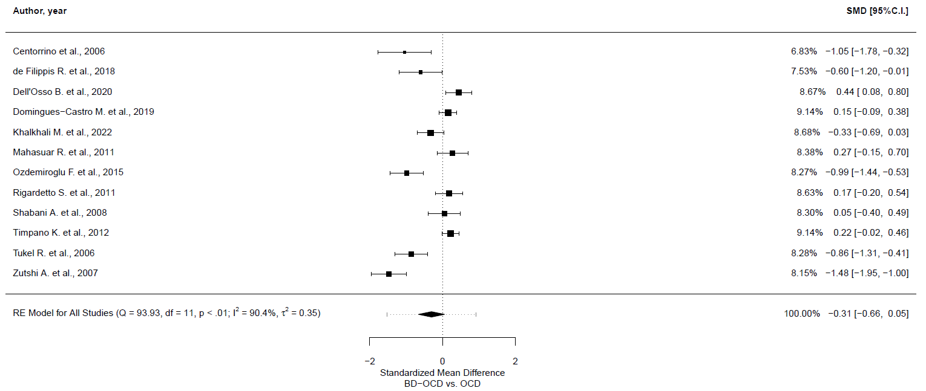
Meta-regression analyses
Outcome | Number of studies | 𝛽 | 95% CI | p-value
Primary outcome [vs. not primary]
Total symptoms | 12 | 0.157 | -0.642, 0.957 | 0.699
Mean age of BD-OCD sample
Total symptoms | 12 | 0.015 | -0.043, 0.073 | 0.611
% of females of BD-OCD sample
Total symptoms | 12 | 0.604 | -1.378, 2.587 | 0.55
Age at onset of OCD in BD-OCD sample
Total symptoms | 9 | -0.058 | -0.141, 0.024 | 0.164
% of people with BD-I
Total symptoms | 10 | -1.985 | -3.963, -0.007 | 0.049
% of euthymic people in BD-OCD sample
Total symptoms | 8 | 0.217 | -2.841, 3.275 | 0.889
% of depressed people in BD-OCD sample
Total symptoms | 8 | -0.068 | -3.506, 3.371 | 0.969
% of (hypo)manic people in BD-OCD sample
Total symptoms | 8 | -20.57 | -66.588, 25.448 | 0.381
% of people with lifetime MDD in OCD sample
Total symptoms | 7 | 1.857 | -2.12, 5.833 | 0.36
Depression symptom severity score
Total symptoms | 7 | 0.101 | -0.389, 0.592 | 0.686

Leave-one-out sensitivity analyses
 | SMD | 95% CI | p-value | Qp | tau² | I²
Centorrino et al., 2006 | -0.251 | -0.617, 0.116 | 0.18 | 1.816E-14 | 0.341 | 90.752
de Filippis R. et al., 2018 | -0.283 | -0.668, 0.102 | 0.15 | 3.184E-15 | 0.378 | 91.474
Dell'Osso B. et al., 2020 | -0.375 | -0.74, -0.01 | 0.044 | 6.672E-14 | 0.33 | 89.744
Domingues-Castro M. et al., 2019 | -0.352 | -0.736, 0.032 | 0.073 | 1.020E-14 | 0.37 | 89.652
Khalkhali M. et al., 2022 | -0.306 | -0.7, 0.088 | 0.128 | 1.908E-15 | 0.392 | 91.224
Mahasuar R. et al., 2011 | -0.359 | -0.736, 0.018 | 0.062 | 3.779E-15 | 0.357 | 90.703
Ozdemiroglu F. et al., 2015 | -0.243 | -0.61, 0.124 | 0.194 | 1.070E-12 | 0.336 | 90.246
Rigardetto S. et al., 2011 | -0.352 | -0.734, 0.031 | 0.072 | 2.512E-15 | 0.368 | 90.753
Shabani A. et al., 2008 | -0.339 | -0.726, 0.048 | 0.086 | 1.094E-15 | 0.379 | 91.243
Timpano K. et al., 2012 | -0.359 | -0.739, 0.021 | 0.064 | 5.214E-14 | 0.361 | 89.412
Tukel R. et al., 2006 | -0.255 | -0.631, 0.12 | 0.182 | 1.765E-13 | 0.353 | 90.685
Zutshi A. et al., 2007 | -0.191 | -0.506, 0.124 | 0.234 | 3.318E-09 | 0.236 | 86.751

GOSH plot

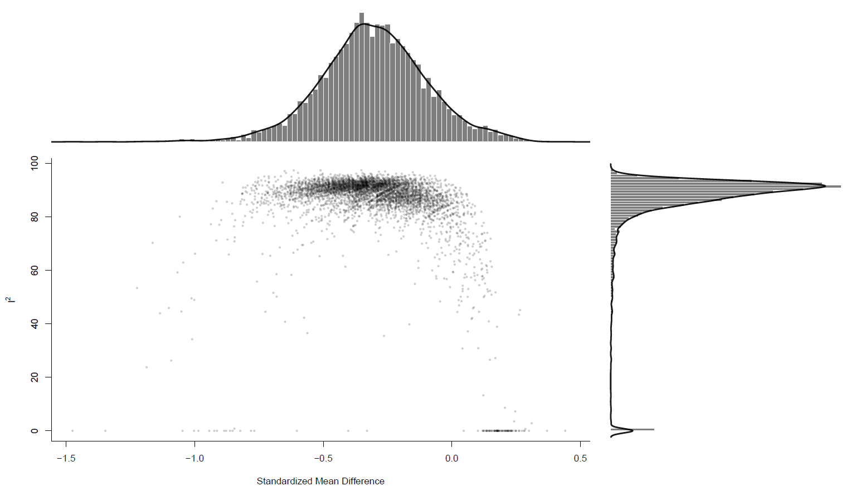
Funnel plot

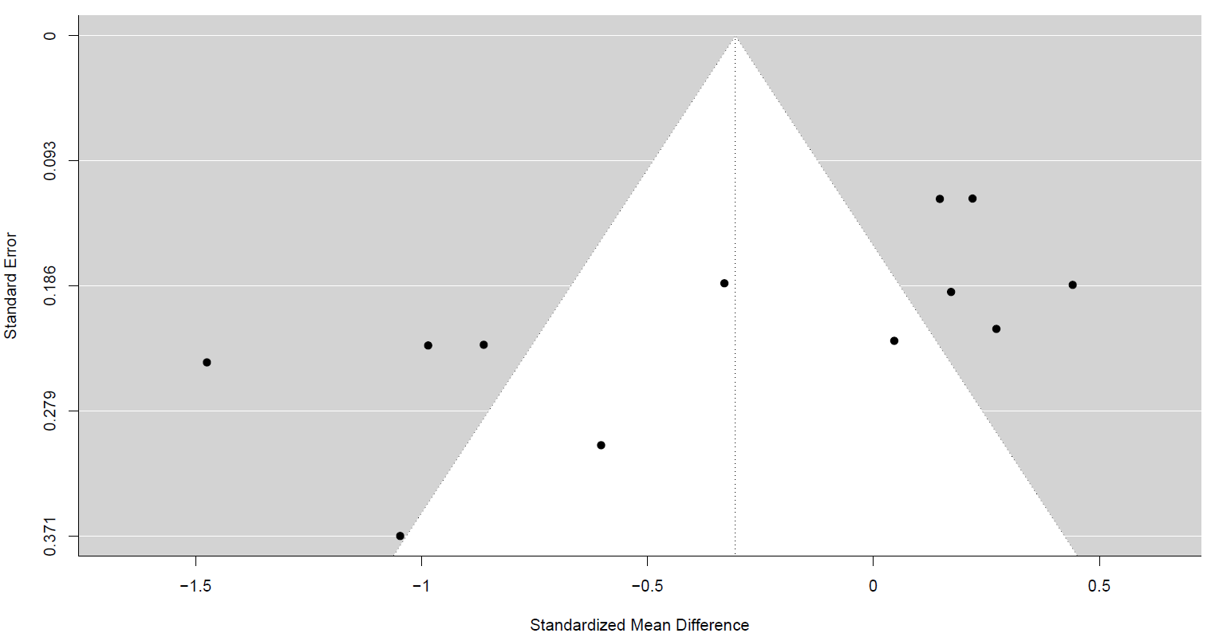
Egger Test: z= -2.5854; p-value=0.009

Obsessive-Compulsive symptomatology, obsessive symptomatology
Main analysis

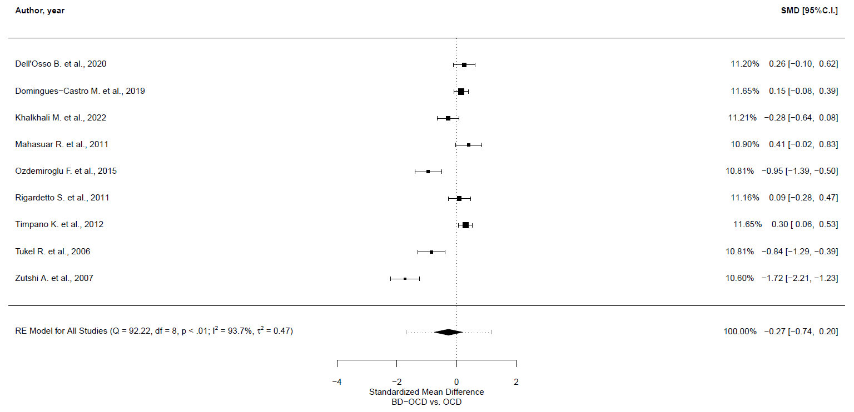
Meta-regression analyses
Outcome | Number of studies | 𝛽 | 95% CI | p-value
Primary outcome [vs. not primary]
Obsessive symptoms | 9 | -0.276 | -1.451, 0.9 | 0.646
Mean age of BD-OCD sample
Obsessive symptoms | 9 | 0.044 | -0.039, 0.128 | 0.292
% of females of BD-OCD sample
Obsessive symptoms | 9 | 0.749 | -2.153, 3.65 | 0.613
Age at onset of OCD in BD-OCD sample
Obsessive symptoms | 9 | -0.062 | -0.15, 0.026 | 0.168
% of people with BD-I
Obsessive symptoms | 8 | -2.495 | -4.859, -0.132 | 0.038
% of euthymic people in BD-OCD sample
Obsessive symptoms | 6 | 0.076 | -3.924, 4.076 | 0.97
% of depressed people in BD-OCD sample
Obsessive symptoms | 6 | 0.082 | -4.422, 4.586 | 0.972
% of (hypo)manic people in BD-OCD sample
Obsessive symptoms | 6 | -16.714 | -76.634, 43.205 | 0.585
% of people with lifetime MDD in OCD sample
Obsessive symptoms | 6 | 2.83 | -1.739, 7.4 | 0.225
Depression symptom severity score
Obsessive symptoms | 5 | 0.112 | -0.4, 0.624 | 0.667

Leave-one-out sensitivity analyses
 | SMD | 95% CI | p-value | Qp | tau² | I²
Dell'Osso B. et al., 2020 | -0.339 | -0.848, 0.171 | 0.193 | 2.231E-16 | 0.502 | 94.115
Domingues-Castro M. et al., 2019 | -0.328 | -0.847, 0.19 | 0.215 | 3.388E-16 | 0.519 | 93.458
Khalkhali M. et al., 2022 | -0.272 | -0.803, 0.258 | 0.315 | 8.738E-17 | 0.548 | 94.567
Mahasuar R. et al., 2011 | -0.354 | -0.85, 0.142 | 0.162 | 4.743E-16 | 0.475 | 94.011
Ozdemiroglu F. et al., 2015 | -0.189 | -0.682, 0.304 | 0.452 | 6.931E-14 | 0.47 | 93.992
Rigardetto S. et al., 2011 | -0.319 | -0.839, 0.202 | 0.23 | 6.354E-17 | 0.526 | 94.407
Timpano K. et al., 2012 | -0.347 | -0.853, 0.16 | 0.18 | 1.192E-14 | 0.493 | 93.134
Tukel R. et al., 2006 | -0.203 | -0.706, 0.301 | 0.43 | 1.312E-14 | 0.491 | 94.24
Zutshi A. et al., 2007 | -0.091 | -0.442, 0.26 | 0.613 | 8.922E-08 | 0.222 | 88.218

GOSH plot

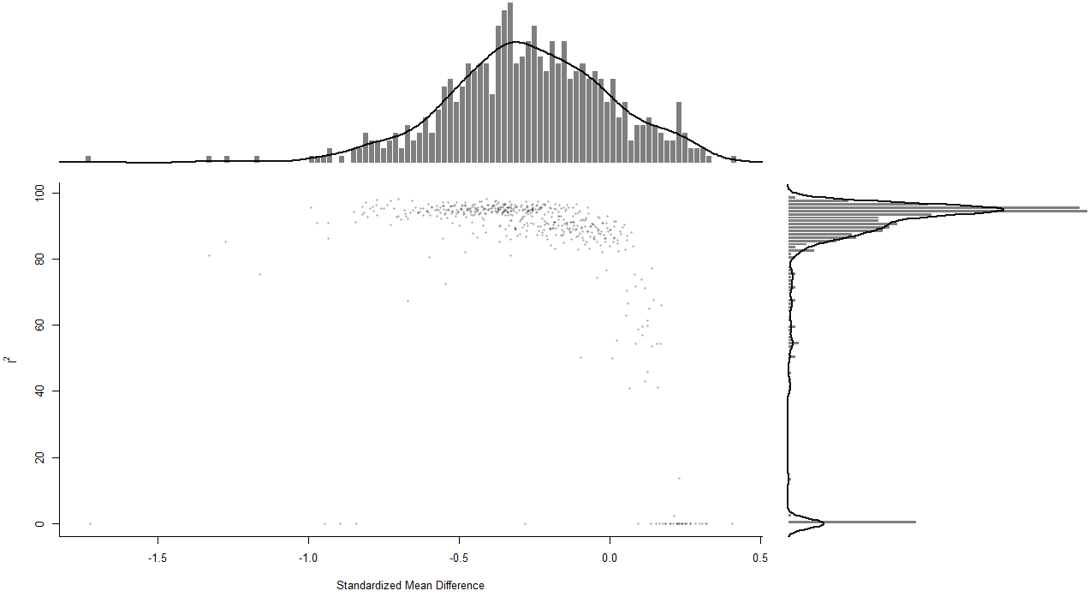

Obsessive-Compulsive symptomatology, compulsive symptomatology
Main analysis

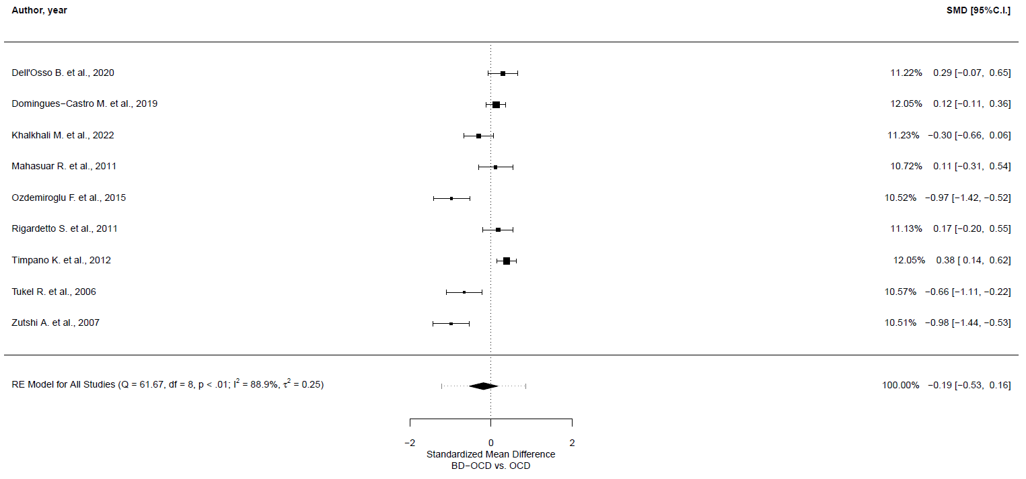
Meta-regression analyses
Outcome | Number of studies | 𝛽 | 95% CI | p-value
Primary outcome [vs. not primary]
Compulsive symptoms | 9 | -0.136 | -1.018, 0.746 | 0.763
Mean age of BD-OCD sample
Compulsive symptoms | 9 | 0.032 | -0.031, 0.095 | 0.322
% of females of BD-OCD sample
Compulsive symptoms | 9 | 0.5 | -1.669, 2.669 | 0.651
Age at onset of OCD in BD-OCD sample
Compulsive symptoms | 9 | -0.06 | -0.119, -0.001 | 0.045
% of people with BD-I
Compulsive symptoms | 8 | -1.315 | -3.334, 0.704 | 0.202
% of euthymic people in BD-OCD sample
Compulsive symptoms | 6 | 0.451 | -2.244, 3.146 | 0.743
% of depressed people in BD-OCD sample
Compulsive symptoms | 6 | -0.342 | -3.396, 2.712 | 0.826
% of (hypo)manic people in BD-OCD sample
Compulsive symptoms | 6 | -21.726 | -58.542, 15.089 | 0.247
% of people with lifetime MDD in OCD sample
Compulsive symptoms | 6 | 1.768 | -1.291, 4.828 | 0.257
Depression symptom severity score
Compulsive symptoms | 5 | 0.141 | -0.219, 0.502 | 0.444

Leave-one-out sensitivity analyses
 | SMD | 95% CI | p-value | Qp | tau² | I²
Dell'Osso B. et al., 2020 | -0.245 | -0.62, 0.129 | 0.199 | 3.168E-10 | 0.255 | 89.192
Domingues-Castro M. et al., 2019 | -0.229 | -0.618, 0.161 | 0.25 | 1.784E-10 | 0.276 | 88.554
Khalkhali M. et al., 2022 | -0.173 | -0.568, 0.222 | 0.391 | 2.157E-10 | 0.287 | 90.274
Mahasuar R. et al., 2011 | -0.223 | -0.61, 0.164 | 0.259 | 8.676E-11 | 0.276 | 90.246
Ozdemiroglu F. et al., 2015 | -0.088 | -0.418, 0.241 | 0.599 | 2.502E-07 | 0.192 | 86.635
Rigardetto S. et al., 2011 | -0.231 | -0.616, 0.153 | 0.238 | 1.238E-10 | 0.271 | 89.812
Timpano K. et al., 2012 | -0.262 | -0.623, 0.1 | 0.156 | 6.104E-08 | 0.233 | 86.702
Tukel R. et al., 2006 | -0.129 | -0.5, 0.242 | 0.496 | 3.171E-09 | 0.252 | 89.456
Zutshi A. et al., 2007 | -0.087 | -0.415, 0.241 | 0.603 | 2.868E-07 | 0.189 | 86.491

GOSH plot

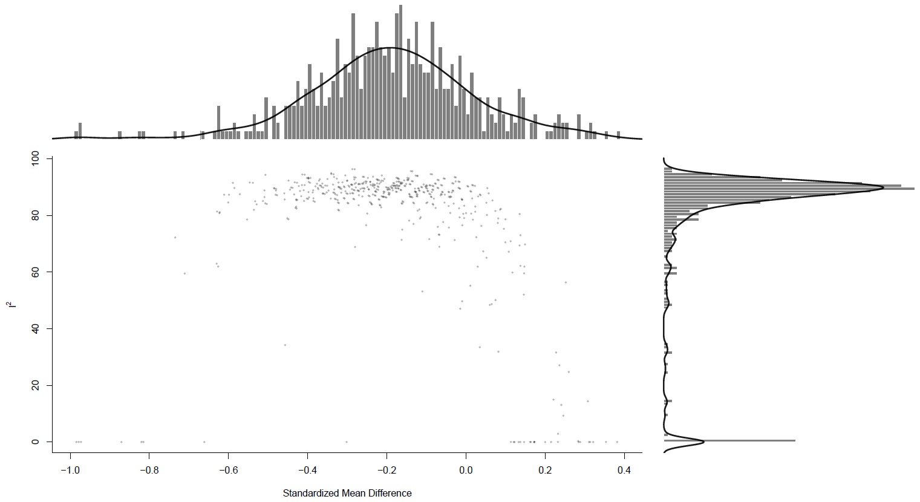

Obsessions, number of obsessions, any
Main analysis

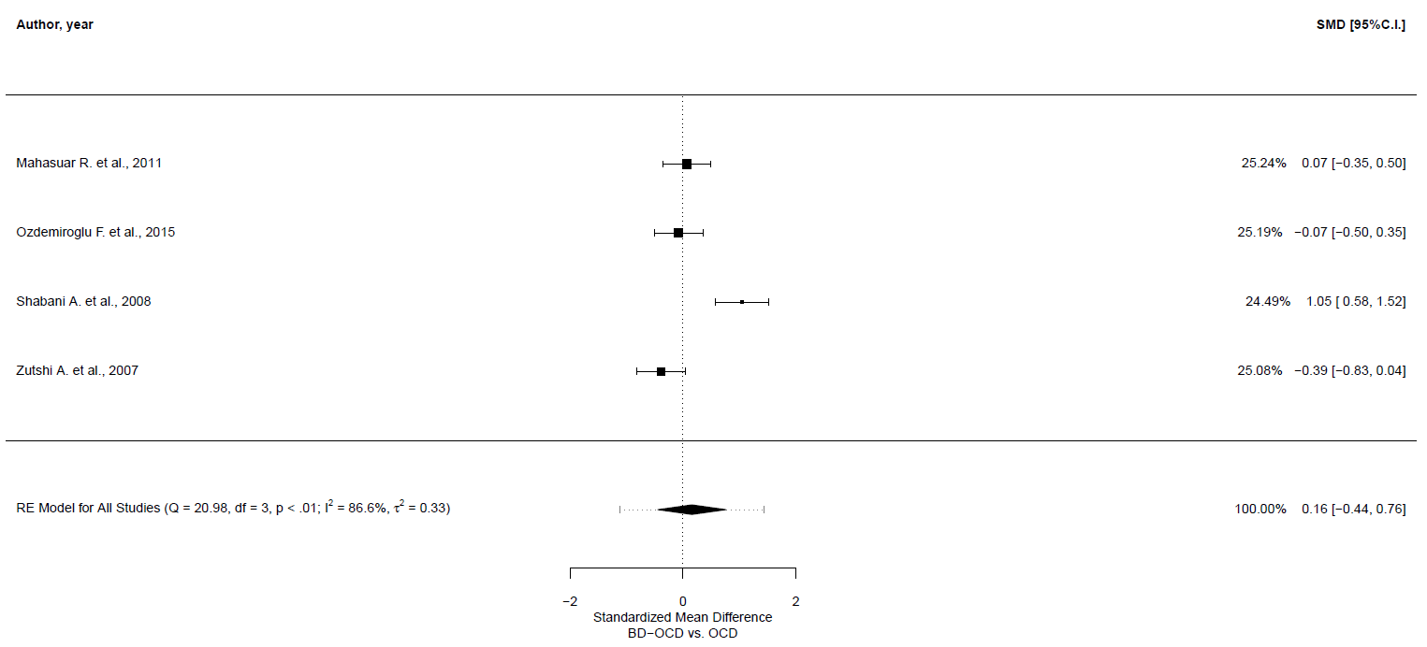
Meta-regression analyses
Outcome | Number of studies | 𝛽 | 95% CI | p-value
Mean age of BD-OCD sample
Number obsessions | 4 | -0.055 | -0.236, 0.125 | 0.547
% of females of BD-OCD sample
Number obsessions | 4 | 2.42 | 0.848, 3.993 | 0.003
Age at onset of OCD in BD-OCD sample
Number obsessions | 3 | 0.003 | -0.068, 0.074 | 0.936
% of people with BD-I
Number obsessions | 4 | -1.763 | -4.793, 1.267 | 0.254
% of euthymic people in BD-OCD sample
Number obsessions | 4 | 0.668 | -2.854, 4.189 | 0.71
% of depressed people in BD-OCD sample
Number obsessions | 4 | -0.772 | -4.84, 3.3 | 0.71
% of (hypo)manic people in BD-OCD sample
Number obsessions | 4 | -10.105 | -63.382, 43.172 | 0.71
% of people with lifetime MDD in OCD sample
Number obsessions | 3 | 0.842 | -10.831, 12.515 | 0.888

Leave-one-out sensitivity analyses
 | SMD | 95% CI | p-value | Qp | tau² | I²
Mahasuar R. et al., 2011 | 0.19 | -0.662, 1.043 | 0.662 | 2.899E-05 | 0.516 | 90.915
Ozdemiroglu F. et al., 2015 | 0.239 | -0.589, 1.067 | 0.572 | 4.918E-05 | 0.484 | 90.416
Shabani A. et al., 2008 | -0.128 | -0.394, 0.138 | 0.346 | 0.313 | 0.007 | 13.308
Zutshi A. et al., 2007 | 0.343 | -0.343, 1.028 | 0.327 | 0.001 | 0.316 | 86.149

Obsessions, aggressive obsessions
Main analysis

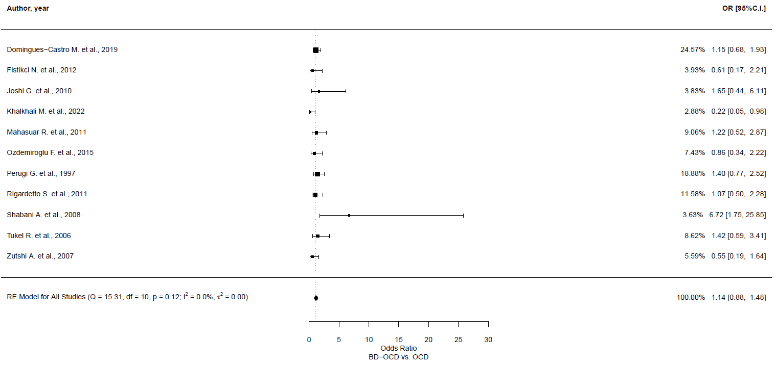
Leave-one-out sensitivity analyses
 | OR | 95% CI | p-value | Qp | tau² | I²
Domingues-Castro M. et al., 2019 | 1.14 | 0.845, 1.539 | 0.392 | 0.082 | 0.005 | 1.948
Fistikci N. et al., 2012 | 1.174 | 0.903, 1.525 | 0.231 | 0.110 | 0 | 0
Joshi G. et al., 2010 | 1.126 | 0.868, 1.464 | 0.371 | 0.090 | 0 | 0.001
Khalkhali M. et al., 2022 | 1.201 | 0.926, 1.559 | 0.168 | 0.311 | 0 | 0.001
Mahasuar R. et al., 2011 | 1.135 | 0.868, 1.487 | 0.354 | 0.083 | 0 | 0
Ozdemiroglu F. et al., 2015 | 1.169 | 0.896, 1.527 | 0.251 | 0.092 | 0 | 0.003
Perugi G. et al., 1997 | 1.092 | 0.821, 1.452 | 0.547 | 0.097 | 0 | 0.002
Rigardetto S. et al., 2011 | 1.153 | 0.877, 1.516 | 0.306 | 0.083 | 0 | 0.001
Shabani A. et al., 2008 | 1.069 | 0.824, 1.39 | 0.614 | 0.492 | 0 | 0
Tukel R. et al., 2006 | 1.12 | 0.856, 1.465 | 0.408 | 0.089 | 0 | 0.001
Zutshi A. et al., 2007 | 1.194 | 0.917, 1.554 | 0.189 | 0.141 | 0 | 0

GOSH plot

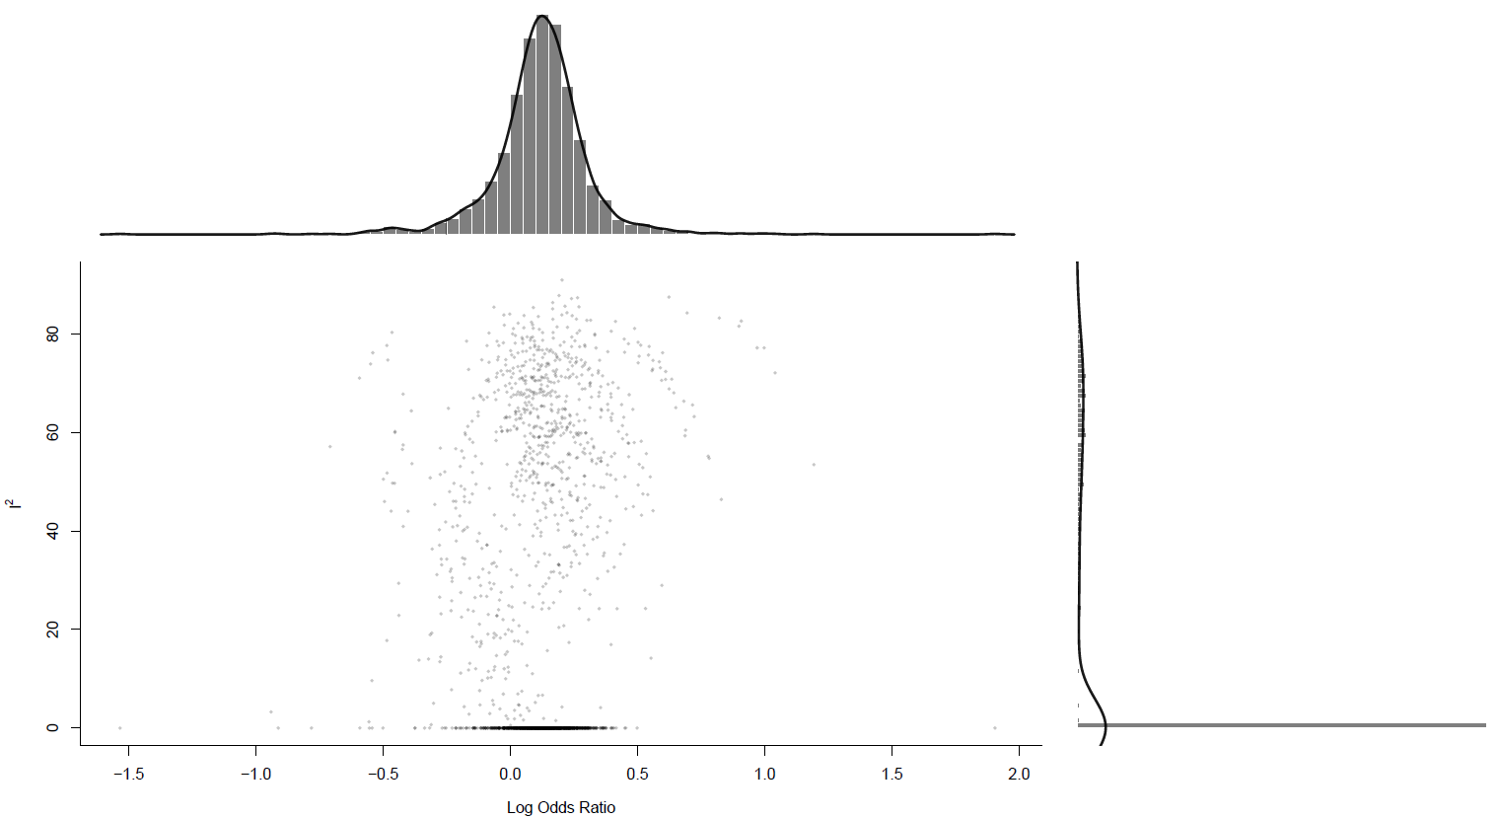
Funnel plot

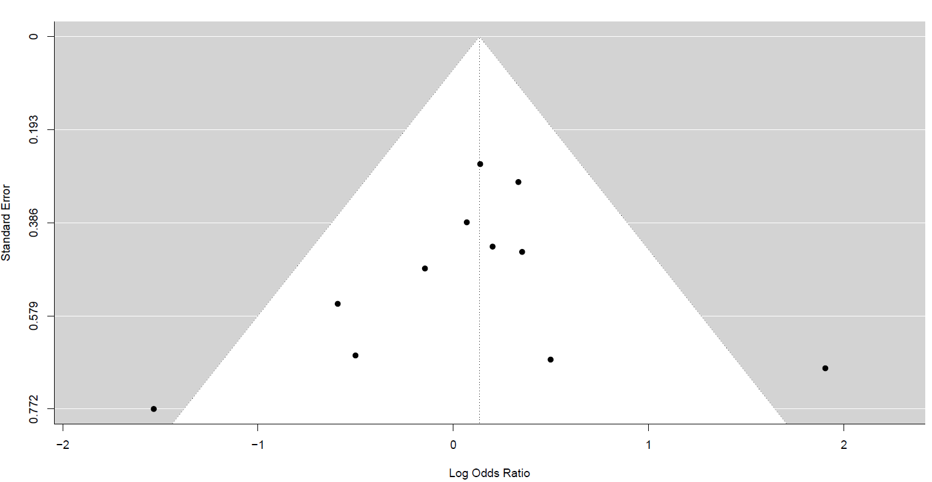
Egger Test: z= -0.671, p-value=0.502

Obsessions, contamination obsessions
Main analysis

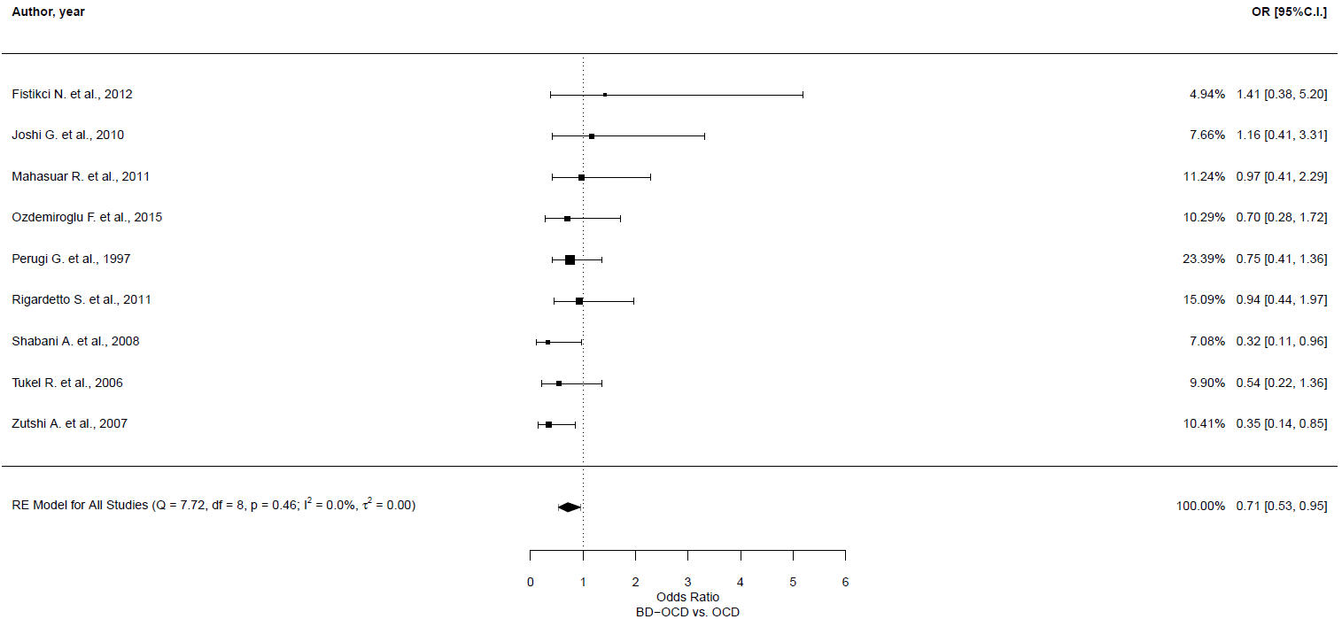
Leave-one-out sensitivity analyses
 | OR | 95% CI | p-value | Qp | tau² | I²
Fistikci N. et al., 2012 | 0.686 | 0.51, 0.924 | 0.013 | 0.471 | 0 | 0
Joshi G. et al., 2010 | 0.683 | 0.505, 0.923 | 0.013 | 0.449 | 0 | 0.002
Mahasuar R. et al., 2011 | 0.684 | 0.503, 0.931 | 0.016 | 0.41 | 0 | 0.001
Ozdemiroglu F. et al., 2015 | 0.713 | 0.525, 0.968 | 0.03 | 0.358 | 0 | 0.004
Perugi G. et al., 1997 | 0.7 | 0.5, 0.98 | 0.038 | 0.361 | 0.007 | 2.921
Rigardetto S. et al., 2011 | 0.678 | 0.495, 0.928 | 0.015 | 0.417 | 0 | 0.003
Shabani A. et al., 2008 | 0.755 | 0.559, 1.02 | 0.067 | 0.589 | 0 | 0
Tukel R. et al., 2006 | 0.733 | 0.54, 0.995 | 0.046 | 0.394 | 0 | 0.001
Zutshi A. et al., 2007 | 0.773 | 0.569, 1.05 | 0.099 | 0.662 | 0 | 0

GOSH plot

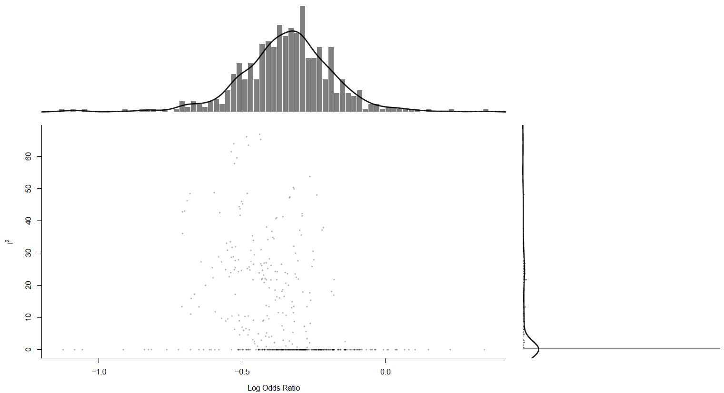

Obsessions, sexual obsessions
Main analysis

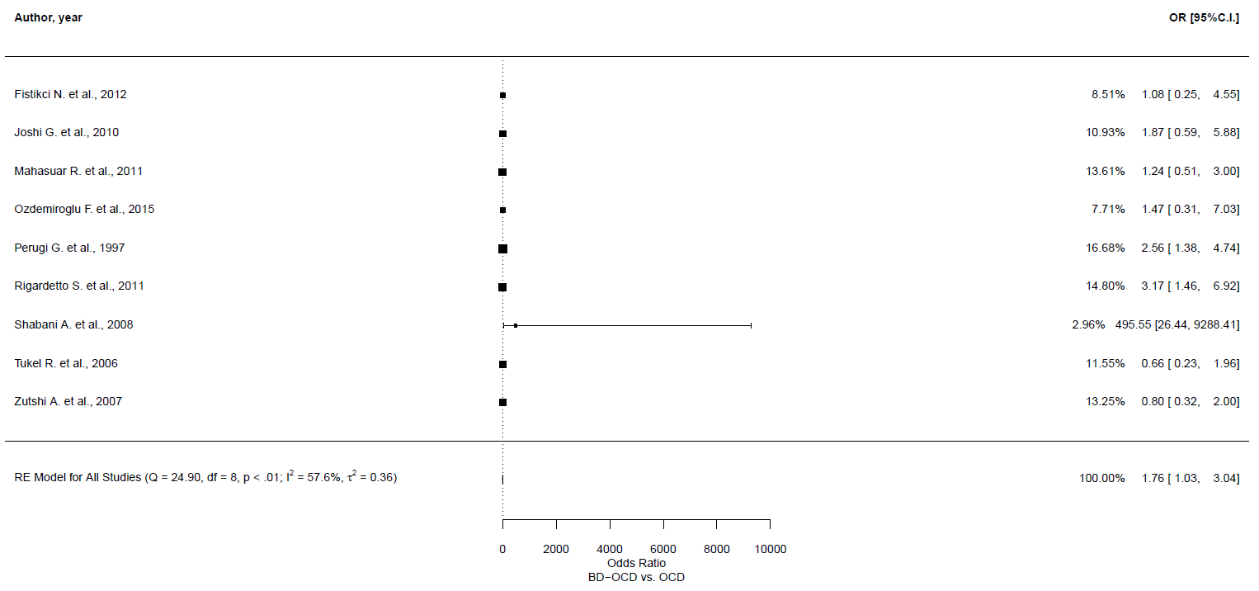
Meta-regression analyses
Outcome | Number of studies | 𝛽 | 95% CI | p-value
Primary outcome [vs. not primary]
Sexual | 9 | 0.298 | -1.353, 1.948 | 0.724
Mean age of BD-OCD sample
Sexual | 9 | -0.017 | -0.12, 0.085 | 0.739
% of females of BD-OCD sample
Sexual | 8 | 3.452 | -1.947, 8.851 | 0.21
Age at onset of OCD in BD-OCD sample
Sexual | 8 | 0.012 | -0.073, 0.097 | 0.782
Age at onset of BD
Sexual | 3 | -0.045 | -0.161, 0.07 | 0.443
% of people with BD-I
Sexual | 8 | -1.039 | -4.263, 2.184 | 0.527
% of euthymic people in BD-OCD sample
Sexual | 6 | 1.252 | -7.196, 9.7 | 0.774
% of depressed people in BD-OCD sample
Sexual | 6 | -1.441 | -13.345, 10.463 | 0.813
% of (hypo)manic people in BD-OCD sample
Sexual | 6 | -0.75 | -10.963, 9.463 | 0.886
% of people with lifetime MDD in OCD sample
Sexual | 7 | -3.578 | -19.434, 12.277 | 0.658
Depression symptom severity score
Sexual | 3 | 0.503 | -0.629, 1.634 | 0.384

Leave-one-out sensitivity analyses
 | OR | 95% CI | p-value | Qp | tau² | I²
Fistikci N. et al., 2012 | 1.91 | 0.99, 3.687 | 0.054 | 0.001 | 0.567 | 69.413
Joshi G. et al., 2010 | 1.836 | 0.902, 3.736 | 0.094 | 0.001 | 0.686 | 72.495
Mahasuar R. et al., 2011 | 1.957 | 0.949, 4.038 | 0.069 | 0.001 | 0.704 | 71.542
Ozdemiroglu F. et al., 2015 | 1.853 | 0.954, 3.598 | 0.069 | 0.001 | 0.589 | 70.43
Perugi G. et al., 1997 | 1.722 | 0.85, 3.488 | 0.131 | 0.002 | 0.633 | 66.188
Rigardetto S. et al., 2011 | 1.594 | 0.884, 2.875 | 0.121 | 0.002 | 0.363 | 55.296
Shabani A. et al., 2008 | 1.536 | 0.988, 2.39 | 0.057 | 0.159 | 0.151 | 38.944
Tukel R. et al., 2006 | 1.979 | 1.159, 3.382 | 0.012 | 0.003 | 0.277 | 51.198
Zutshi A. et al., 2007 | 1.988 | 1.118, 3.534 | 0.019 | 0.003 | 0.345 | 55.495

GOSH plot

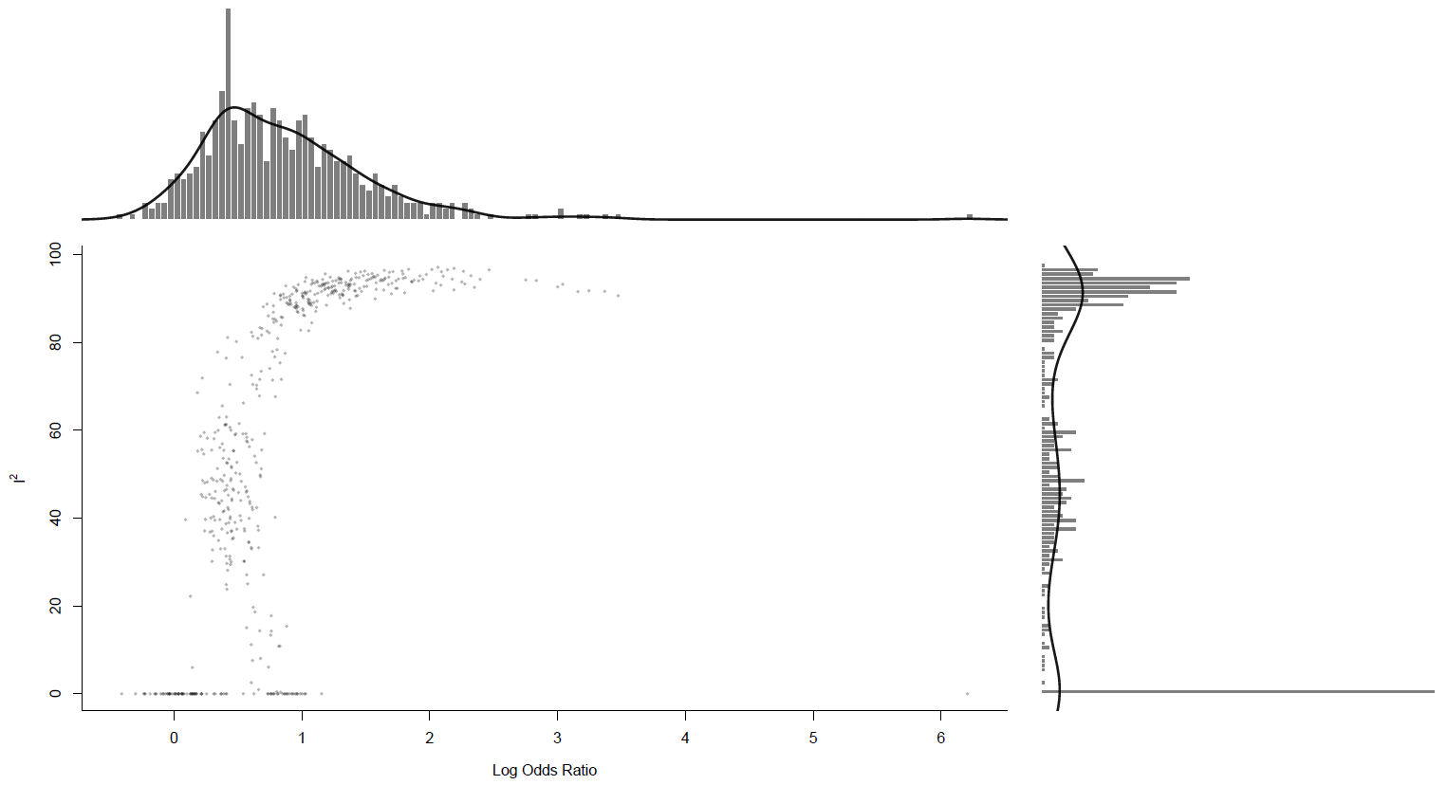

Obsessions, hoarding/saving obsessions
Main analysis

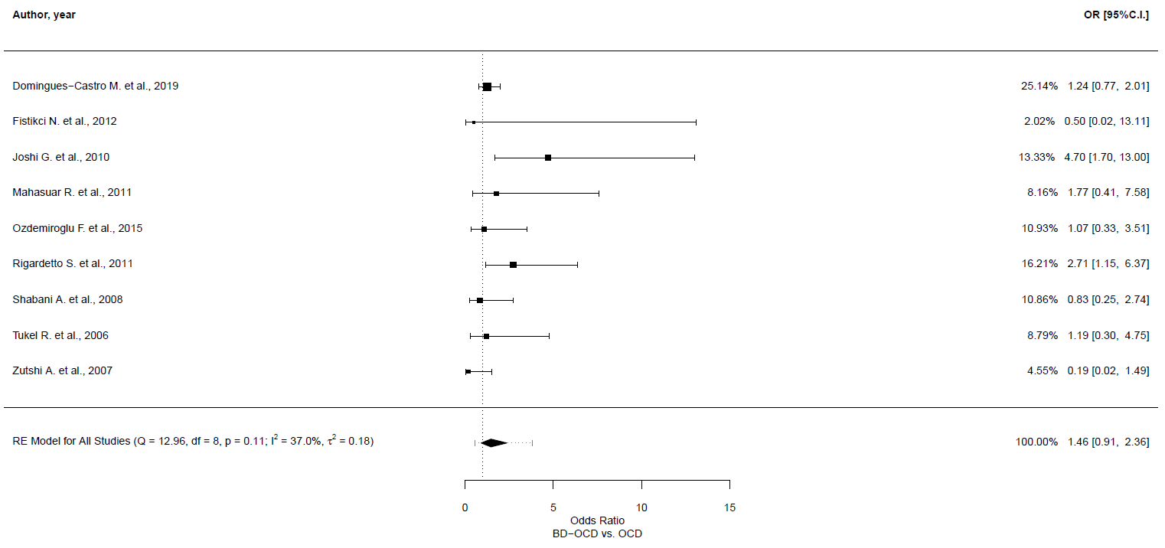
Leave-one-out sensitivity analyses
 | OR | 95% CI | p-value | Qp | tau² | I²
Domingues-Castro M. et al., 2019 | 1.48 | 0.796, 2.75 | 0.216 | 0.098 | 0.316 | 42.142
Fistikci N. et al., 2012 | 1.494 | 0.919, 2.429 | 0.106 | 0.084 | 0.182 | 40.457
Joshi G. et al., 2010 | 1.286 | 0.911, 1.815 | 0.152 | 0.391 | 0 | 0
Mahasuar R. et al., 2011 | 1.415 | 0.823, 2.434 | 0.209 | 0.075 | 0.249 | 46.476
Ozdemiroglu F. et al., 2015 | 1.502 | 0.871, 2.59 | 0.144 | 0.081 | 0.24 | 44.434
Rigardetto S. et al., 2011 | 1.298 | 0.77, 2.189 | 0.327 | 0.154 | 0.177 | 34.278
Shabani A. et al., 2008 | 1.563 | 0.933, 2.618 | 0.09 | 0.1 | 0.191 | 38.998
Tukel R. et al., 2006 | 1.474 | 0.86, 2.528 | 0.158 | 0.076 | 0.241 | 45.418
Zutshi A. et al., 2007 | 1.613 | 1.031, 2.522 | 0.036 | 0.248 | 0.115 | 29.464

GOSH plot

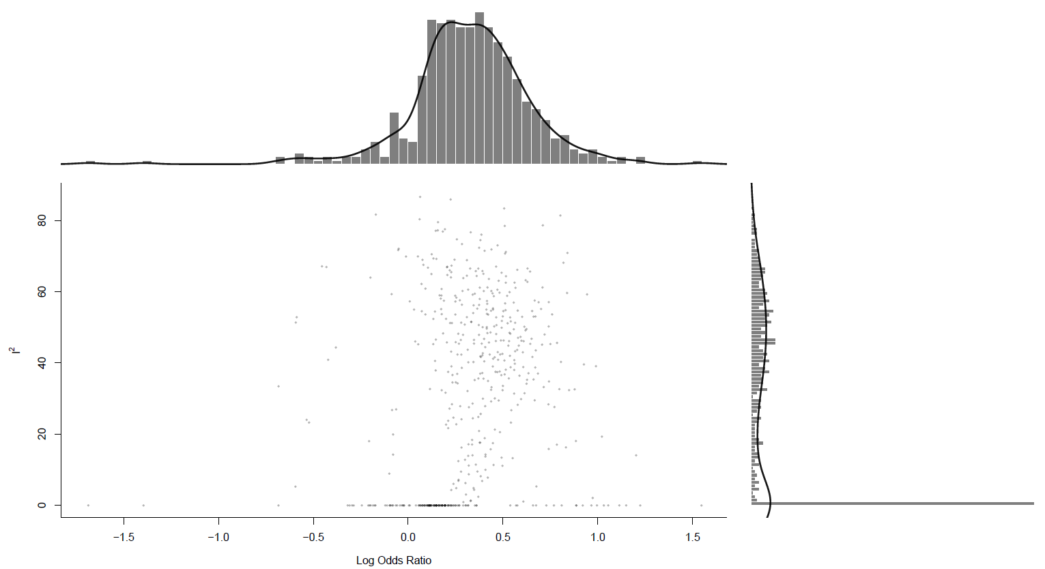

Obsessions, religious obsessions
Main analysis

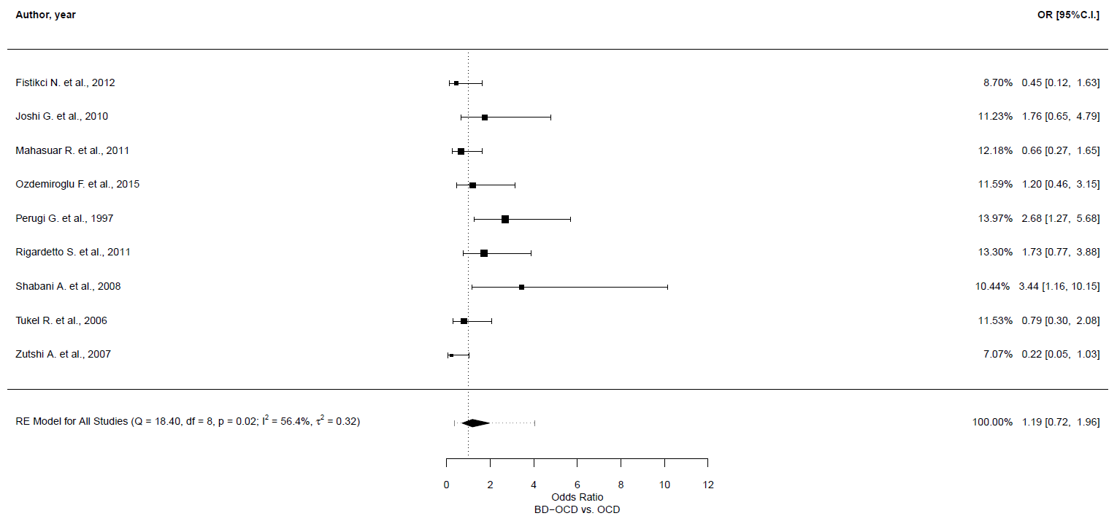
Meta-regression analyses
Outcome | Number of studies | 𝛽 | 95% CI | p-value
Primary outcome [vs. not primary]
Religious | 9 | 0.252 | -1.084, 1.588 | 0.712
Mean age of BD-OCD sample
Religious | 9 | -0.018 | -0.099, 0.063 | 0.066
% of females of BD-OCD sample
Religious | 8 | 1.275 | -1.521, 4.07 | 0.372
Age at onset of OCD in BD-OCD sample
Religious | 8 | -0.004 | -0.094, 0.085 | 0.922
Age at onset of BD
Religious | 3 | -0.056 | -0.3, 0.19 | 0.657
% of people with BD-I
Religious | 8 | -1.398 | -3.733, 0.938 | 0.241
% of euthymic people in BD-OCD sample
Religious | 6 | -1.112 | -4.323, 2.098 | 0.497
% of depressed people in BD-OCD sample
Religious | 6 | 0.447 | -4.288, 5.181 | 0.853
% of (hypo)manic people in BD-OCD sample
Religious | 6 | 1.403 | -2.458, 5.263 | 0.477
% of people with lifetime MDD in OCD sample
Religious | 7 | -0.57 | -9.334, 8.194 | 0.899
Depression symptom severity score
Religious | 3 | 0.493 | -0.113, 1.099 | 0.111

Leave-one-out sensitivity analyses
 | OR | 95% CI | p-value | Qp | tau² | I²
Fistikci N. et al., 2012 | 1.309 | 0.791, 2.165 | 0.295 | 0.029 | 0.277 | 53.809
Joshi G. et al., 2010 | 1.115 | 0.63, 1.972 | 0.71 | 0.012 | 0.408 | 61.995
Mahasuar R. et al., 2011 | 1.284 | 0.747, 2.204 | 0.366 | 0.025 | 0.334 | 56.554
Ozdemiroglu F. et al., 2015 | 1.166 | 0.652, 2.087 | 0.604 | 0.01 | 0.431 | 63.087
Perugi G. et al., 1997 | 1.047 | 0.628, 1.746 | 0.861 | 0.051 | 0.26 | 48.717
Rigardetto S. et al., 2011 | 1.106 | 0.619, 1.976 | 0.733 | 0.013 | 0.416 | 60.99
Shabani A. et al., 2008 | 1.059 | 0.639, 1.755 | 0.824 | 0.036 | 0.27 | 52.402
Tukel R. et al., 2006 | 1.24 | 0.707, 2.173 | 0.453 | 0.016 | 0.383 | 60.357
Zutshi A. et al., 2007 | 1.362 | 0.864, 2.145 | 0.183 | 0.072 | 0.191 | 45.197

GOSH plot

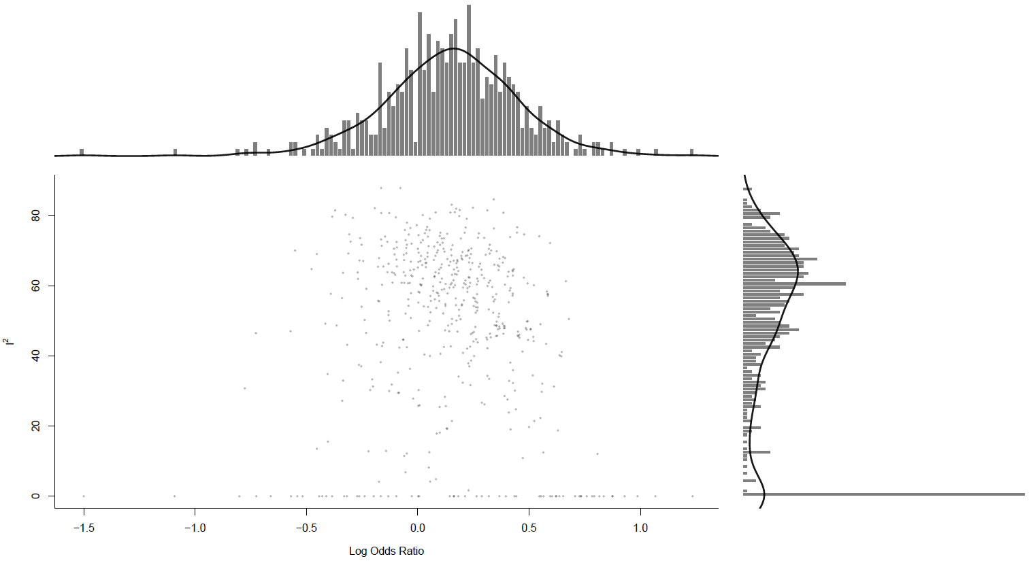

Obsessions, symmetry/exactness obsessions
Main analysis

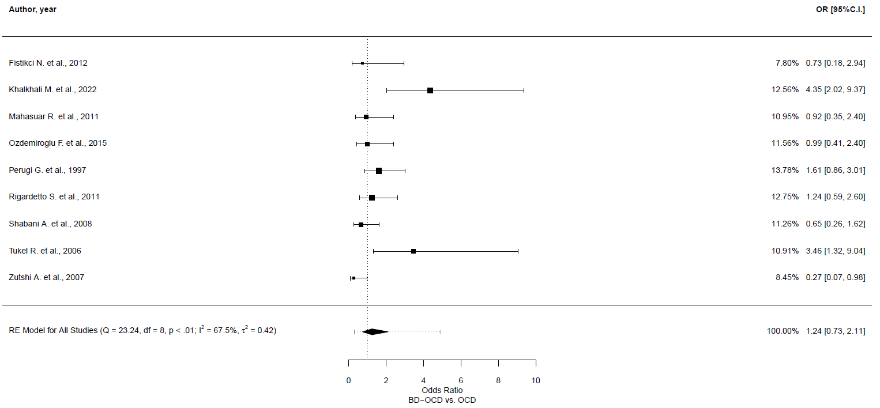
Meta-regression analyses
Outcome | Number of studies | 𝛽 | 95% CI | p-value
Primary outcome [vs. not primary]
Symmetry/exactness | 9 | -0.729 | -1.971, 0.513 | 0.25
Mean age of BD-OCD sample
Symmetry/exactness | 9 | 0.106 | 0.038, 0.174 | 0.002
% of females of BD-OCD sample
Symmetry/exactness | 8 | 0.114 | -3.171, 3.399 | 0.946
Age at onset of OCD in BD-OCD sample
Symmetry/exactness | 8 | -0.036 | -0.206, 0.134 | 0.675
% of people with BD-I
Symmetry/exactness | 9 | -1.183 | -3.471, 1.105 | 0.311
% of euthymic people in BD-OCD sample
Symmetry/exactness | 6 | 0.516 | -4.639, 5.671 | 0.845
% of depressed people in BD-OCD sample
Symmetry/exactness | 6 | -0.596 | -6.55, 5.359 | 0.844
% of (hypo)manic people in BD-OCD sample
Symmetry/exactness | 6 | -7.8 | -85.788, 70.184 | 0.845
% of people with lifetime MDD in OCD sample
Symmetry/exactness | 6 | 4.099 | -3.743, 11.941 | 0.306
Depression symptom severity score
Symmetry/exactness | 3 | 0.102 | -1.212, 1.415 | 0.88

Leave-one-out sensitivity analyses
 | OR | 95% CI | p-value | Qp | tau² | I²
Fistikci N. et al., 2012 | 1.297 | 0.736, 2.287 | 0.368 | 0.002 | 0.464 | 71.115
Khalkhali M. et al., 2022 | 1.073 | 0.687, 1.675 | 0.758 | 0.066 | 0.185 | 46.511
Mahasuar R. et al., 2011 | 1.281 | 0.708, 2.316 | 0.413 | 0.002 | 0.502 | 71.445
Ozdemiroglu F. et al., 2015 | 1.27 | 0.698, 2.312 | 0.434 | 0.002 | 0.514 | 71.514
Perugi G. et al., 1997 | 1.183 | 0.641, 2.183 | 0.592 | 0.002 | 0.532 | 69.885
Rigardetto S. et al., 2011 | 1.231 | 0.668, 2.27 | 0.505 | 0.002 | 0.536 | 71.37
Shabani A. et al., 2008 | 1.351 | 0.769, 2.374 | 0.296 | 0.005 | 0.433 | 68.122
Tukel R. et al., 2006 | 1.105 | 0.646, 1.891 | 0.714 | 0.007 | 0.375 | 65.165
Zutshi A. et al., 2007 | 1.447 | 0.895, 2.34 | 0.132 | 0.019 | 0.276 | 59.163

GOSH plot

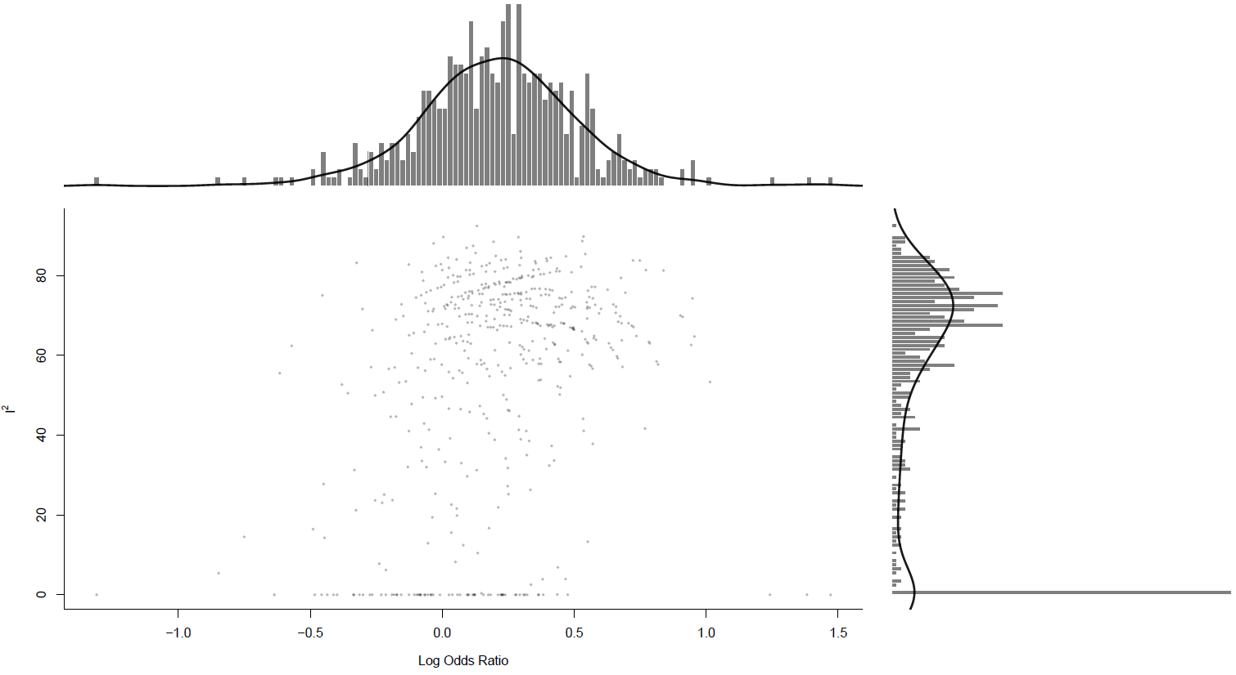

Obsessions, miscellaneous obsessions
Main analysis

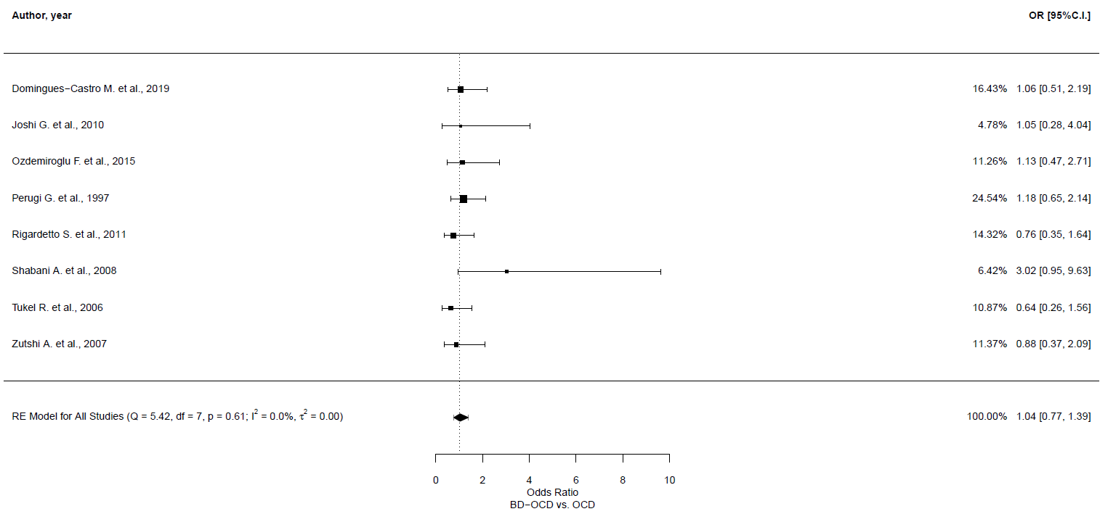
Leave-one-out sensitivity analyses
 | OR | 95% CI | p-value | Qp | tau² | I²
Domingues-Castro M. et al., 2019 | 1.03 | 0.747, 1.42 | 0.857 | 0.492 | 0 | 0
Joshi G. et al., 2010 | 1.034 | 0.765, 1.397 | 0.826 | 0.492 | 0 | 0.001
Ozdemiroglu F. et al., 2015 | 1.024 | 0.75, 1.398 | 0.883 | 0.497 | 0 | 0.001
Perugi G. et al., 1997 | 0.991 | 0.707, 1.39 | 0.96 | 0.523 | 0 | 0.001
Rigardetto S. et al., 2011 | 1.091 | 0.794, 1.498 | 0.591 | 0.585 | 0 | 0
Shabani A. et al., 2008 | 0.962 | 0.71, 1.303 | 0.802 | 0.928 | 0 | 0
Tukel R. et al., 2006 | 1.098 | 0.804, 1.499 | 0.556 | 0.656 | 0 | 0
Zutshi A. et al., 2007 | 1.058 | 0.774, 1.445 | 0.724 | 0.512 | 0 | 0

GOSH plot

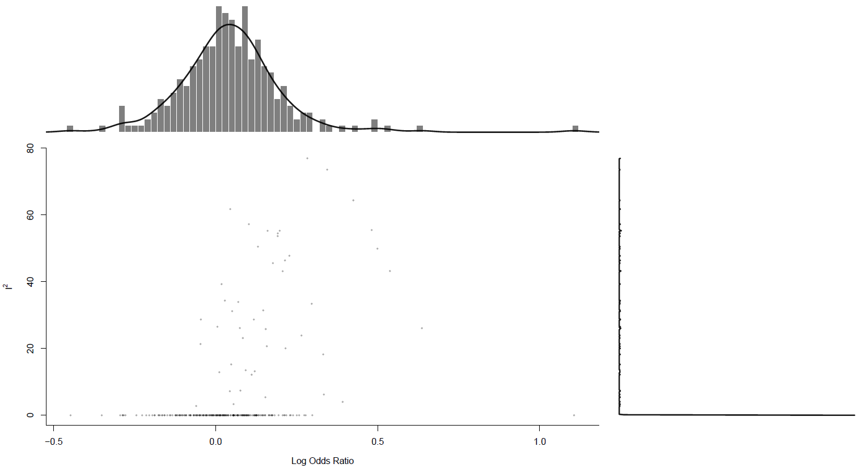

Obsessions, somatic obsessions
Main analysis

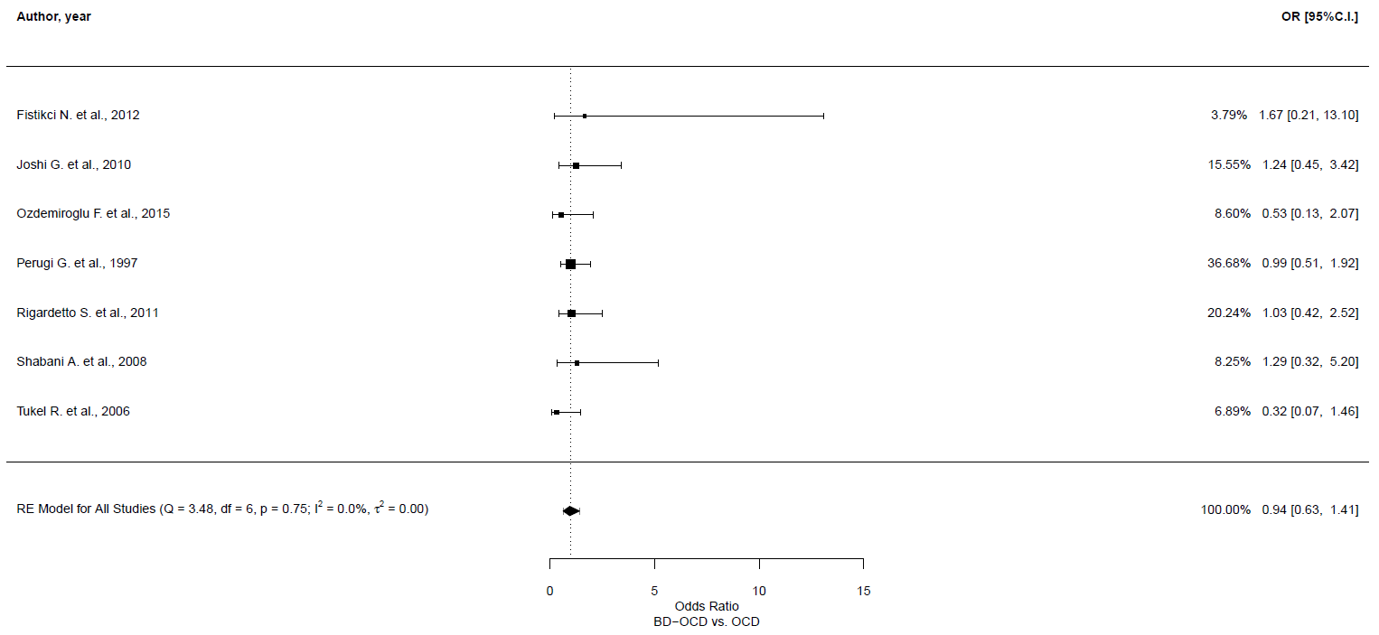
Leave-one-out sensitivity analyses
 | OR | 95% CI | p-value | Qp | tau² | I²
Fistikci N. et al., 2012 | 0.922 | 0.613, 1.389 | 0.699 | 0.674 | 0 | 0
Joshi G. et al., 2010 | 0.898 | 0.58, 1.389 | 0.628 | 0.676 | 0 | 0
Ozdemiroglu F. et al., 2015 | 0.996 | 0.655, 1.516 | 0.986 | 0.744 | 0 | 0
Perugi G. et al., 1997 | 0.917 | 0.554, 1.519 | 0.737 | 0.632 | 0 | 0
Rigardetto S. et al., 2011 | 0.922 | 0.588, 1.444 | 0.722 | 0.635 | 0 | 0
Shabani A. et al., 2008 | 0.917 | 0.603, 1.395 | 0.687 | 0.659 | 0 | 0
Tukel R. et al., 2006 | 1.023 | 0.675, 1.55 | 0.915 | 0.929 | 0 | 0

GOSH plot

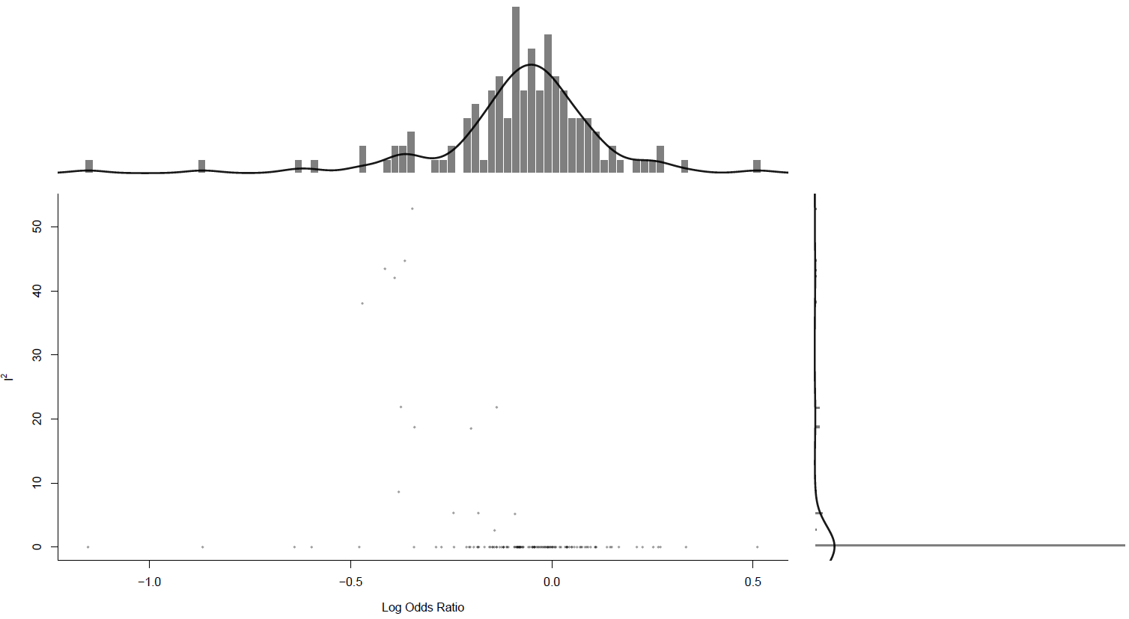

Obsessions, pathological doubt
Main analysis

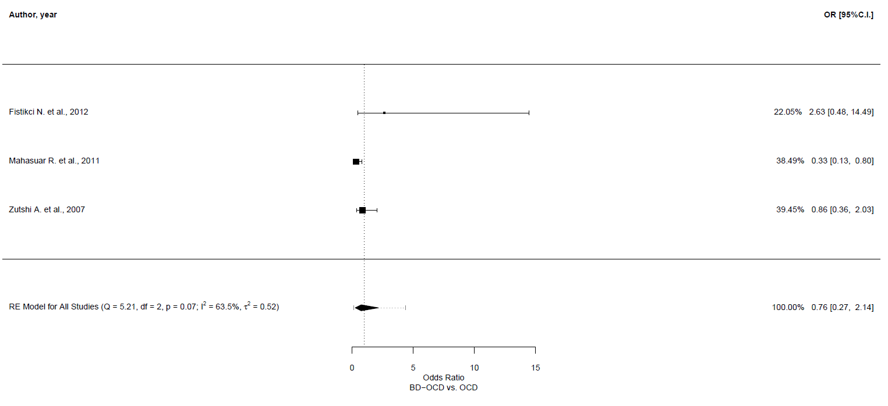
Meta-regression analyses
Outcome | Number of studies | 𝛽 | 95% CI | p-value
Primary outcome [vs. not primary]
Pathological doubt | 3 | -1.594 | -3.793, 0.605 | 0.155
Mean age of BD-OCD sample
Pathological doubt | 3 | 0.251 | -0.143, 0.644 | 0.212
Age at onset of OCD in BD-OCD sample
Pathological doubt | 3 | 0.531 | 0.073, 0.988 | 0.023
% of people with BD-I
Pathological doubt | 3 | -0.77 | -5.724, 4.184 | 0.761

Leave-one-out sensitivity analyses
 | OR | 95% CI | p-value | Qp | tau² | I²
Fistikci N. et al., 2012 | 0.533 | 0.207, 1.376 | 0.194 | 0.129 | 0.265 | 56.588
Mahasuar R. et al., 2011 | 1.165 | 0.438, 3.102 | 0.759 | 0.252 | 0.149 | 23.846
Zutshi A. et al., 2007 | 0.811 | 0.107, 6.17 | 0.84 | 0.034 | 1.692 | 77.692

Compulsions, number of compulsions, any
Main analysis

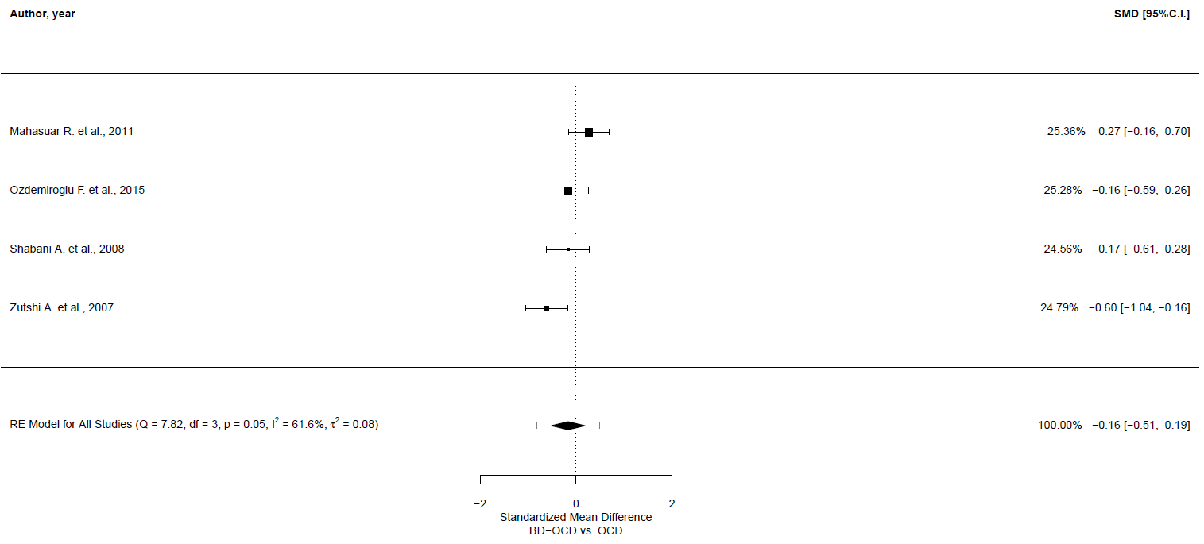
Meta-regression analyses
Outcome | Number of studies | 𝛽 | 95% CI | p-value
Mean age of BD-OCD sample
Number compulsions | 4 | 0.004 | -0.11, 0.117 | 0.949
% of females of BD-OCD sample
Number compulsions | 4 | 0.184 | -1.945, 2.314 | 0.865
Age at onset of OCD in BD-OCD sample
Number compulsions | 3 | -0.008 | -0.139, 0.122 | 0.902
% of people with BD-I
Number compulsions | 4 | -1.532 | -2.682, -0.382 | 0.009
% of euthymic people in BD-OCD sample
Number compulsions | 4 | -0.002 | -2.111, 2.108 | 0.999
% of depressed people in BD-OCD sample
Number compulsions | 4 | 0.002 | -2.435, 2.439 | 0.999
% of (hypo)manic people in BD-OCD sample
Number compulsions | 4 | 0.024 | -31.89. 31.938 | 0.999
% of people with lifetime MDD in OCD sample
Number compulsions | 3 | 3.516 | 1.013, 6.02 | 0.006

Leave-one-out sensitivity analyses
 | SMD | 95% CI | p-value | Qp | tau² | I²
Mahasuar R. et al., 2011 | -0.311 | -0.596, -0.026 | 0.033 | 0.278 | 0.014 | 21.615
Ozdemiroglu F. et al., 2015 | -0.165 | -0.662, 0.331 | 0.514 | 0.02 | 0.143 | 74.202
Shabani A. et al., 2008 | -0.164 | -0.657, 0.329 | 0.514 | 0.02 | 0.142 | 74.509
Zutshi A. et al., 2007 | -0.017 | -0.305, 0.27 | 0.905 | 0.269 | 0.016 | 24.544

Compulsions, cleaning/washing compulsions
Main analysis

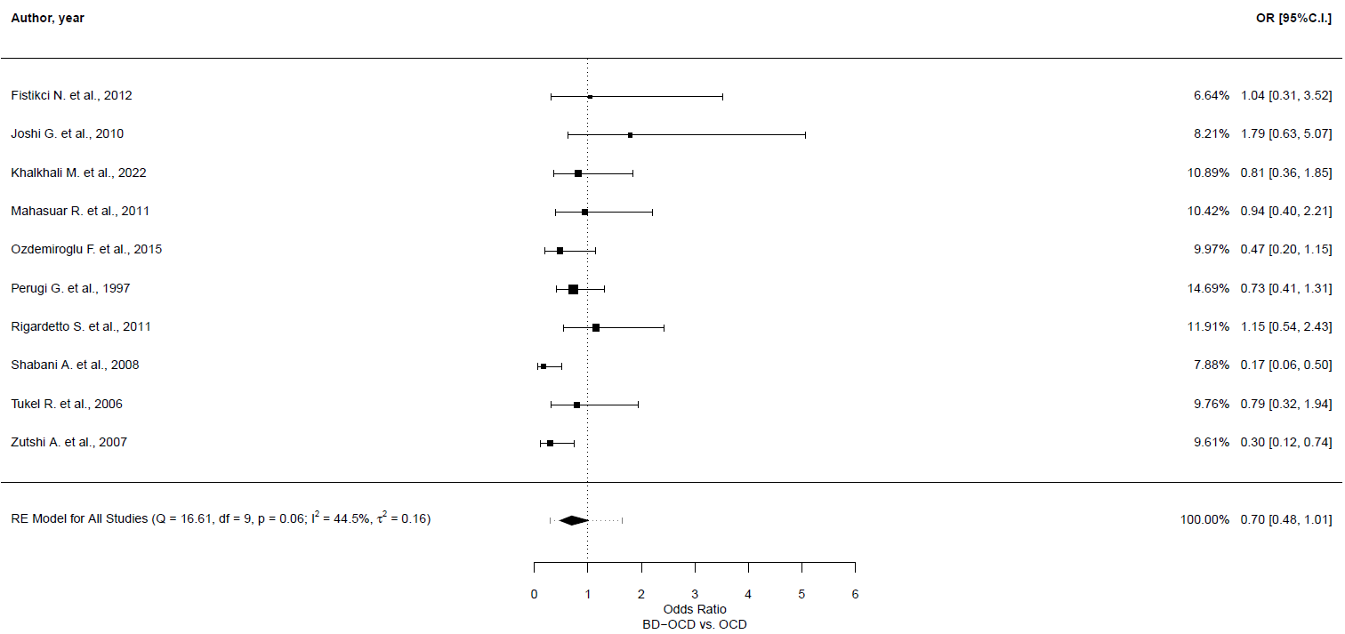
Meta-regression analyses
Outcome | Number of studies | 𝛽 | 95% CI | p-value
Primary outcome [vs. not primary]
Cleaning/washing | 10 | -0.628 | -1.456, 0.199 | 0.137
Mean age of BD-OCD sample
Cleaning/washing | 10 | -0.01 | -0.064, 0.044 | 0.707
% of females of BD-OCD sample
Cleaning/washing | 9 | -1.971 | -3.937, -0.005 | 0.049
Age at onset of OCD in BD-OCD sample
Cleaning/washing | 9 | -0.045 | -0.1, 0.011 | 0.113
Age at onset of BD
Cleaning/washing | 3 | -0.104 | -0.231, 0.023 | 0.107
% of people with BD-I
Cleaning/washing | 9 | -1.114 | -2.498, 0.269 | 0.114
% of euthymic people in BD-OCD sample
Cleaning/washing | 7 | -1.093 | -3.899, 1.715 | 0.446
% of depressed people in BD-OCD sample
Cleaning/washing | 7 | -0.688 | -4.779, 3.403 | 0.742
% of (hypo)manic people in BD-OCD sample
Cleaning/washing | 7 | 2.613 | -0.432, 5.658 | 0.093
% of people with lifetime MDD in OCD sample
Cleaning/washing | 7 | 3.542 | -3.598, 10.682 | 0.331
Depression symptom severity score
Cleaning/washing | 3 | 0.114 | -0.45, 0.678 | 0.692

Leave-one-out sensitivity analyses
 | OR | 95% CI | p-value | Qp | tau² | I²
Fistikci N. et al., 2012 | 0.676 | 0.453, 1.01 | 0.056 | 0.04 | 0.186 | 50.383
Joshi G. et al., 2010 | 0.645 | 0.45, 0.925 | 0.017 | 0.101 | 0.11 | 36.952
Khalkhali M. et al., 2022 | 0.682 | 0.446, 1.045 | 0.079 | 0.036 | 0.216 | 52.377
Mahasuar R. et al., 2011 | 0.672 | 0.442, 1.02 | 0.062 | 0.041 | 0.202 | 50.929
Ozdemiroglu F. et al., 2015 | 0.727 | 0.483, 1.094 | 0.126 | 0.046 | 0.186 | 49.144
Perugi G. et al., 1997 | 0.69 | 0.443, 1.074 | 0.1 | 0.035 | 0.236 | 51.958
Rigardetto S. et al., 2011 | 0.652 | 0.437, 0.972 | 0.036 | 0.064 | 0.162 | 44.665
Shabani A. et al., 2008 | 0.782 | 0.589, 1.037 | 0.087 | 0.303 | 0.005 | 2.366
Tukel R. et al., 2006 | 0.686 | 0.45, 1.047 | 0.081 | 0.035 | 0.213 | 52.555
Zutshi A. et al., 2007 | 0.768 | 0.547, 1.078 | 0.126 | 0.12 | 0.074 | 27.765

GOSH plot

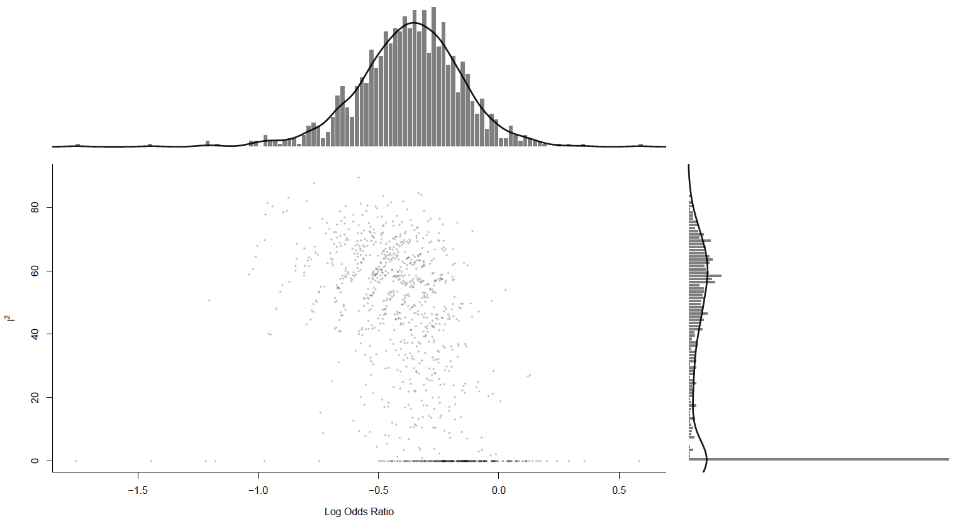
Funnel plot

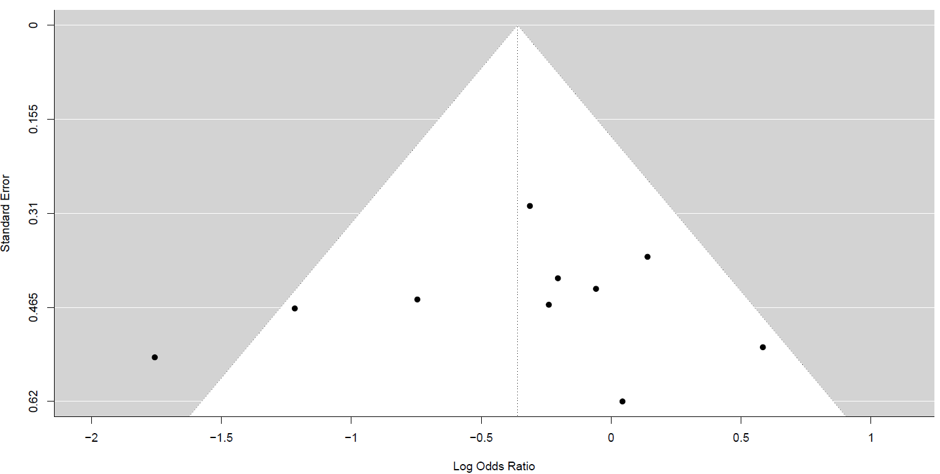
Egger Test: z= -0.422, p-value=0.673

Compulsions, checking compulsions
Main analysis

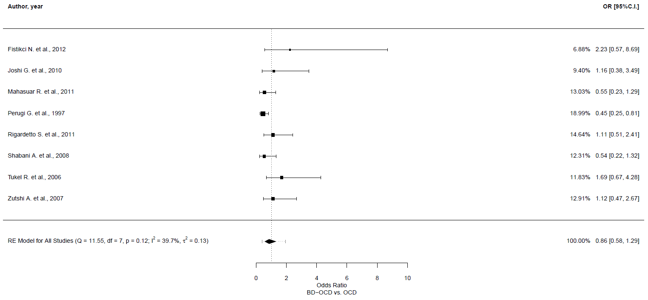
Leave-one-out sensitivity analyses
 | OR | 95% CI | p-value | Qp | tau² | I²
Fistikci N. et al., 2012 | 0.8 | 0.536, 1.193 | 0.274 | 0.16 | 0.106 | 37.09
Joshi G. et al., 2010 | 0.842 | 0.544, 1.305 | 0.442 | 0.086 | 0.153 | 44.98
Mahasuar R. et al., 2011 | 0.931 | 0.595, 1.458 | 0.756 | 0.099 | 0.155 | 43.896
Perugi G. et al., 1997 | 0.989 | 0.69, 1.42 | 0.954 | 0.371 | 0.011 | 4.67
Rigardetto S. et al., 2011 | 0.836 | 0.529, 1.32 | 0.441 | 0.095 | 0.163 | 44.21
Shabani A. et al., 2008 | 0.93 | 0.596, 1.452 | 0.75 | 0.099 | 0.154 | 44.036
Tukel R. et al., 2006 | 0.778 | 0.522, 1.161 | 0.219 | 0.184 | 0.091 | 31.927
Zutshi A. et al., 2007 | 0.838 | 0.534, 1.314 | 0.441 | 0.091 | 0.16 | 44.617

GOSH plot

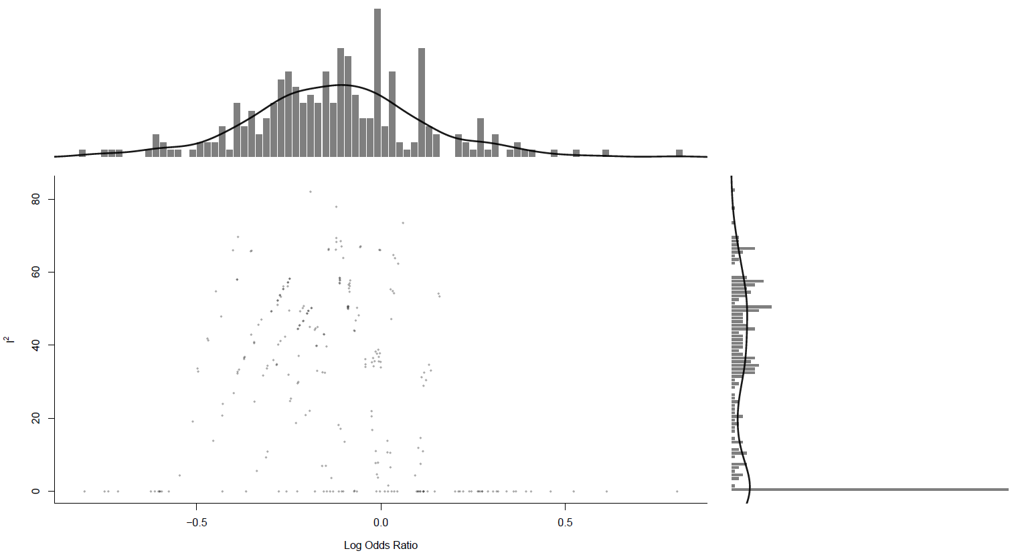

Compulsions, repeating rituals
Main analysis

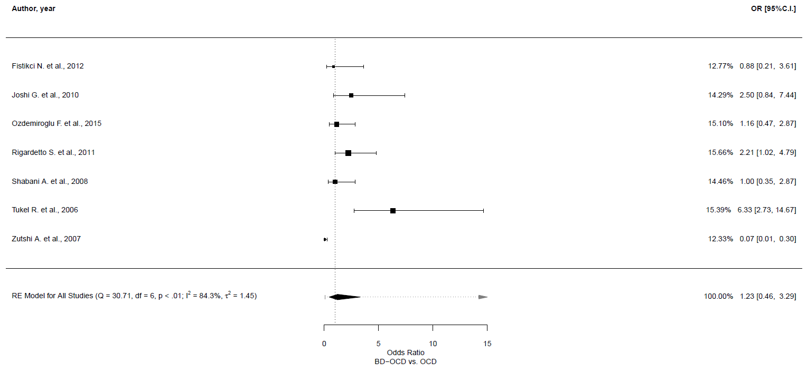
Meta-regression analyses
Outcome | Number of studies | 𝛽 | 95% CI | p-value
Primary outcome [vs. not primary]
Repeating rituals | 7 | -0.307 | -2.738, 2.123 | 0.804
Mean age of BD-OCD sample
Repeating rituals | 7 | -0.006 | -0.153, 0.141 | 0.936
% of females of BD-OCD sample
Repeating rituals | 6 | 1.428 | -4.432, 7.283 | 0.619
Age at onset of OCD in BD-OCD sample
Repeating rituals | 6 | -0.029 | -0.216, 0.157 | 0.755
Age at onset of BD
Repeating rituals | 3 | -0.107 | -0.546, 0.332 | 0.632
% of people with BD-I
Repeating rituals | 6 | -2.231 | -7.589, 3.129 | 0.415
% of euthymic people in BD-OCD sample
Repeating rituals | 5 | -1.552 | -8.886, 5.781 | 0.678
% of depressed people in BD-OCD sample
Repeating rituals | 5 | 0.173 | -10.011, 10.356 | 0.974
% of (hypo)manic people in BD-OCD sample
Repeating rituals | 5 | 2.24 | -6.324, 10.8 | 0.608
% of people with lifetime MDD in OCD sample
Repeating rituals | 5 | 17.18 | -0.694, 35.062 | 0.059

Leave-one-out sensitivity analyses
 | OR | 95% CI | p-value | Qp | tau² | I²
Fistikci N. et al., 2012 | 1.277 | 0.405, 4.034 | 0.676 | 0 | 1.784 | 87.788
Joshi G. et al., 2010 | 1.081 | 0.343, 3.405 | 0.894 | 0 | 1.744 | 86.81
Ozdemiroglu F. et al., 2015 | 1.224 | 0.373, 4.009 | 0.739 | 0 | 1.87 | 86.842
Rigardetto S. et al., 2011 | 1.091 | 0.339, 3.515 | 0.884 | 0 | 1.796 | 85.545
Shabani A. et al., 2008 | 1.255 | 0.388, 4.065 | 0.705 | 0 | 1.84 | 87.288
Tukel R. et al., 2006 | 0.933 | 0.361, 2.412 | 0.886 | 0.002 | 1.08 | 78.66
Zutshi A. et al., 2007 | 1.943 | 1.052, 3.588 | 0.034 | 0.038 | 0.329 | 57.305

GOSH plot

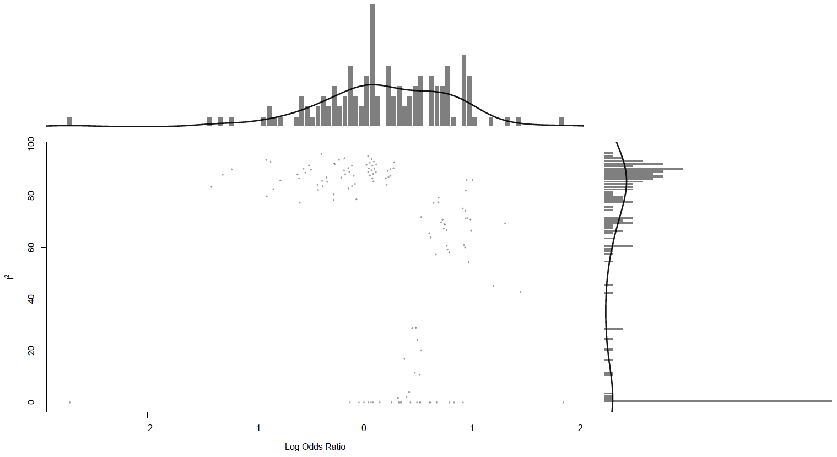

Compulsions, counting compulsions
Main analysis

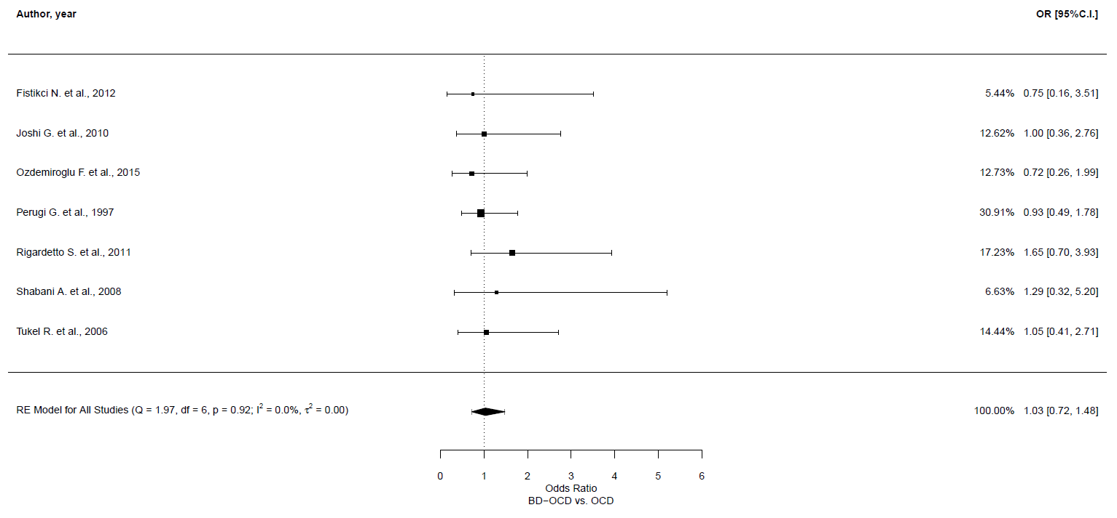
Leave-one-out sensitivity analyses
 | OR | 95% CI | p-value | Qp | tau² | I²
Fistikci N. et al., 2012 | 1.053 | 0.727, 1.524 | 0.786 | 0.876 | 0 | 0
Joshi G. et al., 2010 | 1.038 | 0.706, 1.525 | 0.849 | 0.854 | 0 | 0
Ozdemiroglu F. et al., 2015 | 1.088 | 0.741, 1.599 | 0.667 | 0.921 | 0 | 0
Perugi G. et al., 1997 | 1.082 | 0.702, 1.668 | 0.72 | 0.872 | 0 | 0
Rigardetto S. et al., 2011 | 0.937 | 0.631, 1.391 | 0.747 | 0.988 | 0 | 0
Shabani A. et al., 2008 | 1.017 | 0.701, 1.476 | 0.927 | 0.867 | 0 | 0
Tukel R. et al., 2006 | 1.03 | 0.698, 1.52 | 0.881 | 0.853 | 0 | 0

GOSH plot

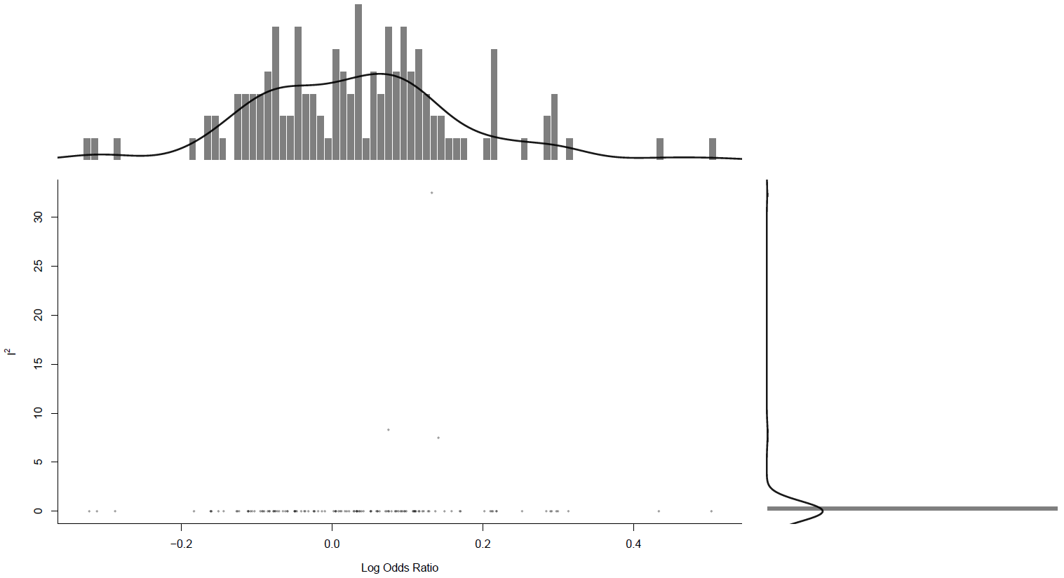

Compulsions, ordering/arranging compulsions
Main analysis

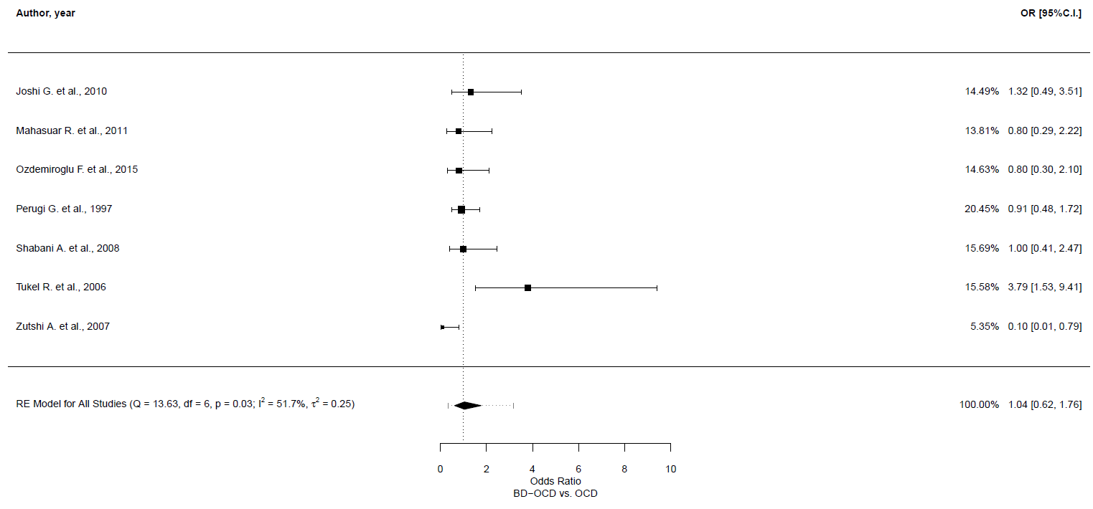
Meta-regression analyses
Outcome | Number of studies | 𝛽 | 95% CI | p-value
Primary outcome [vs. not primary]
Ordering/arranging | 7 | -0.304 | -2.021, 1.413 | 0.73
Mean age of BD-OCD sample
Ordering/arranging | 7 | -0.002 | -0.086, 0.082 | 0.962
% of females of BD-OCD sample
Ordering/arranging | 7 | 1.838 | -1.426, 5.103 | 0.27
Age at onset of OCD in BD-OCD sample
Ordering/arranging | 6 | -0.022 | -0.133, 0.09 | 0.703
Age at onset of BD
Ordering/arranging | 3 | -0.069 | -0.361, 0.224 | 0.646
% of people with BD-I
Ordering/arranging | 6 | -0.761 | -4.17, 2.649 | 0.662
% of euthymic people in BD-OCD sample
Ordering/arranging | 6 | -0.069 | -3.889, 3.752 | 0.972
% of depressed people in BD-OCD sample
Ordering/arranging | 6 | -0.685 | -5.857, 4.488 | 0.795
% of (hypo)manic people in BD-OCD sample
Ordering/arranging | 6 | 0.703 | -3.899, 5.307 | 0.765
% of people with lifetime MDD in OCD sample
Ordering/arranging | 6 | 6.892 | -4.015, 17.8 | 0.216

Leave-one-out sensitivity analyses
 | OR | 95% CI | p-value | Qp | tau² | I²
Joshi G. et al., 2010 | 0.973 | 0.504, 1.879 | 0.935 | 0.019 | 0.405 | 63.527
Mahasuar R. et al., 2011 | 1.065 | 0.564, 2.014 | 0.845 | 0.021 | 0.368 | 61.686
Ozdemiroglu F. et al., 2015 | 1.067 | 0.562, 2.027 | 0.843 | 0.022 | 0.373 | 61.529
Perugi G. et al., 1997 | 1.037 | 0.519, 2.074 | 0.918 | 0.021 | 0.441 | 61.192
Shabani A. et al., 2008 | 1.018 | 0.521, 1.99 | 0.959 | 0.018 | 0.422 | 63.779
Tukel R. et al., 2006 | 0.874 | 0.599, 1.275 | 0.484 | 0.405 | 0.000 | 0.000
Zutshi A. et al., 2007 | 1.185 | 0.742, 1.893 | 0.478 | 0.138 | 0.136 | 40.284

GOSH plot

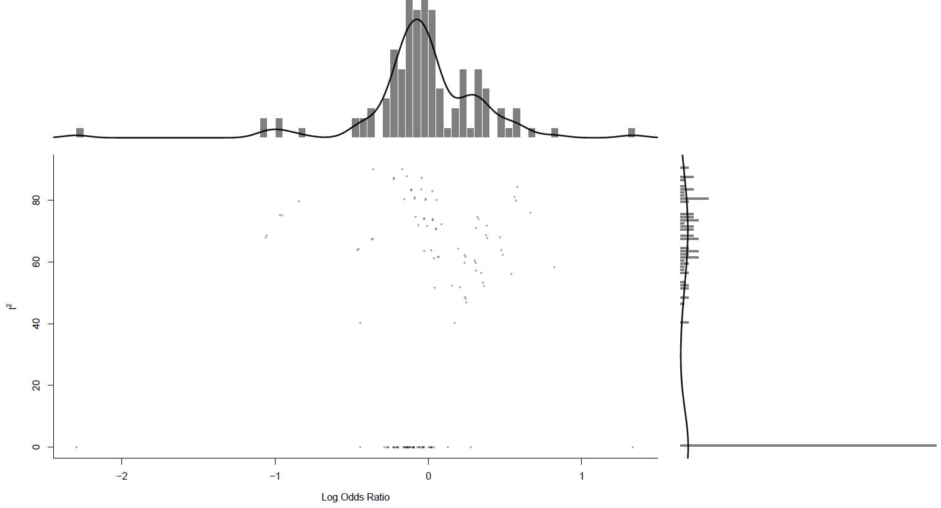

Compulsions, hoarding/collecting compulsions
Main analysis

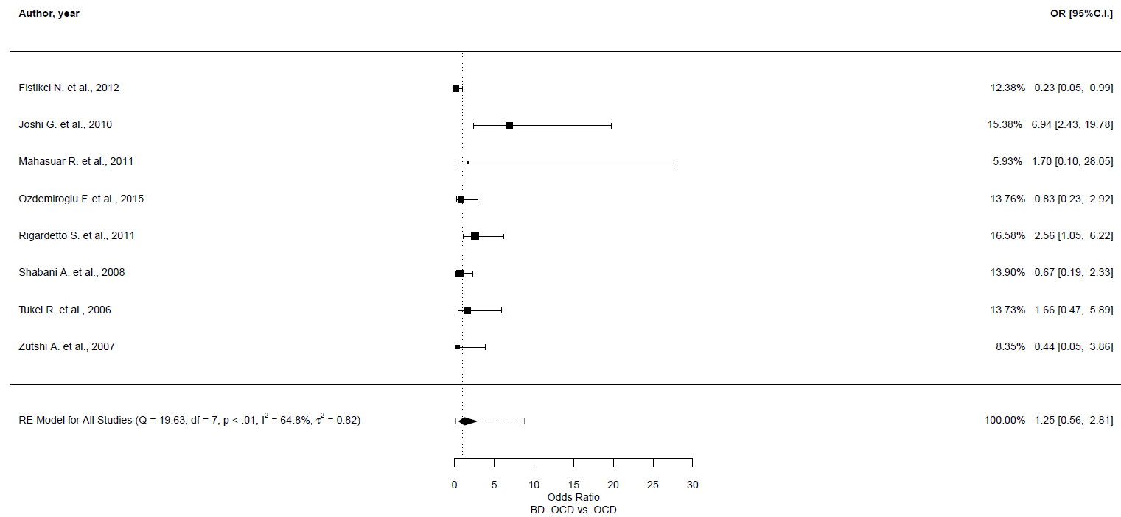
Meta-regression analyses
Outcome | Number of studies | 𝛽 | 95% CI | p-value
Primary outcome [vs. not primary]
Hoarding/collecting | 8 | -0.255 | -2.19, 1.681 | 0.8
Mean age of BD-OCD sample
Hoarding/collecting | 8 | -0.086 | -0.176, 0.003 | 0.059
% of females of BD-OCD sample
Hoarding/collecting | 7 | -2.3 | -5.177, 0.575 | 0.117
Age at onset of OCD in BD-OCD sample
Hoarding/collecting | 7 | -0.095 | -0.203, 0.013 | 0.084
Age at onset of BD
Hoarding/collecting | 3 | -0.157 | -0.268, -0.047 | 0.005
% of people with BD-I
Hoarding/collecting | 7 | 0.996 | -2.614, 4.606 | 0.589
% of euthymic people in BD-OCD sample
Hoarding/collecting | 6 | -2.042 | -6.074, 1.989 | 0.321
% of depressed people in BD-OCD sample
Hoarding/collecting | 6 | -1.656 | -7.659, 4.347 | 0.588
% of (hypo)manic people in BD-OCD sample
Hoarding/collecting | 6 | 4.296 | 1.629, 6.963 | 0.002
% of people with lifetime MDD in OCD sample
Hoarding/collecting | 6 | 4.426 | -7.836, 16.889 | 0.479
Depression symptom severity score
Hoarding/collecting | 3 | 0.308 | -0.812, 1.429 | 0.589

Leave-one-out sensitivity analyses
 | OR | 95% CI | p-value | Qp | tau² | I²
Fistikci N. et al., 2012 | 1.637 | 0.777, 3.452 | 0.195 | 0.053 | 0.506 | 53.677
Joshi G. et al., 2010 | 0.956 | 0.474, 1.926 | 0.899 | 0.131 | 0.358 | 42.249
Mahasuar R. et al., 2011 | 1.216 | 0.512, 2.891 | 0.658 | 0.003 | 0.918 | 69.818
Ozdemiroglu F. et al., 2015 | 1.318 | 0.522, 3.325 | 0.559 | 0.005 | 0.988 | 68.457
Rigardetto S. et al., 2011 | 1.077 | 0.427, 2.715 | 0.875 | 0.006 | 0.944 | 64.267
Shabani A. et al., 2008 | 1.368 | 0.551, 3.398 | 0.5 | 0.007 | 0.937 | 67.182
Tukel R. et al., 2006 | 1.177 | 0.461, 3.005 | 0.734 | 0.003 | 1.027 | 69.317
Zutshi A. et al., 2007 | 1.371 | 0.581, 3.235 | 0.472 | 0.006 | 0.862 | 67.954

GOSH plot

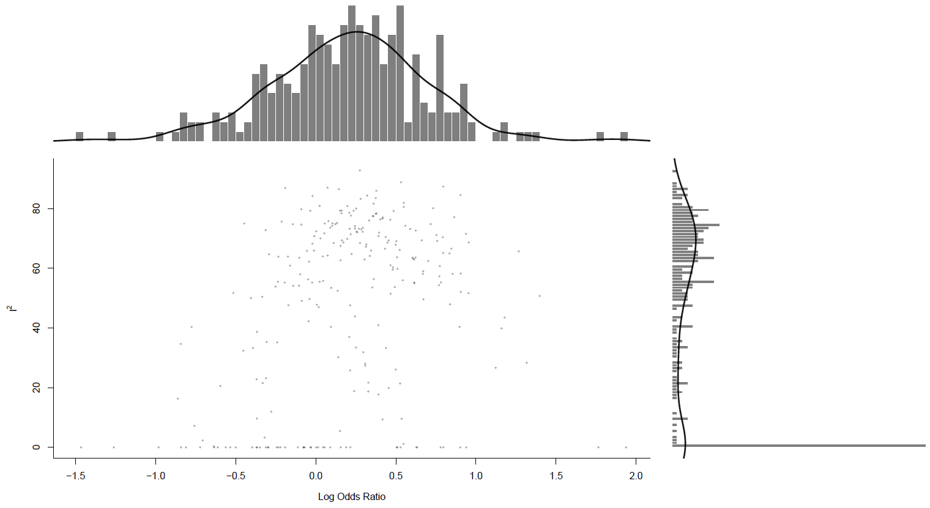

Compulsions, miscellaneous compulsions
Main analysis

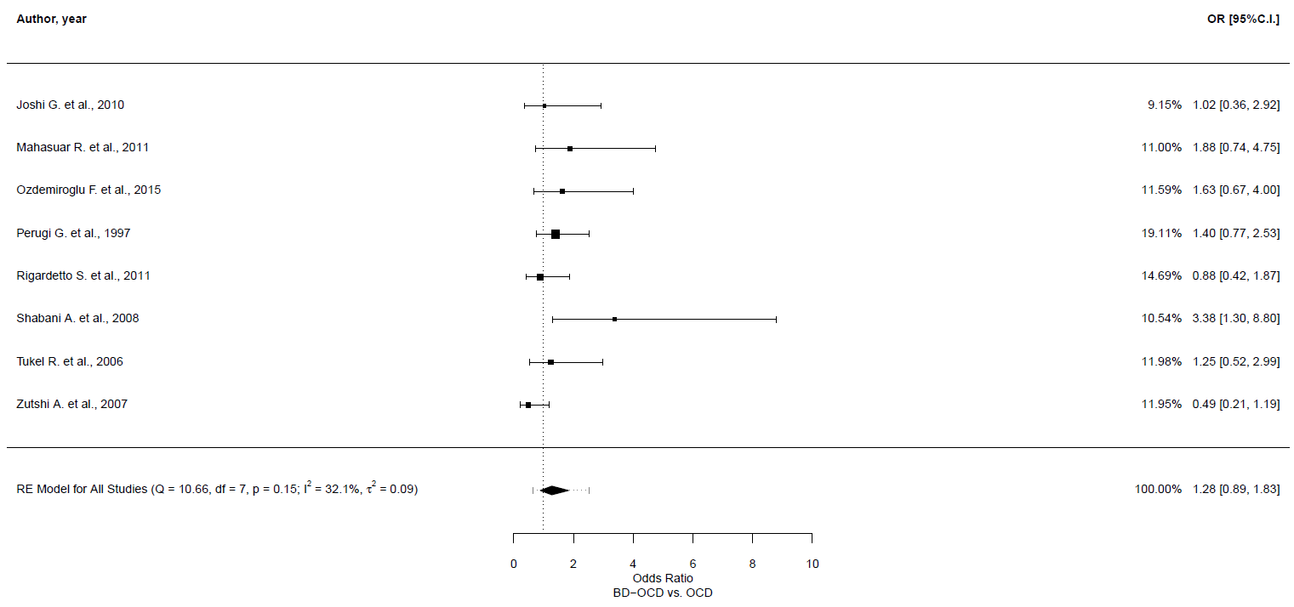
Leave-one-out sensitivity analyses
 | OR | 95% CI | p-value | Qp | tau² | I²
Joshi G. et al., 2010 | 1.31 | 0.872, 1.967 | 0.194 | 0.106 | 0.124 | 41.549
Mahasuar R. et al., 2011 | 1.218 | 0.816, 1.818 | 0.334 | 0.129 | 0.109 | 37.807
Ozdemiroglu F. et al., 2015 | 1.238 | 0.819, 1.872 | 0.311 | 0.112 | 0.126 | 41.066
Perugi G. et al., 1997 | 1.258 | 0.802, 1.972 | 0.317 | 0.104 | 0.158 | 43.149
Rigardetto S. et al., 2011 | 1.362 | 0.905, 2.048 | 0.138 | 0.143 | 0.109 | 36.325
Shabani A. et al., 2008 | 1.148 | 0.844, 1.562 | 0.379 | 0.4 | 0 | 0
Tukel R. et al., 2006 | 1.285 | 0.841, 1.964 | 0.247 | 0.1 | 0.14 | 43.553
Zutshi A. et al., 2007 | 1.432 | 1.049, 1.955 | 0.024 | 0.466 | 0 | 0

GOSH plot

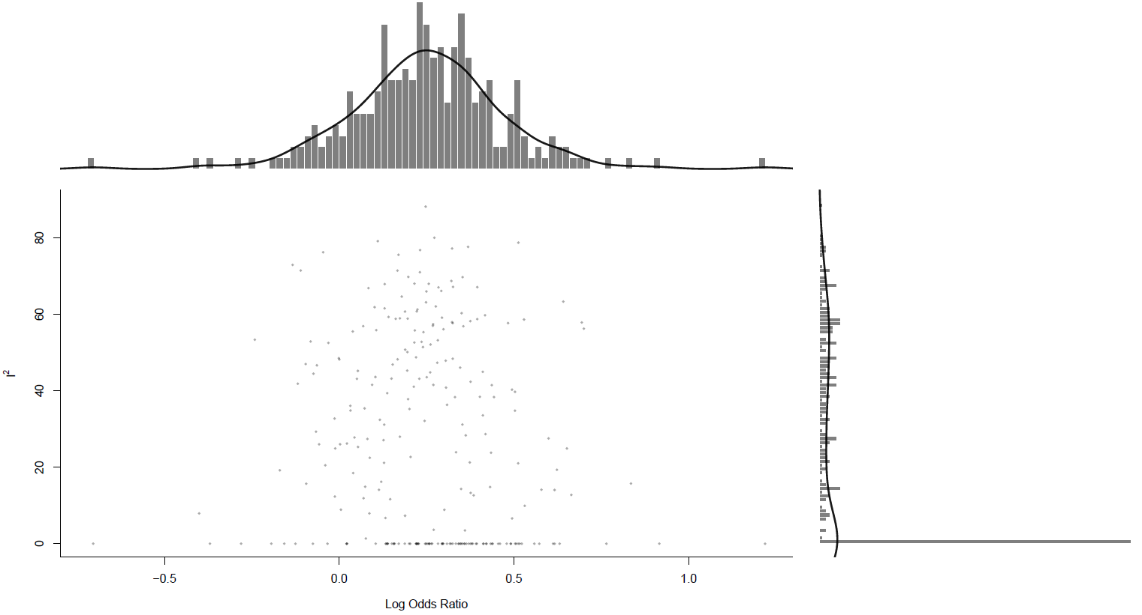

Appendix VI: Sensitivity analysis, good quality studies only

Outcome type | Studies, n | BD-OCD patients, n | OCD patients, n | SMD/OR | 95% CI | p-value | 95% PI | I² (%) | tau² | Q-test p-value
Obsessive-Compulsive symptomatology
Total symptomatology | 9 | 322 | 1855 | -0.301 | -0.743, 0.141 | 0.18 | -1.632, 1.029 | 90.9 | 0.41 | <0.001
Obsessive symptomatology | 7 | 257 | 1796 | -0.358 | -0.946, 0.229 | 0.231 | -1.969, 1.252 | 94 | 0.59 | <0.001
Compulsive symptomatology | 7 | 257 | 1796 | -0.259 | -0.678, 0.161 | 0.227 | -1.378, 0.86 | 88.5 | 0.28 | <0.001
Obsessions, number and type
Number of obsessions, any | 4 | 133 | 235 | 0.159 | -0.443, 0.76 | 0.605 | -1.112, 1.429 | 86.6 | 0.33 | <0.001
Aggressive | 8 | 318 | 1757 | 1.222 | 0.931, 1.603 | 0.148 | 0.931, 1.603 | 0 | 0 | 0.24
Contamination | 7 | 244 | 876 | 0.656 | 0.481, 0.894 | 0.007 | 0.481, 0.894 | 0 | 0 | 0.48
Sexual | 7 | 244 | 876 | 2.17 | 0.803, 5.871 | 0.127 | 0.173, 27.277 | 85.3 | 1.41 | <0.001
Hoarding/saving | 7 | 264 | 1466 | 1.3 | 0.919, 1.838 | 0.138 | 0.919, 1.838 | 0 | 0 | 0.32
Religious | 7 | 244 | 876 | 1.239 | 0.689, 2.228 | 0.474 | 0.326, 4.717 | 61.5 | 0.38 | 0.02
Symmetry/exactness | 7 | 244 | 876 | 1.099 | 0.677, 1.787 | 0.7 | 0.388, 3.12 | 53.1 | 0.22 | <0.001
Miscellaneous | 7 | 287 | 1700 | 1.034 | 0.766, 1.397 | 0.866 | 0.765, 1.397 | 0 | 0 | 0.49
Somatic | 5 | 182 | 741 | 0.872 | 0.558, 1.363 | 0.547 | 0.558, 1.363 | 0 | 0 | 0.59
Pathological doubt | 2 | 62 | 135 | 0.533 | 0.207, 1.377 | 0.194 | 0.134, 2.13 | 55.6 | 0.27 | 0.07
Compulsions, number and type
Number of compulsions, any | 4 | 133 | 235 | -0.164 | -0.515, 0.186 | 0.359 | -0.817, 0.488 | 61.6 | 0.08 | 0.05
Cleaning/washing | 7 | 244 | 876 | 0.589 | 0.374, 0.928 | 0.022 | 0.222, 1.558 | 52.3 | 0.19 | 0.05
Checking | 6 | 212 | 815 | 0.771 | 0.5, 1.19 | 0.241 | 0.342, 1.74 | 42.3 | 0.12 | 0.12
Repeating rituals | 5 | 156 | 528 | 1.1 | 0.273, 4.44 | 0.893 | 0.042, 28.594 | 90.4 | 2.2 | <0.001
Counting | 5 | 182 | 741 | 1.061 | 0.713, 1.578 | 0.772 | 0.713, 1.578 | 0 | 0 | 0.77
Ordering/arranging | 6 | 213 | 617 | 0.973 | 0.504, 1.879 | 0.935 | 0.238, 3.984 | 63.5 | 0.4 | 0.02
Hoarding/collecting | 6 | 190 | 585 | 1.27 | 0.685, 2.355 | 0.448 | 0.515, 3.131 | 18.8 | 0.1 | 0.43
Miscellaneous | 7 | 244 | 866 | 1.31 | 0.872, 1.967 | 0.194 | 0.588, 2.915 | 41.5 | 0.12 | 0.11

PRISMA Checklist

1Section and Topic | Item # | Checklist item | Location where item is reported
TITLE
Title | 1 | Identify the report as a systematic review. | Pag 1
ABSTRACT
Abstract | 2 | See the PRISMA 2020 for Abstracts checklist. | Pag 3
INTRODUCTION
Rationale | 3 | Describe the rationale for the review in the context of existing knowledge. | Pag 5
Objectives | 4 | Provide an explicit statement of the objective(s) or question(s) the review addresses. | Pag 5-6
METHODS
Eligibility criteria | 5 | Specify the inclusion and exclusion criteria for the review and how studies were grouped for the syntheses. | Pag 7
Information sources | 6 | Specify all databases, registers, websites, organisations, reference lists and other sources searched or consulted to identify studies. Specify the date when each source was last searched or consulted. | Pag 7
Search strategy | 7 | Present the full search strategies for all databases, registers and websites, including any filters and limits used. | Supp Mat
Selection process | 8 | Specify the methods used to decide whether a study met the inclusion criteria of the review, including how many reviewers screened each record and each report retrieved, whether they worked independently, and if applicable, details of automation tools used in the process. | Pag 7-9
Data collection process | 9 | Specify the methods used to collect data from reports, including how many reviewers collected data from each report, whether they worked independently, any processes for obtaining or confirming data from study investigators, and if applicable, details of automation tools used in the process. | Pag 7-8
Data items | 10a | List and define all outcomes for which data were sought. Specify whether all results that were compatible with each outcome domain in each study were sought (e.g. for all measures, time points, analyses), and if not, the methods used to decide which results to collect. | Pag 7-8
Data items | 10b | List and define all other variables for which data were sought (e.g. participant and intervention characteristics, funding sources). Describe any assumptions made about any missing or unclear information. | Pag 7-8
Study risk of bias assessment | 11 | Specify the methods used to assess risk of bias in the included studies, including details of the tool(s) used, how many reviewers assessed each study and whether they worked independently, and if applicable, details of automation tools used in the process. | Pag 8
Effect measures | 12 | Specify for each outcome the effect measure(s) (e.g. risk ratio, mean difference) used in the synthesis or presentation of results. | Pag 8-9
Synthesis methods | 13a | Describe the processes used to decide which studies were eligible for each synthesis (e.g. tabulating the study intervention characteristics and comparing against the planned groups for each synthesis (item #5)). | Pag 7-8
Synthesis methods | 13b | Describe any methods required to prepare the data for presentation or synthesis, such as handling of missing summary statistics, or data conversions. | Pag 8-9
Synthesis methods | 13c | Describe any methods used to tabulate or visually display results of individual studies and syntheses. | Pag 8-9
Synthesis methods | 13d | Describe any methods used to synthesize results and provide a rationale for the choice(s). If meta-analysis was performed, describe the model(s), method(s) to identify the presence and extent of statistical heterogeneity, and software package(s) used. | Pag 8-9
Synthesis methods | 13e | Describe any methods used to explore possible causes of heterogeneity among study results (e.g. subgroup analysis, meta-regression). | Pag 8-9
Synthesis methods | 13f | Describe any sensitivity analyses conducted to assess robustness of the synthesized results. | Pag 8-9
Reporting bias assessment | 14 | Describe any methods used to assess risk of bias due to missing results in a synthesis (arising from reporting biases). | Pag 8-9
Certainty assessment | 15 | Describe any methods used to assess certainty (or confidence) in the body of evidence for an outcome. | Pag 8-9
RESULTS
Study selection | 16a | Describe the results of the search and selection process, from the number of records identified in the search to the number of studies included in the review, ideally using a flow diagram. | Pag 10, Figure 1
Study selection | 16b | Cite studies that might appear to meet the inclusion criteria, but which were excluded, and explain why they were excluded. | Figure 1, Supp Mat
Study characteristics | 17 | Cite each included study and present its characteristics. | Pag 10, Table 1
Risk of bias in studies | 18 | Present assessments of risk of bias for each included study. | Table 1, Supp Mat
Results of individual studies | 19 | For all outcomes, present, for each study: (a) summary statistics for each group (where appropriate) and (b) an effect estimate and its precision (e.g. confidence/credible interval), ideally using structured tables or plots. | Pag 10-11, Table 2
Results of syntheses | 20a | For each synthesis, briefly summarise the characteristics and risk of bias among contributing studies. | Pag 10-11
Results of syntheses | 20b | Present results of all statistical syntheses conducted. If meta-analysis was done, present for each the summary estimate and its precision (e.g. confidence/credible interval) and measures of statistical heterogeneity. If comparing groups, describe the direction of the effect. | Pag 11-13, Supp Mat
Results of syntheses | 20c | Present results of all investigations of possible causes of heterogeneity among study results. | Pag 11-13, Supp Mat
Results of syntheses | 20d | Present results of all sensitivity analyses conducted to assess the robustness of the synthesized results. | Pag 11-13, Supp Mat
Reporting biases | 21 | Present assessments of risk of bias due to missing results (arising from reporting biases) for each synthesis assessed. | Pag 13, Supp Mat
Certainty of evidence | 22 | Present assessments of certainty (or confidence) in the body of evidence for each outcome assessed. | Table 2, Supp Mat
DISCUSSION
Discussion | 23a | Provide a general interpretation of the results in the context of other evidence. | Pag 14-18
Discussion | 23b | Discuss any limitations of the evidence included in the review. | Pag 17-18
Discussion | 23c | Discuss any limitations of the review processes used. | Pag 17-18
Discussion | 23d | Discuss implications of the results for practice, policy, and future research. | Pag 17-18
OTHER INFORMATION
Registration and protocol | 24a | Provide registration information for the review, including register name and registration number, or state that the review was not registered. | Pag 7
Registration and protocol | 24b | Indicate where the review protocol can be accessed, or state that a protocol was not prepared. | Pag 7
Registration and protocol | 24c | Describe and explain any amendments to information provided at registration or in the protocol. | Pag 7, Supp Mat
Support | 25 | Describe sources of financial or non-financial support for the review, and the role of the funders or sponsors in the review. | Pag 2,19
Competing interests | 26 | Declare any competing interests of review authors. | Pag 2
Availability of data, code and other materials | 27 | Report which of the following are publicly available and where they can be found: template data collection forms; data extracted from included studies; data used for all analyses; analytic code; any other materials used in the review. | Pag 19

