Supplementary Material

Supplemental Methods 1. Search strings used for PubMed and Embase (search date: November 23, 2023)

PubMed
("circadian disruption" OR "shift work" OR "night work" OR "night" OR "shift" OR "night-shift work" OR "rotating shift work" OR "shiftworking" OR "shift worker" OR "chronobiology disorders" OR "circadian clocks" OR "circadian rythms" OR "evening shift") AND ((breast AND (cancer* OR carcinoma* OR tumor* OR tumour* OR neoplasm*)) OR "Breast Neoplasms"[Mesh]) AND (work* OR occup*)

Embase

((('night'/exp OR night) AND ('shift'/exp OR shift)) OR (('circadian'/exp OR circadian) AND ('rhythm'/exp OR rhythm))) AND (work* OR occup*) AND ('breast cancer'/exp OR 'breast cancer' OR (('breast'/exp OR breast) AND ('cancer'/exp OR cancer OR 'neoplasm'/exp OR neoplasm OR 'tumor'/exp OR tumor))) AND ('article'/it OR 'article in press'/it OR 'chapter'/it OR 'conference paper'/it OR 'conference review'/it OR 'editorial'/it OR 'letter'/it OR 'note'/it OR 'review'/it OR 'short survey'/it)

Supplemental Table 1. Results from the risk of bias assessment according to the OHAT Risk of Bias Rating Tool for Human and Animal Studies (items applicable to cohort and case-control studies¥).
Study | Item 3  Selection bias | Item 4  Confounding* | Item 7  Attrition / Exclusion bias | Item 8  Detection bias (exposure)¶ | Item 9  Detection bias (outcome) | Item 10  Selective reporting bias
Lie et al., 2006 | Definitely low | Probably high | Definitely low | Probably high | Definitely low | Definitely low
Lie et al., 2011 | Definitely low | Probably low | Probably high | Probably low | Definitely low | Definitely low
Hansen & Stevens, 2012 | Definitely low | Probably low | Probably low | Probably low | Definitely low | Definitely low
Grundy et al., 2013 | Probably high | Probably low | Probably low | Probably low | Definitely low | Definitely low
Koppes et al., 2014 | Definitely low | Probably high | Probably low | Probably high | Definitely low | Definitely low
Travis et al., 2016 (MWS) | Definitely low | Probably low | Probably low | Probably low | Definitely low | Definitely low
Wegrzyn et al., 2017 (NHS) | Definitely low | Probably low | Probably low | Probably high | Definitely low | Definitely low
Wegrzyn et al., 2017 (NHS II) | Definitely low | Probably low | Probably low | Probably low | Definitely low | Definitely low
Jones et al., 2019 | Definitely low | Probably low | Probably low | Probably high | Definitely low | Definitely low
Traversini et al., 2020 | Definitely high | Probably high | Probably high | Probably high | Definitely high | Definitely low
Härmä et al., 2023 | Definitely low | Probably low | Probably low | Probably high | Definitely low | Definitely low
Gustavsson et al., 2023 | Definitely low | Probably high | Probably low | Probably high | Definitely low | Definitely low
Abbreviations: NHS, Nurses’ Health Study; MWS, Million Women Study.
¥ Item 3: Did selection of study participants result in appropriate comparison groups? Item 4: Did the study design or analysis account for important confounding and modifying variables? Item 7: Were outcome data complete without attrition or exclusion from analysis? Item 8: Can we be confident in the exposure characterization? Item 9: Can we be confident in the outcome assessment? Item 10: Were all measured outcomes reported?
* Probably low risk of bias: studies adjusting for age, a measure of body weight, and parity, or that evaluated the confounding role of such factors.
¶ Definitely low risk of bias: payroll data and lifetime exposure; Probably low risk of bias: questionnaire data and lifetime exposure or payroll data and partial exposure; Probably high risk of bias: questionnaire data and partial exposure.

Supplemental Figure 1. Funnel plot for detection of publication bias in the meta-analysis of ever versus never night shift work.

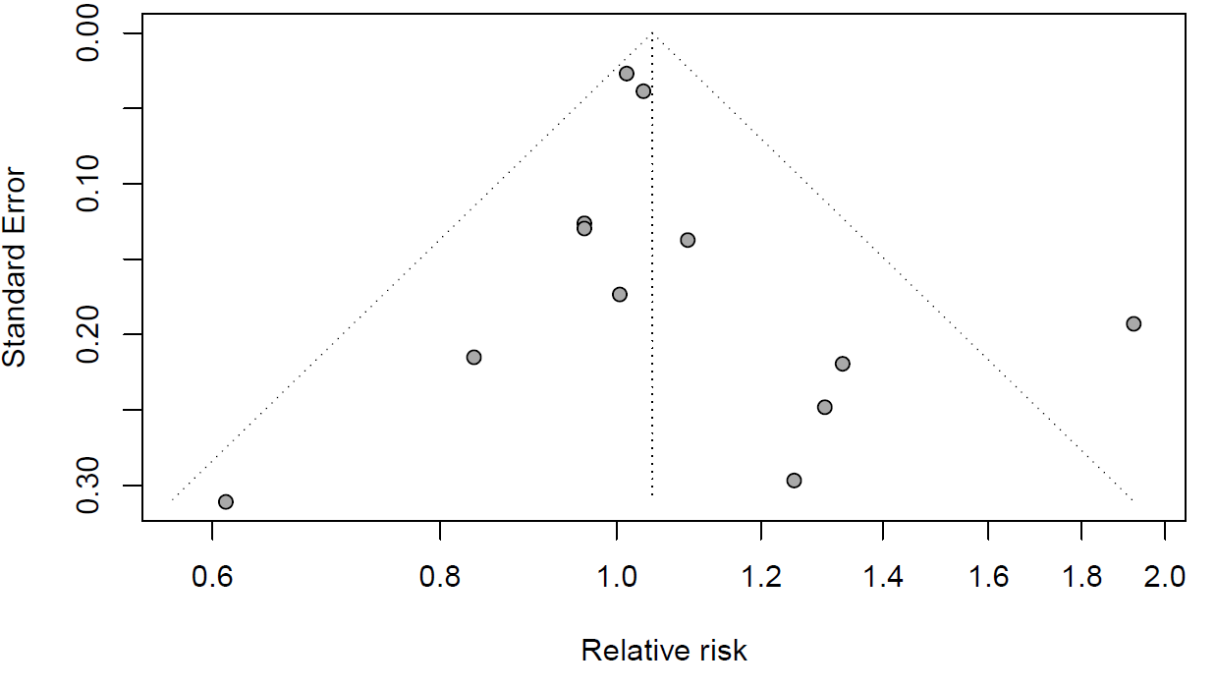

Supplemental Figure 2. Trim and fill analysis for the meta-analysis of ≥20 years of night shift work versus never night shift work*.

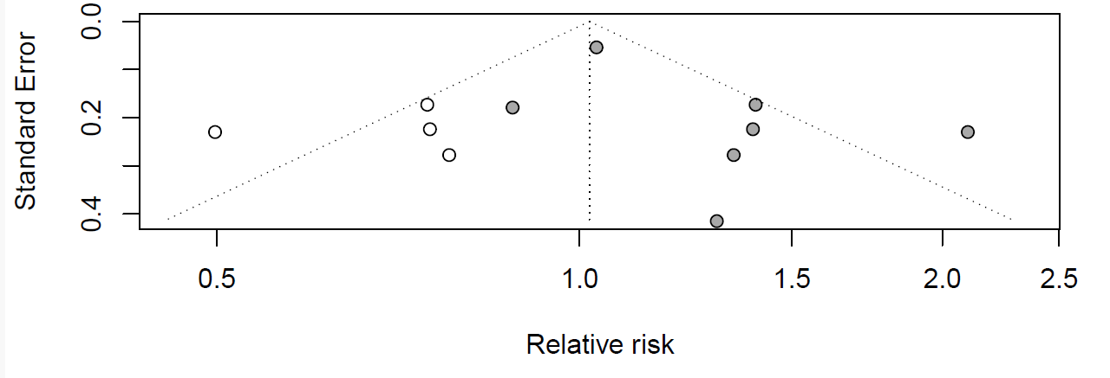
*Trim-and-fill corrected estimate: 1.02 (95% confidence interval: 0.83-1.25)

Supplemental Figure 3. Study-specific and pooled relative risk (RR) of breast cancer, with corresponding 95% confidence intervals (CI), for categories of duration in night shift work in healthcare workers considering only the studies which could contribute to all the categories.
