Characterisation of polyethylene and polyurethane microplastics and their adsorption behaviour on Cu²⁺ and Fe³⁺ in environmental matrices

Ilaria Zanoni¹, Lucia Briccolani², Lara Faccani¹, Magda Blosi¹, Simona Ortelli¹, Matteo Crosera³, Giovanna Marussi³, Stefania Albonetti² and Anna Luisa Costa¹
¹ CNR-ISSMC National Research Council of Italy, Institute of Science, Technology and Sustainability for Ceramics, 48018, Faenza, Italy
² Department of Industrial Chemistry “Toso Montanari”, University of Bologna, Bologna, Italy
³ Department of Chemical and Pharmaceutical Sciences, University of Trieste, Trieste, Italy
Corresponding author: simona.ortelli@issmc.cnr.it

  - Table S1. Heating program for acid digestion of the filter samples.
Stage | Ramp Time (min) | Power (Watt)
1 | 1 | 250
2 | 1 | 0
3 | 4 | 250
4 | 4 | 400
5 | 4 | 600

a)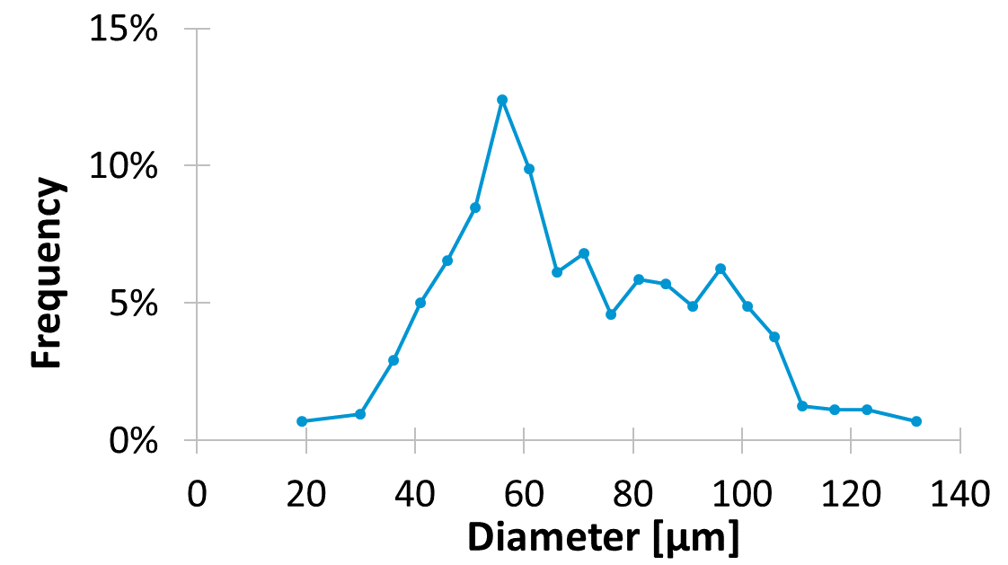 b)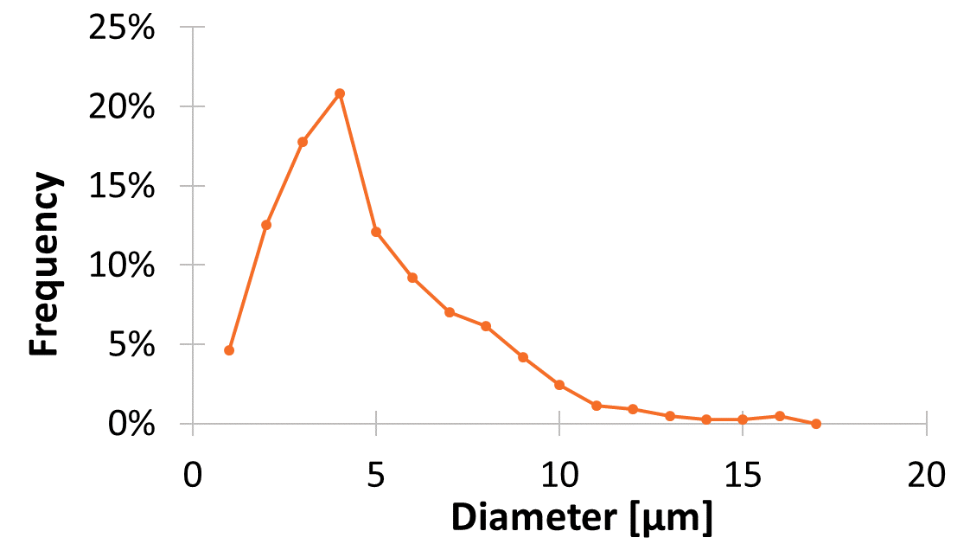
  - Figure S1: FE-SEM size distribution of microplastic samples obtained by ImageJ analysis, a) for LDPE and b) for PU.

  - 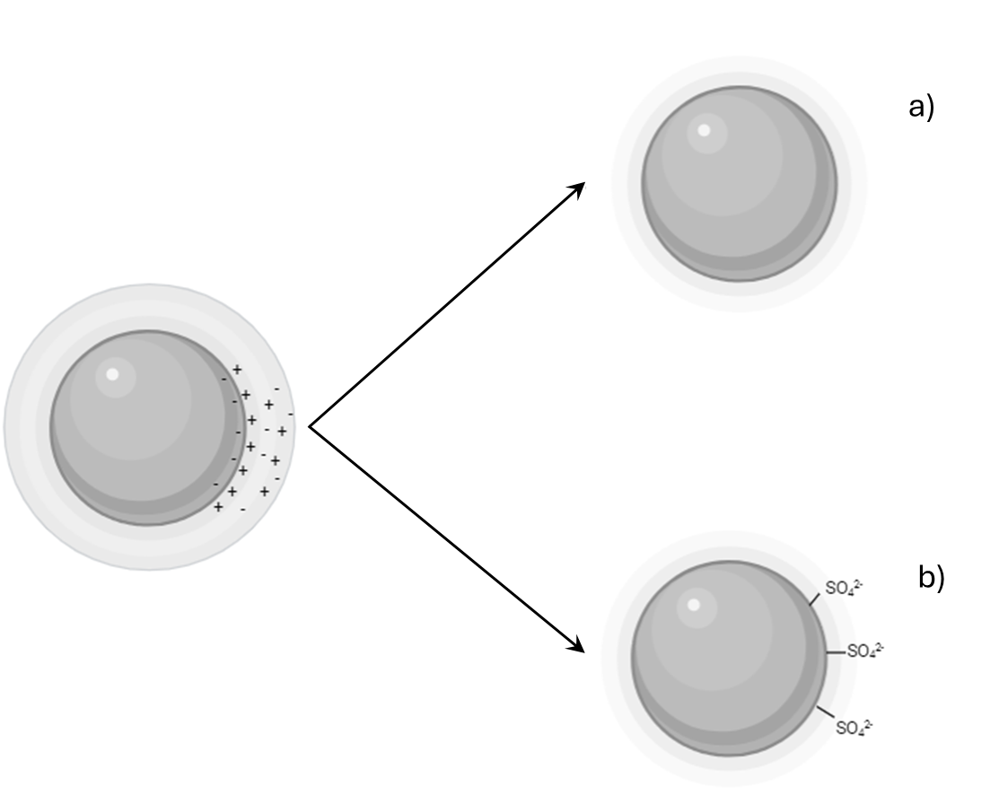
Figure S2: Hypothetical mechanisms involved in the colloidal destabilization of microplastics exposed in environmental media caused by a) the compression of the electrical double layer, observed after the exposure in both environmental media and b) the specific adsorption of polyvalent ions as SO₄²⁻ anions, that occurred in Elendt M7 media.
  - Table S2: metal impurities in [mg g⁻¹] of the pristine MPs of LDPE and PU, through ICP analysis.
Sample | Na | K | Mg | Ca
LDPE | 0.032 ± 0.004 | 0.034 ± 0.075 | 0.002 ± 0.003 | 0.020 ± 0.032
PU | 4.078 ± 0.564 | 0.015 ± 0.011 | 0.014 ± 0.019 | 0.113 ± 0.129

  - Table S3: ZP values and pH values for the LDPE sample at 500 mg L⁻¹ in Egg Water and in Elendt M7.
 | Egg water |  | Elendt M7
 | ZP [mV] | pH | ZP [mV] | pH
1 h | - 5.8 ± 1.1 | 5.8 | - 11.3 ± 0.6 | 7.3
24 h | - 4.1 ± 2.6 | 5.7 | -10.0 ± 1.0 | 7.5
240 h | - 5.6 ± 2.0 | 5.7 | - 8.3 ± 0.7 | 7.3

  - Table S4: ZP values and pH values for the PU samples at 500 mg L⁻¹ in Egg Water and in Elendt M7.
 | Egg water |  | Elendt M7
 | ZP [mV] | pH | ZP [mV] | pH
1 h | - 22.5 ± 0.6 | 5.5 | - 9.0 ± 0.3 | 7.3
24 h | - 20.7 ± 0.6 | 5.5 | - 9.1 ± 0.4 | 7.0
240 h | - 24.4 ± 0.8 | 6.0 | - 16.1 ± 0.5 | 7.4

Dimensional and morphological characterization after exposure
To check any dimensional and morphological changes, the microspheres were collected after exposure and observed by SEM-FEG.
The morphology and size distribution of LDPE exposed for 240 hours in the two media are shown in Figure S3 and S4. We detected an increase in the average size of the microspheres, most likely due to the swelling of the material caused by the permanence in water (swelling), however a possible loss of the smaller fraction during the handling of the sample cannot be excluded. From a morphological point of view, no changes in the spherical shape and appearance of the microspheres were observed. The presence of some broken microspheres, with an average of 12% for the sample exposed in EW and 8% for the sample exhibited in M7 is most likely due to the manipulation of the microspheres by the operator and not to exposure to the medium.
a) b)
Figure S3: FE-SEM images of LDPE microspheres, after exposure to a) Egg Water and b) Elendt M7.
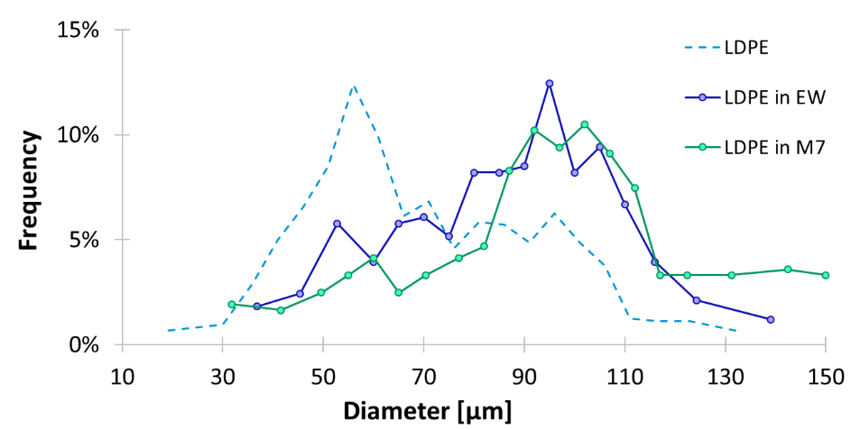
Figure S4: SEM-FEG-size distribution of LDPE obtained by ImageJ analysis, after exposure to Egg Water and Elendt M7 media.
Table S5: Dimensional characterization of LDPE and PU microspheres by ImageJ analysis of SEM-FEG images.
Samples |  | Mean  [μm] | Median  [μm] | Mode  [μm]
LDPE | Pristine material | 70 ± 2 | 65 | 62
LDPE | 240 h in Egg Water | 87 ± 2 | 89 | 93
LDPE | 240 h in Elendt M7 | 92 ± 2 | 95 | 100
PU | Pristine material | 5.8 ± 0.2 | 5 | 5
PU | 240 h in Egg Water | 7.0 ± 0.3 | 7 | 6
PU | 240 h in Elendt M7 | 6.8 ± 0.3 | 6 | 6

The SEM images of the PU microspheres samples exposed to the two media are shown in Figure S5. Comparing the exposed microspheres with the pristine material, no morphological modifications of the surface are observable, but it is possible to notice an aggregation of primary particles. However, it is unclear whether this aggregation is due to a colloidal destabilization within media or to the process of separation and collection of the microspheres from the filter paper. The approximately 30% increase in average size of particles exposed to EW and M7 (Table S5) is likely due to a swelling phenomenon, further facilitated by the nature of the PU material, which is more hygroscopic than LDPE.
a) b)
Figure S5: FE-SEM images of the PU microspheres, after exposure to a) Egg Water and b) Elendt M7.
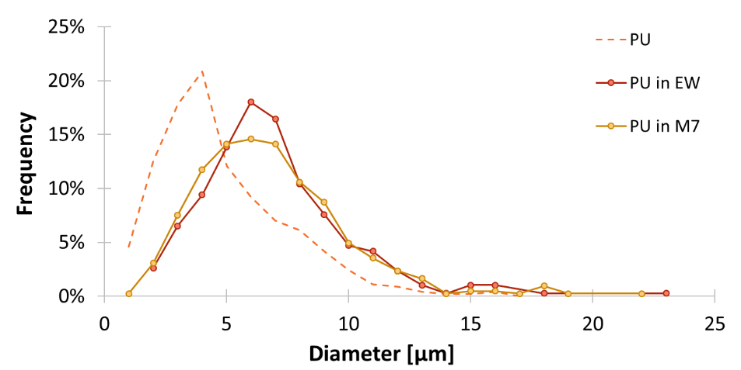
Figure S6: Dimensional distribution of PU after exposure to Egg Water and Elendt M7 media.

ATR-FTIR characterization after exposure
The potential material transformation during the exposure in the medium is analyzed by FTIR.
Figure S7 shows the FTIR spectra for LDPE after 240 hours of exposure in the two media. Both spectra are superimposable to the one of the materials as it is. This finding suggests that exposure in environmental media does not cause substantial changes in the chemical structure of the polymer. In addition, the absence of peaks related to hydroxyl and / or carbonyl groups excludes the occurrence of oxidation / degradation phenomena, respectively 3775–3550 and 1760-1665 cm⁻¹ .
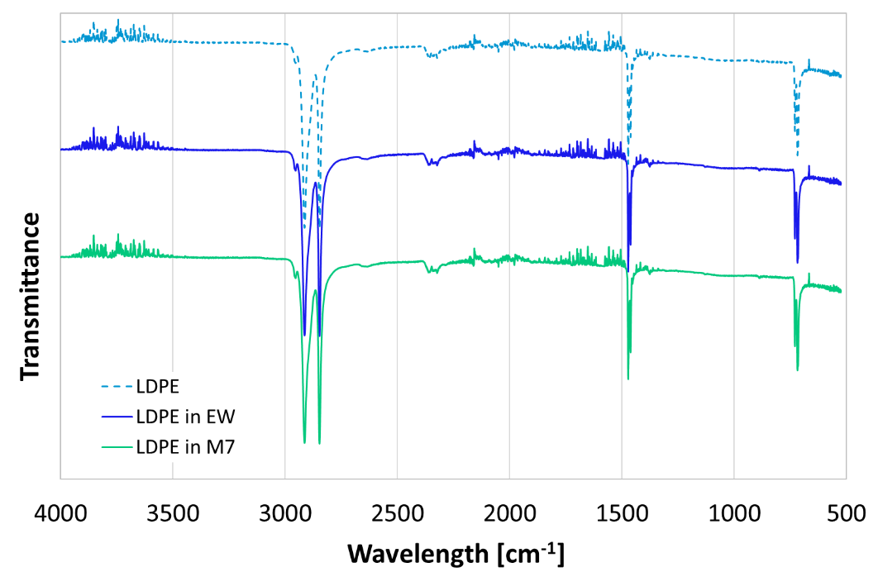
Figure S7: FTIR spectra for LDPE after exposure in Egg Water and Elendt M7.
In Figure S8 we compared the spectra obtained for the PU before and after exposure to the environmental media. We noticed that also in this case the spectra are superimposable, thus the exposure does not substantially change the chemical structure of the polymer. However, it is possible to note the presence of a small signal at approximately 3500 cm⁻¹, a transition typical of the stretching of the O-H bond, probably due to small amounts of residual water in the sample.
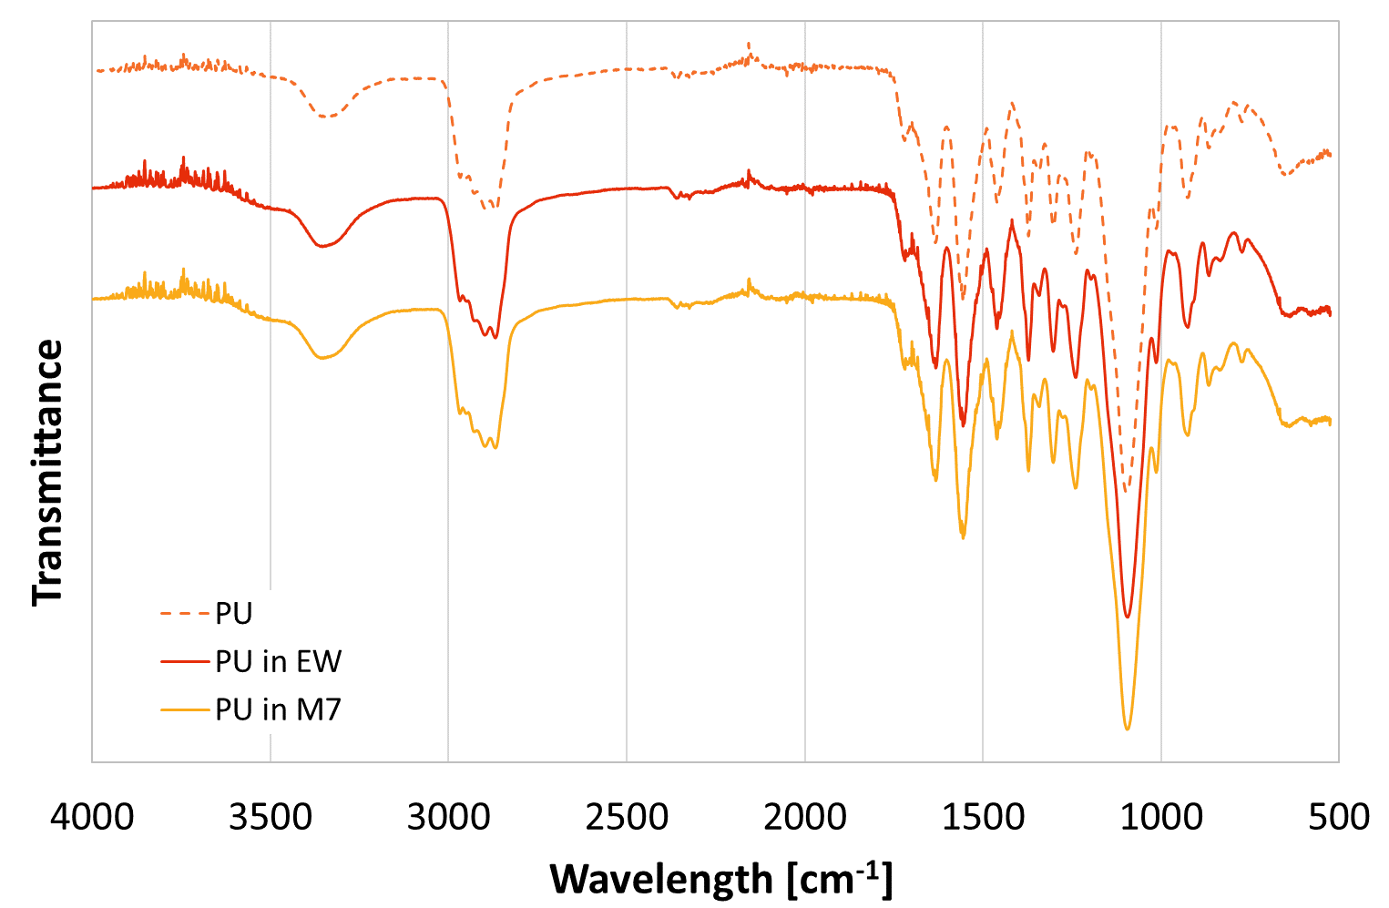
Figure S8: FTIR spectra for PU after exposure in Egg Water and Elendt M7.

Zhang k, et al., (2021) Understanding plastic degradation and microplastic formation in the environment: A review Environ. Pollut., 274:116554 doi: 10.1016/j.envpol.2021.116554
Jiao L, Xiao H, Wang Q, and Sun J, (2013) Thermal degradation characteristics of rigid polyurethane foam and the volatile products analysis with TG-FTIR-MS, Polym. Degrad. Stab., 98, 2687–2696, doi: 10.1016/j.polymdegradstab.2013.09.032

