Supplementary methods:
Cell lines:
Human BC cell lines SKBR3 was cultured in Dulbecco’s Modified Eagle’s Medium (DMEM), while MDA-MB-231 and MDA-MB-453 cells were cultured in DMEM/Nutrient Mixture F-12 (DMEM-F12, Corning, Corning, NY, USA). The media were supplemented with 10% Fetal Bovine Serum (FBS, Corning) and the cells were maintained in a 5% CO2 incubator at 37 °C. All cells were purchased from ATCC in 2022, authenticated by performing short tandem repeat (STR) profiling using PowerPlex 16 HS (Promega Corporation, WI, USA) and confirmed to be mycoplasma-free.
Isolation of Peripheral Blood Mononuclear Cells:
PBMCs were isolated from 10 mL of peripheral blood collected in Ethylenediaminetetraacetic acid (EDTA) tubes from healthy donors (HD). PBMC isolation was performed using SepMate PBMC Isolation Tubes (StemCell Technologies, Vancouver, BC, Canada) according to the manufacturer’s guidelines. Briefly, 15 mL of density gradient medium was pipetted into a SepMate tube. The blood was diluted with phosphate-buffered saline (PBS) containing 2% FBS, carefully layered over the gradient medium, and centrifuged at 1200 x g for 10 min at room temperature with the brake on. The PBMC layer was collected, and the cell pellet was washed twice with PB containing 2% FBS, resuspended in FBS containing 10% dimethyl sulfide (DMSO), and stored at −80 °C for further analysis.
HER2 expression measurements:
Peripheral blood mononuclear cells (PBMCs) from HDs and three breast cancer (BC) cell lines – MDA-MB-231, MDA-MB-453, and SKBR3 – were utilized to model a spectrum of HER2 expression levels, corresponding to HER2-negative (0), intermediate (2+), and high (3+),
respectively.
IF images of the three BC cell lines and HD PBMCs were processed using a combination of a custom CellProfiler (Broad Institute, USA) pipeline and MATLAB code. CellProfiler identified individual cells using the nuclear signal (DAPI) through the ‘Threshold’ module and the ‘IdentifyPrimaryObjects’ module. The ‘MeasureObjectIntensity’ module in CellProfiler was used to quantify the cells’ HER2 expression levels, with data exported via the ‘ExportToSpreadsheet’ module. A custom MATLAB code was used to post-process protein expression data from CellProfiler to establish positivity thresholds and output individual cell protein expression profiles.

HER2 expression quantification on CTCs:
In this study we used a marker-independent workflow combining liquid biopsy, label-free CTC enrichment, immunofluorescent (IF) staining and automated HER2 expression quantification and categorization (Supplementary Fig. 1).
Three breast cancer (BC) cell lines – MDA-MB-231, MDA-MB-453, and SKBR3 – were utilized to model a spectrum of HER2 expression levels, corresponding to HER2-negative (0), intermediate (2+), and high (3+), respectively. PBMCs from HDs were used as a negative control. The IF staining protocol demonstrated accuracy, successfully discriminating between the various cell lines and the negative control: all BC cell lines were DAPI+, EpCAM/cytokeratin (CK)+ and CD45-, whereas PBMCs were DAPI+, EpCAM/CK- and CD45+. PBMCs were excluded from the tumor cell population based on positive CD45 expression. HER2 expression was observed in accordance with the distinct levels across the BC cell lines, consistent with their IHC classification (Supplementary Fig. 2A).
HER2 expression levels varied significantly across the three breast cancer cell lines, with statistically distinct distributions (p < 0.0001), enabling clear categorization of HER2 expression (Supplementary Fig. 2B). MDA-MB-231 cells showed minimal expression, with most cells near undetectable levels (mean relative intensity = 0.03, SD = 0.04). MDA-MB-453 cells exhibited intermediate expression (mean = 0.15, SD = 0.11), while SKBR3 cells demonstrated high HER2 expression (mean = 0.40, SD = 0.27). These values were used to establish HER2 expression thresholds in MATLAB. The low/no expression category included values from 0 up to the mean of MDA-MB-231 plus one standard deviation. Intermediate expression ranged from the upper limit of the low/no expression category to the mean of MDA-MB-453 plus one standard deviation. Values exceeding this intermediate range were classified as high HER2 expression (Supplementary Fig. 2C). This approach allowed for objective classification of HER2 expression levels across individual cells.

Supplemental Figures:
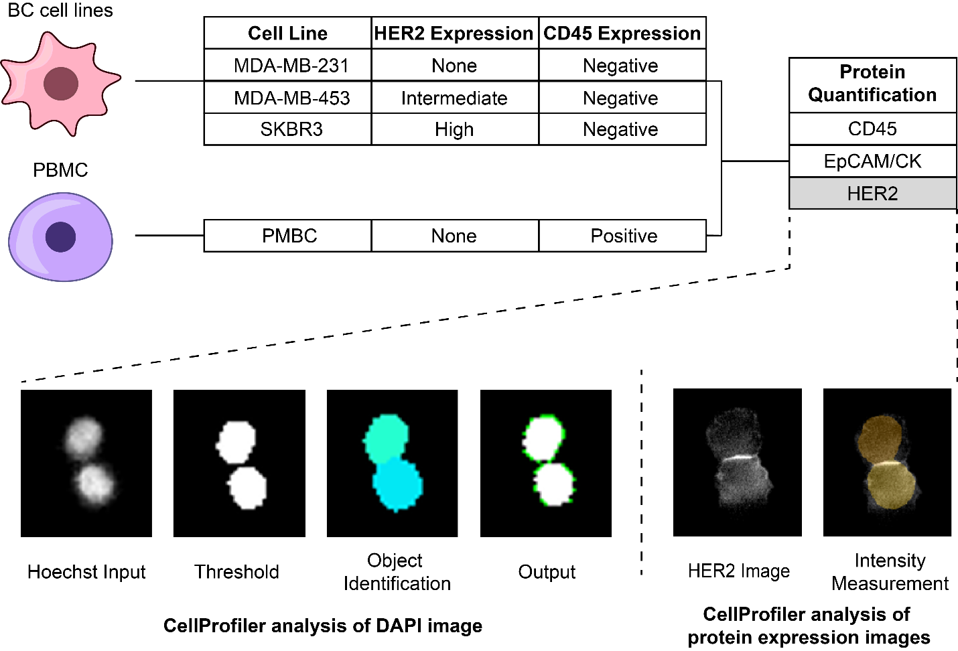
Supplementary Fig. 1 Workflow for automated HER2 expression quantification
Three breast cancer cell lines – MDA-MB-231, MDA-MB-453, and SKBR3 – were utilized to model a spectrum of HER2 expression levels. PBMCs from HDs were used to model CD45-positive cells. HER2 expression was quantified using CellProfiler.

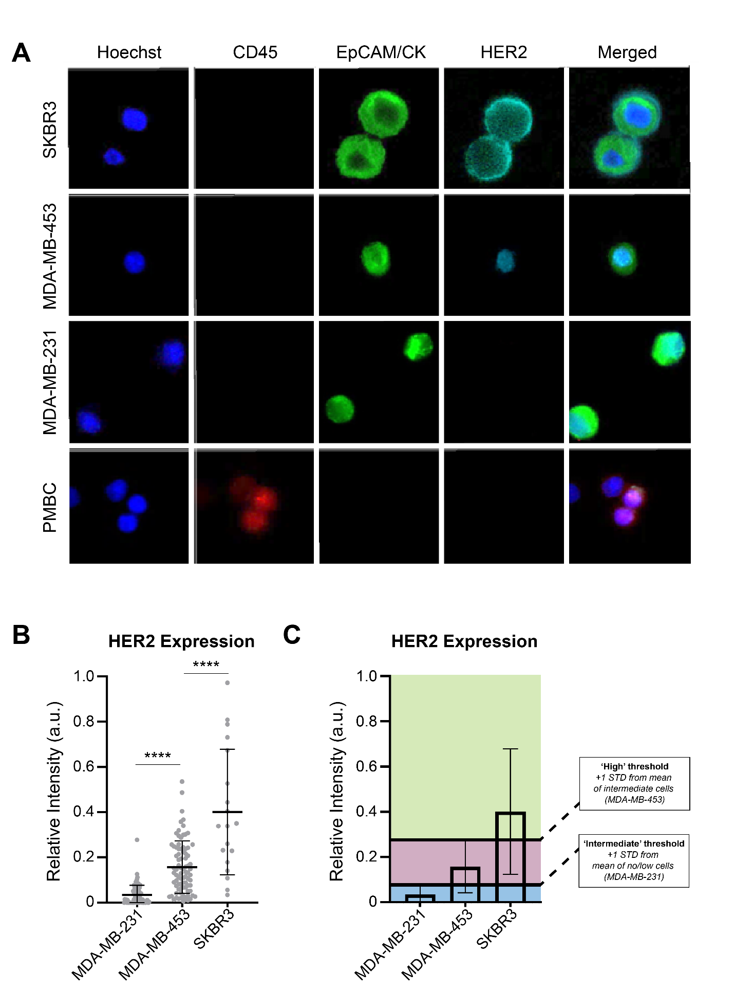
Supplementary Fig. 2 Automated HER2 expression quantification using immunofluorescence intensity of BC cell lines
(A) Immunofluorescence images of cultured BC cell lines (MDA-MB-231, MDA-MB-453 and SKBR3) and PBMCs. Cells were stained for DAPI (blue), CD45 (red), EpCAM/CK (green) and HER2 (cyan) markers. Experiments were performed individually on each cell line. Different levels of HER2 expression were observed across the cell lines consistent with their HER2 expression classification (MDA-MB-231 = 0, MDA-MB-453 = 2+ and SKBR3 = 3+).
(B) HER2 expression in the BC cell lines (MDA-MB-231, MDA-MB-453 and SKBR3) and PBMCs. Error bars indicate standard deviation. The p value was determined by 2-way ANOVA and Bonferroni’s multiple comparisons test (*: p <0.05, **: p <0.01, ***: p <0.001, ****: p <0.0001, ns: non-significant).
(C) Establishment of HER2 thresholds based on the means and standard deviations of HER2 expression in MDA-MB-231, MDA-MB-453 and SKBR3 cell lines. Intensities exceeding one standard deviation above the mean HER2 signal of the HER2-intermediate cell line (MDA-MB-453) were defined as high. Intensities between one standard deviation above the mean signal of the HER2-negative cell line (MDA-MB-231) and the high threshold were defined as intermediate.

