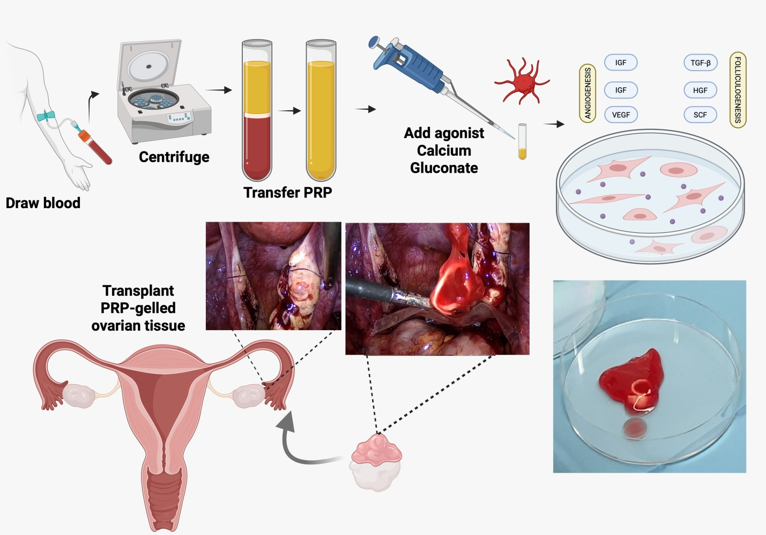
Supplemental Figure 1: Schematic representation of the platelet-rich plasma preparation process and its subsequent use in ovarian tissue reimplantation.
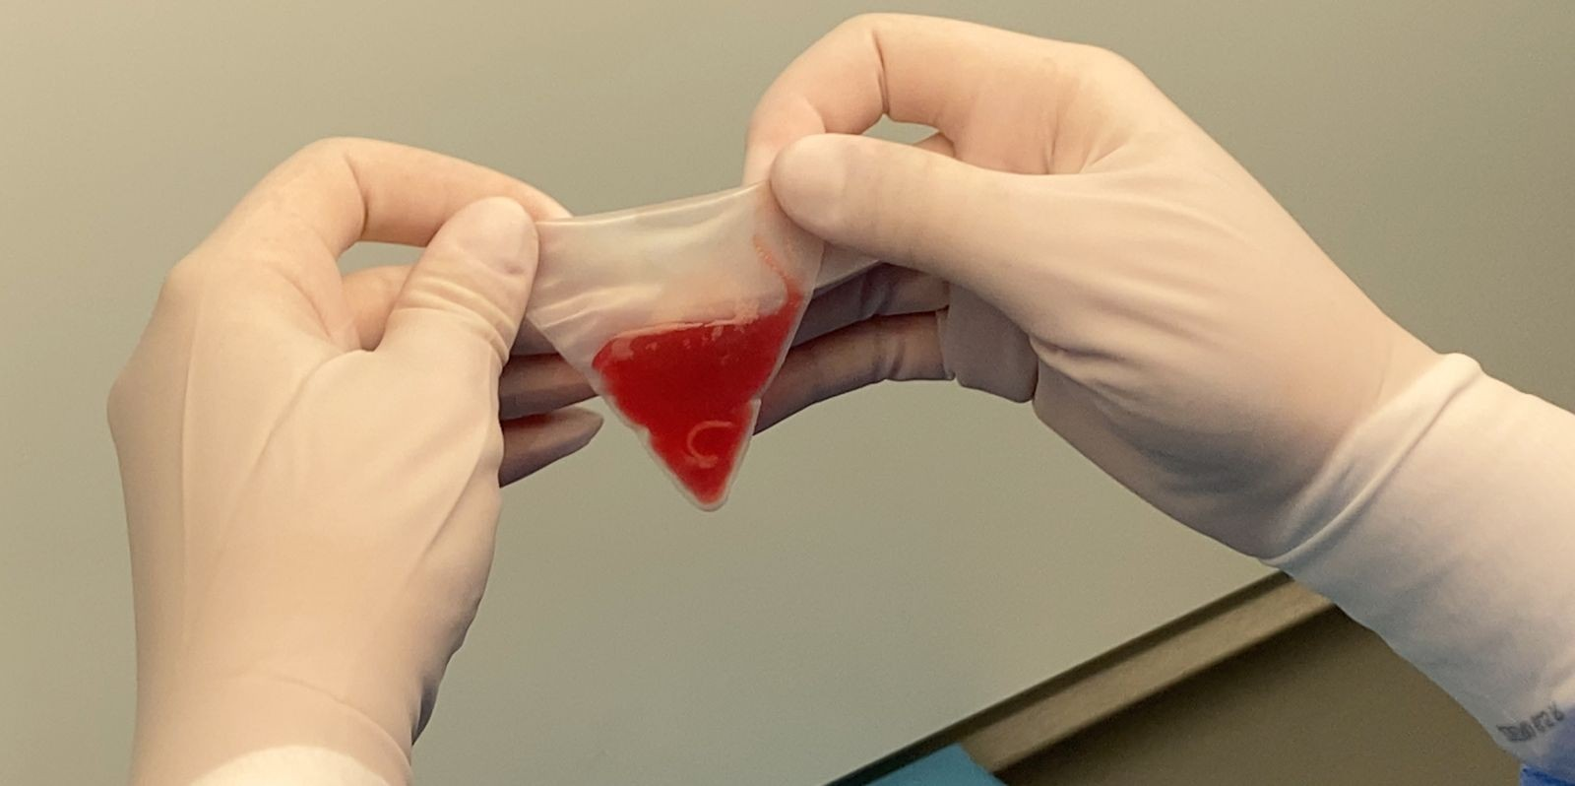
Supplemental Figure 2: Ovarian tissue grafts embedded in platelet-rich plasma gel, enclosed in an endobag and ready for reimplantation.
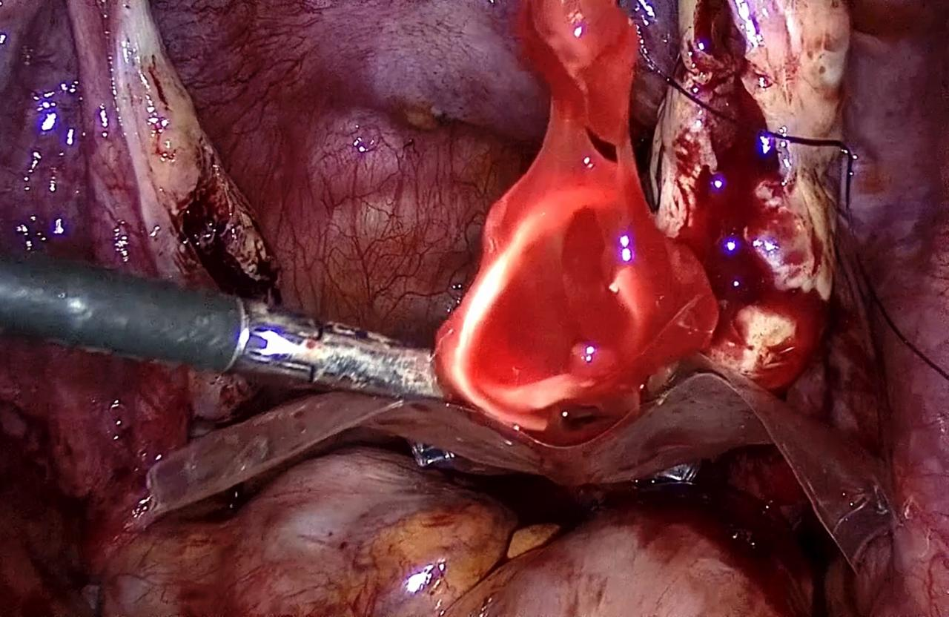
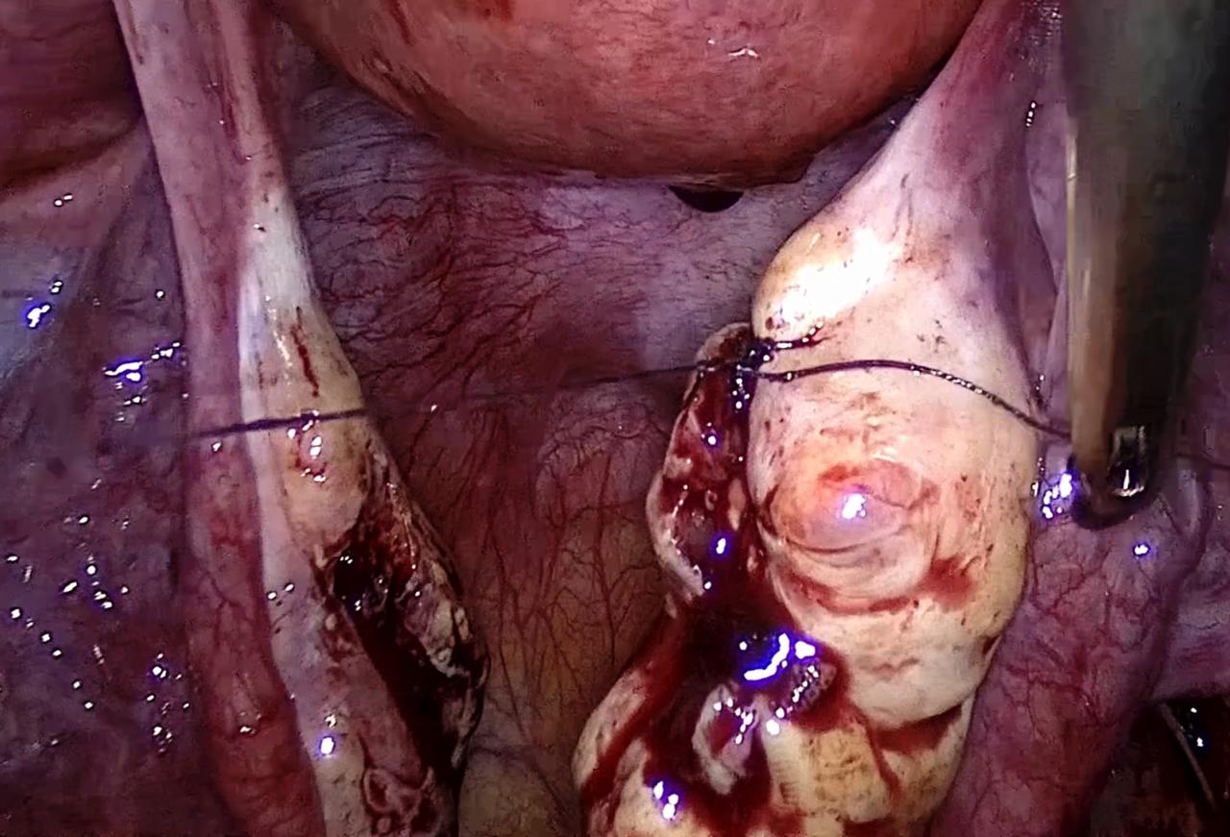
Supplemental Figure 3: Key Steps of laparoscopic transplantation of cryopreserved ovarian tissue with Autologous Platelet-Rich Plasma. 3a: Ovarian tissue grafts embedded in platelet-rich plasma gel delivered into the abdominal cavity via an endobag. 3b: Ovarian fragments inserted into the ovarian pocket, with closure of the graft sites using 4-0 sutures.

