Supplementary Materials
Figure S1
Screenshot of Qualtrics page showing an example of the experimental trial
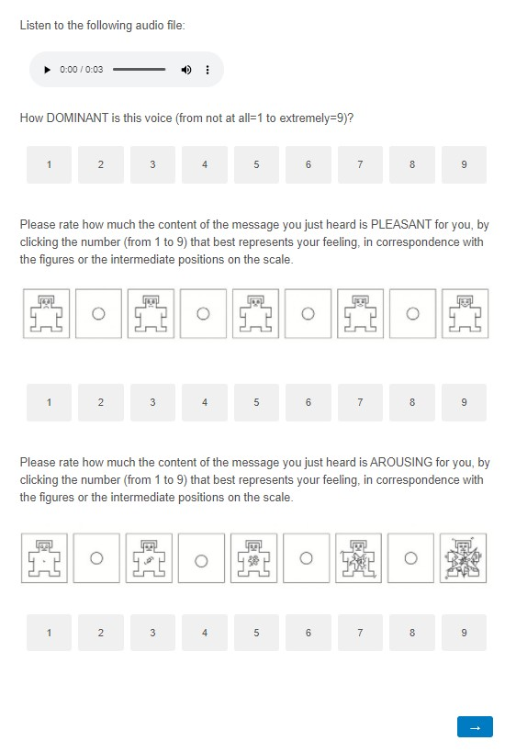
Exploratory Sample
338 Italian individuals participated in the voice rating experiment. Ten participants who reported languages other than Italian as their mother tongue and sixteen participants with extreme rating scores (z scores > ± 3) were excluded. The final sample comprised 312 participants (221 women, mean age= 23.96 years, SD= 4.88 years).
To make Italian listeners unable to access the semantic content but still familiar with the phonetic characteristics of the language, this sample was presented with the scrambled calls. These stimuli were created by applying a reverse scrambling method to the original recordings, which preserved the physical features of the voice while making the verbal content unintelligible.
Zero-order correlations (Sample 1 and Sample 2)
Table S1
Correlations (r, p, BCa CI) between acoustic parameters and emotional and social ratings (Sample 1)
 | Trustworthiness | Dominance | Familiarity | Attractiveness | Valence | Arousal
Fundamental frequency | .04, p = .38  [-.07, .14] | -.06, p = .23  [-.15, .04] | .16, p = .00 [.06, .25] | -.33, p < .001 [-.40, -.24] | -.32, p < .001 [-.41, -.21] | .39, p < .001 [.30, .48]
Intensity | -.01, p = .92  [-.11, .10] | -.01, p = .85  [-.10, .09] | .07, p = .15  [-.02, .15] | -.09, p = .04  [-.19, .01] | -.09, p = .06  [-.18, .02] | .07, p = .14  [-.03, .17]
Intonation | -.05, p = .31  [-.14, .04] | .08, p = .08  [-.02, .18] | .04, p = .44  [-.06, .14] | -.01, p = .79  [-.11, .08] | -.004, p = .93 [-.09, .09] | .03, p = .49  [-.07, .13]
Glide | .01, p = .76  [-.09, .11] | .02, p = .60  [-.08, .13] | -.02, p = .64  [-.11, .07] | -.04, p = .37  [-.15, .06] | -.05, p = .25  [-.16, .05] | -.01, p = .75  [-.11, .08]
Formant dispersion | -.09, p = .05  [-.19, .01] | -.09, p = .06  [-.18, .01] | -.09, p = .05  [-.18, -.00] | .18, p < .001 [.10, .27] | .12, p = .01 [.02, .22] | -.09, p = .04  [-.18, -.01]
Harmonic-to-noise ratio | .23, p < .001 [.13, .33] | -.35, p < .001 [-.44, -.27] | .17, p < .001 [.08, .25] | -.01, p = .80  [-.11, .10] | .10, p = .03 [.00, .21] | -.03, p = .52  [-.12, .06]
Jitter | -.09, p = .06  [-.22, .04] | .01, p = .92  [-.10, .12] | -.03, p = .53  [-.12, .07] | -.15, p = .00  [-.25, -.05] | -.22, p < .001 [-.34, -.10] | .17, p < .001 [.07, .27]
Shimmer | -.24, p < .001  [-.34, -.14] | .17, p < .001 [.07, .27] | -.14, p = .002 [-.23, -.06] | -.13, p = .01  [-.23, -.03] | -.24, p < .001 [-.33, -.14] | .04, p = .37  [-.06, .14]
Note. N = 468; r = Pearson correlation coefficient; BCa CI = 95% bias-corrected and accelerated bootstrap confidence interval based on 2,000 resamples; p-values (p) are two-tailed.
Table S2
Correlations (r, p, BCa CI) between acoustic parameters and emotional and social ratings (Sample 2)
 | Trustworthiness | Dominance | Familiarity | Valence | Arousal
Fundamental frequency | .06, p = .17  [-.03, .16] | .03, p = .46  [-.06, .12] | .02, p = .61  [-.08, .13] | -.23, p < .001 [-.32, -.13] | .17, p < .001 [.06, .27]
Intensity | .10, p = .03 [.00, .19] | -.04, p = .43  [-.12, .05] | .01, p = .78  [-.09, .12] | .04, p = .34  [-.06, .15] | -.04, p = .41  [-.13, .05]
Intonation | -.06, p = .23  [-.15, .04] | -.05, p = .24  [-.15, .04] | -.02, p = .69  [-.10, .07] | -.06, p = .20  [-.15, .03] | -.04, p = .40  [-.13, .06]
Glide | -.01, p = .89  [-.10, .09] | .00, p = .99  [-.08, .10] | .02, p = .67  [-.07, .11] | .01, p = .76  [-.10, .11] | -.02, p = .72  [-.12, .09]
Formant dispersion | -.09, p = .06  [-.17, .01] | -.11, p = .02  [-.19, -.03] | -.11, p = .01  [-.20, -.03] | .03, p = .52  [-.06, .12] | -.09, p = .06  [-.17, -.01]
Harmonic-to-noise ratio | .01, p = .82  [-.07, .09] | -.11, p = .01  [-.21, -.02] | .02, p = .62  [-.08, .12] | -.01, p = .79  [-.10, .09] | .00, p = .99  [-.09, .08]
Jitter | -.06, p = .23  [-.14, .03] | -.03, p = .54  [-.13, .07] | -.10, p = .03  [-.20, .01] | -.14, p = .003 [-.24, -.03] | .02, p = .64  [-.08, .12]
Shimmer | -.06, p = .17  [-.14, .02] | .04, p = .38  [-.06, .14] | -.04, p = .35  [-.14, .05] | -.03, p = .55  [-.11, .06] | -.01, p = .77  [-.10, .07]
Note. N = 468; r = Pearson correlation coefficient; BCa CI = 95% bias-corrected and accelerated bootstrap confidence interval based on 2,000 resamples; p-values (p) are two-tailed.
Table S3
Correlations (r, p, BCa CI) between emotional and social ratings within Sample 1
 | Trustworthiness | Dominance | Familiarity | Attractiveness | Valence | Arousal
Trustworthiness | --
Dominance | -.09, p = .05  [-.19, .01] | --
Familiarity | .31, p < .001 [.23, .39] | .21, p < .001 [.11, .30] | --
Attractiveness | .49, p < .001 [.41, .56] | -.16, p < .001 [-.26, -.06] | -.26, p < .001 [-.35, -.18] | --
Valence | .71, p < .001 [.66, .76] | -.07, p = .11  [-.19, .05] | .30, p < .001 [.22, .37] | .68, p < .001 [.62, .72] | --
Arousal | .16, p = .00 [.05, .27] | .36, p < .001 [.25, .46] | .35, p < .001 [.26, .43] | -.02, p = .62  [-.12, .08] | .06, p = .17  [-.06, .21] | --
Note. N = 468; r = Pearson correlation coefficient; BCa CI = 95% bias-corrected and accelerated bootstrap confidence interval based on 2,000 resamples; p-values (p) are two-tailed.
Table S4
Correlations (r, p, BCa CI) between emotional and social ratings within Sample 2
 | Trustworthiness | Dominance | Familiarity | Valence | Arousal
Trustworthiness | --
Dominance | .36, p < .001 [.28, .43] | --
Familiarity | .31, p < .001 [.23, .39] | .50, p < .001 [.43, .57] | --
Valence | -.11, p = .02  [-.20, -.02] | .11, p = .02 [.02, .20] | .11, p = .02 [.01, .20] | --
Arousal | .58, p < .001 [.52, .64] | .37, p < .001 [.28, .45] | .28, p < .001 [.19, .37] | -.69, p < .001 [-.74, -.63] | --
Note. N = 468; r = Pearson correlation coefficient; BCa CI = 95% bias-corrected and accelerated bootstrap confidence interval based on 2,000 resamples; p-values (p) are two-tailed.
Table S5
Correlations (r, p, BCa CI) between emotional and social ratings between Sample 1 (column) and 2 (row)
 | Trustworthiness | Dominance | Familiarity | Valence | Arousal
Trustworthiness | .31, p < .001 [.23, .39] | .23, p < .001 [.13, .32] | .23, p < .001 [.14, .32] | .10, p = .04 [.01, .18] | .12, p = .01 [.03, .21]
Dominance | .16, p = .00 [.07, .24] | .33, p < .001 [.25, .41] | .13, p = .01 [.04, .22] | -.04, p = .37  [-.14, .06] | .17, p < .001 [.06, .26]
Familiarity | .26, p < .001 [.18, .33] | -.05, p = .26 [-.14, .04] | .05, p = .32  [-.05, .15] | -.24, p < .001 [-.33, -.15] | .21, p < .001 [.12, .30]
Attractiveness | .06, p = .21  [-.03, .15] | .23, p < .001 [.14, .32] | .18, p < .001 [.09, .28] | .33, p < .001 [.24, .41] | -.07, p = .15  [-.16, .02]
Valence | .05, p = .26  [-.04, .15] | .18, p < .001 [.09, .27] | .18, p < .001 [.08, .27] | .23, p < .001 [.12, .32] | -.07, p = .13  [-.18, .04]
Arousal | .06, p = .21  [-.03, .15] | .20, p < .001 [.11, .30] | .15, p = .00 [.06, .24] | -.31, p < .001 [-.40, -.22] | .28, p < .001 [.19, .37]
Note. N = 468; r = Pearson correlation coefficient; BCa CI = 95% bias-corrected and accelerated bootstrap confidence interval based on 2,000 resamples; p-values (p) are two-tailed.
Zero-order correlations (across the three samples)
We observed significant correlations between acoustic parameters and emotional and social ratings across the three samples (Figure S2), confirming that acoustic parameters are correlated with social judgments (Baus et al., 2019; McAleer et al., 2014). These correlations are similar across the three samples. For example, in all three samples, pitch and valence consistently show a negative correlation, while pitch and arousal correlate positively. Additionally, harmonic-to-noise ratio and dominance show a negative correlation across all three samples. This similarity is also reflected in the similarity analysis (see below), suggesting that this relationship between acoustic parameters and perceived social and emotional traits is not influenced by the level of information extracted from the voice. However, there are also interesting sample-specific correlations: for instance, harmonic-to-noise ratio positively correlates with trustworthiness only in Sample 1 (American participants rating calls with the original content), while intensity positively correlates with trustworthiness only in Sample 2 (Italian participants rating calls with the original content).
Figure S2
Heat map showing correlations between acoustic parameters and ratings within each sample
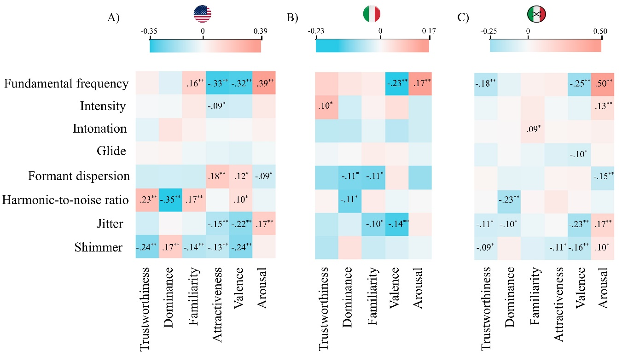
Note. N=468. Light-blue and red colors indicate negative and positive correlations, respectively. Color intensity indicates the strength of the correlation, while asterisks indicate significant correlations (**p < .01; *p < .05). The scale (color intensity) is always centered at 0, but the range of values is determined by the data distribution of each matrix to ensure optimal representation of variations within each sample. Panel A shows correlations in Sample 1 (American participants rating calls with the original content); panel B shows correlations in Sample 2 (Italian participants rating calls with the original content); panel C shows correlations in Exploratory Sample (Italian participants rating calls with the scrambled content).
Significant correlations between social and emotional ratings were observed within each sample, indicating consistent associations between these judgments (Figure S3). In this case, there is a limited similarity across the three samples (see below for statistical analyses). The only consistent correlations are observed between valence and familiarity, and between valence and attractiveness, both present in Sample 1 and Exploratory Sample (Italian participants rating scrambled calls). However, other correlations vary by sample. For instance, dominance and trustworthiness are negatively correlated in Sample 1, but positively correlated in Samples 2 and Exploratory Sample. Familiarity correlates negatively with both trustworthiness and dominance in Exploratory Sample, but positively in Samples 1 and 2. Additionally, valence shows a negative correlation with trustworthiness in Sample 2, but a positive correlation in the other two samples.
Figure S3
Heat map showing correlations between emotional and social ratings within each sample
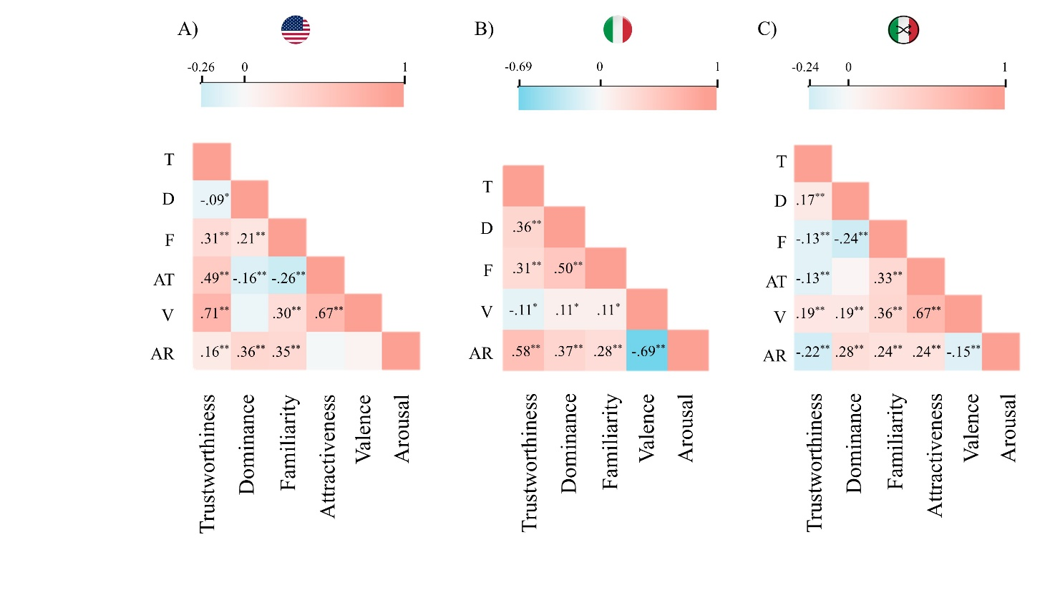
Note. N=468. Light-blue and red colors indicate negative and positive correlations, respectively. Color intensity indicates the strength of the correlation, while asterisks indicate significant correlations (** p < .01; * p < .05). The scale (color intensity) is always centered at 0, but the range of values is determined by the data distribution of each matrix to ensure optimal representation of variations within each sample. Panel A shows correlations in Sample 1 (American participants rating calls with the original content); panel B shows correlations in Sample 2 (Italian participants rating calls with the original content); panel C shows correlations in Exploratory Sample (Italian participants rating calls with the scrambled content). AR = Arousal; AT = Attractiveness; D = Dominance; F = Familiarity; T = Trustworthiness; V = Valence.
Finally, significant correlations were found between social and emotional ratings across the different samples (Figure S4). The correlations of ratings across the different samples show greater similarity between the correlation patterns of Samples 1 and 2 and those of Samples 2 and Exploratory Sample (see below for statistical analyses). For instance, trustworthiness is positively correlated with all other ratings in both the correlations between Sample 1 and Sample 2, and those between Sample 2 and Exploratory Sample. In contrast, in the correlations between the ratings of Samples 1 and Exploratory Sample, trustworthiness is negatively correlated with both familiarity and arousal. Additionally, familiarity is negatively correlated with valence in both the correlations between Sample 1 and Sample 2, and those between Sample 2 and Exploratory Sample, while in the correlations between the ratings of Samples 1 and Exploratory Sample, these two variables are positively correlated.
Figure S4
Heat map showing correlations between emotional and social ratings across samples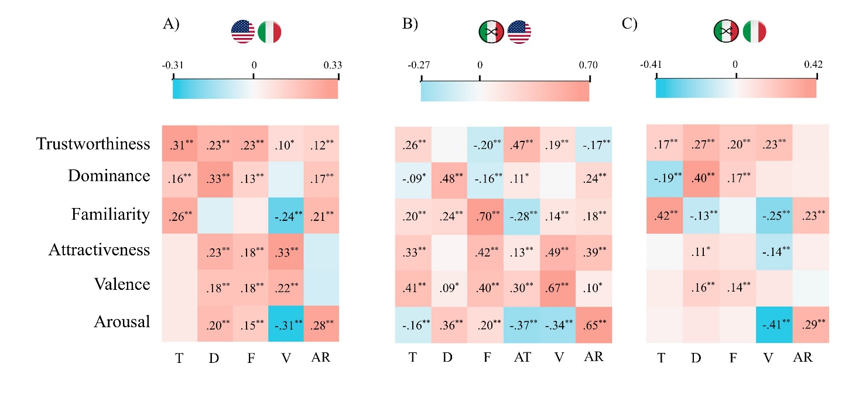
Note. N=468. Light-blue and red colors indicate negative and positive correlations, respectively. Color intensity indicates the strength of the correlation, while asterisks indicate significant correlations (** p < .01; * p < .05). The scale (color intensity) is always centered at 0, but the range of values is determined by the data distribution of each matrix to ensure optimal representation of variations within each sample. panel A shows correlations between Sample 1 (American participants rating calls with the original content) and Sample 2 (Italian participants rating calls with the original content); Panel B shows correlations between Exploratory Sample (Italian participants rating calls with the scrambled content) and Sample 1; panel C shows correlations in Exploratory Sample and Sample 2. AR= Arousal, AT= Attractiveness, D= Dominance, F= Familiarity, T= Trustworthiness, V= Valence.
Similarity Analyses (across the three samples)
To explore the similarity and differences among the three samples, the degree of similarity between correlation matrices was assessed by computing a non-parametric Spearman correlation, which assumes a monotonic relationship between the vectors of Pearson coefficients. Figure S5 shows the degree of similarity (ρ) between matrices showing correlations between acoustic parameters and ratings within each sample (Figure S2). The z-tests assessing the differences in similarity between each matrix pair are also presented. These tests evaluate whether the observed differences in similarity across matrix pairs are statistically significant. The results indicate that acoustic parameters correlate with social and emotional ratings in a similar way across all three samples, suggesting that this relationship is not influenced by the level of information extracted from the voice. This consistency across samples implies that the connection between acoustic parameters and perceived social and emotional traits remains stable, regardless of the depth or amount of vocal information available.
Figure S5
Similarity (ρ) between matrices showing correlations between acoustic parameters and ratings within each sample
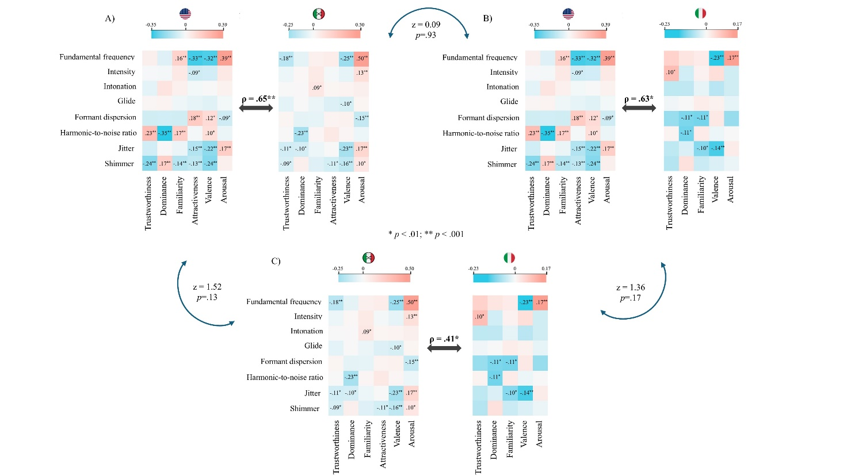
Note. Panel A shows the similarity between the correlations in Sample 1 (American participants rating calls with the original content) and Exploratory Sample (Italian participants rating calls with scrambled content). Panel B shows the similarity between the correlations in Sample 1 and Sample 2 (Italian participants rating calls with the original content). Panel C shows the similarity between the correlations in Exploratory Sample and Sample 2. The "attractiveness" variable has been removed from the matrices of Sample 1 and Exploratory Sample when correlating with Sample 2 to ensure the matrices have the same length.
Figure S6 displays the degree of similarity (ρ) between matrices showing correlations between emotional and social ratings within each sample (Figure S3). The z-tests assessing the differences in similarity between each matrix pair are also presented. The results indicate that the patterns between emotional and social ratings differ from one another, as they do not correlate, suggesting that the level of information extracted from the voice plays a role in the rating of emotional and social traits. Notably, although not statistically significant, the highest correlation is observed between the two Italian samples, which share two levels of extracted information, specifically pre-linguistic invariant information and familiar phonetic cues. This highlights the potential influence of the type and depth of vocal information on how emotional and social traits are evaluated.
Figure S6
Similarity (ρ) between matrices showing correlations between emotional and social ratings within each sample
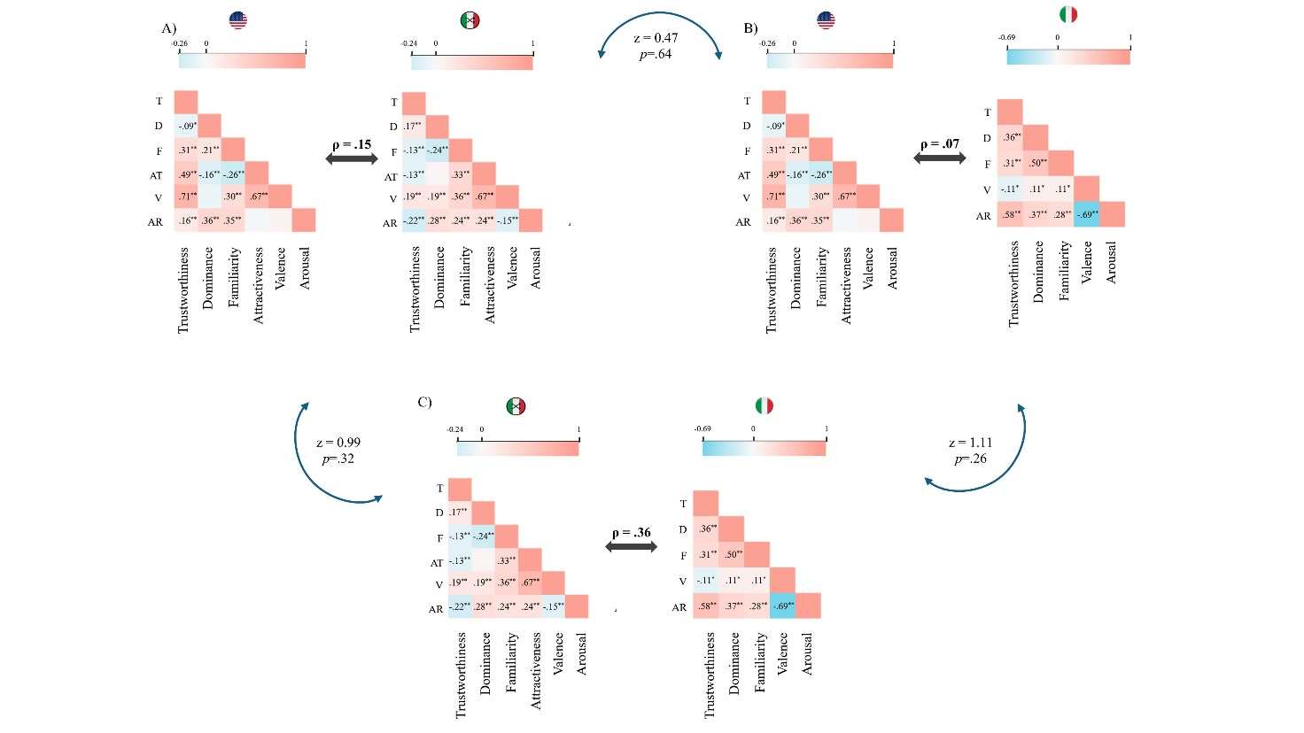
Note. Panel A shows the similarity between the correlations in Sample 1 (American participants rating calls with the original content) and Exploratory Sample (Italian participants rating calls with scrambled content). Panel B shows the similarity between the correlations in Sample 1 and Sample 2 (Italian participants rating calls with the original content). Panel C shows the similarity between the correlations in Sample 2 and Exploratory Sample. The "attractiveness" variable has been removed from the matrices of Sample 1 and Exploratory Sample when correlating with Sample 2 to ensure the matrices have the same length.
Figure S7 shows the degree of similarity (ρ) between matrices showing correlations between emotional and social ratings across samples (Figure 4 in the Main Manuscript). The z-tests assessing the differences in similarity between each matrix pair are also presented. The results indicate that the correlation patterns of the ratings between pairs of samples differ from one another, as the correlation coefficients are not significant. However, despite not reaching statistical significance, the correlation patterns between Italian ratings with semantic comprehension and both American ratings and Italian ratings without semantic comprehension show a correlation coefficient of .66 (panel C in Figure S4), indicating a certain degree of similarity. This suggests that the ratings made when semantic information is available correlate in a similar way with ratings made when only pre-linguistic information is present (as in the American sample) and with ratings made when phonetic familiarity is also involved (as in scrambled calls rated by Italians). In fact, this similarity is reflected by both matrices exhibiting lower correlations compared to the matrix showing correlations between American ratings and Italian ratings of scrambled calls. It is not surprising that ratings made when semantic information is available are less correlated with those made in its absence. When individuals grasp the meaning of the material being rated, their evaluations are likely influenced by a deeper cognitive and emotional engagement with the content. Conversely, in situations where comprehension is compromised, ratings may reflect a more superficial or implicit approach, resulting in lower correlation levels in both matrices (i.e., lower correlations between Sample 1 and Sample 2, and lower correlations between Sample 2 and Exploratory Sample).
On the other hand, for instance, the correlations between ratings in Sample 1 and Exploratory Sample are markedly different from those between Sample 2 and Exploratory Sample (panel B in Figure S7, ρ=-.06), probably due to both cultural differences in sample composition (Americans vs. Italians) and variations in the stimuli used (original vs. scrambled).
Figure S7
Similarity (ρ) between matrices showing correlations between emotional and social ratings across samples
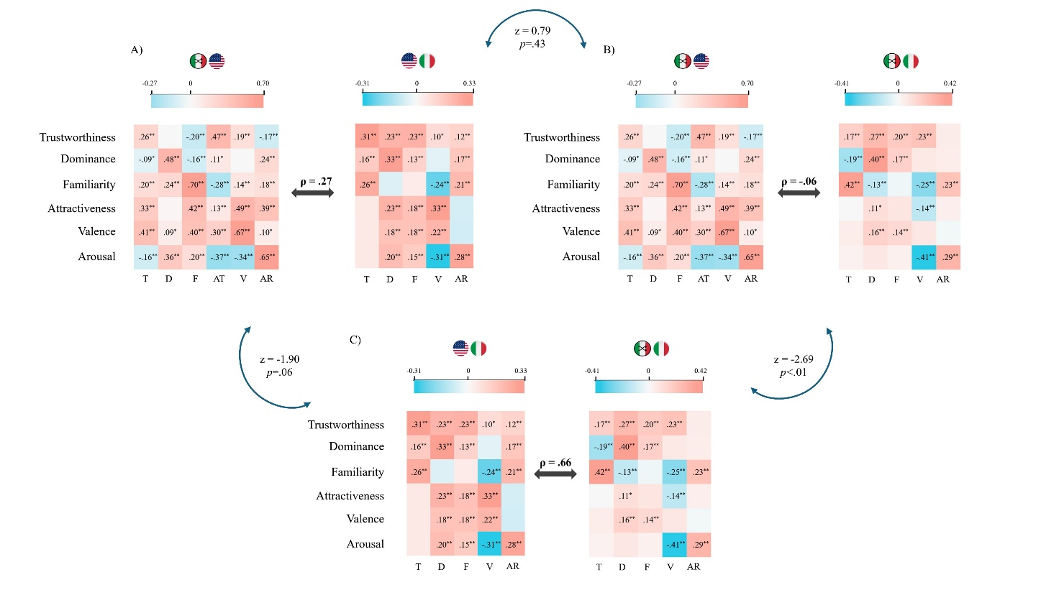
Note. Panel A shows the similarity between correlations between Sample 1 (American participants rating calls with the original content) and Exploratory Sample (Italian participants rating calls with the scrambled content) and correlations between Sample 1 and Sample 2 (Italian participants rating calls with the original content); panel B shows the similarity between correlations between Sample 1 and Sample 2 and correlations between Sample 2 and Exploratory Sample; panel C shows the similarity between correlations between Sample 1and Sample 2 and correlations between Sample 2 and Exploratory Sample.
MANOVA (emotional and social ratings by gender voice)
American sample with original calls (Sample 1)
Significant multivariate effects on ratings on emotional and social traits emerged for gender voice (F (6, 461) = 29.671, p < .001; Wilk's Λ = 0.721, η²_{p} = .28). Specifically, gender voice has a significant effect on arousal (F (1,466) = 13.49; p < .001; η² _{p} = .03), trustworthiness (F (1,466) = 40.41; p < .001; η² _{p} = .08), dominance (F (1,466) = 23.84; p < .001; η² _{p} = .05), familiarity (F (1,466) = 8.59; p < .01; η² _{p} = .02) and attractiveness (F (1,466) = 5.25; p < .05; η² _{p} = .01) scores. Figure S8 shows mean differences in ratings by gender voice.

Figure S8
Box plots of mean differences in social and emotional trait ratings by gender voice
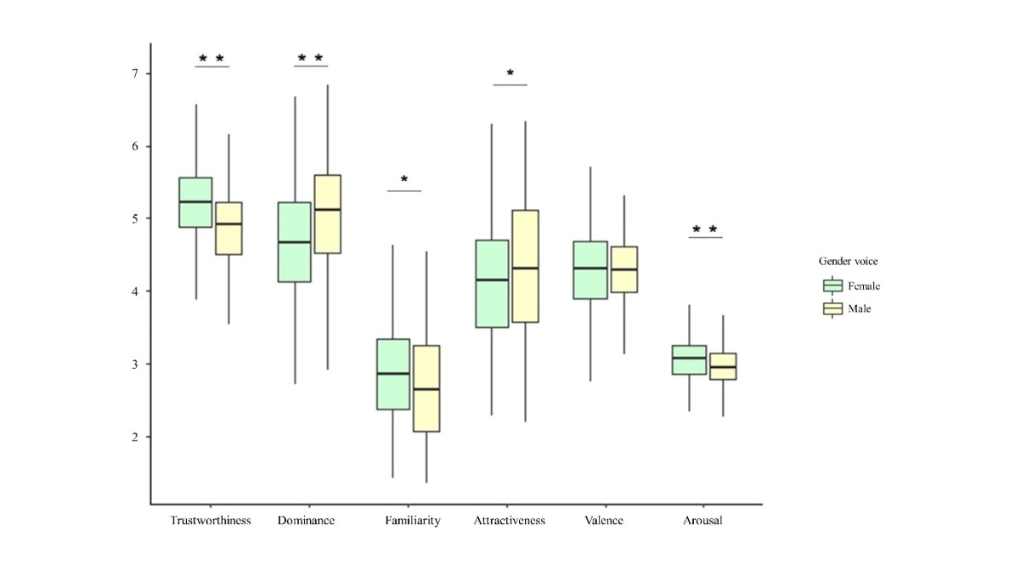
Note. The y-axis shows mean rating scores. Within each box, horizontal black lines indicate median values; lower and upper box boundaries 25th and 75th percentiles, respectively; lower and upper error lines 10th and 90th percentiles, respectively. * p < .01; **p <. 001.

Italian sample with original calls (Sample 2)
Significant multivariate effects on ratings on emotional and social traits emerged for gender voice (F (5, 462) = 4.21, p < .001; Wilk's Λ = 0.956, η²_{p} = .04). Specifically, gender voice has a significant effect on dominance (F (1,466) = 10.77; p < .001; η²_{p} = .02) and familiarity (F (1,466) = 10.18; p < .01; η²_{p} = .02) scores. Figure S9 shows differences in mean ratings by gender voice.
Figure S9
Box plots of mean differences in social and emotional trait ratings by gender voice
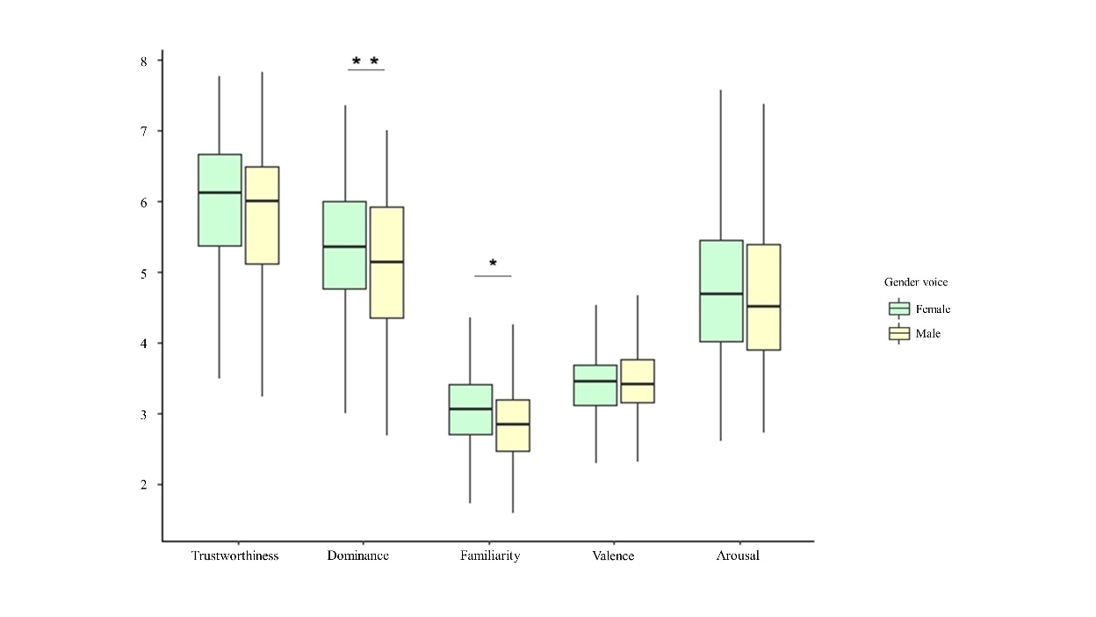
Note. The y-axis shows mean rating scores. Within each box, horizontal black lines indicate median values; lower and upper box boundaries 25th and 75th percentiles, respectively; lower and upper error lines 10th and 90th percentiles, respectively. *p <.01; **p <. 001.

Hierarchical regression models
American sample with original calls (Sample 1)
Table S6
Results of the hierarchical regression model (Sample 1 – Model 1 – Step 1)
Predictor variable | β | SE | Waldª | p | OR | 95% CI
Period | 0.18 | 0.20 | 0.85 | .36 | 1.20 | 0.81 – 1.78
Shift | 0.44 | 0.23 | 3.55 | .60 | 1.55 | 0.98– 2.45
Pathology | 0.61 | 0.25 | 5.80 | .01 | 1.84 | 1.12 – 3.02
Constant | -1.23 | 0.24 | 25.82 | .001 | 0.29
Note. N=468; SE=Standard Error; OR=Odd Ratio; CI=Confidence Interval. ª df=1
Dependent variable: Decision accuracy (Right vs Wrong); the reference category is Right decision.
Predictors entered on step 1: Period, Shift, Pathology.
Statistically significant predictors appear in boldface.

Table S7
Results of the hierarchical regression model (Sample 1– Model 2 – Step 1)
Predictor variable | β | SE | Waldª | p | OR | 95% CI
Period | -0.04 | 0.24 | 0.03 | .86 | 0.96 | 0.60 – 1.52
Shift | 0.12 | 0.26 | 0.20 | .66 | 1.12 | 0.67 – 1.89
Pathology | 1.73 | 0.41 | 17.61 | .00 | 5.66 | 2.52 – 12.70
Constant | -0.274 | 0.27 | 1.04 | .31 | 0.76
Note. N=312; SE=Standard Error; OR=Odd Ratio; CI=Confidence Interval. ª df=1
Dependent variable: Wrong decisions accuracy (Under vs Overestimations); the reference category is Overestimation.
Predictors entered on step 1: Period, Shift, Pathology.
Statistically significant predictors appear in boldface.

Table S8
Results of the hierarchical regression model (Sample 1– Model 2 – Step 2)
Predictor variable | β | SE | Waldª | p | OR | 95% CI
Period | 0.02 | 0.25 | 0.04 | .95 | 1.02 | 0.63 - 1.65
Shift | 0.11 | 0.27 | 0.15 | .70 | 1.11 | 0.65 - 1.91
Pathology | 1.79 | 0.42 | 17.91 | .00 | 6.00 | 2.62 - 13.74
Gender | -1.04 | 0.38 | 7.45 | .006 | 0.35 | 0.17 - 0.75
Fundamental frequency | 0.01 | 0.01 | 5.23 | .02 | 1.01 | 1 - 1.01
Intensity | -0.06 | 0.05 | 1.53 | .21 | 0.94 | 0.85 - 1.04
Intonation | 0.00 | 0.00 | 1.56 | .21 | 0.99 | 0.99 - 1
Glide | 0.00 | 0.00 | 0.04 | .83 | 1.00 | 1 – 1
Formant dispersion | -0.01 | 0.01 | 1.97 | .16 | .99 | 0.98 - 1.01
Harmonic-to-noise ratio | 0.16 | 0.08 | 3.87 | .05 | 1.17 | 1 - 1.37
Constant | 7.28 | 4.86 | 2.25 | .13 | 1458.02
Note. N=312; SE=Standard Error; OR=Odd Ratio; CI=Confidence Interval. ª df=1
Dependent variable: Wrong decisions accuracy (Under vs Overestimations); the reference category is Overestimation.
Predictors entered on step 1: Period, Shift, Pathology; predictors entered on step 2: Gender, Fundamental frequency. Intensity, Intonation, Glide, Formant dispersion, Harmonic-to-noise ratio.
Statistically significant predictors appear in boldface.

Table S9
Results of the hierarchical regression model (Sample 1– Model 2 – Step 3)
Predictor variable | β | SE | Waldª | p | OR | 95% CI
Period | 0.11 | 0.26 | 0.20 | .66 | 1.12 | 0.68 - 1.86
Shift | 0.14 | 0.28 | 0.26 | .61 | 1.15 | 0.66 - 2.01
Pathology | 1.78 | 0.44 | 16.68 | .001 | 5.95 | 2.53 - 14.00
Gender | -1.13 | 0.42 | 7.38 | .007 | 0.32 | 0.14 - 0.73
Fundamental frequency | 0.01 | 0.01 | 5.08 | .02 | 1.01 | 1 - 1.02
Intensity | -0.08 | 0.05 | 2.11 | .15 | 0.93 | 0.84 - 1.03
Intonation | -0.002 | 0.00 | 2.36 | .12 | 0.99 | 1 - 1
Glide | 0.00 | 0.00 | 0.00 | .99 | 1.00 | 1 - 1
Formant dispersion | -0.01 | 0.005 | 2.03 | .15 | 0.99 | 0.98 - 1
Harmonic-to-noise ratio | 0.22 | 0.10 | 4.82 | .03 | 1.24 | 1.02 - 1.50
Trustworthiness | 0.06 | 0.34 | 0.03 | .87 | 1.06 | 0.54 - 2.06
Dominance | 0.49 | 0.19 | 6.59 | .01 | 1.63 | 1.12 - 2.37
Familiarity | 0.17 | 0.27 | 0.41 | .52 | 1.19 | 0.69 - 2.04
Attractiveness | 0.53 | 0.26 | 4.09 | .04 | 1.70 | 1.02 - 2.83
Valence | -0.14 | 0.45 | 0.09 | .76 | 0.87 | 0.36 - 2.11
Arousal | -0.46 | 0.55 | 0.71 | .40 | 0.63 | 0.21 - 1.85
Constant | 4.34 | 5.22 | 0.69 | .41 | 76.76
Note. N=312; SE=Standard Error; OR=Odd Ratio; CI=Confidence Interval. ª df=1
Statistically significant predictors appear in boldface.
Dependent variable: Wrong decisions accuracy (Under vs Overestimations); the reference category is Overestimation.
Predictors entered on step 1: Period, Shift, Pathology; predictors entered on step 2: Gender, Fundamental frequency, Intensity, Intonation, Glide, Formant dispersion, Harmonic-to-noise ratio; predictors entered on step 3: Trustworthiness, Dominance, Familiarity, Attractiveness, Valence, Arousal.

Table S10
Results of the hierarchical regression model (Sample 1– Model 3 – Step 1)
Predictor variable | B | SE | β | t | p
Period | 12.21 | 3.77 | 0.15 | 3.23 | .00
Shift | 2.30 | 4.25 | 0.02 | .54 | .59
Pathology | -1.93 | 5.01 | -0.02 | -.38 | .70
Constant | 100.08 | 4.33 |  | 23.09 | .00
Note. N=461; SE=Standard Error
Dependent variable: Decision response time.
Predictors entered on step 1: Period, Shift, Pathology.
Statistically significant predictors appear in boldface.

Italian sample with original calls (Sample 2)
Table S11
Results of the hierarchical regression model (Sample 2 – Model 1 – Step 1)
Predictor variable | β | SE | Waldª | p | OR | 95% CI
Period | 0.18 | 0.20 | 0.85 | .36 | 1.20 | 0.81 – 1.78
Shift | 0.44 | 0.23 | 3.55 | .60 | 1.55 | 0.98– 2.45
Pathology | 0.61 | 0.25 | 5.80 | .01 | 1.84 | 1.12 – 3.02
Constant | -1.23 | 0.24 | 25.82 | .001 | 0.29
Note. N=468; SE=Standard Error; OR=Odd Ratio; CI=Confidence Interval. ª df=1
Dependent variable: Decision accuracy (Right vs Wrong); the reference category is Right decision.
Predictors entered on step 1: Period, Shift, Pathology.
Statistically significant predictors appear in boldface.

Table S12
Results of the hierarchical regression model (Sample 2– Model 2 – Step 1)
Predictor variable | β | SE | Waldª | p | OR | 95% CI
Period | -0.04 | 0.24 | 0.03 | .86 | 0.96 | 0.60 – 1.52
Shift | 0.12 | 0.26 | 0.20 | .66 | 1.12 | 0.67 – 1.89
Pathology | 1.73 | 0.41 | 17.61 | .00 | 5.66 | 2.52 – 12.70
Constant | -0.274 | 0.27 | 1.04 | .31 | 0.76
Note. N=312; SE=Standard Error; OR=Odd Ratio; CI=Confidence Interval. ª df=1
Dependent variable: Wrong decisions accuracy (Under vs Overestimations); the reference category is Overestimation.
Predictors entered on step 1: Period, Shift, Pathology.
Statistically significant predictors appear in boldface.

Table S13
Results of the hierarchical regression model (Sample 2– Model 2 – Step 2)
Predictor variable | β | SE | Waldª | p | OR | 95% CI
Period | 0.02 | 0.25 | 0.04 | .95 | 1.02 | 0.63 - 1.65
Shift | 0.11 | 0.27 | 0.15 | .70 | 1.11 | 0.65 - 1.91
Pathology | 1.79 | 0.42 | 17.91 | .00 | 6.00 | 2.62 - 13.74
Gender | -1.04 | 0.38 | 7.45 | .006 | 0.35 | 0.17 - 0.75
Fundamental frequency | 0.01 | 0.01 | 5.23 | .02 | 1.01 | 1 - 1.01
Intensity | -0.06 | 0.05 | 1.53 | .21 | 0.94 | 0.85 - 1.04
Intonation | 0.00 | 0.00 | 1.56 | .21 | 0.99 | 0.99 - 1
Glide | 0.00 | 0.00 | 0.04 | .83 | 1.00 | 1 – 1
Formant dispersion | -0.01 | 0.01 | 1.97 | .16 | .99 | 0.98 - 1.01
Harmonic-to-noise ratio | 0.16 | 0.08 | 3.87 | .05 | 1.17 | 1 - 1.37
Constant | 7.28 | 4.86 | 2.25 | .13 | 1458.02
Note. N=312; SE=Standard Error; OR=Odd Ratio; CI=Confidence Interval. ª df=1
Dependent variable: Wrong decisions accuracy (Under vs Overestimations); the reference category is Overestimation.
Predictors entered on step 1: Period, Shift, Pathology; predictors entered on step 2: Gender, Fundamental frequency, Intensity, Intonation, Glide, Formant dispersion, Harmonic-to-noise ratio.
Statistically significant predictors appear in boldface.

Table S14
Results of the hierarchical regression model (Sample 2– Model 2 – Step 3)
Predictor variable | β | SE | Waldª | p | OR | 95% CI
Period | -0.09 | 0.28 | 0.11 | .74 | 0.91 | 0.53 - 1.57
Shift | 0.11 | 0.31 | 0.01 | .97 | 1.01 | 0.55 - 1.86
Pathology | 1.43 | 0.48 | 9.02 | .003 | 4.18 | 1.64 – 10.65
Gender | -1.17 | 0.45 | 6.76 | .009 | 0.31 | 0.13 - 0.75
Fundamental frequency | 0.01 | 0.004 | 2.82 | .09 | 1.01 | 0.99 - 1.01
Intensity | -0.04 | 0.06 | 0.59 | .44 | 0.96 | 0.85 - 1.07
Intonation | -0.001 | 0.001 | 0.47 | .49 | 0.99 | 1 - 1
Glide | 0.001 | 0.001 | 0.26 | .61 | 1.00 | 1 - 1
Formant dispersion | -0.005 | 0.005 | .99 | .32 | 0.99 | 0.99 - 1
Harmonic-to-noise ratio | 0.21 | 0.10 | 5.03 | .02 | 1.24 | 1.03 - 1.49
Trustworthiness | -0.27 | 0.20 | 1.89 | .17 | 0.76 | 0.51 - 1.13
Dominance | 0.07 | 0.21 | 0.10 | .75 | 1.07 | 0.71 - 1.61
Familiarity | 0.22 | 0.30 | 0.52 | .47 | 1.25 | 0.69 - 2.26
Valence | 1.69 | 0.61 | 7.67 | .006 | 5.41 | 1.63 - 17.91
Arousal | 1.61 | 0.35 | 21.70 | .001 | 5.03 | 2.55 - 9.92
Constant | -7.79 | 6.20 | 1.58 | .21 | 0.00
Note. N=312; SE=Standard Error; OR=Odd Ratio; CI=Confidence Interval. ª df=1
Statistically significant predictors appear in boldface.
Dependent variable: Wrong decisions accuracy (Under vs Overestimations); the reference category is Overestimation.
Predictors entered on step 1: Period, Shift, Pathology; predictors entered on step 2: Gender, Fundamental frequency, Intensity, Intonation, Glide, Formant dispersion, Harmonic-to-noise ratio; predictors entered on step 3: Trustworthiness, Dominance, Familiarity, Attractiveness, Valence, Arousal.

Table S15
Results of the hierarchical regression model (Sample 2– Model 3 – Step 1)
Predictor variable | B | SE | β | t | p
Period | 12.21 | 3.77 | 0.15 | 3.23 | .00
Shift | 2.30 | 4.25 | 0.02 | .54 | .59
Pathology | -1.93 | 5.01 | -0.02 | -.38 | .70
Constant | 100.08 | 4.33 |  | 23.09 | .00
Note. N=461; SE=Standard Error
Dependent variable: Decision response time.
Predictors entered on step 1: Period, Shift, Pathology.
Statistically significant predictors appear in boldface.

Table S16
Results of the hierarchical regression model (Sample 2– Model 3 – Step 2)
Predictor variable | B | SE | β | t | p
Period | 12.10 | 3.82 | 0.15 | 3.17 | .002
Shift | 2.10 | 4.31 | 0.02 | 0.49 | .63
Pathology | -1.67 | 5.05 | -0.02 | -0.33 | .74
Gender | 0.54 | 5.97 | 0.006 | 0.09 | .93
Fundamental frequency | -0.02 | 0.05 | -0.03 | -0.45 | .65
Intensity | 0.62 | 0.75 | 0.04 | 0.82 | .41
Intonation | -0.004 | 0.01 | -0.01 | -0.30 | .76
Glide | 0.02 | 0.01 | 0.07 | 1.40 | .16
Formant dispersion | -0.09 | 0.07 | -0.07 | -1.31 | .19
Harmonic-to-noise ratio | -0.03 | 1.21 | -0.002 | -0.02 | .98
Constant | 136.39 | 74.66 |  | 1.83 | .07
Note. N=461; SE=Standard Error
Dependent variable: Decision response time.
Predictors entered on step 1: Period, Shift, Pathology; predictors entered on step 2: Gender, Fundamental frequency, Intensity, Intonation, Glide, Formant dispersion, Harmonic-to-noise ratio.

Statistically significant predictors appear in boldface.

Table S17
Results of the hierarchical regression model (Sample 2– Model 3 – Step 3)
Predictor variable | B | SE | β | T | P
Period | 11.68 | 3.80 | 0.14 | 3.07 | .002
Shift | 1.03 | 4.30 | 0.01 | 0.24 | .81
Pathology | -0.42 | 5.07 | -0.004 | -0.08 | .93
Gender | 1.05 | 6.16 | 0.01 | 0.17 | .86
Fundamental frequency | 0.01 | 0.06 | 0.02 | 0.23 | .81
Intensity | 0.81 | 0.76 | 0.06 | 1.07 | .29
Intonation | -0.002 | 0.01 | -0.008 | -0.15 | .88
Glide | 0.02 | 0.01 | 0.06 | 1.30 | .19
Formant dispersion | -0.08 | 0.07 | -0.06 | -1.19 | .23
Harmonic-to-noise ratio | -0.64 | 1.24 | -0.03 | -0.52 | .60
Trustworthiness | -5.79 | 2.90 | -0.13 | -1.99 | .05
Dominance | -3.06 | 2.82 | -0.07 | -1.08 | .28
Familiarity | -1.12 | 4.18 | -0.01 | -0.27 | .79
Valence | 22.26 | 7.84 | 0.26 | 2.84 | .005
Arousal | 7.87 | 4.45 | 0.20 | 1.77 | .08
Constant | 53.17 | 83.51 |  | 0.64 | .52
Note. N=461; SE=Standard Error
Dependent variable: Decision response time.
Predictors entered on step 1: Period, Shift, Pathology; predictors entered on step 2: Gender, Fundamental frequency, Intensity, Intonation, Glide, Formant dispersion, Harmonic-to-noise ratio; predictors entered on step 3: Trustworthiness, Dominance, Familiarity, Attractiveness, Valence, Arousal.
Statistically significant predictors appear in boldface.

Italian sample with scrambled calls (Exploratory Sample)
Accuracy
The hierarchical regression model on right vs. wrong decisions (Model 1) indicated that non-clinical parameters associated with the voice (i.e., acoustic parameters, gender, emotional and social traits) do not have a significant role in determining the difference between right and wrong decisions of call-takers. In fact, the results showed that only the first step, which included healthcare control variables (i.e., period, shift, and pathology) was significant, χ² (3, N = 468) = 9.96, p < .01, R²=.03. The second step, which included gender voice and acoustic parameters, and the third step, which included emotional and social traits, were not significant.
The hierarchical regression model on wrong decisions (under- vs. over-estimation - Model 2) was conducted to examine whether non-clinical parameters associated with the voice would influence the call-takers’ wrong decision in terms of underestimations (i.e., when the call-taker lowered the right priority) or overestimations (i.e., when the call-taker raised the right priority). The results are shown in Table S18.

Table S18

Standardized Coefficients from Hierarchical Regression Model (Model 2) in Exploratory Sample
Predictor variable | Step 1 | Step 2 | Step 3
 | β; OR | β; OR | β; OR
Period | -.04; .96 | .02; 1.02 | -.04; .96
Shift | .12; 1.12 | .11; 1.11 | .20; 1.22
Pathology | 1.73; 5.66*** | 1.79; 5.99*** | 1.80; 6.05***
Gender |  | -1.04; .36** | -.98; .37*
Fundamental frequency |  | .01; 1.01* | .01; 1.01
Intensity |  | -.06; .94 | -.09; .91
Intonation |  | -.001; .99 | -.001; .99
Glide |  | .000; 1.00 | .000;1.00
Formant dispersion |  | -.006; .99 | -.004;.99
Harmonic-to-noise ratio |  | .16; 1.17* | .20; 1.22*
Trustworthiness |  |  | .19; 1.21
Dominance |  |  | .49; 1.63*
Familiarity |  |  | .13; 1.14
Attractiveness |  |  | -.26; .77
Valence |  |  | 1.07; 2.90
Arousal |  |  | .22; 1.25
χ² (df) | 22.45 (3)*** | 38.07 (10)*** | 56.52 (16)***
R² | .07 | .12 | .17
R² change |  | .05 | .05
Note. N=312; OR=Odd Ratio. * p < .05, ** p < .01, *** p < .001. Dependent variable: Wrong decisions accuracy (Under vs Overestimations); the reference category is Overestimation. Statistically significant predictors appear in boldface.
Response time
The hierarchical regression model on decisions’ response times (Model 3) indicated that non-clinical parameters associated with the voice (i.e., acoustic parameters, gender, emotional and social traits) were not predictive of decisions’ response times. In fact, the results showed that only the first step, which included healthcare control variables (i.e., period, shift, and pathology) was significant, R²=.02, F(3,457) = 3.51, p < .01. The second step, which included gender voice and acoustic parameters, and the third step, which included emotional and social traits, were found to be not significant.

