Supplementary Material

Part 1
The DW images underwent several preprocessing steps, including skull-stripping using the FSL "bet" tool, image denoising using MRtrix3 "dwidenoise" function¹, susceptibility correction using the FSL "topup" function², and combined correction for susceptibility, eddy-current effects, and signal dropout using FSL "eddy openmp". The DWI data were modeled at the voxel level using MRtrix functions, with response function and FODs estimated using the "dwi2response" and "dwi2fod" functions³, respectively, as previously reported⁴. The entire preprocessing pipeline takes about 3-4 h, running on a Intel Xeon Gold 6138 CPU @ 2.00GHz. The preprocessed DW data were aligned to the 3D MPRAGE T1-weighted image using linear+affine registration with the "epi-reg" tool from FSL, and the T1-weighted image was normalized to the MNI152 atlas using FSL "flirt" and "fnirt"⁵. The registration procedure takes about 1-1.5 h on the same CPU.

Part 2
To automatically adapt the tractography pipeline to the cases where SPTs displaced the optic chiasm, we designed an algorithm to determine whether the chiasm was in the expected position, and the consequent modification of its inclusion ROI. The method was based on the empirical observation that the ratio [mean/standard_deviation] (msd_ratio) of the intensities on the T1-weighted image within a ROI located within the tumor and the same ROI in a corresponding position of a healthy subject have significantly different values. In particular, after having registered the chiasm ROI from the MNI to each individual-specific T1-weighted image, we found an average msd_ratio = 9.7 ± 5.4 across patients and an average msd_ratio = 2.1 ± 0.3 across healthy controls. This difference is due to the fact that while in patients with displacement of the optic chiasm the ROI tends to be mostly or fully included within the tumor, in healthy controls the ROI results placed in the suprasellar cisterna, encompassing the optic chiasm, but also surrounding tissues, such as CSF and air. Therefore the range of intensities, and consequently the standard deviation, of the T1-weighted image within the chiasm ROI in a healthy control tends to be much larger than in the tumor, which instead appears mostly uniform on T1. Thus, the msd_ratio is significantly higher in patients compared to controls. Based on the values observed in patients, a threshold of msd_ratio = 4 was set to distinguish whether the original ROI was located within the tumor or not. If it did, the original chiasm ROI was sub-divided into 8 parts considering all the possible combinations of its left/right, superior/inferior and anterior/posterior portions with respect to its center of gravity. For each of those, the msd_ratio was evaluated to find whether one of the octants was more plausibly containing the chiasm and surrounding tissues. A new center of the chiasm ROI was defined as the center of gravity of the relevant octants; then, the center was expanded to a cross structure of radius 4 mm, and the msd_ratio inside this cross was calculated. The radius of this structure was then progressively increased by 4 mm up to 20 mm, to generate a hollow box of thickness 6 mm, until the msd_ratio inside this ROI was below the threshold. Inside the hollow box, an additional exclusion ROI, a sphere with radius equal to the internal radius of the hollow box minus 4 mm, was also generated to make sure that no streamlines crossed the tumor. An example of the result of the automatic modification of the chiasm ROI can be seen in Supplementary Figure 1. Note that it is not strictly needed that the ROI covers the entire course of the AOP in proximity of the chiasm, but it is sufficient that it includes the central part of the chiasm, as fibers must always cross that region. Moreover, the fact that the ROI includes air, skull or other regions outside of the chiasm is not an issue, as streamlines would still not enter those voxels due to the FOD amplitude constraint, or the exclusion ROI generated inside the tumor.

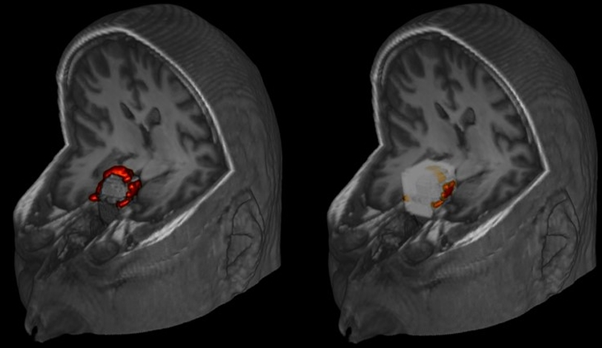
Supplementary Figure 1: Example of the modification of the chiasm ROI in a case of severe displacement from the expected position. In this 3D view, the optic chiasm was manually drawn in red to show its course; on the right, the final output of the modified chiasm ROI is shown in white.

Part 3
We performed a test-retest evaluation by repeating the tractography in each subject and calculating the Dice coefficient between the two reconstructions available at the individual level.
Across all reconstructions (including both healthy controls and patients), the mean Dice coefficient was 0.89 ± 0.09. When considering only healthy controls, the Dice was 0.95 ± 0.01, indicating excellent reproducibility. In patients with sellar or suprasellar tumors, the overall Dice was 0.82 ± 0.10. Subgroup analysis showed a Dice of 0.92 ± 0.05 in patients without chiasmal displacement, and 0.80 ± 0.09 in those with displacement.
These results confirm that the method has excellent reproducibility in healthy controls and in patients without optic chiasm displacement (Dice >90%), and good reproducibility even in the presence of chiasmal displacement (Dice >80%). Therefore, the automated reconstruction technique demonstrates robust test-retest reliability across both cohorts.
To also verify how online freely available ROIs would perform compared to our results, we also repeated the tractography using the ROI of the optic chiasm segmented by FreeSurfer (https://surfer.nmr.mgh.harvard.edu/) and the ROI of the LGN taken from a dedicated, publicly available atlas (https://osf.io/tqayf/)⁶. In the subgroup of the 35 healthy controls and 7 SPT patients without displacement of the chiasm, we then evaluated the tractography results, by assigning a score from 0 to 5 based on the number of portions of the AOP that were fully visible in the tractogram (right/left optic nerve, optic chiasm, right/left optic tract). Using our ROIs, we achieved an average score across subjects of 5/5, compared to the 2.3/5 of obtained using the atlas-derived ROIs.
An example of the tractography using both approaches is shown in Supplementary Figure 2.
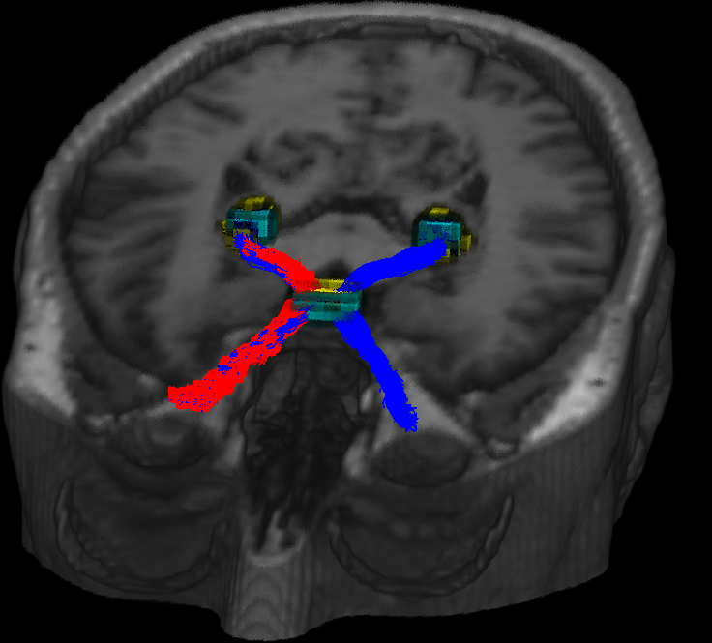
Supplementary Figure 2: Example of the tractography of the anterior optic pathway in a single subject using two different set of ROIs for the optic chiasm and lateral geniculate nucleus: the result obtained using the ROIs described in the manuscript (Figure 1; here shown in light blue) is shown in blue; the result obtained using the atlas-derived ROIs (yellow) is shown in red. The orbit ROIs were the same for both approaches. The atlas-based reconstruction was assigned a score of 2.5/5, as only half of the AOP was successfully identified, compared to the 5/5 score achieved using the ROIs defined for this study.

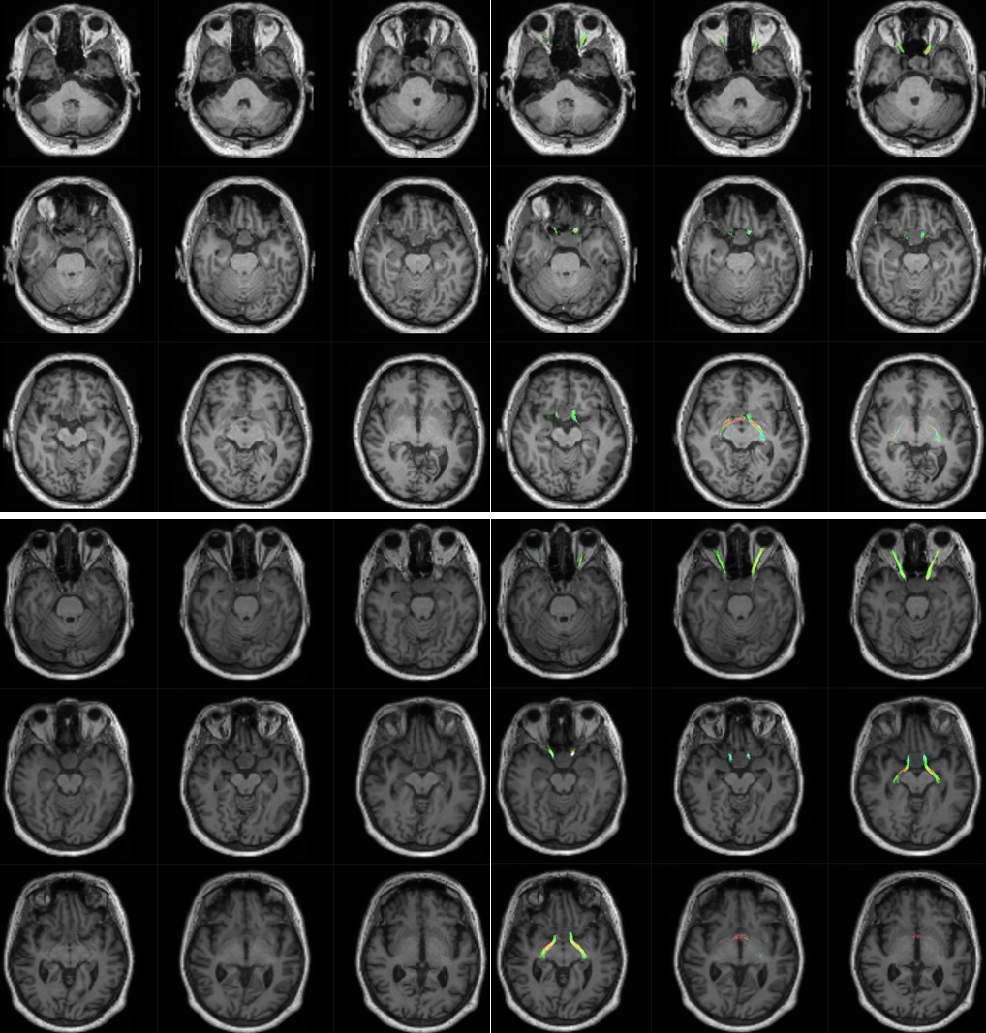
Supplementary Figure 3: Lightbox view of the reconstruction of the anterior optic pathway using the automated pipeline in two patients with severe displacement of the optic chiasm in the posterior (top) and superior (bottom) directions. T1-weighted images are shown on the left, the superimposed tractography of the AOP on the right.

Part 4
we performed a subgroup analysis comparing the along-tract diffusion metrics of patients with specific patterns of visual field deficits to those of healthy controls.
- In the subgroup of patients presenting with bitemporal visual field deficits (n = 12), indicative of chiasmal compression, we observed a consistent and statistically significant reduction in mean diffusivity (MD) specifically at the level of the optic chiasm, when compared to controls. These alterations were more pronounced than those observed in the broader patient group, suggesting that MD reduction at the chiasm may reflect localized microstructural damage due to compression. Results are shown in Supplementary Figure 4.
- In contrast, among patients with homonymous hemianopia (n = 5 for left, n = 4 for right), consistent with post-chiasmatic involvement (optic tracts), the chiasm showed no significant alterations in diffusion metrics. Instead, we observed a reduction in fractional anisotropy (FA) and fiber density (FD) in the posterior segments of the anterior optic pathways, particularly along the optic tracts:
  - In patients with left homonymous hemianopia, changes were most pronounced in the right optic tract (results shown in Supplementary Figure 5).
  - In patients with right homonymous hemianopia, alterations were localized in the left optic tract, with possible involvement of the adjacent posterior segments (results shown in Supplementary Figure 6).
Although the number of patients in each subgroup is relatively small, these findings are promising. They support the potential of along-tract analysis to detect spatially specific diffusion abnormalities that correlate with clinical visual deficits.
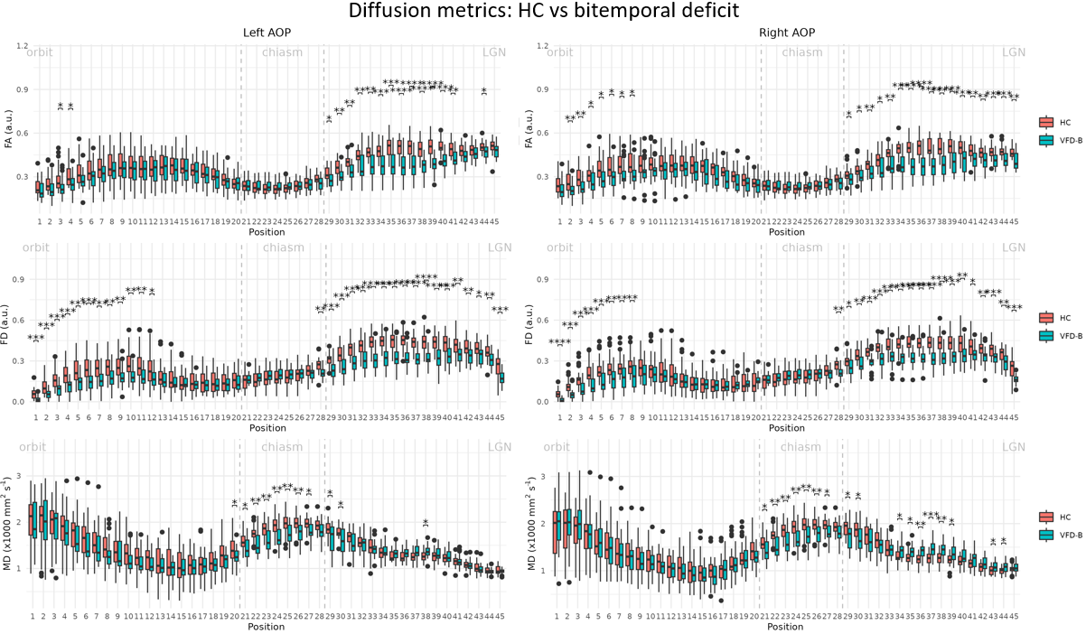
Supplementary Figure 4: Along-tract analysis of fractional anisotropy, mean diffusivity, and fixel density for left (left) and right (right) anterior optic pathway in patients with bitemporal visual field deficit (blue = VFD-B) and controls (red = HC). Position 1 = eye orbit, position 45 = lateral geniculate nucleus. * = adjusted p < 0.05; ** = adjusted p < 0.01; *** = adjusted p < 0.001; **** = adjusted p < 0.0001. Cond = condition, HC = healthy controls, VFD-B = visual field deficit - bitemporal, FA = fractional anisotropy, MD = mean diffusivity, FD = fixel density.

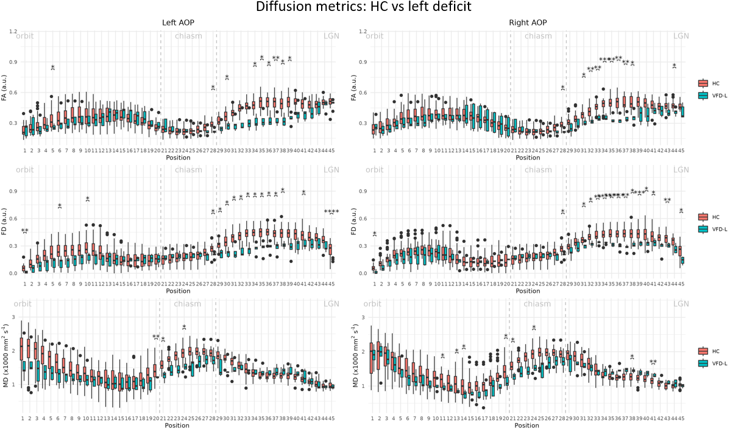
Supplementary Figure 5: Along-tract analysis of fractional anisotropy, mean diffusivity, and fixel density for left (left) and right (right) anterior optic pathway in patients with left visual field deficit (blue = VFD-L) and controls (red = HC). Position 1 = eye orbit, position 45 = lateral geniculate nucleus. * = adjusted p < 0.05; ** = adjusted p < 0.01; *** = adjusted p < 0.001; **** = adjusted p < 0.0001. Cond = condition, HC = healthy controls, VFD-L = visual field deficit - left, FA = fractional anisotropy, MD = mean diffusivity, FD = fixel density.

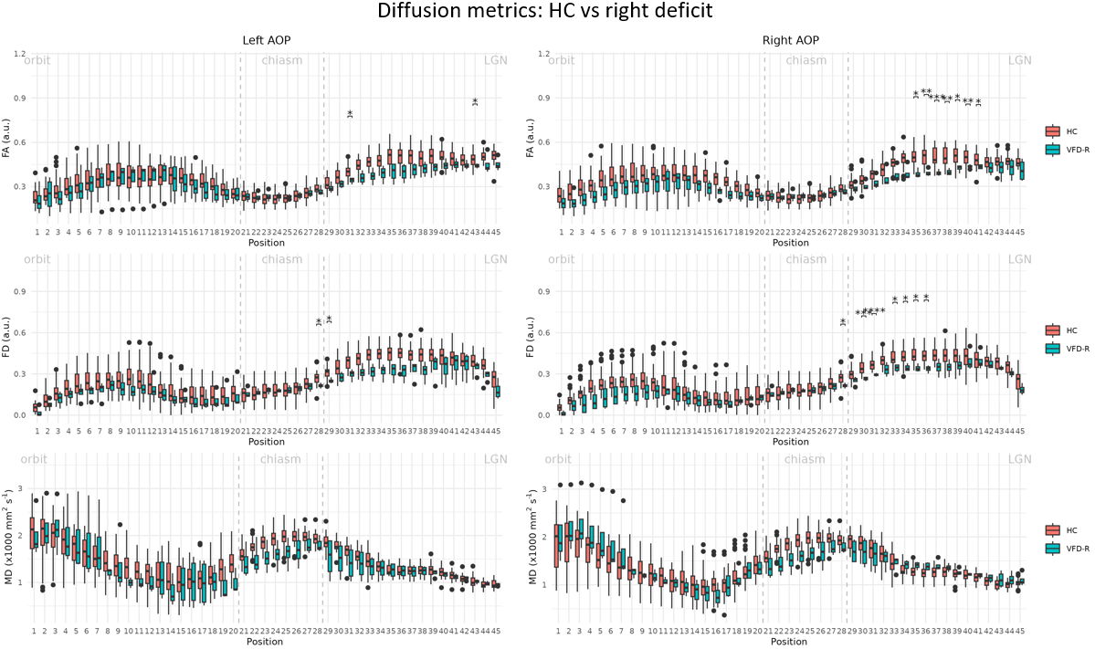
Supplementary Figure 6: Along-tract analysis of fractional anisotropy, mean diffusivity, and fixel density for left (left) and right (right) anterior optic pathway in patients with right visual field deficit (blue = VFD-L) and controls (red = HC). Position 1 = eye orbit, position 45 = lateral geniculate nucleus. * = adjusted p < 0.05; ** = adjusted p < 0.01; *** = adjusted p < 0.001; **** = adjusted p < 0.0001. Cond = condition, HC = healthy controls, VFD-L = visual field deficit - left, FA = fractional anisotropy, MD = mean diffusivity, FD = fixel density.

Part 5
To evaluate the reproducibility of the AOP reconstruction, we calculated the normalized overlap score (NOS) on the group of healthy controls, as described by He and colleagues⁷. To achieve this, the tractograms were converted to NIfTIs, binarized, and registered to the MNI space with a nearest neighbor approach. The masks so obtained were summed into a single image and normalized in the range [0-1]. The NOS is then calculated using the formula:
$$NOS=n^{-1}\sum_{i=0}^{n-1}{\frac{ln⁡(v_{i})}{ln⁡(v_{0})}}$$
where $n$ is the number of thresholds and set equal to 10, $v_{i}$ is the number of voxels with overlap values higher than the i‐th overlap threshold, i.e. $\frac{i}{n}$.
The NOS curve is shown in Supplementary Figure 7, and the NOS value was equal to 0.897, compared to the result of the 0.718 obtained with the approach achieving the highest score among tractography methods attempted by He and colleagues.
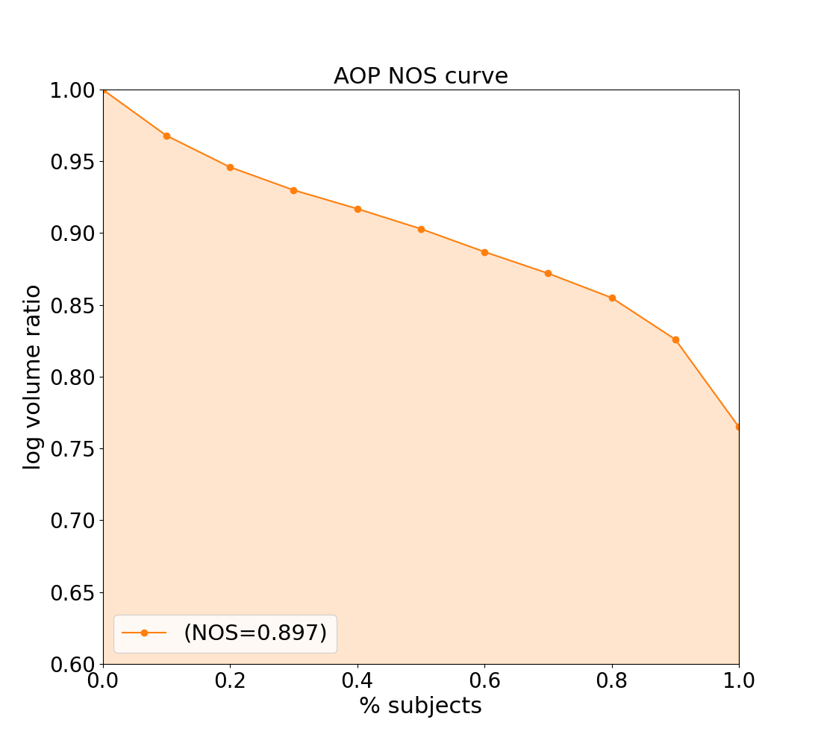
Supplementary Figure 7: Normalized overlap score (NOS) curve for the anterior optic pathway (AOP) calculated over the reconstruction results of 35 healthy controls. NOS = 0.897 indicates excellent reproducibility.

References
1. Veraart J, Novikov DS, Christiaens D, Ades-aron B, Sijbers J, Fieremans E. Denoising of diffusion MRI using random matrix theory. Neuroimage. 2016;142:394-406. doi:10.1016/j.neuroimage.2016.08.016
2. Andersson JLR, Skare S, Ashburner J. How to correct susceptibility distortions in spin-echo echo-planar images: application to diffusion tensor imaging. NeuroImage. 2003;20(2):870-888. doi:10.1016/S1053-8119(03)00336-7
3. Jeurissen B, Tournier JD, Dhollander T, Connelly A, Sijbers J. Multi-tissue constrained spherical deconvolution for improved analysis of multi-shell diffusion MRI data. NeuroImage. 2014;103:411-426. doi:10.1016/j.neuroimage.2014.07.061
4. Manners DN, Gramegna LL, La Morgia C, et al. Multishell Diffusion MR Tractography Yields Morphological and Microstructural Information of the Anterior Optic Pathway: A Proof-of-Concept Study in Patients with Leber’s Hereditary Optic Neuropathy. Int J Environ Res Public Health. 2022;19(11):6914. doi:10.3390/ijerph19116914
5. Jenkinson M, Beckmann CF, Behrens TEJ, Woolrich MW, Smith SM. FSL. Neuroimage. 2012;62(2):782-790. doi:10.1016/j.neuroimage.2011.09.015
6. Müller-Axt C, Eichner C, Rusch H, et al. Mapping the human lateral geniculate nucleus and its cytoarchitectonic subdivisions using quantitative MRI. NeuroImage. 2021;244:118559. doi:10.1016/j.neuroimage.2021.118559
7. He J, Zhang F, Xie G, et al. Comparison of multiple tractography methods for reconstruction of the retinogeniculate visual pathway using diffusion MRI. Hum Brain Mapp. 2021;42(12):3887-3904. doi:10.1002/hbm.25472

