Appendix
Figure 1. Outcome ranking Question1. The board voted on a 7-point Likert scale where 1 was “not very important” and 7 was “very important.”
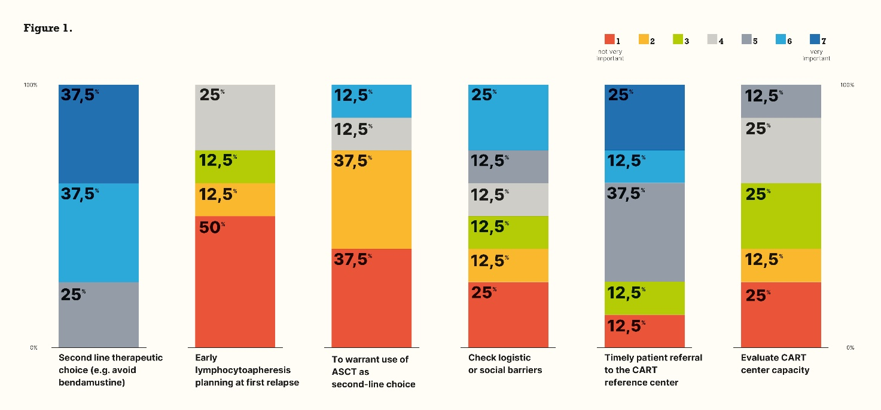

Figure 2. Subgroup ranking Question1. The board voted on a 7-point Likert scale where 1 was “not very important” and 7 was “very important.”
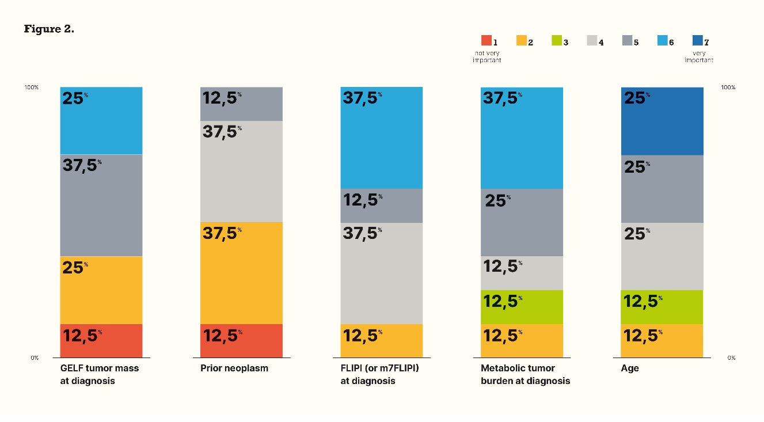
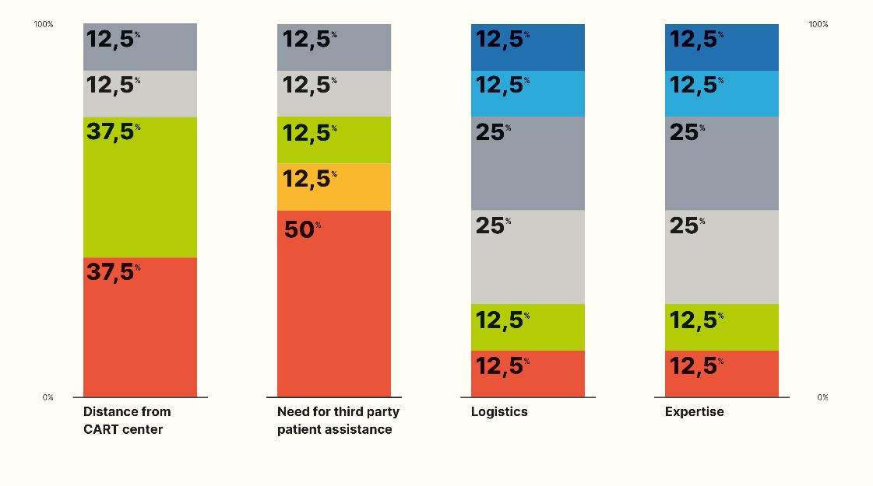

Figure 3. Outcome ranking Question2. The board voted on a 7-point Likert scale where 1 was “not very important” and 7 was “very important.”
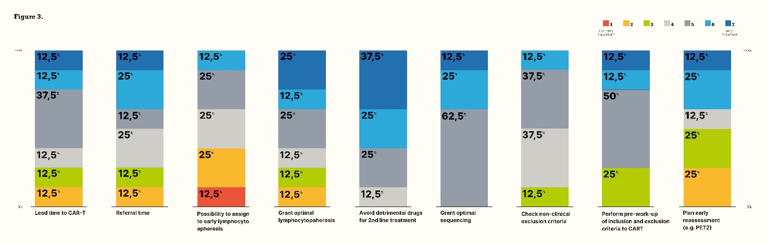

Figure 4. Subgroup ranking Question 2. The board voted on a 7-point Likert scale where 1 was “not very important” and 7 was “very important.”
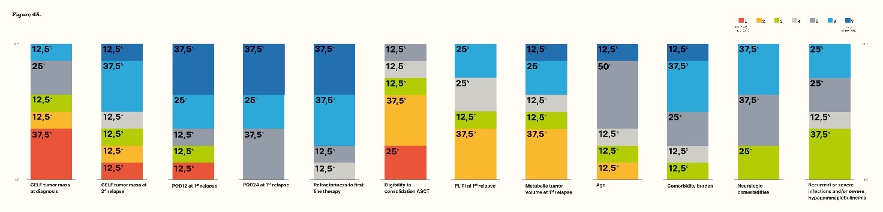
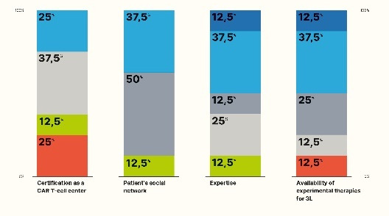

Figure 5. Outcome ranking Question3A. The board voted on a 7-point Likert scale where 1 was “not very important” and 7 was “very important.”
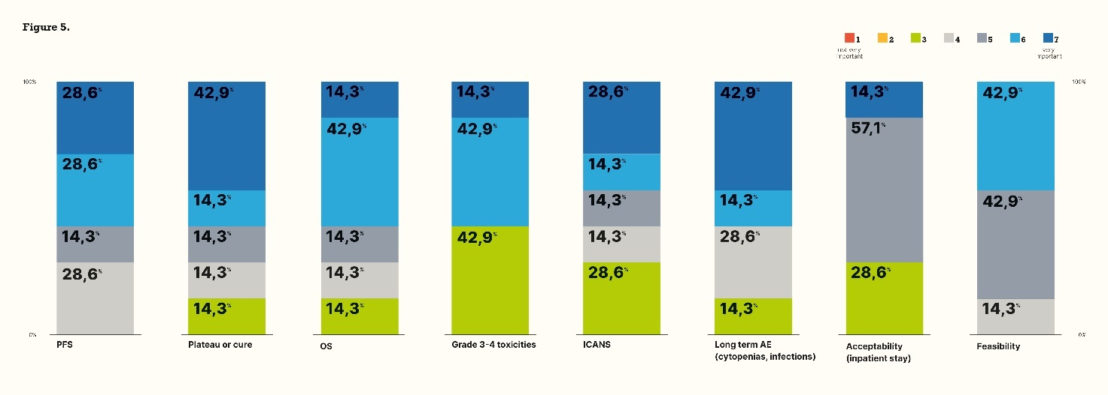

Figure 6. Subgroup ranking Question 3A. The board voted on a 7-point Likert scale where 1 was “not very important” and 7 was “very important.”
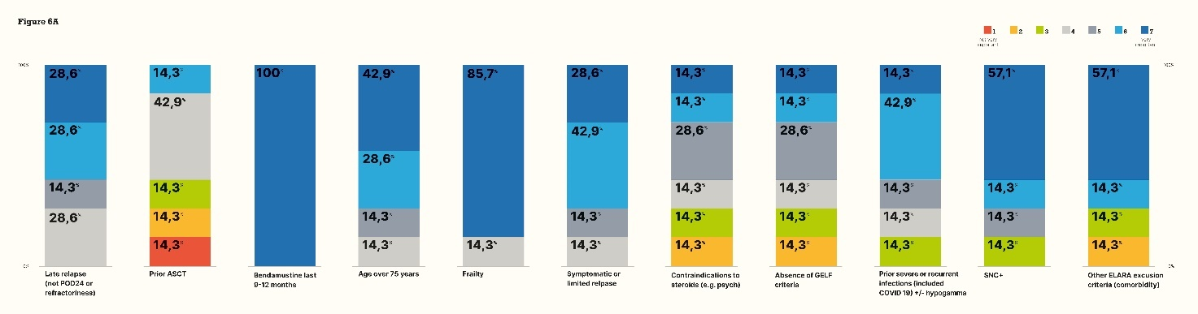
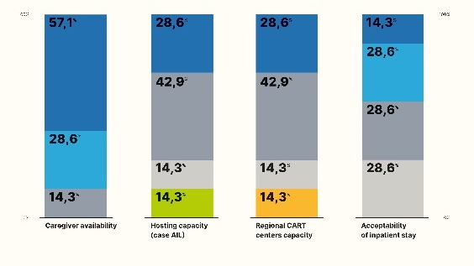

Figure 7. Outcome ranking Question 3B. The board voted on a 7-point Likert scale where 1 was “not very important” and 7 was “very important.”
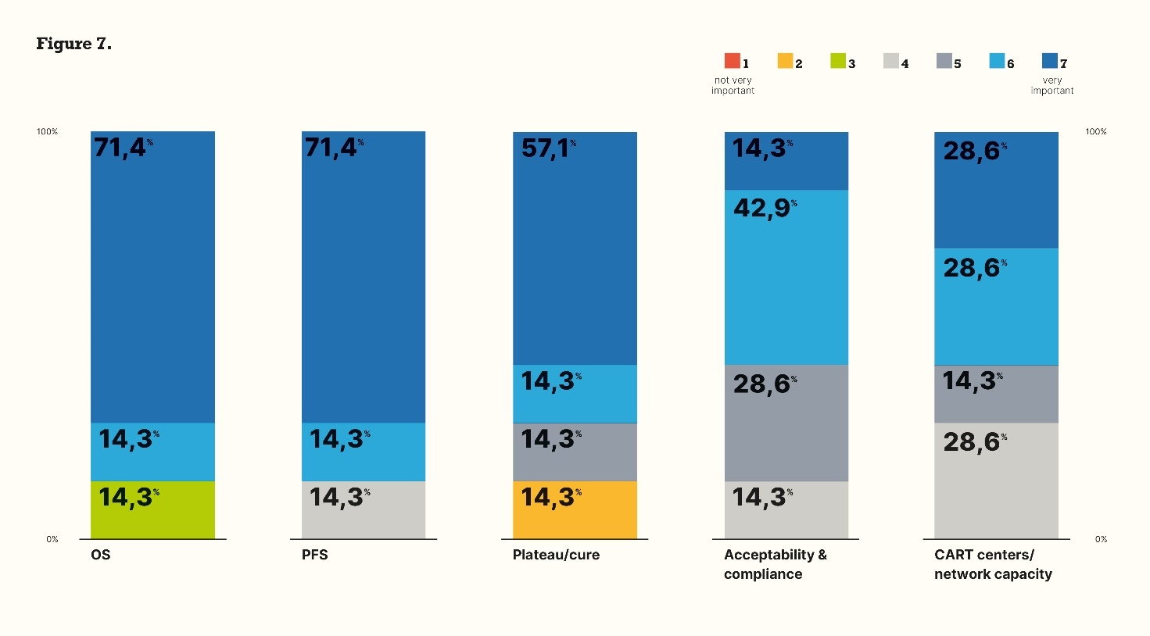

Figure 8. Subgroup ranking Question 3B. The board voted on a 7-point Likert scale where 1 was “not very important” and 7 was “very important.”
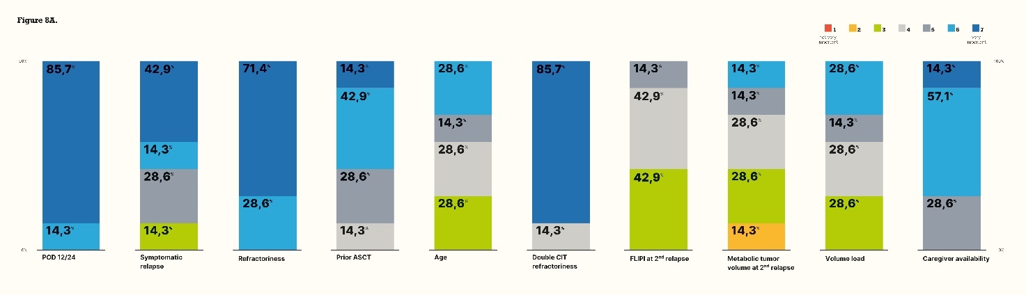

Table 1. Whole panel agreement on statement.

