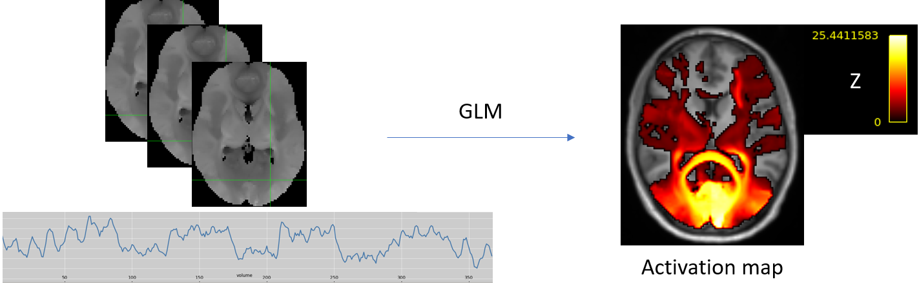
Supplementary Figure 1: Example of a 4D functionnectome generated with the standardized anatomical priors using a visual task, with a voxel timeseries shown below, and the resulting Z-statistic activation map (Z>3) after the application of a general linear model (GLM) with the paradigm design.

Supplementary Table 1: Distribution of tumor classifications, anatomical localizations, and functional tasks performed. Numbers in parentheses indicate the total count per category, with locations and tasks summarized by frequency for each tumor type.
Classification (number) | Localization | Tasks
Glioblastoma  IDH-wildtype (16) | 5 left frontal  2 left temporal  4 right frontal  2 right fronto-temporal  1 right fronto-parietal  2 right parietal | 16 motor  7 language
Astrocytoma (7) | 3 left frontal  1 left fronto-parietal  1 left parietal  1 median parietal  1 right hippocampal | 29 motor  19 language
Glioneuronal (3) | 1 left temporal  1 right fronto-temporal  1 left parietal | 5 language

Part 1
The task paradigms were generated in-house using E-Prime 3.0 (https://pstnet.com/products/e-prime/). Each design consisted of interleaved 30-seconds blocks of resting and task, for a total of 4:30 min acquisition, thus comprising five resting and four active blocks.
The administered task paradigms were designed as follows:
- Finger tapping: the patient was instructed to touch the tips of their thumb and index of the involved hand, at the frequency (1.5 Hz) established by an acoustic stimulation, while keeping their arm and hand still. During the resting intervals, the patient heard white noise;
- Foot plantar flexion: the patient was instructed to flex their involved foot downward, at the frequency (0.75 Hz) established by an acoustic stimulation, while keeping their leg still. During the resting intervals, the patient heard white noise;
- Lip protrusion: the patient was instructed to protrude their lips “as to kiss”, at the frequency (0.75 Hz) established by an acoustic stimulation, while keeping their head still. During the resting intervals, the patient heard white noise;
- Phonemic fluency: the patient was instructed to think of words starting with the letter they heard, excluding names of cities or people, without moving their mouth. In each 30 s block, six letters were administered. During the resting interval, the patient heard a siren reproducing the frequency and volume range of the human voice.
- Semantic fluency: the patient was instructed to think of verbs semantically associated with the noun they heard, without moving their mouth. In each 30 s block, six words were administered. During the resting interval, the patient heard a siren reproducing the frequency and volume range of the human voice.

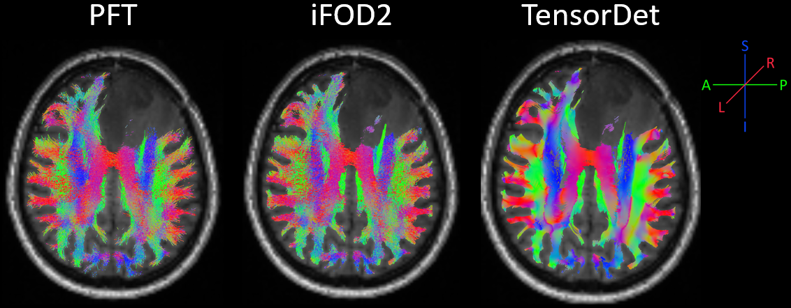
Supplementary Figure 2: Whole-brain tractograms reconstructed using the three different tractography approaches in a single patient with left frontal glioma. While PFT and iFOD2 tractograms appear similar, with the PFT going slightly deeper into the grey matter, the TensorDet tractogram exhibits only streamlines on the principal diffusion direction.

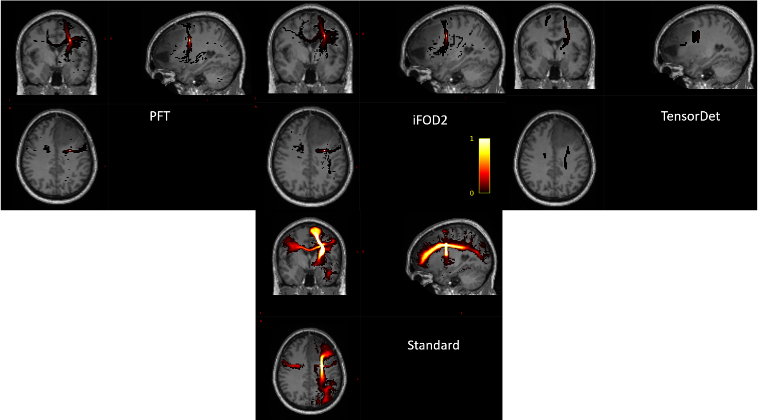Supplementary Figure 3: The voxel (57,62,53) in the 2-mm MNI space, in the case of the specific subject considered, was crossed by projection fibers between the thalamus and the pre-motor cortex, and commissural fibers of the premotor corpus callosum. However, across multiple subjects, the voxel may be also crossed by association fibers connecting the frontal, parietal, temporal and occipital lobes, as revealed by the standardized anatomical prior, which extends to a significantly larger portion of the brain compared to all individualized results.

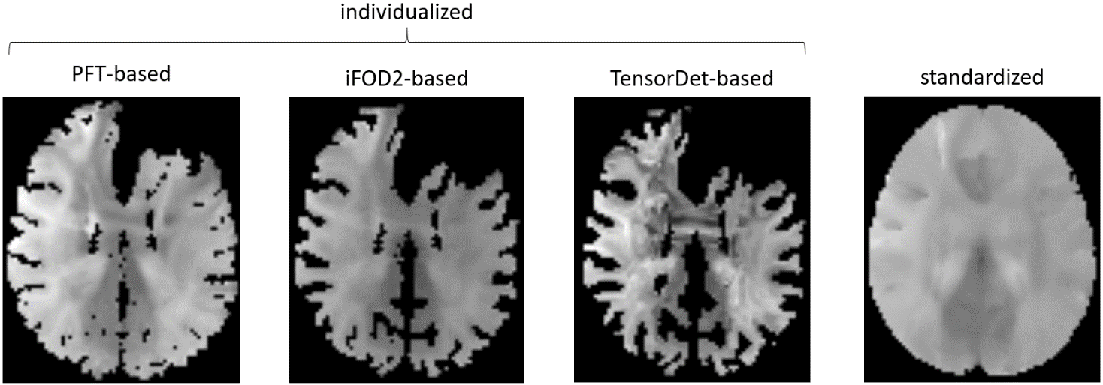
Supplementary Figure 4: Example of the same slice of the 4D functionnectomes estimated using the three different individualized approaches and the standardized one in the same subject with a left frontal glioma. While the standardized functionnectome covers the entire MNI brain mask, all the individualized methods were adapted to the anatomical configuration of the examined subject. Additionally, although the CSD-based functionnectomes appeared qualitatively similar, the tensor-based variant exhibited pronounced and implausible intensity gradients between neighbouring voxels, especially in the corpus callosum. Furthermore, the PFT-based functionnectomes encompassed broader regions of grey matter compared to those derived from the iFOD2 method, reinforcing the notion that PFT offers anatomical priors that penetrate more deeply into grey matter. This can be especially noticed in the region of the posterior cingulate cortex.

Part 2
Detailed results of the reproducibility analysis (“Functionnectome overlap with tract atlas”) in Sections 2.8 and 3.5 of the main Manuscript are reported in this section. The outcomes are represented in Supplementary Figures 4-10 as follows: a histogram is shown in the center of the image that compares the percentage of patients who share the same tract among the best 5 matches with the PFT and standardized functionnectomes, at different Z thresholds (3, 4, 7). The tracts are listed in decreasing order of the percentage of patients of patients sharing them, based on the PFT functionnectome. On the right, a 3D reconstruction of the functionnectome activation maps, thresholded at Z > 3, that are in common between 50% or more of the patients is presented. In addition, the Pearson’s R and the Dice coefficient between the PFT and the standardized activation maps at Z > 3 were calculated.
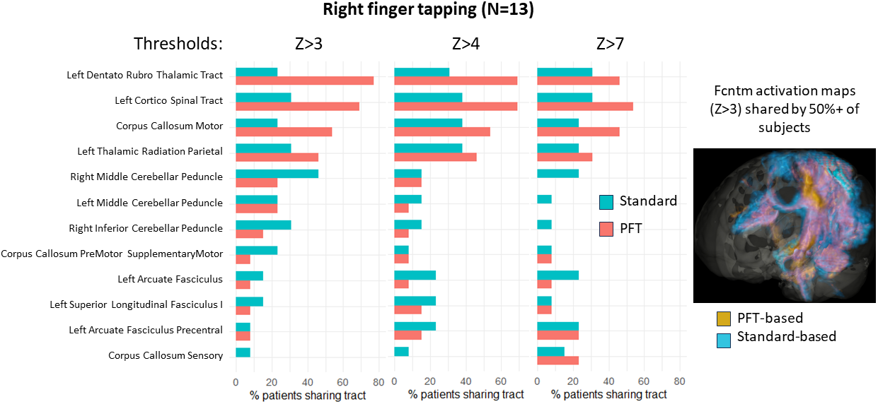
Supplementary Figure 5: Reproducibility of the individualized and standardized Functionnectome for the right finger tapping task. The histogram of the percentage of patients sharing the same tract among the top 5 shows high reproducibility of motor tracts in the individualized case, but not in the standardized one. The activation map shared by >50% of patients is shown on the right. The PFT functionnectome (orange) exhibits a better reproducibility across subjects of the motor pathways, compared to the standardized (blue). Pink color represents the overlap. The Pearson’s correlation between the standardized and the PFT functionnectomes was 0.59 ± 0.11 and the Dice coefficient 0.57 ± 0.16.

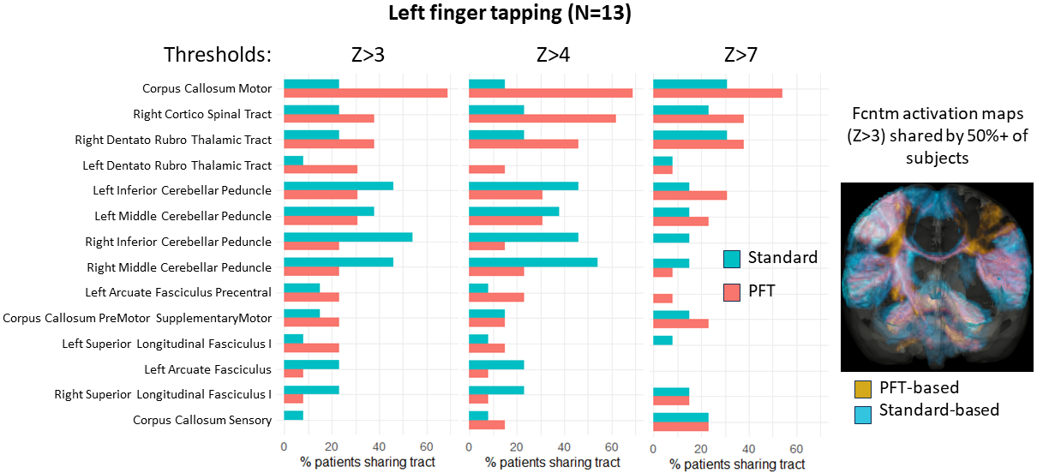
Supplementary Figure 6: Reproducibility of the individualized and standardized Functionnectome for the left finger tapping task. The histogram of the percentage of patients sharing the same tract among the top 5 shows high reproducibility of the motor corpus callosum in the individualized case, while the standardized one mostly overlap cerebellar pathways. The activation map shared by >50% of patients is shown on the right. The PFT functionnectome (orange) exhibits better integrity of the motor pathways across subjects, especially in the corpus callosum, compared to the standardized (blue). Pink color represents the overlap. The Pearson’s correlation between the standardized and the PFT functionnectomes was 0.58 ± 0.10 and the Dice coefficient 0.58 ± 0.16.

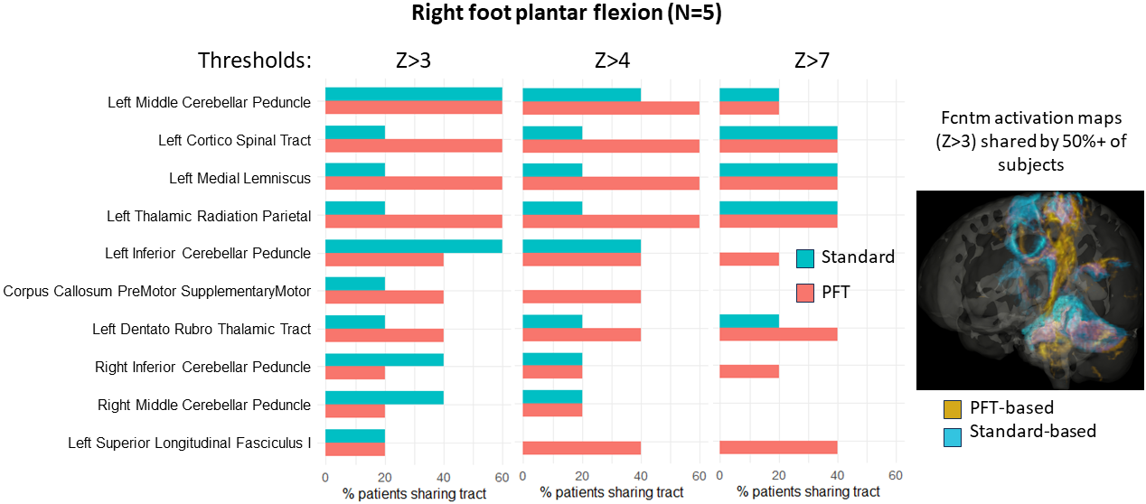
Supplementary Figure 7: Reproducibility of the individualized and standardized Functionnectome for the right foot plantar flexion task. The histogram of the percentage of patients sharing the same tract among the top 5 shows highest reproducibility of the motor pathways in the individualized case, and cerebellar in both cases. The activation map shared by >50% of patients is shown on the right. The PFT functionnectome (orange) is slightly shifted towards the posterior part of the brain and it covers a larger portion of the motor pathways, compared to the standardized (blue). Pink color represents the overlap. The Pearson’s correlation between the standardized and the PFT functionnectomes was 0.47 ± 0.13 and the Dice coefficient 0.55 ± 0.11.

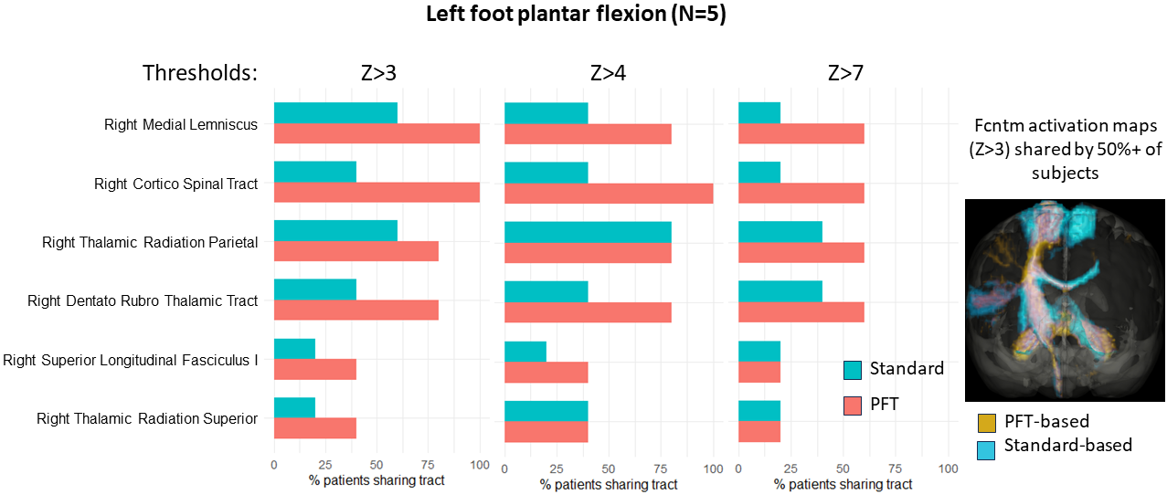
Supplementary Figure 8: Reproducibility of the individualized and standardized Functionnectome for the left foot plantar flexion task. The histogram of the percentage of patients sharing the same tract among the top 5 shows high reproducibility of the motor pathways in the individualized case, lower in the standardized one. The activation map shared by >50% of patients is shown on the right. The PFT functionnectome (orange) exhibits better integrity of the right motor pathways across subjects, compared to the standardized (blue). Pink color represents the overlap. The Pearson’s correlation between the standardized and the PFT functionnectomes was 0.56 ± 0.10 and the Dice coefficient 0.52 ± 0.16.

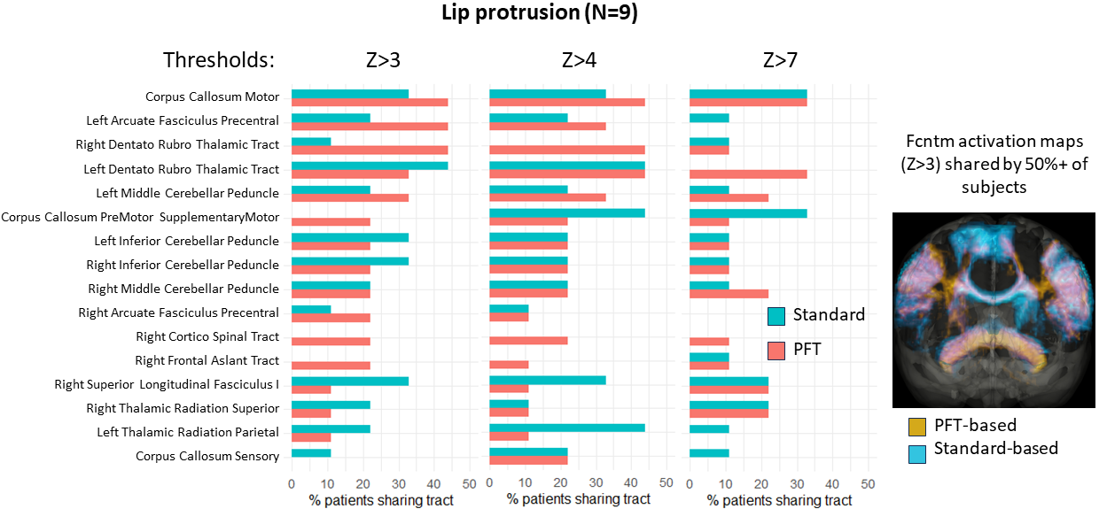
Supplementary Figure 9: Reproducibility of the individualized and standardized Functionnectome for the lip protrusion task. The histogram of the percentage of patients sharing the same tract among the top 5 shows high reproducibility of the motor pathways in the individualized case, partially reproduced in the standardized one. The activation map shared by >50% of patients is shown on the right. The PFT functionnectome (orange) exhibits better integrity of the bilateral motor pathways across subjects, especially in the motor projections of corpus callosum, compared to the standardized (blue). Pink color represents the overlap. The Pearson’s correlation between the standardized and the PFT functionnectomes was 0.50 ± 0.19 and the Dice coefficient 0.54 ± 0.22.

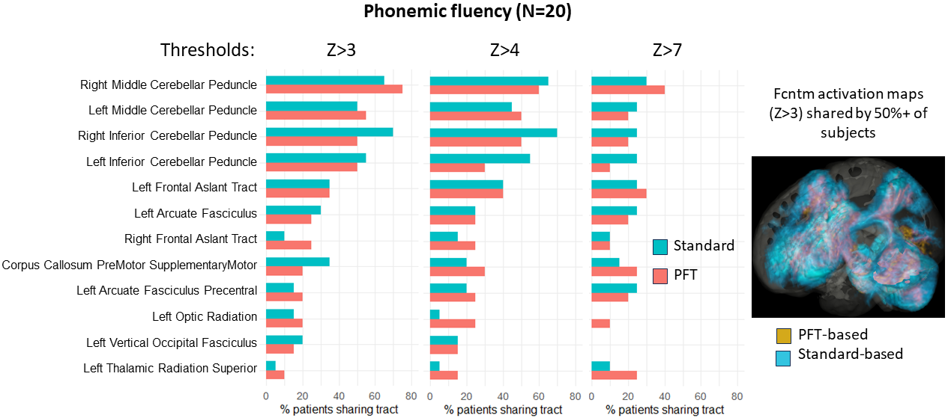
Supplementary Figure 10: Reproducibility of the individualized and standardized Functionnectome for the phonemic fluency task. The histogram of the percentage of patients sharing the same tract among the top 5 shows similar results for the individualized and standardized approaches, with the cerebellar tracts being the most reproduced. The activation map shared by >50% of patients is shown on the right and it shows similar outcomes for both approaches, with the individualized map (orange) extending less in all parts of the brain, compared to the standardized (blue). Pink color represents the overlap. The Pearson’s correlation between the standardized and the PFT functionnectomes was 0.48 ± 0.13 and the Dice coefficient 0.61 ± 0.16.

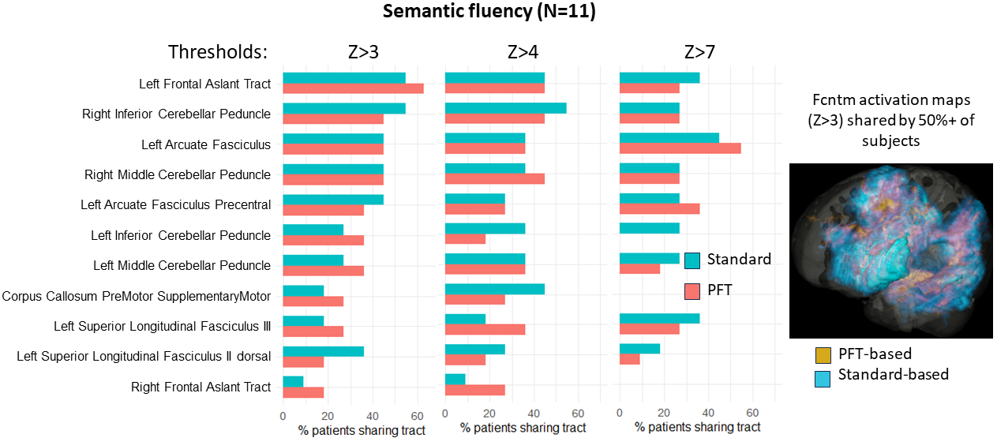 Supplementary Figure 11: Reproducibility of the individualized and standardized Functionnectome for the semantic fluency task. The histogram of the percentage of patients sharing the same tract among the top 5 shows similar results for the individualized and standardized approaches, with the frontal aslant tract, the arcuate fasciculus and the cerebellar tracts being the most reproduced. Interestingly, at Z>7 the arcuate fasciculus is the most shared tract, suggesting that it retains the strongest statistical activation among the ones involved. The activation map shared by >50% of patients is shown on the right and it shows similar outcomes for both approaches, with the individualized map (orange) extending less in all parts of the brain, compared to the standardized (blue). Pink color represents the overlap. The Pearson’s correlation between the standardized and the PFT functionnectomes was 0.50 ± 0.08 and the Dice coefficient 0.61 ± 0.13.

