Supplementary Figure 1. Kaplan Meier curve of risk of death according to being exposed or not to 4DR.
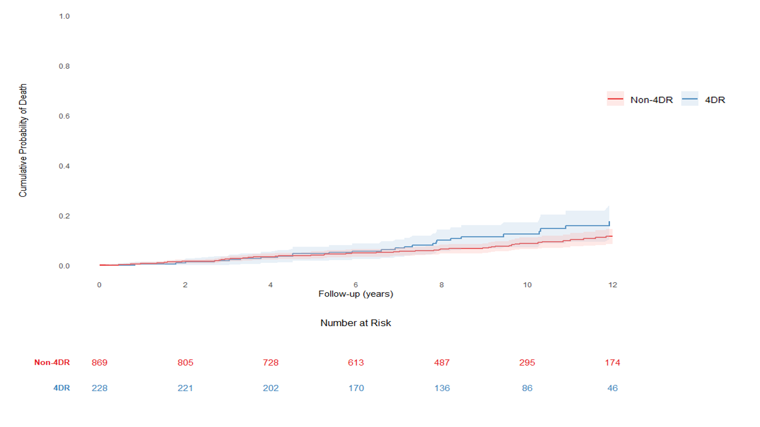

Supplementary Table 1. Causes of death.
Causes of death, n (%) | Non-4-DR PWH  N=67 | 4-DR PWH  N=28
AIDS | 5 (7.5%) | 3 (10.7%)
LIVER | 14 (20.9%) | 0 (0%)
Non AIDS cancer | 20 (29.9%) | 5 (17.9%)
Other non AIDS | 16 (23.9%) | 10 (35.7%)
Suicide | 1 (1.5%) | 1 (3.6%)
Unknown | 11 (16.4%) | 9 (32.1%)

Supplementary Table 2. Multivariable Cox models of risk of death.

Model 1 | aHR | 95% CI | p value
4DR vs Non-4DR | 1.70 | 1.08-2.66 | 0.021
MACEª | 1.64 | 0.76-3.56 | 0.209
CKD^{b} | 3.64 | 1.97-6.71 | <0.0001
Diabetes^{c} | 1.69 | 0.98-2.91 | 0.057
HCV | 2.11 | 1.39-3.20 | 0.0004
Neoplasm | 2.33 | 1.22-4.42 | 0.010
Arterial hypertension^{d} | 1.43 | 0.88-2.33 | 0.145
Model 2 | aHR | 95% CI | p value
4DR vs Non-4DR | 1.57 | 1.00-2.48 | 0.052
MACEª | 1.62 | 0.74-3.51 | 0.225
CKD^{b} | 3.27 | 1.78-5.99 | 0.0001
Diabetes^{c} | 1.66 | 0.96-2.87 | 0.067
HCV | 2.08 | 1.37-3.17 | 0.001
Neoplasm | 2.20 | 1.16-4.16 | 0.016
Arterial hypertension^{d} | 1.39 | 0.86-2.25 | 0.177
AIDS | 2.11 | 1.40-3.17 | 0.0004
Model 3 | aHR | 95% CI | p value
4DR vs Non-4DR | 0.93 | 0.57-1.53 | 0.783
MACEª | 1.56 | 0.72-3.38 | 0.257
CKD^{b} | 2.63 | 1.43-4.83 | 0.002
Diabetes^{c} | 1.72 | 1.00-2.98 | 0.050
HCV | 1.97 | 1.29-3.00 | 0.002
Neoplasm | 1.95 | 1.03-3.69 | 0.041
Arterial hypertension^{d} | 1.52 | 0.94-2.45 | 0.089
AIDS | 1.70 | 1.12-2.58 | 0.013
CD4 cell count. Per 100/mm3 more | 0.80 | 0.73-0.87 | <0.0001

List of abbreviations: CI, confidence interval; aHR, adjusted Hazard Ratio; 4DR, four drug class resistence; MACE, major cardiovascular events; CKD, chronic kidney disease.
ªMACE defined as cardiovascular death, myocardial infarction, unstable angina, stroke, transient ischaemic attack, peripheral arterial ischaemia, and coronary, carotid or peripheral artery revascularization.
^{b}CKD defined as estimated glomerular filtration rate <60 mL/min/1.73 m2 calculated from the CKD-EPI creatinine equation at two measurements >3 months apart.
^{c}Diabetes mellitus defined as fasting glucose ≥126 mg/dL at two measurements, oral glucose tolerance test 2 h value ≥200 mg/dL or glycated haemoglobin ≥48 mmol/mol (≥6.5%).
^{d}Arterial hypertension defined as blood pressure >140/90 mmHg, confirmed with home blood pressure measurement or 24 h blood pressure monitoring, or use of antihypertensive drugs.

