Future scenarios for sustainable water management in Mediterranean agricultural systems: a life cycle case study on water reuse in Northern Italy
Supplementary Materials I
Index
1. Methodology 2
1.1 Environmental and Financial Analysis 2
1.2 Policy Foresight Exercise 7
2. Results 13
3. References 15

List of Figures
Figure A. Screenshot of survey outlook for the two-round of Delphi consultation. 8
Figure B. Screenshot of Miro Boardª used in the focus group for the scenario building process. 11
Figure C. Double sided template used for Focus Group discussion and qualitative data collection. 12
Figure D. Life cycle impacts of the three technologies expressed as single scores over 20 years focusing on the operational phase impacts. 13
Figure E. Results of comparative Monte Carlo Analysis with 1,000 iterations showing the percentage of probability that BAU scenario has greater impact than WR_1 and WR_2. 14

List of Tables
Table A. Water quality of water inflow and outflow and abatement levels in the three technologies in the experimental trials (Foglia et al., 2021; Mancuso et al., 2024; Parlapiano et al., 2024). 2
Table B. Adaptation of Ecoinvent v3.11 tomatoes production process to include avoided fertilisers production and application in Water Reuse Scenario. 3
Table C. Inventories of input and output considered for UASB technology. 4
Table D. Inventories of input and output considered for ACW technology. 5
Table E. Inventories of input and output considered for MIPs technology. 5
Table F. Lists of the 16 Impact Categories of Product Environmental Footprint (EF 3.1). 6
Table G. Monetisation factors and Consumer Price Index used for environmental costs accounting. 6
Table H. Checklist of the consolidated criteria for reporting qualitative studies (COREQ) for Delphi e-surveys and focus groups. 7
Table I. Full list of internal and external drivers of change for water reuse diffusion provided to experts for the two rounds of Delphi e-surveys. Based on (Berti Suman et al., 2023). 8
Table J. Life cycle costs of the three technologies at pilot scale over 20 years. 13
Table K. Mean, median, SD and CV of Monte Carlo simulation results for environmental impact categories. 14
Table L. Description of the four scenarios for non-conventional water resources diffusion by 2050. 15

1. Methodology

1.1 Environmental and Financial Analysis
Table A. Water quality of water inflow and outflow and abatement levels in the three technologies in the experimental trials (Foglia et al., 2021; Mancuso et al., 2024; Parlapiano et al., 2024).
Parameters | Unit | Inflow | Outflow | Abatement Level (%)
UASB
COD | mg/L | 3.74E+02 | 1.75E+02 | 5.33E+01
TSS | mg/L | 2.28E+02 | 7.42E+01 | 6.74E+01
TN | mg/L | 3.40E+01 | 3.38E+01 | 6.10E-01
TP | mg/L | 4.80E+00 | 4.39E+00 | 8.52E+00
NH4-N | mg/L | 2.21E+01 | 2.57E+01 | -1.60E+01
PO4-P | mg/L | 2.33E+00 | 3.46E+00 | -4.76E+01
E. coli | UFC/100mL | 1.00E+06 | 9.95E+05 | 5.20E-01
HCW
COD | mg/L | 1.75E+02 | 3.50E+01 | 8.00E+01
TSS | mg/L | 7.42E+01 | 7.41E+00 | 9.00E+01
TN | mg/L | 3.38E+01 | 1.01E+01 | 7.00E+01
TP | mg/L | 4.39E+00 | 1.75E+00 | 6.00E+01
NH4-N | mg/L | 2.57E+01 | 2.57E+01 | -
PO4-P | mg/L | 3.46E+00 | 3.45E+00 | -
E. coli | UFC/100mL | 9.95E+05 | 9.96E+02 | 9.99E+01
MIPs
Diclofenac | mg/L | 5.00E+00 | 3.50E+00 | 3.00E+01
COD | mg/L | 6.10E+01 | N.M. | N.M.
TN | mg/L | 2.76E+01 | N.M. | N.M.
TP | mg/L | 2.94E+00 | N.M. | N.M.
NH4-N | mg/L | 2.54E+01 | N.M. | N.M.
PO4-P | mg/L | 3.85E+00 | N.M. | N.M.

Table B. Adaptation of Ecoinvent v3.11 tomatoes production process to include avoided fertilisers production and application in Water Reuse Scenario.
Materials/fuels | BAUª |  | WR^{b} | Min^{b} | Max^{b}
Ammonium sulfate {RER}| market for ammonium sulfate | Cut-off, U | 1.03E-04 | kg | 6.40E-05 | 7.74E-05 | 5.16E-05
Transport, freight, inland waterways, barge, diesel {RER}| market for transport, freight, inland waterways, barge, diesel | Cut-off, U | 1.94E-04 | tkm | 1.36E-04
Ammonium nitrate {RER}| market for ammonium nitrate | Cut-off, U | 2.29E-04 | kg | 1.42E-04 | 1.71E-04 | 1.14E-04
Transport, freight, lorry, diesel, unspecified {RER}| market for transport, freight, lorry, unspecified | Cut-off, U | 6.17E-04 | tkm | 4.32E-04
Potassium sulfate {RER}| market for potassium sulfate | Cut-off, U | 9.08E-04 | kg | 2.73E-04 | 3.27E-04 | 2.34E-04
Calcium ammonium nitrate {RER}| market for calcium ammonium nitrate | Cut-off, U | 9.40E-04 | kg | 5.83E-04 | 7.05E-04 | 4.70E-04
Transport, freight, train, fleet average {Europe without Switzerland}| market for transport, freight, train, fleet average | Cut-off, U | 1.14E-03 | tkm | 8.01E-04
Urea {RER}| market for urea | Cut-off, U | 1.16E-03 | kg | 7.20E-04 | 8.71E-04 | 5.81E-04
Inorganic potassium fertiliser, as K2O {RoW}| nutrient supply from potassium nitrate | Cut-off, U | 1.24E-03 | kg | 3.72E-04 | 4.47E-04 | 3.20E-04
Potassium chloride {RER}| market for potassium chloride | Cut-off, U | 1.72E-03 | kg | 5.15E-04 | 6.18E-04 | 4.43E-04
Urea ammonium nitrate mix {RER}| market for urea ammonium nitrate mix | Cut-off, U | 1.81E-03 | kg | 1.12E-03 | 1.35E-03 | 9.03E-04
Inorganic phosphorus fertiliser, as P2O5 {IT}| market for inorganic phosphorus fertiliser, as P2O5 | Cut-off, U | 1.82E-03 | kg | 1.80E-03 | 1.81E-03 | 1.78E-03
Packaging, for fertilisers {GLO}| market for packaging, for fertilisers | Cut-off, U | 1.30E-02 | kg | 9.07E-03
Ammonia, anhydrous, liquid {RER}| market for ammonia, anhydrous, liquid | Cut-off, U | 1.67E-05 | kg | 1.04E-05 | 1.26E-05 | 8.37E-06
Phosphate rock, beneficiated {RER}| market for phosphate rock, beneficiated | Cut-off, U | 3.06E-05 | kg | 3.02E-05 | 3.05E-05 | 3.00E-05
Inorganic nitrogen fertiliser, as N {RoW}| nutrient supply from ammonium nitrate phosphate | Cut-off, U | 5.78E-05 | kg | 3.58E-05 | 4.34E-05 | 2.89E-05
Inorganic nitrogen fertiliser, as N {RoW}| nutrient supply from diammonium phosphate | Cut-off, U | 7.95E-05 | kg | 4.93E-05 | 5.96E-05 | 3.97E-05
Inorganic nitrogen fertiliser, as N {RoW}| nutrient supply from monoammonium phosphate | Cut-off, U | 7.95E-05 | kg | 4.93E-05 | 5.96E-05 | 3.97E-05
Inorganic nitrogen fertiliser, as N {RoW}| nutrient supply from potassium nitrate | Cut-off, U | 7.96E-05 | kg | 4.94E-05 | 5.97E-05 | 3.98E-05
Emissions to air |  | BAUª | WR^{b} | Min^{b} | Max^{b}
Ammonia | low. pop. | 1.45E-04 | 9.00E-05 | 1.09E-04 | 7.26E-05
Carbon dioxide, fossil | low. pop. | 1.28E-03 | 7.91E-04 | 9.57E-04 | 6.38E-04
Dinitrogen monoxide | low. pop. | 3.57E-05 | 2.21E-05 | 2.68E-05 | 1.78E-05
Nitrogen oxides | low. pop. | 4.30E-05 | 2.67E-05 | 3.23E-05 | 2.15E-05
Emissions to water |  | BAUª | WR^{b} | Min^{b} | Max^{b}
Nitrate | groundwater | 3.36E-03 | 2.09E-03 | 2.52E-03 | 1.68E-03
Phosphate | groundwater | 3.03E-06 | 2.99E-06 | 3.02E-06 | 2.96E-06
Phosphate | river | 1.00E-05 | 9.91E-06 | 1.00E-05 | 9.81E-06
Phosphorus | river | 2.18E-06 | 2.16E-06 | 2.18E-06 | 2.14E-06

a. The Business-as-usual (BAU) Scenario includes default values in the Ecoinvent v3.11 process for tomatoes production (IT).
b. The Water Reuse Scenario incorporates the following percentage reductions: –37% nitrogen (N), –1.3% phosphorus (P), and –70% potassium (K), based on the mean values derived from two years of experimental data reported by (Odone et al., 2024). The minimum (–24.3% N, –0.4% P, –64% K) and maximum (–50% N, –2.2% P, –74.2% K) values observed during the trial are also reflected. These reductions were estimated approximately, considering the total fertiliser quantities, even though the reductions were specifically observed in the active compounds. Packaging and transport of fertilisers were reduced approximately by 30%.

Table C. Inventories of input and output considered for UASB technology.
Item | Pilot Scale (m³) | Upscaled (m³) | Unit | Data Source
Construction Phase
Land | 9.78E-04 | 8.56E-06 | m² | Pilot Owner
Tank | 1.66E-01 | 1.18E-04 | kg | Pilot Owner - Material production + main process (injection moulding) + transport (PEF guidelines) - Ecoinvent
Submersible Dewatering Pump | 1.82E-03 | 3.41E-02 | p | Pilot Owner- Adaptation from Ecoinvent process for water pump production (1 piece of 22 kW)- Disposal included
Boiler/Electric resistance | 1.50E-01 | 1.00E+00 | p | Pilot Owner - 1 piece of 10 kW - Ecoinvent
Reactor | 1.77E-02 | 3.23E-03 | kg | Pilot Owner - Material production + main process (injection moulding) + transport (PEF guidelines) - Ecoinvent
Feeding Pump | 2.27E-04 | 6.82E-02 | p | Adaptation from Ecoinvent proces for water pump production (1 piece of 22 kW) - Disposal Included
Effluent Pump | 1.82E-03 | 6.82E-02 | p | Adaptation from Ecoinvent proces for water pump production (1 piece of 22 kW) - Disposal included
Tank | 2.94E-04 | 5.48E-05 | kg | Material production + main process (injection moulding) + transport (PEF guidelines) - Ecoinvent
Operational Phase
Input
Activated Carbon | 6.85E-04 | 2.74E-04 | kg | Hypothesis and HYDROUSA D3.1 - Ecoinvent
Electricity | 2.23E+00 | 3.17E-03 | kW | Pilot Owner- Ecoinvent
Spent Activated Carbon | 2.94E+00 | 2.74E-03 | W | Hypothesis for reactivation - Ecoinvent
Output
Sludge | 3.21E+01 | 2.50E-02 | kg | Hypothesis drying + Sanitary Landfill - Ecoinvent
Biogas | 4.57E-01 | 3.89E-04 | m³ | Economic Allocation (1.14% pilot; 98.6% upscaled)
Disposal Phase
Waste Tank, Reactors | 1.84E-01 | 2.01E-04 | kg | Hypothesis Municipal collection (45km) - Ecoinvent

Table D. Inventories of input and output considered for ACW technology.
Item | Pilot Scale (m³) | Upscaled (m³) | Unit | Data source
Construction Phase
Land | 6.85E-04 | 2.57E-03 | m² | Pilot owner - Ecoinvent
Air Compressors | 7.33E-02 | 3.41E+00 | p | Pilot owner - Adaptation from Ecoinvent process for air compressor production (1 piece of 4 kW) - Disposal included
Pumps | 1.68E-02 | 3.41E-01 | p | Pilot owner - Adaptation from Ecoinvent process for water pump production (1 piece of 22 kW) - Disposal included
Pipes | 9.77E-02 | 6.88E-04 | kg | PVC pipe production – EF 3.1
HDPE geomembrane | 5.87E-03 | 1.33E-03 | kg | Hypothesis - Material production (HDPE) + transport (PEF guidelines) - Ecoinvent
Excavation | 5.02E-04 | 6.88E-04 | m³ | Hypothesis - Ecoinvent
Sand | 7.49E-02 | 1.03E-04 | kg | Pilot owner - Ecoinvent
Pumice | 2.74E-02 | 3.75E-05 | kg | Pilot owner - Ecoinvent
Perlite | 1.83E-02 | 2.50E-05 | kg | Pilot owner - Ecoinvent
Vermiculite | 3.88E-03 | 5.32E-06 | kg | Pilot owner - Ecoinvent
Cork | 4.11E-03 | 5.63E-06 | kg | Pilot owner - Ecoinvent
Gravel | 3.07E-01 | 4.20E-04 | kg | Pilot owner - Ecoinvent
Operational Phase
Input:
Electricity | 2.52E+02 | 5.08E+00 | kW | Pilot owner - Ecoinvent
Output:
Sludge | 4.35E-01 | - | kg | Pilot owner - Ecoinvent
Emissions | 4.18E-07 | 4.37E-03 | kg | IPCC, 2013 – Ecoinvent
Emissions | 3.88E-08 | 4.22E-04 | kg | IPCC, 2013- Ecoinvent
Disposal Phase
Waste Tank, Reactors | 5.39E-01 | 2.22E-03 | kg | Hypothesis Municipal collection (45km) - Ecoinvent
Table E. Inventories of input and output considered for MIPs technology.
Item | Pilot Scale (m³) | Upscaled (m³) | Unit | Data Source
Construction Phase
Land | 9.78E-04 | 8.56E-06 | m² | Pilot Owner
Tanks (2) | 7.00E-02 | 1.18E-04 | p | Pilot Owner - Material production + main process (injection moulding) + transport (PEF guidelines) - Ecoinvent
Pumps (2) | 2.27E-04 | 1.36E-01 | p | Pilot Owner- Adaptation from Ecoinvent process for water pump production (1 piece of 22 kW)- Disposal included
Reactor | 8.20E-02 | 3.23E-03 | kg | Pilot Owner - Material production + main process (injection moulding) + transport (PEF guidelines) - Ecoinvent
Operational Phase
Input
Electricity | 4.02E-01 | 6.99E-02 | kW | Pilot owner - Ecoinvent
deionised water | 2.85E-01 | 7.50E-05 | kg | Pilot owner - Ecoinvent
CHLORIDE ACID (HCl) 1M | 6.33E-03 | 1.91E-06 | g | Pilot owner - Ecoinvent
methaacrylic acid (MAA) | 2.09E+00 | 5.25E-04 | g | Pilot owner - Ecoinvent
ethylene glycol dimethacrylate (EGDMA) | 2.40E+01 | 6.01E-03 | g | Pilot owner - Ecoinvent
AIBN (initiator) | 2.42E-01 | 5.24E-07 | g | Pilot owner - Ecoinvent
acetonitrile | 1.58E-01 | 2.50E-05 | g | Pilot owner - Ecoinvent
methanol | 7.09E+00 | 8.88E-04 | kg | Pilot owner - Ecoinvent
acetic acid | 7.27E-01 | 1.30E-04 | kg | Pilot owner - Ecoinvent
Sand | 5.61E+00 | 2.14E-03 | kg | Pilot owner - Ecoinvent
Output
acidic water | 2.85E+02 | 7.50E-05 | l | Pilot owner – Ecoinvent (hazardous waste disposal)
acetic acid | 7.27E-01 | 1.30E-04 | kg | Pilot owner – Ecoinvent (hazardous waste disposal)
Methanol | 7.09E+00 | 8.88E-04 | kg | Pilot owner – Ecoinvent (hazardous waste disposal)
Sand | 5.61E+00 | 2.14E-03 | kg | Pilot owner – Ecoinvent (hazardous waste disposal)
Disposal Phase
Waste Tank, Reactors | 2.74E-01 | 3.35E-03 | kg | Hypothesis Municipal collection (45km) - Ecoinvent

Table F. Lists of the 16 Impact Categories of Product Environmental Footprint (EF 3.1).
ICs | IC Indicator | Unit | Characterisation Model
Acidification | Accumulated Exceedance (AE) | mol H+ eq | Accumulated Exceedance (Seppälä et al., 2006)
Climate Change | Radiative forcing as global warming potential (GWP100) | kg CO₂ eq | Baseline model of 100 years of the IPCC, 2013
Ecotoxicity, freshwater | Comparative Toxic Unit for ecosystems (CTUe) | CTUe | USEtox model 2.1 (Fankte et al, 2017)
Eutrophication, marine | Fraction of nutrients  reaching marine end  compartment (N) | kg N eq | EUTREND model (Struijs et al, 2008)
Eutrophication, freshwater | Fraction of nutrients reaching freshwater end compartment (P) | kg P eq | EUTREND model (Struijs et al, 2008)
Eutrophication, terrestrial | Accumulated Exceedance (AE) | mol N eq | Accumulated Exceedance (Seppälä et al., 2006)
Human toxicity, cancer | Comparative Toxic Unit for human (CTUh) | CTUh | USEtox model 2.1 (Fankte et al, 2017)
Human toxicity, non-cancer | Comparative Toxic Unit for human (CTUh) | CTUh | USEtox model 2.1 (Fankte et al, 2017)
Ionising radiation, human health | Human exposure efficiency relative to U235 | kBq U235 eq | Human health effect model as developed by Dreicer et al. 1995 (Frischknecht et al, 2000)
Land use | Soil quality index:  - Biotic production  - Erosion resistance  - Mechanical filtration  Groundwater replenishment | Dimensionless (pt):  - kg biotic production  - kg soil  - m³ water  m³ groundwater | Soil quality index based on LANCA (Beck et al., 2010)
Ozone depletion | Ozone Depletion Potential (ODP) | kg CFC-11 eq | Steady-state ODPs as in (WMO 2014 + integrations)
Particulate matter | Impact on human health | disease incidence | PM method recomended by UNEP (UNEP 2016)
Photochemical ozone formation - human health | Tropospheric ozone concentration increase | kg NMVOC eq | LOTOS-EUROS model (Van Zelm et al, 2008) as implemented in ReCiPe 2008
Resource use, fossils | Abiotic resource depletion fossil fuels (ADP-fossil) | MJ | CML 2002 (Guinée et al., 2002) and van Oers et al. 2002
Resource use, minerals and metals | Abiotic resource depletion (ADP ultimate reserve) | kg Sb eq | CML 2002 (Guinée et al., 2002) and van Oers et al. 2002
Water Use | User deprivation potential (deprivation weighted water consumption) | m³ world eq | Available WAter REmaining (AWARE) as recommended by UNEP, 2016
Table G. Monetisation factors and Consumer Price Index used for environmental costs accounting.
Country | ICs | Low | Central | High | CPI (2018) | CPI (2023)
Italy | Climate change | 7.66E-02 | 1.28E-01 | 2.41E-01 | 1.03E+02 | 1.28E+02
Italy | Ecotoxicity, freshwater | 2.98E-24 | 4.76E-05 | 2.34E-04 | 1.03E+02 | 1.28E+02
Italy | Eutrophication, marine | 4.00E+00 | 4.00E+00 | 4.00E+00 | 1.03E+02 | 1.28E+02
Italy | Eutrophication, freshwater | 3.24E-01 | 2.39E+00 | 2.71E+00 | 1.03E+02 | 1.28E+02
Italy | Water use | 0.00E+00 | 2.04E+00 | 8.13E+00 | 1.03E+02 | 1.28E+02
Retrieved from European Commission (2020) and FAOSTAT database.

1.2 Policy Foresight Exercise
Table H. Checklist of the consolidated criteria for reporting qualitative studies (COREQ) (Tong et al., 2007) for Delphi e-surveys and focus groups.
No. Item | Guide questions/description | Reported on Page #
Domain 1: Research team and reﬂexivity
Personal Characteristics
1. Interviewer/facilitator | Which author/s conducted the interview or focus group? | #8
2. Credentials | What were the researcher’s credentials? E.g. PhD, MD | #8
3. Occupation | What was their occupation at the time of the study? | #8
4. Gender | Was the researcher male or female? | #8
5. Experience and training | What experience or training did the researcher have? | #8
Relationship with participants
6. Relationship established | Was a relationship established prior to study commencement? | #8-9
7. Participant knowledge of the interviewer | What did the participants know about the researcher? e.g. personal goals, reasons for doing the research | #8-9
8. Interviewer characteristics | What characteristics were reported about the interviewer/facilitator? e.g. Bias, assumptions, reasons and interests in the research topic | #8-9
Domain 2: Study design
Theoretical framework
9. Methodological orientation and Theory | What methodological orientation was stated to underpin the study? | #8
Participant selection
10. Sampling | How were participants selected? e.g. purposive, convenience, consecutive, snowball | #8-9
11. Method of approach | How were participants approached? e.g. face-to-face, telephone, mail, email | #8-9
12. Sample size | How many participants were in the study? | #8-9
13. Non-participation | How many people refused to participate or dropped out? Reasons? | #8-9
Setting
14. Setting of data collection | Where was the data collected? e.g. home, clinic, workplace | #8-9
15. Presence of non-participants | Was anyone else present besides the participants and researchers? | #8-9
16. Description of sample | What are the important characteristics of the sample? e.g. demographic data, date | #8-9
Data collection
17. Interview guide | Were questions, prompts, guides provided by the authors? Was it pilot tested? | #9
18. Repeat interviews | Were repeat interviews carried out? If yes, how many? | #8-9
19. Audio/visual recording | Did the research use audio or visual recording to collect the data? | #8-9
20. Field notes | Were ﬁeld notes made during and/or after the interview or focus group? | #8-9
21. Duration | What was the duration of the interviews or focus group? | #8-9
22. Data saturation | Was data saturation discussed? | #8-9
23. Transcripts returned | Were transcripts returned to participants for comment and/or correction? | #8-9
Domain 3: analysis and ﬁndings
Data analysis
24. Number of data coders | How many data coders coded the data? | #9
25. Description of the coding tree | Did authors provide a description of the coding tree? | #9
26. Derivation of themes | Were themes identiﬁed in advance or derived from the data? | #9
27. Software | What software, if applicable, was used to manage the data? | #9
28. Participant checking | Did participants provide feedback on the ﬁndings? | #9
Reporting
29. Quotations presented | Were participant quotations presented to illustrate the themes/ﬁndings? Was each quotation identiﬁed? e.g. participant number | #12-14
30. Data and ﬁndings consistent | Was there consistency between the data presented and the ﬁndings? | #12-14
31. Clarity of major themes | Were major themes clearly presented in the ﬁndings? | #12-14
32. Clarity of minor themes | Is there a description of diverse cases or discussion of minor themes? | #12-14

Figure A. Screenshot of survey outlook for the two-round of Delphi consultation.
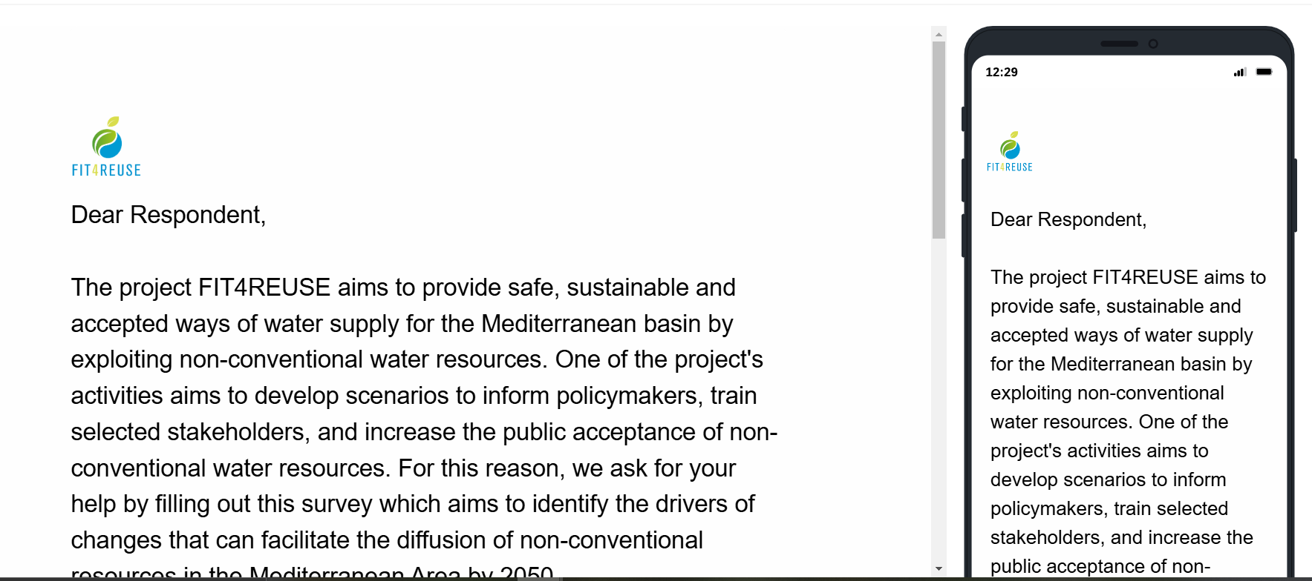
Full preview of survey here
Table I. Full list of internal and external drivers of change for water reuse diffusion provided to experts for the two rounds of Delphi e-surveys. Based on (Berti Suman et al., 2023).
Drivers | Level | Potential Effect | Examples | Country
External drivers
Awareness | Social | Barrier | Gap between awareness of farmers, experts, and reviewers | Turkey
Awareness | Social | Barrier | Low public awareness and mistrust of the provided water quality of the NBS | Greece
 |  |  | Lack of trust of farmers in the plant operators | Spain
Circular Resources Management | Environmental | Incentive | The opportunity to close the "nutrient cycle" supporting the transition to a sustainable agricultural system | Spain
Circular Resources Management | Environmental | Incentive | Energy valorisation | Greece
Communication Strategy | Social | Barrier | Lack of an effective and adequate communication strategy | Italy
Communication Strategy | Social | Barrier | Miscommunication of the risks associated with water reuse | Spain
Communication Strategy | Social | Incentive | Promotion of reliability of the solutions | Greece
Public Acceptance | Social | Barrier | Negative perception associated to wastewater by "average consumer" | Italy
Public Acceptance | Social | Barrier | Initial low public acceptance (especially remote areas) | Greece
Culture | Social | Barrier | Cultural Barriers | Turkey
Education | Social | Barrier | Education on Water Reuse (e.g. schools) | Italy
Education | Social | Incentive | Partnerships with opinion makers to inform and educate about water reuse | Portugal
EU Legislation | Policy | Incentive | EU legislation that streamlines water reuse processes | Italy
EU Legislation | Policy | Barrier | Unclear paperwork brought by the new EU Regulation | Spain
EU Legislation | Policy | Incentive | Innovative legal framework for water reuse | Spain
EU Legislation | Policy | Incentive | New European legislation | Italy
EU Legislation | Policy | Incentive | EU benchmark that can harmonize the standards | Italy
EU Legislation | Policy | Incentive | EU legislation that removes future bottlenecks due to different standards | Italy
EU Legislation | Policy | Barrier | Long and complex adaptation to new EU regulation | Greece
EU Legislation | Policy | Incentive | Build coherence with other food safety regulations | Italy
Financial incentives | Financial | Barrier | Not enough financial incentives for reusing wastewater | Italy
Financial incentives | Financial | Incentive | Incentives in the water tariff as currently in the EU regulation | Italy
Innovation | Financial | Barrier | Industries too weak for innovating | Turkey
Innovation | Social | Barrier | Farmers that are leaving the field and struggle to innovate | France
Lobbying | Political | Barrier | Stronger lobbying against water reuse | Spain
Lobbying | Political | Incentive | Strong lobbying in favour | Spain
National Legislation | Policy | Barrier | Denial of permission once already built the treatment plant | Spain
National Legislation | Policy | Barrier | Late adoption of reuse regulation compared to other countries | Greece
National Legislation | Policy | Barrier | Difficulties in obtaining permits due to national legislation | Portugal
National Legislation | Policy | Barrier | Stricter limit at the national level compared to EU standards | Italy
Policy-makers engagement | Social | Incentive | Involvement of city leaders to implement smart urban projects | Portugal
Reuse cost | Financial | Barrier | High reuse cost for farmers | Italy
Reuse cost | Financial | Barrier | High reuse cost for farmers who do not want to pay for water | Spain
Risk Assessment | Technical | Barrier | Limited Capabilities in assessing real risks for water quality | Turkey
Stakeholders Agreement | Social | Barrier | Lack of agreement between involved stakeholders | Italy
Stakeholders Agreement | Social | Barrier | Different visions among stakeholders | Portugal
Water Governance | Policy | Incentive | The possibility to reuse water in industrial water-demanding processes | Jordan
Water Governance | Political | Barrier | Cumbersome water governance structures | Italy
Water Governance | Policy | Incentive | Future water planning at basin level should include water reuse | Spain
Water Governance | Policy | Incentive | Effective planning on WR | Italy
Water Governance | Policy | Barrier | Lack of policy tools to address water scarcity | Portugal
 | Policy | Barrier | Need to respect minimum distance from urban areas for using treated water in irrigation | France
 | Policy | Incentive | Promote enabling factors (treatment plants, infrastructures) | Italy
Territorial Features | Financial | Barrier | Unfavourable country structure (location of demand distant from agricultural areas) | Greece
Territorial Features | Social | Barrier | Urban concentration pushing to centralized water treatment | Greece
Water Scarcity | Social/ Environmental | Incentive | Water Scarcity perceived as an urgent issue | Spain
Water Scarcity | Social | Barrier | Conflicts over water | Tunisia
Water Scarcity | Social | Barrier | High pressure on water due to tourism | Greece
Water Scarcity | Social | Barrier | Social conflicts on water management (agriculture vs tourism) | Greece
Water Scarcity | Social | Barrier | Social conflicts over river basin during summer | Italy
Bureaucracy | Technical | Barrier | Bureaucratic matters (difficulties in authorizing water reuse plans enabling NBS | Greece
Circular Management of Resources | Technical | Incentive | By-products useful for commercial purposes | Israel
 |  |  | Use of brine for irrigation of medicinal plants | Tunisia
Environmental Risk | Environmental | Barrier | Salinization risks for aquifer and soil due to over exploitation | Tunisa
Profitability | Economic | Barrier | Low motivation for private contractors involved in the construction of non-conventional wastewater treatment technologies at the stage of tender | Greece
Profitability | Economic | Barrier | Combine the various treatments to have an applied technology with sustainable costs | Italy
Profitability | Economic | Barrier | Lack of an accurate cost analysis | Tunisa
Scalability | Technical | Incentive | Application potential (1000m3/h) | Israel
 |  | Barrier | Problem of scale | Italy
 | Environmental | Barrier | Land Footprint of Constructed Wetlands for large areas | Italy
Technical complexity | Technical | Barrier | Difficulties in carrying out cost analysis | Tunisia, Italy
Technology Efficiency | Technical | Incentive | Improved pathogens removal | Tunisia
Technology Efficiency | Technical | Incentive | Cost effectiveness | Italy
Technology Efficiency | Technical | Incentive | Improvement treatment efficiency | Italy
Technology Efficiency | Technical | Incentive | Treatment of domestic wastewater | Greece
Technology Efficiency | Technical | Incentive | Treatment of brine and brackish groundwater | Israel
Technology Efficiency | Technical | Incentive | The possibility to reuse water in industrial water-demanding processes | Jordan
Technology Efficiency | Technical | Incentive | Minimal footprint of innovative solutions | Israel
Technology Efficiency | Technical | Barrier | Difficulties in implementing the pilot | Greece
Technology Efficiency | Environmental | Incentive | Reduced energy consumption | Italy
Technology Efficiency | Environmental | Incentive | Less required area | Israel
Technology Efficiency | Environmental | Incentive | Reduction of nitrate and phosphorus concentration | Israel
Water Quality | Environmental | Barrier | Poor water quality from WR technologies | Greece

Figure B. Screenshot of Miro Boardª used in the focus group for the scenario building process.
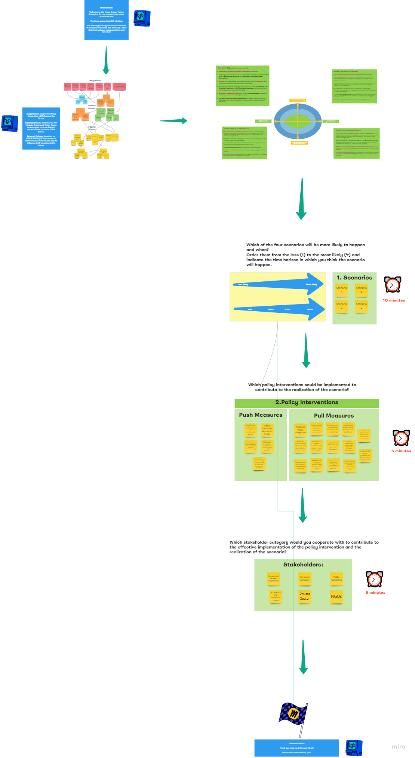
a. Full board available here

Figure C. Double sided template used for Focus Group discussion and qualitative data collection.
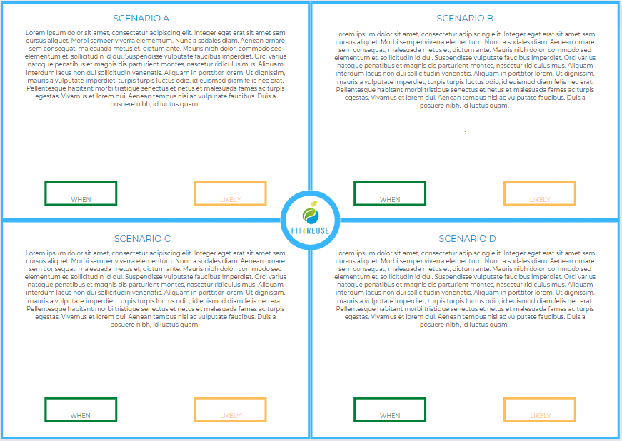

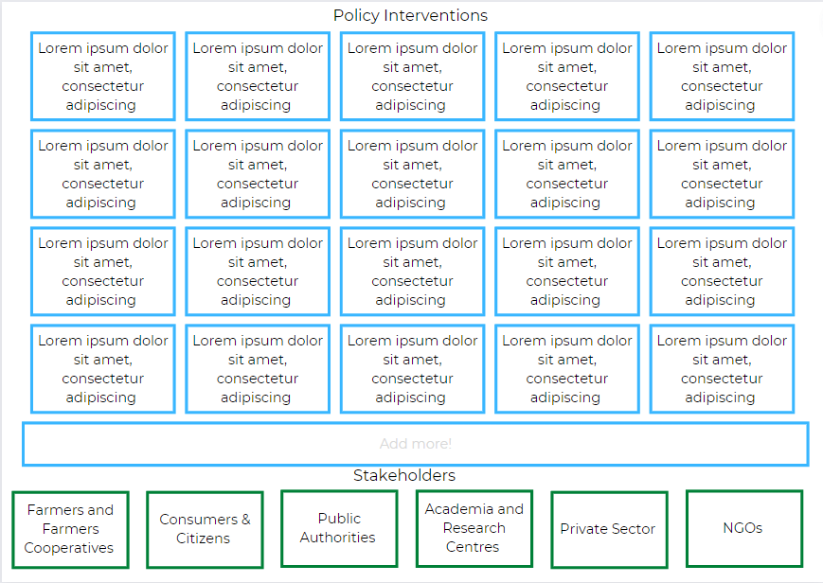

2. Results
Figure D. Life cycle impacts of the three technologies expressed as single scores over 20 years focusing on the operational phase impacts.
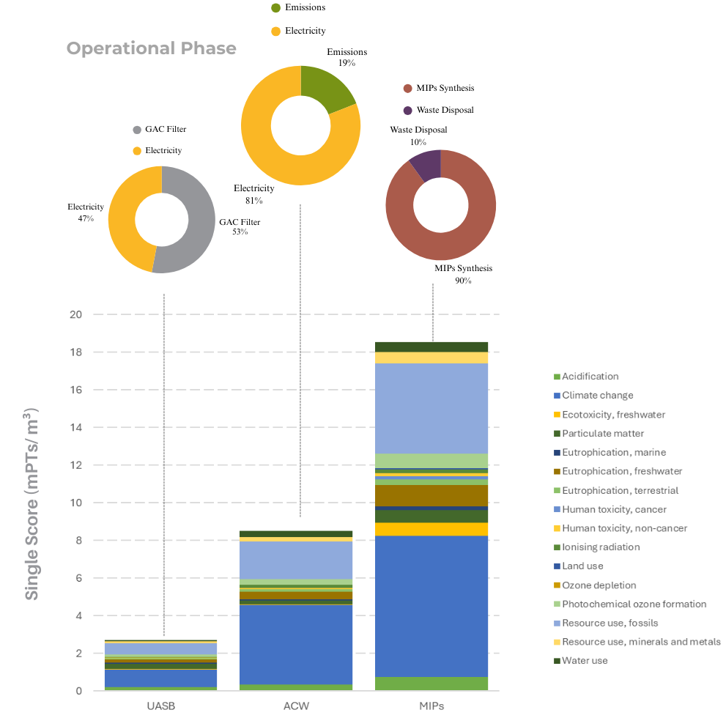
Table J. Life cycle costs of the three technologies at pilot scale over 20 years.
Items | UASB (0.07 m³/d) |  | ACW (0.6 m³/d) |  | MIPs (0.01 m³/d)
Items | Value ₂₀₂₃ (€) | LCC Value ₂₀₂₃ (€/m³) | Value ₂₀₂₃ (€) | LCC Value ₂₀₂₃ (€/m³) | Value ₂₀₂₃ (€) | LCC Value ₂₀₂₃ (€/m³)
Acquisition Costs (€) | 5,410.00 | 10.59 | 10,646.49 | 2.43 | 4,903.79 | 58.31
Hydraulic systems | 1,250.00 | 2.44 | 8,055.00 | 1.83 | 1,488.79 | 17.70
Reactors and Sensors | 3,525.00 | 6.89 | - | - | 940,00 | 11.18
GAC Filter | 635.00 | 1.24 | - | - | - | -
Ponds | - | - | 1,207.49 | 0.28 | - | -
Air Compressors | - | - | 1,384.00 | 0.32 | - | -
MIPs Synthesis | - | - | - | - | 2,475.00 | 29.43
Operative Costs (€/yr) | 153.16 | 5.99 | 8,298.41 | 37.89 | 1,703.21 | 405.06
Activated Carbon | 11.75 | 0.46 | - | - | - | -
Sludge Disposal | 2.48 | 0.10 | 104.89 | 0.48 | - | -
Electricity | 138.93 | 5.44 | 8,193.52 | 37.41 | 160.43 | 38.16
MIPs Synthesis | - | - | - | - | 1,542.77 | 366.90
Maintenance Costs (€) | 270.50 | 0.53 | 519.33 | 0.12 | 245.19 | 2.92
Pumping & Treatmentª | 270.50 | 0.53 | 519.33 | 0.12 | 245.19 | 2.92
Disposal Costs (€) | 6.13 | 0.01 | 129.84 | 0.03 | 671.03 | 7.98
Municipal Waste | 6.13 | 0.01 | 129.84 | 0.03 | 11.00 | 0.13
Hazardous Waste | - | - | - | - | 660.03 | 7.85
Total Costs (20 yrs) | 8,749.86 | 17.12 | 177,276.77 | 40.47 | 39,884.19 | 474.27
a. Maintenance costs were estimated as 5% of acquisition costs according to experts’ interviews.

Figure E. Results of comparative Monte Carlo Analysis with 1,000 iterations showing the percentage of probability that BAU scenario has greater impact than WR_1 and WR_2.

Table K. Mean, median, SD and CV of Monte Carlo simulation results for environmental impact categories.
Hypo | Probability that BAU >= WR_1 |  |  |  | Probability that BAU >= WR_2
IC | Mean | Median | SD | CV | Mean | Median | SD | CV
Acidification | 3.43E-04 | 3.34E-04 | 1.88E-04 | 54,9 % | 3.34E-04 | 3.39E-04 | 1.83E-04 | 54,9 %
Climate change | 3.10E-02 | 3.08E-02 | 2.48E-02 | 80 % | 3.09E-02 | 3.10E-02 | 2.42E-02 | 78,1 %
Ecotoxicity, freshwater | 7.17E-01 | 6.75E-01 | 2.87E+00 | 400 % | 3.55E-01 | 4.40E-01 | 2.75E+00 | 774 %
Eutrophication, freshwater | 9.84E-06 | 8.95E-06 | 5.45E-06 | 55,4 % | 9.79E-06 | 8.92E-06 | 5.57E-06 | 56,9 %
Eutrophication, marine | 3.63E-04 | 3.00E-04 | 3.61E-04 | 99,5 % | 3.38E-04 | 2.85E-04 | 3.50E-04 | 103 %
Eutrophication, terrestrial | 1.23E-03 | 1.19E-03 | 8.12E-04 | 66,2 % | 1.19E-03 | 1.21E-03 | 7.98E-04 | 67,1 %
Human toxicity, cancer | 8.08E-12 | 4.46E-12 | 3.19E-10 | 3,95E3 % | 1.66E-12 | -5.33E-12 | 3.17E-10 | 1,91E4 %
Human toxicity, non-cancer | 1.35E-08 | 1.28E-08 | 7.46E-08 | 551 % | -4.69E-10 | 5.55E-10 | 7.49E-08 | 1,6E4 %
Water use | 1.08E+00 | 1.17E+00 | 1.40E+00 | 129 % | 1.09E+00 | 1.21E+00 | 1.56E+00 | 144 %
ICs : Impact Categories; SD: Standard Deviation; CV: Coefficient of Variation

Table L. Description of the four scenarios for non-conventional water resources diffusion by 2050.
Scenario A (Business as Usual)  Expensive and mistrusted water reuse  · Escalating demand for traditional water resources and no water reuse makes agriculture unviable in many areas.  · Inequitable distribution of freshwater in marginal territories, with most users unable to meet their needs.  · Insufficient investments, low financial incentives, and bureaucratic inefficiencies prevent the scaling up and adoption of water reuse technologies  · Ineffective communication fails to convince stakeholders of the reliability of water reclamation technologies, further hampering adoption. | Scenario B  Cheap, but mistrusted water reuse  · Technological progress in water reclamation reduces freshwater extraction for agriculture.  · Investments, financial incentives, and streamlined bureaucracy boost technological efficiency and profitability in water reclamation.  · Limited awareness due to poor communication impedes full diffusion of water reclamation technologies.  · Uneven access to freshwater resources, with stakeholders struggling to meet their needs, is exacerbated by rapid urbanisation which increases pressure on water resources.
Scenario C  Expensive, but trusted water reuse  · Traditional water resource strain increases, but optimised strategies help to integrate alternative water sources in agriculture.  · Rapid technological advances support efficient water reuse solutions, that yet remain limited in accessibility due to low investments and incentives.  · Effective communication improves trust in water reuse technologies, but bureaucratic inefficiencies hinder practical application.  · Freshwater access is inequitable, causing significant challenges for agricultural water users.  · Urbanisation increases competition for water resources. | Scenario D  Cheap and trusted water reuse  · Demand of traditional water resources remains high, but adaptive strategies optimise usage and integrate reclaimed water into agriculture.  · Significant investments, incentives, and efficient bureaucracy led to the widespread adoption of water reclamation technologies.  · Advanced technologies improve water quality while minimizing environmental risks, supported by market adoption.  · Effective communication builds trust in water reclamation solutions and boosts their adoption.  · Freshwater access remains inequitable, but the use of reclaimed water reduces reliance on freshwater despite ongoing urbanisation.

3. References
Berti Suman, A., García-Herrero, L., Lavrnić, S., Sole, M. C., Toscano, A., & Vittuari, M. (2023). The advent of EU water reuse regulation in the Mediterranean region: policy and legislative adaptation to address non-conventional water resources utilization in agriculture. Water International, 48(7), 839–860. https://doi.org/10.1080/02508060.2023.2277619
Foglia, A., Andreola, C., Cipolletta, G., Radini, S., Akyol, Ç., Eusebi, A. L., Stanchev, P., Katsou, E., & Fatone, F. (2021). Comparative life cycle environmental and economic assessment of anaerobic membrane bioreactor and disinfection for reclaimed water reuse in agricultural irrigation: A case study in Italy. Journal of Cleaner Production, 293, 126201. https://doi.org/10.1016/j.jclepro.2021.126201
Mancuso, G., Foglia, A., Chioggia, F., Drei, P., Eusebi, A. L., Lavrnić, S., Siroli, L., Carrozzini, L. M., Fatone, F., & Toscano, A. (2024). Demo-scale up-flow anaerobic sludge blanket reactor coupled with hybrid constructed wetlands for energy-carbon efficient agricultural wastewater reuse in decentralized scenarios. Journal of Environmental Management, 359, 121109. https://doi.org/https://doi.org/10.1016/j.jenvman.2024.121109
Odone, G., Perulli, G. D., Mancuso, G., Lavrnić, S., & Toscano, A. (2024). A novel smart fertigation system for irrigation with treated wastewater: Effects on nutrient recovery, crop and soil. Agricultural Water Management, 297, 108832. https://doi.org/https://doi.org/10.1016/j.agwat.2024.108832
Parlapiano, M., Foglia, A., Sgroi, M., Pisani, M., Astolfi, P., Mezzelani, M., Gorbi, S., Akyol, Ç., Eusebi, A. L., & Fatone, F. (2024). Assessment of molecularly imprinted polymers for selective removal of diclofenac from wastewater by laboratory and pilot-scale adsorption tests. Journal of Water Process Engineering, 63, 105467. https://doi.org/https://doi.org/10.1016/j.jwpe.2024.105467
Tong, A., Sainsbury, P., & Craig, J. (2007). Consolidated criteria for reporting qualitative research (COREQ): a 32-item checklist for interviews and focus groups. International Journal for Quality in Health Care, 19(6), 349–357. https://doi.org/10.1093/intqhc/mzm042

