Dual [Au(I)]-Catalysis in Regioselective Cycloaddition of Bicyclo[1.1.0]butanes with Allenes
Supplementary Information

Riccardo Giovanelli,^{a,b,‡} Giulio Gallorini,^{a,b,‡} Yuhao Huang,^{a,b} Andrea Brunetti,^{a,b} Kyriakos D. Nikopoulos,ª Magda Monari,^{a,b} Carlos Silva López,^{c} Sofia Kiriakidi,*^{a,c} Giulio Bertuzzi,*^{a,b} Marco Bandini*^{a,b}
ª Bandini, Dipartimento di Chimica “Giacomo Ciamician”, Alma Mater Studiorum – Università di Bologna, Via P. Gobetti 85, 40129 Bologna, Italy. ^{b} Center for Chemical Catalysis – C³ Alma Mater Studiorum – Università di Bologna, via P. Gobetti 85, 40129 Bologna, Italy. ^{c} Departamento de Química Orgánica, Universidade de Vigo, AS Lagoas (Marcosende) s/n, 36310 Vigo, Spain.

Table of Contents

1. General Information S3
2. Preparation of Starting Materials S4
3. Preparation and Characterization of Products 3 and 5 S12
4. Transformations of Product 3aa S24
5. Computational Details S30
6. Crystallographic Data S31
7. Mechanistic Investigations S34
8. NMR Spectra S59
9. References S101

1. General Information
Instrumentation.
¹H NMR, ¹³C NMR and ¹⁹F NMR spectra were recorded on Bruker NeoAvance 600 (600 MHz) or INOVA 600 MR (600 MHz) . Data are reported as follows: chemical shift, multiplicity (s = singlet, d = doublet, dd= double doublet, t = triplet, td = triple doublet, dt = double triplet, q = quartet, sext = sextet, sept = septet, p = pseudo, b = broad, m = multiplet), coupling constants (Hz). Chemical shifts are reported in ppm from TMS with the solvent resonance peak as the internal standard.
HRMS spectra were obtained with a G2XS QTof mass spectrometer using ESI ionization technique, as specified case by case.
Melting points were determined with a Büchi Melting Point B-540 apparatus and are not corrected.
Chemicals.
Chromatographic purification was done with 240-400 mesh silica gel.
Anhydrous solvents were supplied by Sigma Aldrich in Sureseal® bottles and used without any further purification.
Commercially available chemicals and (non-anhydrous) solvents were purchased from Sigma Aldrich, Fluorochem and TCI Chemicals and used without any further purification.

2. Preparation of Starting Materials
BCBs 1 Preparation
Different synthetic routes for bicyclo[1.1.0]butanes 1 preparation have been extensively reported, lately; for this work, all substrates were prepared through modified procedures based on available literature (as referenced case by case). All the reported substrates are known compounds and their characterization can be found in the literature: 1a-m and 1o, 1n, 1p, 1q-w, and 1x.

STEP Ia:¹
In a heat-gun dried 3-necked round bottom flask, equipped with a magnetic stirring bar and under Ar atmosphere, 3-oxocyclobutane carboxylic acid S1 (10 mmol) was dissolved in anhydrous THF (20 mL) and a solution of the appropriate Grignard reagent S2-Mg (20 mmol, 2 equiv, either commercially available or freshly prepared in anhydrous THF (0.7 M, 30 mL) was added dropwise (a slow addition is usually preferred in order to minimize the formation of by-products) at room temperature (a mildly exothermic process occurs) through a dropping funnel. After the addition was completed, the resulting solution was stirred for 30 min and the conversion was checked by ¹H NMR spectroscopy that usually confirmed complete consumption of the starting material. Then, H₂O (5 mL) was carefully added, followed by HCl (aqueous, 2 M, 20 mL or until a strongly acidic pH was reached) and EtOAc (30 mL). The resulting biphasic mixture was transferred to a separatory funnel. The phases were separated, the aqueous layer was extracted again with EtOAc (2 x 30 mL), the combined organic phases were dried with Na₂SO₄, evaporated in vacuo and the resulting crude alcohol S3 (usually in the form of a pale-yellow solid) was used in the next step without any purification.

STEP Ib:¹
In a heat-gun dried 3-necked round bottom flask equipped with a magnetic stirring bar and under Ar atmosphere the appropriate bromo-arene S2 (20 mmol, 2 equiv) was dissolved in anhydrous THF (30 mL) and the resulting solution was cooled to – 78 °C. n-BuLi (2.5 M in hexanes, 20 mmol, 8 mL) was added dropwise and the reaction mixture was stirred at –78 °C for 30 min. Then, a solution of 3-oxocyclobutane carboxylic acid S1 (10 mmol) in anhydrous THF (1M, 10 mL) was added in one portion (a slow addition might result in the formation of by-products) at –78 °C through a dropping funnel onto the solution of intermediate S2-Li. The temperature was then raised to room temperature and the reaction mixture was stirred for 1 h. The conversion was then checked by ¹H NMR spectroscopy that usually confirmed complete consumption of the starting material. Then, H₂O (5 mL) was carefully added, followed by HCl (aqueous, 2 M, 20 mL or until a strongly acidic pH was reached) and EtOAc (30 mL). The resulting biphasic mixture was transferred to a separatory funnel. The phases were separated, the aqueous layer was extracted again with EtOAc (2 x 30 mL), the combined organic phases were dried with Na₂SO₄, evaporated in vacuo and the resulting crude S3 (usually in the form of a pale-yellow solid) was used in the next step without purification.

STEP II:¹
In a round-bottom flask equipped with a magnetic stirring bar, S3 (10 mmol, from the previous step) was suspended in toluene (20 mL) and HCl (aqueous, 37% w/w, 20 mL) was added. The resulting suspension was vigorously stirred for 30 – 45 min and the conversion was checked by ¹H NMR spectroscopy, that usually confirmed complete consumption of the starting material. The biphasic mixture was transferred to a separatory funnel and the phases were separated. The aqueous layer was diluted with H₂O (60 mL) and extracted again with EtOAc (2 x 30 mL), the combined organic phases were dried with Na₂SO₄, evaporated in vacuo and the resulting crude chloride S4 (6-7 mmol, 60-70% yield, usually in the form of a pale-yellow solid) was used in the next step without purification.

STEP IIIa:¹
In a round-bottom flask equipped with a magnetic stirring bar, S4 (7 mmol, from the previous step) was dissolved in DMF (10 mL), K₂CO₃ (15.4 mmol, 2.2 equiv) was added under vigorous stirring, followed by MeI (16.8 mmol, 2.4 equiv, dropwise addition). The resulting suspension was stirred for 1 h and the conversion was checked by TLC (n-hexane/EtOAc = 7:3 + 1% HCOOH) that usually confirmed complete consumption of the starting material. A saturated aqueous solution of NH₄Cl (10 mL), H₂O (10 mL) and EtOAc (20 mL) were added, and the resulting biphasic mixture was transferred to a separatory funnel. The phases were separated, the aqueous layer was extracted again with EtOAc (2 x 10 mL), the combined organic phases were washed with a 0.1 M aqueous solution of NH₄Cl (3 x 20 mL), dried with Na₂SO₄, evaporated in vacuo and the resulting crude S6a (4-5 mmol, 60-70% yield, usually in the form of a pale-yellow oil) was used in the next step without purification.

STEP IIIb:¹
In a round-bottom flask equipped with a magnetic stirring bar, S4 (7 mmol, from the previous step) was dissolved in anhydrous DMF (10 mL), Cs₂CO₃ (8.4 mmol, 1.2 equiv) was added under vigorous stirring, followed by benzyl bromide (8.4 mmol, 1.2 equiv, dropwise addition). The resulting suspension was stirred for 1 h and the conversion was checked by TLC (n-hexane/EtOAc = 7:3 + 1% HCOOH) that usually confirmed complete consumption of the starting material. A saturated aqueous solution of NH₄Cl (10 mL), H₂O (10 mL) and EtOAc (20 mL) were added, and the resulting biphasic mixture was transferred to a separatory funnel. The phases were separated, the aqueous layer was extracted again with EtOAc (2 x 10 mL), the combined organic phases were washed with a 0.1 M aqueous solution of NH₄Cl (3 x 20 mL), dried with Na₂SO₄, evaporated in vacuo and the resulting crude S6b (4-5 mmol, 60-70% yield, usually in the form of a pale-yellow oil) was used in the next step without purification

STEP IIIc:³
In a round-bottom flask equipped with a magnetic stirring bar and under Ar atmosphere, S4 (7 mmol, from the previous step) was dissolved in anhydrous THF (10 mL), then, DMAP (0,35 mmol, 0.05 equiv) and Boc₂O (8.4 mmol, 1.2 equiv) were added and the reaction mixture was stirred for 16 h. The conversion was checked by TLC (n-hexane/EtOAc = 7:3 + 1% HCOOH) that usually confirmed complete consumption of the starting material. A saturated aqueous solution of NH₄Cl (10 mL), H₂O (10 mL) and EtOAc (20 mL) were added, and the resulting biphasic mixture was transferred to a separatory funnel. The phases were separated, the aqueous layer was extracted again with EtOAc (2 x 10 mL), the combined organic phases were washed with brine (2 x 20 mL), filtered over a short silica pad, dried with Na₂SO₄, evaporated in vacuo and the resulting crude S6c (4-5 mmol, 60-70% yield, usually in the form of a pale-yellow oil) was purified via FC (50/1 hexane/EtOAc) on silica gel.

STEP IIId:⁵
In a round-bottom flask equipped with a magnetic stirring bar and under Ar atmosphere, S4 (7 mmol, from the previous step) and S5d (7,35 mmol, 1.05 equiv) were dissolved in anhydrous DCM (15 mL), the solution was then cooled to 0°C, DIPEA (14 mmol, 2 equiv) was added dropwise and, after 5 minutes, EDC*HCl (7,7 mmol, 1.1 equiv) was added in one portion. The resulting suspension was stirred for 1 h at 0 °C. The conversion was checked by TLC (n-hexane/EtOAc = 7:3 + 1% HCOOH) to confirm complete consumption of the starting material. A saturated aqueous solution of NH₄Cl (10 mL), H₂O (10 mL) and EtOAc (20 mL) were added, and the resulting biphasic mixture was transferred to a separatory funnel. The phases were separated, the aqueous layer was extracted again with EtOAc (2 x 10 mL), the combined organic phases were washed with a 0.1 M aqueous solution of HCl (3 x 20 mL), dried with Na₂SO₄, evaporated in vacuo and the resulting crude S6d (4-5 mmol, 60-70% yield, usually in the form of a pale-yellow oil) was used in the next step without purification

STEP IIIe:
In a round-bottom flask equipped with a magnetic stirring bar under anhydrous conditions, S4 (7 mmol, from the previous step) and S5e (7,35 mmol, 1.05 equiv) were dissolved in anhydrous DCM (15 mL), the solution was then cooled to 0°C, DIPEA (14 mmol, 2 equiv) was added dropwise, after 5 minutes EDC*HCl (7,7 mmol, 1.1 equiv) was added in one portion. The resulting suspension was stirred for 1 h at 0 °C. The conversion was checked by TLC (n-hexane/EtOAc = 7:3 + 1% HCOOH) to confirm complete consumption of the starting material. A saturated aqueous solution of NH₄Cl (10 mL), H₂O (10 mL) and EtOAc (20 mL) were added, and the resulting biphasic mixture was transferred to a separatory funnel. The phases were separated, the aqueous layer was extracted again with EtOAc (2 x 10 mL), the combined organic phases were washed with a 0.1 M aqueous solution of NH₄Cl (3 x 20 mL), dried with Na₂SO₄, evaporated in vacuo and the resulting crude S6e (4-5 mmol, 60-70% yield, usually in the form of a pale-yellow oil) was used in the next step without purification

STEP IVa:¹
In a heat-gun dried 3-necked round bottom flask equipped with a magnetic stirring bar and under Ar atmosphere crude S6a, S6b, S6c, S6d or S6e (5 mmol) was dissolved in anhydrous THF (7.5 mL) and cooled to 0°C. A solution of Li- or Na- or KHMDS (minimal differences were noted with the use of the three different bases, 5.5 mmol, 1.1 equiv, 1M in THF) was added dropwise and the resulting red-colored solution was stirred at 0 °C until ¹H NMR spectroscopy (or TLC) confirmed complete consumption of the starting material (10 min – 1h). A saturated aqueous solution of NH₄Cl (10 mL), H₂O (10 mL) and EtOAc (10 mL) were added, and the resulting biphasic mixture was transferred to a separatory funnel. The phases were separated, the aqueous layer was extracted again with EtOAc (2 x 5 mL), the combined organic phases were dried with Na₂SO₄, evaporated in vacuo and the crude mixture was finally purified by fc on silica gel (n-hexane/EtOAc mixtures 20:1 to 5:1) to afford bicyclo[1.1.0]butanes 1.

STEP V:⁴
In a heat-gun dried 3-necked round bottom flask equipped with a magnetic stirring bar and under Ar atmosphere the appropriate bromide S8 (20 mmol, 2 equiv) was dissolved in anhydrous THF (30 mL) and the resulting solution was cooled to -78 °C. n-BuLi (2.5 M in hexanes, 20 mmol, 8 mL) was added dropwise and the reaction mixture was stirred at –78 °C for 30 min. Then, a solution of 1s (10 mmol) in anhydrous THF (1M, 10 mL) was added dropwise at -78 °C through a dropping funnel. The reaction was stirred until the temperature reached about -30 °C (10 – 30 min) and then checked by TLC, that usually confirmed complete consumption of the starting material. Then, H₂O (5 mL) was carefully added, followed by NH₄Cl (aqueous 20 mL) and EtOAc (30 mL). The resulting biphasic mixture was transferred to a separatory funnel. The phases were separated, the aqueous layer was extracted again with EtOAc (2 x 30 mL), the combined organic phases were dried with Na₂SO₄, evaporated in vacuo, the crude mixture was finally purified by fc on silica gel (nHex/EtOAc mixtures 20:1 to 5:1) to afford [1.1.0] bicyclobutanes 1.

Allenamides 2 and O-Allenyl Ethers 4 Preparation
Allenamides 2 and O-allenyl ethers 4 have been prepared according to reported literature procedures.

Gold Catalysts Preparation
Gold catalysts have always been used as pre-cationized complexes, procedures for phosphine complexation of AuCl*DMS and subsequent cationization with silver salts delivering different anions (NTf₂, SbF₆, TFA, PF₆, BF₄) are reported in the literature.

3. Preparation and Characterization of Products 3 and 5.
General Procedure
In a heat-gun dried 10 mL two-necked round bottomed flask covered with an aluminum foil, under inert atmosphere (Ar or N₂), the appropriate bicyclo[1.1.0]butane 1 (0.1 mmol, 1 equiv) the appropriate allenamide 2 (0.15 mmol, 1.5 equiv) or O-allenyl ether 4 (0.15 mmol, 1.5 equiv) and [PedroPhosAu]NTf₂ (0.005 mmol, 4.6 mg, 5 mol% or 0.01 mmol, 9.2 mg, 10 mol% for 1j and 1o-r) were stirred in dry MeCN (2 mL) at room temperature, in the dark, for 16h. The solvent was then evaporated, and the crude mixture was directly purified by FC on silica gel.

Characterization of Products 3 and 4
3aa. White solid. m.p. 111 - 113 °C. FC eluent: nHex/EtOAc 65:35. Yield = 90% (0.090 mmol, 28.2 mg). ¹H NMR (600 MHz, CDCl₃) δ 7.34 – 7.32 (m, 2H), 7.29 – 7.24 (m, 3H, overlapped with the residual solvent peak), 5.79 (t, J = 1.6 Hz, 1H), 3.74 (s, 3H), 3.51 (dd, J = 8.5, 7.2 Hz, 2H), 2.93 (dd, J = 8.5, 7.2 Hz, 2H), 2.80 – 2.80 (m, 2H), 2.32 – 2.30 (m, 2H), 2.23 – 2.22 (m, 2H). ¹³C NMR (151 MHz, CDCl₃) δ 172.3, 157.1, 145.6, 140.3, 127.9 (2C), 126.9, 126.1 (2C), 114.0, 62.0, 57.6, 51.9, 47.8, 47.6 (2C), 46.1, 37.7. HRMS (ESI) m/z [M+H]⁺ calcd. for C₁₈H₂₀NO₄⁺: 314.1387; found 314.1387.

3ba. White solid. m.p. 95 -97 °C. FC eluent: nHex/EtOAc 65:35. Yield = 93% (0.093 mmol, 30.8 mg). ¹H NMR (600 MHz, CDCl₃) δ 7.22 – 7.19 (m, 2H), 7.03 – 7.00 (m, 2H), 5.75 (m, 1H), 3.73 (s, 3H), 3.64 – 3.61 (m, 2H), 3.00 – 2.98 (m, 2H), 2.79 (d, J = 1.7 Hz, 2H), 2.28 – 2.27 (m, 2H), 2.22 – 2.18 (m, 2H). ¹³C NMR (151 MHz, CDCl₃) δ 172.2, 161.74 (d, J = 245.9 Hz), 157.0, 145.6, 136.1 (d, J = 3.3 Hz), 127.7 (d, J = 7.9 Hz, 2C), 114.7 (d, J = 21.3 Hz, 2C), 114.1, 61.8, 57.0, 51.9, 47.7 (2C), 47.6, 46.0, 37.5. ¹⁹F NMR (565 MHz, CDCl₃) δ -115.16 -115.21 (m, 1F). HRMS (ESI) m/z [M+H]⁺ calcd. for C₁₈H₁₉FNO₄⁺: 332.1293; found 332.1295.

3ca. White solid. m.p. 107 - 109 °C. FC eluent: nHex/EtOAc 65:35 to 50:50. Yield = 81% (0.081 mmol, 28.1 mg). ¹H NMR (600 MHz, CDCl₃) δ 7.30 – 7.29 (m, 2H), 7.28 – 7.16 (m, 2H), 5.74 (t, J = 1.6 Hz, 1H), 3.73 (s, 3H), 3.62 – 3.59 (m, 2H), 3.01 – 2.98 (m, 2H), 2.79 – 2.78 (m, 2H), 2.28 – 2.27 (m, 2H), 2.21 - -2.20 (m, 2H). ¹³C NMR (151 MHz, CDCl₃) δ 172.1, 157.0, 145.8, 138.8, 132.7, 127.9 (2C), 127.5 (2C), 114.1, 61.8, 57.0, 51.9, 47.6 (2C), 47.5, 46.1, 37.4. HRMS (ESI) m/z [M+H]⁺ calcd. for C₁₈H₁₉ClNO₄⁺: 348.0997; found 348.0996.

3da. White solid. m.p. 130 - 133 °C. FC eluent: nHex/EtOAc 65:35 to 50:50. Yield = 79% (0.079 mmol, 30.9 mg). ¹H NMR (600 MHz, CDCl₃) δ 7.48 – 7.42 (m, 2H), 7.14 – 7.09 (m, 2H), 5.74 (t, J = 1.7 Hz, 1H), 3.73 (s, 3H), 3.64 – 3.58 (m, 2H), 3.03 – 2.97 (m, 2H), 2.78 (q, J = 1.8 Hz, 2H), 2.30 – 2.24 (m, 2H), 2.24 – 2.16 (m, 2H). ¹³C NMR (151 MHz, CDCl₃) δ 172.1, 157.1, 145.9, 139.3, 131.0 (2C), 127.9 (2C), 120.7, 114.2, 61.9, 57.1, 52.0, 47.6 (2C), 47.6, 46.2, 37.5. HRMS (ESI) m/z [M+H]⁺ calcd. for C₁₈H₁₉BrNO₄⁺: 392.0492; found 392.0499.

3ea. White solid. m.p. 122 - 124 °C. FC eluent: nHex/EtOAc 65:35 to 50:50. Yield = 85% (0.085 mmol, 28.1 mg). ¹H NMR (600 MHz, CDCl₃) δ 7.27 – 7.24 (m, 1H overlapped with the residual solvent peak), 7.22 – 7.19 (m, 1H), 7.12 - 7.10 (m, 1H), 7.02 – 6-99 (m, 1H), 5.71 (t, J = 1.7 Hz, 1H), 3.74 (s, 3H), 3.64 – 3.61 (bm, 2H), 3.19 – 3-17 (m, 2H), 2.80 (s, 2H), 2.33 – 2.30 (m, 4H). ¹³C NMR (151 MHz, CDCl₃) δ 172.2, 161.2 (d, J = 246.7 Hz), 156.9, 144.7, 129.0 (d, J = 4.8 Hz), 128.7 (d, J = 7.9 Hz), 127.3 (d, J = 15.2 Hz), 123.8 (d, J = 3.3 Hz), 114.4 (d, J = 20.9 Hz), 114.0, 62.0, 54.1 (d, J = 1.4 Hz), 51.9, 47.2 (2C), 47.1 (b), 46.9, 37.1. ¹⁹F NMR (565 MHz, CDCl₃) δ -115.28 -115.34 (m, 1F). HRMS (ESI) m/z [M+H]⁺ calcd. for C₁₈H₁₉FNO₄⁺: 332.1293; found 332.1294.

3fa. White solid. m.p. 115 - 118 °C. FC eluent: nHex/EtOAc 65:35 to 50:50. Yield = 72% (0.072 mmol, 28.6 mg). ¹H NMR (600 MHz, CDCl₃) δ 7.28 – 7.24 (m, 2H, overlapped with the residual solvent peak), 7.19 – 7.16 (m, 2H), 5.73 (t, J = 1.7 Hz, 1H), 3.73 (s, 3H), 3.61 – 3.55 (m, 2H), 3.04 – 2.96 (m, 2H), 2.79 (q, J = 1.8 Hz, 2H), 2.31 – 2.27 (m, 2H), 2.24 – 2.20 (m, 2H). ¹³C NMR (151 MHz, CDCl₃) δ 172.1, 157.1, 148.1 (q, J = 1.9 Hz), 145.9, 139.2, 127.5 (2C), 120.6 (2C), 120.5 (q, J = 257.1 Hz), 114.2, 61.7, 57.0, 52.0, 47.7 (2C), 47.5, 46.2, 37.4. ¹⁹F NMR (565 MHz, CDCl₃) δ - 57.9 (s, 3F). HRMS (ESI) m/z [M+H]⁺ calcd. for C₁₉H₁₉F₃NO₅⁺: 398.1210; found 398.1204.
3ga. White solid. m.p. 90 - 92 °C. FC eluent: nHex/EtOAc 65:35. Yield = 72% (0.072 mmol, 23.6 mg). ¹H NMR (600 MHz, CDCl₃) δ 7.21 – 7.18 (m, 1H), 7.15 – 7.12 (m, 2H), 7.10 – 7.09 (m, 1H), 5.89 (t, J = 1.7 Hz, 1H), 3.76 – 3.73 (m, 4H), 3.33 – 3.29 (m, 1H), 3.10 – 3.06 (m, 1H), 2.80 – 2.79 (m, 2H), 2.53 – 2.49 (m, 1H), 2.41 – 2.35 (m, 2H), 2.29 - 2.25 (m, 5H). ¹³C NMR (151 MHz, CDCl₃) δ 172.4, 157.7, 142.5, 138.3, 137.9, 130.3, 127.3, 127.0, 125.4, 114.9, 62.4, 58.2, 51.9, 48.9, 48.4, 47.2, 45.9, 38.0, 20.2. HRMS (ESI) m/z [M+H]⁺ calcd. for C₁₉H₂₂NO₄⁺: 328.1543; found 328.1540.

3ha. Colourless oil. FC eluent: nHex/EtOAc 65:35. Yield = 64% (0.064 mmol, 22.0 mg). ¹H NMR (600 MHz, CDCl₃) δ 7.25 – 7.22 (m, 1H), 6.83 – 6.79 (m, 3H), 5.80 (t, J = 1.6 Hz, 1H), 3.81 (s, 3H), 3.74 (s, 3H), 3.59 – 3.56 (m, 2H), 2.98 – 2.95 (m, 2H), 2.79 – 2.79 (m, 2H), 2.31 – 2.30 (m, 2H), 2.21 – 2.20 (m, 2H). ¹³C NMR (151 MHz, CDCl₃) δ 172.3, 159.3, 157.1, 145.5, 141.9, 129.0, 118.4, 114.0, 112.9, 111.4, 62.0, 57.6, 55.3, 51.9, 47.9, 47.7 (2C), 46.0, 37.7. HRMS (ESI) m/z [M+H]⁺ calcd. for C₁₉H₂₂NO₅⁺: 344.1492; found 344.1496.

3ia. Colourless oil. FC eluent: nHex/EtOAc 65:35 to 50:50. Yield = 81% (0.081 mmol, 26.5 mg). ¹H NMR (600 MHz, CDCl₃) δ 7.20 (t, J = 7.9 Hz, 1H), 7.09 – 7.06 (m, 2H), 7.02 (dt, J = 7.4, 1.7 Hz, 1H), 5.78 (t, J = 1.6 Hz, 1H), 3.73 (s, 3H), 3.50 (dd, J = 8.7, 7.1 Hz, 2H), 2.91 (t, J = 7.9 Hz, 2H), 2.77 (q, J = 1.8 Hz, 2H), 2.33 (s, 3H), 2.32 – 2.25 (m, 2H), 2.22 – 2.15 (m, 2H). ¹³C NMR (151 MHz, CDCl₃) δ 172.4, 157.2, 145.8, 140.2, 137.7, 127.9, 127.6, 126.9, 123.1, 114.0, 62.0, 57.6, 51.9, 47.9, 47.6 (2C), 46.1, 37.7, 21.3. HRMS (ESI) m/z [M+H]⁺ calcd. for C₁₉H₂₂NO₄⁺: 328.1543; found 328.1538.

3ja. White solid. m.p. 95 - 97 °C. FC eluent: nHex/EtOAc 65:35 to 50:50. Yield = 79% (0.079 mmol, 29.2 mg). ¹H NMR (600 MHz, CDCl₃) δ 7.32 – 7.30 (m, 1H), 7.27 – 7.24 (m, 2H), 7.04 – 7.03 (m, 1H), 5.80 (t, J = 1.6 Hz, 1H), 3.74 (s, 3H), 3.46 - 3.43 (m, 2H), 2.90 – 2.88 (m, 2H), 2.79 – 2.79 (m, 2H), 2.31 – 2.30 (m, 2H), 2.23 – 2.22 (m, 2H), 1.31 (s, 9H). ¹³C NMR (151 MHz, CDCl₃) δ 172.4, 157.1, 151.0, 145.8, 139.9, 127.6, 124.0, 123.0 (2C overlapped), 114.1, 61.9, 57.8, 51.8, 48.0, 47.6 (2C overlapped, b), 46.1, 37.7, 34.7, 31.2 (3C).HRMS (ESI) m/z [M+H]⁺ calcd. for C₂₂H₂₈NO₄⁺: 370.2013; found 370.2015.

3ka. White solid. m.p. 136 - 138 °C. FC eluent: nHex/EtOAc 60:40. Yield = 51% (0.051 mmol, 18.5 mg). ¹H NMR (600 MHz, CDCl₃) δ 7.84 – 7.79 (m, 3H), 7.63 (bs, 1H), 7.50 – 7.45 (m, 2H), 7.42 (dd, J = 8.4, 1.8 Hz, 1H), 5.82 (t, J = 1.7 Hz, 1H), 3.76 (s, 3H), 3.06 (bs, 2H), 2.85 – 2.83 (m, 4H), 2.40 (bs, 2H), 2.32 – 2.31 (m, 2H). ¹³C NMR (151 MHz, CDCl₃) δ 172.3, 157.2, 145.6, 137.8, 132.8, 132.3, 127.7, 127.5, 127.4, 126.4, 125.9, 124.8, 124.1, 114.2, 61.6, 57.8, 51.9, 47.8 (2C), 47.7, 46.2, 37.7. HRMS (ESI) m/z [M+H]⁺ calcd. for C₂₂H₂₂NO₄⁺: 364.1543; found 364.1540.

3la. White solid. m.p. 115 - 117 °C. FC eluent: nHex/EtOAc 65:35 to 50:50. Yield = 69% (0.069 mmol, 22.6 mg). ¹H NMR (600 MHz, CDCl₃) δ 7.13 (s, 4H), 5.78 (t, J = 1.7 Hz, 1H), 3.73 (s, 3H), 3.57 – 3.48 (m, 2H), 2.97 – 2.89 (m, 2H), 2.78 (q, J = 1.8 Hz, 2H), 2.34 (s, 3H), 2.30 – 2.24 (m, 2H), 2.22 – 2.16 (m, 2H).¹³C NMR (151 MHz, CDCl₃) δ 172.5, 157.2, 145.6, 137.3, 136.6, 128.6 (2C), 126.1 (2C), 114.0, 62.0, 57.5, 51.9, 47.9, 47.7 (2C), 46.1, 37.7, 21.1. HRMS (ESI) m/z [M+H]⁺ calcd. for C₁₉H₂₂NO₄⁺: 328.1543; found 328.1536.
3ma. White solid. m.p. 186 - 188 °C. FC eluent: nHex/EtOAc 65:35. Yield = 45% (0.045 mmol, 17.5 mg). ¹H NMR (600 MHz, CDCl₃) δ 7.59 – 7.57 (m, 4H), 7.47 – 7.44 (m, 2H), 7.38 – 7.35 (m, 1H), 7.34 – 7.32 (m, 2H), 5.80 (t, J = 1.6 Hz, 1H), 3.76 (s, 3H), 3.51 – 3.48 (m, 2H), 3.00 – 2.97 (m, 2H), 2.82 – 2-82 (m, 2H), 2.36 - 2.35 (m, 2H), 2.27 – 2.26 (m, 2H).¹³C NMR (151 MHz, CDCl₃) δ 172.3, 157.1, 146.1, 140.6, 139.9, 139.3, 128.9 (2C), 127.4, 126.9 (2C), 126.5 (2C), 126.5 (2C), 114.1, 61.9, 57.4, 51.9, 47.8, 47.6 (2C), 46.2, 37.6. HRMS (ESI) m/z [M+H]⁺ calcd. for C₂₄H₂₄NO₄⁺: 390.1700; found 390.1702.

3na. Yellowish dense oil. FC eluent: nHex/EtOAc 80:20. Yield = 72% (0.072 mmol, 24.4 mg). ¹H NMR (600 MHz, CDCl₃) δ 7.39 – 7.32 (m, 5H), 6.32 (dd, J = 17.3, 10.6 Hz, 1H), 5.72 (t, J = 1.7 Hz, 1H), 5.16 (s, 2H), 5.12 – 5.06 (m, 2H), 4.30 – 4.27 (m, 2H), 3.61 – 3.59 (m, 2H), 2.71 (q, J = 1.7 Hz, 2H), 2.12 – 2.11 (m, 2H), 1.93 - 1.92 (m, 2H). ¹³C NMR (151 MHz, CDCl₃) δ 171.8, 158.1, 146.0, 136.6, 135.8, 128.6 (2C), 128.2, 127.9 (2C), 114.6, 113.6, 66.3, 61.9, 57.2, 48.7, 47.2 (2C), 46.1, 37.4. HRMS (ESI) m/z [M+H]⁺ calcd. for C₂₀H₂₂NO₄⁺: 340.1543; found 340.1539.

3oa. White solid. m.p. 130 - 133 °C. FC eluent: nHex/EtOAc 65:35. Yield = 75% (0.075 mmol, 29.2 mg). ¹H NMR (600 MHz, CDCl₃) δ 7.39 – 7.31 (m, 7H), 7.28 – 7.24 (m, 3H overlapped with the residual solvent peak), 5.78 (s, 1H), 5.18 (s, 2H), 3.51 – 3.49 (m, 2H), 2.94 - 2.91 (m, 2H), 2.84 - 2.83 (m, 2H), 2.34 – 2.34 (m, 2H), 2.26 - 2.25 (m, 2H). ¹³C NMR (151 MHz, CDCl₃) δ 171.6, 157.0, 145.6, 140.2, 135.8, 128.6 (2C), 128.2, 127.9 (2C), 127.8 (2C), 126.9, 126.1 (2C), 114.0, 66.3, 61.9, 57.6, 47.7, 47.6 (2C) , 46.2, 37.6. HRMS (ESI) m/z [M+H]⁺ calcd. for C₂₄H₂₄NO₄⁺: 390.1700; found 390.1699.

3pa. White solid. m.p. 115 - 118 °C. FC eluent: nHex/EtOAc 65:35. Yield = 72% (0.072 mmol, 25.6 mg). ¹H NMR (600 MHz, CDCl₃) δ 7.33 – 7.31 (m, 2H), 7.27 – 7.24 (m, 3H overlapped with the residual solvent peak), 5.76 (s, 1H), 3.50 – 3.48 (m, 2H), 2.94 – 2.91 (m, 2H), 2.75 – 2.75 (m, 2H), 2.26 - 2.25 (m, 2H), 2.19 – 2.18 (m, 2H), 1.47 (s, 9H). ¹³C NMR (151 MHz, CDCl₃) δ 171.6, 157.1, 146.2, 140.5, 127.9 (2C), 126.8, 126.1 (2C), 113.7, 80.7, 61.9, 57.3, 47.8, 47.6 (2C), 47.2, 37.6, 28.0 (3C). HRMS (ESI) m/z [M+H]⁺ calcd. for C₂₁H₂₆NO₄⁺: 356.1856; found 356.1853.

3qa. White solid. m.p. 143 - 145 °C. FC eluent: nHex/EtOAc 50:50. Yield = 92% (0.092 mmol, 33.0 mg). ¹H NMR (600 MHz, CDCl₃) δ 7.94 – 7.92 (m, 2H), 7.59 – 7.57 (m, 1H), 7.49 – 7.46 (m, 2H), 7.34 – 7.27 (m, 5H overlapped with the residual solvent peak), 5.80 (t, J = 1.6 Hz, 1H), 3.54 – 3.51 (m, 2H), 2.98 – 2.95 (m, 4H), 2.55 – 2.54 (m, 2H), 2.42 - 2.41 (m, 2H). ¹³C NMR (151 MHz, CDCl₃) δ 200.5, 157.1, 146.2, 140.1, 135.8, 133.2, 128.7 (2C), 128.5 (2C), 127.9 (2C), 126.9, 126.2 (2C), 113.9, 62.0, 56.6, 52.9, 48.6 (2C), 47.7, 40.3. HRMS (ESI) m/z [M+H]⁺ calcd. for C₂₃H₂₂NO₃⁺: 360.1594; found 360.1601.

3ra. White solid. m.p. 157 - 160 °C. FC eluent: nHex/EtOAc 50:50. Yield = 45% (0.045 mmol, 17.5 mg). ¹H NMR (600 MHz, CDCl₃) δ 7.95 – 7.94 (m, 2H), 7.36 – 7.29 (m, 5H), 6.96 – 6.95 (m, 2H), 5.81 (t, J = 1.6 Hz, 1H), 3.89 (s, 3H), 3.54 – 3.52 (m, 2H), 2.98 – 2.97 (m, 2H), 2.96 – 2.95 (m, 2H), 2.54 – 2.53 (m, 2H), 2.40 – 2.39 (m, 2H). ¹³C NMR (151 MHz, CDCl₃) δ 198.9, 163.6, 157.2, 146.4, 140.3, 130.9 (2C), 128.7, 128.0 (2C), 126.9, 126.2 (2C), 113.9 (2C + 1C overlapped), 62.0, 56.5, 55.5, 52.8, 48.8 (2C), 47.7, 40.5. HRMS (ESI) m/z [M+H]⁺ calcd. for C₂₄H₂₄NO₄⁺: 390.1700; found 390.1696.

3sa. White solid. m.p. 180 - 182 °C. FC eluent: nHex/EtOAc 65:35. Yield = 75% (0.075 mmol, 30.7 mg). ¹H NMR (600 MHz, CDCl₃) δ 8.45 (bs, 1H), 8.02 – 8.00 (m, 2H), 7.93 – 7.89 (m, 2H), 7.65 – 7.58 (m, 2H), 7.38 – 7.34 (m, 4H), 7.32 – 7.29 (m, 1H), 5.85 – 5.84 (m, 1H), 3.56 – 3.54 (m, 2H), 3.05 (d, J = 1.8 Hz, 2H), 3.01 – 2.98 (m, 2H), 2.67 – 2.63 (m, 2H), 2.49 – 2.48 (m, 2H). ¹³C NMR (151 MHz, CDCl₃) δ 200.5, 157.2, 146.4, 140.2, 135.6, 133.1, 132.5, 130.2, 129.6, 128.7, 128.6, 128.0 (2C), 127.8, 126.9 (2C overlapped), 126.2 (2C), 124.2, 114.0, 62.0, 56.7, 53.1, 48.9 (2C), 47.8, 40.6.HRMS (ESI) m/z [M+H]⁺ calcd. for C₂₇H₂₄NO₃⁺: 410.1751; found 410.1755.

3ta. White solid. m.p. 185 - 187 °C. FC eluent: nHex/EtOAc 50:50. Yield = 68% (0.068 mmol, 24.8 mg). ¹H NMR (600 MHz, CDCl₃) δ 7.78 (dd, J = 3.8, 1.1 Hz, 1H), 7.68 (dd, J = 4.9, 1.1 Hz, 1H), 7.37 – 7.34 (m, 2H), 7.31 – 7.29 (m, 3H), 7.17 (dd, J = 4.9, 3.8 Hz, 1H), 5.82 (t, J = 1.7 Hz, 1H), 3.55 – 3.52 (m, 2H), 2.99 – 2.95 (m, 4H), 2.54 - 2.53 (m, 2H), 2.42 – 2.41 (m, 2H). ¹³C NMR (151 MHz, CDCl₃) δ 193.0, 157.1, 145.8, 142.1, 140.1, 133.8, 132.4, 128.2, 128.0 (2C), 127.0, 126.2 (2C), 114.0, 62.0, 57.0, 52.5, 48.4 (2C), 47.7, 40.6. HRMS (ESI) m/z [M+H]⁺ calcd. for C₂₁H₂₀NO₃S⁺: 366.1158; found 366.1153.

3ua. White solid. m.p. 132 - 133 °C. FC eluent: nHex/EtOAc 66:33. Yield = 71% (0.071 mmol, 21.1 mg). ¹H NMR (600 MHz, CDCl₃) δ 7.35 – 7.31 (m, 2H), 7.29 – 7.24 (m, 3H, overlapped with the residual solvent peak), 5.78 (t, J = 1.7 Hz, 1H), 3.53 – 3.46 (m, 2H), 2.97 – 2.90 (m, 2H), 2.76 (t, J = 1.6 Hz, 2H), 2.23 (s, 4H), 2.21 (s, 3H). ¹³C NMR (151 MHz, CDCl₃) δ 208.1, 157.1, 145.7, 140.2, 128.0 (2C), 127.0, 126.1 (2C), 114.2, 62.0, 57.1, 53.5, 47.7, 47.3 (2C), 37.6, 26.5. HRMS (ESI) m/z [M+H]⁺ calcd. for C₁₈H₂₀NO₃⁺: 298.1438; found 298.1429.

3va. White solid. m.p. 100 - 103 °C. FC eluent: nHex/EtOAc 70:30. Yield = 65% (0.065 mmol, 22.0 mg). ¹H NMR (600 MHz, CDCl₃) δ 7.34 – 7.32 (m, 2H), 7.29 – 7.25 (m, 3H), 5.79 (s, 1H), 3.52 – 3.49 (m, 2H), 2.95 – 2.92 (m, 2H), 2.76 – 2.77 (m, 2H), 2.51 (t, J = 7.4 Hz, 2H), 2.23 (s, 4H), 1.61 – 1.57 (m, 2H), 1.35 – 1.31 (m, 2H), 0.92 (t, J = 7.4 Hz, 3H). ¹³C NMR (151 MHz, CDCl₃) δ 210.2, 157.1, 145.8, 140.3, 127.9 (2C), 126.9, 126.1 (2C), 114.0, 62.0, 57.1, 53.2, 47.7, 47.3 (2C), 38.6, 37.8, 25.4, 22.4, 13.8. HRMS (ESI) m/z [M+H]⁺ calcd. for C₂₁H₂₆NO₃⁺: 340.1907; found 340.1911.

3wa. White solid. m.p. 114 - 116 °C. FC eluent: nHex/EtOAc 70:30. Yield = 67% (0.067 mmol, 21.6 mg). ¹H NMR (600 MHz, CDCl₃) δ 7.35 – 7.30 (m, 2H), 7.28 – 7.23 (m, 3H, overlapped with the residual solvent peak), 5.93 (dddd, J = 18.0, 10.3, 7.3, 6.3 Hz, 1H), 5.78 (s, 1H), 5.21 (dq, J = 10.2, 1.3 Hz, 1H), 5.15 (dq, J = 17.2, 1.5 Hz, 1H), 3.53 – 3.47 (m, 2H), 3.30 (dt, J = 6.8, 1.4 Hz, 2H), 2.96 – 2.90 (m, 2H), 2.81 – 2.74 (m, 2H), 2.24 (s, 4H). ¹³C NMR (151 MHz, CDCl₃) δ 207.7, 157.2, 145.7, 140.2, 130.0, 128.0 (2C), 127.0, 126.1 (2C), 119.2, 114.1, 62.0, 57.2, 53.2, 47.7, 47.4 (2C), 43.9, 37.8. HRMS (ESI) m/z [M+H]⁺ calcd. for C₂₀H₂₂NO₃⁺: 324.1594; found 324.1602.

3xa. White solid. m.p. 196 - 198 °C. FC eluent: nHex/EtOAc 50:50. Yield = 84% (0.084 mmol, 31.7 mg). ¹H NMR (600 MHz, CDCl₃) δ 7.31 – 7.23 (m, 5H overlapped with the residual solvent peak), 5.91 (s, 1H), 5.75 (bs, 1H), 3.48 – 3.45 (m, 2H), 3.06 – 3.06 (m, 2H), 2.93 – 2.90 (m, 2H), 2.52 – 2.51 (m, 5H), 2.35 – 2.34 (m, 2H), 2.19 (s, 3H). ¹³C NMR (151 MHz, CDCl₃) δ 173.0, 157.2, 152.4, 146.6, 144.0, 140.5, 127.9 (2C), 126.7, 126.3 (2C), 113.3, 110.8, 62.0, 56.2, 49.3, 48.7 (2C), 47.9, 40.0, 14.3, 13.8. HRMS (ESI) m/z [M+Na]⁺ calcd. for C₂₂H₂₃N₃NaO₃⁺: 400.1632; found 400.1641.

3ab. White solid. m.p. 132 - 134 °C. FC eluent: nHex/EtOAc 40:60 to 30:70. Yield = 71% (0.071 mmol, 22.1 mg). ¹H NMR (600 MHz, CDCl₃) δ 7.38 – 7.35 (m, 2H), 7.31 – 7.27 (m, 3H overlapped with the residual solvent peak), 5.81 (bs, 1H), 3.81 (s, 3H), 2.94 (t, J = 7.1 Hz, 2H), 2.88 (q, J = 1.8 Hz, 2H), 2.35 – 2.34 (m, 2H), 2.30 - 2.29 (m, 2H), 1.85 (t, J = 8.3 Hz, 2H), 1.33 (dt, J = 15.3, 7.6 Hz, 2H). ¹³C NMR (151 MHz, CDCl₃) δ 174.9, 172.5, 144.6, 140.2, 127.6 (2C), 126.6, 126.3 (2C), 114.8, 57.5, 51.8, 50.2, 47.7 (2C) , 46.1, 37.6, 30.1, 17.7. HRMS (ESI) m/z [M+H]⁺ calcd. for C₁₉H₂₂NO₃⁺: 312.1594; found 312.1597.

3ac. White solid. m.p. 150 - 153 °C. FC eluent: nHex/EtOAc 85:15. Yield = 96% (0.048 mmol, 19.7 mg). ¹H NMR (600 MHz, CDCl₃) δ 7.52 – 7.50 (m, 2H), 7.35 – 7.33 (m, 2H), 7.31 – 7.27 (m, 3H overlapped with the residual solvent peak) , 7.25 – 7.24 (m, 2H), 5.32 (t, J = 1.6 Hz, 1H), 3.74 (s, 3H), 2.73 (d, J = 1.6 Hz, 2H), 2.42 (s, 3H), 2.33 – 2.32 (m, 2H), 2.23 – 2.21 (m, 5H). ¹³C NMR (151 MHz, CDCl₃) δ 172.6, 146.9, 143.2, 140.1, 133.6, 129.4 (2C), 127.6 (2C), 127.6 (2C), 126.7 (2C), 126.6, 118.0, 58.1, 51.8, 47.6 (2C), 46.0, 38.3, 37.8, 21.5. HRMS (ESI) m/z [M+H]⁺ calcd. for C₂₃H₂₆NO₄S⁺: 412.1577; found 412.1579.

5aa. White solid. m.p. 62 - 63 °C. FC eluent: nHex/EtOAc 94:6. Yield = 72% (0.072 mmol, 27.1 mg). ¹H NMR (600 MHz, CDCl₃) δ 7.23 – 7.15 (m, 7H), 6.48 – 6.46 (m, 2H), 6.35 (t, J = 1.6 Hz, 1H), 3.76 (s, 3H), 2.78 – 2.78 (m, 2H), 2.29 - 2.28 (m, 2H), 2.21 – 2.20 (m, 2H), 1.26 (s, 9H). ¹³C NMR (151 MHz, CDCl₃) δ 173.0, 154.9, 144.2, 141.2, 131.7, 127.5 (2C), 126.7, 126.2 (2C), 126.1, 125.9 (2C), 114.3 (2C), 56.8, 51.8, 47.6 (2C), 46.5, 35.7, 34.0, 31.5 (3C). HRMS (ESI) m/z [M+Na]⁺ calcd. for C₂₅H₂₈NaO₃⁺: 399.1931; found 399.1933.

5ab. Pale yellow solid. m.p. 88 - 90 °C. FC eluent: nHex/EtOAc 95:5. Yield = 71% (0.071 mmol, 31.7 mg). ¹H NMR (600 MHz, CDCl₃) δ 7.43 – 7.40 (m, 2H), 7.20 – 7.16 (m, 3H), 7.13 – 7.11 (m, 2H), 6.28 – 6.27 (m, 3H), 3.76 (s, 3H), 2.79 – 2,78 (m, 2H), 2.29 – 2.28 (m, 2H), 2.21 - 2.20 (m, 2H). ¹³C NMR (151 MHz, CDCl₃) δ 172.7, 157.1, 141.0, 137.9 (2C), 130.7, 129.3, 127.6 (2C), 126.3, 126.0 (2C), 117.0 (2C), 83.6, 56.8, 51.8, 47.5 (2C), 46.5, 35.6. HRMS (ESI) m/z [M+Na]⁺ calcd. for C₂₁H₁₉INaO₃⁺: 469.0271; found 469.0275.

5ac. White solid. m.p. 102 - 104 °C. FC eluent: nHex/EtOAc 91:9. Yield = 43% (0.043 mmol, 15.6 mg). ¹H NMR (600 MHz, CDCl₃) δ 7.79 – 7.77 (m, 2H), 7.18 – 7.17 (m, 3H), 7.12 – 7.10 (m, 2H), 6.52 – 6.50 (m, 2H), 6.38 – 6.38 (m, 1H), 3.76 (s, 3H), 2.84 – 2.81 (m, 2H), 2.52 (s, 3H), 2.32 – 2.28 (m, 2H), 2.24 – 2.20 (m, 2H). ¹³C NMR (151 MHz, CDCl₃) δ 196.7, 172.6, 161.0, 140.8, 130.9, 130.4, 130.2, 130.2 (2C), 127.6 (2C), 126.3, 126.0 (2C), 114.2 (2C), 56.9, 51.9, 47.4 (2C), 46.5, 35.7, 26.3. HRMS (ESI) m/z [M+Na]⁺ calcd. for C₂₃H₂₂NaO₄⁺: 385.1410; found 385.1406.

5ad. Yellowish dense oil. FC eluent: nHex/EtOAc 94:6. Yield = 61% (0.061 mmol, 21.6 mg). ¹H NMR (600 MHz, CDCl₃) δ 7.17 – 7.11 (m, 7H), 6.88 (dd, J = 8.2, 1.4 Hz, 1H), 6.84 (td, J = 7.7, 1.4 Hz, 1H), 6.24 (t, J = 1.6 Hz, 1H), 3.76 (s, 3H), 2.82 (bd, J = 1.5 Hz, 2H), 2.30 – 2.29 (m, 2H), 2.25 - 2.24 (m, 2H). ¹³C NMR (151 MHz, CDCl₃) δ 172.8, 153.0, 140.5, 131.1, 130.1, 129.8, 127.7 (2C), 127.2, 126.4, 125.9 (2C), 122.4, 122.0, 114.4, 56.9, 51.8, 47.6 (2C), 46.5, 35.9. HRMS (ESI) m/z [M+Na]⁺ calcd. for C₂₁H₁₉ClNaO₃⁺: 377.0915; found 377.0920.

5ae. Off-white solid. m.p. 68 - 70 °C. FC eluent: nHex/EtOAc 97:3. Yield = 52% (0.052 mmol, 19.2 mg). ¹H NMR (600 MHz, CDCl₃) δ 7.72 – 7.69 (m, 2H), 7.58 – 7.56 (m, 1H), 7.44 – 7.41 (m, 1H), 7.34 – 7.31 (m, 1H), 7.18 – 7.17 (m, 5H), 7.03 – 7.02 (m, 1H), 6.49 – 6.48 (m, 2H), 3.78 (s, 3H), 2.86 – 2.86 (m, 2H), 2.32 – 2.31 (m, 2H), 2.26 – 2.25 (m, 2H). ¹³C NMR (151 MHz, CDCl₃) δ 172.9, 155.2, 141.2, 134.1, 131.1, 129.3, 129.2, 128.7, 127.6, 127.6 (2C), 126.7, 126.3, 126.2, 126.1 (2C), 123.8, 118.1, 107.7, 56.9, 51.8, 47.5 (2C), 46.6, 35.7. HRMS (ESI) m/z [M+Na]⁺ calcd. for C₂₅H₂₂NaO₃⁺: 393.1461; found 393,1457.

5af. White solid. m.p. 110 - 112 °C. FC eluent: nHex/EtOAc 95/5. Yield = 35% (0.035 mmol, 14.0 mg). ¹H NMR (600 MHz, CDCl₃) δ 7.60 (d, J = 3.0 Hz, 1H), 7.21 – 7.16 (m, 4H), 7.10 – 7.08 (m, 2H), 6.65 (dd, J = 8.7, 3.1 Hz, 1H), 6.29 (t, J = 1.5 Hz, 1H), 3.76 (s, 3H), 2.80 (bd, J = 1.5 Hz, 2H), 2.30 – 2.29 (m, 2H), 2.21 – 2.20 (m, 2H). ¹³C NMR (151 MHz, CDCl₃) δ 172.5, 153.3, 140.6, 137.4, 132.7, 131.7, 130.1, 127.8, 127.7 (2C), 126.5, 125.9 (2C), 124.7, 56.9, 51.9, 47.4 (2C), 46.5, 35.6. HRMS (ESI) m/z [M+Na]⁺ calcd. for C₂₀H₁₈NO₃⁺: 422.0362; found 422.0366.

4. Transformations of Product 3aa
Preparation and Characterization of Aldehyde 6
In a 10 mL round-bottom flask equipped with a magnetic stirring bar, 3aa (0.2 mmol, 62.6 mg), CHCl₃ (2 mL) and HCl (aqueous, 37% wt., 1.0 mL) were added; the reaction mixture was stirred for 18 h at room temperature. After TLC analysis confirmed complete conversion of the starting material, the reaction mixture was added with water (5 mL) and extracted with DCM (3x5 mL), the combined organic phases were dried with Na₂SO₄, the solvent was evaporated in vacuo and the resulting crude product was purified via FC on silica gel.
6. White solid. m.p. 88 - 89 °C. FC eluent: nHex/EtOAc 90:10. Yield = 65% (0.13 mmol, 31.7 mg). ¹H NMR (600 MHz, CDCl₃) δ 9.63 (d, J = 2.1 Hz, 1H), 7.36 – 7.33 (m, 2H), 7.30 – 7.24 (m, 1H), 7.23 – 7.18 (m, 2H), 3.74 (s, 3H), 3.23 (dq, J = 6.4, 2.0 Hz, 1H), 2.51 (ddd, J = 11.5, 3.9, 2.9 Hz, 1H), 2.25 (ddd, J = 11.5, 8.8, 2.7 Hz, 1H), 2.22 – 2.17 (m, 1H), 2.14 (dd, J = 6.0, 2.7 Hz, 1H), 2.10 (t, J = 5.3 Hz, 2H). ¹³C NMR (151 MHz, CDCl₃) δ 203.0, 172.6, 139.8, 128.6 (2C), 127.2, 125.8 (2C), 55.7, 54.3, 51.8, 49.2, 47.7, 40.7, 31.8. HRMS (ESI) m/z [M+Na]⁺ calcd. for C₁₅H₁₆NaO₃⁺: 267.0992; found 267.0994.

Preparation and Characterization of Unsaturated Ester 7
In a 10 mL round-bottom flask equipped with a magnetic stirring bar, 6 (0.10 mmol, 24.4 mg) and S9 (0.15 mmol, 52.2 mg) were dissolved in DCM (2 mL) and the reaction mixture was stirred for 16 h at room temperature. After TLC analysis confirmed complete conversion of the starting material, the solvent was evaporated in vacuo and the resulting crude product was purified via FC on silica gel.
7. White solid. m.p. 103 - 105 °C. FC eluent: nHex/EtOAc 90:10. Yield = 96% (0.096 mmol, 30.2 mg). ¹H NMR (600 MHz, CDCl₃) δ 7.31 – 7.28 (m, 2H), 7.22 – 7.20 (m, 1H), 7.11 – 7.10 (m, 2H), 6.87 (dd, J = 15.6, 8.5 Hz, 1H), 5.73 – 5.70 (m, 1H), 4.13 (qd, J = 7.1, 1.3 Hz, 2H), 3.73 (s, 3H), 3.09 (td, J = 8.6, 3.8 Hz, 1H), 2.45 (ddd, J = 11.3, 8.7, 2.4 Hz, 1H), 2.15 – 2.10 (m, 3H), 2.05 – 2.00 (m, 2H), 1.24 (t, J = 7.1 Hz, 3H). ¹³C NMR (151 MHz, CDCl₃) δ 172.9, 166.2, 149.0, 140.5, 128.3 (2C), 126.7, 126.0 (2C), 122.8, 60.2, 55.0, 51.7, 48.3, 48.3, 47.4, 40.7, 37.4, 14.2. HRMS (ESI) m/z [M+Na]⁺ calcd. for C₁₉H₂₂NaO₄⁺: 337.1410; found 337.1407.

Preparation and Characterization of Bromo-Aldehyde 8
The ElectraSyn 2.0 vial (5 mL), equipped with a stir bar, was charged with 3aa (0.10 mmol, 31.3 mg), NaBr (0.20 mmol, 10.2 mg) and LiClO₄ (0.20 mmol, 21.0 mg). The ElectraSyn vial cap, equipped with a graphite anode and a nickel cathode, was inserted into the mixture and sealed with a rubber septum. Then, acetonitrile (3 mL) was added, and the mixture was stirred until the complete dissolution of the solids. The solution was subsequently bubbled with air (balloon) while stirring for 1 minute. The reaction mixture was electrolyzed (under air, balloon) at a constant current of 4 mA, until a total charge of 0.40 mF (4.0 F/mol_{3aa}) was reached. Then, the ElectraSyn vial cap was removed, and the electrodes and vial were rinsed with EtOAc (10 mL) and a solution of HCl_{(aq)} (2 M, 10 mL), which were combined with the crude mixture in a separatory funnel. Then, the organic layer was separated, the aqueous layer was extracted with EtOAc (2 x 10 mL), the combined organic phases were dried with Na₂SO₄, the solvent was evaporated in vacuo and the resulting crude product was purified via FC on silica gel.
8. White solid. m.p. 135 - 138 °C. FC eluent: nHex/EtOAc 90:10. Yield = 80% (0.080 mmol, 25.8 mg). ¹H NMR (600 MHz, CDCl₃) δ 9.29 (s, 1H), 7.36 – 7.31 (m, 3H), 7.16 – 7.15 (m, 2H), 3.74 (s, 3H), 3.37 (dd, J = 12.8, 2.9 Hz, 1H), 2.81 – 2.78 (m, 1H), 2.55 (dd, J = 12.9, 3.2 Hz, 1H), 2.38 (dd, J = 7.1, 2.9 Hz, 1H), 2.21 – 2.20 (m, 2H).¹³C NMR (151 MHz, CDCl₃) δ 192.8, 171.4, 136.6, 128.2 (2C), 127.8, 126.9 (2C), 75.0, 59.0, 52.0, 47.4, 47.4, 41.8, 41.3. HRMS (ESI) m/z [M+Na]⁺ calcd. for C₁₅H₁₅BrNaO₃⁺: 345.0097; found 345.0099.

Preparation and Characterization of Epoxide 9
In a 10 mL round-bottom flask equipped with a magnetic stirring bar 8 (0.08 mmol, 25.8 mg) was dissolved in methanol (2 mL) and NaBH₄ (0.24 mmol, 8.9 mg) was slowly added; the reaction mixture was stirred for 16 h at room temperature. After TLC analysis confirmed complete conversion of the starting material, the reaction mixture was added with water (5 mL), a saturated solution of NH₄Cl and extracted with EtOAc (3x5 mL), the combined organic phases were dried with Na₂SO₄, the solvent was evaporated in vacuo and the resulting crude product was purified via FC on silica gel.
9. White solid. m.p. 71 - 73 °C. FC eluent: nHex/EtOAc 80:20. Yield = 58% (0.046 mmol, 11.2 mg). ¹H NMR (600 MHz, CDCl₃) δ 7.31 – 7.28 (m, 2H), 7.25 - 7.23 (m, 1H), 7.12 – 7.11 (m, 2H), 3.75 (s, 3H), 2.81 (d, J = 4.5 Hz, 1H), 2.54 – 2.48 (m, 2H), 2.38 (dd, J = 6.8, 3.8 Hz, 1H), 2.36 (d, J = 4.5 Hz, 1H), 2.28 – 2.23 (m, 3H). ¹³C NMR (151 MHz, CDCl₃) δ 172.5, 137.1, 128.0 (2C), 127.0, 126.6 (2C), 67.5, 53.6, 51.9, 48.8, 47.0, 45.6, 45.0, 38.3. HRMS (ESI) m/z [M+Na]⁺ calcd. for C₁₅H₁₆NaO₃⁺: 267,0992; found 267,0989.

Oxidation with m-CPBA: Preparation and Characterization of Product 10
In a 10 mL round-bottom flask equipped with a magnetic stirring bar 3aa (0.10 mmol, 31.3 mg) was dissolved in DCM (2 mL) and m-CPBA (56% wt., 0.4 mmol, 122 mg) was added; the reaction mixture was stirred for 16 h at room temperature. After conversion of the starting material checked by TLC (nHex/EtOAc) the reaction mixture was quenched with water (5 mL), a saturated solution of K₂CO₃ (5 mL) and extracted with DCM (3x5 mL), the combined organic phases were dried with Na₂SO₄, the solvent was evaporated in vacuo and the resulting crude product was purified via FC on silica gel.
10. White solid. m.p. 177 - 180 °C. FC eluent: nHex/EtOAc 50:50. Yield = 42% (0.042 mmol, 20.4 mg). ¹H NMR (400 MHz, CD₃CN) δ 8.16 (t, J = 1.7 Hz, 1H), 8.06 (d, J = 7.8 Hz, 1H), 7.70 – 7.68 (m, 1H), 7.54 (t, J = 7.9 Hz, 1H), 7.30 – 7.27 (m, 5H), 6.74 (s, 1H), 4.26 (s, 1H), 3.84 – 3.80 (m, 1H), 3.65 (s, 3H), 3.35 (q, J = 9.0 Hz, 1H), 3.24 – 3.20 (m, 1H), 3.01 (q, J = 8.5 Hz, 1H), 2.68 (dd, J = 9.3, 6.7 Hz, 1H), 2.41 (dd, J = 11.8, 3.0 Hz, 1H), 2.35 – 2.32 (m, 1H), 2.30 – 2.28 (m, 1H), 2.03 – 1.98 (m, 1H). ¹³C NMR (101 MHz, CD₃CN) δ 172.9, 164.6, 157.7, 140.7, 135.0, 134.4, 132.4, 131.3, 130.5, 129.4, 128.3 (2C), 127.6 (2C), 127.5, 83.1, 81.0, 63.3, 57.8, 52.2, 47.4, 46.7, 45.9, 43.8, 42.0. HRMS (ESI) m/z [M+Na]⁺ calcd. for C₂₅H₂₄ClNNaO₇⁺: 508.1134; found 508.1135.
Suzuki Coupling of 3da: Preparation and Characterization of Product 12
In a Schlenk tube, under an Ar atmosphere and magnetic stirring, bromo-derivative 3da (39.1 mg, 0.10 mmol), Cs₂CO₃ (0.3 mmol, 81.0 mg) and boronic acid 11 (35.0 mg, 0.20 mmol) were suspended in a THF/H₂O mixture (10:1, 0.55 mL). The resulting suspension was de-gassed by bubbling Ar for 1 min, then PdCl₂(PPh₃)₂ (0.005 mmol, 3.5 mg, 5 mol%) was added and the resulting mixture was stirred at 70 °C for 3 h. The reaction mixture was cooled to room temperature and a saturated aqueous solution of K₂CO₃ (2 mL), H₂O (5 mL) and EtOAc (5 mL) were added, and the resulting biphasic mixture was transferred to a separatory funnel. The phases were separated, the aqueous layer was extracted again with EtOAc (5 mL), the combined organic phases were washed with a saturated aqueous solution of K₂CO₃ (2 x 5 mL), dried with Na₂SO₄, evaporated in vacuo and finally purified by FC on silica gel.
12. White solid. m.p. 190 - 192 °C. FC eluent: DCM/Et₂O 83:17. Yield = 88% (0.088 mmol, 39.0 mg). ¹H NMR (400 MHz, CDCl₃) δ 7.83 (d, J = 1.5 Hz, 1H), 7.65 – 7.59 (m, 2H), 7.46 (dd, J = 8.5, 1.8 Hz, 1H), 7.39 (d, J = 8.5 Hz, 1H), 7.33 – 7.29 (m, 2H), 7.10 (d, J = 3.1 Hz, 1H), 6.54 (dd, J = 3.1, 0.8 Hz, 1H), 5.81 (t, J = 1.6 Hz, 1H), 3.83 (s, 3H), 3.75 (s, 3H), 3.53 – 3.45 (m, 2H), 3.00 – 2.89 (m, 2H), 2.81 (q, J = 1.8 Hz, 2H), 2.39 – 2.32 (m, 2H), 2.29 – 2.20 (m, 2H). ¹³C NMR (101 MHz, CDCl₃) δ 172.5, 157.3, 146.1, 141.4, 138.2, 136.3, 132.2, 129.7, 129.0, 126.8 (2C), 126.5 (2C), 121.1, 119.2, 114.1, 109.6, 101.3, 62.0, 57.5, 51.9, 47.9, 47.7 (2C), 46.2, 37.7, 33.0. HRMS (ESI) m/z [M+H]⁺ calcd. for C₂₇H₂₇N₂O₄⁺: 443.1965; found 443.1959.

5. Computational Details
We used Density Functional Theory (DFT) at the M06/def2svp level for all the calculations presented in this manuscript. All geometry optimizations have been optimized using tight convergence criteria in the SCF and an ultrafine grid to guarantee the accuracy of the reported results. Solvent effects were modelled using the Polarizable Continuum Model (PCM) using dichloromethane (dcm) as a solvent, as implemented in the Gaussian 16 package. The calculations were performed considering 1.0 atm and 298 K to simulate the reaction conditions. The nature of all optimized structures was determined using frequency analysis to correctly identify them as minima or transition states. For all stationary points, the stability of the wave function was also examined.
Additional Computational Figures
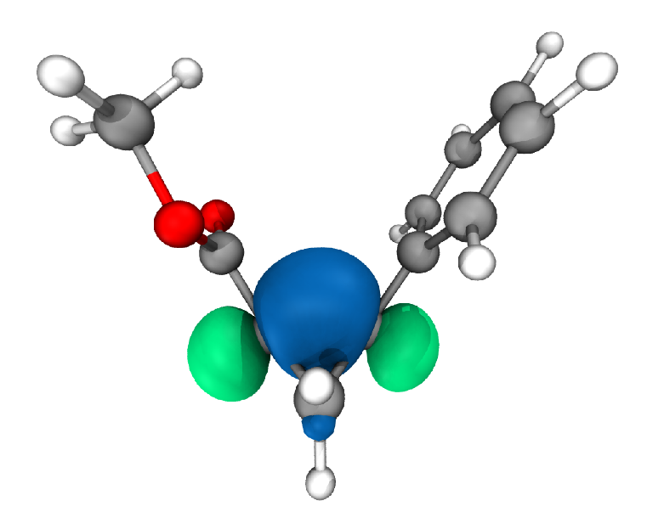
Figure S1. Molecular orbital forming the bicyclobutane bridge bond (MO 44) computed at the M06/def2svp/PCM (dcm) level. The orbital was plotted using the wavefunction file as produced by Gaussian 16 and the MultiWfn software. For visualization purposes VMD was employed. The molecular orbital is formed by the two remaining p orbitals of the sp²-hybridized carbons that are combined in an out-of-plane orientation, adding π-character to the C-C bond.

6. Crystallographic Data
The X-ray intensity data for 3aa were collected on a Bruker APEX-II CCD diffractometer using Mo−Kα radiation. All data were processed using the Bruker suite of programs and the structure was solved by direct methods and refined with the SHELX program suite in the space group P2₁/n. All non-hydrogen atoms were assigned anisotropic displacement parameters. The hydrogen atoms, were placed in idealized positions and included as riding with constrained isotropic displacement parameters (C—H = 0.96 Å for methyl protons, C—H = 0.97 Å for methylene protons and C—H = 0.93 Å for aromatic protons) and refined as riding with U_{iso}(H) = 1.5U_{eq}(C)_{methyl} or 1.2U_{eq}(C), respectively). Molecular graphics were generated using the program Mercury Table S1 reports crystal data and refinement parameters for 3aa.

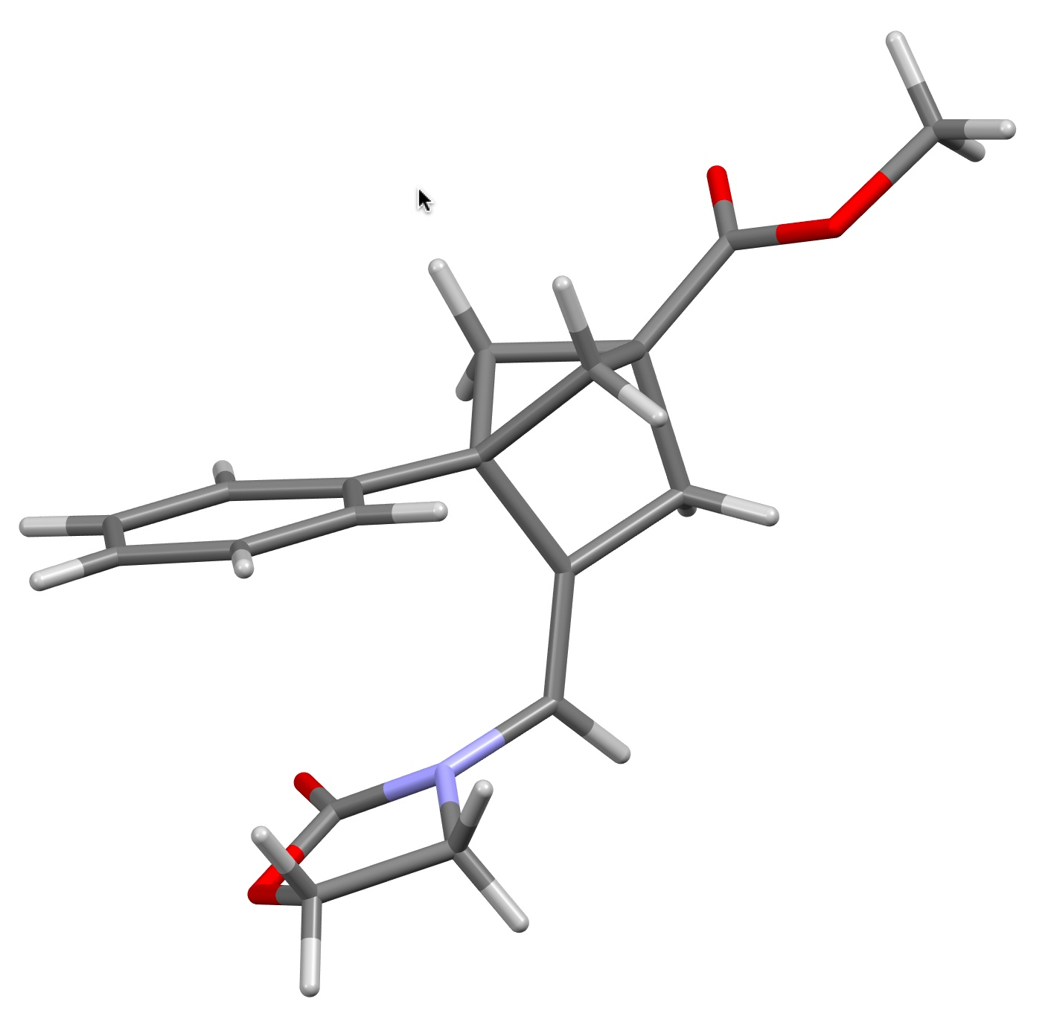
Figure S2. Structure of compound 3aa

Table S1. Crystal data and structure refinement for 3aa.
Compound | 3aa
Formula | C₁₈H₁₉NO₄
Fw | 313.34
T, K | 296
λ, Å | 0.71073
Crystal symmetry | Monoclinic
Space group | P2₁/n
a, Å | 11.7668(6)
b, Å | 6.1192(3)
c, Å | 22.4434(12
α,° | 90
β,° ° | 95.353(2)
γ, | 90
Cell volume, Å³ | 1608.95(14)
Z | 4
Dc, Mg m⁻³ | 1.294
Absorption coefficient, mm⁻¹ | 0.092
F(000) | 664
Crystal size/ mm | 0.30 x 0.25 x 0.25
ϴ limits, ° | 1.823 to 24.995
Reflections collected | 21070
Unique obs. Reflections  [F_{o} > 4σ(F_{o})] | 2777 [R_{int} = 0.0971]
Goodness-of-fit-on F² | 1.251
R₁(F)ª, wR₂(F²)^{b} [I > 2 σ(I)]  ^{b} | 0.0627, 0.1474
Largest diff. peak and hole, e. Å⁻³ | 0.184 and -0.236
CCDC | 2448401

- R₁ = Σ||F_{o}|-|F_{c}||/Σ|F_{o}|.^{b} wR₂ = [Σw(F_{o}²-F_{c}²)²/Σw(F_{o}²)²]^{1/2} where w = 1/[σ²(F_{o}²) + (aP)²+ bP] where P = (F_{o}² + F_{c}²)/3.

7. Mechanistic Investigation
General Procedure for the Kinetic Studies.
Compound 1a (6.6 mg, 0.035 mmol for [1a] = 50.0 mM or 3.3 mg, 0.0175 mmol for [1a] = 25.0 mM) and 2a (8.0 mg, 0.053 mmol) were placed into a glass vial and CH₂Br₂ was added as internal standard (the added amount is specified case by case below). This mixture was dissolved in a quantity of CD₃CN such that, after addition of the solution containing [Au(L₂)NTf₂] catalyst (vide infra), a total volume of 0.7 mL was reached (0.05 M 1a, as in the preparative reaction, the added amount is specified case by case below). This solution was transferred into a dry NMR tube and, prior to record the array of spectra, the desired amount (specified case by case below) of a 7.0 mM solution of [Au(L₂)NTf₂] in CD₃CN was added via Hamilton syringe. The solution was vigorously shaken, and the tube was placed into the NMR instrument (600 MHz, 25 °C), where ¹H NMR spectra were recorded periodically (as specified case by case below).
The amount of product formed in each case was measured by comparative integration of the internal standard signal (s, 5.09 ppm, 2H) to the signal corresponding to the OMe group (s, 3.68 ppm, 3H) of 3aa.

[Au(L₂)NTf₂] = 1.5 mM (3 mol%), [1a] = 50.0 mM
- CH₂Br₂ added: 11.3 mg (0.065 mmol)
- CD₃CN added: 550 μL
- [Au(L₂)NTf₂] solution added: 150 μL (0.00105 mmol, final [Au(L₂)NTf₂] = 1.5 mM).
- Spectra recorded every 15 minutes.
Table S2. Data collected for the reaction run at [Au(L₂)NTf₂] = 1.5 mM (3 mol%), [1a] = 50.0 mM
Entry | Time  [s] | 3aa  [mmol] | Conc. 3aa  [mM] | Yield of 3aa  [%] | Time•[Au(L₂)NTf₂]  [s•mol•L⁻¹] | Time•[Au(L₂)NTf₂]²  [s•mol²•L⁻²]
t₁ | 1080 | 0.003766 | 5.38 | 10.76 | 1.62 | 0.00243
t₂ | 1980 | 0.005939 | 8.48 | 16.97 | 2.97 | 0.004455
t₃ | 2880 | 0.007811 | 11.16 | 22.32 | 4.32 | 0.00648
t₄ | 3780 | 0.009416 | 13.45 | 26.90 | 5.67 | 0.008505
t₅ | 4680 | 0.010807 | 15.44 | 30.88 | 7.02 | 0.01053
t₆ | 5580 | 0.012198 | 17.43 | 34.85 | 8.37 | 0.012555
t₇ | 6480 | 0.013375 | 19.11 | 38.21 | 9.72 | 0.01458
t₈ | 7380 | 0.014445 | 20.64 | 41.27 | 11.07 | 0.016605
t₉ | 8280 | 0.015515 | 22.16 | 44.33 | 12.42 | 0.01863
t₁₀ | 9180 | 0.016371 | 23.39 | 46.77 | 13.77 | 0.020655
t₁₁ | 10080 | 0.017227 | 24.61 | 49.22 | 15.12 | 0.02268
t₁₂ | 10980 | 0.018083 | 25.83 | 51.67 | 16.47 | 0.024705
t₁₃ | 11880 | 0.018832 | 26.90 | 53.81 | 17.82 | 0.02673
t₁₄ | 12780 | 0.019474 | 27.82 | 55.64 | 19.17 | 0.028755
t₁₅ | 13680 | 0.020223 | 28.89 | 57.78 | 20.52 | 0.03078
t₁₆ | 14580 | 0.020758 | 29.65 | 59.31 | 21.87 | 0.032805
t₁₇ | 15480 | 0.0214 | 30.57 | 61.14 | 23.22 | 0.03483
t₁₈ | 16380 | 0.022042 | 31.49 | 62.98 | 24.57 | 0.036855
t₁₉ | 17280 | 0.02247 | 32.10 | 64.20 | 25.92 | 0.03888
t₂₀ | 18180 | 0.023005 | 32.86 | 65.73 | 27.27 | 0.040905
t₂₁ | 19080 | 0.023433 | 33.48 | 66.95 | 28.62 | 0.04293
t₂₂ | 19980 | 0.023968 | 34.24 | 68.48 | 29.97 | 0.044955
t₂₃ | 20880 | 0.024289 | 34.70 | 69.40 | 31.32 | 0.04698
t₂₄ | 21780 | 0.024717 | 35.31 | 70.62 | 32.67 | 0.049005
t₂₅ | 22680 | 0.025038 | 35.77 | 71.54 | 34.02 | 0.05103
t₂₆ | 23580 | 0.025573 | 36.53 | 73.07 | 35.37 | 0.053055
t₂₇ | 24480 | 0.025894 | 36.99 | 73.98 | 36.72 | 0.05508
t₂₈ | 25380 | 0.026215 | 37.45 | 74.90 | 38.07 | 0.057105

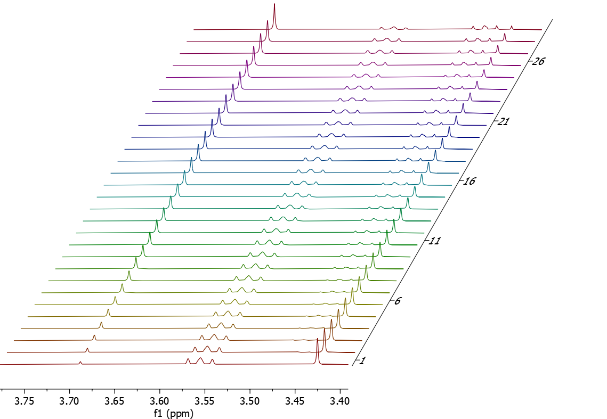
Figure S3. Array of ¹H NMR spectra (CD₃CN, 600 MHz, zoom between 3.75 and 3.40 ppm) recorded monitoring the reaction proceeding at [Au(L₂)NTf₂] = 1.5 mM (3 mol%) and [1a] = 50.0 mM, from t₁ (t = 1080 s, maroon line, bottom) to t₂₈ (t = 25380 s, violet line, top).

[Au(L₂)NTf₂] = 2.0 mM (4 mol%), [1a] = 50.0 mM
- CH₂Br₂ added: 11.1 mg (0.064 mmol)
- CD₃CN added: 500 μL
- Au(L₂)NTf₂ solution added: 200 μL (0.00140 mmol, final [Au(L₂)NTf₂] = 2.0 mM).
- Spectra recorded every 5 minutes for 2.5 h, then every 30 minutes for additional 3 h.
Table S3. Data collected for the reaction run at [Au(L₂)NTf₂] = 2.0 mM (4 mol%), [1a] = 50.0 mM
Entry | Time  [s] | 3aa  [mmol] | Conc. 3aa  [mM] | Yield of 3aa  [%] | Time•[Au(L₂)NTf₂]  [s•mol•L⁻¹] | Time•[Au(L₂)NTf₂]²  [s•mol²•L⁻²]
t₁ | 420 | 0.00262 | 3.74 | 7.49 | 0.84 | 0.00168
t₂ | 720 | 0.00407 | 5.81 | 11.63 | 1.44 | 0.00288
t₃ | 1020 | 0.0054 | 7.71 | 15.43 | 2.04 | 0.00408
t₄ | 1320 | 0.00659 | 9.41 | 18.83 | 2.64 | 0.00528
t₅ | 1620 | 0.00773 | 11.04 | 22.09 | 3.24 | 0.00648
t₆ | 1920 | 0.00875 | 12.50 | 25.00 | 3.84 | 0.00768
t₇ | 2220 | 0.00973 | 13.90 | 27.80 | 4.44 | 0.00888
t₈ | 2520 | 0.01064 | 15.20 | 30.40 | 5.04 | 0.01008
t₉ | 2820 | 0.01149 | 16.41 | 32.83 | 5.64 | 0.01128
t₁₀ | 3120 | 0.01231 | 17.59 | 35.17 | 6.24 | 0.01248
t₁₁ | 3420 | 0.01303 | 18.61 | 37.23 | 6.84 | 0.01368
t₁₂ | 3720 | 0.01374 | 19.63 | 39.26 | 7.44 | 0.01488
t₁₃ | 4020 | 0.01441 | 20.59 | 41.17 | 8.04 | 0.01608
t₁₄ | 4320 | 0.01503 | 21.47 | 42.94 | 8.64 | 0.01728
t₁₅ | 4620 | 0.01569 | 22.41 | 44.83 | 9.24 | 0.01848
t₁₆ | 4920 | 0.01622 | 23.17 | 46.34 | 9.84 | 0.01968
t₁₇ | 5220 | 0.01679 | 23.99 | 47.97 | 10.44 | 0.02088
t₁₈ | 5520 | 0.01727 | 24.67 | 49.34 | 11.04 | 0.02208
t₁₉ | 5820 | 0.01779 | 25.41 | 50.83 | 11.64 | 0.02328
t₂₀ | 6120 | 0.01825 | 26.07 | 52.14 | 12.24 | 0.02448
t₂₁ | 6420 | 0.01871 | 26.73 | 53.46 | 12.84 | 0.02568
t₂₂ | 6720 | 0.01913 | 27.33 | 54.66 | 13.44 | 0.02688
t₂₃ | 7020 | 0.01955 | 27.93 | 55.86 | 14.04 | 0.02808
t₂₄ | 7320 | 0.01994 | 28.49 | 56.97 | 14.64 | 0.02928
t₂₅ | 7620 | 0.02032 | 29.03 | 58.06 | 15.24 | 0.03048
t₂₆ | 7920 | 0.02069 | 29.56 | 59.11 | 15.84 | 0.03168
t₂₇ | 8220 | 0.02101 | 30.01 | 60.03 | 16.44 | 0.03288
t₂₈ | 8520 | 0.02177 | 31.10 | 62.20 | 17.04 | 0.03408
t₂₉ | 10320 | 0.02363 | 33.76 | 67.51 | 20.64 | 0.04128
t₃₀ | 12120 | 0.02509 | 35.84 | 71.69 | 24.24 | 0.04848
t₃₁ | 13920 | 0.02627 | 37.53 | 75.06 | 27.84 | 0.05568
t₃₂ | 15720 | 0.02734 | 39.06 | 78.11 | 31.44 | 0.06288
t₃₃ | 17520 | 0.02823 | 40.33 | 80.65 | 35.04 | 0.07008
t₃₄ | 19320 | 0.02888 | 41.26 | 82.51 | 38.64 | 0.07728
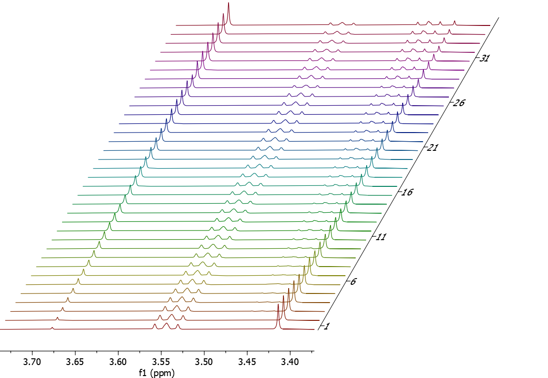
Figure S4. Array of ¹H NMR spectra (CD₃CN, 600 MHz, zoom between 3.75 and 3.40 ppm) recorded monitoring the reaction proceeding at [Au(L₂)NTf₂] = 2.0 mM (4 mol%) and [1a] = 50.0 mM, from t₁ (t = 420 s, maroon line, bottom) to t₃₄ (t = 19320 s, violet line, top).
[Au(L₂)NTf₂] = 2.5 mM (5 mol%), [1a] = 50.0 mM
- CH₂Br₂ added: 6.0 mg (0.034 mmol)
- CD₃CN added: 450 μL
- Au(L₂)NTf₂ solution added: 250 μL (0.00175 mmol, final [Au(L₂)NTf₂] = 2.5 mM).
- Spectra recorded every 4 minutes for 2 h, then every 30 minutes for additional 3 h.
Table S4. Data collected for the reaction run at [Au(L₂)NTf₂] = 2.5 mM (5 mol%), [1a] = 50.0 mM
Entry | Time  [s] | 3aa  [mmol] | Yield of 3aa  [%] | Time•[Au(L₂)NTf₂]  [s•mol•L⁻¹] | Time•[Au(L₂)NTf₂]²  [s•mol²•L⁻²]
t₁ | 540 | 0.0063 | 18 | 1.35 | 0.003375
t₂ | 780 | 0.00789 | 22.54 | 1.95 | 0.004875
t₃ | 1020 | 0.00897 | 25.63 | 2.55 | 0.006375
t₄ | 1260 | 0.01000 | 28.57 | 3.15 | 0.007875
t₅ | 1500 | 0.01094 | 31.26 | 3.75 | 0.009375
t₆ | 1740 | 0.01188 | 33.94 | 4.35 | 0.010875
t₇ | 1980 | 0.01273 | 36.37 | 4.95 | 0.012375
t₈ | 2220 | 0.01373 | 39.23 | 5.55 | 0.013875
t₉ | 2460 | 0.01431 | 40.89 | 6.15 | 0.015375
t₁₀ | 2700 | 0.01497 | 42.77 | 6.75 | 0.016875
t₁₁ | 2940 | 0.01559 | 44.54 | 7.35 | 0.018375
t₁₂ | 3180 | 0.01630 | 46.57 | 7.95 | 0.019875
t₁₃ | 3420 | 0.01700 | 48.57 | 8.55 | 0.021375
t₁₄ | 3660 | 0.01733 | 49.51 | 9.15 | 0.022875
t₁₅ | 3900 | 0.01795 | 51.29 | 9.75 | 0.024375
t₁₆ | 4140 | 0.01840 | 52.57 | 10.35 | 0.025875
t₁₇ | 4380 | 0.01896 | 54.17 | 10.95 | 0.027375
t₁₈ | 4620 | 0.01933 | 55.23 | 11.55 | 0.028875
t₁₉ | 4860 | 0.01983 | 56.66 | 12.15 | 0.030375
t₂₀ | 5100 | 0.02024 | 57.83 | 12.75 | 0.031875
t₂₁ | 5340 | 0.02068 | 59.09 | 13.35 | 0.033375
t₂₂ | 5580 | 0.02125 | 60.71 | 13.95 | 0.034875
t₂₃ | 5820 | 0.02169 | 61.97 | 14.55 | 0.036375
t₂₄ | 6060 | 0.02210 | 63.14 | 15.15 | 0.037875
t₂₅ | 6300 | 0.02243 | 64.09 | 15.75 | 0.039375
t₂₆ | 6540 | 0.02273 | 64.94 | 16.35 | 0.040875
t₂₇ | 6780 | 0.02321 | 66.31 | 16.95 | 0.042375
t₂₈ | 7020 | 0.02364 | 67.54 | 17.55 | 0.043875
t₂₉ | 7260 | 0.02409 | 68.89 | 18.15 | 0.045375
t₃₀ | 9060 | 0.02622 | 74.90 | 22.65 | 0.056625
t₃₁ | 10860 | 0.02776 | 79.31 | 27.15 | 0.067875
t₃₂ | 12660 | 0.02897 | 82.78 | 31.65 | 0.079125
t₃₃ | 14460 | 0.03004 | 85.84 | 36.15 | 0.090375
t₃₄ | 16260 | 0.03087 | 88.20 | 40.65 | 0.101625
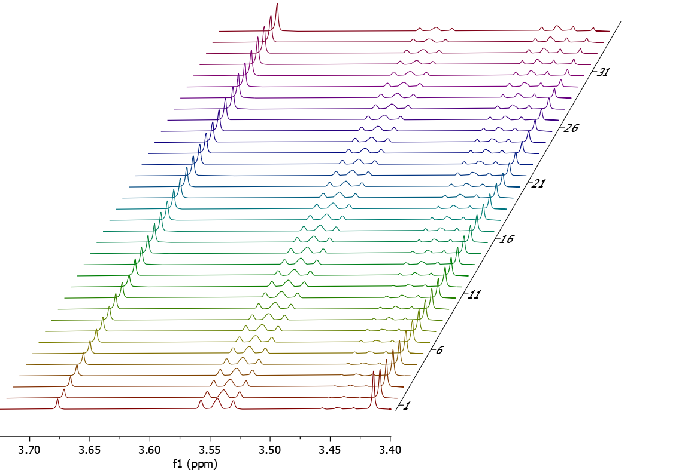
Figure S5. Array of ¹H NMR spectra (CD₃CN, 600 MHz, zoom between 3.75 and 3.40 ppm) recorded monitoring the reaction proceeding at 5 mol% Au(L₂)NTf₂, from t₁ (t = 540 s, maroon line, bottom) to t₃₄ (t = 16260 s, violet line, top).

[Au(L₂)NTf₂] = 3.0 mM (6 mol%), [1a] = 50.0 mM
- CH₂Br₂ added: 10.4 mg (0.060 mmol)
- CD₃CN added: 400 μL
- Au(L₂)NTf₂ solution added: 300 μL (0.00210 mmol, final [Au(L₂)NTf₂] = 3.0 mM).
- Spectra recorded every 3 minutes for 1.5 h, then every 30 minutes for additional 3 h.
Table S5. Data collected for the reaction run at [Au(L₂)NTf₂] = 3.0 mM (6 mol%), [1a] = 50.0 mM
Entry | Time  [s] | 3aa  [mmol] | Conc. 3aa  [mM] | Yield of 3aa  [%] | Time•[Au(L₂)NTf₂]  [s•mol•L⁻¹] | Time•[Au(L₂)NTf₂]²  [s•mol²•L⁻²]
t₁ | 300 | 0.00411 | 5.87 | 11.74 | 0.9 | 0.0027
t₂ | 480 | 0.00581 | 8.30 | 16.60 | 1.44 | 0.00432
t₃ | 660 | 0.00732 | 10.46 | 20.91 | 1.98 | 0.00594
t₄ | 840 | 0.00872 | 12.46 | 24.91 | 2.52 | 0.00756
t₅ | 1020 | 0.01003 | 14.33 | 28.66 | 3.06 | 0.00918
t₆ | 1200 | 0.0112 | 16.00 | 32.00 | 3.6 | 0.0108
t₇ | 1380 | 0.01203 | 17.19 | 34.37 | 4.14 | 0.01242
t₈ | 1560 | 0.01334 | 19.06 | 38.11 | 4.68 | 0.01404
t₉ | 1740 | 0.01429 | 20.41 | 40.83 | 5.22 | 0.01566
t₁₀ | 1920 | 0.01517 | 21.67 | 43.35 | 5.76 | 0.01728
t₁₁ | 2100 | 0.01601 | 22.87 | 45.74 | 6.3 | 0.0189
t₁₂ | 2280 | 0.017 | 24.29 | 48.57 | 6.84 | 0.02052
t₁₃ | 2460 | 0.01751 | 25.01 | 50.03 | 7.38 | 0.02214
t₁₄ | 2640 | 0.01815 | 25.93 | 51.86 | 7.92 | 0.02376
t₁₅ | 2820 | 0.01882 | 26.89 | 53.77 | 8.46 | 0.02538
t₁₆ | 3000 | 0.01945 | 27.79 | 55.57 | 9 | 0.027
t₁₇ | 3180 | 0.02001 | 28.59 | 57.17 | 9.54 | 0.02862
t₁₈ | 3360 | 0.02064 | 29.49 | 58.97 | 10.08 | 0.03024
t₁₉ | 3540 | 0.02113 | 30.19 | 60.37 | 10.62 | 0.03186
t₂₀ | 3720 | 0.02166 | 30.94 | 61.89 | 11.16 | 0.03348
t₂₁ | 3900 | 0.02209 | 31.56 | 63.11 | 11.7 | 0.0351
t₂₂ | 4080 | 0.02262 | 32.31 | 64.63 | 12.24 | 0.03672
t₂₃ | 4260 | 0.02304 | 32.91 | 65.83 | 12.78 | 0.03834
t₂₄ | 4440 | 0.02345 | 33.50 | 67.00 | 13.32 | 0.03996
t₂₅ | 4620 | 0.02378 | 33.97 | 67.94 | 13.86 | 0.04158
t₂₆ | 4800 | 0.02428 | 34.69 | 69.37 | 14.4 | 0.0432
t₂₇ | 4980 | 0.02457 | 35.10 | 70.20 | 14.94 | 0.04482
t₂₈ | 5160 | 0.02499 | 35.70 | 71.40 | 15.48 | 0.04644
t₂₉ | 6960 | 0.02749 | 39.27 | 78.54 | 20.88 | 0.06264
t₃₀ | 8760 | 0.02925 | 41.79 | 83.57 | 26.28 | 0.07884
t₃₁ | 10560 | 0.03054 | 43.63 | 87.26 | 31.68 | 0.09504
t₃₂ | 12360 | 0.0315 | 45.00 | 90.00 | 37.08 | 0.11124
t₃₃ | 14160 | 0.03218 | 45.97 | 91.94 | 42.48 | 0.12744
t₃₄ | 15960 | 0.03276 | 46.80 | 93.60 | 47.88 | 0.14364
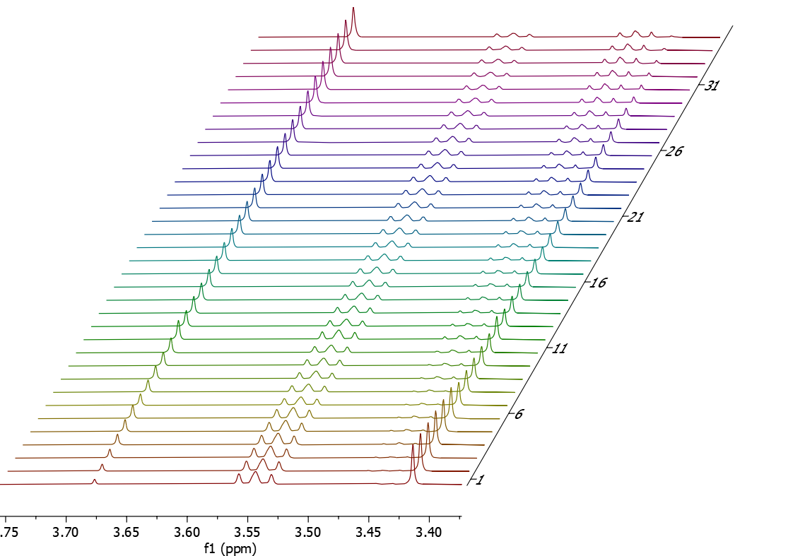
Figure S6. Array of ¹H NMR spectra (CD₃CN, 600 MHz, zoom between 3.75 and 3.40 ppm) recorded monitoring the reaction proceeding at [Au(L₂)NTf₂] = 3.0 mM (6 mol%) and [1a] = 50.0 mM, from t₁ (t = 300 s, maroon line, bottom) to t₃₄ (t = 15960 s, violet line, top).
[Au(L₂)NTf₂] = 5.0 mM (10 mol%), [1a] = 50.0 mM
- CH₂Br₂ added: 14.3 mg (0.082 mmol)
- CD₃CN added: 450 μL
- L₂AuNTf₂ solution (14.0 mM concentration) added: 250 μL (0.00350 mmol, final [L₂AuNTf₂] = 5.0 mM).
- Spectra recorded every 102 seconds for 1 h, then every 10 minutes for additional 1.5 h.
Table S6. Data collected for the reaction run at [Au(L₂)NTf₂] = 5.0 mM (10 mol%), [1a] = 50.0 mM
Entry | Time  [s] | 3aa  [mmol] | Conc. 3aa  [mM] | Yield of 3aa  [%] | Time•[L₂AuNTf₂]  [s•mol•L⁻¹] | Time•[L₂AuNTf₂]²  [s•mol²•L⁻²]
t₁ | 43 | 0.00311 | 4.45 | 8.89 | 0.21 | 0.00106
t₂ | 145 | 0.00487 | 6.96 | 13.92 | 0.72 | 0.00361
t₃ | 247 | 0.00694 | 9.92 | 19.83 | 1.23 | 0.00616
t₄ | 349 | 0.00825 | 11.79 | 23.57 | 1.74 | 0.00871
t₅ | 451 | 0.00971 | 13.88 | 27.75 | 2.25 | 0.01126
t₆ | 553 | 0.01110 | 15.86 | 31.71 | 2.76 | 0.01381
t₇ | 655 | 0.01235 | 17.65 | 35.29 | 3.27 | 0.01636
t₈ | 757 | 0.01354 | 19.34 | 38.69 | 3.78 | 0.01891
t₉ | 859 | 0.01464 | 20.92 | 41.83 | 4.29 | 0.02146
t₁₀ | 961 | 0.01569 | 22.41 | 44.82 | 4.80 | 0.02401
t₁₁ | 1063 | 0.01667 | 23.81 | 47.61 | 5.31 | 0.02656
t₁₂ | 1165 | 0.01751 | 25.02 | 50.03 | 5.82 | 0.02911
t₁₃ | 1267 | 0.01839 | 26.27 | 52.55 | 6.33 | 0.03166
t₁₄ | 1369 | 0.01917 | 27.39 | 54.78 | 6.84 | 0.03421
t₁₅ | 1471 | 0.01994 | 28.49 | 56.98 | 7.35 | 0.03676
t₁₆ | 1573 | 0.02065 | 29.50 | 58.99 | 7.86 | 0.03931
t₁₇ | 1675 | 0.02133 | 30.47 | 60.94 | 8.37 | 0.04186
t₁₈ | 1777 | 0.02196 | 31.37 | 62.73 | 8.88 | 0.04441
t₁₉ | 1879 | 0.02253 | 32.18 | 64.37 | 9.39 | 0.04696
t₂₀ | 1981 | 0.02306 | 32.94 | 65.87 | 9.90 | 0.04951
t₂₁ | 2083 | 0.02361 | 33.72 | 67.45 | 10.41 | 0.05206
t₂₂ | 2185 | 0.02420 | 34.57 | 69.14 | 10.92 | 0.05461
t₂₃ | 2287 | 0.02471 | 35.29 | 70.59 | 11.43 | 0.05716
t₂₄ | 2389 | 0.02495 | 35.33 | 71.29 | 11.94 | 0.05971
t₂₅ | 2491 | 0.02552 | 36.46 | 72.91 | 12.45 | 0.06226
t₂₆ | 2593 | 0.02598 | 37.12 | 74.23 | 12.96 | 0.06481
t₂₇ | 2695 | 0.02637 | 37.67 | 75.33 | 13.47 | 0.06736
t₂₈ | 2797 | 0.02677 | 38.25 | 76.50 | 13.98 | 0.06991
t₂₉ | 3307 | 0.02838 | 40.54 | 81.09 | 16.53 | 0.08266
t₃₀ | 3817 | 0.02972 | 42.46 | 84.92 | 19.08 | 0.09541
t₃₁ | 4327 | 0.03091 | 44.16 | 88.31 | 21.63 | 0.10816
t₃₂ | 4837 | 0.03182 | 45.46 | 90.92 | 24.18 | 0.12091
t₃₃ | 5347 | 0.03262 | 46.59 | 93.19 | 26.73 | 0.13366
t₃₄ | 5857 | 0.03319 | 47.41 | 94.82 | 29.28 | 0.14641
t₃₅ | 6367 | 0.03385 | 48.35 | 96.71 | 31.83 | 0.15916
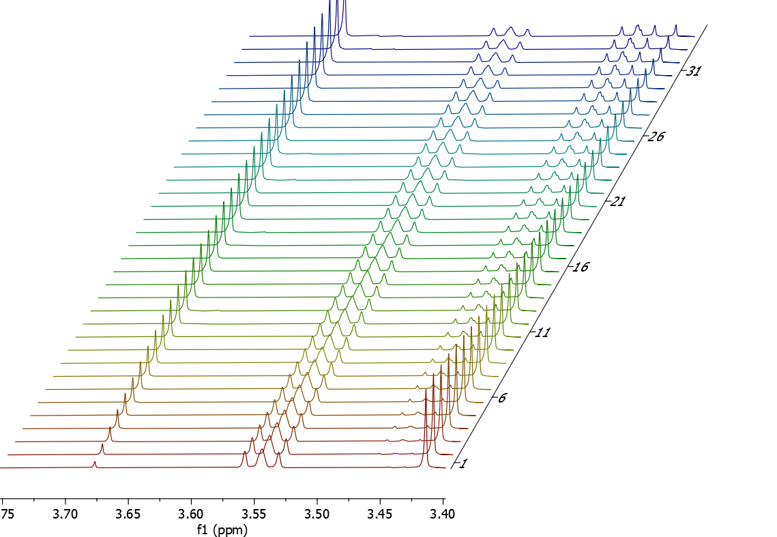
Figure S7. Array of ¹H NMR spectra (CD₃CN, 600 MHz, zoom between 3.75 and 3.40 ppm) recorded monitoring the reaction proceeding at [Au(L₂)NTf₂] = 5.0 mM (10 mol%), [1a] = 50.0 mM, from t₁ (t = 43 s, maroon line, bottom) to t₃₅ (t = 6367 s, violet line, top).
[Au(L₂)NTf₂] = 2.0 mM (4 mol%), [1a] = 50.0 mM + 30 mol% 3aa
- CH₂Br₂ added: 10.8 mg (0.062 mmol)
- CD₃CN added: 500 μL
- L₂AuNTf₂ solution added: 200 μL (0.00140 mmol, final [L₂AuNTf₂] = 2.0 mM).
- Deviation from the General Procedure: 30 mol% (0.0105 mmol, 3.3 mg) of product 3aa was added to the mixture before adding the catalyst solution. The reported amount and yields of 3aa are corrected for this initial amount.
- Spectra recorded every 5 minutes for 2.5 h, then every 30 minutes for additional 3 h.
Table S7. Data collected for the reaction run at [Au(L₂)NTf₂] = 2.0 mM (4 mol%), [1a] = 50.0 mM + 30 mol% 3aa
Entry | Time  [s] | 3aa  [mmol] | Yield of 3aa  [%]
t₁ | 417 | 0.0026 | 7.43
t₂ | 733 | 0.004144 | 11.84
t₃ | 1018 | 0.005387 | 15.39
t₄ | 1319 | 0.006586 | 18.82
t₅ | 1640 | 0.007826 | 22.36
t₆ | 1935 | 0.008816 | 25.19
t₇ | 2176 | 0.009536 | 27.24
t₈ | 2553 | 0.01078 | 30.80
t₉ | 2767 | 0.011273 | 32.21
t₁₀ | 3175 | 0.012527 | 35.79
t₁₁ | 3402 | 0.012961 | 37.03
t₁₂ | 3777 | 0.013949 | 39.85
t₁₃ | 4008 | 0.014368 | 41.05
t₁₄ | 4269 | 0.014853 | 42.44
t₁₅ | 4633 | 0.015733 | 44.95
t₁₆ | 4929 | 0.016249 | 46.43
t₁₇ | 5242 | 0.016859 | 48.17
t₁₈ | 5415 | 0.01694 | 48.40
t₁₉ | 5734 | 0.017529 | 50.08
t₂₀ | 6018 | 0.017946 | 51.28
t₂₁ | 6480 | 0.018885 | 53.96
t₂₂ | 6704 | 0.019084 | 54.53
t₂₃ | 7149 | 0.019909 | 56.88
t₂₄ | 7326 | 0.019956 | 57.02
t₂₅ | 7570 | 0.020186 | 57.67
t₂₆ | 7792 | 0.020354 | 58.16
t₂₇ | 8113 | 0.020737 | 59.25
t₂₈ | 8545 | 0.021834 | 62.38
t₂₉ | 10175 | 0.023298 | 66.57
t₃₀ | 11992 | 0.024826 | 70.93
t₃₁ | 13655 | 0.02577 | 73.63
t₃₂ | 15615 | 0.027158 | 77.59
t₃₃ | 17604 | 0.028366 | 81.04
t₃₄ | 19039 | 0.02846 | 81.31

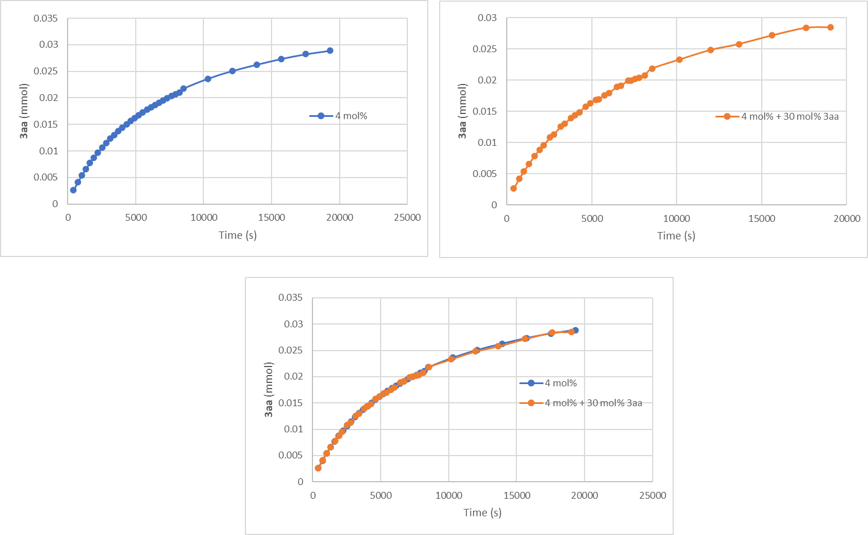
Figure S8. Kinetic curves of the reaction run in the presence of an initial amount of 3aa (orange line) and the reaction run under standard conditions (blue line) both at 4 mol% L₂AuNTf₂.

Given the superimposition of the curve obtained in this case and the one obtained with the same amount of catalyst (4 mol%) without adding 3aa (vide supra) we exclude a poisoning of the catalytic process exerted by the reaction product.
[Au(L₂)NTf₂] = 2.0 mM (4 mol%), [1a] = 50.0 mM with 3.0 equivalents of 2a.
- CH₂Br₂ added: 12.3 mg (0.071 mmol)
- CD₃CN added: 500 μL
- L₂AuNTf₂ solution added: 200 μL (0.00140 mmol, final [L₂AuNTf₂] = 2.0 mM).
- Deviation from the General Procedure: 3 equiv (0.105 mmol, 16.0 mg) of allenamide 2a were employed.
- Spectra recorded every 5 minutes for 1.5 h, then every 30 minutes for additional 2 h.
Table S8. Data collected for the reaction run at [Au(L₂)NTf₂] = 2.0 mM (4 mol%), [1a] = 50.0 mM with 3.0 equivalents of 2a
Entry | Time  [s] | 3aa  [mmol] | Yield of 3aa  [%] | Time•[2a]  [s•mol•L⁻¹]
t₁ | 212 | 0.00264 | 7.54 | 22.222
t₂ | 363 | 0.004101 | 11.72 | 38.084
t₃ | 506 | 0.005362 | 15.32 | 53.177
t₄ | 649 | 0.006483 | 18.52 | 68.174
t₅ | 816 | 0.007789 | 22.25 | 85.702
t₆ | 970 | 0.00884 | 25.26 | 101.841
t₇ | 1120 | 0.009814 | 28.04 | 117.560
t₈ | 1278 | 0.010793 | 30.84 | 134.199
t₉ | 1426 | 0.011623 | 33.21 | 149.759
t₁₀ | 1585 | 0.01251 | 35.74 | 166.456
t₁₁ | 1741 | 0.013266 | 37.90 | 182.803
t₁₂ | 1827 | 0.013498 | 38.57 | 191.857
t₁₃ | 2028 | 0.014541 | 41.55 | 212.968
t₁₄ | 2159 | 0.015021 | 42.92 | 226.658
t₁₅ | 2277 | 0.015465 | 44.19 | 239.075
t₁₆ | 2489 | 0.016412 | 46.89 | 261.362
t₁₇ | 2558 | 0.016454 | 47.01 | 268.572
t₁₈ | 2799 | 0.017514 | 50.04 | 293.889
t₁₉ | 2949 | 0.01803 | 51.51 | 309.667
t₂₀ | 3085 | 0.018398 | 52.57 | 323.902
t₂₁ | 3168 | 0.018463 | 52.75 | 332.594
t₂₂ | 3319 | 0.018898 | 54.00 | 348.528
t₂₃ | 3550 | 0.01977 | 56.49 | 372.701
t₂₄ | 3596 | 0.019591 | 55.97 | 377.567
t₂₅ | 3740 | 0.019948 | 56.99 | 392.724
t₂₆ | 3909 | 0.020424 | 58.35 | 410.458
t₂₇ | 4175 | 0.021343 | 60.98 | 438.399
t₂₈ | 4293 | 0.02194 | 62.68 | 450.787
t₂₉ | 5168 | 0.023666 | 67.62 | 542.623
t₃₀ | 5956 | 0.024661 | 70.46 | 625.412
t₃₁ | 6858 | 0.025885 | 73.96 | 720.078
t₃₂ | 7873 | 0.027386 | 78.25 | 826.690
t₃₃ | 8692 | 0.028012 | 80.03 | 912.687
t₃₄ | 9548 | 0.028545 | 81.56 | 1002.521

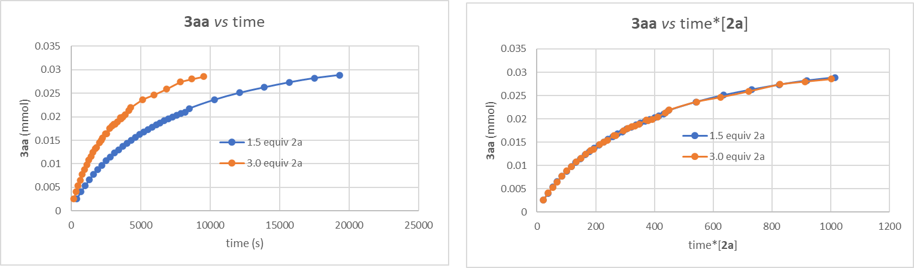
Figure S9. Left: kinetic curves of the reaction run in the presence of 3.0 equiv of 2a (orange line) and the reaction run under standard conditions (blue line) both at 4 mol% Au(L₂)NTf₂. Right: First order behavior in 2a.

The data recorded in the presence of twice the amount of allenamide 2a with respect to the standard conditions suggest a first-order in 2a. This deems a poisoning effect exerted by the allenamide unlikely.

[Au(L₂)NTf₂] = 1.5 mM (6 mol%), [1a] = 25.0 mM
- CH₂Br₂ added: 10.7 mg (0.061 mmol)
- CD₃CN added: 550 μL
- [Au(L₂)NTf₂] solution added: 150 μL (0.00105 mmol, final [Au(L₂)NTf₂] = 1.5 mM).
- Spectra recorded every 4 minutes for 2 h, then every 10 min for 1 h and then every 15 min for 1 h.
Table S9. Data collected for the reaction run at [Au(L₂)NTf₂] = 1.5 mM (6 mol%), [1a] = 25.0 mM
Entry | Time  [s] | 3aa  [mmol] | Conc. 3aa  [mM] | Yield of 3aa  [%] | Time•[Au(L₂)NTf₂]  [s•mol•L⁻¹] | Time•[Au(L₂)NTf₂]²  [s•mol²•L⁻²]
t₁ | 300 | 0.000676 | 0.97 | 3.86 | 0.45 | 0.000675
t₂ | 540 | 0.001078 | 1.54 | 6.16 | 0.81 | 0.001215
t₃ | 780 | 0.00147 | 2.10 | 8.40 | 1.17 | 0.001755
t₄ | 1020 | 0.001842 | 2.63 | 10.53 | 1.53 | 0.002295
t₅ | 1260 | 0.002195 | 3.14 | 12.54 | 1.89 | 0.002835
t₆ | 1500 | 0.002509 | 3.58 | 14.34 | 2.25 | 0.003375
t₇ | 1740 | 0.002852 | 4.07 | 16.30 | 2.61 | 0.003915
t₈ | 1980 | 0.003107 | 4.44 | 17.75 | 2.97 | 0.004455
t₉ | 2220 | 0.003371 | 4.82 | 19.26 | 3.33 | 0.004995
t₁₀ | 2460 | 0.003724 | 5.32 | 21.28 | 3.69 | 0.005535
t₁₁ | 2700 | 0.003989 | 5.70 | 22.79 | 4.05 | 0.006075
t₁₂ | 2940 | 0.004234 | 6.05 | 24.19 | 4.41 | 0.006615
t₁₃ | 3180 | 0.004469 | 6.38 | 25.54 | 4.77 | 0.007155
t₁₄ | 3420 | 0.004694 | 6.71 | 26.82 | 5.13 | 0.007695
t₁₅ | 3660 | 0.004939 | 7.06 | 28.22 | 5.49 | 0.008235
t₁₆ | 3900 | 0.005135 | 7.34 | 29.34 | 5.85 | 0.008775
t₁₇ | 4140 | 0.005331 | 7.62 | 30.46 | 6.21 | 0.009315
t₁₈ | 4380 | 0.005566 | 7.95 | 31.81 | 6.57 | 0.009855
t₁₉ | 4620 | 0.005753 | 8.22 | 32.87 | 6.93 | 0.010395
t₂₀ | 4860 | 0.005909 | 8.44 | 33.77 | 7.29 | 0.010935
t₂₁ | 5100 | 0.006105 | 8.72 | 34.89 | 7.65 | 0.011475
t₂₂ | 5340 | 0.006282 | 8.97 | 35.90 | 8.01 | 0.012015
t₂₃ | 5580 | 0.006488 | 9.27 | 37.07 | 8.37 | 0.012555
t₂₄ | 5820 | 0.006644 | 9.49 | 37.97 | 8.73 | 0.013095
t₂₅ | 6060 | 0.006791 | 9.70 | 38.81 | 9.09 | 0.013635
t₂₆ | 6300 | 0.006987 | 9.98 | 39.93 | 9.45 | 0.014175
t₂₇ | 6540 | 0.007134 | 10.19 | 40.77 | 9.81 | 0.014715
t₂₈ | 6780 | 0.007262 | 10.37 | 41.50 | 10.17 | 0.015255
t₂₉ | 7380 | 0.007615 | 10.88 | 43.51 | 11.07 | 0.016605
t₃₀ | 7980 | 0.007997 | 11.42 | 45.70 | 11.97 | 0.017955
t₃₁ | 8580 | 0.00831 | 11.87 | 47.49 | 12.87 | 0.019305
t₃₂ | 9180 | 0.008585 | 12.26 | 49.06 | 13.77 | 0.020655
t₃₃ | 9780 | 0.00884 | 12.63 | 50.51 | 14.67 | 0.022005
t₃₄ | 10680 | 0.009222 | 13.17 | 52.70 | 16.02 | 0.02403
t₃₅ | 11580 | 0.009555 | 13.65 | 54.60 | 17.37 | 0.026055
t₃₆ | 12480 | 0.009839 | 14.06 | 56.22 | 18.72 | 0.02808
t₃₇ | 13380 | 0.010104 | 14.43 | 57.74 | 20.07 | 0.030105
t₃₈ | 14280 | 0.010398 | 14.85 | 59.42 | 21.42 | 0.03213

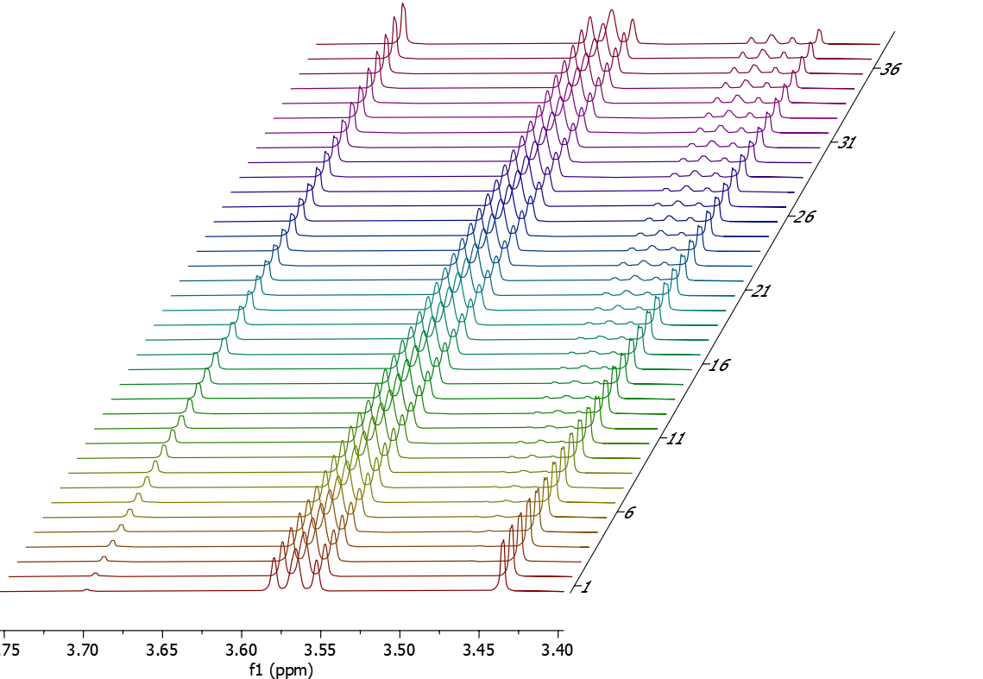
Figure S10. Array of ¹H NMR spectra (CD₃CN, 600 MHz, zoom between 3.75 and 3.40 ppm) recorded monitoring the reaction proceeding at [Au(L₂)NTf₂] = 1.5 mM (6 mol%), [1a] = 25.0 mM, from t₁ (t = 300 s, maroon line, bottom) to t₃₈ (t = 14280 s, violet line, top).

[Au(L₂)NTf₂] = 2.0 mM (8 mol%), [1a] = 25.0 mM
- CH₂Br₂ added: 9.9 mg (0.057 mmol)
- CD₃CN added: 500 μL
- [Au(L₂)NTf₂] solution added: 200 μL (0.00140 mmol, final [Au(L₂)NTf₂] = 2.0 mM).
- Spectra recorded every 4 minutes for 2 h, then every 10 min for 1 h and then every 15 min for 1 h.
Table S10. Data collected for the reaction run at [Au(L₂)NTf₂] = 2.0 mM (8 mol%), [1a] = 25.0 mM
Entry | Time  [s] | 3aa  [mmol] | Conc. 3aa  [mM] | Yield of 3aa  [%] | Time•[Au(L₂)NTf₂]  [s•mol•L⁻¹] | Time•[Au(L₂)NTf₂]²  [s•mol²•L⁻²]
t₁ | 53 | 0.00032 | 0.46 | 1.83 | 0.106 | 0.000212
t₂ | 293 | 0.00097 | 1.39 | 5.54 | 0.586 | 0.001172
t₃ | 533 | 0.00154 | 2.20 | 8.80 | 1.066 | 0.002132
t₄ | 773 | 0.00206 | 2.94 | 11.77 | 1.546 | 0.003092
t₅ | 1013 | 0.00258 | 3.69 | 14.74 | 2.026 | 0.004052
t₆ | 1253 | 0.00305 | 4.36 | 17.43 | 2.506 | 0.005012
t₇ | 1493 | 0.00346 | 4.94 | 19.77 | 2.986 | 0.005972
t₈ | 1733 | 0.00384 | 5.49 | 21.94 | 3.466 | 0.006932
t₉ | 1973 | 0.00422 | 6.03 | 24.11 | 3.946 | 0.007892
t₁₀ | 2213 | 0.00458 | 6.54 | 26.17 | 4.426 | 0.008852
t₁₁ | 2453 | 0.00494 | 7.06 | 28.23 | 4.906 | 0.009812
t₁₂ | 2693 | 0.00525 | 7.50 | 30.00 | 5.386 | 0.010772
t₁₃ | 2933 | 0.0056 | 8.00 | 32.00 | 5.866 | 0.011732
t₁₄ | 3173 | 0.00587 | 8.39 | 33.54 | 6.346 | 0.012692
t₁₅ | 3413 | 0.00622 | 8.89 | 35.54 | 6.826 | 0.013652
t₁₆ | 3653 | 0.00644 | 9.20 | 36.80 | 7.306 | 0.014612
t₁₇ | 3893 | 0.00669 | 9.56 | 38.23 | 7.786 | 0.015572
t₁₈ | 4133 | 0.00695 | 9.93 | 39.71 | 8.266 | 0.016532
t₁₉ | 4373 | 0.00719 | 10.27 | 41.09 | 8.746 | 0.017492
t₂₀ | 4613 | 0.00739 | 10.56 | 42.23 | 9.226 | 0.018452
t₂₁ | 4853 | 0.00764 | 10.91 | 43.66 | 9.706 | 0.019412
t₂₂ | 5093 | 0.00786 | 11.23 | 44.91 | 10.186 | 0.020372
t₂₃ | 5333 | 0.00806 | 11.51 | 46.06 | 10.666 | 0.021332
t₂₄ | 5573 | 0.00824 | 11.77 | 47.09 | 11.146 | 0.022292
t₂₅ | 5813 | 0.00838 | 11.97 | 47.89 | 11.626 | 0.023252
t₂₆ | 6053 | 0.00861 | 12.30 | 49.20 | 12.106 | 0.024212
t₂₇ | 6293 | 0.00881 | 12.59 | 50.34 | 12.586 | 0.025172
t₂₈ | 6533 | 0.00897 | 12.81 | 51.26 | 13.066 | 0.026132
t₂₉ | 7133 | 0.00937 | 13.39 | 53.54 | 14.266 | 0.028532
t₃₀ | 7733 | 0.00975 | 13.93 | 55.71 | 15.466 | 0.030932
t₃₁ | 8333 | 0.01011 | 14.44 | 57.77 | 16.666 | 0.033332
t₃₂ | 8933 | 0.01041 | 14.87 | 59.49 | 17.866 | 0.035732
t₃₃ | 9533 | 0.01071 | 15.30 | 61.20 | 19.066 | 0.038132
t₃₄ | 10433 | 0.01109 | 15.84 | 63.37 | 20.866 | 0.041732
t₃₅ | 11333 | 0.01149 | 16.41 | 65.66 | 22.666 | 0.045332
t₃₆ | 12233 | 0.01172 | 16.74 | 66.97 | 24.466 | 0.048932
t₃₇ | 13133 | 0.0121 | 17.29 | 69.14 | 26.266 | 0.052532
t₃₈ | 14033 | 0.01242 | 17.74 | 70.97 | 28.066 | 0.056132

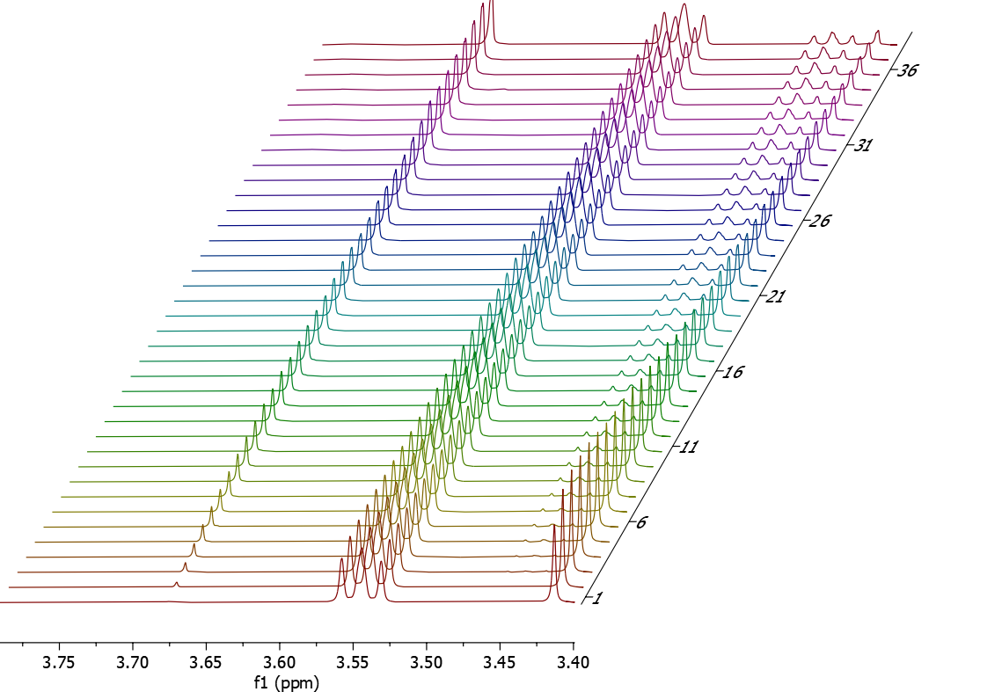
Figure S11. Array of ¹H NMR spectra (CD₃CN, 600 MHz, zoom between 3.75 and 3.40 ppm) recorded monitoring the reaction proceeding at [Au(L₂)NTf₂] = 2.0 mM (8 mol%), [1a] = 25.0 mM, from t₁ (t = 53 s, maroon line, bottom) to t₃₈ (t = 14033 s, violet line, top).

[Au(L₂)NTf₂] = 2.4 mM (9.4 mol%), [1a] = 25.0 mM
- CH₂Br₂ added: 10.3 mg (0.059 mmol)
- CD₃CN added: 464 μL
- [Au(L₂)NTf₂] solution added: 236 μL (0.00165 mmol, final [Au(L₂)NTf₂] = 2.4 mM).
- Spectra recorded every 4 minutes for 2 h, then every 10 min for 1 h and then every 15 min for 1 h.
Table S11. Data collected for the reaction run at [Au(L₂)NTf₂] = 2.4 mM (9.4 mol%), [1a] = 25.0 mM
Entry | Time  [s] | 3aa  [mmol] | Conc. 3aa  [mM] | Yield of 3aa  [%] | Time•[Au(L₂)NTf₂]  [s•mol•L⁻¹] | Time•[Au(L₂)NTf₂]²  [s•mol²•L⁻²]
t₁ | 285 | 0.0014 | 2.00 | 0.6717857 | 0.0015835 | 8.00
t₂ | 525 | 0.00194 | 2.77 | 1.2375 | 0.002917 | 11.09
t₃ | 765 | 0.00255 | 3.64 | 1.8032143 | 0.0042504 | 14.57
t₄ | 1005 | 0.0032 | 4.57 | 2.3689286 | 0.0055839 | 18.29
t₅ | 1245 | 0.00381 | 5.44 | 2.9346429 | 0.0069174 | 21.77
t₆ | 1485 | 0.00435 | 6.21 | 3.5003571 | 0.0082508 | 24.86
t₇ | 1725 | 0.00486 | 6.94 | 4.0660714 | 0.0095843 | 27.77
t₈ | 1965 | 0.00533 | 7.61 | 4.6317857 | 0.0109178 | 30.46
t₉ | 2205 | 0.00584 | 8.34 | 5.1975 | 0.0122513 | 33.37
t₁₀ | 2445 | 0.00622 | 8.89 | 5.7632143 | 0.0135847 | 35.54
t₁₁ | 2685 | 0.0066 | 9.43 | 6.3289286 | 0.0149182 | 37.71
t₁₂ | 2925 | 0.00699 | 9.99 | 6.8946429 | 0.0162517 | 39.94
t₁₃ | 3165 | 0.00733 | 10.47 | 7.4603571 | 0.0175851 | 41.89
t₁₄ | 3405 | 0.00764 | 10.91 | 8.0260714 | 0.0189186 | 43.66
t₁₅ | 3645 | 0.00797 | 11.39 | 8.5917857 | 0.0202521 | 45.54
t₁₆ | 3885 | 0.0083 | 11.86 | 9.1575 | 0.0215855 | 47.43
t₁₇ | 4125 | 0.00856 | 12.23 | 9.7232143 | 0.022919 | 48.91
t₁₈ | 4365 | 0.00882 | 12.60 | 10.288929 | 0.0242525 | 50.40
t₁₉ | 4605 | 0.0091 | 13.00 | 10.854643 | 0.0255859 | 52.00
t₂₀ | 4845 | 0.00932 | 13.31 | 11.420357 | 0.0269194 | 53.26
t₂₁ | 5085 | 0.00956 | 13.66 | 11.986071 | 0.0282529 | 54.63
t₂₂ | 5325 | 0.00977 | 13.96 | 12.551786 | 0.0295864 | 55.83
t₂₃ | 5565 | 0.01 | 14.29 | 13.1175 | 0.0309198 | 57.14
t₂₄ | 5805 | 0.01015 | 14.50 | 13.683214 | 0.0322533 | 58.00
t₂₅ | 6045 | 0.01035 | 14.79 | 14.248929 | 0.0335868 | 59.14
t₂₆ | 6285 | 0.01058 | 15.11 | 14.814643 | 0.0349202 | 60.46
t₂₇ | 6525 | 0.0107 | 15.29 | 15.380357 | 0.0362537 | 61.14
t₂₈ | 6765 | 0.01094 | 15.63 | 15.946071 | 0.0375872 | 62.51
t₂₉ | 7365 | 0.01125 | 16.07 | 17.360357 | 0.0409208 | 64.29
t₃₀ | 7965 | 0.01164 | 16.63 | 18.774643 | 0.0442545 | 66.51
t₃₁ | 8565 | 0.01192 | 17.03 | 20.188929 | 0.0475882 | 68.11
t₃₂ | 9165 | 0.01216 | 17.37 | 21.603214 | 0.0509219 | 69.49
t₃₃ | 9765 | 0.01246 | 17.80 | 23.0175 | 0.0542555 | 71.20
t₃₄ | 10665 | 0.01279 | 18.27 | 25.138929 | 0.059256 | 73.09
t₃₅ | 11565 | 0.01308 | 18.69 | 27.260357 | 0.0642566 | 74.74
t₃₆ | 12465 | 0.0133 | 19.00 | 29.381786 | 0.0692571 | 76.00
t₃₇ | 13365 | 0.01353 | 19.33 | 31.503214 | 0.0742576 | 77.31
t₃₈ | 14265 | 0.01371 | 19.59 | 33.624643 | 0.0792581 | 78.34

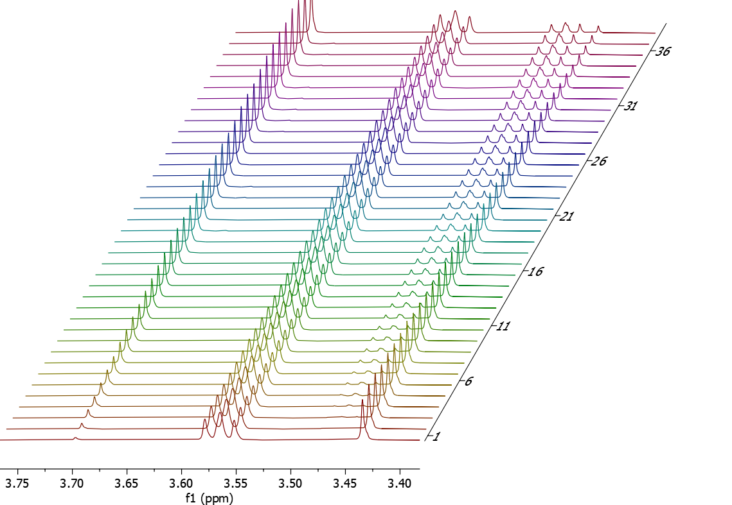
Figure S12. Array of ¹H NMR spectra (CD₃CN, 600 MHz, zoom between 3.75 and 3.40 ppm) recorded monitoring the reaction proceeding at [Au(L₂)NTf₂] = 2.4 mM (9.4 mol%), [1a] = 25.0 mM, from t₁ (t = 285 s, maroon line, bottom) to t₃₈ (t = 14265 s, violet line, top).

Since a lack of perfect overlay of the curve run at [Au(L₂)NTf₂] = 5.0 mM (10 mol%), [1a] = 50.0 mM and the others run at [1a] = 50.0 mM was observed (Figure 2C, main text) a scenario involving catalyst deactivation was deemed possible. Keeping this into account, and following the method described by Burès et al., to corroborate the operativity of a mechanism involving sibling catalytic species, we run three kinetic profiles at [1a] = 25.0 mM changing again the catalyst concentration (Tables S9, S10 and S11 and Figures S10, S11 and S12). Also in this case, a good overlap of the three curves was observed in the case of a second-order kinetic (Figure S13). Then, we extrapolated the initial rate constants both in the series of reactions run at [1a] = 50.0 mM (Figure S14) and in the ones run at [1a] = 25.0 mM (Figure S15). Plotting these initial rates (collected in Table S12) against the catalyst concentration (Figure S15), two straight lines were obtained, showing a different X-intercept, suggesting a mechanism with a step involving sibling catalytic species.

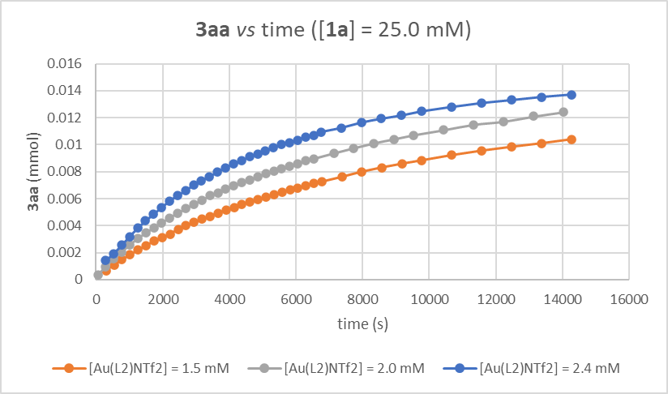

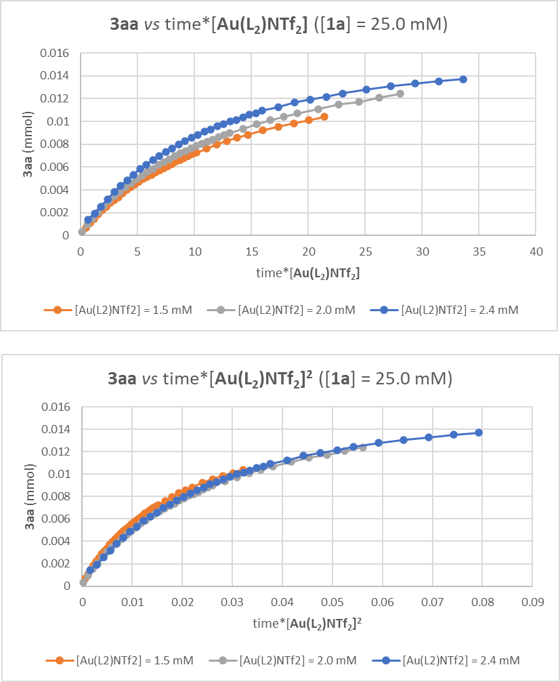
Figure S13. Kinetic curves obtained with [1a] = 25.0 mM and [Au(L₂)NTf₂] = 1.5, 2.0 and 2.4 mM (top) and their fit against a first-order (middle) or second-order reaction mechanism.
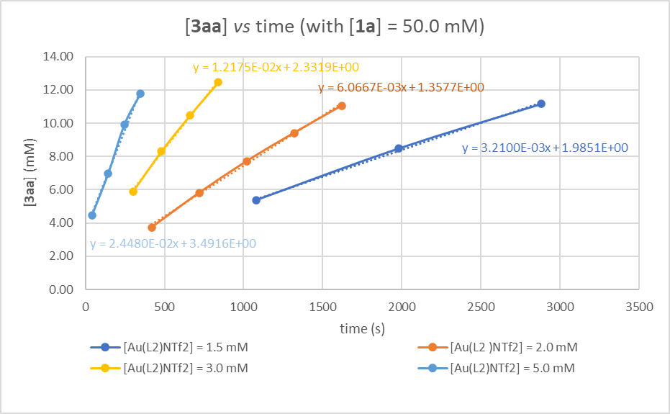
Figure S14. Extrapolation of the initial reaction rates for [1a] = 50.0 mM and [Au(L₂)NTf₂] = 1.5, 2.0, 3.0 and 5.0 mM.

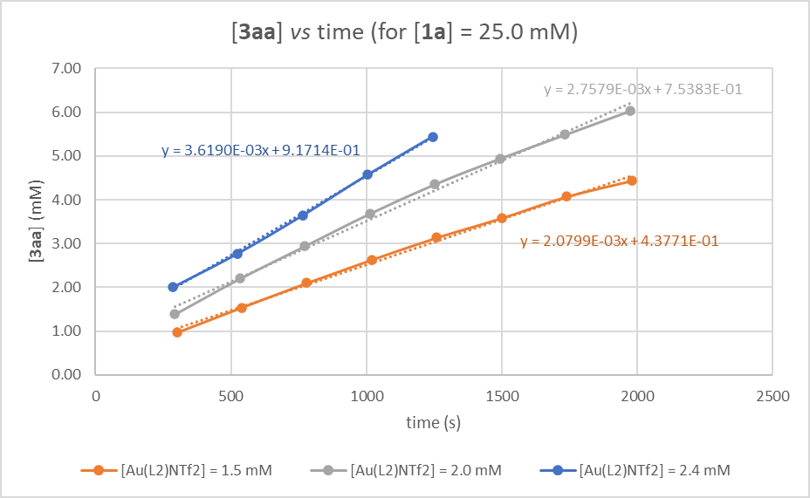
Figure S15. Extrapolation of the initial reaction rates for [1a] = 25.0 mM and [Au(L₂)NTf₂] = 1.5, 2.0 and 2.4 mM.

Table S12. Initial reaction rates extrapolated from Figures S14 and S15.
Entry | Conc. 1a  [mM] | [Au(L₂)NTf₂]  [mM] | Initial rate [mM*s⁻¹]
1 | 50.0 | 1.5 | 3.21*10⁻³
2 | 50.0 | 2.0 | 6.07*10⁻³
3 | 50.0 | 3.0 | 1.22*10⁻²
4 | 50.0 | 5.0 | 2.45*10⁻²
5 | 25.0 | 1.5 | 2.08*10⁻³
6 | 25.0 | 2.0 | 2.76*10⁻³
7 | 25.0 | 2.5 | 3.62*10⁻³

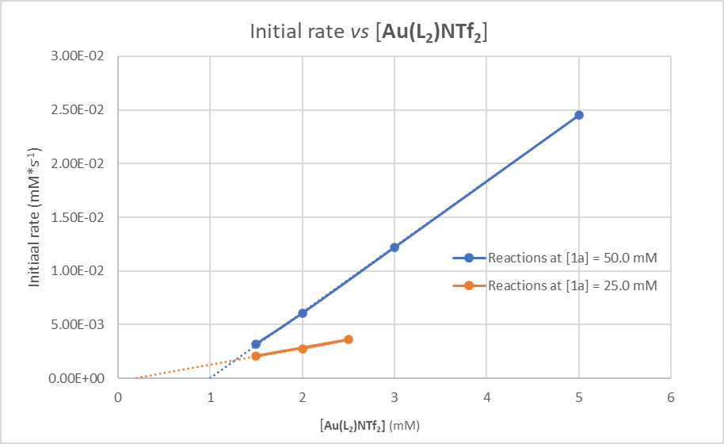
Figure S16. Plot of the initial reaction rates against [Au(L₂)NTf₂] concentration in the case of [1a] = 50.0 mM (blue line) and [1a] = 25.0 mM (orange line) and interpolation of the resulting lines to show the X-intercept.

8. NMR Spectra
3aa ¹H NMR (600 MHz, CDCl₃)
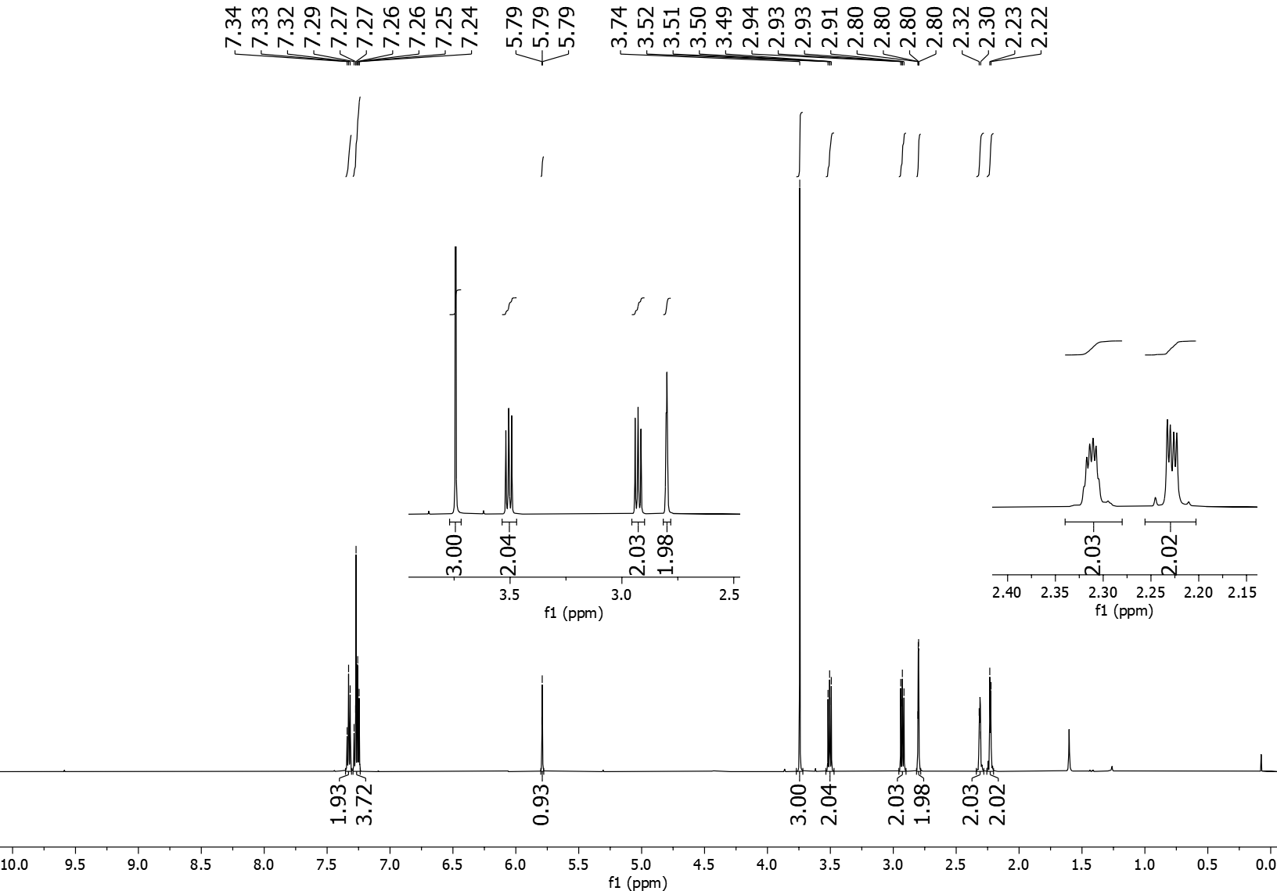
3aa ¹³C NMR (151 MHz, CDCl₃)
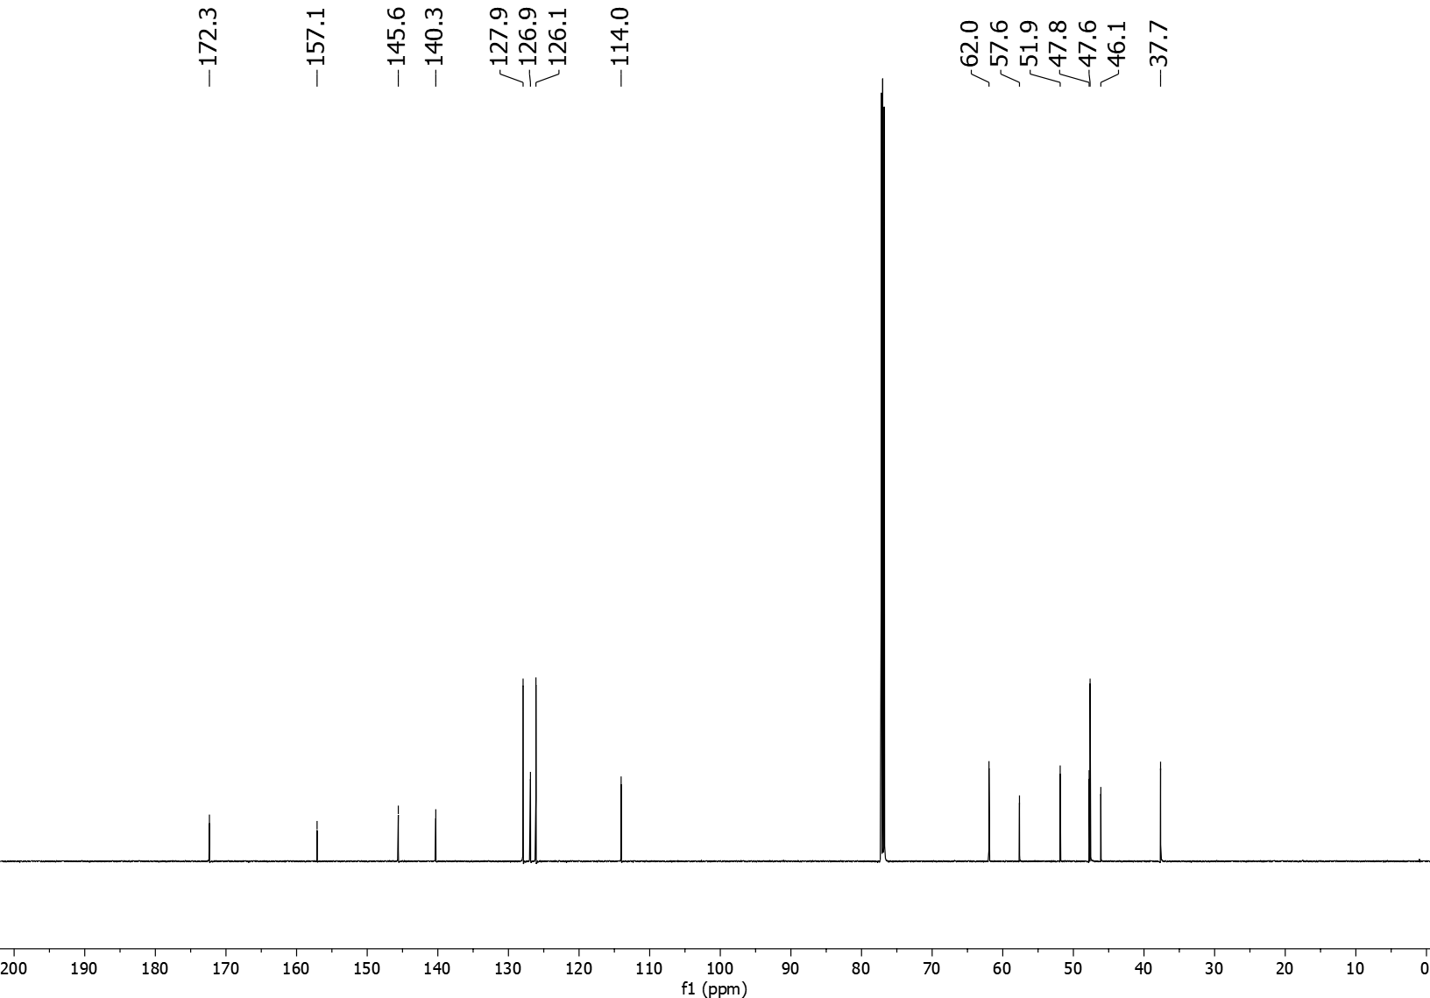
3ba ¹H NMR (600 MHz, CDCl₃)
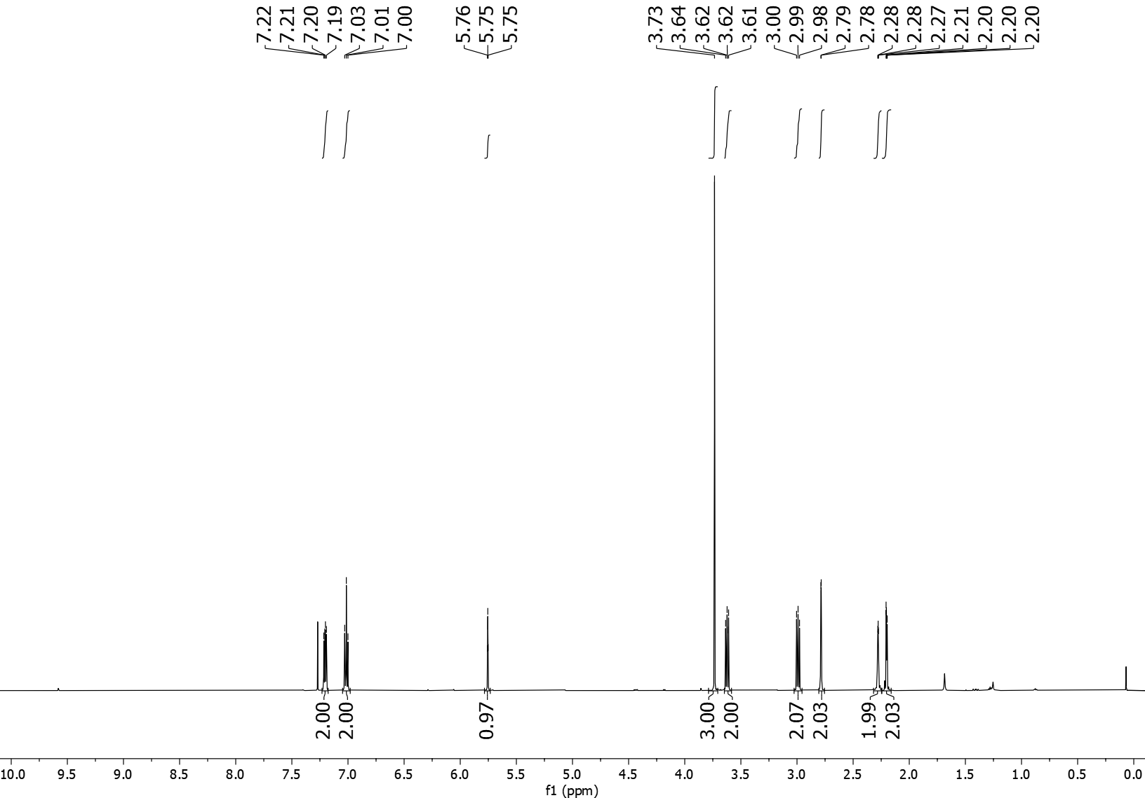
3ba ¹³C NMR (151 MHz, CDCl₃)
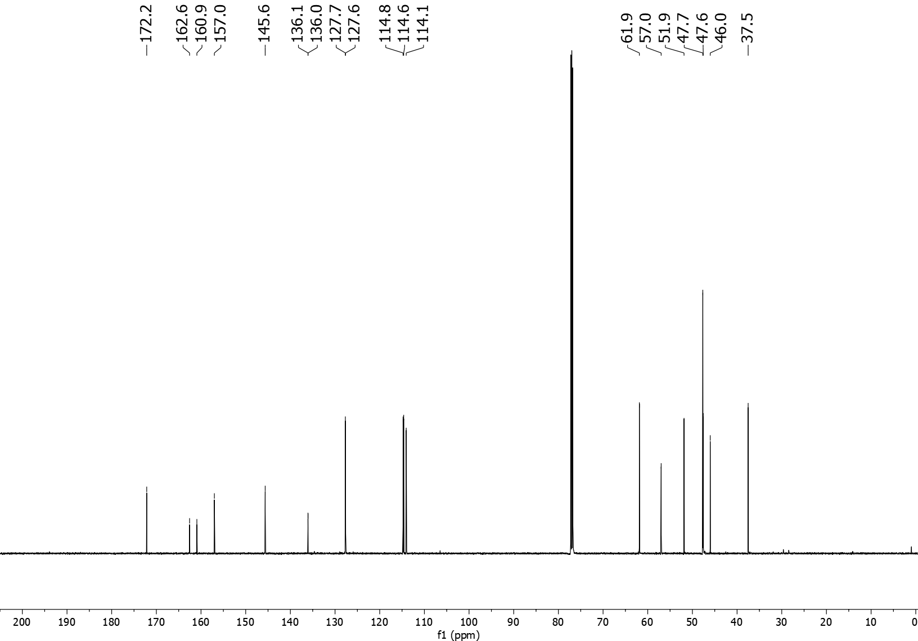
3ba ¹⁹F NMR (565 MHz, CDCl₃)
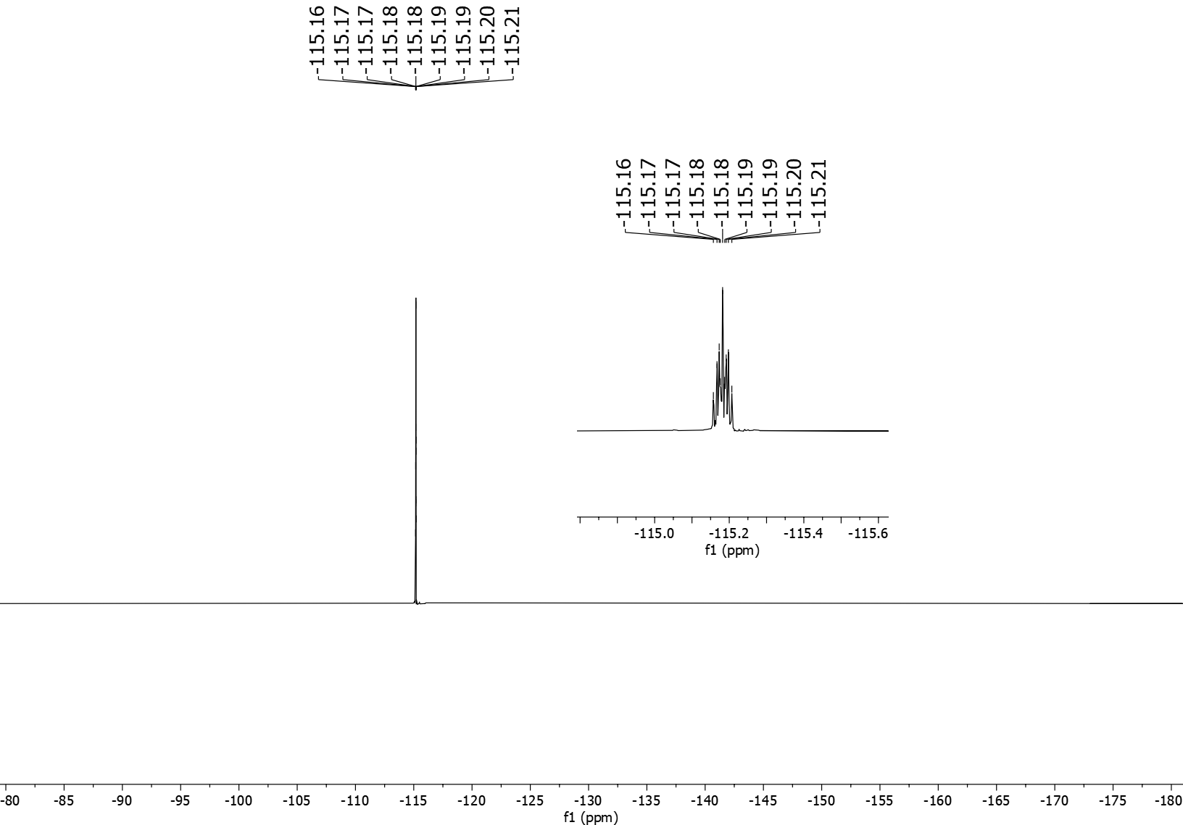
3ca ¹H NMR (600 MHz, CDCl₃)
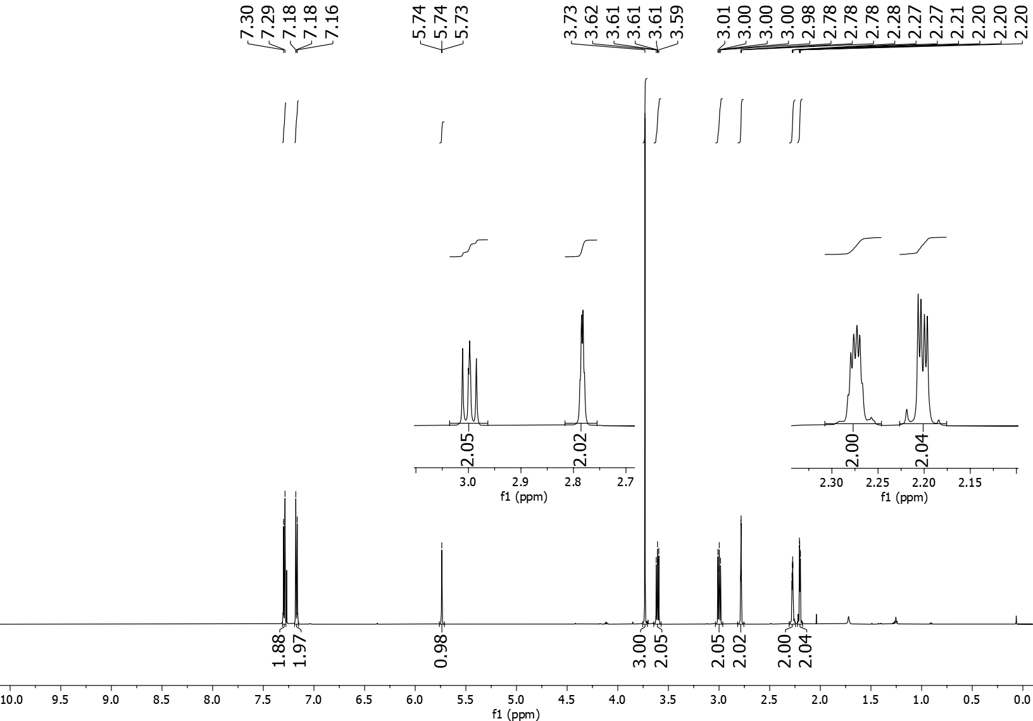
3ca ¹³C NMR (151 MHz, CDCl₃)
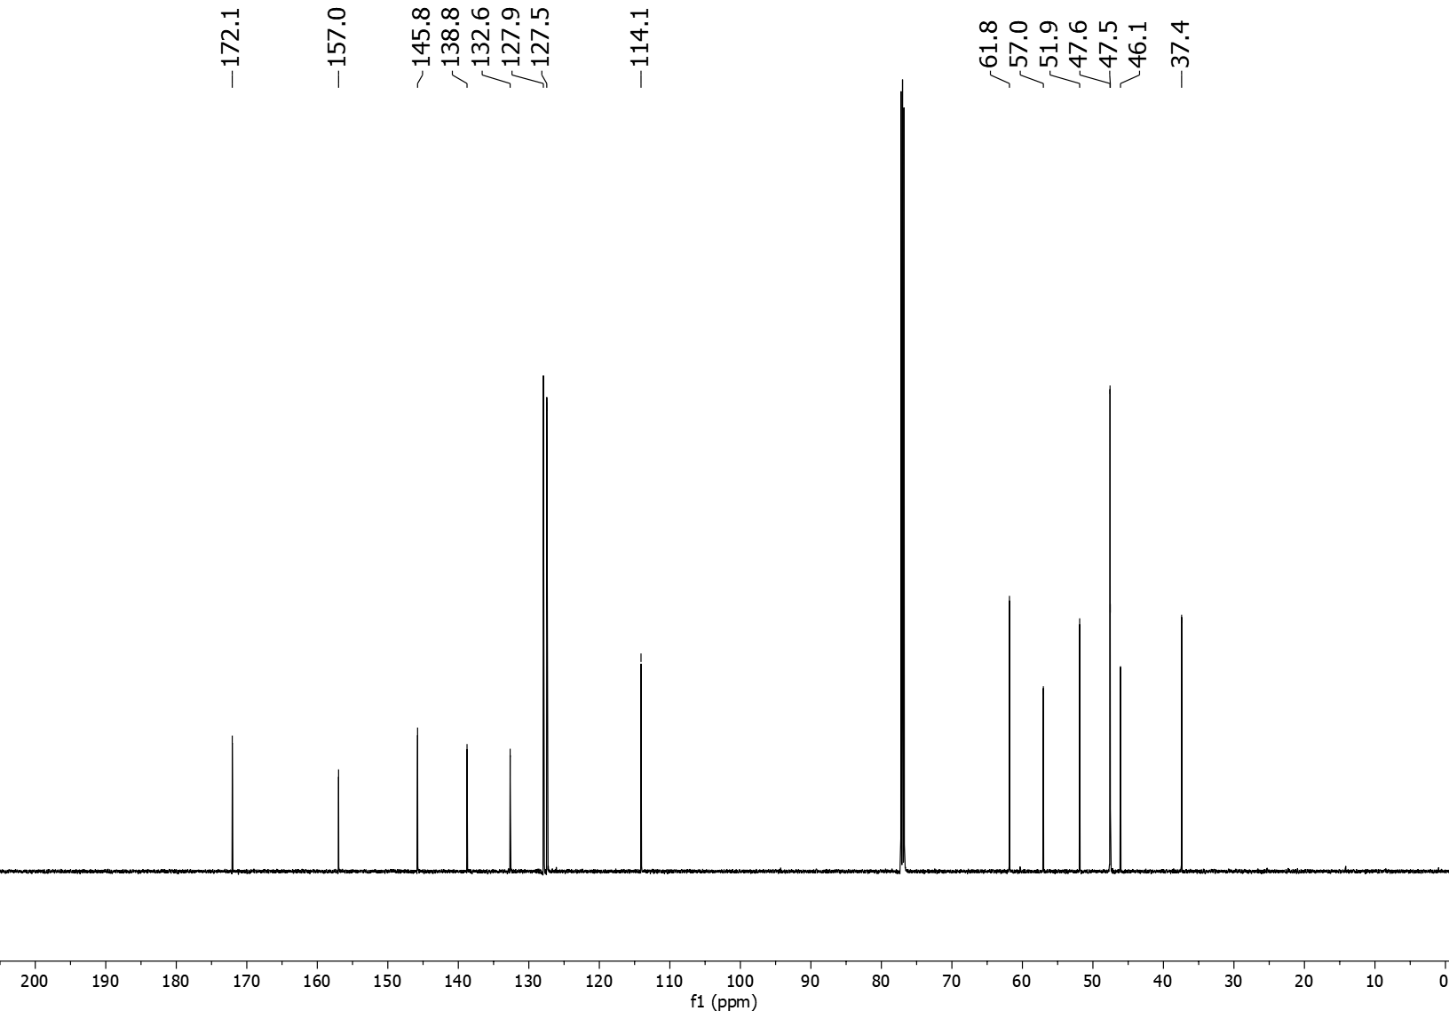
3da ¹H NMR (600 MHz, CDCl₃)
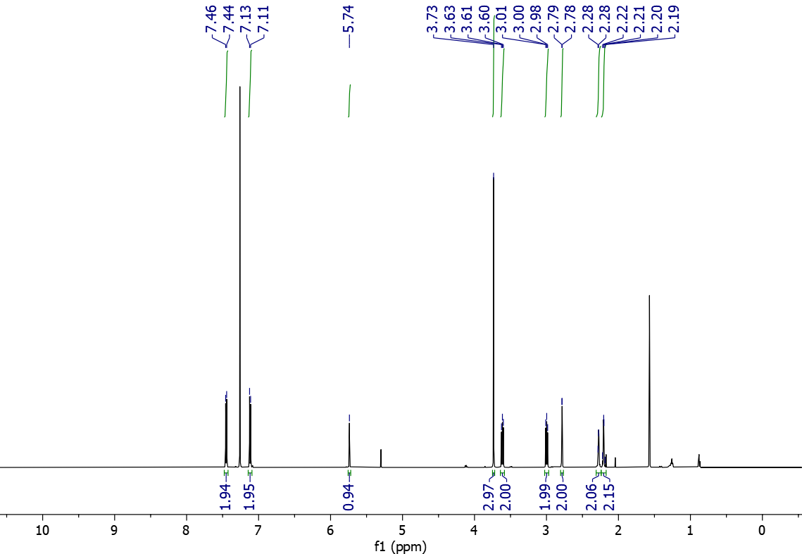
3da ¹³C NMR (151 MHz, CDCl₃)
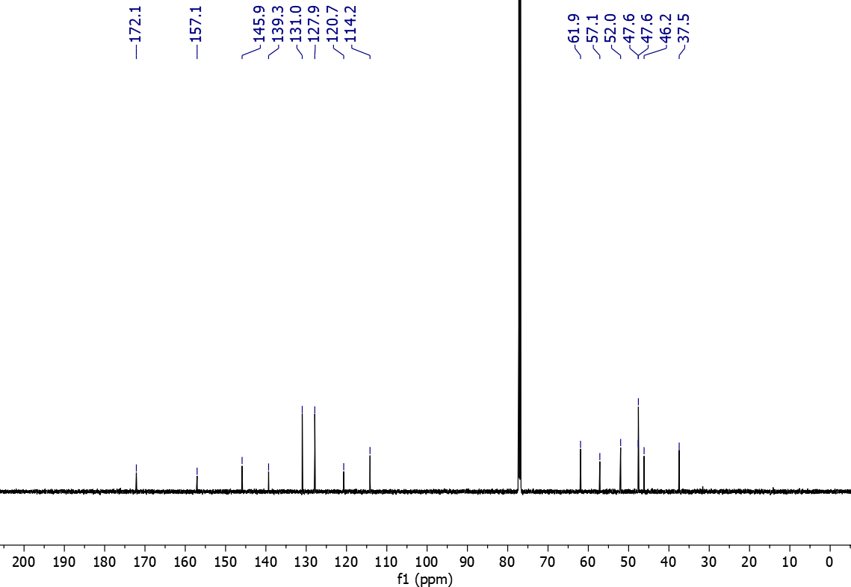
3ea ¹H NMR (600 MHz, CDCl₃)
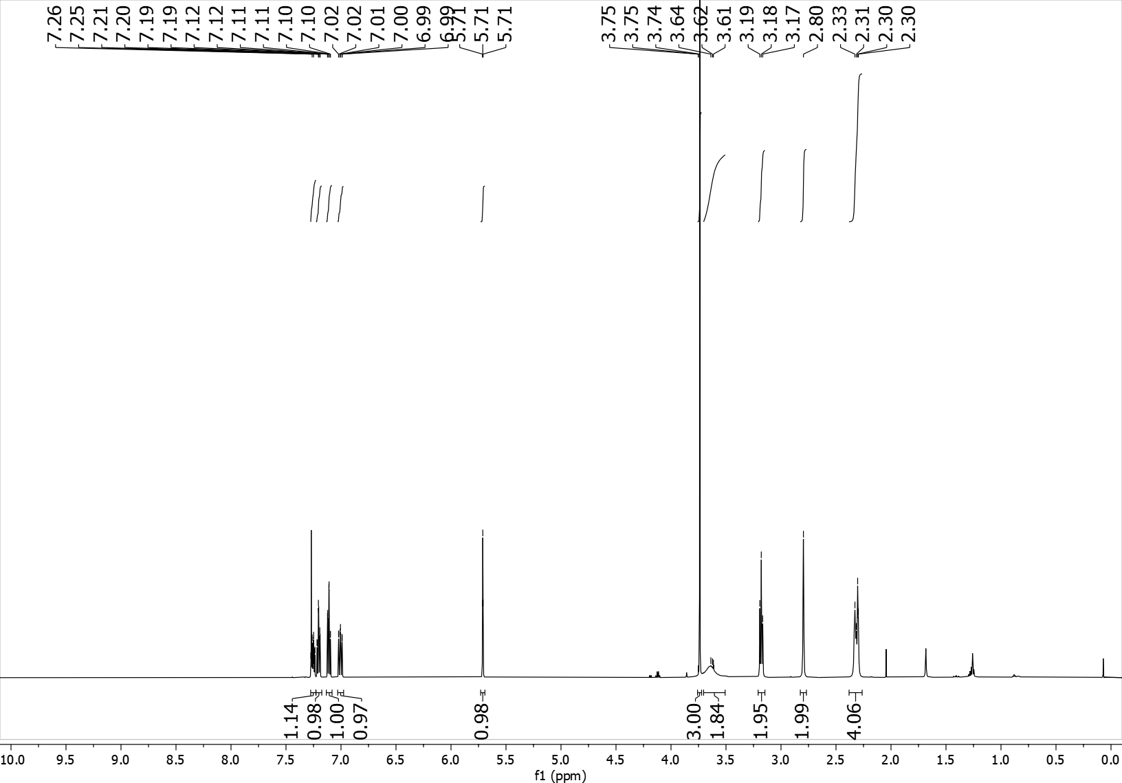
3ea ¹³C NMR (151 MHz, CDCl₃)
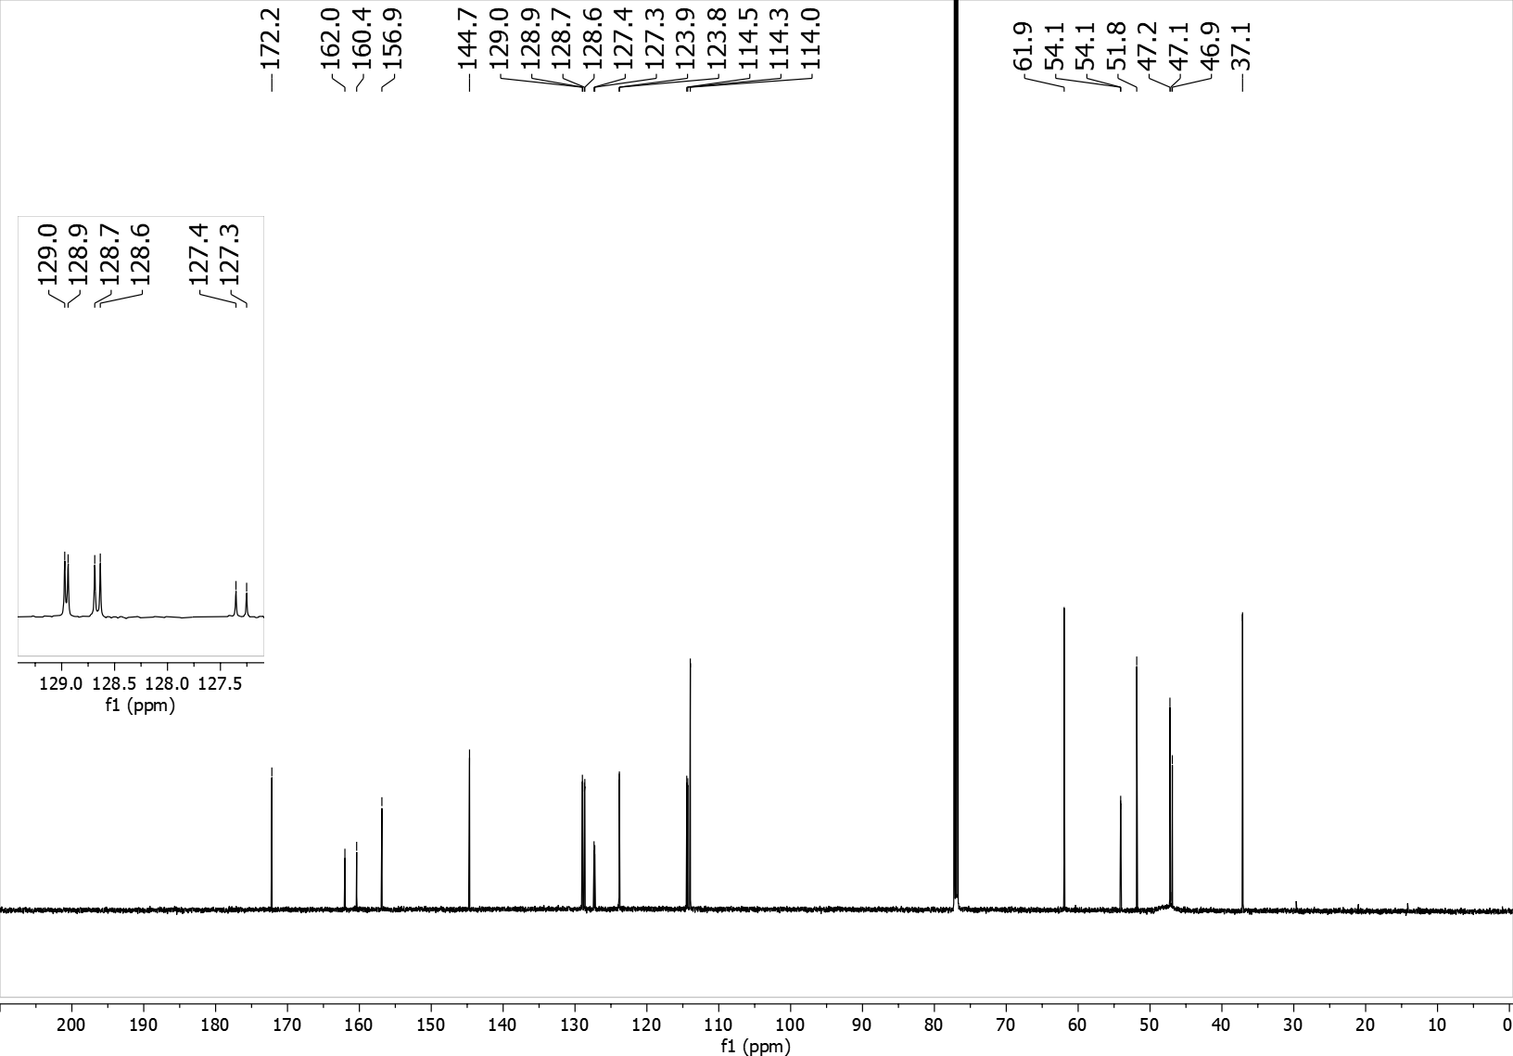
3ea ¹⁹F NMR (565 MHz, CDCl₃)
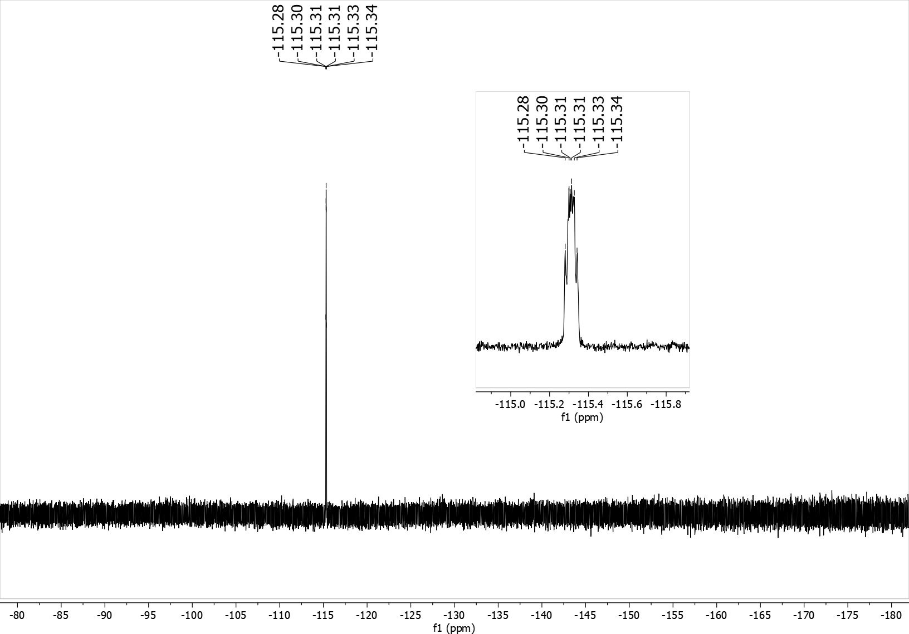
3fa ¹H NMR (600 MHz, CDCl₃)
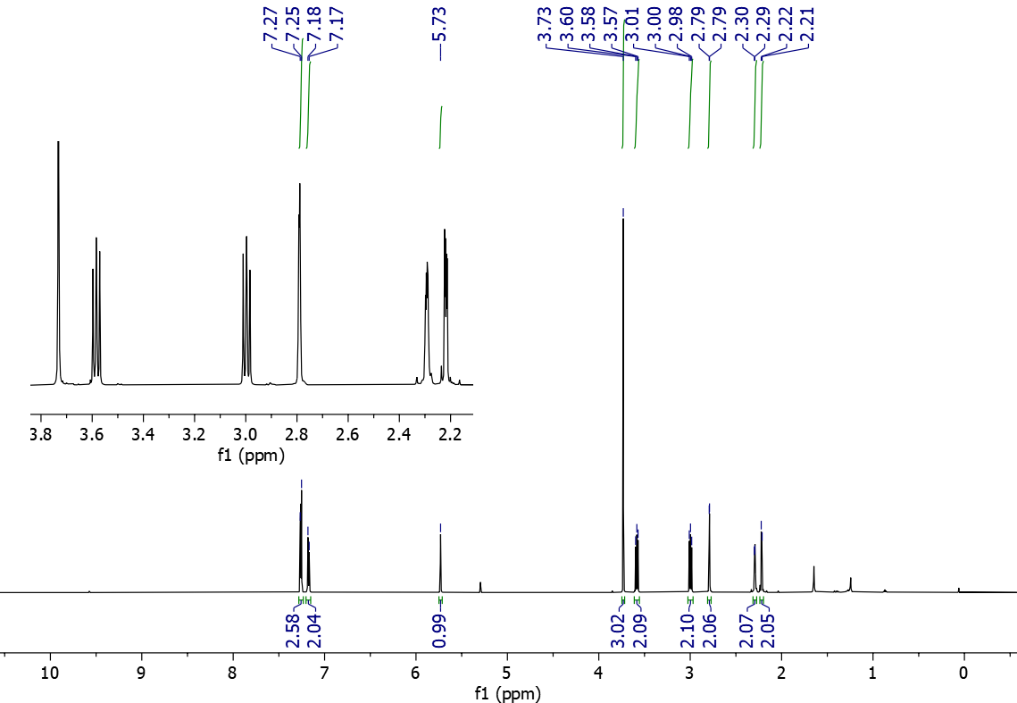
3fa ¹³C NMR (151 MHz, CDCl₃)
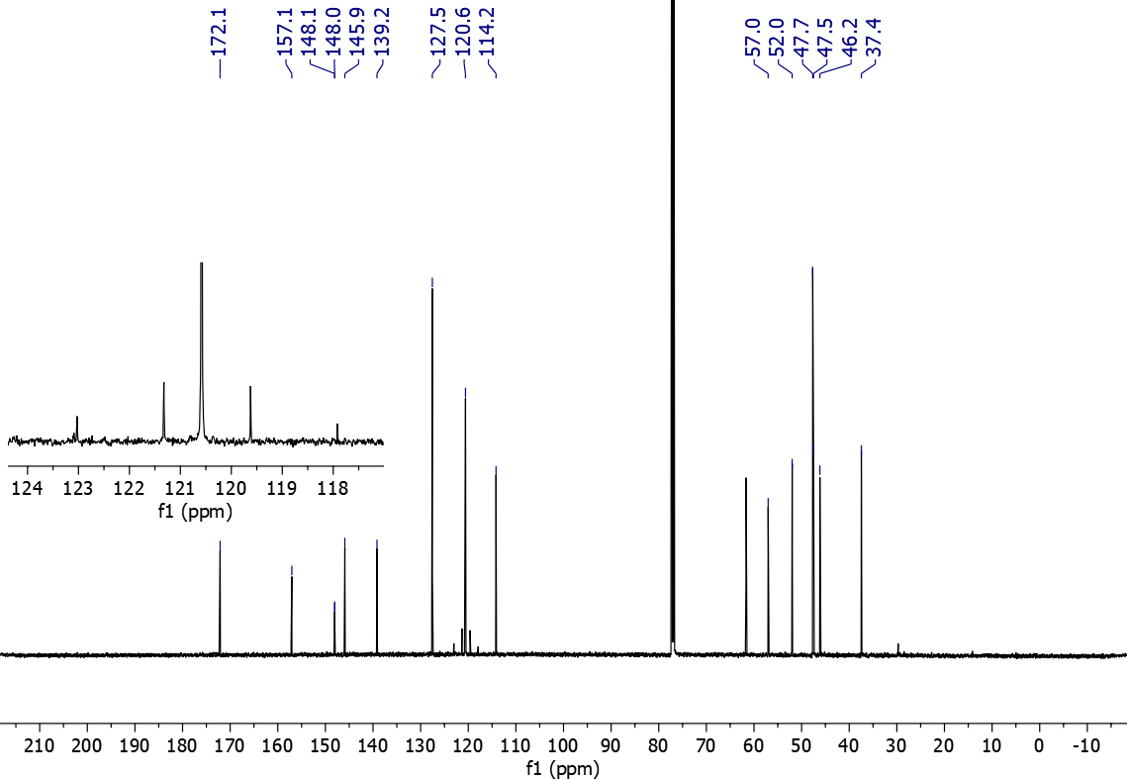

3fa ¹⁹F NMR (565 MHz, CDCl₃)
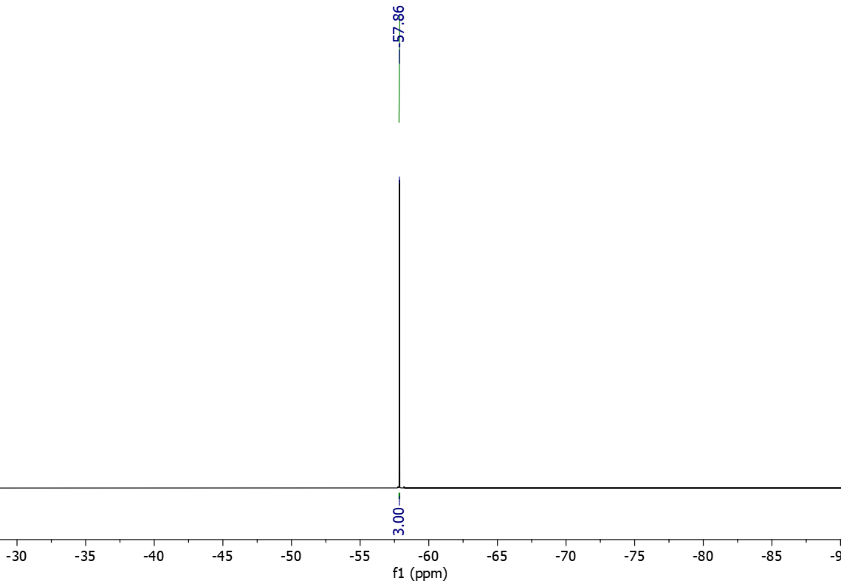

3ga ¹H NMR (600 MHz, CDCl₃)
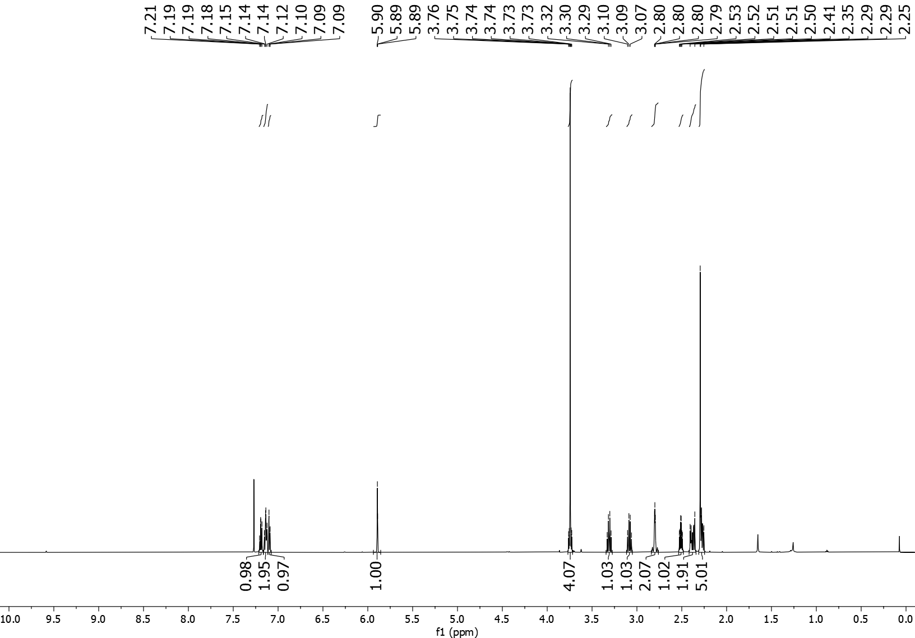
3ga ¹³C NMR (151 MHz, CDCl₃)
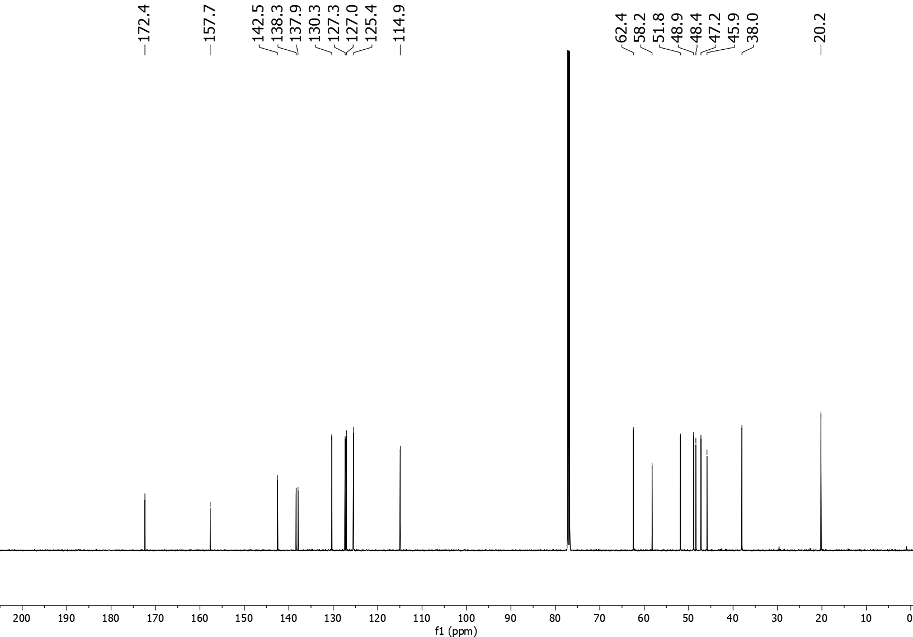
3ha ¹H NMR (600 MHz, CDCl₃)
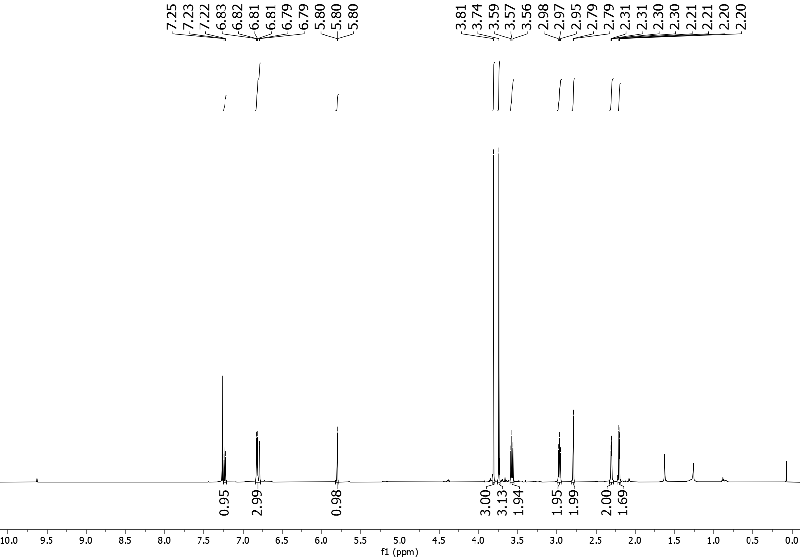
3ha ¹³C NMR (151 MHz, CDCl₃)
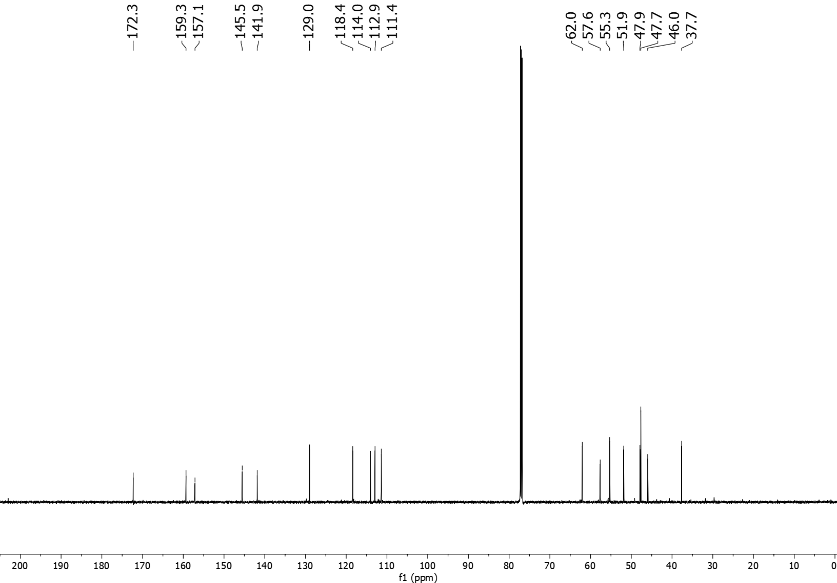
3ia ¹H NMR (600 MHz, CDCl₃)
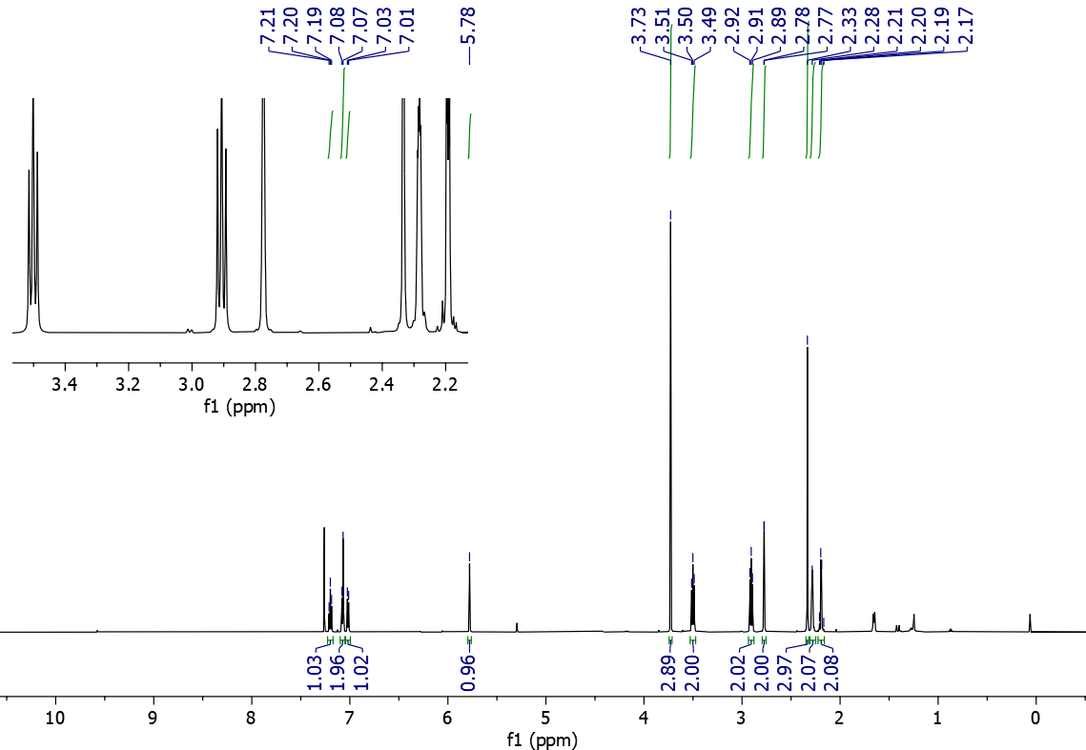
3ia ¹³C NMR (151 MHz, CDCl₃)
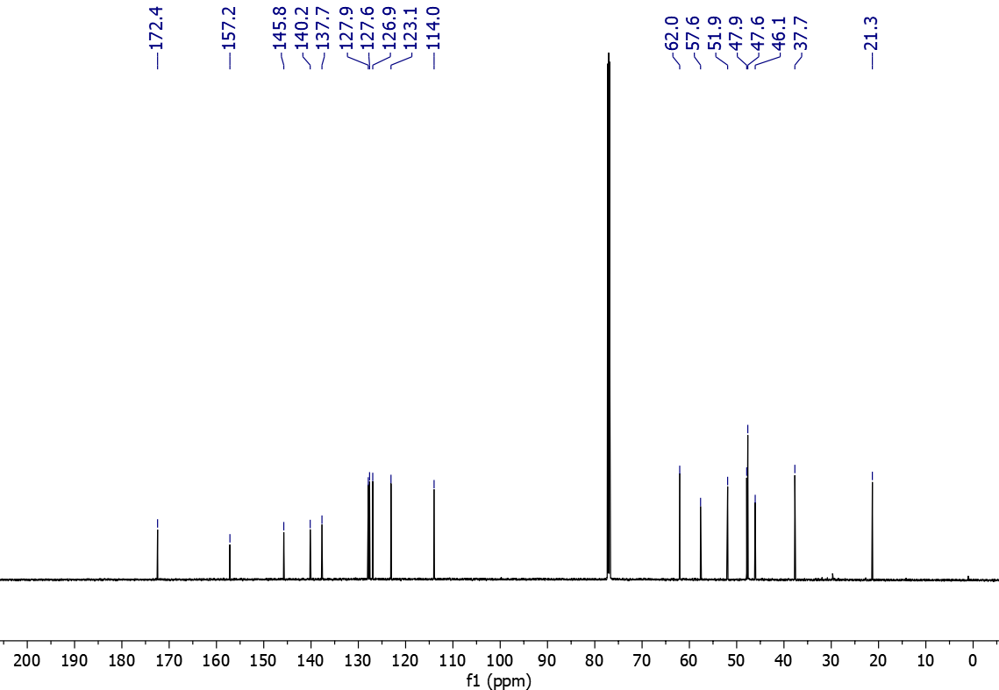
3ja ¹H NMR (600 MHz, CDCl₃)
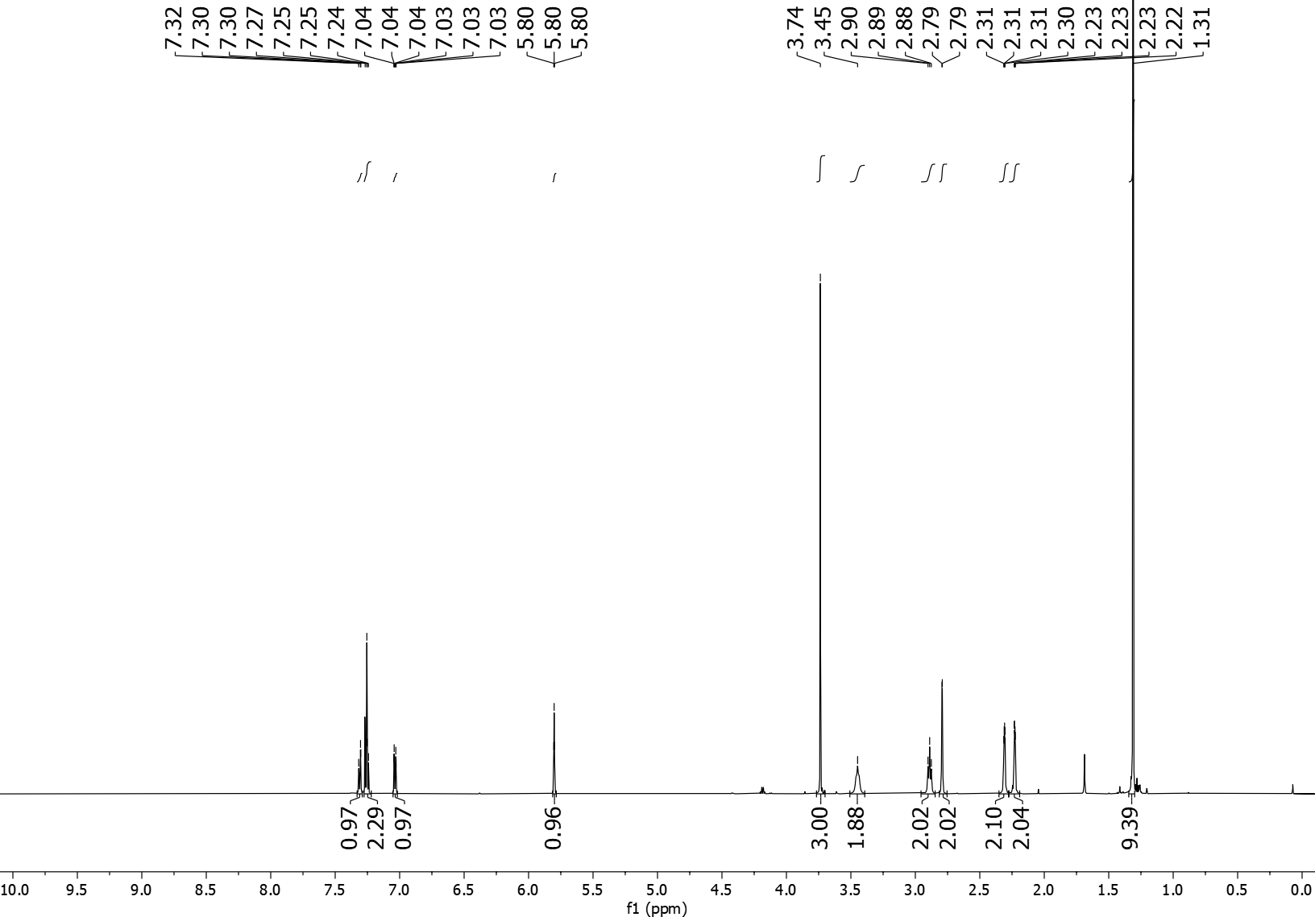
3ja ¹³C NMR (151 MHz, CDCl₃)
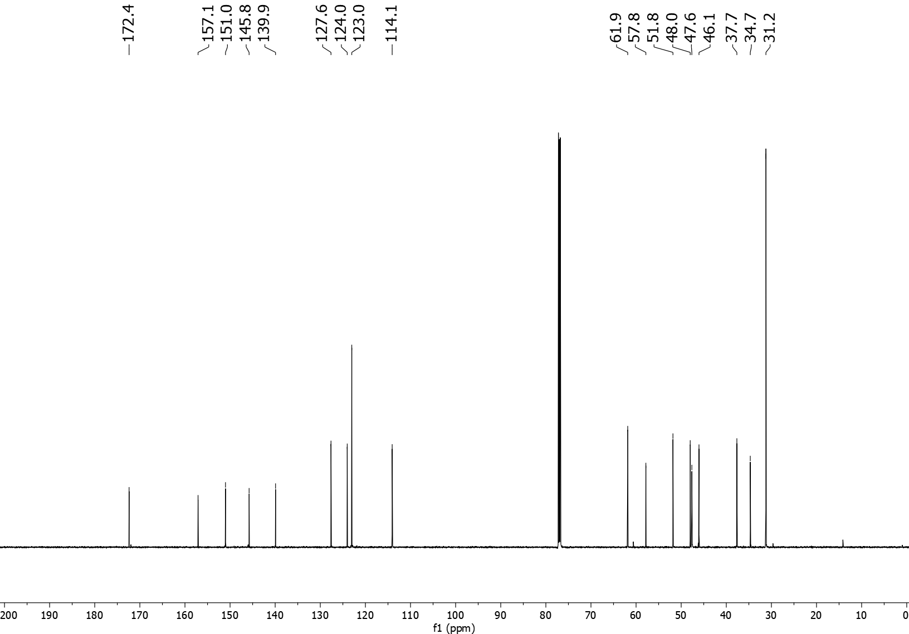
3ka ¹H NMR (600 MHz, CDCl₃)
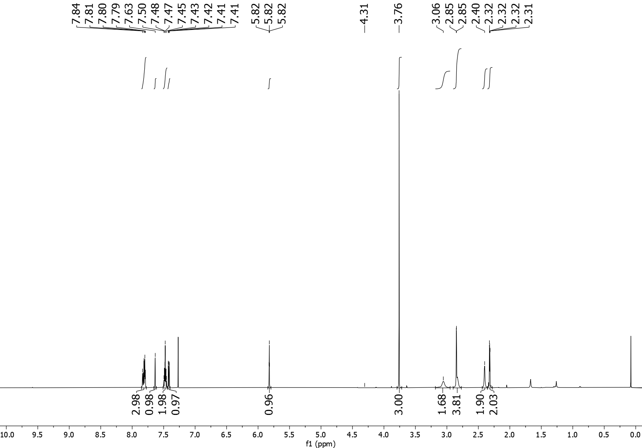
3ka ¹³C NMR (151 MHz, CDCl₃)
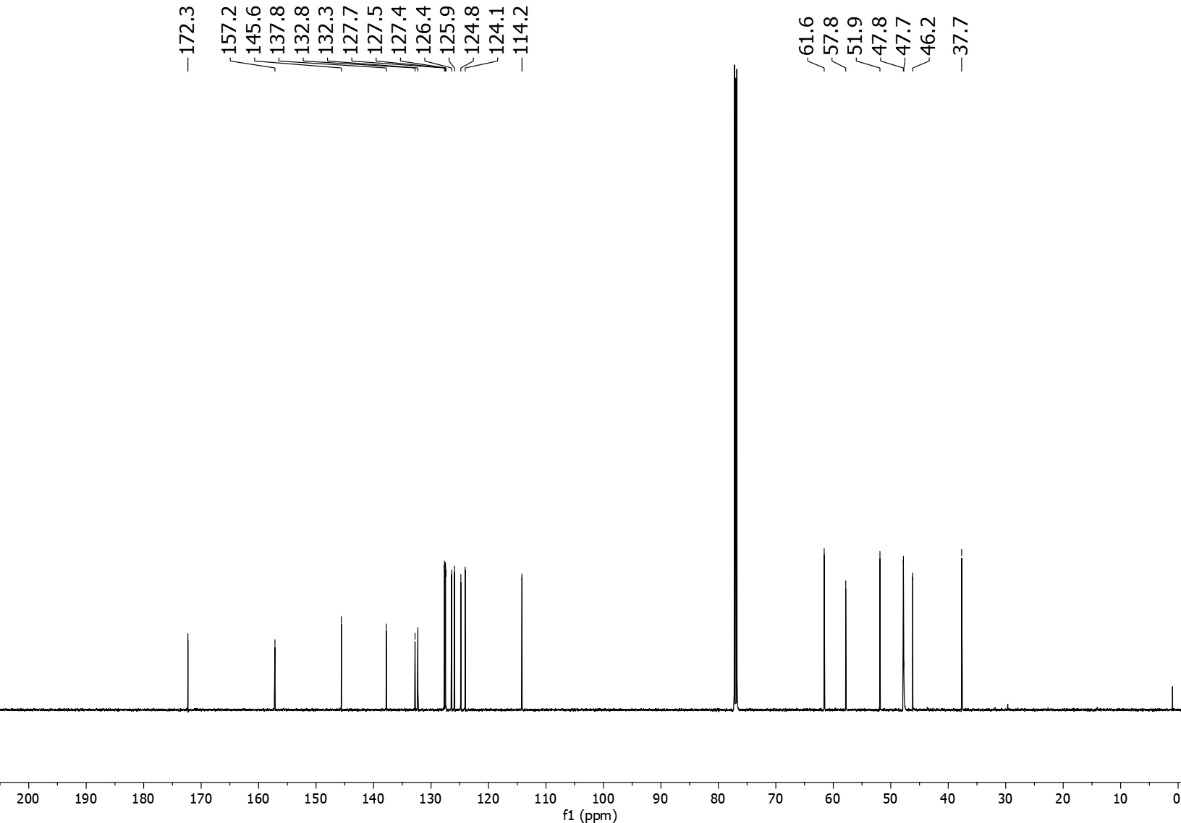
3la ¹H NMR (600 MHz, CDCl₃)
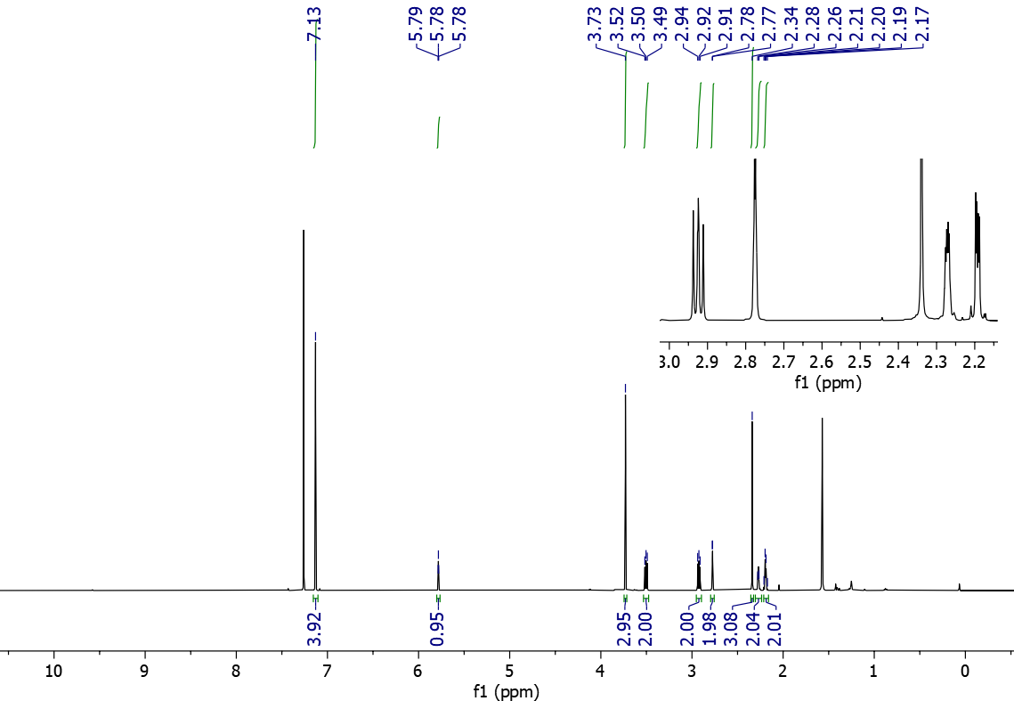
3la ¹³C NMR (151 MHz, CDCl₃)
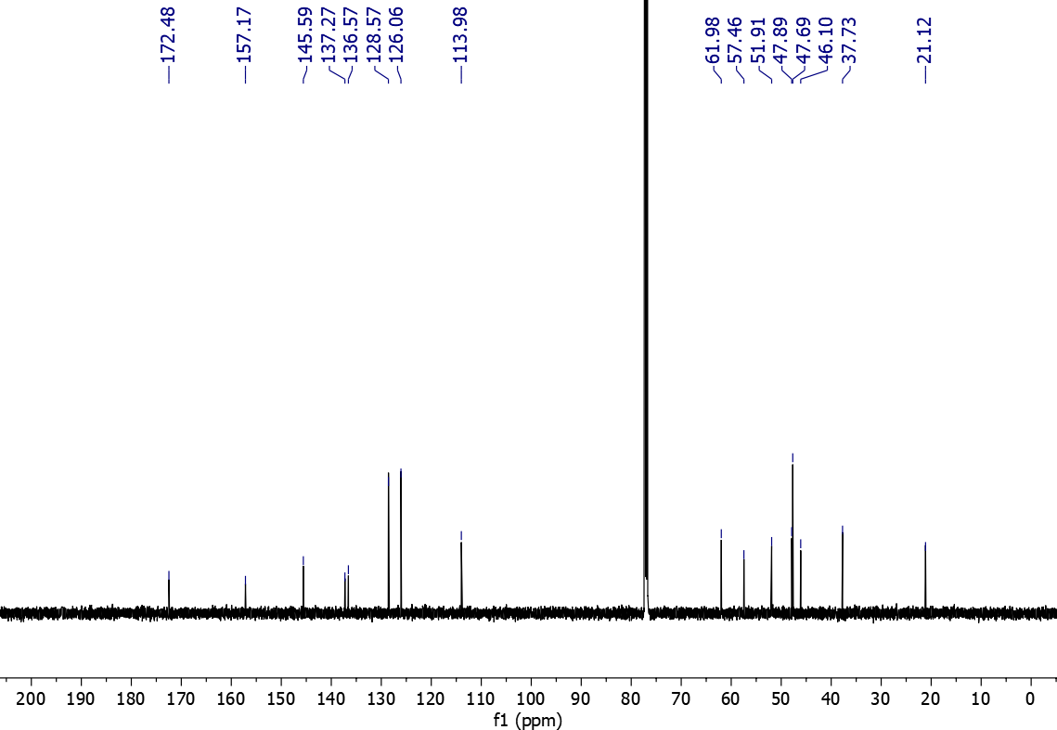
3ma ¹H NMR (600 MHz, CDCl₃)
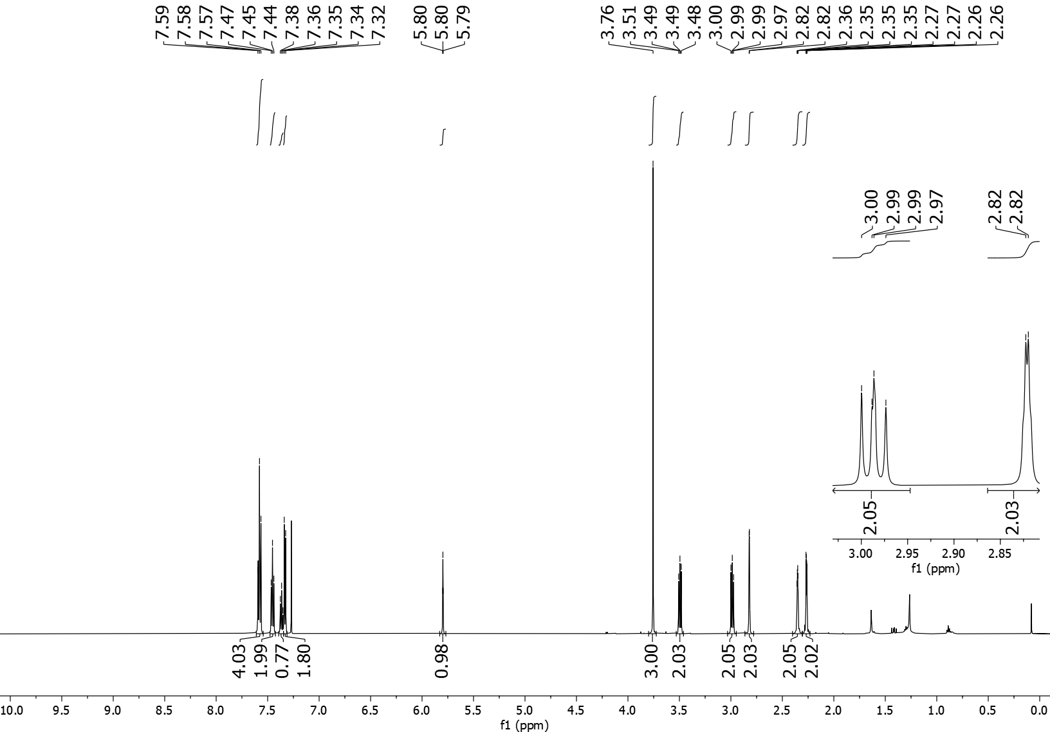
3ma ¹³C NMR (151 MHz, CDCl₃)
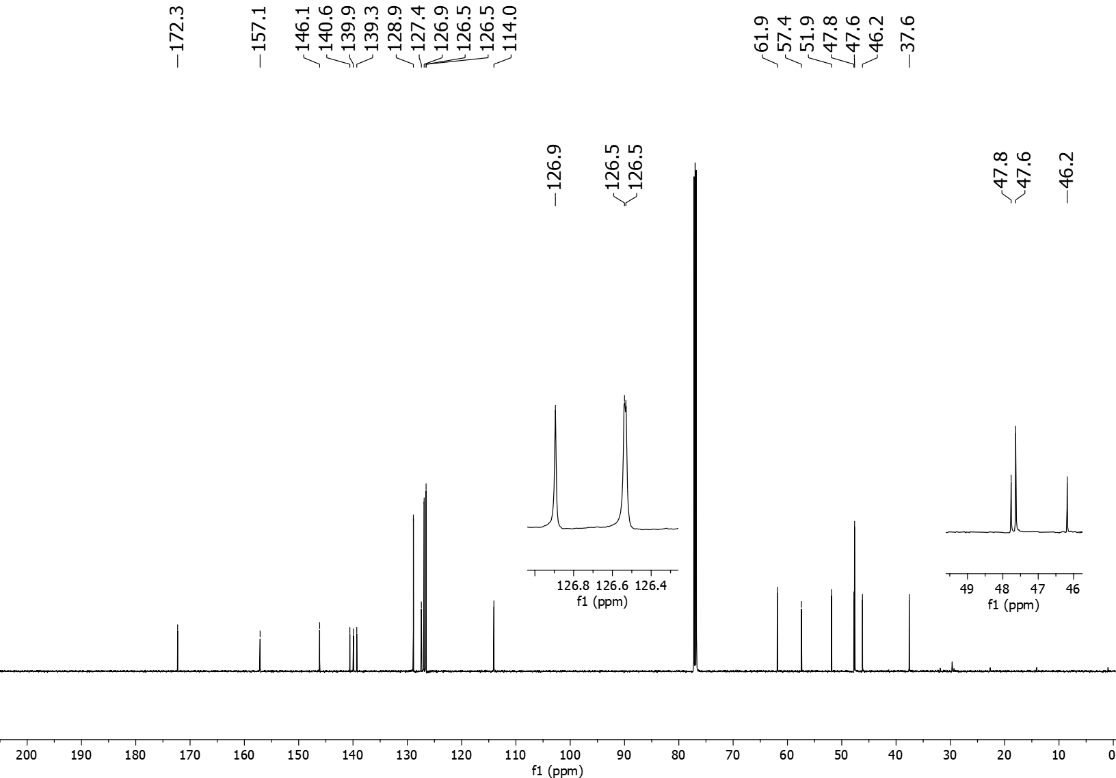
3na ¹H NMR (600 MHz, CDCl₃)
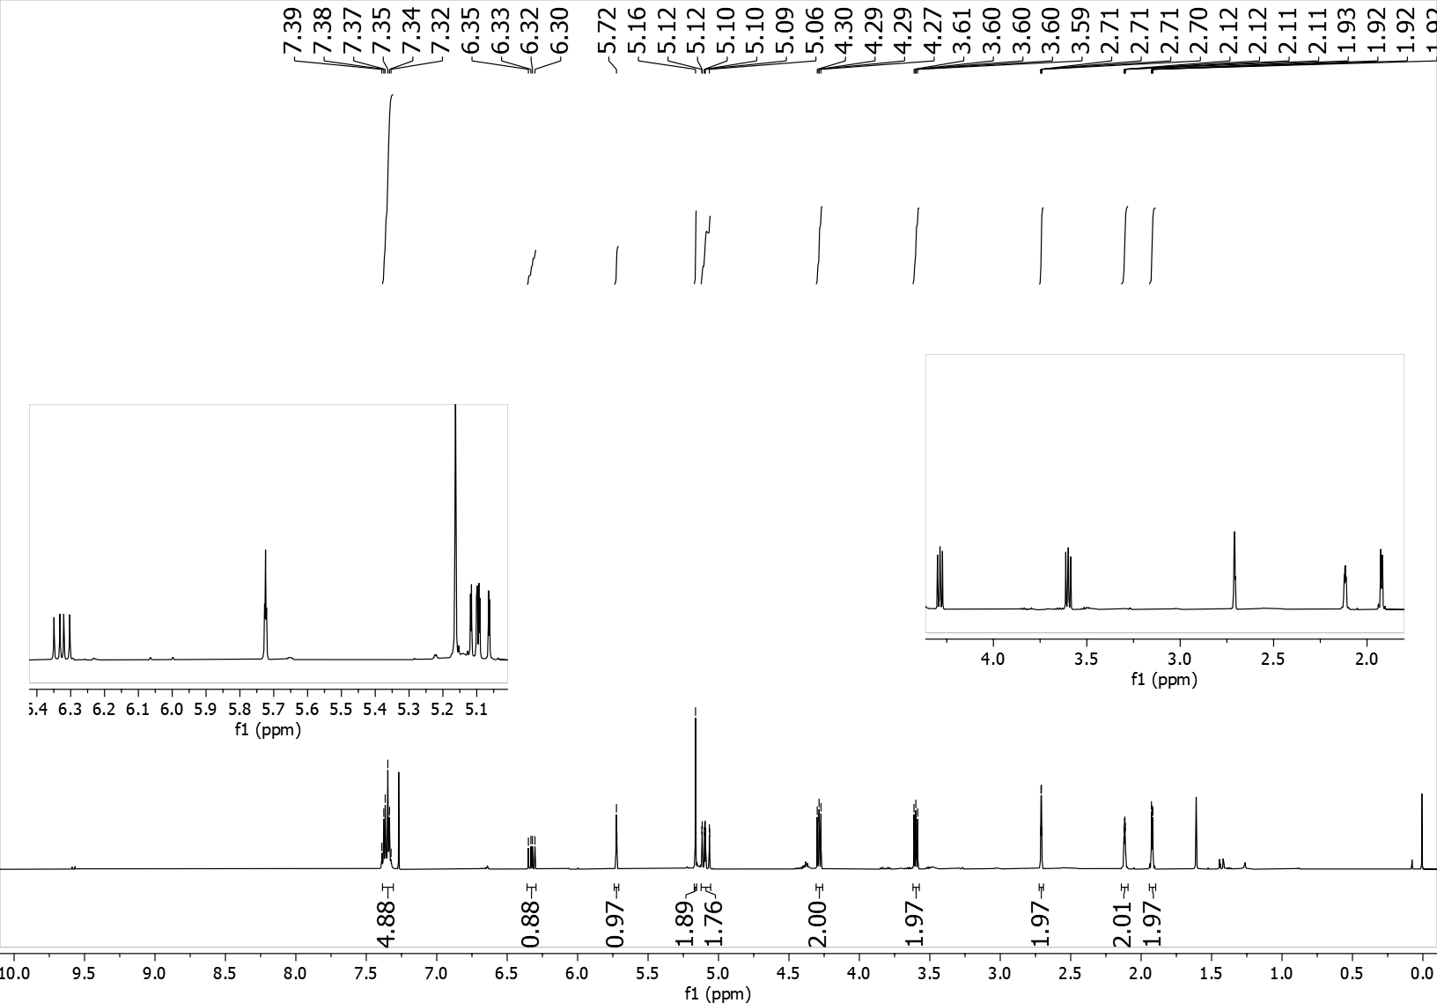

3na ¹³C NMR (151 MHz, CDCl₃)
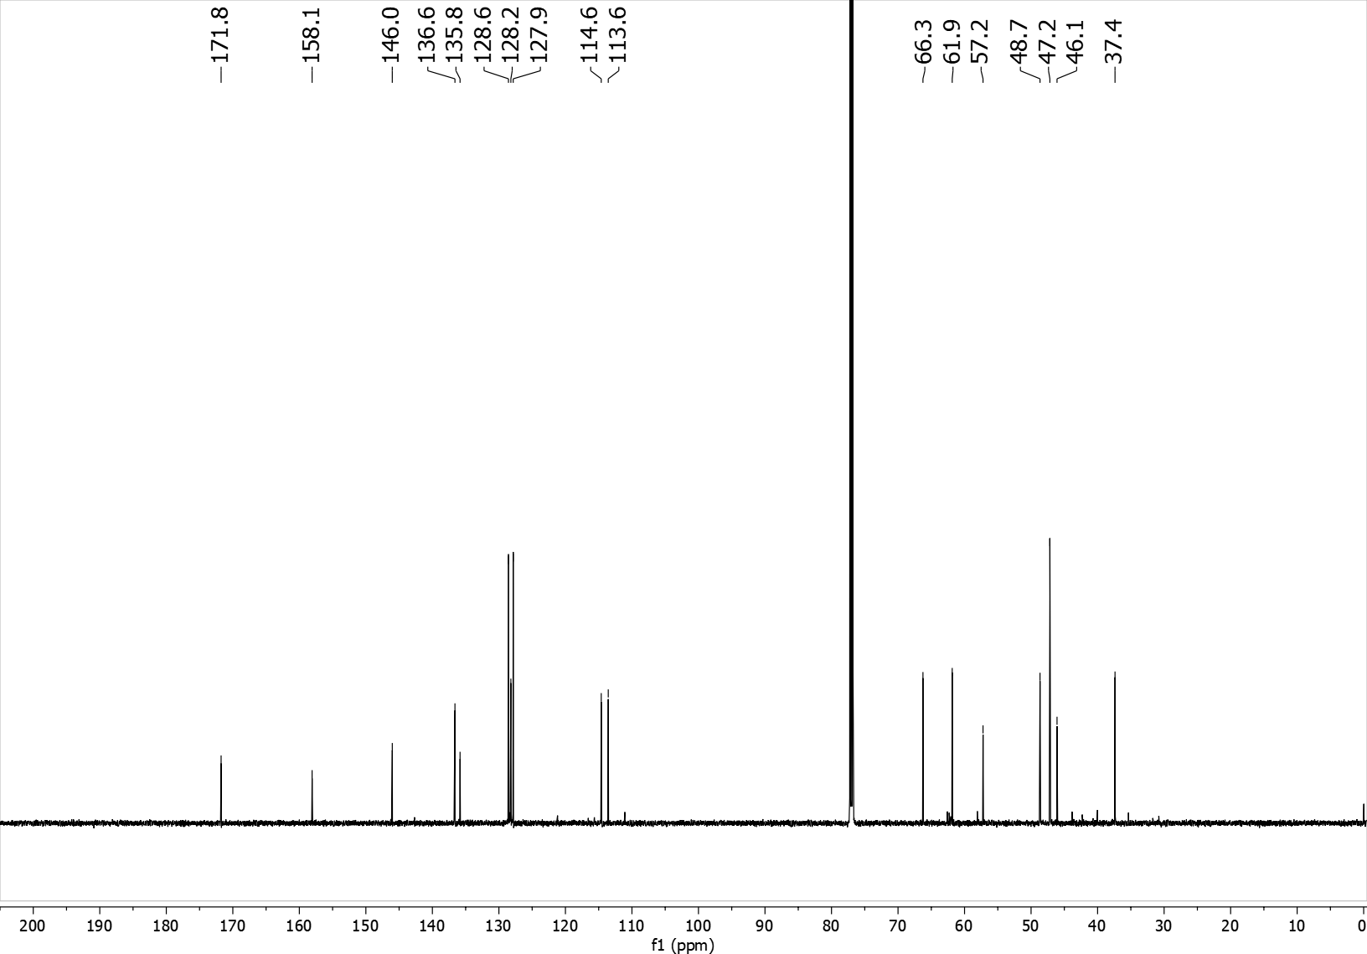
3oa ¹H NMR (600 MHz, CDCl₃)
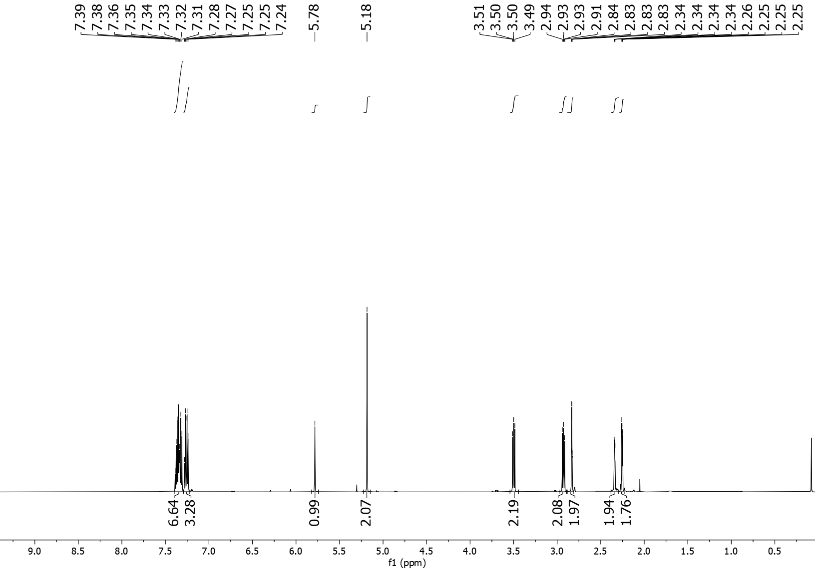
3oa ¹³C NMR (151 MHz, CDCl₃)
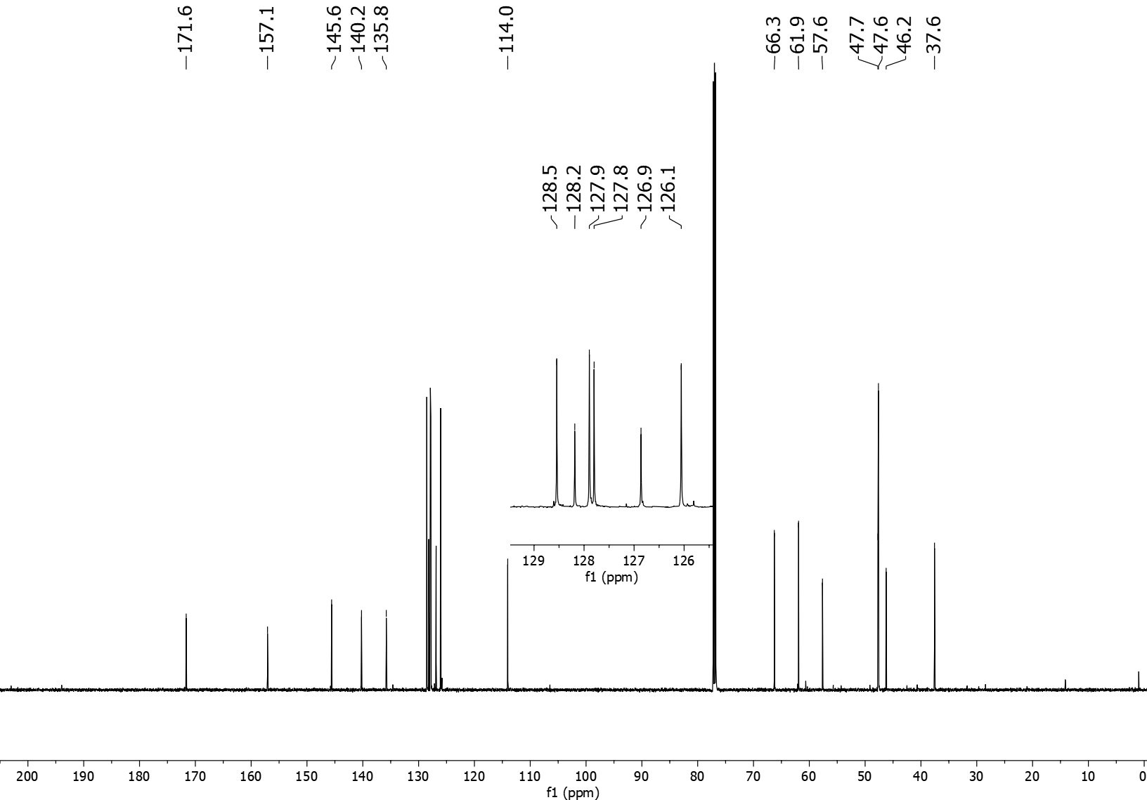
3pa ¹H NMR (600 MHz, CDCl₃)
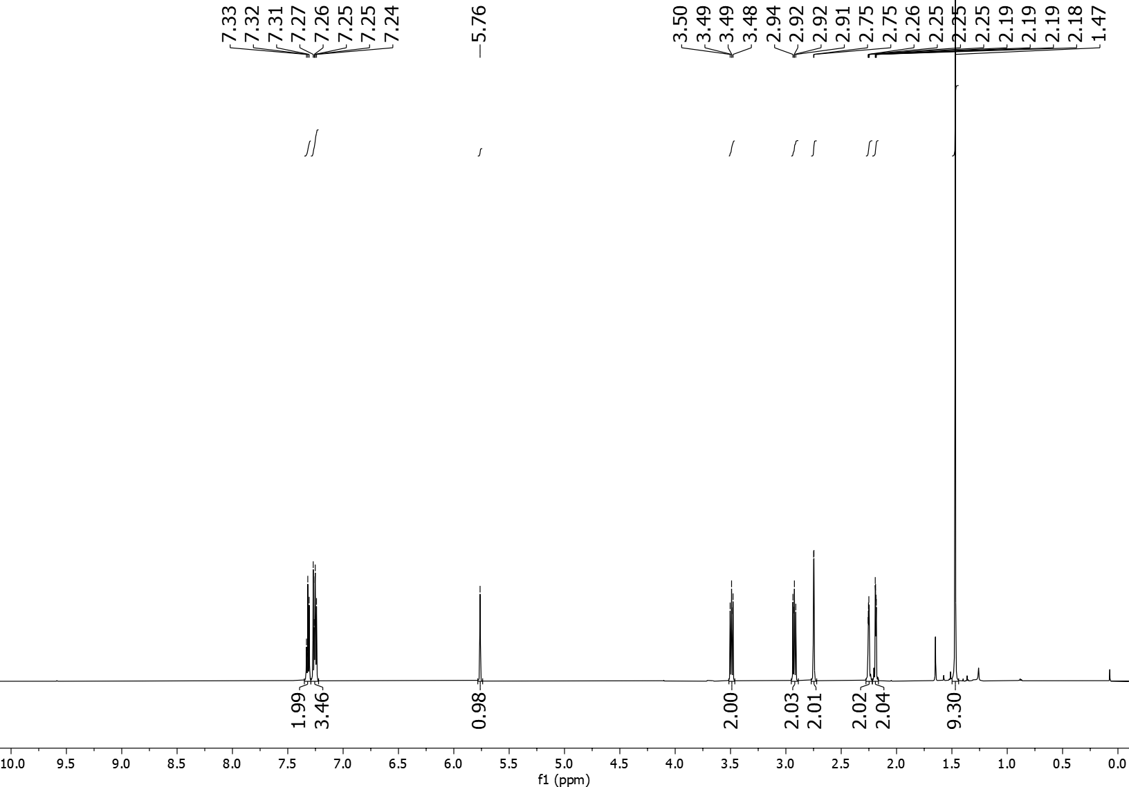
3pa ¹³C NMR (151 MHz, CDCl₃)
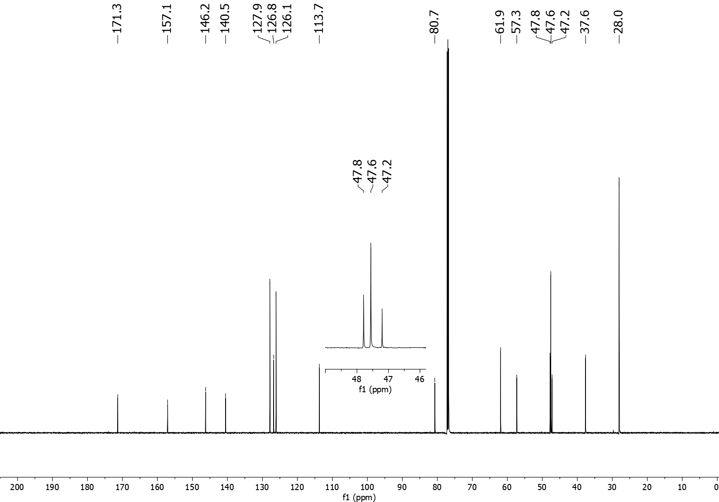
3qa ¹H NMR (600 MHz, CDCl₃)
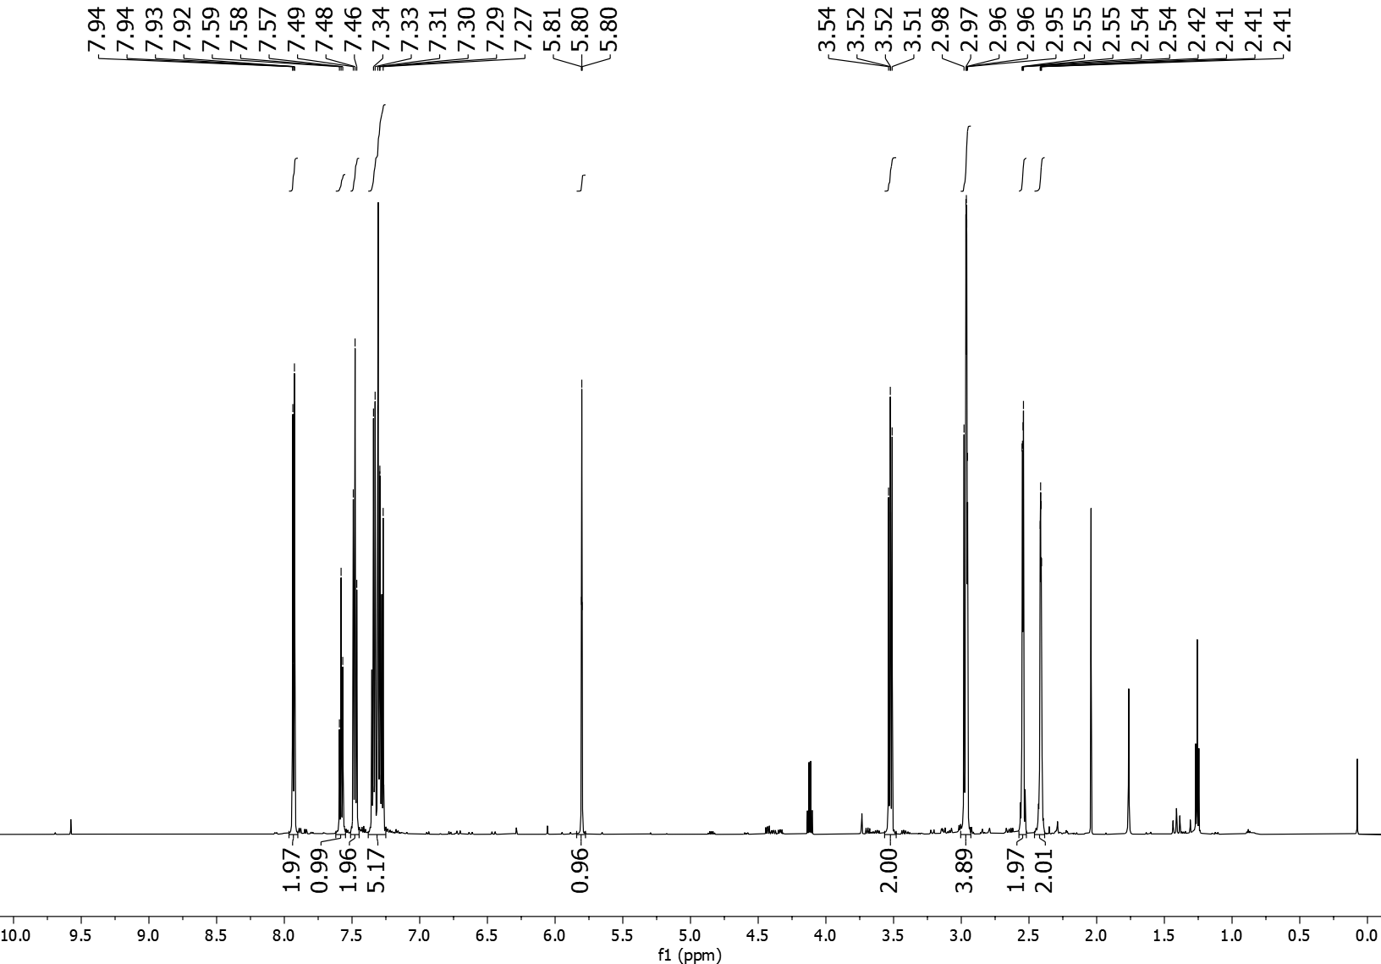
3qa ¹³C NMR (151 MHz, CDCl₃)
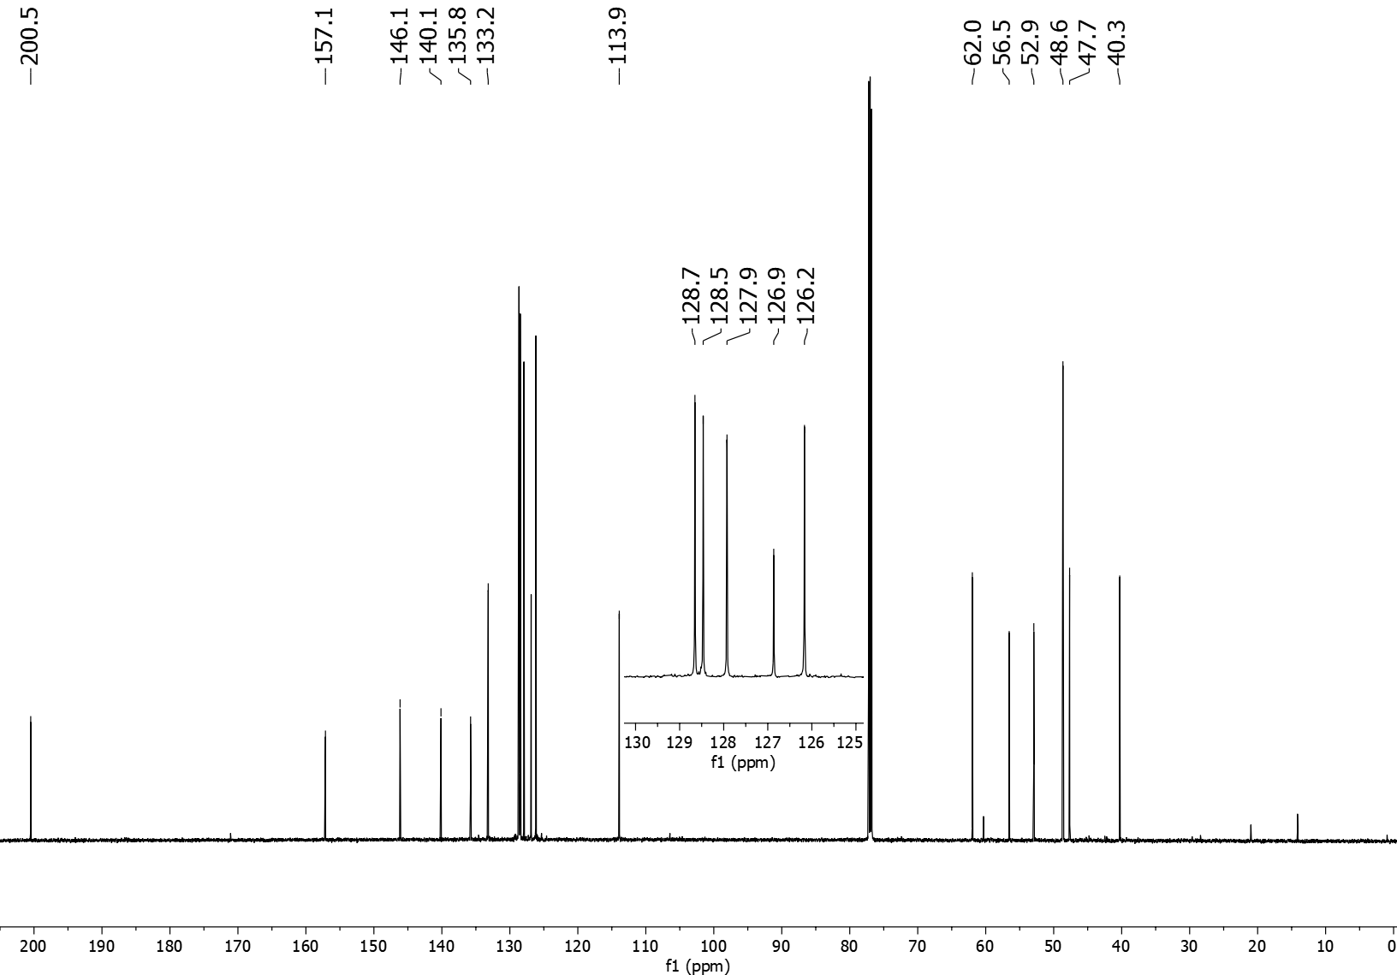
3ra ¹H NMR (600 MHz, CDCl₃)
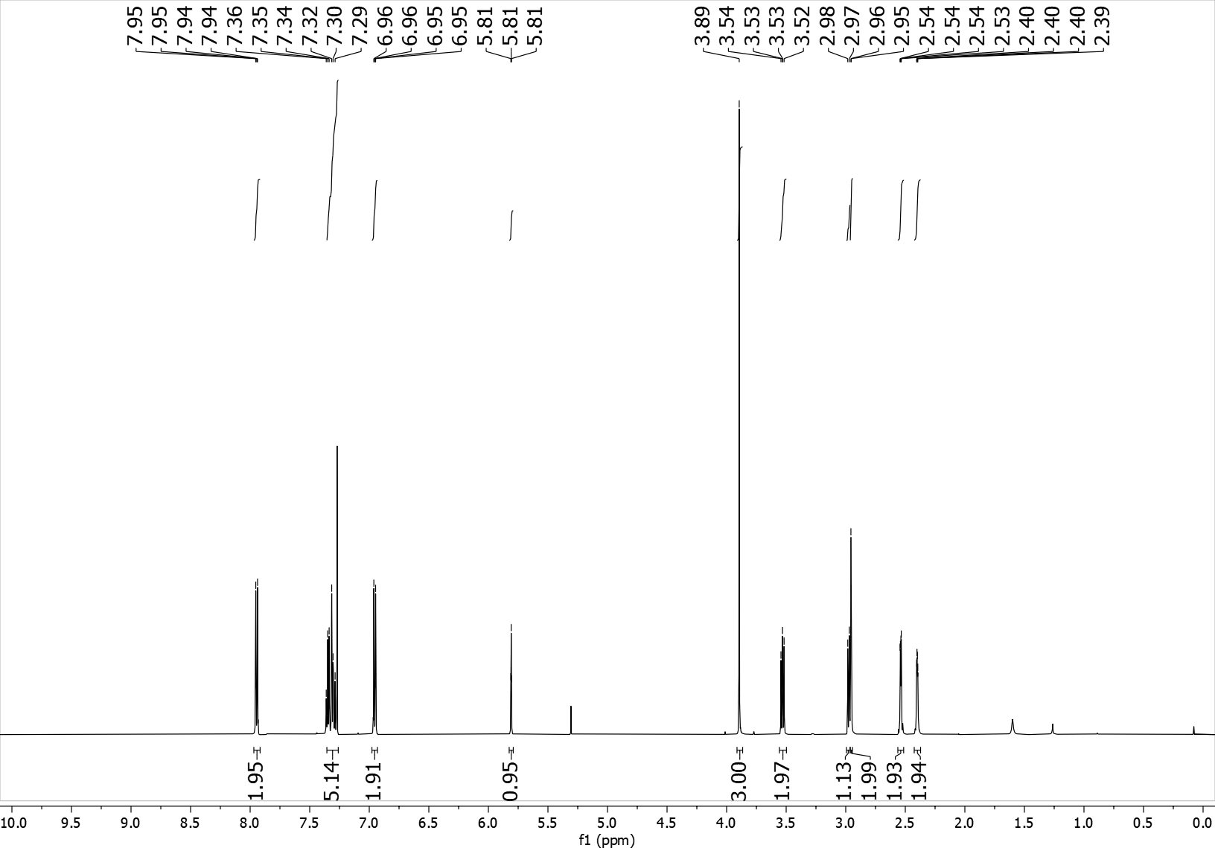
3ra ¹³C NMR (151 MHz, CDCl₃)
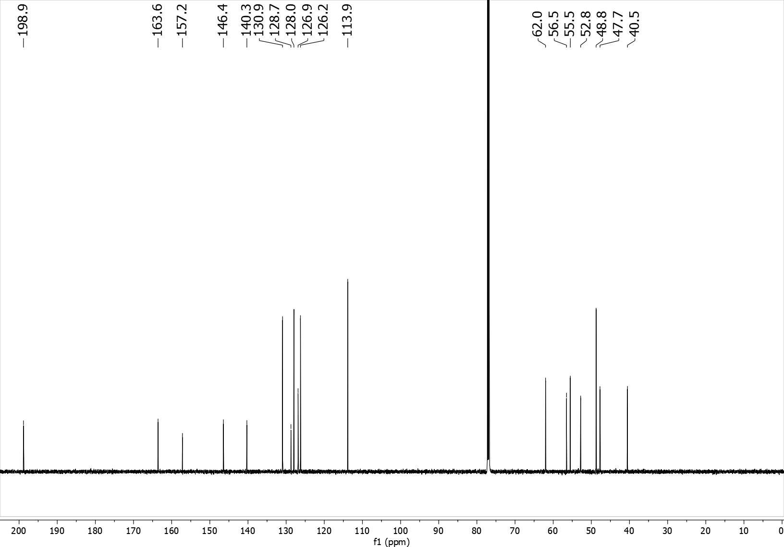

3sa ¹H NMR (600 MHz, CDCl₃)
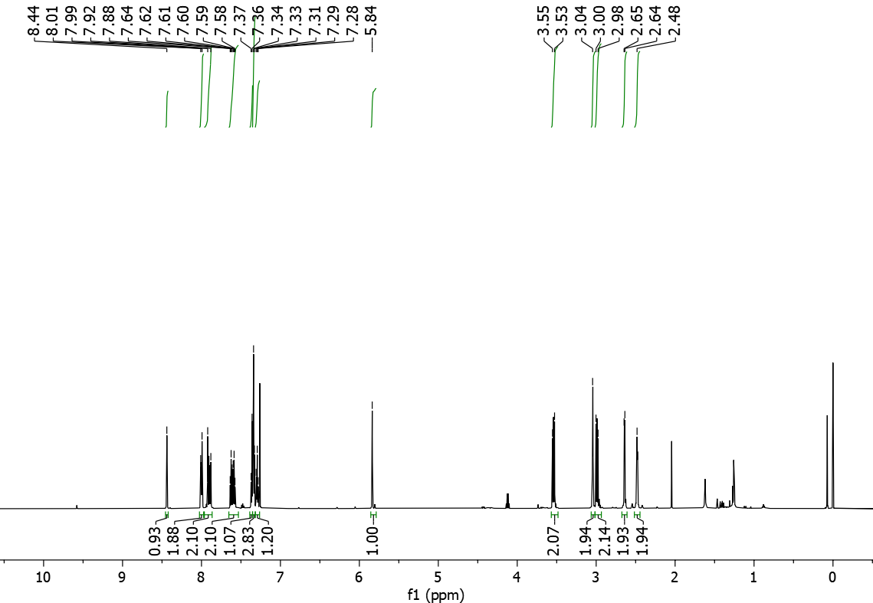
3sa ¹³C NMR (151 MHz, CDCl₃)
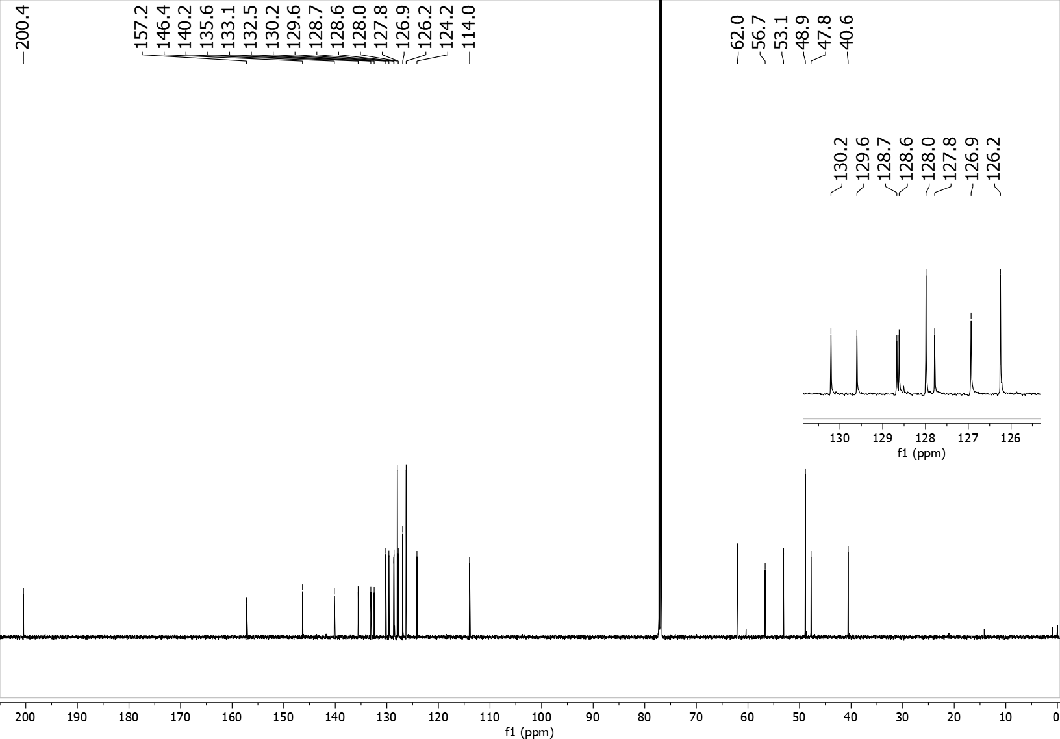
3ta ¹H NMR (600 MHz, CDCl₃)
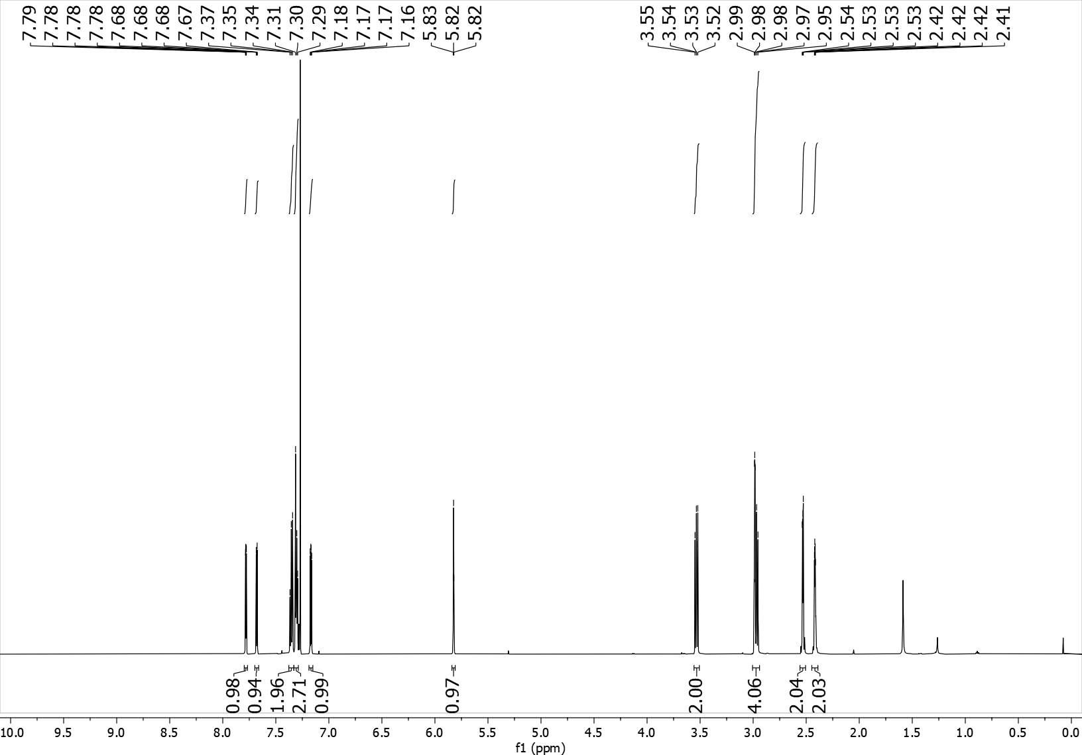
3ta ¹³C NMR (151 MHz, CDCl₃)
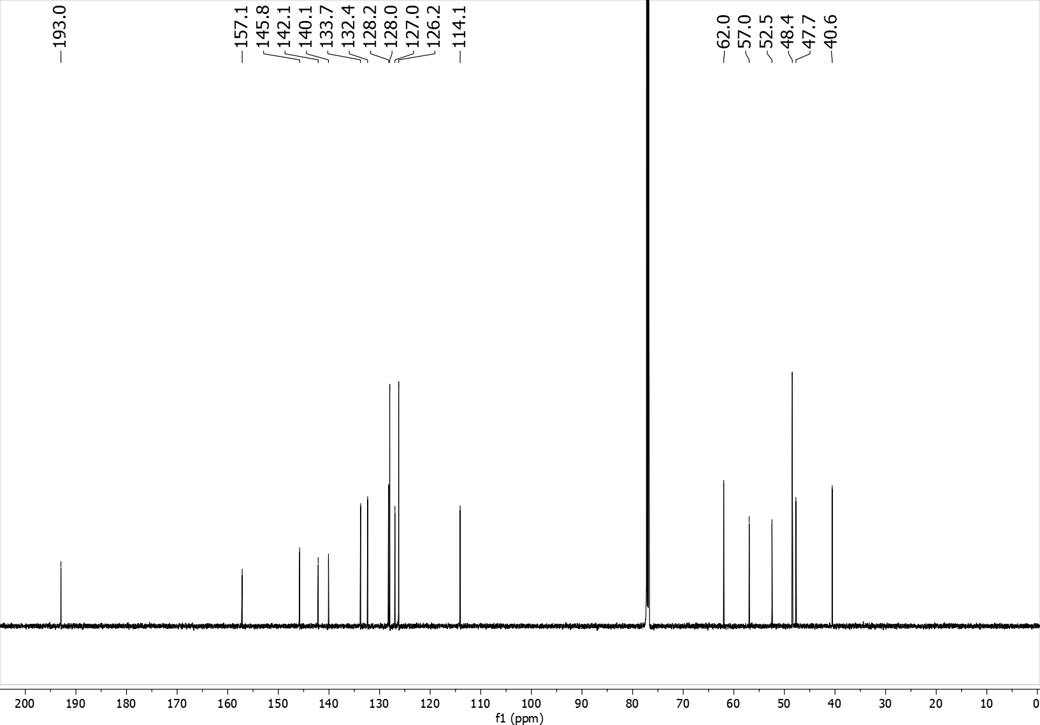

3ua ¹H NMR (600 MHz, CDCl₃)
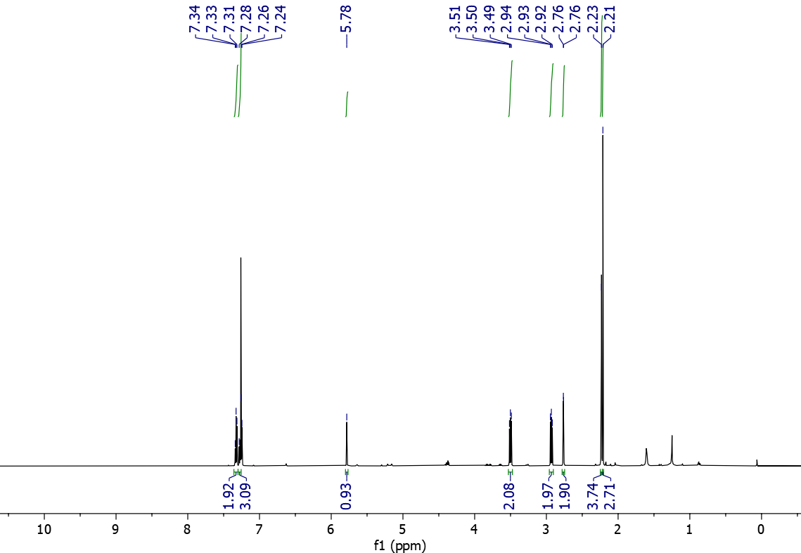
3ua ¹³C NMR (151 MHz, CDCl₃)
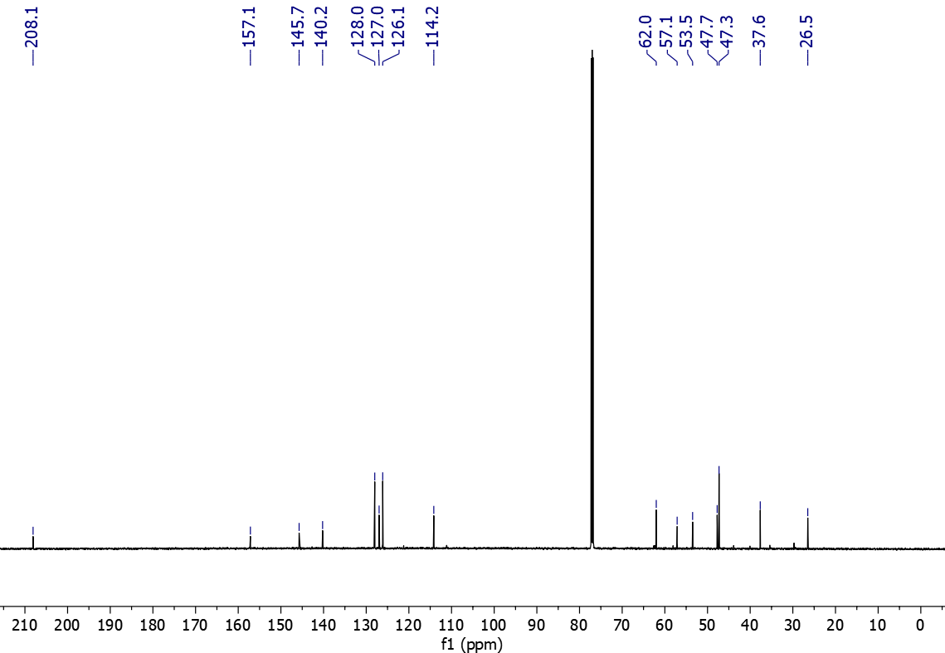

3va ¹H NMR (600 MHz, CDCl₃)
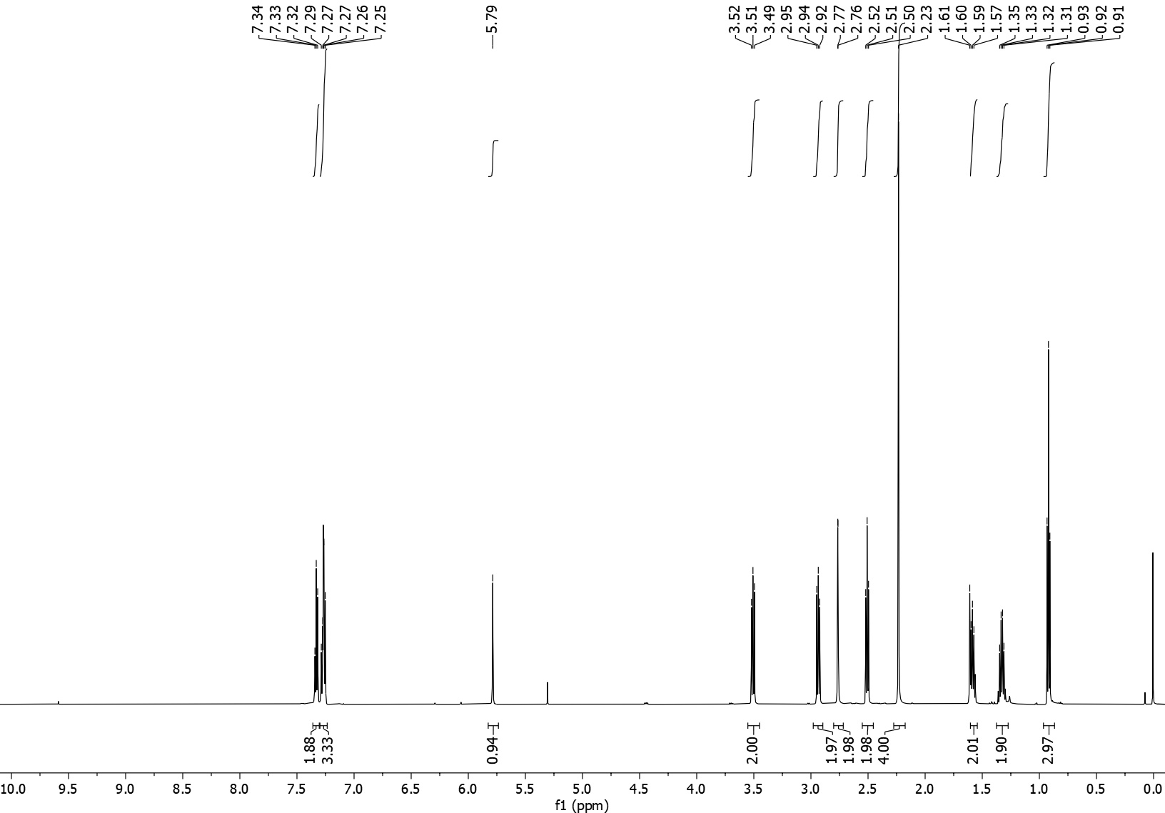
3va ¹³C NMR (151 MHz, CDCl₃)
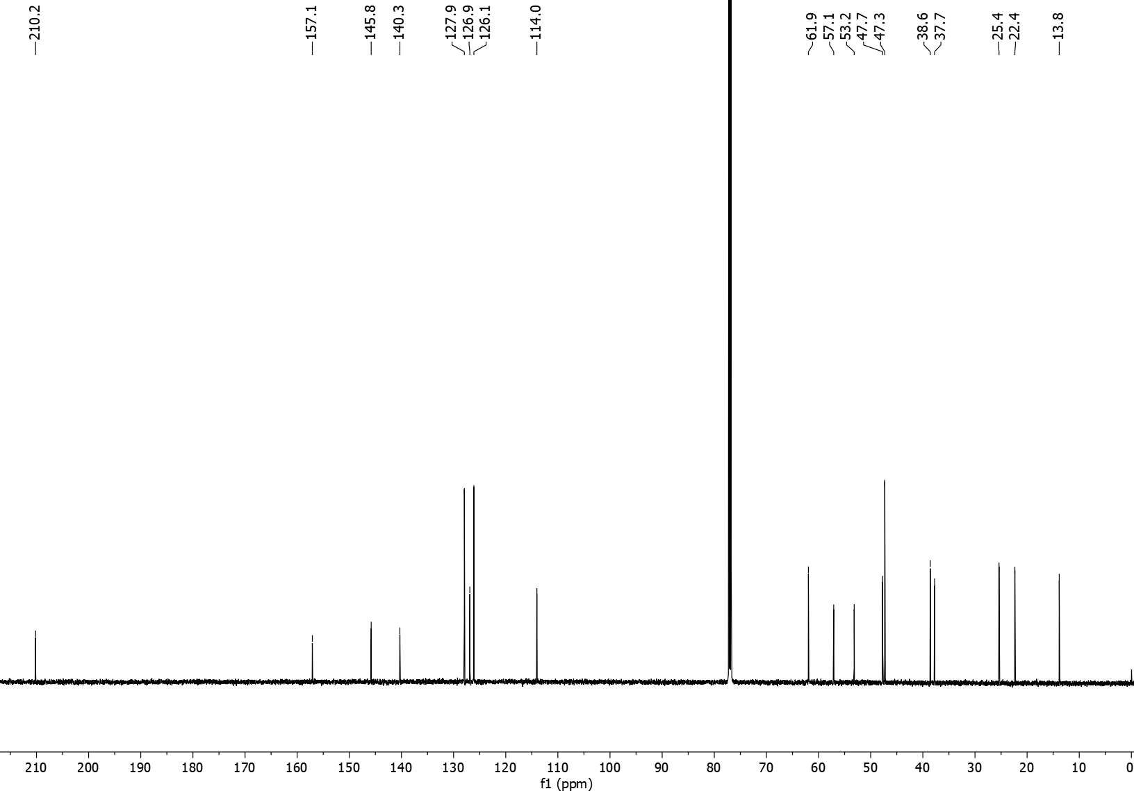
3wa ¹H NMR (600 MHz, CDCl₃)
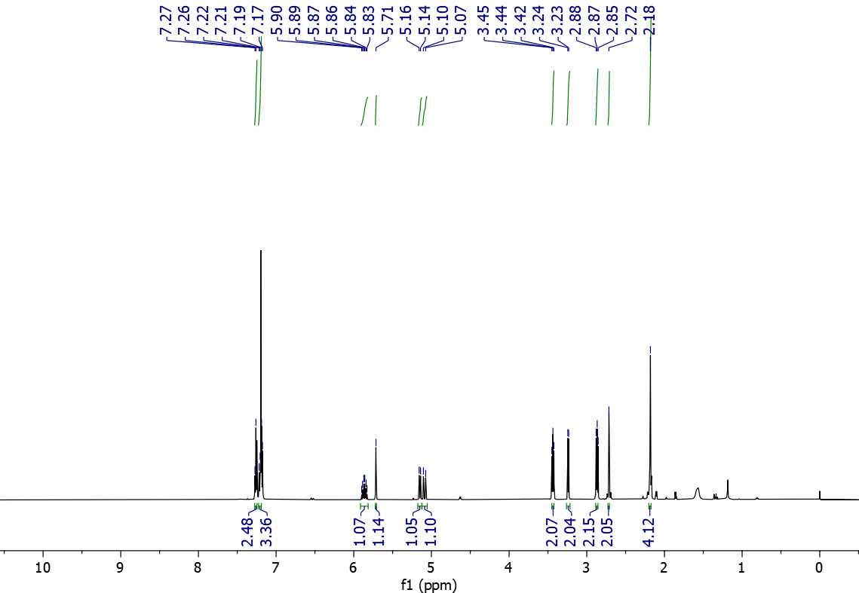

3wa ¹³C NMR (151 MHz, CDCl₃)
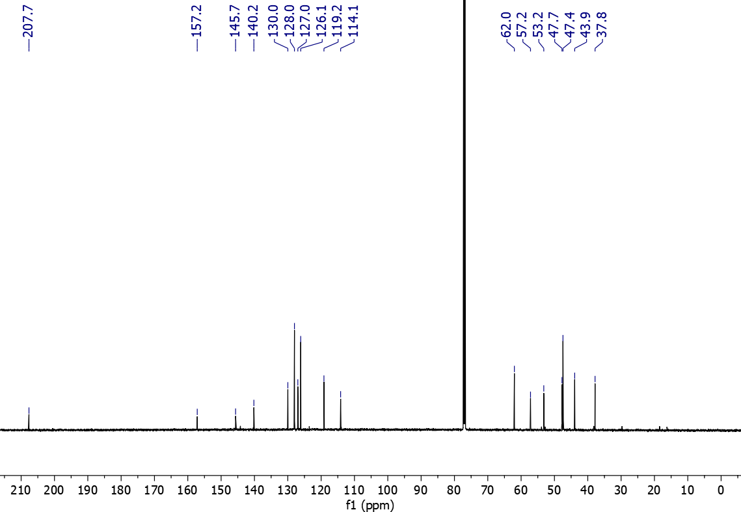
3xa ¹H NMR (600 MHz, CDCl₃)
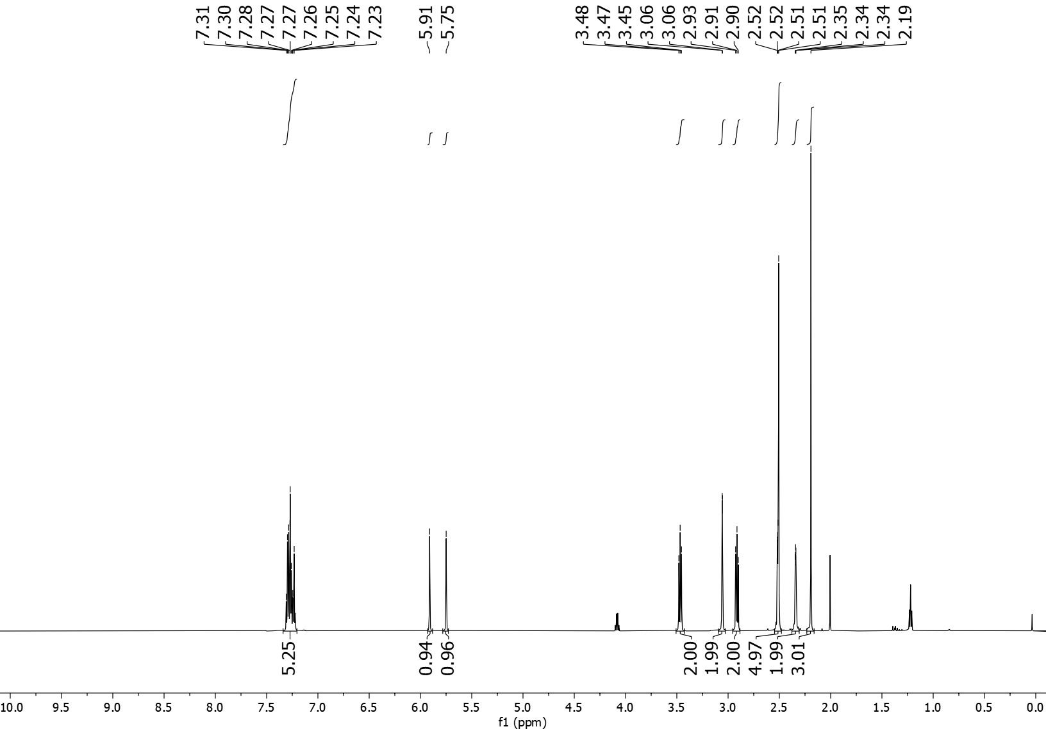

3xa ¹³C NMR (151 MHz, CDCl₃)
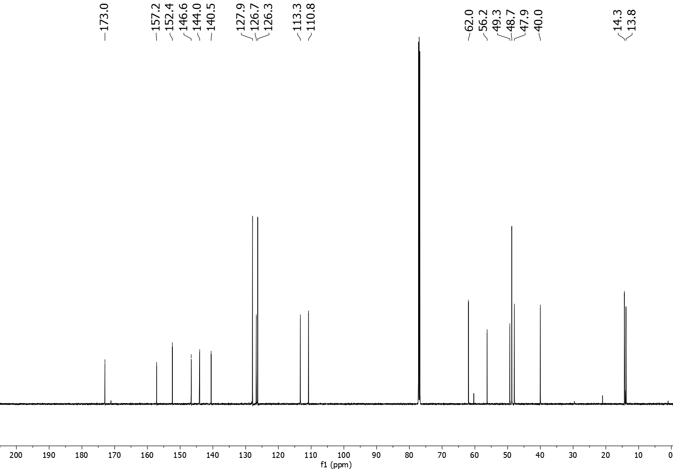
3ab ¹H NMR (600 MHz, CDCl₃)
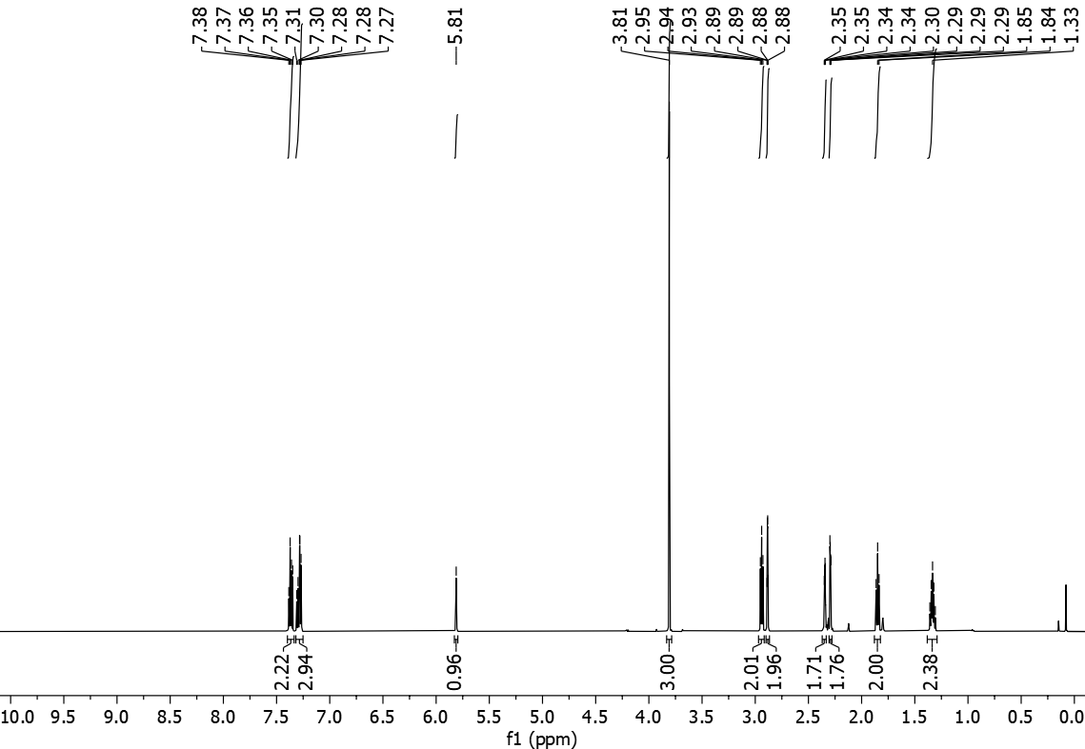

3ab ¹³C NMR (151 MHz, CDCl₃)
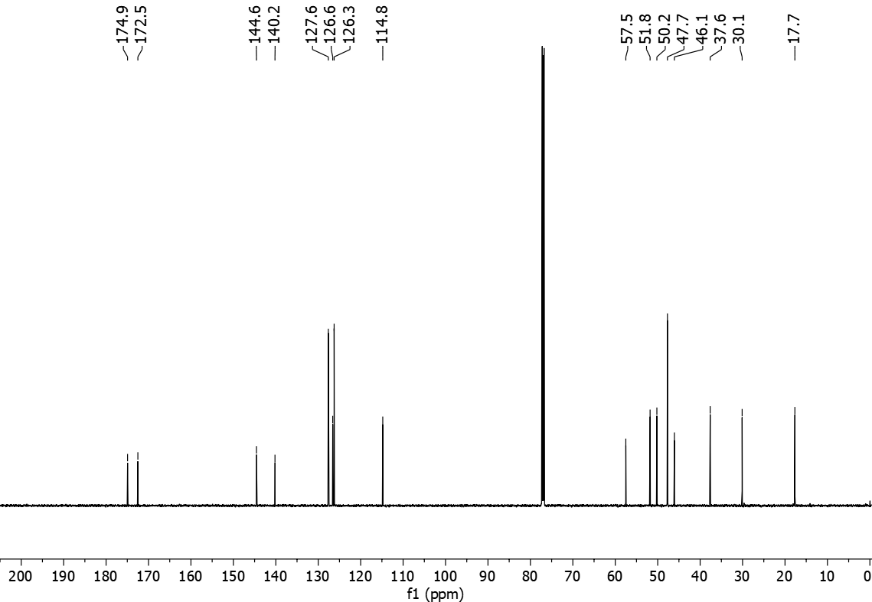
3ac ¹H NMR (600 MHz, CDCl₃)
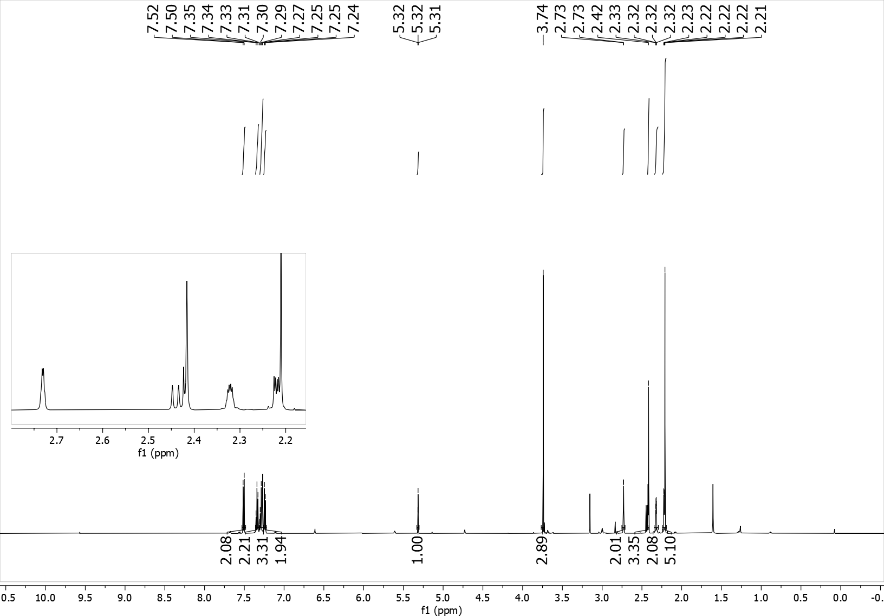
3ac ¹³C NMR (151 MHz, CDCl₃)
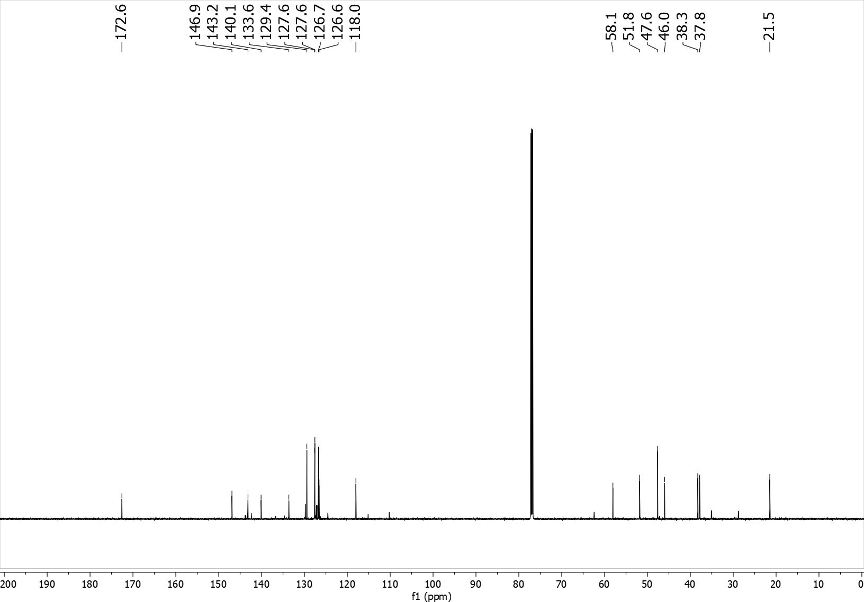
5aa ¹H NMR (600 MHz, CDCl₃)
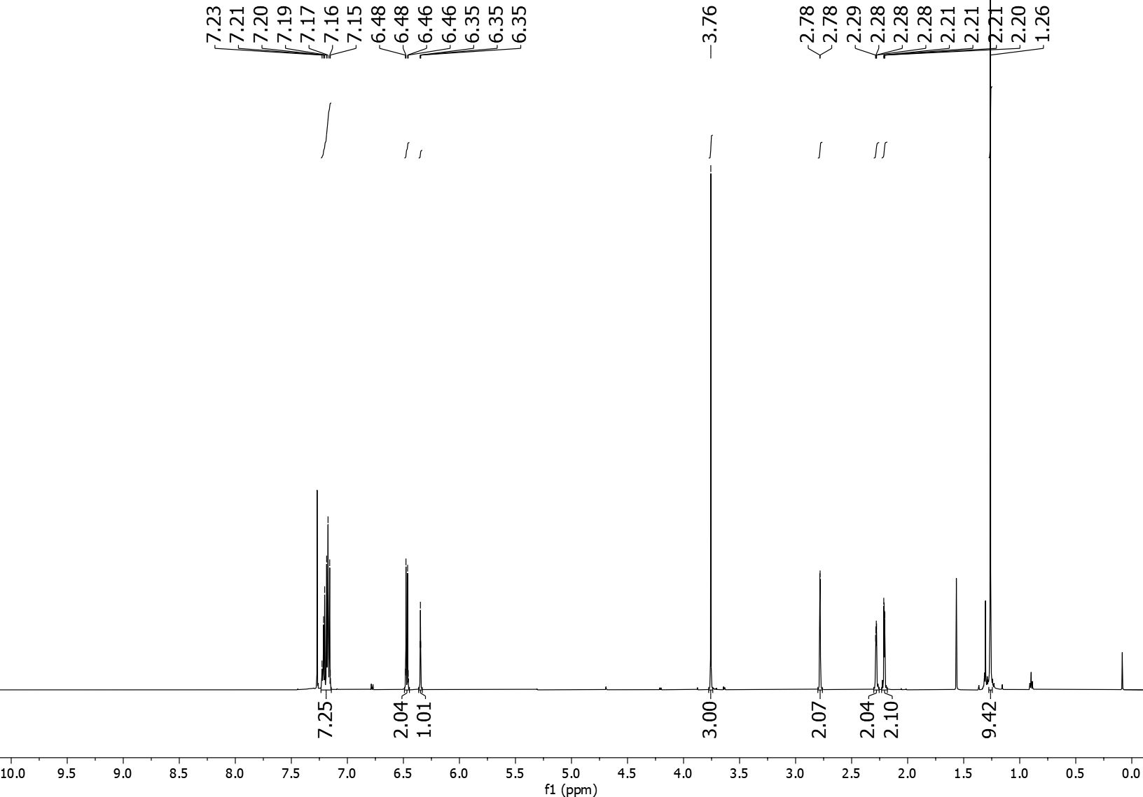
5aa ¹³C NMR (151 MHz, CDCl₃)
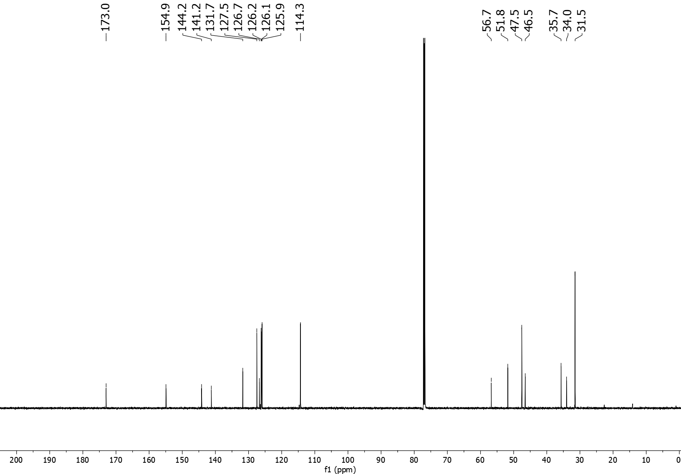

5ab ¹H NMR (600 MHz, CDCl₃)
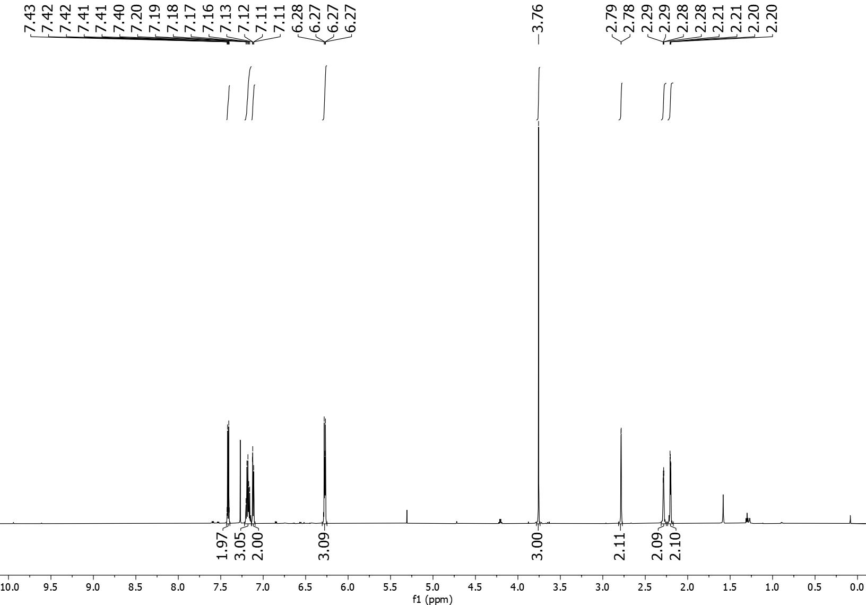
5ab ¹³C NMR (151 MHz, CDCl₃)
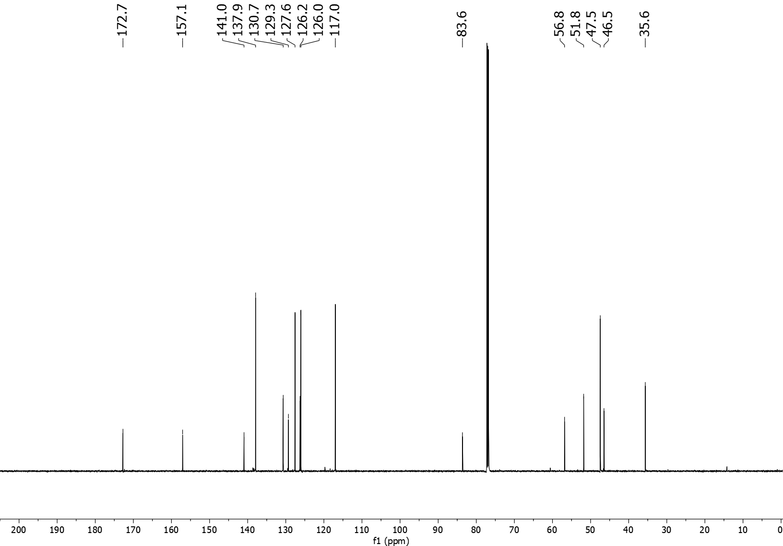
5ac ¹H NMR (600 MHz, CDCl₃)
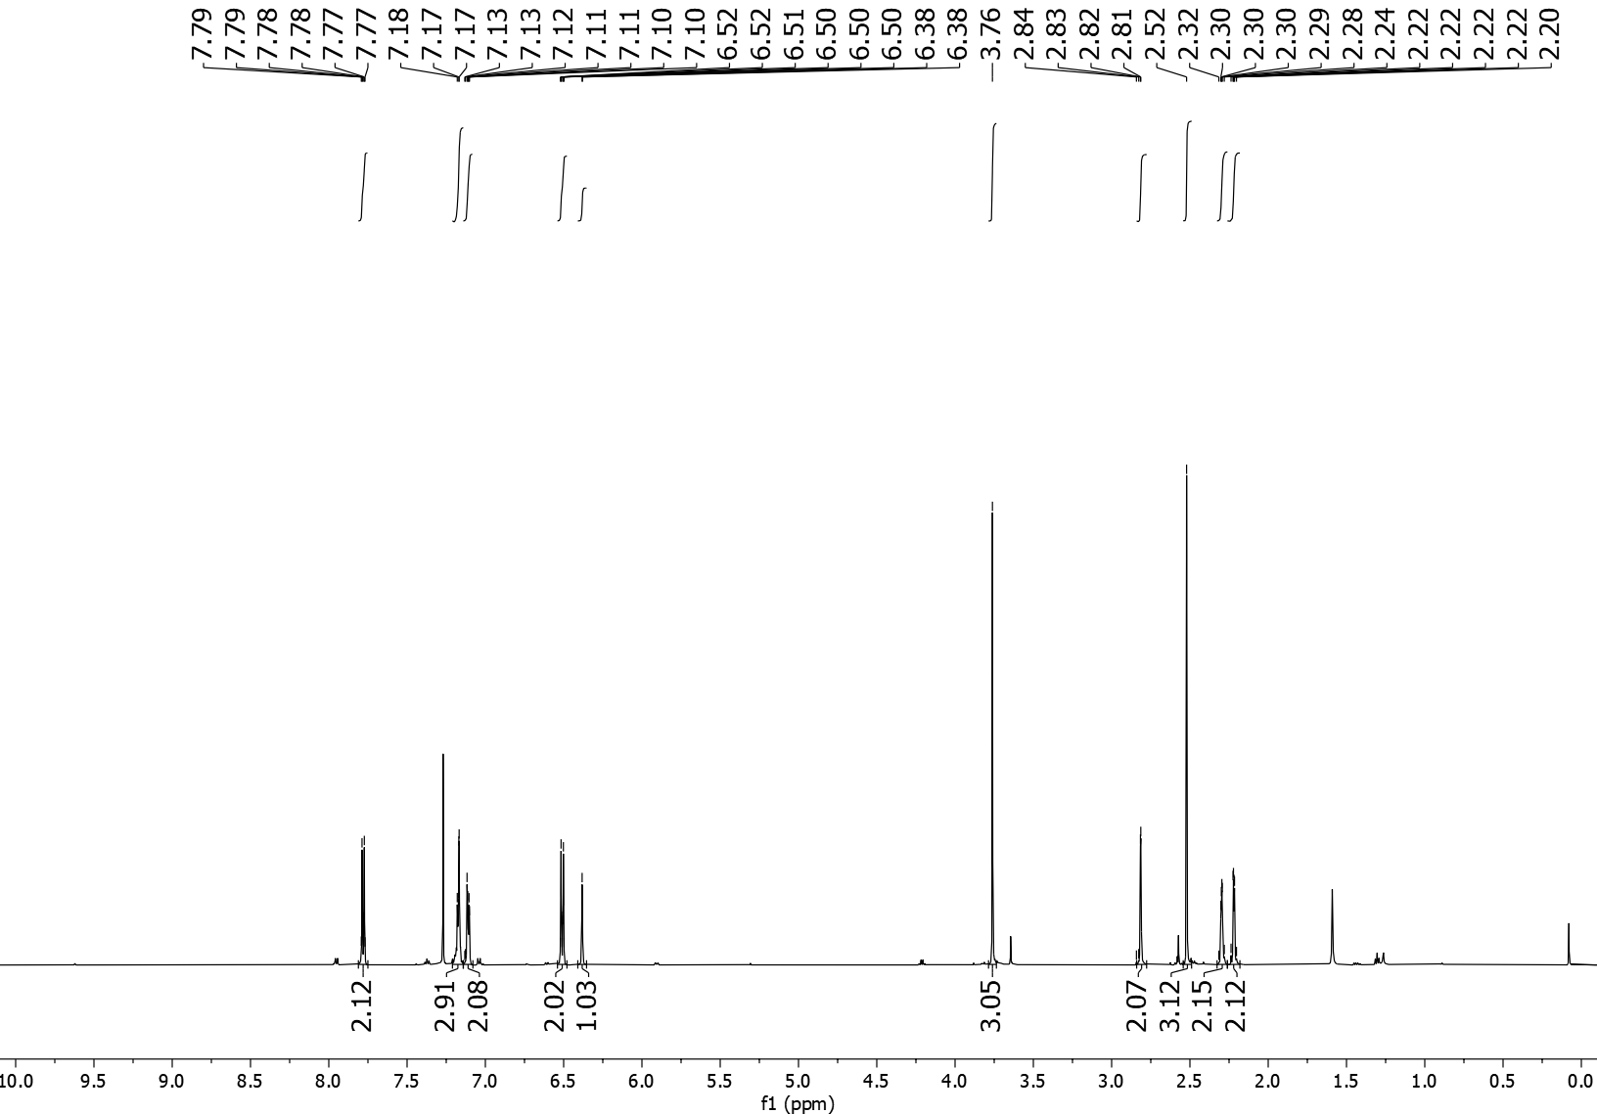
5ac ¹³C NMR (151 MHz, CDCl₃)
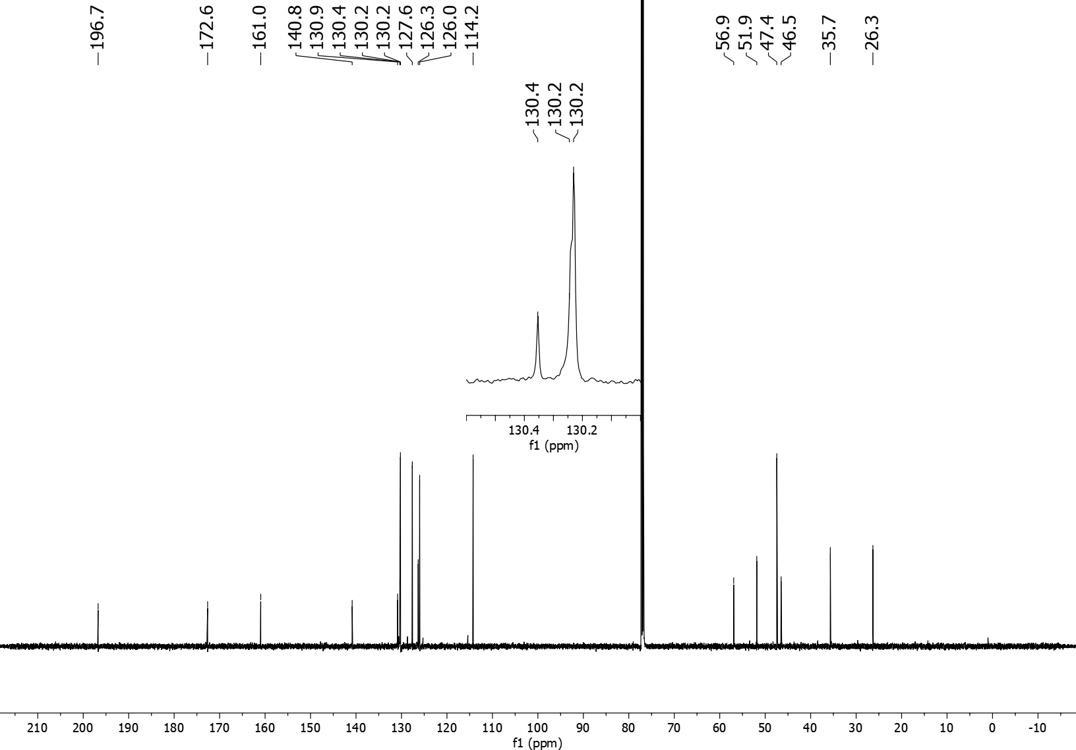
5ad ¹H NMR (600 MHz, CDCl₃)
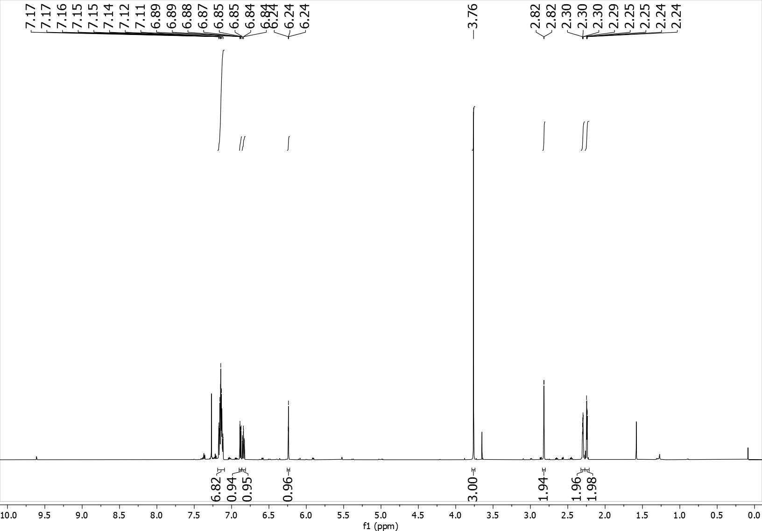
5ad ¹³C NMR (151 MHz, CDCl₃)
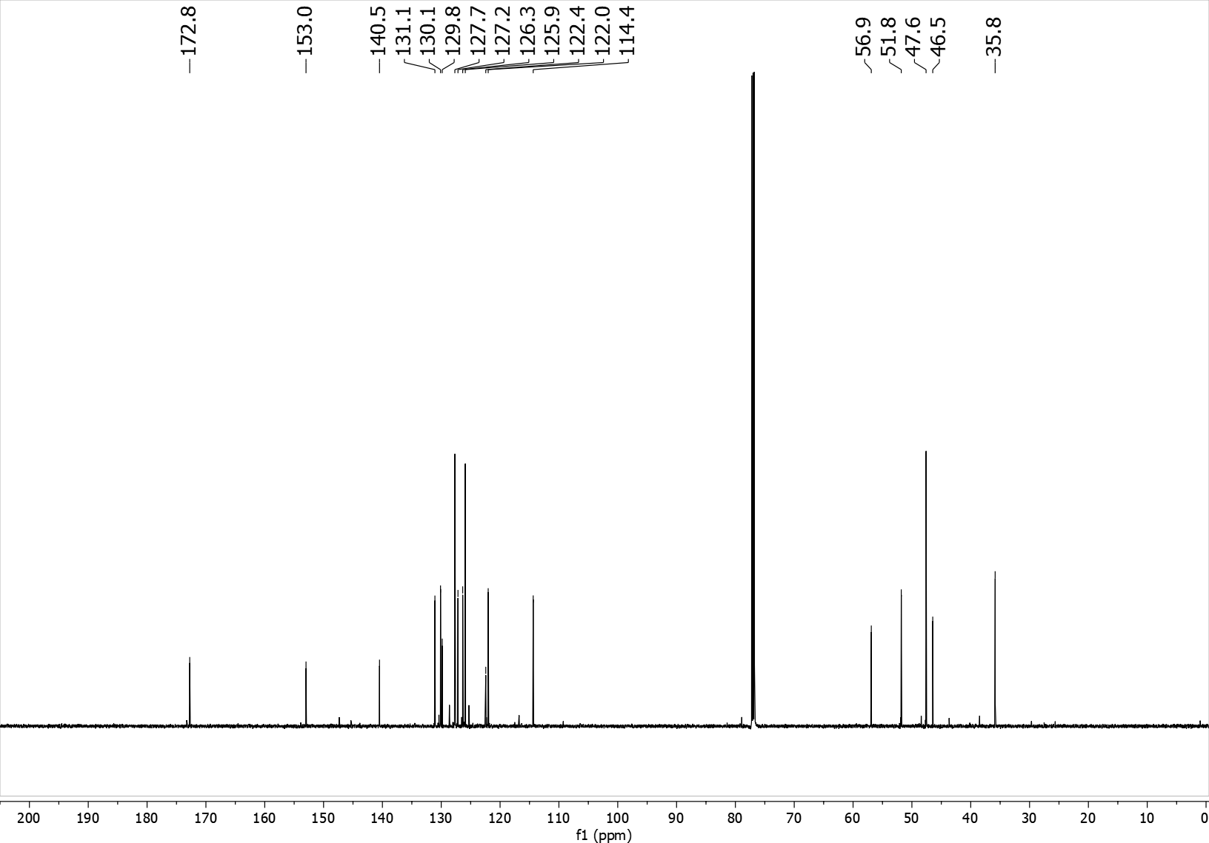

5ae ¹H NMR (600 MHz, CDCl₃)
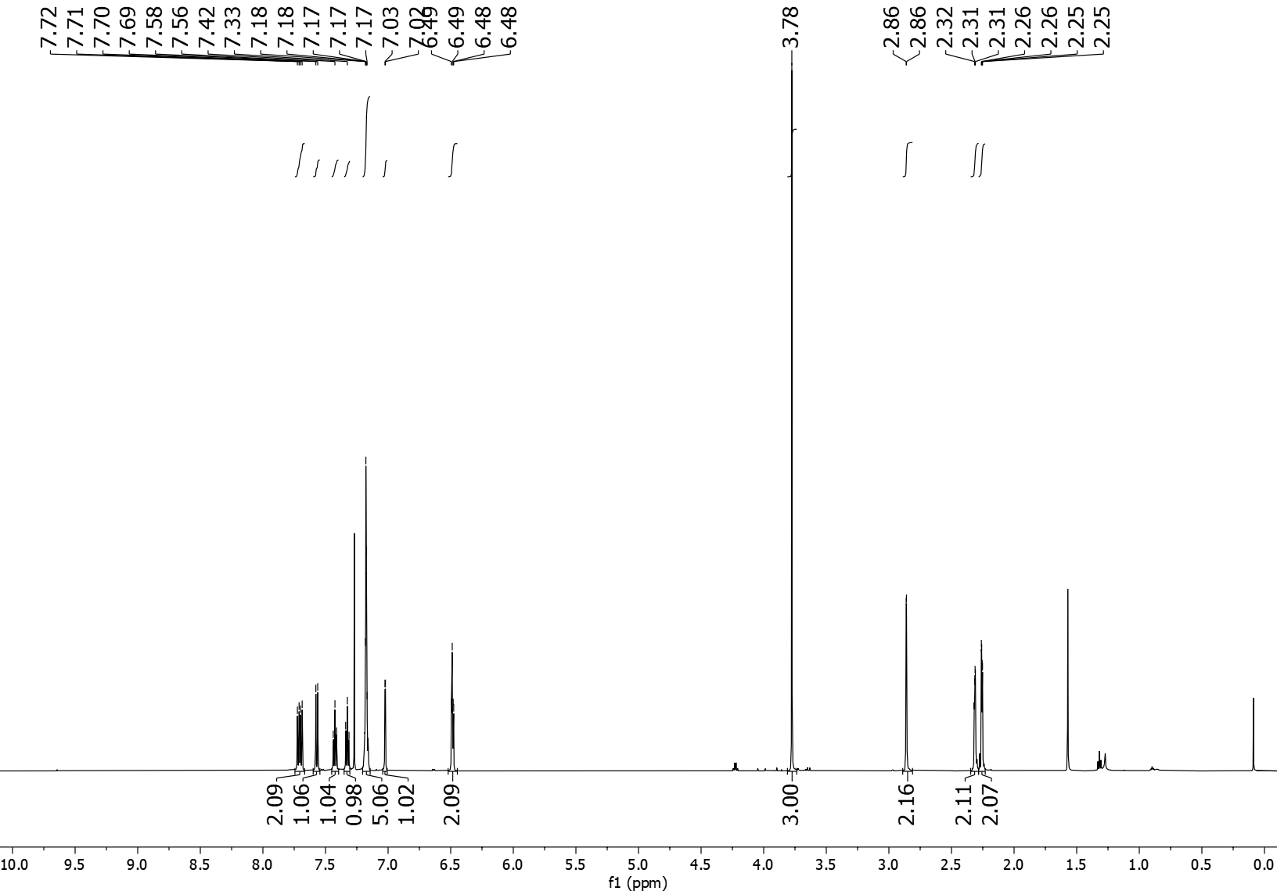
5ae ¹³C NMR (151 MHz, CDCl₃)
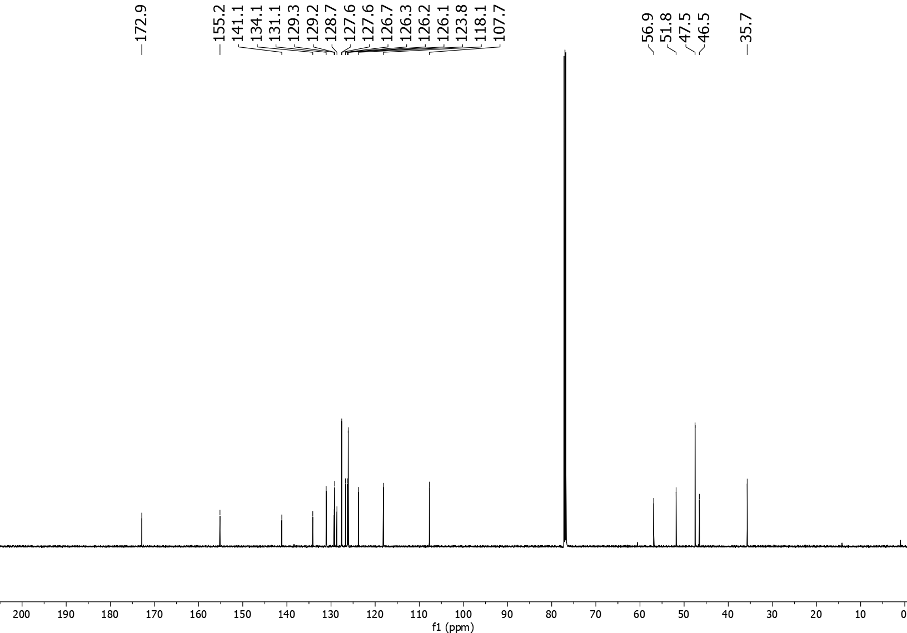
5af ¹H NMR (600 MHz, CDCl₃)
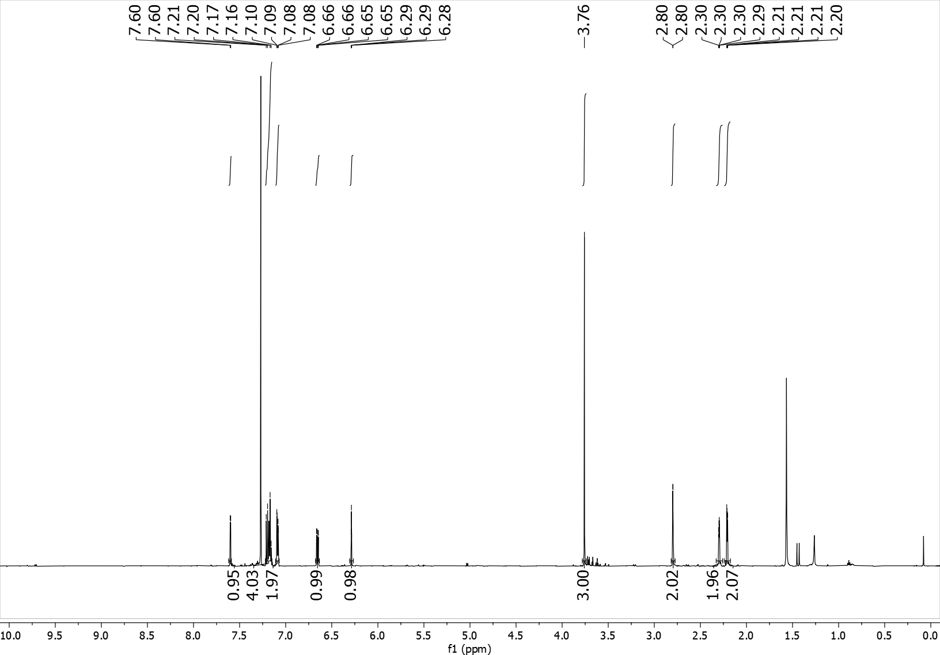
5af ¹³C NMR (151 MHz, CDCl₃)
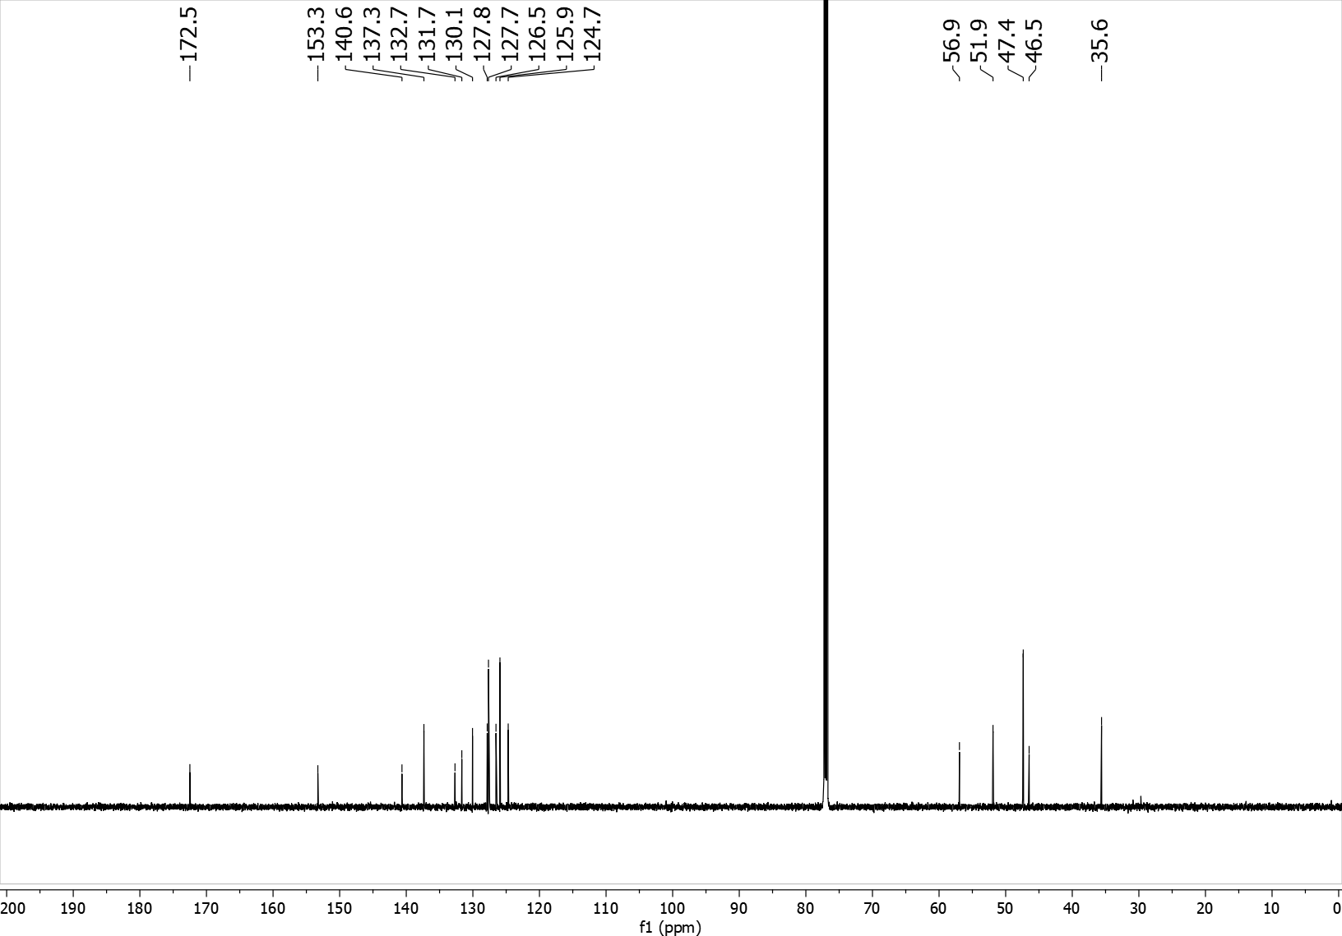
6 ¹H NMR (600 MHz, CDCl₃)
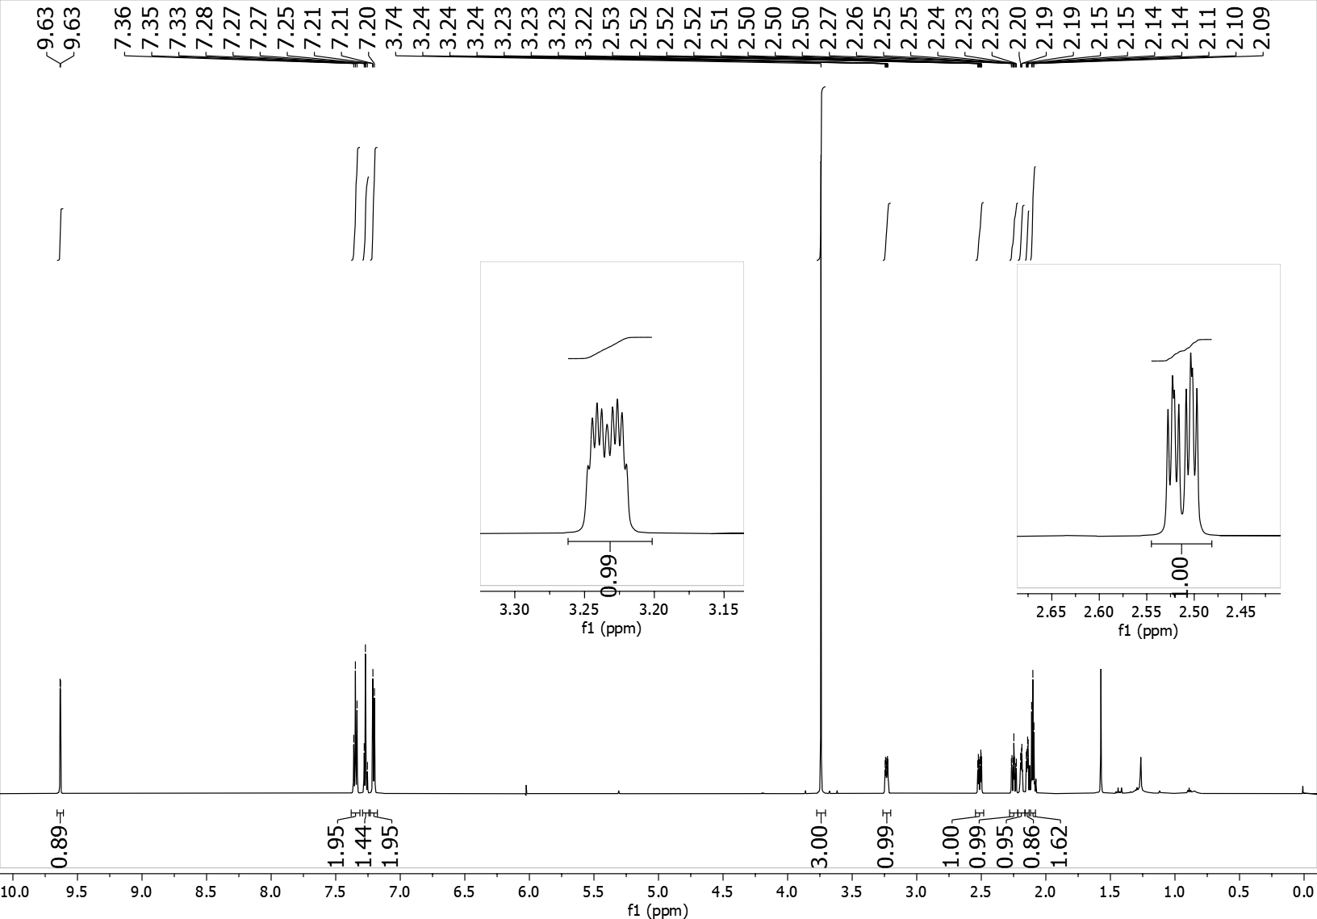

6 ¹³C NMR (151 MHz, CDCl₃)
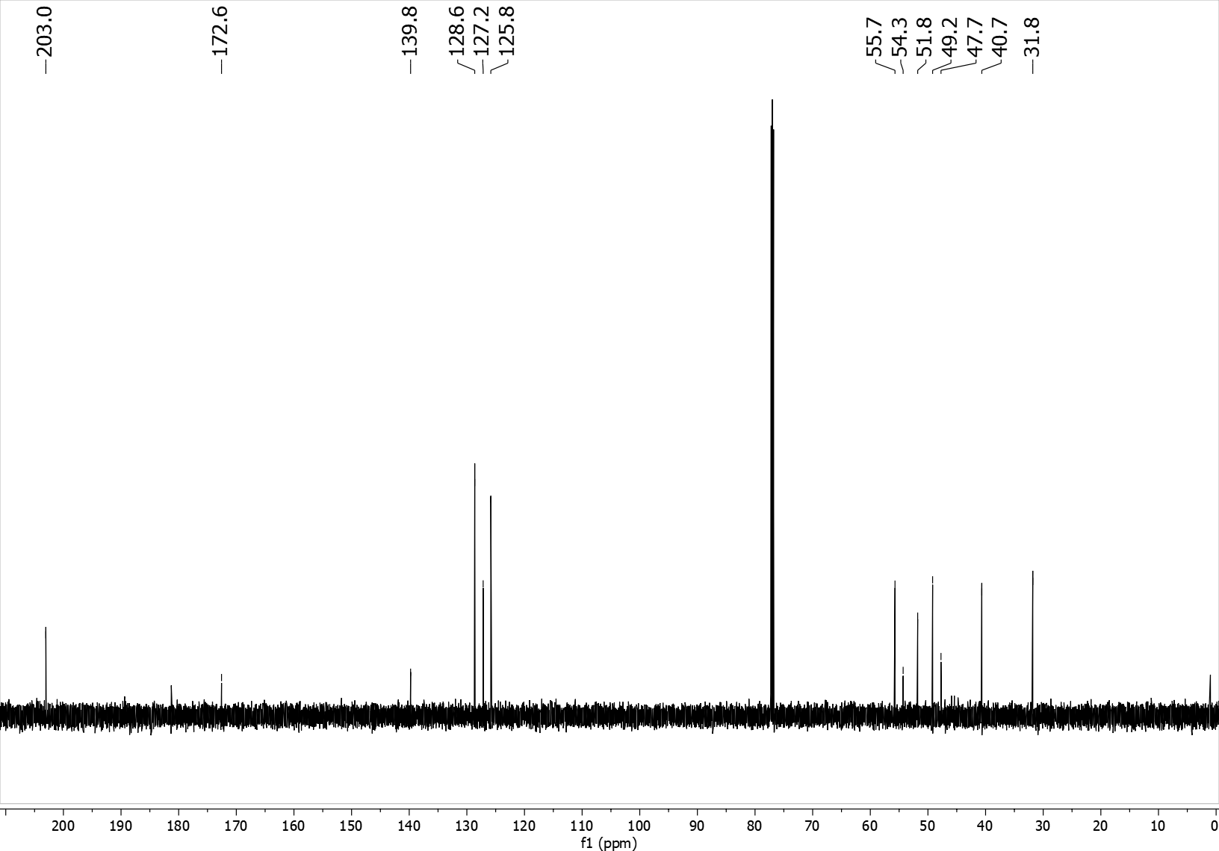
7 ¹H NMR (600 MHz, CDCl₃)
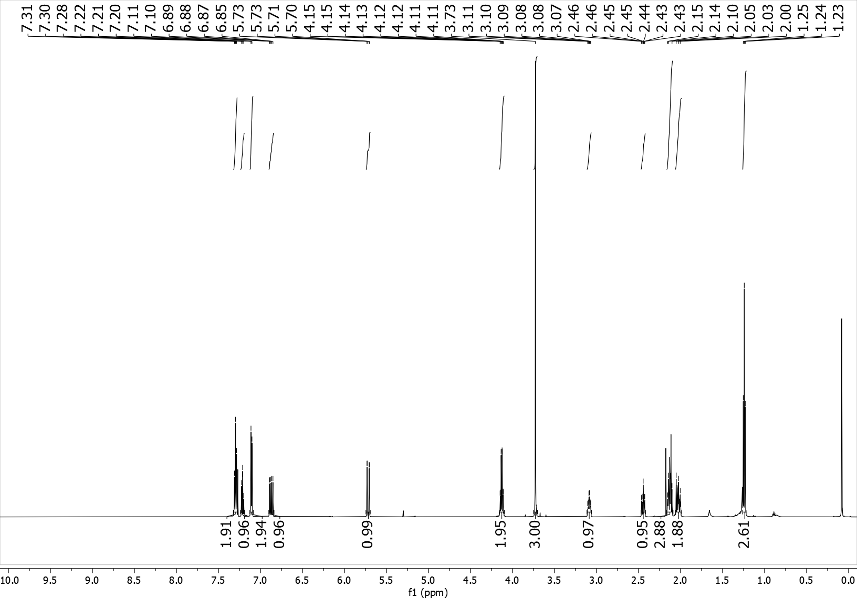
7 ¹³C NMR (151 MHz, CDCl₃)
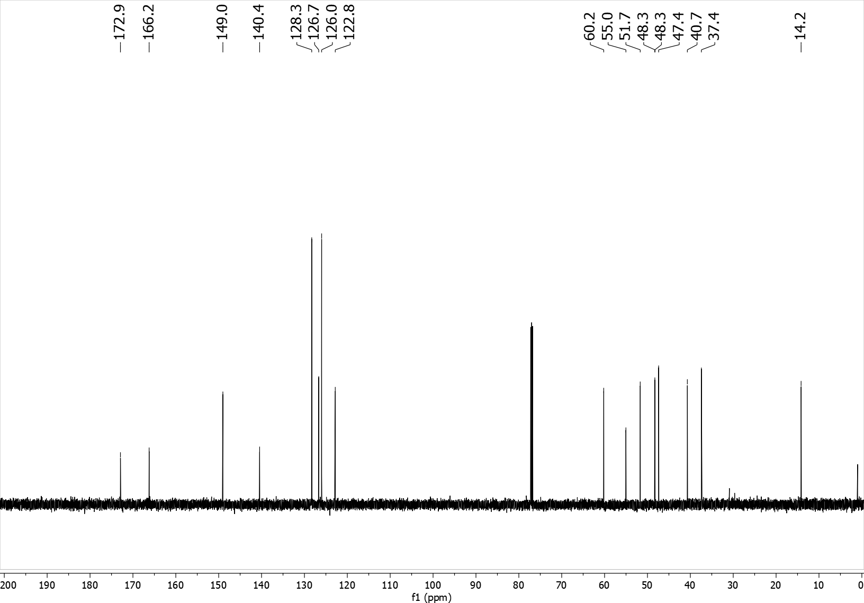

8 ¹H NMR (600 MHz, CDCl₃)
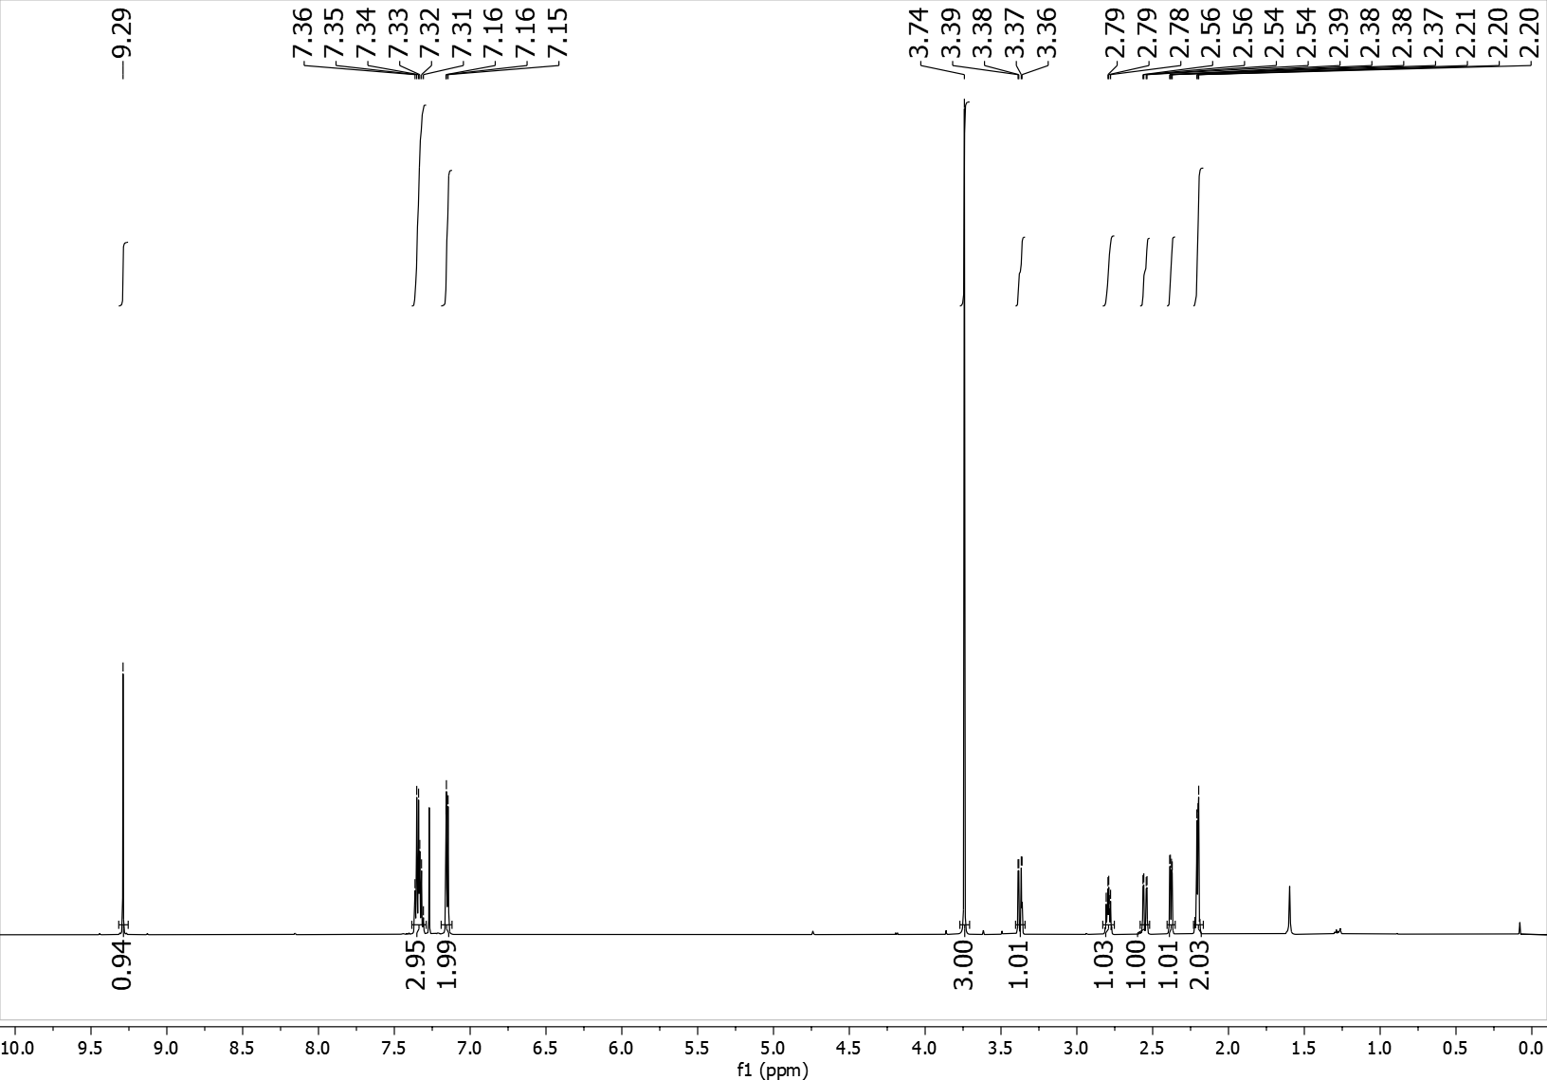
8 ¹³C NMR (151 MHz, CDCl₃)
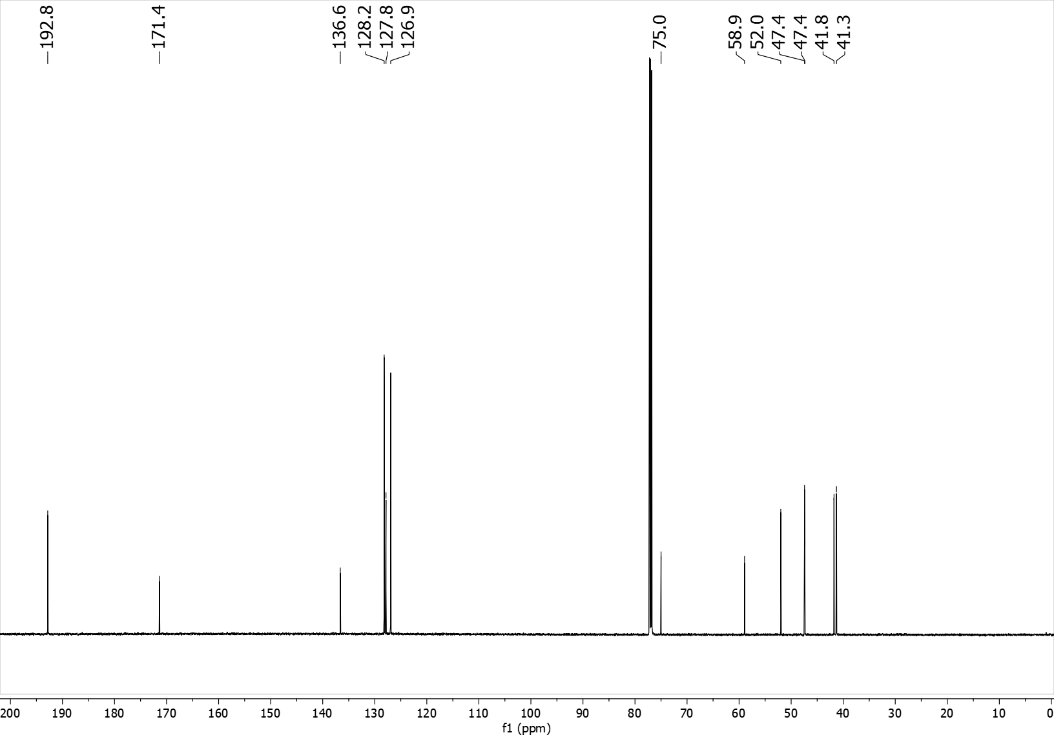

9 ¹H NMR (600 MHz, CDCl₃)
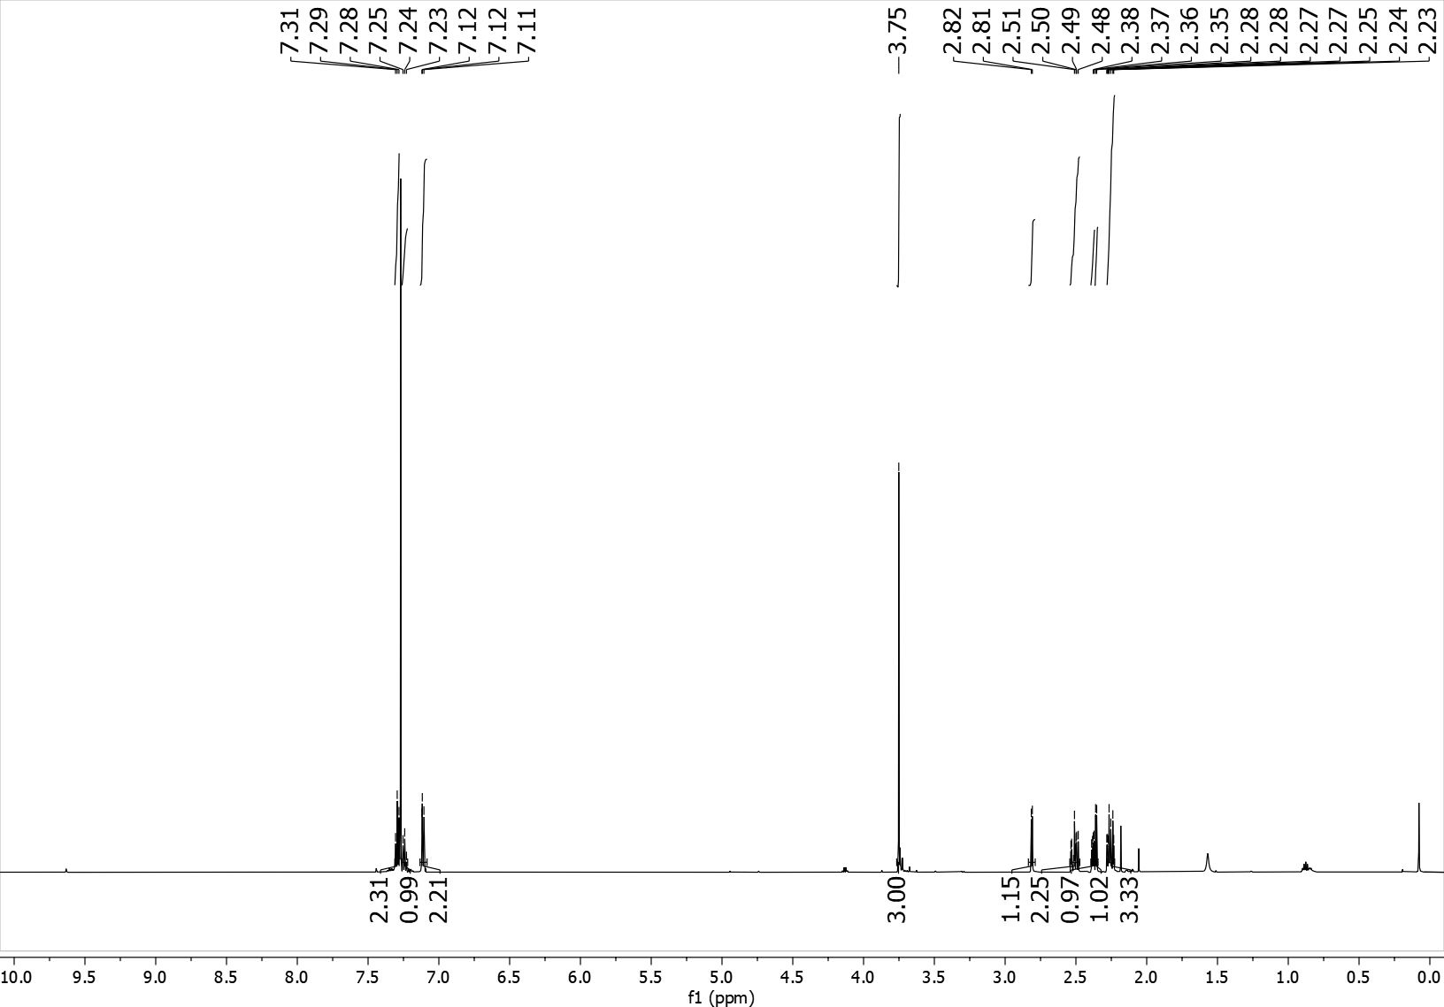
9 ¹³C NMR (151 MHz, CDCl₃)
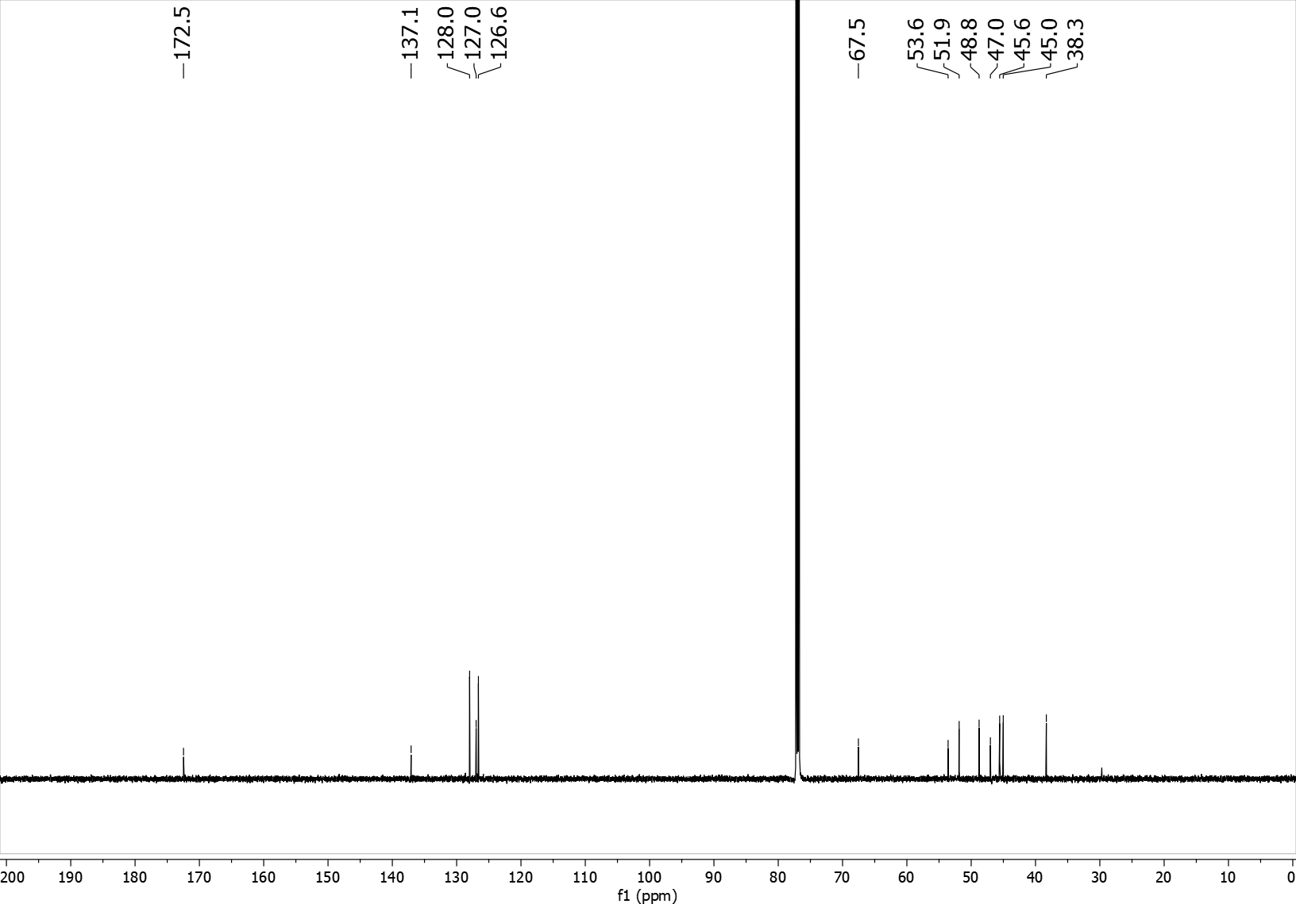

10 ¹H NMR (400 MHz, CD₃CN)
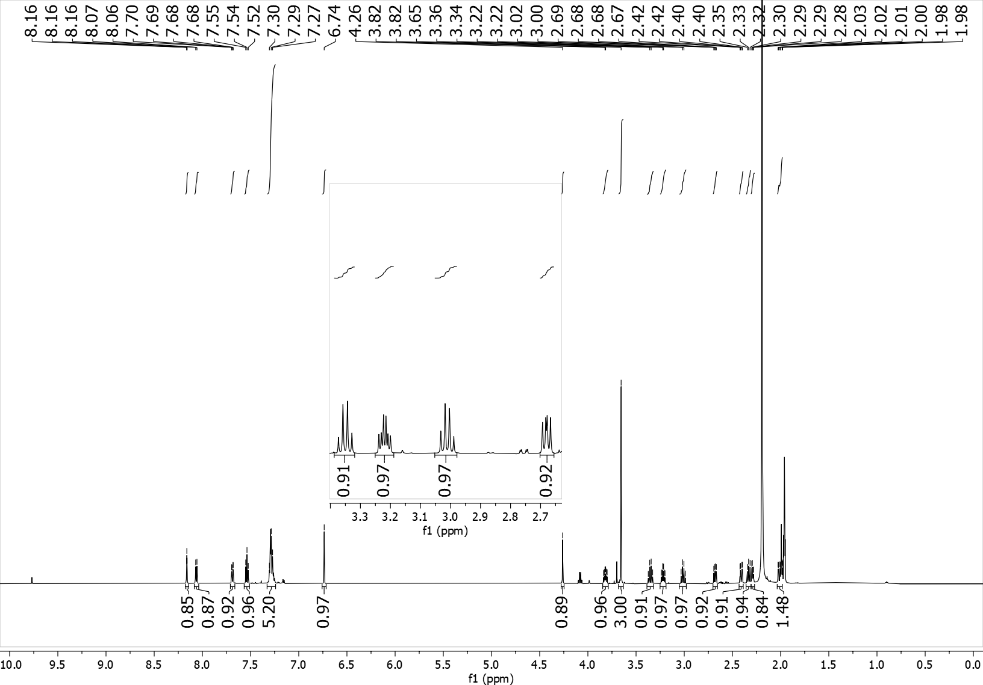
10 ¹³C NMR (101 MHz, CD₃CN)
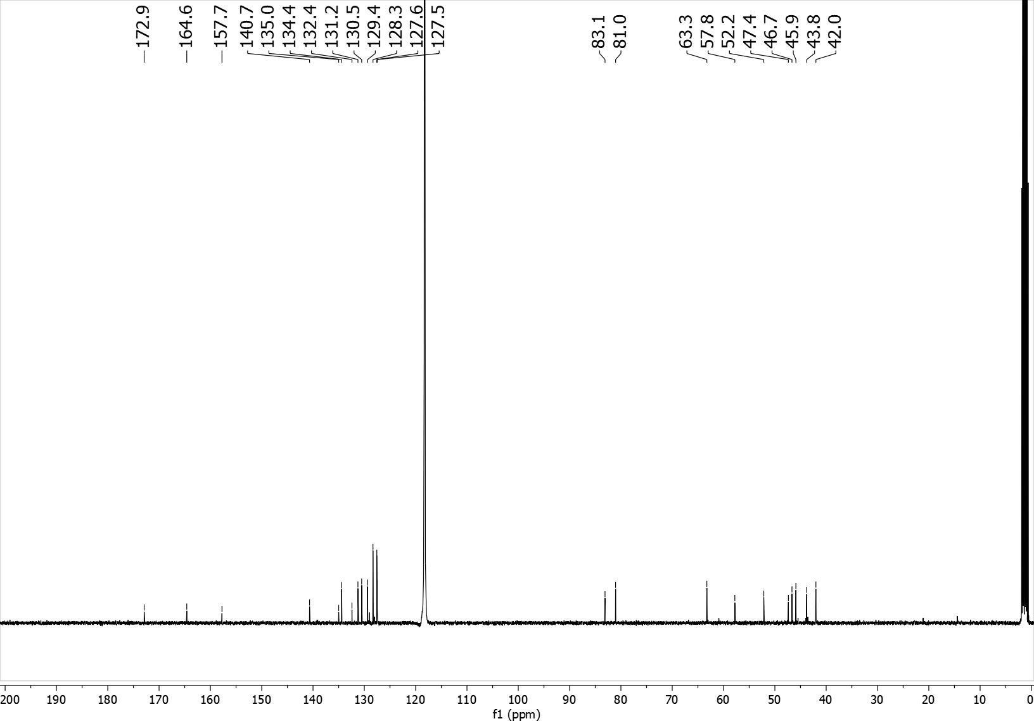
12 ¹H NMR (400 MHz, CD₃CN)
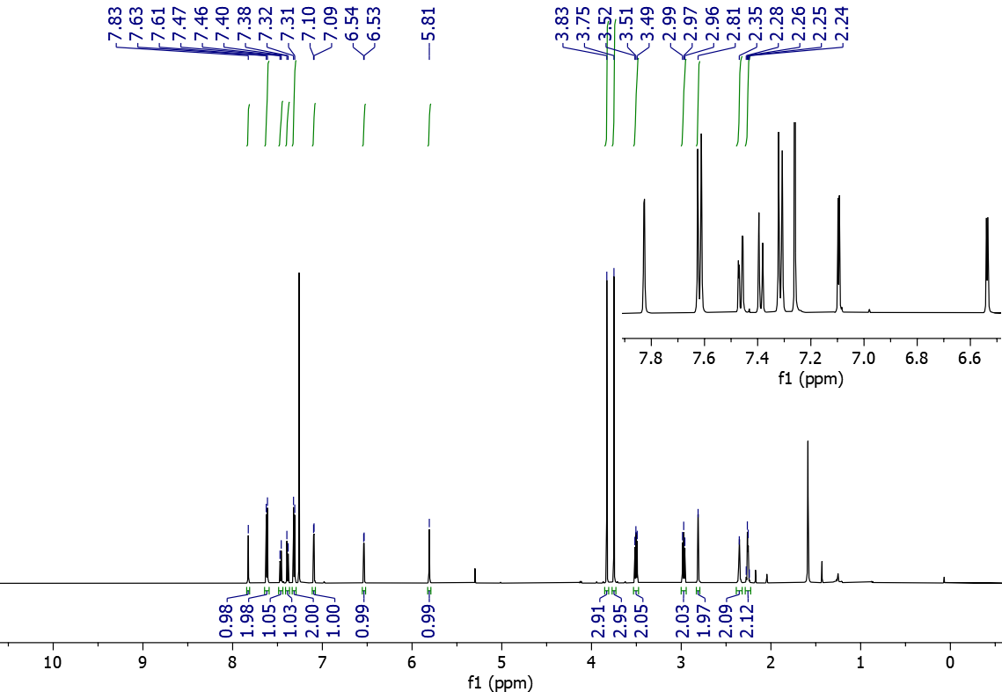
10 ¹³C NMR (101 MHz, CD₃CN)
9. References

a) R. M. Bycheck, V. Hutskalova, Y. P. Bas, O. A. Zaporozhets, S. Zozulya, V. V. Levterov, P. K. Mykhailiuk, J. Org. Chem. 2019, 84, 15106; b) K. Dhake, K. J. Woelk, J. Becica, A. Un, S. E. Jenny, D. C. Leitch, Angew. Chem. Int. Ed. 2022, 61, e202204719; c) K. Livingstone, K. Siebold, S. Meyer, V. Martìn-Heras, C. G. Daniluc, R. Gilmour, ACS Catal. 2022, 12, 14507.
For the preparation of 1j (vinyl residue instead of aryl group) we followed the synthesis reported in: X. Ma, W. Pinto, L. N. Pham, D. L. Sloman, Y. Han, Eur. J. Org. Chem. 2020, 4581.
Y. Zhu, X. Lv, J. Hong, S. Wu, Z. Li, M. Wang, X. Jianf, Green Chem 2025, 27, 2464.
H. Ren, T. Li, J. Xing, Z. Li, Y. Zhang, X. Yu, J. Zheng, Org. Lett. 2024, 26, 1745.
Y. Liang, F. Paulus, C. G. Daniluc, F. Glorius, Angew. Chem. Int. Ed. 2023, 62, e202305043.
If the commercial Grignard reagent or the prepared solution concentration is above 0.7 M dilution with anhydrous THF is recommended; this helps in lowering the formation of byproducts.
This step was adapted from: S. Dutta, D. Lee, K. Ozols, C. G. Daniluc, R. Shintani, F. Glorius, J. Am. Chem. Soc. 2024, 146, 2789.
For substrate1u MeLi was used directly; for substrate 1v n-BuLi was used directly; for substrate 1w allylmagnesium bromide was used directly.
a) L. García, J. Sendra, N. Miralles, E. Reyes, J. J. Carbó, J. L. Vicario, E. Fernández, Chem. Eur. J. 2018, 24, 14059-14062 b) M. Lu, Y. Liu; Organic Letters 2024 26, 5493-5499
The cationization step should be executed in a dark vessel due to the use of silver salts which are light sensitive. R. Pedrazzani, S. Kiriakidi, M. Monari, I. Lazzarini, G. Bertuzzi, C. Silva López, M. Bandini; ACS Catalysis 2024 14, 6128.
a) Y. Zhao, D. G. Truhlar, Theor. Chem. Acc. 2008 120, 215. b) Y. Zhao, D. G. Truhlar, Acc. Chem. Res. 2008 41, 157.
a) F. Weigend, Phys. Chem. Chem. Phys. 2006 8, 1057. b) F. Weigend, R. Ahlrichs, Phys. Chem. Chem. Phys. 2005 7, 3297.
B. Mennucci, J. Tomasi, R. Cammi, J.R. Cheeseman, M.J. Frisch, F. J. Devlin, S. Gabriel, P. J. Stephens, J. Phys. Chem. A 2002 106, 6102.
Gaussian 16, Revision C.01, M. J. Frisch, G. W. Trucks, H. B. Schlegel, G. E. Scuseria, M. A. Robb, J. R. Cheeseman, G. Scalmani, V. Barone, G. A. Petersson, H. Nakatsuji, X. Li, M. Caricato, A. Marenich, J. Bloino, B. G. Janesko, R. Gomperts, B. Mennucci, H. P. Hratchian, J. V. Ortiz, A. F. Izmaylov, J. L. Sonnenberg, D. Williams-Young, F. Ding, F. Lipparini, F. Egidi, J. Goings, B. Peng, A. Petrone, T. Henderson, D. Ranasinghe, V. G. Zakrzewski, J. Gao, N. Rega, G. Zheng, W. Liang, M. Hada, M. Ehara, K. Toyota, R. Fukuda, J. Hasegawa, M. Ishida, T. Nakajima, Y. Honda, O. Kitao, H. Nakai, T. Vreven, K. Throssell, J. A. Montgomery, J. E. Peralta, F. Ogliaro, M. Bearpark, J. J. Heyd, E. Brothers, K. N. Kudin, V. N. Staroverov, T. Keith, R. Kobayashi, J. Normand, K. Raghavachari, A. Rendell, J. C. Burant, S. S. Iyengar, J. Tomasi, M. Cossi, J. M. Millam, M. Klene, C. Adamo, R. Cammi, J. W. Ochterski, R. L. Martin, K. Morokuma, O. Farkas, J. B. Foresman, D. J. Fox, Gaussian, Inc., Wallingford CT, 2016.
a) H. B. Schlegel, J. J. W. McDouall, Dordrecht: Springer Netherlands 1991, 167. b) R. Bauernschmitt, R. Ahlrichs, J. Chem. Phys. 1996 104, 9047. c) R. Seeger, J. A. Pople, J. Chem. Phys. 1977 66, 3045.
T. Lu, F. Chen, J. Comput. Chem. 2012 33, 580–592.
W. Humphrey, A. Dalke, K. Schulten, J. Molec. Graphics, 1996 14, 33-38.
a) APEX3 Software Package V2019; Bruker AXS Inc.: Madison, WI, 2019; b) Bruker SAINT, v8.40A: Part of the APEX3 Software Package V2019; Bruker AXS Inc.: Madison, WI, 2019; c) Bruker SADABS V2016/2: Part of the APEX3 Software Package V2019; Bruker AXS Inc.: Madison, WI, 2019.
a) G. M. Sheldrick, Acta Crystallogr., Sect. A: Found. Adv. 2015, 71, 3; b) G. M. Sheldrick, Acta Crystallogr., Sect. C: Cryst. Struct. Commun. 2015, 71, 3.
C. F. Macrae, I. J. Bruno, J. A. Chisholm, P. R. Edgington, P. McCabe, E. Pidcock, L. Rodriguez-Monge, R. Taylor, J. Streek, P. A. van de Wood, J. Appl. Crystallogr. 2008, 41, 466.
Alamillo-Ferrer, C.; Hutchinson, G.; Burés, J. Nat. Rev. Chem. 2023, 7, 26–34
The curve corresponding to the kinetic profile of the reaction run at XXX was not included in this set, as the first point recorded showed a yield as high as 18% rendering the initial-rate method difficult to apply.

