Supplementary material:
Quality improvement of refrigerated sardine fillets using shrimp waste-based edible coatings

Maria Alessia Schouten^{a,} *, Margherita D’Alessandro^{b}, Ana Cristina de Aguiar Saldanha Pinheiro^{b}, Pietro Rocculi^{a, b}, Silvia Tappi^{a, b}, Urszula Tylewicz^{a, b}, Davide Gottardi^{a, b}, Francesca Patrignani^{a, b}, Santina Romani^{a, b}

ª Department of Agricultural and Food Sciences, Alma Mater Studiorum, University of Bologna, Campus of Food Science, Piazza G. Goidanich 60, 47521, Cesena (FC), Italy
^{b} Interdepartmental Centre for Agri-Food Industrial Research, Alma Mater Studiorum, University of Bologna, Via Q. Bucci, 336, 47521, Cesena (FC), Italy

*Corresponding author: maria.schouten2@unibo.it

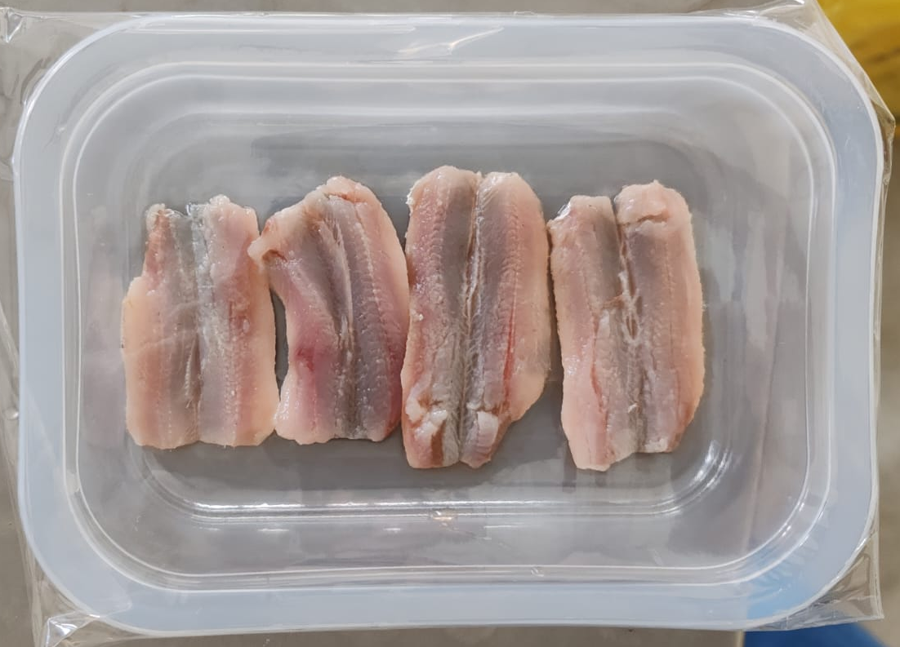
Figure S1. Final appearance of packaged samples: raw sardine fillets (Sardina pilchardus) arranged in a single layer (four per tray; approximately 37.5 ± 4.1 g) in a polypropylene (PP) tray sealed in air with a PP high-barrier film.

