Supporting information

Continuous production of 𝛾-valerolactone from furfural using optimized catalysts containing Zr and Nb
Adrián García¹, Anna Saotta^{2,3}, Elianny Da Silva¹, Pablo J. Miguel¹, Alessandro Allegri^{2,3}, Rita Sánchez-Tovar¹, Jean-Charles Morin⁴, Olivier Gardoll⁴, Tomás García⁵, José Manuel López⁵, Stefania Albonetti ^{2,3}*, Nikolaos Dimitratos ^{2,3}*, Benjamin Solsona^{1,}*

- ¹Departamento de Ingeniería Química, ETSE, Universitat de València, Av. Universitat, Burjassot-Valencia 46900, Spain. * benjamín.solsona@uv.es
- ²Dipartimento di Chimica Industriale “Toso Montanari”, Alma Mater Studiorum – Università di Bologna, Via Piero Gobetti 85, 40129 Bologna, Italy

- ³Center for Chemical Catalysis – C3, Alma Mater Studiorum –, Università di Bologna, Via Piero Gobetti 85, 40129 Bologna, Italy
* stefania.albonetti@unibo.it *nikolaos.dimitratos@unibo.it
- ⁴Unité de Catalyse et Chimie du Solide-UMR CNRS,
Université de Lille, Villeneuve d'Ascq, 59655, France
- ⁵Instituto de Carboquímica (CSIC), C/Miguel Luesma Castán 4, 50018 Zaragoza, Spain.

Table S1. Comparison between the GVL yield (%) achieved in this work in comparison to the results published in literature for the same reaction in batch mode.
Furfural [M] | Catalyst | Hydrogen source | T  (°C) | Time (h) | Yield to  GVL (%) | Reference
0.2 | Zr-Vc-3 | 2-propanol | 180 | 12 | 76.2 | [1]
0.04 | Ru-Zr@ZSM-OH | Molecular hydrogen | 175 | 2 | 92.6 | [2]
0.03 | Zr-808-TF (MOF) | 2-propanol | 160 | 8 | 83 | [3]
0.2 | Zr-SBA-15 | 2-propanol | 190 | 24 | 93 | [4]
0.33 | Zr-Mont | 2-propanol | 180 | 5 | 62 | [5]
0.05 | Zr-Silica | 2-propanol | 180 | 8 | 72.4 | [6]
0.2 | ZrPO-HT-550 | 2-propanol | 180 | 6 | 42.7 | [7]
0.17 | CuAl + H-ZSM-5 | Molecular hydrogen | 160 | 4 | 90.5 | [8]
0.05 | Fe₃O₄/ZrO₂@MCM-41 | 2-propanol | 150 | 30 | 85 | [9]
0.2 | FM-Zr-ARS | 2-propanol | 160 | 8 | 72.4 | [10]
0.3 | AuRu/Y–ZrO₂ | 2-propanol | 150 | 5 | 71 | [11]
0.2 | Zr/Silica | 2-propanol | 200 | 6 | 40.8 | [12]
0.2 | Zr-HY + Al-HY | 2-pentanol | 120 | 5 | 85 | [13]
0.4 | Zr-HY + Al-HY | 2-pentanol | 120 | 10 | 78
0.26 | ZrO₂-SBA-15 | 2-propanol | 170 | 7 | 37 | [14]

GC-FID calibration for continuous flow reactions
In order to obtain the moles of the various compounds actually present at the end of the reaction, it is necessary to calibrate the instrument. Calibrations were carried out on the individual compounds, obtaining the standards by diluting the stock solution in 25mL flasks and adding 20μl of octane as an internal standard in each.
The theoretical concentrations of the stock solution and the various standards have been reported in Tables S2 and S3. The compounds used for the calibrations were: furfural (FUR), furfuryl alcohol (FAL), α-angelic lactone (AnL), propyl levulinate (PL), furfuryl ethyl ether (FEE) and γ-valerolactone (GVL). It was not possible to calibrate isopropyl levulinate (which is the molecule that is actually formed during the reaction) as it is not a commercial molecule. It was therefore decided to use its isomer (propyl levulinate) assuming that the two response factors are equal. Furfuryl isopropyl ether (FPE) is also a compound absent on the market and its response factor has been assumed to be the same as that of FEE since it was the closest molecule of those commercially available. The chromatogram obtained from the calibration of the species described is shown in Figure S1.

Table S2. List of compounds used and their quantities for the preparation of stock solutions using iPrOH as a solvent.
Compound | Molecular Weight (g/mol) | Purity (%) | Theoretical concentration (mol/l) |  | Flask  volume (ml) | Theoretical mass (g)
Furfural | 96.09 | 100 |  | 0.5 | 5 | 0.2402
Furfuryl Alcohol | 98.10 | 98 |  | 0.5 | 5 | 0.2503
α/β - angelica lactone | 98.10 | 98 |  | 0.5 | 5 | 0.2503
Levulinic  Acid | 116.12 | 98 |  | 0.5 | 5 | 0.2938
Propyl Levulinate | 158.19 | 95 |  | 0.5 | 5 | 0.4163
GVL | 100.12 | 99 |  | 0.5 | 5 | 0.2528
Furfuryl Etyl Ether | 126.15 | 98 |  | 0.5 | 5 | 0.3218

Table S3. Concentrations of the standards prepared for each individual compound from their own stock solutions.
 | Theoretical concentration (mol/l) | Flask volume (ml) | Sampling volume (ml) | Octane volume (μl)
Standard 1 | 0.05 | 25 | 2.5 | 20
Standard 2 | 0.03 | 25 | 1.5 | 20
Standard 3 | 0.015 | 25 | 0.75 | 20
Standard 4 | 0.0002 | 25 | 0.01 | 20

Table S4. XPS results for the different O1s spectral region contributions.
Catalyst | XPS analysis (at%)
 | Metal oxide | Si-O-Al | Si-O-Si
 | 530.7-531.1 eV | 532.3-532.7 eV | 533.2-533.6 eV
Zr/Al-HY | 18.6 | 13.7 | 67.7
(Nb)Al-HY | 48.8 | 13.2 | 38.0
Zr/(Nb)Al-HY | 44.9 | 8.3 | 46.8

Table S5. Furfural transformation on Nb- and/or Zr- catalysts either bulk or supported on Al-HY zeoliteª.
Catalyst | Furfural conversion (%) | Yield to GVL (%) | Yield to IPL (%) | Yield to other (%) | GVL Selectivity (%)
Zr/Al-HY | 100 | 43.5 | 43.2 | 13.2 | 43.5
Nb/Al-HY | 100 | 51.7 | 32.1 | 16.3 | 51.7
Zr/(Nb)/Al-HY | 100 | 67.0 | 20.7 | 12.4 | 67.0
Zr2/Al-HY | 89.0 | 52.0 | 4.1 | 32.9 | 58.5
Nb2/Al-HY | 92.9 | 44.2 | 26.7 | 22.0 | 47.6
ª Reaction conditions: 5 mL of 2-propanol, 0.125 mmol of FF, 0.1 g of catalyst, 180 °C, 3h, Batch.

Comparison with the literature

Table S6. Comparison between the GVL space time yield (µmol_{GVL} * g_{CAT}⁻¹ * h⁻¹) achieved in this work in comparison to the results published in literature for the same reaction in continuous flow mode.
Entry | Catalyst | Furfural concentration (mM) |  | Reaction Temperature (°C) | GVL  Space Time Yield  (mmol_{GVL} * g_{CAT}⁻¹ * h⁻¹) | Reference
1 | 10Zr/(Nb)Al-HY |  | 25 | 180 | 1.103 | This work
2 | 1Pt/Sep +10Zr/Sep |  | 67 | 180 | 0.216 | [15]
3 | Ti/Zr/O (1:1) |  | 67 | 180 | 0.372 | [16]
4 | Zr-Al-Beta |  | 62 | 150 | 0.090 | [17]

Figure S1. Chromatogram depicting the signals of the standard used, of all the calibrated species and of those obtained from the reactions carried out, at their respective retention times.

The response factors of the various compounds were calculated by constructing the relative calibration lines. The ratio of compound area/standard area as a function of moles of the compound/standard moles was then shown in a graph so as to be able to normalize the quantities injected with respect to the internal standard.

XRD

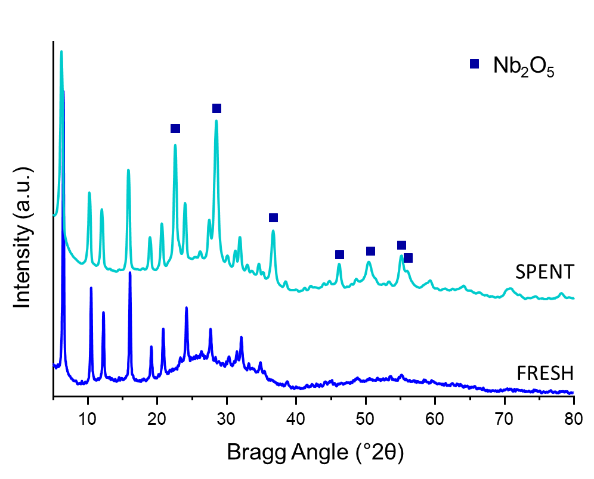

Figure S2. XRD comparison between fresh and used 3 times Zr/(Nb)Al-HY catalyst after working in batch conditions in the following conditions: 5 mL of 2-propanol, 0.125 mmol of FF, 0.1 g of catalyst, 180 °C, 3h.

Continuous flow reactions

Figure S3. Furfural conversion and products selectivities (%) over the time on stream (h) using (Nb)Al-HY catalyst. Reaction conditions: 180°C, [FF] = 25 mM, τ = 10 min.

Figure S4. Furfural conversion and products selectivities (%) over the time on stream (h) using (Nb)Al-HY. Reaction conditions: 180°C, [FF] = 25 mM, τ = 5 min.

Figure S5. XRD comparison between fresh and used (Nb)Al-HY catalyst using or not water in the reaction media. Note: Used in continuous regime.

References

[1] Wu M, Liu W, Deng F, Liu S, Song K, Zhou X, Guo J, He J, Li H. Steering acid‐base site distribution and hydrophobicity of bioresourced bifunctional hybrid materials for direct synthesis of γ‐valerolactone from biomass‐based furfural. ChemSusChem 2025;18: e202402165. https://doi.org/10.1002/cssc.202402165
[2] Yuan Y, Chen X, Deng L, Zhou S, Qiao C, Diao Z, Wang H, Tian Y. Production of γ-valerolactone from furfural by core-shell ZSM-5 supporting Ru-Zr bimetals through enhanced cascade reaction. Appl Catal A Gen 2025;690:120031. https://doi.org/10.1016/j.apcata.2023.119064
[3] Xue W, Ma M, Hou P, Zhang P, Liu W, Liu Y, Yue H, Wang X, Tian G, Feng S. One-pot tandem conversion of furfural to γ-valerolactone over a series of modified zirconium-based metal–organic frameworks with variational Lewis and Brønsted acid sites. Fuel 2024;371:132115. https://doi.org/10.1016/j.fuel.2024.132115
[4] Liu Z, Zhang Z, Fu R, Xu J, Lu J, Wen Z, Xue B. One-pot conversion of furfural to gamma-valerolactone over Zr-SBA-15: cooperation of Lewis and Brønsted acidic sites. ACS Appl Nano Mater 2023;6:13196-13207. https://doi.org/10.1021/acsanm.3c01845
[5] Zhang P, Ma M, Hou P, Cao J, Guo Q, Yue H, Tian G, Feng S. Influence of the insertion of zirconium ion on the catalytic performance of montmorillonite for one-pot cascade conversion of furfural to γ-valerolactone under mild conditions. Mol Catal 2023;535:112832. https://doi.org/10.1016/j.mcat.2022.112832
[6] García A, Miguel PJ, Ventimiglia A, Dimitratos N, Solsona B. Optimization of the Zr-loading on siliceous support catalysts leads to a suitable Lewis/Brønsted acid sites ratio to produce high yields to γ-valerolactone from furfural in one-pot. Fuel 2022;324:124549. https://doi.org/10.1016/j.fuel.2022.124549
[7] He J, Liu X, Bai L, Liu S, Song K, Zhou X, Guo J, Meng X, Li C. Effective one‐pot tandem synthesis of γ‐valerolactone from biogenic furfural over zirconium phosphate catalyst. Biofuels, Bioprod Biorefin 2022;16:1613-1626. https://doi.org/10.1002/bbb.2394.
[8] Shao Y, Li Q, Dong X, Wang J, Sun K, Zhang L, Zhang S, Xu L, Yuan X, Hu X. Cooperation between hydrogenation and acidic sites in Cu-based catalyst for selective conversion of furfural to γ-valerolactone. Fuel 2021;293:120457. https://doi.org/10.1016/j.fuel.2021.120457
[9] Gao X, Yu X, Peng L, He L, Zhang J. Magnetic Fe₃O₄ nanoparticles and ZrO₂-doped mesoporous MCM-41 as a monolithic multifunctional catalyst for γ-valerolactone production directly from furfural. Fuel 2021;300:120996. https://doi.org/10.1016/j.fuel.2021.120996
[10] Peng Q, Wang H, Xia Y, Liu X. One-pot conversion of furfural to gamma-valerolactone in the presence of multifunctional zirconium alizarin red S hybrid. Appl Catal A Gen 2021;621:118203. https://doi.org/10.1016/j.apcata.2021.118203
[11] Morandi S, Manzoli M, Chan-Thaw CE, Bonelli B, Stucchi M, Prati L, Stormer H, Wang W, Wang D, Pabel M, Villa A. Unraveling the effect of ZrO₂ modifiers on the nature of active sites on AuRu/ZrO₂ catalysts for furfural hydrogenation. Sustain Energy Fuels 2020;4:1469-1480. https://doi.org/10.1039/C9SE00847K
[12] He J, Li H, Xu Y, Yang S. Dual acidic mesoporous KIT silicates enable one-pot production of γ-valerolactone from biomass derivatives via cascade reactions. Renew Energy 2020;146:359-370. https://doi.org/10.1016/j.renene.2019.06.105
[13] Zhang H, Yang W, Roslan II, Jaenicke S, Chuah GK. A combo Zr-HY and Al-HY zeolite catalysts for the one-pot cascade transformation of biomass-derived furfural to γ-valerolactone. J catal 2019;375:56-67. https://doi.org/10.1016/j.jcat.2019.05.020
[14] Iglesias J, Melero, JA, Morales G, Paniagua M, Hernández B, Osatiashtiani A, Lee AF, Wilson K. ZrO₂-SBA-15 catalysts for the one-pot cascade synthesis of GVL from furfural. Catal Sci Technol 2018;8:4485-4493. https://doi.org/10.1039/C8CY01121D
[15] García A, Saotta A, Miguel PJ, Sánchez-Tovar R, Fornasari G, Allegri A, Torres-Olea B, Cecilia JA, Albonetti S, Dimitratos N, Solsona B. Promoter effect of Pt on Zr catalysts to increase the conversion of furfural to γ-valerolactone using batch and continuous flow reactors: Influence of the way of the incorporation of the Pt sites. Energy Fuels 2024;38:9849-9861. https://doi.org/10.1021/acs.energyfuels.4c01174.
[16] Saotta A, Allegri A, Liuzzi F, Fornasari G, Dimitratos N, Albonetti S. Ti/Zr/O Mixed Oxides for the Catalytic Transfer Hydrogenation of Furfural to GVL in a Liquid-Phase Continuous-Flow Reactor. ChemEngineering 2023;7:23. https://doi.org/10.3390/chemengineering7020023.
[17] López-Aguado C, Paniagua M, Melero JA, Iglesias J, Juárez P, López Granados M, Morales G. Stable continuous production of γ-valerolactone from biomass-derived levulinic acid over Zr–Al-Beta zeolite catalyst. Catalysts 2020;10:678. https://doi.org/10.3390/catal10060678.

