Identification of antimicrobial resistance genes in Escherichia coli through network diffusion – Supplementary Material

Anis MANSOURI¹*, Francesco DURAZZI¹*, Muhammad Ahmed IHSAN²*, Sholeem GRIFFIN², Gerardo MANFREDA⁴, Vasilis P. VALDRAMIDIS^{2,3}, Frédérique PASQUALI⁴, Daniel REMONDINI¹⁺

1 Department of Physics and Astronomy, University of Bologna, Bologna, Italy.
2 Department of Food Sciences and Nutrition, Faculty of Health Sciences, University of Malta, 2080 Msida, Malta.
3 Department of Chemistry, Faculty of Sciences, National and Kapodistrian University of Athens, Athens, Greece.
4 Department of Agricultural and Food Sciences, University of Bologna, Bologna, Italy.
* Equal contribution
⁺ Corresponding author: daniel.remondini@unibo.it

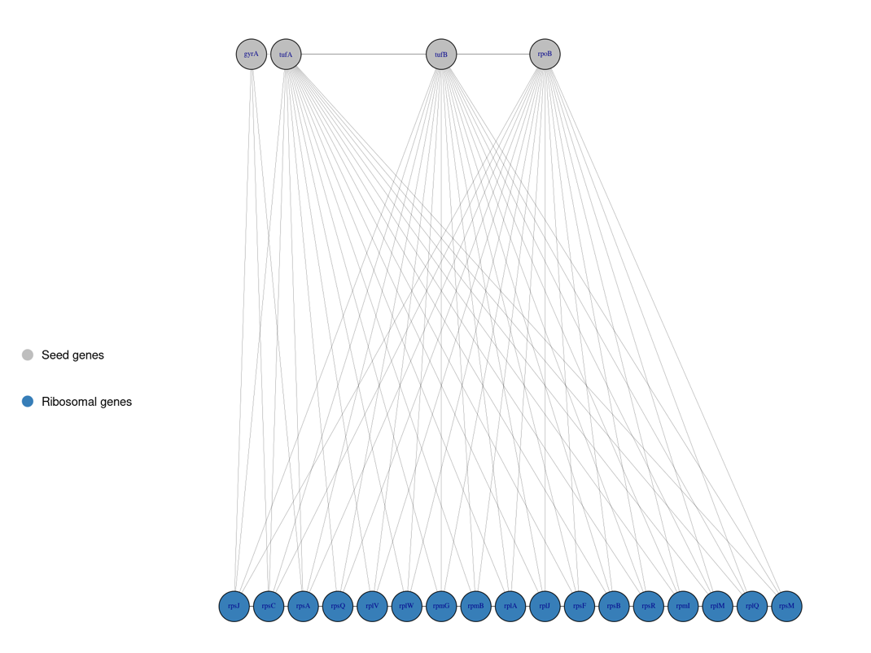

Figure S1: network representation of the ribosomal genes’ first-order neighborhood highlighting links with four seed genes tufA, tufB, rpoB and gyrA.

