AC–DC Electric Field-Induced Microstructure Arrangement in SiCw/SE Composites for Enhanced Electro-Thermal Performance

Huanmin Yaoª , Haibao Muª* , Wenrui Tianª , Andrea Cavallini^{b}* , Maoqun Shenª , Wendong Liª , Daning Zhangª , Haoxiang Zhao^{a,c,d}* , Guanjun Zhangª*

ªState Key Laboratory of Electrical Insulation and Power Equipment, Xi’an Jiaotong University, 710049 Shaanxi, China
^{b}The Department of Electrical, Electronic, and Information Engineering "Guglielmo Marconi", University of Bologna, Italy
^{c}Department of Mathematics and Computer Science, Eindhoven University of Technology, Eindhoven 5600MB, The Netherlands
^{d}Department of Applied Physics, Eindhoven University of Technology, Eindhoven 5600MB, The Netherlands

* (Haibao Mu) Mail: School of Electrical Engineering, Xi’an Jiaotong University, Xi’an, China. Phone: +86 181 9225 1233. E-mail: haibaomu@mail.xjtu.edu.cn.
* (Andrea Cavallini) E-mail: andrea.cavallini@unibo.it
* (Haoxiang Zhao) E-mail: h.zhao@tue.nl
* (Guanjun Zhang) E-mail: gjzhang@xjtu.edu.cn

Abstract: Advanced power modules are evolving toward higher operation voltage and miniaturization, imposing stringent challenges on the electro-thermal co-optimization of packaging materials. However, conventional doping strategies are constrained by the orientation and spatial distribution of fillers, making it difficult to simultaneously achieve high thermal conductivity and excellent electrical insulation. Precisely regulating filler orientation and spatial distribution to maximize electro-thermal synergy remains a critical challenge. This study proposes a synergistic AC-DC combined electric field induction strategy to achieve precise control over filler orientation and targeted enrichment. The AC electric field drives the electrorotation and attraction of SiC whiskers (SiCw), allowing precise orientation to maximize their nonlinear electrical conductivity and thermal conduction properties. Meanwhile, the DC electric field induces the electrophoretic migration of SiCw toward regions of high electric and thermal field concentration, enabling device-level targeted optimization. Experimental results demonstrate that this strategy enhances the thermal conductivity of SiCw/silicone elastomer (SE) composites by 333% (reaching 0.65 W/(m·K)) while maintaining excellent thermal stability. Additionally, the nonlinear electrical conductivity coefficient is tunable within the range of 0.9 to 4.9, and the switch-field strength is reduced to 1.07 kV/mm, showing superior electric field responsiveness. Further simulations and experiments reveal that the composite reduces peak electric field stress by 32.5% and increases the partial discharge inception voltage (PDIV) by 54.4%, significantly enhancing the insulation reliability of power modules. This breakthrough in electro-thermal performance optimization marks a significant advancement in the electrical insulation and thermal protection of high-voltage power modules.

Keywords: Assembly arrangement; Non-linear conductivity; Thermal management; Electric field optimization

- Introduction
As the global energy landscape undergoes a paradigm shift, solar and wind power have emerged as dominant renewable energy sources. By 2024, the global capacity of photovoltaic and wind power has surpassed the terawatt scale [1, 2]. However, due to the performance limitations of power modules—the critical components in energy conversion, the grid integration efficiency of renewable energy remains as low as 20%, far below expectations. To enhance energy conversion efficiency and increase power density, power modules are becoming increasingly compact, while operating at ever-higher temperatures and voltages [3]. Within these modules, packaging materials must simultaneously provide efficient heat dissipation and high electrical insulation—two inherently conflicting properties. Enhancing thermal conductivity often comes at the cost of reduced electrical insulation, whereas improving insulation typically compromises thermal transport [4, 5]. Breaking this electro-thermal constraint has become a critical scientific challenge.
In recent years, researchers have explored hybrid filler strategies to optimize both the thermal conductivity and electrical insulation of power modules. This approach commonly incorporates ceramic fillers (e.g., Al₂O₃, BN) to enhance heat dissipation. Additionally, because power modules are subjected to sustained positive polarity voltage, space charge accumulation becomes a major cause of distorted electric fields. To mitigate this, nonlinear electric conductive fillers (e.g., SiC, ZnO) are typically introduced into the insulating matrix alongside thermally conductive fillers to accelerate charge dissipation, thereby improving insulation performance [6, 7]. However, the inclusion of multiple fillers increases interfacial density, forming high thermal resistance regions that hinder phonon transport and reduce overall thermal conductivity. Furthermore, under an applied electric field, Maxwell-Wagner polarization at filler interfaces leads to increased dielectric loss, accelerating insulation degradation [8-10]. Therefore, overcoming interfacial challenges associated with multi-filler doping remains a key issue. Electro-thermal co-optimization using a single functional filler has become a critical breakthrough in the development of packaging materials.
A promising solution is to introduce β-SiC whiskers (SiCw) into the insulating matrix, where increased filler concentration facilitates direct contact between whiskers, significantly enhancing both nonlinear electrical conductivity and thermal performance [11, 12]. SiCw possesses an intrinsic thermal conductivity of up to 200 W/(m·K) and exhibits superior nonlinear electrical properties, making it an ideal dual-functional reinforcing filler. Compared to spherical fillers, SiCw's high aspect ratio promotes contact formation, facilitating the creation of thermal conduction pathways that reduce interfacial thermal resistance and enhance phonon transport and heat dissipation [13]. Moreover, due to the percolation effect, contacted SiCw structures exhibit superior nonlinear electrical conductivity, dynamically optimizing electric field distribution [14, 15]. Specifically, the nonlinear conductivity behavior of the material can be divided into two stages. In the low electric field region, when the electric field stress is below the switch-field strength, the conductivity remains nearly unchanged with increasing electric field stress, and the low conductivity ensures excellent insulation performance. In the high electric field region, when the electric field stress exceeds the switch-field strength, the conductivity increases rapidly, entering the nonlinear region. This facilitates local charge dissipation and alleviates electric field distortion [16, 17]. The rate of increase in conductivity is defined as the nonlinear coefficient, while the turning point between the low and high electric field regions is known as the switch-field strength; together, these are referred to as the nonlinear parameters of the material. Accordingly, a lower switch-field strength enables the composite to respond more sensitively to changes in the electric field and to increase its conductivity at an earlier stage of electric field distortion, thereby achieving electric field homogenization in a timely manner.
Despite the significant advancements of SiCw in enhancing electro-thermal performance, no reported insulating material has simultaneously reduced peak electric field stress by 20% while achieving a thermal conductivity of ≥0.5 W·m⁻¹·K⁻¹. The scarcity of such high-thermal-conductivity insulating materials is primarily attributed to two key factors:
1) Lack of Orientation Structure in Fillers: The disordered arrangement of fillers disrupts the continuity of electrical and thermal conduction networks, weakening synergetic effects and resulting in suboptimal nonlinear electrical conductivity and thermal performance.
2) Lack of Filler Enrichment in High Field Areas: Fillers are randomly dispersed in the matrix instead of being enriched and oriented in the high electric/thermal field areas, further reducing insulation stability and heat dissipation efficiency.
To address these challenges, this study proposes an innovative AC-DC combined electric field synergistic induction strategy to precisely regulate the orientation and enrichment of SiCw in packaging materials, achieving electro-thermal co-optimization in power modules. The AC electric field drives polarized SiCw to undergo electrorotation and attraction, enabling precise control over filler orientation through energy input regulation, thereby maximizing both nonlinear electrical conductivity and thermal conduction [18, 19]. Concurrently, the DC electric field induces electrophoretic migration of SiCw, prompting spontaneous enrichment of fillers in regions with high electric and thermal field intensity, realizing device-level targeted optimization [20, 21]. Benefiting from this strategy, the thermal conductivity of SiCw/silicone elastomer (SE) composites is significantly enhanced by 333%, reaching 0.65 W/(m·K) while maintaining outstanding thermal stability. This is the best performance among existing composites of the same type. Additionally, the nonlinear electrical conductivity coefficient is tunable between 0.9 and 4.9, and the switch-field strength is reduced to 1.07 kV/mm, reaching the lowest value under existing research. Further simulations and experimental results indicate that this composite effectively reduces peak electric field stress by 32.5% and increases the partial discharge inception voltage (PDIV) by 54.4%. This study successfully achieves electrical insulation and thermal performance synergy, providing a novel solution for power module miniaturization and high-voltage operation.
- Experimental section
2.1 Microstructure design of composites
When designing composite structures to enhance the electro-thermal performance of power modules, two key aspects need to be considered: 1) Maximizing the functional potential of the composite to achieve optimal nonlinear electrical conductivity and thermal performance. 2) Optimizing the efficiency of the composite by enabling targeted enhancement in regions with concentrated electric and thermal fields. To address these challenges, an AC-DC combined electric field induction strategy was employed to control filler arrangement, as illustrated in Fig. 1(a).
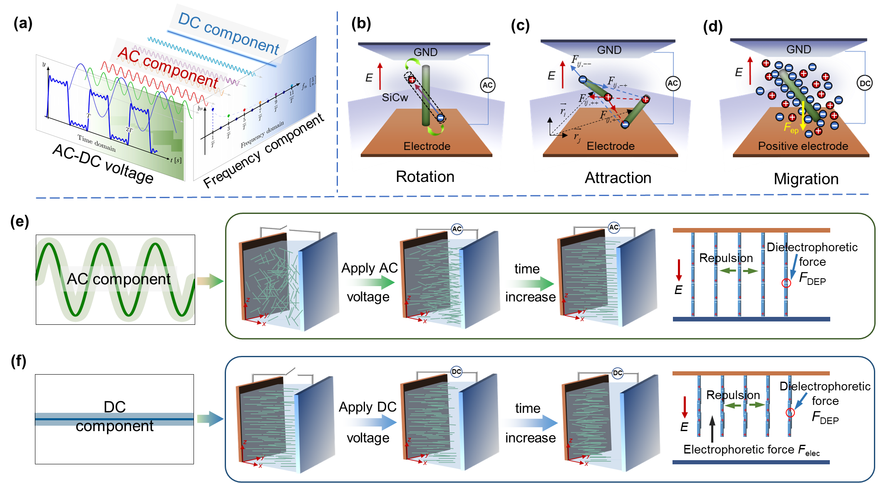
Fig. 1. The method for composite structure design. (a) AC-DC combined voltage. (b) The charge distribution and forces of rotation. (c) The charge distribution and forces of attraction. (d) The charge distribution and forces of migration. (e) AC component induces precise filler orientation. (f) DC component induces filler enrichment.
Under the combined AC-DC electric field, fillers experience rotational motion, mutual attraction, and migration toward the electrodes, as shown in Fig. 1(b)~(d). Specifically, under the combined AC–DC electric field, the SiCw filler suspended in the SE matrix become polarized, resulting in internal charge separation and the subsequent formation of electric dipoles p [22], as illustrated in Fig. 1(b). When the angle between the filler's long axis and the electric field direction is θ, an electric torque T_{align}=pEsinθ is generated. This torque drives the fillers to rotate, reducing θ in order to minimize the system's energy. The governing equation can be expressed as [23]:
where, V_{p} represent the volume of the SiCw filler; α∗ is the equivalent Clausius-Mossotti (CM) factor, which depends on frequency; E is the electric field stress; θ is the angle between the long axis of the filler and the direction of the electric field; a and b denote the lengths of the semi-major and semi-minor axes of the filler, respectively; ε_{p}* and ε_{m}* are the complex permittivity of of SiCw and SE respectively; L is the depolarization factor, given by L=[ln(2k)-1]/k². k is the aspect ratio of SiCw, k=a/b.
Furthermore, the electric field gradient induced by the interaction of charges at the filler ends leads to head-to-head attraction, resulting in the formation of chain-like structures, as shown in Fig. 1(c). This interaction force, known as the local dielectrophoretic force, is given by [24]:
Finally, due to the significant dielectric mismatch between SiCw and the surrounding SE matrix, an interfacial double layer is formed on the SiCw surface under the influence of the Maxwell–Wagner polarization effect [25, 26], as illustrated in Fig. 1(d). The potential at the slipping plane near the surface of SiCw is defined as the zeta potential. Measurements show that the zeta potential of SiCw is −26 mV, indicating that its surface carries a negative charge. As a result, under the influence of the DC component, the fillers migrate toward the positive electrode driven by the electrophoretic force. The expression for the electrophoretic force is [27]:
where, ε₀ is the permittivity of vacuum, r_{e} is the equivalent radius of SiCw, ζ represents the zeta potential of SiCw, and E_{DC} denotes the electric field stress of the DC component.
The AC component modulates the rotation and attraction free energy of SiCw, helping them overcome Boltzmann energy fluctuations. This ensures precise orientation, facilitating the formation of both nonlinear conductive pathways and thermal conduction networks, as shown in Fig. 1(e).
The DC component induces an electrophoretic effect, causing fillers to migrate toward regions of high electric and thermal field intensity. This targeted enrichment maximizes their functional contribution, as illustrated in Fig. 1(f). In essence, this AC-DC combined electric field approach enables spatiotemporal energy modulation, which can be described as U_{total}=U_{AC}+U_{DC}. U_{AC} governs filler orientation optimization, ensuring precise control over SiCw’s nonlinear electrical conductivity and thermal conductivity. U_{DC} governs filler distribution optimization, ensuring that SiCw is positioned optimally within the system to enhance overall efficiency. This strategy provides a systematic framework for achieving electro-thermal synergy in composite materials.
2.2 Experimental materials
The two-component silicone elastomer (SE) was selected as the matrix materials. The two components, vinyl-terminated polydimethylsiloxane and polymethylhydrogensiloxane, were purchased from Dow Chemical Company. Under the action of a platinum catalyst, these components undergo a cross-linking reaction to form SE. The filler used is SiCw, purchased from Merck, Germany, with a diameter of approximately 100 nm and a length of 8~15 µm. To prevent filler agglomeration and enhance compatibility within the matrix, KH550 was grafted onto the surface of SiCw. KH550 was sourced from Shanghai Aladdin Co., Ltd.
2.3 Optical observation of fillers dynamic behavior
To observe the motion characteristics of the filler under the influence of the AC-DC combined electric field, a mixture was prepared, and an experimental platform was set up. Fig. 2(a) illustrates the preparation process of the mixture. To prevent filler agglomeration, the surface of the SiCw was first modified with KH550. The modified filler was then mixed with components A and B of SE, and stirred under vacuum conditions to form the mixture.
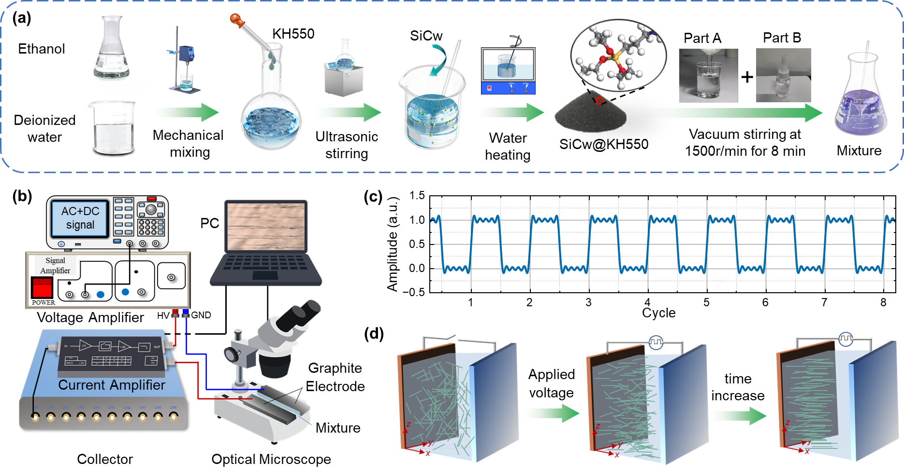
Fig. 2. Material preparation process and experimental platform. (a) SiCw surface modification and mixture preparation. (b) Optical-electrical testing platform. (c) AC-DC combined voltage waveform. (d) Arrangement state of fillers under different electric field stress.
Fig. 2(b) shows the optical-electrical testing platform, which consists of parallel graphite electrodes, a Tektronix AFG31000 signal generator, a Trek 623B voltage amplifier, a FEMTO current amplifier, a SMAX signal acquisition card, and an Olympus SZ51 optical microscope. After preparation, the mixture was poured between the parallel graphite electrodes, which were spaced 1 mm apart. An AC-DC combined voltage generated by the voltage amplifier was applied across the electrodes, with the left electrode set as the positive terminal and the right electrode grounded. The voltage waveform, shown in Fig. 2(c), had a frequency of 1 kHz, a 50% duty cycle, and a slew rate of 120 V/us. During the experiment, the voltage amplitude and application time were adjusted, and the filler motion was observed using an optical microscope at a temperature of approximately 25°C. The schematic of the change in the filler arrangement with increasing applied electric field stress is shown in Fig. 2(d). The current amplifier and signal acquisition card were used to measure the current passing through the mixture.
2.4 Fabrication of the SiCw/SE composites
A mixture was prepared by incorporating SiCw into SE at a mass fraction of 5%, the concentration selected to balance optimal material performance with the desired enrichment effect, as detailed in Section 3.2. The mixture was then poured between customized parallel electrodes, and a positive square-wave was applied for 300 seconds at varying amplitudes. The positive square-wave voltage not only contains both DC and AC components, but its waveform is also similar to the operating voltage of the power module. This makes the induced filler distribution very consistent with the actual electric/thermal field distribution. The voltage frequency was determined based on the Re[α*]. The larger the value of Re[α*], the stronger the rotational and attractive effects acting on the filler. As calculated from (3), Re[α*] remains constant at approximately 2300 within the frequency range of 0.1~1 kHz. However, when the frequency exceeds 1 kHz, Re[α*] declines sharply and approaches zero around 100 kHz. Thus, 1 kHz can be considered a threshold frequency for the transition in Re[α*]. Frequencies below this threshold may induce electrochemical reactions, whereas higher frequencies significantly diminish the filler’s orientation degree [28]. Consequently, the applied frequency was set at 1 kHz. The electric field stress was selected from the [3] and ranged from 0 to 800 V/mm in increments of 200 V/mm. Following voltage application, all samples were cured in an oven at 60 °C, with a balancing voltage maintained during curing to prevent thermally induced disarrangement of the filler structure. For rod-like fillers, the equilibrium electric field stress was calculated according to the method described in reference [19]:
where 2a is the long axis of the filler, CM is the Clausius-Mossotti factor, and ε_{m} is the dielectric constant of the liquid SE.
2.5 Characterization of cured SiCw/SE composites
The microstructures of the fillers and composites were analyzed using transmission electron microscopy (TEM) and scanning electron microscopy (SEM). X-ray photoelectron spectroscopy (XPS) was used to verify the effectiveness of the surface modification of SiCw. Lattice diffraction patterns within the 10~90° range were acquired using a Bruker X-ray diffractometer (XRD-D8), and the peak ratio method was employed to quantitatively assess the filler arrangement degree. Thermal conductivity was measured with a flash thermal conductivity meter (LFA 467 HyperFlash). Temperature response characteristics were evaluated using a thermal infrared imager (FLIR ONE, Teledyne FLIR, Wilsonville, OR, USA). The thermal stability of the composites was assessed with a thermogravimetric analyzer (TGA), while the dielectric loss of the samples was measured using a DIRANA. The nonlinear electric conductivity characteristics at room temperature were examined with a high resistance meter (Keithley 6517B), applying field strengths from 0.25 to 3 kV/mm. Finally, thermally stimulated depolarization current (TSDC) measurements were performed using the Novocontrol Concept 80. To verify the repeatability of the thermal and electrical conductivity measurements, three independent batches of samples were prepared and tested, all using the same fabrication process. The average relative standard deviations of thermal conductivity and electrical conductivity among samples of the same type were 1.33% and 2.03%, respectively. Additionally, to assess the experimental stability, one batch of samples was tested three times over a 15-day period, with a 5-day interval between each test. The results exhibited minimal variation across tests, indicating that the measurements possess good repeatability and stability.
- Results and discussion
3.1 The motion characteristics of fillers in SiCw/SE suspension
The arrangement of the filler is the key to enhancing the electro-thermal performance of the material. In order to better control the arrangement state, the distribution of the filler under different AC-DC combined electric field stress and duration was observed using the optical microscope, as shown in Fig. 3(a). In each subfigure, the red line on the left denotes the positive electrode, while the blue line on the right indicates the ground, establishing an electric field direction from left to right. The vertical axis (from top to bottom) represents the increase of the electric field stress from 200 V/mm to 800 V/mm, and the horizontal axis (from left to right) represents the increase of the application time from 0 to 10 mins. Based on Fig. 3(a), the filler density along the x-direction was calculated through the image processing procedure depicted in Fig. 3(b), with results presented in Fig. 3(c). Specifically, the filler density is obtained by superimposing the image pixels in Fig. 3(a) in the vertical direction. The darker the area in the image (where the filler is located), the larger the pixel value, and vice versa. Therefore, the filler density can reflect the degree of accumulation of the filler in the x direction.
At 2 minutes, for instance, when the electric field stress is 200 V/mm, it is observed that the filler distribution is relatively uniform, with no apparent chain or stripe formation. This indicates that the electric field stress at this level is insufficient to overcome viscous resistance, Brownian forces, and other factors needed to induce oriented movement. As the electric field stress increases (400 V/mm to 800 V/mm), the chain structure formed by the filler arrangement becomes increasingly evident. The higher the electric field stress, the thicker the chain structure. According to (1) and (4), the rotational force F_{rotation} is proportional to the square of the electric field stress, and the gradient of the squared electric field also causes the dielectrophoretic force F_{DEP} to increase linearly. As a result, the enhanced electric field accelerates the rotation and attraction processes of the fillers. Meanwhile, the chain-like fillers also gradually begin to move toward the positive electrode. As shown in (5), the increase in electric field stress enhances the electrophoretic force F_{EP}. The increase in electric field stress will accelerate the enrichment of fillers, and the density of fillers near the ground electrode will gradually decrease. From the positive electrode to the ground electrode, the density of fillers shows a trend of first being stable and then decreasing. It is also observed that longer voltage application times reduce the uniformity of the chain structure. This is attributed to electrofluidic behavior in the dielectric liquid at high electric field stress. Specifically, the electric field causes the liquid SE to flow, generating drag forces that move the filler and create eddy currents, ultimately disrupting the filler arrangement [23].
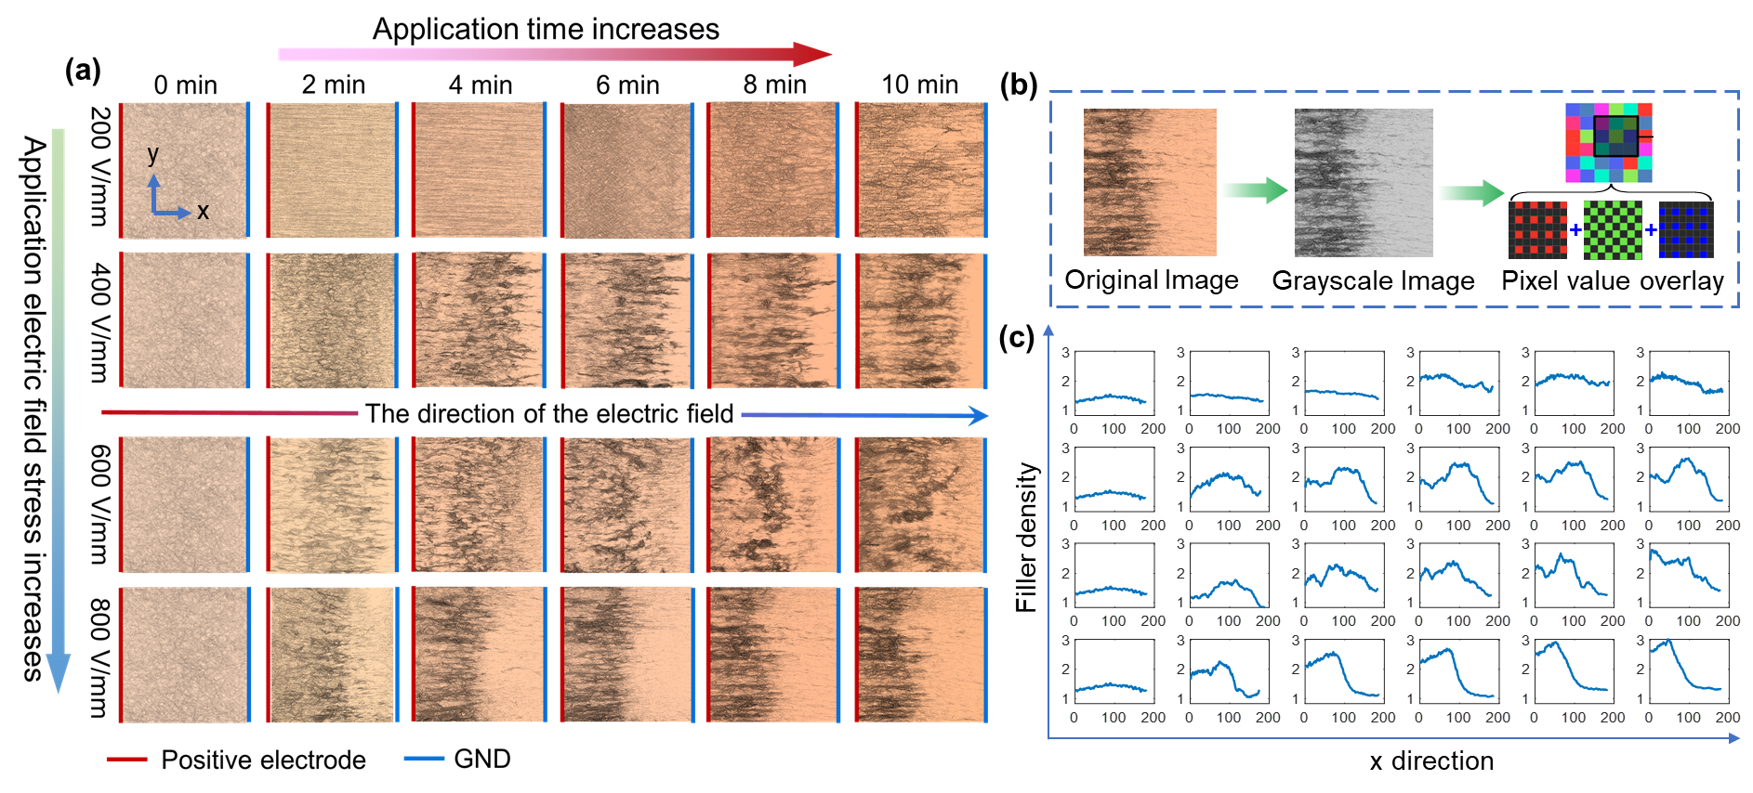
Fig. 3. The motion characteristics of fillers. (a) Optical observation of filler distribution state under different electric field stress and durations. (b) Image processing flow. (c) The filler density along the x direction.
The influence of the AC-DC combined electric field duration on the filler arrangement was also analyzed. Taking the applied electric field stress of 400 V/mm as an example, the evolution process of the filler arrangement is as follows. Firstly, during the initial 0~4 minutes, the filler gradually transitions from a uniform distribution to a chain structure along the electric field direction, with no significant change in filler density. Between 4~8 minutes, the chain structure thickens and begins to move toward the positive electrode, causing the filler density near the positive electrode to increase. From 8 to 10 minutes, the chain structure continues to thicken, and the density near the ground electrode decreases. The evolution of the filler arrangement at other electric field stress follows a similar trend. However, higher electric field stress accelerates this process, leading to faster transitions through the stages.
In fact, under the AC-DC combined electric field, the forces acting on the fillers can be categorized into four components: rotational torque aligning the filler with the electric field, coulomb attraction between fillers, dielectrophoretic force along the electric field gradient, and electrophoretic force driving the fillers toward the positive electrode [29]. Based on these forces, the filler movement can be described through four processes, as illustrated in Fig. 4(a).
1) Process 1: The SiCw rod-shaped fillers, initially dispersed uniformly in the mixture, experience rotational torque that aligns their long axes parallel to the electric field lines, forming chain-like structures. 2) Process 2: The AC-DC combined electric field induces macroscopic polarization charges at the ends of the fillers. The coulomb attraction between opposite charges causes the fillers to connect head-to-head, promoting the elongation of the chain structures. 3) Process 3: Due to the opposite charge signs at the two ends of the fillers within the parallel chain structures, the chains attract each other, resulting in thicker chain. 4) Process 4: Under the combined influence of electrophoretic and dielectrophoretic forces, the fillers migrate toward the electrode. The electrophoretic force predominates, causing the chain structures to shorten as they aggregate near the electrode.
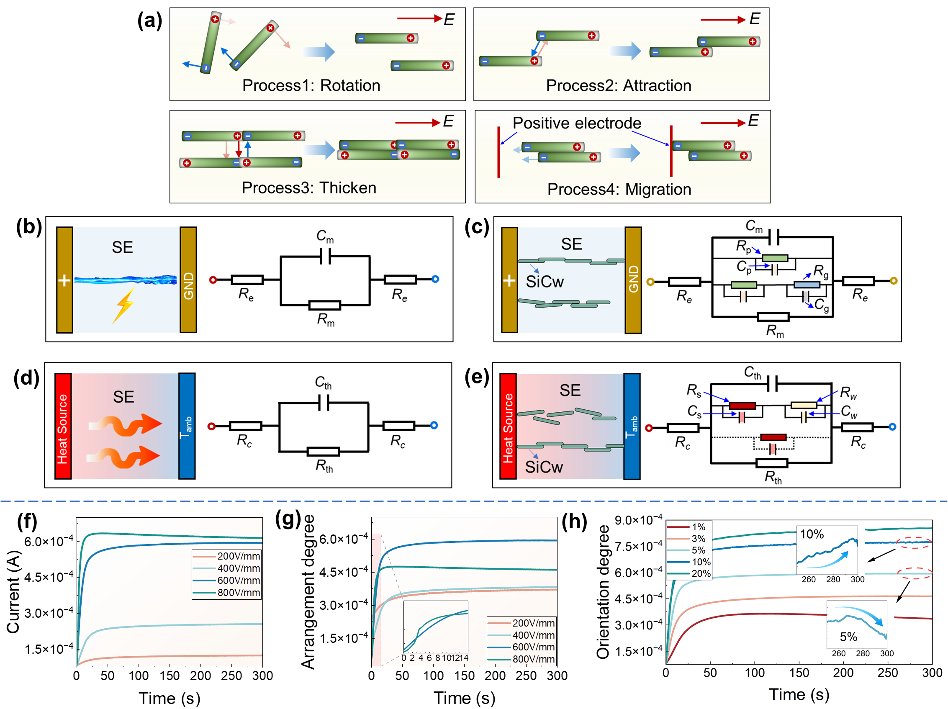
Fig. 4. Equivalent electric / thermal circuit model and global arrangement characterization. (a) The filler motion process under AC-DC voltage. (b) The equivalent electric circuit model of the system composed of electrode and liquid SE. (c) The equivalent electric circuit model of the system composed of electrode and SiCw/SE suspension. (d) The equivalent thermal circuit model of the system composed of source and SE. (e) The equivalent thermal circuit model of the system composed of source and SiCw/SE composites. (f) The current of the sample with a 5% filler mass fraction under different electric field stress. (g) The global arrangement degree of fillers in samples with 5% filler mass fraction. (h) The global arrangement degree of fillers in samples with different filler mass fraction.
To elucidate the mechanism by which filler arrangement synergistically enhances electro-thermal performance, we propose innovative equivalent electrical and thermal circuit models, as shown in Fig. 4(b)~(e). Fig. 4(b) illustrates the equivalent electrical circuit comprising liquid SE and electrodes under an applied electric field. This configuration includes electrode resistance (R_{e}), SE resistance (R_{m}), and SE capacitance (C_{m}). As shown in Fig. 4(c), when SiCw transition from a random dispersion to an oriented arrangement, multiple parallel resistance and capacitance branches are established within the system. The parameters of these parallel branches are determined by the filler resistance (R_{p}), filler capacitance (C_{p}), local matrix resistance (R_{g}), and local matrix capacitance (C_{g}). Among them, R_{e} can be obtained by impedance spectroscopy testing. C_{m} and R_{m} can be obtained by measuring the transient and steady-state values of the current in the circuit, as follows:
Similarly, R_{p}, C_{p}, R_{g} and C_{g} can also be obtained by fitting the current into three exponential processes:
This paper only makes a qualitative analysis of the changes in circuit parameters. Initially, as the fillers align with the electric field and attract each other, R_{g} decreases while C_{g} increases. Subsequently, as the chain structures formed by the fillers elongate and widen, R_{p} decreases and C_{p} increases. These changes collectively reduce the system's total resistance and enhance conductivity, thereby facilitating electron transport. Notably, alterations in circuit parameters are ultimately reflected in the material's electric conductivity characteristics. Consequently, composites with highly oriented SiCw exhibit excellent nonlinear electric conductivity, rapidly dissipating internal charges and effectively mitigating electric field distortion. This improved behavior underscores the critical role of filler arrangement in optimizing the composite's electrical performance.
Analogous to the electrical circuit model, the thermal circuit model is presented in Fig. 4(d). Here, R_{c} represents the contact resistance between the material and the heat source, while R_{th} and C_{th} denote the thermal resistance and thermal capacity of SE, respectively. The parallels between electrical and thermal circuits are evident: voltage, current, and resistance in electrical circuits correspond to temperature difference, heat flow, and thermal resistance in thermal circuits, respectively. Voltage drives current through a resistor, whereas temperature difference drives heat flow through a thermal resistor, both adhering to similar linear relationships (Ohm's law and Fourier's law). By orienting SiCw, the material attains superior nonlinear electric conductivity characteristics alongside enhanced thermal conductivity. As shown in Fig. 4(e), in the random distribution of SiCw, the R_{C} components comprising filler thermal resistance (R_{s}) and thermal capacitance (C_{s}), along with those consisting of local matrix thermal resistance (R_{w}) and thermal capacitance (C_{w}), are connected in parallel within the original equivalent thermal circuit. This configuration reduces the system's overall thermal resistance and increases thermal capacitance. As SiCw orientation improves, certain branches exhibit thermal resistance and capacitance solely as R_{s} and C_{s}. Consequently, the system's total thermal resistance decreases, phonon transmission is facilitated, and thermal conductivity efficiency is significantly enhanced.
In summary, the proposed electrical and thermal circuit models elucidate the principles underlying the simultaneous enhancement of nonlinear electric conductivity and thermal conductivity. These models substantiate the feasibility of SiCw arrangement as a strategy to synergistically improve the electro-thermal performance of composites.
3.2 The assessment of global filler arrangement degree
The arrangement degree is a key parameter that reflects the distribution state of the filler and is affected by the orientation and enrichment of the filler. It is important to note that image processing and spectroscopy, due to optical limitations, can only evaluate the filler arrangement degree in local areas of highly transparent samples (those with low filler content). To address this limitation, this study proposes a method for quantitatively evaluating the global arrangement degree of fillers based on the current during the filler arrangement process, from the perspective of resistance and capacitance changes. Since the current reflects the overall arrangement characteristics of the filler, the global arrangement degree can take into account both the orientation and enrichment of the filler.
Fig. 4(f) presents the current response of samples with a 5% filler mass fraction under various electric field stress. To ensure consistency and eliminate the influence of Ohmic behavior at different voltage amplitudes, all measured values were normalized to a reference voltage of 600 V. Based on this normalization, Fig. 4(g) illustrates the evolution of the global arrangement degree of the filler over time. As shown in Fig. 4(g), for a 5% filler mass fraction, the arrangement degree gradually increases over time under lower electric field stresses (200~400 V/mm, corresponding to samples P1 and P2). When the electric field stress increases to 600~800 V/mm (samples P3 and P4), the arrangement degree initially increases but subsequently decreases over time. Notably, the final arrangement degree under 800 V/mm (P4) is lower than that under 600 V/mm (P3). This phenomenon can be explained as follows: under low electric field stress, the electrophoretic force is insufficient to overcome the viscous resistance, and the filler gradually forms chain-like structures through rotational torque and local dielectrophoretic forces. As a result, the arrangement degree increases steadily. Under higher electric field stresses, the rotational force initially exceeds the viscous resistance, rapidly aligning the filler along the electric field and forming chain structures—as seen in the magnified image inset. Simultaneously, the stronger DC electrophoretic force at high fields causes significant filler migration. Over time, this migration shortens the chain structures, leading to a decline in the global arrangement degree. This trend is observed at both 600 V/mm and 800 V/mm. However, due to the stronger electrophoretic force at 800 V/mm, the filler enrichment is more pronounced and the chain structures are correspondingly shorter. As a result, the arrangement degree at 800 V/mm is initially higher than at 600 V/mm, but it gradually declines and eventually falls below that of the 600 V/mm case as the field application time increases. Therefore, the sample subjected to 600 V/mm achieves the optimal filler arrangement, exhibiting the highest orientation degree while also enabling effective filler migration toward the electrode.
Fig. 4(h) illustrates the variation in the global arrangement degree at different filler mass fractions under an electric field stress of 600 V/mm. When the mass fraction is ≤5%, the global arrangement degree increases rapidly with time, followed by a gradual decline. In contrast, at mass fractions >5%, the global arrangement degree no longer decreases but instead rises sharply before reaching a steady state. This behavior is attributed to the increased viscosity of the composite with higher filler content, which hinders the electrophoretic force from effectively overcoming the viscous drag to drive filler migration. As a result, within the observed timeframe, filler enrichment near the positive electrode remains limited. Thus, only rotation (process 1) and attraction (process 2) dominate, leading to a trend of rapid orientation followed by stabilization.
More importantly, the mass fraction of SiCw plays a critical role in determining the electrothermal performance of the composites. Numerous studies have demonstrated that increasing SiCw content can enhance both the nonlinear electrical conductivity and thermal conductivity. However, excessive filler loading increases the system's viscosity, thereby restricting filler migration toward regions of high electric and thermal fields. Based on the combined analysis of Fig. 4(g) and (h), a filler mass fraction of 5% emerges as the upper limit at which both orientation and enrichment effects can be effectively achieved. Therefore, 5% is identified as the optimal filler concentration for material preparation.
3.3 The microstructural properties of cured composites
To investigate the microstructural morphology of the cured composites, SEM, TEM, and XRD analyses were performed. As shown in Fig. 5(a), SiC presents a rod-like structure with a diameter of about 0.1~1um and a length of about 8~15um. Fig. 5(b) and (c) compare the filler edges before and after surface modification, revealing that the modified SiCw is coated with an encapsulation layer approximately 4 nm. Furthermore, XPS analysis was conducted on unmodified and modified SiCw samples, as illustrated in Fig. 5(d-1) and (d-2). The modified sample exhibited a distinct C-N peak at 286 eV, confirming the successful grafting of KH550 onto the SiCw surface. Fig. 5(e) shows the cross section of SE. Since the filler is not doped, the cross section is very smooth. Fig. 5(f) shows a sample doped with SiCw but without applying a voltage. It can be found that the filler is evenly distributed in its cross section, further illustrating that the modified SiCw and the matrix have good compatibility. Fig. 5(g)~(j) depict the spatial arrangement of the fillers under varying electric field stresses. As the electric field stress increases from 200 to 400 V/mm, the degree of SiCw orientation gradually improves; however, no significant enrichment is observed. At higher electric field stress of 600 V/mm and 800 V/mm, both orientation and enrichment of SiCw occur simultaneously, as also confirmed by the results in Fig. 4(g). A comparative analysis reveals that at 600 V/mm, the fillers achieve moderate enrichment while maintaining a well-organized, oriented structure. In contrast, under 800 V/mm, the significantly stronger electrophoretic force leads to excessive filler accumulation, which shortens the chain structures and disrupts the overall filler orientation due to more intense electrophoretic motion.
More importantly, it is desirable to construct the filler distribution structure shown in Fig. 5(i) in an actual power module. In such modules, electric and thermal fields are often intensified at the electrode edges and at triple-phase boundaries among metal, ceramic, and polymer layers, leading to localized electrothermal stress concentrations. In application scenarios, an external inducing field can be applied via the module’s inherent parallel electrode configuration to produce the aligned and locally enriched SiCw filler structure as presented in Fig. 5(i). Under such conditions, the filler alignment reaches an optimal state, exhibiting excellent nonlinear conductivity and thermal conduction. Furthermore, the moderate enrichment of fillers in critical zones allows for the tuning of local dielectric properties, which helps to alleviate field distortions and reduce breakdown risks. Simultaneously, it provides improved thermal pathways, enabling more efficient heat dissipation and mitigation of thermal stress. Therefore, the proposed composite insulation system demonstrates promising applicability under the high-voltage and high-heat-flux conditions characteristic of power module operation.
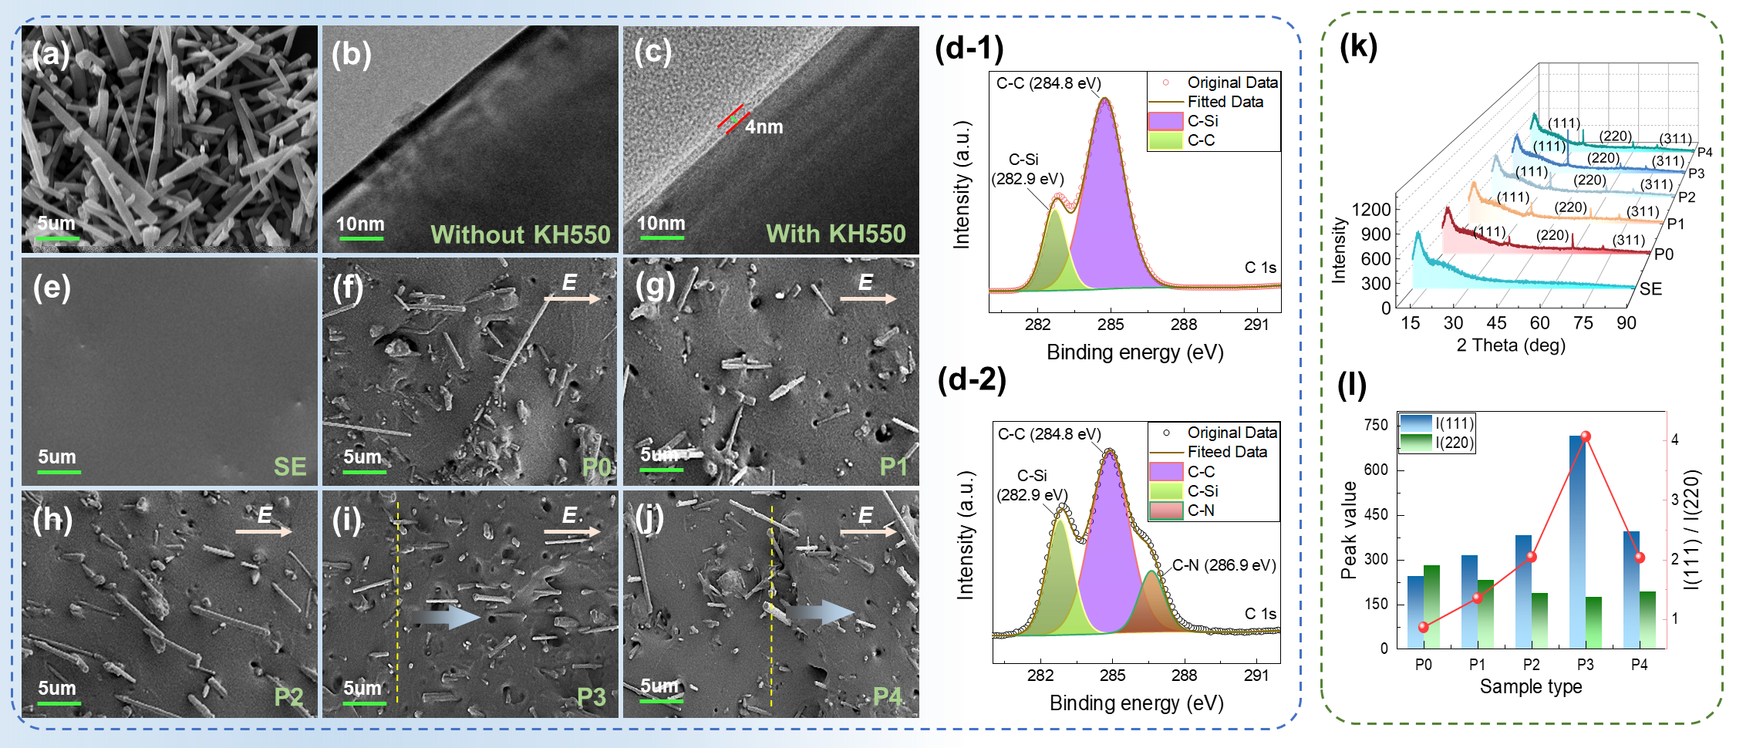
Fig. 5. The microstructure of the filler and samples. (a) The SEM of fillers. (b) The TEM of the edge of unmodified filler. (c) The TEM of the edge of modified filler. (d) The XPS of unmodified and modified SiCw. (e) SEM of SE cross-section. (f) SEM of P0 cross-section. (g) SEM of P1 cross-section. (h) SEM of P2 cross-section. (i) SEM of P3 cross-section. (j) SEM of P4 cross-section. (k) The XRD test results of the cured composites. (l) Characterizing filler arrangement degree using the diffraction peak ratio method.
To quantitatively characterize the arrangement degree of the filler within the cured sample, XRD analysis was performed. XRD is a powerful method for studying the microstructure of composite s, based on the Bragg equation 2dsinθ=nλ [30]. When the angle between the incident X-ray and the specific crystal plane of SiCw satisfies the Bragg equation, strong X-ray diffraction lines are observed in specific directions, and vice versa. Thus, changes in the intensity of diffraction peaks at 2θ=35° and 60° in the XRD spectrum can reflect the arrangement degree of SiCw, as shown in Fig. 5(k). It is observed that SE does not have the characteristic diffraction peak of SiCw. With increasing applied electric field stress, the diffraction peak at 35° first increases and then decreases, while the diffraction peaks at 60° exhibits the opposite trend. The ratio of the peak intensity at 35° to that at 60° is defined as the local arrangement degree, with its variation trend shown in Fig. 5(l). This trend reveals that the filler arrangement degree also increases initially and then decreases with increasing electric field stress. This observation is consistent with the results from SEM and current measurements, thereby providing cross-validation for the effectiveness of the global arrangement degree evaluation index. In summary, based on the comprehensive analysis of the global arrangement degree, SEM, and XRD results, it can be concluded that sample P3, prepared under an electric field stress of 600 V/mm, exhibits the optimal filler arrangement. This includes the highest degree of orientation along with an appropriate level of filler enrichment.
3.4 Thermal conductivity and thermal stability of SiCw/SE composites
The arrangement degree of the filler will inevitably impact the thermal conductivity of the composite. Using the laser flash method, the thermal conductivity of SE and the composites in the vertical direction was measured, as shown in Fig.6 (a). The thermal conductivity of SE is only 0.144 W/(m⋅K). In contrast, the composites exhibit significantly enhanced thermal conductivity due to the construction of thermal conduction paths. Furthermore, from samples P0 to P4, the thermal conductivity of the composite initially rises and then decreases. Sample P3 achieves the highest thermal conductivity at 0.656 W/(m⋅K), representing a 333% improvement over SE. This enhancement is due to the ordered chain structure formed after arrangement. It helps mitigate filler agglomeration, reduces interfacial thermal resistance between the matrix and filler, and facilitates phonon transmission. This is corresponding to the thermal circuit model shown in Fig. 4(e). Specifically, in composites with randomly dispersed traditional fillers, the lack of direct contact between fillers forces heat to traverse multiple filler–matrix interfaces. This results in high interfacial thermal resistance and significantly hampers thermal conductivity. In contrast, the present study utilizes a combined AC and DC electric field to induce the arrangement of SiCw, forming interconnected chain structures that enhance filler connectivity and continuity of the thermal conduction pathways. SEM images in Fig. 5(i) clearly show the formation of these chain-like structures within the composite. Such structures minimize heat flow interruption points and reduce scattering probability at interfaces, enabling more efficient heat transfer throughout the system. In addition, the relationship between thermal conductivity and interfacial thermal resistance R_{int} is well described by the Maxwell-Garnett Effective Medium Theory (EMT) as expressed in (11) and (12) [31]:
where, λ is the overall thermal conductivity of the composite material, km is the thermal conductivity of the SE matrix. ϕ is the filler volume fraction. k_{f}* is the equivalent filler thermal conductivity, considering the correction value of the interface thermal resistance, k_{f} is the intrinsic thermal conductivity of SiCw, R_{int} is the interface thermal resistance, and r_{e} is the filler equivalent radius (r_{e}=a^{1/3}*b^{2/3}), a and b are the major and minor semi-axis lengths of the filler, respectively.
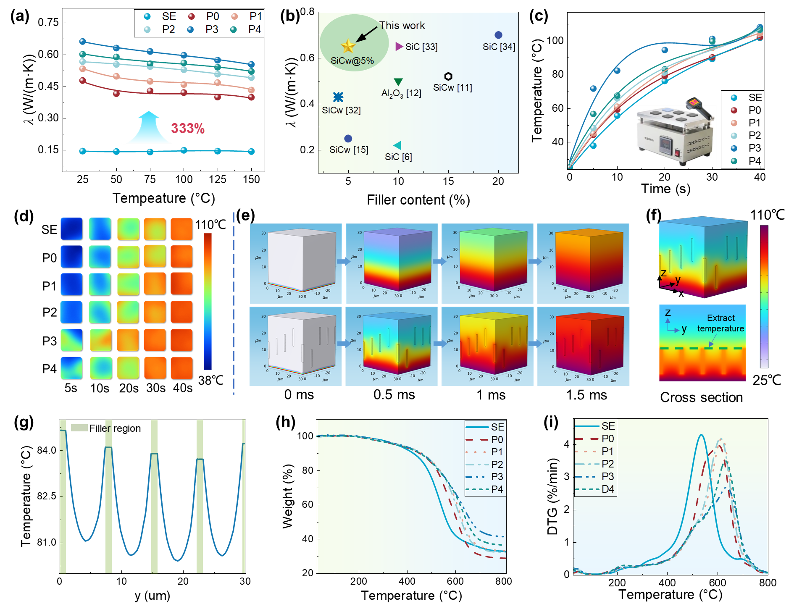
Fig. 6. The thermal conductivity and thermal stability of composites. (a) The thermal conductivity versus temperature curves of the samples. (b) Comparison of thermal conductivity with other literature. (c) The surface temperature of the sample variation heating time. (d) The infrared imaging results of the sample surface temperature at different times. (e) The thermal conduction process of SE and composite. (f) The temperature distribution at composite’s cross section. (g) The temperature distribution in the y-direction on the cross-section. (h) The thermogravimetric analysis (TGA) curves of the samples. (i) The differential Thermogravimetric (DTG) curves of samples.
A clear negative correlation is observed between R_{int} and thermal conductivity, indicating that increasing the degree of filler arrangement significantly lowers interfacial thermal resistance, thereby improving the overall thermal performance of the composite. However, in sample P4, filler enrichment leads to phonon scattering during transmission, which is not conducive to heat dissipation, thereby reducing the thermal conductivity. Compared with samples P0~P3, the significantly stronger electrophoretic force in P4 induces excessive enrichment of fillers, resulting in shortened chain structures and disrupted orientation. Our findings indicate that reducing the electric field stress during the preparation process can effectively suppress this phenomenon. For instance, sample P3, prepared under a lower electric field stress than P4, exhibits a more uniform and continuous chain-like structure, along with superior thermal conductivity. In addition, Fig. 6(b) compares the thermal conductivity of the composites prepared in this study with similar composites reported in the literature [32-34].
It can be found that the proposed sample exhibits superior thermal performance while requiring the lowest filler content. Notably, its thermal conductivity is the largest among samples with the same filler content. This outstanding performance can be attributed to the well-constructed oriented structure of one-dimensional SiCw, which effectively optimizes phonon transport and minimizes thermal resistance. These findings underscore the effectiveness of the proposed strategy in enhancing the thermal conductivity of polymer-based composites.
To visualize the thermal conductivity, block samples of the same size but with different filler arrangements were heated on a 110°C heating table. Surface temperature changes over time were observed using an infrared thermal imaging camera, as shown in Fig. 6(c) and (d). With increasing heating time, the sample surface temperature rose from room temperature to nearly 110°C. The surface temperature of the SiCw-doped samples increased faster than that of the SE sample. Among them, sample P3 exhibited the fastest surface temperature rise, reaching near 110°C in the shortest time, confirming its superior thermal conductivity. These observations are consistent with the thermal conductivity test results.
In addition, to investigate the heat transfer process in the composite, a finite element model was established, as shown in Fig. 6(e). The model dimensions are 30×30×30 µm. A heat source of 110°C was applied to the bottom of the sample. Fig. 6(e) show the heat conduction process of SE and filler-oriented samples, while Fig. 6(f) and (g) show the temperature distribution state on the cross section of the composite and the temperature curve in the y direction, respectively. Among them, Fig. 6(g) is obtained by extracting the temperature on the green dashed line in Fig. 6(f). The results show that the heat transfer process in the composites with arranged fillers is significantly faster than that in SE, and the temperature in the filled area increases significantly. This demonstrates that the oriented arrangement of high thermal conductivity fillers effectively creates dedicated heat conduction paths within the matrix, enhancing thermal energy transfer.
Finally, the thermal stability of the composites was analyzed. Fig. 6 (h) and (i) presents the TGA and DTG curves of the samples. The temperature corresponding to 90% weight loss and the peak thermal decomposition rate in the composite is higher than that of SE, indicating excellent thermal stability. This improvement is attributed to a more elastic molecular structure, which effectively resists molecular cyclization degradation. Furthermore, as the sample label increases, the temperatures for 90% weight loss and peak thermal decomposition initially rise and then decline. This suggests that the sample achieves optimal thermal stability at arrangement degree P3, where the molecular structure of the composite is more ordered and uniform.
3.5 The electrical performance of SiCw/SE composites
To investigate the dielectric properties of composites with varying filler arrangements, dielectric loss and conductivity measurements were conducted. As shown in Fig. 7(a), due to the low filler content, composites across different arrangements exhibit low dielectric loss, with a maximum value of only 10%. Below 1 Hz, the dielectric loss of the composites is lower than that of SE, and it does not show significant increase across the entire frequency range.
The nonlinear electric conductivity property enables the composite to achieve adaptive optimization of the electric field. Fig. 7(b) shows the conductivity curves of composites with different filler arrangements as a function of electric field stress. It is important to note that the electric field stress here refers to the conductivity test electric field stress, not the auxiliary electric field stress used during material preparation. The pure SE sample exhibits almost no change in conductivity as electric field stress increases. In contrast, composites with SiCw demonstrate nonlinear electric conductivity behavior. To comprehensively analyze the loss characteristics of the composites, the leakage current under the electric field of 1.2 kV/mm was extracted based on Fig. 7(b), as shown in the Fig. 7(c). It can be observed that from sample SE to P4, the leakage current first increases and then decreases. Nevertheless, the maximum leakage current remains below 10⁻¹² A, indicating a relatively low level overall.
The two key parameters used to evaluate nonlinear electric conductivity are the nonlinear coefficient γ and the switch-field strength Eth, collectively referred to as nonlinear parameters. Their relationship with electric conductivity σ is expressed by the following equation [35]:
where, 𝜎 represents the material conductivity, 𝜎₀ is the initial conductivity, 𝛾 is the nonlinear coefficient, and E_{th} is the switch-field strength. The nonlinear parameters of the samples were obtained by fitting the data to formula (1), as summarized in Fig. 7(d). Compared with other literature [36-42], the composite prepared in this paper obtains the lowest switch-field strength at a lower filler content, as shown in Fig. 7(e). The results show that the nonlinear coefficients of composites P1 to P4 initially increase and then decrease, while the switch-field strength exhibits the opposite trend. These nonlinear parameters are strongly influenced by the filler arrangement degree. A higher filler arrangement degree results in a larger nonlinear coefficient and a lower switch-field strength. To clarify the underlying mechanism by which filler arrangement degree affects the nonlinear conductive behavior of the composite, we employed the hopping conduction model and the tunneling breakdown model to analyze its performance under low and high electric field stresses, respectively. Under low electric field stress, conduction is primarily governed by thermally activated hopping of electrons between localized energy states. This behavior is described by the hopping conduction model, with the conductivity given by [43]:
where e is the elementary charge, R is the average hopping distance, K_{B} is the Boltzmann constant, T is the temperature, v is the attempt-to-escape frequency, E_{t} is the trap energy level, E_{A} is the acceptor energy level of SiCw, and A(T) is a temperature-dependent pre-factor for low-field conduction. As shown in Fig. 8(i), with increasing filler arrangement, the trap energy level E_{t} of the composite gradually decreases, leading to an increase in the A(T) component. Consequently, the low-field conductivity σ₀ of the composite also increases as filler arrangement degree improves.
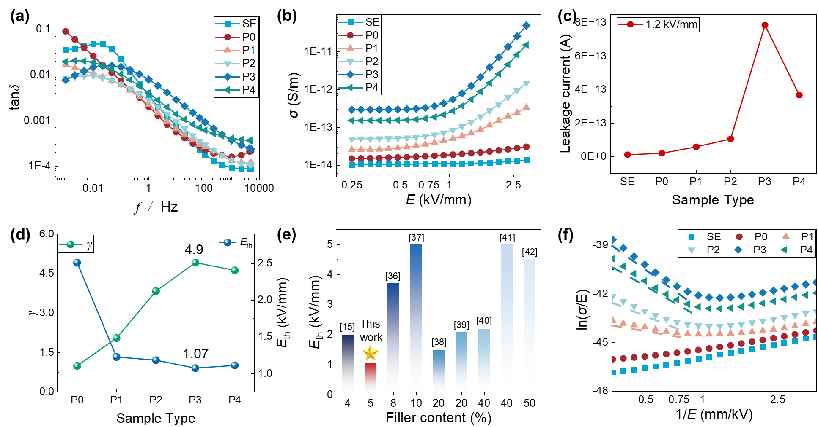
Fig. 7. The electrical properties of the composite. (a) The dielectric loss of samples. (b) The nonlinear electric conductivity of samples. (c) The leakage current of samples. (d) The γ and E_{th} of samples. (e) Comparison of E_{th} with other literature. (f) The relationship between ln(σ/E) and 1/E.
Under high electric field stress, electron transport occurs predominantly through a tunneling breakdown mechanism. In this regime, the conductivity is expressed as [43]:
where C is a constant, D is a parameter proportional to the trap level E_{t}, and E is the applied electric field stress. As the filler arrangement degree increases, the contact surface area between SiCw particles expands, significantly reducing the trap level E_{t}. This results in a smaller D value and a substantial increase in conductivity under the tunneling mechanism. Fig.7(f) presents the fitted relationship between ln(σ/E) and 1/E. It is evident that greater filler arrangement degree increases the slope of the fitted line, indicating an increase in the nonlinear coefficient γ. Additionally, the earlier establishment of conductive pathways enables the composite to enter the nonlinear conduction region at lower electric field stress, as reflected by the decreased switch-field strength E_{th}.
From a macroscopic perspective, the enhanced nonlinear conductivity due to filler arrangement is primarily attributed to the percolation effect. According to the percolation theory, when the filler concentration exceeds the percolation threshold, effective inter-filler contact is established, resulting in the emergence of nonlinear conductivity [44, 45]. The key lies in creating a substantial effective contact area between fillers and constructing a complete conductivity path, which generates nonlinear potential barriers [46]. In this study, the AC-DC combined electric field was used to actively induce filler arrangement and contact. By increasing the filler arrangement degree, the nonlinear coefficient is enhanced, and the switch-field strength is reduced. Additionally, this method enables effective filler contact at low concentrations, significantly reducing the amount of filler required for industrial preparation and avoiding agglomeration and dielectric loss surges.
The excellent nonlinear electric conductivity of the SiCw/SE composite effectively suppresses space charge accumulation and optimizes local electric field. To evaluate its influence on electric field stress, a simulation model was developed based on the chipless Direct Bond Copper (DBC) board structure of a real power module, as shown in Fig. 8(a). The specific preparation procedure for the sample is as follows: ① The well-mixed insulating prepolymer is applied to the triple point region of the DBC board using a brush, followed by vacuum degassing in an oven for approximately 10 minutes, as shown in Fig. 8(b). ② A positive-polarity square-wave voltage (600 V/mm, 1 kHz) is then applied using the metal plate of the DBC as electrodes at room temperature to induce filler arrangement, as shown in Fig. 8(c) and (d). ③ The coated DBC board is subsequently heated to 60 °C for curing, , and a balancing voltage is applied during the curing process. Finally, SE is poured around the DBC to complete the encapsulation process.
The simulation model and results are shown in Fig. 8(e). To avoid singular value issues, the point T, located 20 μm horizontally and vertically from the triple point, was chosen to represent the maximum electric field stress. Three cases were compared: SE as the packaging material (Case 1), the composite with uniformly distributed fillers (Case 2, Corresponding sample P0), and the composite with oriented fillers (Case 3, Corresponding sample P3). In Case 1, the maximum electric field stress reached 35.12 kV/mm, concentrated at the triple point, exceeding the breakdown threshold of SE. Introducing the composite with uniformly distributed fillers (Case 2) reduced this value by 12.6% to 30.69 kV/mm. With oriented fillers (Case 3), the peak stress further dropped to 7.25 kV/mm. Although the maximum shifted to the coating's edge, it remained 32.5% lower than in Case 1 and considerably lower than in Case 2.
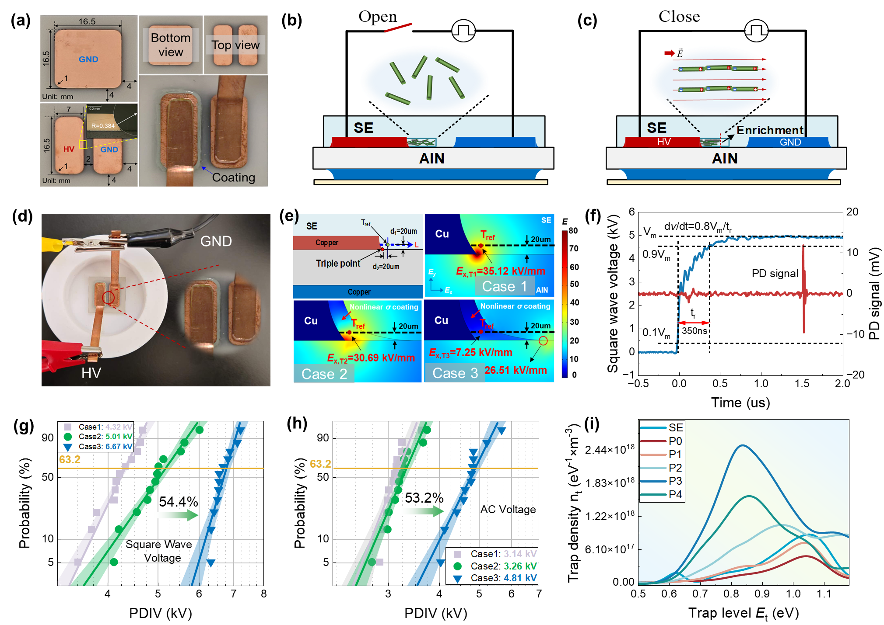
Fig. 8. Coating preparation and insulation performance testing. (a) The structure and dimensions of the chipless power module. (b) Schematic diagram without induced electric field. (c) Schematic diagram of applying induced electric field. (d) Photograph of applying induced electric field. (e) The simulation model and results of the electric field distribution in the power module. (f) Positive square wave and PD signal. (g) The PDIV of the sample under positive square wave voltage. (h) The PDIV of the sample under AC voltage. (i) The TSDC curves of samples.
Furthermore, we evaluated the partial discharge inception voltage (PDIV) of these three cases under both a unipolar square wave and a AC voltage. The square wave had a frequency of 1 kHz and a rising edge of 350 ns, as shown in Fig. 8(f). EMI has been filtered out by a high-pass filter to avoid interfering with the measurement of PDIV. Each sample was tested twelve times to ensure statistical reliability. As shown in Fig. 8(g), under the square wave voltage, the sample with directionally aligned fillers (Case3, Corresponding P3) exhibited a significant PDIV enhancement—an increase of 54.4%—compared to the pure SE (Case1, Corresponding SE) and the sample with randomly distributed fillers (Case2, Corresponding P0). This improvement is primarily attributed to the reduction in switch-field strength enabled by the filler arrangement. A lower switch-field strength implies that the material enters a nonlinear conduction regime at a lower applied electric field stress, which facilitates earlier charge redistribution within the insulation. This redistribution helps suppress initial electric field distortion, thereby effectively increasing PDIV. Fig. 8(h) further validates the enhanced PDIV under AC voltage, following the IEC 60270 standard [47]. The trend observed under AC voltage is consistent with that under square wave conditions—Case 3 (aligned fillers) exhibits the highest PDIV, followed by random distribution and pure SE. However, the absolute PDIV values under AC voltage are generally lower than those under square wave voltage. This discrepancy is likely due to differences in space charge dynamics. While space charge accumulation occurs under both waveforms, the unipolar square wave induces stronger space charge buildup, which generates a built-in electric field that weakens the local electric field stress. As a result, a higher external voltage is required to trigger partial discharge. In summary, the AC–DC electric field-induced filler arrangement strategy proposed in this work effectively mitigates local electric field distortion and enhances the insulation performance of the composite under both square wave and AC voltage conditions.
Investigating the influence of filler arrangement degree on trap characteristics is essential for elucidating the mechanism behind the improved electric insulation performance of power modules. Fig. 8(i) presents the TSDC curve of the sample, illustrating its trap energy levels E_{t} and trap density n_{t}. It is observed that the trap energy level of the SiCw/SE composite is lower than that of pure SE. In SE, traps primarily originate from physical imperfections caused by the disordered arrangement of polymer chains. In contrast, the traps in the SiCw/SE composite are mainly associated with the interfacial regions between SiCw fillers and between SiCw and the SE matrix. However, due to the high intrinsic order and excellent interfacial compatibility of SiCw, the traps formed at these interfaces are typically shallow, resulting in an overall lower trap energy level compared to pure SE.
Notably, the trap energy level of the composite decreases progressively with increasing filler arrangement degree. This trend can be explained by the evolution of the microscopic interfacial structure. When the orientation of SiCw is low, a complex mesoscale interface network forms, consisting of both SiCw–SE and SiCw–SiCw interfaces. Under these conditions, the charge transport path is discontinuous and must traverse multiple interfacial barriers, requiring higher energy and leading to deeper trap levels. As SiCw becomes more aligned, it tends to arrange in parallel within the matrix, forming a more coherent conductive path with fewer interfacial disruptions. This transition simplifies the interface types, significantly reducing the number of SiCw–SE interfaces. Consequently, charge hopping across interfaces becomes more efficient, and the trap energy level is notably reduced. A lower trap energy level facilitates carrier transport across the Schottky barrier, accelerates charge mobility, and suppresses space charge accumulation. These effects collectively enhance the electrical insulation reliability of the composite, significantly reducing the risk of dielectric breakdown in power modules.
- Conclusions
In summary, this study utilizes an AC-DC combined electric field induction strategy to align SiCw, effectively integrating nonlinear electrical conductivity and thermal performance within the composite. This approach enables the synergistic enhancement of both electrical insulation and thermal management in power module packaging materials. Comprehensive experimental and simulation analyses reveal that, at low filler concentrations, the AC-DC combined electric field drives the filler through four dynamic stages: rotation, attraction, chain thickening, and migration toward the electrode. This process elucidates the underlying mechanism of filler motion. The prepared composite exhibits exceptional thermal conductivity, reaching a maximum of 0.65 W/(m⋅K), a 333% improvement over SE. Infrared imaging and finite element simulations confirm that oriented SiCw forms efficient thermal conduction pathways, significantly accelerating heat transfer. More importantly, the composite's superior nonlinear electric conductivity properties enable a 24.5% reduction in maximum electric field stress and a 54.4% increase in PDIV compared to SE, greatly enhancing the dielectric strength of power modules. Overall, this work represents the first report on utilizing an AC-DC combined electric field strategy to enhance the electro-thermal performance of insulating materials. The findings highlight the enormous potential of SiCw-based composites for improving electrical insulation and thermal management, offering a promising solution for the industrial application of high-performance power modules.
However, certain technical challenges remain in practical applications. For example, electric-field-induced arrangement typically requires extended processing time, which limits manufacturing efficiency. Additionally, when applied as a surface coating, the material must exhibit good process compatibility and controllability. These challenges can be addressed by increasing the electric field stress, optimizing electrode structures, or introducing rapid curing and shear-assisted techniques to accelerate arrangement. Moreover, the development of low-temperature, scalable processes such as spraying or screen printing could enable seamless integration of the material into existing packaging workflows.
Furthermore, this strategy holds promising application potential in other material systems, such as flexible electronic skins, electrostatic energy storage devices, and gradient functional materials. In the future, high-throughput, multi-scale simulations based on electric-field-induced mechanisms, combined with data-driven material design and performance prediction, may provide an efficient and scalable pathway for advanced material optimization.

CRediT authorship contribution statement
Huanmin Yao: Conceptualization, Data curation, Formal analysis, Investigation, Methodology, Writing-original draft, Funding acquisition. Haibao Mu: Conceptualization, Formal analysis, Methodology, Supervision, Writing–review & editing. Wenrui Tian: Formal analysis, Writing – review & editing. Andrea Cavallini: Formal analysis, Writing-review & editing. Maoqun Shen: Formal analysis, Writing – review & editing. Wendong Li: Conceptualization, Writing–review & editing. Daning Zhang: Conceptualization, Writing–review & editing. Haoxiang Zhao: Conceptualization, Writing – review & editing. Guanjun Zhang: Formal analysis, Writing–review & editing, Supervision.

Acknowledgments
This paper was supported by the National Natural Science Foundation of China Youth Student Basic Research Project (523B2081) and the Fundamental Research Funds for the Central Universities (xzy022024072).

Declaration of competing interest
The authors declare that they have no known competing financial interests or personal relationships that could have appeared to influence the work reported in this paper.

Reference
- Ure, Climate Change and the Environment (SDGs 13, 6, 7, 11, 14, 15), in: Achieving the United Nations Sustainable Development Goals: Late or Too Late?, Emerald Publishing Limited, (2024) 61-114.
- K. Raja, Barriers and Opportunities in Achieving Washington State’s Target of a 100 Percent Clean Energy Grid by 2045, (2024).
- S. Mao, Z. Pan, Y. Ye, P. Han, J. Tang, C. Pan, Electric-field-induced assists fabrication of micro-SiC/Epoxy coating with low additive amount to improve surface insulating performance of HVDC insulator, Compos. Sci. Technol. (2024) 110696.
- J. Chen, Y. Zhou, X. Huang, C. Yu, D. Han, A. Wang, Y. Zhu, K. Shi, Q. Kang, P. Li, P. Jiang, X. Qian, H. Bao, S. Li, G. Wu, X. Zhu, Q. Wang, Ladderphane copolymers for high-temperature capacitive energy storage, Nature 615 (7950) (2023) 62-66.
- A. Zandieh, P. Buahom, E. B. Shokouhi, L. H. Mark, R. Rahmati, O. A. Tafreshi, M. Hamidinejad, A. Mandelis, K. S. Kim, C. B. Park, Highly anisotropic thermally conductive dielectric polymer/boron nitride nanotube composites for directional heat dissipation, Small 20 (48) (2024) 2404189.
- Y. Wang, J. Wu, Y. Yin, T. Han, Effect of micro and nano-size boron nitride and silicon carbide on thermal properties and partial discharge resistance of silicone elastomer composite, IEEE Trans. Dielectr. Electr. Insul. 27 (2) (2020) 377-385.
- C. Dai, X. Chen, Q. Wang, M. Awais, G. Zhu, Y. Shi, A. Paramane, Y. Tanaka, Electrical and thermal performances of epoxy-based micro–nano hybrid composites at different electric fields and temperatures, Nanotechnology 32 (31) (2021) 315715.
- Wong T, Timoshkin I, MacGregor S, et al. Dielectric interfaces in high-voltage technology: Overview and theoretical approaches to the modeling of functional and breakdown behavior[J]. IEEE Electrical Insulation Magazine, 2023, 39(4): 34-49.
- Li H, Zhang G, Wang Y, et al. Dependence of polarization behaviors on electrical and thermal aging for pulse metallized polypropylene film capacitor[J]. IEEE Transactions on Dielectrics and Electrical Insulation, 2022, 29(4): 1553-1562.
- Zhang D, Yun H, Zhan J, et al. Insulation condition diagnosis of oil-immersed paper insulation based on non-linear frequency-domain dielectric response[J]. IEEE Transactions on Dielectrics and Electrical Insulation, 2018, 25(5): 1980-1988.
- Y. Zhang, Z. Huang, F. Wang, J. Li, H. Wang, Design of bioinspired highly aligned bamboo-mimetic metamaterials with structural and functional anisotropy, IEEE Trans. Dielectr. Electr. Insul. 30 (3) (2023) 1170-1177.
- H. Wang, Z. Huang, J. Li, F. Wang, Z. Feng, H. Tian, H. Zhao, L. Li, Design of 3D printed bioinspired nacre-like structured materials with significantly enhanced thermal conductivity, Appl. Phys. Lett. 118 (13) (2021).
- G. Yang, Y. Li, M. Liang, S. Xia, S. Zhou, H. Zou, Improved thermal conductivity of high‐density polyethylene by incorporating hybrid fillers of copper powders and silicon carbide whiskers, J. Appl. Polym. Sci. 141 (42) (2024) e56099.
- Z. Zhang, Q. Yuchi, C. Nicholas, K.D.T. Ngo, G.-Q. Lu, Effective field grading at 200°C of a nonlinear resistive polymer nanocomposite coating for medium-voltage power modules, IEEE Trans. Power Electron. 39 (4) (2024) 3974-3978.
- Q. Wang, X. Chen, X. Huang, A. Muhammad, Y. Shi, C. Dai, N. Ren, A. Paramane, Tailoring electric field distortion in high-voltage power modules utilizing epoxy resin/silicon carbide whisker composites with field-dependent conductivity, ACS Appl. Electron. Mater. 4 (1) (2022) 478-493.
- A.K. Jonscher, Dielectric relaxation in solids, J. Phys. D: Appl. Phys. 32 (14) (1999) R57.
- Han Y, Chen J, Yin H, et al. Improvement of Nonlinear Conductivity and Flashover Characteristics of SiC/LDPE Composite Via the DC Electric Field Assist[J]. IEEE Transactions on Dielectrics and Electrical Insulation, 2024.
- H. Yao, H. Mu, M. Shen, A. Cavallini, H. Li, H. Zhao, W. Li, D. Zhang, G. Zhang, Bamboo-inspired metamaterials design: Microstructure dielectrophoretic orientation for enhancing insulation performance of advanced power modules, Appl. Mater. Today 42 (2025) 102560.
- Z. Shen, X. Wang, T. Zhang, Z. Jia, In situ electric field driven assembly to construct adaptive graded permittivity BaTiO3/epoxy resin composites for improved insulation performance, Appl. Mater. Today 20 (2020) 100647.
- S. Diaham, Z. Valdez-Nava, L. Lévêque, T.T. Le, L. Laudebat, T. Lebey, Field grading composites tailored by electrophoresis—Part 1: Principle and permittivity gradient in uniform electric field, IEEE Trans. Dielectr. Electr. Insul. 28 (2) (2021) 333-340.
- S. Diaham, Z. Valdez-Nava, T.T. Le, L. Lévêque, L. Laudebat, T. Lebey, Field grading composites tailored by electrophoresis—Part 2: Permittivity gradient in non-uniform electric field, IEEE Trans. Dielectr. Electr. Insul. 28 (2) (2021) 341-347.
- Oliva-Avilés A I, Alonzo-García A, Zozulya V V, et al. A dielectrophoretic study of the carbon nanotube chaining process and its dependence on the local electric fields[J]. Meccanica, 2018, 53: 2773-2791.
- T. B. Jones, Electromechanics of particles, (1995).
- Li R, Zhou X. Interfacial particle motion by dielectrophoretic force[J]. Colloids and Surfaces A: Physicochemical and Engineering Aspects, 2024, 682: 132876.
- Martinez-Duarte R. Editorial for the Special Issue on Micromachines for Dielectrophoresis[J]. Micromachines, 2022, 13(3): 417.
- Pethig R. Review article dielectrophoresis: Status of the theory[J]. Biomicrofluidics, 2010, 4(2): 022811.
- Khair A S. Nonlinear electrophoresis of colloidal particles[J]. Current Opinion in Colloid & Interface Science, 2022, 59: 101587.
- Brizuela Guerra N, Lima J V M, Paulin J V, et al. Electrochemical behavior of non‐functionalized and sulfonated melanins at different pH values[J]. Polymer International, 2024, 73(11): 992-1000.
- Z. Shen, X. Wang, Y. Zhang, M. Zhou, Y. Hao, Z. Jia, Tuning dielectric/mechanical performance of polymeric composites for flexible electronics based on electric field-driven configurational entropy change: High throughput simulation and application, Compos. Commun. 38 (2023) 101513.
- H. Majiya, F. Clegg, C. Sammon, Bentonite-Chitosan composites or beads for lead (Pb) adsorption: Design, preparation, and characterisation, Appl. Clay Sci. 246 (2023) 107180.
- Pietrak K, Wiśniewski T S. A review of models for effective thermal conductivity of composite materials[J]. Journal of Power Technologies, 2015, 95(1).
- Xiao C, Chen L, Tang Y, et al. Enhanced thermal conductivity of silicon carbide nanowires (SiCw)/epoxy resin composite with segregated structure[J]. Composites Part A: Applied Science and Manufacturing, 2019, 116: 98-105.
- Sima W, Pang W, Sun P, et al. Cactus-like double-oriented magnetic SiC and BN networks leading to simultaneously enhanced dielectric strength and thermal conductivity of epoxy composites[J]. Ceramics International, 2023, 49(12): 19950-19959.
- Song X, Xue X, Qi W, et al. Research on the compound optimization method of the electrical and thermal properties of SiC/EP composite insulating material[J]. Polymers, 2021, 13(19): 3369.
- X. Yang, J. Hu, S. Wang, P. Meng, X. Zhao, S. Peng, Z. Yuan, C. Yuan, Q. Li, J. He, A dielectric polymer/metal oxide nanowire composite for self-adaptive charge release, Nano Lett. 22 (13) (2022) 5167-5174.
- Xue J, Li Y, Dong J, et al. Surface charge transport behavior and flashover mechanism on alumina/epoxy spacers coated by SiC/epoxy composites with varied SiC particle size[J]. Journal of Physics D: Applied Physics, 2020, 53(15): 155503.
- Xue J Y, Chen J H, Dong J H, et al. The regulation mechanism of SiC/epoxy coatings on surface charge behavior and flashover performance of epoxy/alumina spacers[J]. Journal of Physics D: Applied Physics, 2019, 52(40): 405502.
- Shen Z, Xu C, Wang X, et al. The impact of electric field treatment on nonlinear conductivity of tetra-needle-shaped ZnO whisker/carbon fiber/liquid silicone rubber composites[J]. CSEE Journal of Power and Energy Systems, 2021.
- Wang Q, Chen X, Huang X, et al. Enhanced field-dependent conductivity and material properties of nano-AlN/micro-SiC/silicone elastomer hybrid composites for electric stress mitigation in high-voltage power modules[J]. Nanotechnology, 2022, 33(47): 475706.
- Sun Y, Yuan Z, Hu J, et al. Self‐adaptive electrostatic discharge performance of ZnO microvaristors doped silicone rubber composites[J]. High Voltage, 2023, 8(6): 1180-1187.
- Chen M, Wang Y, Ding Y, et al. Self-Adaptive Field-Grading Coating for Partial Discharge Mitigation of High Voltage Power Module under High dv/dt Square Wave Voltage[J]. IEEE Transactions on Power Electronics, 2024.
- Sun K B, Mei Y H, Shuai Z B, et al. Insulation and reliability enhancement by a nonlinear conductive polymer-nanoparticle coating for packaging of high-voltage power devices[J]. IEEE Transactions on Dielectrics and Electrical Insulation, 2023, 30(6): 2514-2521.
- Yao H, Mu H, Li H, et al. The mechanism of tuning filler orientation degree in composites based on AC electric field assist: from microscopic dynamical model to macroscopic electrical properties[J]. Journal of Physics D: Applied Physics, 2024, 57(44): 445501.
- K. C. Kao, Dielectric phenomena in solids, (2004).
- Zhang D, Xie C, Xu H, et al. Self-Adaptive Dielectrics with Tunable Nonlinear Electrical Conductivity via Virus‐Like Structures Composed of Metal Particles[J]. Advanced Materials, 2025: 2411645.
- Guo N, Wang J, Han C, et al. Effect of SiC grain size on curing and dielectric properties of SiC/EP composites[J]. IEEE Transactions on Dielectrics and Electrical Insulation, 2025.
- Standard I. High-voltage test techniques: partial discharge measurements[J]. IEC-60270, 2000: 13-31.

