Thermal desorption and coke deposition studies of spent zeolite catalysts in the hydrocracking of expanded polystyrene waste
Olajumoke Alabi-Babalola*^{1,2}, Vijayalakshmi Thangaraj¹, Nasser Alqahtani^{1,4}, Hubertus Warsahartana¹,
Matthew Smith¹, Edidiong Asuquo¹, Carmine D’Agostino^{1,3}, Arthur Garforth^{*1}
¹Department of Chemical Engineering, School of Engineering, Engineering A, University of Manchester, Oxford Road, Manchester, M13 9PL, UK
²Department of Chemical Engineering, Obafemi Awolowo University, Ile-Ife, Nigeria
³Dipartimento di Ingegneria Civile, Chimica, Ambientale e dei Materiali (DICAM), Alma Mater Studiorum – Universita` di Bologna, Via Terracini, 28, 40131 Bologna, Italy
⁴King Abdulaziz City for Science and Technology, Saudi Arabia
Corresponding authors: olajumoke.alabi-babalola@manchester.ac.uk, arthur.garforth@manchester.ac.uk

SUPPLEMENTARY INFORMATION
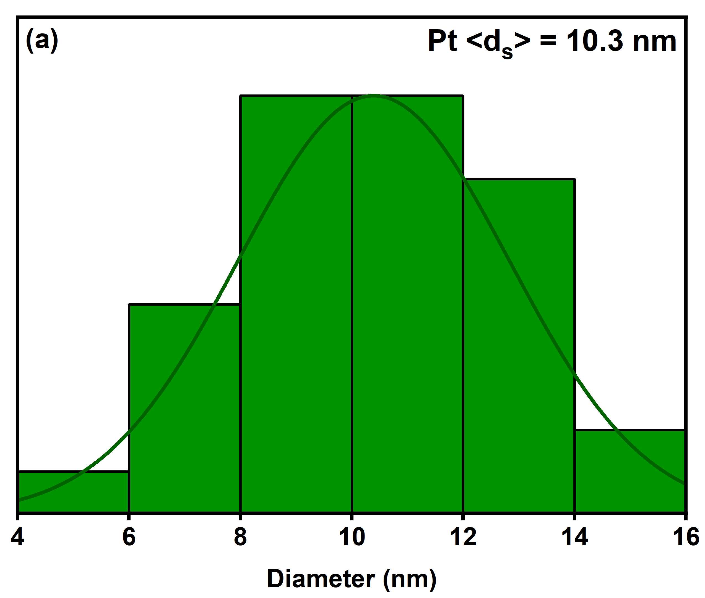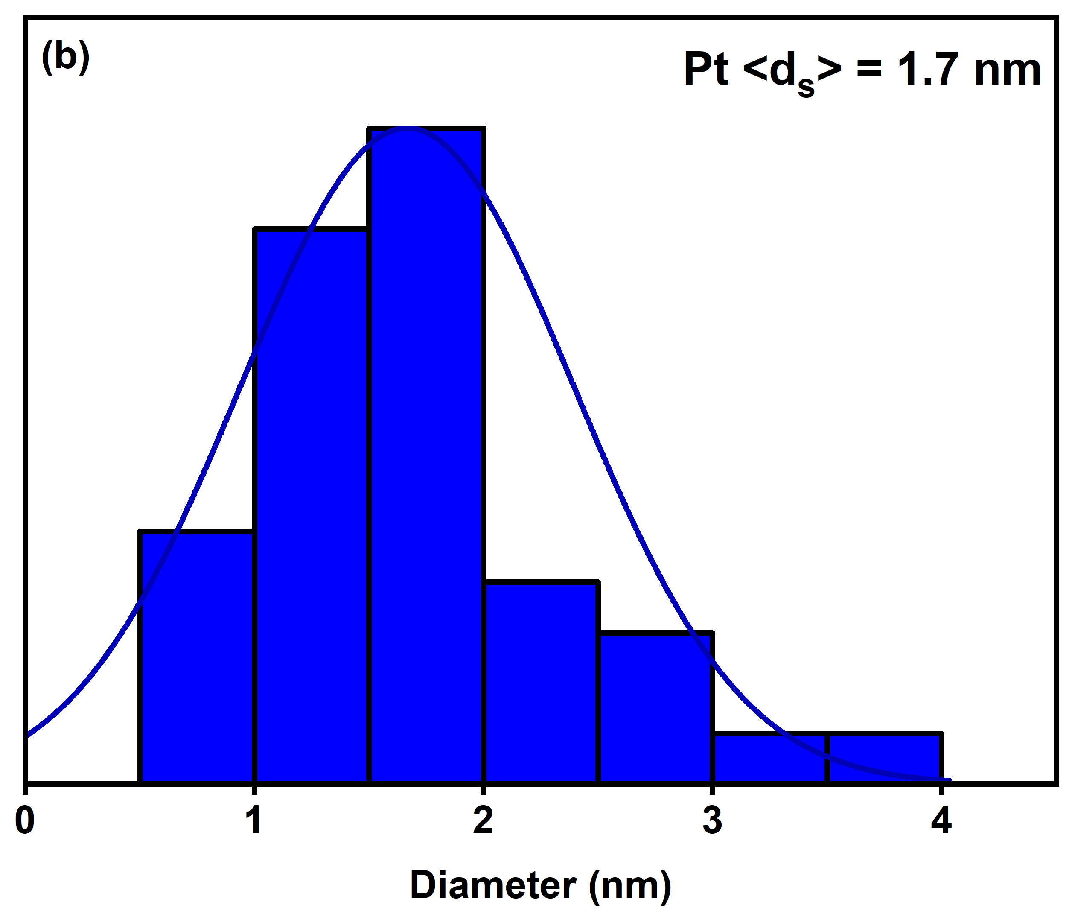
Figure S1 Average particle size distribution of platinum in (a) 1Pt⁰HY (b) 1Pt⁰ZBeta catalysts.

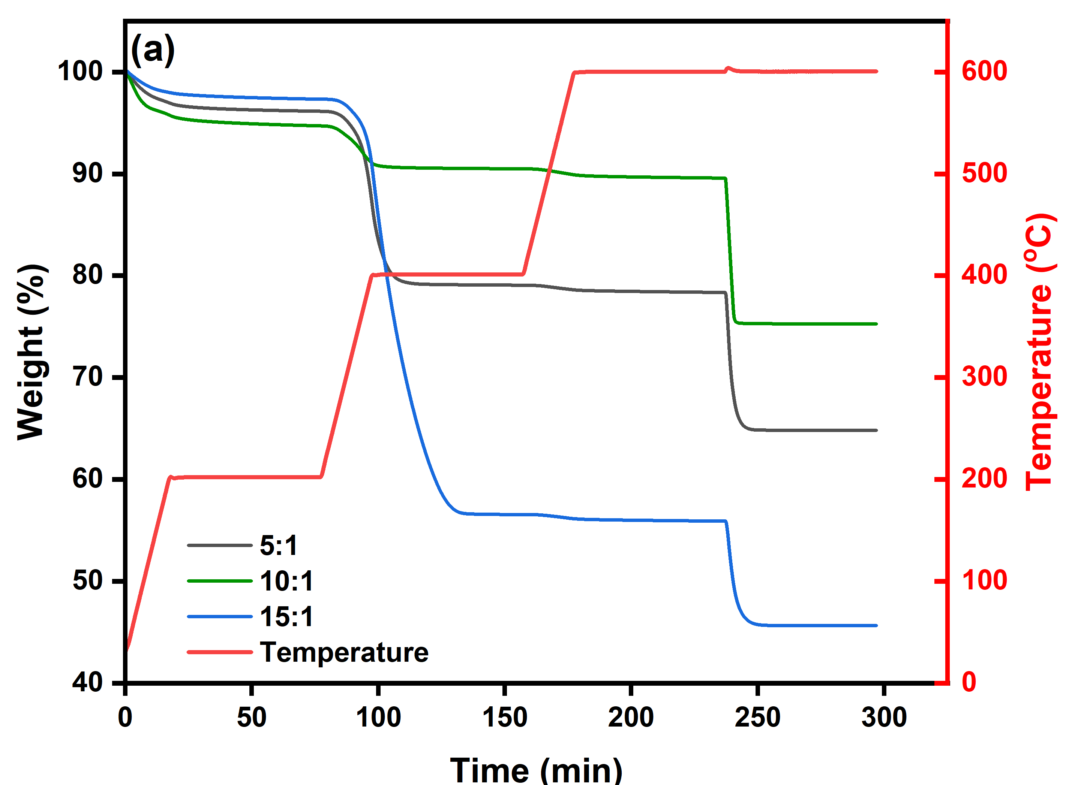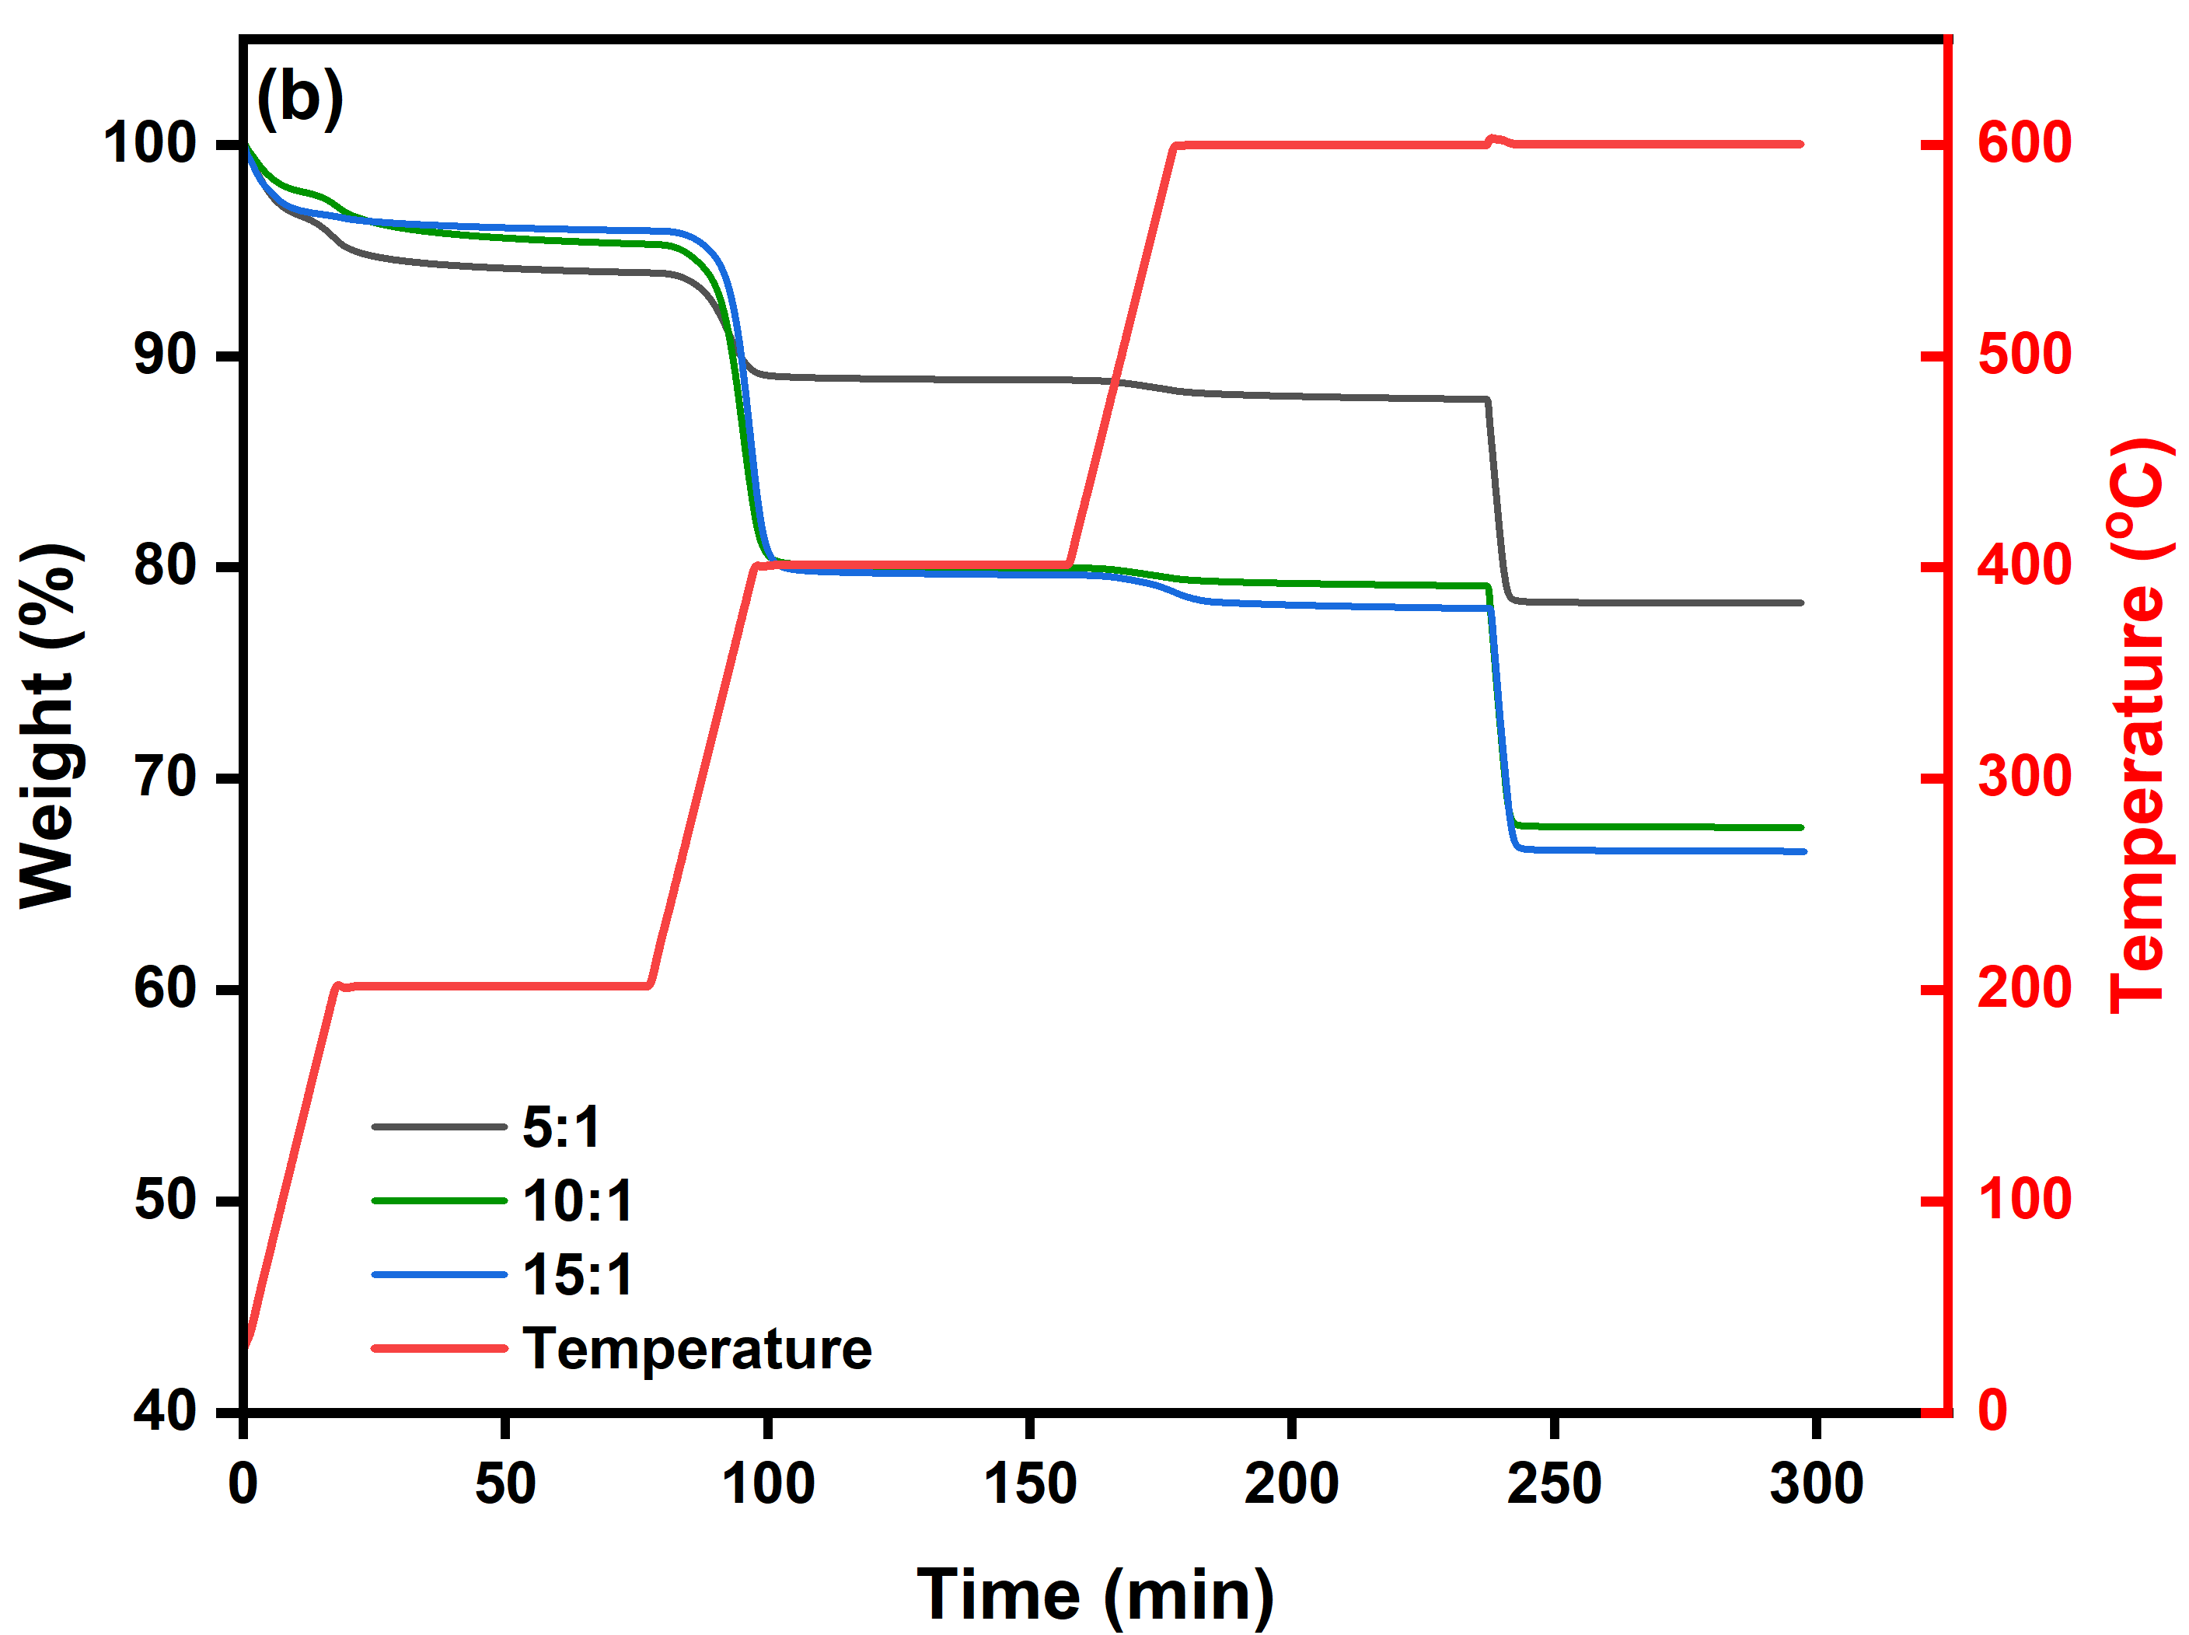
Figure S2 Schematic representation of TGA analysis for coke content obtained from mass-dependent polystyrene hydrocracking reactions using (a) 1Pt⁰HY (b) 1Pt⁰ZBeta catalysts.
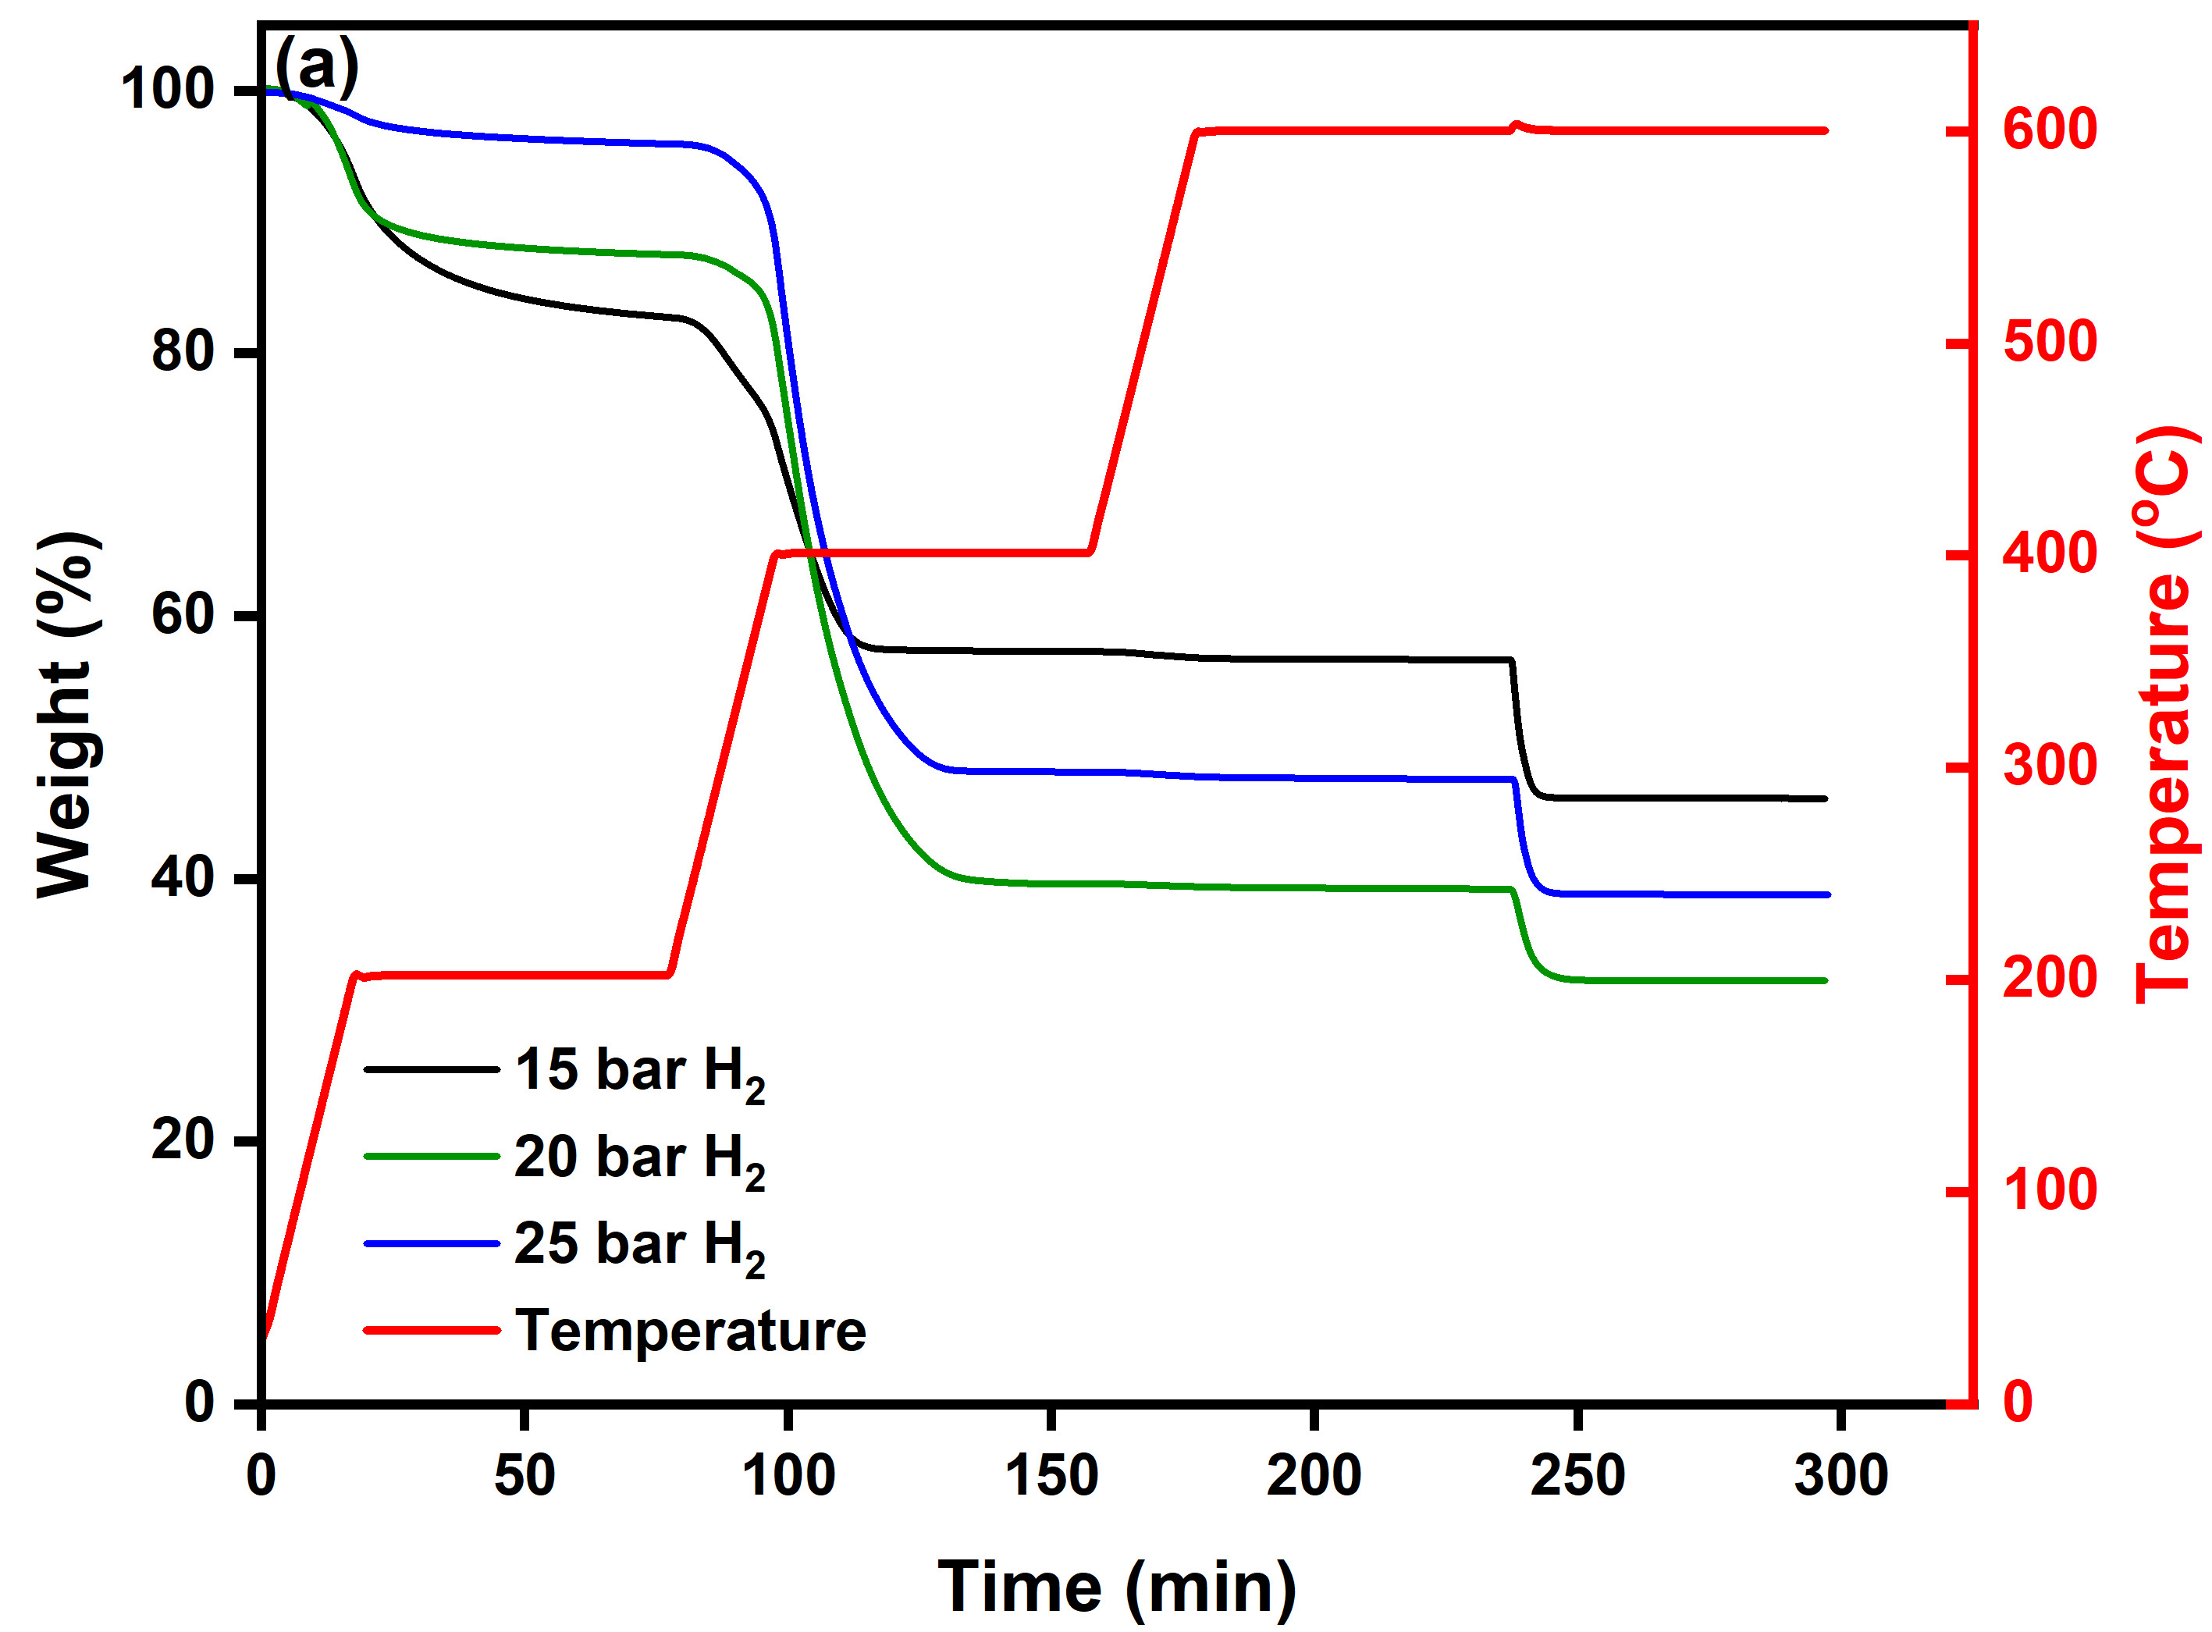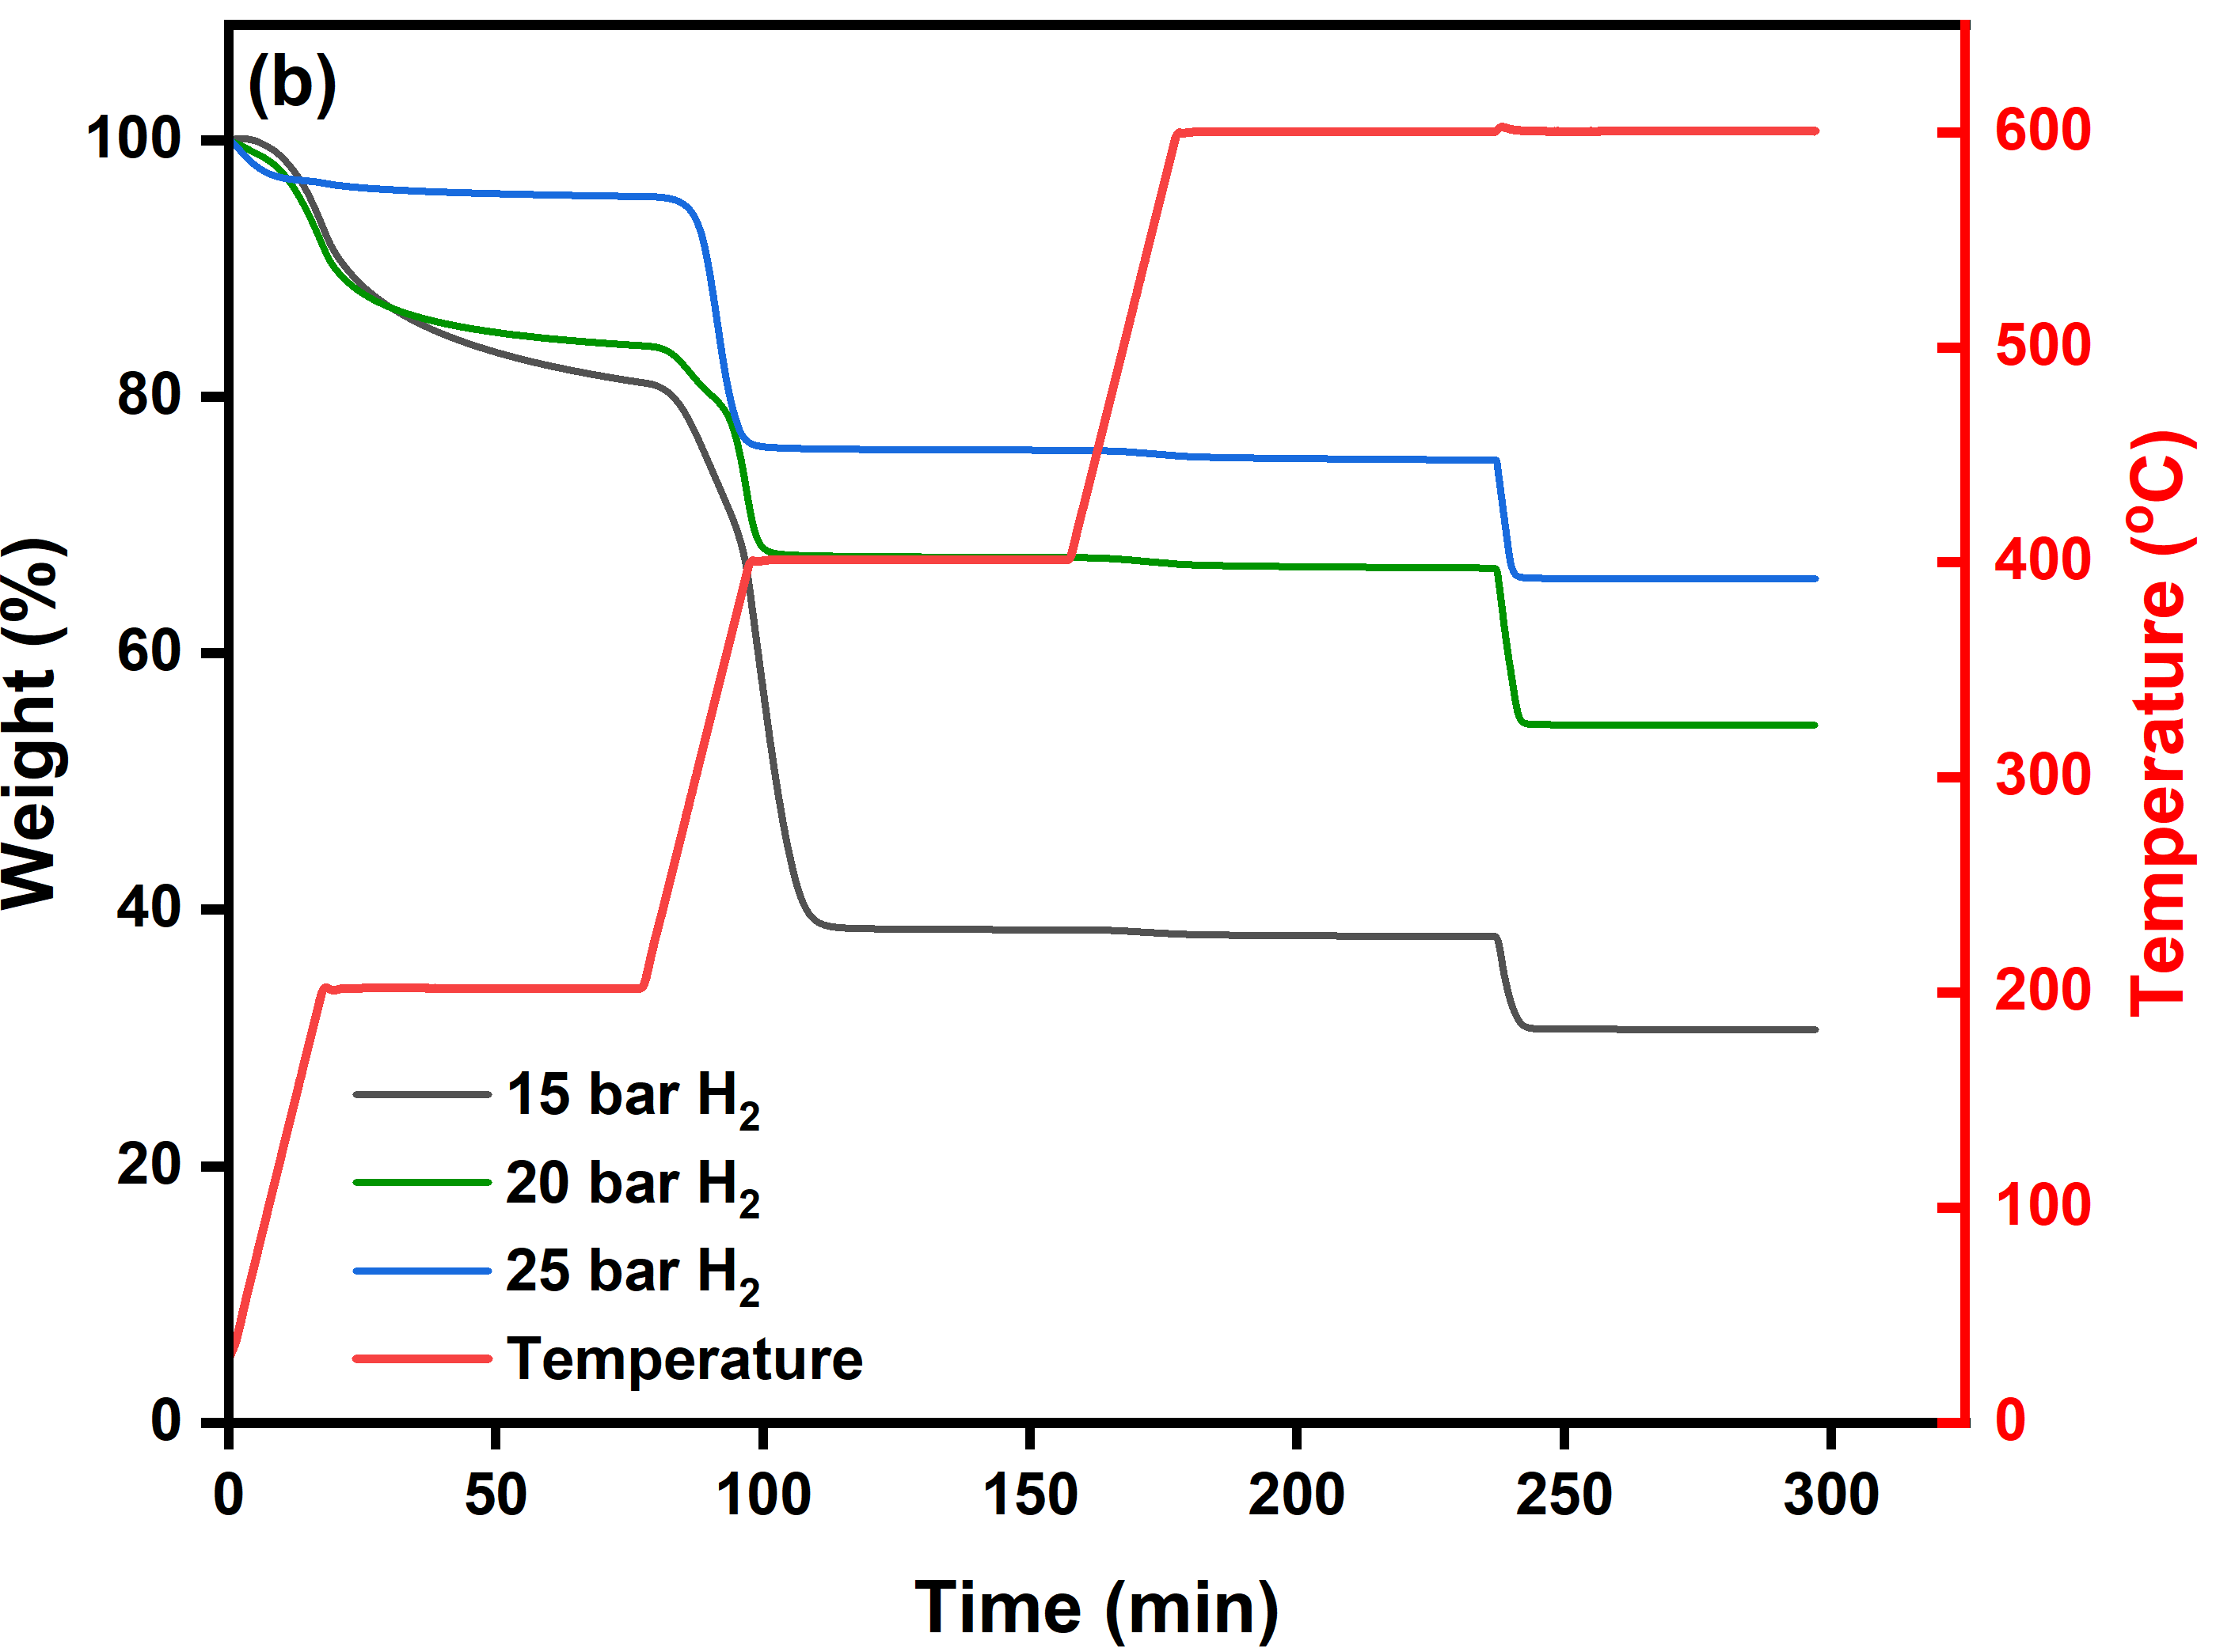
Figure S3 Schematic representation of TGA analysis for coke content obtained from pressure-dependent polystyrene hydrocracking reactions using (a) 1Pt⁰HY (b) 1Pt⁰ZBeta catalysts.

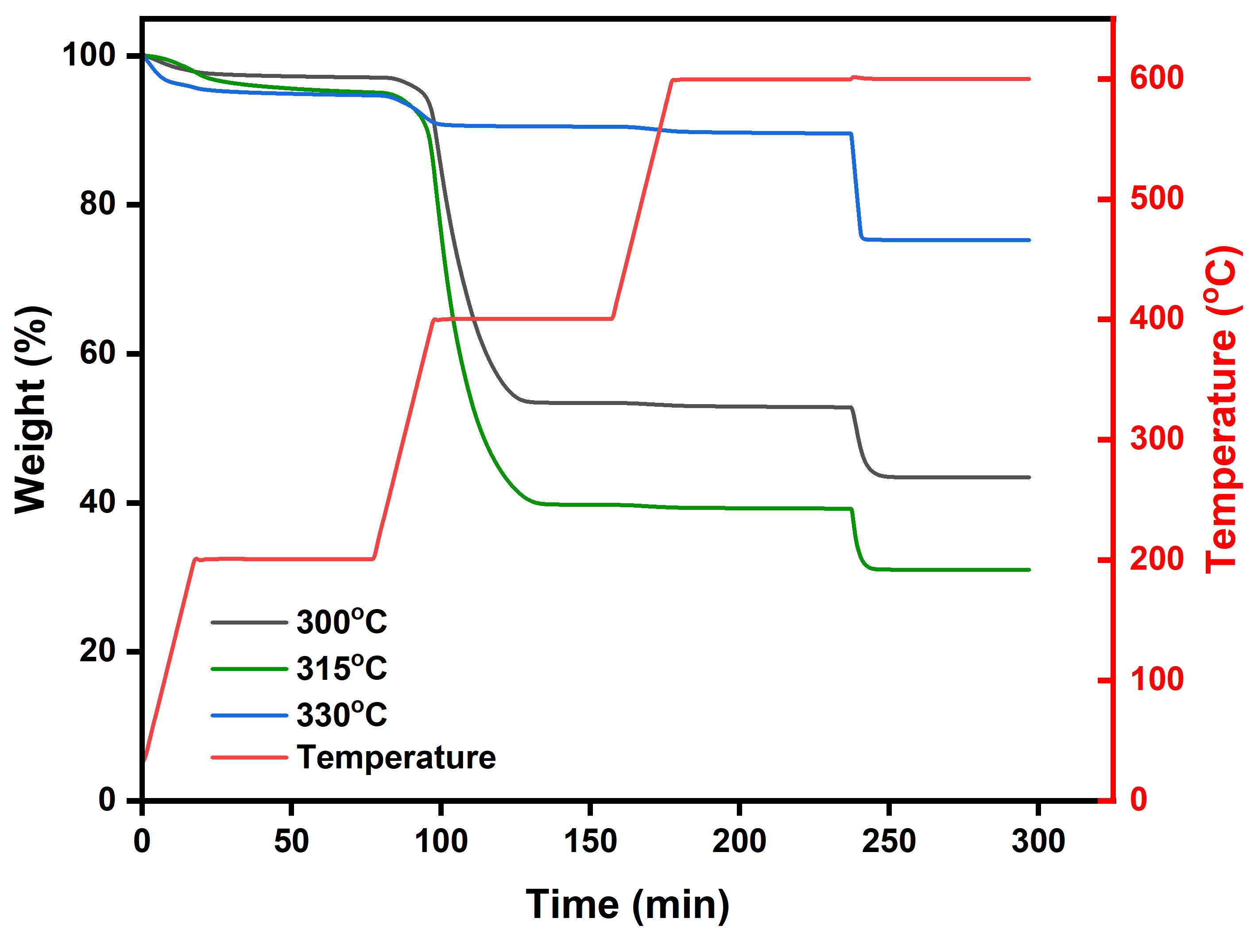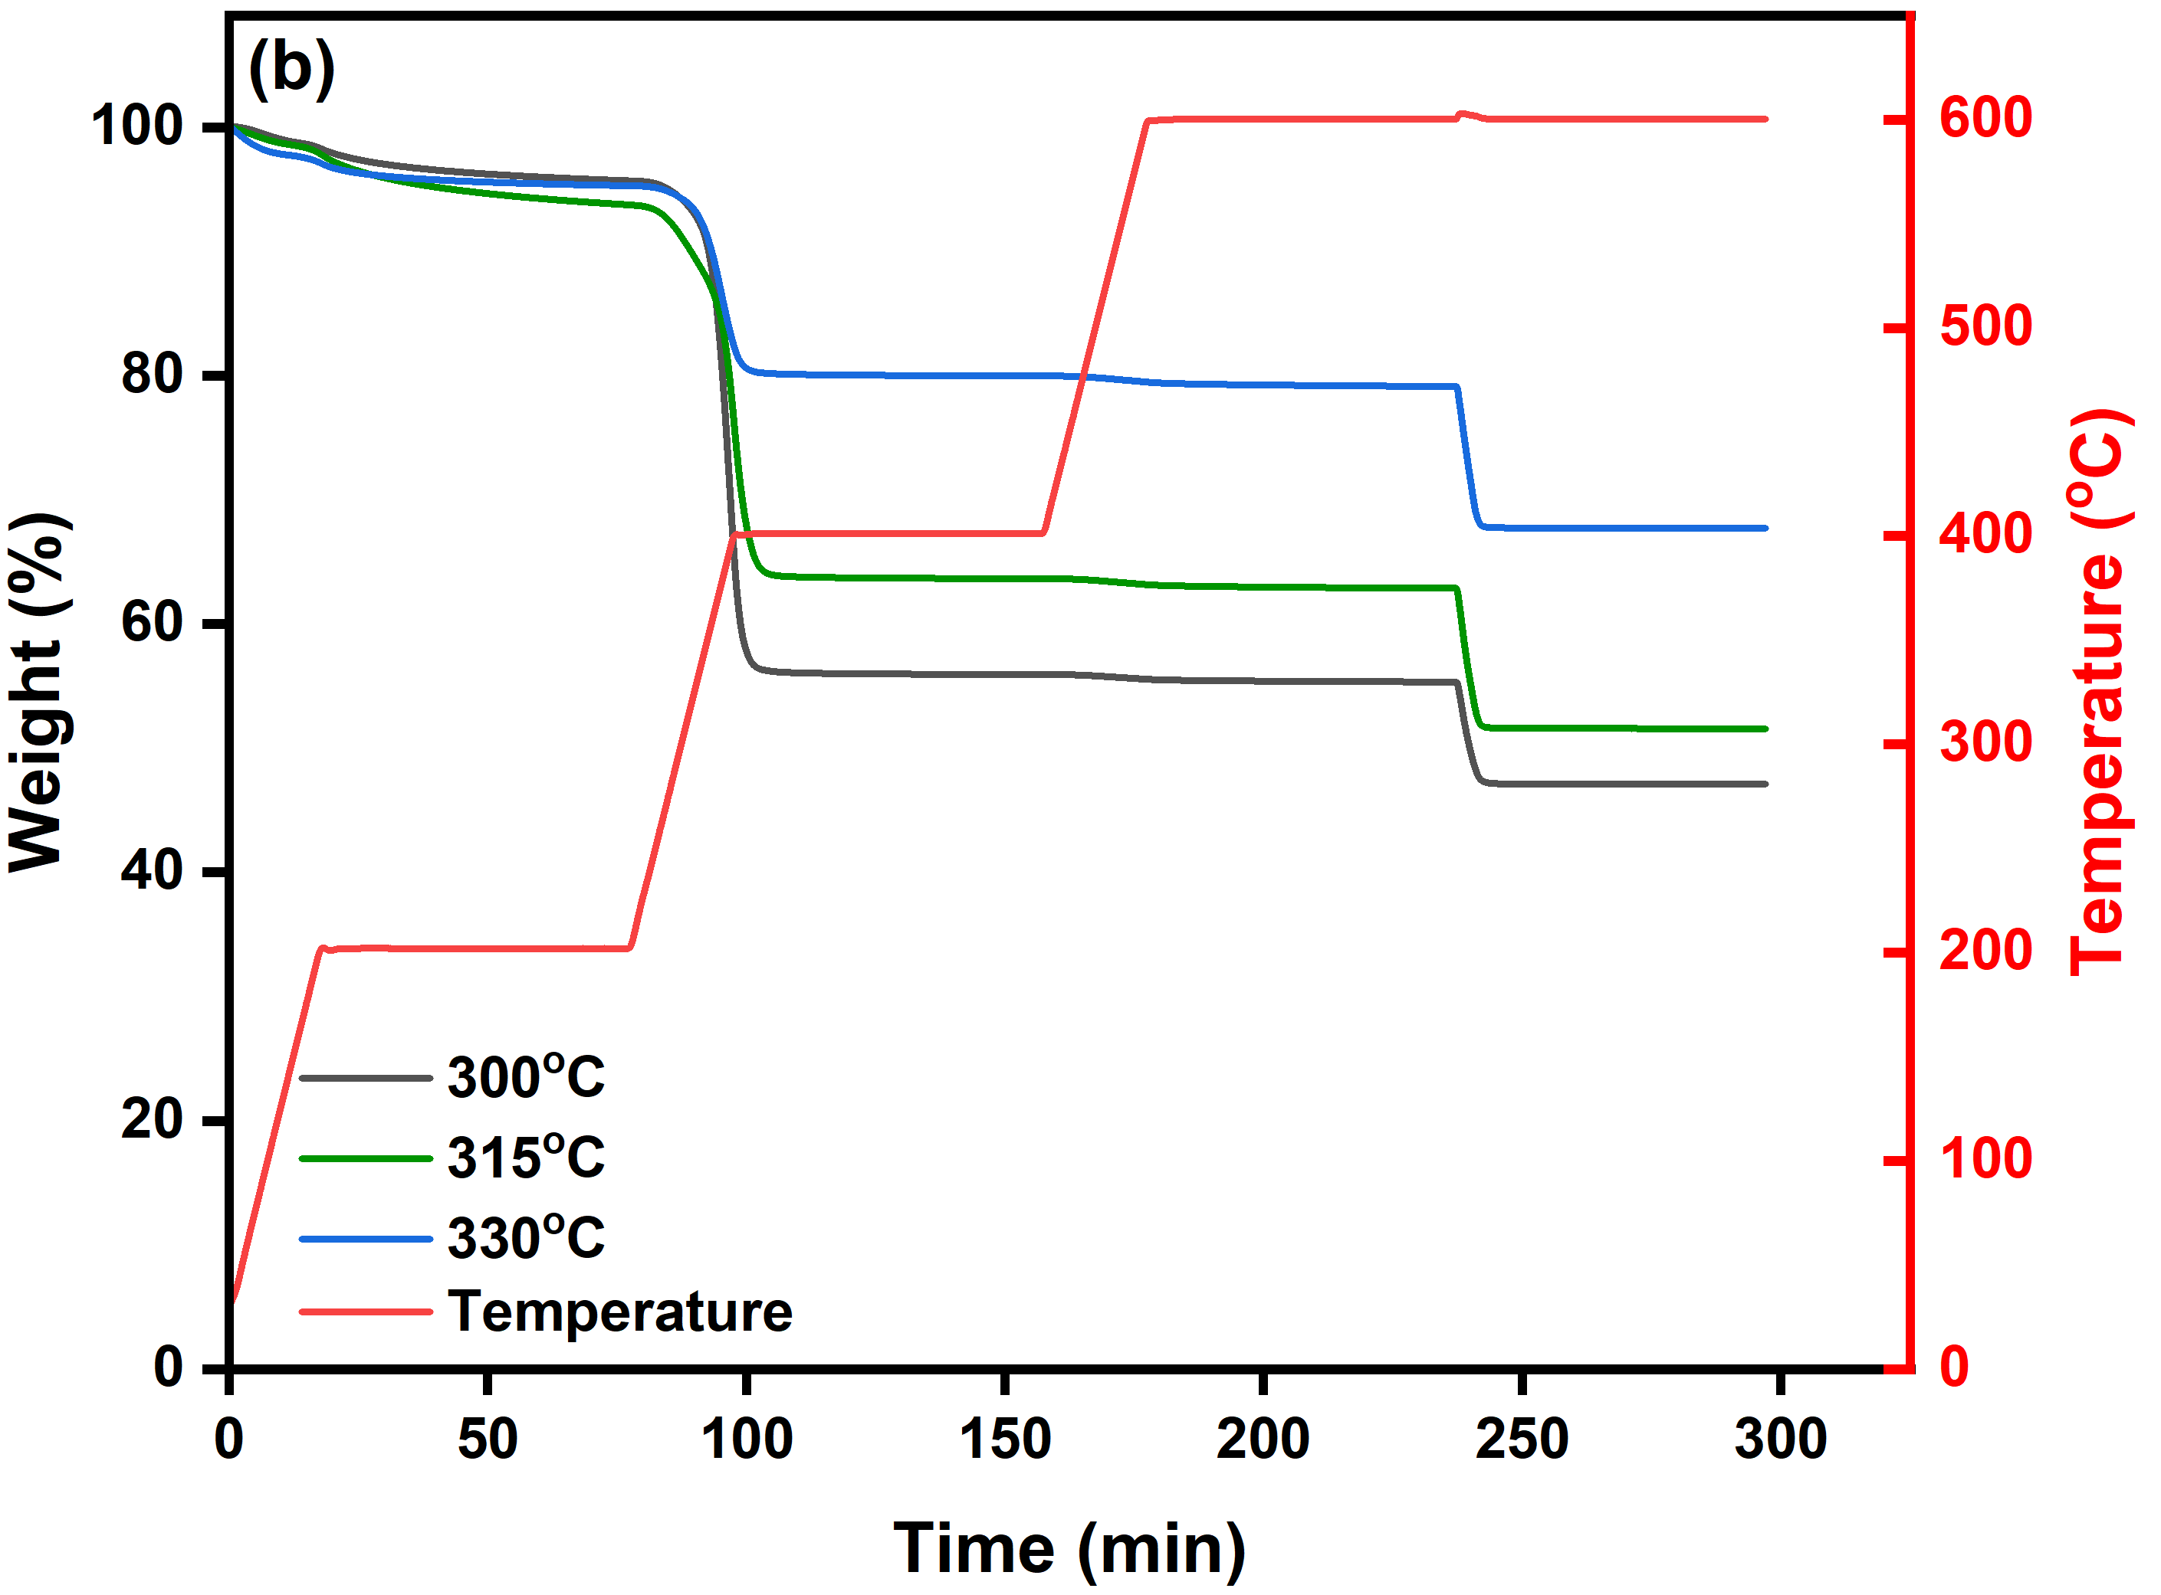
Figure S4 Schematic representation of TGA analysis for coke content obtained from temperature-dependent polystyrene hydrocracking reactions using (a) 1Pt⁰HY (b) 1Pt⁰ZBeta catalysts.

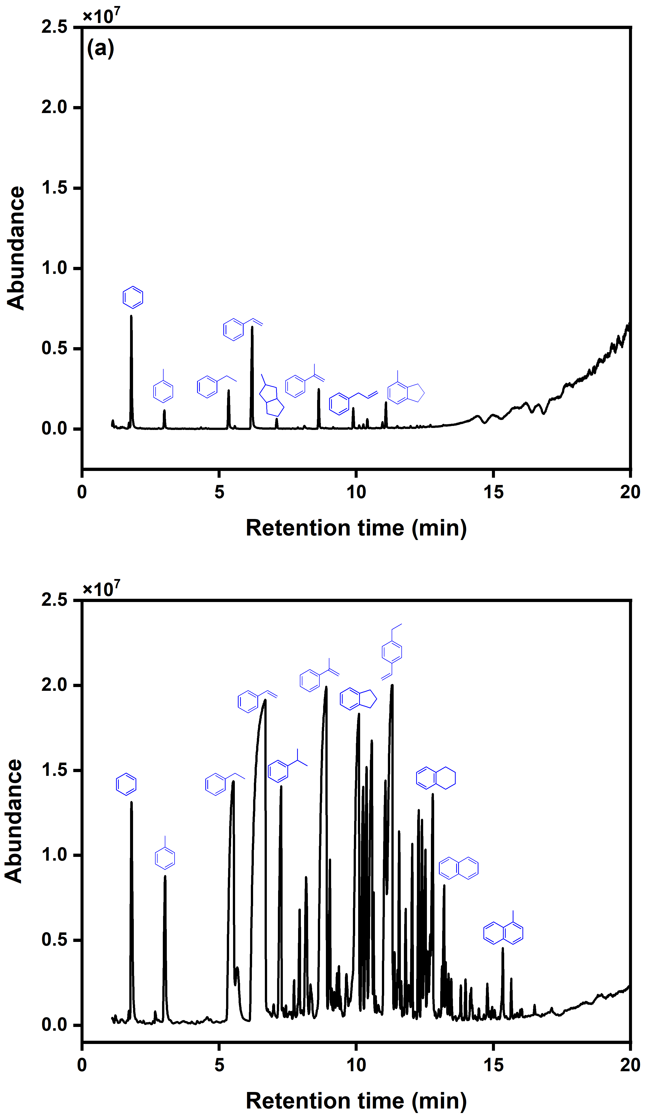
Figure S5 Gas chromatogram spectra of spent 1Pt⁰HY catalyst for a single run (a) ramp region from ambient to 700 $℃$ (b) isothermal region @700 $℃$ for 30 min.

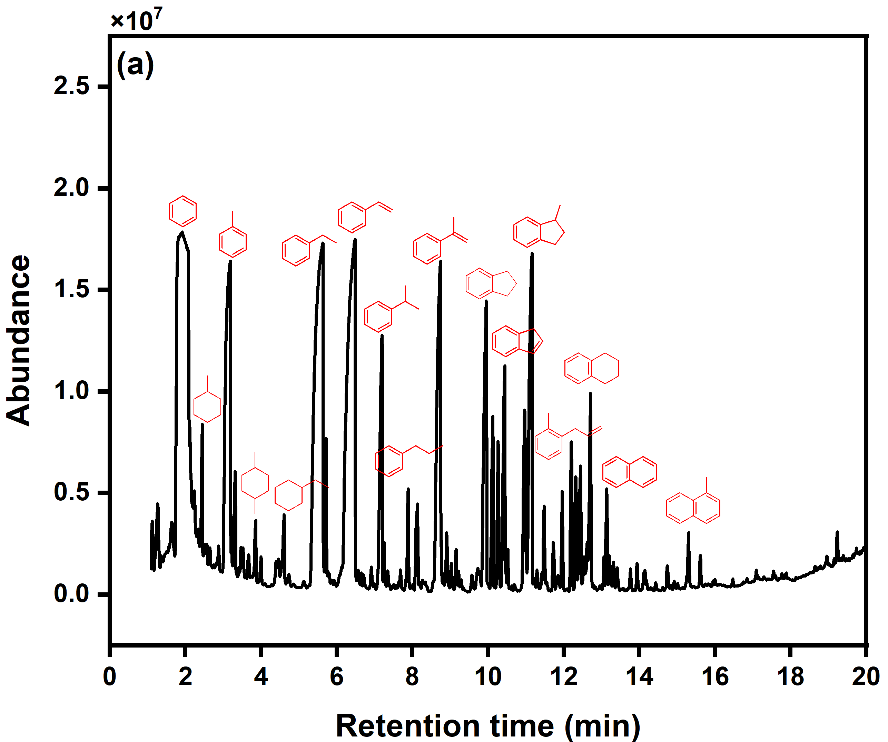
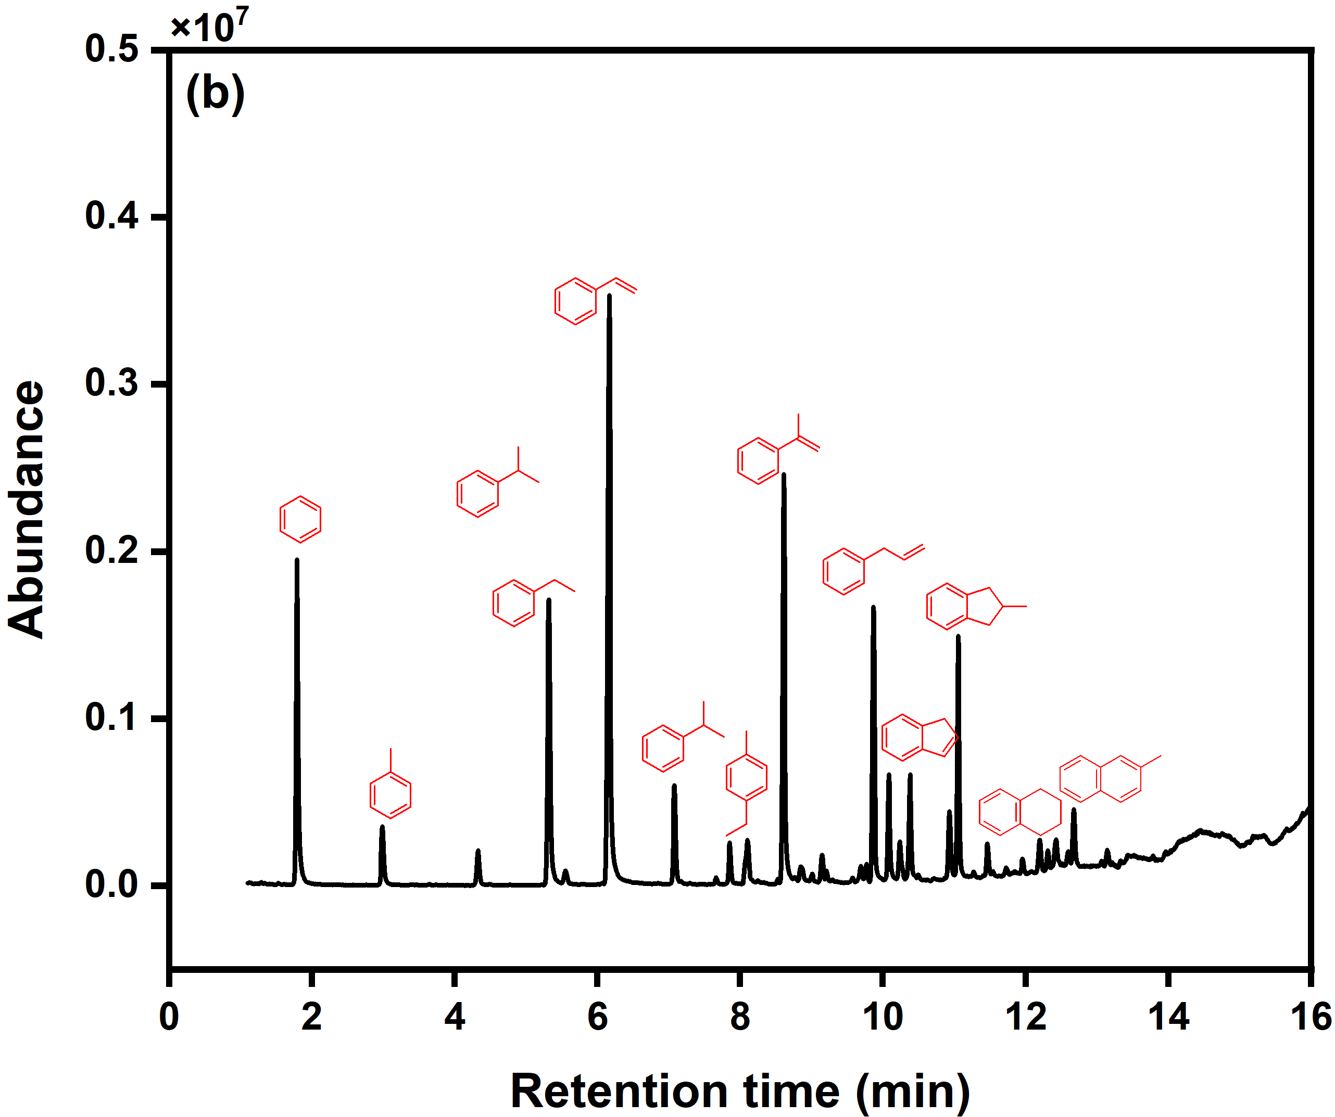
Figure S6 GC-MS chromatogram of N₂ desorption of spent single 1Pt⁰ZBeta catalyst with different heat regions (a) ramp region from ambient to 700 $℃$ (b) isothermal region @700 $℃$ for 30 min.

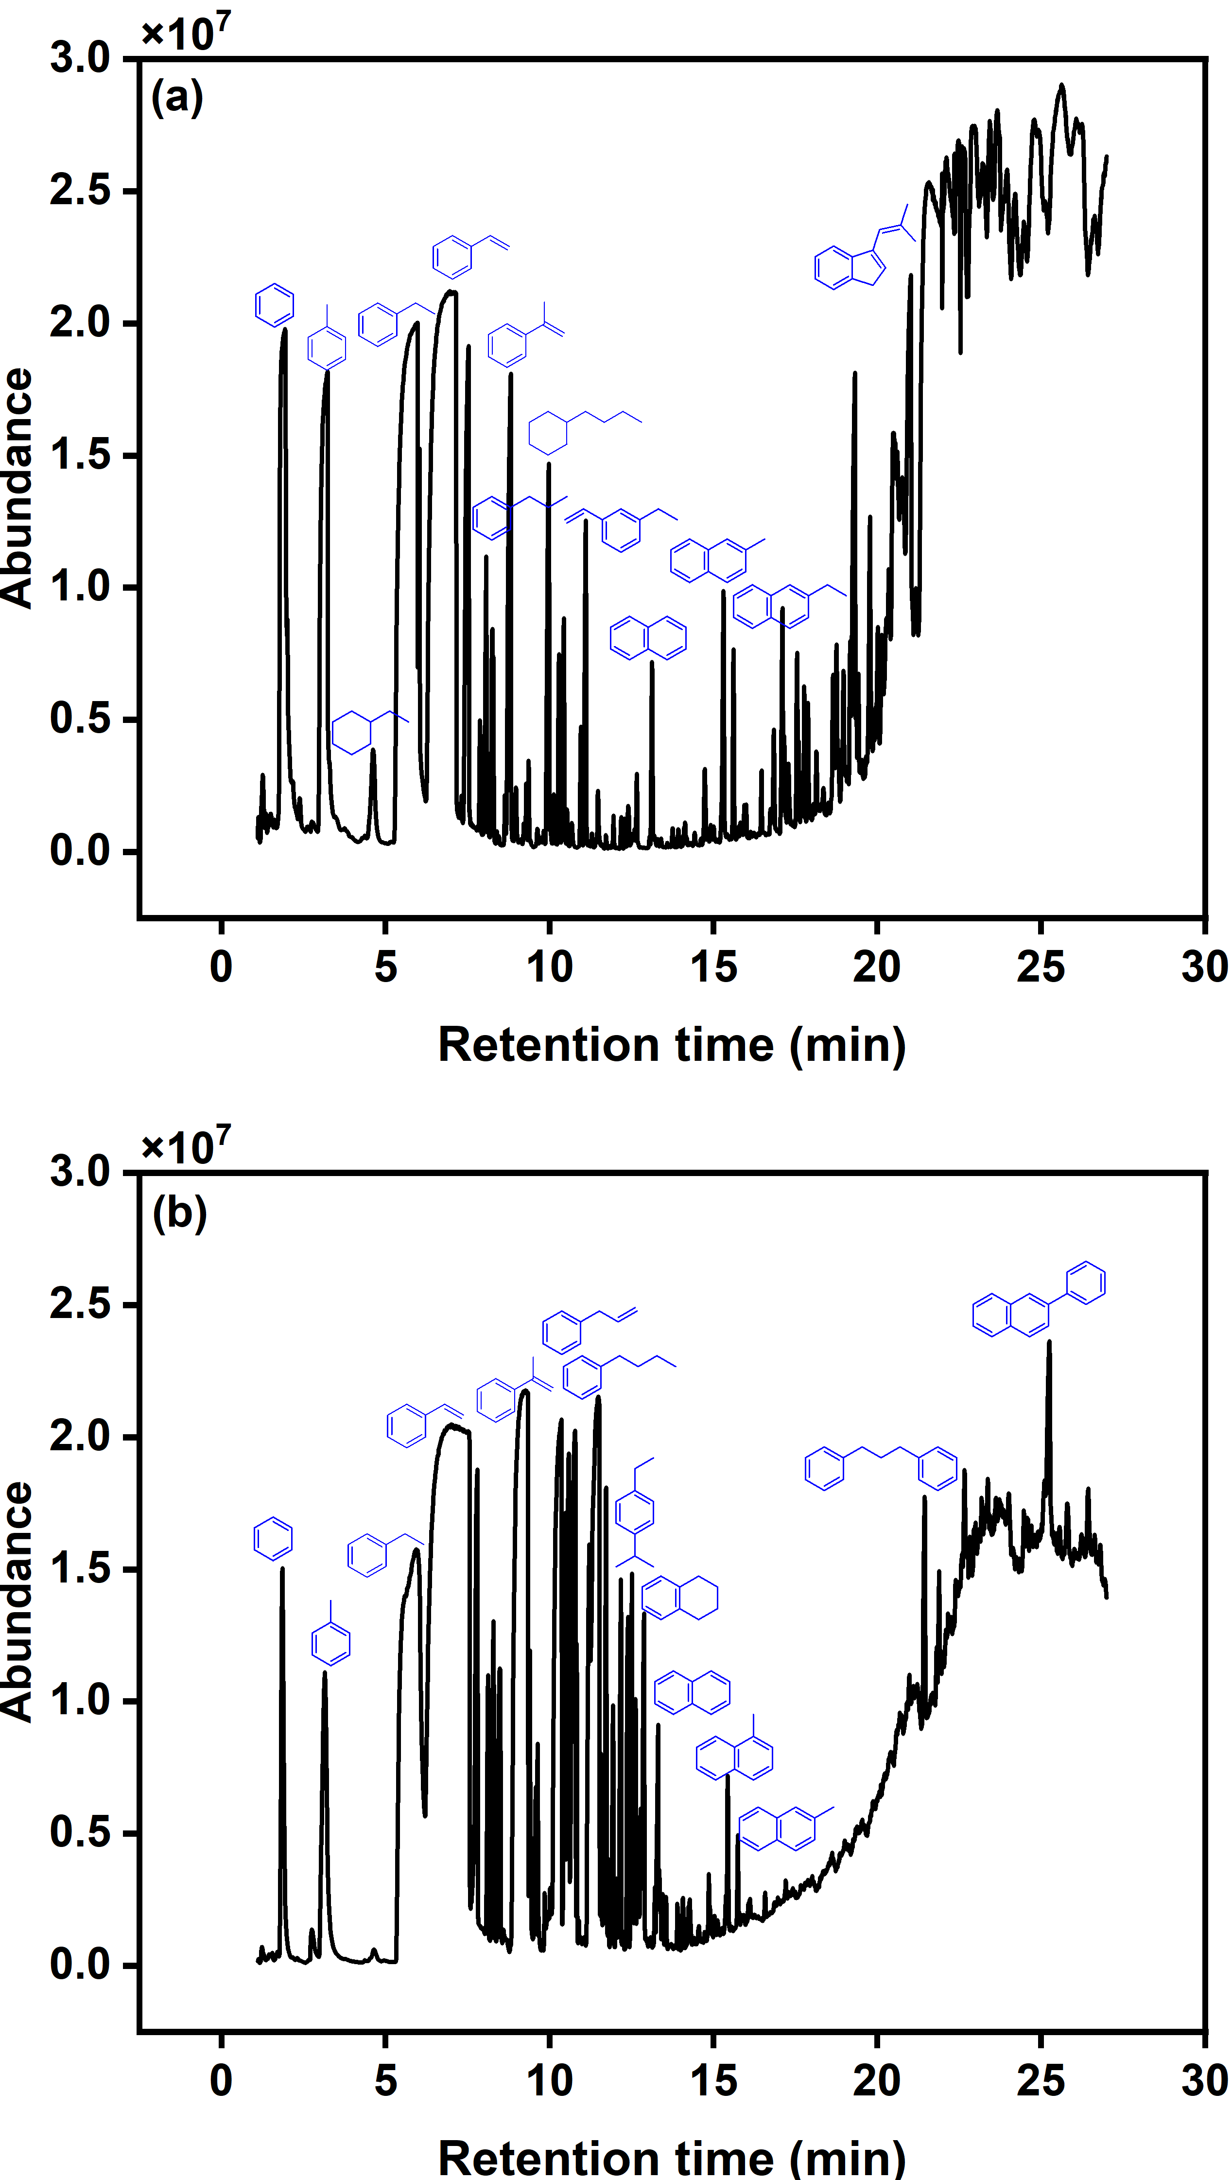
Figure S7 Thermal desoprtion-gas chromatogram spectra of spent 1Pt⁰HY catalyst for a 4th repeated run (a) ramp region 25–700 $℃$ (b) isothermal process@700 $℃$ for 30 min.

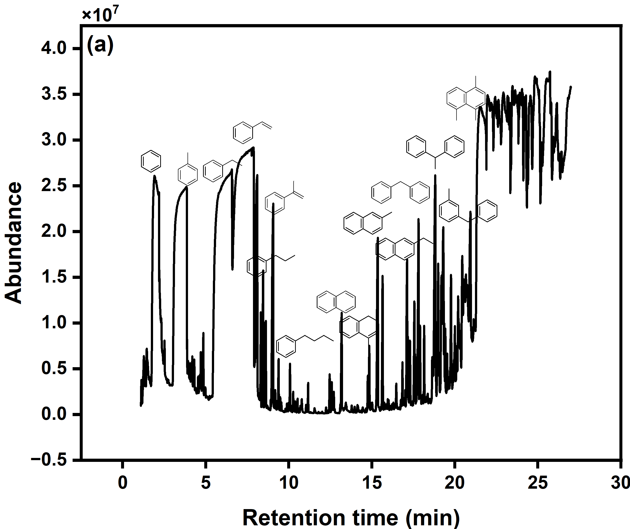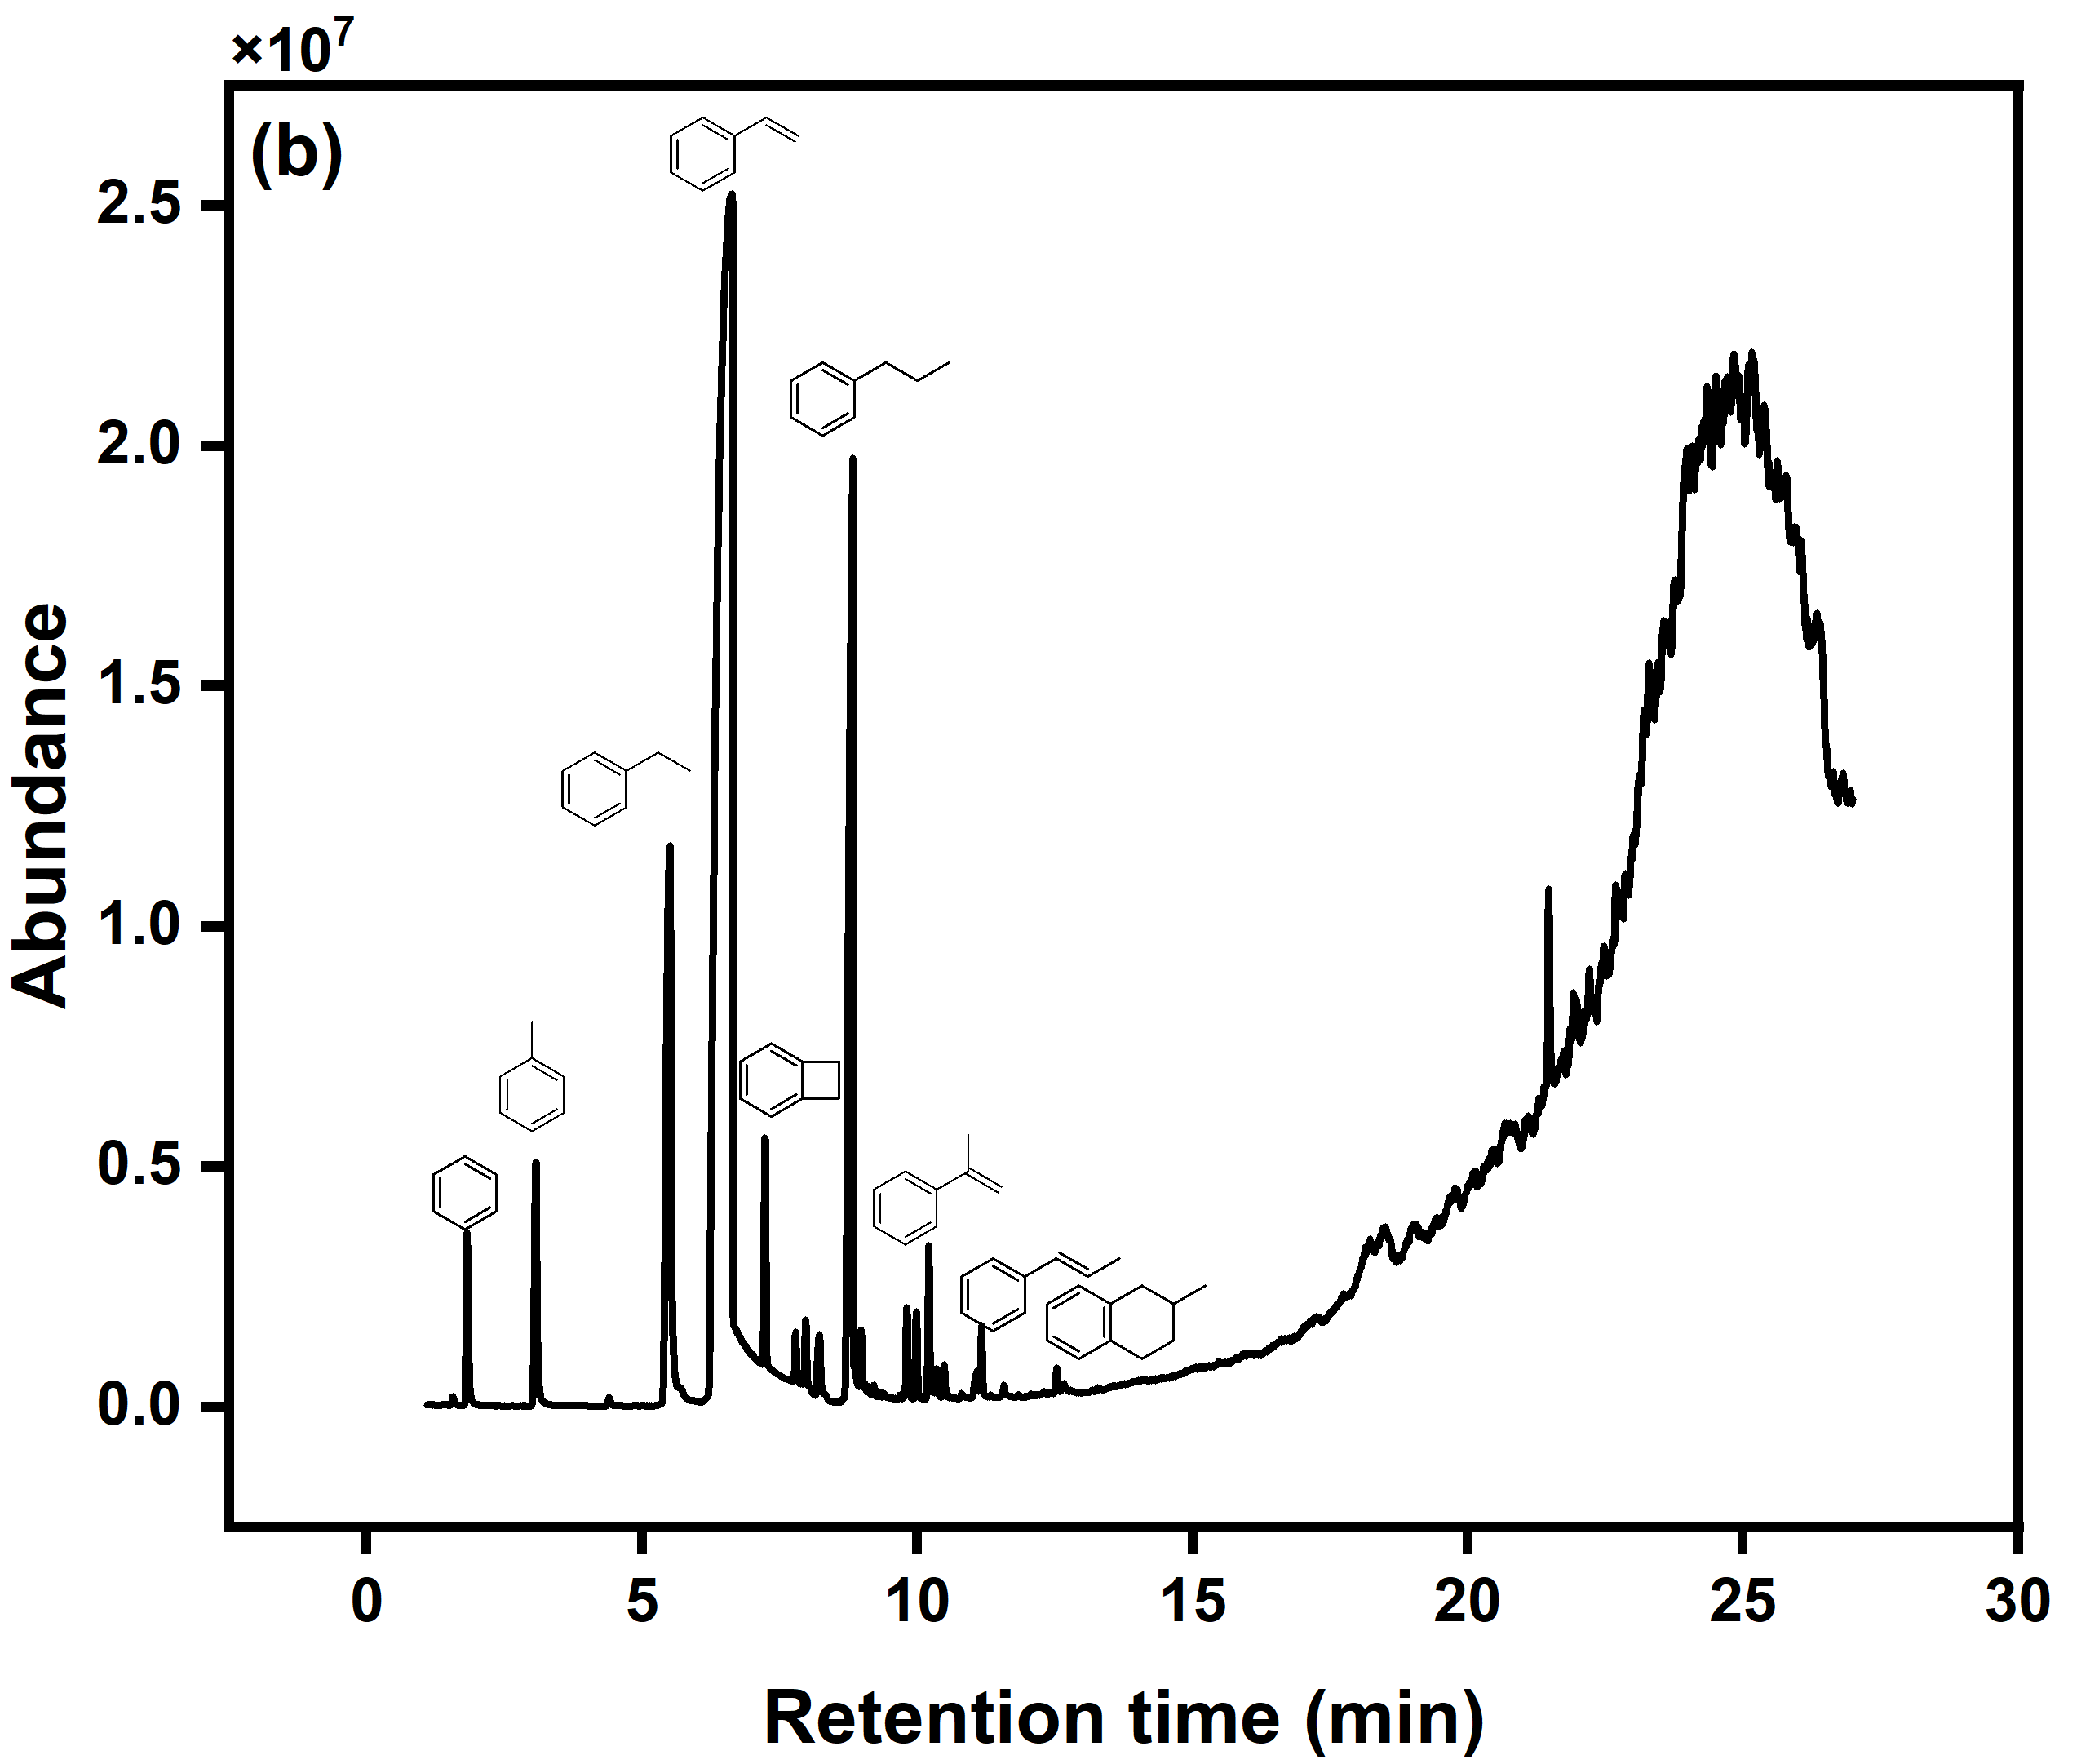
Figure S8 GC-MS chromatogram of N₂ desorption of spent recycled 1Pt⁰ZBeta catalyst with different heat regions (a) ramp region from ambient to 700 $℃$ at 20 $℃$min^{–1}, (b) isothermal@700 $℃$ for 30 min.

