Supporting information
Development of a nickel-based catalyst for syngas production via tri-reforming of biogas
Andrea Brigliadori,^{[a]} Filippo Suzzi,^{[a]} Andrea Bartoletti,^{[a]} Elisa Mercadelli,^{[a]} Davide Gardini,^{[a]} Elisabetta Orfei,^{[b]} Andrea Fasolini,^{[b]} Jacopo De Maron,^{[b]} Francesco Basile*,^{[b]} Angela Gondolini*^{[a]}, Alessandra Sanson^{[a]}
[a] CNR-ISSMC, Institute of Science, Technology and Sustainability for Ceramics National Research Council of Italy, Via Granarolo, 64, 48018 Faenza (Italy)
[b] Department of Industrial Chemistry, C3-Centre for Chemical Catalysis, CIRI-FRAME
Alma Mater Studiorum – University of Bologna, Viale Risorgimento 4, 40136, Bologna (Italy)
*Corresponding authors: angela.gondolini@issmc.cnr.it (A. Gondolini); f.basile@unibo.it (F. Basile)

Catalytic test: experimental conditions
The conditions employed for the catalytic tests of the material are reported in Table S1. Different temperatures (tests 2–4), steam content (tests 6–8), and oxygen levels (tests 10–13) were analyzed. The catalyst stability was studied at optimal thermodynamic conditions at the beginning and end of each parameter study (tests 1, 5, 9, and 14).

Table S1. Catalytic test operative conditions employed in this work together with experimental and equilibrium conversion for CH₄ and CO₂.
# | T (°C) | Feed composition | Thermodynamic Eq. CH₄ Conversion (%) | Thermodynamic Eq. CO₂ Conversion (%) | CH₄ Conversion pellet (%) | CO₂ Conversion pellet (%) | CH₄ Conversion foam (%) | CO₂ Conversion foam (%)
1 | 800 | CH₄/CO₂ 1.5 | 100 | 57.9 | 98.4 | 25.9 | 100 | 42.1
1 | 800 | S/CH₄ 0.2
1 | 800 | O₂/CH₄ 0.5
2 | 700 | CH₄/CO₂ 1.5 | 100 | 50.8 | 83.7 | 15.7 | 87 | 9.9
2 | 700 | S/CH₄ 0.2
2 | 700 | O₂/CH₄ 0.5
3 | 750 | CH₄/CO₂ 1.5 | 100 | 56.8 | 94.2 | 22.9 | 99.4 | 25.2
3 | 750 | S/CH₄ 0.2
3 | 750 | O₂/CH₄ 0.5
4 | 800 | CH₄/CO₂ 1.5 | 100 | 57.9 | 98.4 | 25.9 | 100 | 42.1
4 | 800 | S/CH₄ 0.2
4 | 800 | O₂/CH₄ 0.5
5 | 800 | CH₄/CO₂ 1.5 | 100 | 57.9 | 98.5 | 24.2 | 100 | 43.2
5 | 800 | S/CH₄ 0.2
5 | 800 | O₂/CH₄ 0.5
6 | 800 | CH₄/CO₂ 1.5 | 100 | 72 | 98.3 | 30.4 | 100 | 45.2
6 | 800 | S/CH₄ 0
6 | 800 | O₂/CH₄ 0.5
7 | 800 | CH₄/CO₂ 1.5 | 100 | 57.9 | 98.5 | 24.2 | 100 | 43.2
7 | 800 | S/CH₄ 0.2
7 | 800 | O₂/CH₄ 0.5
8 | 800 | CH₄/CO₂ 1.5 | 100 | 56.1 | 99.5 | 22.8 | 100 | 23.6
8 | 800 | S/CH₄ 0.5
8 | 800 | O₂/CH₄ 0.5
9 | 800 | CH₄/CO₂ 1.5 | 100 | 57.9 | 98.7 | 26.8 | 100 | 36.4
9 | 800 | S/CH₄ 0.2
9 | 800 | O₂/CH₄ 0.5
10 | 800 | CH₄/CO₂ 1.5 | 100 | 79 | 91.6 | 76.4 | 97.7 | 80
10 | 800 | S/CH₄ 0.2
10 | 800 | O₂/CH₄ 0.21
11 | 800 | CH₄/CO₂ 1.5 | 100 | 59.2 | 97.4 | 51.5 | 100 | 43.8
11 | 800 | S/CH₄ 0.2
11 | 800 | O₂/CH₄ 0.4
12 | 800 | CH₄/CO₂ 1.5 | 100 | 57.9 | 98.7 | 36.4 | 100 | 46.8
12 | 800 | S/CH₄ 0.2
12 | 800 | O₂/CH₄ 0.5
13 | 800 | CH₄/CO₂ 1.5 | 100 | 57.7 | 99.6 | 20.7 | 100 | 23.1
13 | 800 | S/CH₄ 0.2
13 | 800 | O₂/CH₄ 0.6
14 | 800 | CH₄/CO₂ 1.5 | 100 | 57.9 | 98 | 23.7 | 100 | 31.3
14 | 800 | S/CH₄ 0.2
14 | 800 | O₂/CH₄ 0.5

Morphological characterization
The as-synthesized Ni₂₄Mg₅₆Al₂₀ starting powder shows a bimodal particle size distribution constituted by fine aggregates with a diameter below 1 µm and larger clusters with dimensions up to 100 µm.
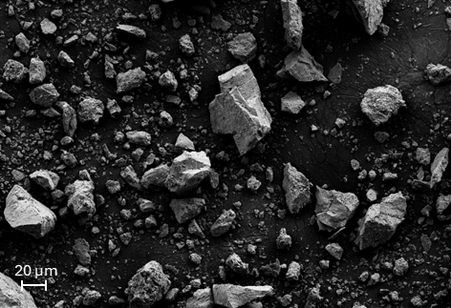
Fig. S1. FE-SEM image of the Ni₂₄Mg₅₆Al₂₀ raw powder.

Viscosity behaviour
Fig. S2 highlighted a predominantly Newtonian behavior (constant viscosity as a function of the shear rate) for both binders, polyvinyl alcohol (PVA) and hydroxypropyl cellulose (HPC).
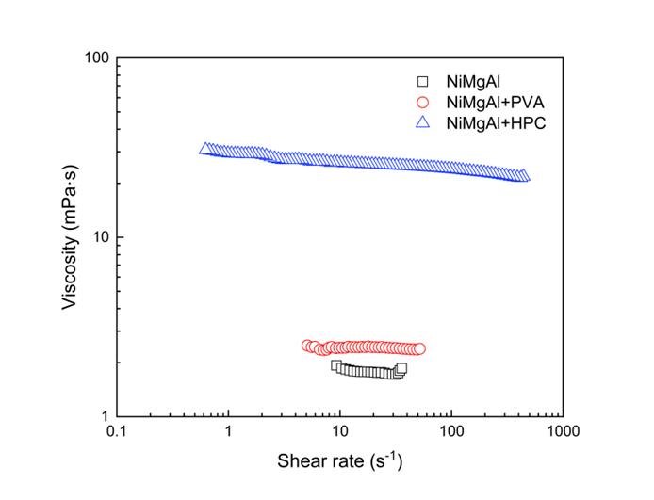
Fig. S2. Viscosity curves of the milled powder suspended in water without additives (NiMgAl), compared to the suspension implementing polyvinyl alcohol (NiMgAl+PVA) or hydroxypropyl cellulose (NiMgAl+HPC) as a binder.

Deflocculant influence on rheological properties
Deflocculating agents are generally used to increase suspension stability, avoiding agglomeration and sedimentation. In this case, Dolapix PC 21 was tested as deflocculant, but detrimental effect was observed, in fact, once Dolapix PC 21 (0.3 wt%) was added to the suspension containing NiMgAl milled powder (2.5 wt%) and HPC (2.5 wt%) as a binder, an increase in viscosity and a non-Newtonian behavior were recorded, as reported in Fig. S3. In light of the stability of the suspension without deflocculant, Dolapix PC 21 was not implemented in the final formulation as it did not provide any advantage from a rheological standpoint.
Fig. S3. Viscosity profile comparison between NiMgAl+HPC suspension with and without Dolapix PC 21.

Contact angles
Contact angle measurements demonstrated slightly hydrophobic properties of the NiCrAl foam against the water-based suspension. The suspension with hydroxypropyl cellulose exhibited less hydrophobic behavior and a time-dependent change in the contact angle, with decreasing values observed after 30 and 60 s.
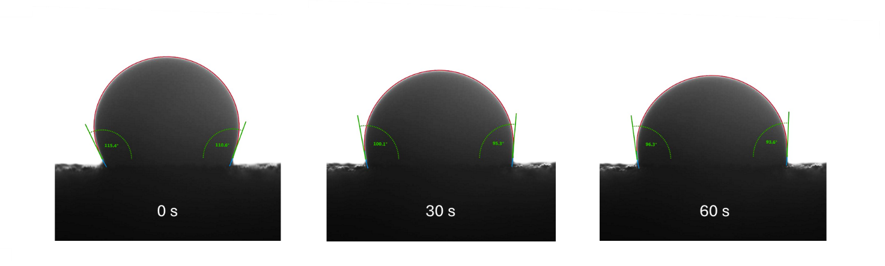
Fig. S4. Images of the droplet used for the contact angle measurements after 0, 30, and 60 seconds. Over time, the Ni₂₄Mg₅₆Al₂₀ drop penetrated slightly into the NiCrAl foam, lowering and widening.

Surfactant influence on rheological properties
Surfynol SE-F was added as a surfactant to reduce the surface tension of the NiMgAl suspension favoring the interaction between the suspension and the NiCrAl foam during the dip-coating. To preserve the same dip-coating efficiency, it is crucial to preserve the same rheological behavior, so the suspension implementing Surfynol SE-F was tested at the rheometer. Results reported in Fig. S5 demonstrated that the two curves of the suspension containing NiMgAl and HPC, with and without Surfynol SE-F, were perfectly superimposable, confirming that the surfactant did not affect the rheology of the suspension at the tested concentration (0.15 wt%).
Fig. S5. Viscosity profile comparison between NiMgAl+HPC suspension with and without Surfynol SE-F.

Thermal analysis (TGA-DSC) of NiMgAl and NiCrAl
Previous dilatometric analyses demonstrated good stability of the NiCrAl foam till about 1050 °C. In Fig. S6-a reports the thermal analyses (TGA-DSC) of the metallic foam (non-ox) and the oxidized foam (ox). The thermogravimetric curves evidence a weight gain due to oxidation phenomena at high temperatures. In particular, oxidation occurs at temperatures above 800 °C for the non-oxidized foam, while the pre-oxidized one is stable up to 900 °C. These results confirmed that the pre-oxidized foam is preferable to the non-oxidized one, being compatible with the calcination temperature (900 °C) and catalytic testing.
Thermal analysis (TGA-DSC) was also performed on the suspension constituted by NiMgAl 2.5 wt%, HPC 2.5 wt%, and Surfynol 0.15 wt% (Fig. S6-b). The DSC curve evidences the endothermic evaporation of water at 100 °C, leading to a mass loss of about 93 %. A second weight loss of 3.5 % was recorded in the 250-400 °C range, corresponding to the degradation of the organic (HPC+Surfynol). A 3.5 % residual mass was registered at 1100 °C, representing the inorganic fraction (NiMgAl). The concentrations of organic and inorganic components were slightly higher than the theoretical 2.5 wt% (both 1 % higher); these variations are below or close to the instrumental accuracy limit of ≈ 1 %.
Fig. S6. TGA-DSC combined analysis. (a) NiMgAl 2.5 wt% + HPC 2.5 wt% + Surfynol 0.15 wt% suspension (black TGA, red DSC exo-up). (b) Solid lines NiCrAl non-oxidized (NiCrAl non-ox), dotted lines NiCrAl oxidized (NiCrAl ox), (black TGA, red DSC exo-up).

EDX analysis of the NiMgAl coated NiCrAl foam
EDX elemental analysis was conducted to confirm the composition of the NiCrAl substrate and NiMgAl coating produced by dip-coating using the optimized suspension.
Results showed the elements constituting the substrate (Ni, Cr, Al) and the active phase coating (Ni, Mg, Al). The element maps reported in Fig. S7 made clearly visible the different compositions of the substrate compared to the coating.
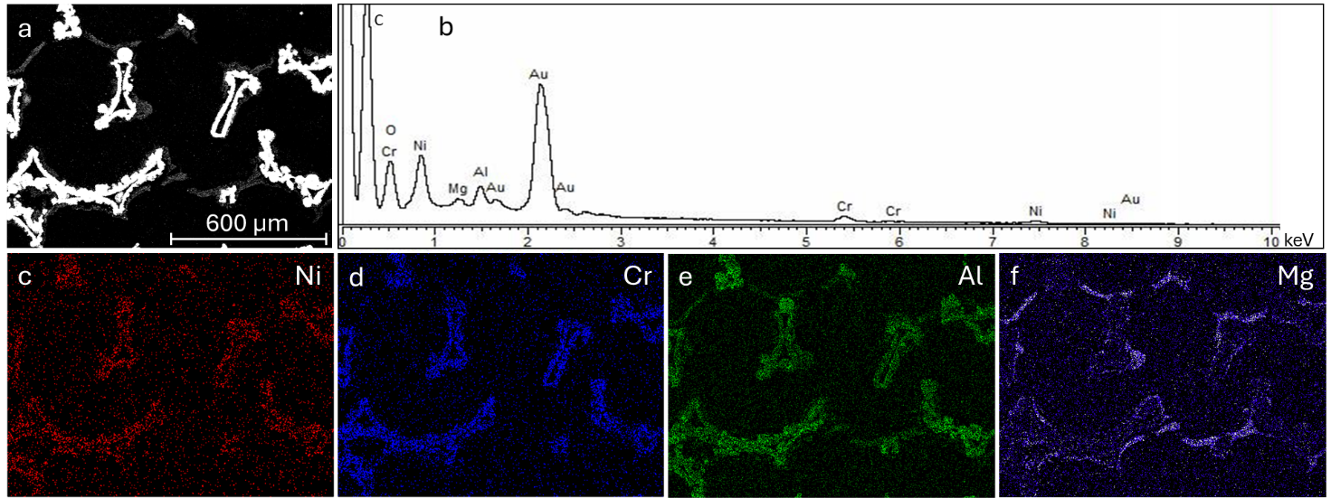
Fig. S7. EDX analysis of the coated sample: (a) electron image; (b) EDX spectrum; (c) Ni Kα1 map; (d) Cr Kα1 map; (e) Al Kα1 map; (f) Mg Kα1 map.
Spectrum 1 (Fig. S8-a) shows the punctual analysis of the NiCrAl foam in which the signals of Ni, Cr, and Al were recorded together with the Au used as a conductive thin film for the analysis. In Fig. S8-b the spectrum generated by the coating is reported, where it was possible to detect Ni, Mg, and Al peaks together with Au and O typical of the mixed oxide phase.
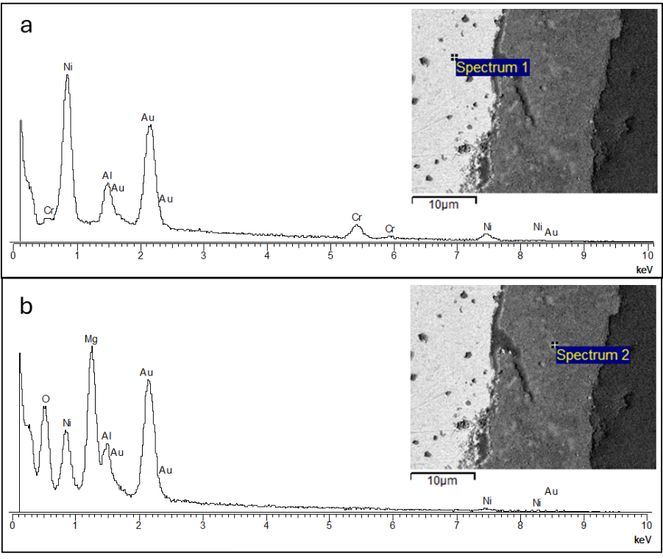
Fig. S8. EDX elemental analysis of the coated sample: (a) spectrum of the NiCrAl substrate, (b) spectrum of the NiMgAl coating.
XRD analysis of the spent catalyst
The XRD of the used catalysts show the presence of the following phases: a NiAl alloy representative of the metallic foam, A MgO and a MgAl₂O₄ phase typical of the catalyst and also reported in Fig. 6, a metallic nickel phase. Comparison of the XRD show a decrease in the peak intensity of Ni in the top part of the foam, which is the one exposed to oxidative conditions (high amount of oxygen and steam and low hydrogen content) indicating that the slight deactivation is related to Ni oxidation, consistently with the TPR results. Moreover, in the upper part of the foam catalytic bed a slight reflects related to Cr oxide has been observed, suggesting Cr segregation from the foam.
Fig. S9. XRD analysis of the spent catalyst: comparison of the top and bottom part of the foam.
EDX element distribution analysis of the NiMgAl coated NiCrAl foam after catalytic test
From the maps reported in Fig. S10 it was possible to observe a homogenous magnesium-containing layer (indicative of the NiMgAl catalyst layer) on the surface of the chromium-containing substrate. Nickel and aluminium were evenly distributed all over the sample, as they are components of both the foam and the catalysts, while chromium was mainly concentrated in the inner structure, and magnesium was confined in the surface layer. Oxygen was detected as part of the mixed oxides structure, and carbon represented the intruded resin counterpart of the sample.
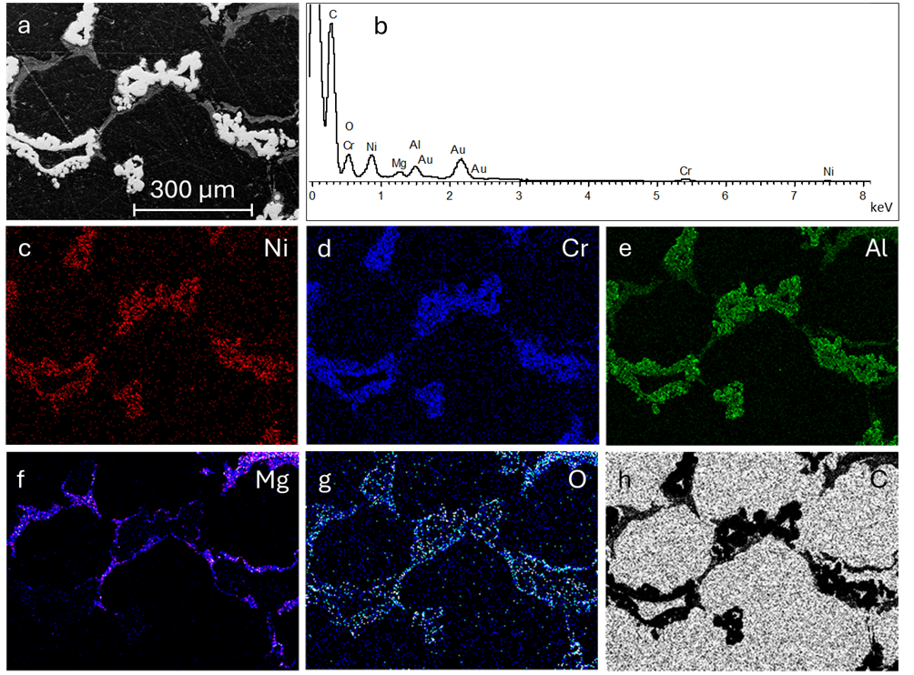
Fig. S10. EDX elemental analysis of the spent catalyst: (a) electron image; (b) EDX spectra; (c) Ni Kα1 map; (d) Cr Kα1 map; (e) Al Kα1 map; (f) Mg Kα1 map; (g) O Kα1 map; (h) C Kα1 map.

EDX analysis on the structured catalyst before and after use
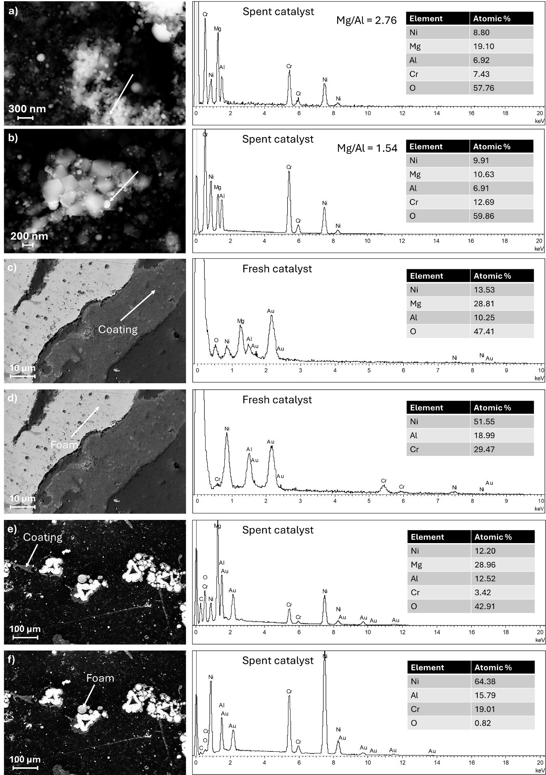
Fig. S11. EDX analysis of the spent catalyst: a) area rich in Mg indicative of MgO, b) area with a lower Mg/Al ratio indicative of MgAl₂O₄ spinel, c) fresh catalyst NiMgAl coating not containing Cr, d) fresh catalyst NiCrAl foam, e) spent catalyst NiMgAl coating revealing traces of Cr, and f) spent catalyst NiCrAl foam.

